The Emerging QCD Frontier: The Electron Ion Collider

I. A New Experimental Quest to Study the Glue That Binds us All

Without gluons there would be no protons, no neutrons, and no atomic nuclei. The exchange of gluons between quarks (particles with “color” charge) mediates the color force that provides the internal binding in all strongly interacting particles, just as the exchange of photons between electrically charged particles mediates the electromagnetic force that binds electrons to nuclei in atoms. But unlike photons, gluons are much more than mere force carriers in QCD. The gluons themselves have a color charge, and thus they interact among themselves. The self-interactions of gluons determine all the unique features of QCD and lead to a dominant abundance of gluons inside matter. Despite this dominance, the properties of gluons in matter remain largely unexplored. The world’s premier accelerator facilities focused on QCD – RHIC, CEBAF and HERA – have increasingly addressed selected aspects of gluon behavior accessible to them. But getting to the heart of the matter – unveiling the collective behavior of dense assemblies of gluons under conditions where their self-interactions dominate – will require a new facility with capabilities well beyond those of any existing accelerator.

The QCD equations governing the interactions among quarks and gluons are easy to write down, but difficult to solve. This is especially so at large length scales, where the interactions grow very strong, or at high densities, where the theory becomes highly non-linear. Recent breakthroughs have identified conditions of high density, but sufficiently weak coupling, where the theory may be amenable to a systematic solution, starting from a view of the dense assembly of gluons as a very strong classical field. These developments suggest that all hadrons and all nuclei should appear the same when viewed at sufficiently high energy – as a universal form of gluonic matter, of saturated density, known as the Color Glass Condensate. Saturation of the density – a predicted result of the growing importance of gluon recombination (two gluons merging into one) as the density increases – is critical to avoid a theoretical catastrophe in which predicted high energy scattering probabilities would exceed 100% if extrapolated linearly from gluon properties measured to date. Hints of this saturation have been extracted from measurements of electron-proton collisions at HERA and of deuteron-nucleus and nucleus-nucleus collisions at RHIC. Saturated gluon densities would have a profound influence on heavy-ion collisions at the LHC. But a definitive search for this universal gluonic matter, with a cleanly interpretable probe of its properties, requires an Electron-Ion Collider (EIC).

Counter-intuitively, high-energy electron (or muon) beams provide the best gluon microscope, by interacting primarily with individual electrically charged quarks, in a process known as deep inelastic scattering (DIS). When the struck quark emits a gluon, or arises from a gluon conversion to a quark-antiquark pair, these QCD corrections modify the precisely understood electromagnetic interaction of the electron and quark in ways that allow us to infer the gluon properties. For this inference to be precise, DIS must be studied over a broad range of energies and scattering angles. Collider energies are needed to reach the desired resolving power of the microscope. As explained below, the density of gluons probed by the electron beam is amplified inside a nucleus, as compared to a single proton. These features define the specifications of an EIC of high and variable energy, with beams of heavy nuclei, needed for robust access to the saturated gluon density regime.

The addition of spin-polarized proton and light-ion beams to collide with polarized electrons and positrons would give the EIC unprecedented access to the spatial and spin structure of protons and neutrons in the gluon-dominated region. Polarized DIS measurements would be greatly extended in kinematic reach and precision, in comparison to present-generation experiments with fixed polarized targets at CEBAF, HERA, CERN and SLAC. Tomographic images of the nucleon’s internal landscape would be pushed far beyond the valence quark region to be probed with 12 GeV electron beams at CEBAF. These extensions will be critical to complete our picture of the origin of the nucleon’s spin, by providing new sensitivity to the orbital motion of sea quarks and to the spin preferences of very soft (low momentum, highly abundant) gluons.

Results and measurement programs at the world’s existing QCD laboratories point to the physics accessible at an EIC as the next QCD frontier. EIC measurements will be critical in answering one of the overarching questions for our field: What is the role of gluons and gluon self-interactions in nucleons and nuclei? Self-interacting force carriers exist in interaction theories other than QCD (e.g., for the weak force and various hypothesized forces beyond the Standard Model), but without comparable opportunities to discover unique manifestations of those self-interactions in matter. EIC experiments would also yield missing links needed to answer two other overarching questions: What is the internal landscape of the nucleons? What governs the transition of quarks and gluons into pions and nucleons?

II. The Electron Ion Collider

The detailed requirements for the machine complex and detectors at an EIC are driven by the need to access the relevant kinematic region that will allow us to explore gluon saturation phenomena and image the gluons in the nucleon and nuclei with great precision. These considerations constrain the basic design parameters to be a 3 to at least 10 GeV energy electron beam colliding with a nucleon beam of energy between 25 and 250 GeV or with nuclear beams ranging from 20 to 100 GeV/nucleon.
While the HERA collider at DESY provided electron-proton collisions at even higher energies, the performance needed at EIC relies on three major advances over HERA: (1) Beams of heavy nuclei, at least up to gold, are essential to access the gluon saturation regime under conditions of sufficiently weak QCD coupling, and to test the universality of the Color Glass Condensate. (2) Collision rates exceeding those at HERA by at least two orders of magnitude are required for precise and definitive measurements of the gluon distributions of interest, especially with the complete outgoing particle detection needed for tomographic imaging. (3) Polarized light-ion beams, in addition to the polarized electrons available at HERA, are mandatory to address the central question of the nucleon’s spin structure in the gluon-dominated region.
A new EIC facility will require the design and construction of new optimized detectors profiting from the experience gained from those operated at DESY. A central collider detector providing momentum and energy measurements and particle identification for both leptons and hadrons will be essential. Special purpose detectors that provide extreme forward/backward coverage are also required.
There are currently two complementary concepts to realize an EIC: eRHIC, to construct an electron beam to collide with the existing RHIC ion complex and ELIC, to construct an ion complex to collide with the upgraded CEBAF accelerator. Both rely on new accelerator and detector technology, and on allocation of suitable R&D resources for their expeditious development. Over the next five years we anticipate sufficient R&D to choose the implementation that optimizes scientific impact and cost. In parallel with the technical developments, continuing progress on the theoretical treatment of saturated gluonic matter is needed to ensure that a future facility incorporate capabilities suitable to answer the most critical scientific questions.

III. The Physics Program at an Electron ion Collider

Saturation of Gluon Densities and the Color Glass Condensate. A major discovery of the last decade is the dominant role of gluons in nucleons viewed by a high-energy probe. The density of gluons grows extremely rapidly as one probes gluons carrying progressively smaller fractions x of a proton’s overall momentum. This growth reflects a QCD cascade in which higher-momentum (harder) parent gluons successively split into two or more lower-momentum (softer) daughter gluons. But this growth cannot continue unabated without eventually violating fundamental rules of physics. Physicists expect the growth to be tamed because at sufficiently high gluon densities softer gluons will again recombine into harder ones. The competition between the splitting and recombination processes should lead to a saturation of gluon densities at small x. Recent theoretical breakthroughs suggest that this saturation regime is characterized by new physics that can be best studied at an EIC.

The onset of saturation depends not only on the gluon’s momentum fraction x, but also on the spatial resolution with which the nucleon is probed. As the momentum kick Q imparted by a beam electron to the struck parton is decreased, the resolution of structure details in the plane transverse to the beam direction gets coarser. This increases the sensitivity to the recombination of gluons. This sensitivity also increases when the target nucleons are contained within a heavy nucleus, where many closely spaced nucleons along the beam path can conspire to contribute gluons to the recombination cause, amplifying the gluon density. The predicted result of these multiple dependences is a saturation scale Q_{s}² ∝ (A/x)^{1/3} that grows with increasing nuclear mass number A and with decreasing gluon momentum fraction x (see Fig. 1). When the probe has much finer spatial resolution, Q² >> Q_{s}², the physics is described by the well-studied linear regime of QCD, dominated by gluon splitting. But as Q² decreases below Q_{s}² one enters the novel non-linear regime of saturated gluonic matter

Gluons are among the class of particles known as bosons that are permitted by quantum physics to have more than one particle in the same state. In fact, the occupancy of gluons in the saturation regime is proportional to the inverse of the QCD coupling strength. When Q_{s}² is large, this coupling is weak, and therefore the occupancy is large and the behavior of the gluon ensemble is nearly classical. In this limit, theorists predict that one should gain access to a fascinating facet of all matter: a dense swarm of gluons, wherein the individual gluons interact weakly but collectively form a coherent classical color field whose intensity may be the strongest allowed in nature! This predicted universal facet of matter has much in common with Bose-Einstein condensates (whose study led to the 2001 Nobel Prize in Physics) and with glassy materials, and has thus been labeled the Color Glass Condensate, CGC.

To reach CGC conditions one needs a suitable combination of high beam energy (small x) and heavy ion (large A) beams to collide with the probing electrons. A hypothetical observer co-moving with the electron will see a tidal wave of gluons from protons and neutrons along the entire depth of the nucleus. Using heavy nuclei as an amplifier of gluon densities allows us to reach this regime with 10 times lower beam energy than would be needed in an electron-proton collider.
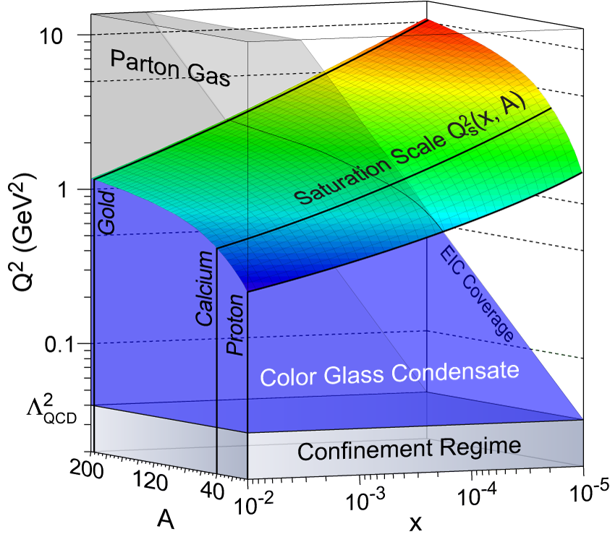
Figure 1: Regimes of hadronic matter in QCD at high energies, as a function of the resolving momentum transfer of the electron, Q², the relative momentum fraction of the gluon in the nucleus, x, and the atomic number of the nuclei probed, A. The multi-colored surface indicates the saturation scale Q_{s}² as a function of x and A. The saturation regime (Q²<Q_{s}²) that is kinematically accessible by the EIC is depicted in blue. For very large Q² matter exists in the form of a parton gas, while the confining regime of QCD is characterized by very low Q² values. The higher Q_{s}² (large A), the larger the accessible Q² range of the Color Glass Condensate and the more nearly classical its expected behavior. Acceptance at Q≈Q_{s} is not essential, coverage of the region at Q<Q_{s} is. The beam energies of the EIC would allow robust study of the saturation regime for gluons carrying as little as 0.01% of the nucleus’ momentum.

The regimes probed in atomic nuclei at high energies are shown in Fig. 1 as a function of the resolving momentum Q² of the probe, the gluon momentum fraction x and the atomic number A. As suggested by the figure, the Color Glass regime is expected to be universal across all atomic nuclei and for resolving momenta below the saturation scale. The use of large nuclei and high energies together opens a wide window to explore, with unmatched precision, this novel regime. The figure also shows that the CGC regime of strong gluon fields lies adjacent to the confining regime of QCD, where the interactions among individual gluons grow very strong. The transition between the two regimes may hold the key to understanding the confining dynamics at the heart of all matter.

Is there, in fact, a universal saturation scale, as suggested by QCD theory? Are the properties of the gluon-dominated matter beyond this scale truly the same in neutrons, protons and all nuclei? Do such universal properties explain remarkable patterns in particle production via strong interactions that have so far defied quantitative understanding? The discovery of the CGC would represent a major breakthrough in our understanding of QCD and nuclear matter. We turn next to the EIC measurement programs key to such a discovery.

A Precise Image of Gluons in Nucleons and Nuclei. The energy dependence of the high energy scattering process of electrons from nucleons and nuclei renders an indirect but precise measure of gluons through the evolution with energy scale of quark properties. Application of this technique established the massive wall of gluons found in HERA data when one probes protons with increasing spatial resolution. However, at the moderate resolutions and very small gluon momenta of the saturation region, the situation is much less understood. The conventional linear QCD analysis of energy evolution is expected to break down here, and its application to HERA data yields puzzling results.
In nuclei, the region of gluons for x < 0.01 is terra incognita and measurements at an EIC will be the first. Figure 2 shows projections of EIC measurements of the ratio of gluon distributions for a lead nucleus relative to that for deuterium. The saturated gluon densities associated with the CGC and those anticipated in linear QCD approaches (labeled as HKM and FGS here) are shown. By combining measurements such as those in Fig. 2 for a variety of nuclear beams with different masses A, one can search directly for a universal scaling behavior that collapses all the data onto a single curve as a function of Q²/Q_{s}². Such scaling would demonstrate the universality of the CGC and directly determine how the saturation scale depends on x and A.

The deep inelastic scattering measurements determine how the gluons are distributed in momentum inside nuclei. It is also important to see how they are distributed in space; e.g., are the conditions for saturation achieved first in localized regions within the nucleus? The spatial distribution can be probed when the scattering electron produces a single high-energy photon, or a meson with the same quantum numbers as the photon, without exciting the target nucleus. The results would provide insight into the role of strong color fields in binding nuclei and in more complex processes of multiple particle production.
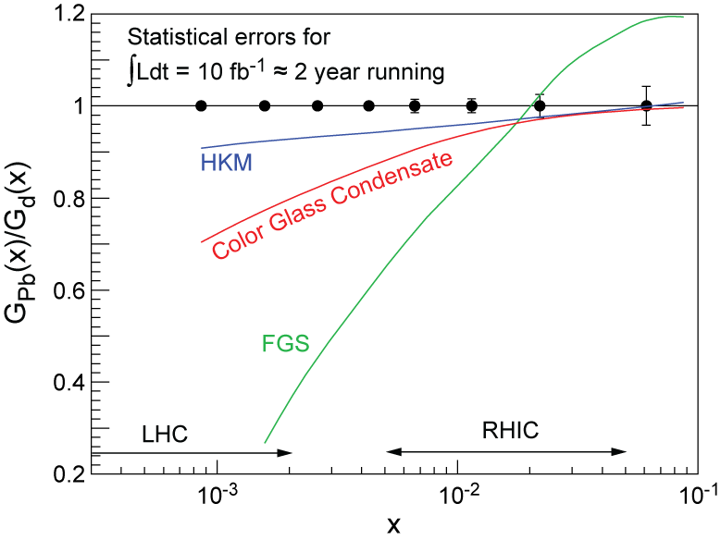
Figure 2: The ratio of gluon distributions in lead relative to deuterium as determined from projected measurements with an EIC, as a function of gluon momentum fraction x. HKM and FGS represent QCD parameterizations of existing data extrapolated linearly to small x. The curve labeled Color Glass Condensate is a saturation model prediction. Domains relevant to nucleus-nucleus collisions at RHIC and the LHC are shown.

Strong gluon fields also enhance the probability for a high-energy probe to interact gently with the nucleus by exchanging a colorless particle comprising multiple gluons – a particle sometimes called the Pomeron. Indeed, experiments at the HERA collider produced the striking discovery that a proton at rest remains intact in roughly one-seventh of its collisions with electrons of energy roughly 25,000 times the proton rest mass. Several models suggest that the amplified gluon fields in heavy nuclei may cause the nucleus to remain intact nearly 30-40% of the time in EIC collisions. This would be truly astounding if confirmed experimentally at an EIC. Measurements for such events place strong demands on EIC detector design.

The Spin Structure of the Proton. As described in Chap. <?”Hadron Structure”>, deep inelastic scattering of high-energy electrons and muons from fixed polarized targets have shown that spin alignment of quarks and antiquarks surprisingly accounts for only about 30% of the nucleon’s spin. The remainder must be due to the spin of the gluons and/or the orbital motion of the constituents (quarks and gluons). EIC with its unique high luminosity, highly polarized electron and nucleon capabilities, and its extensive energy span, will allow access to quark and gluon spin contributions at substantially lower momentum fractions x than current and forthcoming experiments at RHIC, DESY, CERN and JLab.
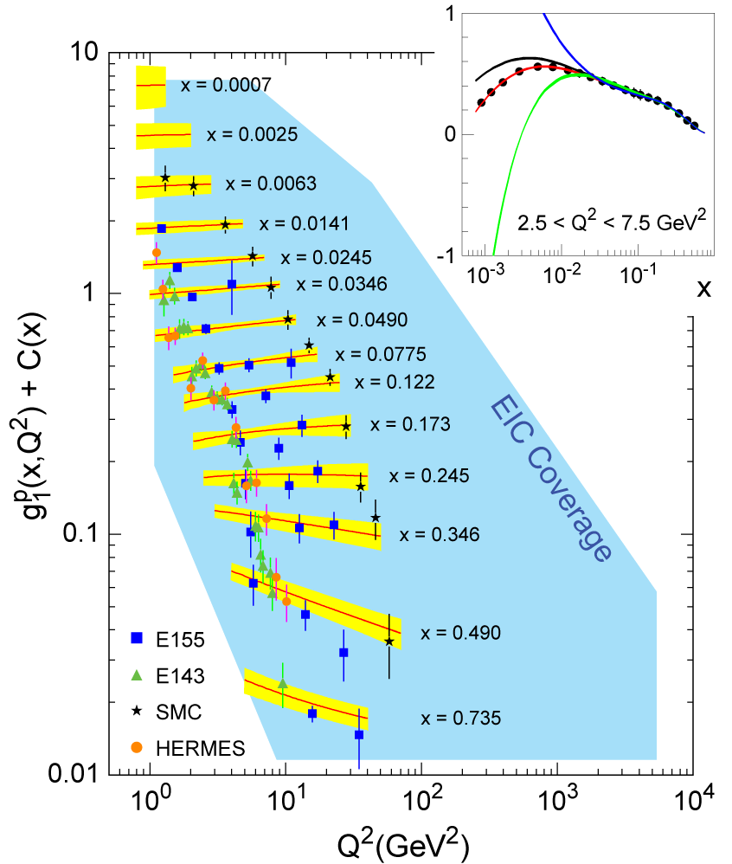
Figure 3: The world database of polarized deep inelastic scattering results for the proton, from SLAC experiments E143 and E155, CERN-SMC, and DESY-HERMES. The curves (and error bands) are from a global QCD fit by Boetcher and Bluemlein. The blue-shaded area represents the enlarged (x,Q²) area accessible by an EIC. The insert shows one example of the consequent physics reach, comparing projected data as a function of x in one Q² bin for about one year of EIC running with theoretical predictions based on global QCD fits to the present world data under differing assumptions for gluon spin preferences.

We currently know much less about the spin preferences than about the number density of low-momentum gluons in a nucleon because there has been no polarized electron—polarized nucleon collider. EIC deep inelastic scattering measurements would rectify the situation, expanding the kinematic coverage as indicated in Fig. 3. The insert shows quantitative projections for EIC results in comparison with model predictions that make different assumptions regarding the sign and magnitude of the gluon spin contribution to the proton spin. Data from polarized proton collisions at RHIC are now beginning to establish preferences among these particular four models at x > 0.03, but will not be able to constrain the shape of the gluon spin distribution at lower x, where the density of gluons rapidly increases.

With polarized deuteron or 3-Helium beams at an EIC, electrons could also be scattered by polarized neutrons, allowing a precision test of the fundamental Bjorken sum rule, which relates the proton and neutron spin structure via the axial weak coupling strength measured in neutron beta-decay. Corrections to this relation are known to higher order in the strong coupling constant α_{s}(Q²) than any other quantity in QCD. This measurement could very well provide the best determination of α_{s}(Q²) away from the CERN measurements at the Z-particle mass, and thus constrain the evolution of the strong force with energy to high precision.

Various avenues have emerged to investigate the contribution of orbital angular momentum to the proton spin. One of them is the study of correlations of the transverse momentum of a quark in the nucleon with the nucleon spin transverse to its momentum. Such correlations have been found to cause surprisingly large left-right asymmetries for the final-state hadrons produced in the scattering process. Measurements at an EIC would allow quantitative investigation of how quarks and antiquarks of different flavor are orbiting in protons and neutrons. An alternative approach will utilize reactions to probe Generalized Parton Distributions (GPDs), to which we turn next.

The Complete Image: Measurements of Generalized Parton Distributions. GPDs may be viewed as functions describing distributions of a nucleon’s constituents in position and momentum simultaneously. They represent the closest analog to a classical phase space density allowed by the uncertainty principle. The concept of GPDs has revolutionized the way scientists visualize nucleon structure, in the form of either two-dimensional tomographic images (analogous to CT scans in medical imaging) or genuinely six-dimensional space-momentum images.

Measurements of GPDs are possible in select high-energy processes. The experimental study of these rare processes requires high luminosities. While initial maps of GPDs in the valence-quark region will be carried out with the 12 GeV upgrade at JLab, the EIC would allow unique access to the gluon, sea-quark and antiquark GPDs, through study of reactions in which an electron scattering also produces a single photon or hadron (e.g., pion, kaon or J/Ψ particle). The production probabilities encode information about the spatial distribution of the nucleon’s constituents. Precise EIC measurements over a wide kinematic range would probe whether gluons are clumped in the nucleon, or are uniformly distributed. Such spatial gluon distributions could be measured for varying gluon momenta. In a nucleus, this could be correlated with the hunt for gluon saturation in localized spatial regions. From the trends in measured GPDs, one could invoke the so-called Ji sum rule to infer the orbital contributions of sea quarks and antiquarks to the nucleon spin, thus testing nucleon structure models in which a proton spends part of its time as a fluctuation into a neutron and an orbiting positively charged pion.

The Formation of Hadronic Final States from Light Quarks and Massless Gluons. High-energy scattering from nucleons in a collider environment lends itself specifically to study how the creation of matter from energy is realized in QCD when an essentially massless (but colored) quark or gluon evolves into massive (and color-neutral) hadrons. We have known since the work of Einstein that matter can be created out of pure energy, a concept that is at the root of modern physics, but full understanding of this process remains lacking. The availability of a high-luminosity polarized electron-ion collider, using high-efficiency detectors with good particle identification, will facilitate experiments to measure new features of this fragmentation process, such as its dependence on quark flavor, spin orientation, and motion, and on passage through nuclear matter. It is already apparent now, from measurements in electron-positron collisions and in fixed-target electron scattering, that correlations exist between the momentum components of hadron fragments transverse to the jet axis and any quark spin preference transverse to its momentum. In addition to systematic exploration of these initial hints at EIC, it may be possible for selected final-state hadrons - e.g., ρ-mesons - reconstructed from their decay daughters to correlate their own spin preferences with the spin orientation of the fragmenting quark. Such measurements are likely to launch a new stage in modeling how quarks accrete colored partners from the vacuum or the debris of the high-energy collision to form colorless hadrons.

Connection to Other Fields. EIC measurements will provide critical input to two dramatic aspects of heavy-ion collisions at RHIC and at the LHC. The strong flow observed suggests that the hot fireball formed in a central heavy ion collisions thermalizes into a nearly perfect liquid in the remarkably short time interval of ~3×10⁻²⁴ seconds! Does this rapid equilibration result from “shattering” the Color Glass Condensate in the incident nuclei? EIC measurements of the saturation scale as a function of energy, nuclear size, and position within the nucleus will test this idea further against data at both RHIC and LHC. The observed strong suppression of high-momentum hadrons in the final state of RHIC collisions has been interpreted as evidence of the rapid loss of energy of quarks and gluons traversing the hot, gluon-rich matter. However, recent observations of the strong attenuation of heavy quarks are difficult to explain quantitatively in this scenario. Our understanding of parton energy loss in hot matter can be enhanced significantly by studying similar processes in “cold matter”. The EIC will enormously expand the energy range of previous fixed target measurements, allowing for the first time the study of attenuation of heavy-quark mesons in cold nuclear matter.

A detailed study of collective phenomena in cold QCD matter facilitates comparison with more familiar collective behavior in condensed (QED) matter systems. In addition to the close analogy to Bose-Einstein condensation, saturated gluons also have stochastic properties analogous to that of glassy (“spin glass”) systems in condensed matter physics. Further, the behavior of QCD cross sections as they approach saturation are equivalent to that of a wide class of statistical reaction diffusion systems from physics to biology. These connections should blossom as the CGC properties become better delineated.

High energy studies with polarized electron and proton beams seek to uncover the origin of the proton’s spin in terms of the underlying quark and gluon fields. Spin is a fundamental quantum mechanical property of sub-atomic particles that underlies all of chemistry and explains magnetism. The nuclear physics of spin-½ protons and neutrons explains the origin of the chemical elements and their properties. As a practical consequence, the medical diagnostic technique of magnetic resonance imaging (MRI) is based on the manipulation of nuclear spins in a patient’s body. Resolving how spin arises in QCD would settle how an important aspect of nature works at a fundamental level.

IV. Outlook

The Electron-Ion Collider embodies the vision of our field for reaching the next QCD frontier: the study of the glue which binds all atomic nuclei. A high luminosity EIC with center-of-mass energy in the range from 30 to 100 GeV with polarized nucleon beams and the full mass range of nuclear beams could be sited either at Brookhaven National Laboratory or at Thomas Jefferson National Accelerator Facility. EIC is the natural evolution of the JLab 12 GeV upgrade, which will be focused on the role of valence quarks, and of the RHIC II upgrade, which will complete the study of the hot, dense matter discovered in RHIC’s heavy ion collisions and will allow a first look at the gluon contribution to proton spin. Precision measurements with the EIC, directly interpretable within the framework of QCD, will open a new window to the regime dominated by direct manifestations of the defining feature of QCD: the self-interactions of gluons. These self-interactions lie at the heart of nucleon and nuclear structure and are expected to be essential to the understanding of high energy heavy ion collisions.

To develop the most compelling case for EIC in a timely way it is clear that over the next five years significant progress must be made in the design of the accelerator and the optimized suite of detectors. It will be important to converge on one, optimized design for the accelerator. This can only happen after essential R&D is completed in a number of areas including: cooling of high-energy hadron beams, high intensity polarized electron sources, and high energy high current Energy Recovery Linacs. This R&D effort should be carried out so as to leverage existing expertise and capabilities at laboratories and universities. R&D for a high energy EIC will maintain U.S. leadership in an area with important societal applications. The design of collider detectors integrated into the accelerator will also be a high priority requiring detailed physics simulations as well as detector R&D.

Theoretical developments have been essential in shaping the scientific arguments for EIC, have attracted a growing number of young physicists and have sparked one of the most active areas in all of theoretical high energy physics. The coming years should see new insights into the universal character of gluon fields when viewed in hadrons at high energies. In addition, first-principles QCD calculations using lattice techniques are expected to provide increasingly realistic predictions to be tested with data. It is essential that theoretical support for EIC related physics is maintained at a healthy level in the coming years.

When realized, EIC will be a unique facility to study QCD complementary to next generation accelerators either under construction or planned in Europe and Asia. Thus, EIC has attracted significant interest from physicists around the world, which can be nurtured by timely allocation of resources for continuing R&D and theoretical progress. It is natural and important that future EIC planning ensure a strong international participation.

