A Heavy Flavor Tracker for STAR

Contents
1 Executive Summary 8
1.1 Scientific Motivation 8
1.2 Detector Concept 10
1.3 Cost and Schedule 10
2 The Physics of the HFT 11
2.1 Introduction 11
2.2 Initial Heavy Quark Production 12
2.3 Probing medium density: Heavy Quark Energy Loss 15
2.4 Probing medium thermalization: charm quark re-interaction 17
2.4.1 Transverse Momentum Distributions 18
2.4.2 Elliptic Flow 20
2.4.3 Charm Hadro-Chemistry 22
2.5 Measuring Vector Mesons with Dileptons 25
3 HFT Conceptual Design and Performance 28
3.1 Overview of the Experiment 28
3.2 Design of the HFT 29
3.3 Simulated HFT Performance 30
3.3.1 An example: Open Charm and Beauty Reconstruction 33
3.4 Additional Issues that Relate to the Performance of the HFT 39
3.4.1 Measured Hit Density at 6 cm Radius in STAR 41
3.4.2 Calculated background from Ultra Peripheral Collisions 41
4 CMOS Sensors 43
4.1 Introduction 43
4.2 Main Features and Established Performance 43
4.3 MIMOSTAR-1 Sensor Design 46
4.3.1 Thinning 47
4.4 Additional R&D 48
5 Data Acquisition 51
5.1 Requirements 51
5.2 Architecture 52
5.2.1 Readout Chip 53
5.3 Data Synchronization 55
5.4 Alternate Read-out Strategy 56
6 Integration with the Experiment 57
6.1 Mechanical Introduction 57
6.2 Support Carriage for Rapid Installation and Removal 58
6.2.1 Position Alignment and Calibration 62
6.3 Ladder Design and Fabrication 62
6.3.1 Detector Radiation Length 64
6.4 Ladder Mechanical Tests 65
6.4.1 Load Distortion Tests 65
6.4.2 Thermal Distortion Tests 67
6.4.3 Cooling Measurements 67
6.5 Cabling 68
6.6 Beam Pipe 69
6.6.1 Minimum Beam Pipe Radius Consistent with Injected Beam 71
6.6.2 Beam Pipe Radius - Vacuum Considerations 71
6.6.3 Supporting Section 72
6.6.4 Central Beam Pipe Thin Window Section 72
6.6.5 RF Background from the Wake Field 72
6.6.6 Beam Pipe Insertion and Removal 73
6.6.7 Bake Out 73
6.7 Compatibility with the SVT and FTPCs 73
6.8 Compatibility with an Upgraded Inner Si Tracker Barrel 74
7 Cost, Schedule, Manpower and Funding 75
7.1 Cost and Schedule - 01/25/2005 75
7.2 Sensor 77
7.2.1 Estimated Costs 78
7.2.2 Manpower 78
7.3 DAQ 78
7.4 Trigger 79
7.5 Mechanical Systems 79
8 Summary 80
9 Appendix I – MIMOSTAR Specifications 81
10 Appendix II – MIMOSTAR Users Guide 81
11 Appendix III – Inner Tracker Interface Specification 81
12 Appendix IV – SVT Interface Specification 81
13 References 82

List of Figures
Figure 1: Contributions to charm production at RHIC energies. The distributions were calculated with an energy density of 3.2 GeV/fm³ at the moment of thermal equilibration. The figure is from Ref. [12]. 14
Figure 2: cc production cross-sections per nucleon-nucleon collision vs. the collision energy. The dashed line depicts a PYTHIA calculation. The solid and dot-dashed lines depict two NLO pQCD calculations with MRST HO, m_{c} = 1.2 GeV/c², µ_{F} = 2m_{c}, µ_{R} = m_{c} and 2m_{c}, respectively. The figure is from Ref. []. 15
Figure 3: The ratio of suppression factors in hot matter for charm (H) and light (L) quarks. The solid line represent results from calculations with unrestricted gluon radiation, while the dashed line is based on calculations with a cut on gluon energies ω > 0.5 GeV. The size of the static medium traversed by the fast quark is assumed to be 5 fm. The figure is from Ref. [23]. 16
Figure 4: Separation of high-p_{T} B-meson decay from combinatorial background. The arrow indicates a cut at 250 μm optimizing the signal to background ratio. 17
Figure 5: B and D meson spectra at RHIC. The data points are from Ref. [] showing 0-10% central Au + Au collisions at √S_{NN} = 130 GeV at RHIC. 20
Figure 6: Elliptic flow of strange hadrons at RHIC. The top panel demonstrates mass ordering, the bottom panel shows constituent quark scaling. 21
Figure 7: A hint of charmed elliptic flow at RHIC. Blue and Red symbols are data of non-photonic electron v₂ from PHENIX and STAR. Only statistical errors are shown for both results. Dashed-dotted-line represents the input D-meson v₂ distributions, assuming the scaling of constituent quarks for meson v₂. The corresponding decayed electron v₂ are shown as the hatched band [ref.1]. Dashed-line represents the results from Greco et al. [ref.2] . In this coalescence calculation, similar v₂ distributions for c- and u-quarks are assumed. The figure is adopted from Ref. []. 22
Figure 8: Left top: TPC dE/dx vs p in d+Au collisions. Left bottom: TPC dE/dx vs p after TOFr PID selection of | 1-β | < 0.03. Clean electron identification is achieved. Right: dE/dx from TPC after TOFr PID selection (left bottom panel) for 1.0 < p < 1.5 GeV/c. 26
Figure 9: Electron p_{T} spectra from γ conversions reconstructed by requiring TPC tracking, a TPC hit and 2 SVT hits, or a TPC hit and 2 SVT hits and 2 HFT hits. The rejection factor with an additional SVT hit (2 hits) is 3 and with an additional pixel hit is 50. 27
Figure 10: The STAR detector at RHIC. The primary detector elements at mid-rapidity are shown in this cut-away view of the detector. For scale, the TPC is 4.2 meters long and 4 meters in diameter. Heavy Ion beams enter from the left and right while collisions take place at the centerline under the Silicon trackers. 28
Figure 11: Left - Schematic view of the HFT detector ladder arrangement with 6 ladders forming the inner layer and 18 ladders forming the outer layer. The width of the ladders (the dimension seen in this view) is 19 mm. The shingled layers provide cross calibration of the ladders and provide an open geometry for ease of installation. Right - The HFT is shown embedded inside the SVT+SSD. 30
Figure 12: The efficiency for finding tracks in central Au+Au collisions in the STAR TPC, SSD, SVT, and the HFT. In this simulation, the beam luminosity is assumed to be four times the RHIC design luminosity. 31
Figure 13: Left – The number of ghost tracks and reconstructed tracks passing through the pixels of the HFT as a function of p_{T}. Right - The ratio of ghost tracks to good tracks. 32
Figure 14: Probability of getting the correct hit on the outer pixel layer, given two different SVT geometries and a search window of 640 μm 33
Figure 15: The decay topology for a D⁰ decaying to a kaon and a pion. Isolation cuts to identify the D⁰ from the background tracks are described in the text. 35
Figure 16: The absolute yield of D⁰s into the TPC+SVT+HFT divided by the input D⁰ yield. The classical configuration includes all three layers of the SVT. In the SVT-1 configuration, the innermost layer of the SVT has been removed in order to allow more room for the HFT. And finally, the Alice geometry assumes thick Si detectors that are similar to the wafers used in the ALICE vertex detector. For all three detector configurations shown the D⁰ reconstruction cuts were optimized using the program MINUIT. 36
Figure 17: The number of central Au+Au events needed as a function of the Si ladder thickness and the position resolution of the detector. 37
Figure 18: Left: SVT-1 configuration without TOF. Right: SVT-1 configuration plus TOF. The estimated statistical uncertainties are shown on the top line. 37
Figure 19: We need a D_{s} figure, here. 38
Figure 20: Flow results 39
Figure 21: Epitaxial Silicon used as a sensor. In this design, a primary ionizing particle creates free charges in the epitaxialy grown Si layer that is a few tens of microns thick. The liberated charges are then free to diffuse towards a potential well structure at the top of the sensor where they are extracted and readout into a DAQ system. The bulk silicon does not participate in the detection process. 44
Figure 22: Wafer of reticle size sensors (left) and zoomed-in view of individual chips (right). 45
Figure 23: DAQ Layout: schematic of DAQ system. Depending on effective data rate, multiple ladders can be combined to one optical link. Using PCI and gnu/Linux, allows flexible and transparent access to complex test setups while minimizing changes from prototype to the final detector. 53
Figure 24: ROC block diagram: preliminary schematic/floor-plan of readout chip. Internal design is subject to recent development. 54
Figure 25: Readout Layout: schematic sketch of the readout-topology on a detector ladder. This figure shows one of ten APS and the corresponding readout chip layout. You can likewise add more APS chips. (Note: this plot does not aim to be a complete view of the interfaces. The readout chips will be mounted piggy-back on the APS.) 55
Figure 26: Data flow and processing stages in the readout chip. Each stage can be bypassed to allow raw/unprocessed data to be routed through the DAQ. 56
Figure 27: The HFT is shown integrated with the STAR inner detectors cone assembly. 58
Figure 28: Close up view of the HFT ladders. 59
Figure 29: Detector support structure with kinematic mounts to insure repeatable detector positioning. 60
Figure 30: Kinematic mount structure. 61
Figure 31: Precision tie points coupling the HFT system to the STAR support cone 61
Figure 32: Ladder assembly. The current ladder is composed of a row of 10 thinned APS detector on top of a matching row of thinned readout chips and a three layer aluminum kapton cable. The silicon cable structure is bonded to a carbon composite v, closing the beam to make a rigid structure. 63
Figure 33: Close up view of the ladder showing APS detector chips mounted on top of the readout chip. The chips are mounted and wire bonded on a three layer aluminum kapton cable. 64
Figure 34: A cross-section of the prototype detector ladder showing its structure and materials composition. 65
Figure 35: The prototype ladder on the testing apparatus. 66
Figure 36: Measured bend of a silicon/carbon composite ladder test structure and the calculated bend shape. The ladder was rigidly supported at one end with a 10 gm weight placed on the other. 66
Figure 37: TV Holography system viewing test ladder in a small transparent wind tunnel. Inset shows diffraction pattern with color map of the surface displacement. 67
Figure 38: A prototype readout cable for the HFT. 69
Figure 39: Mechanical Prototype with 4 MIMOSA5 detectors glued to the kapton cable assembly. 69
Figure 40: Beam pipe structure with outer support barrel in the center. 70
Figure 41: View of the beampipe mid-section. 71
Figure 42: End view showing the HFT ladders between spokes to the inner beam pipe support. 73
Figure 43: Estimated time line for major tasks in the building of the HFT detector. 75
Figure 44: Estimated cost projection for the HFT project showing accumulated cost during the time of design and construction. The final total is 4.1 M$. 76

List of Tables
Table 1: Charm quark fragmentation functions. The left column is from Ref. [49, 50]. The right column is from Ref.[48]. The D⁺ and D⁰ yields include feed-down from D^{*+} and D^{*0} decays. 24
Table 2: Number of central Au+Au events required to observe a 3-σ signal for ω and φ in their leptonic decay channels under different detector configurations. 27
Table 3: Selected HFT parameters. 30
Table 4: Luminosity and other parameters that determine the particle flux on the HFT. 40
Table 5: Integrated hit loading on the HFT and associated pileup. 40
Table 6: Hit loading on the HFT from Au+Au central collisions and associated pileup. 41
Table 7: Comparison between MIMOSA-5 characteristics and HFT specifications. 46
Table 8: Requirement Summary: constraints for the APS, due to signal expectation, available design process, and mechanics 51
Table 9: Materials in the beam pipe and the first detector layer with their radiation length fractions. For details see Ref. [] 65
Table 10: Estimated manpower requirements for the HFT project 77
Table 11: Tentative sensor design schedule. 77
Table 12: Tentative chip production cost estimate. 78
Table 13: Tentative sensor design schedule. 79

Executive Summary
The proposed HFT detector is an integral part of the STAR Inner Tracking Upgrade. This upgrade will bring new physics capabilities to STAR and will ensure that STAR will be able to take data at the highest luminosity attainable throughout the proposed RHIC II phase. The tracking upgrade consists of three projects. Each of the projects has its own, independent physics justification and natural time scale. The three projects are:
- The Heavy Flavor Tracker is the subject of this proposal. It will bring full D-meson capability to STAR with the goal to be at least partially operational for the next full energy Au+Au run.
- The Silicon Barrel detector will replace the SVT in the high luminosity era and will serve as a pointing detector for the HFT.
- The Forward Tracker will enable W measurements for the 500 GeV polarized proton run.

Scientific Motivation
We propose to construct a Heavy Flavor Tracker (HFT) for the STAR experiment at RHIC. The HFT will significantly enhance the physics capabilities of the STAR detector at central rapidities. The primary motivation for the HFT is to provide precise measurements of heavy quark production in p+p, d+Au and Au+Au collisions, including polarized p+p. These are key measurements for the continuing heavy ion and spin physics programs at RHIC. Heavy quark measurements will facilitate the heavy ion program as it moves from the discovery phase to the systematic study of the dense medium created in heavy ion collisions as well as the nucleon spin structure in polarized p+p collisions. The primary physics topics addressed by the HFT are as follows:
A precise measurement of the spectra of several D meson states will shed light on several open questions in heavy ion collisions. From the spectra and the production ratios of D states we will be able to extrapolate to the total yield for charm quark production. Furthermore, the open charm production rate is high enough at RHIC, that the coalescence process becomes relevant for Charmonium production. The total production cross section for charm quarks is also essential to know as a baseline for J/ψ measurements. A meaningful answer to the question of whether the J/ψ are suppressed or enhanced at RHIC and to the question if we observe Debye screening of the cc pairs will need precise knowledge of the charm production in heavy ion reactions.
The most exciting prospective measurement with the pixel detector is to perform a measurement of the elliptic flow of D mesons down to very low pT values. It is a generally accepted fact that elliptic flow is established in the partonic phase. If charm quarks, with a mass much larger than the temperature of the system, acquire elliptic flow then it has to come from many collisions with the abundant light quarks. Thus, flow of charm quarks can be taken as a probe for frequent re-scatterings of light quarks and thus as an indication of thermalization reached at the early stages of heavy ion collisions at RHIC. Proof of thermalization requires further measurement like thermal photons and low mass di-lepton spectra. Proof of thermalization constitutes the last missing step towards establishment of the QGP.
The D meson transverse momentum spectra will also be affected by re-scattering with light quarks, as well as re-scattering at the hadronic level, mainly pion-D interactions. The effect of re-scattering will be probed by comparing transverse mass spectra measured in d-Au and Au+Au collisions.
The pixel detector will allow us to measure the ratio of different D meson states with high precision. This measurement can be used to test if the different states are produced in the same ratio as in elementary particle collisions or if the ratios are established according to chemical equilibrium.
The heavy quark can also be used as a probe to study the properties of the medium created in heavy ion collisions. The production of gluons is kinematically suppressed for heavy flavors (dead cone effect) and as a consequence heavy flavors should loose less energy in the dense medium.
The pixel detector offers the possibility of measuring the low mass e⁺e⁻ spectrum down to the vector meson region by removing the gamma conversion background, while electrons and positrons are identified in the TPC and TOF. Vector mesons reconstructed in the di-lepton channel may have decayed at any stage of the systems evolution, since leptons are very unlikely to re-interact. Thus, studying low mass e⁺e⁻ spectrum may yield crucial insights into the nature of the system before it reaches the low density hadronic freeze-out stage. Measuring the low-mass vector mesons through their leptonic decay channel may also yield information about the onset of chiral symmetry restoration.
With the current STAR detector configuration, heavy quark production has been measured in p+p and d+Au collisions through the observation of single electrons and the use of the event-mixing technique. These methods are limited in their accuracy by the systematic uncertainties resulting from large background subtractions. Furthermore, these methods require large amounts of data to overcome the poor signal to background ratio. The HFT detector will bring extremely high precision tracking capabilities to STAR with a point resolution of less than 10 microns, over a large pseudo-rapidity range, and complete azimuthal angle coverage. The HFT will enable STAR to perform high precision measurements of heavy-quark production over the broadest range of phase space, colliding system sizes and energies.

Detector Concept
The proposed HFT detector has two tracking layers composed of monolithic CMOS pixel detectors with 30 μm × 30 μm square pixels. These critical innermost tracking layers at ~1.5 cm radius and ~4.5 cm radius will provide our best identification of tracks that are displaced a few 10s of microns from the primary vertex. The detector chips will be thinned to 50 μm and mounted on low mass carbon fiber structures to minimize pointing errors generated by multiple coulomb scattering. The two layer barrel of detectors is active over 20 cm in z and has ~100 Million pixels.

Cost and Schedule
The projected cost of this detector, less contributed labor, is 4.1 M$ and will be constructed and installed over a two year period (2006 and 2007) in time for the next full energy Au + Au running at RHIC.

The Physics of the HFT

Introduction
The goal of high-energy nuclear collisions is to understand Quantum Chromodynamics (QCD) at extreme temperatures and energy densities over large volumes. Under these extraordinary conditions, we believe that the fundamental entities and symmetries of QCD will reveal themselves: quarks and gluons will be the relevant degrees of freedom, color will be deconfined and chiral symmetry will be restored. Calculations within the framework of regularized lattice QCD predicts a fast cross-over from ordinary nuclear matter into a deconfined and locally thermalized state of quarks and gluons called the Quark-Gluon Plasma (QGP).
High-energy nuclear collisions may be characterized by three distinct phases: the initial phase where hard interactions between the partons of the incoming nuclei dominate, an intermediate phase where re-interactions between the constituents in the matter result in collectivity, and a final stage where hadronization, chemical, and thermal freeze-out occur. The matter produced in high-energy nuclear collisions can be investigated by studying the dynamics of the collective expansion of the bulk of the produced particles and by studying the interaction of the medium with penetrating probes such as jets. The measurement of large elliptic flow and the observation of strong modifications of high p_{T} particle production, have provided evidence for a high density and strongly interacting state of matter at RHIC. The goal of our research is to elucidate the nature of this matter, in particular whether it is dominated by hadronic or partonic degrees of freedom.
Rare processes provide additional ways to probe the medium generated in high-energy nuclear collisions. Bjorken proposed that hard scattered partons (quarks and gluons) drawn from the incoming nuclei will interact with the medium in a density-dependent way. Bjorken’s initial energy loss mechanism (elastic scattering) did not provide effects large enough to be observed but medium-induced radiation (gluonic bremsstrahlung) could generate significant energy loss effects,. Hard partons are indirectly observable in elementary particle collisions (e⁺+e⁻, p+p) due to their fragmentation into collimated sprays of energetic hadrons (jets) at large transverse angle to the beam. Jets can also be identified in high energy nuclear collisions on a statistical basis; the modification of their properties could signal novel energy loss mechanisms in a dense medium by the parton that initiated the jet. Full jet reconstruction in heavy ion collisions is exceedingly difficult but leading hadrons (i.e. high p_{T} hadrons, which typically carry a large fraction of the jet energy) and their correlations may provide the essential signals of partonic interactions in the medium.
Collective flow measurements have played a prominent role in understanding the physics of nuclear collisions because the magnitude and pattern of the collective motion is closely related to the equation of state (EOS) of the produced matter. If local equilibrium is achieved, the EOS will be driven by the degrees of freedom relevant for the basic constituents which make up the matter. By studying flow it is possible to determine key information about the nature of the matter and when it is produced.
Heavy quark production (c,b) provides important observables. Due to their large masses, c and b quarks are produced dominantly by the interactions of the initial incoming partons whereas lighter quarks are produced throughout the evolution of a heavy ion collision. Thus, the total yields of c and b quark production provide a direct connection to the initial state.
Due to their heavy mass and presumably small hadronic cross sections, charmed quarks are a sensitive probe for the amount of interactions and therefore the degree of thermalization among constituents before hadronization. At high p_{T}, heavy quarks may be less suppressed than light quarks due to the "dead cone" effect, giving an additional way to study partonic energy loss. If charmed quarks participate sufficiently in re-scatterings, they will develop flow, i.e. transverse radial and elliptic flow which can be observed in charmed hadrons momentum distributions. Finally, charmed quarks might reach thermal kinetic equilibrium in the surrounding medium leading to statistical hadronization. In that case, relative abundances of charmed hadrons are significantly modified.

Initial Heavy Quark Production
Heavy quarks are produced through gluon fusion and qq annihilation. Heavy quark production is sensitive to the parton distribution function and the mass of the heavy quark. Therefore, the production of heavy quarks in nuclear collisions should scale with the number of binary nucleon-nucleon collisions. For heavy-quarks, their masses are not modified by the surrounding QCD medium and the values of their masses are much higher than the initial excitation of the system, they constituentconstitute ideal probes to study the properties of the hot-dense medium created in high-energy nuclear collisions.
Understanding the charm hadron yield in hadron-hadron collisions requires a knowledge of the projectile and target parton distribution functions, the cross sections for gluon fusion σ( gg → cc ), the cross-section for quark anti-quark annihilation σ( qq → cc ), and the fragmentation functions for c (b) quarks into charm (bottom) hadrons. These cross-sections are usually calculated in a perturbative QCD framework up to next-to leading-order (NLO). The parton distributions within the proton are extracted by parameterizing the data from electron-proton collisions. We note that the parton and gluon distribution functions within the nucleus, relevant to the charm and bottom quark production at RHIC energies, are poorly understood. Thus, precise measurements of the charm cross-section in p+p, d+Au and Au+Au collisions will provide a handle on the gluon distribution function within the proton or in a gold nucleus.
Pertubative QCD predictions for the cross section σ(cc ) and σ(b) in p+p collisions at √S_{NN} = 200 GeV may be found in the literatureError: Reference source not found.

σ (cc ) = 289 - 445 µb
8 - 13 cc pairs per central Au+Au collision at √S_{NN} = 200 GeV
σ (b) = 1.64 - 2.16 µb
0.04 - 0.06 b pairs per central Au+Au collision at √S_{NN} = 200 GeV

The uncertainty arises from a reasonable variation of quark masses (m_{c} = 1.2-1.4 GeV, m_{b} = 4.5-5.0 GeV), factorization scale (μ/m = 0.5, 1, 2), and parton distribution functions (MRST, CTEQ, GRV). The number of pairs per central Au+Au collision was obtained by multiplication with the nuclear overlap integral T_{AA} (29.3/mb), corresponding to ~ 1150 binary nucleon-nucleon scatterings per Au+Au collision. The cross section values are normalized per participating nucleon-pair, thus in the calculation of yield for central Au+Au collisions, a factor of N_{binary} = 350 must be taken into account.
Final state interactions may enhance charm production relative to the binary scaling of initial parton collisions and could lead to thermal production. An analogous mechanism dominates strangeness production. The heavy quark mass (m_{c} ≈ 1.2 to 1.8 GeV, m_{b} ≈ 4.5 to 5.0 GeV), however, should greatly suppress this channel, making heavy quark production rates sensitive to the dynamics of the early partonic stage of the collision. Figure 1 shows the calculated contributions to the total charm production at y = 0 at √S_{NN} = 200 GeV, with an energy density of 3.2 GeV/fm³ at the moment of thermal equilibration.
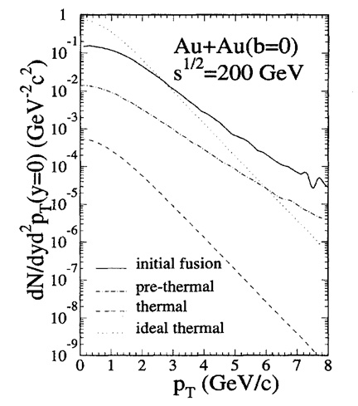
Figure 1: Contributions to charm production at RHIC energies. The distributions were calculated with an energy density of 3.2 GeV/fm³ at the moment of thermal equilibration. The figure is from Ref. [Error: Reference source not found].
In Au-Au collisions, a large thermal enhancement with respect to the expectations of pQCD is ruled out by the recent single electron spectra measured by the PHENIX collaboration. On the other hand, the STAR collaboration has reported an unexpectedly large cross-section for open charm in d-Au collisions by doing a direct reconstruction of the open charm hadrons. The data are shown in Figure 2. In general, single electron spectra only provide an indirect measurement of the charmed (bottom) hadron yield because the secondary decays of charm and bottom decay products account for a significant fraction of the electron yield at high momentum (above 2-3 GeV/c for charm hadrons and above 5 GeV/c for bottom hadrons). Large systematic errors are associated with the extraction of these charmed (bottom) quark yields because of the large background subtraction required at low momentum and the assumptions that need to be made on the charm (bottom) hadron composition and spectra.
In contrast, the HFT will directly measure the spectra of the various charmed hadrons, including the D⁺, D⁻, D⁰, D_{s}⁺, and possibly Λ_{c}⁺, thus overcoming these systematic problems.
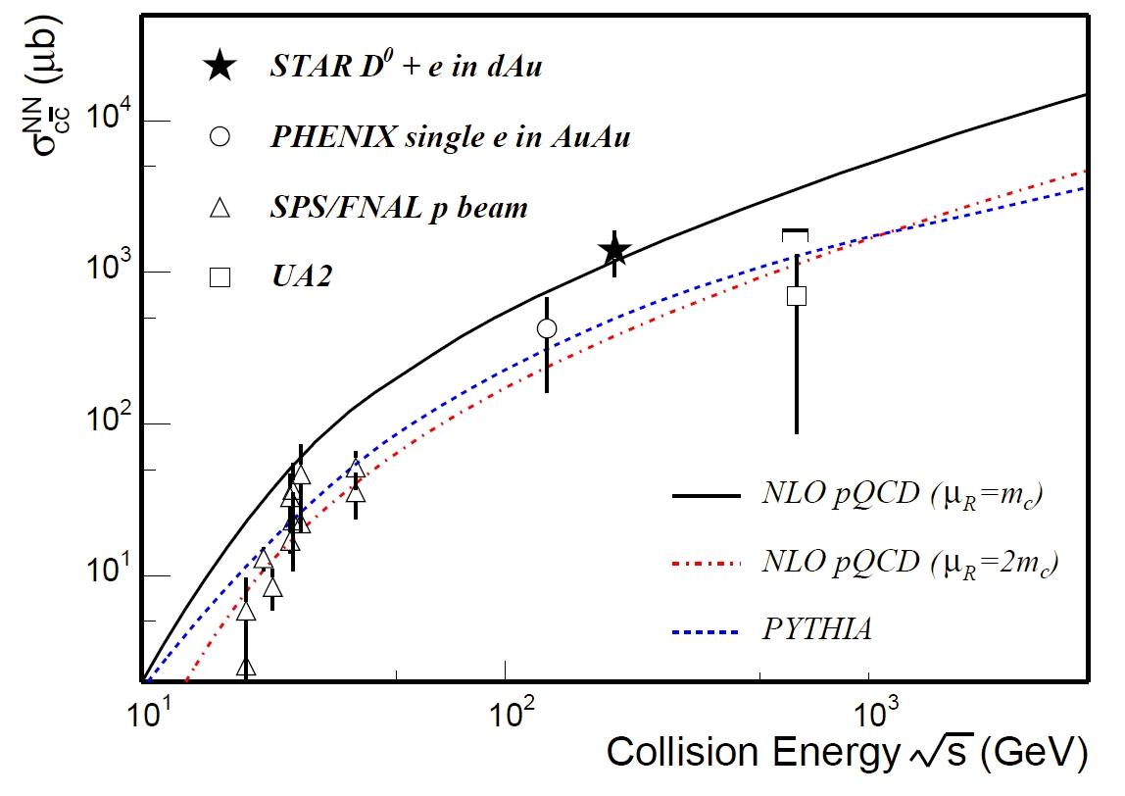
Figure 2: cc production cross-sections per nucleon-nucleon collision vs. the collision energy. The dashed line depicts a PYTHIA calculation. The solid and dot-dashed lines depict two NLO pQCD calculations with MRST HO, m_{c} = 1.2 GeV/c², µ_{F} = 2m_{c}, µ_{R} = m_{c} and 2m_{c}, respectively. The figure is from Ref. [].

Probing medium density: Heavy Quark Energy Loss
The discovery of a factor of 4 to 5 suppression of high p_{T} hadrons (5 < p_{T} < 10 GeV/c) produced in Au+Au collisions at RHIC and the disappearance of the away-side jet has been interpreted as evidence for jet quenching,,,. This effect was predicted to occur due to radiative energy loss of high energy partons that propagate through a dense and strongly interacting medium. Heavy quarks are also predicted to lose energy as they traverse the medium. The energy loss, however, is predicted to be significantly less because of a suppression of gluon radiation at angles Θ < M_{Q} /E, where M_{Q} is the heavy quark mass and E is the heavy quark’s energy. This kinematic effect is known as the “dead cone” effect. This suppression of small angle radiation has the advantage that the heavy quark fragmentation function and the spectrum of light particles produced in association with the heavy quarks can be calculated perturbatively.
Figure 3 shows the result for the ratio of charm (H) to light (L) quark suppression from QCD calculations assuming a size of about 5 fm for the static medium traversed by the fast quark. Above a transverse momentum p_{T} > 7.5 GeV/c this ratio is predicted to be about two due to the smaller energy loss of the heavy quark. In the case where heavy quarks suffer the same amount of energy loss as light quarks, this ratio would be unity. This ratio is exponentially sensitive to the density of color charges in the medium. Therefore, the measurement of nuclear modification factors of open charmed mesons at large transverse momentum is a promising tool to study and further characterize QCD matter at RHIC.
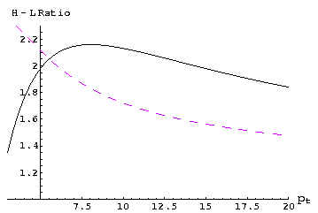
Figure 3: The ratio of suppression factors in hot matter for charm (H) and light (L) quarks. The solid line represent results from calculations with unrestricted gluon radiation, while the dashed line is based on calculations with a cut on gluon energies ω > 0.5 GeV. The size of the static medium traversed by the fast quark is assumed to be 5 fm. The figure is from Ref. [Error: Reference source not found].
Measuring high transverse momentum charm and beauty quark production requires a trigger to take full advantage of the large RHIC luminosity because their production cross section is very small. A significant fraction of B (~10%) and D (6-17%) meson decays include an electron/positron in the final state. The STAR electromagnetic calorimeter allows triggering on high transverse momentum electromagnetic showers, which include electrons and positrons. The only source of high transverse momentum electrons and positrons are D and B decay. Thus, the D and B transverse momentum distribution can be inferred above a certain momentum from the electron and positron spectra.
If an electromagnetic shower can be matched to a track reconstructed in the TPC, it is tagged as an electron/positron, otherwise it is a photon. Background to the reconstructed electron comes from charged pions going through a charge-exchange process, i.e. becoming neutral pions, in the calorimeter. The neutral pions decay immediately in two photons, which produces an electromagnetic shower identical to an electron shower. The charge-exchange cross-section is poorly known, which leads to large uncertainties in the estimates for such processes. The only measurable difference between an electron/positron from D and B decay and a high transverse momentum pion producing an electromagnetic shower is their spatial origin. High pT charged pions come from the primary vertex while electrons and positrons come from the B and D decay vertex, displaced from the primary vertex by typically a few hundred m.
The CDF collaboration has shown that B jet tagging can be achieved by associating the electron/positron to one of the other charged hadrons decay products. Figure 4 shows a feasibility study applying a similar reconstructing technique to remove background using the HFT. The B channel studied is 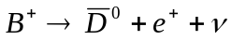 and 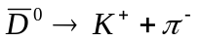. The positron is matched with either the kaon or pion from the D meson decay, if their distance of closest approach is less than 150 microns. The B decay vertex is then located at the mid-point between both points of closest approach on each helices. The variable shown in figure 7 is the distance between the B and the primary vertices. The sign is given by scalar product of the electron momentum with the vector constructed from the primary vertex to the reconstructed decay vertex. The background is simulated by embedding high transverse momentum tracks into events that match the momentum distribution measured in central Au-Au collisions at 200 GeV below 3 GeV/c. The relative normalization between the background and B decay distribution is arbitrary as the charge-exchange cross-section is not well known. By applying a signed-decay-length cut of more than 250m, the background is suppressed by a factor 200 while keeping 60% of the signal. Thus, adding the decay vertex information will help significantly remove the background in the high transverse momentum electron/positron spectra and substantially increase statistical significance for such a measurement.
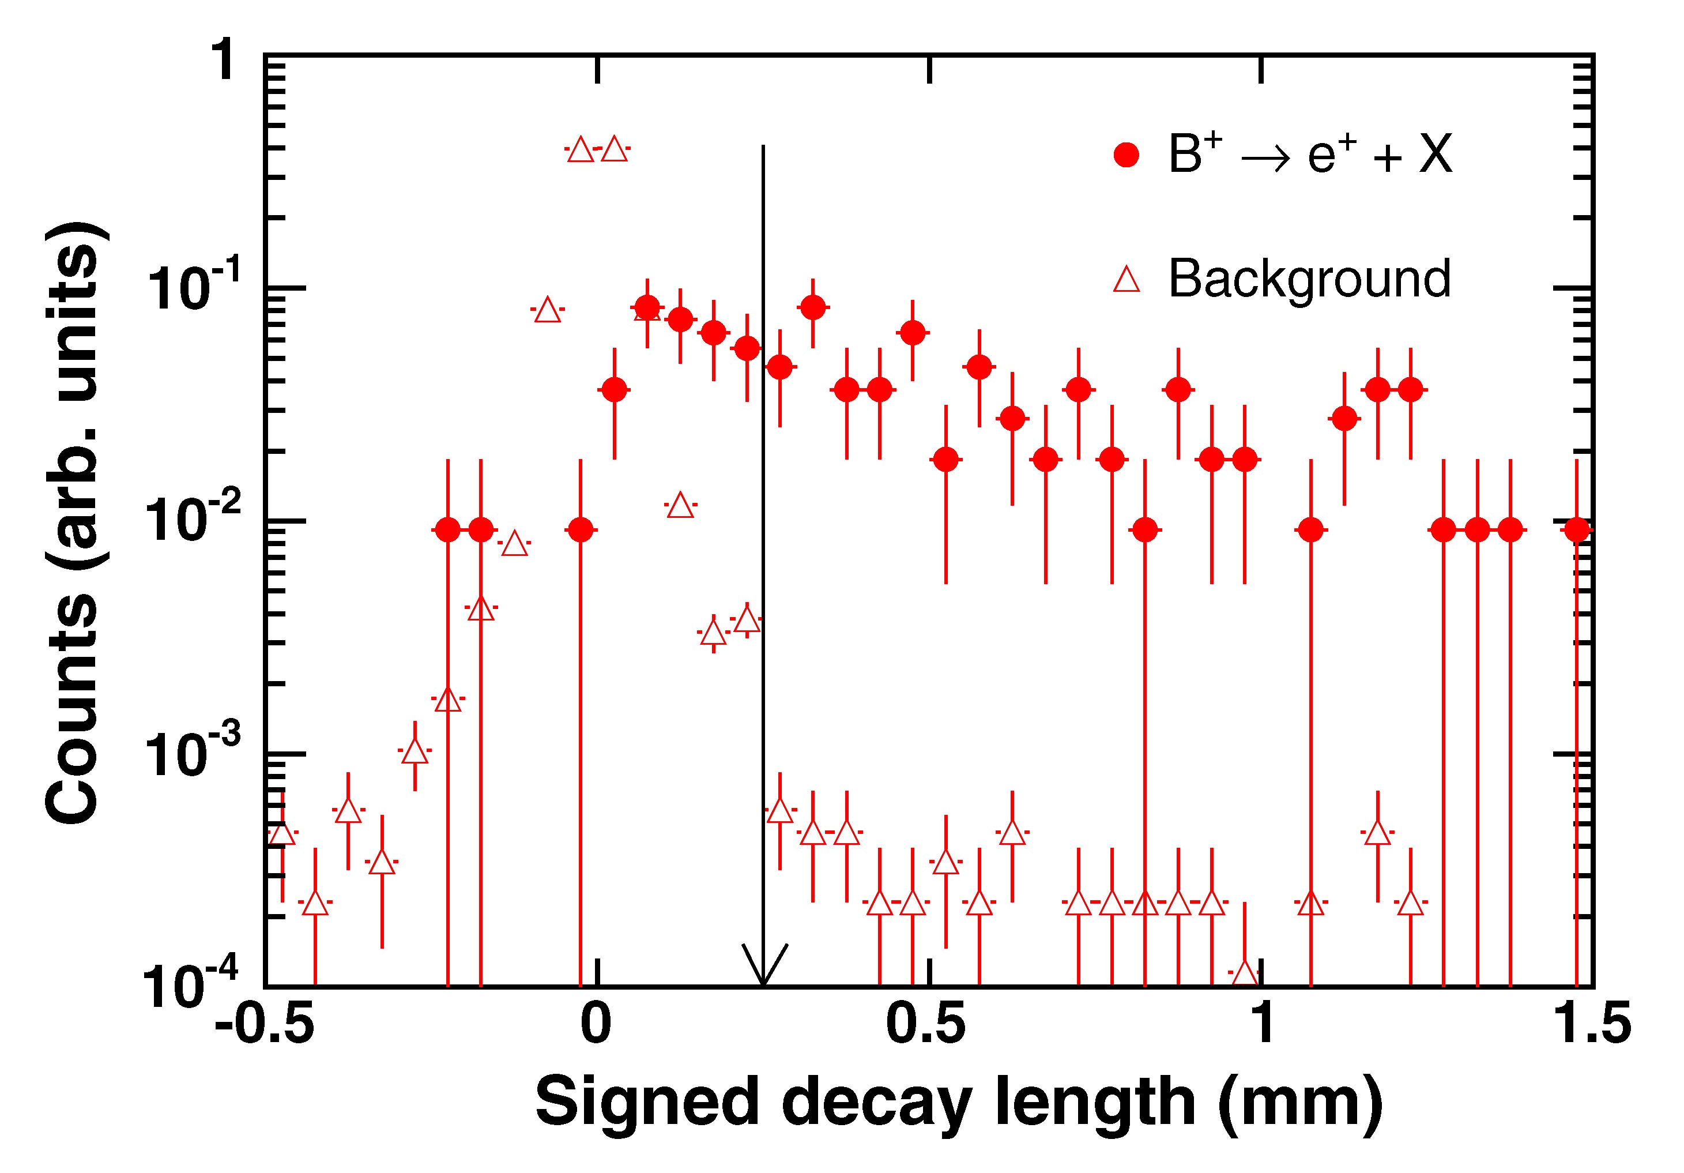
Figure 4: Separation of high-p_{T} B-meson decay from combinatorial background. The arrow indicates a cut at 250 μm optimizing the signal to background ratio.

Probing medium thermalization: charm quark re-interaction
A measurement of transverse radial and elliptic flow of identified hadrons consisting of light quark flavors (q = u,d,s) has been performed at RHIC. The main conclusions from these studies are: the system created in ultra-relativistic Au+Au collisions at RHIC exhibits strong collective expansion. Compared to measurements at lower SPS energies, the degree of collectivity is stronger. Also multi-strange hadrons (Ξ and Ω) appear to freeze-out at a higher temperature and lower collective velocity than lighter hadrons. This has been interpreted as an indication that sizeable partonic collectivity develops at RHIC. Details of these studies can be found in the literatureError: Reference source not found,,,,. The successful measurement of partonic collectivity of light flavor hadrons is an important step towards the discovery of a QGP. However, this is not sufficient. It is also important to address the issue of thermalization together with collectivity.
At RHIC energies, theoretical calculations indicate that thermalization may be reached at temperatures T_{eq} ≈ 0.3-0.5 GeV and that the duration of the equilibrium period is on the order of 5-10 fm/c,. Thermal production of cc pairs is therefore suppressed (m_{cc} = 2.2 – 2.3 GeV/c²). However, charmed hadrons may still be produced in a thermalized fashion if the c and c quarks become embedded in a thermalized bath of light quarks. The relative probability of creating different charmed hadrons will be driven by the property of the medium providing the additional quarks necessary to form the hadrons. The relative yield of various charmed hadrons is thus sensitive to the collective properties (temperature and chemical potentials) of the light quark medium.
The strength of the charm hadron flow is potentially an indicator of thermalization occurring at the partonic level. If charm quarks flow together with the light flavor quarks, there must be copious interactions among light and charmed quarks. Therefore, thermalization is likely be reached through parton re-scattering. In order to test the question of thermalization experimentally, we propose to measure the charmed hadron transverse radial (spectra) and elliptic flow (v₂) with the STAR HFT detector. The combination of the open charm spectra and v₂ will allow us to determine the collective properties of the charmed quark and therefore the probable degree of thermalization of light quarks connected with it.

Transverse Momentum Distributions
The development of collectivity at the partonic level (among quarks and gluons) in high-energy nuclear collisions and the degree of thermalization are closely related to the underlying equation of state of partonic matter. Theoretical arguments show that different aspects of the measured final hadronic momentum distributions are determined at different stages of the collision history. Hence, hadronic observables and their corresponding parameterizations characterizing the freeze-out distributions constrain the dynamical evolution and thus yield indirect information about different stages of the collision. After hadronization, inelastic interactions changing the particle species cease and particle abundances are fixed: this is commonly referred to as chemical freeze-out. Later, when elastic interactions cease, the particle momentum spectra are fixed at kinetic freeze-out. For most particles, transverse radial flow is accumulated throughout the whole collision history while transverse elliptic flow is believed to saturate earlier.
The separation of thermal motion and collective flow in the analysis of soft-hadron spectra requires a thermal model analysis. Measured transverse mass spectra can be fit with a hydrodynamically motivated approach using a kinetic freeze-out temperature T_{fo} and a mean collective flow velocity <β_{r}>. This type of analysis does not take into account the abundances of particles and thus only tests the kinetic thermal equilibrium and is not sensitive to chemical equilibrium.
The spectra of low mass particles, like pions, are dominated by the temperature parameter, while the spectra of heavier mass particles are dominated by the flow velocity. Transverse radial flow modifies the particle spectrum by depopulating the yield at low momentum. The result is a characteristic shoulder in the low-momentum region, strongly depending on particle mass. Hence, the measurement of particles to the lowest possible momentum is essential for spectral analysis in the charm sector. Also, good momentum coverage is necessary to reliably extract integrated yields. This minimizes systematic uncertainties in extrapolating yields especially at low momentum where theoretically the particle spectrum is not well known.
Figure 5 shows the invariant yield, as a function of transverse momentum, for D and B mesons, as predicted for p+p collisions (solid lines) and assuming the existence of flow (dashed lines). Clearly, the development of flow modifies the spectra when compared to p+p collisions. The largest differences, about 30%, occur at momenta below 2 GeV/c. Therefore, the study of charmed flow requires precise measurements of charmed hadron spectra at low momentum. The filled squares represent the inclusive measurement of heavy flavor production in the electron decay channel, D → e+X. The systematic errors are large at lower momentum due to the large experimental background from photonic electron production. To reduce these large uncertainties, a direct reconstruction of D → π + K is essential. This also minimizes the ambiguities due to the decay kinematics in the electron channel and helps disentangle contributions from D and B mesons. As one can see in the figure, the difference seen in the D-meson spectra between hydrodynamic behavior (solid-line) or pQCD behavior (dotted line) are indistinguishable in the decayed-electron spectra. From measured electron distributions alone, these differences are unlikely to be disentangled because at the higher p_{T} region, decays from B-meson become more and more important.
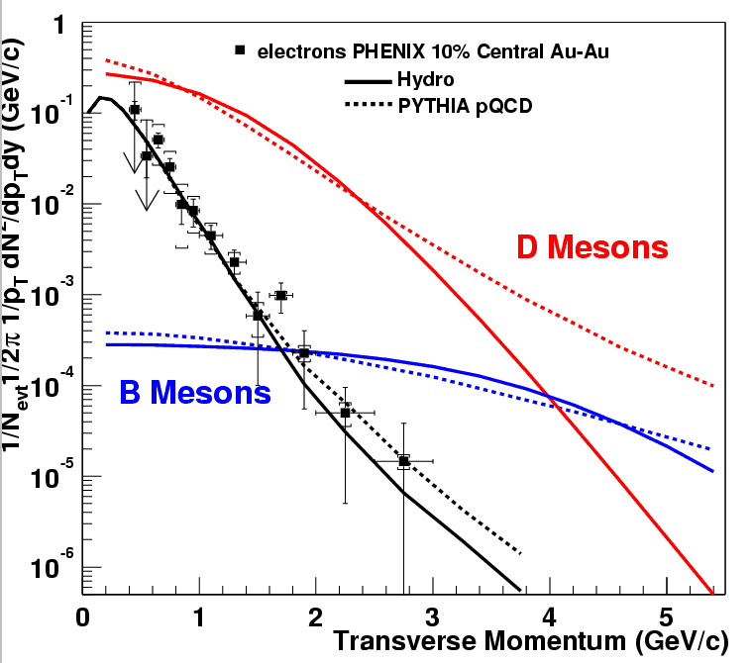
Figure 5: B and D meson spectra at RHIC. The data points are from Ref. [] showing 0-10% central Au + Au collisions at √S_{NN} = 130 GeV at RHIC.

Elliptic Flow
The build-up of pressure and pressure gradients, in a nuclear collision, leads to collectivity. In non-central collisions, the initial overlap zone between the colliding nuclei is spatially deformed. If the matter produced in the reaction zone re-scatters sufficiently, then this spatial anisotropy is transferred into a momentum space anisotropy. The development of anisotropies does not require thermalization, only re-scattering. The largest momentum anisotropies are obtained in the hydrodynamic limit, where zero mean free path length and therefore infinitely fast re-scattering is assumed; this leads to instantaneous local thermal equilibrium.
The momentum space anisotropies lead to a dependence of the transverse-momentum distribution on the emission angle relative to the reaction plane. The anisotropy can be quantified by the coefficients of an azimuthal Fourier decomposition of the distribution.
The largest contribution comes from the second Fourier coefficient v₂(p_{T}, y), the elliptic flow coefficient. In the evolution of elliptic flow, the strong and early spatial deformation decreases because the matter begins to expand more rapidly in the short direction. As the spatial deformation disappears, the build-up of flow due to pressure gradients ceases and the elliptic flow saturates. Therefore, elliptic flow is considered to be a signal that develops in the early stages of a collision. RHIC data,, show that in semi-central Au+Au collisions the measured elliptic flow reaches the hydrodynamic limit for transverse momenta up to 2 GeV/c, suggesting early thermalization and pressure buildupError: Reference source not found. Thus, information about the equation of state can be determined. If all hadron species experience the same anisotropic flow, their v₂ coefficients should obey simple hydrodynamic relationsError: Reference source not found and exhibit a characteristic mass dependence. As an example, Figure 6 (top) shows the measured elliptic flow of strange hadrons up to the multiply-strange Cascade baryon. At low momentum, all particles exhibit a linear rise in v₂ and a clear mass ordering appears; from the lower mass Kaon to the heavier Cascade. These measurements demonstrate that collectivity is established at the partonic level. The bottom plot of Figure 6 shows the measured elliptic flow versus transverse momentum; where both axes are scaled with the number of constituent quarks. Quark coalescence models predict a universal scaling of v₂/n versus p_{T}/n at intermediate momentum where quark recombination is (supposedly) the dominant hadron production mechanism. In these models, collectivity – the elliptic flow of constituent quarks – is intrinsically built in and supports the idea of partonic collectivity.
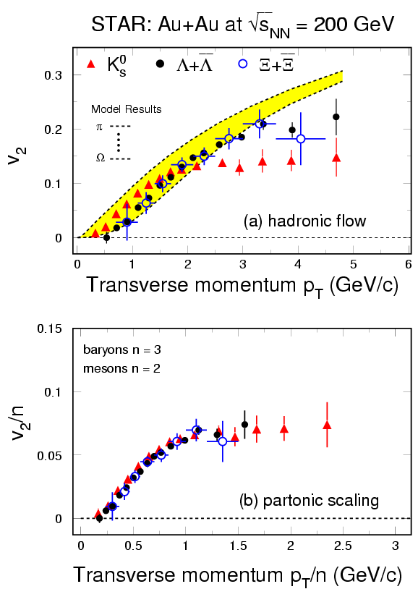
Figure 6: Elliptic flow of strange hadrons at RHIC. The top panel demonstrates mass ordering, the bottom panel shows constituent quark scaling.
At RHIC energies, charmed quarks are abundantly produced. Due to their high mass and small interaction cross section, the strength of elliptic flow of heavy flavor hadrons may be a good indicator of thermalization occurring at the partonic level. If heavy flavor hadrons flow together with the light flavor hadrons, this indicates frequent interactions between the light and heavy quarks. Hence, thermalization of light quarks is likely to have been reached through partonic re-scattering.
Figure 7 shows a first indication of charm particle elliptic flow at RHIC measured in the inclusive electron channel. The predictions assume elliptic flow for the light quarks as determined by fits to experimental data. The solid line results from elliptic flow of the charmed quarks, whereas the dashed line represents zero elliptic flow for the charmed quarks. Presently, the data support the idea that the heavy charmed quarks flow. However, uncertainties are rather large, especially at low transverse momentum where hydrodynamic behavior should occur. A precise measurement of directly reconstructed open charm hadrons to low momentum is essential to confirm and further quantify elliptic flow of the charmed quarks.
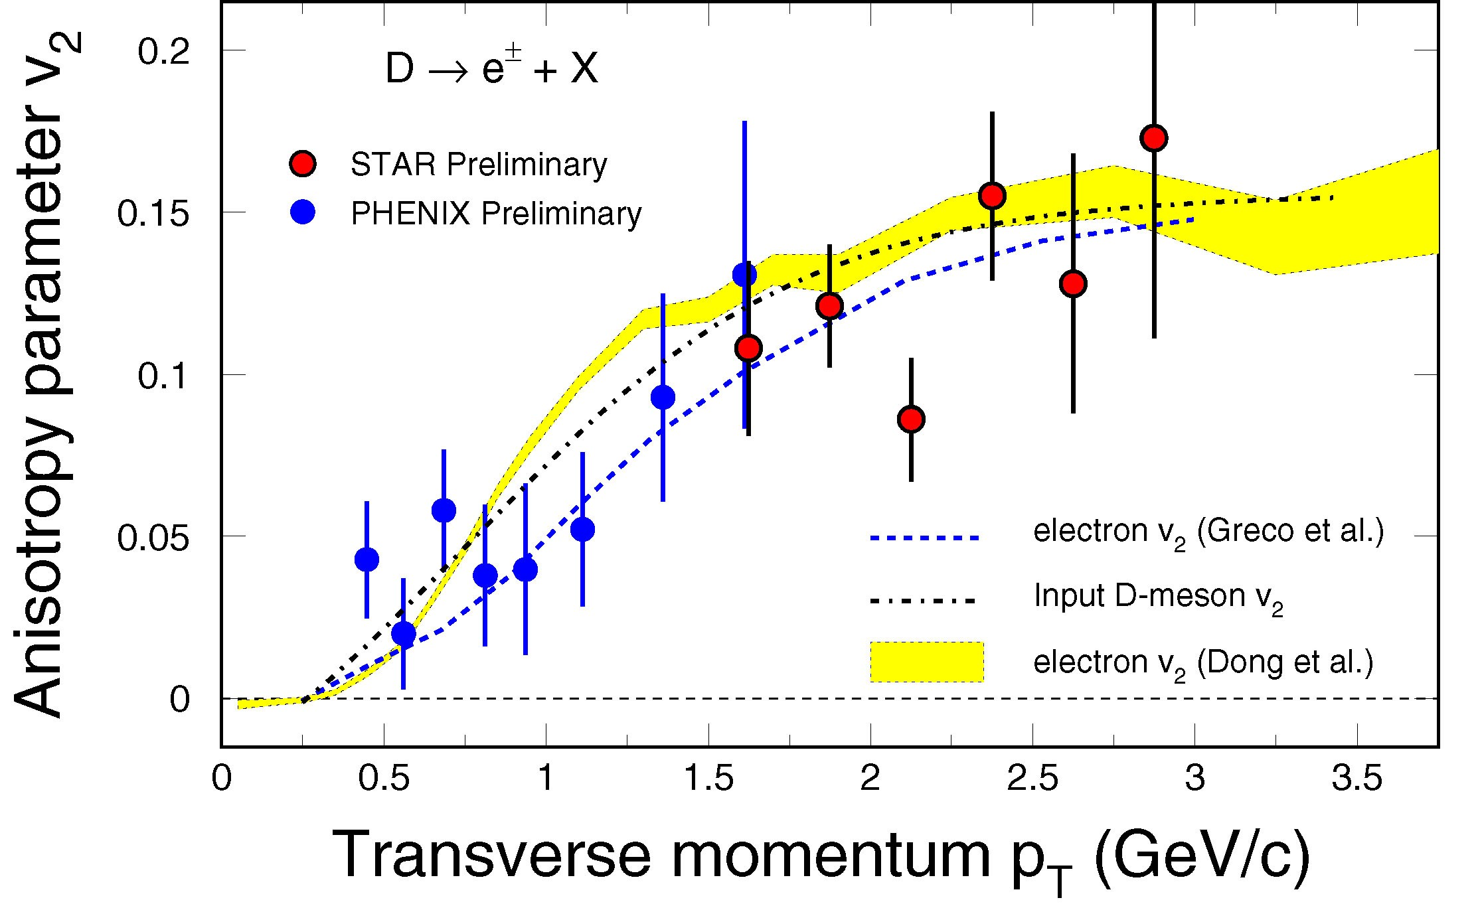
Figure 7: A hint of charmed elliptic flow at RHIC. Blue and Red symbols are data of non-photonic electron v₂ from PHENIX and STAR. Only statistical errors are shown for both results. Dashed-dotted-line represents the input D-meson v₂ distributions, assuming the scaling of constituent quarks for meson v₂. The corresponding decayed electron v₂ are shown as the hatched band [ref.1]. Dashed-line represents the results from Greco et al. [ref.2] . In this coalescence calculation, similar v₂ distributions for c- and u-quarks are assumed. The figure is adopted from Ref. [].

Charm Hadro-Chemistry
Measured hadronic yields and their ratios, from AGS to RHIC energies, have been successfully described with statistical models,. The relevant parameters are the chemical freeze-out temperature T_{ch}, and the chemical potentials μ_{i} for conserved quantum numbers, i.e. net strangeness, charge, and baryon number conservation. The extracted chemical freeze-out temperature T_{ch} turns out to be higher than the kinetic freeze-out temperature T_{fo} extracted from momentum spectra.
It has been claimed, at the SPS and RHIC, that for most particles the chemical freeze-out temperature coincides with the critical temperature T_{c} predicted from lattice QCD. Wide resonances might be an exception. Obviously, this critical temperature T_{c} serves as an upper limit for hadronic systems. Larger temperatures from partonic systems might be observed when measuring thermal spectra of penetrating electro-magnetic probes such as dileptons and photons.
Charmed quarks are dominantly produced in initial parton-parton scatteringsError: Reference source not found and the thermal production of charmed quarks is suppressed due to their large mass. In case of sufficient re-scattering, initially produced charmed quarks might thermally (but not chemically) equilibrate with the surrounding medium. This means their momentum distribution can be described by a temperature parameter consistent with the spectra of light quarks; while the total abundance of charmed quarks is conserved.
These arguments lead to the idea of statistical hadronization of charmed quarks,. Statistical coalescence scenarios predict large changes in open (regarding relative abundances, e.g. the D⁰ / D_{s}⁺ ratio) and hidden charm production with strong centrality dependence. Statistical coalescence implies that charmed quarks travel over significant distances, e.g. in a QGP. And so we believe that a consistent description of precision data by these models would be an indication of deconfinementError: Reference source not found.
Measuring the total charm and bottom yields requires measuring the yields of several different hadrons. Indeed, charmed quarks may fragment into a variety of hadrons as shown in the first column of Table 1. These fragmentation ratios have recently been compiled by experiments H1 and ZEUS at HERA, using e-p and e⁺-e⁻ collision data. These ratios are found to be independent of the collision energies and the collision system (e-p or e⁺-e⁻). They are likely to be the same in p-p collisions at mid-rapidity where the HFT will detect charmed particles, even though the ratios calculated using PYTHIA, shown in the second column of Table 1, differ significantly from the measured ratios. To avoid any uncertainties on the charge yield measurement, these ratios will have to be measured in p+p collisions at RHIC energies.

 | e-p and e⁺-e⁻  average | Pythia | Statistical coalescence
ƒ(c → D ⁺ ) | 0.232 | 0.162 | 0.21
ƒ(c → D ⁰ ) | 0.549 | 0.639 | 0.483
ƒ(c → D_{s}⁺ ) | 0.101 | 0.125 | 0.182
ƒ(c → Λ_{c}⁺ ) | 0.076 | 0.066 | 0.080
ƒ(c → J/Ψ ) |  | 0.006 | 0.057
Table 1: Charm quark fragmentation functions. The left column is from Ref. [Error: Reference source not found, Error: Reference source not found]. The right column is from Ref.[Error: Reference source not found]. The D⁺ and D⁰ yields include feed-down from D^{*+} and D^{*0} decays.
The effect of statistical coalescence is shown in the last column of Table 1. This calculation assumes that charmed quarks statistically coalesce with lighter quarks, i.e. according to the temperature and chemical potential of the light-quark system. The temperature and chemical potential are set so that the light hadron yields measured at RHIC are reproduced. The number of charmed quarks present in the system is set by pQCD calculations; this is reflected by a charm-chemical potential in the statistical coalescence model. Statistical coalescence increases the yield of the D_{s}⁺ meson by 80 % and the J/ψ yield by a factor of 10 compared to PYTHIA while the yield of D⁰ and D⁺ decrease slightly. Thus, the ratios D_{s}⁺/ D⁰, D_{s}⁺/D⁺ and J/ψ / D⁰ are the most sensitive probes of thermal charm hadron production.
Measuring the D_{s}⁺/D⁰ and D_{s}⁺/D⁺ ratios with the precision required to separate direct and thermal production sets stringent requirements on the HFT detector performance. Neglecting the errors on the D⁰ yield, the D_{s}⁺ yield needs to be measured with a 2% precision for separating the two scenarios. Such small statistical and systematic errors are very hard to achieve. To separate both scenarios using the D_{s}⁺/D⁺ ratio, the yields of both D⁺ and D_{s}⁺ need to be measured with a precision of about 7%. When comparing D_{s}⁺ and D⁺ yields, most of the systematic errors cancel out because both are reconstructed in very similar decay channels: D⁺ → K⁻ π⁺ π⁺ and D_{s}⁺ → K⁻ π⁺ K⁺. If heavy quarks become embedded within partonic matter, they provide a unique tool to study the properties of such matter. Indeed, their yield can be accurately extrapolated from p-p measurements. Any change in the charm and bottom hadron behavior between proton-proton and heavy-ion collisions will provide information about the matter these hadrons traverse. Thermal kinetic equilibration and subsequent statistical coalescence of the charmed quarks would be strong evidence for partonic matter formation since the pion-charm hadron cross-section is small. Furthermore, exotic phenomena such as the formation of charmed penta-quarks or enhancement of the B_{c} meson yield may also take place. A precise measurement of the total charm production (mostly carried by open charm mesons) will also serve as a baseline for J/ψ enhancement/suppression measurements suggested as a possible signature for QGP formation.

Measuring Vector Mesons with Dileptons
Besides the direct measurement of open charm hadrons, the HFT will serve as a powerful device to discriminate background in the measurement of electromagnetic probes.
Photons and leptons emitted from the early stages of heavy ion collisions suffer few interactions with their surroundings since they interact via the electromagnetic force instead of the strong one. Therefore, electromagnetic probes are ideal tools to study the properties of matter created by relativistic heavy ion collisions.
On the other hand, processes which produce photons and leptons are rare and are overwhelmed by photons and leptons from electromagnetic decays of hadrons and subsequent γ conversions to leptons. In addition, the final state electrons and positrons are the integrated yield of radiation over the whole evolution of the colliding system. Despite all the experimental difficulties, the low and intermediate mass dileptons have been measured at the CERN-SPS and an excess of radiation above the hadron cocktail has been observed in the invariant mass region at 0.2 < M_{ee} < 0.6 GeV/c^{^2} in semi-central Pb+Au collisions[ref]. Also, new and exciting results from the first three RHIC runs indicate that jets have lost a large fraction of their energy in dense matter and the hadronic phase is relatively short. We believe that these observations at RHIC favor experimental measurements of photons and dileptons due to thermal radiation and will result in a clearer signature than from lower energy heavy ion collisions.
At STAR, electron identification is made possible by a combination of a measurement of the energy lost by charged particles due to ionization of the TPC gas (dE/dx) and a velocity measurement with the time-of-flight system. The relativistic rise of the electron dE/dx separates the electron dE/dx from those of hadrons except at the crossovers with pions at momentum of ~ 0.2 GeV/c, kaons at ~ 0.6 GeV/c, protons at ~ 1.1 GeV/c and deuterons at ~ 1.5 GeV/c. A time-of-flight measurement, using a requirement that |1-β| < 0.03, eliminates slow hadrons and cleans up the crossovers. This results in clean electron identification, as shown in Figure 8. The plot on the top left shows the conventional dE/dx measurement in the TPC gas as a function of particle momentum. The lower plot shows the same dE/dx measurement but now requiring at TOF of |1-β| < 0.03. The upper electron band is clearly separated from the lower pion band. Heavier particles (e.g. kaons and protons) are completely removed by the TOF requirement. The right hand plot of Figure 8 shows a dE/dx projection in the transverse momentum range p_{T} = 1.0-1.5 GeV/c. Even at this rather large momentum, the Gaussian-shaped distribution of electrons are clearly separated from the distribution of charged pions at the lower energy losses.
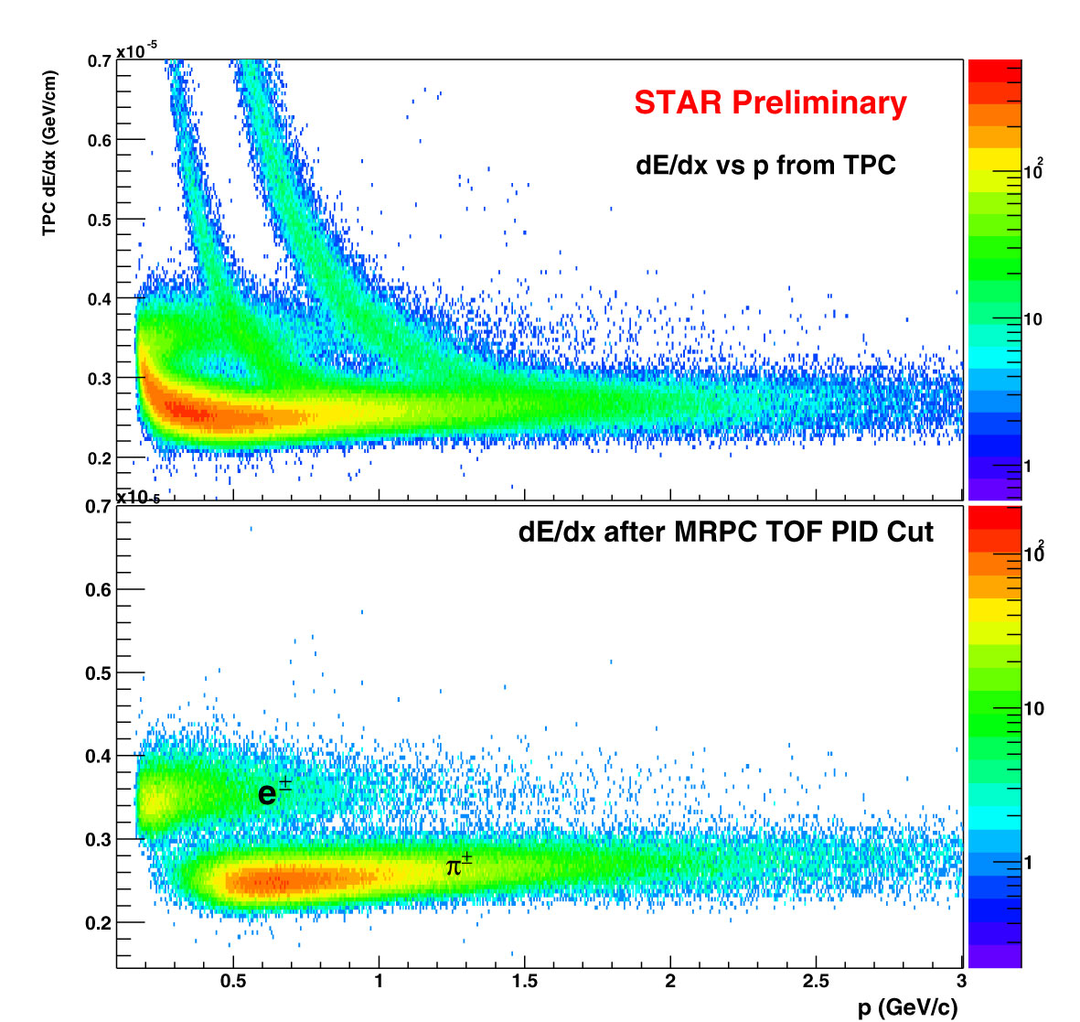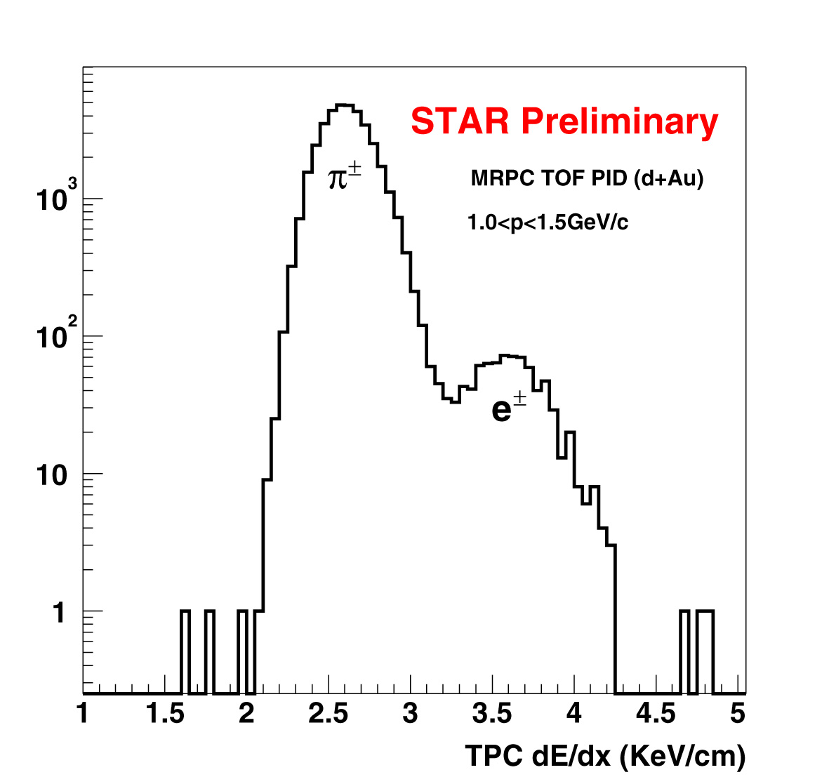
Figure 8: Left top: TPC dE/dx vs p in d+Au collisions. Left bottom: TPC dE/dx vs p after TOFr PID selection of | 1-β | < 0.03. Clean electron identification is achieved. Right: dE/dx from TPC after TOFr PID selection (left bottom panel) for 1.0 < p < 1.5 GeV/c.
These electrons are to a large extent from photons converting into electron-positron pairs, γ → e⁺ e⁻ in the detector material. The HFT detector will reduce the background electrons and positrons from these γ conversions. By requiring hits in the HFT, electrons from photon conversion outside the HFT, i.e. the SVT,SSD, TPC inner field cage are rejected. Figure 9 shows the resulting yield from pure Monte Carlo simulations (no tracking involved) of conversion electrons when requiring hits in the TPC only (open circles), hits in the TPC and SVT (open triangles) and hits in the TPC+SVT+HFT (closed circles). The requirement of hits in the HFT reduces the detected yield of conversion electrons by a factor of 50. Another source of electron background stems from the semi-leptonic decays of heavy quarks, charm and bottom. The dominant source at intermediate mass, is from the semi-leptonic decays of open charm. Due to the lifetime of ~100μm of heavy-flavor hadrons, this background can be largely reduced by measuring the displaced decay vertex with high resolution as provided by the HFT detector. Detailed simulations are in progress.
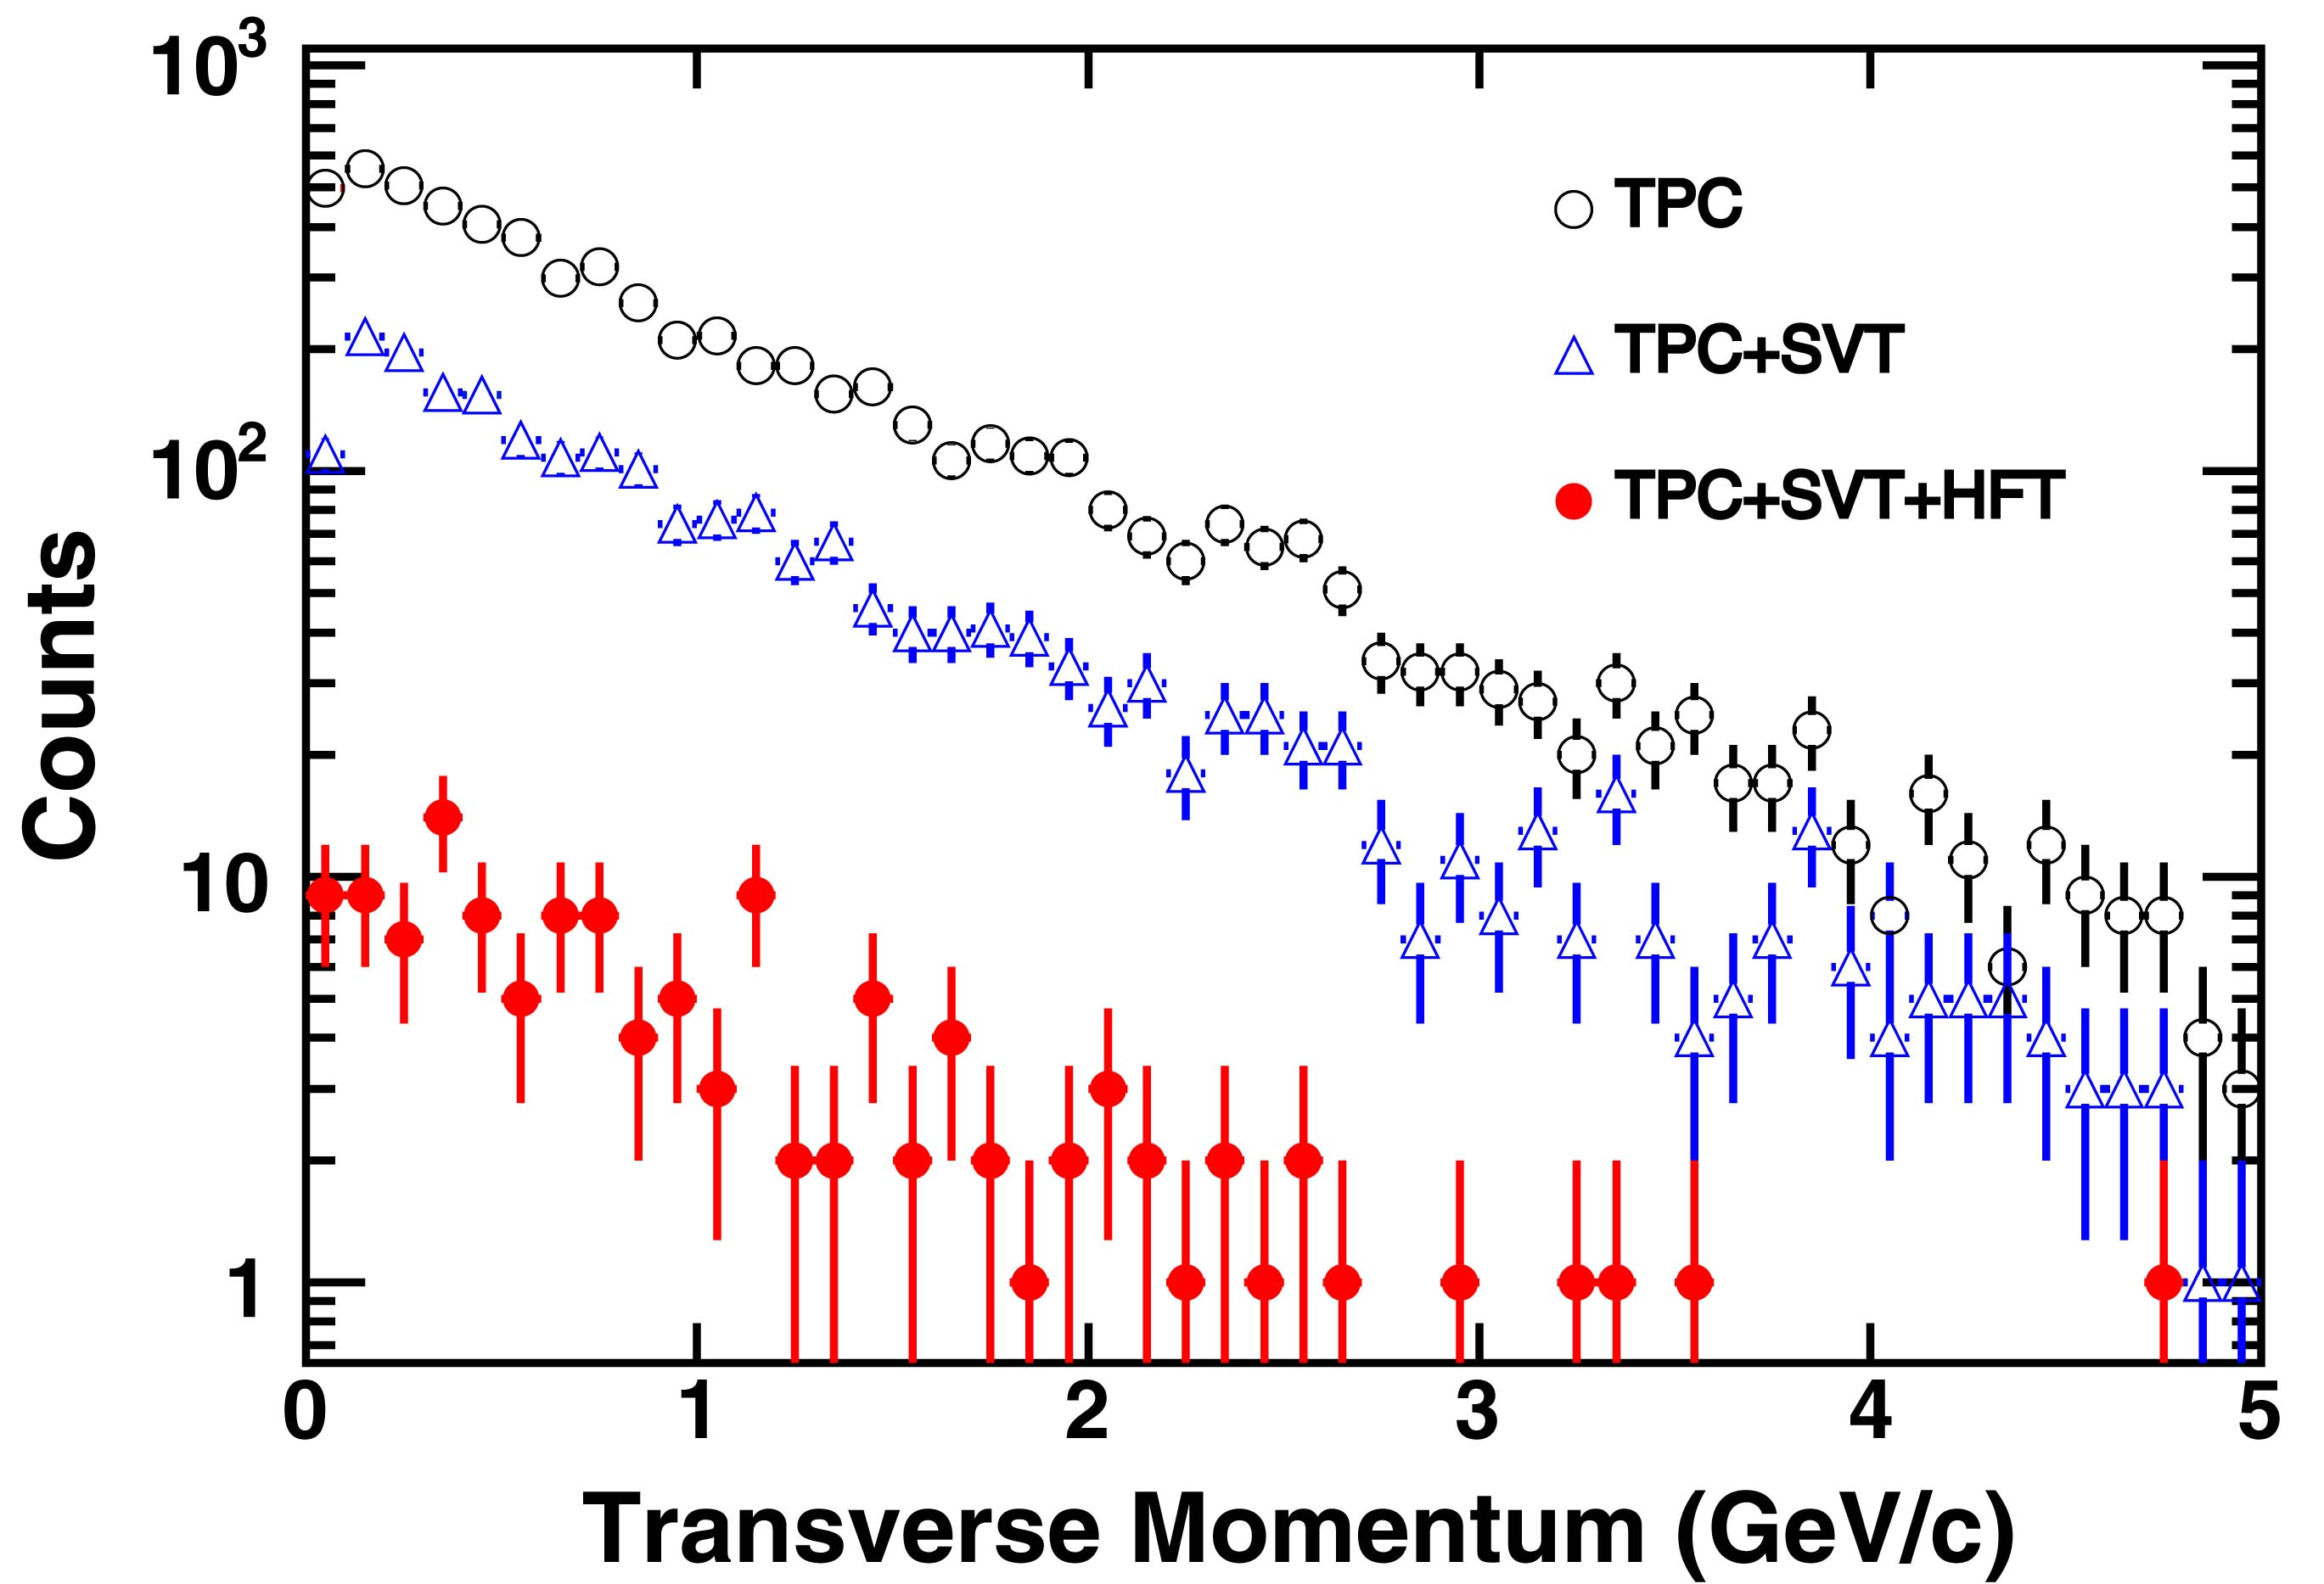
Figure 9: Electron p_{T} spectra from γ conversions reconstructed by requiring TPC tracking, a TPC hit and 2 SVT hits, or a TPC hit and 2 SVT hits and 2 HFT hits. The rejection factor with an additional SVT hit (2 hits) is 3 and with an additional pixel hit is 50.
The large reduction in electron background will enable us to observe electromagnetic decays of short-lived vector meson, e.g. φ, ω → e⁺e⁻ and intermediate mass dileptons with a few hundred thousand central Au+Au events in STAR. The rejection of π⁰ and  η Dalitz decays and can be achieved by measuring the pair simultaneously due to the large acceptance of the STAR TPC. Table 2 shows our estimate of central AuAu collisions needed in order to observe a signal with a statistical significance of 3σ. Compared to a measurement incorporating only TPC and TOF, the HFT will enhance the sensitivity of electro-magnetic vector meson decay by a factor 20-40. We are in the process of simulating the effect of the combinatorial background in more detail.

Detectors | ω | φ
TPC+TOF | 8M | 2M
TPC+TOF+SVT+HFT | 200K | 100K
Table 2: Number of central Au+Au events required to observe a 3-σ signal for ω and φ in their leptonic decay channels under different detector configurations.

HFT Conceptual Design and Performance

Overview of the Experiment
STAR is a suite of detectors that surround the 6 o’clock collision region at RHIC (see Figure 10). The primary goal of the experiment is to provide momentum analysis and particle identification over a wide range of rapidities, over the full azimuth, and over a broad range of momenta. In this respect, STAR is unique. It is the only experiment at RHIC whose primary detectors cover the full azimuth in φ, cover ±1.5 units in rapidity, and track particles from 100 MeV/c to 20 GeV/c. The Heavy Flavor Tracker will extend these unique capabilities even further by providing particle identification for hadrons containing charm and beauty.
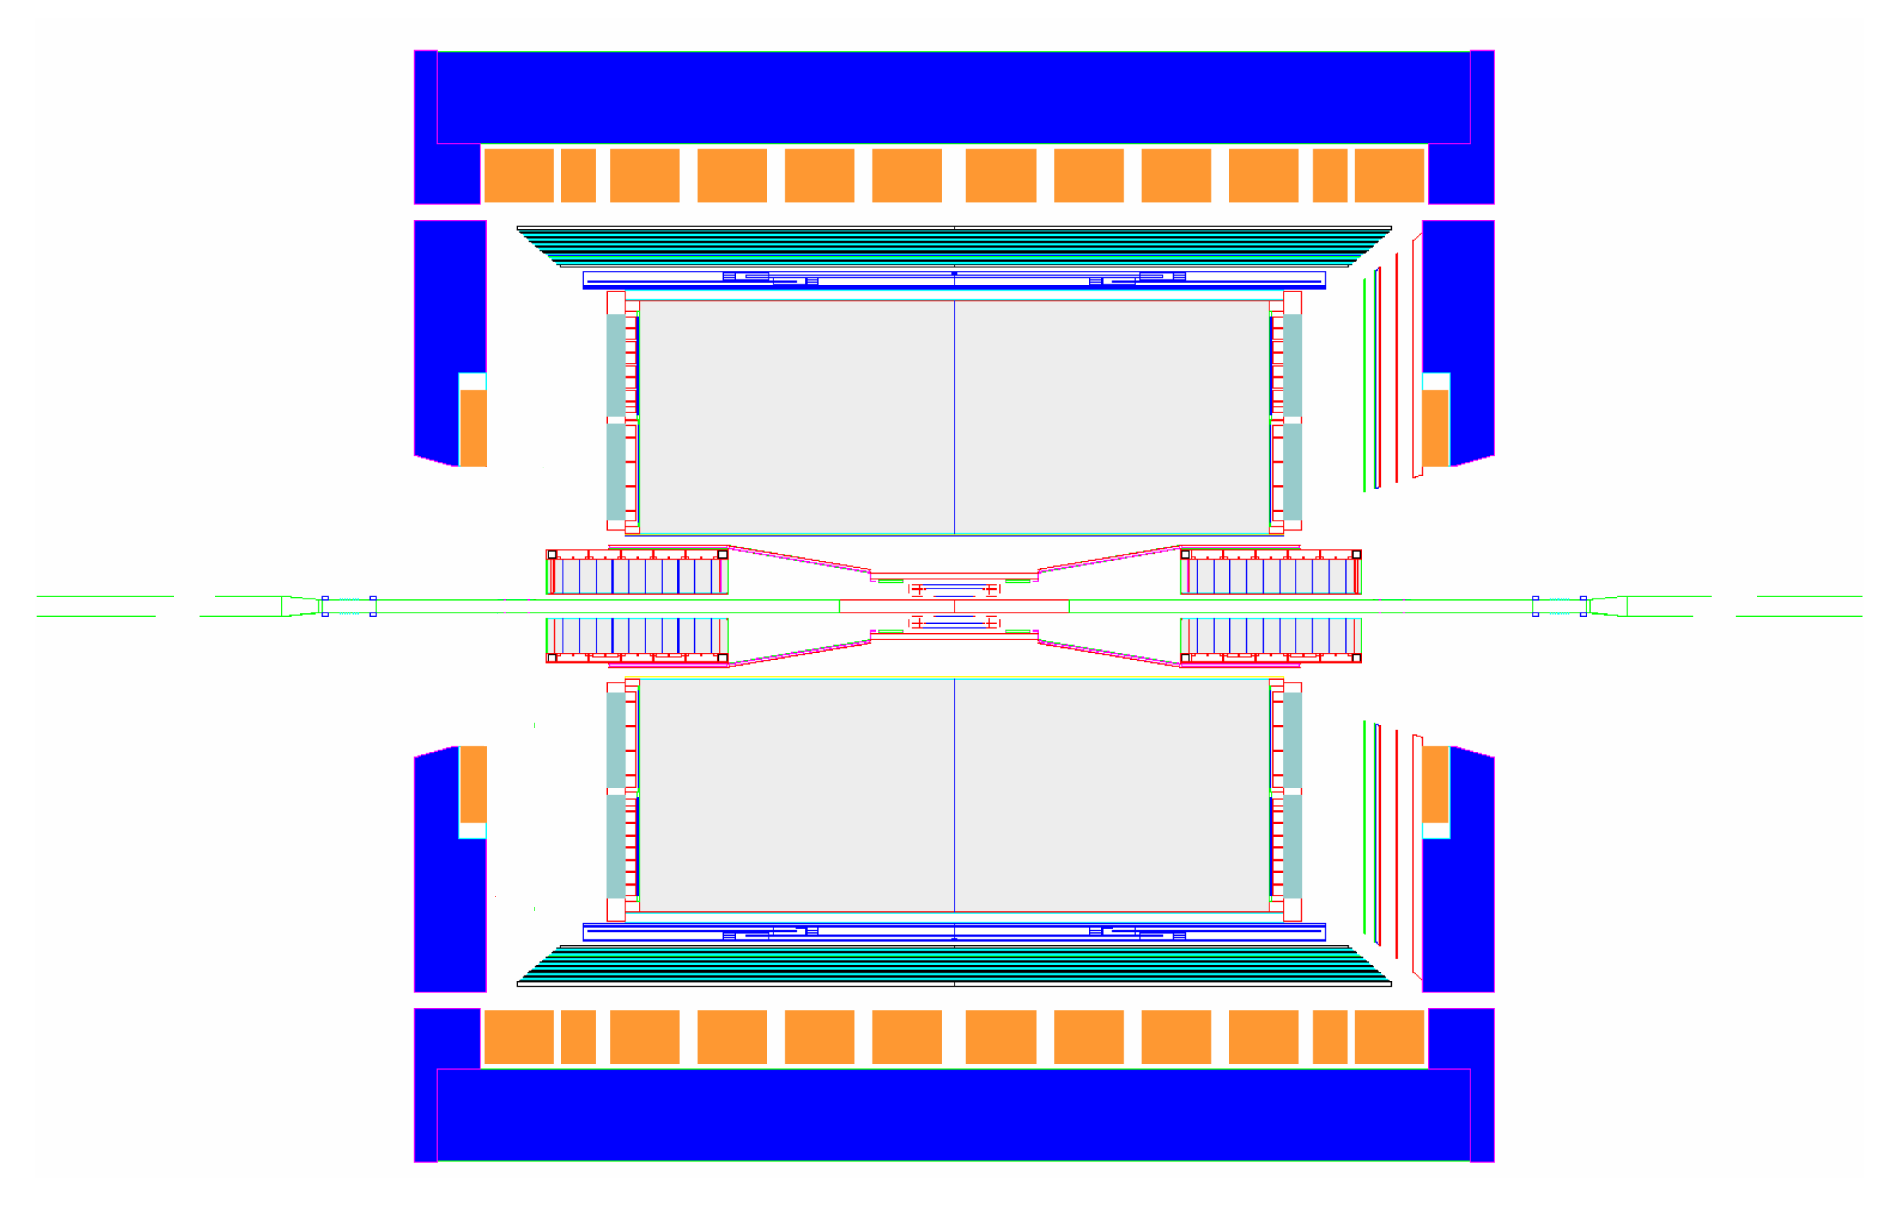
Barrel EM Calorimeter
FTPCs
Time Projection Chamber
Silicon Trackers
SVT & SSD
Endcap Calorimeter
Magnet
Coils
TPC Endcap & MWPC
Central Trigger Barrel & TOF
Beam Beam Counters
Figure 10: The STAR detector at RHIC. The primary detector elements at mid-rapidity are shown in this cut-away view of the detector. For scale, the TPC is 4.2 meters long and 4 meters in diameter. Heavy Ion beams enter from the left and right while collisions take place at the centerline under the Silicon trackers.
In the current STAR detector configuration, the important tracking elements at mid-rapidity are the Silicon Vertex Tracker (SVT), the Silicon Strip Detector (SSD) and the Time Projection Chamber (TPC). The SVT surrounds the interaction vertex with Silicon drift detectors at radii of approximately 7, 11, and 15 cm. The SSD is installed at a radius of 23 cm while the TPC tracking begins at a radius of approximately 60 cm. The TPC tracking system extends out to a radius of 190 cm and yields a total of 45 position measurements along the track. In the future, a complete Time of Flight detector will surround the TPC barrel (φ = 2π).
The goal of the STAR detector is to start measuring a particle’s trajectory as close as possible to the interaction vertex and then to follow it continuously to a large radius as it traverses a uniform magnetic field of 0.5 T. The STAR tracking philosophy, on the other hand, is to start from the outside where the hit density is lowest and to follow the track inwards. This design allows us to measure the collision vertex with great precision. Using this information we can identify a short lived particles ’whosthe decay is displaced from the vertex by a significant distance. The K_{S}⁰ is one example. It decays into two pions with a mean lifetime of 0.896 x 10⁻¹⁰ seconds and it has a characteristic decay distance of 2.68 cm. It is relatively easy to identify this non-vertex decay using the TPC, alone, because the TPC has a vertex pointing accuracy of approximately 5 mm.
After including the SVT in the analysis, the vertex resolution is approximately 2 mm which substantially improves the efficiency for finding topologically complex strange decays such as the Ω baryon.
The HFT improves upon these capabilities even further because it will be placed between the beam pipe and the SVT detector. It will have two layers of silicon pixel detectors; one at 1.5 cm radius and the other at 5 cm radius. Each layer will be composed of 30 μm × 30 μm pixels and the pointing accuracy of the system (including multiple coulomb scattering in the beam pipe and Si layers) will then be 25 μm for 1 GeV/c tracks. The primary reason we need the HFT is because the charmed mesons have a characteristic decay length on the order of 125 μm. Thus, the HFT is the enabling technology for making direct charm and beauty measurements at STAR.

Design of the HFT
The parameters for the HFT are summarized in Table 3 and the detector is shown schematically in Figure 11. The inner layer of the detector lies at a mean radius of 1.5 cm radius and it is composed of 6 detector ladders. The outer layer lies at a mean radius of 5.0 cm and it is composed of 18 ladders. Each ladder contains a row of 10 monolithic CMOS detector chips and each ladder has an active area of 19.2 cm by 1.92 cm. Each CMOS detector chip contains a 640 by 640 array of 30 μm square pixels. It is our goal to thin down each chip to a total thickness of 50 μm in order to minimize the multiple coulomb scattering (MCS) between layers of the detector. The beam pipe must also be made thinner (0.5 mm) to reduce scatterihe in front of the HFT. The HFT is designed to be as close as possible to the interaction point. This will require a new, smaller radius beam pipe. This smaller, thinner, beam pipe is an essential part of this proposal (see section 6.6 ).
Number of pixels | 98,304,000
Pixel dimension | 30 μm × 30 μm
Detector Chip active area | 19.2 mm × 19.2 mm
Detector Chip pixel array | 640 × 640
Number of ladders | 24
Ladder active area | 192 mm × 19.2 mm
Number of barrels | 2
Inner barrel (6 ladders) | r = 1.5 cm
Outer barrel (18 ladders) | r = 5.0 cm
Frame read time | 4 ms
Pixel read rate, after zero suppression | 63 MHz
Ladder (w/Al cable) % X₀ | 0.36 %
Pointing Accuracy, σ | 14 μm + 12 μm (GeV/c) / p
Beam Pipe Thickness | 0.5 mm or 0.14% X₀
Table 3: Selected HFT parameters.
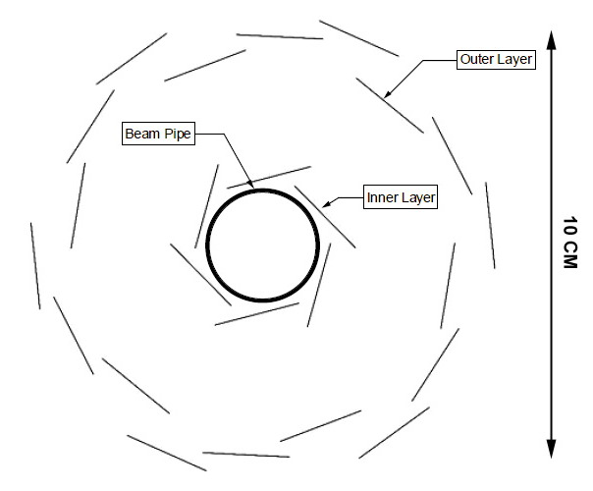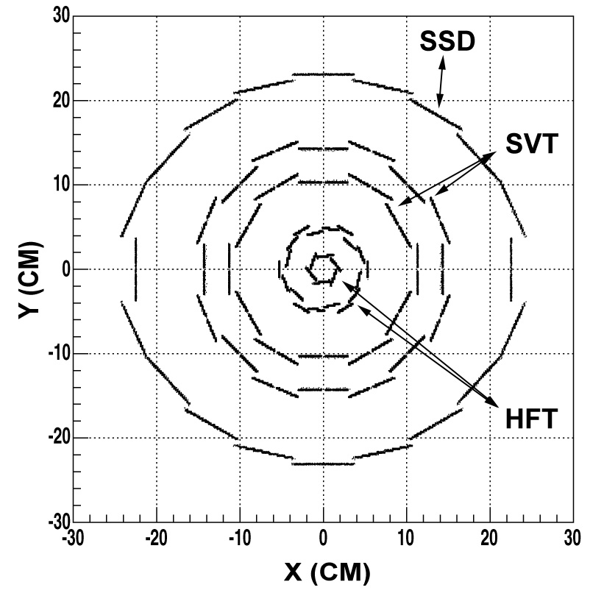
Figure 11: Left - Schematic view of the HFT detector ladder arrangement with 6 ladders forming the inner layer and 18 ladders forming the outer layer. The width of the ladders (the dimension seen in this view) is 19 mm. The shingled layers provide cross calibration of the ladders and provide an open geometry for ease of installation. Right - The HFT is shown embedded inside the SVT+SSD.

Simulated HFT Performance
The performance of the HFT has been studied using tracks from √S_{NN} = 200 GeV central Au+Au collisions generated by the “MEVSIM” code. We have also studied the performance of the detector by using single particle tracks. The simulated tracks and simulated events were processed through GEANT and, finally, a detailed response function for the Time Projection chamber (TPC) and a response function for the Silicon Vertex Tracker (SVT) were applied to the data. These response functions carefully take into account physical effects in the detector and the subsequent electronics. For the HFT, we smeared generated Monte Carlo hits by a Gaussian function with a width of σ=6μm in the x-y-plane and in the z-direction. This accounts for the finite hit resolution we expect for the HFT. The limited read-out speed of the 1st generation HFT will lead to pile-up of up to 120 Au+Au collisions in the HFT at four times the RHIC design luminosity. We account for that by randomly uploading hits on top of the Monte Carlo generated hits in the HFT. The topic of pile-up is discussed in detail in Sec. 3.4. Tracks with at least 15 hits in the TPC, 1 hit in the SVT and 2 hits in the HFT detector were reconstructed with the STAR inner-tracker code.. Figure 12 shows the efficiency for tracking pions with |y| < 0.5 in various detector configurations. The TPC results are designated by the open circles (red), TPC+SVT by triangles (green), and the TPC+SVT+HFT detector by filled dots (blue). Note that the TPC tracking efficiency limits the efficiency of the SVT at low transverse momentum and, in addition, the efficiency of the HFT at low momentum is affected by ghost tracks and event pileup. But at high momentum, the acceptance of the detectors is quite uniform and the overall efficiency for the HFT tracking system is 50% or above at a transverse momentum larger than 500 MeV/c. Simulations using monoenergetic pions show that the efficiency stays approximately constant up to 20 GeV/c.
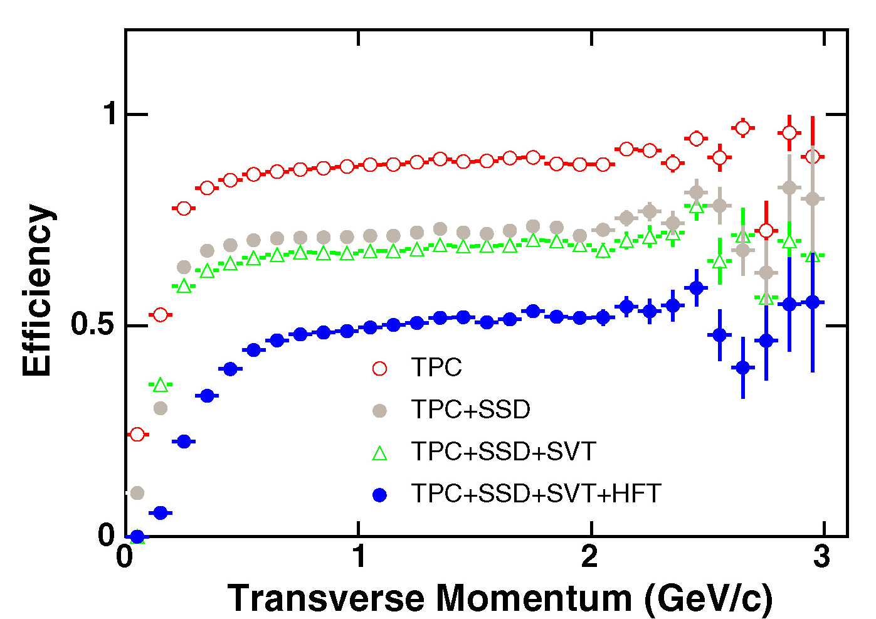
Figure 12: The efficiency for finding tracks in central Au+Au collisions in the STAR TPC, SSD, SVT, and the HFT. In this simulation, the beam luminosity is assumed to be four times the RHIC design luminosity.
In the high multiplicity environment of a central Au+Au collision, there can be ambiguities in finding the next hit on a track while following a track along its path. A ghost track is defined to be a reconstructed track with at least one hit from a different track. With the present tracking algorithm, the number of ghost tracks in the TPC is less than 1% compared to all reconstructed tracks. The HFT, however, is more complicated because it is continuously read out and events can pile up between successive reads of the pixel chips which occur every 4 msec. So we have studied the influence of the ghost tracks in the HFT detector by using simulated central Au+Au collisions in the TPC++SSD+SVT+HFT. At low momentum, ghost tracks dominate due to multiple Coulomb scattering.
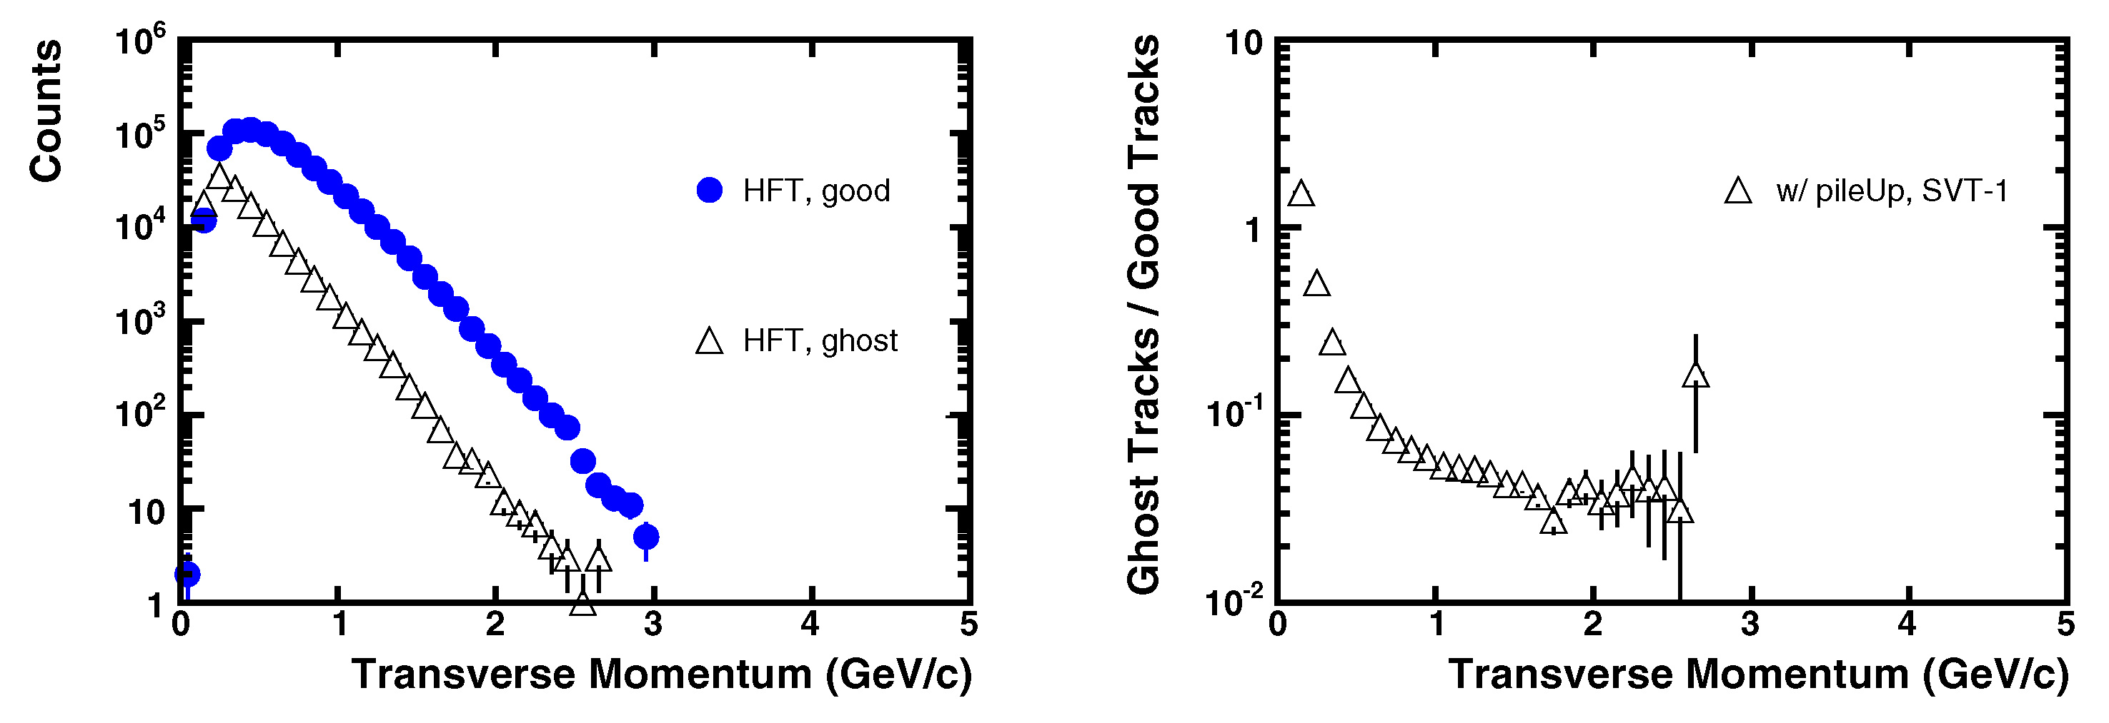
Figure 13: Left – The number of ghost tracks and reconstructed tracks passing through the pixels of the HFT as a function of p_{T}. Right - The ratio of ghost tracks to good tracks.
Figure 13 shows the number of ghost tracks observed in the full HFT tracking system. In this simulation, the SSD+SVTedetector was assumed to be the intermediate tracker but we removed the first layer of the SVT to test the performance of the system in this configuration. (This configuration is called “SVT-1” and is pronounced SVT minus one). The bulk of the ghost tracks appear below 0.5 GeV/c and the effect of these miss-identified tracks can be seen in Figure 12; the tracking efficiency for the HFT is steeply dropping below 0.5 GeV/c and substantially lower compared to TPC+SSD+SVT. The ratio of ghost tracks to good tracks is 10% at 0.5 GeV/c and saturates at 4% above 2 GeV/c (see the right hand panel of Figure 13).
These results are in good agreement with hand calculations of the same quantities. The analytical estimate of the tracking efficiency for various geometries has been studied. The pile-up hit density, ρ, is set to 30 hits/cm². The probability to pick up the correct hit is described by the following equation:
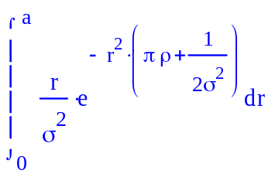
where σ is the uncertainty in the track extrapolation from the SVT to the pixel layer and ‘a’ is the search cone radius. The quantity σ includes contributions from multiple Coulomb scattering and the position uncertainty in the hits used on the track. The calculation matches the data fairly well at momenta > 1 GeV/c.While the caluclations can reproduce the shape of the distribution, the efficiency below 1 GeV/c is systematically overestimated. This is most likely due to details in the full tracking reconstruction algorithm, which are not considered in these hand calculations. The calculation uses a straight line technique to estimate the projection error, where only the two closest points on the track are used to determine σ when extrapolating to the HFT. The uncertainties from previous measurements on the track, therefore, are not accounted for in the calculation and may account for differences between Monte-Carlo results and the calculation.
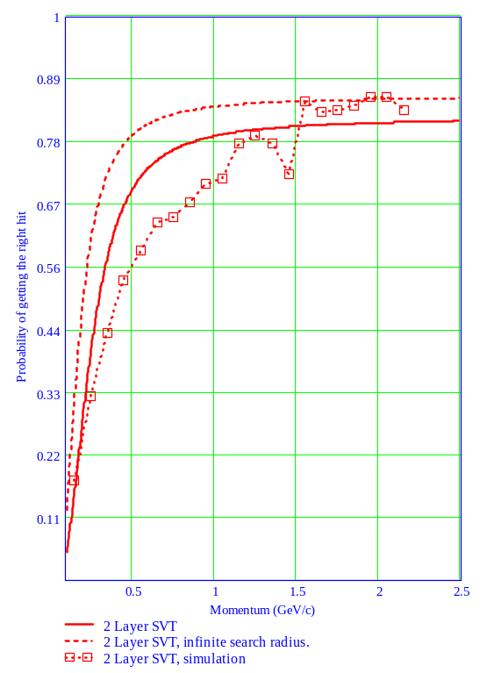
Figure 14: Probability of getting the correct hit on the outer pixel layer, given two different SVT geometries and a search window of 640 μm
The overall efficiency of the tracker and the number of ghost tracks affects the efficiency for finding charmed mesons with the HFT. We have performed a complete set of simulations of the TPC+SSD+SVT+HFT tracking system and the results are given in the next section.

An example: Open Charm and Beauty Reconstruction
Charm and beauty quarks occur in a wide variety of hadrons and these hadrons decay into a number of different channels. We have investigated a few specific channels, including: D⁰ → K⁻ π⁺, D_{s}⁺ → K⁻ π⁺ K⁺. These decays represent a crucial sample of the physics capabilities that can be achieved with the HFT detector.
Signal and background events for this study were generated separately. The signal consists of one D⁰ or D_{s}⁺ per event. The transverse momentum distribution of the charmed hadrons follow a Boltzman distribution which reproduce the <p_{T}> of D-mesons as measured by STAR in d+Au collisions at √S_{NN} = 200 GeV 15[] and the rapidity distribution suggested by perturbative QCD calculations applying the program code Pythia. The background is simulated using the MevSim event generator parameterized to reproduce the experimentally measured particle multiplicities in Au+Au collisions at √S_{NN} = 200 GeV. Our parameterization is accurate for particles below 3 GeV/c. It may underestimate the background above this momentum. The distributions of reconstructed D-meson signal and background were scaled to match the expected D-meson production per central Au+Au collision [48]. Also, the higher track reconstruction efficiency in single (D0 signal) events compared to central Au+Au collisions (background) was taken into account.
The HFT detector allows us to identify a D⁰ decay-vertex by reconstructing the trajectory of its two daughters. The following selection criteria were used to separate the D⁰ signal from background, see Figure 15.
- The decay length l, i.e. the distance between the primary vertex and the D-meson -vertex
- The difference Δm between the reconstructed invariant mass and the D⁰ rest mass
- The distance of closest approach DCA between the two daughter tracks
- The cos(θ) with  θ the angle between the D⁰ momentum (vector sum of the two daughter momenta) and the vector joining the primary vertex to the D-meson decay vertex
- The cos(θ*) with θ* the angle between the kaon in the D-meson Center of Mass frame and the D-meson momentum
Table 4 list the values of the cuts applied for D-meson reconstruction in the SVT-1 configuration.
<We miss a table here…>
Table 4. Cuts applied for D-meson reconstruction in the SVT-1 configuration
Charged decay daughters were identified by their specific energy loss in the TPC gas; i.e. to identify pions, we used a 3 σ cut around the expected band for pions with a momentum dependent width extracted from experimental data. With that method, pions can be separated from Kaons up to 700MeV/c. In addition, a time of flight PID selection criteria was applied. We assume that the pions and kaons can be separated up to 1.8 GeV/c; as demonstrated from exisiting STAR data with a small set of the full ToF detector[ref]. Tracks with a momentum above the range of the selected PID method entered the reconstruction algorithm twice, once under a pion mass assumption, once assuming a kaon.
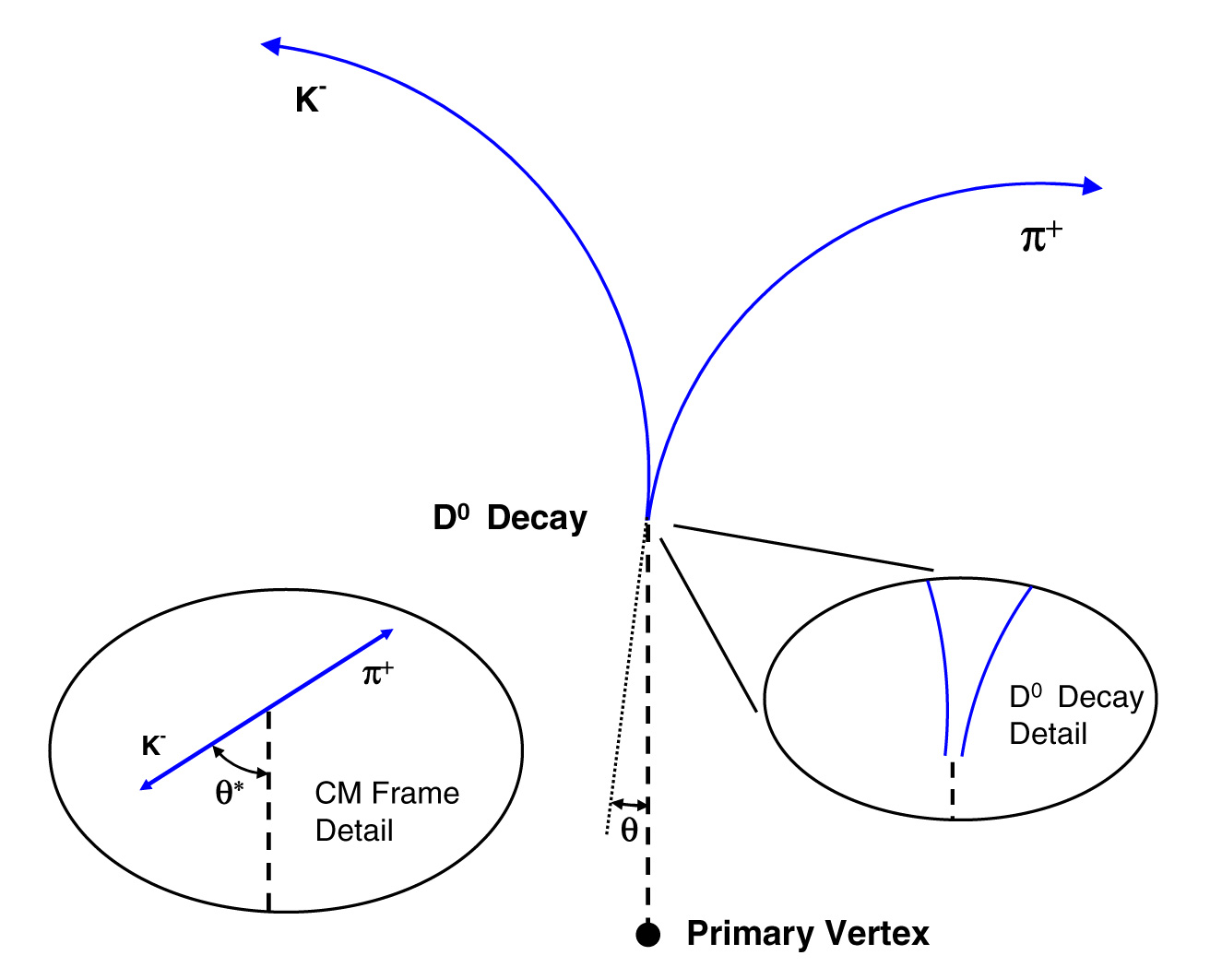
Figure 15: The decay topology for a D⁰ decaying to a kaon and a pion. Isolation cuts to identify the D⁰ from the background tracks are described in the text.
The applied cuts for D⁰ reconstruction were determined by using the program MINUIT in order to achieve the highest statistical significance of the reconstructed D⁰ yield. This is a tradeoff between the reconstructed D⁰ yield and background. The resulting yield of D⁰s divided by the input D⁰ yield, as a function of transverse momentum is shown in Figure 16. This is the overall reconstruction efficiency taking into account acceptance, single track efficiency and D⁰ reconstruction efficiency. At low momentum, the selected D⁰ decay length of ~100 μm dominates, leading to a rather small number of reconstructed D⁰s. The overall reconstruction efficiency increases with increasing momentum and seems to saturate above 3 GeV/c at a value of about 10%. From the single track efficiency of the HFT, the maximum D⁰ reconstruction efficiency can be estimated to 0.5*0.5 (tracks) = 25%, not taking into account the D⁰ acceptance effects, i.e. at least one of the decay daughters does not reach the TPC volume. The best results are achieved with the full SVT 3 layer configuration; removing the innermost SVT layer leads to somewhat smaller but still acceptable numbers. The main difference between the SVT and SVT-1 configuration is the resulting smaller single track efficiency of the HFT. Replacing the thinned Si wafers of the HFT by ones similar to those used in the ALICE detector (3* thicker), cause the D0 reconstruction efficiency to drop by a factor 8, independent of momentum. This would require an 8 times longer data taking period. Therefore, we exclude the ALICE detector configuration.
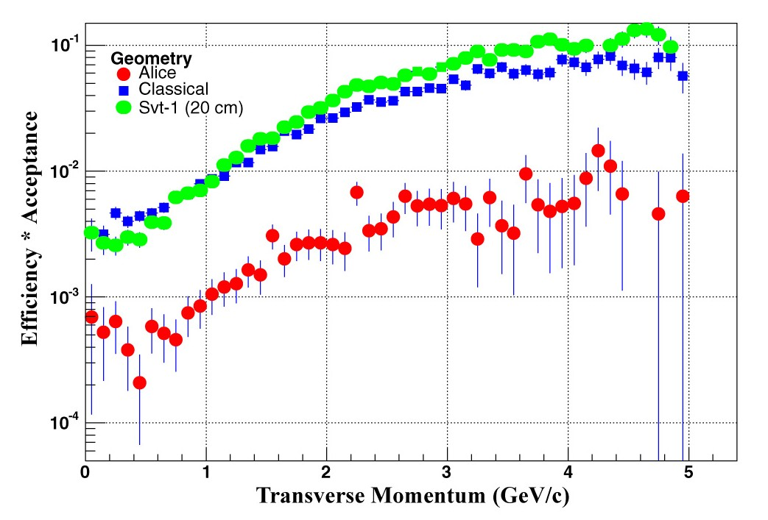
Figure 16: The absolute yield of D⁰s into the TPC+SVT+HFT divided by the input D⁰ yield. The classical configuration includes all three layers of the SVT. In the SVT-1 configuration, the innermost layer of the SVT has been removed in order to allow more room for the HFT. And finally, the Alice geometry assumes thick Si detectors that are similar to the wafers used in the ALICE vertex detector. For all three detector configurations shown the D⁰ reconstruction cuts were optimized using the program MINUIT.
We studied the influence of different HFT hit resolutions and Si ladder thicknesses. As a figure of merit we use the number of central Au+Au collisions required to measure a D⁰ signal with a statistical significance of 3σ. Figure 17 shows the number of central Au+Au collisions needed as a function of the HFT hit resolution for different Si ladder thicknesses. The curve is almost flat between 0 and 10 μm and then rises linearly. With increasing ladder thickness, multiple-Coulomb scattering leads to larger distortions of the reconstructed tracks and therefore requires more and more events. In the following we choose a position resolution of 6 μm and a total ladder thickness of 240 m Si-equivalent (0.3% X₀). We present projected statistical errors on D-meson spectra and elliptic flow.
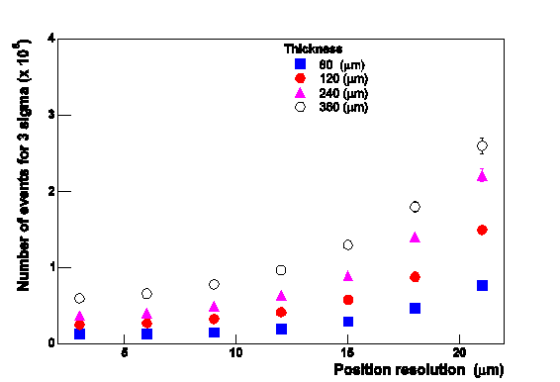
Figure 17: The number of central Au+Au events needed as a function of the Si ladder thickness and the position resolution of the detector.
For the first year of data taking with the HFT, we assume a total of 50M central Au-Au collisions at 200 GeV. (A similar number of events were taken by STAR during the RHIC Run IV in 2004.) Figure 18 shows the anticipated D⁰ spectrum from pQCD calculations (no flow) and a Blast wave prediction (0.4 β_{T}). The main differences between the spectra fall below 3 GeV/c. The top line shows the estimated statistical uncertainty in the measured spectrum with dE/dx PID (left) and additional TOF PID (right). At D⁰ momenta below 1 GeV/c, the estimated uncertainties are similar while at higher momentum the TOF measurement of D⁰ daughters leads to smaller uncertainties. This is due to the reduced background due to PID at larger momentum with the TOF. Even without the TOF measurements (the TOF detectors are expected to be fully installed before the HFT is complete) we can clearly distinguish flow from the non-flow case in the D⁰ spectrum. Usage of ALICE-type Si-ladders for the HFT would require far more than 100M central Au-Au collisions which is not feasible in one year of data taking.

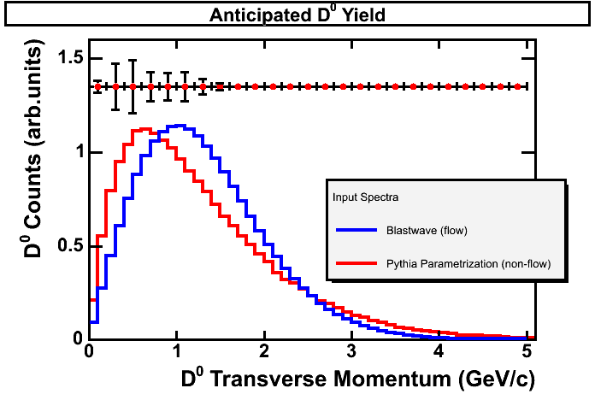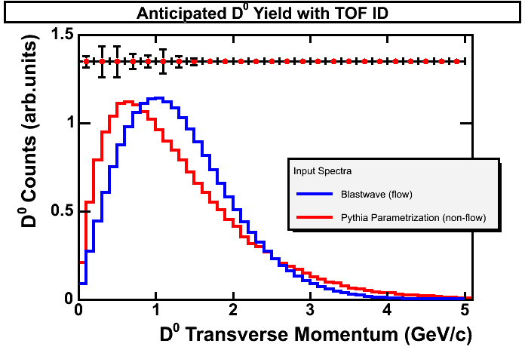
Figure 18: Left: SVT-1 configuration without TOF. Right: SVT-1 configuration plus TOF. The estimated statistical uncertainties are shown on the top line.
We performed a similar study for the D_{s} meson. Here the goal was to measure the D_{s} yield and extrapolate over all p_{T} to extract the dN/dy for hadro-chemistry studies. Figure 19 shows the estimated statistical uncertainties of D_{s} measurement as a function of p_{T}. Our measurement will cover the momentum range 0-3 GeV/c which contains 95% of the total D_{s} yield. Therefore, the extracted dN/dy will not rely greatly on extrapolation and this minimizes systematic uncertainties. The statistical errors in each p_{T} bin are larger than for the D₀ decay since the D_{s} decays to 3 daughters with a much smaller decay length of ~100 μm. The estimated uncertainty in dN/dy (summed over all p_{T} bins) is +-xx%. This is sufficient for probing the charmed quark coalescence scenarios predicting an increase of the D_{s}/D⁰ yield by a factor of two.

Figure 19: We need a D_{s} figure, here.
Finally we study the performance of our D⁰ elliptic flow measurement. This measurement is the clearest probe of D-meson (and therefore charmed quark) flow. However, it requires a measurement of the D⁰ spectrum at different angles with respect to the reaction plane and is therefore the most challenging measurement of all. Figure 20 shows the estimated statistical uncertainties in the D⁰ elliptic flow measurement on the top line as a function of transverse momentum. We assume one year of data taking. The uncertainties are largest at low momentum due to the rather small D⁰ reconstruction efficiency, they reach a minimum around 2 GeV/c, and then increase due to the exponentially falling D⁰ yield at larger momentum. The solid lines show the expected D⁰ azimuthal anisotropy parameter v₂ as a function of p_{T}. The upper line is the case of full charm quark flow (upper line) and for non charm-quark flow. It is evident that after a year of data taking that the charmed quark flow measurement can be fully addressed.
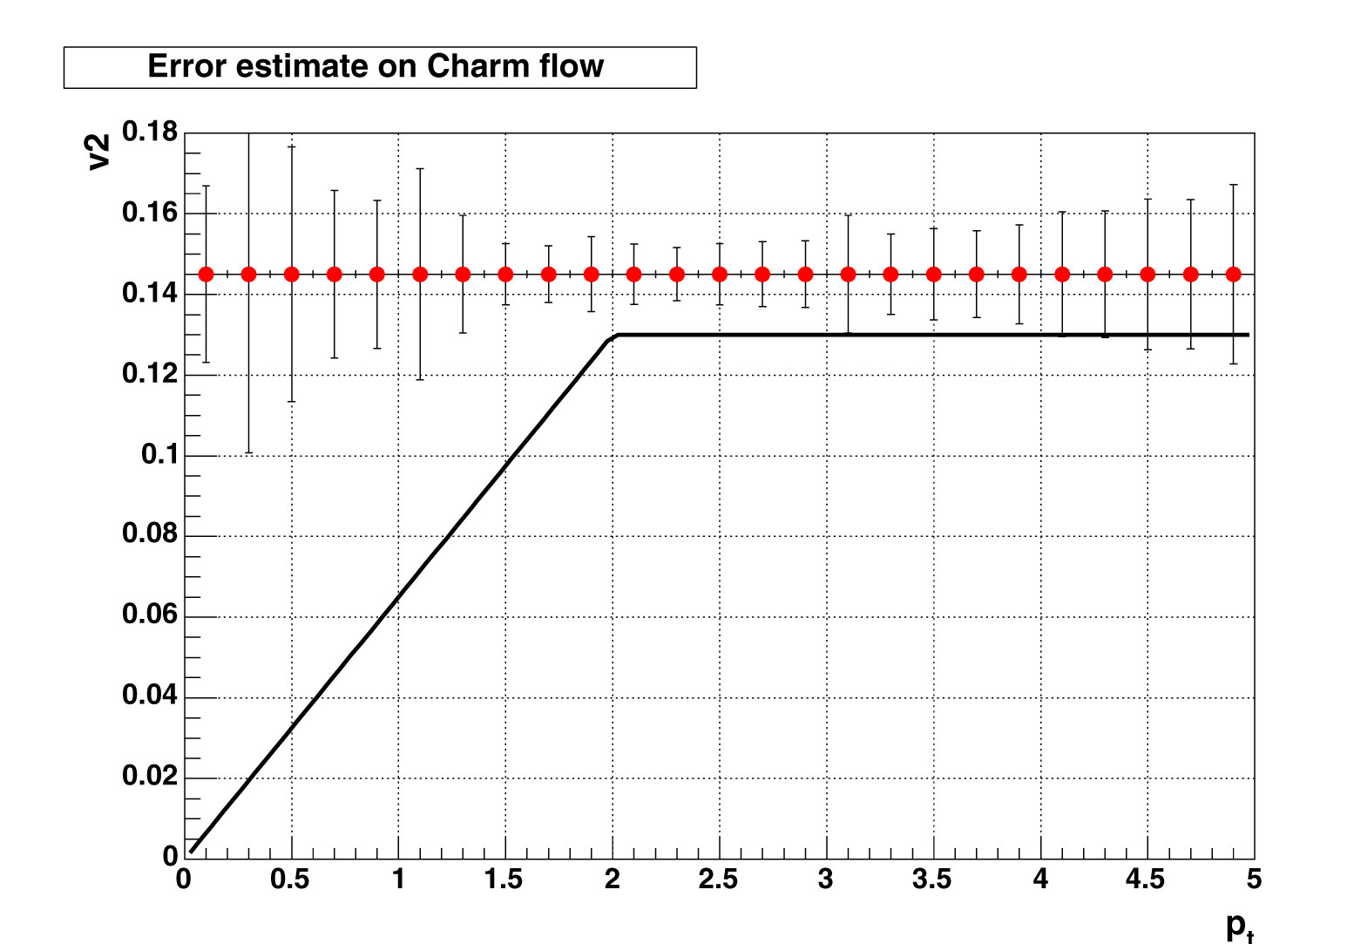
Figure 20: Flow results

Additional Issues that Relate to the Performance of the HFT
This section addresses several issues that may affect the performance of the proposed detector. The HFT is not triggered and is continually active, recording all particles that pass through it. This means that in tracking the events of interest there will be extraneous hits and pileup in the detector due to other collisions at an earlier or later time, tracks from beam gas showers, and other background sources. The areal density of extraneous hits that can be tolerated depends on the tracking precision projected onto the HFT surface and on details of the particle reconstruction algorithms while the extraneous hit density depends on the HFT frame readout speed, beam luminosity, interaction cross sections and background rates from additional sources. Reasonable limits on these processes have been included in the simulations. The focus of this section is to discuss and quantify these and other background issues that go into the simulations.
To set the scale of the problem, consider the extraneous hit density from normal interactions. The parameters used in the calculation are shown in Table 4 and an estimate of the hit density is shown in Table 5.

Au+Au Luminosity | 1x10²⁷ / cm² sec
dN/dη (min bias) | 170
Min bias cross section | 10 barns
Interaction diamond size, σ | 30 cm
Table 4: Luminosity and other parameters that determine the particle flux on the HFT.
As shown in Table 5, the accumulated hit density from the integrated Au+Au collisions is 17/cm² in the outer layer and 72/cm² in the inner layer of the HFT. This produces a pileup probability in the track search window of 10% at both the inner and outer HFT barrels. The area of the track search window in this case is based on the projection resolution for 1 GeV/c pions as determined from GEANT simulations. For comparison the unresolved hit pileup intrinsic to the HFT detector is much less, 0.14% and 0.6%, for the outer and inner barrel respectively. This meets our specifications.
The luminosity applied in this case is the maximum instantaneous luminosity that was recorded during the Au+Au run in 2004 (1×10²⁷/cm²/sec). This is 5 times the nominal “design luminosity”. (Design luminosity is defined to be 2×10²⁶/cm²/sec averaged over a 10 hour fill. An instantaneous luminosity of 2×10²⁶/cm²/sec is equivalent to an instantaneous ZDC coincidence rate of 2000 Hz.) It should be noted that the RHIC beam luminosity starts high and drops with time over the course of a fill. During the RHIC II era, the most important improvements in RHIC luminosity will be longer decay times during the fill, but we also expect an increase in peak luminosity by a factor of 4. This is important, and so under RHIC II conditions we will have to improve the readout time of the HFT in order to limit pileup in the tracking search window to about 10%.

 | HFT Outer Layer | HFT Inner Layer
Radius | 4.5 cm | 1.5 cm
Hit Flux | 4,300 Hz/cm² | 18,000 Hz/cm²
Hit Density 4 ms Integration | 17/cm² | 72/cm²
Projected Tracking Window Area | 0.6 mm² | 0.15 mm²
Probability of Tracking Window Pileup | 10% | 10%
HFT Hit Resolving Area | 0.001 mm² | 0.001 mm²
Probability of HFT Pileup | 0.14% | 0.58%
Table 5: Integrated hit loading on the HFT and associated pileup.
Table 6 gives the same loading information resulting from a single central Au+Au collisionError: Reference source not found. The numbers for a single collision is a factor of 10 less then the integrated load which demonstrates that an isolated collision is easily tracked by the HFT.

 | HFT Outer Layer | HFT Inner Layer
Radius | 4.5 cm | 1.5 cm
Hit Density Au+Au Central Collision | 1.8/cm² | 7.4/cm²
Projected Tracking Window Area | 0.6 mm² | 0.15 mm²
Probability of Tracking Window Pileup | 1% | 1.1%
HFT Hit Resolving Area | 0.001 mm² | 0.001 mm²
Probability of HFT Pileup | 0.014% | 0.06%
Table 6: Hit loading on the HFT from Au+Au central collisions and associated pileup.

Measured Hit Density at 6 cm Radius in STAR
We have used SVT data to actually measure the hit density that will contribute to pileup in the HFT. The SVT is the innermost detector currently available in STAR and it gives the best hit density information close to the interaction point. This is of interest because it can identify potential background contributions including very low momentum tracks. As it turned out the measured hit density at the SVT inner layer for central collision triggers is 1 hit/cm². This is consistent with the expected track density for central Au+Au collisions with dN/dη = 700, so we see no evidence of additional background beyond the pileup of normal Au+Au collisions. This measurement was done at B = 0.25 T, half the normal STAR magnet field, to open the acceptance to lower momentum particles. It would be desirable to use SVT events with a zero bias trigger to have a measure of other background sources such as beam gas showers, but so far our noise suppression filters for the SVT are not sufficient for this task.
Although we do not have a direct measure of beam showering, we do know from studies of space charge distortions in STAR TPC that at larger radii, 65 cm to 200 cm, the ionization density due to normal Au+Au interactions is significantly larger than other contributions such as beam gas.

Calculated background from Ultra Peripheral Collisions
The following addresses a question about a low momentum source of background that is not visible in the SVT but might be an issue at a smaller radius in the vicinity of the HFT. In ultra-peripheral Au+Au collisions (UPCs), both nuclei interact only via the long range electromagnetic force. Due to the large atomic number (Z = 79) the cross section for these interactions is rather large. We examined the cross section from UPCs generating e⁺e⁻ pairs which create hits in the HFT. The total cross section of electron pairs created in UPC was calculated in first order QED and determined to be 53 kbarn. These electrons appear at low transverse momentum below 200 MeV/c with an exponential spectral shape. The innermost ladder lies at a radius of 1.5 cm which requires electrons to have at least 22 MeV in the full STAR magnetic field. Electron pairs were fed through GEANT with a realistic vertex distribution of σ = 65 cm in width for UPC events. From these simulations, the cross section for creating a single hit in the HFT is estimated to be 17 barns. The spiraling of low momentum electrons in the magnetic field may cause multiple hits and contributes about 12 % to the estimated cross section. The cross section for hadronic interactions is 8 barns. Compared to the huge number of charged particles (dN/dη = 700) created in a central collision, we conclude that the contribution from electrons created in ultra-peripheral Au+Au collisions is negligible.

CMOS Sensors

Introduction
The STAR physics program requires a fast, thin, detector that can operate in a relatively high radiation dose environment. Our goal is to measure rare charmed decays and to measure flow in the charmed sector. Since flow is a soft process, the HFT will measure transverse momenta down to 150 MeV/c and this requires a very thin detector in order to maintain precise tracking without degradation by multiple Coulomb scattering.. It is difficult to meet all of these requirements using the techniques currently employed in high energy physics experiments.
One possible technology choice for a vertex detector is Charged Coupled Devices (CCD). They provide the necessary granularity and can be thinned down to the desired thickness, but these detectors are slow, radiation sensitive and complex to operate. On the other hand, Hybrid Pixel Sensors, and other sensor concepts, are fast and radiation tolerant but suffer from modest granularity problems and are usually too thick for our application.
The emergence of CMOS sensor technology offers a new perspective on high precision charged particle tracking and vertex finding. This technology can provide the performance parameters required by the HFT. Recent developments have shown that CMOS technology is capable of excellent spatial resolution and charge collection efficiency, together with satisfactory radiation tolerance.

Main Features and Established Performance
CMOS sensors are manufactured in industry-standard CMOS technology. This offers low fabrication costs and fast turn-around times in their development. The key element of this technology, for our purposes, is the use of an n-well/p-epi diode to collect the charge, through thermal diffusion, which is generated by the impinging particles in the thin epitaxial layer underneath the read-out electronics. (See Figure 21.) An attractive feature of these sensors is that they allow fabrication of System-on-Chips (SoC) by integrating signal processing micro-circuits (amplification, pedestal correction, digitization, discrimination, etc.) on the detector substrate. Moreover, a CMOS substrate can be thinned down to a few tens of microns because the active region is less than 20 μm thick.

p well
p well
p well
p well
p well
p well
p well
Figure 21: Epitaxial Silicon used as a sensor. In this design, a primary ionizing particle creates free charges in the epitaxialy grown Si layer that is a few tens of microns thick. The liberated charges are then free to diffuse towards a potential well structure at the top of the sensor where they are extracted and readout into a DAQ system. The bulk silicon does not participate in the detection process.
The ability of these sensors to provide charged particle tracking is now well established and several prototypes, called MIMOSA, have been built by the IReS group in Strasbourg. Our group has also built and successfully tested these sensors. The prototype detectors have explored different fabrication processes and key parameters of the charge sensing system, and the results demonstrated that a detection efficiency of ~99 % and a single point resolution of ~2 μm can be achieved using a pixel pitch of 20 μm. The prototypes also show that digitizing the charge with a small number of ADC bits does not degrade the resolution significantly (the measured reduction was ~2.5–3 μm) and the double hit resolution is ~30 μm. Our group has shown that results from 20 µm can easily be extrapolated to 30 µm – the proposed pitch of this detector.
The radiation tolerance of the sensors to bulk damage was also investigated.. No significant performance loss was observed up to fluences close to 10¹² n_{eq} cm⁻². As far as ionizing radiation damage is concerned, the real potential of this technology is still being explored, but it is already established that it stands up to more than 100 kRads.
Most of the R&D at IReS was performed with small prototypes (a few mm²) containing a few thousand pixels. A full size prototype (i.e. ~3.5 cm²) called MIMOSA-5 was also built, see Figure 22. It is composed of ~1 million of pixels per chip, and it was fabricated on a 6 inch wafer, as shown in Figure 22. The wafers were thinned down to 120 μm before the chip was cut and diced into individual, reticle sized, detector elements.
Tests at the CERN-SPS confirmed that MIMOSA-5 performed as well as the smaller prototypes: a 99% detection efficiency was observed with ~2 μm single point resolution. The prototypes were operated with a read-out time of ~25 ms, which was limited by the maximum operation frequency of the read-out board (i.e. 10 MHz). The chip was actually designed for about 4 times faster read-out speed.
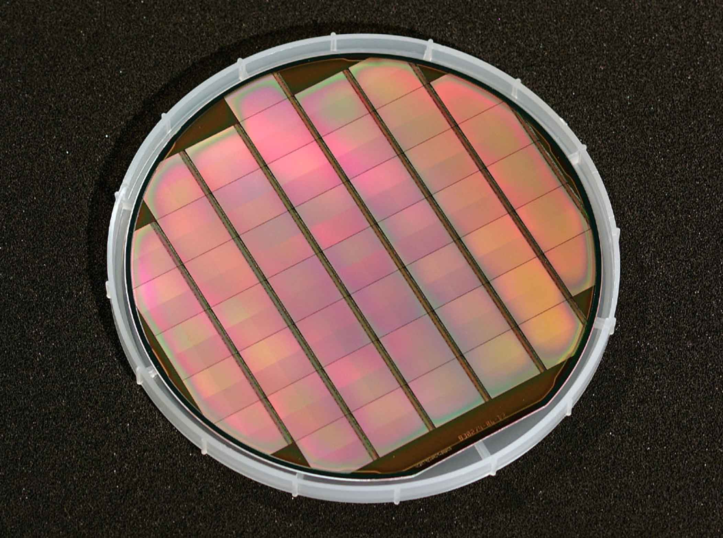
Figure 22: Wafer of reticle size sensors (left) and zoomed-in view of individual chips (right).
Table 7 shows how the measured performance of the MIMOSA-5 sensors compare to the specifications of the HFT detector for STAR.
Most of the requirements (granularity, radiation tolerance, thinning, read-out speed, power dissipation, and sensor size) are already satisfied with MIMOSA-5. Some effort is still needed to achieve a higher read-out speed and higher yield during thinning. Moreover, since the sensors will be operated at room temperature, special attention has to be given to the magnitude of the leakage current in order to keep the corresponding noise at an acceptable level. This issue has consequences for the read-out time and on the choice of the fabrication technology.

Parameter | HFT specifications | MIMOSA-5 performance
Detection efficiency | > 98 % at 30 – 40° C | ~99 % ≤ 20° C
Single point resolution | 10 μm | ~2 μm
Granularity (pixel pitch) | 30 μm | 17 μm
Read-out time | 4 – 10 ms | 24 ms (< 20 ms possible)
Ionizing radiation tolerance | 2.6 kRad/yr | > 100 kRad
Fluence tolerance | 2⋅10¹⁰ n_{eq}/cm² | ≤ 10¹² n_{eq}/cm²
Power dissipation | < 100 mW/cm² | ~10 mW/cm²
Chip size | ~2 x 2 cm² | 1.9 x 1.7 cm²
Chip thickness | ∼50 μm | 120 μm
Table 7: Comparison between MIMOSA-5 characteristics and HFT specifications.

MIMOSTAR-1 Sensor Design
Based on the results of MIMOSA-5, a new chip has been fabricated. It is called MIMOSTAR-1. It’s most significant design parameters are summarized below:

- Fabrication process: TSMC 0.25 μm (digital option).
- Pixel pitch: 30 μm.
- Pixel array: 640 x 640, i.e. active area of 19. 2x19.2 mm².
- Side band devoted to FEE: ~1.5–1.7 mm wide.
- Chip dimension: ~21x20 mm².
- Additional details can be found in Ref. [].

Since the read-out speed requirement is not very demanding, the chip’s architecture is based on relatively slow signal processing at the pixel level. This feature favors moderately low noise and modest power consumption. On the other hand, high speed signal processing is needed at the chip level (i.e. after amplification and multiplexing) due to the need for short integration times and limited shot noise. In order to achieve these goals, the chip is subdivided into 10 groups of 64x640 pixels. Each group is split into two equal size sub-groups, and each of these sub-groups is connected to a common amplifier which is placed on the outer edge of the chip. The 2x10 amplifiers operate in parallel in order to achieve a pixel read-out frequency of 2.5 MHz. A fast multiplexer, driven at a frequency of 50 MHz, will receive the outputs of each of the 10 groups. Therefore, the chip read-out time is approximately 8 ms.
A more ambitious version of the chip is under consideration, where the read-out and multiplexing frequencies are 5 and 100 MHz respectively, thus allowing us to readout the chip in only 4 ms.
The chip is foreseen to include JTAG based remote control functionality (e.g. bias setting, test settings, etc.). The power dissipation of this architecture is estimated to be slightly more than 50 mW (i.e. less than 15 mW/cm²) which can easily be cooled with air flow.
At the time of writing this proposal, the MIMOSTAR-1 chips have been fabricated in Strasbourg. The specifications used to design the chip are shown in Appendix I – MIMOSTAR Specifications and a detailed guide to using the chip has been completed and is included in Appendix II – MIMOSTAR Users Guide. The testing of the chip’s performance parameters is not yet complete but so far the Strasbourg group has shown that the chip responds well to a high radiation dose (0 to 24 kRad using a ⁶⁰Co source), that the conventional controls work (via the JTAG controller), and that the bias circuits work and exhibit linear response via their DACs. Finally, the analogue performance of the chips has been tested and the gain on the pre-amplifiers is about 3.5 at the two 10 MHz outputs. The next step will be to test each pixel on the sensor, but this process has not yet begun.
We plan to learn from the MIMOSTAR-1 architecture and this will be the final prototype run before trying to produce the actual chips to be used in the HFT. These chips will be called MIMOSTAR-2 and a test production run for these chips is scheduled for the end of 2005 or early 2006.
Meanwhile, several fabrication processes will be explored, aiming to find the process providing the smallest leakage current. In general, several parameters underlying the sensor performance parameters depend on features specific to each fabrication process and so the process specific characteristics of the chips need to be explored in parallel with the development of the chip architecture. For instance, a new fabrication technology, relying on a lightly doped substrate but exhibiting no epitaxial layer was investigated with two different prototypes chips. The IReS tests show that a detection efficiency of 99.9% can be achieved, as well as a single point resolution of about 2.5 μm. A major advantage of this technology is that a large signal can be generated because the charges are collected from several tens of microns of Si instead of from 10 or 14 microns in an epi layer. This makes it well suited to applications where one has to cope with substantial electronic noise generated in the pixel.

Thinning
Up to now, MIMOSA-5 chips have been thinned down to 120 μm thickness. This operation is successful and we have not found any degradation of the sensor parameters. The desired MIMOSTAR thickness is ~50 μm. Thinning a 6 or 8 inch wafer down to this thickness is not expected to be an issue since the process is an industry standard technique. We have demonstrated that 50 µm sensors are mechanically stable and can be assembled into ladders. We plan to use MIMOSA-5 wafers to make these investigations and several companies will be contacted in order to demonstrate the required thinning.

Additional R&D
CMOS sensors have been developed in Strasbourg since 1999 for various applications, which range from vertex detectors for subatomic physics, to bio-medical imaging (e.g. beam monitoring for oncotherapy, dosimeters for brachyotherapy) and operational dosimetry (e.g. control of ambient radon and neutron radiation levels in nuclear plants).
Several application domains call for SoCs providing fast read-out speed (meaning signal treatment and data flow reduction integrated on the chip), high radiation tolerance, minimal material budget and low power dissipation. Developments for the STAR upgrade will thus benefit from the synergy with the R&D for other applications, in terms of fabrication process exploration, development of fast signal processing architectures, radiation tolerance investigations and improvements. More information on the activities and achievements of the Strasbourg research team are available in Ref. [].
Starting with a IReS design, the LBNL/UCI group has built several generations of APS sensors. These devices were built in the 0.25 µm process at TSMC. These ICs have been tested using ⁵⁵Fe, 1.5 GeV electrons and in a scanning electron microscope.
Our measurements have confirmed the IReS results that APS sensors can measure charged particles with excellent spatial resolution,. They confirm much of the work that the IReS group obtained. Figure 1A shows several 1.5 GeV electrons recorded at LBNL’s Advanced Light Source.
To study, the effects of radiation, we exposed the chips to protons at LBNL’s 88” Cyclotron. Afterwards, we measured the change in leakage current and pulse height. These results show that there was a modest change with an irradiation of 300 krad. What was most interesting is that after 6 months, the device self annealed. Therefore, the effect of gradual radiation is much less than that of an acute exposure. These radiation measurements are complementary to the neutron exposures measured by the IReS group.
We completed a study on the effect of varying the pixel pitch. We built and tested a sensor with 5, 10, 20 and 30 µm spacing. Our tests show that to first order the charge collection was identical when comparing the central pixel to the charge collected on its neighbors. As the pixel spacing decreases, more total charge is collected. This observation can be explained by the fact that as pixel spacing becomes smaller, the charge is collected by the diode faster, so there is less time for it to recombine. This result implies that we can easily extrapolate our measurements at 20 µm spacing to the selected spacing of 30 µm for Mimostar.
While the current design of Mimostar is suitable for this proposal, our group has been looking at several techniques for a next generation detector. It is clearly desirable to speed up the readout and reduce the signal spread.
We can increase the fraction of charge collected by a single pixel using the photo-gate technology. In principle, this technology allows to use a large area photo-gate for charge collection while not increasing the capacitance because the charge is collected through a small size gate. Even though we have demonstrated the sensitivity of the photo-gate structure to X-rays, we have not achieved the expected performances. The transfer time required for moving electrons from the photo-gate to the drain appears to be very long (several ms). We believe this undesirable signal delay is probably consistent with surface traps at the Si0₂ silicon boundary. Studies to find a way to avoid this delay are in a SBIR proposal that is currently being considered.
Correlated double sampling (CDS) is a standard technique that is used to remove the fixed pattern noise introduced by the reset transistor. Its main drawback is to require reading out at least two frames, hence doubling the power consumption. To avoid doing CDS, we have produced a clamp circuit that reduces the reset noise by a factor of 3.
Two generations of “active reset chips” have been fabricated and tested. In this approach the pixel voltage is reset to the empty level with a feed back amplifier potentially reducing fixed pattern noise and the KTC noise associated with a passive reset switch. Preliminary testing shows some noise reduction, but not the full potential improvement. We will be making some changes to this circuit and fabricating this in a new sensor design.
To explore how charge is collected on a sensor as a function of position, we tested a device at LBNL’s National Center for Electron Microscopy. Using the scanning electron microscope, we have been able to position the beam on a pixel with precision of about 1 µm. This allows us to explore algorithms for determining the position of an incoming particle by relating how charge is shared on neighboring pixels. The results show that we can easily obtain the position of the incoming electron by weighting the charge collected from nearby pixels
We have also been collaborating with colleagues at UC San Diego on the suitability of using an APS sensor in an electron microscope. We have been studying the response of electrons from energies of 100 keV to 300 keV. Results show that single electrons can be detected with a good single to noise ratio. This technique is well suited for this application overcoming problems with traditional CCDs that suffer radiation damage. Using APS devices are very appealing for this different type of application.
We have several ideas on how to make a better device. We have fabricated a sensor with different diode sizes. We plan to study this device and understand the effect of diode size on signal to noise. We will be soon submitting an IC design without an epi-layer. Simulations show that we should be able to collect more charge from the process. In addition, we are studying ways to reduce the sampling time. In the current MimosaSTAR design, the sensor is always sensitive to radiation. We will study a sample and hold circuit to see if we can reduce the sensitivity.
These new APS designs are promising but speculative. These R&D studies will be done concurrently with the construction of the HFT detector. If any of these ideas leads to significant improvements, then they can be added to a second-generation vertex detector.

Data Acquisition

Requirements
The data acquisition is designed to read out the very large body of data from the individual sensors, to digitize the signals, to perform data compression, and to deliver the sparsified data for event building and taping. A summary of the requirements is provided in Table 8.

Total number of pixels | 98*10⁶
Number of pixels per chip | 640*640
Pixel Readout rate | 100 ns (10MHz)
Readout time per frame | 4 ms
Dynamic range of ADC | 10 bits
Raw data from one sensor using a 10 bit ADC | 1 Gbit/sec
Fixed pattern noise | 2000 e⁻
Noise after Correlated Double Sampling | 10 e⁻
Maximum signal | 900 e⁻
Dynamic range after Correlated Double Sampling | 8 bits
Total power consumption | 90 W
Table 8: Requirement Summary: constraints for the APS, due to signal expectation, available design process, and mechanics
Digitizing the analog signal on each pixel into 10 bit digital signal yields 1 GBit/sec per sensor chip when reading out in 4 ms. This number becomes 240 GBit/sec when multiplying by the number of chips equipping the whole HFT. This volume of data must be reduced before being handled by the STAR DAQ event builder and written to tape.
Data compression is achieved by performing correlated double sampling (CDS) and then leakage current subtraction, i.e. subtraction of two consecutive frames, then the subtraction of the pedestal, followed by zero suppression. CDS cancels out fix pattern and reset noises and reduces 1/f noise. The fixed pattern noise corresponds to the spread of the baseline voltage in all pixels. It has been measured on the MIMOSA5 chip to be 2000 electrons. The noise remaining after CDS must be on the order of 10 e⁻ to guarantee an efficiency of greater than 99%. The maximum signal is estimated from dE/dx calculation and by measuring how charge spreads over pixels. The signal can be truncated above 900 e⁻ without compromising either the efficiency or the position resolution, so 8 bits is a sufficient dynamic range for signal storage. The use of forced air cooling limits the total power dissipation to about 100 mW/cm².

Architecture
A sketch of the readout architecture is shown in Figure 23. Reading all sensors in parallel, the DAQ system must handle data rates of about 240 Gbits/. The bottleneck of the low-level DAQ, is the data path from the sensors to the end of the ladder where Readout Transceiver PC Boards (RTB) interface to the STARDAQ via high speed optical links.
Each sensor will be read out by a custom designed read-out chip that is mounted together with the sensor on the ladder. This solution has the disadvantage of doubling the thickness of the silicon and of increasing the power dissipation on the ladder. These disadvantages are fully compensated by the fact that we will not need long analog signal lines to the end of the ladder. Multiple parallel analogue outputs from the detector chips are wire bonded directly to the RDO chips. A serial digital network (~500 Mbit/sec) connects the read-out chips to the RTB boards.
8 bits are necessary to store the signal after CDS is performed. Zero suppression requires subtracting a pedestal from each pixel. This can be directly followed by cluster finding. Applying this kind of algorithm ensures the most efficient compression but at the risk of compromising the data quality if the threshold setting and cluster finding are not well optimized. On the other hand, a lossless Huffman encoding may be applied to the data. Serial acquisition allows online computation of a data entropy table. This allows assigning an optimal length prefix-free symbol for each value before transmitting it over the readout network significantly reducing the needed bandwidth.
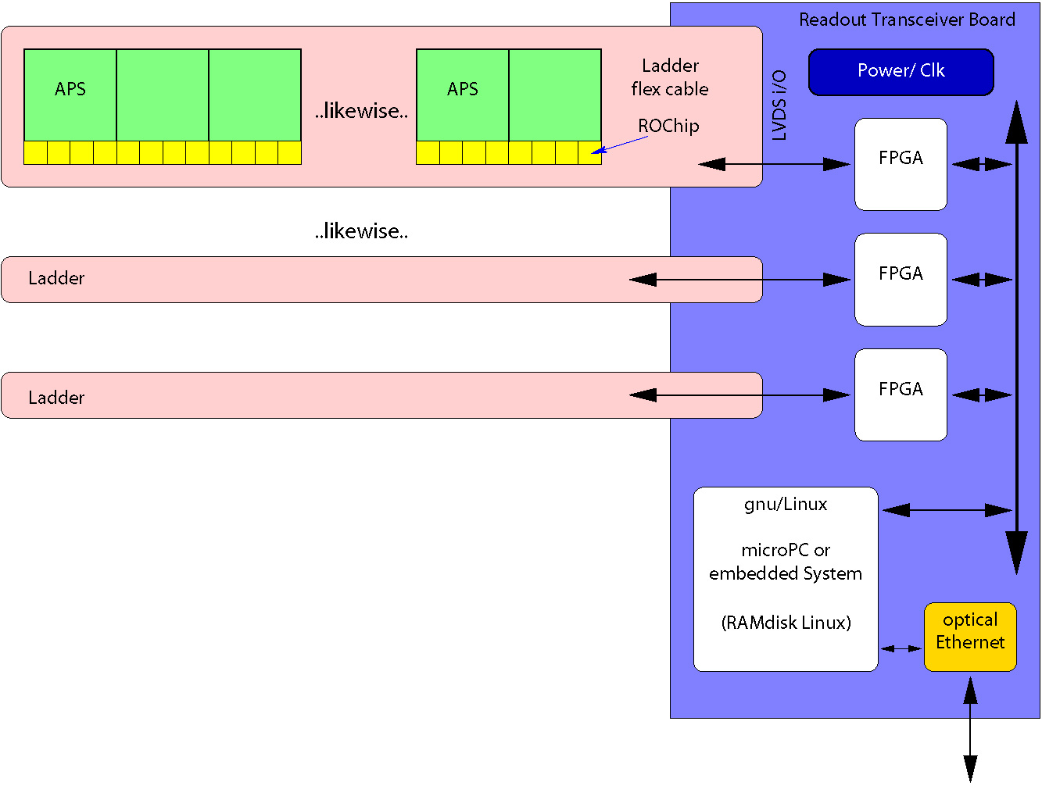
Figure 23: DAQ Layout: schematic of DAQ system. Depending on effective data rate, multiple ladders can be combined to one optical link. Using PCI and gnu/Linux, allows flexible and transparent access to complex test setups while minimizing changes from prototype to the final detector.
The data processing steps are being developed in a modular fashion so that they can later be configured to a complete readout-system of: digitization, data (pre)processing, (de)compression, data transmission and DAQ control. This modular approach permits DAQ modules to be configured in hardware (custom ASIC or FPGA) and/or software located on on-board PCs.

Readout Chip
A schematic diagram of the readout chip is shown in Figure 24. The chip contains 3 ADCs, which digitize in parallel and are located close to the sensors to minimize noise and crosstalk pickup. It also includes logic to control the acquisition and buffer data. Adding memory (RAM) to the ROChip may allow data preprocessing (CDS), transcoding and compression algorithms, before transmitting the data over the ladder-cable.
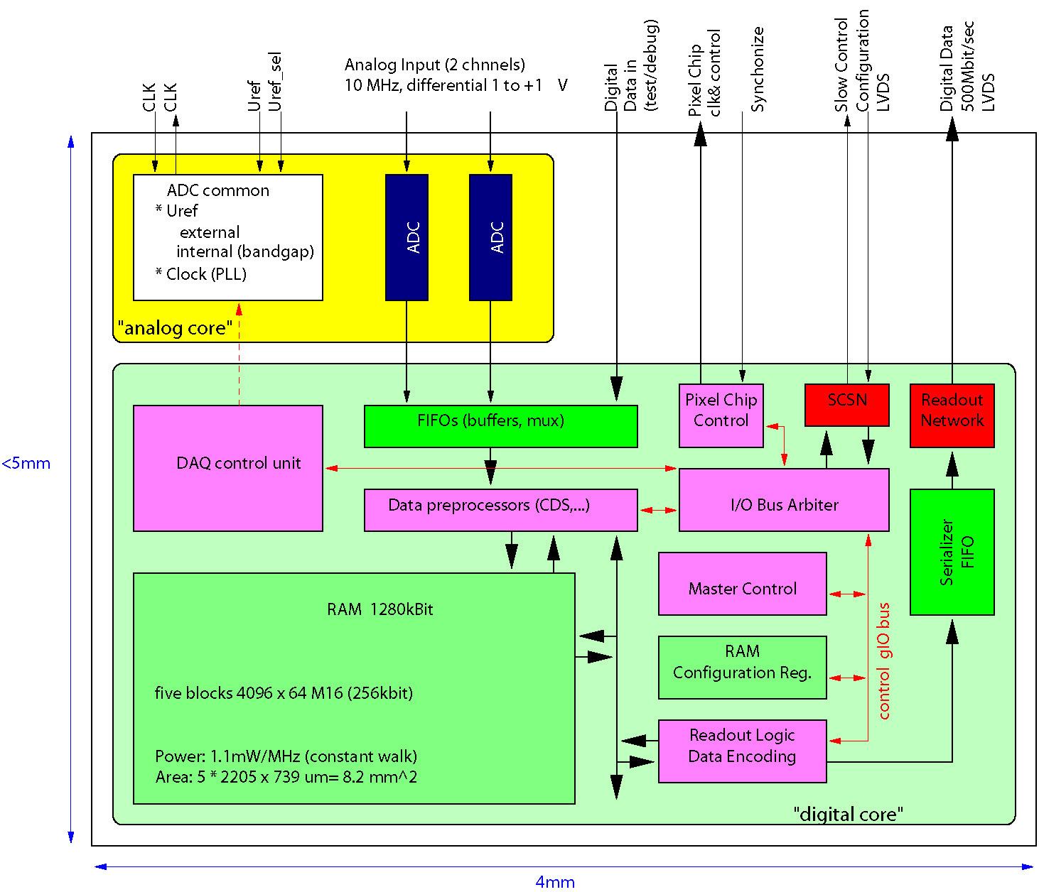
Figure 24: ROC block diagram: preliminary schematic/floor-plan of readout chip. Internal design is subject to recent development.
The readout chip is bonded to the sensor chip. Its task is to digitize the signal and either transfer it directly to the end of the ladder, or further apply compression schemes before transferring the data. Since power dissipation depends directly on speed, the main logic will operate as slow as appropriate, i.e. at 10MHz. ADCs need to get 12 times this frequency (pipelined ADC). ADC design process and ASIC design flow available to us through the university of Heidelberg lead us to using the UMC L18 (.18 μm) mixed mode process. Chip-geometry aspect-ratio limitations, require using 54 ROChips per APS and 2 ADCs per ROC in a smaller than 4x5 mm package as shown schematically in Figure 25.
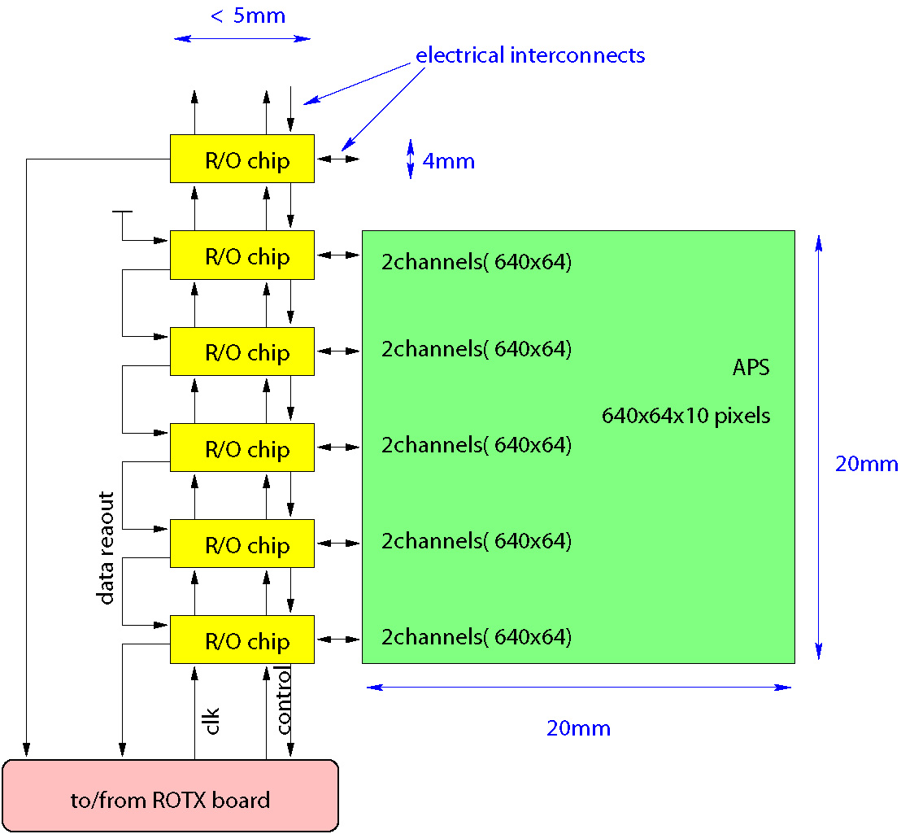
Figure 25: Readout Layout: schematic sketch of the readout-topology on a detector ladder. This figure shows one of ten APS and the corresponding readout chip layout. You can likewise add more APS chips. (Note: this plot does not aim to be a complete view of the interfaces. The readout chips will be mounted piggy-back on the APS.)
To perform CDS and pedestal subtraction, each readout chip needs to have at least 160 kbyte of memory (4Mbit per APS, 54 ROC per APS). RAM blocks in UMC technology: 4096 x 64 M16 (256kbit) - 2205x739 μm – 1107 μW/MHz. Static memory consumes no power when unused, which drives optimization effort on RAM access algorithms.

Data Synchronization
The readout of the HFT is continuous, i.e. it is not triggered. It will enter the STAR DAQ as a separate sequential data stream. Synchronization with the individually triggered events will be done by assigning a RHIC clock time stamp to each HFT readout frame.
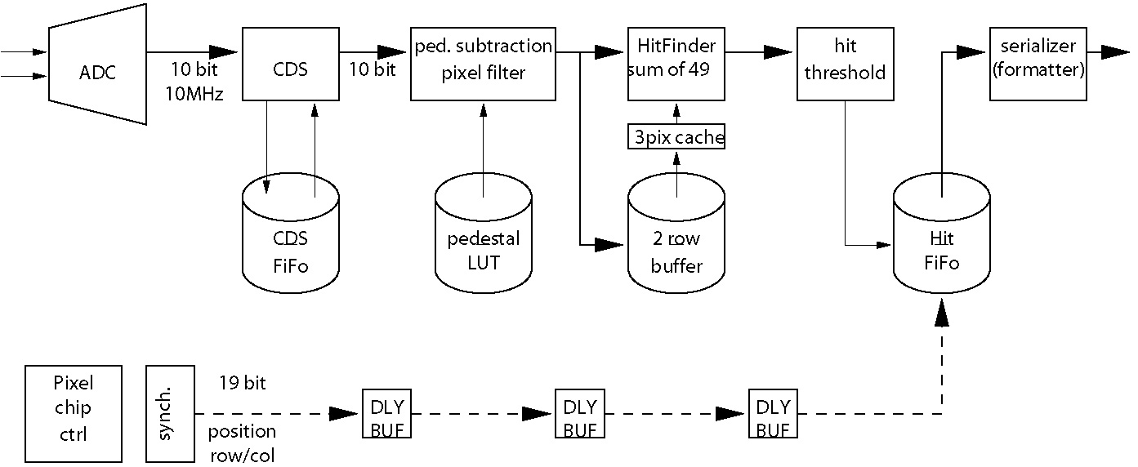
Figure 26: Data flow and processing stages in the readout chip. Each stage can be bypassed to allow raw/unprocessed data to be routed through the DAQ.

Alternate Read-out Strategy
As a fall-back solution for the custom designed read-out chip we are developing a cable that brings the analog outputs of the sensors to an area where the available volume is large enough to implement the functionality of the read-out chip and the RTB boards in discrete technology. A technology choice will be made in Spring of 2006.

Integration with the Experiment

Mechanical Introduction
Our simulations have shown that for D identification in the high track density environment encountered in Au+Au collisions, it is imperative to minimize the scattering thickness of the beam pipe and the first detection layer. This requirement has been the primary driver of the current design. By using the APS technology we can use thinned silicon with modest connection requirements to minimize the support electronics and cable requirements. In addition, the low power nature of these devices allows a mechanical design that is air cooled which helps to minimize scattering material in the track path. Several conceptual designs have been considered. We present the design that is currently the focus of our investigations.
In recognition of difficulties encountered in a variety of experiments, we are adopting design requirements for rapid insertion and removal of the vertex detector, rapid calibration and calibration transfer and multiple detector copies. It is felt that by addressing these issues early in the design cycle the requirements can be met without major cost impact.
Our mechanical design makes significant use of carbon composite material which has nearly the same radiation length as beryllium. This allows us to take advantage of the extensive carbon composite work going on at LBNL for the ATLAS pixel detector. In our development work with carbon composites we are maintaining a close relationship with the LBNL engineering and technician staff working on the ATLAS pixel project. This should be a significant advantage when we move into the production phase of the project.
Since the design of the original STAR detector system there has been significant progress in tools available for mechanical work. Very powerful low cost 3D CAD programs are now available which allow complex modeling with moving parts and direct interfacing to CNC machines and rapid prototyping. These tools provide the means to tackle the more complex mechanical designs required for rapid insertion and alignment. The tools are much easier to learn than older software, but because of their newness, there is still have a limited base of users available to us. The R&D effort to develop fabrication and fixturing methods is allowing us to gain the required expertise with these new tools.
The design to be reported is a conceptual design which we have started to evaluate with test structures, detector carrier support elements, and digitizing and readout electronics boards.

Support Carriage for Rapid Installation and Removal
A conceptual design has been developed for the support carriage that will permit rapid insertion and removal without moving other detector components. This system is shown in Figure 27 as it will be positioned for operation in the STAR detector system. The HFT is the small inner detector in the center. It is shown positioned inside the SVT detector (half of which is removed so that the HFT is visible). Alternative outer tracking detectors could be installed in place of the SVT. As shown, the mechanical support and electronic service for the HFT is located on one end only. The light weight guide track and support bridge are permanent elements of the HFT design. The illustrated detector system permits rapid removal and replacement while maintaining reproducible position through the use of fully defined kinematic mounts.
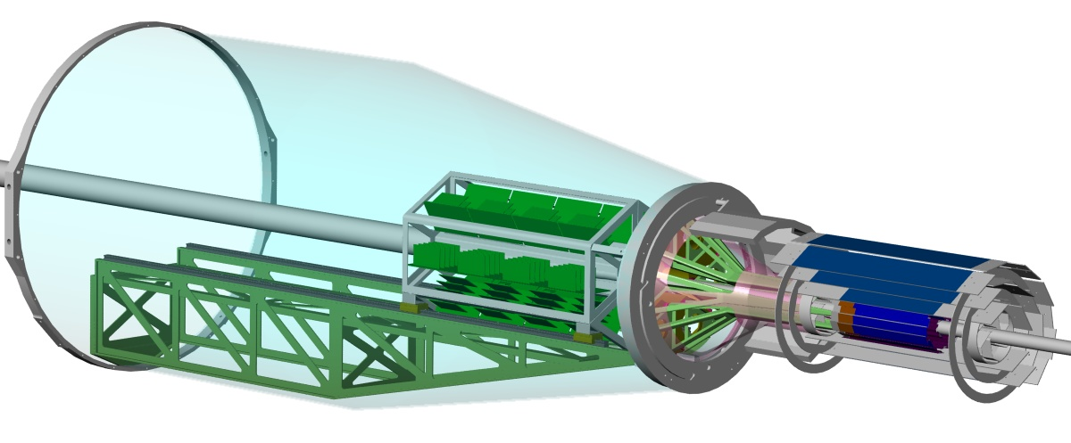
Figure 27: The HFT is shown integrated with the STAR inner detectors cone assembly.
For simplicity several existing STAR structures are not shown. One of the cone supports that is integral to the support of the SVT and the SSD is not shown and the SSD which provides an additional tracking layer outside the SVT is not shown.
A close up view, Figure 28, shows the HFT ladder arrangement. There are two tracking layers: one starting at 1.5 cm radius and the other starting at 4.5 cm radius. The ladder design shown consists of a single thin gull shaped carbon fiber beam with a flex PC cable plus multiple thinned silicon APS detector chips. Other two layer carbon fiber laminates are also being developed which are simpler to construct but pose additional challenges in mechanical integration.

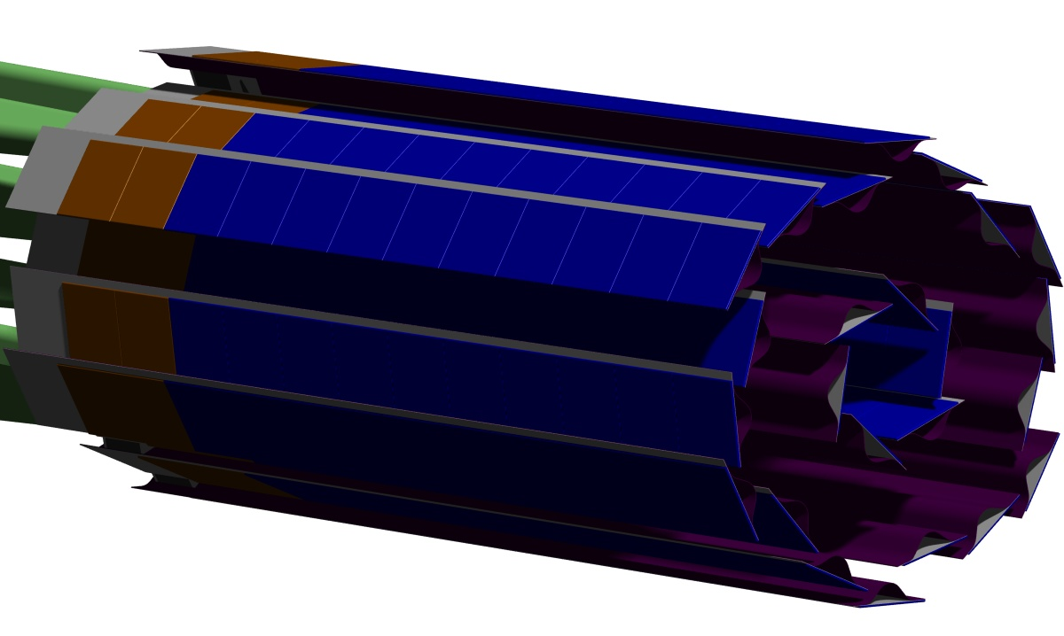
Figure 28: Close up view of the HFT ladders.
The detector support structure illustrated in Figure 29 shows elements of the kinematic position control assembly. The detector ladders are arranged in 6 modules with 3 outer layer ladders and 1 inner ladder on each module. The module is supported on a long structure, shown in green. The long green structure allows stable support of the ladder while avoiding contact with cabling and outer structures that are part of the SVT system. The brass colored structures provide common tie points for coupling the detector system in a reproducible manner. A more detailed view of this support system appears in Figure 30 showing the three identical frames (brass colored) that are kinematically joined around the beam pipe using ball on cylinder contacts.

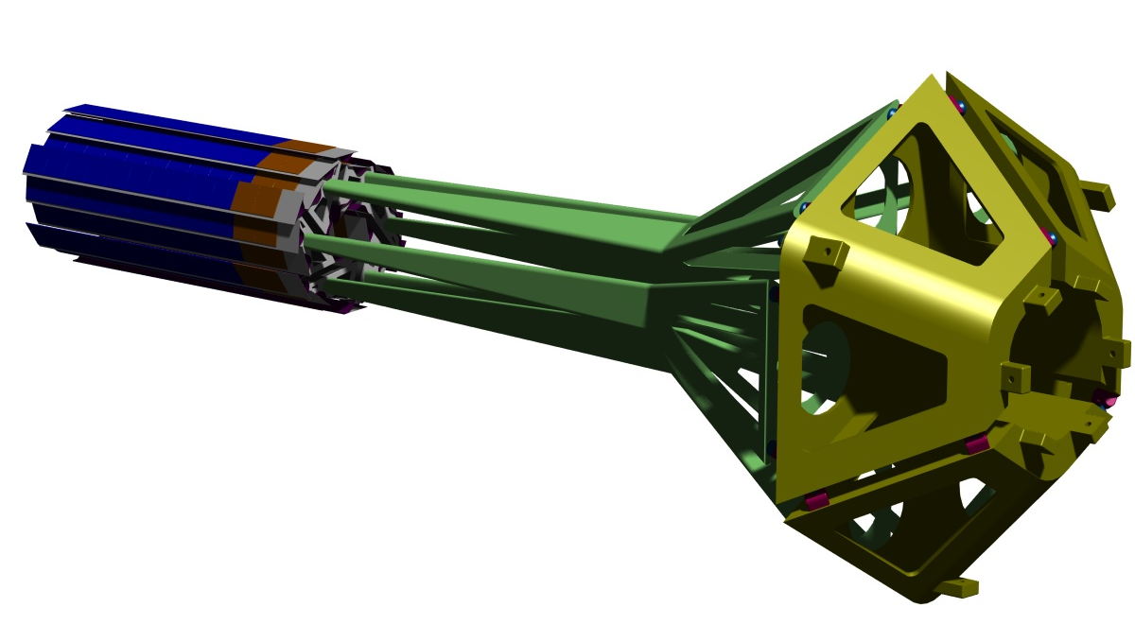
Figure 29: Detector support structure with kinematic mounts to insure repeatable detector positioning.
The system provides three point kinematic mounts for each of the detector module stalks. This allows opening of the ladders to pass over the large radius region of the beam pipe during detector insertion and removal. The three multi coupling structures are joined with each other (a total of 6 contact points joining the three structures) again providing a defined reproducible assembly in lockdown while allowing separation for disassembly from around the beam pipe. Finally there is an additional 3 point kinematic mount on the 3 fold multi coupler to lock it to the STAR support cone. All the contacts use commercially available ball on cylinder pairs. Releasable capture mechanisms are required to load the kinematic mounts. These devices are not shown in the illustrations.
The common tie point joining the HFT detector system to the STAR support cone is illustrated in Figure 31. The blue grey piece is the final common tie point for critical mating parts. It supports the beam pipe wheel structure, the kinematic detector frame, the roll in rails and joins the HFT detector assembly as a whole to the existing STAR support cone. This design will allow preassembly and testing of the critical matching pieces prior to final installation into the STAR system. The final installation requires simply securing the blue grey piece to the STAR support cone using existing bolt holes. Note, the card barrel is loosely coupled to the detector cluster giving freedom for the kinematic mount to define final precision positioning.
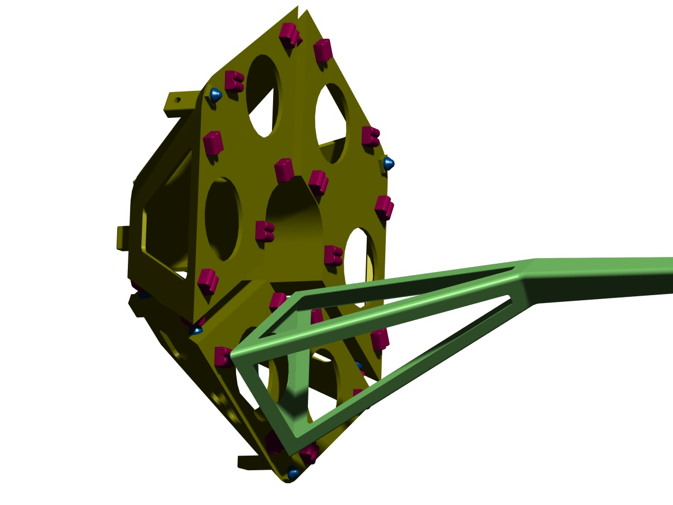
Figure 30: Kinematic mount structure.
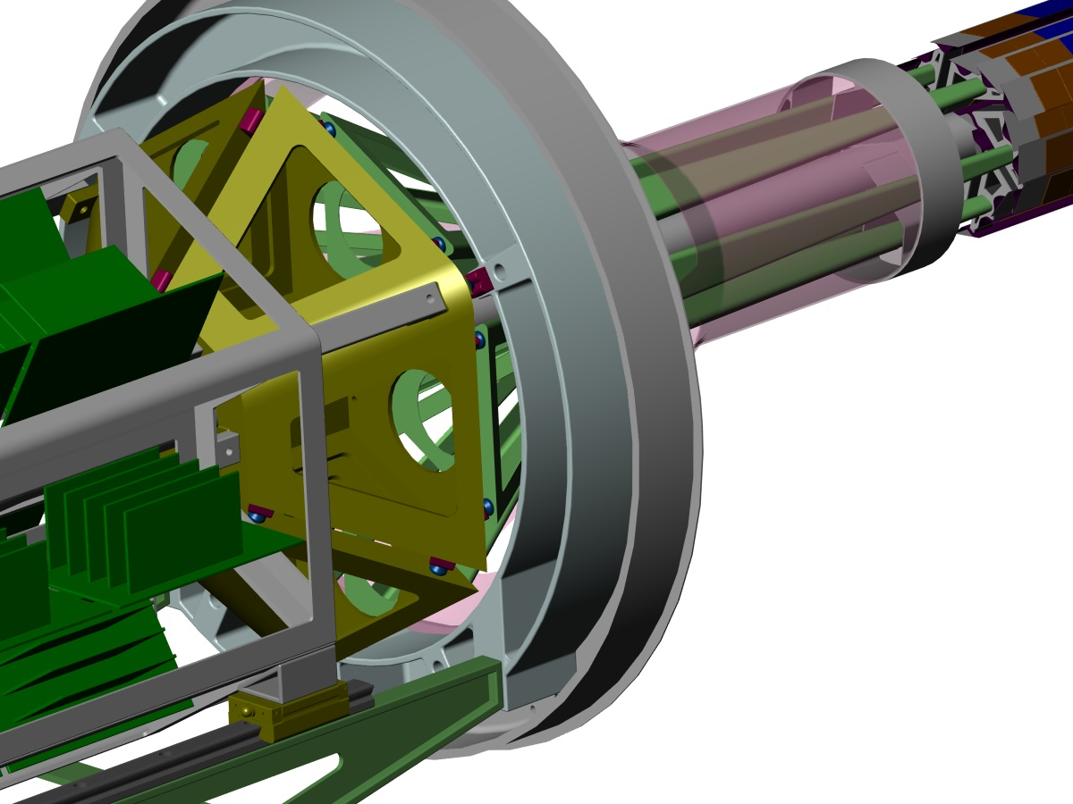
Figure 31: Precision tie points coupling the HFT system to the STAR support cone

Note, this is an on going development. The illustrations represent the current state of our 3D CAD model which is being used for evaluation and refinement

Position Alignment and Calibration
The required position resolution of 4 microns is a significant challenge for calibration and alignment. The detector system being small permits a design with a single kinematic support to define a reproducible position centered in the STAR system. With the proposed mechanical design the detector system can be moved as a unit between the visual coordinate measuring system and the docking support in the STAR experiment without disturbing the relative HFT ladder positions. The brass colored structures shown in Figure 30 can be separated and reassembled with out changing their relative alignment. This opening of the structure is necessary both for installation around the beam pipe and for visually accessing the inner layer detector surfaces with the visual coordinate measuring machine. The detector silicon will be patterned with a fiducial grid in the top aluminum connection layer (see Figure 33). This fine grained grid will be mapped in 3D with the visual coordinate measuring machine.
The pixel to pixel mapping will be preserved through transfer and docking in the middle of the STAR detector system. The calibration burden by track matching will be limited to determining the 6 parameters defining the location of the vertex detector unit within the other STAR detectors. It is expected that success of this approach will require careful temperature control. Further analysis and measurements will quantify this requirement.

Ladder Design and Fabrication
One of the ladder designs currently under evaluation is shown in Figure 32. This structure must be stiff enough to be supported on one end only and maintain reliable position stability to 4 microns. The ladder is made up of a 150 micron two ply carbon composite open beam which is closed with the detector sandwich to make a rigid structure. The bottom layer of the detector sandwich is an aluminum kapton cable. The thinned, 50 micron readout chip is bonded to the cable and the detector chip is bonded on top with the active side. These components are staggered as shown in the magnified view in Figure 33 to allow wire bonding between the elements. Since the number of connections is modest it is believed that wire bonding will suffice without need to resort to bump bonding. It was found with test structures that it is relatively straight forward to make wire bonds on these thinned devices where vacuum chucks maintain the sandwich as a flat firm surface. Alternate carrier designs are also being investigated.
A method to bond the silicon sandwich has been developed using DuPont Pyralux LF thermally activated acrylic sheet adhesive. Advantages of using sheet adhesive include fixed bondline thickness and ease of handling. Other bonding methods including low viscosity epoxies are also under investigation.
A complete ladder using silicon-sandwiches has not been produced but we have tested fabrication methods that are promising using a uni-layer silicon structure. We have used vacuum chuck fixturing to butt joint chips side by side against a straight edge and have then bonded them to kapton with Pyralux. This bonded structure was then bonded at room temperature to the carbon beam using Hysol EA9396 aerospace epoxy. 75 micron glass spacer beads were added to the epoxy for the initial test structure to control the bondline thickness. Prior to bonding, both the sandwich and carbon beam are quite flexible and their shape is defined during bonding with vacuum chucks.
A few µm protective polymer, Parylene, will be used to protect the exposed wire bonds and to control the spread of carbon dust. Parylene coating is process available in the electronics industry. The coating material is applied at the molecular level by a vacuum deposition process at ambient temperature. The thickness is well controlled and uniform without pin holes, so protection can be achieved without compromising detector thickness. Application at room temperature avoids introducing stresses that distort the ladder shape.
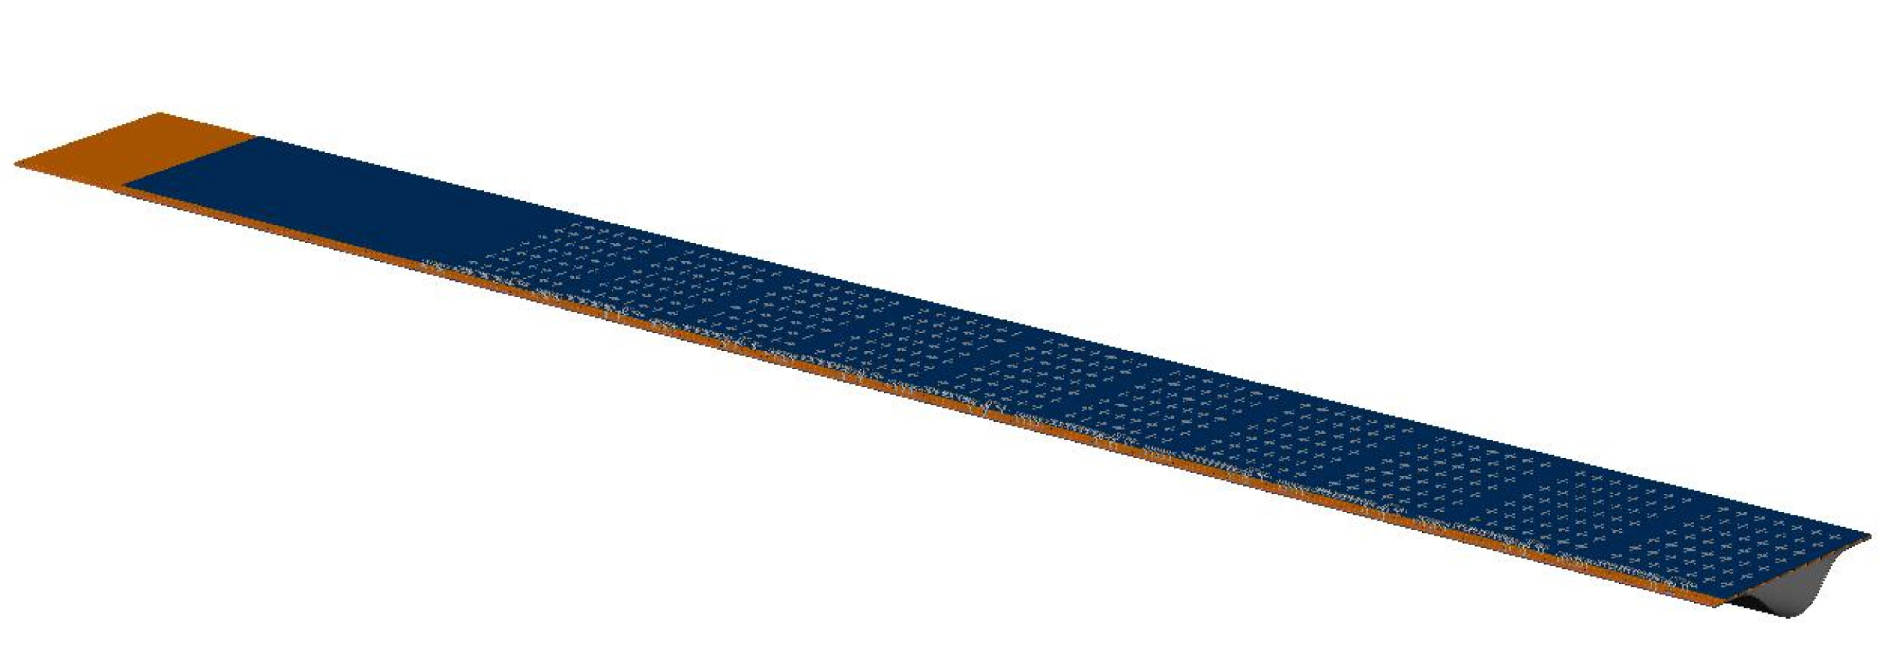
Figure 32: Ladder assembly. The current ladder is composed of a row of 10 thinned APS detector on top of a matching row of thinned readout chips and a three layer aluminum kapton cable. The silicon cable structure is bonded to a carbon composite v, closing the beam to make a rigid structure.

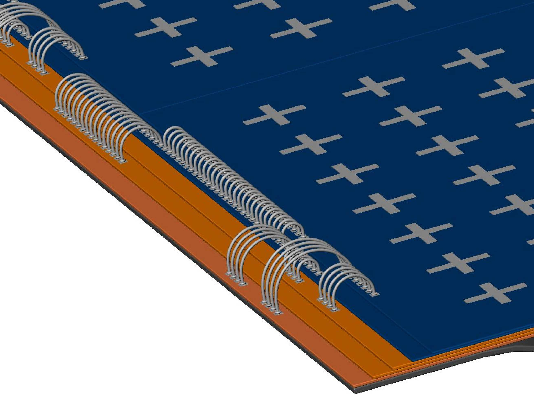
Figure 33: Close up view of the ladder showing APS detector chips mounted on top of the readout chip. The chips are mounted and wire bonded on a three layer aluminum kapton cable.

Detector Radiation Length
Multiple scattering in the beam pipe and the first inner layer of the vertex detector sets the ultimate limit in precision of vertex resolution. The radiation thickness for an inner ladder and the beam pipe is given in Table 9. The detector ladder is placed at an angle and is quite close to the interaction point so particles pass through the material at varying angles. This results in path length through the materials that is greater than the thickness. The average effective thickness is represented in the table.

Material | X₀ (cm) | Material thickness (μm) | % X₀
Beryllium beam pipe | 35 | 500 | 0.14
Aluminum | 9.0 | 10 | 0.007
Silicon | 9.4 | 112 | 0.12
Kapton | 35 | 170 | 0.05
Adhesive | 35 | 85 | 0.024
Carbon Composite | 28 | 174 | 0.062
Ladder Total |  | 550 | 0.26
Table 9: Materials in the beam pipe and the first detector layer with their radiation length fractions. For details see Ref. []

Ladder Mechanical Tests

Load Distortion Tests
Figure 34 and Figure 35 show a prototype of the ladder and detector carrier that we have built. The mechanical tests have shown that the stiffness and bending characteristics of the assembly are acceptable. For these and similar tests, the ladder’s mechanical structure was supported on one end and the surface contours were measured using the vision measuring machine at LBNL with and without a 10 gm end load. The deflection profile is shown in Figure 36 along with the calculated deflection for a simple triangular closed beam. The stiffness is within 20% of expectations from the engineering model. The measured fundamental frequency of the ladder is 140 Hz while the engineering model gives a resonant frequency of 135 Hz. We have also measured the vibrational environment at the STAR detector and it is dominated by low frequencies, ~1 Hz, and so we anticipate that the ladder will maintain its position to better than a few microns.

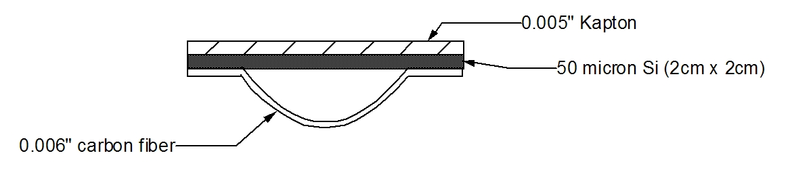
Figure 34: A cross-section of the prototype detector ladder showing its structure and materials composition.
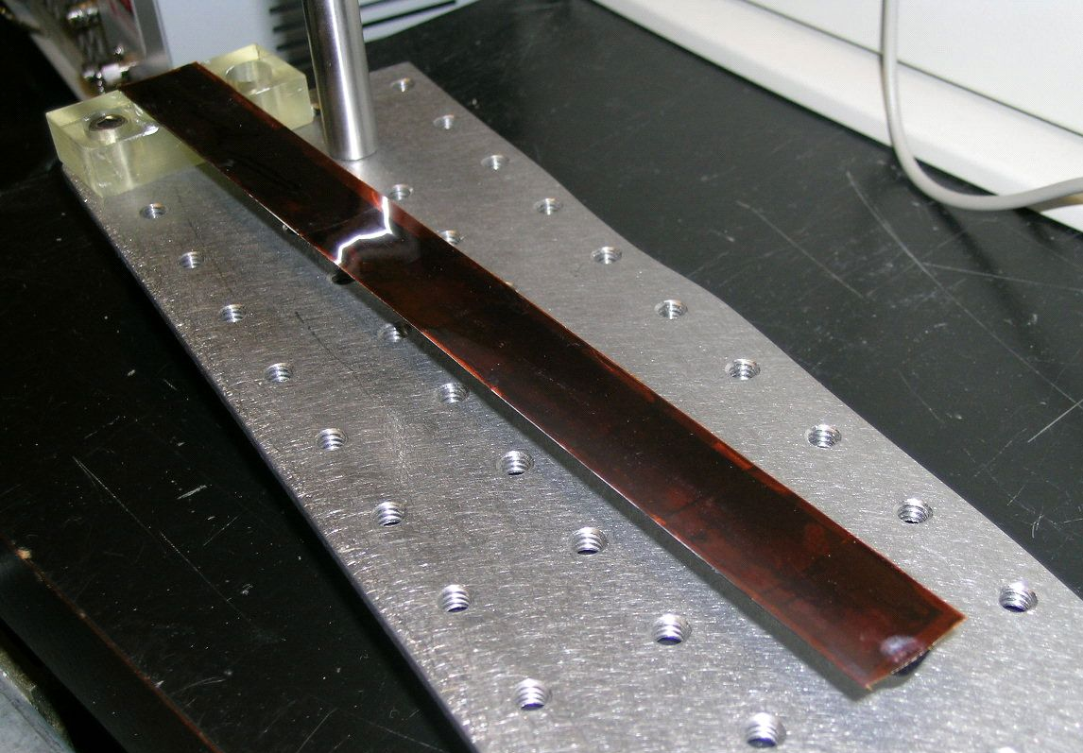
Figure 35: The prototype ladder on the testing apparatus.

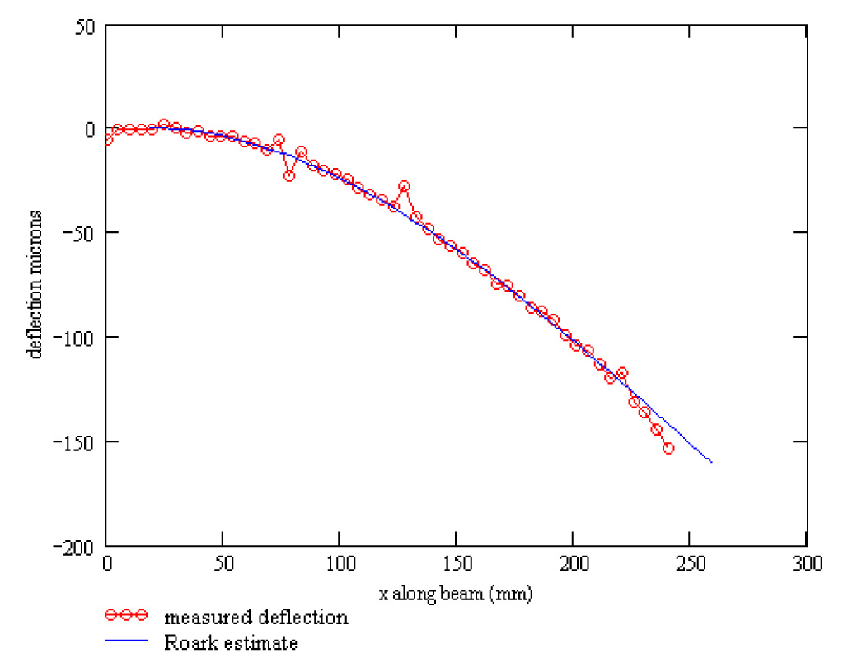
Figure 36: Measured bend of a silicon/carbon composite ladder test structure and the calculated bend shape. The ladder was rigidly supported at one end with a 10 gm weight placed on the other.

Thermal Distortion Tests
We are in the process of measuring thermal generated deflections using TV holography. This tool, available to us, courtesy of the ATLAS Pixel project, provides a rapid visual distortion map on the sub micron scale. This is proving to be a useful tool for identifying and understanding different design parameters. Measurements are done on structures thermally isolated in a transparent box (see Figure 37). This tool will also be used to test the stability of the final detector.

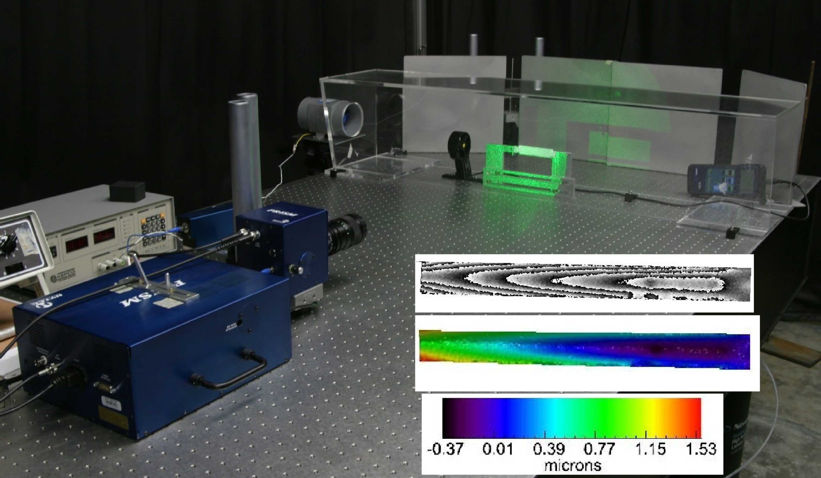
Figure 37: TV Holography system viewing test ladder in a small transparent wind tunnel. Inset shows diffraction pattern with color map of the surface displacement.

Cooling Measurements
In the interest of low mass, the detector system is being designed to use air cooling for the detector structure in the active tracking volume. A small wind tunnel has been constructed (see Figure 37) to evaluate the cooling capacity of air and the design of the system. Measurements with resistive heated ladder test structures and thermocouple readouts show that air velocities on the order of 1 m/s are sufficient to handle power levels of 150 mW/cm². This setup, with its thermal camera, will be used to check operating silicon-ladder-devices to evaluate localized heating issues. In addition to cooling tests the wind tunnel is being used to evaluate the vibration stability of the ladder design under the required wind flow conditions. The amplitude of cooling air driven vibrations in the ladder is measured with non-contact capacitive probes and if necessary specific vibration modes can be monitored with the TV holography system. The vibration induced by the air cooling gives an acceptable positional location σ of 1.6 µm. The low mass ladder structure is the critical design element requiring vibration testing, but the full detector structure will be evaluated with this system as well. Additional information on the cooling studies is available on the web.

Cabling
Connection to the detector readout chips will be done with an aluminum kapton cable with three conduction layers. A connection topology that does not require vias is shown in Figure 33 in which the bottom layer carries analog and digital power. The mid layer carries dedicated data lines, control lines and reference voltages. Common lines are daisy chained through the silicon chips to avoid crossovers in the aluminum flex PC cable. The top layer carries analog and digital grounds. The power and ground layers are patterned to reduce conductor material. We have recently found a commercial vendor that makes aluminum cables with vias so the concept illustrated above will probably not be necessary.
Fabrication tests have been done with 0.35 mil aluminum with 1 mil kapton plus two 1 mil acrylic adhesive layers. Wire bonding tests with this material have been successful, but development work is required to fabricate the staggered layer design illustrated in Figure 33. The issue to be addressed is having clean bonding pads on the three layers after cable fabrication.
Zero suppression or other data compression will be done locally, so that a small number of traces should be sufficient for each readout chip to carry the limited data load. This is key to minimizing the cable mass in the tracking path while leaving some design flexibility for readout speed and ladder length. The cable is part of the ladder and is located underneath the two thinned silicon chips, APS detector and readout chip.
Connections leaving the detector structure will be limited to power, fiber optic and possibly water cooling for data interface boards.
Figure 38 shows the prototype for a HFT readout cable. The prototype is an active cable with a buffer and differential amplifier for each sector of 10 MIMOSA detectors for use in testing the MIMOSA5 detectors. The final detector readout cable will not have the components shown but will narrower and will be sized to be slightly wider than the detectors themselves to allow wire bonding. The cable in the figure uses a copper conductor on a 25 µm Kapton insulator. The final cable will be a 4-layer low-mass aluminum conductor cable with a radiation length equivalent of 84 µm of Si. The prototype has been successfully tested and is working in our prototype ladder readout system.
Additional and more recent information on cable and ladder developments may be found on the web.
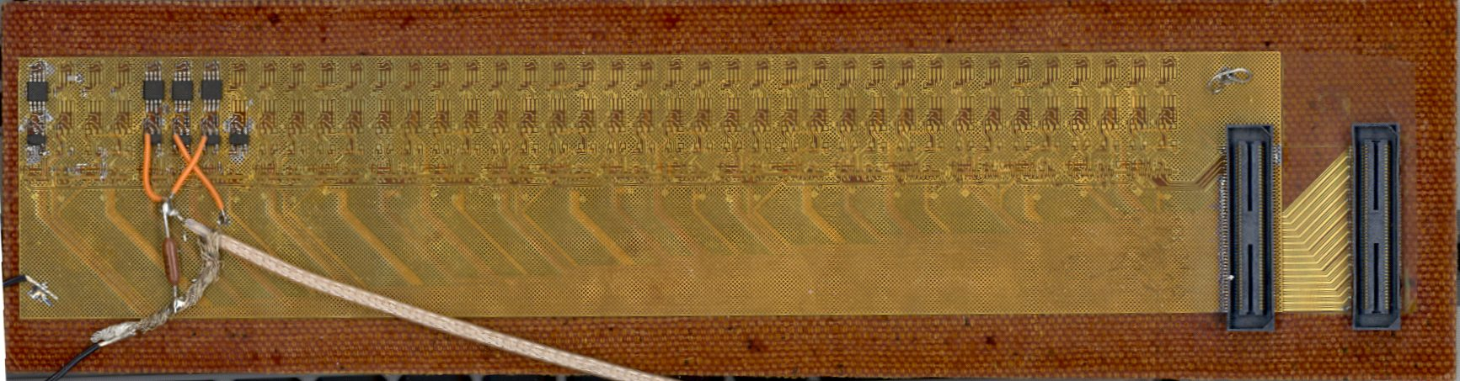
Figure 38: A prototype readout cable for the HFT.
Figure 39 shows a mechanical Prototype with 4 MIMOSA5 detectors glued to the kapton cable assembly with a thin acrylic film adhesive. The adhesive has a bond line of 50 µm. The MIMOSA is relatively flat in X but has a “dish” shape in Y. The magnitude of these distortions is, however, quite small. The largest deviation from a linear fit in Y is only ± 6 µm. This low rate of deformation will allow us to make a minimum number of measurements of the detector positions on the ladders in order to locate the individual pixel position to the required accuracy by a parameterized location function.

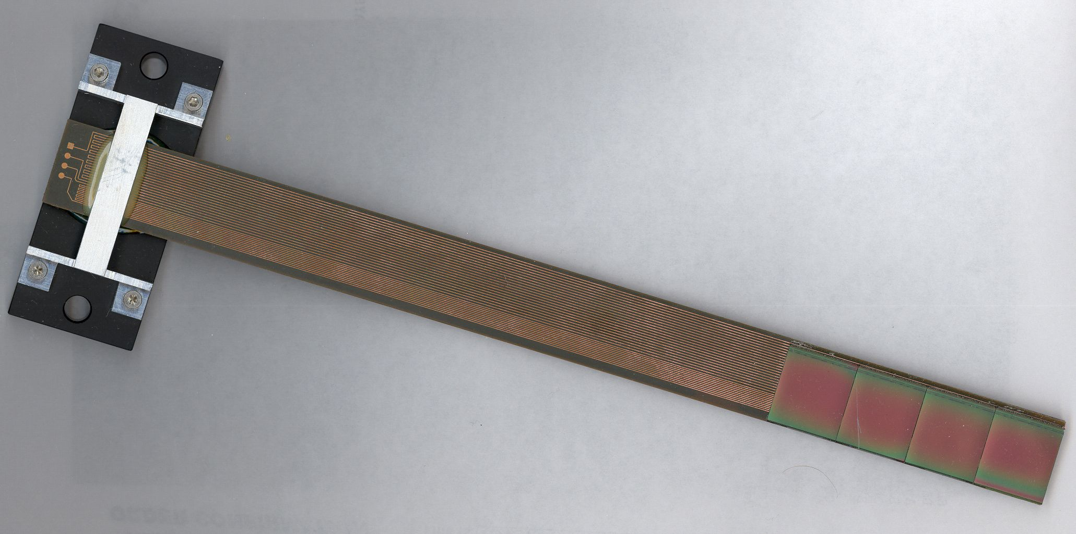
Figure 39: Mechanical Prototype with 4 MIMOSA5 detectors glued to the kapton cable assembly.

Beam Pipe
The vertex detector extends the measurement radius to 15 mm from the interaction axis and will require a new small radius beam pipe for STAR. The design concept for this pipe is shown in Figure 40.
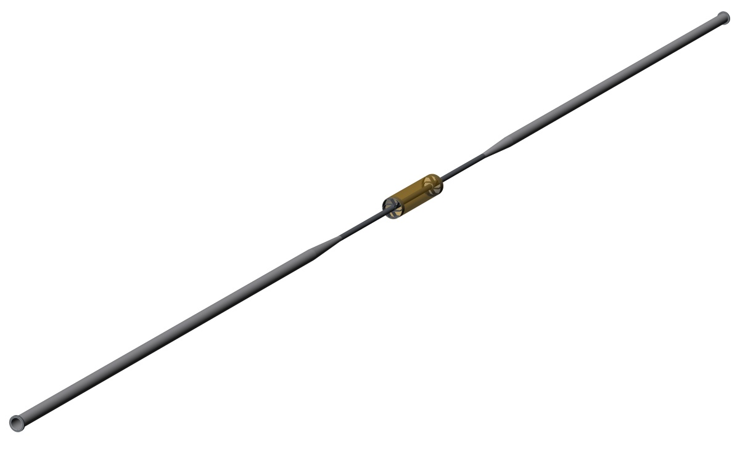
Figure 40: Beam pipe structure with outer support barrel in the center.
The beam pipe is constructed from 60 mm diameter aluminum tubes that taper down to a 29 mm diameter beryllium beam pipe with 1 mm thick walls. The central region where the HFT is located is a 29 mm diameter beryllium pipe with a 0.5 mm thick wall. An exoskeleton made up of an outer tube and the two spoked wheels carries the support load, isolating the thin central tube such that it only has to carry vacuum load. Central support of the beam pipe system against gravity is provided by securing the exoskeleton structure. The central portion with the exoskeleton structure is shown more clearly in Figure 41. The outer shell has been made transparent in the figure to show the inner structure.
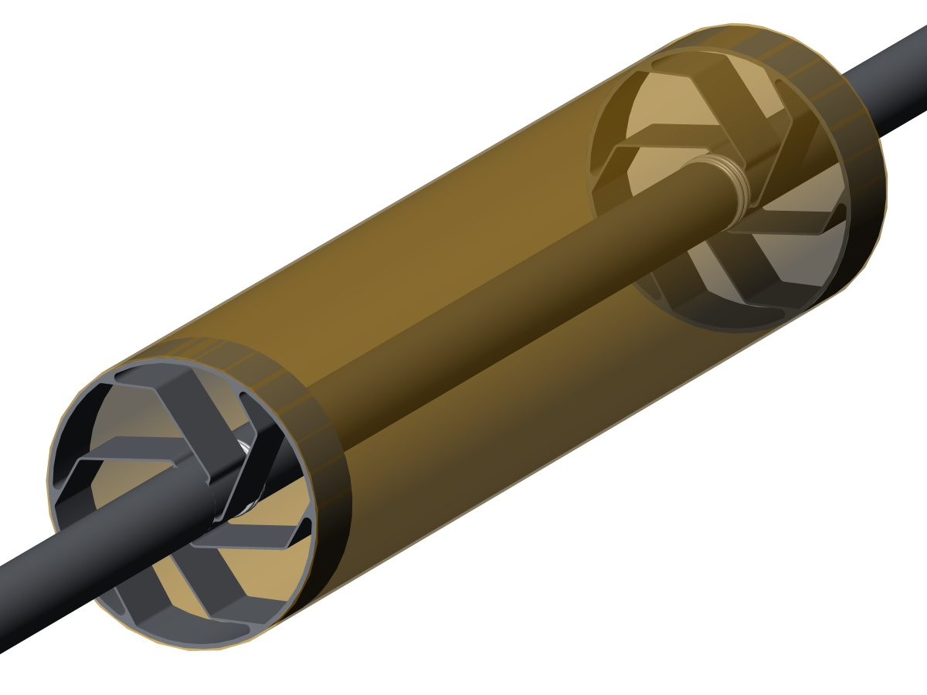
Figure 41: View of the beampipe mid-section.

Minimum Beam Pipe Radius Consistent with Injected Beam
We have chosen a minimum radius for the beam pipe, which now that the RHIC optics have stabilized, is reasonable conservative. From the standpoint of beam pipe interaction with beam optics, the beam pipe wall should, according to accelerator physicists, have a minimum radius of 6 σ while 10 σ is very conservative. σ is the beam envelope at injection. For STAR at injection the beam emittance is 15 π mrad⋅mm, β* is 10 m, βγ is 10.52 which gives σ = 1.5 mmError: Reference source not found,,. For protons injection σ is smaller and therefore less of a constraint. We have chosen an inner beam pipe radius of 14 mm or ~9 σ. This should be tolerable because it is not the minimum aperture in the STAR line. The abort kicker is the limiting aperture ( 7.3 σ horizontal plane and 6.0 σ vertical plane ).

Beam Pipe Radius - Vacuum Considerations
The dimensions of the beam pipe sets limits on pumping speed and the expected pressure at the center of the interaction region in STAR. The 1600 mm long central section with a 28 mm diameter joins a larger 58 mm diameter pipe which extends 3000 mm to the pumping section. A simple analysis was performed,, which gives a pressure increase at the center in the interaction region of ~10⁻¹¹ torr. This is the pressure increase above the pressure at the pumping station and it is based on a surface outgassing rate of 5.3 x 10⁻¹¹ W/m² and a conservative estimate of the pipe conductanceError: Reference source not found. This is well within the requirements. The greatest uncertainty in this estimate is the outgassing rate, but a factor of 10 greater value is still tolerable.

Supporting Section
The central supporting section will be attached to the existing carbon cone in STAR and will provide the support for the center portion of the beam pipe. The outer cylinder and spoke section, made of either carbon composite or beryllium, is designed to support the pipe sections extending from either end and constrain them sufficiently that a very thin beam pipe structure can be used in the center region. This outer cylinder with spokes plus flex sections will isolate the thin central pipe from outside forces so that the central pipe only has to support the vacuum load. The spokes that couple the extended beam pipe to the outer cylinder are shaped to allow free insertion of the vertex detector into the enclosed center region. The end view in Figure 42 shows how the detector ladders mesh with the support spokes.

Central Beam Pipe Thin Window Section
The current plan for the thin central region is to use a beryllium pipe with a 0.5 mm wall thickness. It is believed that this will provide the minimum coulomb scattering while maintaining a reasonable structural safety margin. Preliminary analysis indicates a 50:1 safety margin for buckling. There is a structure failure limit imposed by the degree of roundness of the cylinder. A stress analysis indicates that a 1 mm deviation from a cylinder (1 mm difference between major and minor axis of an ellipse) sets a 20:1 safety margin for material failure.

RF Background from the Wake Field
It is believed that the beam pipe in STAR will be sufficient to suppress wake field signals in the detector to well below the expected signal. The evidence for this belief comes from experience with the gas jet polarimeter and carbon strip polarimeter located at the 12 o’clock intersection region of RHIC. These polarimeters have silicon detectors located inside the beam pipe close to the beam and it has been found that a few microns of conductor are sufficient to shield these detectors from the wake field.
The HFT will be located outside the beam pipe and will benefit from the RF shielding this pipe provides. The pipe will be constructed from at least 500 microns of Beryllium. The maximum beam in RHIC will be 1x10⁹ gold ions per bunch. This gives a wake field current of 110 mA (counting both beams) which with a 1 micron skin depth will generate a resistive potential drop of only 7 mV. A more sophisticated calculation should include induction, rise time and skin depth and detector filtering but the scale from the simple view suggests that the wake field will not compromise the detector signal.
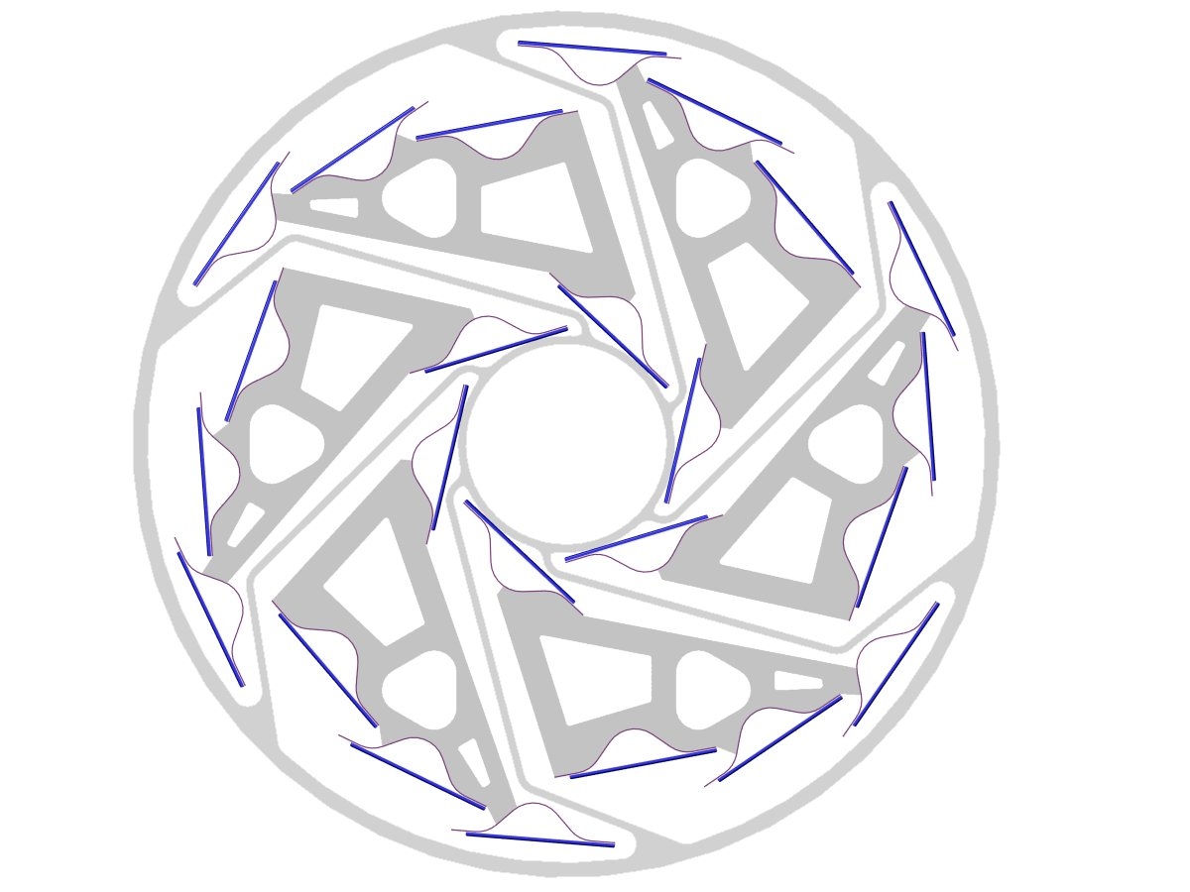
Figure 42: End view showing the HFT ladders between spokes to the inner beam pipe support.

Beam Pipe Insertion and Removal
We are currently investigating the removal and insertion of the beampipe. We anticipate replacing the current center section of the STAR beampipe with the components described above. This will likely entail a period of refit and installation to install the new beampipe after which removal and reinsertion should not be necessary during the normal course of running and detector repair.

Bake Out
Beam pipe bake out is still under discussion. It is expected that the NEG coating will be used and there are two possibilities in how this will be treated. It may either be a minimum bake out to remove primarily water as it is done now with a hot dry nitrogen scrub gas at 150 deg C to 110 deg C or it could be a full activation of the NEG coating turning it into a pumping surface. This later case requires baking at 150 deg C to 200 deg C with vacuum. This could impose additional constraints on beam pipe materials and would require additional thermal isolation from the other detectors. If it is decided that the less aggressive bake out procedure is adequate then carbon composites can be used in the construction of the beam pipe exoskeleton. In either case the HFT will be withdrawn during bake out from the operating location to isolate it from the heated beam pipe.

Compatibility with the SVT and FTPCs
If the SVT remains as the tracking detector outside of the HTF then the inner layer of the SVT can be removed along with associated cabling to make room for the HFT and it’s supporting structure. The FTPC on one end will have to be removed to accomedate the HFT and support electronics as shown in Figure 27.

Compatibility with an Upgraded Inner Si Tracker Barrel
If the SVT is replaced with a new inner Si Tracker barrel and forward disks for the tracking outside of the SVT then the support structure for the new tracker will be installed from one end of STAR and the HFT will be supported and installed from the opposite end. This approach is being further developed by our group and the MIT Si barrel group.

Cost, Schedule and Manpower

Cost and Schedule - 01/25/2005
A rough estimate has been made of cost and schedule. Figure 43 shows the projected time line for completion of the major tasks associated with the project. In this analysis the major tasks shown have been broken down into at least design and fabrications phases and in many cases include more detail such as prototype and testing tasks. The completion date has been tied to the expected running time for the next long heavy ion run of Au-Au in 2007. At this stage, consideration has been given to the necessary completion times and expected effort requirements, but analysis with more detailed task breakdown and resource loading is left for the future.
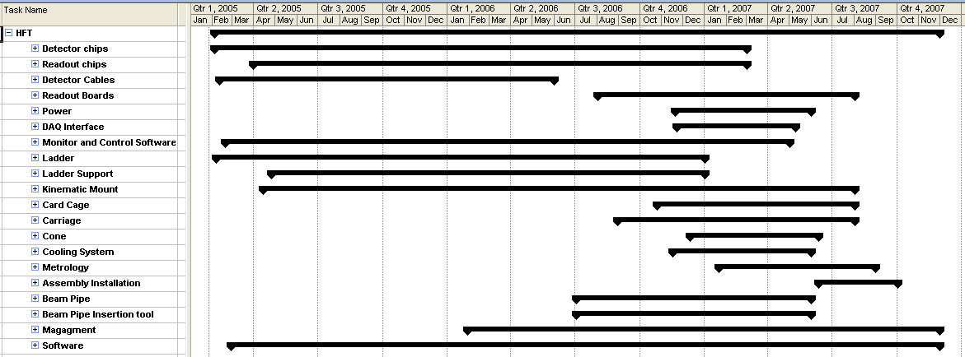
Figure 43: Estimated time line for major tasks in the building of the HFT detector.
In costing the project we have added a contingency of 75% for most items. This has been reflected in the labor costs, but the time contingency has not been included in the time line shown above. The accumulated cost with time is shown in Figure 44 with a final completion cost of 4.1 M$. For purchases, costs are counted at the time of placing the order.
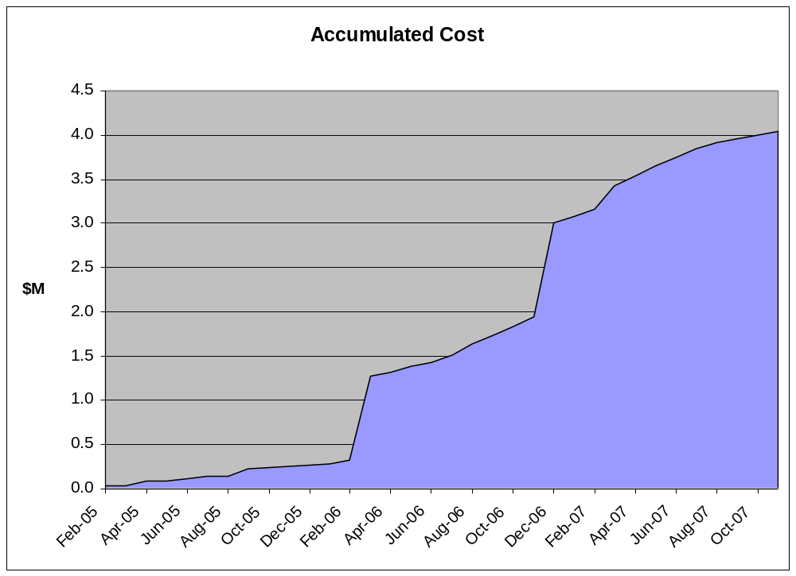
Figure 44: Estimated cost projection for the HFT project showing accumulated cost during the time of design and construction. The final total is 4.1 M$.
The cost estimate presented relies on a significant amount of contributed labor that does not appear in the final sum. Table 10 provides a breakdown of the assumed contributed and project funded effort. The cost of the contributed effort comes to 5.4 M$ - this includes the 75% contingency charge. At this stage effort has been allocated to mechanical and electrical engineering at both BNL and LBNL, technicians at both institutions and management. The significant contributed effort already provided by IReS and on the detector chips as well as their future effort has not been included. As shown in the table, one of the biggest contributed items is 5.6 years of electronic engineering from LBNL which over the life of the project exceeds the expected resource at LBNL by ~1 person. This will have to be addressed in some way, possibly through additional contributions from other institutions.
 | contributed  (man years) | project supported  (man years)
electronic engineer LBNL | 5.1 | 0.0
electronic engineer BNL | 0.4 | 0.0
mechanical engineer LBNL | 3.5 | 0.3
mechanical engineer BNL | 0.4 | 0.0
technician LBNL | 0.3 | 1.8
technician BNL | 2.7 | 0.5
management | 1.1 | 2.2
total | 13.4 | 4.8
Table 10: Estimated manpower requirements for the HFT project

As mentioned above IReS/LEPSI is contributing significant manpower resources developing the sensor chip which has not been included in the above tabulation. This work involves several engineers and physicists, most of who are part time only. A list of these contributors may be found in Table 11r

IReS
design engineers | F.Guilloux, A.Himmi, Ch.Hu, I.Valin
test engineers | K.Jaaskelainen, Ch.Olivetto, M.Pelliciol
physicists | A.Besson, M.Deveaux, G.Gaycken, D.Grandjean, M.Winter
LEPSI
design engineers | C.Colledani, G.Deptuch, W.Dulinski
test engineers | G. Claus, M. Szelezniak

Table 11 IReS/LEPSI manpower contributions developing the HFT readout chip

Summary
Assessing whether or not charm quarks pick up flow and thermalizes is the next important step towards proving the formation of the Quark Gluon Plasma at RHIC. Furthermore, measuring the energy lost by high transverse momentum beauty quarks while traversing the medium will help disentangle between energy loss scenarios in cold nuclear matter and in partonic matter. The HFT is designed to tackle both tasks by precisely measuring charm hadron yields, spectra and elliptic flow (v₂) as well as tagging the electrons produced by high transverse momentum beauty hadrons. The design requirements are fulfilled by having two thin ( ≤ 0.2 % radiation length) layers of Active Pixel Sensors (APS) having a position resolution better than 10 μm. APS technology is the only option that fits these requirements while compromising neither the efficiency nor the readout speed. Indeed, APS can be thinned down to 50 μm and their low power consumption allows using air cooling. Matching the readout speed required at RHIC will be achieved in two steps, first by building two separate chips, one readout chip mounted on a purely analog sensor, and then by designing one chip combining both analog and digital features. The mechanical support has been carefully designed so that the detector can be easily retracted to be externally aligned, repaired and upgraded. By combining cutting edge sensor and readout technologies with a flexible and robust mechanical design, the HFT will provide the high precision data on heavy flavor hadrons that are crucial to understand the nature of the medium formed in Au+Au collisions at RHIC.

Appendix I – MIMOSTAR Specifications
La ti da

Appendix II – MIMOSTAR Users Guide
La ti da

Appendix III – Inner Tracker Interface Specification
La ti do

Appendix IV – SVT Interface Specification
La ti de

References

standing for Minimum Ionizing particle MOS Active pixel sensor.
F. Karsch,. Nucl. Phys. A699, 199c (2002).
K.H. Ackermann et al., Phys. Rev. Lett. 86, 402 (2001).
J. Adams et al., Phys. Rev. Lett. 91, 172302 (2003).
C. Adler et al., Phys. Rev. Lett. 90, 082302 (2003).
J. D. Bjorken, FERMILAB-Pub-82/59-THY.
X. N. Wang, M. Gyulassy, I. Vitev, and B. Zhang, nucl-th/0302077.
D. Schiff, R. Baier, and B. Zakharov, Ann. Rev. Nucl. Part. Sci., 50, 37 (2000).
B.L. Combridge, Nucl. Phys. B151, 429 (1979).
B. Mueller, nucl-th/0404015.
R. Vogt.
K.J. Eskola, V.J. Kolhinen and R. Vogt.
P. Levai, B. Mueller, and X.N. Wang, Phys. Rev. C51, 3326 (1995).
K. Adcox et al., Phys. Rev. Lett. 88, 19230 (2002).
J. Adams et al. (STAR Collaboration), Phys. Rev. Lett., in print; nucl-ex/0407006.
T. Sjostrand et al., Computer Physics Commun.135, 238 (2001). PYTHIA 6.152 was used with the parameter settings: MSEL=1, CTEQ5M1. Bottom contribution was estimated to be 20-30% in p_{T}=2-3 GeV/c, 40-50% in 3-4 GeV/c to the total non-photonic electrons, and negligible at lower p_{T}.
R. Vogt, Int. J. Mod. Phys. E 12, 211 (2003); R. Vogt, hep-ph/0203115.
J. Adams et al. (STAR Collaboration), Phys. Rev. Lett., in print; nucl-ex/0407006.
J. Adams et al., Transverse momentum and collision energy dependence of high p(t) hadron suppression in au + au collisions at ultra-relativistic energies. Phys. Rev. Lett. 91, 172302 (2003).
S. S. Adler et al., Suppressed pi0 production at large transverse momentum in central au + au collisions at s(nn)**(1/2) = 200-gev. Phys. Rev. Lett. 91, 072301 (2003).
S. S. Adler et al., Mid-rapidity neutral pion production in proton proton collisions at s**(1/2) = 200-gev. Phys. Rev. Lett. 91, 241803 (2003).
C. Adler et al., Disappearance of back-to-back high p(t) hadron correlations in central au + au collisions at s(nn)**(1/2) = 200-gev. Phys. Rev. Lett. 90, 082302 (2003).
M. Gyulassy and M. Plümer, Jet quenching as a probe of dense matter. Nucl. Phys. A527, 641c (1991).
Y. L. Dokshitzer and D. E. Kharzeev,. Heavy quark colorimetry of qcd matter. Phys. Lett. B519, 199 (2001).
T. Affolder et al., Phys. Rev. D 64, 032002 (2001)
J. Adams et al., Particle dependence of azimuthal anisotropy and nuclear modification of particle production at moderate p(t) in au + au collisions at s(nn)**(1/2) = 200-gev. Phys. Rev. Lett. 92, 052302 (2004).
K. Schweda et al., J. Phys. G 30, S693 (2004).
J. Castillo et al., J. Phys., G 30, S1207 (2004).
J. Adams et al., nucl-ex/0309012.
E. Shuryak, Phys. Lett. B78, 150 (1978).
R. Rapp and J. Wambach, Adv. Nucl. Phys. 25, 1 (2000).
R. Rapp, Phys. Rev. C 63, 054907 (2001); R. Rapp, hep-ph/0201101; R. Rapp and J. Wambach, hep-ph/9909229.
K. Adcox et al., PHENIX Collaboration, Phys. Rev. Lett. 88, 192303 (2002)
U. Heinz and P.F. Kolb, Nucl. Phys. A702, 269c (2002).
H. Sorge, Phys. Rev. Lett. 78, 239 (1997); H. Sorge, Phys. Rev. Lett. 82, 2048 (1999).
K.H. Ackermann et al., STAR Collaboration, Phys. Rev. Lett. 86, 402 (2001).
C. Adler et al., STAR Collaboration, Phys. Rev. Lett. 87, 262301 (2001).
C. Adler et al., STAR Collaboration, Phys. Rev. Lett. 89, 132301 (2002).
P. Huovinen et al., Phys. Lett. B503, 58 (2001).
M. Kaneta, J. Phys. G: Nucl. Part. Phys. 30 S1217 (2004)
J. Stachel, Nucl. Phys. A654, 119c (1999).
P. Braun-Munzinger, D. Magestro, K. Redlich, and J. Stachel, Phys. Lett. B518, 41 (2001).
P. Braun-Munzinger, K. Redlich, and J. Stachel, nucl-th/0304013.
E. Schnedermann, J. Sollfrank, and U. Heinz, Phys. Rev. C48, 2462 (1993).
P. Braun-Munzinger, J. Stachel, J.P. Wessels, and N. Xu, Phys. Lett. B365, 1 (1996); P. Braun -Munzinger, I. Heppe, and J. Stachel, Phys. Lett. B465, 15 (1999).
P. Fachini et al., STAR Collaboration, nucl-ex/0203019; Z. Xu et al., STAR Collaboration, Nucl. Phys.A698, 607c (2002).
P. Braun-Munzinger and J. Stachel, Phys. Lett. B490, 196 (2000).
P. Braun-Munzinger and J. Stachel, Nucl. Phys. A690, 119c (2001).
A. Andronic, P. Braun-Munzinger, K. Redlich, and J. Stachel,. Phys. Lett. B571, 36 (2003).
http://www-h1.desy.de/psfiles/confpap/EPS2003/H1prelim-02-076.ps
http://www-zeus.desy.de/physics/phch/conf/eps03/564/paper.pdf
T.Sjöstrand,. Comp. Phys. Commun. 82, 74 (1994).
Z. Lin, C.M. Ko, and B. Zhang, Phys. Rev. C61, 024904 (2000).
H. Lipkin, Nucl. Phys. A625, 207 (1997).
M. Schroedter, R. L. Thews, and J. Rafelski, B/C meson production in nuclear collisions at RHIC. Phys. Rev. C62, 024905 (2000).
R. Rapp, Signatures of thermal dilepton radiation at RHIC. Phys. Rev. C63, 054907 (2001).
R. Rapp, Dileptons in high-energy heavy-ion collisions. Pramana 60, 675 (2003).
Technical report, http://www-rnc.lbl.gov/~wieman/HitDensityMeasuredLuminosity.htm
Technical report, http://www-rnc.lbl.gov/~wieman/TrackDensityApr2004.htm
Jim Thomas, Private Communication.
R. Turchetta et al., Nucl. Inst. and Meth. A458, 677 (2001).
M. Winter et al., Proc. of the 8th ICATPP, Como Italy (2003).
M. Devaux et al., Nucl. Inst. and Meth. A512, 71 (2003).
Technical report, http://www-lepsi.in2p3.fr/~huch/MimoStar181203.pdf
W. Dulinski et al., Proc. IEEE Nuclear Science Symposium, Portland OR. Trans. Nucl. Sci. (2003).
Technical report, http://ireswww.in2p3.fr/ires/recherche/capteurs/index.html
“Charged Particle Detection Using a CMOS Active Pixel Sensor”, Howard S. Matis, Fred Bieser, Stuart Kleinfelder, Gulshan Rai, Fabrice Retiere, Hans Georg Ritter, Kunal Singh, Samuel E. Wurzel, Howard Wieman, and Eugene Yamamoto, IEEE Trans. on Nucl. Sci., 50, 1020-1025, 2003.
“Integrated X-Ray and Charged Particle Active Pixel CMOS Sensor Arrays using an Epitaxial Silicon Sensitive Region” S. Kleinfelder, H. Bichsel, F. Bieser, H. S. Matis, G. Rai, F. Retiere, H. Weiman, E. Yamamoto, Proceedings of the SPIE, Hard X-Ray and Gamma Ray Detector Physics IV, July, 2002, Vol. 4784, pp 208-217.
“Using an Active Pixel Sensor in a vertex detector”. Howard S. Matis, Fred Bieser, Yandong Chen, Robin Gareus, Stuart Kleinfelder, Markus Oldenburg, Fabrice Retiere, Hans Georg Ritter, Howard H. Wieman, Samuel E. Wurzel, Eugene Yamamoto, To be published in NUCLEAR INSTRUMENTS & METHODS IN PHYSICS RESEARCH Section A – In Proceedings of Vertex 2003.
“Novel Integrated CMOS Pixel Structures for Vertex Detectors”, Stuart Kleinfelder, Fred Bieser, Yandong Chen, Robin Gareus, Howard S. Matis, Markus Oldenburg, Fabrice Retiere, Hans Georg Ritter, Howard H. Wieman, Eugene Yamamoto, IEEE Trans. Nucl. Sci. 51, 2328 (2004).
“First use of a high-sensitivity active pixel sensor array as a detector for electron microscopy”, N.H. Xuong, A.-C. Milazzo, P. LeBlanc, F. Duttweiler, J. Bouwer, S. Peltier, M. Ellisman, P. Denes, F. Bieser, H.S. Matis, H. Wieman, S. Kleinfelder, In “Sensors and Camera Systems for Scientific, Industrial, and Digital Photography Applications V”SPIE 5301 242, 2004.
Technical report, http://www-rnc.lbl.gov/~wieman/RadiationLengthsProposal.htm
http://www.lbnl.leog.org/writeup.htm
Technical report, http://www-rnc.lbl.gov/~wieman/StiffnessLadder1.htm
TV Holography System at LBNL, courtesy of Eric Andersen and the ATLAS project.
Technical report, http://www.lionprecision.com/modular/probes.html
Technical report, http://www.lbnl.leog.org/writeup.htm
Technical report, http://www.lbnl.leog.org/ir prelim writeup.htm
Technical report, http://www.lbnl.leog.org/cable constraints.htm
Technical report, http://www.lbnl.leog.org/crossing_lines_measurement_first_look.htm
Steve Peggs and Steve Tepikian, Private Communication.
S. Tepikian,. Twiss functions and beam sizes of the RHIC intersection. RHIC/AP25 (1994).
Technical report, http://wwwrnc.lbl.gov//~wieman/BeamPipeRadiusLimitsRHICAP25.htm
Wolfram Fischer, private communication, 28-Nov-2004.
Technical report, http://www-rnc.lbl.gov/~wieman/BeamPipeVacuumShortAns.htm
John O’Hanlon, A User’s Guide to Vacuum Technology. John Wiley and Sons, second edition (1989).
Seth Wieman, Private Communication.
Technical report, http://www-rnc.lbl.gov/~wieman/TopThinPipeAnalysis.htm
Sandro Bravar, Private Communication.
Dan Weiss, Private Communication 30-Nov-2004.

