Expanded Federal Parent Locator Service

Interstate Referral Guide (IRG)

Release 02-02 – Minor: November 15, 2002

Release Specifications

February 2003

TABLE OF CONTENTS

PART 1.0 Interstate Roster and Referral Guide

1.1 Introduction 1-1

PART 2.0 Local CSE Offices (IRG 1480)

2.1 Overview 2-1
2.2 Implementation 2-1
2.3 IRG Processing 2-1
2.3.1 Local CSE Offices 2-1
2.3.2 New Mode for Addresses 2-2
2.3.3 Edit Mode 2-2
2.3.4 Search Capabilities 2-3
2.4 Impact on States 2-3

PART 3.0 Link to State Laws and Statutes (IRG 1482)

3.1 Overview 3-1
3.2 Implementation 3-1
3.3 IRG Processing 3-1
3.3.1 Edit Mode 3-1
3.3.2 Search Capabilities 3-1
3.4 Impact on States 3-1

PART 4.0 Enlarge Comments Section (IRG 1483)

4.1 Overview 4-1
4.2 Implementation 4-1
4.3 IRG Processing 4-1
4.3.1 New Mode 4-1
4.3.2 Edit Mode 4-1
4.3.3 Search Capabilities 4-2
4.4 Impact on States 4-2

TABLE OF CONTENTS (Continued)

APPENDICES

Appendix A: Download Record Format for Addresses A-1
Appendix B: Sample Screen Prints B-1

CHARTS

Chart A-1: Downloading FIPS Codes and Addresses to States A-1

FIGURES

Figure B-1: Local Child Support Office Text Box – New Mode B-2
Figure B-2: Select Child Support Office – Edit Mode B-3
Figure B-3: Local Child Support Office – Edit Mode B-4
Figure B-4: Comments Dialog Text Box B-5
Figure B-5: Links to State Laws and Statues – View Mode B-6
Figure B-6: Links to State Laws and Statues – New Mode B-7

PART 1.0
Interstate Roster and Referral Guide

Introduction

The Interstate Roster and Referral Guide (IRG) is an information resource tool used to facilitate the exchange of child support enforcement information between states. The IRG data includes the states’ profiles of services, valid Federal Information Processing Standard (FIPS) Codes and addresses, Federal and regional office data, and demographic data on international Child Support Enforcement agencies. The IRG data referred to throughout this document consists of the State Profile and the state FIPS Codes and address data.

This document provides specifications for the capability to add, delete, view, and modify address information for county offices on the IRG. It also identifies new links that are being provided in the State Profile section. Further it contains an explanation of the impact of these changes on the states.

Part 2.0, “Local CSE Offices”, describes how states may enter address information for multiple local child support offices.

Part 3.0, “ Link to State Laws and Statutes”, describes how states can view other state’s laws and statutes by linking directly to each state’s statutory citation information.

Part 4.0, “Enlarge Comments Section”, describes the enlarged Comments section that allows states to provide a better description of an address type and identify areas of responsibility.

The appendices provide a layout of the format in which states receive the IRG data and the screen prints that illustrate the changes being implemented under this release.

PART 2.0
Local CSE Offices
(IRG 1480)

Overview

States have requested that the IRG allow state administrators the capability to add, modify and delete address descriptions for local Child Support Enforcement (CSE) offices within a county. In addition, states requested the capability to view addresses for local CSE offices.

Implementation

Upon implementation, states will have the option to add, delete, modify and view addresses for multiple local CSE offices for a desired county.

IRG Processing

This section describes the changes being made to allow adding, editing and searching for the new address type.

Local CSE Offices

The following is a list of additional valid local CSE offices address descriptions and their associated address type codes:

- CON - Child Support Office I
- CTW -Child Support Office II
- CTH – Child Support Office III
- CFO – Child Support Office IV
- CFV – Child Support Office V
- CSX – Child Support Office VI
- CSV – Child Support Office VII
- CET – Child Support Office VIII
- CNN – Child Support Office IX
- CTN – Child Support Office X
- CEL – Child Support Office XI
- CTV – Child Support Office XII
- CTR – Child Support Office XIII
- CFR – Child Support Office XIV
- CFT – Child Support Office XV
- CST – Child Support Office XVI
- CSE – Child Support office XVII
- CEI – Child Support Office XVIII
- CNI – Child Support Office XIX
- CTY – Child Support Office XX

New Mode for Addresses

After selecting the state on the navigation panel, click the County button to display the “New County Address Data” screen (refer to Appendix B, Figure B-1, “Local Child Support Office Text Box – New Mode”). All text boxes (except the “Select County FIPS Code” text box) are disabled.

- Click the arrow located on the right side of the “Select County FIPS Code” text box. A list of valid FIPS Codes appears.
- Select the desired county FIPS Code and its FIPS Code appears in the “Select County FIPS Code” text box. Wait a few seconds. The IRG will associate the available address descriptions and child support offices (if applicable) for the selected county. The associated text boxes are enabled.
- Click the arrow located on the right side of the “Local CSE” address type, which is located beneath the “FIPS Code-State/County” text boxes (refer to Appendix B, Figure B-1, “Local Child Support Office Text Box – New Mode,” for the revised screen). A list of valid local CSE Offices appears.
- Select the desired local CSE office and the selected local office appears in the “Child Support Office” text box. Enter the new address data on this screen. Click the County Search button. Enter the new address data on this screen.

The following data is required: address description or local CSE address, city, state/province and Zip Code. Please note: The “Select Address Description” text box is not available after clicking the down arrow on the “Child Support Office” text box. The “Select State Extension Code” text box is not available after clicking the “Child Support Offices” text box. A state administrator cannot select a child support office and a state extension code at the same time.

Edit Mode

After selecting the state on the navigation panel, click the County button to display the “Select County Addresses” screen (refer to Appendix B, Figure B-2, “Select Child Support Office – Edit Mode”). To search for a local CSE office:

- Click the down arrow located on the “Select County Name” text box. A list of valid county names appears.
- Select the desired county name and the name appears in the “Select County Name” text box. Wait a few seconds. The IRG will associate the available address descriptions and child support offices for that county.
- Click the down arrow located on the “Child Support Office” text box. A list of valid local CSE offices appears.
- Select the desired local CSE and the name appears in the “Select Local CSE” text box.
- Click the County button under Select Address Type to display the associated local CSE office address data (refer to Appendix B, Figure B-3, “Local Child Support Office – Edit Mode”).

To select a different local office, return to the “Select County Address” menu screen. Please note: The “Select County Names” and “Select Local CSE” text boxes must contain data.

Search Capabilities

To search for a local CSE office, return to the “Select County address” menu screen. Please note: the following data required: address description or local CSE address, city and Zip Code. After selecting the state on the navigation panel, click the County button (refer to Appendix B, Figure B-3, “Local Child Support Office – Edit Mode”). To search for a local CSE office address:

- Click “Select County Name” arrow located on the right side of the text box and select the desired county. The selected county name appears in the “Select County Name” text box.
- Click the “Local CSE” arrow located on the right side of the “Local CSE” text box. Select the desired local CSE and it appears in the “Select Local CSE” text box.
- Click the Search button and the desired local CSE office address data appears on the “View County Address Data (View Only)” screen.

To search for a different local CSE office, return to the “Select County address” menu screen. Please note: the following data is required: address description or local CSE address, city and Zip Code. The “Select County Names” and “Select Local CSE” text boxes must contain data.

Impact on States

This enhancement may require that the states modify their systems to accommodate the new local CSE offices address types.

PART 3.0
Link to State Laws and Statutes
(IRG 1482)

Overview

States have requested that the IRG provide links to other state’s statutory citation information in the State Profile section.

Implementation

Upon implementation, the OCSE administrator, state administrators, state users and the public will have the capability to view any state’s statutory citation information (refer to Appendix B, Figure B-5, “Link to State Laws and Statutes” – View Mode”). The OCSE administrator will have the capability to edit URL addresses for all states (refer to Appendix B, Figure B-6, “Link to State Laws and Statutes” – Edit Mode”). The state administrators will have the capability to edit their own state’s URL information.

IRG Processing

The links and the associated questions that contain statutory citation information will be located in the State Profile section of the IRG.

Edit Mode

While in View mode, state administrators can click the Edit link on the task bar to edit each URL’s address. The system warns the administrator to print a backup copy of the data before editing. The administrator can press OK to print the data or Cancel to go directly to edit without printing.

After either printing the data or canceling the dialogue box, the “Edit Profile’ screen appears. To edit a URL, click the section jumpers of the State Profile section. Scroll through the data until a question is reached that contains a statutory citation link. Edit the URL information and click the Save button to save the changes. The updated URL address can be tested by clicking the link beneath the URL’s editable text box labeled “Test Current Link – Click Here” (refer to Appendix B, Figure B-6, “Link to State Laws and Statutes” – Edit Mode”).

3.3.2 Search Capabilities

The state, public and OCSE users can search for URL information in the State Profile section by scrolling until the URL information appears.

Impact on States

This modification will not require a program change to the state system.

PART 4.0
Enlarge Comments Section
(IRG 1483)

4.1 Overview

States have requested that the IRG display a larger Comments section on all address screens. This will allow states the capability to provide a detailed address type and defined area of responsibility. The public user can view the Comments section located on the address screens.

4.2 Implementation

Upon implementation, the state administrator will be able to enter a maximum of 500 characters in the Comments section.

IRG Processing

The address screens will contain a Comments section that allows entry or display of data up to 500-characters in length (please refer to Appendix B, Figure B-4, “Comments Dialog Box”).

New Mode

After selecting the state on the navigation panel, press the State, Region, or County button to display the “New [State, Region, or County] Address Data” screen (please refer to the Online IRG User Guide for information about adding state, region or county addresses).

- Click the comment text box to enter comments. The state administrator can type text up to 40 characters in length in the comment text box. On the 41st character the comment display window opens. The text in the comment text box will transfer to the display window. Continue typing up to 500 characters in length.
- Click the Done button to temporarily store the data and close the display window or click Cancel if you do not wish to store the data. The new comment data is not saved until the Save button is clicked.
- Click the Save button to save the new comment.

Please note: The total number of characters allowed in the Comment text box may vary due to character type and font size. For example, in Internet Explorer 5.5, (Times Roman, medium font type) the approximate total number of characters allowed is 41. In Netscape 4.7, the text located in the comment text box will not display in the window. After the 41st character has been typed the state administrator must click the “More…” button to continue typing up to 500 characters. The display window will not automatically display.

Edit Mode

After selecting the state on the navigation panel, press the State, Region or County button to display the “Select [State, Region, or County] Addresses” screen (please refer to the Online IRG User Guide for information about editing state, region or county addresses).

- The comments section of the address displays a maximum of 40 characters on the screen. A state administrator can edit up to 40 characters in the text in the comments text box. Additional comments can be viewed and edited by clicking the “More…” button to open the display window. The state administrator can edit at this time. Click the Done button to temporarily store the data and close the display window.
- If you do not want to commit the changes to the comments, click Cancel and the window closes without saving the changes. Changes to comments are not saved until the Save button is clicked.
- Click the Save button to save the modified address.

Please note: If the user wants to utilize the cut/paste text function and the text is more that 40 characters, the user must copy the cut/paste text to the display window. The Comment text box will not accept more that 40 characters.

Search Capabilities

After selecting the state on the navigation panel, press the State, Region or County button to display the “New [State, Region, or County] Address Data (Read Only)” screen (please refer to the Online IRG User Guide for information about viewing state, region or county addresses).

- If comments exist, a maximum of 40 characters is automatically displayed on the screen. If there are additional comments, the comments are available for viewing by clicking the “More…” button. Click the “More…” button and the display window will open.
- If comments do not exist, the “More…” button is disabled.
- After viewing, click the Cancel button.

Impact on States

This modification does not require a program change to state systems.

Appendices

download record FORMAT FOR ADDRESSES

This record format provides the specifications for downloading FIPS Codes and addresses to the states. Type ‘A’ is alphabetic, type ‘N’ is numeric, and type ‘A/N’ is alphanumeric.

CHART A-1: DOWNLOADING FIPS CODES AND ADDRESSES TO STATES
Label Fields | Position in Record | Length | Type | Description
Address Type 1 | 1-3 | 3 | A | Type of Address  STA – State  LOC – County/Local  FED – Federal  INT – International
Address Type 2 | 4-6 | 3 | A | Type of Address  Address Type 1 LOC  COL – Collection  AGO – Attorney General  CHC – Chancery Court  CLC – Clerk of the Court  CTC – Circuit Court  DAO – District Attorney  DTC – District Court  FAC – Family Court  FRC – Friends of the Court  JDR – Juvenile and Domestic  PAO – Prosecuting Attorney  Relations Court  RES – Responding  SPO – State Prosecutor  SUP – Superior Courts  TLC – Tribal Court  CON – Child Support Office I  CTW – Child Support Office II  CTH – Child Support Office III  CFO – Child Support Office IV  CFV – Child Support Office V  CSX – Child Support Office VI  CSV – Child Support Office VII  CET – Child Support Office VIII  CNN – Child Support Office IX  CTN – Child Support Office X  CEL – Child Support Office XI  CTV – Child Support Office XII  CTR – Child Support Office XIII  CFR – Child Support Office XIV  CFT – Child Support Office XV  CST – Child Support Office XVI  CSE – Child Support office XVII  CEI – Child Support Office XVIII  CNI – Child Support Office XIX  CTY – Child Support Office XX  Address Type 1 STA  AIP – Automated Interstate Case Payment Requests  AIS – Automated Interstate Case Status Requests  BVS – Bureau of Vital Statistics  CDC – Collection and Distribution Contact  CEJ – Continuing Exclusive Jurisdiction Contact  COC – Copy of Order Contact  CRG – Central Registry Contact  CNT – CSENet Contact  EAC – Employer Assistance Contact  EFT – Electronic Funds Transfer Contact  EIW – Employer Income Withholding Contact  FDM – Financial Institution Data Match Contact  GCL – Guidelines Calculations Contact  GTI – Genetic Testing and Interstate Teleconferencing Contact  IPC – Interstate Policy Contact  IRG – Interstate Roster and Referral Guide Contact  IVD – State IV-D Director  NHR– New Hire Reporting Contact  NVD– Non IV-D Contact  PRW– PRWORA-Administrative Policies, Procedures Contact  PAF – Paternity Acknowledgement Forms Contact  PAT – Paternity Acknowledgement Copies Contact  PDC – Passport Denial Contact  PFR – Putative Father Registry  PRC – Privatization Contact  PYR – Payment Records Contact  SDU – State Disbursement Unit  SLA – State Long Arm Statute and Process Contact  SLC – State Lien Contact  SPA – State Paternity Acknowledgement Hospital Contact  SPC – Service of Process Contact  SPL – State Parent Locator Service  TOC – Tax Offset Coordinator  UCW – Unemployment Compensation Withholding  WCW – Workers Compensation Withholding  RON – Regional Office I  RTW – Regional Office II  RTH – Regional Office III  RFO – Regional Office IV  RFV – Regional Office V  RSX – Regional Office VI  RSV – Regional Office VII  RET – Regional Office VIII  RNN – Regional Office IX  RTN – Regional Office X  Address Type 1 FED  CEN – OCSE Central Office  REG – OCSE Region  Address Type 1 INT  FRC – Foreign Country
State Code or Country | 7-8 | 2 | A/N | State, Territory Code or Country  (e.g., ‘04’ or ‘RP’)
County Code  (Local Code)  International City or Province | 9-11 | 3 | A/N | County FIPS Code (e.g., ‘000’)  International City or Province (e.g., ‘0D9’ or space in the first ‘0’ as a place- holder).
State Extension Code  (Sub Local Code) or International ID | 12-13 | 2 | N | Assigned by state (e.g., ‘00’)  International ID is zero or space.
Department Name | 14-48 | 35 | A | Department name
Title | 49-83 | 35 | A | Title
Street Address Line 1 | 84-118 | 35 | A/N | First line of street address
Street Address Line 2 | 119-153 | 35 | A/N | Second line of street address
CITY | 154-183 | 30 | A | Name of the city
State or Country | 184-203 | 20 | A | State abbreviation or country name
Zip Code | 204-212 | 9 | N | U.S. Zip Code
Area Code | 213-215 | 3 | N | Telephone area code
Exchange | 216-218 | 3 | N | Telephone exchange
Sequence Number | 219-222 | 4 | N | Telephone number
Extension Number | 223-227 | 5 | N | Telephone extension
Action Code | 228-228 | 1 | A | A – Address added  C – Address changed  D – Address deleted
Facsimile | 229-231 | 3 | N | Facsimile telephone area code
Facsimile Exchange 1 | 232-234 | 3 | N | Facsimile telephone exchange
Facsimile Sequence Number | 235-238 | 4 | N | Facsimile telephone number
Record Date | 239-246 | 8 | N | System generated date when record is added, changed or deleted in the format CCYYMMDD
Filler | 247-247 | 1 | A/N | Filler

Notes:

Downloaded data that is marked as having been “changed” (designated by an Action Code of ‘C’ in the 228th position) may not actually appear as changed. Not all data elements are downloaded, and the change may have occurred in one of the data elements that was not downloaded.

Sample SCREEN PRINTS

The following are sample screen prints for the address description for the local child support office screen, comments screen, and citation screen.

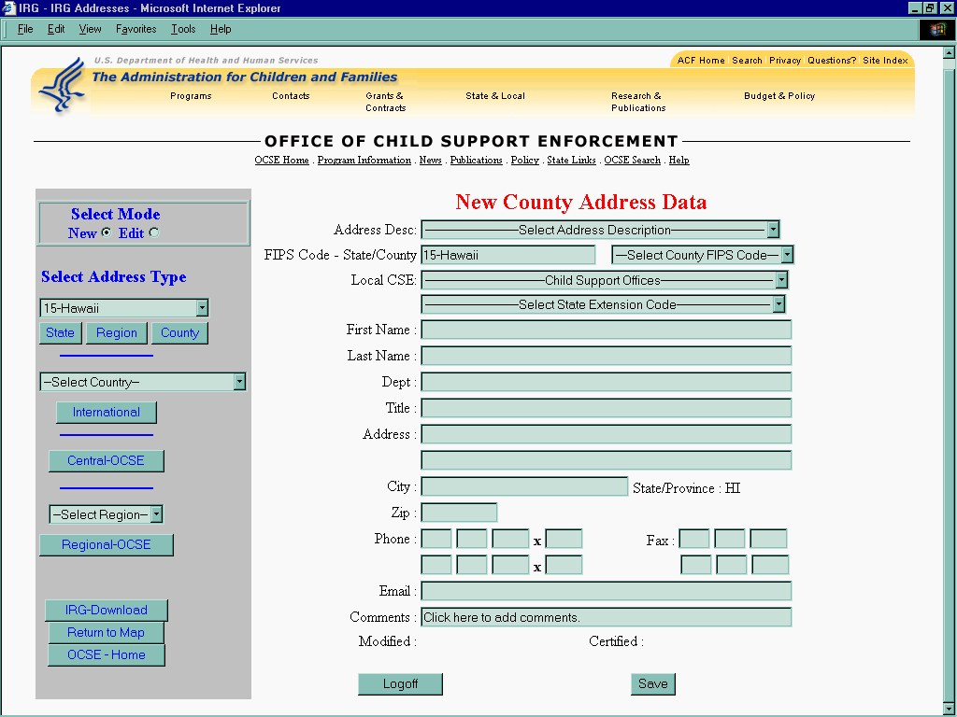

Figure B-1: Local Child Support Office Text Box – New Mode

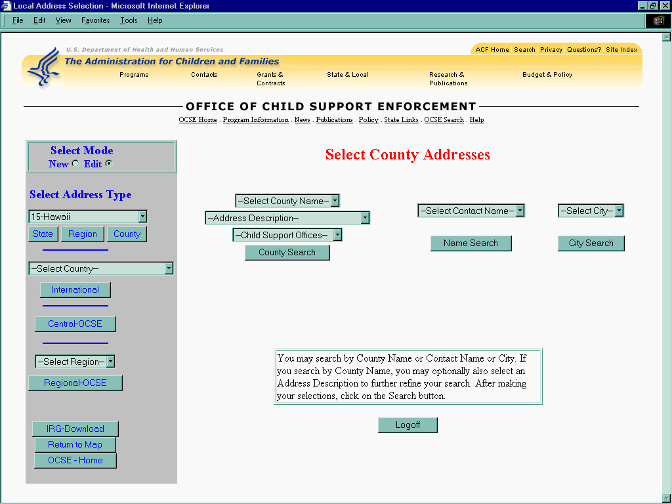

Figure B-2: Select Child Support Office– Edit Mode

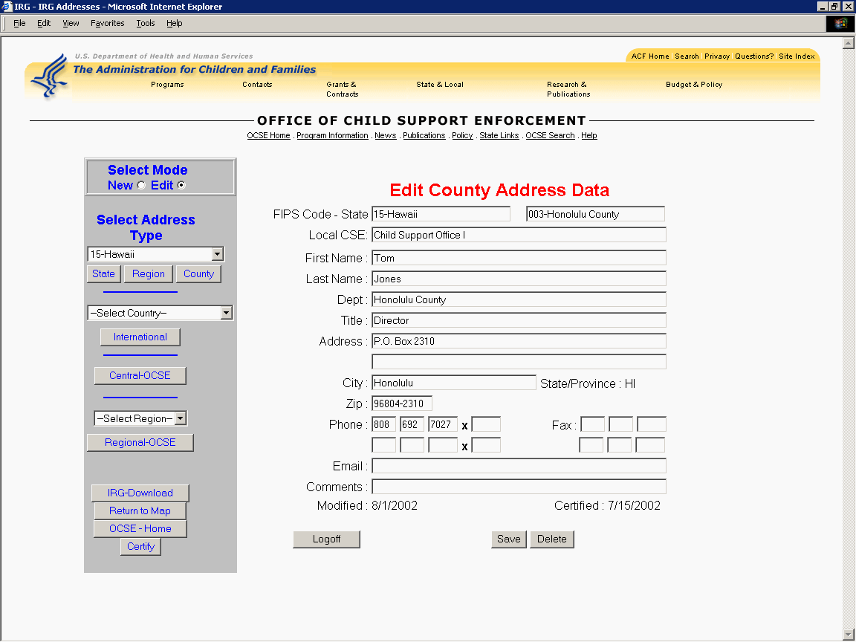

Figure B-3: Local Child Support Office – Edit Mode

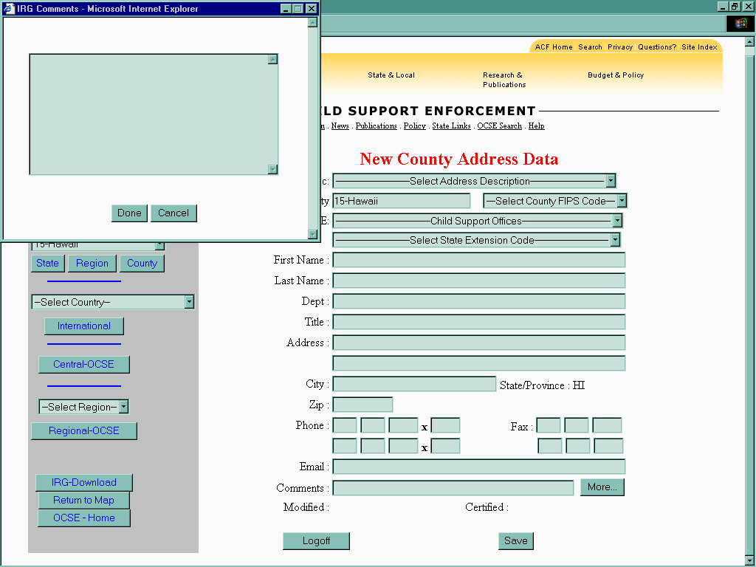

Figure B-4: Comments Dialog Text Box

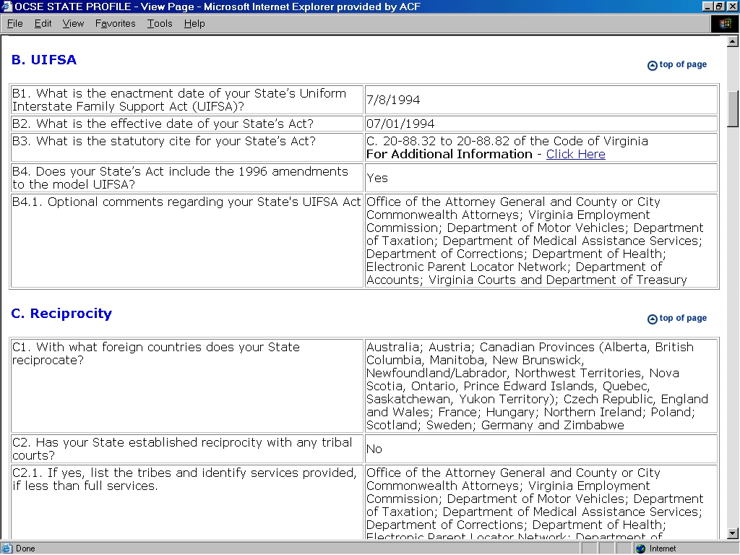

Figure B-5: Link to State Laws and Statutes – View Mode

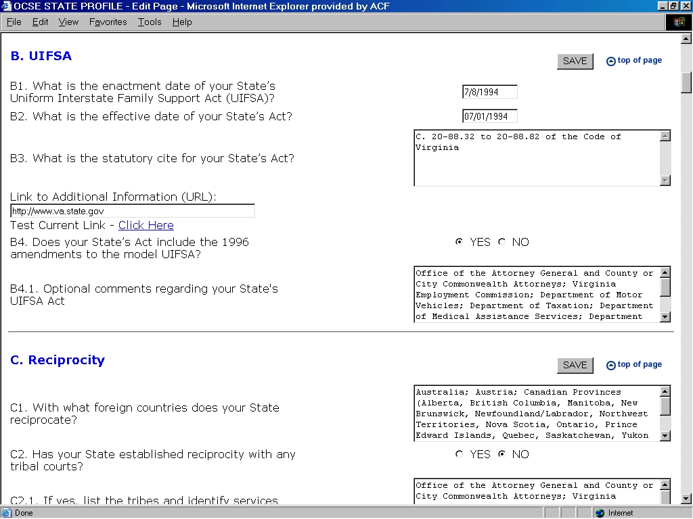

Figure B-6: Link to State Laws and Statutes – Edit Mode

