PUBLIC NOTICE
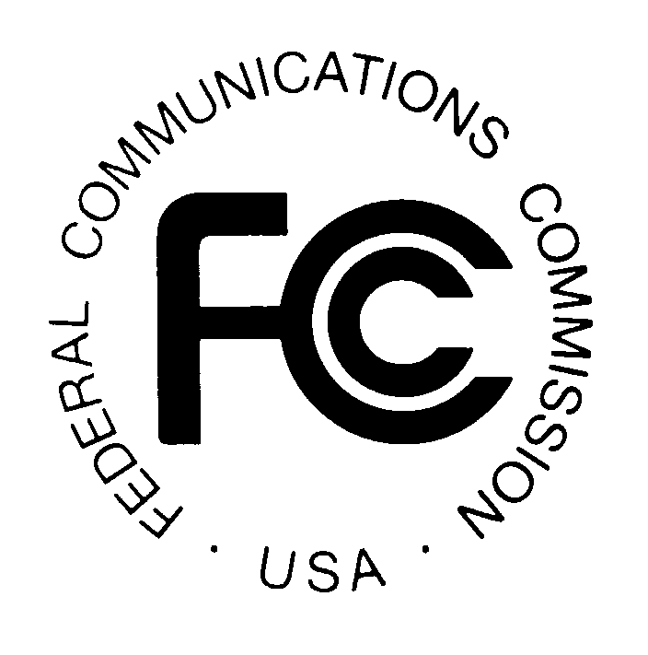
FEDERAL COMMUNICATIONS COMMISSION
445 12th STREET, S.W.
WASHINGTON, D.C. 20554 DA 01-1477

News media information 202/418-0500 Fax-On-Demand 202/418-2830 Internet: http://www.fcc.gov ftp.fcc.gov

CABLE SERVICES BUREAU ACTION June 22, 2001

Effective Date of Broadcast Signal Carriage Rule Provisions Requiring OMB Approval
CS Docket Nos. 00-96 and 99-363

On November 30, 2000, the Commission, in CS Docket Nos. 00-96 and 99-363, released a Report and Order (FCC 00-417, 16 FCC Rcd 1918 (2000)) adopting a rule, 47 C.F.R. 76.66 (Satellite Broadcast Signal Carriage rule), requiring satellite carriers, by January 1, 2002, to carry all local television stations seeking carriage in any market in which they provide local-into-local service. The rule, which was published in the Federal Register at 66 FR 7410 (Jan. 23, 2001), was adopted pursuant to Section 338 of the Communications Act of 1934, adopted as part of the Satellite Home Viewer Improvement Act of 1999 (“SHVIA”). The rule covers: carriage obligations and definitions, market definitions, delivery of a good quality signal, duplicating signals, channel positioning, content to be carried, material degradation, compensation for carriage, and remedies for carriage violations. Sections 76.66(c)(3), (c)(5), (d), and (m) of the rule, however, contained information collection requirements that required approval from the Office of Management and Budget (“OMB”) before they could become effective. OMB approved the information collection requirements on June 7, 2001 (see OMB No. 3060-0980). Accordingly, Sections 76.66(c)(3), (c)(5), (d), and (m) of the Satellite Broadcast Signal Carriage rule will become effective upon publication of this notice in the Federal Register.

Media Contact: Michelle Russo 202-418-2358
Cable Services Bureau Contact: Eloise Gore 202-418-7200, TTY 202-418-7172.

-- FCC --

