APPENDIX B

FIGURES FOR PM STAFF PAPER, CHAPTER 5, SECTION ON VISIBILITY

Washington, DC Images

Figure 5-3. Washington, DC - 2.5 Fg/m³ PM_{2.5} (122 km visual range)

Figure 5-4. Washington, DC - 5 Fg/m³ PM_{2.5} (76 km visual range)

Figure 5-5. Washington, DC - 10 Fg/m³ PM_{2.5} (44 km visual range)

Figure 5-6. Washington, DC - 15 Fg/m³ PM_{2.5} (31 km visual range)

Figure 5-7. Washington, DC - 20 Fg/m³ PM_{2.5} (24 km visual range)

Figure 5-8. Washington, DC - 30 Fg/m³ PM_{2.5} (16 km visual range)

Figure 5-9. Washington, DC - 40 Fg/m³ PM_{2.5} (12 km visual range)

Figure 5-10. Washington, DC - 65 Fg/m³ PM_{2.5} (8 km visual range)

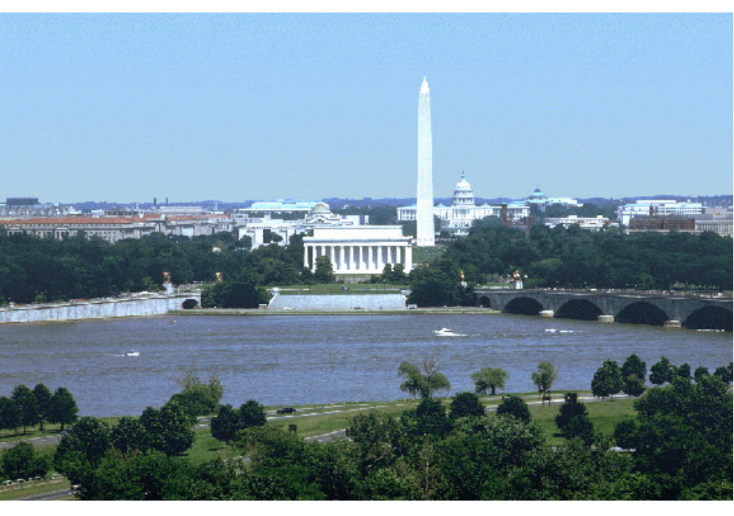
Figure 5-3. Washington, DC - 2.5 Fg/m³ PM_{2.5} (122 km visual range)

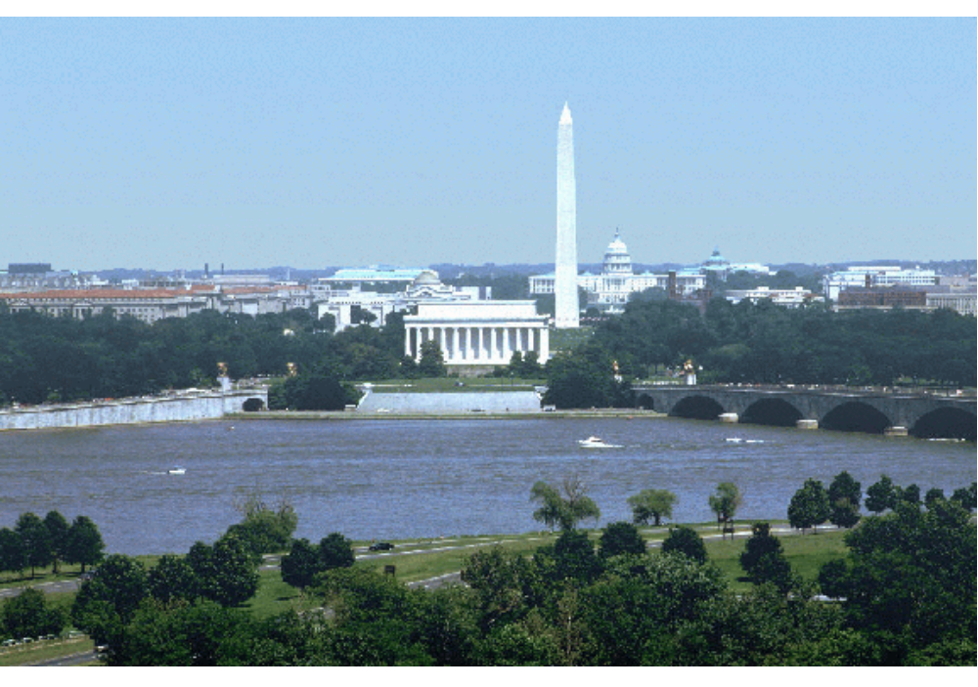
Figure 5-4. Washington, DC - 5 Fg/m³ PM_{2.5} (76 km visual range)

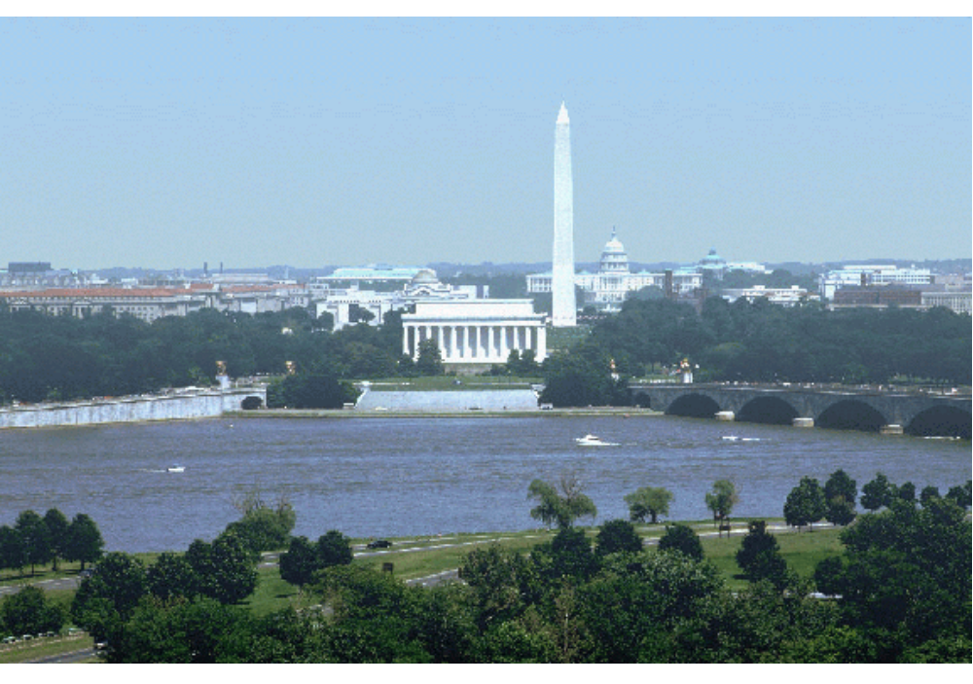
Figure 5-5. Washington, DC - 10 Fg/m³ PM_{2.5} (44 km visual range)

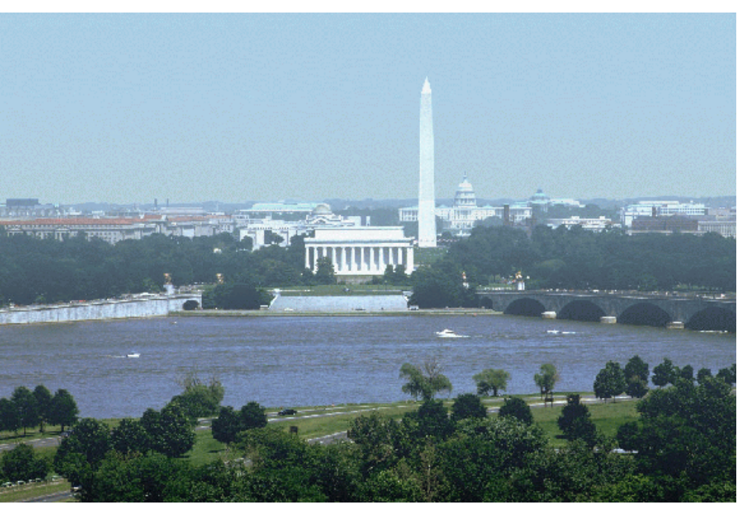
Figure 5-6. Washington, DC - 15 Fg/m³ PM_{2.5} (31 km visual range)

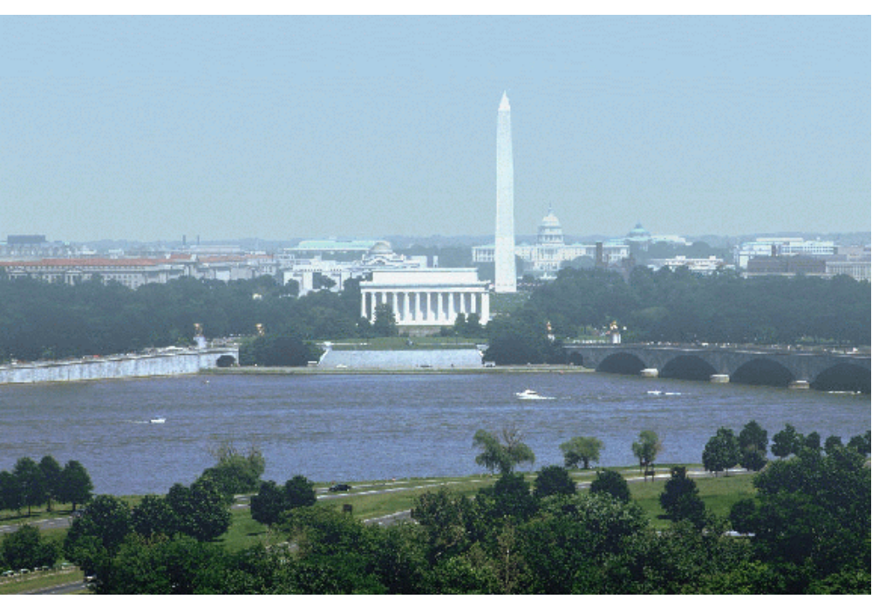
Figure 5-7. Washington, DC - 20 Fg/m³ PM_{2.5} (24 km visual range)

Figure 5-8. Washington, DC - 30 Fg/m³ PM_{2.5} (16 km visual range)

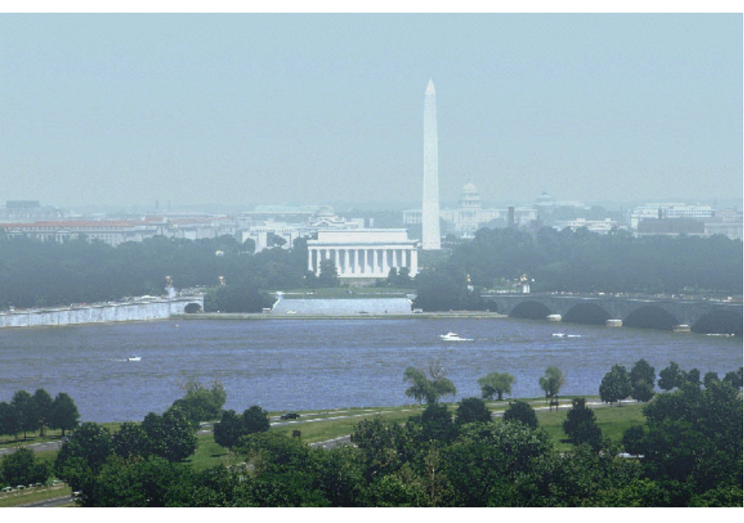
Figure 5-9. Washington, DC - 40 Fg/m³ PM_{2.5} (12 km visual range)

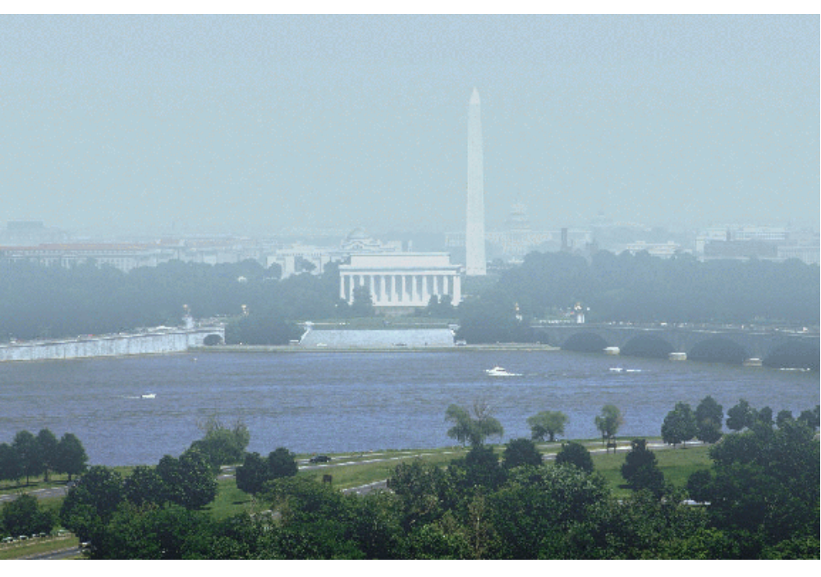
Figure 5-10. Washington, DC - 65 Fg/m³ PM_{2.5} (8 km visual range)

