
304-A West Millbrook Road
Raleigh, North Carolina 27609
Tel: (919) 845-1422 Fax: (919) 845-1424
October 23, 2006

Ms. Rachel Rineheart

U.S. EPA Region 5
77 W. Jackson Blvd.
Chicago, IL 60604

Subject: Land Use / Land Cover Near Archer Daniels Midland (ADM) Company’s Decatur , Illinois Complex

Dear Ms. Rineheart:

As we discussed last week, RTP Environmental Associates, Inc. (RTP) has reviewed the potential for impacts on certain endangered species in proximity to ADM’s Decatur Complex in conjunction with permitting the construction of a new glycols production plant within the existing fence-line of the Complex. Note that I have confirmed that all property within 3 kilometers of this facility is located within Macon County, Illinois. The endangered species of interest are the:
- Eastern prairie fringed orchid (EPFO);
- Prairie bush clover (PBC); and
- Indiana bat.

Based on RTP’s review of the land use / land cover map for the area, the only species potentially affected by the project is the Indiana bat. This map is attached for your reference along with a listing of the land use types found in proximity of the plant. As this map shows, there are no suitable habitats for either the EPFO or the PBC in proximity to the complex. Due to the proximity of Lake Decatur and some forested land, it appears there may be some potential feeding areas for the Indiana Bat located near the complex.

As I understand the next step in this process, you will use the information in this letter to confer with the Fish and Wildlife Service. Should you have any questions on this information or on the project, please give me a call.

Sincerely,
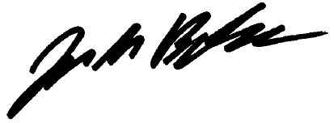
Jack M. Burke
Land Use / Land Cover Map for the Area Surrounding ADM’s Decatur Complex
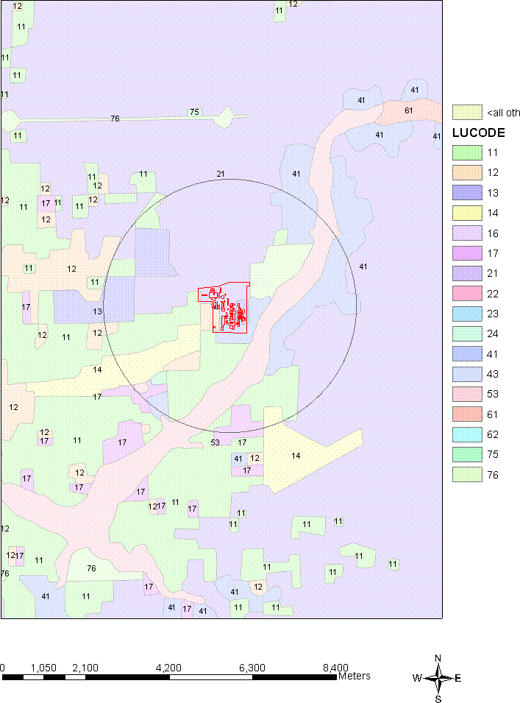
76
11
13
53
11
ADM Decatur Complex
12
11
75
53
41
12
41

LUCODE DESCRIPTION
11: Residential
12: Commercial Services
13: Industrial
14: Transportation
16: Mixed Urban or Built-up Land
17: Other Urban or Built-up Land
21: Croplands and Pasture
22: Orchards, Groves, Vineyards, Nurseries
23: Confined Feeding Operations
24: Other Agricultural Land
41: Deciduous Forest Land
43: Mixed Forest Land
53: Reservoirs
61: Wetland
62: Norforested Wetlands
75: Strip Mines, Quarries, and Gravel Pits
76: Transitional Areas*

* Note that the “Transitional Area” located just Northeast of the Decatur Complex is a golf course.

