ZLC Weather Impact Playbook

A. ARTCC AND NWS CONTACT INFORMATION:

1. ZLC Air Route Traffic Control Center (ARTCC):
Air Traffic Manager: Sherry Butler -2501
Assistant Air Traffic Manager: Don Frenya -2502
Air Traffic Executive Secretary: Marie Crandall -2503
Airway Facilities: Ron Perks -2528
Quality Assurance: Arno Bosley -2544
Training Officer: Jim Kelsey -2540
Logistics (Supplies) Officer: Cathy Simmons -2523
Flight Data: Charlie Palmer -2550

2. WFO SLC (Supporting Warning Forecast Office):
WFO Meteorologist in Charge (MIC): Larry Dunn 524-4377/4378
WFO Science Operations Officer (SOO): Randy Graham 524-4377/4378
Regional Aviation Meteorologist (RAM): Scott Birch 524-4000
CWSU Meteorologist in Charge (MIC): David Hogan 320-2588
WFO Administrative Services Assistant (ASA): Barbara Dietz 524-3324
Electronics Systems Analyst (ESA): Greg Wallace 524-5710
Aviation Focal Point (AFP): Mark Struthwolf 524-4377/4378

3. WFOs writing TAFs within the airspace (see Map Below for TAF sites (red dots are wildfires)):
MSO TAFs: GPI, MSO, BTM, SMN. (406) 329-4840/4718/4841/4715
TFX TAFs: BZN, CTB, GTF, HLN, HVR, LWT. (406) 453-9642/9957/2081
GGW TAFs: GGW, OLF, GDV, SDY. (406) 228-4042/2850
BYZ TAFs: LVM, BIL, MLS, SHR, BHK. (406) 652-3109/2314/0851
BIS TAFs: ISN. (701) 250-4452/4224/4494/4582
BOI TAFs: BNO, BKE, BOI, MYL, TWF. (208) 334-9508/9518/9528
PIH TAFs: SUN, PIH, IDA, BYI. (208) 232-9316/9306
RIW TAFs: BPI, COD, JAC, LND, RIW, RKS, WRL. (307) 857-3898 OR (800) 211-1448
EKO TAFs: EKO, ELY, TPH, WMC. (775) 738-3018
SLC TAFs: BCE, CDC, ENV, LGU, OGD, PVU, SLC. 524-4377/4378
GJT TAFs: VEL. (970) 256-9463 EXT 632 (FCSTR)

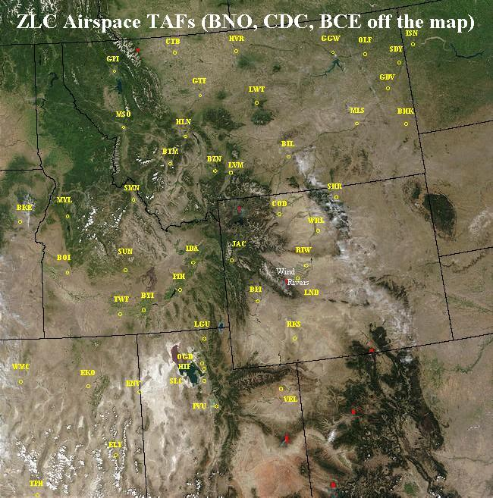

B. OTHER FACILITIES:

1. TRACONs/Approach Controls: (non-Air Force) with phone #s (TMU works with these facilities when it comes to operations such as Ground Delays, Ground Stoppages. En route controllers do “hand-offs” to them)
SLC: 325-9670
BIL: (406) 657-6604, (406) 245-9271, (406) 248-8384
GTF: (406) 454-7500
BOI: (208) 334-1643/1642
TWF: (208) 734-7160
MSO: (406) 549-6001
HLN: (406) 449-5273, (406) 449-5756, (406) 442-8482
Weather Impacts to Internal TRACONs/Approach Controls:

BIL: ASOS site with ILS. Because they have many runway and landing options it is unusual to not be able to release equipment for maintenance. They do not use the TAF much if at all. A contract observer (not the tower) does the ASOS augmentation.
GTF: ASOS site with ILS. They have VOR approaches which enable them to land planes down to 400 ft Cigs and 1 mile visibility. If the weather is getting anywhere near IFR conditions, though, they will not release the ILS for maintenance just to be safe. They definitely use the GTF TAF, key-in on cigs and visibility. They have found the Terminal Forecasts from GTF to be quite good with no bias towards over or under-forecasting weather.
BOI: ASOS site with ILS. As long as they can continue with visual approaches they are OK releasing equipment for maintenance. They use the TAF whenever there is any threat of significant weather, key-in on cigs, windshifts, and visibility, and have not noticed any bias in the TAFs. Their landing minimums are 200 feet and 3/8 mile visibility.
TWF Approach: ASOS site with ILS. Much like MSO (see below) they generally prefer to not release the ILS for maintenance when ceilings drop below 5000 feet or visibilities drop below 6 sm. Regarding the TAFs, they do not look at the TAFs, but look at the NWS public forecasts. Their landing minimums are 200 feet and ½ mile visibility. When looking up the forecasts, they key-in on precipitation and snow.
MSO Approach: ASOS site with ILS. Generally speaking, they are uncomfortable releasing the ILS for maintenance when ceilings drop below 5000 feet or when visibilities drop below 6 sm. Regarding the TAFs, they do not look at the TAFs, but look at the NWS public forecasts. Regarding ASOS, they do augment, mainly for visibility. They noted that the ASOS tends to be too slow at improving visibility. The manager’s name is Tony Terzo.
HLN Approach: ASOS site with ILS. They have both VOR and ILS approaches, but do not have a “radar approach”. For VOR approaches they need a ceiling of about 8000 feet (12,000 feet MSL…they need about 3000 feet of clearance over the top of the surrounding 9000 ft msl mountains. For ILS approaches they need ceilings of about 6-7000 feet. Any restrictions to visibility make them hesitant to release ILS or VOR for maintenance, etc. They use the TAFs, mainly looking for reduced visibilities (apparently it is difficult to forecast ceilings in the HLN area because they do not put much weight in the TAF ceiling forecasts). The approach control does augment the ASOS. They indicate that the TAFs may be a little on the pessimistic side, but that they are OK with that (stay on the safe side). The manager’s name is Richard Duchscher.

2. FAA Towers: (for small airports, tower performs duties of approach control and Tracon)
OGD: 625-5569
PIH: (208) 236-6801

Weather Impacts to Internal FAA Towers:

OGD: ASOS site. They are uncomfortable releasing equipment for maintenance any time ceilings are below 5000 feet and visibilities below 6 miles. They use the TAFs every day, key-in on ceilings and visibility, and have noted no bias in the forecasts. When it comes to ASOS augmentation, they do it mainly for visibility.
PIH: ASOS site. They are uncomfortable releasing equipment for repair if they have any threat of IFR conditions. They use the TAF regularly obtaining it from the PIH NWS web site and key-in on winds and visibility. They have observed no general biases in the TAF forecasts and find them to be “very good”.

3. Contract Towers:
JAC: (307) 732-0664
HLE: (208) 788-3702 Dan Gearhardt manager.
BZN: (406) 388-9082
EKO: (775) 738-4877
IDA: (208) 523-7045 Felicia Hillman manager.
GPI: (406) 257-0229

Weather Impacts to Internal Contract Towers:

JAC: AWOS site with ILS. When Cig drops Below 1500 ft they cannot release the ILS for servicing/repair. (other notes: when the Tower is “open” the AWOS is overridden (“manual” mode) by the Tower, the AWOS auto broadcast/transmission is shut-down (no obs every 20 min), they call obs data into Casper FSS hourly and for Specials, Casper enters the data into the “system”. Their landing minimums are 250 feet and ¾ mile visibility.
HLE: AWOS site with no ILS or VOR precision landing systems. Because of noise abatement issues and mountains, they land going north and take off going south. Exceptions to this are at pilot’s discretion. Landing is more difficult under a south flow because the valley narrows to the north. Their landing minimums are 1900 feet and 1 ½ mile visibility. Like JAC they call in obs hourly to a Flight Service Station. Apparently there is often a ½ hour time lag between when the ob is taken and it makes it into the system (delays by FSS in entering the data?).
BZN: ASOS site with ILS. When Cig drops to 6-7,000 feet can’t release ILS for maintenance because they need it for landings. During the cool season they have poor Doppler radar coverage…the radar tends to overshoots precipitation. The TAFs tend to over-forecast weather at BZN. The “mountains block a lot of the weather” (rain shadow).
EKO: ASOS site with no ILS. Elko Tower has found the EKO TAFs to have no apparent bias towards over or under-forecasting. EKO tower will be closed in the next year.
IDA: ASOS site with ILS. They can’t release the ILS for maintenance if the ceilings and visibility are anywhere near standard IFR levels (1000 & 3). If there is a solid overcast ceiling of 040 (MVA, Minimum Vectoring Altitude) or less they still need the ILS to land planes. If there are breaks in the 4000 ft ceiling they can land planes without the ILS. They have a lot of Air Cargo traffic and Fed Ex does not permit any landings or takeoffs in “frozen/freezing precipitation”. They have found the PIH TAFs to have no leaning towards over or under-forecasting.
GPI: ASOS site with ILS. They are very uncomfortable releasing equipment for repair when ceilings are below 6500 feet (minimum vectoring altitude). They have no other precision landing systems (VORs etc.) and so they can be very restricted when weather blows in. If their ILS goes down it’s a big problem, especially considering the big increases in traffic that they are seeing of late. Notes regarding the ASOS: the ASOS is significantly slow or delayed in reporting visibility changes (both up and down). The ceiling sensor tends to underestimate cloud coverage because it is looking directly overhead and misses low cloud layers which apparently are fairly common. This is a site where using the nearby webcam is strongly advisable. Their landing minimums are 200 feet and ½ mile visibility.

Note: all of the ASOS locations have augmentation responsibilities.

4. Other Airports:
LGU: landing minimums 600 feet and 1 mile visibility.
EVW: landing minimums 700 feet and 1 mile visibility.
ENV: landing minimums 500 feet and 1 mile visibility.
VEL: landing minimums 600 feet and 1 mile visibility.

5. Automated Flight Service Stations (AFSSs):
BOI: (208) 334-1643/9770
CDC: (435) 586-1412/1525
GTF: (406) 268-2119_Cliff Oravec manager
CPR: (307) 261-5573
RNO: 1-800-732-7723

6. Air Force Towers and/or Approach Controls:
GFA: (406) 731-2787
HIF: 777-2909
MUO: (208) 828-2710

7. Other WFOs forecasting for our airspace (although not responsible for any TAFs in our airspace):
Rapid City: (605) 341-0346, 343-8160
Reno: (775) 673-8107, 784-5471
Pendleton: (541) 276-4493
Las Vegas: (701) 263-9744/9750
Flagstaff: (602) 779-3890, 556-7505
Denver: (303) 361-0661
Cheyenne: (307) 772-2370/2376
Albuquerque: (505) 766-2170

8. Airlines Dispatch Meteorological Contacts:
Delta Airlines Dispatch Meteorologist: (404) 715-0174
United Airlines Meteorologist: (312) 952-6301
Northwest Airlines Meteorologist: (612) 726-0615

9. Aviation Weather Center:
West Desk: (816) 584-7227
Lead Desk: (816) 584-7269

10. Air Traffic Control System Command Center (ATCSCC or Central Flow Control) Weather Unit: (703) 904-4504

11. CWSUs at Air Route Traffic Control Centers (see map below):

Albuquerque ZAB: (505) 856-4690
Auburn ZSE: (206) 351-3741 (Ops) -3402 (MIC)
Denver ZDV: (303) 651-4251 (Ops) -4201 (MIC)
Oakland ZOA: (510) 745-3457 (Ops) -3425 (MIC)
Los Angeles ZLA: (661) 265-8258 (Ops) -8340 (MIC)
Minneapolis ZMP: (651) 463-5589
Anchorage ZAN: (907) 338-1010, 269-1145
Atlanta ZTL: (404) 946-7693
Boston ZBW: (603) 886-7698
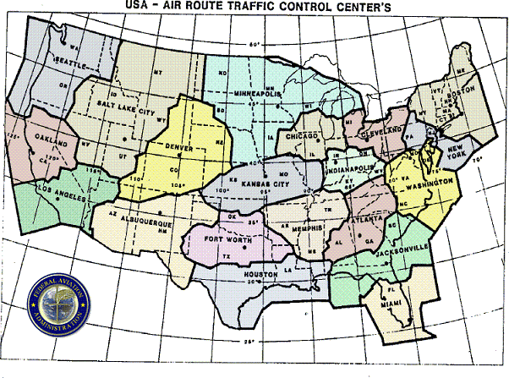

C. ARTCC FACILITY STRUCTURE
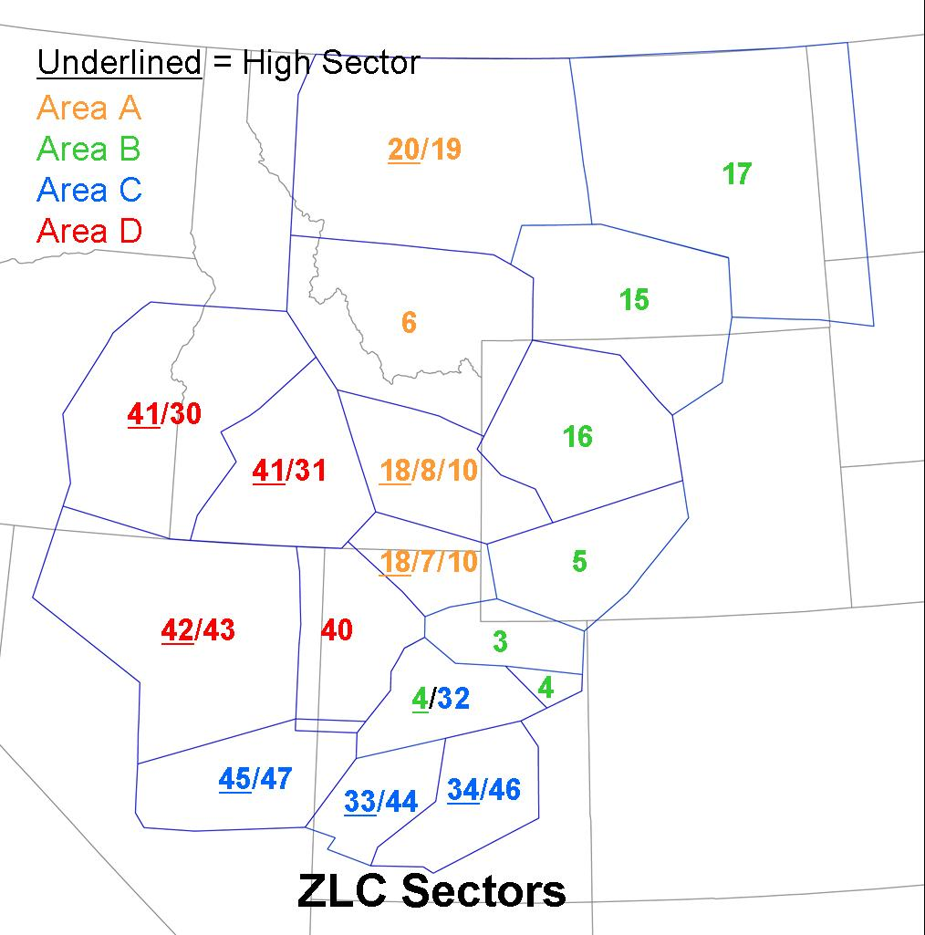

1. Area A Sectors: western MT, eastern ID, UT-ID border area
a. Ops Manager: Rocco Vitacca, Ext -3212,
b. Area Supervisors: Dan Williamson, Greg Northcutt, Paul Newbury, Steve Nelson, Alberto Uribe
c. Sector Descriptions (usually 5 out of 7 possible sectors open):
Low-High Combined: sector 6
High: sectors 20, 18
Low: sectors 19, 7, 8, 10
Notes: sector 18 overlays sectors 7 & 8 (AOA FL330, typically split-off/open during morning push), sector 10 underlays sectors 7 & 8 (AOB Alt130, typically opened during the evening cargo push), and sector 20 overlays sector 19 (typically open/split off several hours during the day) when transcon traffic increases.
d. En Route Weather Impacts: thunderstorms (especially near Bearr and Cartr approaches), turbulence, icing, mountain waves, strong winds, volcanic ash, and mountain obscuration. Other impacts include any weather that forces airport closures or landing restrictions such as low cigs and visibility due to snow, dense fog, or low clouds and mountain obscuration.

2. Area B Sectors: eastern MT, MT-ND border area, and MT-SD border, western WY, and northeast Utah.
a. Ops Manager: Matt Csisery, Ext -3034
b. Area Supervisors: Greg Tinnes, Mike Sonognini, Tom Meyer, Richard Seaman, Penny Jones, Luther Glass.
c. Sector Descriptions (6 sectors, open most of the time during the day):
Low-High Combined: sectors 17, 15, 16, 5, 3, and eastern-most corner of 4
High: sector 4
Notes: sector 4 overlays Area C Sector 32 (AOA FL310+)
d. En Route Weather Impacts: see Area A Impacts (page 6 above)

3. Area C Sectors: central & southern UT, east central NV.
a. Ops Mngr: Don McFarland, Ext -3230
b. Area Supervisors: Bill Combs, Greg Grant, Laura Matthews, Jim Leake, Mike Blackburn.
c. Sector Descriptions (5 or 6 of 7 sectors usually open during the day and frequently all 7):
Low-High Combined: none.
High: sectors 33, 34, 45
Low: sectors 32 (AOB FL310), 44, 46, 47.
Notes: sector 32 underlays sector 4 in Area B. Sector 33 is unique in that it can go from a single sector to as many as 4 sectors. Phase 1 split is a high-low split (33 high and 44 low). Phase 2 splits off the lower portion of the east half calling it sector 46. Phase 3 splits off the higher portion of the east half calling it sector 34.
d. En Route Weather Impacts:
Nellis-South UTTR Corridor: thunderstorms in the corridor between Nellis and the Utah Test and Training Range South can cause flow problems because of the high volume of traffic forced through this corridor (sector 47). See Military airspace diagrams in Section E.
See Thunderstorms in Southern Utah (Impacts related to TMU “R2” position)
See also Area A Impacts (page 6 above)

4. Area D Sectors: southeast OR, southwest ID, northern NV, northwest UT.
a. Ops Mngr: Larry Jordan, Ext – 3213
b. Area Supervisor: Robert Langley, Perry Halls, Steve Goering, Mike Smith, Joe Bowman, Jim Rudnicki
c. Sector Descriptions (usually about 4 out of 6 sectors open during the day):
Low-High Combined: sector 40
High: sectors 41, 42
Low: sectors 30, 31, 43
Notes: sector 28 (still on some charts) used to be the southern split off portion of 40.
Sector 42 typically splits off of 43 for a couple hours during the day. Sector 41 overlays both 30 and 31. Sector 30 splits off the west half of sector 31 (only happens a handful of times a year when have both weather and high traffic into Sun Valley).
d. En Route Weather Impacts:
See West Gate Choke Point (Weather Impacts related to TMU “R1” position)
See also Area A Impacts (page 6 above)

5. Traffic Management Unit (TMU):
Traffic Management Officer (TMO): Kelly Moffitt -2580
Supervisory TM Controllers: -2581 (Matt Csicsery, Joe Poirier, Cindy Gerber-Chavez)

6. TMU “R1” Position: SLC Meter: position responsibilities: everything within approximately 75-100 miles, Salt Lake Arrivals, Monitor Alert (sector volume alarms), Weather Coordinator (pireps), Military Ops (updates to UTTRs, GABs, MHs). Very busy in the winter due to low cigs and vsbys, IFR approaches, snow, fog. Also responsible for FSM (flight schedule monitor) which is the AAR chart from the FAA page.

WEATHER IMPACTS RELATED TO THE TMU “R1” POSITION:

a. West Gate Choke Point: when both the military ranges (Utah Test and Training Range (UTTR) north and south of I-80 are “hot”, jets have little room to deviate for thunderstorms.
The south side of Knole corridor/gate is for eastbound traffic, while the north side is for westbound traffic…when one side is clogged by thunderstorms both east and westbound traffic is forced to stack-up in a single lane and take different Flight Levels.
Thunderstorms over Knole Gate/Wendover Choke-point force flow way around to the north or south of the Utah Test and Training Range (UTTR).
Also, when the ranges are ‘hot”, holding is often done west of Wendover. Thus the area near Wendover becomes a “choke point”.

b. Thunderstorms over Approaches/Departures: any thunderstorms (regardless of height of tops) can cause avoidance problems for air traffic when they are in the approach/departure routes and may lead to MIT restrictions and/or shut down a particular gate.

c. Lines or Areas of Thunderstorms that force traffic into a neighboring sector can cause controller manpower problems (sector overload alarms at the R1 position)

d. Runway Changes (wind shifts) in the middle of a “push” create big problems and delays. Aircraft have to go into holding pattern while runway is changed…they may be forced to fly to alternate if they have to hold too long (supposed to carry enough fuel to both hold for 30-45 minutes and fly to alternate airport)

e. Thunderstorms directly over the airport cause big problems: shear, turbulence, wind shifts, lightning alerts for ground crews, etc, etc.

f. Thunderstorms over SPANE and CARTR Arrivals: if thunderstorms form over one of the two east gates it forces the normally split stream into a single stream…thunderstorms south of the Uintas force flow to pile up on the north side of the Uintas and vice versa.

g. Thunderstorms over BEARR and CARTR Arrivals: if thunderstorms form over one of the two north gates it forces the normally split stream into a single stream…thunderstorms over Bearr force flow to stack up over Cartr and vice versa.

h. Mountain Wave Turbulence and Clear Air Turbulence can affect SLC Approaches by creating altitude compression problems: see graphic in appendix for areas prone to these types of turbulence.

i. Ceilings below 060-070 at SLC: flights are forced to do IFR approaches when ceilings drop below 6000 to 7000 feet. These approaches are more circuitous and take more time because they are forced farther south/north to line-up with ILS in FFU/OGD. This drops the AAR from 84 down to 64. When running visual approaches they can land planes side-by-side. When ceilings drop to 060 or lower they are forced to do IFR approaches and stagger landings on the parallel runways. Sometimes even a scattered layer below 060-070 can force ILS approaches and a decrease in Airport Arrival Rates.

j. Winter-time Haze or Light Fog: on cool-season days when there is haze, smog, or light fog in the valley (reducing visibility to less than 6 miles approximately) the Airport Arrival Rates can be reduced as planes are forced to do IFR approaches, especially in the morning when there is a low sun angle causing glare and reduced slantwise visibility. During daytime haze/fog events, pilots prefer to land towards the north because when landing to the south, the reflection of the sun off the fog/haze can make it very hard to see the runway and runway lights.
In this type of scenario TMU prefers a north runway so that planes are landing with the sun (and glare) at their backs. Prevailing south-southeast drainage winds in the morning typically force a south runway, but if the south winds are 3-4 kts or less they will land with the light tail wind so that they hopefully maintain VFR approaches. Using the north runway during the morning push has a couple other advantages as well: 1. the heavy arrival volume from the south (the bulk of the morning push is from the south) can fly straight in and 2. there are more departure gates (3 instead of 2) with a north runway than a south runway (less congestion).

k. Dense Fog: this can be a big issue in the winter. When fog settles in around the airport, clearance to land is based not on ASOS visibilities (like those forecast in the TAF), but based on RVRs and the RVR landing minimums of the aircraft.
Weather Minimums for Salt Lake Airport are:
ILS Cat I: 200 ft CIG, 1800 ft RVR (1/2 mile vis if RVR not available).
ILS Cat II: 100 ft CIG, 1200 ft RVR
ILS Cat IIIa: 0 ft CIG, 700 ft RVR
ILS Cat IIIb: 0 ft CIG, 300 ft RVR
ILS Cat IIIc: 0 ft CIG, 0 ft RVR
Per FAA regulations RVR of 2400 ft = ½ mile vis
RVR of 1600 ft = ¼ mile vis

Special training and equipment onboard the plane define what ILS categories a pilot can use. Most Delta jets can land Cat III. Most regional jets (i.e., Skywest) can use Cat II. Others, like America West, are only Cat I. It costs money to keep pilots proficient with Cat II and Cat III landings, as well as the computer equipment on the plane.

l. Compression Problems at Arrival Gates: for example, strong northwest winds cause compression problems for aircraft approaching the north gates. Planes coming from the north have already accounted for the tailwind. Planes from the south have to make a big turn and may fail to adjust their ground speed to account for the switch from head wind to tail wind. This often causes compression of traffic (horizontal separation issues).

m. Evening Cargo Push: there is an evening cargo push made up mostly of smaller planes from Idaho and Montana that lands on runway 17/35. The evening cargo push is easiest with a south wind. The planes fly straight in and (if it’s IFR) pick up the ILS at Ogden on the way. About a third of the evening cargo push do not show up on Airport Arrival Rate charts because they do not file flight plans (no flight plan required unless it’s IFR). In other words, there is more traffic during the evening than the AAR charts would suggest.

n. Snow Accumulation on Runways: as little as a quarter inch of snow can close a runway for plowing or “brooming”. Very localized “Lake Effect” snow bands can cause serious problems for the airport due to the extreme snowfall rates. They can also come and go very quickly and are difficult to predict. Fortunately though, they are most common overnight after the evening push, but can continue into the morning push before dissipating.

o. Crosswinds: crosswinds are fairly uncommon at the SLC airport due to the fact that most wind is channeled into a roughly north-south orientation by nearby mountains. Crosswinds, when they do occur are usually fairly short-lived and are frequently due to microbursts, thunderstorm outflows, or cold fronts.

p. Microbursts: the tower, tracon, and flow control can be greatly benefited by even a 15 minute heads-up on wind shifts or cross-winds related to microbursts and thunderstorms.

q. “Canyon Winds”: although the airport sensors rarely if ever pick up on the infrequent strong easterly “Canyon Winds” that occur along the Wasatch Front, these winds can cause severe turbulence as well as low-level wind shear problems around the airport.

r. “Lake Breeze”: although the lake breeze can be fairly predictable on days with light winds, it can become very difficult to forecast on days when there is a stiff south wind. Strong south winds can hold off the typical afternoon lake breeze completely. On such days the lake breeze can also get stalled directly over the airport leading to a tail wind at one end of the runway and a head wind at the other end. The normal daily wind cycle consists of an afternoon through mid-evening lake breeze (northwest wind), which turns around during the late evening to a southeasterly “Land Breeze”. This southeast breeze, under normal circumstances, continues until the lake breeze returns the next afternoon.

s. Icing in Sector 7 during Cargo Push: icing around altitude 120-150 in the evening over BEARR and CARTR approaches can cause significant problems for smaller aircraft coming into SLC during the evening push.

7. TMU “R2” Position: En Route: position responsibilities: ZLC airspace beyond 100 miles from SLC; MIT and ground delays for other facilities; playbook routes, and MIT for ZLC en route airspace. R2 is very busy in summer due to severe weather and thunderstorms (often requires 2 people to cover the position). R2 gets especially busy in the afternoon around shift change (2 pm) when they receive calls from Flow Control requesting numerous playbooks for re-routing around afternoon convection. They commonly monitor convection on the TSD (Traffic Situation Display) overlaying the CCFP and national radar mosaic. Pacing airports that have the most impact on R2 are #1 SFO (typically request MIT in the morning push), #2 Newark/JFK, and #3 LAS & PHX (MIT in the morning push).

WEATHER IMPACTS RELATED TO THE “R2” TMU POSITION:

a. Playbooks: ZLC does not have its own “playbooks” but is affected by playbooks initiated elsewhere (typically east of the Rockies). These playbooks are disseminated through the R2 TMU Position. For example, a line of thunderstorms in the Midwest or west of Chicago forces Playbooks which affect en route traffic over ZLC. The same applies for thunderstorms in the Chicago-NYC corridor. See Section D on Playbooks.

b. Thunderstorms with tops above FL300 cause avoidance problems for en route air traffic. For example, significant coverage of high-topped thunderstorms in southern Utah (the BCE-MLF corridor) can cause flow problems for traffic headed south to LAS, PHX, or LAX. Area C has the highest density of traffic of the four Areas in ZLC and hence is most sensitive to thunderstorm activity.

c. Mountain Wave Turbulence and Clear Air Turbulence can affect en route air traffic by creating altitude compression problems (see map below for areas prone to CAT and Mountain Wave Turbulence based on historical PIREP records).
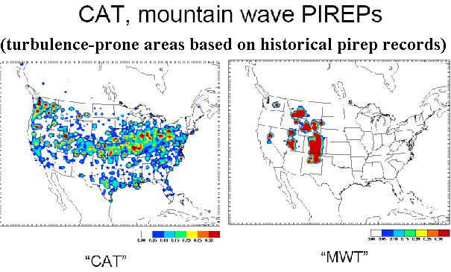

d. Traffic Restrictions at Pacing Airports outside ZLC: low visibilities and ceilings, cross winds, and thunderstorms at airports such as SFO, DEN, ORD, LGA, PHL, and DCA can force delays, MIT, or other flow restrictions for ZLC enroute aircraft.

D. SALT LAKE CITY INTERNATIONAL (HUB AIRPORT):
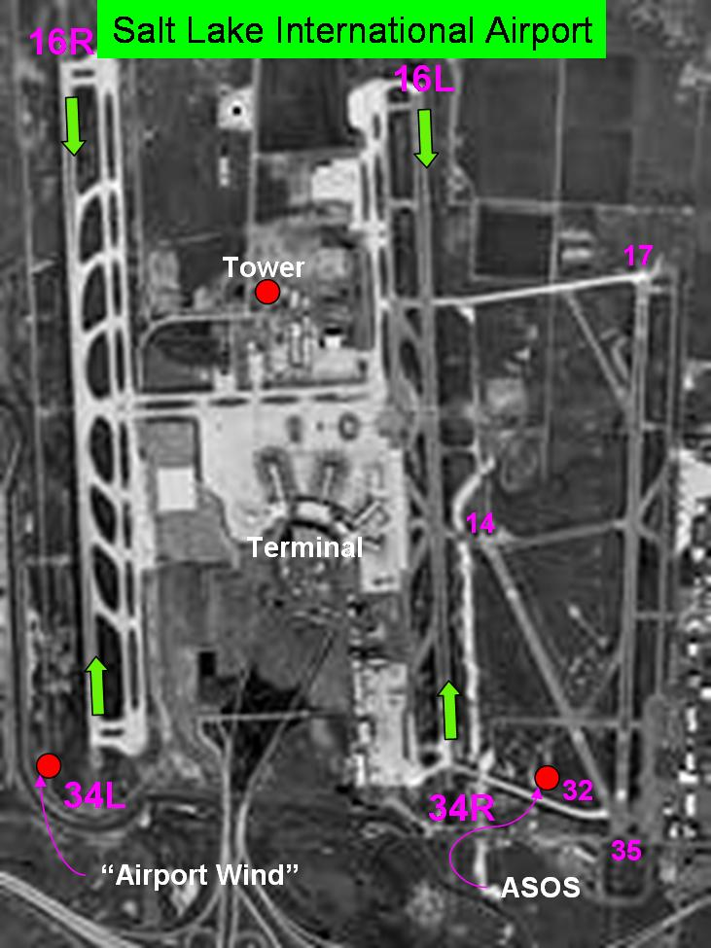

1. SLC Daily Pushes
a. Morning: 8-10 a.m.
b. Afternoon: 3-4 p.m.
c. Evening: 6-8 p.m. Note: this push is bigger than AAR charts indicate because approximately 30% of the planes do not show up on the chart because many of the cargo push planes do not file flight plans under VFR conditions.
d. Other: Fridays and Sundays are busiest days of the week.

2. SLC Runways: (see Airport Photo above or Airport Diagram at end of document)
a. 34L/16R, 34R/16L:
Minimums: depends on aircraft (See TMU “R1” Weather Impacts #11)
Limiting Issues: crosswinds (microbursts), dense fog, heavy snow
b. 35/17:
Minimums: 200 ft ceiling, ½ mile visibility
Limiting Issues: see above
c. 32/14:
Minimums: 1000 ft ceiling, 3 mile visibility
Limiting Issues: see above

3. Significant Weather at SLC: the 3 main things that can shut down runways are:
a. crosswinds or microburst thunderstorm winds (pilots have to pull out of landings when winds are contrary…when they don’t meet certain criteria),
b. heavy snow requiring plowing of the runways (the city of Salt Lake calls the shots on plowing, not the FAA…they usually close down a runway for plowing the moment they get pireps indicating fair/poor braking action or (if there is little traffic…approximately 10+ minutes between landings) when the test vehicle measures fair/poor braking action (takes about an hour to plow a single runway with all the plows operating), and
c. dense fog: during dense fog episodes, some planes can land while others are forced to hold for improved RVRs. This depends on the Instrument Rating of the aircraft and crew (see TMU “R1” Weather Impacts #11). The regional jets tend to have the poorer capability for landing in dense fog. If it’s cold enough (and it usually is with dense fog) cloud seeders seed the area just west of the runway, a hole develops in the fog as the air drifts east over the runways, opening up the west runway first, then the east runway a little later as the hole continues its eastward drift.
d. Also see TMU “R1” Weather Impacts.

4. SLC Arrival and Departure Gates (see map below): (for weather impacts at the Gates see “weather impacts related to the TMU “R1” position” above)
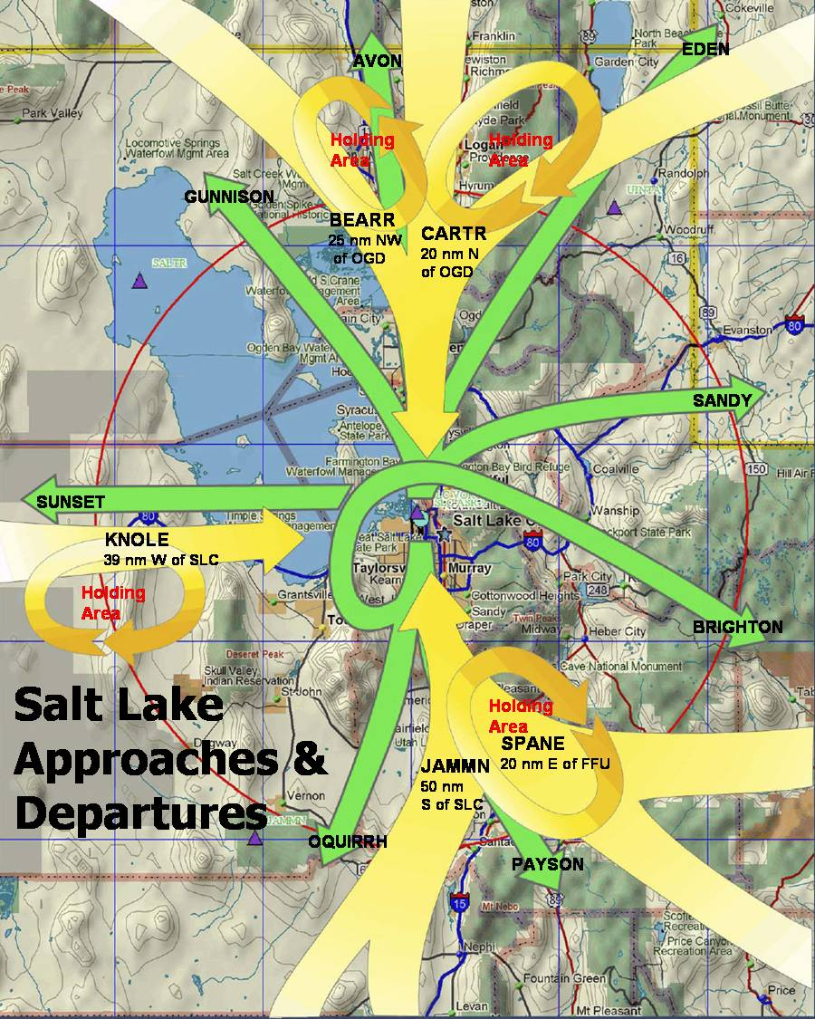

5. Actual 24-hr Flows for SLC Airport (a single day in 2005):
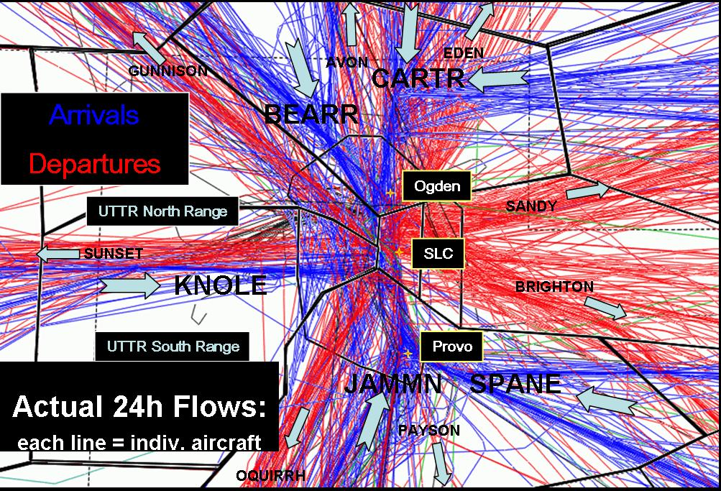

6. SLC Arrival-Departure Crossing Points--South Flow: when operating in a South Flow (see chart below) there are 4 points at which incoming and outgoing traffic can potentially cross paths. By contrast, in a North Flow (see the next chart below) there are only 2 points at which incoming and outgoing traffic can potentially cross paths. In this sense, a North Flow pattern makes for simpler traffic patterns and easier air traffic control.
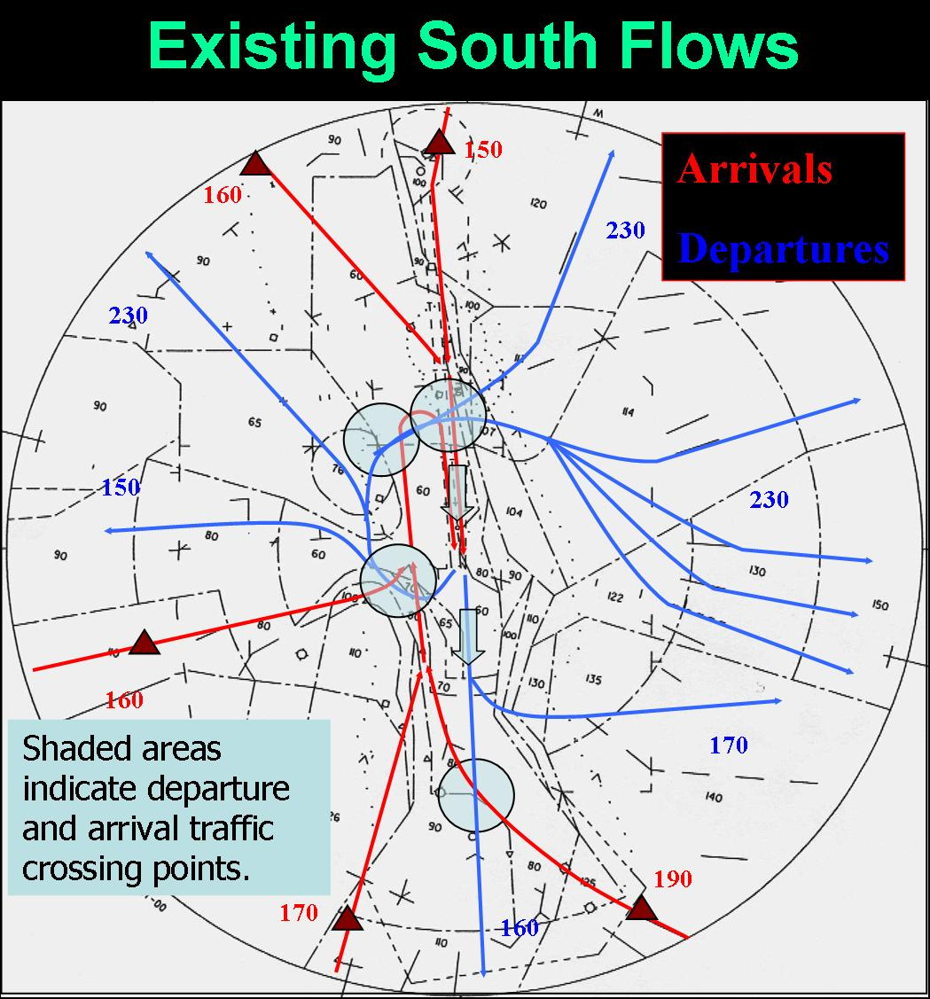

7. SLC Arrival-Departure Crossing Points--North Flow: when operating in a North Flow there are only 2 points at which incoming and outgoing traffic can potentially cross paths. By contrast, in a South Flow (see chart above) there are 4 points at which incoming and outgoing traffic can potentially cross paths.
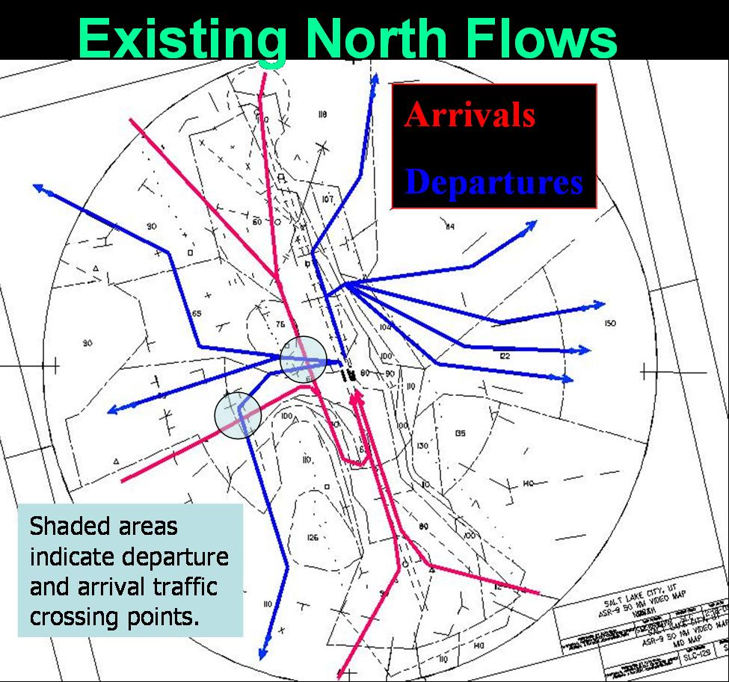

8. SLC General Climatology:
Salt Lake City is located in a northern Utah valley surrounded by mountains on three sides and the Great Salt Lake to the northwest. The city varies in altitude from near 4200 feet to 5000 feet above seal level.
The Wasatch Mountains to the east have peaks to nearly 12,000 feet. Their orographic effects cause more precipitation in the eastern part of the city than over the western part.
The Oquirrh Mountains to the southwest of the city have several peaks above 10,000 feet. The Traverse Mountain Range at the south end of the Salt Lake Valley rises to above 6,000 feet. These mountain ranges help to shelter the valley from storms from the southwest in winter, but are instrumental in developing thunderstorms which can drift over the valley in the summer.
Besides the mountain ranges, the most influential natural feature affecting the climate of Salt Lake City is the Great Salt Lake. This large inland body of water, which never freezes over due to its high salt content, can moderate the temperatures of cold winter winds blowing from the northwest and helps drive a lake/valley wind system. The warmer lake water during the fall through the spring also contributes to increased precipitation in the valley downwind from the lake. The combination of the Great Salt Lake and the Wasatch Mountains often enhances storm precipitation in the valley.
Salt Lake City normally has a semi-arid continental climate with four well-defined seasons. Summers are characterized by hot, dry weather, but the high temperatures are usually not oppressive since the relative humidity is generally low and the nights usually cool. July is the hottest month with average maximum readings in the nineties.
The average temperature range is about 30 degrees in the summer and 18 degrees during the winter. Summer temperatures above 102 degrees or winter temperatures colder than -10 degrees occur only 1 season out of 4.
Winters are cold, but usually not severe. Mountains to the north and east act as a barrier to frequent invasions of cold continental air. The average annual snowfall is around 60 inches at the airport, but much greater amounts fall on higher bench locations. Heavy fog often develops under temperature inversions in the winter and can persist for several days.
Precipitation, generally light during the summer and early fall, reaches a maximum in the spring when storms from the Pacific Ocean are moving through the area more frequently than in any other season of the year.
Winds are usually light, although occasional high winds have occurred in every month of the year, particularly in March.
See Salt Lake City LCD (Local Climate Data) for 30-year averages of temperature, degree days, sunshine, sky cover, precipitation, snow, thunderstorms, fog, station pressure, humidity, wind, etc at http://www.wrcc.dri.edu/cgi-bin/clilcd.pl?ut24127

9. SLC Aviation Climatology: these charts are based on 30 years of data at SLC International Airport from the years 1961-1990.

a. Hourly Frequency of Thunderstorms (by season): the highest frequency of thunderstorms at the airport is during the summer months with the minimum during the winter. The maroon bars represent lightning within 50nm of the airport as reported by lightning detection systems. The purple bars represent thunderstorms reported in the observation by a human observer. See chart below.
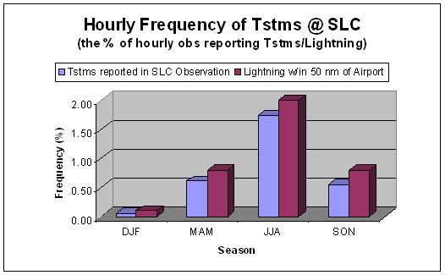

b. Daily Frequency of Thunderstorms (by season): During the summer months there is approximately a 1 in 4 chance of thunderstorms at the airport on any given day whereas during the spring and fall there is about a 1 in 8 or 9 chance of thunderstorms at the airport on any given day. See chart below.
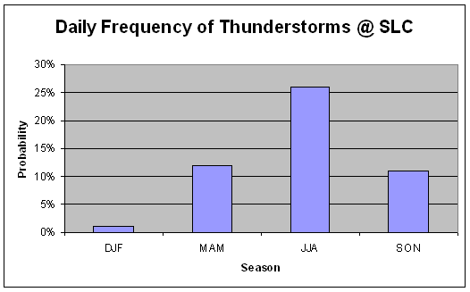

c. Hourly Frequency of Significant Ceilings (by season): During the winter ceilings below 7000 feet occur over 1/3 of the time (probably shooting instrument landings with an AAR of 64). Also during the winter, Low IFR ceilings (<500 ft) occur over 9% of the time (adding up the frequency of the lowest three categories). See chart below.
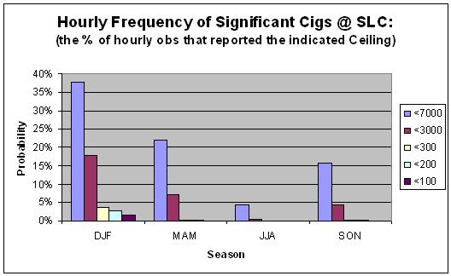

d. Hourly Frequency of Significant Visibilities (by season): During the winter visibilities below 7 miles occur over 1/3 of the time (probably shooting instrument landings due to slant-wise visibility with an AAR of 64). Also during the winter, Low IFR visibilities (<1 mile) occur over 7% of the time (adding up the frequency of the lowest two categories). IFR visibilities (<3 miles) occur over ¼ of the time. See chart below.

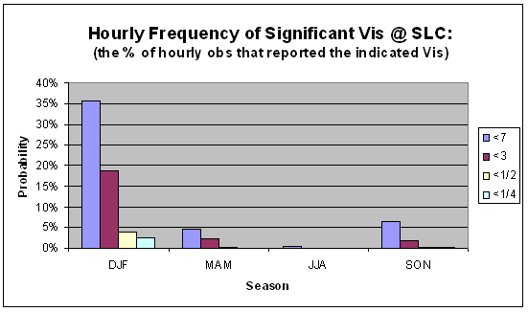

E. FAA PLAYBOOK OPERATIONS AND CCFP:

1. Most Common Playbooks affecting Air Traffic over ZLC:
a. IIU (“Louisville”): Thunderstorms over the Great Lakes and/or the Northeast forces traffic to shift a gate south. See chart below.
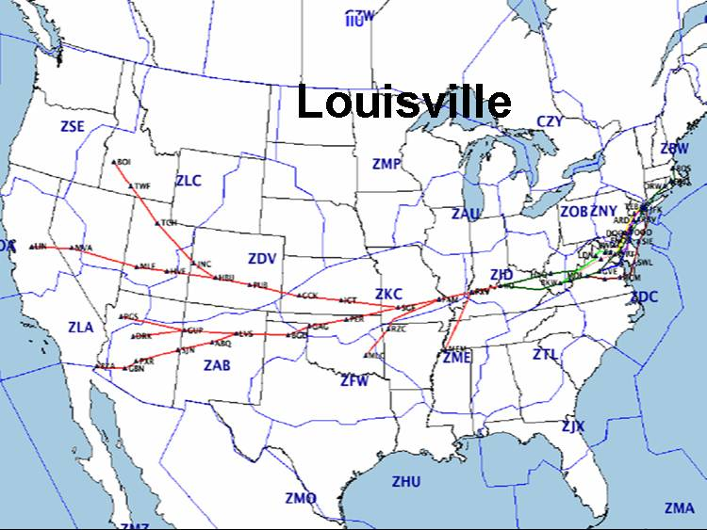

b. VUZ (“Vulcan”): Thunderstorms over or near Tennessee leads to a big re-route. Air traffic is forced two gates south. See chart below.
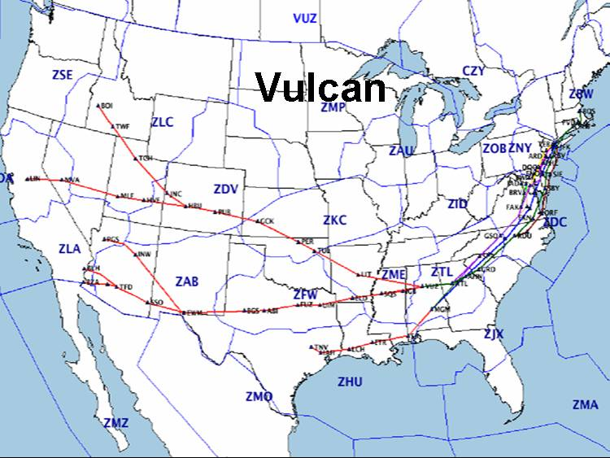

c. BAE1 & BAE2 (“Bradford” or “Badger”): this playbook is called-up when there are thunderstorms over Bradford Center airspace west of Chicago or in the South. Traffic is forced one gate to the north or northwest. See chart below.
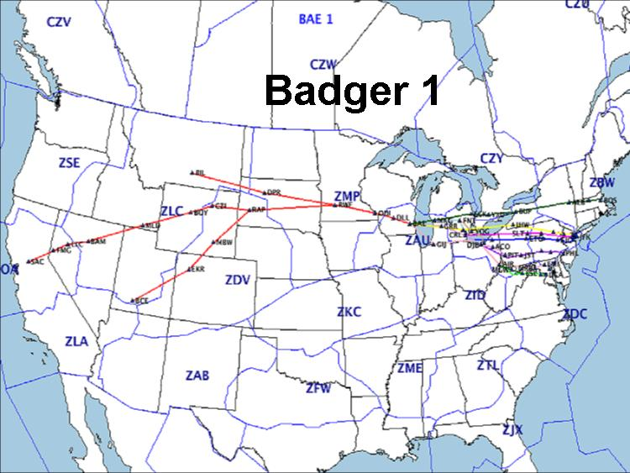

d. CAN1/CAN2/CAN6: Thunderstorms over the northeast or southern Great Lakes forces traffic a gate north into Canada. See chart below.
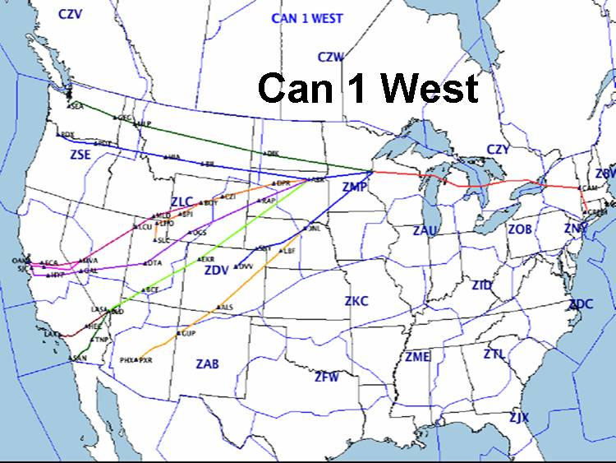

e. IAH (Houston West): Thunderstorms in the Dallas-Albuquerque area. See chart below.
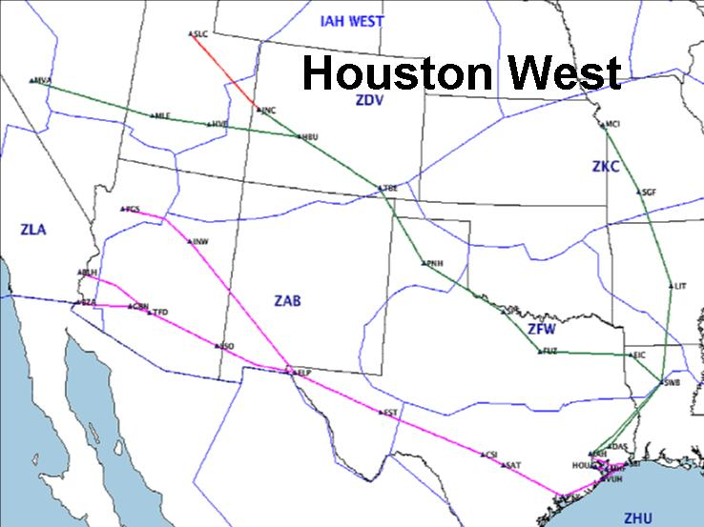

f. DFW DKW (“Bouie”): Thunderstorms in KS, TX, OK…forces re-routes 1 gate west/southwest of normal routes. See chart below.
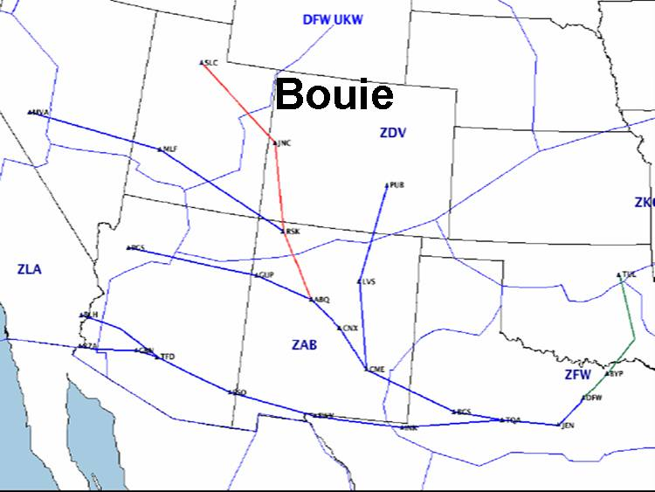

2. Support to Strategic Plan of Operations Telcon:
Participants: airlines managers and mets, major tracons, FAA Command Center, nbaa desk
Telcon Schedule: every 2 hours beginning at 1215Z, ending based on weather.
Weather Requirements: none

3. Weather Impacts to Nearby Pacing Airports(Outer-Tier):
a. SFO: fog and low ceilings
b. LAX: fog and low ceilings
c. LAS & PHX: blowing dust, wind, thunderstorms

4. Airway Closers: thunderstorms, severe turbulence, severe icing, volcanic ash. See maps of Jet Airways and Victor Airways below.
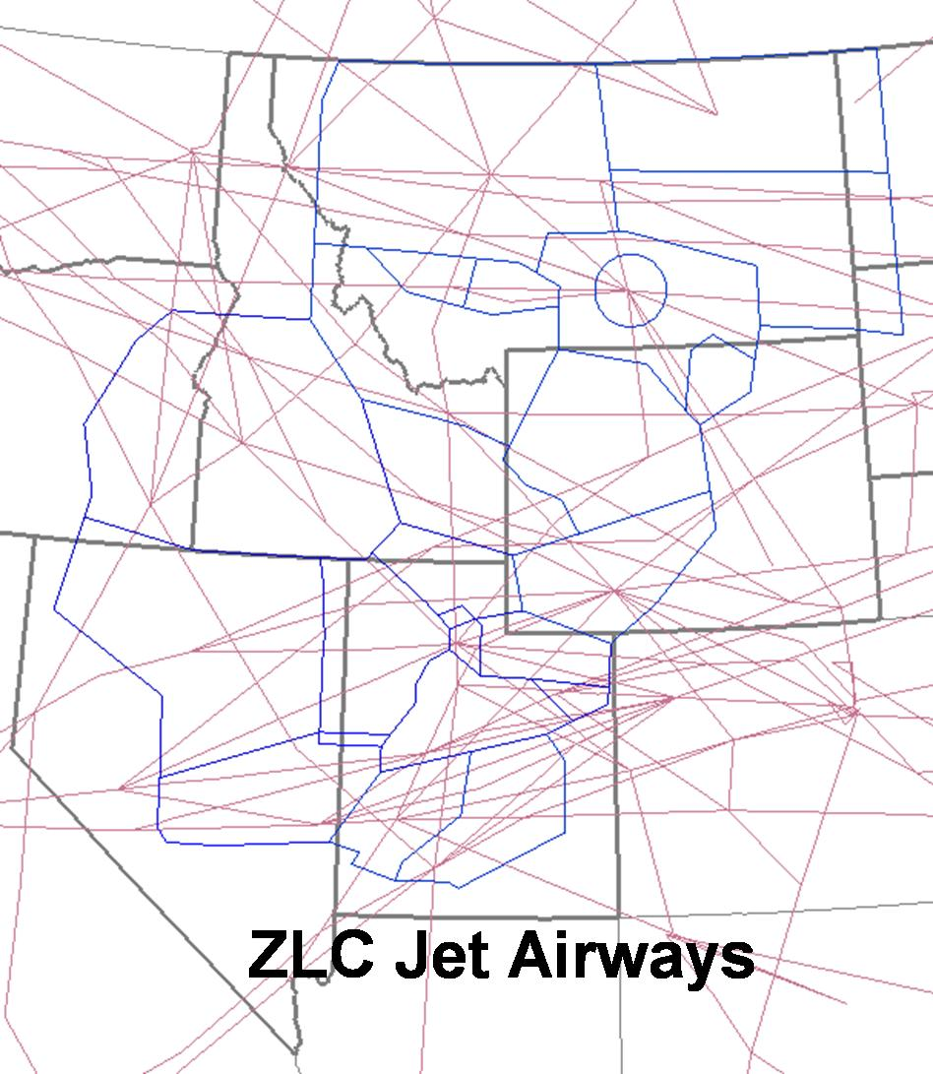

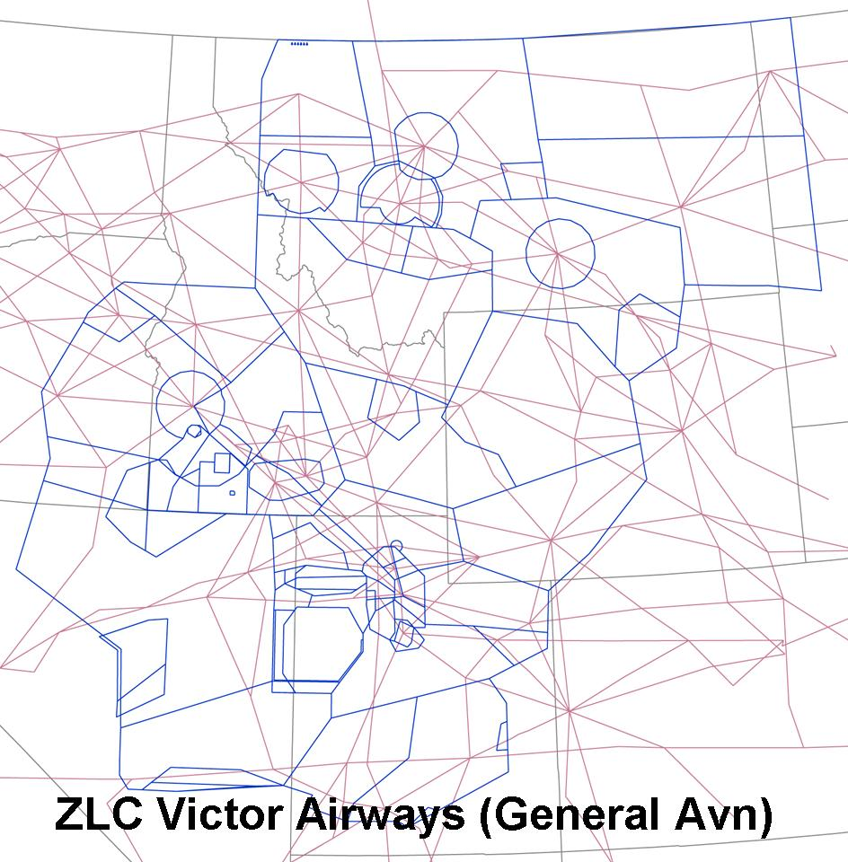
5. Regional Routes: no Regional Playbooks for ZLC.

F. SPECIAL ARTCC REQUIREMENTS:

1. Quality Assurance Office: Weather Support Needs:

a. Operational Errors: observations 1-hour before through 1 hour after, radar, satellite, airmets and sigmets, thunderstorms in the vicinity.
b. Aircraft Accidents (fatal and non-fatal): notify affected NWS forecast office with all available information regarding the crash. Be prepared to provide weather information to Quality Assurance upon request (observations 1-hour before through 1 hour after, radar, satellite, airmets and sigmets, thunderstorms in the vicinity, pireps, winds aloft, etc.).

2. Routine Briefings to ARTCC and other FAA Facilities:
a. ARTCC Verbal Briefings:
Standup Briefing: 8:05 am, 4:15 pm. Briefing Content: Goes-West IR2, National Radar, MTX Radar, Upper Level Winds, Current Conditions, Forecast (out 8 hours), Airmets/Sigmets.
Pre-Standup Briefing of OMIC: around 7:00 am.
Close-Up Briefing of TMU: around 9:30 pm prior to closing CWSU for the night.
b. ARTCC Written Briefings: None

3. Special Event Briefings
a. Special Traffic Management Programs (STMPs): Jackson, Sun Valley, & Twin Falls. Typically the forecast is requested first thing in the morning for the following morning (24-hour forecast).
Date of Event: Labor Day weekend, several days surrounding the 4th of July, Thanksgiving, and Christmas through New Year’s
Weather Issues: aircraft required to sign up for landing slots at resort airports having high volume of air traffic near holidays. Landing minimums at TWF 200’ and ½ mile visibility, at JAC 250’ and ¾ mile visibility, and at SUN 1900’ and 1.5 mile visibility.
Requested Products: forecast of ceilings, visibilities, and weather 24 hours in advance so they can schedule volume/number of slots according to expected airport arrival rates.
b. ”Herb Allen Fly-In” at Sun Valley:
Date of Event: begins 1st Tuesday after 4th of July..lasts four days…but the STMP runs from Monday to Monday surrounding the event. All the richest businessmen in the country fly into the area for big financial meetings.
Weather Issues & Requested Products: see STMP program above.

4. Automated Flight Service Station (AFSS) Support: no routine support; on an “as needed” basis.

5. Outreach Programs: SLCC Aviation Program, University of Utah Meteorology Program, Utah Air National Guard, Civil Air Patrol, SLC Tower and Tracon, NWS forecast offices within the airspace, towers and tracons within ZLC airspace.

6. Center-Unique Support to FAA and NWS Components: Tracon/TMU Briefer Web Page including Compression and Gate Forecast Tactical Decision Aids. We proactively brief the SLC Tower and Tracon for thunderstorms, wind shifts, snow, microbursts, etc.

E. MISCELLANEOUS:

1. Aerial Photograph of ZLC Airspace with annotations of Land Forms:

2. ZLC Military Airspace with Military Area Names (without sectors):

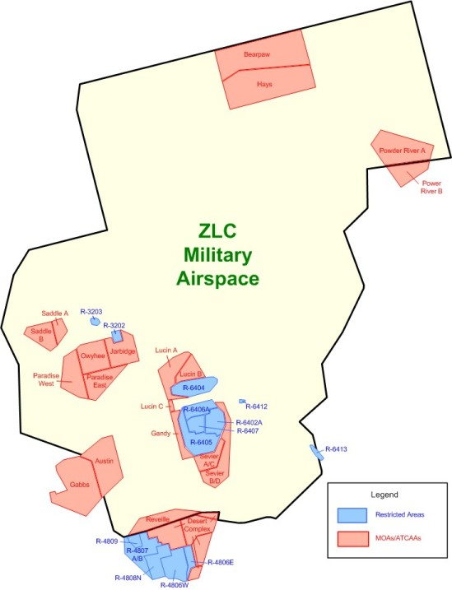

3. ZLC Military Airspace with Sectors:
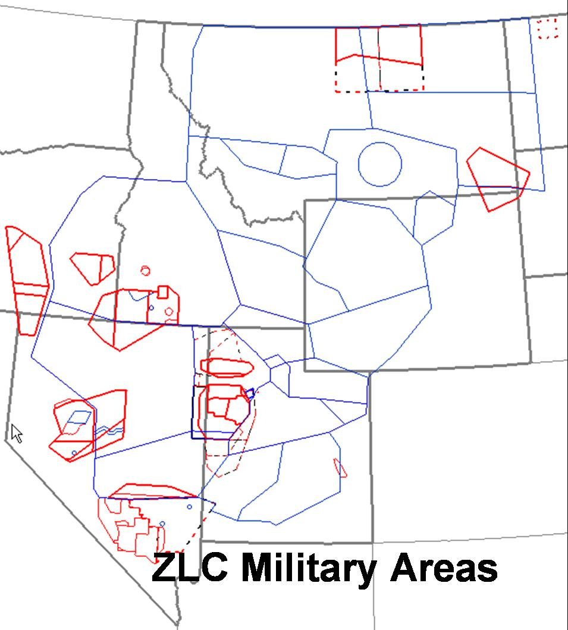

3. SLC Airport Diagram:
