HVAC Air Systems

Recirculation Air System Types

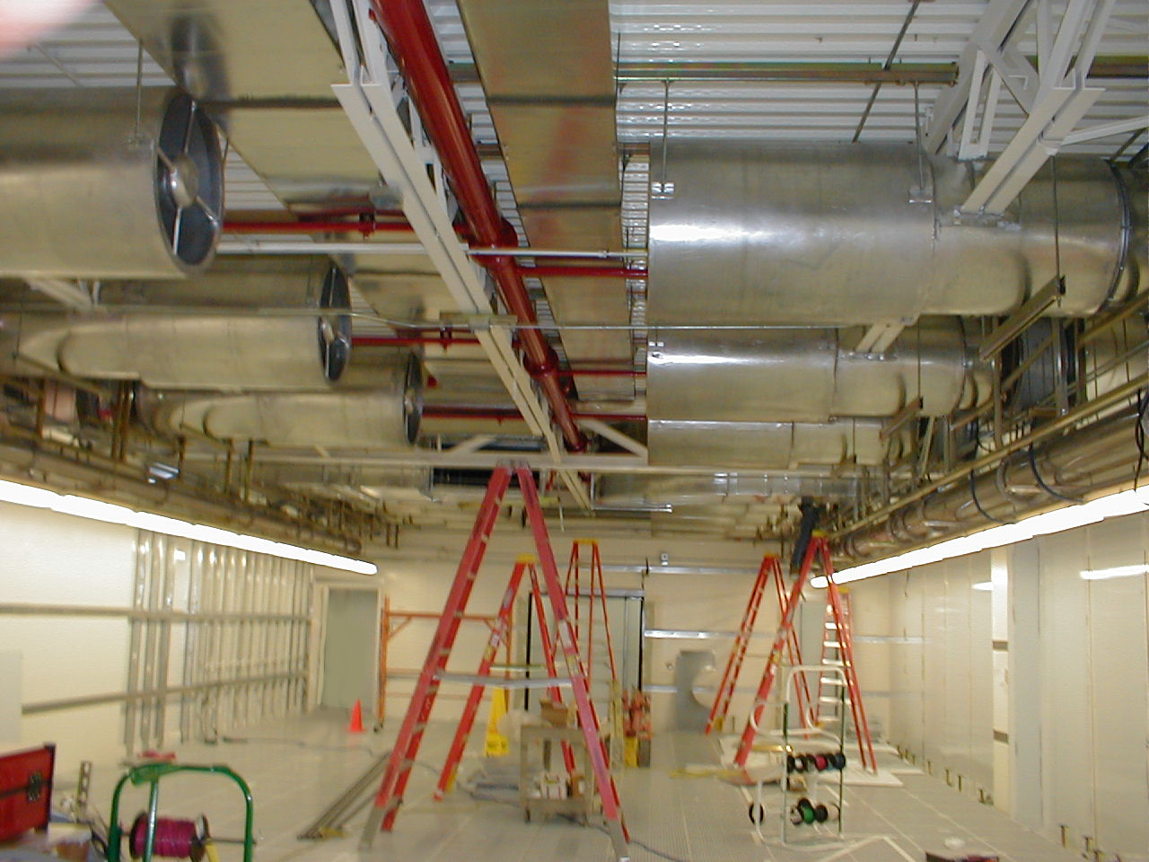

Summary
Recirculation air handler fan energy can account for 10 to 30% of total cleanroom energy use. There are three fundamental recirculation system configurations: fan filter unit (FFU), ducted HEPA, and pressurized plenum. The selection of the system configuration is usually dictated by building configuration, initial investment cost, and constructability.

Figure 1. Examples of Cleanroom Configurations (MUAH-Makeup Air Handler, RCU-Recirculation Air Unit, OSA-Outside Air)
The LBNL Benchmarking project measured the performance of a number of operating installations of each air handling configuration and found the pressurized plenum design to be the most efficient for class 10 and 100 cleanrooms. Pressurized plenum cleanrooms performed the best due to the low pressure drop of the supply and return air paths. Within all system configurations, a large variation in efficiencies was seen; regardless of the configuration selected, there are many opportunities to reduce the energy usage by over 50% compared to the average for that system configuration. When determining the efficiency of a recirculation air system, the fan energy used to provide sensible cooling also must be considered.

Figure 2. Average Measured Efficiency of Recirculation System Types

Principles
- The recirculation system efficiency equation is:
$${\text{cfm}}/{\text{kW}}=\frac{\text{Total}\text{Ceiling}\text{Airflow}(\text{cfm})}{\text{Recirculation Fan kW }+\text{ Sensible Cooling Coil Fan kW}}$$
- Low fan power consumption is predominantly influenced by low pressure drop (see Low Pressure Drop Air Systems best practice). All system configurations have been seen to realize large energy savings from low pressure drop design.
- Fan and motor efficiency becomes important only when taken to the extreme of small motors and fans, such as used in 2’ x 4’ FFU modules.

Approach
Initial investment cost, site limitations imposed by the building layout, long term maintenance, and energy efficiency all must be considered when evaluating the recirculation air configuration for a cleanroom facility. Data shows that a pressurized plenum system design can be the best energy performer of the three fundamental system types, however care must be taken in the initial design effort to properly implement it. In all systems, low pressure drop design can yield significant energy savings.
Low pressure drop design is key to an efficient system. The pressure drops in the return air path as well as through the air handler or fan filter are the main determinants of performance. The use of deeper filters in air handlers and the ceiling operating at lower face velocities lower the total pressure drop regardless of the recirculation system type. Deeper filters with lower pressure drops result in energy savings and can allow the downsizing of fans. Increasing the surface area of HEPA or ULPA filters in a ceiling also results in energy savings if the face velocity is then reduced. Utilizing plenum returns typically allows far lower velocities and pressure drops than ducted systems, regardless of system configuration. A low pressure drop sensible cooling solution also is critical to maximize system efficiency. Very low face velocity coils with a low row count were implemented successfully to keep coil pressure drops to 0.20 inches w.g. (water gauge) or lower in both pressurized plenum and FFU configurations.
Fan and motor efficiency also play a notable secondary role in the total system efficiency. FFU cleanrooms consist of many small individual fans. Small fans and motors are inherently inefficient when compared to larger fans, causing poor performance in even some low pressure drop FFU cleanroom configurations. The use of larger FFU modules, such as 4’ by 4’, can allow the use of more efficient fans and result in significantly more efficient systems.
Variable flow capability is highly recommended to allow for implementation of active flow control and/or off hours setback if the space is ever unoccupied (without people in the space, airflow rates can often be reduced without impacting the cleanliness of the space). Speed controlled recirculation fans or FFUs can operate the cleanroom at lower HEPA face velocities, lowering pressure drop and therefore lowering the power cost per cfm. (See Demand Controlled Filtration best practice).
Another key consideration is cleanroom flexibility. The ability to target specific cleanroom areas for higher levels of HEPA flow is often desired. For example, providing higher coverage near the access doors of minienviroments or over aisles. FFUs tend to be favored for their flexibility, but ducted HEPA systems and pressurized plenums can also provide flexibility, requiring only the rearrangement of the non-powered filter and blank off panels in the ceiling grid. FFUs do tend to be able to operate with lower plenum height requirements than a pressurized plenum or ducted HEPA system, although in bay and chase systems the height requirements can be equivalent.
FFU and pressurized plenum cleanrooms require sensible cooling to be either provided by cooling coils located in the recirculation air path, or by air handlers. In many benchmarked sites, the FFUs were found to be efficient, but the sensible air handler was inefficient, thus compromising the efficiency of the whole system. The most efficient FFU systems were in cleanrooms where the coils were large and were in the return air path, providing low pressure drop cooling that utilized only the FFUs’ built in fans.

Real World Experiences (Benchmarking Findings / Case Studies)
Figure 3. Measured Recirculation Air Handling Performance for ISO Class 4 through ISO Class 7 Cleanrooms (LBNL Benchmarking Study)
The figure above shows the variation in performance between the three fundamental recirculation system types in the LBNL Benchmarking project. The FFU cleanrooms were measured to have similar performance as the ducted HEPA cleanrooms. The most energy efficient systems were the pressurized plenum configured cleanrooms, which had an average efficiency more than double of the FFU and ducted HEPA cleanrooms. However, the best FFU arrangement, which utilized plenum return with integrated low face velocity sensible cooling coils, performed better than some of the pressurized plenum cleanrooms. If a FFU configuration is dictated by other design factors, careful design can result in a system that is two to four times more efficient than a typical FFU system.
The layout of the best FFU cleanroom (referred to as facility G) measured in the LBNL Benchmarking project is shown in Figure 4. The recirculation air handling efficiency for this 4,200 sf cleanroom was 4,224 cfm/kW.
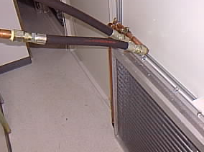

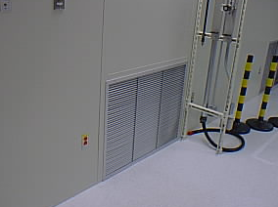

Figure 4. Facility G FFU Cleanroom Layout and Cooling Coil in Cleanroom and Interstitial Space
The recirculation fan system measured in a cleanroom referred to as Facility C uses VFD (variable frequency drive also known as variable speed drive) controlled axial fans to pressurize a plenum with a raised floor and through-chase return. This design is inherently low in pressure drop. Air return and supply are both via large plenum chambers, under the floor and above the ceiling. The large airflow paths mean negligible pressure drops compared to a ducted supply and/or return system. Multiple large diameter axial vane fans are controlled by VFDs with a design pressure rise of 1” w.g. At low pressure drops, axial fans are the most efficient fan type. The only significant pressure drop in the recirculation system is through the HEPA filters, resulting in low required static pressure. Sensible cooling was done via an air handler; in this application low loads minimized the fan power penalty incurred by the relatively high pressure drop sensible cooling air path. Beyond the significant energy savings of a low pressure drop system, the low pressure drop allowed for a slower, quieter fan selection.
Figure 5. Recirculation Air Handling System Design Schematic at Facility C
The design power consumption per airflow delivered from the system was 5,000 cfm/kW. However, the system was actually performing at an impressive 10,140 cfm/kW. The large difference is due to the numerous design conservatism’s inherent in cleanroom systems, such as oversizing for future build out, the use of fully loaded filter conditions, and estimating poorly-defined system effects. The use of variable speed drives on all the fans in the system allowed it to be tuned to the actual operating conditions at balance, realizing significant efficiency benefits from the built-in surplus capacity.

Related Best Practices
Recirculation System Types Demand Controlled Filtration
Air Change Rates Right Sizing
Fan Filter Efficiency Low Pressure Drop Air Systems

References
- http://ateam.lbl.gov/cleanroom/benchmarking/index.htm.
- Xu, Tengfang, “Considerations for Efficient Airflow Design in Cleanrooms,” Journal of the IEST, Volume 47, 2004.
- Xu, Tengfang, “Performance Evaluation of Cleanroom Environmental Systems,” Journal of the IEST, Volume 46, August 2003.

Resources
- Jaisinghani, Raj, “New ways of thinking about air handling,” Cleanrooms magazine, January 2001.
- IEST-RP-CC012.1, “Considerations in Cleanroom Design,” The Institute of Environmental Sciences and Technology (IEST), 1993.

