INTEGRATED TIME AND ATTENDANCE SYSTEM (ITAS)

ITAS
COORDINATOR
WEB
HANDBOOK

Health and Human Services
Program Support Center
Information Systems Management Service
Enterprise Application Division
June 2004
Updated February 2009

TABLE OF CONTENTS

Log On/Off ITAS………………………………….……………………………………………….…..3

Add New Employee ……………………………………………………………………………….......4

Create Leave Balance……………………………………………………………………………….…..8

Modify an Employee Profile……………………………………………………………….…………..10

Modify an Employee Timecard………….…………….………………………………….……………11

Modify Leave Balances……………………………………………………..…………….……………13

Submitting Leave Request…………………………………………………..…………….……………15

Leave Transfer Program…………………………………………………………………………….…..20

Maintaining Relationships………………………………………………………………………………23

Maintain Organizations………………………………………………………………………………….25

Reports…………………………………………………………………………….……………………..26
Logging On to ITAS:

- Double click on the Internet Explorer or Netscape icon on your desktop. This will take you to your Home page.

- Enter the following URL: http://www.psc.gov/itas/index.html

- This brings you to the Integrated Time and Attendance System Home Page.

- Click on appropriate link for your OPDIV’s ITAS Coordinator icon to get to your logon screen.

- In the Login ID BOX; Enter your ITAS LAN ID*. Press the tab key – or click on the password field.

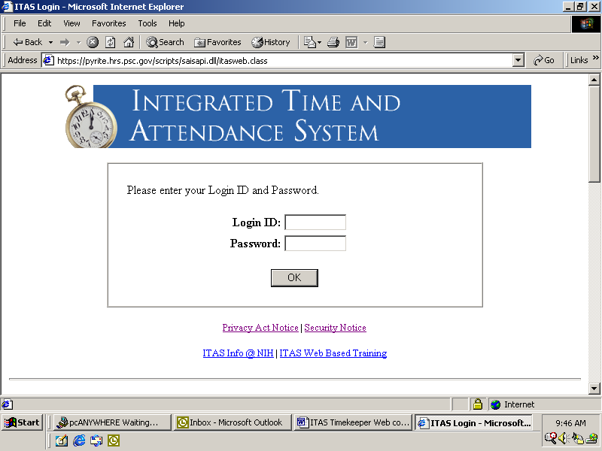

- In the Password Box; Enter your password and press the enter key – or click the OK button.

  - Once logged on, you will see the main menu. You will have access only to those roles to which you have been assigned.

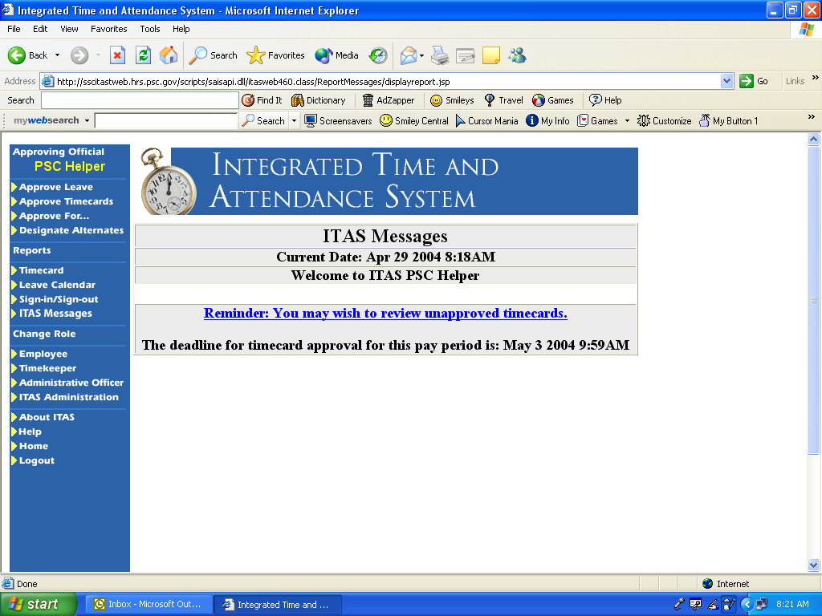

  - Go to “Change Role”, click on Administrative Officer (ITAS Coordinator).

*ITAS LAN ID is the first Letter of your first name, the second two Letters of your last name and the last 5 digits of your SSN. i.e. John Doe SSN:999-27-3364 – ITAS LAN ID = jdo73364

Logging Off ITAS:
Click on “Home”
On the main menu, click “Logout”.
Close the internet browser.

NOTE: Only use navigation buttons in ITAS. Do not use the browser buttons (such as the back arrow button) to navigate in ITAS.
ADD NEW EMPLOYEE

Rule: Only the ITAS Coordinator can add employee profile and update leave balances.

- Click on New Emp from the menu on left side of screen.
- Enter Social Security Number of new employee.
- Click on one of the buttons NEW, MULTIPLE APPT or UNSEPARATE.
- New – new employee
- Multiple Appt – use to add new appointment for an active employee (Expert/Consultant Only)
- UnSeparate – reactivate a previously separated employee’s record.
- Click ‘OK’
- This will bring you to Personal Information Screen

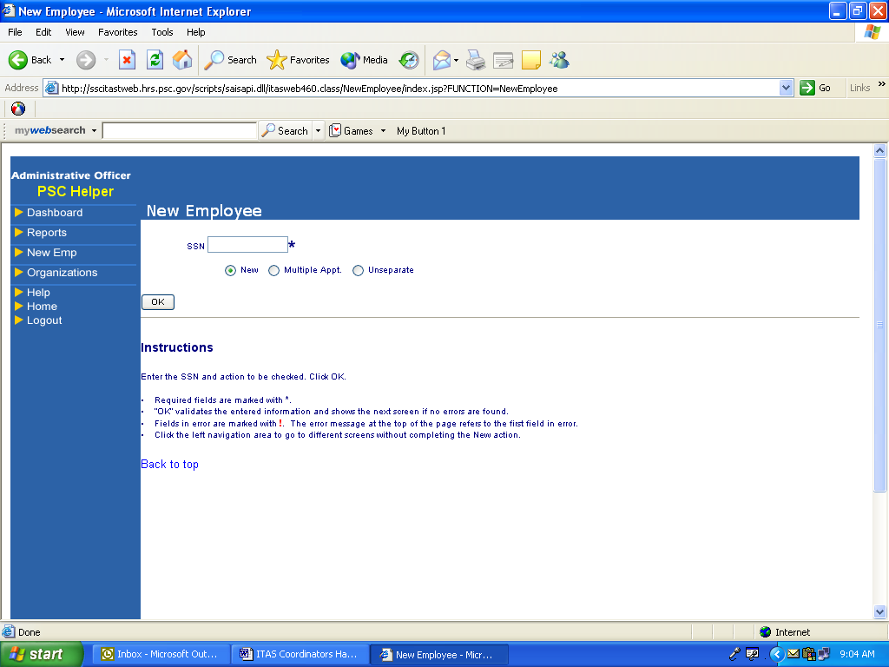

Personal Tab

- Enter employee’s Last Name, First Name and middle initial.
- Agency Code defaults to HHS.
- Enter SAC Code
- Click on down arrow button and select Approving Official
- Click on down arrow button and select timekeeper
- Enter employee’s email address (Maximum length of email address is 21 characters)
- Enter generic password eight to ten characters in length tab and retype password.
- Click on FLSA button.
- Click on the “OK” button to accept information.
10. You will see a confirmation screen….click “OK”. You also have the option at this time to click on the □ (box) if you do not want to see the confirmation screen each time you make a change for the rest of the session.

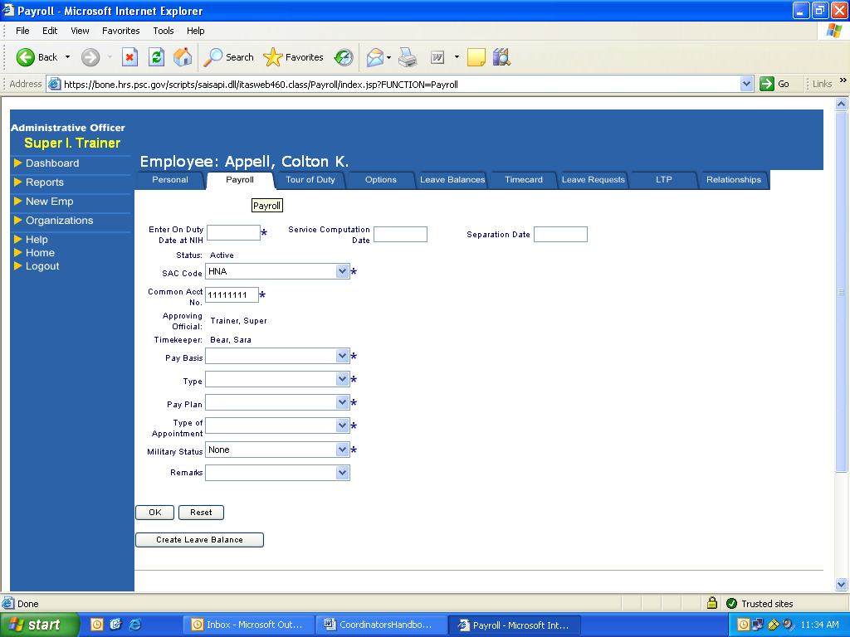

Payroll Tab

- Click on Payroll Tab
- Enter employees enter on duty date
- Enter Service computation date
- Status defaults to “Active”.
- Click on Common Acct No. (CAN) default “11111111” change to employing CAN (format sample 9E123456).
- Approving Official and Timekeeper default from previous entered information.
- Click on down arrow and select Pay Basis
- Click on down arrow and select type of employee
- Click on down arrow and select Pay Plan
- Click on down arrow and select type of appointment.
- Military Status defaults to “None” to change click on down arrow and select appropriate status.
- Click on down arrow and select “EOD” Remark.
- Click on ‘OK’
- Click ‘OK’ on Confirmation Screen

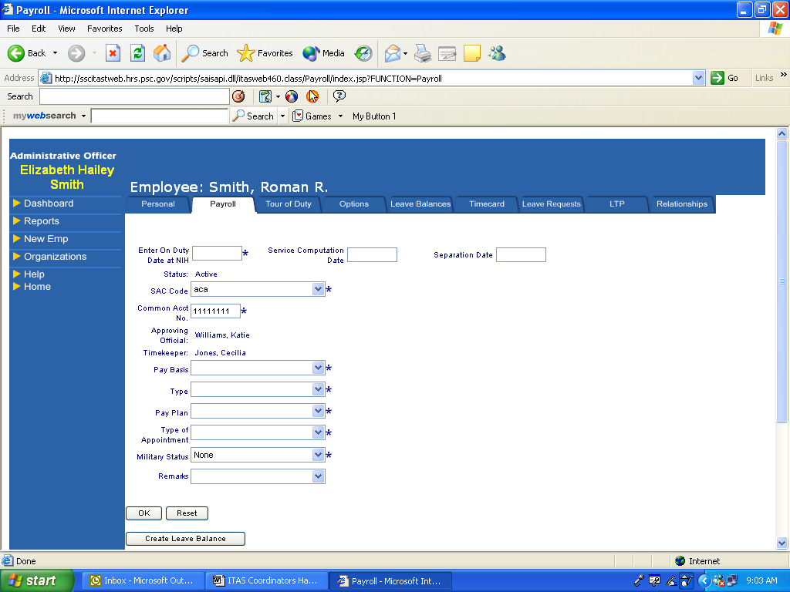

- Click on Create Leave Balance button.

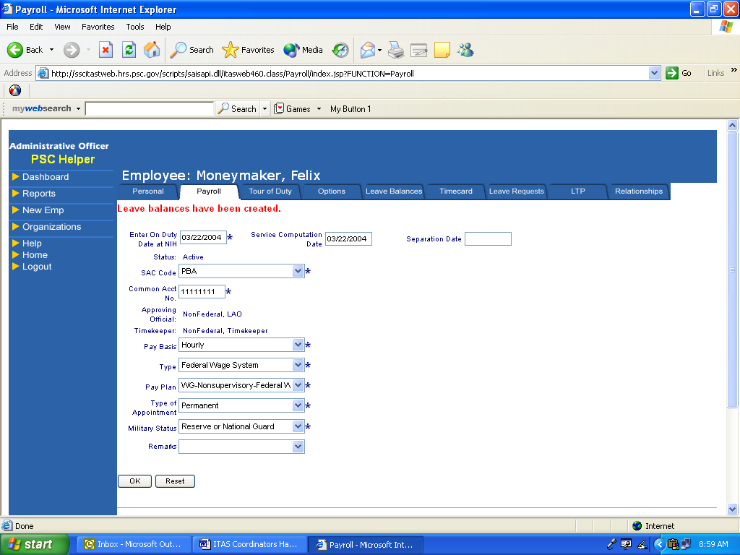

- Should receive message “leave balance have been created”. Once leave balance is created button disappears.

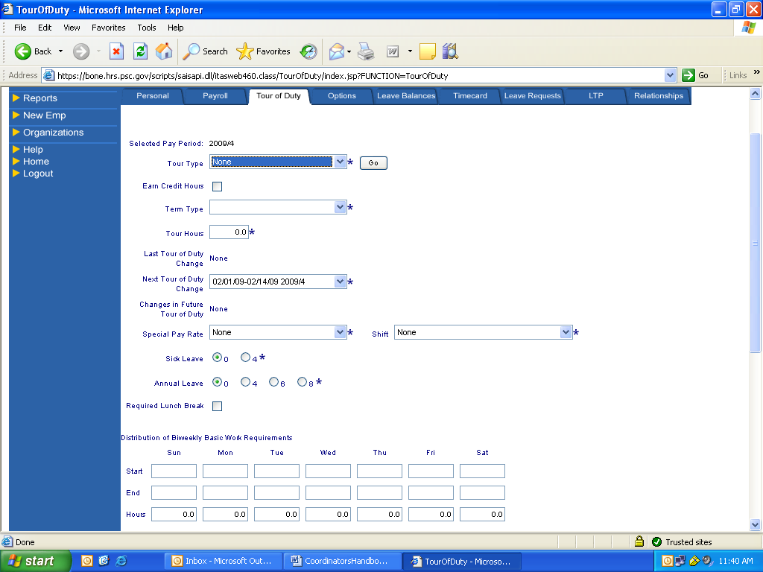

Tour of Duty Tab

- Click on Tour of Duty Tab
- Click on down arrow box next to tour type and select tour.
- Press the “GO” button ITAS will default information associated with tour type.
- Remember that ONLY Flexible or Variable work schedule can “Earn Credit Hours”
- Term Type equals Full Time, Part Time or Intermittent.
- Tour Hours is employees bi-weekly total hours i.e. 80
- Last tour of duty change indicates the last pay period in which change was made.
- Next tour of duty changes is effective date of tour change defaults current pay period.
- Change in future tour of duty will only contain information if tour of duty effective date is different from current pay period.
- Special Pay Rate - click on down arrow and select the appropriate information.
- Shift defaults according to tour type. Special Rate and FWS employee must have shift information updated accordingly.
- Sick leave click on appropriate button.
- Annual leave click on appropriate leave category button.
Remember in order for ITAS to update leave accrual each pay period these buttons must be set to appropriate leave category.
- Defaults to Required Lunch Break.
- Check Distribution of Biweekly Basic Work Requirements to assure employee’s start and end times and tour hours are correct. This is what is used to populate the employee timecard. (Not necessary for Flexible Work Schedule).

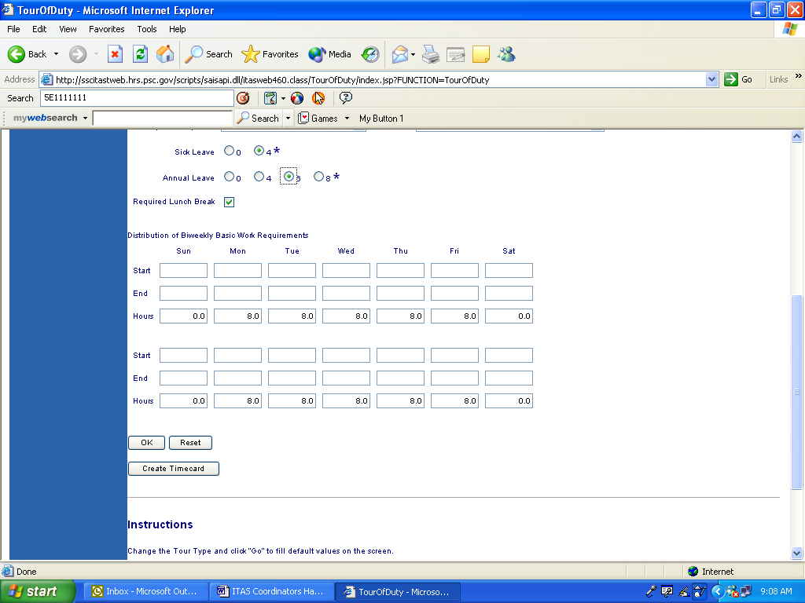

- Click ‘OK’ to accept information.
- Click ‘OK’ on Confirmation Screen
- Click on Create Timecard – employee will not have timecard until you click on this button. Once timecard is created button disappears.

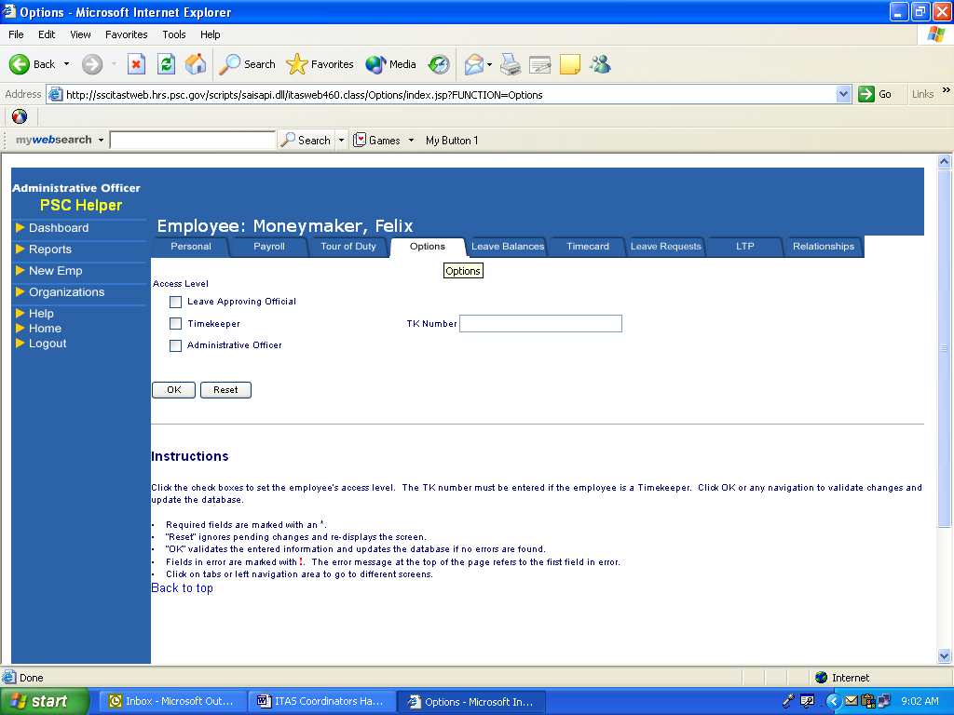

Options Tab

Rule: Use to identify employees who are Timekeepers, Approving Officials or ITAS Coordinators (Administrative Officers) in ITAS. IF EMPLOYEE DOES NOT FALL INTO ONE OF THESE CATEGORIES THEN LEAVE BLANK.

- Click on Options Tab.
- Timekeeper requires a 5 digit timekeeper number.
- Click ‘OK’ to accepted information OR
- Click Dashboard to Exit

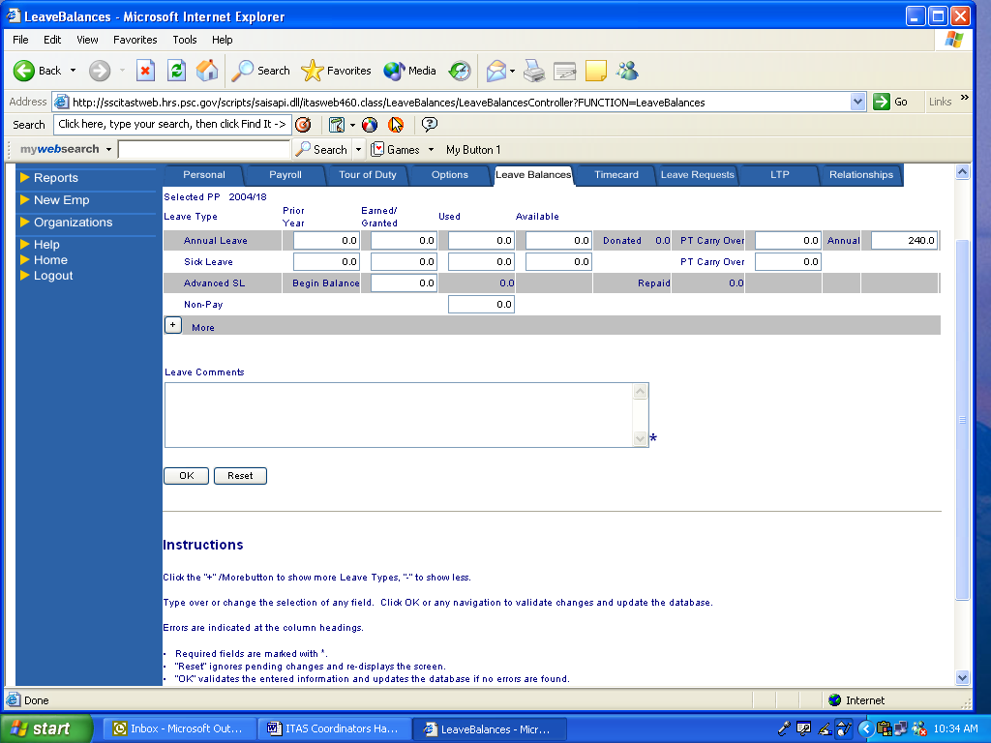

Create Leave Balances

- Click on Leave Balance
- Click on Annual box on far right hand side enter 240 limitations for annual leave.
- Click on “+” for more options

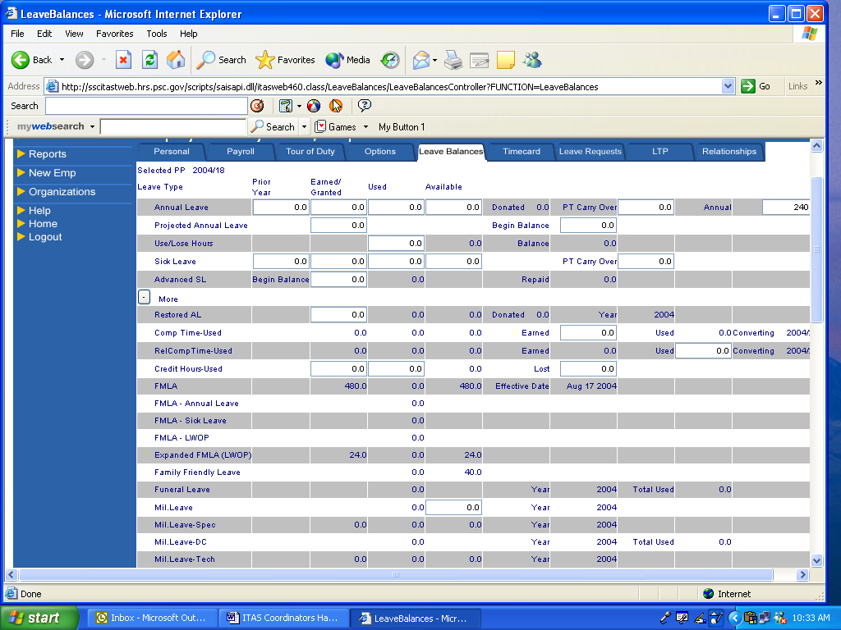

- Click on Begin Balance box and enter annual leave employee will earn from current pay period up until end of leave year.
- Click on Project Annual Leave box and enter same number of hours as entered in begin balance box.
- Click on Comment box and enter remark. You must enter remark or ITAS will not let you continue.
- Click ‘OK’ to accept information.
- Click ‘OK’ on Confirmation Screen
- Click on Timecard and verify leave information at top of timecard.

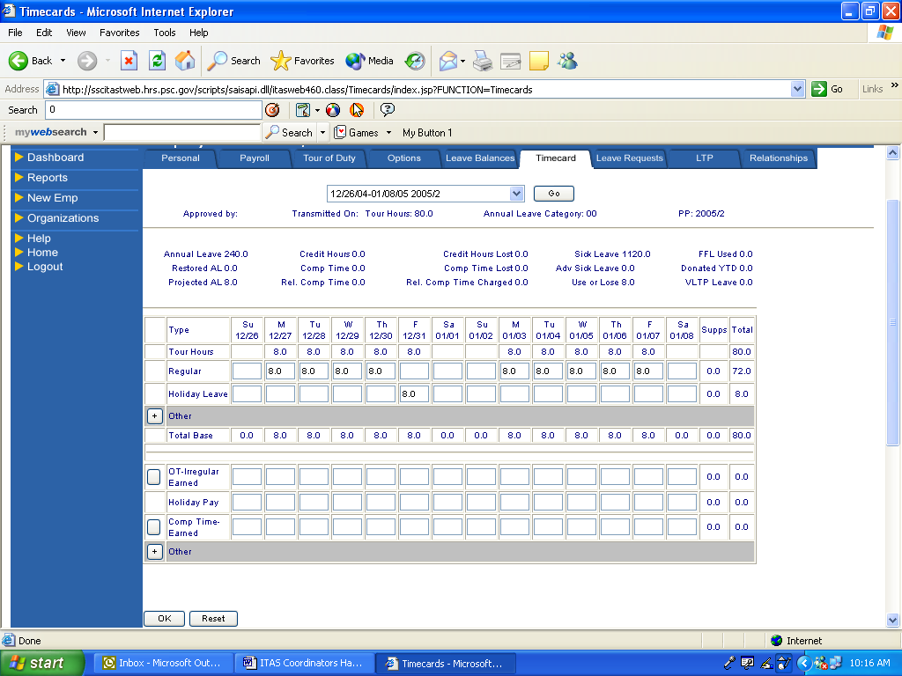

Note: To calculate projected annual leave, determine the number of hours of annual leave the employee will be earning each pay period ( 4, 6 or 8 hours) and multiply by the number of pay periods remaining in the leave year, including the current pay period.
MODIFY AN EMPLOYEE PROFILE

RULE: The ITAS Coordinator and the Timekeeper can modify employee’s profile.

Modify Profile: To update information for existing employees.

- From the Dashboard to modify employee information, click on employee’s SSN or one of the following: To quickly locate an employee name, use Ctrl+F keys and type in the employee’s name in the text box. Hit enter (or find next) and the employee’s name will be highlighted.

- PERSONAL – Employee Name
- PAYROLL – Admin Code
- TOUR OF DUTY – Hours
- Access (Options) – Emp

Note: Clicking on the TAB (i.e. Personal, etc) at the top of the Dashboard will only change the order of employees name from descending to ascending order in alphabetical order.

- To select employee, click on the SSN or employee name.

- You will see first tab “Personal”.

- When updating information use drop down menus and change/pick a new selection. With select button’s select or de-select. With text boxes delete old information and insert new information.

- Click on the OK button to accept changes.

- You will see a confirmation screen…. click “OK”. You also have the option at this time to click on the box if you do not want to see the confirmation screen each time you make a change for the rest of the session.

- Once you are in the employee profile you can click on the tabs at top of the page to move from one screen to another

MODIFY EMPLOYEE TIMECARD

RULE: The ITAS Coordinator and the Timekeeper can modify employee timecard.

Modify Current Timecard Only: ITAS automatically generates a timecard every pay period which will include holiday if applicable, so you only need to process exceptions. Remember, leave is posted automatically by ITAS once the Approving Official has approved a request for leave. You can process timecard change for the current pay period directly to the timecard or process changes for prior pay period via the Supplement procedures.

- From the Dashboard to modify information.

- To select an employee, click on the box next to SSN and employee name and then scroll over to Timecard Tab and click on “unapproved”. OR you can click on employee’s name, which will take you to the “Personal” screen of the profile. Then click on “Timecard”.

- You will see a timecard for the employee, that displays their tour hours and any extra work hours or leave already recorded.

- To modify hours, select a day and click on Leave or Hours Types. Click the “+” to show more Leave or Hours Types.
- To add additional hours worked to timecard click on day and type in number of hours.
- Click on “OK” button to save and you will be directed to start/stop time’s screen.
- Enter start and end time for hours worked on day highlighted in red. Use military or AM/PM times.
- If needed, click the “More” button for extra start/stop lines.
- Click on “OK” button to save your changes and you will be directed to the confirmation screen to complete the process. Click on the Ok button on confirmation screen.

- To delete hours worked from an employee timecard, identify the hour type row you wish to delete. Click on day by highlighting hour(s) and delete. Remember you must also delete the start/stop time.

- Click on “OK” button to save your changes and you will be directed to the confirmation screen to complete the process.

- Click on the OK button on confirmation screen.

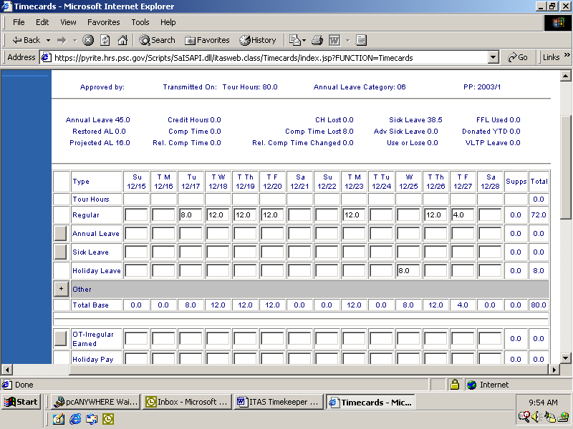
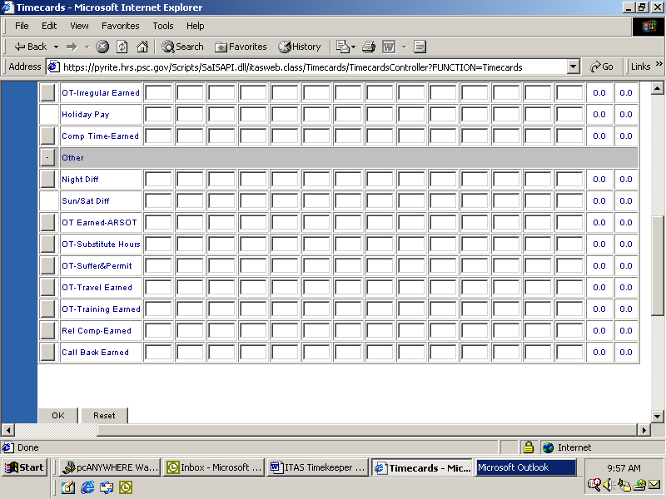
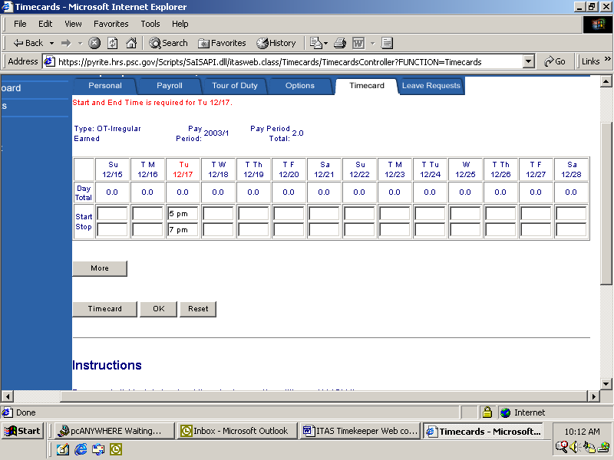
MODIFY LEAVE BALANCES

Rule: Only the ITAS Coordinator can modify an employee’s leave balances.

Leave Balances - An adjustment to the employee’s leave balance is made when an employee transfers to HHS from another agency, base on Earning and Leave Statement adjustment, restored leave, etc. New hire employees without prior service ITAS will automatically update balance at end of pay period.

Reminder: Active employees Annual and Sick leave accrual updates at end of pay period during the pay period close process.

Update Balances

- From the Dashboard to modify information.
- Click on employee “U/L”* balance” under the Leave Balances tab.
- Click on the box you wish to update.
- Click on the “+” for more options.
- Click on box you want to add or change leave balance.
- Enter leave information into appropriate box.
- You can only update information with a box. All others are updated by information posted to the timecard. ITAS will default any leave restriction associated with certain leave categories. (i.e. FLMA, etc.)
- Continuation of Pay (COP) – Click on arrow in “Injury” box and select reason. Employee can have more then one COP and you must enter each instance in ITAS.
- Tab and enter effective date.
- Click in “Leave Comment” box and enter appropriate information.
- Click ‘OK’
- ITAS will default COP 45 days

New Employees

- Click on Leave Balance
- Click on Annual box on far right hand side enter 240 limitations for annual leave.
- Click on “+” for more options
- Click on Begin Balance box and enter annual leave employee will earn up until end of leave year.
- Click on Project Annual Leave box and enter same number of hours as entered in begin balance box.
- Click on Comment box and enter remark.
- Click ‘OK’ to accept information.
- Click ‘OK’ on Confirmation Screen

NOTE: If employee is transferring from another government agency or from within HHS who are not in ITAS you will need a copy of their latest Earning and Leave statement to update annual and sick leave balances. Employees from other federal agency will need to wait until his or her leave has been transfer to DFAS and update shows on Earning and Leave statement otherwise employee will be put in advance leave status or leave without pay.

*U/L stands for use or loose. A “U/L 0.00” in the Leave Balance column indicates that employee has no use or loose leave balance.

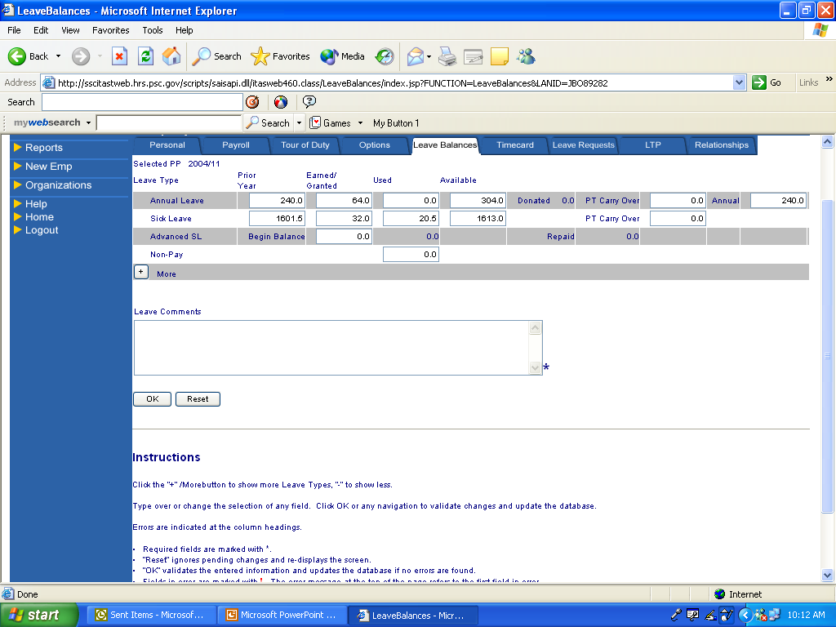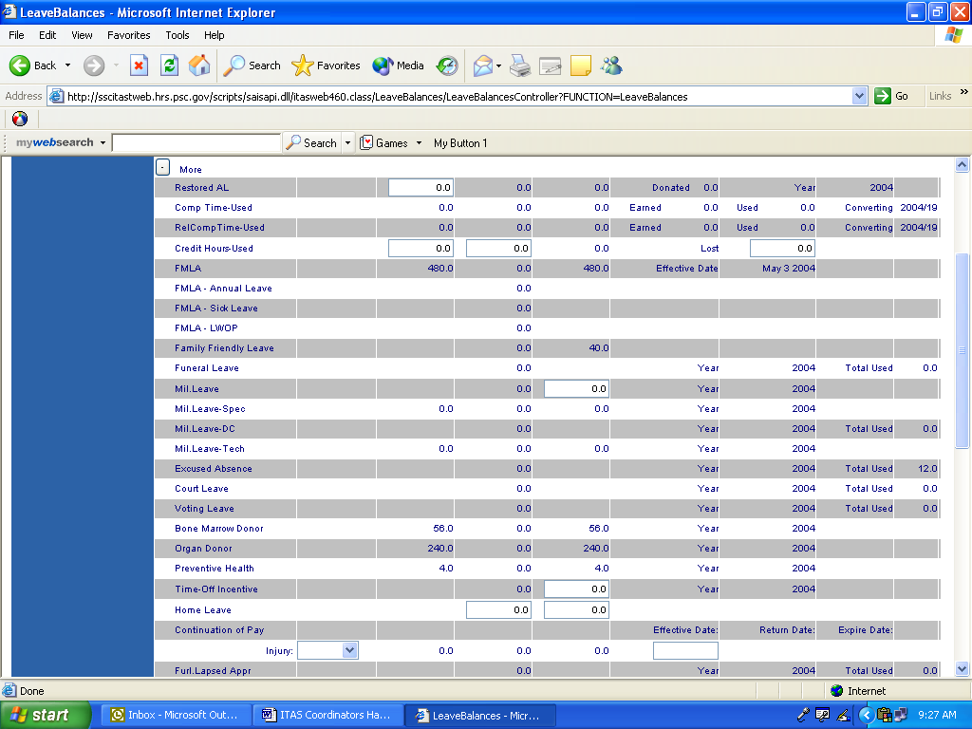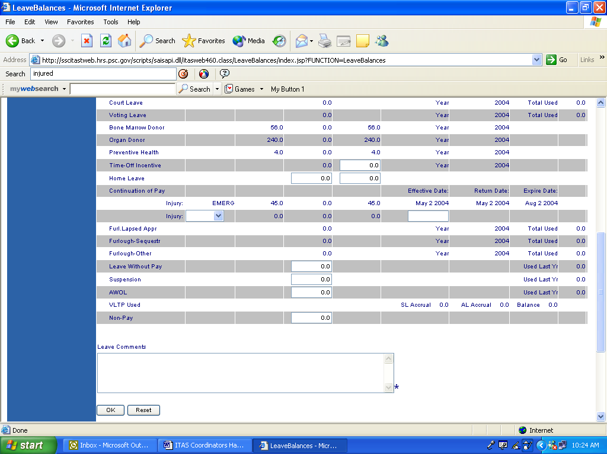

SUBMITTING LEAVE REQUEST FOR ASSIGNED EMPLOYEES

Rule: The ITAS Coordinator and the Timekeeper can process leave request for employees.

Process Leave Requests: A request to use leave can be made for a past, current, or future pay periods. Requests can be made for a full day, a partial day, and for multiple days, and multiple types of leave may be requested for the same day.

Delete Leave Requests: If it is for a future date, approved or unapproved, it may be removed by the ITAS Coordinator, Timekeeper, or Employee.

If the approved leave is in the current pay period, but the date has passed, only
Timekeeper or ITAS Coordinator may remove the leave. If the pay period has
passed, the Timekeeper or the ITAS Coordinator must remove the leave via a
supplement (amendment) timecard.

Important: If you are recording leave used under the Family Medical Leave Act or Family Friendly Leave Act, be sure to click on the “+”for more leave types and then click on FMLA or Family Friendly Leave box then type in hours and select a remark from drop arrow when processing FMLA leave request. All leave requests must be saved and the employee’s Approving Official must approve all requests before it can be applied to the timecard.

Note: Leave request involving Continuation of Pay (COP), Restored Annual Leave, Time Off Awards Transfer-In Leave from previous and Advanced Sick Leave must be updated in Defense Civilian Pay System (DCPS) and reflected on employees’ Earning and Leave Statement (ELS) prior to requesting leave. If requested and it has not been updated on ELS then employee could see leave conversion by DCPS to annual, credit, comp time or leave without pay.

- From the Dashboard to request leave.

- To select an employee, click on the box next to SSN and employee name and then scroll over to Leave Request Tab and click on Request. OR you can click on employee’s name, which will take you to the “Personal” screen of the profile. Then click on “Leave Request” tab.

- To request leave

INSTRUCTIONS:

    - To create a full day request:

- Click on Leave Request
- Fill in the Start Date and End Date.
- Select a Leave Type and type in hours. If the desired type is not shown or you want multiple types, click on ‘+’ more Types. More Types denotes all leave types includes FFL, FMLA, and LWOP that is appropriate for that employee.
- Click the OK button.

- To create a partial day request:

- Click on Leave Request
- Fill in the Start Date and End Date.
- Fill in the Start Time of your leave.
- Fill in either the End Time or # Hours; the other will be populated for you when you press the “GO” key.
- Select a Leave Type. If your desired type is not shown, click on ‘+’ more Types to be directed to the other types of leave.
- Click the OK button.

- To Request leave for two or more types of leave on the same day:

- Click on Leave Request
- Fill in the Start Date and End Date.
- Partial day request follow instruction above.
- Click on ‘+’ More
- ITAS will open window in which you will click on the type of absence and enter number of hours you wish to apply to the first leave category.
- Click on the type of absence and enter number of hours of the type of leave you are requesting for the remaining hours.
- Continue until all hours are accounted for.
- Click on the OK button.

- To Request COP Leave

- Click on Leave Request
- Fill in Start Date and End Date.
- Click on ‘+’ More
- ITAS will open window in which you will click on the COP and enter the total number of DAYS not hours in the box. .
- Click on the OK button.

- To Request Partial Day COP Leave

- Click on Request Leave
- Fill in the Start Date and End Date.
- Fill in the Start Time and End Time
- Click on “GO” ITAS will default hours
- Click on ‘+’ More
- Click on the COP and type in “1” equals a day of COP. DO NOT TYPE IN HOURS.
- Click on the OK button.
- Once it is approved ITAS will post timecard with both types of leave in the hours requested but will subtract one full day of COP from COP balance.

- Separate COP leave request must be done for each pay period involved. Cannot cross over pay periods.

ITAS automatically sends an email notification to the Approving Official of the pending leave request. Leave Request will appear in the Approving Official’s Pending Leave Request window. If the Approving Official then approves the leave the leave will be added to the employee’s timecard and email notification is sent to employee.
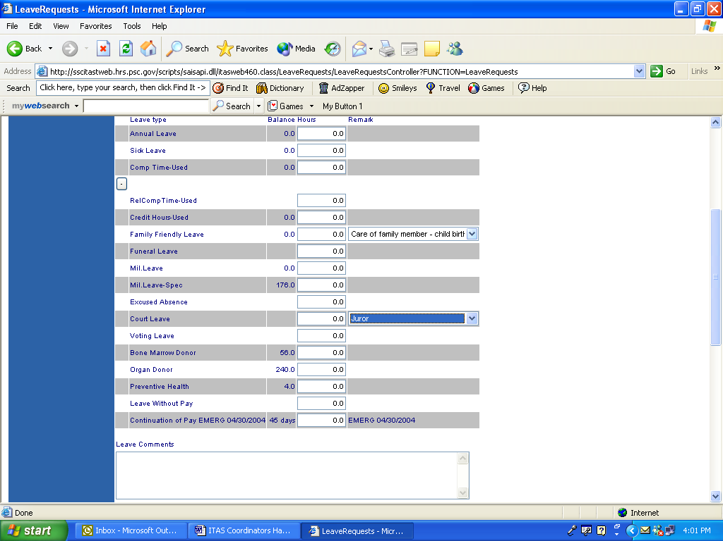

COP Leave - Partial
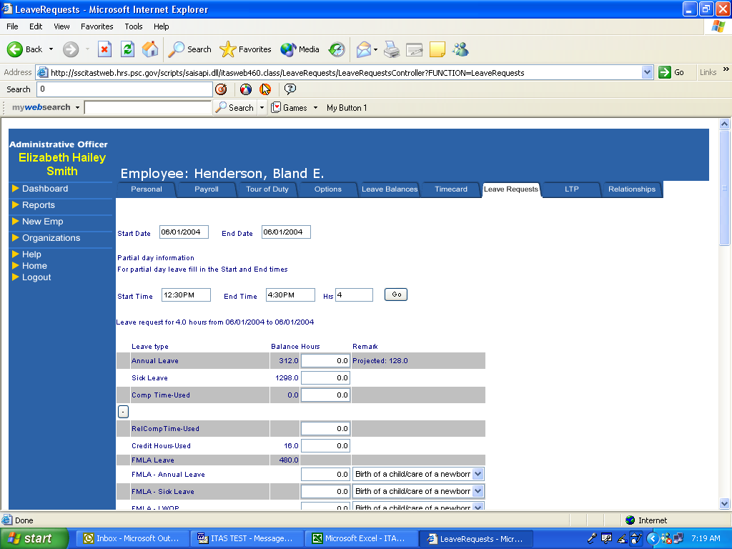

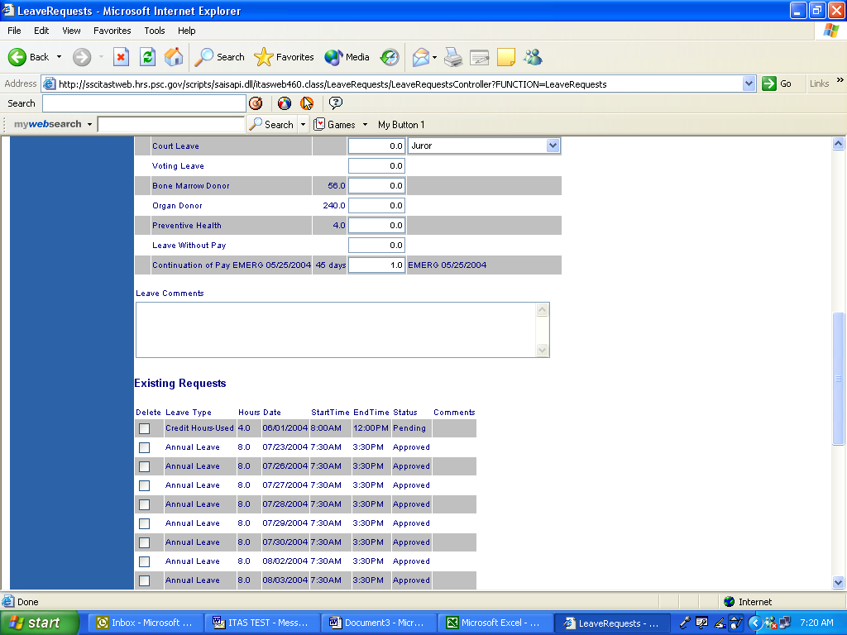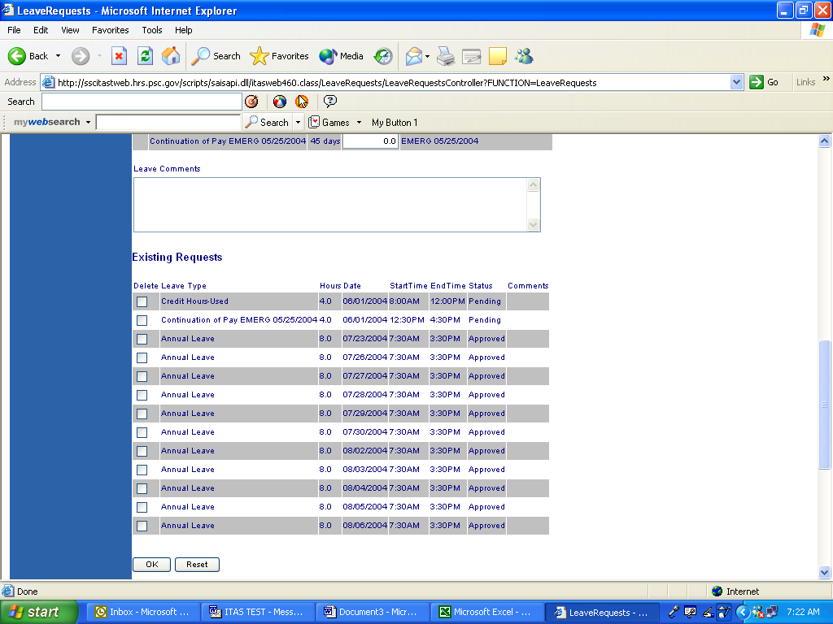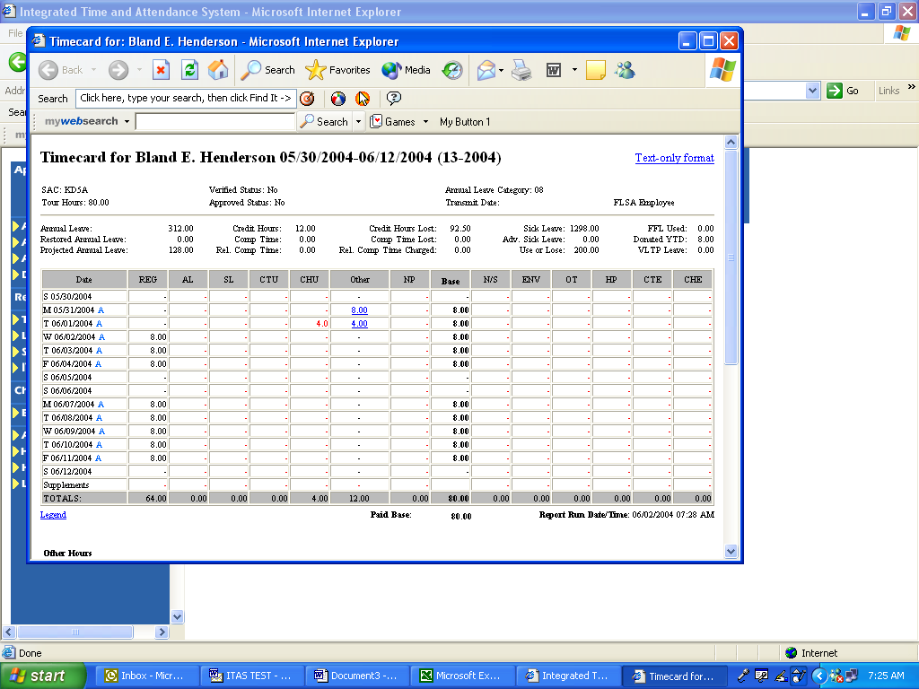

- Removing a Leave Request:

You may use this process to remove a leave request that has not yet been approved or is for a future date.

- Click on Leave Request
- Scroll down to “Existing request”.
- To select a leave request for deletion, check the box in Delete column
- Click ‘OK’

ITAS automatically send an email notification to the Approving Official that the leave has been deleted.

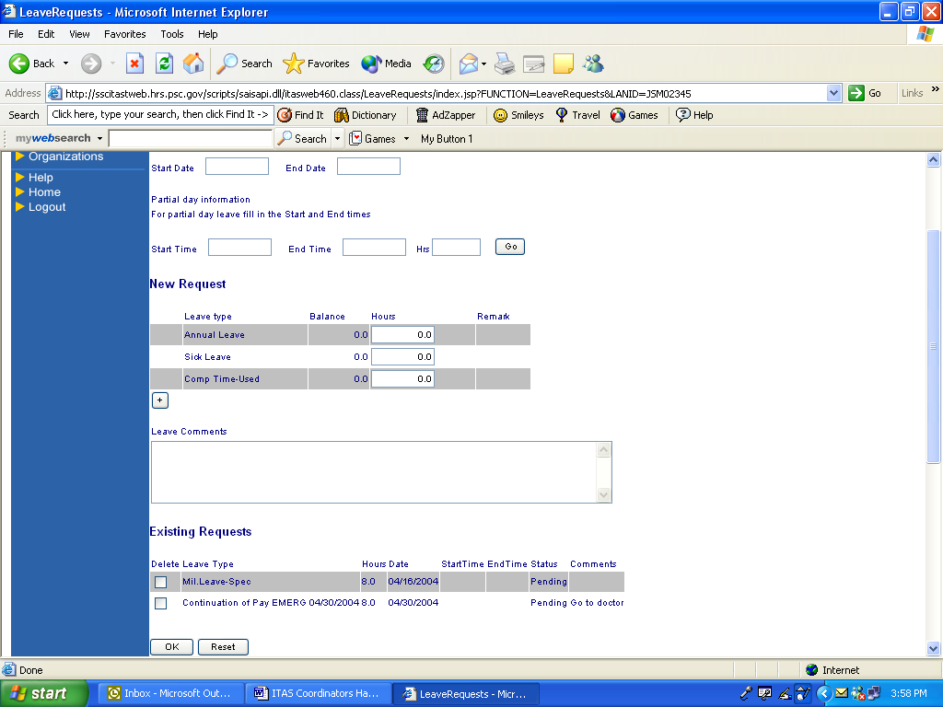
LEAVE TRANSFER PROGRAMS (LTP)

Rule: ITAS Coordinator and Timekeeper can maintain the LTP.

Leave Transfer Program – covers employees participating in Voluntary Leave Transfer Program (VLTP) and HHS Emergency Leave Transfer Program (ELTP). Currently the ELTP program is not accepting any more leave donations.

Note: Prior to entering information into ITAS you should check the your OPDIV’s VLTP coordinator or Payroll Liaison to
ensure information has been provided to Payroll Service Division for update to the DFAS payroll system.

LTP – Donations

1. From the Dashboard to LTP
2. Select “Employee”
3. Scroll across until you see LTP Donations
4. Click on “Donate”
5. Top portion of screen shows number of annual leave hours available for donation and the number of restored annual leave hours available.
6. Click on arrow in “Name Reason Org” box to select employee name you wish to donate leave to.
7. Click on arrow in “Hour Type” box and select hour type.
8. Tab to “Hours” box and enter number of hours.
9. Tab to “Date” box ITAS defaults to current date. Accept or change.
10. Click “OK”

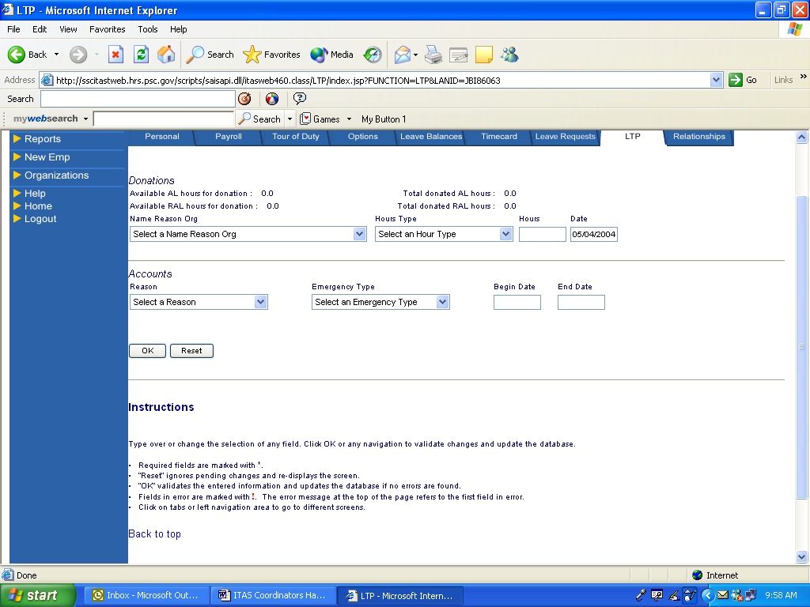

LTP – Accounts

1. From the Dashboard to LTP.
2. Select “Employee”
3. Scroll across until you see LTP Accounts
4. Click on “New”
5. Bottom half of screen label “Accounts” is where you will enter information on the employee that has been approved to participate in VLTP.
6. Click on the arrow in “Reason” box and select reason.
7. Click on the arrow in “Emergency type” and select emergency type.
8. Tab to Begin Date and enter date of emergency.
9. End Date – enter date employee returns to duty full time. DO NOT complete until employee has return to duty full time.
9. Click “OK”
Leave Transfer Program (LTP)

Donor or Recipient from outside the Department – you must establish a profile in ITAS for this type of employee under “New Emp” from main menu.

- Click on New Emp
- Key in SSN
- Key in donor/recipient name
- Tab to Agency code
- Click on down arrow key and select agency.
- Tab to Leave Approving Official select “Approving Official”
- Tab to Timekeeper select “Timekeeper”
- Click “OK”
- Click “OK on the Confirmation Screen
- Click on Payroll Tab you should see message “No Payroll Information exists, Employee is an LTP donor/recipient only.”

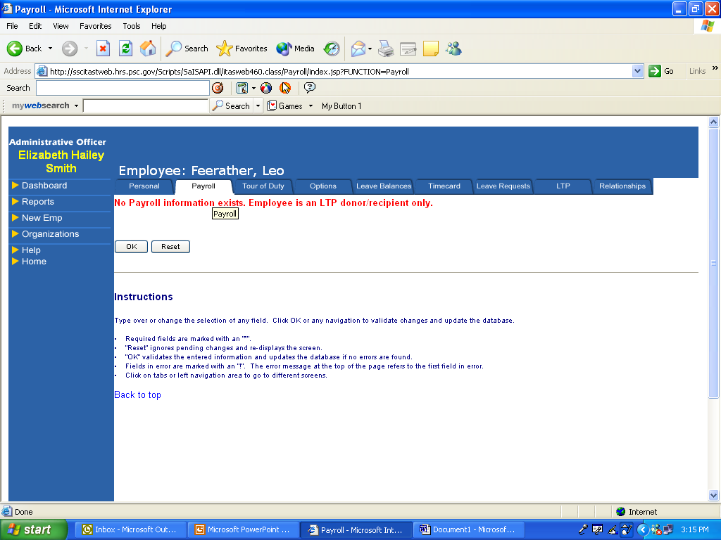

To donate leave:

- Click on LTP tab.
- Under Donations click on the down arrow key.
- Select employee name/reason/org for which donation is for.
- Tab to Hour Type – Click on down arrow box.
- Select type of leave.
- Tab to hours
- Type in hours to be donated.
- Click “OK”.

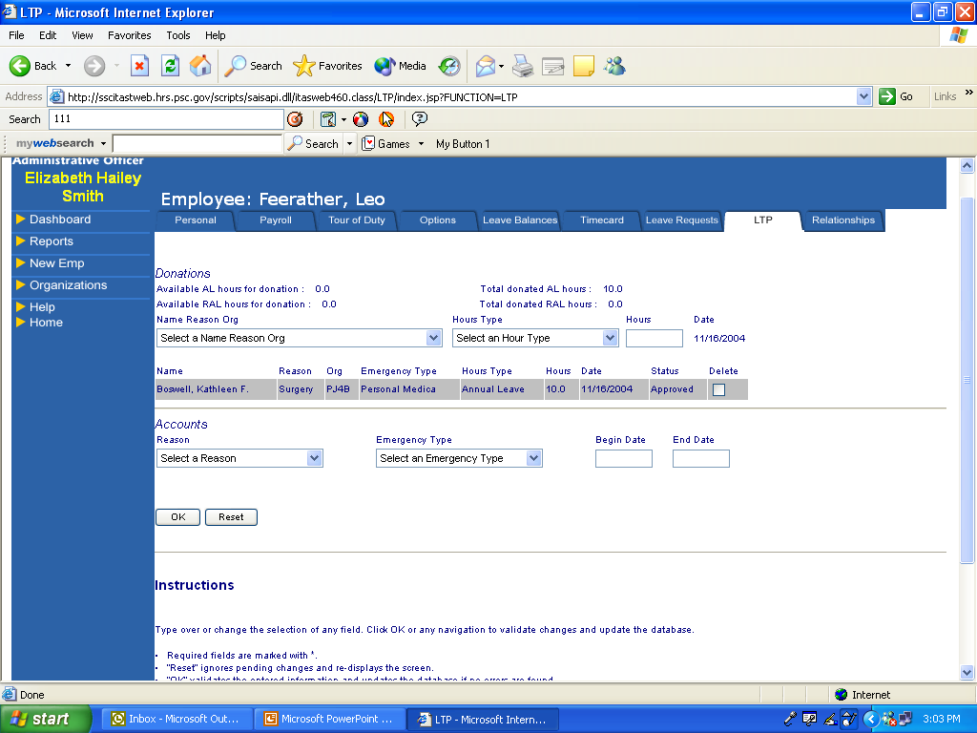

To set up recipient’s account:

- Click on LTP tab.
- Under Accounts - Click on the down arrow key.
- Select reason
- Tab to Emergency Type – Click on down arrow box.
- Select type of emergency.
- Tab to begin date
- Type in begin date.
- Leave end date blank.
- Click “OK”.

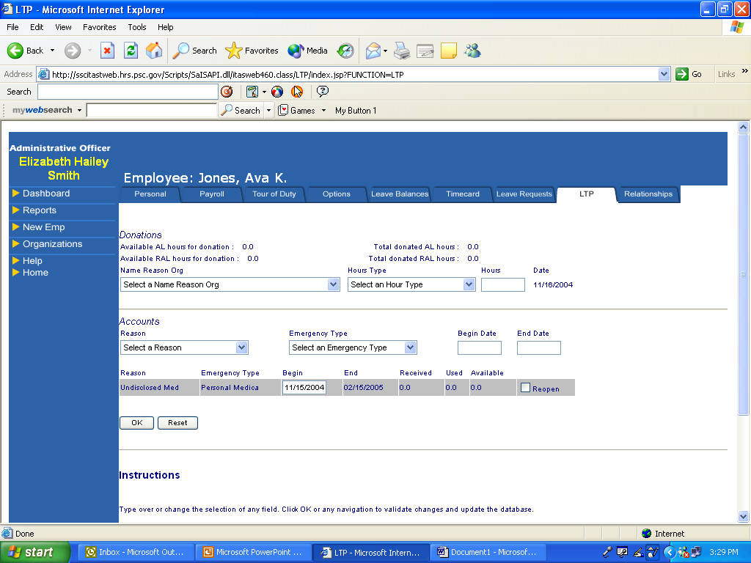

MAINTAIN RELATIONSHIPS

Rule: Only the ITAS Coordinator can maintain relationships.

Relationships to Employee - During an individual’s employment, it may be necessary to reassign their Approving Official or Timekeeper. You may need to reassign all the employees to an Approving Official or Timekeeper or simply change one employee’s designation. To reassign all employees you will use the “Relationships” tab in ITAS. For one employee you can process the change under the “Personal” tab or “Relationship” tab from the Dashboard.

Approving Official (Supervisor) to Employee

1. From the Dashboard to Relationships
2. Click on Approving Official Name and scroll over to “Relationships” tab.
3. Click on “Relationships”
4. ITAS screen should show access level “LAO/EMP”
5. Box equals “Supervisor to Employee”
6. Click on “GO”
7. Employees assigned to Approving Official will show at top of list with Check in box beside their name.
- To add an employee – Scroll to employee name and click on box beside their name.
- Click “OK’
- Employees will now show up at top of screen with other employees.
- To delete an assigned employee from approving official…. Click on box to remove check.

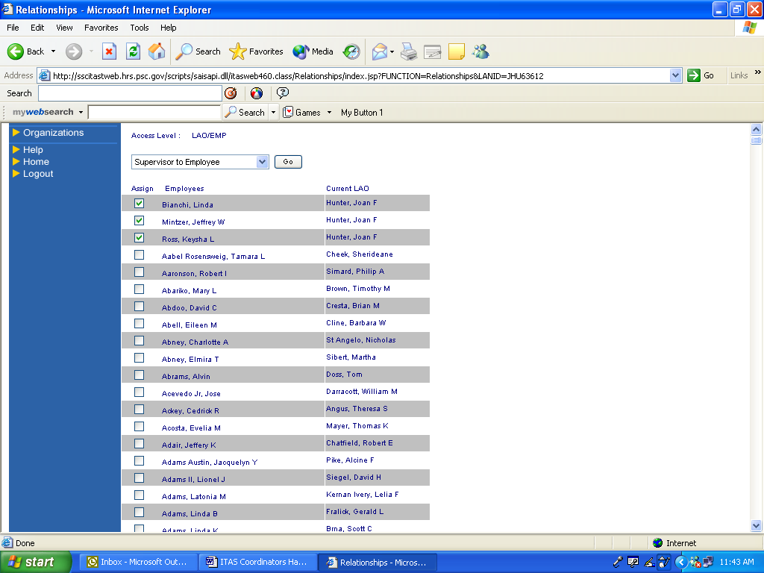

Approving Official to Alternate Approving Official

- Click on Approving Official Name and scroll over to “Relationships” tab.
- Click on “Relationships”
- ITAS screen should show access level “LAO/EMP
- Box equals “Supervisor to Employee
- Click on arrow and change to “Supervisor to Alt. Supervisor”
- Click on “GO”
- Alternates assigned to Approving Official will show at top of list with Check in box beside their
name.
- To add an alternate – Scroll to employee name and click on box beside their name.
- Click “OK’
- Alternate will now show up at top of screen with other employees.
- To delete an assigned alternate from approving official…. Click on box to remove check mark.

MAINTAIN RELATIONSHIPS - Timekeeper

Timekeeper to Employee

- From the Dashboard to Relationships
- Click on Timekeeper Name and scroll over to “Relationships” Tab
- Click on “Maintain”
- ITAS screen should show access level “TK/EMP”
- Box equals “Timekeeper to Employee
- Click on “GO”
- Employees assigned to Timekeeper will show at top of list with Check in box beside their
name.
- To add an employee – Scroll to employee name and click on box beside their name.
- Click “OK’
- Employees will now show up at top of screen with other employees.
- To move employee to another timekeeper through their “Personal” tab on dashboard.

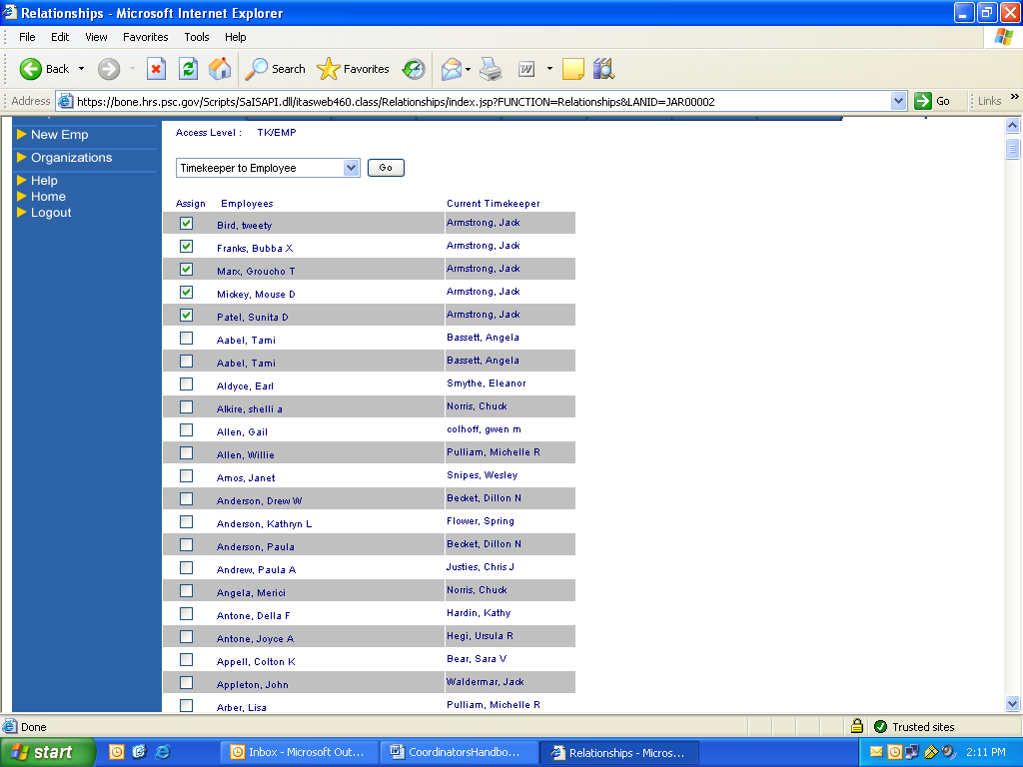

Timekeeper to Alternate Timekeeper

1. Click on Timekeeper’s Name and scroll over to “Relationships” tab.
2. Click on “Maintain”
3. ITAS screen should show access level “TK/EMP”
4. Box equals “Timekeeper to Employee”
5. Click on arrow and change to “Timekeeper to Alt. Timekeeper”
6. Click on “GO”
7. Alternates assigned to Timekeeper will show at top of list with Check in box beside their
name.
8. To add an alternate – Scroll to employee name and click on box beside their name.
- Click “OK’
10. Alternate will now show up at top of screen with other employees.
- To delete an assigned alternate from timekeeper…. Click on box to remove check.
Maintain (Modify/Add) ORGANIZATION Information

Rule: Only the ITAS Coordinator can modify or add new Organization.

Organization – Fields on the Organization window contains a short description, code and abbreviation for each organization.

Modify Organization:

1. Click on “Organizations”.
2. Click on Arrow to select organization.
3. Click on “GO” to retrieve information.
4. Click on box to modify appropriate data in the fields as necessary.
5. Click “OK”

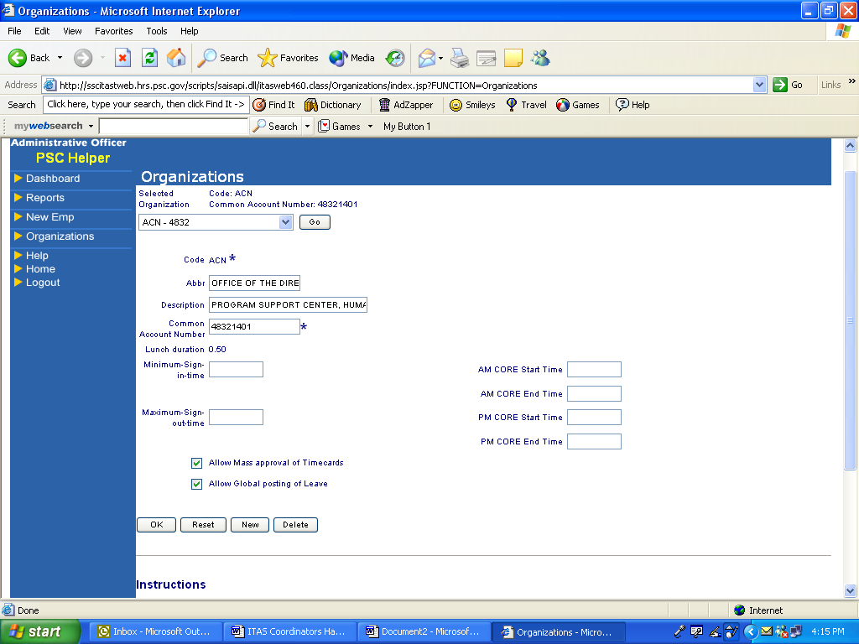

Add new Organization:

1. Click on “Organizations”
2. Click on “NEW” button at bottom of screen.
3. Click on “Code” box and type in new organization code.
4. Tab to “Abbr” box and type in organization abbreviation.
5. Tab to Description box and type in short description.
6. Tab to Common Account Number and type in number first digit being the last digit of the current fiscal year, then a letter and last six numbers. (ex: 9J111111)
7. ITAS defaults “Lunch Duration” equal 0.50
8. Tab to “Allow Mass approval of Timecards” and check the box.
9. Tab to “Allow Global posting of Leave” and check the box.
10. Click “OK” to complete the process.

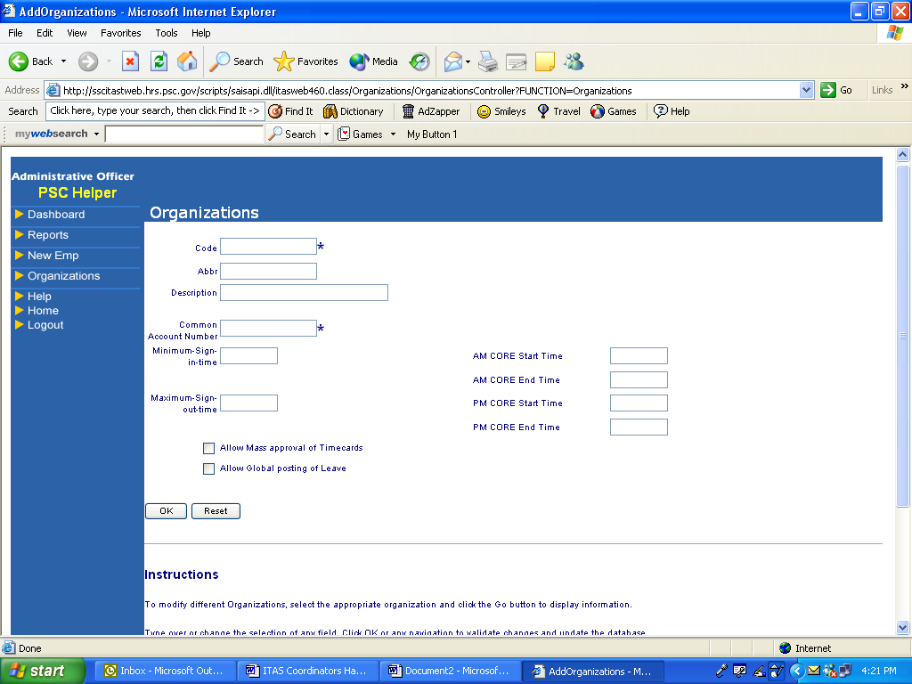

NOTE: As the ITAS Coordinator, you will not be able to view the new organization information or add employees to this organization until you request the ESS, HELPDESK grants you access to the organization code. Please call ESS, HELPDESK at 301-504-3000 or email them at HelpdeskESS@psc.hhs.gov.

REPORTS

Rule: The ITAS Coordinator and Timekeeper can prepare reports.

You may view and/or print any of the reports below:

- Alt Supervisor to Supervisor Relationship – Shows Supervisors assigned as Alternate to other Supervisors.

- Alt Timekeeper to Timekeeper Relationship – Shows Timekeepers assigned as Alternate to other Timekeepers.

- Approved Leave Report – Contains a list of all leave request by employees that have been approved by the Approving Official that are within you specified parameters.

- ALTR – Administrative Leave and Time Record – Contains online copy of the HHS 564 Administrative Leave and Time Record. Do not use “all employees” when setting your parameters. See special instructions for printing ALTR report on page 31.

- Balance Adjustment Report – Contains a list of all employees who’s leave balance have been adjusted manually.

- FFLA Activity Report – Contains a list of all employees that used leave under the Family Friendly Leave Act.

- FMLA Activity Report – Contains a list of employees that used leave under the Family Medical Leave Act.

- Leave Request Report – Displays a list of all leave requests processed for selected pay period.

- Payslip Differences Report – Currently not available

- Payslip Mini Report – Currently not available

- Payslip Regular Report - Currently not available.

- Printable Timecard – Displays timecard for selected employees within you parameters. You will need to do some setup procedures to have timecard print on one page. From tool bar click on View and select Text size – set to Smallest. Then go to File and Page Setup set left and right margins to .20 (2/10 inch) and Orientation to Portrait.

- Sign-in/Sign-Out Report – Contains a list of all employees and their sign-in and/or sign-out times for the parameters you enter. Not Applicable for most of HHS.

- Supervisory to Alt Supervisor Relationship - Displays list of all employees and relationships between Approving Official/Alternate Approving official.

- Supervisory to Employees Relationship - Displays list of all employees and relationships between Approving Official/employee.

- Timecard Error Report – Displays a list of employees with discrepancies between their required tour of duty and the total number of hours on their timecard for current pay period.

- Timekeeper to Alt Timekeeper Relationship – Displays list of all employees and relationships between timekeeper and Alternate timekeeper.

- Timekeeper to Employee Relationship - Displays list of all employees and relationships between timekeeper/employee.

- Unapproved Timecard Report – Displays a list of employees who timecards have not been approved.

- VLTP Recipient Report – List of all employees that used, donated, or received VLTP within the parameters you set.

To view or print available on-line reports:

- Click on Reports from menu bar.

- Click on the drop drown arrow box and select your report type.

- Select your parameters.

- Click on OK button.

- To print click on the printer icon on your toolbar except for ATLR report.

ALTR PRINT INSTURCTIONS

To print the ATLR, you need to access ITAS by using Internet Explorer 6.0 and your printer must handle LEGAL size paper.

To print:
- Display the ATLR Report to print
- Click File / Page Setup on the top menu bar to open the Page Setup dialog box
- Note existing settings before proceeding
- Change the Paper Size to Legal
- This will vary depending on your default, but there should be some variation of Legal available
- Clear the Headers and Footers fields
- Click the Landscape radio button
- Clear all the Margin Size boxes
- The minimum values based on your printer will be filled in. The left and right margins can be no larger than .20 (2/10) inches
- Click OK to save and close the dialog box
- Click Print from the Print Preview window or File
- Check the printer and manually feed the legal size paper if called for
- Click on ‘on-line’ button on your printer
- ATLR should start to print

Remember that all printers are not a like. You will need to check various things like default margin settings, fonts, etc. Please check with your IT person for help with your printer.

