Phenix LDRD Pixel Plane Specifications

Version 1

Jeff Andresen, Guilherme Cardoso

April 19, 2007

- Introduction
This document describes the specifications for the pixel plane utilized by the Phenix LDRD project. The pixel plane described here is the prototype for the LDRD. The goal of this pixel plane is the test of:
a group of 10 8-chip pixel modules working together in a system.
different power supply schemes.
different grounding schemes.
preliminary cooling using carbon-TPG substrate.
different interfaces to the DAQ.
- Electrical Specifications
  - Charge Injection
A triangular-shaped analog voltage waveform can be used to inject charge on the preamplifier of the FPIX2.1 chips. Since the FPIX2.1 chips don’t have an internal pulser, an external voltage pulse must be supplied to calibrate the system once in operation. The pulser must comply to the following specifications
1- Triangular waveform
The issues to be considered in the design of the pulser are:
Each 8 chip module will have its own charge inject signal and ground coming into the pixel plane. A 24 pin Hirose DF11-24DP-2DS right angle through hole connector is used on the pixel plane for these signals. Once on the pixel plane, the ground is the common analog ground plane. Table 1 has the connector pinout for the charge injection.

PIN # | SIGNAL | PIN # | SIGNAL
1 | INJECTIN_1 | 2 | ANALOG GND
3 | INJECTIN_2 | 4 | ANALOG GND
5 | INJECTIN_3 | 6 | ANALOG GND
7 | INJECTIN_4 | 8 | ANALOG GND
9 | INJECTIN_5 | 10 | ANALOG GND
11 | INJECTIN_6 | 12 | ANALOG GND
13 | INJECTIN_7 | 14 | ANALOG GND
15 | INJECTIN_8 | 16 | ANALOG GND
17 | INJECTIN_9 | 18 | ANALOG GND
19 | INJECTIN_10 | 20 | ANALOG GND
21 | NO CONNECT | 22 | NO CONNECT
23 | SHIELD GND | 24 | SHIELD GND
Table 1: Charge Inject Connector Pinout

2- Charge in the chip’s preamplifier is collected in the falling edge of the triangular waveform.
  - Power Supplies
Hv and Lv power supplies

Each 8 chip module will have its own low voltage digital power, low voltage analog power, and high voltage power. Three 24 pin Hirose DF11-24DP-2DS connectors are used on the pixel plane for these powers. The low voltage digital powers have separate grounds at the connector where it becomes a common digital ground on the pixel plane. The low voltage analog powers and high voltage powers have separate grounds at the connector where it becomes a common analog ground on the pixel plane. Table 2, table 3, and table 4 have the power supply connector pinouts.

PIN # | SIGNAL | PIN # | SIGNAL
1 | VDDD_10 | 2 | DGND
3 | VDDD_9 | 4 | DGND
5 | VDDD_8 | 6 | DGND
7 | VDDD_7 | 8 | DGND
9 | VDDD_6 | 10 | DGND
11 | VDDD_5 | 12 | DGND
13 | VDDD_4 | 14 | DGND
15 | VDDD_3 | 16 | DGND
17 | VDDD_2 | 18 | DGND
19 | VDDD_1 | 20 | DGND
21 | +3.3V | 22 | DGND
23 | SHIELD GND | 24 | SHIELD GND
Table 2: Low Voltage Digital Power Supply Connector

PIN # | SIGNAL | PIN # | SIGNAL
1 | VDDA_1 | 2 | AGND
3 | VDDA_2 | 4 | AGND
5 | VDDA_3 | 6 | AGND
7 | VDDA_4 | 8 | AGND
9 | VDDA_5 | 10 | AGND
11 | VDDA_6 | 12 | AGND
13 | VDDA_7 | 14 | AGND
15 | VDDA_8 | 16 | AGND
17 | VDDA_9 | 18 | AGND
19 | VDDA_10 | 20 | AGND
21 | +3.3V | 22 | DGND
23 | SHIELD GND | 24 | SHIELD GND
Table 3: Low Voltage Analog Power Supply Connector

PIN # | SIGNAL | PIN # | SIGNAL
1 | VDET_1_IN | 2 | AGND
3 | VDET_2_IN | 4 | AGND
5 | VDET_3_IN | 6 | AGND
7 | VDET_4_IN | 8 | AGND
9 | VDET_5_IN | 10 | AGND
11 | VDET_6_IN | 12 | AGND
13 | VDET_7_IN | 14 | AGND
15 | VDET_8_IN | 16 | AGND
17 | VDET_9_IN | 18 | AGND
19 | VDET_10_IN | 20 | AGND
21 | NO CONNECT | 22 | NO CONNECT
23 | SHIELD GND | 24 | SHIELD GND
Table 4: High Voltage Connector

The digital powers have National Semiconductor LP3874EPM-2.5 fixed 2.5V output regulators located under the HDIs near the VDDD wire bond pad. The analog powers have Maxim MAX1793EUE25+ variable output regulators located under the HDIs near the VDDA wire bond pad. There are two resistors that set the desired output voltage. The Pixel Plane PCB can operate without regulators if the regulators are not left off of the PCB and the input is shorted to the output. As this PCB is inside the detector, voltage protection will be done before this PCB.

  - Interface to DAQ
The DAQ signals will interface with the PTA through 10 3M P50LE-050P1-SML-TGF connectors. All signals are differential pairs. There are 6 control signals for each HDI module. There is 1 data signal for each chip for a total of 8 data signals for each module. As the 8 chip module has data signals at both ends, there are 5 connectors on each side of the 10 modules. Table 5 through table 10 have the connector pinouts for the data and control signals of the 8 chip HDI modules.

PIN # | SIGNAL | PIN # | SIGNAL
1 | OUT5_1_10 | 2 | OUT5_1_10*
3 | OUT6_1_10 | 4 | OUT6_1_10*
5 | SCK_+A | 6 | SCK_*A
7 | FFR1 | 8 | FFR1*
9 | FFR2 | 10 | FFR2*
11 | PTAGND | 12 | PTAGND
13 | FFR3 | 14 | FFR3*
15 | SHIFTOUT1 | 16 | SHIFTOUT1*
17 | SHIFTOUT2 | 18 | SHIFTOUT2*
19 | SHIFTOUT3 | 20 | SHIFTOUT3*
21 | PTAGND | 22 | PTAGND
23 | OUT8_1_1 | 24 | OUT8_*1_1
25 | OUT7_1_1 | 26 | OUT7_*1_1
27 | OUT6_1_1 | 28 | OUT6_*1_1
29 | OUT5_1_1 | 30 | OUT5_*1_1
31 | PTAGND | 32 | PTAGND
33 | OUT8_1_2 | 34 | OUT8_*1_2
35 | OUT7_1_2 | 36 | OUT7_*1_2
37 | OUT6_1_2 | 38 | OUT6_*1_2
39 | OUT5_1_2 | 40 | OUT5_*1_2
41 | PTAGND | 42 | PTAGND
43 | OUT8_1_3 | 44 | OUT8*_1_3
45 | OUT7_1_3 | 46 | OUT7*_1_3
47 | OUT6_1_3 | 48 | OUT6*_1_3
49 | OUT5_1_3 | 50 | OUT5*_1_3
Table 5: Left Side PTA Connector J1

PIN # | SIGNAL | PIN # | SIGNAL
1 | SHIFTOUT10 | 2 | SHIFTOUT*10
3 | FFR10 | 4 | FFR*10
5 | SCK_+B | 6 | SCK_*B
7 | FFR4 | 8 | FFR*4
9 | FFR5 | 10 | FFR*5
11 | PTAGND | 12 | PTAGND
13 | FFR6 | 14 | FFR*6
15 | SHIFTOUT4 | 16 | SHIFTOUT*4
17 | SHIFTOUT5 | 18 | SHIFTOUT*5
19 | SHIFTOUT6 | 20 | SHIFTOUT*6
21 | PTAGND | 22 | PTAGND
23 | OUT8_1_4 | 24 | OUT8_*1_4
25 | OUT7_1_4 | 26 | OUT7_*1_4
27 | OUT6_1_4 | 28 | OUT6_*1_4
29 | OUT5_1_4 | 30 | OUT5_*1_4
31 | PTAGND | 32 | PTAGND
33 | OUT8_1_5 | 34 | OUT8_*1_5
35 | OUT7_1_5 | 36 | OUT7_*1_5
37 | OUT6_1_5 | 38 | OUT6_*1_5
39 | OUT5_1_5 | 40 | OUT5_*1_5
41 | PTAGND | 42 | PTAGND
43 | OUT8_1_6 | 44 | OUT8_*1_6
45 | OUT7_1_6 | 46 | OUT7_*1_6
47 | OUT6_1_6 | 48 | OUT6_*1_6
49 | OUT5_1_6 | 50 | OUT5_*1_6
Table 6: Left Side PTA Connector J2

PIN # | SIGNAL | PIN # | SIGNAL
1 | OUT7_1_10 | 2 | OUT7_*1_10
3 | OUT8_1_10 | 4 | OUT8_*1_10
5 | SCK_CNTRL | 6 | SCK_CNTRL*
7 | FFR7 | 8 | FFR*7
9 | FFR8 | 10 | FFR*8
11 | PTAGND | 12 | PTAGND
13 | FFR9 | 14 | FFR*9
15 | SHIFTOUT7 | 16 | SHIFTOUT*7
17 | SHIFTOUT8 | 18 | SHIFTOUT*8
19 | SHIFTOUT9 | 20 | SHIFTOUT*9
21 | PTAGND | 22 | PTAGND
23 | OUT8_1_7 | 24 | OUT8_*1_7
25 | OUT7_1_7 | 26 | OUT7_*1_7
27 | OUT6_1_7 | 28 | OUT6_*1_7
29 | OUT5_1_4 | 30 | OUT5_*1_4
31 | PTAGND | 32 | PTAGND
33 | OUT8_1_8 | 34 | OUT8_*1_8
35 | OUT7_1_8 | 36 | OUT7_*1_8
37 | OUT6_1_8 | 38 | OUT6_*1_8
39 | OUT5_1_8 | 40 | OUT5_*1_8
41 | PTAGND | 42 | PTAGND
43 | OUT8_1_9 | 44 | OUT8_*1_9
45 | OUT7_1_9 | 46 | OUT7_*1_9
47 | OUT6_1_9 | 48 | OUT6_*1_9
49 | OUT5_1_9 | 50 | OUT5_*1_9
Table 7: Left Side PTA Connector J5

PIN # | SIGNAL | PIN # | SIGNAL
1 | OUT1_1_10 | 2 | OUT1_*1_10
3 | OUT2_1_10 | 4 | OUT2_*1_10
5 | BCO+A | 6 | BCO+A
7 | SHIFTCTRL1 | 8 | SHIFTCTRL*1
9 | SHIFTCTRL2 | 10 | SHIFTCTRL*2
11 | PTAGND | 12 | PTAGND
13 | SHIFTCTRL3 | 14 | SHIFTCTRL*3
15 | SHIFTIN1 | 16 | SHIFTIN*1
17 | SHIFTIN2 | 18 | SHIFTIN*2
19 | SHIFTIN3 | 20 | SHIFTIN*3
21 | PTAGND | 22 | PTAGND
23 | OUT4_1_1 | 24 | OUT4_*1_1
25 | OUT3_1_1 | 26 | OUT3_*1_1
27 | OUT2_1_1 | 28 | OUT2_*1_1
29 | OUT1_1_1 | 30 | OUT1_*1_1
31 | PTAGND | 32 | PTAGND
33 | OUT4_1_2 | 34 | OUT4_*1_2
35 | OUT3_1_2 | 36 | OUT3_*1_2
37 | OUT2_1_2 | 38 | OUT2_*1_2
39 | OUT1_1_2 | 40 | OUT1_*1_2
41 | PTAGND | 42 | PTAGND
43 | OUT4_1_3 | 44 | OUT4_*1_3
45 | OUT3_1_3 | 46 | OUT3_*1_3
47 | OUT2_1_3 | 48 | OUT2_*1_3
49 | OUT1_1_3 | 50 | OUT1_*1_3
Table 8: Right Side PTA Connector J3

PIN # | SIGNAL | PIN # | SIGNAL
1 | OUT4_1_10 | 2 | OUT4_*1_10
3 | SHIFTIN10 | 4 | SHIFTIN*10
5 | BCO+B | 6 | BCO*B
7 | SHIFTCTRL4 | 8 | SHIFTCTRL*4
9 | SHIFTCTRL5 | 10 | SHIFTCTRL*5
11 | PTAGND | 12 | PTAGND
13 | SHIFTCTRL6 | 14 | SHIFTCTRL*6
15 | SHIFTIN4 | 16 | SHIFTIN*4
17 | SHIFTIN5 | 18 | SHIFTIN*5
19 | SHIFTIN6 | 20 | SHIFTIN*6
21 | PTAGND | 22 | PTAGND
23 | OUT4_1_4 | 24 | OUT4_*1_4
25 | OUT3_1_4 | 26 | OUT3_*1_4
27 | OUT2_1_4 | 28 | OUT2_*1_4
29 | OUT1_1_4 | 30 | OUT1_*1_4
31 | PTAGND | 32 | PTAGND
33 | OUT4_1_5 | 34 | OUT4_*1_5
35 | OUT3_1_5 | 36 | OUT3_*1_5
37 | OUT2_1_5 | 38 | OUT2_*1_5
39 | OUT1_1_5 | 40 | OUT1_*1_5
41 | PTAGND | 42 | PTAGND
43 | OUT4_1_6 | 44 | OUT4_*1_6
45 | OUT3_1_6 | 46 | OUT3_*1_6
47 | OUT2_1_6 | 48 | OUT2_*1_6
49 | OUT1_1_6 | 50 | OUT1_*1_6
Table 9: Right Side PTA Connector J4

PIN # | SIGNAL | PIN # | SIGNAL
1 | OUT3_1_10 | 2 | OUT3_1_10
3 | SHIFTCTRL10 | 4 | SHIFTCTRL*10
5 | BCO_CNTRL | 6 | BCO_CNTRL*
7 | SHIFTCTRL7 | 8 | SHIFTCTRL*7
9 | SHIFTCTRL8 | 10 | SHIFTCTRL*8
11 | PTAGND | 12 | PTAGND
13 | SHIFTCTRL9 | 14 | SHIFTCTRL*9
15 | SHIFTIN7 | 16 | SHIFTIN*7
17 | SHIFTIN8 | 18 | SHIFTIN*8
19 | SHIFTIN9 | 20 | SHIFTIN*9
21 | PTAGND | 22 | PTAGND
23 | OUT4_1_7 | 24 | OUT4_*1_7
25 | OUT3_1_7 | 26 | OUT3_*1_7
27 | OUT2_1_7 | 28 | OUT2_*1_7
29 | OUT1_1_7 | 30 | OUT1_*1_7
31 | PTAGND | 32 | PTAGND
33 | OUT4_1_8 | 34 | OUT4_*1_8
35 | OUT3_1_8 | 36 | OUT3_*1_8
37 | OUT2_1_8 | 38 | OUT2_*1_8
39 | OUT1_1_8 | 40 | OUT1_*1_8
41 | PTAGND | 42 | PTAGND
43 | OUT4_1_9 | 44 | OUT4_*1_9
45 | OUT3_1_9 | 46 | OUT3_*1_9
47 | OUT2_1_9 | 48 | OUT2_*1_9
49 | OUT1_1_9 | 50 | OUT1_*1_9
Table 10: Right Side PTA Connector J7

  - Clock Fanouts
Figure 1 shows the Micrel SY89828L clock fanout I.C.
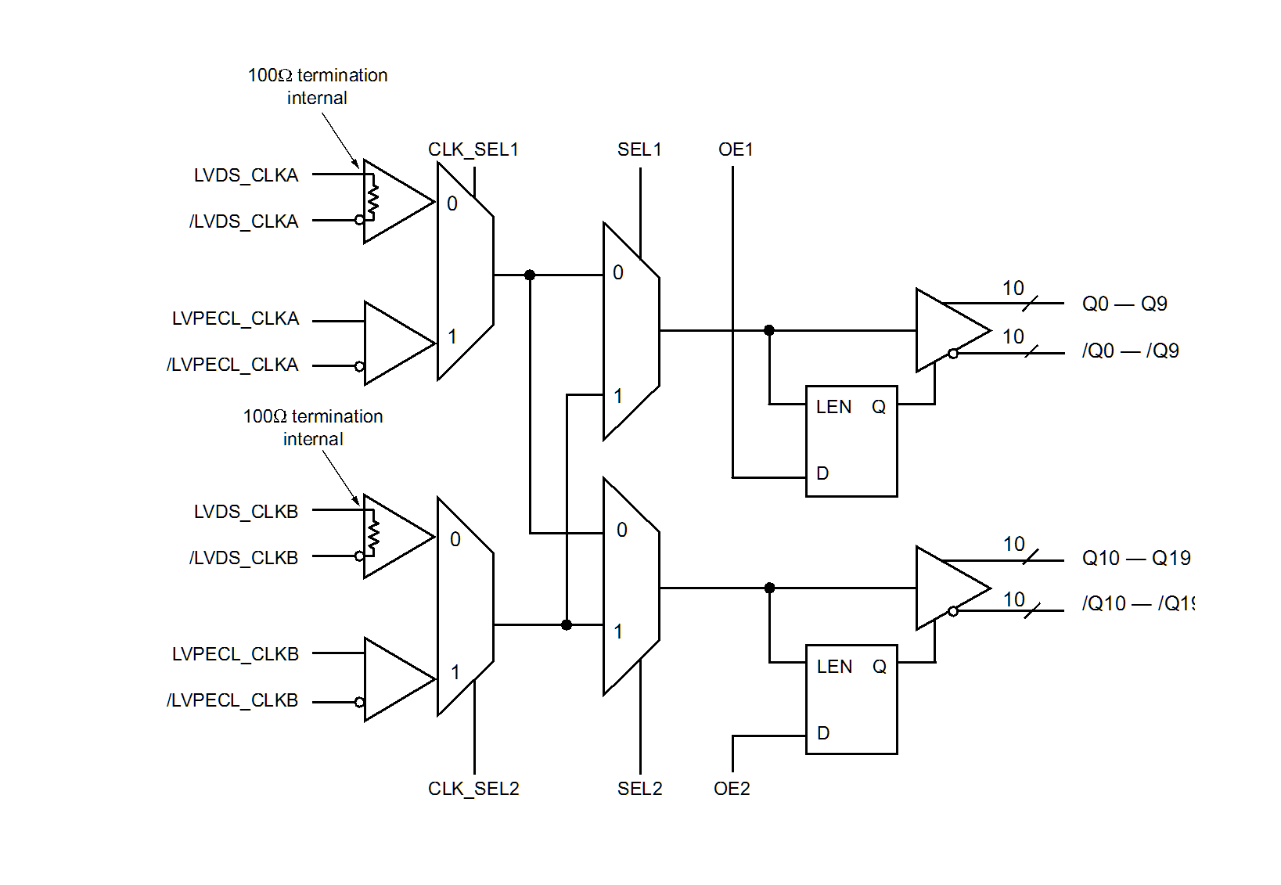
Figure 1: Micrel SY8928L Clock Fanout I.C.

This I.C. will be used for the fanout of SCLK 1:10 and BCOCLK 1:10. Using this I.C. lessens the number of clock pins required on the PTA connectors, provides signal redundancy, and increases signal quality with less skew. There is an A and B LVDS input clock for redundancy. The CLK_SEL inputs are pulled low which always uses the LVDS inputs. The SEL inputs selects which LVDS input is used. The OE pins selects whether outputs Q0-Q9 are used or Q10-19 are used for further redundancy. A pair of Maxim MAX9130 I.C.s control the SEL and OE inputs.

  - Chip Hit

The OUT 6 data pair for each FPIX2 chip on the HDI can be wire bonded on the HDI so that those pads are the CHIPHIT pair instead. On the PIXEL Plane PCB, these pads will be used for CHIPHIT. The CHIPHIT signals for HDI modules 1 through 10 will be on 4 PTA connectors. Table 11 through table 14 have the pinouts for the CHIPHIT connectors.

PIN # | SIGNAL | PIN # | SIGNAL
1 | NO CONNECT | 2 | NO CONNECT
3 | CHIPHIT8_1 | 4 | CHIPHIT*8_1
5 | CHIPHIT7_1 | 6 | CHIPHIT*7_1
7 | CHIPHIT6_1 | 8 | CHIPHIT*6_1
9 | CHIPHIT5_1 | 10 | CHIPHIT*5_1
11 | PTAGND | 12 | PTAGND
13 | CHIPHIT8_2 | 14 | CHIPHIT*8_2
15 | CHIPHIT7_2 | 16 | CHIPHIT*7_2
17 | CHIPHIT6_2 | 18 | CHIPHIT*6_2
19 | CHIPHIT5_2 | 20 | CHIPHIT*5_2
21 | PTAGND | 22 | PTAGND
23 | CHIPHIT8_3 | 24 | CHIPHIT*8_3
25 | CHIPHIT7_3 | 26 | CHIPHIT*7_3
27 | CHIPHIT6_3 | 28 | CHIPHIT*6_3
29 | CHIPHIT5_3 | 30 | CHIPHIT*5_3
31 | PTAGND | 32 | PTAGND
33 | CHIPHIT8_4 | 34 | CHIPHIT*8_4
35 | CHIPHIT7_4 | 36 | CHIPHIT*7_4
37 | CHIPHIT6_4 | 38 | CHIPHIT*6_4
39 | CHIPHIT5_4 | 40 | CHIPHIT*5_4
41 | PTAGND | 42 | PTAGND
43 | CHIPHIT8_5 | 44 | CHIPHIT*8_5
45 | CHIPHIT7_5 | 46 | CHIPHIT*7_5
47 | CHIPHIT6_5 | 48 | CHIPHIT*6_5
49 | CHIPHIT5_5 | 50 | CHIPHIT*5_5
Table 11: Left Side PTA Connector J6

PIN # | SIGNAL | PIN # | SIGNAL
1 | NO CONNECT | 2 | NO CONNECT
3 | CHIPHIT8_6 | 4 | CHIPHIT*8_6
5 | CHIPHIT7_6 | 6 | CHIPHIT*7_6
7 | CHIPHIT6_6 | 8 | CHIPHIT*6_6
9 | CHIPHIT5_6 | 10 | CHIPHIT*5_6
11 | PTAGND | 12 | PTAGND
13 | CHIPHIT8_7 | 14 | CHIPHIT*8_7
15 | CHIPHIT7_7 | 16 | CHIPHIT*7_7
17 | CHIPHIT6_7 | 18 | CHIPHIT*6_7
19 | CHIPHIT5_7 | 20 | CHIPHIT*5_7
21 | PTAGND | 22 | PTAGND
23 | CHIPHIT8_8 | 24 | CHIPHIT*8_8
25 | CHIPHIT7_8 | 26 | CHIPHIT*7_8
27 | CHIPHIT6_8 | 28 | CHIPHIT*6_8
29 | CHIPHIT5_8 | 30 | CHIPHIT*5_8
31 | PTAGND | 32 | PTAGND
33 | CHIPHIT8_9 | 34 | CHIPHIT*8_9
35 | CHIPHIT7_9 | 36 | CHIPHIT*7_9
37 | CHIPHIT6_9 | 38 | CHIPHIT*6_9
39 | CHIPHIT5_9 | 40 | CHIPHIT*5_9
41 | PTAGND | 42 | PTAGND
43 | CHIPHIT8_10 | 44 | CHIPHIT*8_10
45 | CHIPHIT7_10 | 46 | CHIPHIT*7_10
47 | CHIPHIT6_10 | 48 | CHIPHIT*6_10
49 | CHIPHIT5_10 | 50 | CHIPHIT*5_10
Table 12: Left Side PTA Connector J13

PIN # | SIGNAL | PIN # | SIGNAL
1 | NO CONNECT | 2 | NO CONNECT
3 | CHIPHIT4_1 | 4 | CHIPHIT*4_1
5 | CHIPHIT3_1 | 6 | CHIPHIT*3_1
7 | CHIPHIT2_1 | 8 | CHIPHIT*2_1
9 | CHIPHIT1_1 | 10 | CHIPHIT*1_1
11 | PTAGND | 12 | PTAGND
13 | CHIPHIT4_2 | 14 | CHIPHIT*4_2
15 | CHIPHIT3_2 | 16 | CHIPHIT*3_2
17 | CHIPHIT2_2 | 18 | CHIPHIT*2_2
19 | CHIPHIT1_2 | 20 | CHIPHIT*1_2
21 | PTAGND | 22 | PTAGND
23 | CHIPHIT4_3 | 24 | CHIPHIT*4_3
25 | CHIPHIT3_3 | 26 | CHIPHIT*3_3
27 | CHIPHIT2_3 | 28 | CHIPHIT*2_3
29 | CHIPHIT1_3 | 30 | CHIPHIT*1_3
31 | PTAGND | 32 | PTAGND
33 | CHIPHIT4_4 | 34 | CHIPHIT*4_4
35 | CHIPHIT3_4 | 36 | CHIPHIT*3_4
37 | CHIPHIT2_4 | 38 | CHIPHIT*2_4
39 | CHIPHIT1_4 | 40 | CHIPHIT*1_4
41 | PTAGND | 42 | PTAGND
43 | CHIPHIT4_5 | 44 | CHIPHIT*4_5
45 | CHIPHIT3_5 | 46 | CHIPHIT*3_5
47 | CHIPHIT2_5 | 48 | CHIPHIT*2_5
49 | CHIPHIT1_5 | 50 | CHIPHIT*1_5
Table 13: Right Side PTA Connector J8

PIN # | SIGNAL | PIN # | SIGNAL
1 | NO CONNECT | 2 | NO CONNECT
3 | CHIPHIT4_6 | 4 | CHIPHIT*4_6
5 | CHIPHIT3_6 | 6 | CHIPHIT*3_6
7 | CHIPHIT2_6 | 8 | CHIPHIT*2_6
9 | CHIPHIT1_6 | 10 | CHIPHIT*1_6
11 | PTAGND | 12 | PTAGND
13 | CHIPHIT4_7 | 14 | CHIPHIT*4_7
15 | CHIPHIT3_7 | 16 | CHIPHIT*3_7
17 | CHIPHIT2_7 | 18 | CHIPHIT*2_7
19 | CHIPHIT1_7 | 20 | CHIPHIT*1_7
21 | PTAGND | 22 | PTAGND
23 | CHIPHIT4_8 | 24 | CHIPHIT*4_8
25 | CHIPHIT3_8 | 26 | CHIPHIT*3_8
27 | CHIPHIT2_8 | 28 | CHIPHIT*2_8
29 | CHIPHIT1_8 | 30 | CHIPHIT*1_8
31 | PTAGND | 32 | PTAGND
33 | CHIPHIT4_9 | 34 | CHIPHIT*4_9
35 | CHIPHIT3_9 | 36 | CHIPHIT*3_9
37 | CHIPHIT2_9 | 38 | CHIPHIT*2_9
39 | CHIPHIT1_9 | 40 | CHIPHIT*1_9
41 | PTAGND | 42 | PTAGND
43 | CHIPHIT4_10 | 44 | CHIPHIT*4_10
45 | CHIPHIT3_10 | 46 | CHIPHIT*3_10
47 | CHIPHIT2_10 | 48 | CHIPHIT*2_10
49 | CHIPHIT1_10 | 50 | CHIPHIT*1_10
Table 14: Right Side PTA Connector J15

  - Layout considerations

The Pixel Plane PCB has 8 layers. The digital data, chiphit, and control signals are differential pairs that will have 100 ohm edge coupled controlled impedance. The PCB layer stackup is as follows.

Layer 1: Top, trace layer 1.
Layer 2: IN3, trace layer 2
Layer 3: GND, digital ground plane, impedance reference for layer 1 and layer 2
Layer 4: PWR, +3V and VDDAs power plane
Layer 5: IN1, VDDDs and AGND power plane
Layer 6: IN2, digital ground plane, impedance reference for layer 7 and layer 8
Layer 7: IN4, trace layer 3
Layer 8: BOT, trace layer 4

There will be a large cutout in the Pixel Plane PCB under the active area of the 8 chip modules. This area will be filled with TPG with a .018” thickness. A cooling pipe will be on the back of the TPG. The Pixel Plane PCB will have a thickness of .093”. The Pixel Plane PCB must be rigid enough to support the 10 8 chip modules. The Pixel Plane PCB will be mounted face to face to a second Pixel Plane PCB with a 6.2 mm offset. The connectors will be on the back of the Pixel Plane PCB. High voltage minimum clearances will be required. The Pixel Plane PCB is under a size restriction which makes the layout and the cable routing a challenge.

  - Grounding
The low voltage digital powers have separate grounds at the connector where it becomes a common digital ground on the Pixel Plane PCB. The low voltage analog powers and high voltage powers have separate grounds at the connector where it becomes a common analog ground on the pixel plane. The connectors for are 24 pin for the 10 HDI modules. This provides an unused bottom pair of pins that can be used for SHIELD GROUND as an option. There is a large digital ground pad near each power connector to allow for the connection of a cable ground shield to digital ground if it is needed. There are pads for a zero ohm resistor in several spots on the Pixel Plane PCB to allow the connecting of analog ground to digital ground if it is needed.

  - Dimensions of the board
Figure 2 is the Pixel Plane PCB layout. The outer circle is the detector barrel which has a radius of 180mm. The lower circle of the Pixel Plane PCB is the beam pipe area with a diameter of 31.2mm. The Pixel Plane PCB has a maximum width of 353.16mm and a maximum height of 173.8mm. The PCB has a cutout under the HDI detectors that is 74mm wide and 133.0mm in height. This cutout area will be filled with a carbon-TPG substrate and contain a cooling pipe.

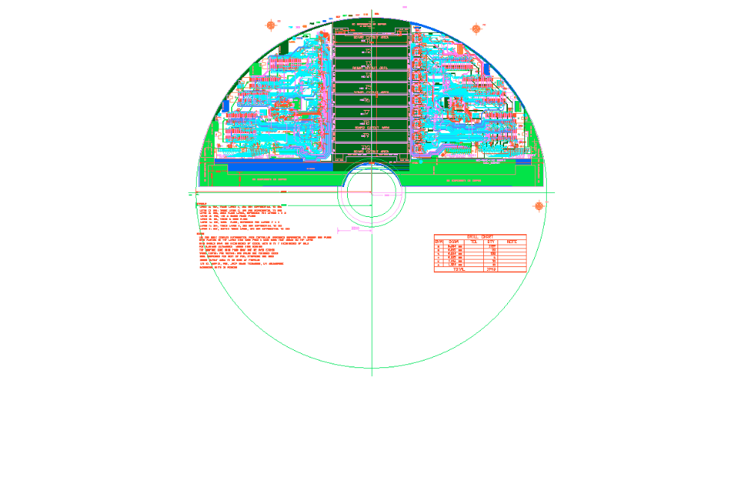 Figure 2: Pixel Plane PCB

The two Pixel Plane PCBs will be mounted face to face with the connectors mounted on the back side of the PCBs.
3.3 Pixel Plane PCB Design Schematic.


