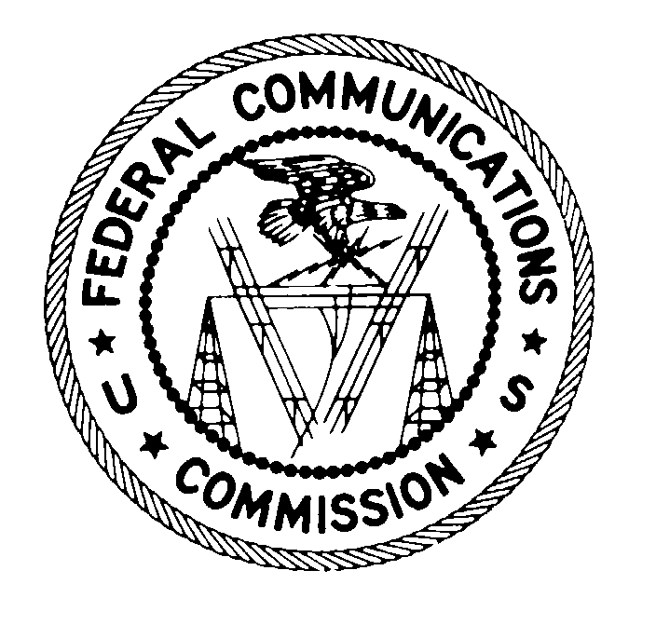 April 30, 2007
FEDERAL COMMUNICATIONS COMMISSION
WASHINGTON, D.C. 20554

VIA CERTIFIED MAIL
RETURN RECEIPT REQUESTED

Germany Country Direct
Attn: Susan Walter
2 International Drive, 2nd Floor
Rye Brook, NY 10573

RE: EB-07-TC-1389

Dear Ms. Susan Walter:

This is an official CITATION, issued pursuant to section 503(b)(5) of the Communications Act of 1934, as amended (the Act), 47 U.S.C. § 503(b)(5), for violations of the Act and the Federal Communications Commission’s rules that govern telephone solicitations and unsolicited advertisements. As explained below, future violations of the Act or Commission’s rules in this regard may subject you and your company to monetary forfeitures.

It has come to our attention that your company, acting under your direction, apparently sent one or more unsolicited advertisements to telephone facsimile machines in violation of Section 227(b)(1)(C) of the Communications Act, as described in the attached complaint(s). Section 227(b)(1)(C) makes it “unlawful for any person within the United States, or any person outside the United States if the recipient is within the United States . . . to use a telephone facsimile machine, computer, or other device to send an unsolicited advertisement to a telephone facsimile machine.” As relevant here, an “unsolicited advertisement” is “any material advertising the commercial availability or quality of any property, goods, or services which is transmitted to any person without that person’s prior express invitation or permission.” Under Commission rules and orders in effect during the relevant period here, the Commission considered an established business relationship between a fax sender and recipient to constitute prior express invitation or permission to send a facsimile advertisement. Mere distribution or publication of a fax number, however, does not establish consent to receive advertisements by fax.

If, after receipt of this citation, you or your company violate the Communications Act or the Commission’s rules in any manner described herein, the Commission may impose monetary forfeitures not to exceed $11,000 for each such violation or each day of a continuing violation.

You may respond to this citation within 30 days from the date of this letter either through (1) a personal interview at the Commission’s Field Office nearest to your place of business, (2) a written statement, or (3) a teleconference interview with the Commission’s Telecommunications Consumers Division in Washington, DC. Your response should specify the actions that you are taking to ensure that you do not violate the Commission’s rules governing telephone solicitation and unsolicited advertisements, as described above.

Please contact Al McCloud at (202) 418-2499 to arrange for an interview at the closest field office, if you wish to schedule a personal interview. You should schedule any interview to take place within 30 days of the date of this letter. You should send any written statement within 30 days of the date of this letter to:

Kurt A. Schroeder
Deputy Chief
Telecommunications Consumers Division
Enforcement Bureau
Federal Communications Commission
445-12th Street, S.W., Rm. 4-C222
Washington, D.C. 20554

Reference EB-07-TC-1389 when corresponding with the Commission.

Reasonable accommodations for people with disabilities are available upon request. Include a description of the accommodation you will need including as much detail as you can. Also include a way we can contact you if we need more information. Please allow at least 5 days advance notice; last minute requests will be accepted, but may be impossible to fill. Send an e-mail to fcc504@fcc.gov or call the Consumer & Governmental Affairs Bureau:

For sign language interpreters, CART, and other reasonable accommodations:
202-418-0530 (voice), 202-418-0432 (tty);

For accessible format materials (braille, large print, electronic files, and audio
format): 202-418-0531 (voice), 202-418-7365 (tty).

Under the Privacy Act of 1974, 5 U.S.C. § 552(a)(e)(3), we are informing you that the Commission’s staff will use all relevant material information before it, including information that you disclose in your interview or written statement, to determine what, if any, enforcement action is required to ensure your compliance with the Communications Act and the Commission’s rules.

The knowing and willful making of any false statement, or the concealment of any material fact, in reply to this citation is punishable by fine or imprisonment under 18 U.S.C. § 1001.

Thank you in advance for your anticipated cooperation.

Sincerely,

Kurt A. Schroeder
Deputy Chief, Telecommunications Consumers Division
Enforcement Bureau
Federal Communications Commission

Enclosures

47 U.S.C. § 227; 47 C.F.R. § 64.1200. A copy of these provisions is enclosed for your convenience. Section 227 was added to the Communications Act by the Telephone Consumer Protection Act of 1991 and is most commonly known as the TCPA. The TCPA and the Commission’s parallel rules restrict a variety of practices that are associated with telephone solicitation and use of the telephone network to deliver unsolicited advertisements, including fax advertising. We refer in this citation to the Commission’s rules as they existed at the time of the violations in this matter. Revised rules in this area took effect on August 1, 2006. 47 U.S.C. § 64.1200(a)(3); Rules and Regulations Implementing the Telephone Consumer Protection Act of 1991 – Junk Fax Protection Act of 2005, Report and Order and Third Order on Reconsideration, 21 FCC Rcd 3787 (2006) (2006 TCPA Report and Order).
We have attached 1 complaint at issue in this citation. The complaint addresses a facsimile advertisement that contains the telephone number 866-879-6178, which your business utilized during the time period at issue.
47 U.S.C. § 227(b)(1)(C); see also 47 C.F.R. § 64.1200(a)(3) (providing that no person or entity may . . . use a telephone facsimile machine, computer, or other device to send an unsolicited advertisement to a telephone facsimile machine). Both the TCPA and the Commission’s rules define “telephone facsimile machine” as “equipment which has the capacity to transcribe text or images, or both, from paper into an electronic signal and to transmit that signal over a regular telephone line, or to transcribe text or images (or both) from an electronic signal received over a regular telephone line onto paper.” 47 U.S.C. § 227(a)(2); 47 C.F.R. § 64.1200(f)(8). The Commission has stated that “[t]he TCPA’s definition of ‘telephone facsimile machine’ broadly applies to any equipment that has the capacity to send or receive text or images.” Thus, “faxes sent to personal computers equipped with, or attached to, modems and to computerized fax servers are subject to the TCPA’s prohibition on unsolicited faxes. . . [although] the prohibition does not extend to facsimile messages sent as email over the Internet.” Rules and Regulations Implementing the Telephone Consumer Protection Act of 1991, Report and Order, 18 FCC Rcd 14014, 14131-32 (2003) (2003 TCPA Report and Order).
47 U.S.C. § 227(a)(4) (1991); 47 C.F.R. § 64.1200(f)(10) (2003); see 47 U.S.C. § 227 (a)(4) (2005); 47 C.F.R. § 64.1200(f)(13) (2006) (amending the definition of “unsolicited advertisement” to specify that prior express invitation or permission may be “in writing or otherwise”).
See Rules and Regulations Implementing the Telephone Consumer Protection Act of 1991, Memorandum Opinion and Order, 10 FCC Rcd 12391, 12405 (1995) (1995 TCPA Reconsideration Order). The Junk Fax Prevention Act of 2005, Pub. L. 109-21, 119 Stat. 359 (2005), and the Commission’s parallel rules, which took effect August 1, 2006, further specify the conditions under which an established business relationship provides an exception to the prohibition on unsolicited fax advertising.
1995 Reconsideration Order, 10 FCC Rcd at 12408-09; see also 2003 TCPA Report and Order, 18 FCC Rcd at 14128 (concluding that mere publication of a fax number in a trade publication or directory does not demonstrate consent to receive fax advertising).

