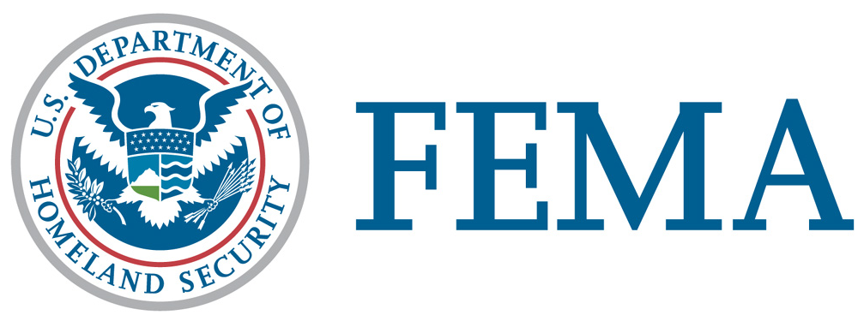

Office of Legislative Affairs
202-646-4500

HOTLINES AND WEBSITES FOR MISSING PERSONS,
VOLUNTEERS, AND DONATIONS

HurrICANE KATRINA

We have compiled the following list of websites and phone numbers from the Alabama, Louisiana, and Mississippi state websites.

Please bear with the emergency personnel and rescue teams and realize that it may be difficult to get through because of downed communication lines, and the overwhelming life-saving measures that are taking place. If you are aware of additional phone numbers or website that may be useful, please let us know. We will update this list as more information becomes available.

Louisiana (see http://www.louisiana.gov/wps/portal/)

To report missing persons, please call the American Red Cross at 1(866) 438-4636.
Louisiana Governor Blanco's hotline: 800-469-4828
Louisiana Evacuation Office: 225-925-7514
Louisiana State Police: 225-925-7708 or 7709
Shelter Information:
Red Cross- 1(866)(438-4636)
Special Needs Shelter Information
Triage Phone Numbers:
Alexandria: 800-841-5778
Baton Rouge: 800-349-1372
Slidell/Hammond: 866-280-7724
Lafayette: 800-901-3210
Lake Charles: 866-280-2711
Monroe: 866-280-7287
Houma/Thibodaux: 800-228-9409
Here is a list of phone numbers set up solely for cash donations and/or volunteers.
To donate cash, please call:
American Red Cross 1-800-435-7669 English
1-800-257-7575 Spanish
Operation Blessing 1-800-436-6348
America’s Second Harvest 1-800-344-8070
Donate Cash to and Volunteer with:
Adventist Community Services 1-800-381-7171
Catholic Charities, USA 703 549-1390
Christian Disaster Response 941-956-5183 or 941-551-9554
Christian Reformed World Relief Committee 1-800-848-5818
Church World Service 1-800-297-1516
Convoy of Hope 417-823-8998
Lutheran Disaster Response 1-800-638-3522
Mennonite Disaster Service 717-859-2210
Nazarene Disaster Response 888-256-5886
Presbyterian Disaster Assistance 1-800-872-3283
Salvation Army 1-800-725-2769
Southern Baptist Convention -- Disaster Relief 1-800-462-8657, ext. 6440
United Methodist Committee on Relief 1-800-554-8583
For further information: please visit the website for the National Voluntary Organizations Active in Disaster (NVOAD) at:
http://www.nvoad.org/

Mississippi (see www.mema.ms.gov )

Red Cross 1-866-Get Info (Missing Persons)
To report missing persons, please email missingpersons@seoc.ms.gov

Use this form: www.mema.ms.gov/missing.person.form.gov

Red Cross 1-800-Help Now (Donations)

MDOT traffic hotline: 601-352-7017

Volunteers

Medical personnel:

Doctors call: 601-987-3079;

EMTs call: 601-576-8085;

Nurses call: 601-497-8022

Non-professional volunteers: contact Red Cross, Salvation Army other established volunteer organizations.

Alabama (http://www.governor.state.al.us/hurricane_katrina/katrina2.htm)

Alabamians who want to volunteer for disaster relief efforts can sign up over the Internet through the Governor’s Office of Faith-Based and Community Initiatives. The website where Alabamians can sign up to volunteer is www.servealabama.gov/

American Red Cross
1-866-GET-INFO
For assistance, to volunteer or to assist click here:
http://www.redcross.org/
Alabama Emergency Management Agency
205-280-2200
Click below for your county EMA contact information:
http://207.157.116.10
Alabama Department of Transportation
Emergency Road Closure Information and Evacuation Updates:
1-888-588-2848 or 1-334-353-6650
http://www.dot.state.al.us/docs
Attorney General
1-800-392-5658
To report price gouging contact the Consumer Affairs Office:
http://www.ago.state.al.us/
Alabama Department of Mental Health & Mental Retardation
1-800-367-0955
Facilities and Health Care Information

