
The Unified Lunar Control Network 2005
By Brent A. Archinal¹, Mark R. Rosiek¹, Randolph L. Kirk¹, and Bonnie L. Redding¹

2006

Open-File Report 2006-1367 - Version 1.0
U.S. Department of the Interior
U.S. Geological Survey

U.S. Department of the Interior
Dirk Kempthorne, Secretary
U.S. Geological Survey
Mark Myers, Director
U.S. Geological Survey, Reston, Virginia 2006
For product and ordering information:
This report is a Web-only publication:
pubs.usgs.gov/of/2006/1367/
World Wide Web: http://www.usgs.gov/pubprod
Telephone: 1-888-ASK-USGS
For more information on the USGS—the Federal source for science about the Earth,
its natural and living resources, natural hazards, and the environment:
World Wide Web: http://www.usgs.gov
Telephone: 1-888-ASK-USGS
Suggested citation:
Archinal, B.A., Rosiek, M.R., Kirk, R.L., and Redding, B.L., 2006, The Unified Lunar Control Network 2005: U.S. Geological Survey Open-File Report 2006-1367 [http://pubs.usgs.gov/of/2006/1367/ ].
Any use of trade, product, or firm names is for descriptive purposes only and does not imply
endorsement by the U.S. Government.
Although this report is in the public domain, permission must be secured from the individual
copyright owners to reproduce any copyrighted material contained within this report.

Contents
Contents iii
Figures iii
Tables iii
Abstract 1
Introduction 1
Previous Networks 2
ULCN 2005 2
Available Files 4
Uses of the ULCN 2005 6
Future Work 8
Acknowledgements 9
References Cited 9

Figures
Figure 1. Color-coded topography derived from the ULCN 2005 solution 13
Figure 2. Example detail topographic map of the Oppenheimer crater derived from a TIN of Clementine LIDAR radii (km) and showing the position of LIDAR measurements. 14
Figure 3. Example detail topographic map of the Oppenheimer crater, derived from a TIN of ULCN 2005 radii (km) and showing the position of Clementine image tie point measurements. 17
Figure 4. Close up of the topographic model shown in Figure 1, for the north polar area of the Moon. 16
Figure 5. Close up of the topographic model shown in Figure 1, for the south polar area of the Moon. 16
Figure 6. Absolute horizontal difference in the image boresight position of 43,866 images, between the ULCN 2005 solution and the CLCN solution. 17

Tables
Table 1. Lunar Horizontal Control Net Comparison. 17
Table 2. Vertical Data Sources for the Moon. 18

.
The Unified Lunar Control Network 2005
by Brent A. Archinal, Mark R. Rosiek, Randolph L. Kirk, and Bonnie L. Redding

Abstract
This report documents a new general unified lunar control network and lunar topographic model based on a combination of Clementine images and a previous network derived from Earth based and Apollo photographs, and Mariner 10 and Galileo images. This photogrammetric network solution is the largest planetary control network ever completed. It includes the determination of the 3-D positions of 272,931 points on the lunar surface and the correction of the camera angles for 43,866 Clementine images, using 546,126 tie point measurements. The solution RMS is 20 µm (= 0.9 pixels) in the image plane, with the largest residual of 6.4 pixels. The explanation given here, along with the accompanying files, comprises the release of the network information and of global lunar digital elevation models (DEMs) derived from the network. A paper that will describe the solution and network in further detail will be submitted to a refereed journal, and will include additional background information, solution details, discussion of accuracy and precision, and explanatory figures.

Introduction
We have completed a new general unified lunar control network and lunar topographic model based on Clementine images and the previous ULCN network, which had been derived from Earth-based and Apollo photographs, and Mariner 10 and Galileo images of the Moon. This photogrammetric network solution is the largest planetary control network ever completed. It includes the determination of the 3-D positions of 272,931 points on the lunar surface and the correction of the camera angles for 43,866 Clementine images, using 546,126 tie point measurements. The solution RMS is 20 µm (= 0.9 pixels) in the image plane, with the largest residual of 6.4 pixels. We have previously issued progress reports on this work [Archinal, et al., 2005a-e, 2006a-c]. The explanation given here, along with the accompanying files, comprises the release of the network information and of global lunar digital elevation models (DEMs) derived from the network. We also plan to submit a paper to a refereed journal describing the network in detail. This information is being released as an Open-File Report prior to such publication due to its importance in the planning of current and upcoming lunar missions.

Previous Networks
In recent years there have been two generally accepted lunar control networks. These are the Unified Lunar Control Network (ULCN) and the Clementine Lunar Control Network (CLCN), both derived by M. Davies and T. Colvin at RAND. The original ULCN was described in the last major publication about a lunar control network [Davies, et al., 1994]. See Tables 1 and 2 for statistics on this and the other networks discussed here. Images for this network are from the Apollo, Mariner 10, and Galileo missions, and Earth-based photographs. This network is important because (1) its accuracy is relatively well-quantified, (2) it connects the four different types of image data, and (3) published information on the network is available.
The CLCN was derived from Clementine images and measurements on Clementine 750-nm images. The purpose of this network was to determine the geometry for the Clementine Base Map [USGS, 1997]. The geometry of that mosaic was used to produce the Clementine UVVIS digital image model [USGS, 1999; Eliason, et al., 1999] and the Near-Infrared Global Multispectral Map of the Moon from Clementine [USGS, in preparation; Eliason, et al., 2003]. Because of the extensive use of these products, they and the underlying CLCN effectively define the accepted current coordinate frame for reporting and describing the location of lunar features. The CLCN is described in print only briefly [Edwards, et al., 1996]. See http://astrogeology.usgs.gov/Projects/ControlNetworks/ for further information and ULCN and CLCN files.
Our efforts have merged these two networks into an improved ULCN, improving greatly upon the accuracy of the CLCN, determining radii for the CLCN points, further improving the original ULCN, and providing for a single unified photogrammetrically determined network.

ULCN 2005
The primary significant feature of our new network in comparison to the previous ones is that we solve for the radii of the control points. This avoids distortion of horizontal positions (of about 7 km average, and up to 15 km or more), that have been pointed out by previous authors [Malin and Ravine, 1998; Cook, et al., 2000; Cook, et al., 2002]. Solution for radii is possible because the overlapping Clementine images provide stereo information. The expected vertical precision of such information is generally on the order of several hundred meters, and the radii derived from the images appear to be compatible with Clementine LIDAR [Smith, et al., 1997], previously the most accurate radii data, at this level of precision. When the ULCN 2005 solution radii of all 272,931 control points are compared to the a priori radii derived from an interpolation of a combination of Clementine LIDAR and polar Clementine stereo data [Rosiek, et al., 2001], the differences are not significant. Specifically, the mean absolute difference of the solution radii from their a priori values is 137 m, with a standard deviation of 219 m, thus showing there is no systematic difference between the LIDAR and newly derived values, and that the radii must therefore be of similar accuracy (a few hundred meters). Thus a by-product of this network is a global lunar topographic model that is denser than that provided by LIDAR and of similar accuracy. Only in limited areas of the Moon are higher density topographic data available [Rosiek, et al., 1998; Rosiek, et al., 1999; Rosiek and Aeschliman, 2001; Rosiek, et al., 2001; see http://astrogeology.usgs.gov/Projects/ISPRS/MEETINGS/; Margo, 1999; Margo, et al., 1999 and 2000; Wu and Doyle, 1990]. With 272,931 control points, and assuming a spherical moon with radius = 1737.4, there is an average of one point for every ~46 km², or one point every ~6.8 km. This radius information is also defined in a consistent, full, absolute, 3D frame. This is the only lunar topographic model where both height and horizontal positions are estimated in a globally-consistent frame. See Figure 1 for a representation of this topographic model. Figures 2 and 3 compare, for the area of the Oppenheimer crater, results from Clementine LIDAR and the ULCN 2005 DEM model. Figures 4 and 5 show perspective views of the ULCN 2005 DEM in the areas of the north and south pole of the Moon.
A second significant feature of the ULCN 2005 is that we have used a constraint for the camera angles of 1º, although we have allowed angles that show changes of more than 0.6º to change freely. This is on the assumption that angles with such large changes result from angle measurement errors (a few angles change by up to ~25º, probably due to unaccounted for spacecraft operations). The constraint of 1º is quite conservative in comparison to the much greater accuracy with which the angles were measured, i.e. reportedly 0.03º [Nozette, et al., 1994]. We believe this feature provides significant improvement in the horizontal accuracy of the network (and therefore in the vertical accuracy, which is coupled), because we have substantially eliminated apparent large errors that exist in the original camera angle measurements, while allowing for minor (and generally expected) adjustments in the angles. Note that from an average altitude of 640 km, the implied horizontal position accuracy due to the 0.03º accuracy of the a priori information is 335 m. Because 99% of the angles change less than 0.45º, this and the 640 km altitude would also imply that even if the a priori angles were perfect, the greatest 3 standard deviation horizontal error in our solution could not exceed 5.1 km. This also assumes that the spacecraft positions – which we do not adjust – are perfectly accurate. Obviously, this is not the case, but the cited errors [Zuber, et al., 1994] in the orbit positions (at least radially) are ~100 m, which when root square sum added to the pointing errors, would still cause additional errors of a maximum of a few hundred meters. The change (and therefore improvement) in camera boresight positions between the CLCN and ULCN 2005 is represented in Figure 6. Because the estimated errors in the CLCN solution are so much larger than those of the ULCN 2005, this is also effectively a map of the improvement in the control network.
A third feature of the ULCN 2005 is that a majority of the original ULCN points were identified on Clementine images and their measurements were included in the new ULCN 2005. 1,261 points were measured, and 754 of them were measured on two or more images. This therefore allows for the direct incorporation of the ULCN into the new ULCN 2005. We have done so by weighting the ULCN points appropriately (0.18-5 km horizontally, 2-6 km vertically) for the accuracies as described in [1]. A subset containing 124 ULCN points, that had particularly high residuals, was interpreted as consisting of misidentified points or points where the original ULCN was in error. These points were subsequently weighted the same as non-ULCN points (2 km horizontally and 10 km vertically, or effectively free to adjust). This tie to the ULCN and the use of Clementine a priori spacecraft position data in the mean Earth/polar axis system also places our solution in that same mean Earth/polar axis system (see Davies, et al. [1994]).

Available Files
The files accompanying this text explanation comprise the ULCN 2005 solution input and output files, and derived files of interest. An accompanying file, “ReadMe-ULCN2005.txt” describes all the files in detail. However, here we summarize those files and provide suggestions for their possible use.
The directory structure used for the files separates them into three categories: 1) solution input and output files (sub directory “solution”); 2) Miscellaneous derived files of interest (“derived”); and 3) global DEMs and DEM images (“dems”). Where appropriate, text explanations of file formats are also included as ASCII (ASC) and Adobe Acrobat (PDF) files.
The solution input and output files include (in ASCII format) the tie point measurement file and the primary output file. The latter includes ULCN 2005 solution control point positions and camera angles (the latter accompanied by the input image numbers, times, and spacecraft positions). The control point positions define the global DEM, from which the DEM files described below are derived.
Miscellaneous derived files include: 1) A list of the sorted solution residuals, from the last iteration, which could be used to characterize the precision of the control point positions; and 2) the calculated statistics for each control point, including in particular the minimum expected vertical precision at each point. This latter file includes the image resolution at each point, which could be used with the residual information to estimate the (residual) uncertainty for each control point measurement in meters.
The global DEM files are derived from the control point positions. Two types of DEM files are provided in multiple formats. All of the DEMs are in global simple cylindrical projection.
The following types of DEMs were produced:

- The first DEM is at a resolution of 16 pixels/degree (e.g. about 1.895 km resolution), as a grid created from a triangle irregular network (TIN) of the original points. Note that no smoothing has been done to the points, so at the meter to tens of meters level significant noise (e.g. due to orbit errors and varying vertical and horizontal precision) can be seen in this DEM particularly if “hill-shading” is applied. However, in any given local area, the user may find this to be the most accurate representation of topography. This format was created using ESRI™ ArcMap™ 3D Analyst™ functions.
- A second DEM is also at a resolution of 16 pixels/degree (e.g. about 1.895 km resolution), as a grid created from a polynomial fit through the original points. For many users this will be the most useful DEM representation because the algorithm smoothes the sub areas and gives the most aesthetically pleasing DEM. However, users should be cautioned that the smoothing does attenuate the topography in some areas where only one point indicates a local high or low radius, for example. This format was created using ArcMap™ Geostatistical Analyst function.

The DEMs have been produced in the following formats:

- ISIS cube files.
- A BIL (“band interleaved by line” format) header that can be used with the ISIS cube files by changing the file extension from .cub to .bil.
- ArcMap™ grids.
- ArcMap™ ASCII grid files.
- TIFF image files.

A simple ASCII listing file has also been included. This includes, for each ULCN 2005 control point the following information:
Pt_name - point name. The 22 points that tied the ULCN to the CLCN are place or feature names (i.e. Clerke). Other points from the ULCN are either a number (i.e. 655) or start with M or P and then a number (P7084 or M5). These later names are from the original ULCN [Davies, et al., 1994], with the “P” points being from the Catalog of Lunar Positions based on the Lunar Positional Reference System (1974) that was published by the Defense Mapping Agency. The “M” points are Mariner 10 points. The Clementine points are 2 letters, 4 numbers, and then 1 letter (i.e. AF0510C, in a rather arbitrary system use to number points on Clementine images).
set - a number 1-5 indicating the data source (1 - Apollo Network, 2 - Telescopic Network, 3 - Mariner 10 Network, 4 - Galileo Network, and 5-CLCN)
measures - number of measurements on a point
evp_m - expected vertical precision in meters
lat - latitude (degrees) from final solution of ULCN2005
lon_360 - longitude (degrees) in positive east 360 longitude system from final ULCN2005 solution
lon_180 - longitude (degrees) in positive east ±180 longitude system from final ULCN2005 solution
radius_km - radius value for point in kilometers from final ULCN2005 solution
ht_m - height in meters referenced to a sphere of 1,737,400 meters based on radius_km value lpo_ht - height in meters referenced to a sphere of 1,737,400 meters based on interpolating a grid using a local polynomial interpolator on the radius_km values
lpo_diff - difference between the lpo_ht and the ht_m
grid_ht - height in meters referenced to a sphere of 1,737,400 meters based on interpolating a grid using a bilinear interpolator between the radius_km values
grid_dif - difference between the grid_ht and the ht_m

NOTE: Radii (km) and height values may not be equal due to: (1) round off from real to integer value; (2) multiple points in the same grid cell; (3) smoothing; and (4) interpolation.

We caution that it has been challenging to make DEMs from the ULCN 2005 control point solution due to the irregular distribution of the data, the sparseness of the data (compared to, for example, using MOLA data from Mars), and the highly variable precision of the control point positions (due to the varying stereo geometry). For users who wish to obtain the highest accuracy from this dataset for a given area, we recommend starting from the original set of control points, checking the size of the residuals for the control point measurements and the expected vertical precision of the control points, and examining and possibly editing/filtering/smoothing the data in the area of interest to remove outliers. Most likely, the best accuracy of the data will still be in the few hundred meter range, if only due to the uncertainty in the Clementine spacecraft positions, although the relative accuracy between adjacent and nearby points may be much better, as indicated by the expected vertical precision information.

Uses of the ULCN 2005
We envision multiple possible uses for the ULCN 2005 control network and topographic model. The original reason that we updated the CLCN solution was because it contained significant (several km) horizontal errors, which were noted in it during the late 1990s and early 2000s. Our hope was that the updated solution could be used to correct positions measured from the USGS Clementine mosaics – which to some extent has become a default source for coordinates of lunar features – or that some or all of these mosaics could be remade using the new network.
It is now clear that there are a number of other possible uses for the ULCN 2005 solution information, particularly since we have been able to recover control point radii, a significantly dense set of topographic information. We summarize here some of the most significant uses.

- The change in control point coordinates (or somewhat equivalently the image boresight positions) from the CLCN to the ULCN 2005 defines a transformation field. With appropriate software that information could be used to convert (“warp”, “rubber sheet”, etc.) coordinates from the old CLCN and Clementine mosaic frame to the (more accurate) ULCN 2005 frame. This would allow the positions of features of interest (e.g. scientific/geologic or operational for landing site selection) to be determined as accurately as possible. This could also be done with portions or all of the Clementine mosaics (the Clementine Base Map, UVVIS, or Near-Infrared Global Multispectral Map). We have had some success in transforming small areas of the Clementine Base Map mosaic using ArcInfo Workstation by ESRI. Other publicly and commercially available tools could also be used for such work (e.g. ISIS, ENVI by ITT Visual Information Solutions, GDAL).
- The Clementine mosaics could be rigorously regenerated using the new network, thus removing the large scale distortions in them so that positions could be accurately measured directly from the mosaics. The regeneration process would also be an opportunity to introduce other improvements to these mosaics, such as improving the radiometric calibration, changing the tiling scheme to using larger file sizes, and projecting the images onto the ULCN 2005 topography, thereby creating a true orthomosaic rather than a mosaic projected onto a sphere. In addition, the regeneration process could be done in such as way that it could easily be repeated in the future. That will be necessary as the control network continues to be improved with new mission data and while users still require registration between old and new datasets at the sub-pixel level. It is true that taking advantage of these opportunities will require significant funding, although not approaching the cost of the original creation of the mosaics. However, there will also be substantial savings in the future for users of the mosaics (since they will not need to maintain software and do coordinate conversions) when either using the mosaics or geometrically improving them further.
- Because this improved network is now available, we will tie the Lunar Orbiter global digital mosaic now being generated to this network [Becker, et al., 2005; Weller, et al., 2006; see http://astrogeology.usgs.gov/Projects/LunarOrbiterDigitization/]. Tie point measurements are being made between the Lunar Orbiter images and an independent global lunar orbiter test network is being created from those measures. Tie points are also being measured between the Lunar Orbiter images and some of the Clementine images in the ULCN 2005 – thus allowing the Lunar Orbiter images to be positioned in an absolute sense into the same ULCN 2005 frame.
- The vertical positions of the ULCN 2005 points now provide a global topographic model for the Moon with a more uniform distribution of points compared to existing topographic information, such as the non-polar LIDAR data, the Clementine polar stereo data from Rosiek et al [1998, 1999, Rosiek and Aeschliman, 2001; 2001], and the (unreleased) irregular Clementine stereo data from Cook, et al. [2000]. Though such a DEM is nowhere near as dense or as accurate as, for example, those generated from the MOLA data at Mars, it will serve as the best global topography model for the Moon until it is supplanted in a few years with new data. In any case, such a global DEM obviously has diverse uses, such as:
- Assisting in studies of global and regional geology and morphology of the Moon, including the investigation of the Moon’s impact basins and larger craters.
- Providing a surface onto which oblique images can be orthorectified, in order to remove image distortions due to topographic effects.
- Providing operational information for near-term lunar operations, e.g. for the planning of the acquisition of new imaging and other (e.g. altimeter) data (SELENE, Chang’E-1, Chandrayaan-1, LRO), and the determination of lunar radius in areas planned for possible landings (the U.S. planned 2011 LPRP lander) or impacts (e.g. SMART-1 in 2006, LCROSS in 2008). Because the Lunar Orbiter mosaic will be tied to this network, users could determine horizontal positions of features of interest from that mosaic. Then the approximate radii at those locations could be determined using the ULCN 2005 derived DEM. As an example of this, the DEM was used along with the Clementine stereo models of Cook, et al. (Anthony Cook, Thomas Watters, and Mark Robinson) to predict possible impact points for the SMART-1 spacecraft on 2006 September 3. The orbit of the spacecraft was raised several hundred meters on the basis of this information so the impact would occur on the orbit best suited for Earth-based observation. The impact also appears to have occurred within a few hundred meters of where it was predicted via the ULCN 2005 and Cook, et al. stereo data. [See e.g. http://www.esa.int/SPECIALS/SMART-1/SEMV386LARE_0.html and http://www.esa.int/SPECIALS/SMART-1/SEMWX03VRRE_1.html].
- The global ULCN 2005 DEM can also be used for registering other regional or local topographic information. For example, we are working with Cook, et al. to register their “planet-wide” Clementine DEMs into this frame, so this Clementine stereo information can finally be easily used. Other DEMs, such as those derived from the digitization of old maps [Willoughby, et al., 2004] or new processing of Lunar Orbiter or Apollo imagery [Rosiek, et al., 2006a-c] can also be registered to this frame so that the internal coordinates will be accurate at the level of the ULCN 2005 itself (e.g. the few hundred meter level, rather than with the several kilometers of error that some of these DEMs currently have).
- The tie point measurements used in the ULCN 2005 can be used to locate the specific control point locations on the Clementine images, and through interpolation, to estimate the coordinates of intermediate points in the ULCN 2005 frame.
- Individual Clementine images used in the ULCN 2005 can also now be projected onto the UCLN 2005 DEM and - with the appropriate software (e.g. ISIS) - points of interest can be identified and measured in three dimensions directly.
- Finally, the ULCN 2005 network can serve as a base for tying other existing imagery (e.g. Earth-based, Lunar Orbiter, Apollo, Mariner 10, Galileo, other Clementine images, SMART-1 images) and future imagery and data. This type of use is discussed further in the next section.

Future Work
We are already at work on an improved version of the ULCN 2005 (tentatively to be called the ULCN 2007). This will be a new solution, incorporating additional datasets. We are checking the Mariner 10 and Galileo [Belton, et al., 1992, 1994; Schenk and Bussey, 2004] image measurements already used in the ULCN, and directly incorporating them into the solution instead of relying on the constraints on the original ULCN [Davies, et al., 1994] points. We will, however, continue to use constrained positions for the original ULCN points based on Apollo and Earth based imagery, rather than reanalyzing these extensive sub networks. We also plan to directly incorporate the Lunar Orbiter image measurements. Because of their wide area of coverage relative to image size (in comparison to Clementine images) we expect that adding the earlier images will strengthen the horizontal accuracy of the network, both regionally where the Mariner 10 and Galileo imagery exist, and globally in the case of the Lunar Orbiter imagery. We are adding ties to the current absolute reference frame described by the Lunar Laser Ranging (LLR) and Apollo Lunar Science Experiment Package (ALSEP) network [Davies and Colvin, 2000]. This should further improve the accuracy of the network in the vicinity of the Apollo landing sites. The merging of these datasets should not only improve the horizontal and vertical accuracy and density of the global network, but places all of the data (e.g. Lunar Orbiter, Mariner 10, Galileo, Clementine, and to some extent Apollo) into a common network (reference frame).
We also plan to “densify” the available topographic information. First, we will attempt to interpolate our camera angle solutions to the time of the LIDAR observations in order to correct the spacecraft pointing for the LIDAR data. This should then allow a direct merging of the LIDAR and our ULCN 2005 (or later solution) topographic information, e.g. increasing the number of points to (272931 plus 72548) ~345,479. As already described, we are working with Cook, et al. (2000, 2002) to take their “planet-wide” Clementine stereo information and register it into the ULCN 2005 and its successor solutions. Not only will the expected vertical precision of the derived radii will generally be significantly better than the ULCN 2005 radii, in regions where the data exists the density of such points will be increased by ~2 orders of magnitude.
In the long term, there are a number of options for further improving the lunar network and topography that we will attempt as funding permits. This would include the continuing incorporation of past datasets, such as the Apollo images, the Rosiek et al. Clementine polar stereo, and Earth-based radar information.
The larger and more important challenge will be to incorporate data from all of the current and planned missions. This is necessary so that these new datasets can be compared among themselves and to prior data, particularly the Lunar Orbiter global mosaic and the Clementine multispectral products. Interested readers are referred to our recent review [Kirk, et al., 2006] of past, present, and planned future lunar mapping efforts, which includes detailed recommendations for future work.

Acknowledgements
We acknowledge the efforts of Tim Colvin and the late Merton Davies of RAND for their development of the ULCN and CLCN and for the algorithms and software used. This work is partially funded through the NASA Planetary Geology and Geophysics Program.

References Cited
Archinal, B. A., M. R. Rosiek, and B. L. Redding (2005a). “Unified Lunar Control Network 2005 and Topographic Model,” Lunar Planetary Sci., XXXVI, Lunar and Planetary Institute, Houston, abstract no. 2106 [CD-ROM].
Archinal, B. A., M. R. Rosiek, R. L. Kirk, and B. L. Redding (2005b). “Improved Lunar Control and Topography, AAS Division of Planetary Sciences meeting,” September 4-9, Cambridge, UK. Abstract.
Archinal, B. A., M. R. Rosiek, R. L. Kirk, and B. L. Redding (2005c). “Update on the Unified Lunar Control Network 2005,” Space Resources Roundtable VII: LEAG Conference on Lunar Exploration, October 25 – 28, League City, Texas. Abstract no. 2061.
Archinal, B. A., M. R. Rosiek, R. L. Kirk, and B. L. Redding (2005d). “Unified Lunar Topographic Model,” Space Resources Roundtable VII: LEAG Conference on Lunar Exploration, October 25 – 28, League City, Texas. Abstract no. 2060.
Archinal, B. A., M. R. Rosiek, R. L. Kirk, and B. L. Redding (2005e). “Unified Lunar Control Network 2005 - A Global 3-D Photogrammetric Network,” Eos Trans. AGU, 86(52), Fall Meet. Supplement, Abstract G53C-01.
Archinal, B. A., M. R. Rosiek, R. L. Kirk, and B. L. Redding (2006a). “Completion of the Unified Lunar Control Network 2005 and Topographic Model,” Lunar Planet. Sci., XXXVII, Abstract 2310, Lunar and Planetary Institute, Houston (CD-ROM). [Note that a possible 700 m bias in point radii mentioned in this abstract has been resolved – no such bias exists now between UCLN 2005 radii and Clementine LIDAR radii.]
Archinal, B. A., M. R. Rosiek, R. L. Kirk, and B. L. Redding (2006b). “A Clementine Derived Control Network and Topographic Model - The Unified Lunar Control Network 2005,” XXVIth IAU General Assembly, Session JD10, Prague, August 14-25, 2006, abstract 2332, accepted.
Archinal, B. A., M. R. Rosiek, R. L. Kirk, and B. L. Redding (2006c). “A report on the Unified Lunar Control Network 2005 and lunar topographic model,” Europlanet #1, European Planetary Science Congress 2006, Berlin, Germany, September 18-22, 2006. Submitted.
Becker, T., L. Weller, L. Gaddis, D. Soltesz, D. Cook, B. Archinal, A. Bennett, T. McDaniel, B. Redding, and J. Richie (2005). “Lunar Orbiter Revived: Update on Final Stages of Scanning, Archiving, and Cartographic Processing at USGS,” Lunar Planet. Sci., XXXVI: Lunar and Planetary Institute, Houston, Abstract no. 1836 [CD-ROM].
Belton, M. J. S., et al. (1992). “Lunar impact basins and crustal heterogeneity—New western limb and far side data from Galileo,” Science, 255, 570–576.
Belton, M. J. S., et al. (1994). “Galileo multispectral imaging of the north polar and eastern limb regions of the Moon,” Science, 264, 1112–1115.
Cook, A.C., T. R. Watters, M. S. Robinson, P. D. Spudis, and D. B. J. Bussey (2000). “Lunar polar topography derived from Clementine stereo imagery,” JGR, 105, no. E5, Pages 12,023-12,033, May 25.
Cook, A. C., M. S. Robinson, B. Semenov, and T. R. Watters (2002). “Preliminary Analysis of the Absolute Cartographic Accuracy of the Clementine UVVIS Mosaics,” American Geophysical Union, Fall Meeting 2002, Abstract no. P22D-09. Presentation available at http://astrogeology.wr.usgs.gov/Teams/Geomatics/geodesy/davies.html.
Davies, M. E., T. R. Colvin, D. L. Meyer, and S. Nelson (1994). “The unified lunar control network: 1994 version,” JGR, 99, no. E11, Pages 23,211-23,214. November 25.
Davies, M. E., and T. R. Colvin (2000). “Lunar coordinates in the regions of the Apollo landers,” JGR, 105, no. E8, pp. 20,277-20,280, August 25.
Edwards, K. E., T. R. Colvin, T. L. Becker, D. Cook, M. E. Davies, T. C. Duxbury, E. M. Eliason, E. M. Lee, A. S. McEwen, H. Morgan, M. S. Robinson, and T. Sorensen (1996). “Global Digital Mapping of the Moon,” Lunar Planet. Sci., XXVII: Houston, Lunar and Planetary Institute, 335.
Eliason, E. M., A. S. McEwen, M. S. Robinson, E. M. Lee, T. Becker, L. Gaddis, L. A. Weller, C. E. Isbell, J. R. Shinaman, T. Duxbury, E. Malaret (1999). “Digital processing for a Global Multispectral Map of the Moon from the Clementine UVVIS Imaging Instrument,” Lunar Planet. Sci., XXX: Lunar and Planetary Institute, Houston, Abstract no. 1933 [CD-ROM].
Eliason, E. M., E. M. Lee, T. L. Becker, L. A. Weller, C. E. Isbell, M. I. Staid, L. R. Gaddis, A. S. McEwen, M. S. Robinson, T. Duxbury, D. Steutel, D. T. Blewett, and P. G. Lucey (2003). “A Near-Infrared (NIR) Global Multispectral Map of the Moon from Clementine,” Lunar Planet. Sci., XXXIV: Lunar and Planetary Institute, Houston, Abstract no. 2093, [CD-ROM].
Isbell, C. E., E. M. Eliason, T. Becker, E. M. Lee, A. McEwen, and M. Robinson (1997). “The Clementine Mission: an Archive of a Digital Image Model of the Moon,” Lunar Planet. Sci., XXVIII: Lunar and Planetary Institute, Houston, p. 623.
Kirk, R. L., B. A. Archinal, L. R. Gaddis, and M. R. Rosiek (2006). “Cartography for Lunar Exploration: 2006 Status and Planned Missions,” International Archives of Photogrammetry, Remote Sensing and Spatial Information Sciences, XXXVI, Part 4, "Geospatial Databases for Sustainable Development", Goa (CD-ROM).
Malin, M. and M. Ravine (1998). Clementine High Resolution Camera Mosaicking Project, TR, Malin Space Science Systems San Diego.
Margot, J-L. C. (1999). Lunar topography from earth-based radar interferometric mapping, PhD Thesis, Cornell University.
Margot, J-L., D. B. Campbell, R. F. Jurgens, and M. A. Slade (1999). “Topography of the lunar poles from radar interferometry: A survey of cold trap locations,” Science, 284, pp. 1658-1660.
Margot, J-L., D. B. Campbell, R. F. Jurgens, and M. A. Slade (2000). “Digital elevation models of the Moon from Earth-based radar interferometry,” IEEE Trans. on Geoscience and Remote Sensing, 38, no. 2, pp. 1122-1133.
Nozette, S., and 34 others (1994). “The Clementine mission to the Moon,” Science, 266, pp. 1835-1839, 16 December.
Rosiek, M. R., R. L. Kirk, and E. T. Howington-Kraus (1998). “Lunar topographic maps derived from Clementine imagery,” Lunar Planet. Sci., XXX: Lunar and Planetary Institute, Houston, Abstract no. 1853 [CD-ROM].
Rosiek, M. R., R. L. Kirk, and E. T. Howington-Kraus (1999). “Lunar topographic maps derived from Clementine imagery,” Lunar Planet. Sci., XXX: Houston, Lunar and Planetary Institute, abstract no. 1853 [CD-ROM].
Rosiek, M. R, and R. A. Aeschliman (2001). “Lunar shaded relief map updated with Clementine data,” Lunar Planet. Sci., XXXII: Lunar and Planetary Institute, Houston, Abstract no. 1943 [CD-ROM].
Rosiek, M. R., R. L. Kirk, and E. T. Howington-Kraus (2001). “Combining lunar photogrammetric topographic data with Clementine LIDAR data,” Planetary Mapping 2001, International Society for Photogrammetry and Remote Sensing, Working Group IV/9: Flagstaff, Arizona, web publication, available at http://astrogeology.usgs.gov/Projects/ISPRS/MEETINGS/Flagstaff2001/index.html.
Rosiek, M. R., B. A. Archinal, R. L. Kirk, T. L. Becker, L. Weller, B. Redding, E. Howington-Kraus, and D. Galuszka (2006a). “Utilization of Digitized Apollo and Lunar Orbiter Imagery for Mapping the Moon,” Lunar Planet. Sci., XXXVII, Abstract 2171, Lunar and Planetary Institute, Houston (CD-ROM).
Rosiek, M. R., R. L. Kirk, B. A. Archinal, T. L. Becker, L. Weller, B. Redding, E. Howington-Kraus, and D. Galuszka (2006b). “Using Digitized Spacecraft Film and a Revised Lunar Control Network for Photogrammetric Mapping,” ASPRS 2006 Annual Conference, Reno, Nevada, May 1-5.
Rosiek, M. R., R.L. Kirk, B.A. Archinal, L. R. Gaddis, T.L. Becker, L. Weller, B. Redding, E. Howington-Kraus, and D. Galuszka (2006c). “Lunar Mapping with Digitized Apollo and Lunar Orbiter Imagery,” ISPRS International Archives of Photogrammetry, Remote Sensing and Spatial Information Sciences, XXXVI, part 4, submitted.
Schenk, P. M., and D. B. J. Bussey (2004). “Galileo stereo topography of the lunar north polar region,” Geophys. Res. L., 31, L23701, 4 pp.
Smith, D. E., M. T. Zuber, G. A. Neumann, and F. G. Lemoine (1997). “Topography of the Moon from the Clementine LIDAR,” JGR, 102, no. E1, p. 1591–1611.
USGS (1997). Clementine Basemap Mosaic, USA_NASA_PDS_CL_30xx, NASA Planetary Data System.
USGS (1999). Clementine UVVIS Mosaic, USA_NASA_PDS_CL_40xx, NASA Planetary Data System.
USGS (2002). Color-Coded Topography and Shaded Relief Maps of the Lunar Hemispheres, Geologic Investigations Series I-2769, U. S. Geological Survey.
Weller, L., B. Redding, T. Becker, L. Gaddis, R. Sucharski, D. Soltesz, D. Cook, B. Archinal, A. Bennett, and T. McDaniel (2006). “Lunar Orbiter Revived: Very High Resolution Views of the Moon,” Lunar Planet. Sci., XXXVII: Lunar and Planetary Institute, Houston, Abstract no. 2143 [CD-ROM].
Willoughby, N. J., A. C. Cook, and M. S. Robinson (2004). “Semi-Automated Extraction of Contours from Lunar Topographic Maps,” Lunar Planet. Sci., XXXV: Lunar and Planetary Institute, Houston, Abstract no. 2040 [CD-ROM].
Wu, S. S. C. and F. J. Doyle (1990). “Topographic Mapping,” in Planetary Mapping, R. Greeley and R.M. Batson, eds., Cambridge University Press, Cambridge, 169–207.
Zuber, M. T., D. E. Smith, F. G. Lemoine, and G. A. Neumann (1994). “The Shape and Internal Structure of the Moon from the Clementine Mission,” Science, 266, 1839-1843, 16 December.

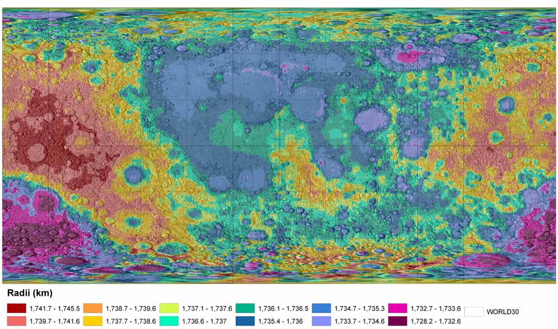

Figure 1. Color-coded topography derived from the ULCN 2005 solution. The topographic information is superimposed on the USGS shaded relief airbrush map of the Moon. This constitutes an improved lunar topographic model, the densest such global model existing. The topography is derived from smoothing the solution radii of all 272,931 control points, using a priori radii derived from an interpolation of a combination of Clementine LIDAR and polar Clementine stereo data. The mean absolute difference of these radii from their a priori radii is 137 m, with a standard deviation of 219 m, thus showing there is no systematic difference between the LIDAR and newly derived values, and that the radii must therefore be of similar accuracy (a few hundred m). Camera angles were constrained to 1° of their a priori (NAIF values), with angles changing by more than 0.6° left free. 99% of the image boresight directions change by less than 0.45 degrees (~5.1 km on the Moon, from the average 640 km altitude). 1,261 of the points are also UCLN (1994) points, of which 1,137 were constrained (0.18 – 5 km horizontally, 2-6 km vertically) to their ULCN positions. The overall ULCN 2005 solution RMS is 20 micrometers (= 0.9 pixels) in the image plane, with a largest residual of 6.4 pixels. The map here is a global simple cylindrical projection with north up and east to the right, 0° longitude at center, and a 30° spacing longitude and latitude grid.
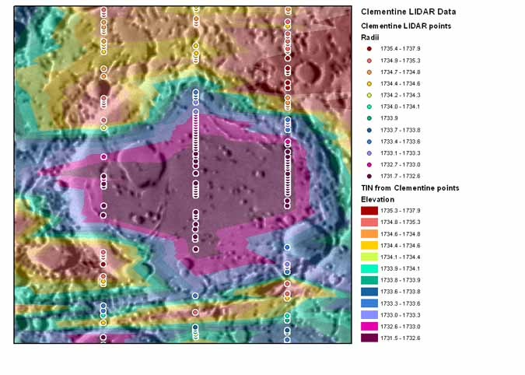
Figure 2. Example detail topographic map of the Oppenheimer crater (193.7° east longitude, 35.2° south latitude, in the northern part of the South Pole – Aitken basin), derived from a TIN of Clementine LIDAR radii (km) and showing the position of LIDAR measurements. Due to the sparseness of the LIDAR data, note the general lack of correlation between interpolated elevation and surface features, except for the overall low of Oppenheimer. Simple cylindrical projection with north up and east to the right, with USGS shaded relief airbrush lunar map as background.

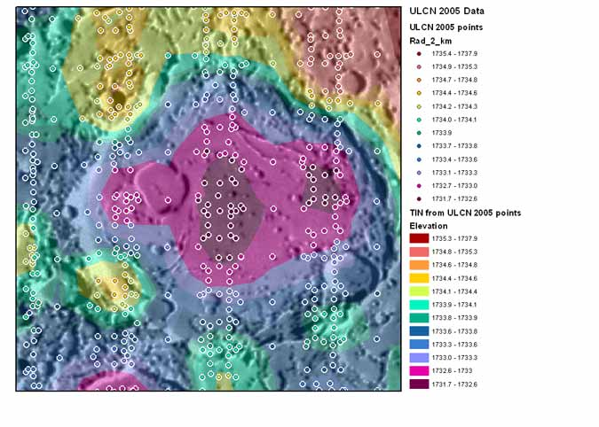
Figure 3. Example detail topographic map of the Oppenheimer crater, derived from a TIN of ULCN 2005 radii (km) and showing the position of Clementine image tie point measurements. Compare to Figure 2. With the increased density of ULCN 2005 points, note the good correlation between elevation and surface features, particularly for the central portion of the Oppenheimer crater and some of the smaller craters and mountains around the crater. Simple cylindrical projection with north up and east to the right, with USGS shaded relief airbrush lunar map as background.

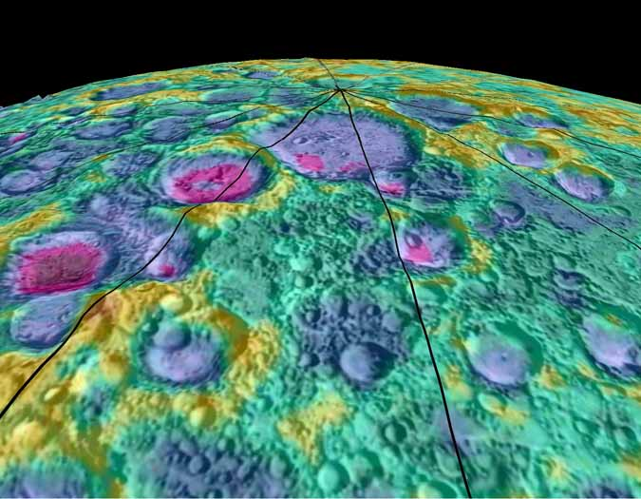
Figure 4. Close up of the topographic model shown in Figure 1, for the north polar area of the Moon. Color-coded topographic information (using the same coding as in Figure 1) is shown with the USGS shaded relief airbrush map in the background, but projected onto topography with 10x exaggeration. Meridians of longitude are shown every 30° and are projected onto the topography. The 210° east longitude meridian is in the right foreground. The correspondence between the newly-derived absolute topography and the shaded relief topographic representation appears reasonable.
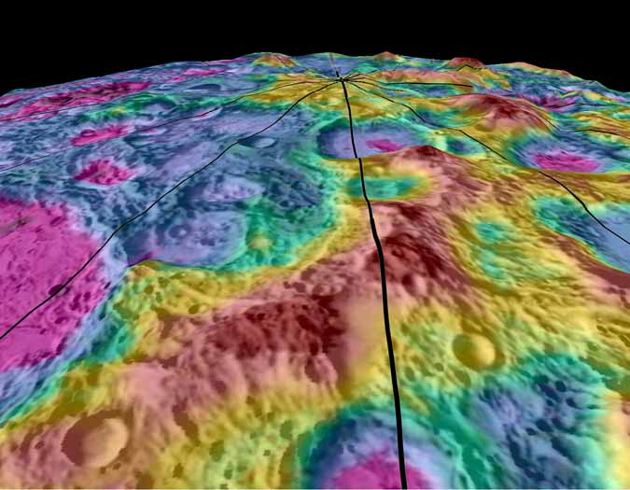
Figure 5. Close up of the topographic model shown in Figure 1, for the south polar area of the Moon. The 90° east longitude meridian is in the right foreground.
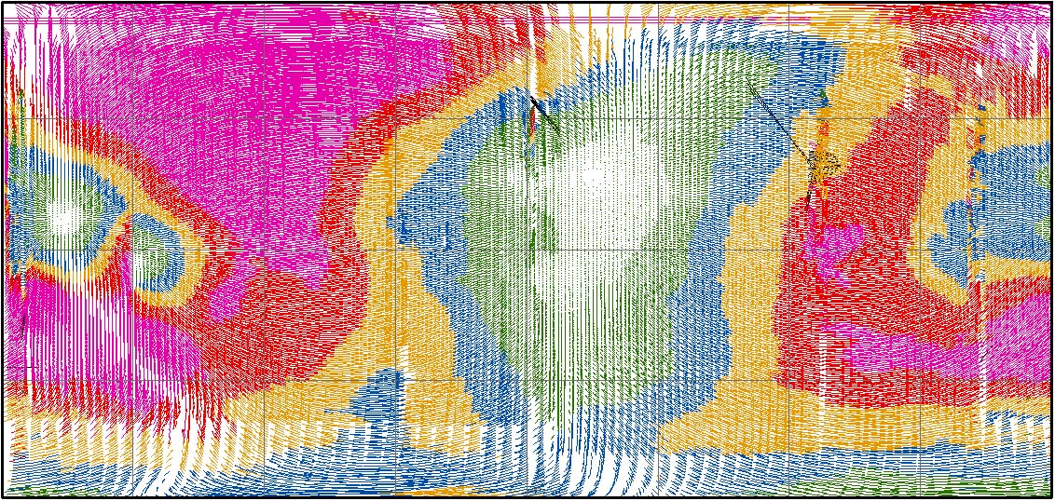
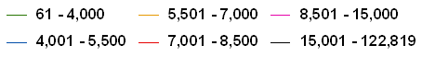
Figure 6. Absolute horizontal difference (m) in the image boresight position of 43,866 images, between the ULCN 2005 solution and the CLCN solution. This demonstrates the approximate horizontal position improvement of the ULCN 2005 over the CLCN. Shown as a global rectangular projection with north up and east to the right, and 0° longitude at center.

Name | Number of points | Number of images | Horizontal Accuracy | Vertical Accuracy
ULCN | 1,478 | n/a | 100 m to 3 km | Few km?
CLCN | 271,634 | 43,871 | Few km to some>15 km | Sphere
ULCN 2005 | 272,931 | 43,866 | ~100 m to few km | ~100’s  meters

Table 1. Lunar Horizontal Control Net Comparison.

Name | Number of points | Vertical Accuracy | Comments
ULCN | 1,286 | Few km? | Sparse, mostly nearside
Clem. LIDAR | 72,548 | 130 m | Sparse, between ±75°
Clem. polar stereo | 3,198,240 | ~1-2 km absolute | Polar only
Clem. stereo | not released | Few km absolute | Random coverage
Earth radar | ~33.8x10⁶ | Few km absolute | Polar and Tycho only
Apollo LIDAR | 5,629 | Few km? | <20% coverage
Apollo stereo | Contour maps | As above | <20% coverage
ULCN 2005 | 272,931 | ~100’s m | Global uniform coverage

Table 2. Vertical Data Sources for the Moon.

2255 N. Gemini Drive, Flagstaff, AZ 86001, USA, barchinal@usgs.gov

