



NSRL-0 RUN

FINAL REPORT

Marcelo E. Vazquez

Medical Department
NASA-BNL Liaison Scientist
BNL/NASA webpage:
http://www.bnl.gov/medical/NASA/NASA-home%20frame.htm

August 2003

TABLE OF CONTENTS

Executive Summary 3

NSRL-0 Proposals/SACR Review 4

Participants 5

Participants Statistics 6

Participants Institutions 7

Run Dates/Beam Time Description 8

Statistics 11

Beam Characteristics 15

Run Statistics and Incidents 16

Experimenters and Run Statistics 17

Participants, Experimental Samples and Endpoints 18

List of Personnel 19

EXECUTIVE SUMMARY
During the summer of 2003, a series of radiobiological and physics experiments were performed using the NASA Space Radiation Laboratory to accelerate iron, carbon and titanium beams (NSRL-0). These experiments were part of the NSRL commissioning run sponsored by NASA’s Space Radiation Health Program (SRHP) heavy ion radiobiology research program at BNL.

A total of 12 proposals were approved to participate in the NSRL-0 run. Seven institutions from the United States and 2 from foreign countries (Italy and Japan) were represented, totaling 33 users. More than 900 biological samples were exposed at the NSRL beam line, employing 158 hours of beam time (33.5 hours for in vivo studies and 48 hours for in vitro studies). In addition, 36 hours were used for physics experiments, and a total of 24.5 hours were necessary for beam characterization, tuning, dosimetry, and calibration. A total of 16 hours of beam time were lost (10%) due to accelerator or power supply related problems.

During NSRL-0, AGS provided iron (0.964 GeV/nucleon, LET: 151.5 keV/µm), Carbon (0.292 GeV/n, LET: 12.9 keV/µm) and Titanium (0.976 GeV/n, LET: 108.2 keV/µm) beams for biology and physics experiments. The dose/rates used were as low as 1 cGy/min and as high as 2.5 Gy/min. The spill rate employed was 11 for Fe and Ti and 30 spills/min for C with duration of 400 msec/spill. The spill fluence was (particles/spill) 4 x 10⁹ (max) and 5 x 10⁵ (min). A 20 x 20 cm square beam spot was employed as a nominal spot for the majority of the exposures.

Tandem-Booster set-up started on July 5 with the transport and circulation of Fe beams at the NSRL complex. Beam was tuned into cave on July 7. 1000 MeV/n Fe beams were available for tuning on July 6. The next several shifts were spent on beam development (A. Rusek: tuning into the target area, beam diagnostics and establishing several different combinations of beam intensities and spot shapes and sizes for physics and biology studies) and some physics experiments (J. Miller: beam characterization). Biology studies started on the afternoon of July 8 (M. Vazquez, BNL)) and proceeded through early July 11. On July 14, AGS tuned 0.29 GeV/n carbon beams for physics studies for 13 hours. Biology studies started on July 15 (B. Sutherland, BNL) and continued until July 18. On July 21, AGS complex delivered titanium beams for beam development and physics. Biology experiments started on July 22 (F. Cucinotta, JSC) running until early afternoon on July 24. NSRL-0 officially ended at 1330 pm, July 24 2003.

Radiobiological experiments employed cells, tissues, and intact specimens, which required a complex coordination and planning of their respective logistic support. Biological studies used human, mouse, rat and hamster cell lines, human-hamster hybrid cell lines, tumor cell lines and intact specimens (rodents). The full program was completed in 17 days.

Projects Approved by NASA and BNL’s management for the NSRL Commissioning run (NSRL-0):

Project | P.I. | NSRL-0 Participation
N-9 | Gewirtz/Sutherland | Yes
N-19 | Kronenberg | Yes
N-73 | Sutherland | Yes
N-76 | Green | Yes
N-77 | Nelson | Yes
N-78 | Nelson | Yes
N-79 | Pecaut | Yes
N-80 | Gonda | Yes
N-81 | Vazquez | Yes
N-82 | Obenaus | Yes
N-83 | Obenaus | Yes
N-84 | Cucinotta | Yes

NSRL-0 PARTICIPANTS

Exp. | Participants | Affiliation | Title
N-9 | A. Gerwirtz*  B. Sutherland  P. Bennett  A. Georgakilas  M. Hada  S. Paul  J. Sutherland  D. Monteleone  J. Trunk | University of Pennsylvania, Dept. of Medicine  Brookhaven National Laboratory  "  "  "  “  “  “  “ | Ph.D., Principal Investigator  Ph.D., Co-Principal Invest.  MS., Biology Associate  Ph.D., Co-Worker  Ph.D., Co-Worker  Ph.D., Co-Worker  Ph.D., Co-Worker  Co-Worker  Co-Worker
N-19 | A. Kronenberg | Lawrence Berkeley National Lab | Ph.D., Principal Investigator
N-73 | B. Sutherland  P. Bennett  A. Georgakilas  M. Hada  S. Paul  J. Sutherland  D. Monteleone  J. Trunk | Brookhaven National Laboratory  "  "  "  “  “  “  “ | Ph.D., Principal Investigator  MS., Biology Associate  Ph.D., Co-Worker  Ph.D., Co-Worker  Ph.D., Co-Worker  Ph.D., Co-Worker  Co-Worker  Co-Worker
N-76 | L. Green  B. Bianski | Loma Linda University, CA  “ | Ph.D., Principal Investigator  Co-Worker
N-77  N-78 | G. Nelson  - Smith  T. Jones | Loma Linda University, CA  "  “ | Ph.D., Principal Investigator  BS, Co-Worker  BS, Co-Worker
N-79 | M. Pecaut  G. Nelson  - Smith  S. Rightnar  T. Jones | Loma Linda University, CA  "  “  “  “ | Ph.D., Principal Investigator  Ph.D., Co-Principal Invest.  BS, Co-Worker  BS, Co-Worker  BS, Co-Worker
N-80 | S. Gonda  E. Behravesh | NASA, Johnson Space Center, TX  “ | Ph.D., Principal Investigator  Ph.D., Co-Worker
N-81 | M. Vazquez  P. Guida  K. Nojima  S. Otto  M. Bruneus  A. Billups  S. Russell | Brookhaven National Laboratory  “  “  “  “  “  “ | MD, Ph.D., Principal Invest.  Ph.D., Co-Worker  Ph.D., Co-Worker  BS, Co-Worker  MA, Co-Worker  BA, Co-Worker  BS, Co-Worker
N-82  N-83 | A. Obenaus | Loma Linda University, CA | Ph.D., Principal Investigator
N-84 | F. Cucinotta  K. George  P. O’Neill  E. Davis  H. Wu  N. Desai  M. Durante | NASA, Johnson Space Center, TX  “  “  “  “  “  University “Federico II”, Napoli, Italy | Ph.D., Principal Investigator  Senior Research Associate  Ph.D., Co-Principal Invest.  Ph.D., Co-Worker  Ph.D., Co-Worker  BS, Co-Worker  Ph.D., Co-Worker
*Not Present During Actual Run
NSRL-0 PARTICIPANTS STATISTICS

PARTICIPANTS | NSRL-0
Ph.D., Principal Investigators | 10
M.D., Ph.D., Principal Investigators | 1
Ph.D., Co-Principal Investigators | 3
Ph.D., Co-Investigator | 0
Co-Workers  Ph.D.  M.D.  B.S./B.A.  M.S./M.A.  MS Biology Associate  Senior Research Associates  Undergraduate Student | 4  14  1  9  3  1  1  0
Total: | 33

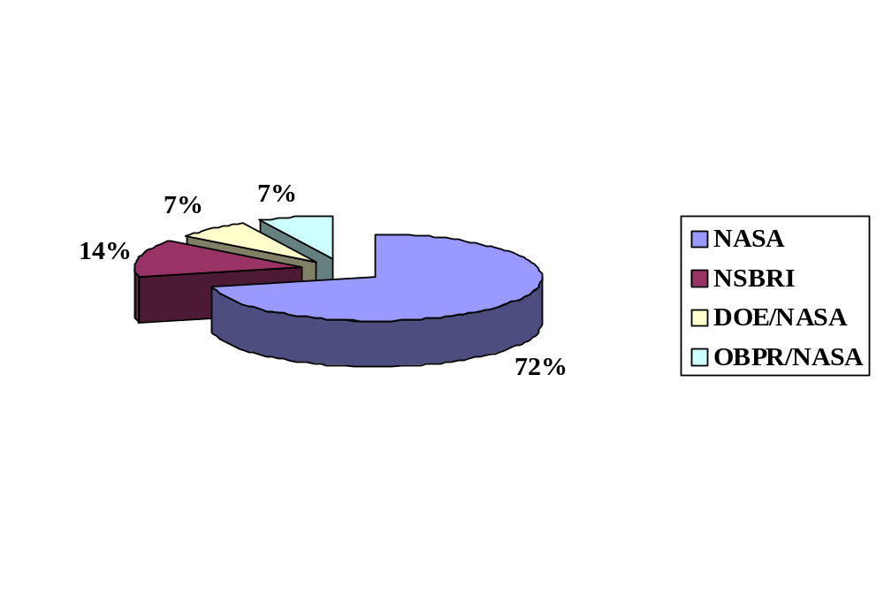

RESEARCH PROJECT SPONSORS:

Participant Institutions

NASA related centers/institutes (3)
- NASA, Headquarters, DC
- NASA, Johnson Space Center, TX
- National Space Biomedical Research Institute, TX

National Laboratories/Institutes (2)
- Brookhaven National Laboratory, NY
- Lawrence Berkeley National Laboratory, CA

Universities (2)
  - Loma Linda University, CA
  - University of Pennsylvania, PA

Foreign Institutions (2)
    - University “Federico II”, Napoli, Italy
    - International Space Radiation Laboratory, Chiba, Japan

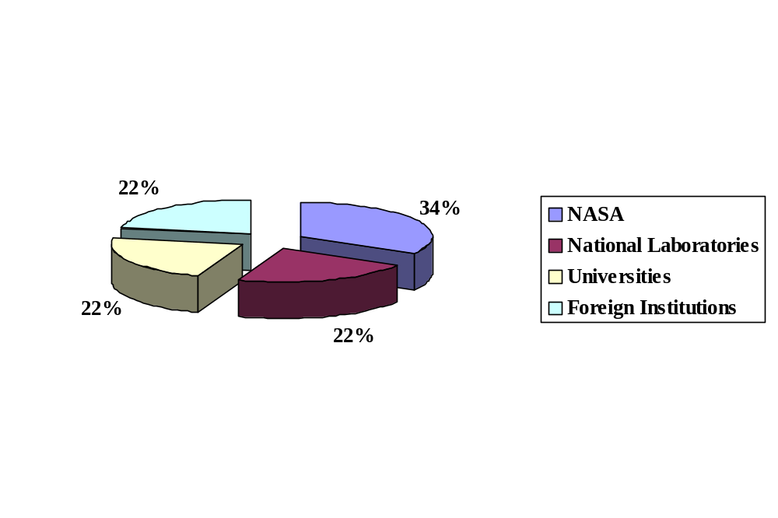INSTITUTIONS STATISTICS:

NSRL-0 IRON RUN DESCRIPTION

RUN DATES
Run dates | Scheduled |  | Actual
 | Date | Time | Date | Time
Run start | 07/07 | 0700 | 07/07 | 0700
Run end | 07/11 | 1900 | 07/11 | 2000
Tuned into cave | 07/07 | 0700 | 07/07 | 1200
Beam delivered for Physics
Fe 1 GeV/n | 07/07 | 0900 | 07/07 | 1400
End run | 07/08 | 1300 | 07/08 | 1230
Beam delivered for Biology
Fe 1 GeV/n | 07/08 | 1300 | 07/08 | 1500
End run | 07/11 | 1900 | 07/11 | 2000

Beam Time Description (hours)

Total Clock Time | (from 07/07 0700 to 07/11 2000) |  | 62.5
Total Beam-on time |  |  | 56.5
Total Beam-off time |  |  | 6
Beam Time for Biology
Fe 1 GeV/n In Vitro Studies | 20
Fe 1 GeV/n In Vivo Studies | 12.5
Sub-total |  | 32.5
Beam Time for Physics
Fe 1 GeV/n | 10
Sub-total |  | 10
Beam time for dosimetry, calibration, tuning, etc.
Fe 1 GeV/n | 4
Sub-total |  | 4
Set Up Time
Fe 1 GeV/n | 10
Sub-total |  | 10
Totals |  | 56.5
Contingency T. Planned | 12.5
Contingency T. Used | 8

NSRL-0 CARBON RUN DESCRIPTION

RUN DATES
Run dates | Scheduled |  | Actual
 | Date | Time | Date | Time
Run start | 07/14 | 0700 | 07/14 | 0700
Run end | 07/18 | 1800 | 07/18 | 1330
Tuned into cave | 07/14 | 0700 | 07/14 | 0815
Beam delivered for Physics
C 0.29 GeV/n | 07/14 | 0900 | 07/14 | 1200
End run | 07/15 | 1300 | 07/15 | 1400
Beam delivered for Biology
C 0.29 GeV/n | 07/15 | 1300 | 07/15 | 1400
End run | 07/18 | 1800 | 07/18 | 1330

Beam Time Description (hours)

Total Clock Time | (from 07/14 0700 to 07/18 1330) |  | 52.5
Total Beam-on time |  |  | 50
Total Beam-off time |  |  | 2.5
Beam Time for Biology
In Vitro Studies | 13
In Vivo Studies | 11
Sub-total |  | 24
Beam Time for Physics
C 0.29 GeV/n | 13
Sub-total |  | 13
Beam time for dosimetry, calibration, tuning, etc.
C 0.29 GeV/n | 0
Sub-total |  | 0
Set Up Time
C 0.29 GeV/n | 13
Sub-total |  | 13
Contingency T. Planned | 8
Contingency T. Used | 6
Totals |  | 56.5

NSRL-0 TITANIUM RUN DESCRIPTION

RUN DATES
Run dates | Scheduled |  | Actual
 | Date | Time | Date | Time
Run start | 07/21 | 0700 | 07/21 | 0700
Run end | 07/24 | 1800 | 07/24 | 1330
Tuned into cave | 07/21 | 0700 | 07/21 | 0815
Beam delivered for Physics
Ti 1 GeV/n | 07/21 | 0900 | 07/21 | 0900
End run | 07/22 | 1300 | 07/22 | 1100
Beam delivered for Biology
Ti 1 GeV/n | 07/22 | 0900 | 07/22 | 1600
End run | 07/24 | 1800 | 07/24 | 1330

Beam Time Description (hours)

Total Clock Time | (from 07/21 0700 to 07/24 1330) |  | 43
Total Beam-on time |  |  | 35.5
Total Beam-off time |  |  | 7.5
Beam Time for Biology
In Vitro Studies | 15
In Vivo Studies | 0
Sub-total |  | 15
Beam Time for Physics
Ti 1 GeV/n | 13
Sub-total |  | 13
Beam time for dosimetry, calibration, tuning, etc.
Ti 1 GeV/n | 0
Sub-total |  | 0
Set Up Time
Ti 1 GeV/n | 7.5
Sub-total |  | 7.5
Contingency T. Planned | 6.5
Contingency T. Used | 4.5
Totals |  | 35.5

NSRL-0 FINAL RUN DATES
Run dates | Scheduled |  | Actual
 | Date | Time | Date | Time
Run start | 07/07 | 0700 | 07/07 | 0700
Run end | 07/24 | 1800 | 07/24 | 1330
Tuned into cave | 07/07 | 0700 | 07/07 | 1200

total Beam Time Description (hours)

Total Clock Time | (from07/07 0700 to 07/24 1330) |  | 158
Total Beam-on Time
Fe 1 GeV/n | 56.5
C 0.29 GeV/n | 50.0
Ti 1 GeV/n | 35.5
Total |  | 142
Total Beam-off time
Fe 1 GeV/n | 6
C 0.29 GeV/n | 2.5
Ti 1 GeV/n | 7.5
Total |  | 16
Total Beam Time for Biology
In Vivo Studies | 33.5
In Vitro Studies | 48
Total |  | 81.5
Beam Time for Physics | 36
Total |  | 36
Beam time for dosimetry, calibration, tuning, etc. | 4
Total |  | 4
Set Up Time | 20.5
Total |  | 20.5
Contingency T. Planned | 27
Contingency T. Used | 8.5
Totals |  | 142 | 158

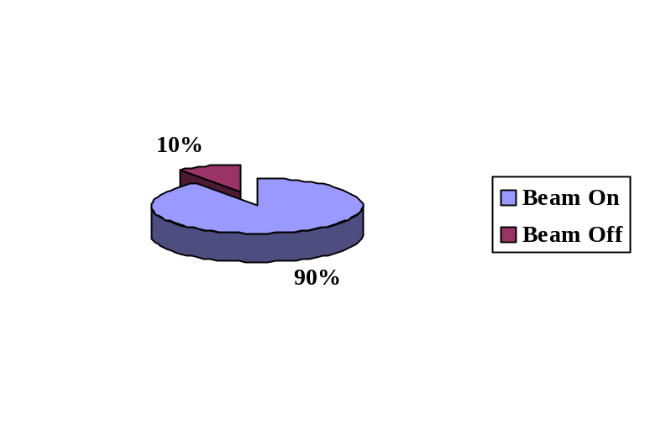Descriptive statistics

- fe 1 GeV/n Beam Availability

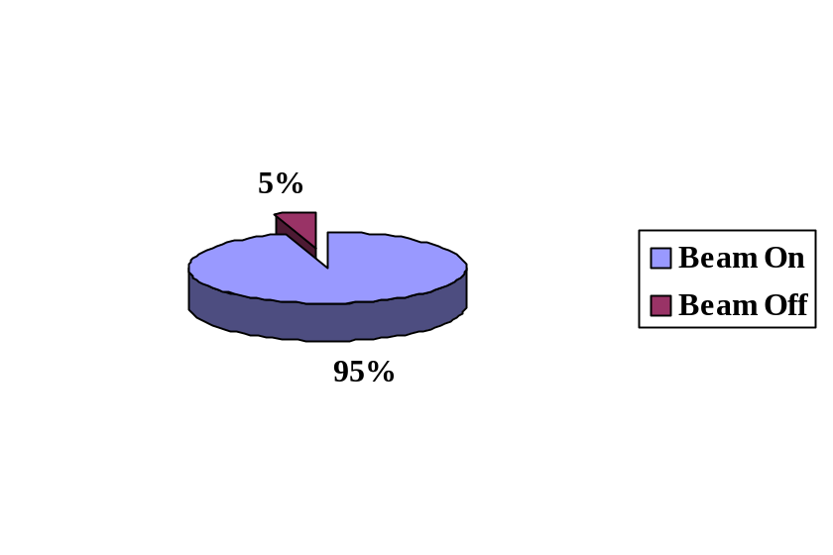

- C 290 MeV/n Beam Availability

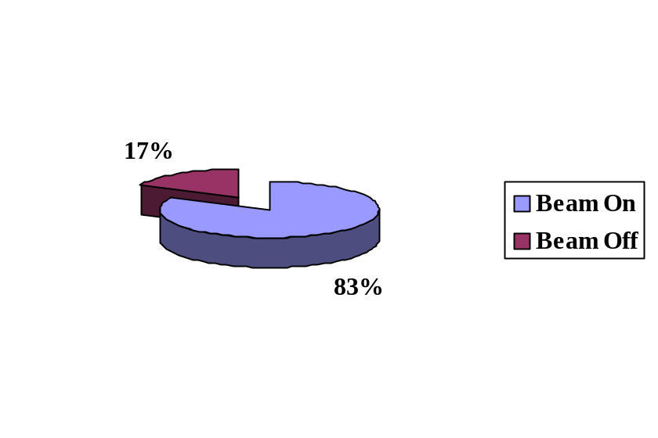

• Ti 1 GeV/n Beam Availability

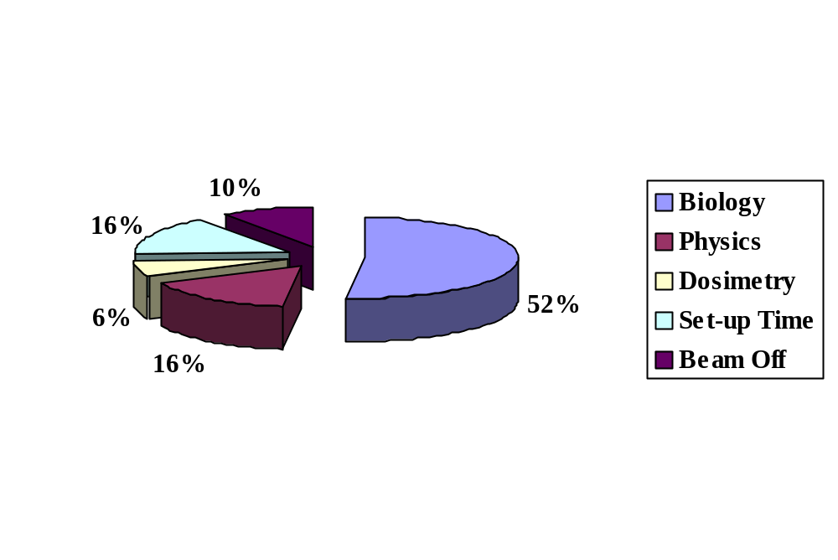

IRON ION RUN:
- Fe 1 GeV/n Distribution of Beam Time Usage:

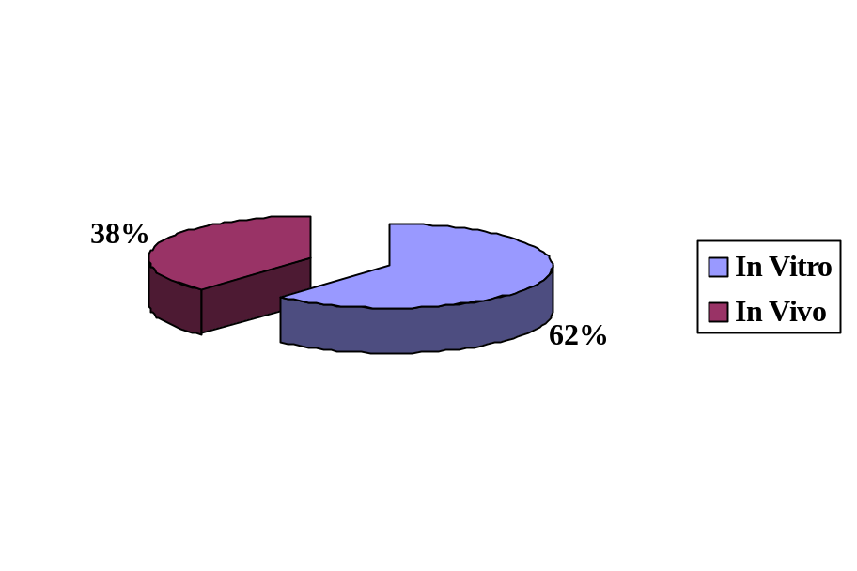
- Fe 1 GeV/n Distribution of Beam Time for Biology:

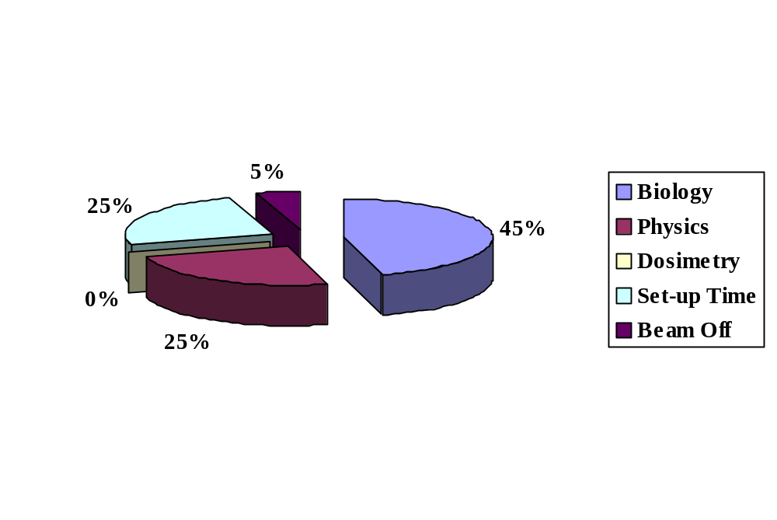

CARBON ION RUN

C 0.29 GeV/n Distribution of Beam Time Usage:

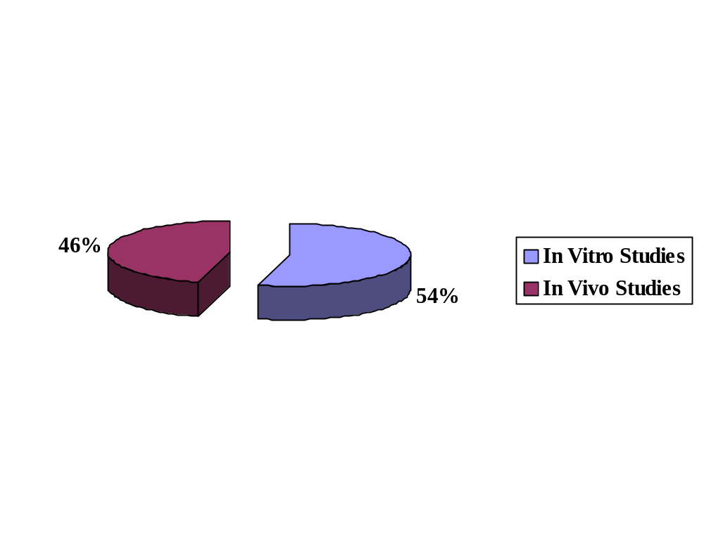

C 0.29 GeV/n Distribution of Beam Time for Biology:

TITANIUM ION RUN
- Si 1 GeV/n Distribution of Beam Time Usage:
- Ti 1 GeV/n Distribution of Beam Time for Biology:

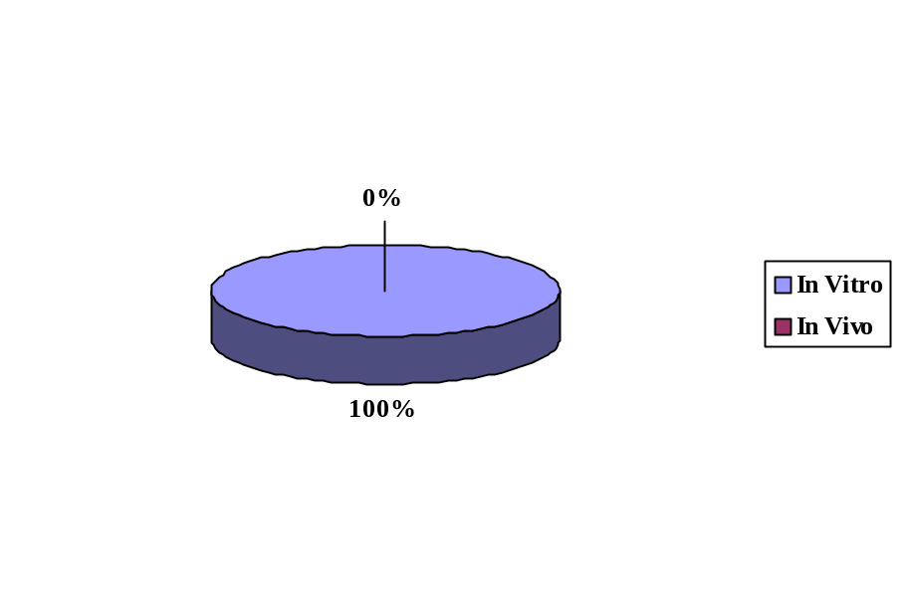

NSRL-0 TOTAL BEAM TIME SUMMARY
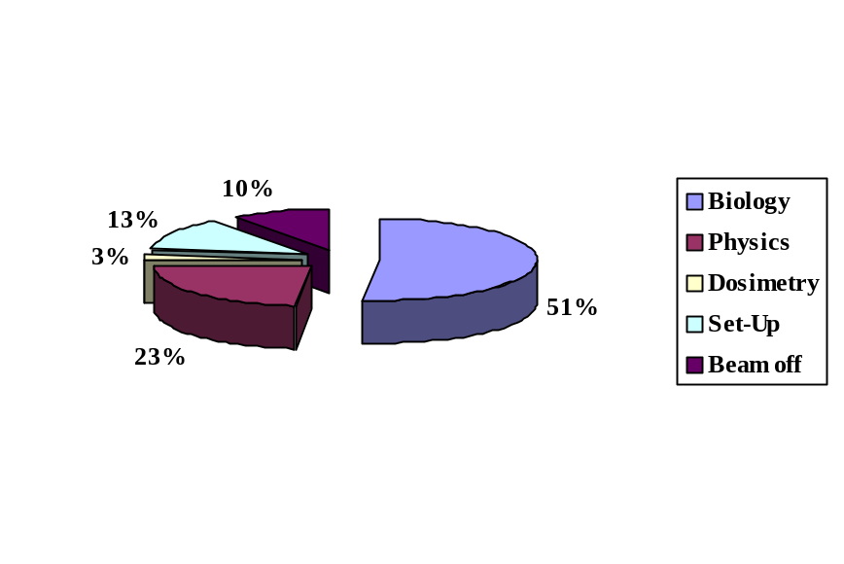

DISTRIBUTION OF BEAM TEAM USAGE:

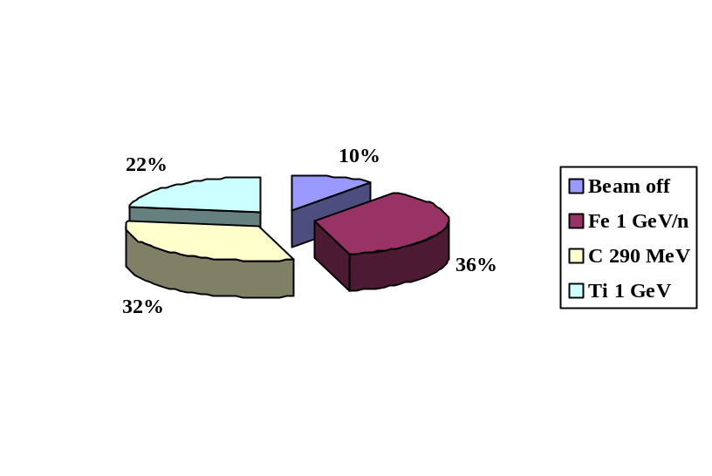

DISTRIBUTION OF BEAM TEAM BY SPECIES AND ENERGIES:

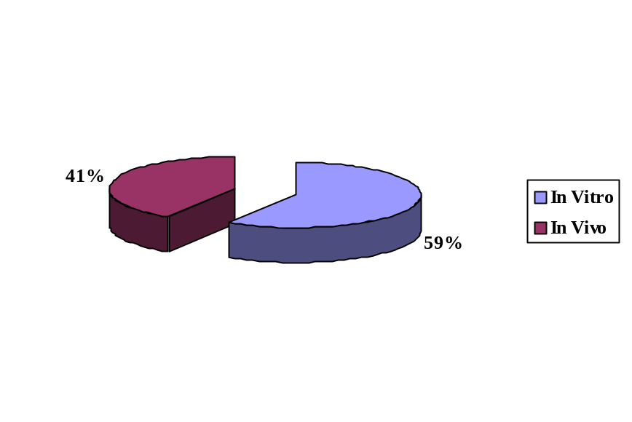

DISTRIBUTION OF BEAM TEAM FOR BIOLOGY EXPERIMENTS:

BEAM CHARACTERISTICS

Ion | ⁵⁶Fe²⁶ | ⁴⁸Ti²² | ¹²C⁶
Fluence (particles/cm²/sec)  Maximum on target  Minimum on target | TBD | TBD | TBD
Spill rate (spills/min) | 11 | 11 | 30
Spill length (msec) | 400 | 400 | 400
Particles/spill  Maximum  Minimum | 1 x 10⁹  5.0 x 10² | 3.5 x 10⁸  5.0 x 10² | 4.0 x 10⁹  5.0 x 10²
Beam Size | 25 x 25 | 20 x 20, 10 x 10 | 25 x 25
Beam Cut Off Accuracy | ~ 0.5 % | ~ 0.5 % | ~ 0.5 %
Actual Energy (MeV/n)  Extracted  On Target | 1005  964 | 1007  976 | 300  292
Actual LET on Target (keV/µm) | 151.5 | 108.2 | 12.9
Dose Rate (Gy/min)  Maximum  Minimum | 3.0  0.01 | 0.5 (20 x 20), 2.5 (10 x 10)  0.01 | 3.0  0.01
Total Dose (Gy)  Maximum  Minimum | 5  0.1 | 5  0.1 | 5  0.1

The “On Target” energies were obtained from Bragg Curve measurements.
The LET reported here is that for the primary ion at the “on target” energy. Fragmentation was not taken into account. If significant, fragmentation would result in a lower LET (fragmentation does not appear to be significant at the target area).
The Dose Rate is measured at the center of the ion-chamber, and does not necessarily scale with beam size.
NSRL-0 Run Statistics and Incidents
Date | Shift | HIP Avail.  (set-up t.) | Non-HIP* | Remarks (CAD 2 shift/day: 7-14/14-21 hr)
07/07/02 | 1 | 2 (2) | 5 | 1 GeV/n Fe run start. Booster magnet trip.
 | 2 | 6.5 | 0 | No incidents.
07/08/02 | 3 | 7 (2) | 0 | No incidents. End Physics Beam development run
 | 4 | 6.5 | 0 | No incidents. Biology run start.
07/09/02 | 5 | 7 (2) | 0 | No incidents.
 | 6 | 5 | 1 | Gate door security problems
07/10/02 | 7 | 7 (2) | 0 | No incidents.
 | 8 | 3.5 | 0 | No incidents.
07/11/02 | 9 | 7 (2) | 0 | Tandem problems (valves closed), Vacuum leak at
 | 10 | 6 | 0 | Booster. Vacuum leak at TTB
07/14/02 | 11 | 7 (5) | 0 | Switch to C 0.29 GeV/n.
 | 12 | 6 | 0 | Physics run Beam development
07/15/02 | 13 | 7 (2) | 0 | Physics run completed
 | 14 | 3 | 0 | Biology run start
07/16/02 | 15 | 7 (16) | 0 | No incidents.
 | 16 | 4.5 | 0 | No incidents.
07/17/02 | 17 | 6.5 (2) | 0.5 | Sweep lost.
 | 18 | 4 | 0 | No incidents.
07/18/02 | 19 | 4.5 (2) | 2 | False fire alarm
 | 20 |  |  | CAD beam development (Adam Rusek)
07/21/02 | 21 | 7 (2) | 0 | Switch to Ti 1 GeV/n. Physics run start.
 | 22 | 6 | 0 | No incidents.
07/22/02 | 23 | 4 (2) | 3 | Physics run end. Magnet cooling system problems.
 | 24 | 2.5 | 2 | Magnet problems. Biology run start.
07/23/02 | 25 | 5 (1.5) | 2 | RHIC fire alarm. Transport problems.
 | 26 | 3 | 0.5 | Sweep lost.
07/24/02 | 27 | 7 (2) | 0 | No incidents.
 | 28 | 0.5 | 0 | End NSRL-0
Totals: | 18 | 142 hr. (89%) | 16 hr. (11%)
*Time loss due to machine or power supply problems, setting up operations.
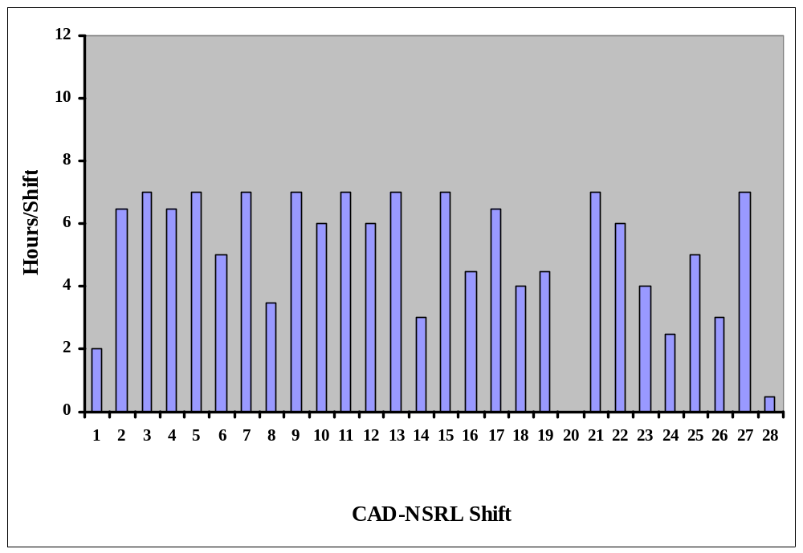
NSRL-0 Beam Time Availability Summary
7/7 7/8 7/9 7/10 7/11 7/14 7/15 7/16 7/17 7/18 7/21 7/22 7/23 7/24
1 GeV Fe
0.29 GeV C
1 GeV Ti

NSRL-0 operational schedule assumptions:
    - 7 to 9 am: set-up, initial dosimetry (2 hr)
    - 9 to 17 pm: experimental run (8 hr)
    - 17 to 19 pm: contingency and wrap up operations (2 hr)
Total daily operation: 12 hrs

NSRL-0 EXPERIMENTERS AND RUN STATISTICS
Exp. ID | Principal Investigator | Ion & Energy | Beam T. Approv. | Beam Time Used | Dose Range (cGy) | Dose/Rate (cGy/min) | Number of Samples
N-9 | Gewirtz | Fe, 1 GeV/n  C, 290 MeV/n  Ti, 1 GeV/n | 0.5  0.5  0.5 | 0.5  0.5  0.5 | 10-30 | 100 | 50
N-19 | Kronenberg | Fe, 1 GeV/n  C, 290 MeV/n  Ti, 1 GeV/n | 3  0  3 | 5.5  3.0  2.5 | 15.75-189  14-168  12.3-147.6 | 40-80  50-100  30-50 | 21  21  21
N-73 | Sutherland | Fe, 1 GeV/n  C, 290 MeV/n  Ti, 1 GeV/n | 3  3  3 | 2.0  2.5  4.0 | 10 to 25000 | 50 to2000 | 200
N-76 | Green | Fe, 1 GeV/n | 1.5 | 2.5 | 0-50 | 50 | 13
N-77 | Nelson | Fe, 1 GeV/n  C, 290 MeV/n  Ti, 1 GeV/n | 4.2  4.8  3.4 | 3.5  3.0  1.0 | 100 to 1000 | 1000 | 100
N-78 | Nelson | C, 290 MeV/n | 2.5 | 3.0 | 100 to 1000 | 200 | 50
N-79 | Pecaut | Fe, 1 GeV/n  C, 290 MeV/n | 0  2.75 | 0.0  3.0 | 0-200  0-500 | 70-90  120-210 | 9  54
N-80 | Gonda | Fe, 1 GeV/n  C, 290 MeV/n | 2  2 | 1.5  2.0 | 10-200  20-400 | 100  200 | 30  30
N-81 | Vazquez | Fe, 1 GeV/n  C, 290 MeV/n  Ti, 1 GeV/n | 7  2  2 | 9.0  1.5  2.0 | 0-240  0-200  0-200 | 40-50  40-50  40-50 | 140  50  60
N-82 | Obenaus | Fe, 1 GeV/n  C, 290 MeV/n  Ti, 1 GeV/n | 1.3  1.3  2.3 | 1.0  2.0  1.0 | 10 to 200  10 to 200  10 to 200 | 200 | 8  8  8
N-83 | Obenaus | Fe, 1 GeV/n  C, 290 MeV/n | 5.5  5.5 | 4  1.0 | 10 to 200  10 to 200 | 200 | 30  30
N-84 | Cucinotta | Fe, 1 GeV/n  C, 290 MeV/n  Ti, 1 GeV/n | 4  1.5  2.5 | 3.0  3.5  2.5 | 2-300 | 100 | 50
Totals |  |  | 73.7 | 71 | 0-25000 | 30-2000 | 983

NSRL-0 PARTICIPANTS, EXPERIMENTAL SAMPLES AND ENDPOINTS

Exp. | Participants | Samples | Endpoints
N-9 | Effects of Deep Space Radiation on Human Hematopoietic Stem Cells  A. Gewirtz (PI) | Human bone marrow mononuclear cells | Production of differentiated, lineage-specific cells in CFU assays.  Alterations in gene expression patterns by microarray analysis.
N-19 | Mutagenesis and Genomic Inestability in Human cells  A. Kronenberg (PI) | Human lymphoid cells (TK6) | Cell killing comparisons to previously published results, colony formation and survival curves.
N-73 | DNA damage clusters in low level radiation responses of human cells.  B. Sutherland (PI) | T7 DNA  Human bone marrow cells  Human monocytes  Supercoiled DNA | DNA damage cluster induction and repair at the molecular and cellular levels.
N-76 | Response of Thyroid Tissue Units to Space-Like Radiation Fields.  L. Green (PI) | FRTL-5 cells (rat thyroid) | Gene expression alterations.
N-78 | Carbon Radiation Induced Gene Expression in C57BL/6 Mice.  G. Nelson (PI) | C57BL/6 Mice | Gene expression using microarray analysis.
N-79 | The Effects of Head-Only and Whole-Body Irradiation on CNS-Immune Function.  M. Pecaut (PI) | C45BL/6 Mice | Interleukin-1 expression using immunohistochemical (IHC) and MRI analysis.
N-80 | Comparison of Cell and Tissue 3D Models for Assessment of Genotoxic Damage by High Energy Charged Particles.  S. Gonda (PI) | Normal & Transgenic fibroblast cells  Normal & Transgenic epithelial cells | Mutation types and frequency induced in target genes at molecular level  Dose relationships
N-81 | In Vitro and In Vivo CNS Damage Studies  M. Vazquez (PI) | C57BL/6 Mice  NT-2 neural stem cells  hNT post-mitotic neurons | Behavioral Testing: Locomotor activity  Survival, apoptosis, gene expression
N-82 | Dosimetry Gels (Magic Gels) as Biological Reporters of Radiation Dose.  A. Obenaus (PI) | Dosimetry Gels (Magic Gels) | A more complete dose response curve.
N-83 | Changes in Neuronal Excitability Following ⁵⁶Fe and Carbon Irradiation: Correlation of Electrophysiological Alterations with Magnetic Resonance Imaging.  A. Obenaus (PI) | Sprague-Dawley Rats | Neuroimaging using MRI and MRS.
N-84 | Comparison of Cytogenetic Damage measured at the NASA Space Radiation Laboratory (NSRL) to Results from AGS and HIMAC.  F. Cucinotta (PI) | Normal human lymphocytes and fibroblasts | Cytogenetic damage  DNA double strand breaks and repair by immuno staining.

List of personnel that participated in the planning, organization and execution of NSRL-0 run
BNL Management:
- Laboratory Director: Peter Paul
- Associate Director for High Energy and Nuclear Physics: Tom Kirk
- Associate Laboratory Director for Life Sciences: Helene Benveniste
NASA Management:
- Headquarters: Walter Schimmerling, David Tomko
- JSC: Frank Cucinotta, Frank Sulzman, Barbara Corbin
Scientific Advisory Committee:
- Betsy Sutherland (Chair), BNL
- Louis Pena, BNL
- Richard Setlow, BNL
- Joel Bedford, CSU
- Les Braby, PNL
- Charles Geard, Columbia University
Collider Accelerator Department-AGS
- Chairman: Derek Lowenstein
- Deputy Chairman: W.T. Weng
- Associate Chair of Operations: A.J. McNerney
- Experimental Planning and Support Head: Philip Pile
- Associate Chair for ESHQ: Ed Lessard
- ESHQ Division Head: Ray Karol
- ESH Coordinator: Asher Etkin
- Facility Support Representative: Chuck Schaefer / Henry Kahnhauser
- Environmental Coordinator: Joel Scott
- Training and Procedures Manager : John Maraviglia
- Main Control Room: Peter Ingrassia
- Work Control Manager: Peter Cirnigliaro
- BNL Laser Safety Officer: Chris Weilandics
- Experimental Safety Review Committee: Yousef Makdisi (Chair)
- Radiation Safety Committee: Dana Beavis (Chair)
- Accelerator Safety Review Committee: Woody Glenn (Chair)
- ALARA Committee: Chuck Schaefer (Chair
- Associate Chair for ES&H/Q.A: E. Lessard
- Accelerator Division Head: Thomas Roser
- Chief Electrical Engineer: J. Sandberg
- Chief Mechanical Engineer: J. Tuozzolo
- Accelerator Physicist lead by: Leif Aherns
- Tanden Group leader: Peter Thieberger
- Physics Support: Yusef Makadisi
- CAD Components and instrumentation support: David Gassner
- AGS Radiation Safety Committee: Ken Reece
- C-A Dept Training Manager: John Maraviglia
- AGS Control Section lead by: Don Barton
- Liaison Engineering Group lead by: David Phillips
- Liaison physicist: Adam Rusek
- RHIC&AGS Users Center: Susan White-DePace, Angela Melocoton
- Mechanical Service Technicians led by: Fred Kobasiuk
- Survey Group led by: Frank Karl
- Beam Service Technicians led by: Paul Valli
- Electronic Service Technicians led by: Bill Anderson
- AGS Instrumentation Group led by: Pete Stillman
- AGS Main Control Room and Operations led by: Pete Ingrassia
- AGS MCR Operation Coordinators:
Jim Jamilkowski
Greg Marr
Sanjee Abeytunge
Jennifer Kozak
Brian van Kuik,
Travis Shrey
- AGS Electricians led by Bill Softye
- AGS Riggers led by: Nick Cipolla
- Carpenter and Welder Support Service and Technical Support led by: Roger Hubbard
Dosimetry:
- Don Lazarus
- Adam Rusek
- I-Hung Chiang
- Kin Yip
- Peter Oddo
- Bart Frak

Medical Department:
NASA LTSF TEAM:
- Medical Liaisons: Marcelo E. Vazquez, Peter Guida
- Technical support: Bea Pyatt, Stacey Russell, Adele Billups
- Dept. Chair: John Gatley
- Building Manager: Chris Harris
- Administration: Denise White and Donna Russo
- Animal Care Facilities: Maryann Kershaw, Kerry Bonti, Patricia Leone
- Training Coordinator: Ann Emrick
- RCD
- Kay Conkling
- Dennis Ryan
- Deana Buckallew
- Jim Williams
- Bob Colichio

Plant Engineering:
- BLAF Custodian, P. Abrams
- Plumbers: B. McCafferty
- Painters/Carpenters: B. Laakmann
- Electricians: T. Baldwin
Biology Department:
- Chairman: Carl Anderson
- Biology Liason: Betsy Sutherland
- Technical Support: Mamta Naidu, Debasish Roy
- Cesiun Source Manager: Richard Sautkulis
Lawrence Berkeley National Laboratory Dosimetry Technical Suppoer:
- R. P. Singh
NSRL-0 PICTORIAL
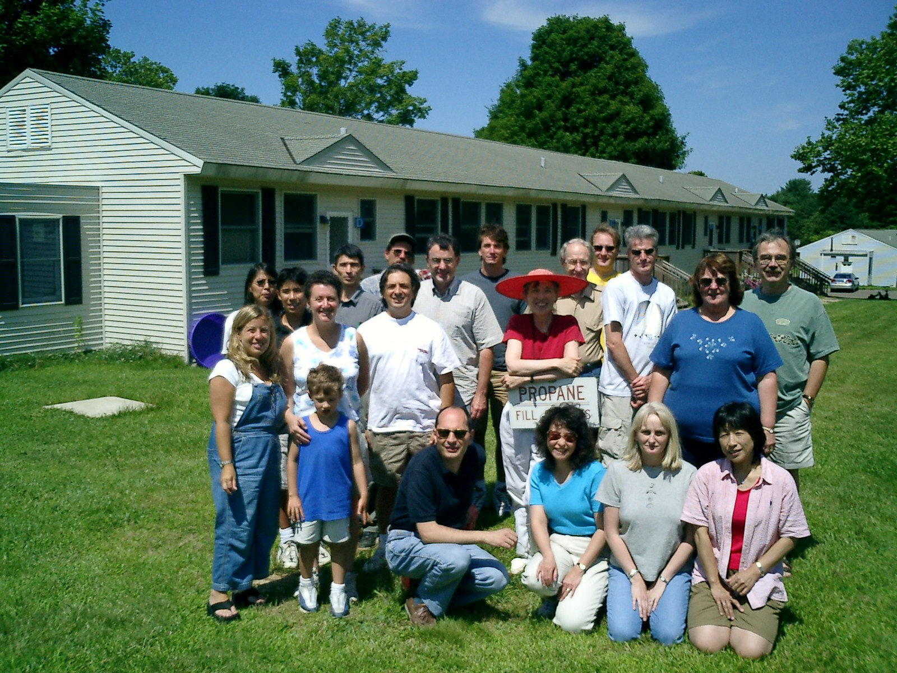

NSRL-0 participants: First row left to right, Marco Durante (ISA), Tamako Jones (LLUMC), Kerry George (JSC), Kumie Nojima (NIRS); second row, Amy Kronenberg (LBNL), Marcelo Vazquez (BNL), Betsy Sutherland (BNL), Anna Smith (LLUMC); third row, Adam Rusek (BNL), Frank Cuccinota (JSC), John Sutherland (BNL), Andrew Obenaus (LLUMC), Greg Nelson (LLUMC); last row, Jack Miller (LBNL), S. Guetersloh and Michael Pecaut.

