Schedule 1324

Description: Organochlorine pesticides + gross PCBs, WWR

Analyte Name | Test ID | LTMDL by Spk Std Dev | LTMDL in use | Std Dev | Change To: | LCL | UCL | LRL
ALDRIN, TOT (WATER) | 39330C | 0.00916 | 0.006 | 0.0037 | 0.0092 | 0.0071 | 0.0129 | 0.018
LINDANE, TOT (WATER) | 39340C | 0.00678 | 0.007 | 0.0027
DDD, TOTAL (WATER) | 39360C | 0.00645 | 0.008 | 0.0026
DDE, TOTAL (WATER) | 39365C | 0.00521 | 0.007 | 0.0021
DDT, TOTAL. (WATER) | 39370C | 0.00936 | 0.005 | 0.0037 | 0.0094 | 0.0073 | 0.0131 | 0.019
DIELDRIN, T. (WATER) | 39380C | 0.00933 | 0.004 | 0.0037 | 0.0093 | 0.0072 | 0.0131 | 0.019
ENDOSULFAN I TOTAL | 39388C | 0.01431 | 0.006 | 0.0057 | 0.0143 | 0.0111 | 0.0201 | 0.029
ENDRIN, TOTAL(WATER) | 39390C | 0.00864 | 0.006 | 0.0035 | 0.0086 | 0.0067 | 0.0121 | 0.017
HEPTACHLOR T.(WATER) | 39410C | 0.01036 | 0.004 | 0.0041 | 0.0104 | 0.008 | 0.0145 | 0.021
HEPT EPOX, T (WATER) | 39420C | 0.00727 | 0.004 | 0.0029 | 0.0073 | 0.0057 | 0.0102 | 0.015
METHOXYCHLOR T.(WAT) | 39480B | 0.01239 | 0.003 | 0.005 | 0.0124 | 0.0096 | 0.0174 | 0.025
MIREX, TOT. | 39755B | 0.00708 | 0.003 | 0.0028 | 0.0071 | 0.0055 | 0.0099 | 0.014

Constituent Name | Test ID | Lab Code | Start Date | End Date | LRL MRL Code | Long Term MDL | Reporting Level | Units
Aldrin | 39330C | 11324 | 20031001 |  | lrl | 0.006 | 0.013 | ug/L
Aldrin | 39330C | 11324 | 20010512 | 20030930 | lrl | 0.006 | 0.013 | ug/L
Aldrin | 39330C | 11324 | 19991001 | 20010511 | lrl | 0.007 | 0.013 | ug/L
Aldrin | 39330C | 11324 | 19941013 | 19990930 | mrl | N/A | 0000.010 | ug/L
Chlordane, technical mix | 39350B | 11324 | 20031001 |  | mrl | N/A | 0.1 | ug/L
Chlordane, technical mix | 39350B | 11324 | 20010515 | 20030930 | mrl | N/A | 0000.100 | ug/L
Chlordane, technical mix | 39350B | 11324 | 19941013 | 20010514 | mrl | N/A | 0000.100 | ug/L
Dieldrin | 39380C | 11324 | 20041001 |  | lrl | 0.004 | 0.008 | ug/L
Dieldrin | 39380C | 11324 | 20031001 | 20040930 | lrl | 0.008 | 0.016 | ug/L
Dieldrin | 39380C | 11324 | 20021001 | 20030930 | lrl | 0.008 | 0.017 | ug/L
Dieldrin | 39380C | 11324 | 20010515 | 20020930 | lrl | 0.003 | .006 | ug/L
Dieldrin | 39380C | 11324 | 20001001 | 20010514 | lrl | 0.003 | .006 | ug/L
Dieldrin | 39380C | 11324 | 19991001 | 20000930 | lrl | 0.004 | .009 | ug/L
Dieldrin | 39380C | 11324 | 19941013 | 19990930 | mrl | N/A | 0000.010 | ug/L
Endrin | 39390C | 11324 | 20031001 |  | lrl | 0.006 | 0.012 | ug/L
Endrin | 39390C | 11324 | 20021001 | 20030930 | lrl | 0.012 | 0.023 | ug/L
Endrin | 39390C | 11324 | 20010515 | 20020930 | lrl | 0.007 | 0.014 | ug/L
Endrin | 39390C | 11324 | 19991001 | 20010514 | lrl | 0.007 | 0.014 | ug/L
Endrin | 39390C | 11324 | 19941013 | 19990930 | mrl | N/A | 0000.010 | ug/L
Heptachlor | 39410C | 11324 | 20031001 |  | lrl | 0.004 | 0.008 | ug/L
Heptachlor | 39410C | 11324 | 20010515 | 20030930 | lrl | 0.007 | 0.014 | ug/L
Heptachlor | 39410C | 11324 | 20001001 | 20010514 | lrl | 0.007 | 0.014 | ug/L
Heptachlor | 39410C | 11324 | 19991001 | 20000930 | lrl | 0.004 | 0.009 | ug/L
Heptachlor | 39410C | 11324 | 19941013 | 19990930 | mrl | N/A | 0000.010 | ug/L
Heptachlor epoxide | 39420C | 11324 | 20031001 |  | lrl | 0.004 | 0.009 | ug/L
Heptachlor epoxide | 39420C | 11324 | 20010515 | 20030930 | lrl | 0.004 | 0.009 | ug/L
Heptachlor epoxide | 39420C | 11324 | 19991001 | 20010514 | lrl | 0.004 | 0.009 | ug/L
Heptachlor epoxide | 39420C | 11324 | 19941013 | 19990930 | mrl | N/A | 0000.010 | ug/L
Lindane | 39340C | 11324 | 20031001 |  | lrl | 0.007 | 0.014 | ug/L
Lindane | 39340C | 11324 | 20021001 | 20030930 | lrl | 0.007 | 0.014 | ug/L
Lindane | 39340C | 11324 | 20010515 | 20020930 | lrl | 0.003 | 0.006 | ug/L
Lindane | 39340C | 11324 | 20001001 | 20010514 | lrl | 0.003 | 0.006 | ug/L
Lindane | 39340C | 11324 | 19991001 | 20000930 | lrl | 0.006 | 0.012 | ug/L
Lindane | 39340C | 11324 | 19941013 | 19990930 | mrl | N/A | 0000.010 | ug/L
Mirex | 39755B | 11324 | 20031001 |  | lrl | 0.003 | 0.006 | ug/L
Mirex | 39755B | 11324 | 20021001 | 20030930 | lrl | 0.006 | 0.012 | ug/L
Mirex | 39755B | 11324 | 20010515 | 20020930 | lrl | 0.003 | 0.006 | ug/L
Mirex | 39755B | 11324 | 20001001 | 20010514 | lrl | 0.003 | 0.006 | ug/L
Mirex | 39755B | 11324 | 19991001 | 20000930 | lrl | 0.005 | 0.010 | ug/L
Mirex | 39755B | 11324 | 19941013 | 19990930 | mrl | N/A | 0000.010 | ug/L
Perthane | 39034A | 11324 | 19941013 | 20000711 | mrl | N/A | 0000.100 | ug/L
Polychlorinated biphenyls, total | 39516B | 11324 | 20031001 |  | mrl | N/A | 0.1 | ug/L
Polychlorinated biphenyls, total | 39516B | 11324 | 20010515 | 20030930 | mrl | N/A | 0000.100 | ug/L
Polychlorinated biphenyls, total | 39516B | 11324 | 19941013 | 20010514 | mrl | N/A | 0000.100 | ug/L
Polychlorinated naphthalenes | 39250B | 11324 | 19941013 | 20000711 | mrl | N/A | 0000.100 | ug/L
Toxaphene | 39400B | 11324 | 20031001 |  | mrl | 1 | 1 | ug/L
Toxaphene | 39400B | 11324 | 20010515 | 20030930 | mrl | N/A | 0001.000 | ug/L
Toxaphene | 39400B | 11324 | 19941013 | 20010514 | mrl | N/A | 0001.000 | ug/L
alpha-Endosulfan | 39388C | 11324 | 20041001 |  | lrl | 0.006 | 0.012 | ug/L
alpha-Endosulfan | 39388C | 11324 | 20031001 | 20040930 | lrl | 0.015 | 0.030 | ug/L
alpha-Endosulfan | 39388C | 11324 | 20010515 | 20030930 | lrl | 0.007 | 0.015 | ug/L
alpha-Endosulfan | 39388C | 11324 | 19991001 | 20010514 | lrl | 0.007 | 0.015 | ug/L
alpha-Endosulfan | 39388C | 11324 | 19941013 | 19990930 | mrl | N/A | 0000.010 | ug/L
p,p'-DDD | 39360C | 11324 | 20031001 |  | lrl | 0.008 | 0.016 | ug/L
p,p'-DDD | 39360C | 11324 | 20021001 | 20030930 | lrl | 0.008 | 0.016 | ug/L
p,p'-DDD | 39360C | 11324 | 20010515 | 20020930 | lrl | 0.004 | 0.007 | ug/L
p,p'-DDD | 39360C | 11324 | 20001001 | 20010514 | lrl | 0.004 | 0.007 | ug/L
p,p'-DDD | 39360C | 11324 | 19991001 | 20000930 | lrl | 0.007 | 0.014 | ug/L
p,p'-DDD | 39360C | 11324 | 19941013 | 19990930 | mrl | N/A | 0000.010 | ug/L
p,p'-DDE | 39365C | 11324 | 20031001 |  | lrl | 0.007 | 0.014 | ug/L
p,p'-DDE | 39365C | 11324 | 20021001 | 20030930 | lrl | 0.007 | 0.014 | ug/L
p,p'-DDE | 39365C | 11324 | 20010515 | 20020930 | lrl | 0.003 | 0.006 | ug/L
p,p'-DDE | 39365C | 11324 | 20001001 | 20010514 | lrl | 0.003 | 0.006 | ug/L
p,p'-DDE | 39365C | 11324 | 19991001 | 20000930 | lrl | 0.008 | 0.016 | ug/L
p,p'-DDE | 39365C | 11324 | 19941013 | 19990930 | mrl | N/A | 0000.010 | ug/L
p,p'-DDT | 39370C | 11324 | 20031001 |  | lrl | 0.005 | 0.010 | ug/L
p,p'-DDT | 39370C | 11324 | 20010515 | 20030930 | lrl | 0.005 | 0.009 | ug/L
p,p'-DDT | 39370C | 11324 | 20001001 | 20010514 | lrl | 0.005 | 0.009 | ug/L
p,p'-DDT | 39370C | 11324 | 19991001 | 20000930 | lrl | 0.008 | 0.017 | ug/L
p,p'-DDT | 39370C | 11324 | 19941013 | 19990930 | mrl | N/A | 0000.010 | ug/L
p,p'-Methoxychlor | 39480B | 11324 | 20031001 |  | lrl | 0.003 | 0.006 | ug/L
p,p'-Methoxychlor | 39480B | 11324 | 20010515 | 20030930 | lrl | 0.007 | 0.015 | ug/L
p,p'-Methoxychlor | 39480B | 11324 | 19991001 | 20010514 | lrl | 0.007 | 0.015 | ug/L
p,p'-Methoxychlor | 39480B | 11324 | 19941013 | 19990930 | mrl | N/A | 0000.010 | ug/L

NOTES
- 2005 data used MPV rather than Expected Value for recovery calculations. Using the MPV results in recovery corrected values, which may not match previous years calculations of percent recovery.
- 24 samples run in 9 batches over 2 months.
- No data for Toxaphene in WY05.
- No data for Technical Chlordane in WY05
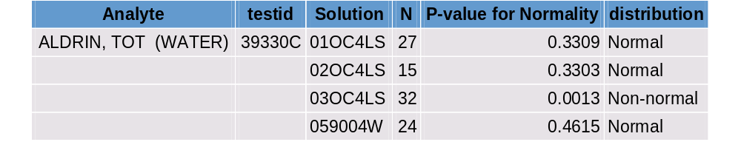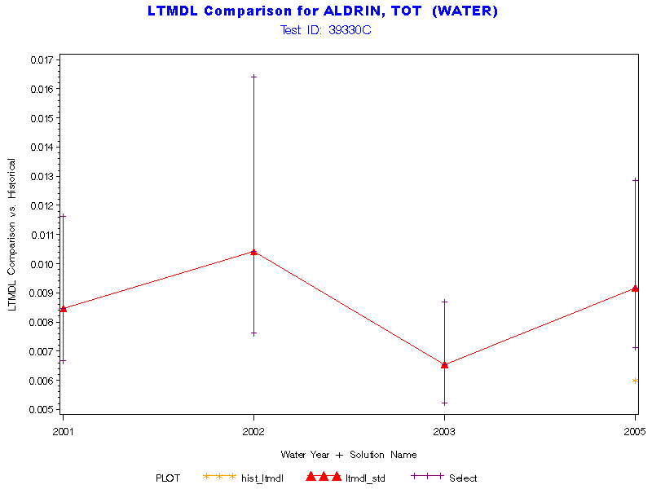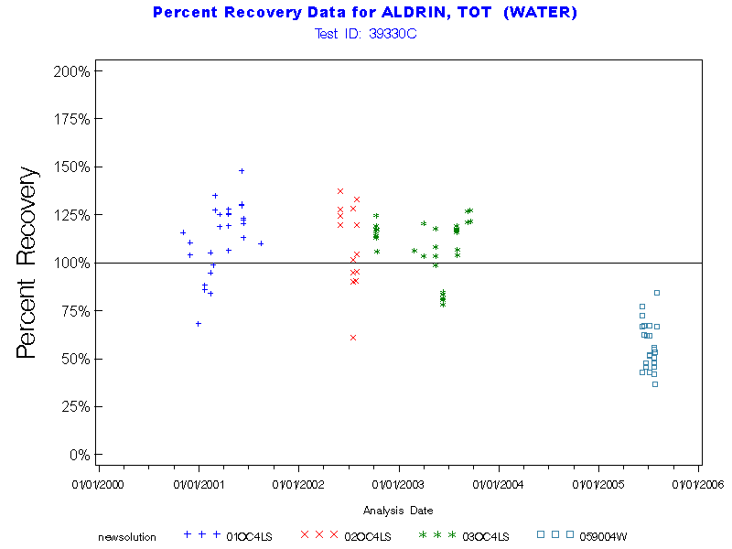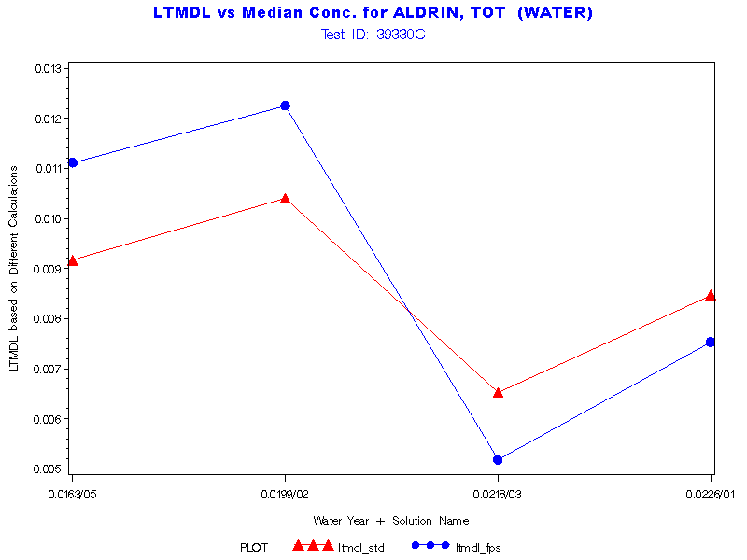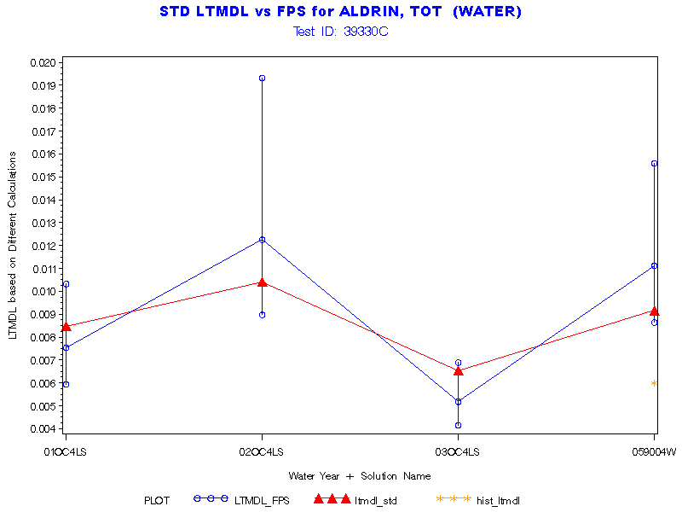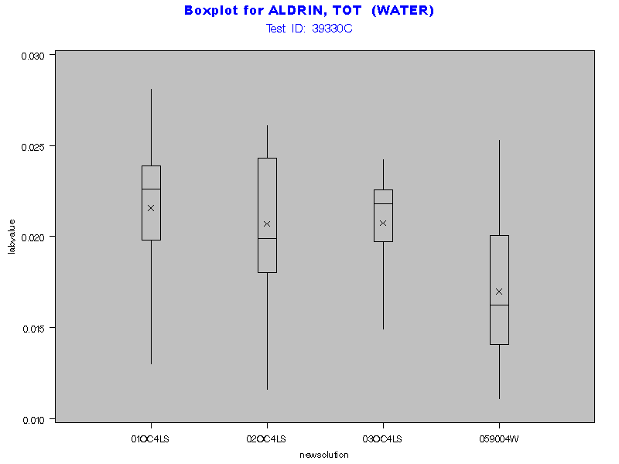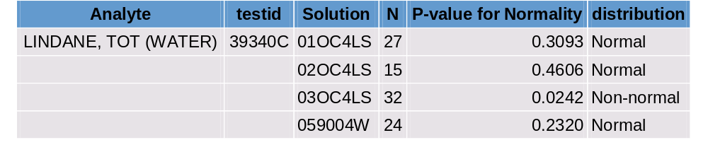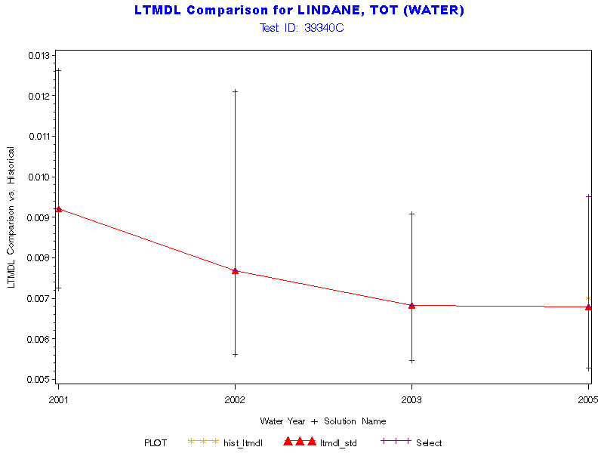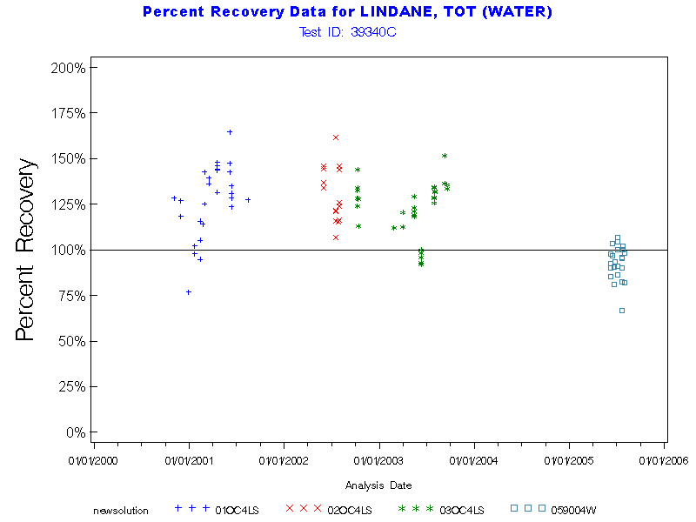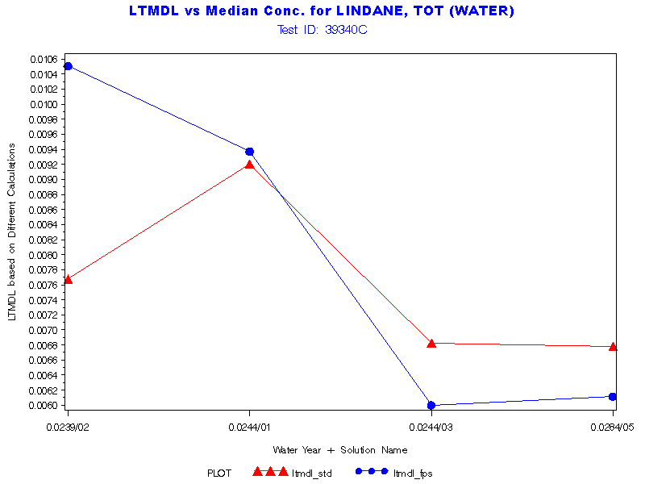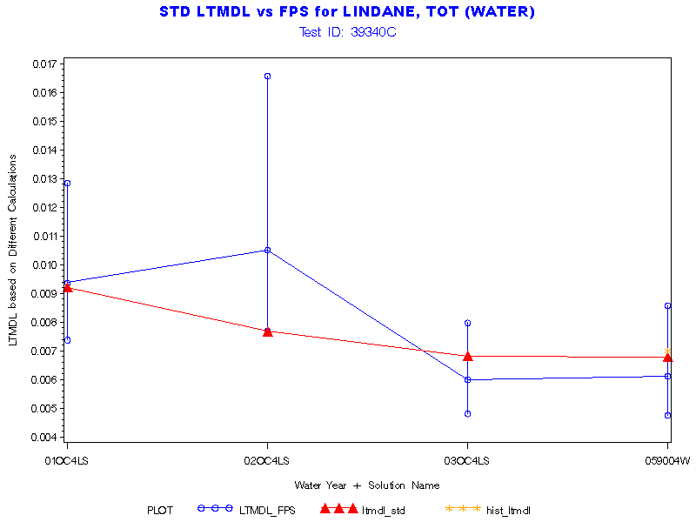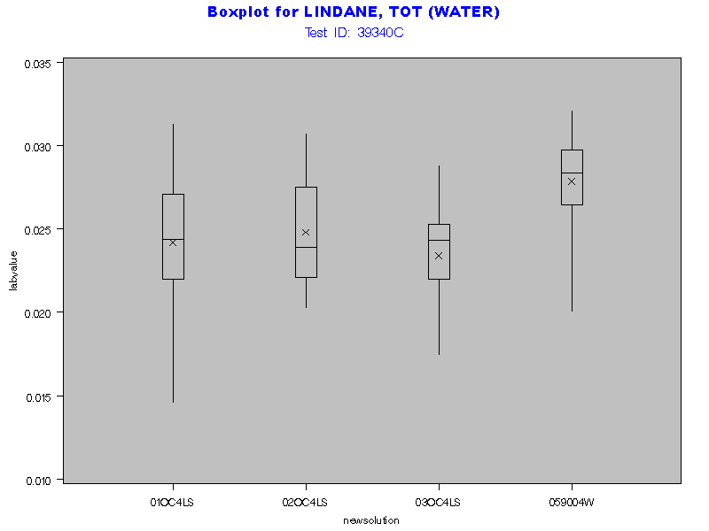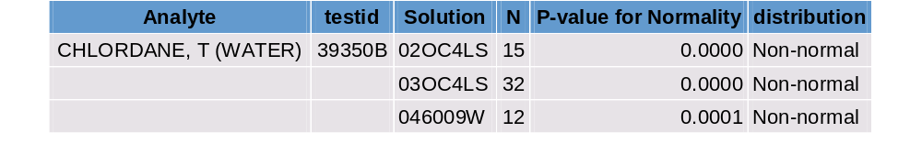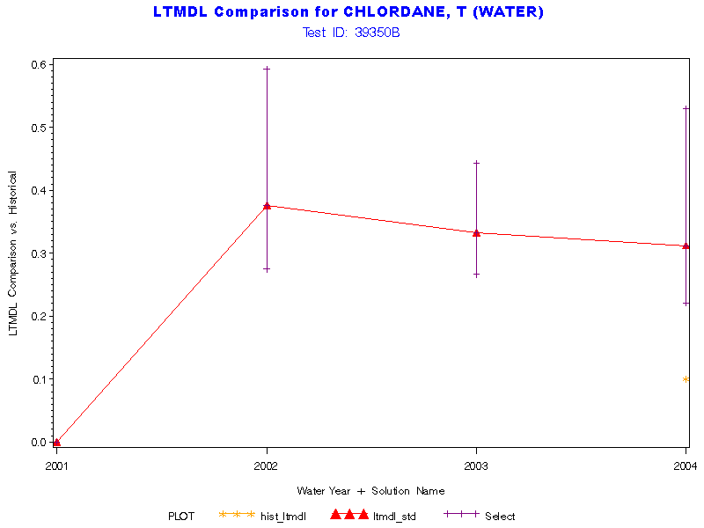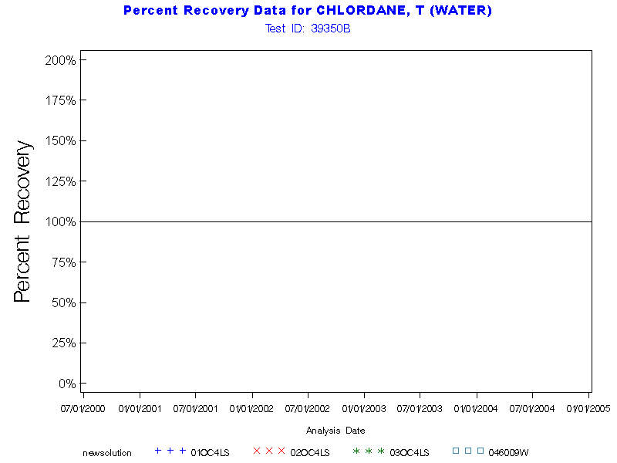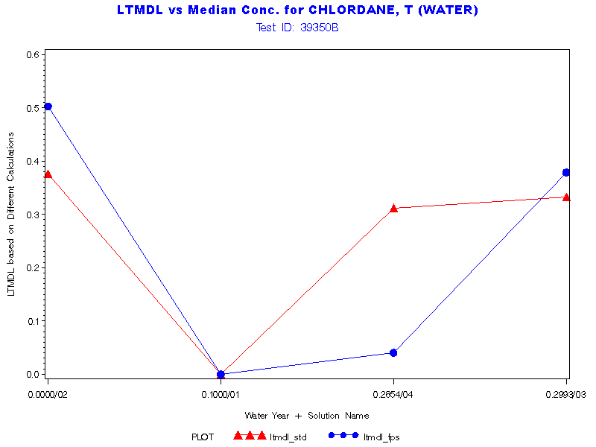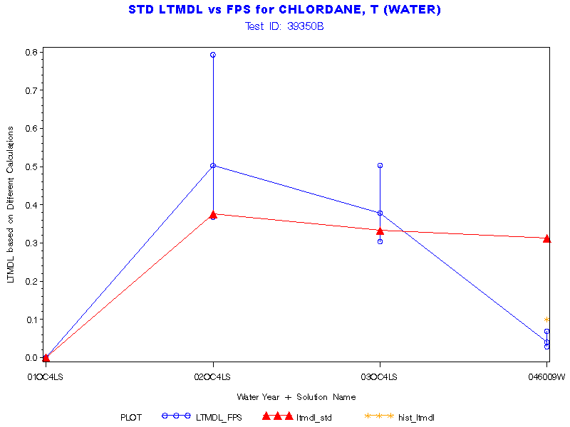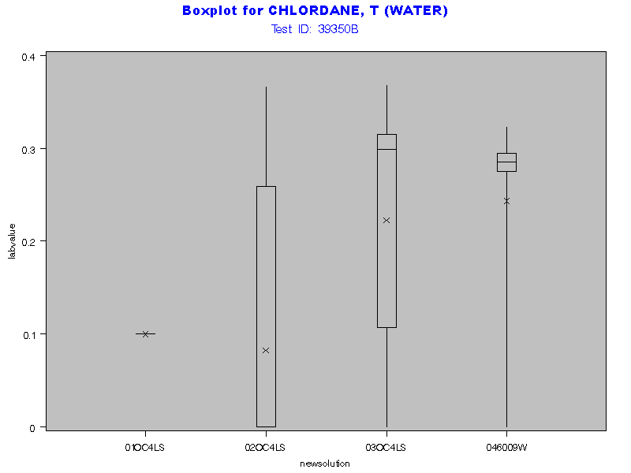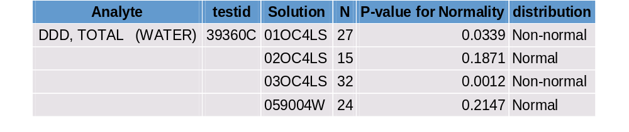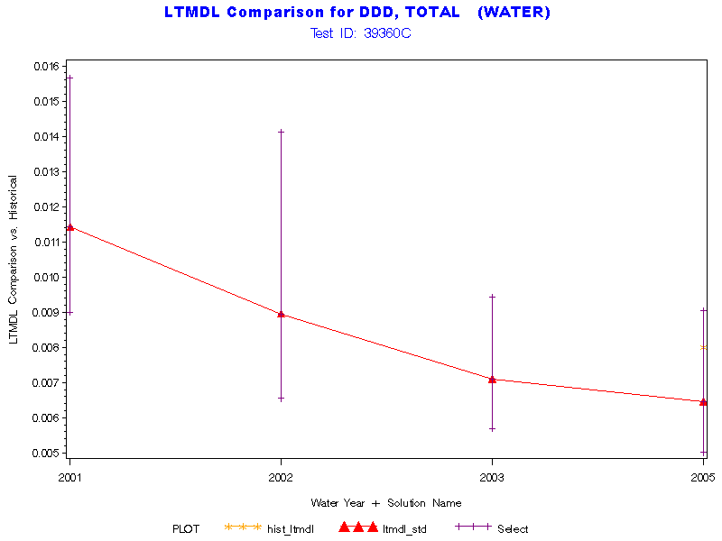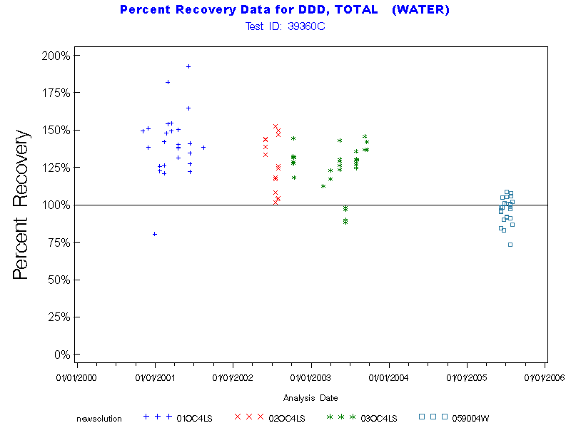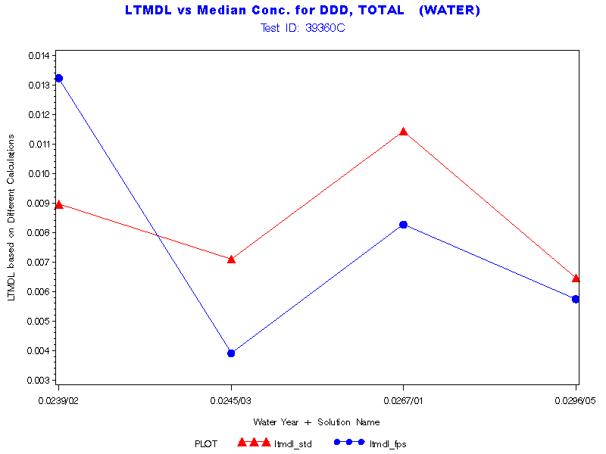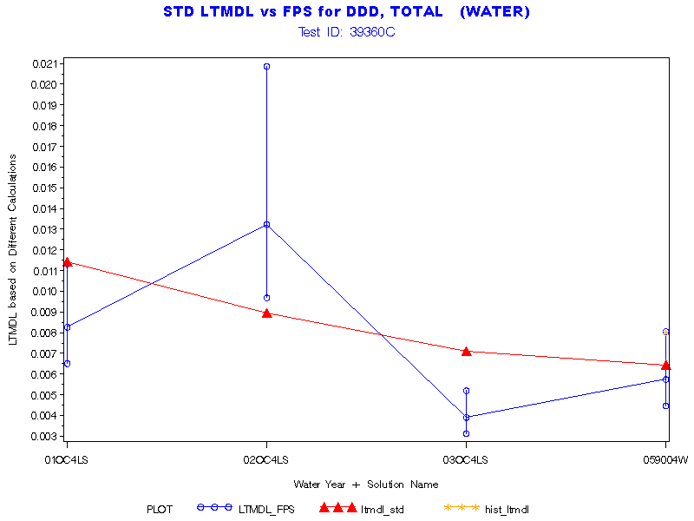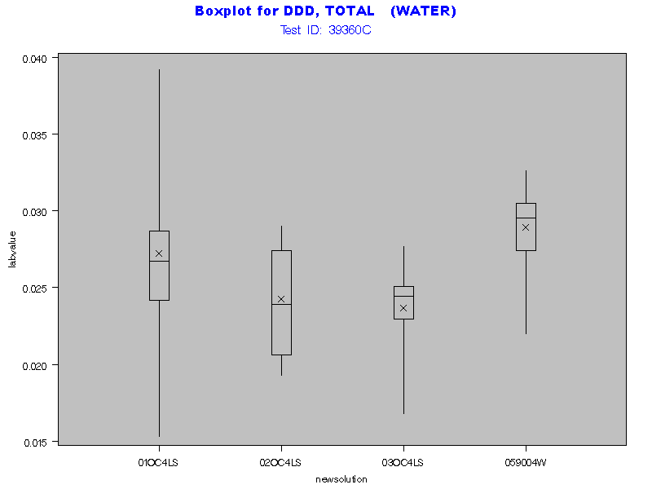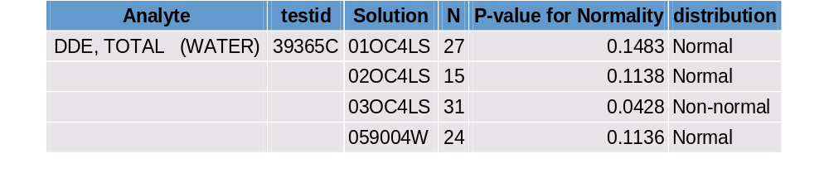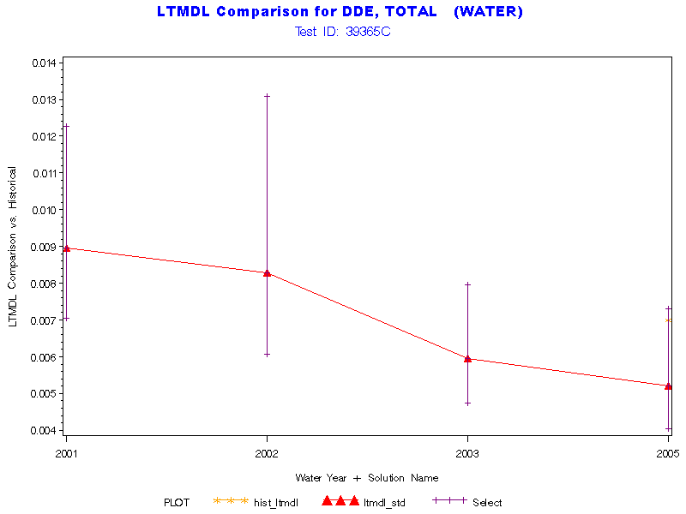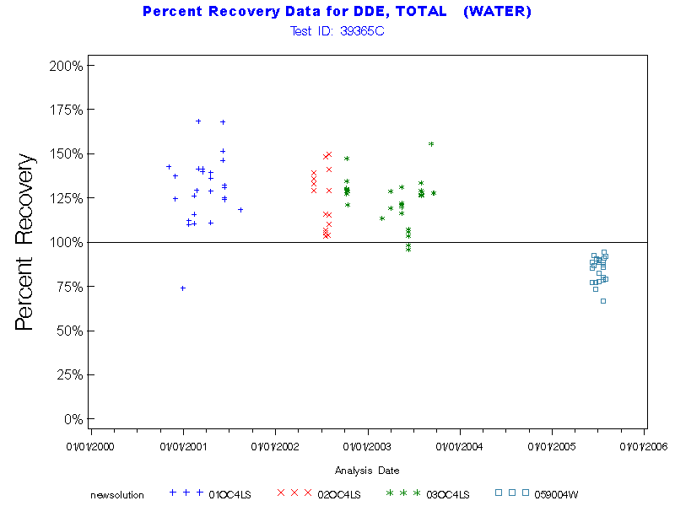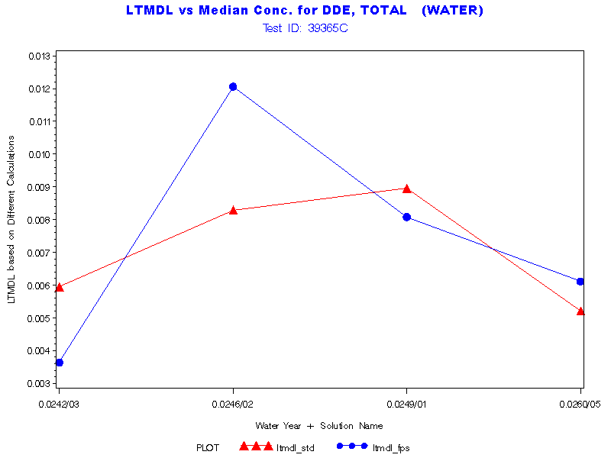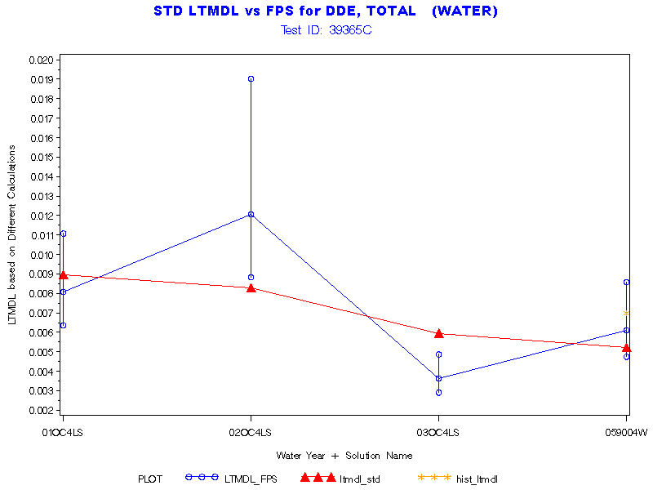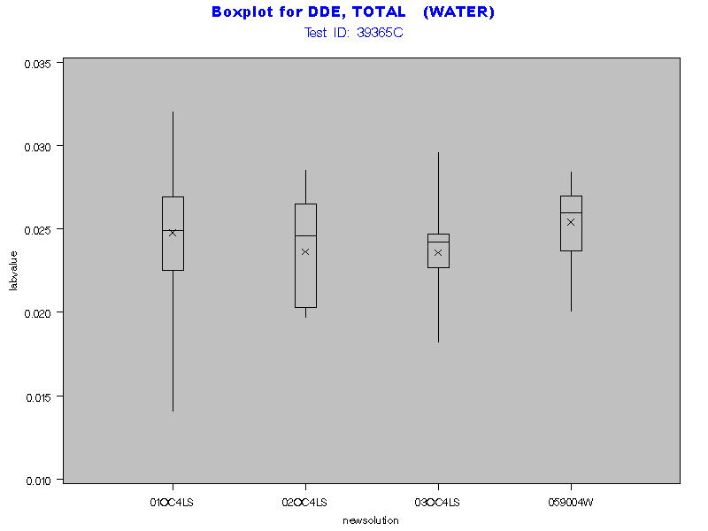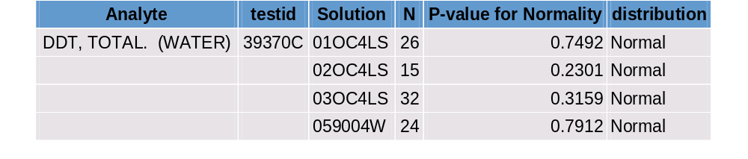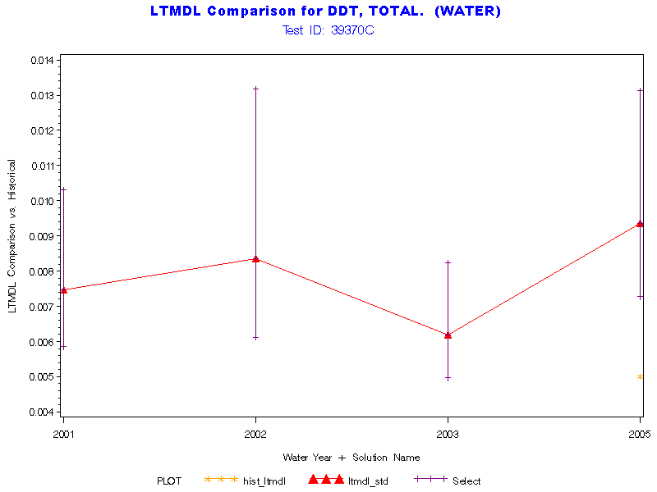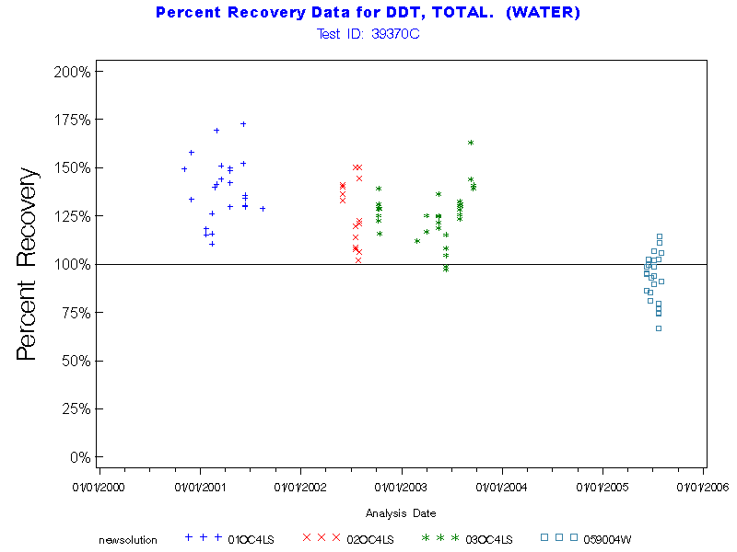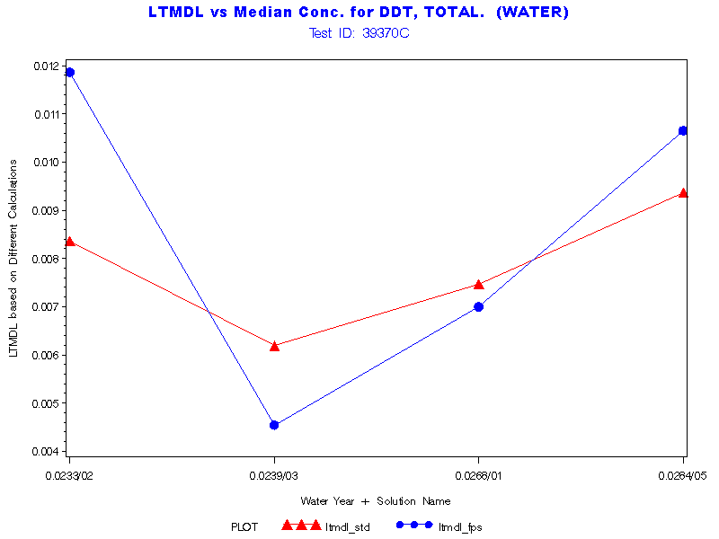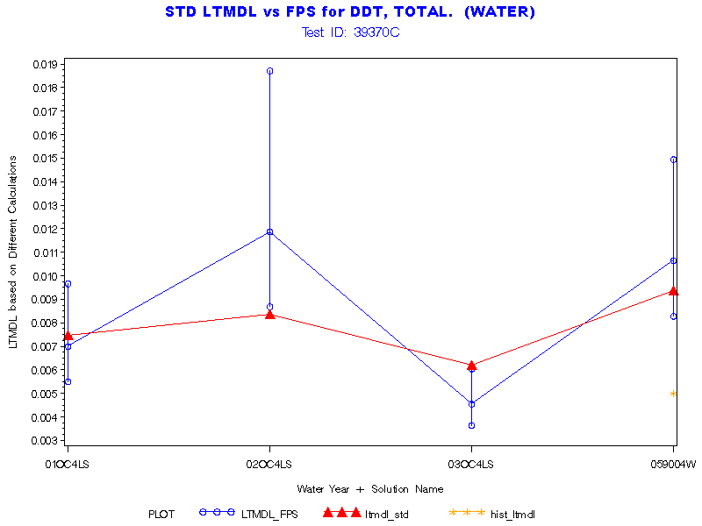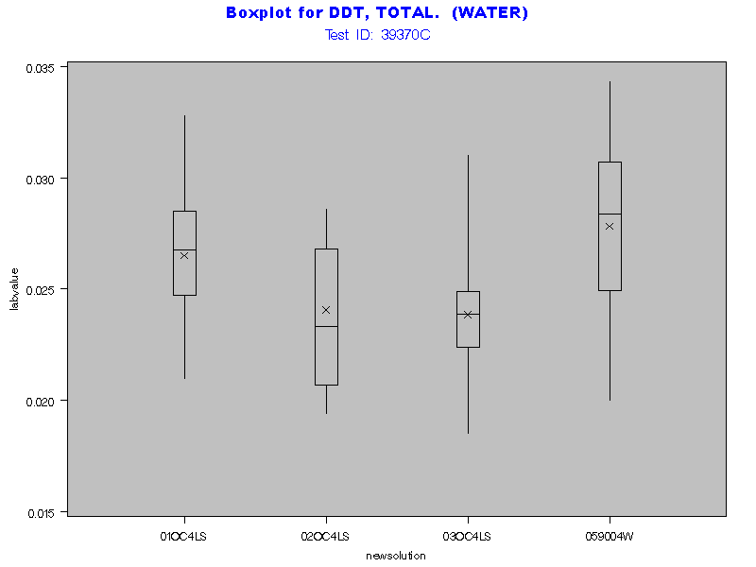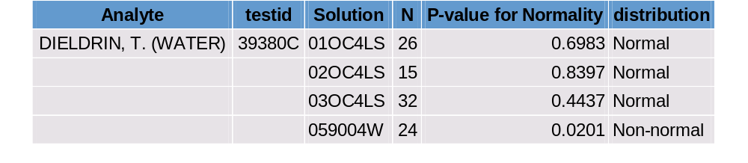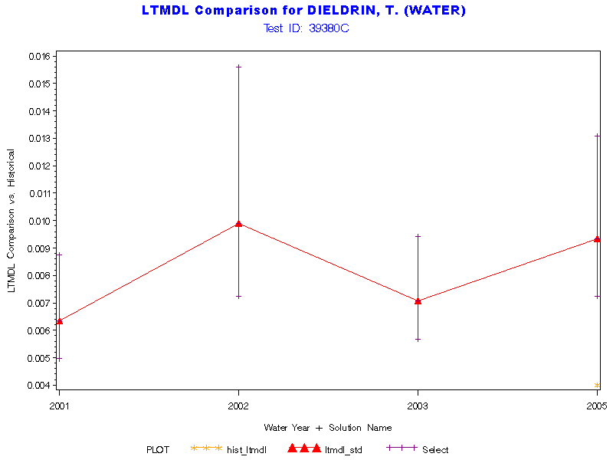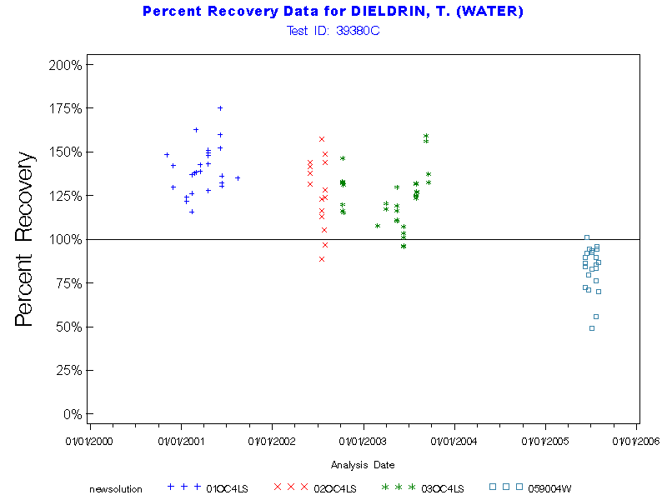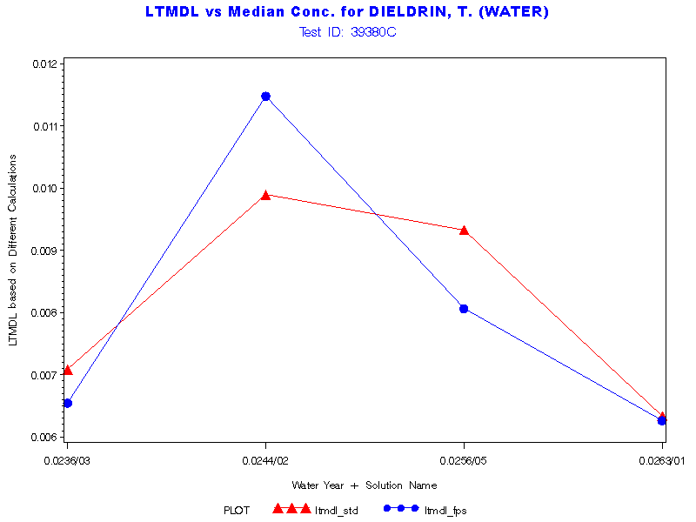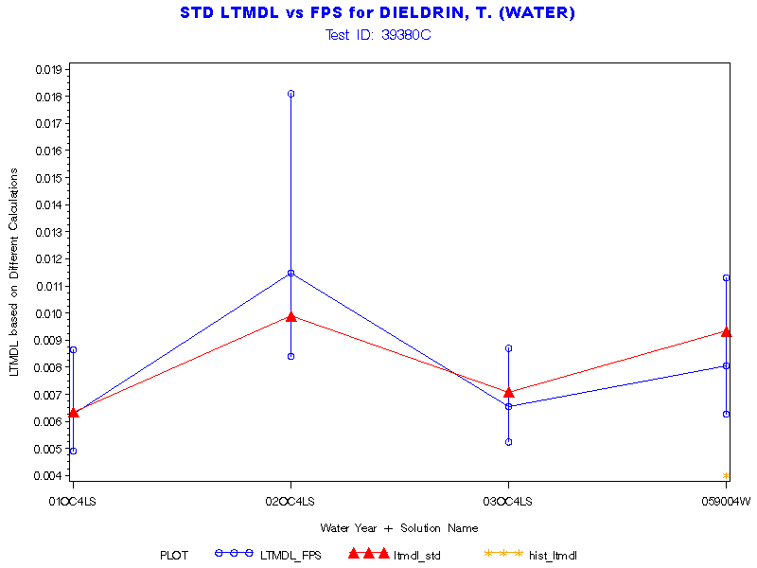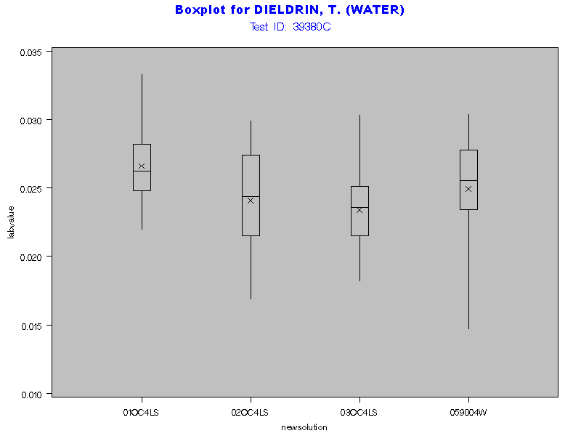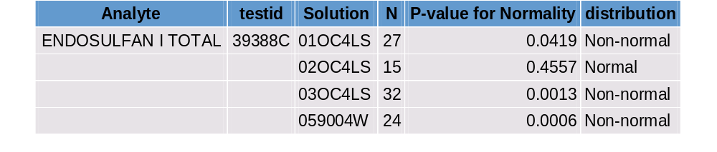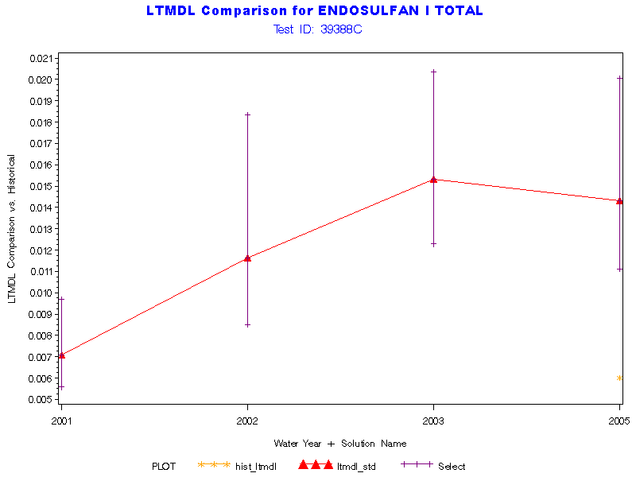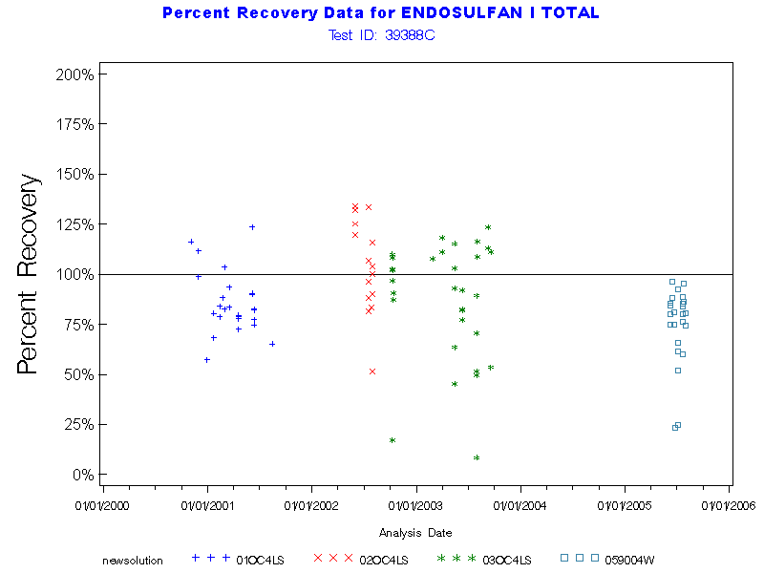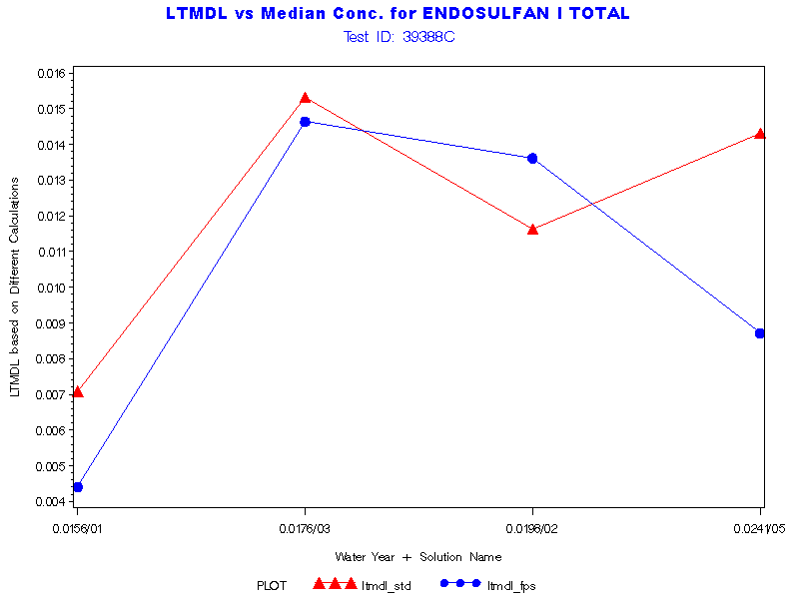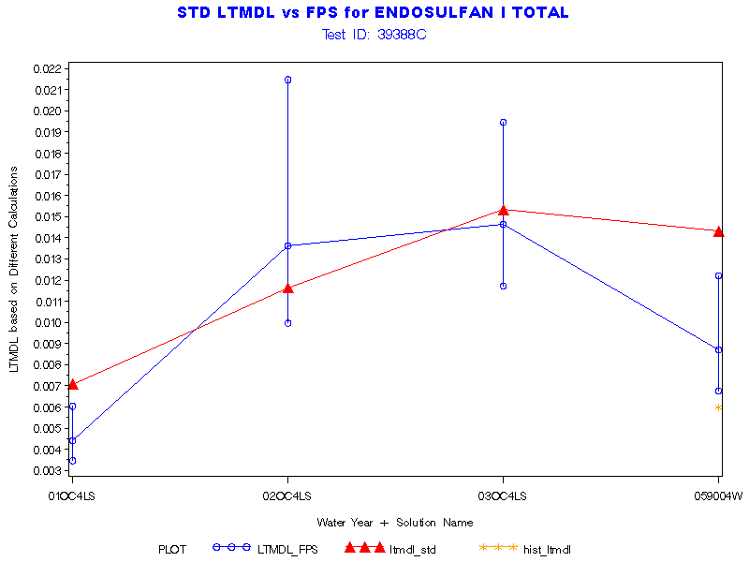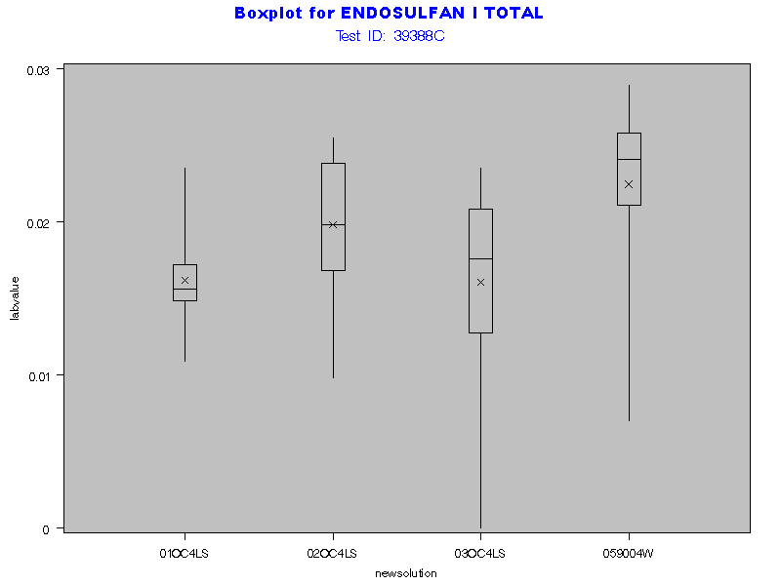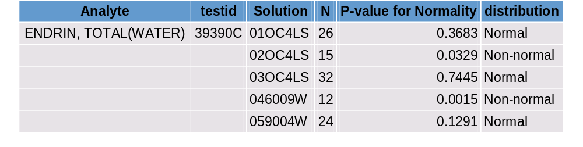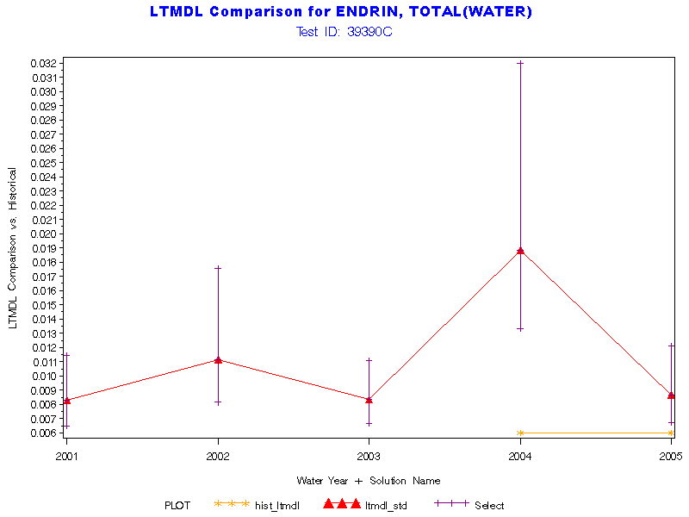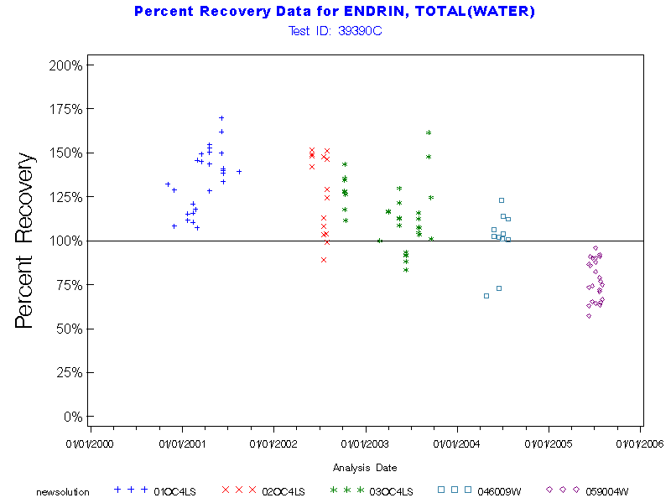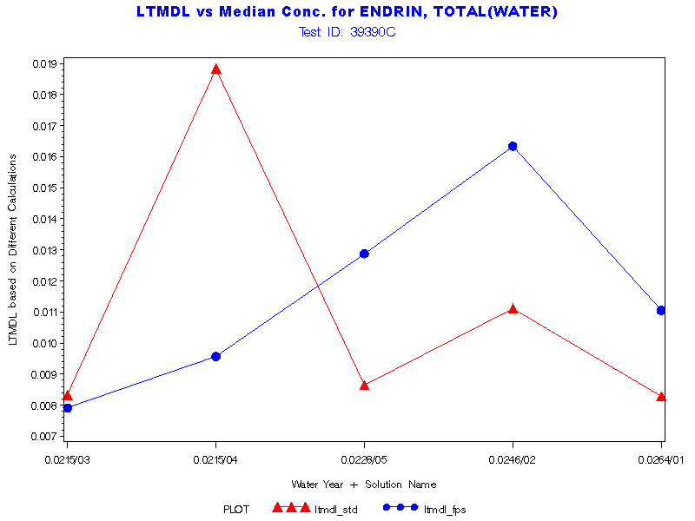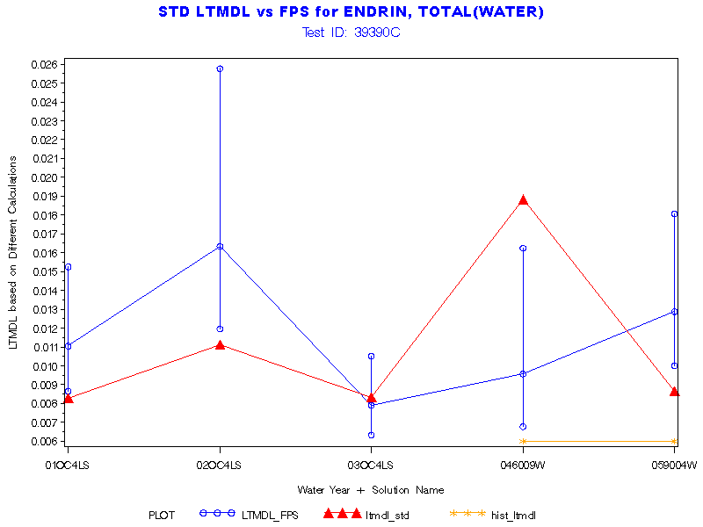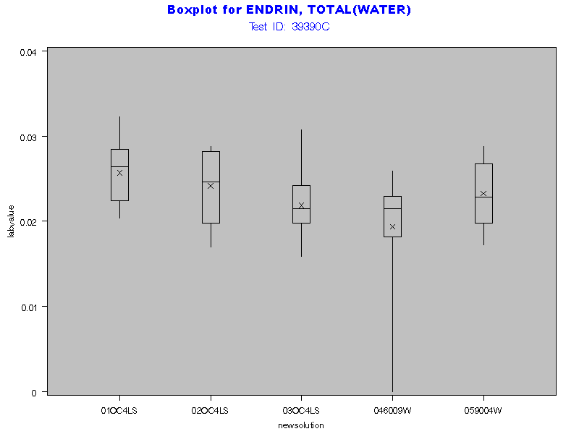

No Normality Table available for Toxaphene

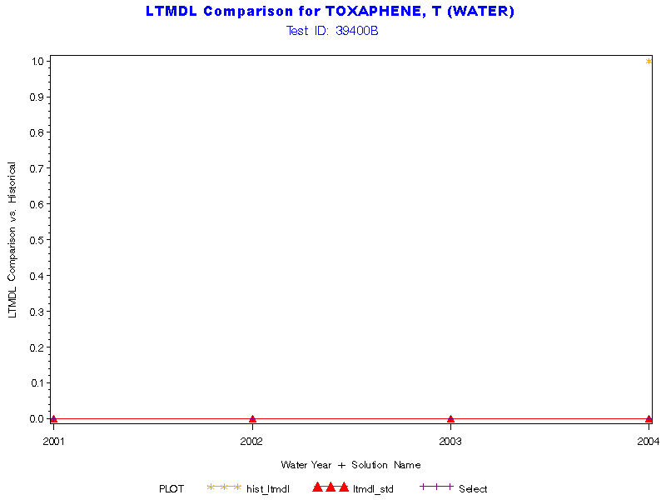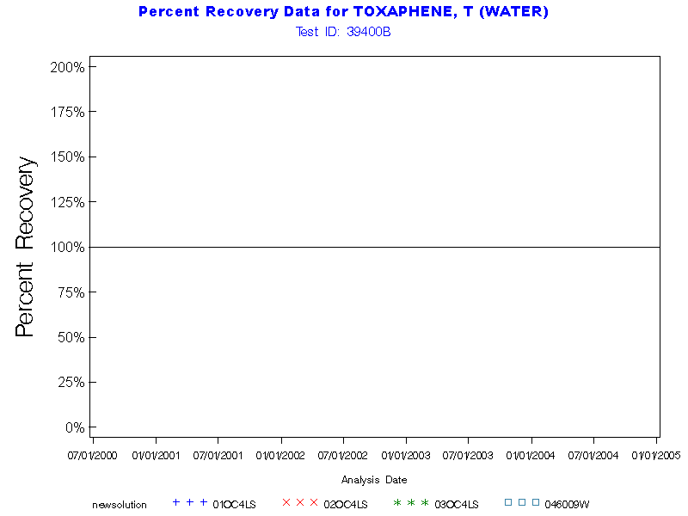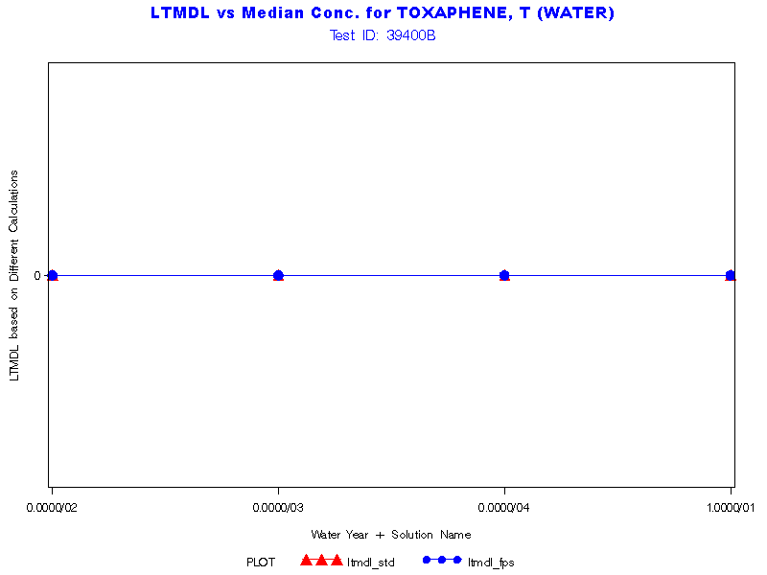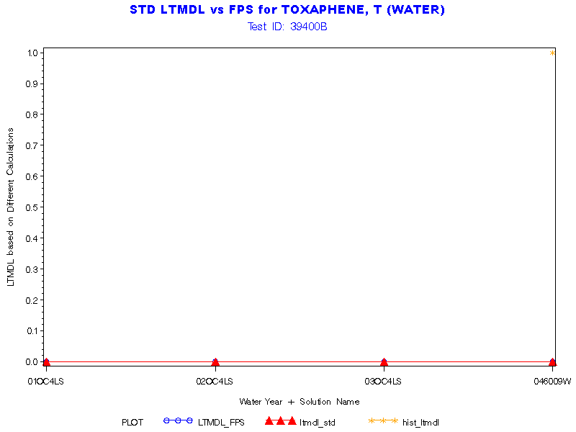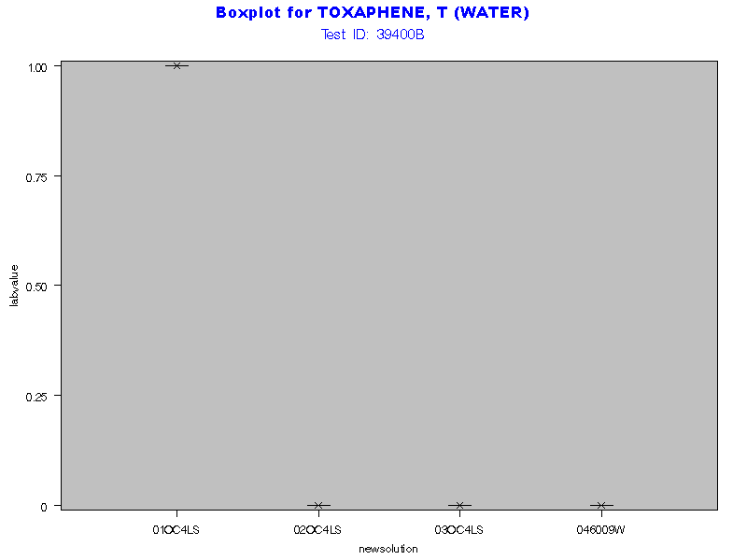
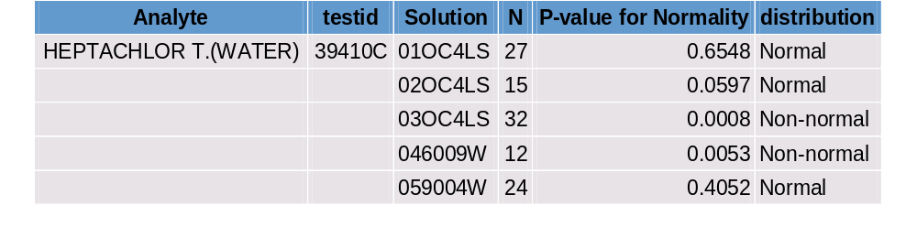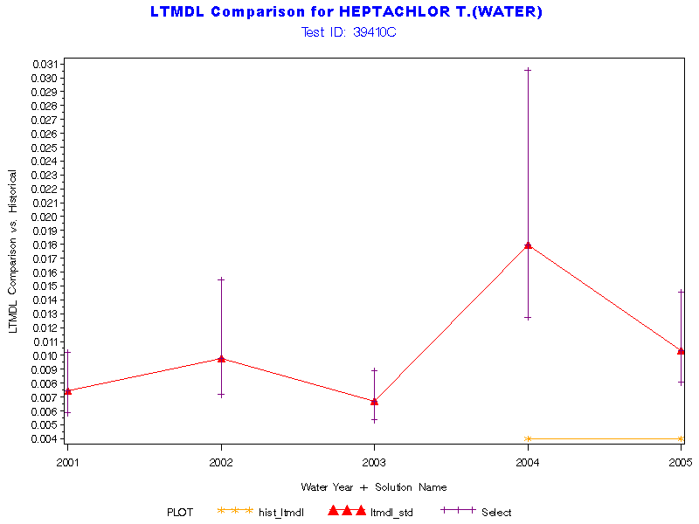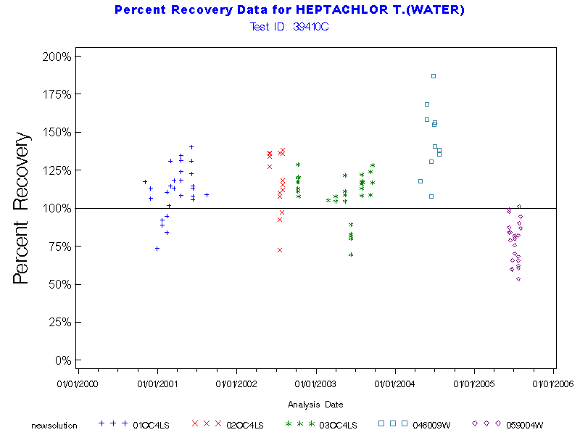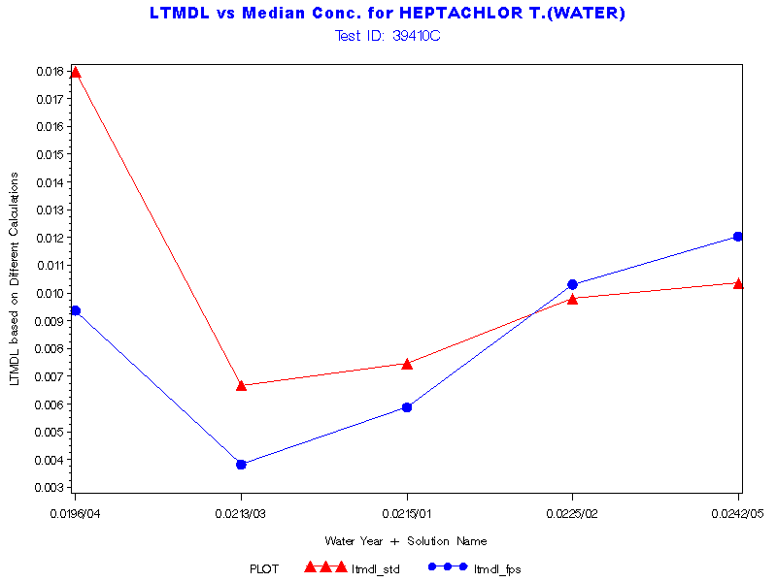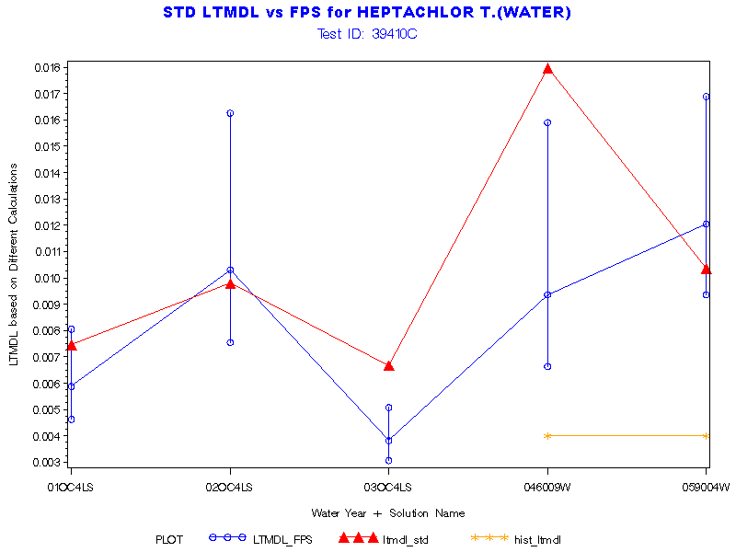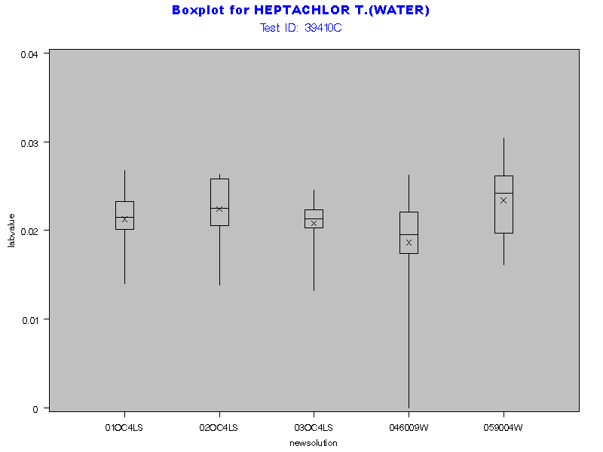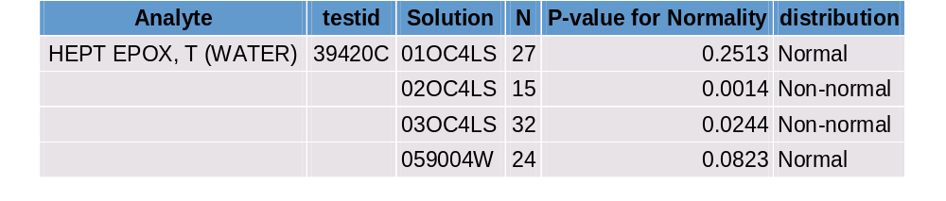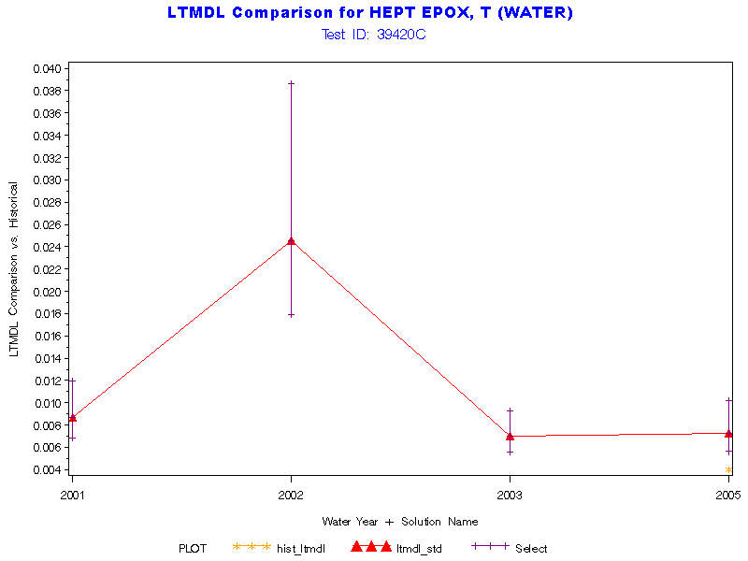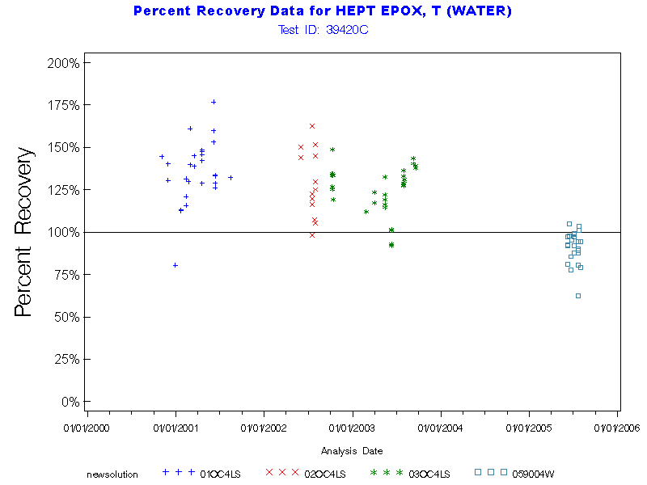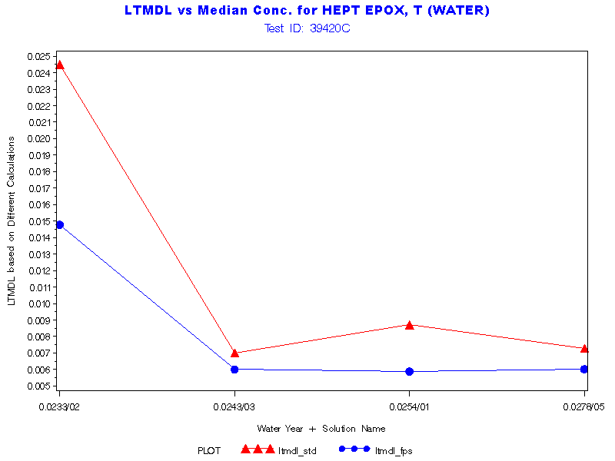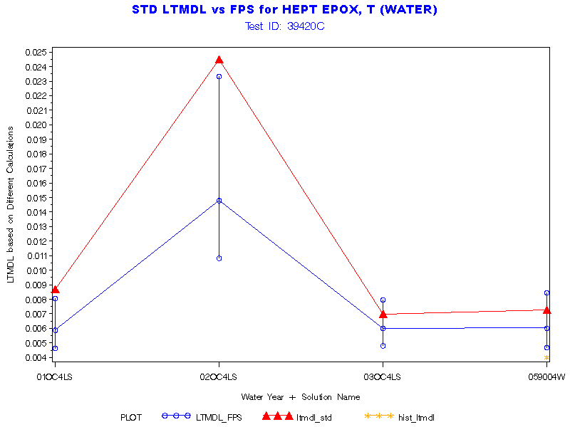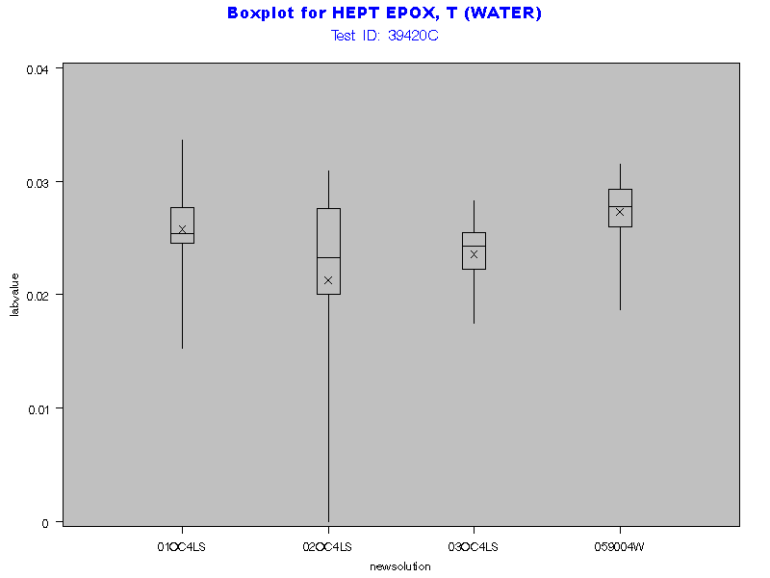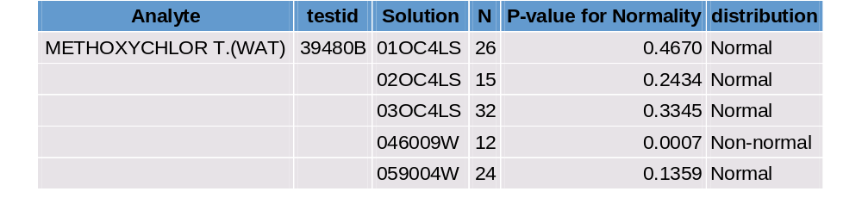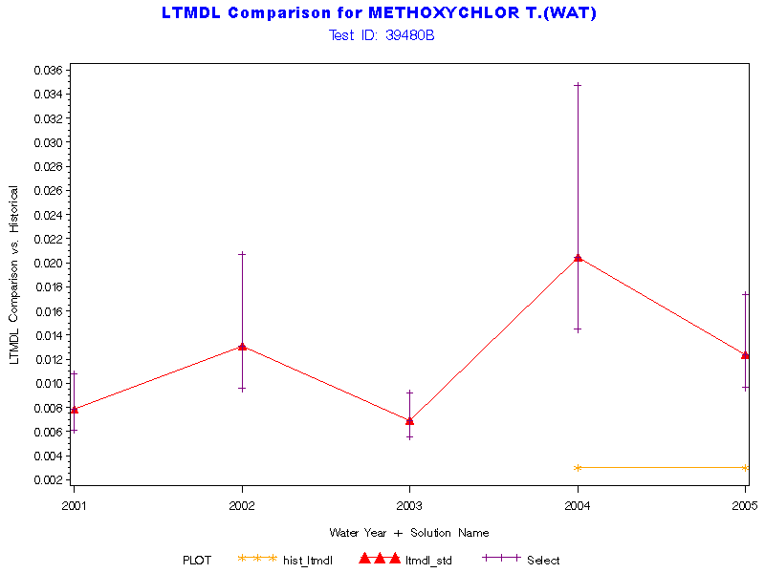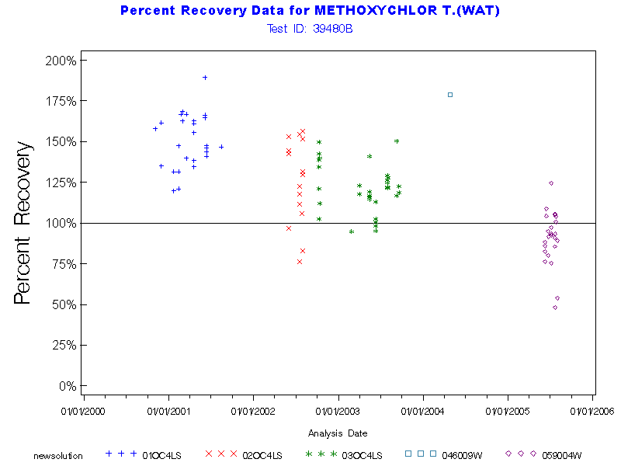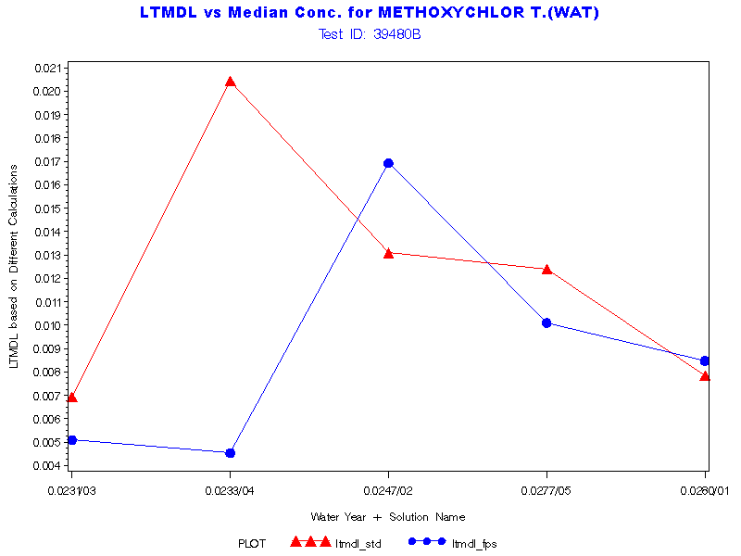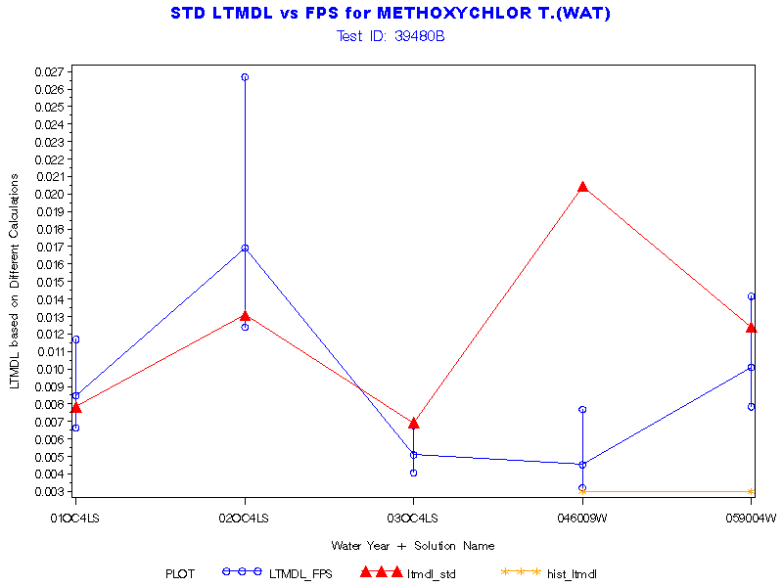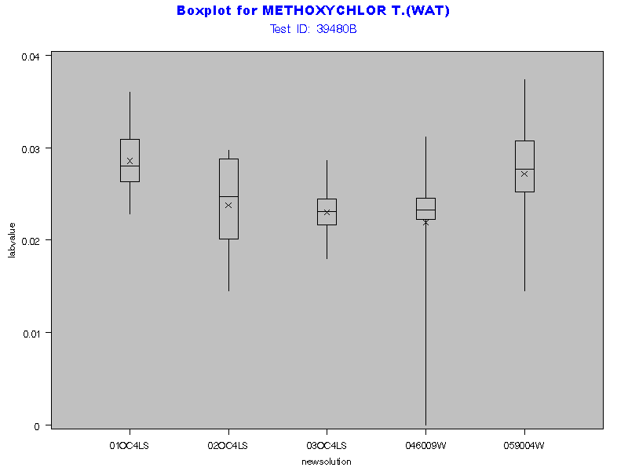

No Normality Plot for Gross PCBs available



