Biology A495A: Internship in Biological Sciences Kodiak College.
Biology Internship with the Alaska Fisheries Science Center, NMFS, NOAA Kodiak, AK. Fall 2006. December 14, 2006.
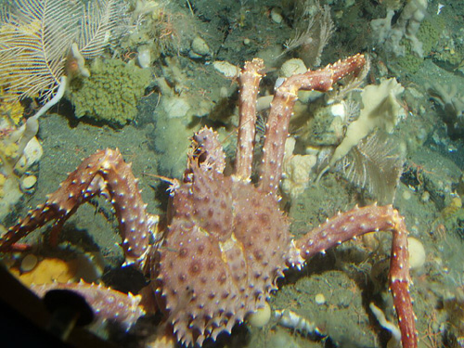
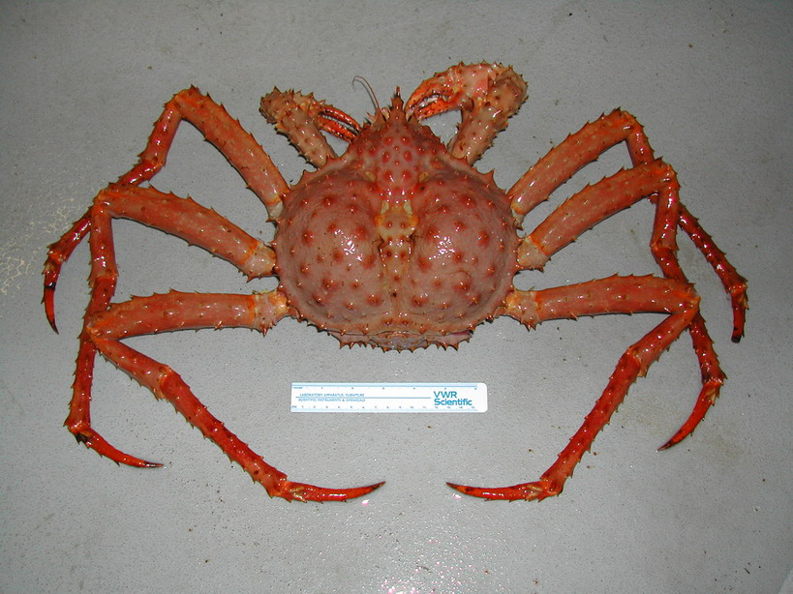
Tabitha Hughes

Instructor: Dr. Cindy Trussell, Kodiak College

Mentor: Scott Van Sant, AFSC, NMFS, NOAA Kodiak

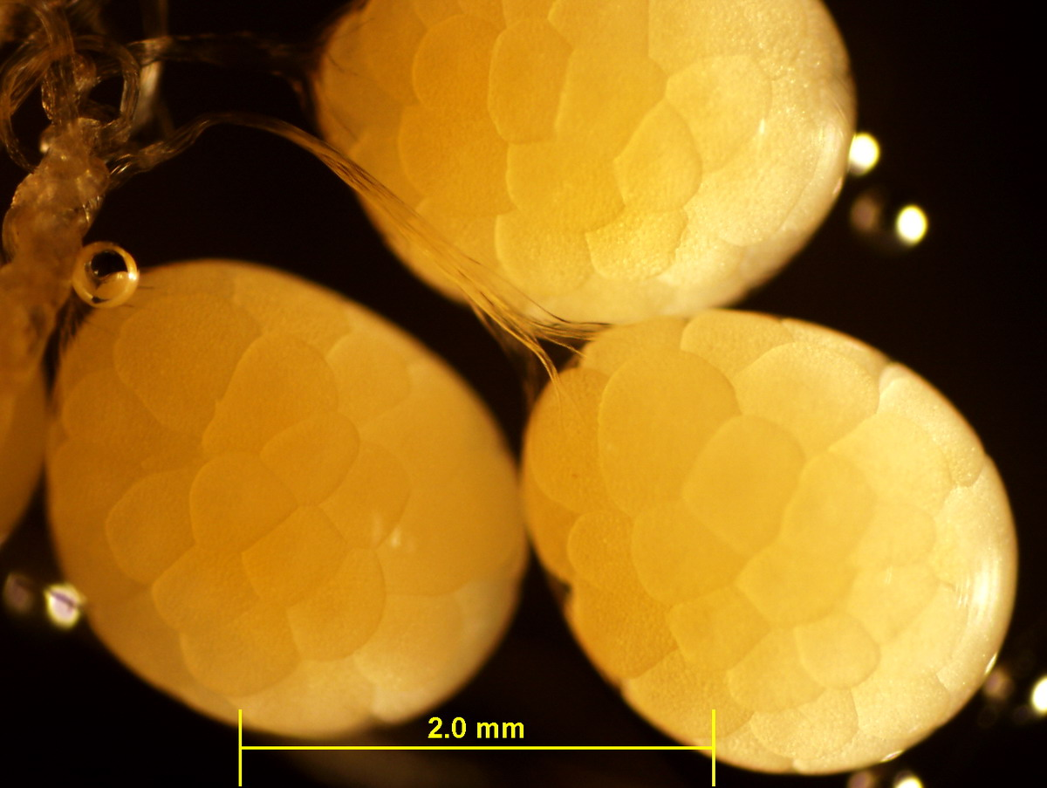
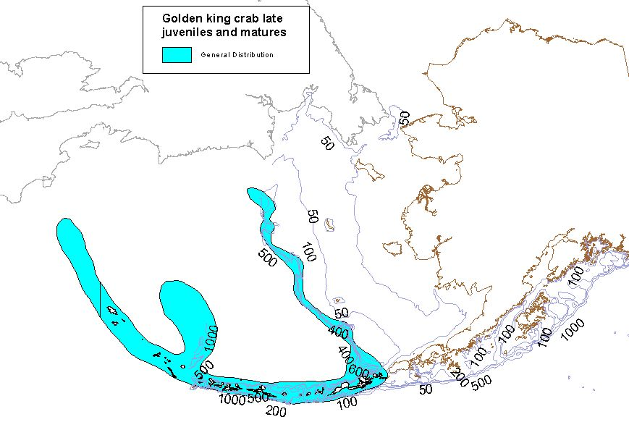
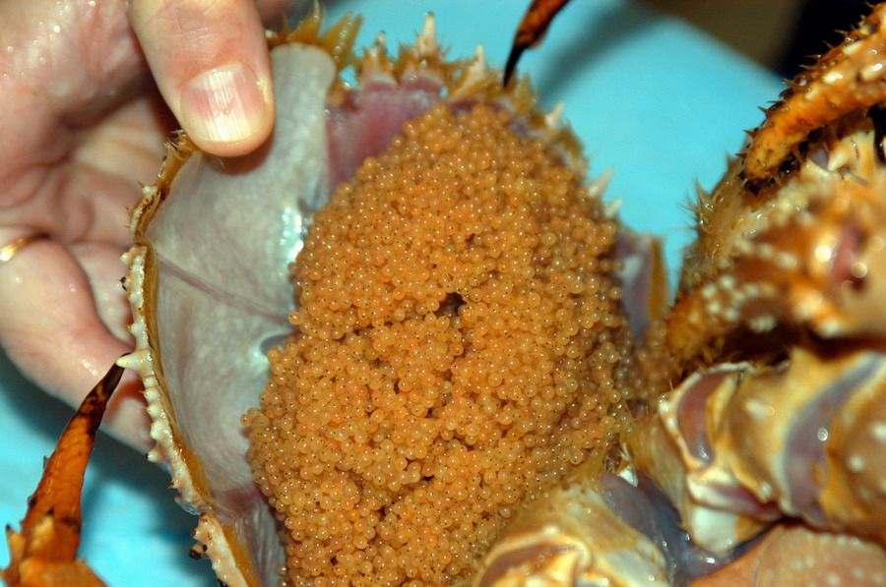
On December 14, 2006, I fulfilled the requirements of my federal internship with the National Marine Fisheries Service (NMFS) in conjunction with the National Atmospheric and Oceanic Administration (NOAA). The primary focus of the internship was concerned with studies of the reproduction biology and embryonic development of golden king crab (Lithodes aequispinus). Research was conducted in the Alaska Fisheries Science Center’s 2500sq.ft. seawater laboratory located in the Kodiak Fisheries Resource Center. During this internship, I was given proper instruction and guidance by Scott Van Sant on the reproduction, embryonic development, larval cultivation, and juvenile growth of the golden king crab (GKC). With this guidance, I was able to achieve a greater understanding of scientific techniques and witnessed firsthand how the scientific method is applied to the research process.

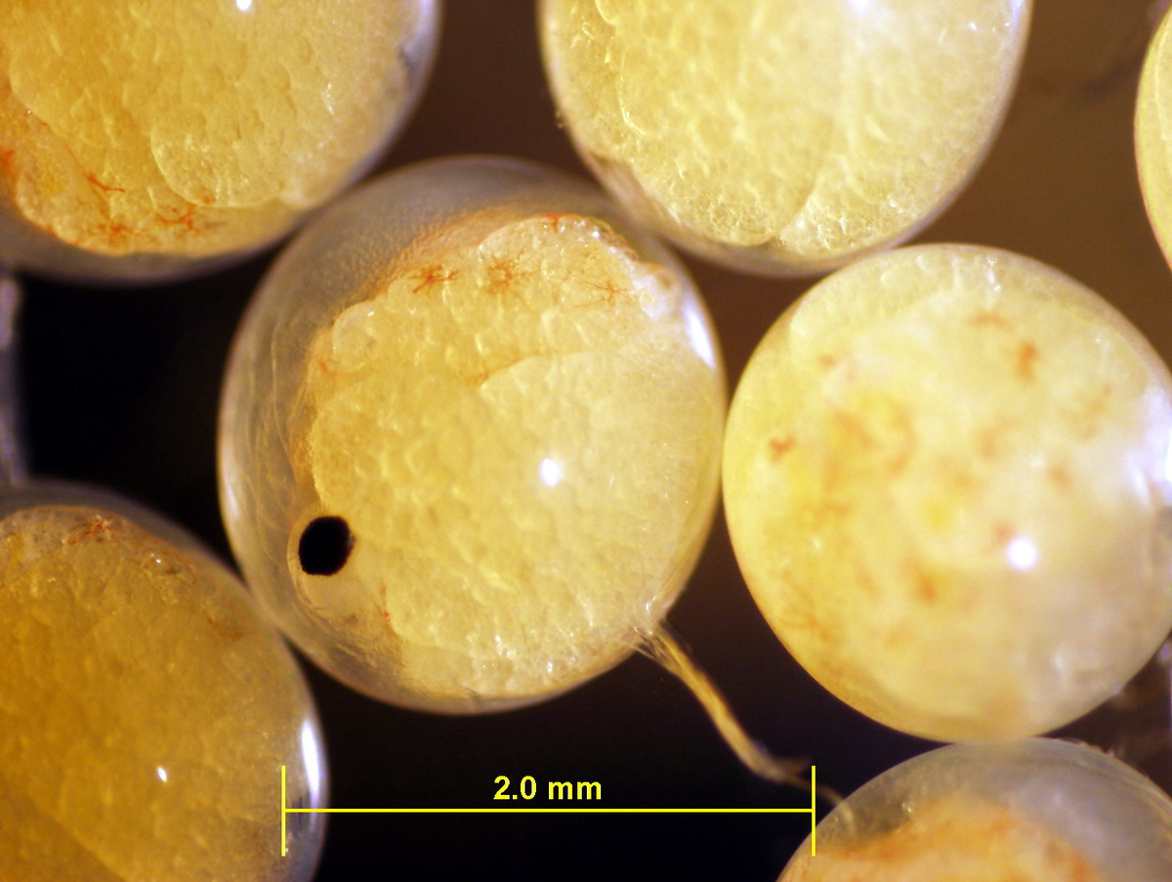
The duration of this internship was based on acquiring a greater understanding of the life history characteristics of the GKC. Upon first entering the program, I was given literature on GKC anatomy and physiology, reproduction, and larval cultivation. During the week of September 4, 2006, both male and female GKC were collected via traps from the Bering Sea. On September 23, 2006, they were shipped live from Dutch Harbor and arrived safely in Kodiak, AK. Scott Van Sant and I transported them to the laboratory where they were tagged and each individual’s measurements, weights, and reproductive condition were recorded.

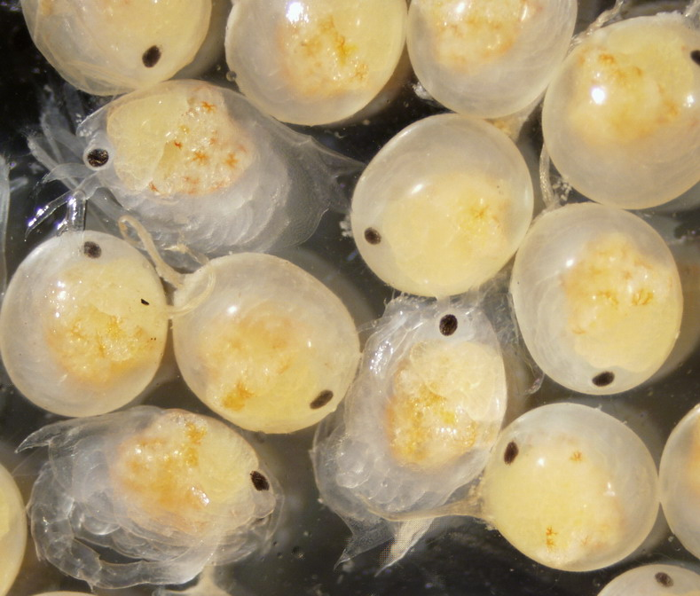
In Alaskan waters golden king crab (Lithodes aequispinus) occur in rocky habitats in deep waters of the Aleutian Islands, Bering Sea, and Gulf of Alaska (Donaldson and Byersdorfer, 2005). Females carry their eggs on their abdomen for 12 months and spawn year round. The larvae go through four zoeal stages and one glaucothoe stage. They are lecithotrophic or ‘yolk-bearing’ therefore do not feed during larval development.
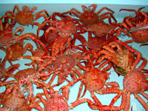
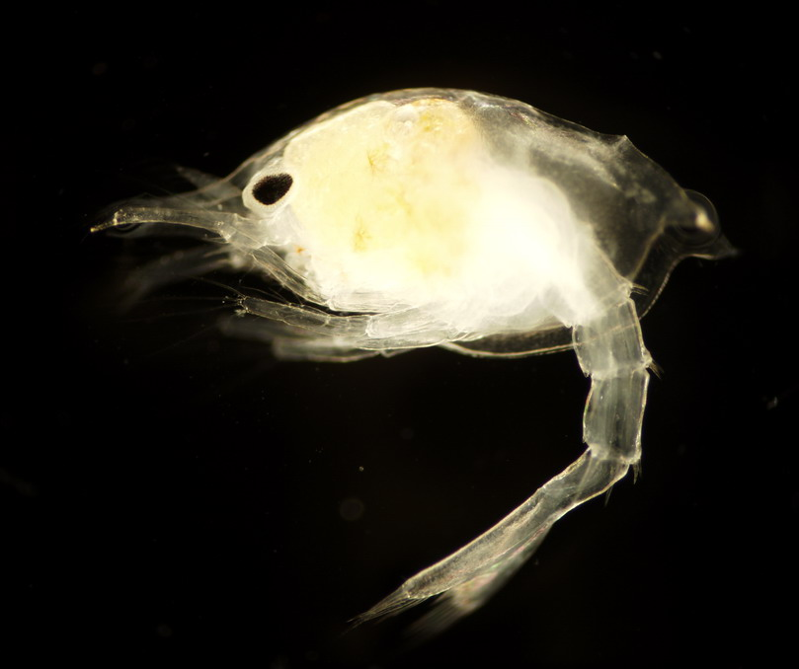
I was instructed on the techniques of recording data concerning embryonic development, and the applications of digital photomicroscopy and image analysis. The embryonic development study began with the extraction of 20-30 fertilized embryos at timed intervals for the duration of the embryo stage. Embryonic development takes approximately a year to complete; I was witness to a fraction of this. Half of the embryos were examined live, and the remaining where placed in a fixative and stain called Bouin’s solution for 5 minutes. At that time, the stained embryos were placed on a slide in filtered seawater and examined under a dissecting microscope at 4X magnification. Digital photomicroscopy was used to record the images and image analysis software was then applied to record the area (A), maximum diameter (L), minimum diameter (W), and mean diameter (based on a number of perimeter measurements) of each developing embryo. The same digital photomicroscopy and image analysis techniques were applied to estimate hatching on the more developed embryos. During the last few months of development the increase in body size of the embryo and the decrease in yolk area can be monitored to predict hatching. These larvae hatched are then collected live and used for cultivation experiments. These embryos hatch with approximately 55% yolk as compared to red and blue king crab which hatch with approximately 12% (Scott Van Sant, pers. com., 2006). This lecithotrophic or ‘yolk nourishing’ feeding mode is prevalent throughout all of their larval stages and therefore they do not require food or plankton in the open ocean or during cultivation studies unlike the planktonotrophic red and blue king crab.

Through Kodiak College, I participated in cultivation studies earlier in the year with a previous batch of GKC larvae. Later, I assisted with the care and feeding of 100 juvenile GKC for a study that compared growth and survival fed different diets. During this internship I also preformed water quality tests that measured the levels of ammonia and nitrate in rearing tanks. General husbandry of the golden and red king crab was also done on a daily basis. These duties included feeding, tank or equipment cleaning, sterilization of seawater, and the maintenance of experiments.

Previous biology coursework, internships, and employment within a laboratory environment contributed to my understanding of laboratory procedures with NMFS/NOAA. My understanding in the research process has improved greatly upon entering this program, and I look forward to participating in a future research internship to further my education in the field of biology.

References
Donaldson, W.E. and S.C. Byersdorfer, 2005. Biological field techniques for lithodid crabs. Alaska Sea Grant College Program, University of Alaska. AK-SG-05-03. 82 pp.

Van Sant, S.B. 2006. Personal communications. AFSC/NMFS/NOAA Kodiak, AK.

