PUBLIC NOTICE
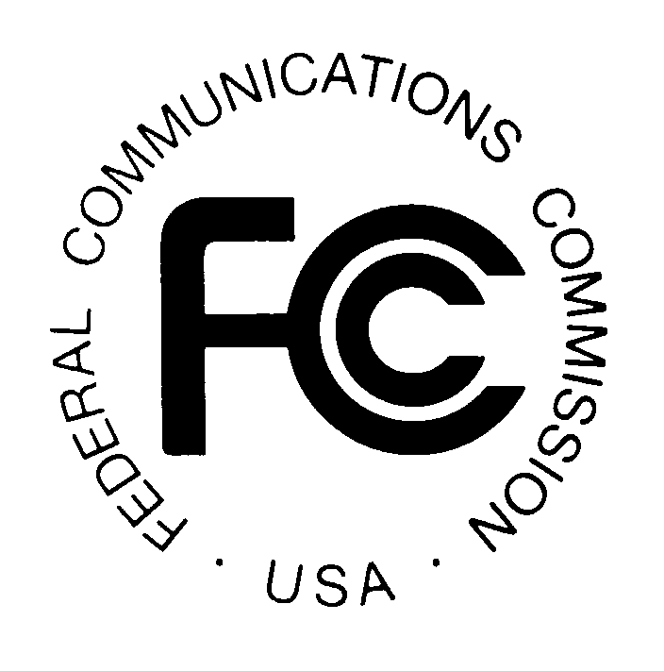
FEDERAL COMMUNICATIONS COMMISSION
445 12th STREET, S.W.
WASHINGTON, D.C. 20554 DA 08-1253

News media information 202/418-0500 Fax-On-Demand 202/418-2830 Internet: http://www.fcc.gov ftp.fcc.gov

MEDIA BUREAU ACTION Released June 2, 2008

PETITION SEEKING DECLARATORY RULING THAT RESTRICTIONS OF A HOMEOWNERS ASSOCIATION IN KENTUCKY ARE PREEMPTED BY THE COMMISSION’S OVER-THE-AIR RECEPTION DEVICES RULE

RESPONSES DUE: July 2, 2008
REPLIES DUE: July 17, 2008

The Commission has received a Petition for Declaratory Ruling from Mr. William H. Culver, asking the Commission to determine whether antenna restrictions of the Northridge Farms Homeowners Association Inc. (“Northridge Farms”) restricting installation and placement of television antennas and satellite dishes is preempted by Section 1.4000 of the Commission’s rules (Over-the-Air Reception Devices Rule). The Petition alleges that the Association’s covenants, rules and regulations violate the Commission’s rule by establishing placement preferences and height restrictions that prevent the Petitioner from obtaining a signal. Northridge Farms is located in Crestwood, Kentucky. This Public Notice announces the pleading cycle for this Petition during which responses and replies may be filed.

For purposes of our ex parte rules, this proceeding will be considered as non-restricted pursuant to Section 1.1206 of the Commission’s rules (“Permit-but-disclose proceeding”).

Parties may file responses to the Petition on or before July 2, 2008 and replies on or before July 17, 2008. Please place the case identifier, CSR-7925-O, on all filings.

An original and two copies of all filings should be addressed to the Commission’s Secretary, Marlene H. Dortch, Office of the Secretary, Federal Communications Commission, 445 12th Street, S.W., Suite TW-A325, Washington, D.C. 20554. Attn: Media Bureau, Policy Division. One copy of responses, replies, or other communications must be served on all participants in the case.

Filings can be sent by hand or messenger delivery, by commercial overnight courier, or by first-class or overnight U.S. Postal Service mail (although we continue to experience delays in receiving U.S. Postal Service mail).

- The Commission’s contractor will receive hand-delivered or messenger-delivered paper filings for the Commission’s Secretary at 236 Massachusetts Avenue, NE, Suite 110, Washington, DC 20002. The filing hours at this location are 8 a.m. to 7 p.m. All hand deliveries must be held together with rubber bands or fasteners. Any envelopes must be disposed of before entering the building.

- Commercial overnight mail (other than U.S. Postal Service Express Mail and Priority Mail) must be sent to 9300 East Hampton Drive, Capitol Heights, MD 20743.

- U.S. Postal Service first-class, Express, and Priority mail should be addressed to 445 12th Street, SW, Washington, DC 20554.

People with Disabilities: To request materials in accessible formats for people with disabilities (braille, large print, electronic files, audio format), send an e-mail to fcc504@fcc.gov or call the Consumer & Governmental Affairs Bureau at 202-418-0530 (voice), 202-418-0432 (tty).

Copies of the petitions and other filings in this proceeding will be available for public inspection and copying during regular business hours at the FCC Reference Information Center, Portals II, 445 12th Street, SW, Room CY-A257, Washington, DC 20554, telephone (202) 418-0270.

Copies of filed documents may be obtained from the Commission’s duplicating contractor, Best Copy and Printing, Inc., Portals II, 445 12th Street, SW, Room CY-B402, Washington, DC, 20554, telephone 202-488-5300 or (800) 378-3160, facsimile 202-488-5563, or via e-mail at fcc@bcpiweb.com; or via their website at FCC@BCPIWEB.COM.

Media Contact: Clyde Ensslin (202) 418-0506.

Media Bureau Contacts: Kenneth Lewis (202) 418-2622

-- FCC --

