Underutilized observations for studying tropical climate variations: the historical pilot balloon database

Michael Douglas¹ John Mejia², Raquel Orozco², Javier Murillo³
¹National Severe Storms Laboratory/NOAA, ²Cooperative Institute for Mesoscale Meteorological Studies, ³Weather Decision Technologies
Norman, Oklahoma

Abstract

The longest-running atmospheric sounding database is that from pilot balloon observations (“pibals”), whose routine observations date from the early 20th century. Such observations are still made today, though mostly in developing countries in Asia and Africa. Although pibals are subject to limitations (cloudiness and darkness being the two most obvious ones), their low cost has historically allowed for more frequent and more widespread use than radiosondes. Much less well-known, and less appreciated, is that pibals have some advantages over radiosonde winds for studies of climate variability. The procedure for making a pibal has not fundamentally changed in 100 years, unlike wind observations obtained from rawinsonde systems – which have used radiotheodolites, Omega, LORAN and now GPS. Wind profiles obtained from these different systems show somewhat differing characteristics, which can complicate identifying historical trends in wind data.

Making effective use of historical pilot balloon data for climate studies requires availability of the original angle data and some metadata - such as the characteristics of the balloons and inflation procedures. We discuss the difficulty in obtaining both of these; a major effort at digitizing the global database of pilot balloon observations will be required.

Introduction

Perhaps the simplest upper air wind measurement that can be made in clear skies is that of a pilot balloon observation (Fig 1). A small balloon, inflated precisely to produce a known (but approximate) ascent rate, is tracked by a theodolite and the elevation and azimuth angles measured at fixed intervals. With trigonometry the horizontal position over the earth can be found and the horizontal displacement (and thus wind) obtained. Although early measurements of this kind were made in the late 1800’s, the first suitable measurements were made around 1905. By the end of WWI (~1918) there were approximately 20 pilot balloon stations in the US and similar observations were being made in a number of countries.

Although an online NOAA history states that “The pibal was replaced by the radiosonde in 1938” this is a considerable oversimplification of what actually took place during this period (http://celebrating200years.noaa.gov/foundations/weather_obs/welcome.html#adv). Rawinsonde observations, with winds obtained by tracking the signal of the radiosonde, did not become widely available until WW2 and a mean wind map from June 1949 (Fig. 3) shows that pilot balloon observations were still more numerous than rawinsonde observations. By 1956 (Fig. 4) rawinsonde observation sites (~63) were similar in number to pilot balloon sites (~65). (These maps of wind data over the US were routinely published in Monthly Weather Review from 1938 to just after 1956.)

The pilot balloon history in the rest of the world is somewhat similar to that in the US, except that in many countries the transition to rawinsonde observations was not made smoothly. Pilot balloon observations were relatively widespread in many parts of colonial Africa and the Indian subcontinent in the 1940’s and 50’s. Upon independence, many of the weather monitoring networks gradually deteriorated and many pilot balloon stations ceased to operate. The exact history varied greatly from country to country, with some maintaining extensive networks up to the present (e.g. India, Fig. 5). Many others however, ceased observations, or continued observations intermittently. East African pibals were critical in describing the east African low-level jet and its northward extension, the Somali jet (Fig. 6). Many Mexican pilot balloon observations continued well into the 1960’s and early 70’s, and agreements between the US and Mexico specified the stations to be operated, with some making 4 pilot balloon observations per day (Fig. 7).

Many of the current pilot balloon observations are not routinely transmitted via the GTS and so it is not always easy to determine whether observations are being made of not. For example, the IMD web site states that there are 62 pilot balloon stations current in India (Fig. 5). Yet few of the observations are internationally disseminated. Many stations are listed as pilot balloon stations in current WMO Station lists, but we know from personal experience that some of these have not made observations for many years. There is a serious lack of metadata about the stations. Hill (1979), in showing the locations of pilot balloons he used in central Africa (Fig. 8), admitted that it used mean winds from other analyses, since the original data was hard to find.

Value of historical pilot balloon data

Since there have been few fundamental changes in pilot balloon observation procedures since their advent, there should be little variation in the uncertainties associated with the observations over time. This is very unlike radiosonde measurements, where sensors have changed as each new model appears. And there are very significant variations between different manufacturers of radiosondes, so that a major effort has been necessary to account for these historical changes when studying long-term upper air temperature and humidity variations. Even winds from radiosonde systems have changed with time. Early radiotheodolites had certain error characteristics, losing balloons at low elevation angles. Then Omega navigation windfinding required long averaging intervals, thus smoothing the wind profiles. LORAN was higher vertical resolution, but geographically limited. And although GPS-windfinding is now very accurate, it has been subject to radio interference from local sources. All radiosonde wind measurements are subject to balloon drift characteristics, and even the high resolution GPS winds include the sonde-balloon pendulum motion that must be filtered. And 1-sec winds are of little use in most meteorological applications anyway, as averaging is needed for most analysis and weather prediction applications - does anyone use 5-sec winds from an automatic surface station?
If the historical data can be recovered, pilot balloon observations could be used to extend backwards in time by several decades our description of circulation changes over parts of the world. Areas where such observations have been extensive include North America, tropical Africa, and south Asia.

If consideration is being given to generating a reanalysis product based solely on surface observations over the northern hemisphere, the addition of pilot balloon data would certainly be an important addition to such a reanalysis. Modern data assimilation systems should be able to use the wind information to generate much more reliable atmospheric structures than from surface data alone. Whether through data-assimilation based reanalyses or diagnostic studies of the original data from pibal networks, the historical tendencies of circulation characteristics can be diagnosed over a longer period than can temperature tendencies from radiosondes. This may be useful for many climate studies.

Since pilot balloon observations are still widespread across south Asia, this would probably be the most suitable region to test the usefulness of diagnosing long-term changes in atmospheric circulation from only pilot balloon observations. Such a diagnosis could be compared with reanalysis-based changes to determine the sensitivity of the changes to changes in initial data quantity and type.

Feasibility of obtaining the raw observations

There is an ongoing need to digitize the historical paper archives that exist of pilot balloon observations in many, many countries. It is not enough to compile GTS-reports, which are a very large underestimate of the observations actually made. The raw angle observations are essential, so that the winds can be examined for errors and only then winds calculated.
Historical procedures to calculate winds were either manual or calculator-based, neither of which could easily detect and correct observational errors. In fact, errors are virtually impossible to detect when using the programmable hand calculators widely used in Africa today. And errors in entering the data cannot be detected. Unfortunately, the poor quality of GTS pibal data has led to a certain disregard for the quality of such observations. And unfortunately for data impact studies, the demise of widespread pilot balloon observations occurred mostly prior to the widespread development of numerical weather prediction activities. There were virtually no pilot balloon observations taking place over North America by the time NWP models had developed to a point where they could show a positive impact from assimilating higher spatial-resolution wind soundings (Fig. 10). The impact of such observations could still be assessed with regional NWP models over parts of south Asia, where pibals are numerous. And the impact of pibals on future higher-resolution reanalyses is sure to be positive in much of Africa and Asia.

To obtain and digitize the historical pilot balloon database would be a very major undertaking, and one that is likely to be successful only if funded by the international community. Understandably, it is a low priority for most weather services, since the value of such observations is primarily for climate research. The urgency of the digitization is apparent to anyone who has visited data archives of a meteorological service in Africa. The need to obtain metadata on the procedures, balloons, and historical changes to the networks should also be documented urgently. Quite literally, knowledge of this is dying off, as few observers remain from the early years of pilot balloon observations.

References:

Hills, R.C., 1979: The Structure of the Inter-tropical Convergence Zone in Equatorial Africa and its relatonship to East African rainfall. Transactions of the Institute of British Geographers, New Series, Vol.4, No. 3, pp329-352.

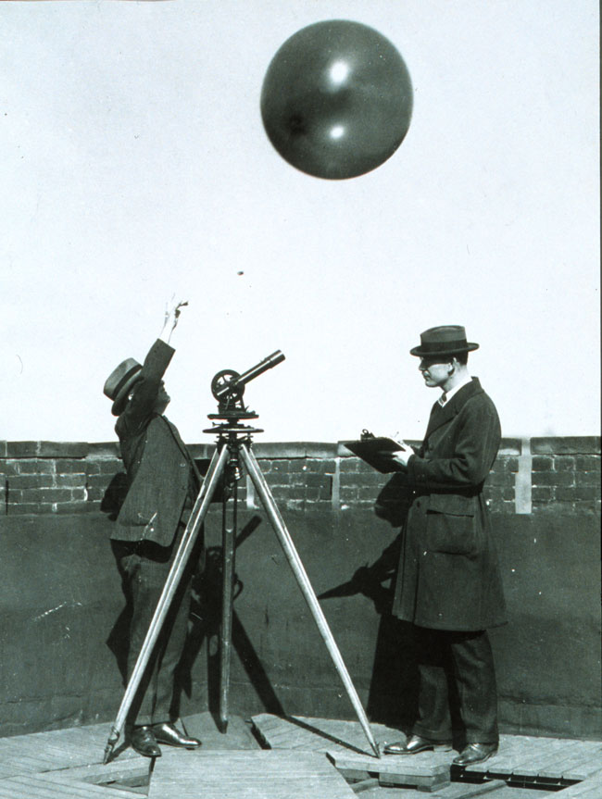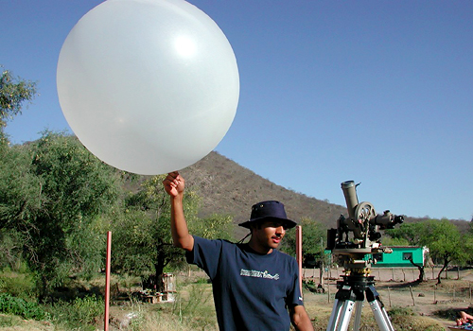

Fig. 1. Pilot balloon launch (in 1930’s??,from NOAA web page) and in 2004 (northern Mexico). The advantage of the same technology…

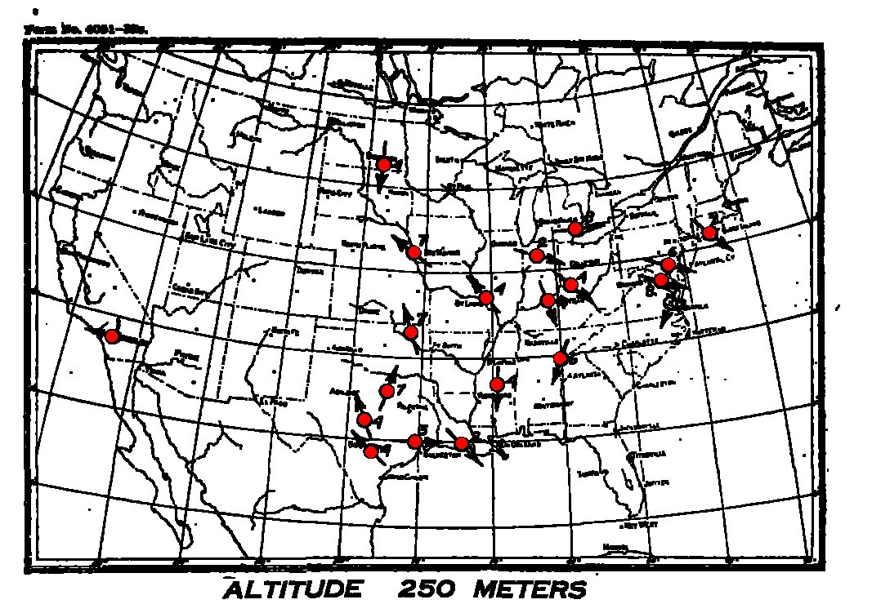

Fig. 2. Pilot balloon stations (red) around 1919.

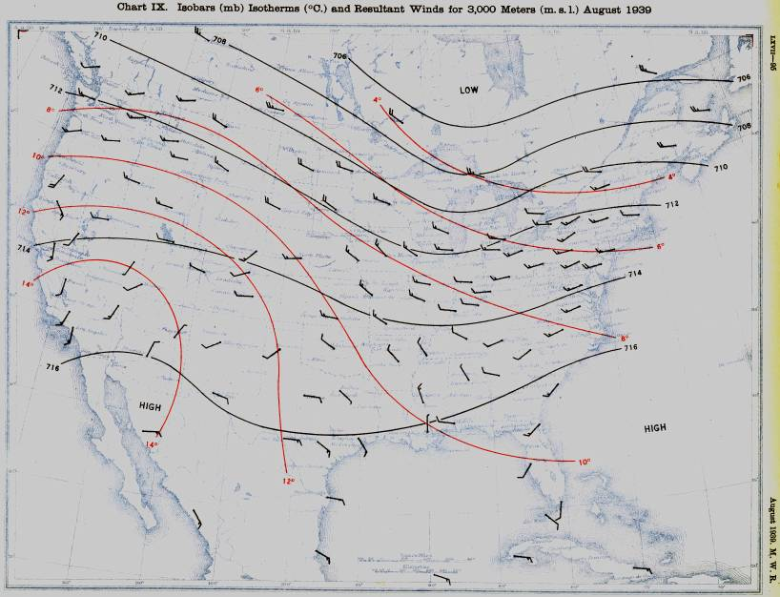

Fig. 3. Pilot balloon observations – mean winds for August 1939. Some radiosonde observations are available for the isotherm analysis – but winds are obtained by tracking of the radiosonde balloons.

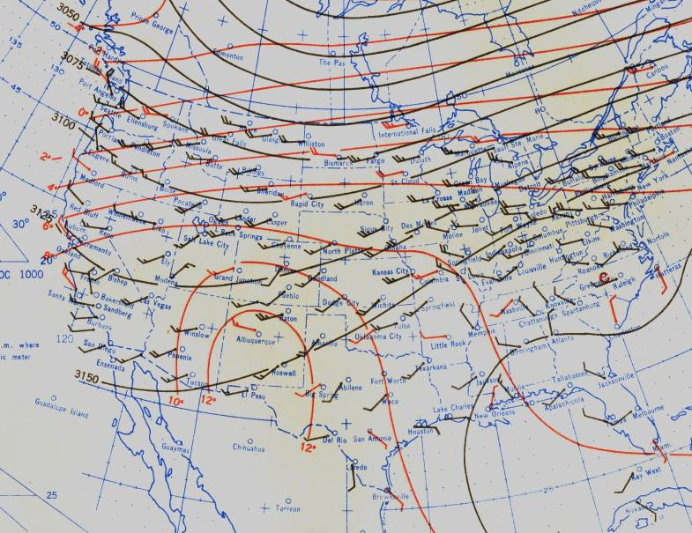

Fig. 4. Pilot balloon (black) and radiosonde (red) mean winds at 700 mb for June 1949. More pibals than rawins.

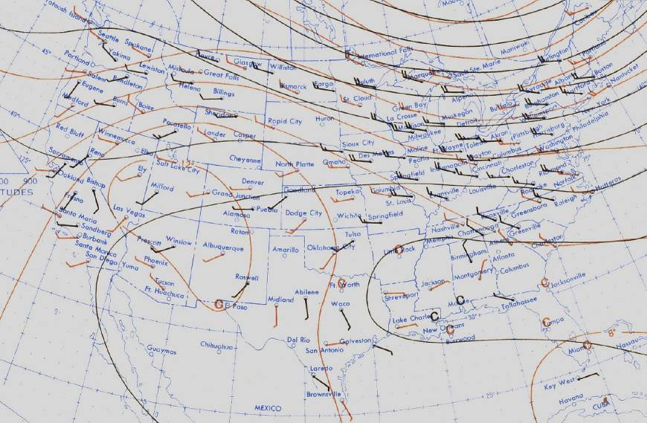

Fig. 5. Pilot balloon (black) and radiosonde (red) mean winds for August 1956. Still many pibals are present, though rawinsondes are now more numerous.

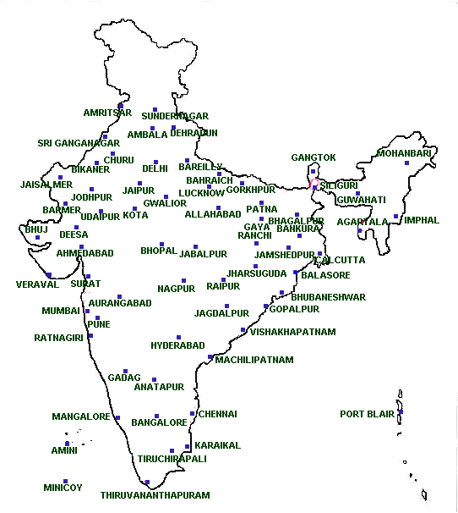

Fig. 6. Current Indian pilot balloon network according to the Indian Meteorological Department web page.

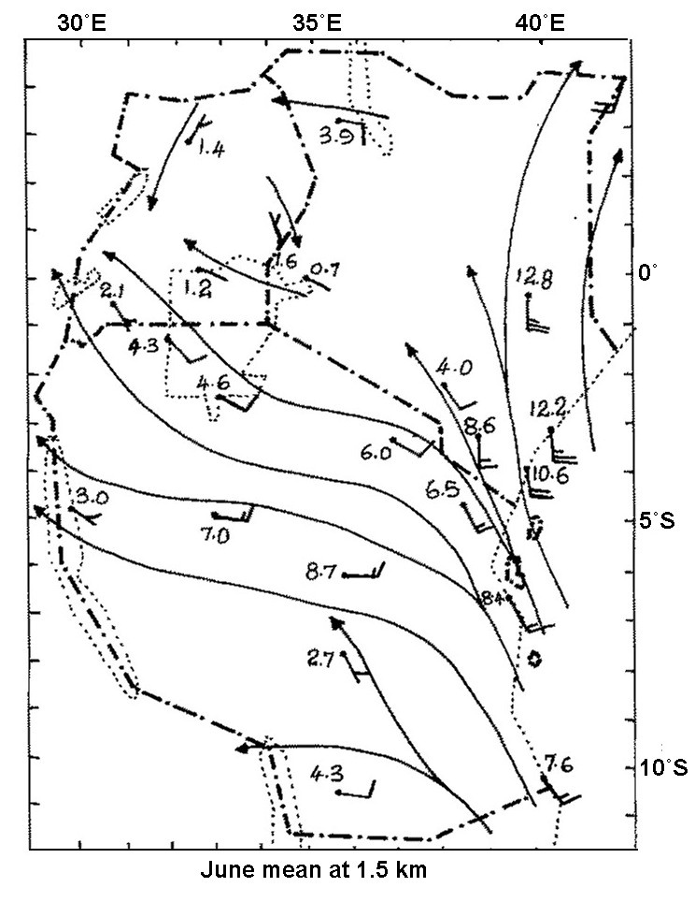

Fig. 7. Mean 1.5 km June winds from pibal stations in east Africa from the period 1950’s-1970’s. Dates vary with stations, but 23 stations are present in this analysis. Only 1-2 radiosonde stations are functioning in this same area today.

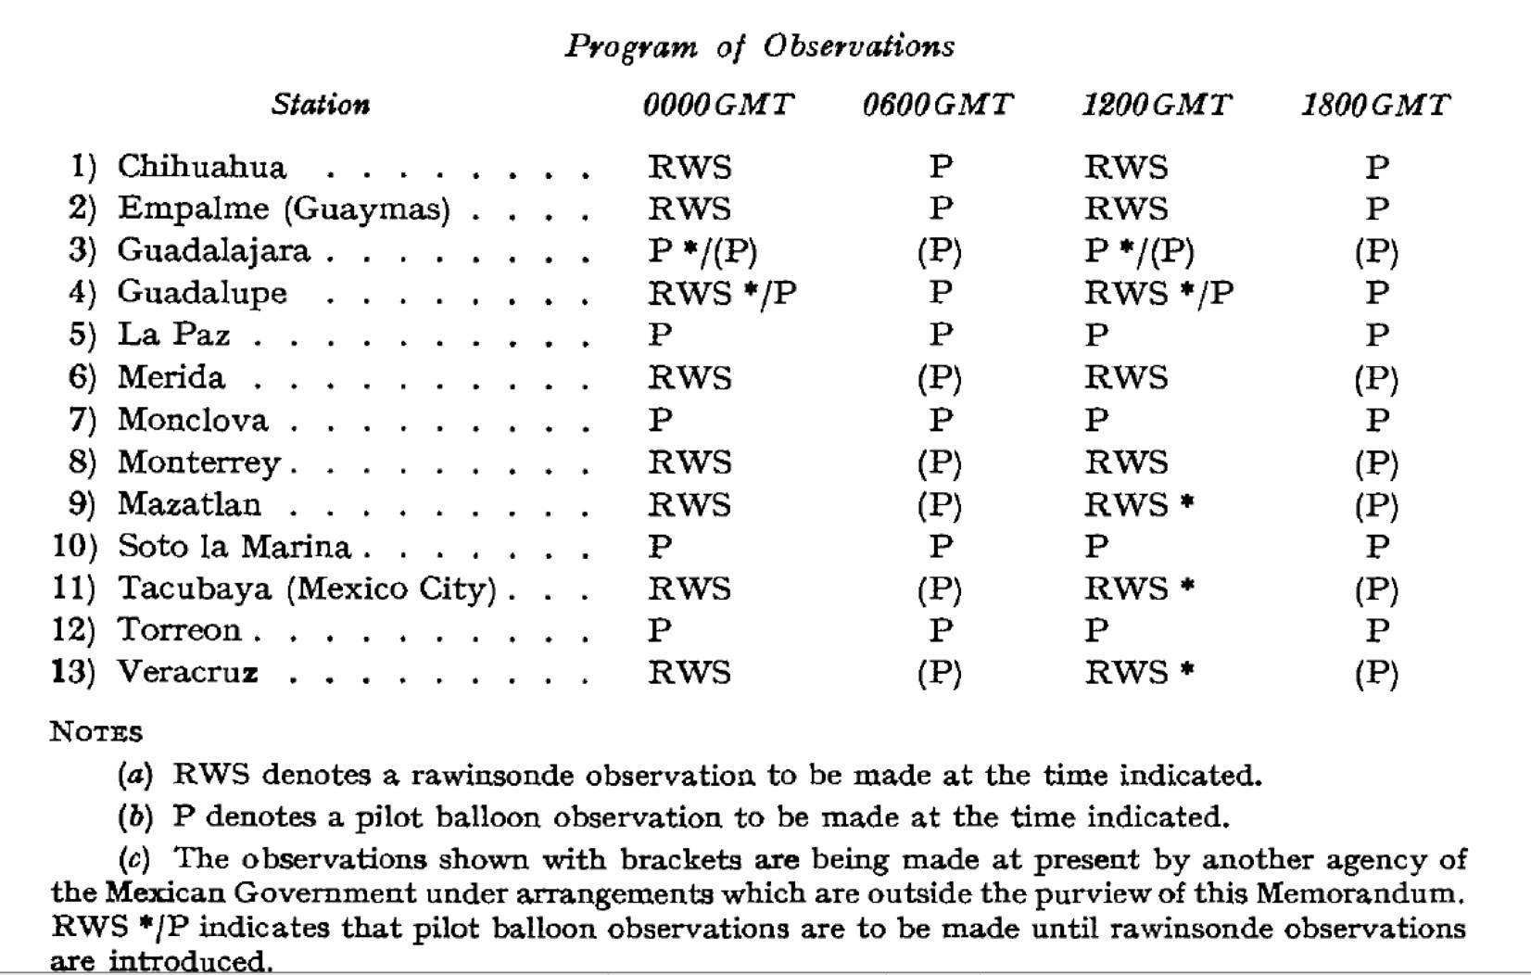

Fig. 8. A table showing Mexican upper air stations specified for the period 1966-68 (actual observations not known). Note 4-times daily pibals at some sites.

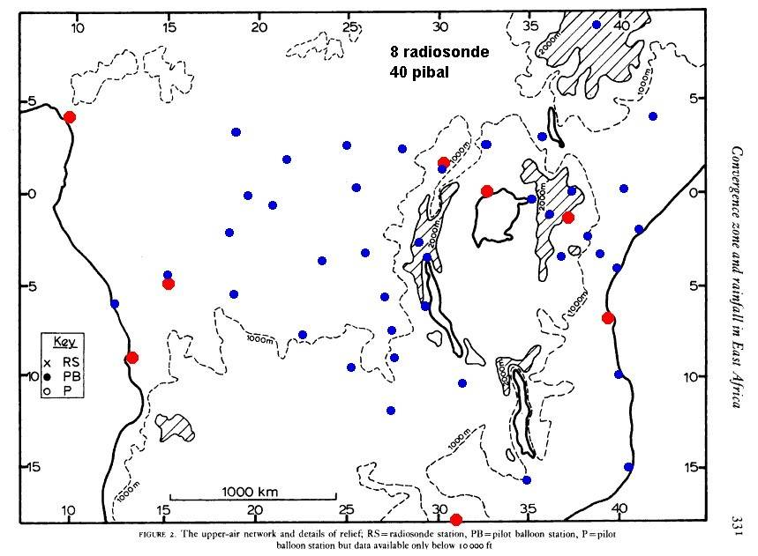

Fig. 9. Pilot balloon stations (blue) in central Africa in the ~ 60-70’s. In this region there were 40 pibal and 8 radiosonde (red) stations. From Hills, 1979.

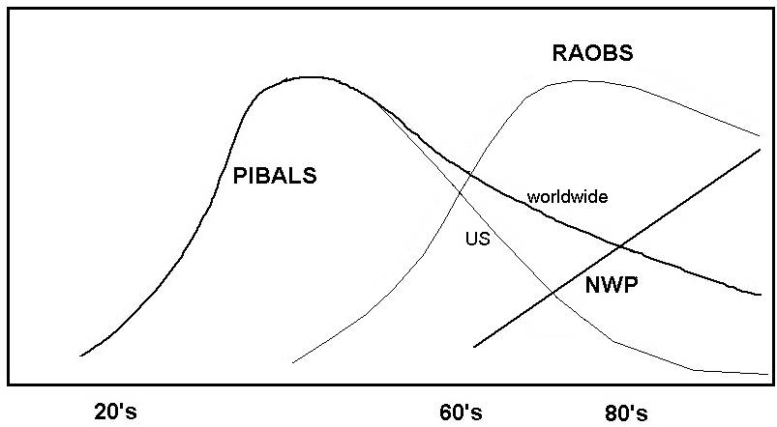

Fig. 10. A schematic suggesting why pilot balloon observations did not have a major impact on numerical weather prediction activities. The peak of pilot balloon activity occurred several decades before the advent of NWP (ascending line), and by the time NWP could benefit from dense pibal networks (90’s?) there were few available. Bottom axis is year of 20th century, vertical axis is number of observations. Pibals decayed more rapidly in US than worldwide.

