PUBLIC NOTICE
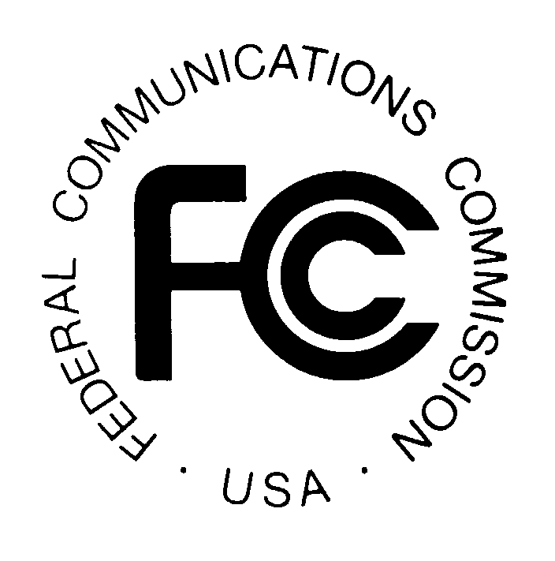
FEDERAL COMMUNICATIONS COMMISSION
445 TWELFTH STREET, S.W.
WASHINGTON, D.C. 20554 DA 06-1247

News media information 202/418-0500 Fax-On-Demand 202/418-2830 Internet: http://www.fcc.gov ftp.fcc.gov

Released: June 9, 2006

EX PARTE STATUS OF APPLICATIONS FOR THE ASSIGNMENT OF LICENSES FROM DENALI PCS, L.L.C. TO ALASKA DIGITEL, L.L.C. AND THE TRANSFER OF CONTROL OF INTERESTS IN ALASKA DIGITEL, L.L.C. TO GENERAL COMMUNICATION, INC

WT Docket No. 06-114

On January 27, 2006, Alaska DigiTel, LLC (“Alaska DigiTel”) and Denali PCS, LLC (“Denali”) filed joint applications pursuant to Section 310(d) of the Communications Act of 1934, as amended (the “Communications Act”) asking the Federal Communications Commission (“the Commission”) to approve the assignment of licenses held by Denali to Alaska DigiTel and the transfer of control of interests in Alaska Digitel to General Communication, Inc. (“GCI”). These applications appeared on public notice as accepted for filing on February 1, 2006.

Applications for consent to the assignment or transfer of control of licenses are subject, unless otherwise provided, to treatment by the Commission as restricted proceedings for ex parte purposes under section 1.1208 of the Commission’s rules. However, pursuant to section 1.1200(a) of the Commission’s rules, the Commission may modify the applicable ex parte procedures in particular proceedings if the public interest so requires. We announce that this proceeding will be governed by permit-but-disclose ex parte procedures that are applicable to non-restricted proceedings under section 1.1206 of the Commission’s rules.

Parties making oral ex parte presentations are directed to the Commission’s statement reemphasizing the public’s responsibility in permit-but-disclose proceedings and are reminded that memoranda summarizing the presentation must contain the presentation’s substance and not merely list the subjects discussed. More than a one- or two-sentence description of the views and arguments presented is generally required. Other rules pertaining to oral and written presentations are set forth in section 1.1206(b) as well.

Under the Commission’s current procedures for the submission of filings and other documents, filings in this matter may be filed electronically (i.e., through ECFS) or by hand delivery to the Commission’s Massachusetts Avenue location.

- If filed by ECFS, filings shall be sent as an electronic file via the Internet to http://www.fcc.gov/e-file/ecfs.html. In completing the transmittal screen, parties should include their full name, Postal Service mailing address, and the applicable docket number. Parties may also submit an electronic comment by Internet e-mail. To get instructions for e-mail filings, parties should send an e-mail to ecfs@fcc.gov, and should include the following words in the body of the message, “get form <your e-mail address>.” A sample form and directions will be sent in reply.

- If filed by paper, the original and four copies of each filing must be filed by hand or messenger delivery, by commercial overnight courier, or by first-class or overnight U.S. Postal Service mail (although we continue to experience delays in receiving U.S. Postal Service mail). The Commission’s contractor, Natek, Inc., will receive hand-delivered or messenger-delivered paper filings for the Commission’s Secretary at 236 Massachusetts Avenue, N.E., Suite 110, Washington, D.C. 20002. The filing hours at this location are 8:00 a.m. to 7:00 p.m. All hand deliveries must be held together with rubber bands or fasteners. Any envelopes must be disposed of before entering the building. Commercial overnight mail (other than U.S. Postal Service Express Mail and Priority Mail) must be sent to 9300 East Hampton Drive, Capitol Heights, MD 20743. U.S. Postal Service first-class mail, Express Mail, and Priority Mail should be addressed to 445 12th Street, S.W., Washington, D.C. 20554. All filings must be addressed to the Commission’s Secretary, Office of the Secretary, Federal Communications Commission.

A copy of each filing also should be delivered electronically, by e-mail or facsimile, or if delivered as paper copy, by hand or messenger delivery, by commercial overnight courier, or by first-class or overnight U.S. Postal Service mail (according to the procedures set forth above for paper filings), to: (1) the Commission's duplicating contractor, Best Copy and Printing, Inc., at FCC@BCPIWEB.COM or (202) 488-5563 (facsimile); (2) Erin McGrath, Mobility Division, Wireless Telecommunications Bureau, at erin.mcgrath@fcc.gov, or (202) 418-7447 (facsimile); (3) Susan Singer, Spectrum and Competition Policy Division, Wireless Telecommunications Bureau, at susan.singer@fcc.gov, or (202) 418-7447 (facsimile).

Copies of the application and any subsequently-filed documents in this matter may be obtained from Best Copy and Printing, Inc. in person at 445 12th Street, S.W., Room CY-B402, Washington, D.C. 20554, via telephone at (202) 488-5300, via facsimile at (202) 488-5563, or via e-mail at FCC@BCPIWEB.COM. The applications and any associated documents are also available for public inspection and copying during normal reference room hours at the following Commission office: FCC Reference Information Center, 445 12th Street, S.W., Room CY-A257, Washington, D.C. 20554. The applications are also available electronically through the Commission’s ECFS, which may be accessed on the Commission’s Internet website at http://www.fcc.gov. In addition, applications filed under Parts 22, 24, 90, and 101 of the Commission’s rules are available electronically through ULS, which may be accessed on the Commission’s Internet website. Alternate formats of this public notice (computer diskette, large print, audio recording, and Braille) are available to persons with disabilities by contacting Brian Millin at (202) 418-7426 (voice), (202) 418-7365 (TTY), or send an e-mail to access@fcc.gov.

For any questions regarding this proceeding, contact Erin McGrath, Mobility Division, Wireless Telecommunications Bureau, at (202) 418-2042, or Susan Singer, Spectrum and Competition Policy Division, Wireless Telecommunications Bureau, at (202) 418-1340.

-FCC-

47 U.S.C. §§ 214, 310(d).
Application to Assign Licenses Held by Denali PCS, L.L.C. to Alaska DigiTel, L.L.C., File No. 0002453582 (filed Jan. 27, 2006); Application to Transfer Control of Licenses Held by Alaska DigiTel, L.L.C., File No. 0002453706 (filed Jan. 27, 2006).
See Wireless Telecommunications Bureau Assignment of License Authorization Applications, Transfer of Control of Licensee Applications, and De Facto Transfer Lease Applications Accepted for Filing, Public Notice, Report No. 2383 (rel. Feb. 1, 2006).
47 C.F.R. § 1.1208.
47 C.F.R. § 1.1200(a).
Id. § 1.1206.
See Commission Emphasizes the Public’s Responsibilities in Permit-But-Disclose Proceedings, Public Notice, 15 FCC Rcd. 19945 (2000).
See 47 C.F.R. § 1.1206(b)(2).
Id. § 1.1206(b).
See Implementation of Interim Electronic Filing Procedures for Certain Commission Filings, Order, 16 FCC Rcd. 21483 (2001); see also FCC Announces a New Filing Location for Paper Documents and a New Fax Number for General Correspondence, Public Notice, 16 FCC Rcd. 22165 (2001); Reminder: Filing Locations for Paper Documents and Instructions for Mailing Electronic Media, Public Notice, 18 FCC Rcd. 16705 (2003).
See Electronic Filing of Documents in Rulemaking Proceedings, GC Docket No. 97-113, Report and Order, 13 FCC Rcd. 11322 (1998).

