ARGOS O/C 37, CLS

Prepared by : L. Mesnier, CLS
Date : May 13th, 2003

Agenda item F-2.3: System Use

System use between April 2002 and April 2003

The number of platforms seen each day and averaged over one month (see Table 1) increased over the year from 4962 to 5393 platforms, i.e. a 8.7 % increase. This increase is lower than last year (13.6%). The yearly increase averaged over the last three years is 9.4 % and it is 11.4 % over the last six years.

The number of platforms seen daily whose data were sent onto the GTS increased from 720 to around 760 in January 2003. Concerning drifting buoys only, the graph gives for each country, the total number of buoys and the number whose data were sent onto the GTS in January 2003. Out of 1244 drifting buoys, 717 are transmitted onto the GTS, i.e. 57%. It should be noted that this percentage was still at 57% in January 2002 (648 drifters on GTS out of 1144). These data come from the DBCP technical coordinator who got them from Meteo France.

Categories of platforms

Figure 1 shows the number of PTT's by type. This number is rather stable for moored buoys fixed stations and mobiles and increasing slightly for drifting buoys. It is increasing more significantly for fishing vessels and animals.

Figure 2 shows the increase in PTT's over the last fourteen years. The lower curve is the average number of PTT's which are seen each day. The upper curve is the total number of PTT's which are seen at least once in a month, which is the definition of “active platforms”. The difference between these two curves has increased regularly since 1988 from 480 to more than 4300 in June 2000. The increase was due to the more frequent use of PTT's transmitting only part of the time in the. The ratio which has reached 2.0 in 2000 is now stable around 1.8.

Figure 3 shows the increase of PTT's seen daily over the last seventeen years. The average increase was 11 % per year.

Geographical distribution of platforms :

Figure 4 shows the system duty coefficient in reference to the Argos2 on-board equipment capacity. The average system occupation rate has been increasing regularly each year. As Argos2 is now operational on-board 4 satellites, the system occupation rate is only calculated in reference to the Argos 2 instrument capacity. The average system occupation rate is now around 12.3 % of the Argos2 capacity.

The maximum system occupation rate is observed in South America with a peak at about 50%. The chart was drawn by using data received during 12 hours of one day only (May 14, 2003).

Figure 5 shows the ground distribution of active platforms seen during April 2003. For each platform, only the last known position was used to draw the chart.

Table 1 : 2002-2003 Argos system use

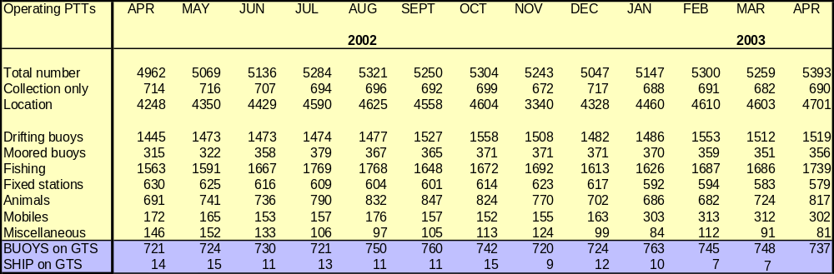

METEO DRIFTING BUOYS ON GTS

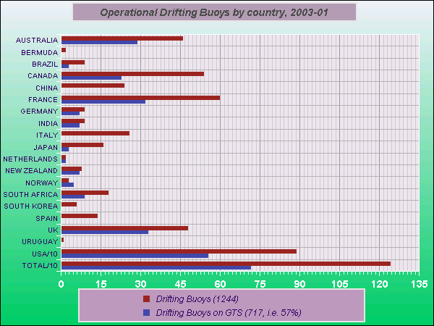

Remark: Statistics computed from GTS in situ marine data provided by Météo France.

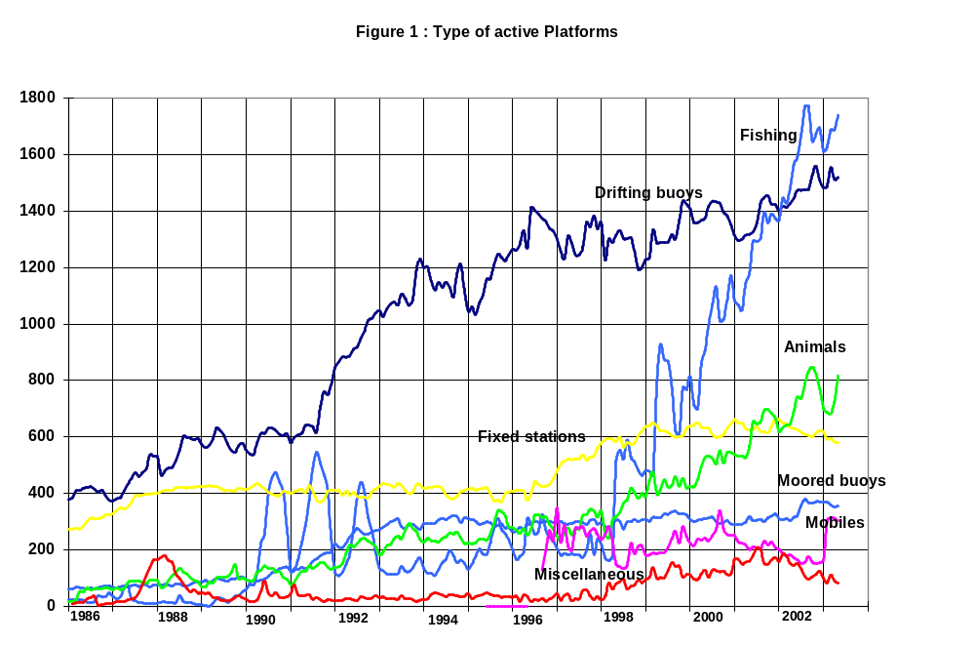
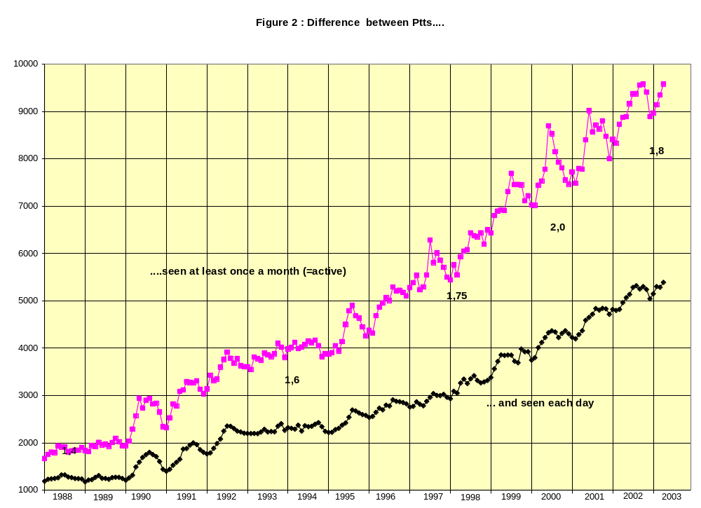
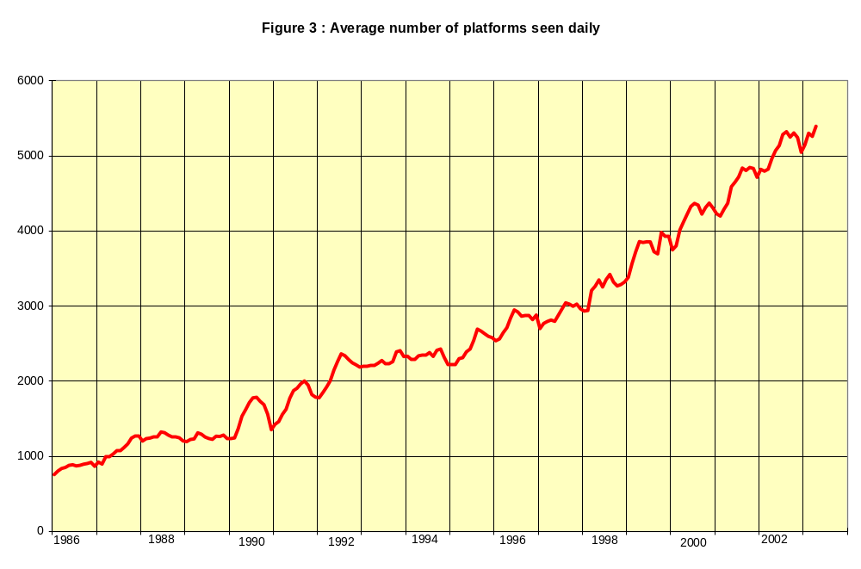

Figure 4 : System duty coefficient based on Argos 2 capacity

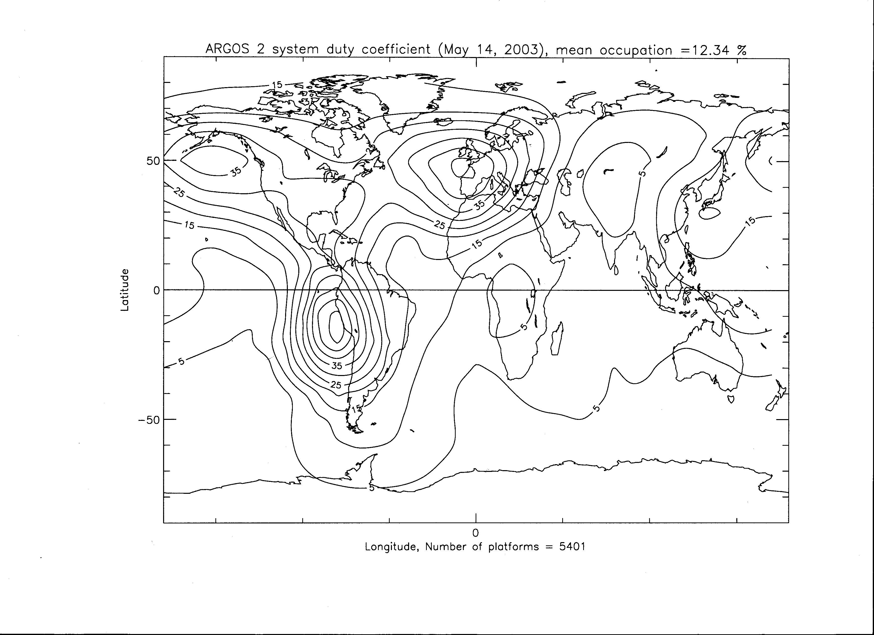

Figure 5 : Ground distribution of operating platforms (April 2003)



