SOFT TARGET AWARENESS COURSE
December 11-13, 2007

Soft targets” are potential targets for terrorist attacks because of the ability to inflict casualties, cause economic damage and instill fear. They are especially vulnerable because they are open to the general public, and the presence of a significant number of American citizens is assured at given times.” (Department of Homeland Security)

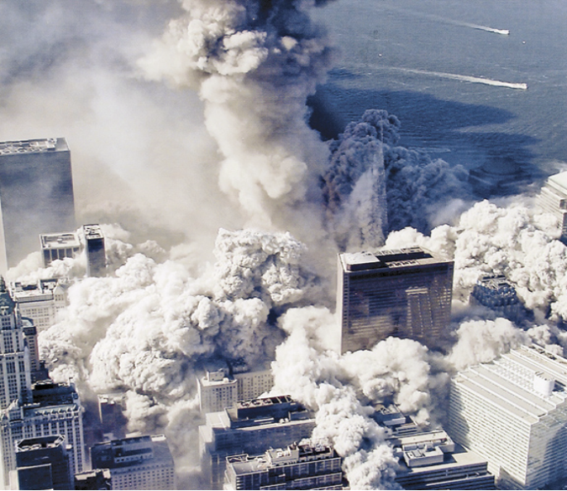

The U. S. Department of Homeland Security and the Mobile County Emergency Management Agency are jointly sponsoring a FREE seminar on Soft Target Awareness to help keep our communities safe and secure.

Location: Mobile County EOC
348 McGregor Avenue
Mobile, AL 36608

- Malls & Shopping Centers December 11, 2007 -- 0830 to 1230
- Hotels, Hospitals, Large Buildings, and Medical Facilities December 11, 2007 – 1300 to 1700
- Places of Worship (All Denominations) December 12, 2007 – 0830 to 1230
- Public & Private School systems and Institutions
of Higher Learning December 12, 2007 -- 1300 to 1700
- Stadiums and Arenas December 13, 2007 – 0800 to 1230

*Pre-Registration Required
Registration Deadline: 3:00 PM, December 8, 2007
(Attendees must show a driver’s license or other government-issued photo ID for entry)
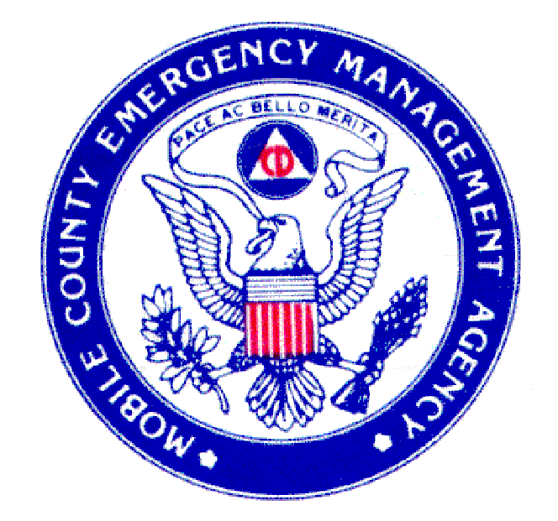

The Department of Homeland Security and your Mobile County Emergency Management Agency is delighted to invite you to attend a FREE Soft Target Awareness Course. Also, we want to extend a thank you to the Alabama State Docks for providing the venue for this training. You as a participant will:

- Receive an introduction to terrorism.
- Learn to recognize and prevent terrorist activities.
- Learn the basics of detection, deterrence and defense against potential terrorist attacks.
- Learn to recognize suspicious activities.
- Learn to be proactive and better understand your role in defending your facility.
- Discuss with other attendees issues related to security at your company or business.

Target Audience: Leaders, teachers, managers, supervisors, security and safety staff, facility personnel.
In addition, Local Law Enforcement officers who require basic awareness training are also encouraged to attend. Seating is limited to the first 45 for each module and will be handled on a first come first served basis.

COURSE REGISTRATION FORM

Choose one: Malls, Shopping Centers, & Banks December 11, 2007 – 8:30 am to 12:30 pm
Hotels, Hospitals, Large Buildings, and Medical Facilities December 11, 2007 – 1:00 pm to 5:00 pm
Places of Worship (All Denominations December 12, 2007 – 8:30 am to 12:30 pm
Educational Institutions December 12, 2007 – 1:00 pm to 5:00 pm
Stadiums and Arenas December 13, 2007 - 8:30 am to 12:30 pm
Name (Last, First):

Current Position/Title:
Agency, Company, Business:
Mailing Address: | Phone (Work):
Mailing Address: | Phone (Home):
Mailing Address: | Fax Number:
Email Address:

Please obtain supervisor approval if applicable:
Supervisor Signature:  Supervisor Position/Title: | Date:

I certify that the information recorded on this application is correct.
Applicant Signature: | Date:

Email (with scanned signature), FAX or Mail Registration Form to:
Mobile County EMA
Attention: Shannon Saucier/Nikki Carter
348 McGregor Avenue
Mobile, Alabama 36608

FAX Number: (251) 460-8035
Email: ssaucier@mcema.net
Phone Number: (251) 460-8000

