3. Cerenkov Radiation
“Vision - the art of seeing things invisible.”....Jonathen Swift
“And God said, let there be light; and there was light.”....Genesis 1:1
Cerenkov radiation is emitted when a particle moving in a medium has a velocity exceeding the velocity of light in that medium. Since the angle of emission and the intensity of radiation depends on the velocity of the particle, Cerenkov radiation can be used to determine the velocity of a charged particle. The emitted Cerenkov light can be converted into a fast electrical pulse using a PMT (see Section 2). For a particle with energy > 1 GeV, only a negligible fraction of its energy is radiated as photons, making the process “non-destructive”. The velocity and momentum of the incident particle are assumed to be the same in vacuum and in the medium.

3.1 Units
We begin with Maxwell’s equations and introduce the key concepts of index of refraction, skin depth, and plasma frequency. These concepts find immediate application in “deriving” the results for Cerenkov radiation, and will also appear in the next Section on “Transition Radiation”. The basic relations are given in Table 3.1 in both CGS and MKS units. As stated previously, CGS units will normally be used in calculations. However, it is easy, using the relationships given in Table 3.1, to convert back and forth from CGS to MKS units. In fact, numerical calculations will always be quoted in MKS units which are more widely used in engineering applications. It is important for us to develop a facility in both systems of units.
The basic difference between the two systems of units, as shown in Table 3.1, is in the relationship between the sources and the potentials. Clearly, there is an arbitrariness in the definition of charge in terms of physical quantities such as forces or the work done on particles. In the Gaussian, CGS, system the static electrical potential V is just the charge divided by the distance from the charge to the observation point. By contrast, in MKS units, the electric potential has an additional factor 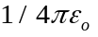. That added factor obviously changes the relationship between the charge and the potential, and hence the charge and the physical forces.
Table 3.1
Electromagnetic Relations

Quantity | Gaussian CGS | SI
Charge:  Electron charge e:  Potential:  Magnetic field: | 2.997 924 58 x 10⁹ esu  4.803 206 8 x 10⁻¹⁰ esu  (1/299.792 458) statvolt (ergs/esu)  10⁴ gauss = 10⁴ dyne/esu | = 1 C – 1 A s  = 1.602 177 33 x 10⁻¹⁹ C  = 1 V = 1 J c⁻¹  = 1 T = 1 N A⁻¹m⁻¹
Lorentz force: | 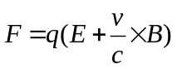 | 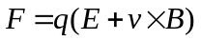
Maxwell equations: | 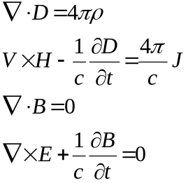 | 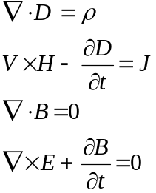
Materials:  Permitivity of free space:  Permeability of free space: | 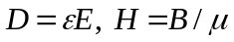  1  1 | 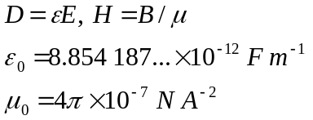
Fields from potentials: | 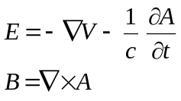
Static potentials  (coulomb gauge) | 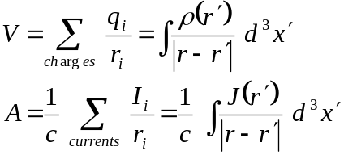 | 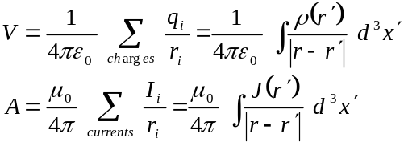
Relativistic transformations  (v is the velocity of the  primed frame as seen in  the unprimed frame) | 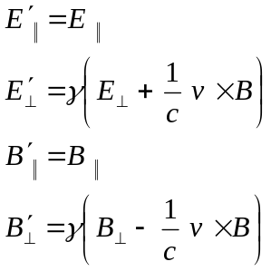 | 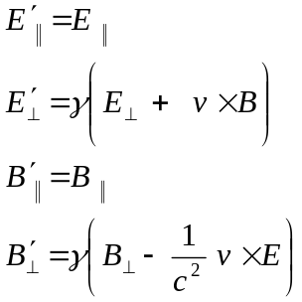

Similarly, the relationship between the current and the vector potential 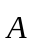 differs. In CGS units the potential is simply the current divided by the distance and the speed of light, whereas in MKS units the permeability of free space appears as an additional factor, 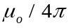. Going from potential 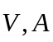 to field 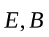 to Lorentz force 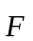, Table 3.1 shows that there is another factor of c for CGS units. Since 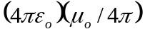 = 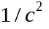 the conversion becomes clear. Additional discussion is available in Ref. 3.1. We will freely convert back and forth in what follows as an exercise in gaining facility with electromagnetic units.

3.2 Index of Refraction
Maxwell's equations in the sourceless case, but within a medium defined by dielectric and dimagnetic constants and , are given below.
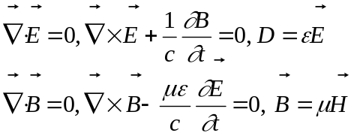 (3.1)
The content of Maxwell's equations in the absence of sources is that the electromagnetic fields are divergenceless and that the "rotation" or curl of the electric field is due to the time variation of the magnetic field while the curl of the magnetic field is due to the time variation of the electric field. In a medium the two curl equations lead to a second order wave equation with a wave propagation speed v that is not the vacuum velocity c but is given by c divided by the index of refraction, n. Assuming a plane wave for both with exp 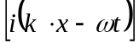 behavior and substituting into Eq. 3.1.:
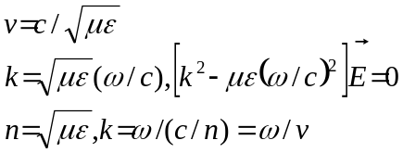 (3.2)
Representative values of n are given in Table 1.2 for different materials. For gases n - 1 ~10⁻⁴, while for solids and liquids, n - 1 ~ 0.3. Both the permitivity and permeability of the medium contribute to the index of refraction, although most often μ = 1..

3.3 Optical Theorum
We can connect the macroscopic propagation of light in the medium, characterized by n, to the microscopic atomic process of scattering characterized by the total cross section (see Section 1), through the forward scattering amplitude, A(0), Eq. 1.8. We baldly assert that if incoherent scattering off atomic electrons with number density n_{e} = N_{o}ρ(Z/A) is the cause of n, then;
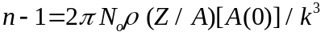 (3.3)
The departure of the index of refraction from one is due to scattering. An imaginary part to A(0) indicates absorption. In Appendix B we argue that the bound atomic electrons are confined to a region of volume 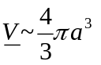. Hence the index is roughly;
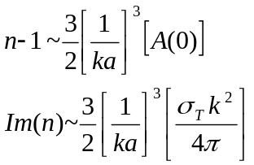 (3.4)
Thus, for example, for an electromagnetic cross section of size 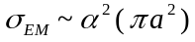, see Section 10, the index 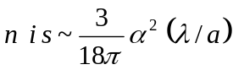. For optical photons, 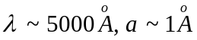, we find 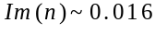, which is of the right order of magnitude, as seen in Table 1.2.

3.4 Conducting Medium and Skin Depth
Let us consider now the slightly more complicated case where there are currents in a neutral medium currents that are the sources. For the case of a medium with conductivity (not to be confused with cross section) with a current density , the modified Maxwell's equation are;
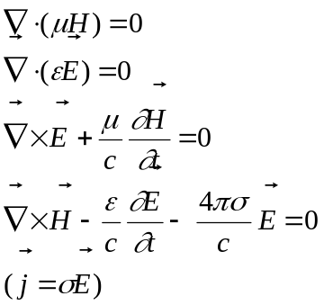 (3.5)
If we again assume a plane wave form for the electric and magnetic fields, the two curl equations again lead to a wave equation which takes the form;
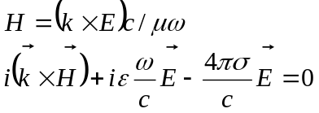 (3.6)
Clearly, Eq. 3.6 implies that 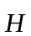, 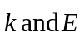 are again mutually orthogonal. Eliminating the magnetic field we again find a second order wave equation. Note that in Eq. 3.7 if we let the conductivity of the medium go to zero we recover Eq. 3.2.
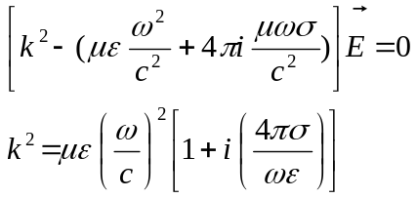 (3.7)
The complex nature of the square of the wave number implies that the assumed plane wave solution has an exponentially damped behavior. Therefore, the electric field inside a conducting medium is not rigorously zero, as in the static case with infinite conductivity, but penetrates a finite amount. The characteristic penetration distance, , which we define to be the “skin depth” is inversely proportional to the imaginary part of the wave number.
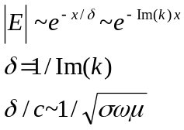 (3.8)
The skin depth approaches 0 as , since in that case the charges are infinitely mobile and hence free to move around and reorient themselves so as to completely exclude the electric field. For finite conductivity the skin depth is finite and depends on frequency as 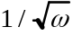. This implies that high frequency waves stay on the surface of a conductor.
For example, in copper, using the appropriate values for the conductivity and permeability, we find that the skin depth is 6.6 cm/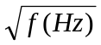 when the frequency f is expressed in Hertz. In copper at 60 Hz the skin depth is roughly 0.85 cm. At 100 MHz the skin depth is roughly 7.1 microns. Therefore in your home wiring efforts you can choose to simply crimp the wires since the electric fields will penetrate through the oxide insulator. On the other hand, it is a good approximation to say that radio frequency fields stay totally on the surface of any conductor and require elaborate waveguide “plumbing” structures.

3.5 Plasma Frequency
Now let's consider a special case where the conductivity, , is due to the existence of a number density, ne, of electrons per unit volume which are free to move. This is a rough approximation to the behavior of electrons in the medium. Normally, in this text we use n to denote number density and N denotes number, while is used to denote either charge or mass density or resistivity, (see the Glossary at the end of this volume).
In the presence of an electric field the free charges are accelerated. The nonrelativistic expression for their acceleration 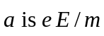, (see Table 3.1 for the Lorentz force equation).
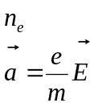 (3.9)
For high frequency electric fields the displacement of the electron is small because the motion is limited by the short period of the harmonic driving force. Therefore, we obtain an approximate expression for the velocity by ignoring those small displacements and assuming 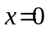 for the spatial part of 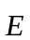, which goes as 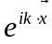, v = a/ω. We write the current density in terms of the electron number density 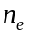 and the velocity of the electrons. We can then write down the conductivity due to the existence of a free electron density. In this particular case we have a purely imaginary conductivity which decreases with frequency as 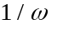.
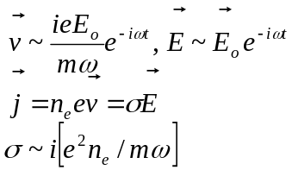 (3.10)
Looking back to Eq. 3.7 we see that if there is a purely imaginary conductivity then the relationship between k and for the plane wave solution is real, implying oscillatory propagation as long as k² > 0. We define a “plasma frequency”. 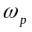.
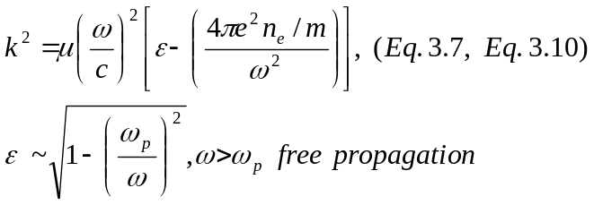 (3.11)
The plasma frequency, 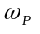, is dependent only on the fine structure constant, , the density of free electrons and the mass of the electron. For greater than the electric permitivity is real and there is free propagation. For 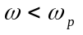 the wave is reflected.
Assigning a number density for electrons, which assumes all electrons in the atom are free, and recalling the relationship between the Bohr radius, 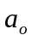, and the electron Compton wavelength, 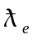 derived in Section 1, we have an alternative expression for in terms of the binding energy of the hydrogen atom, E_{o}. Note that, since the factor 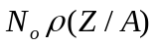 is the number of electrons per mole, and 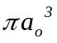 is roughly the volume of an atom, we expect 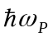 to be equal to the binding energy of the hydrogen atom times a number of order 1.
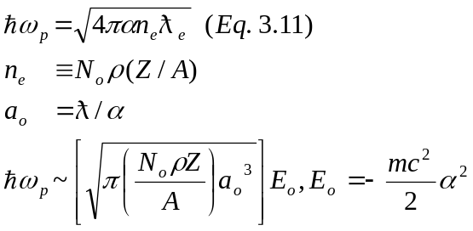 (3.12)
For a typical density of 1 gm/cm3 and for Z/A = 1/2, is ~ 18.8 eV. Specifically, in lithium, which is used in foils of transition radiation detectors, the plasma energy is 14 eV. We will return to in our discussion of transition radiation in the next Section.
It is interesting to recall that the Earth’s ionosphere is a dilute plasma with an electron density 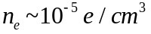. Hence, ~ 6 x 10⁷ Hz, and radio waves 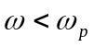 are reflected from the ionosphere, making short wave radio “bounces” possible. Higher frequency radio, e.g. FM at ~ 100 MHz, is not reflected as you can infer by noting the line of sight microwave relay towers that dot our countryside. Higher frequency fields are excluded from the plasma. Note that numerically, 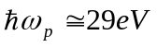 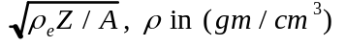.

3.6 Two “Derivations” of the Cerenkov Angle
We now turn specifically to Cerenkov radiation, having quickly reviewed Maxwell’s equations. A charged particle in uniform unaccelerated motion in vacuum does not radiate, see Section 10. However, if a particle is moving with a uniform constant velocity in a medium, its’ electric field will interact with the medium. This interaction can cause the emission of real photons. Energy and momentum are balanced by the medium. This concept was discovered theoretically by a Russian physicist, Cerenkov, in the early part of the 20th century. The effect is now in common use in detectors used in high energy physics.
A construction for the geometry of the Cerenkov emission angle is given in Fig. 3.1.
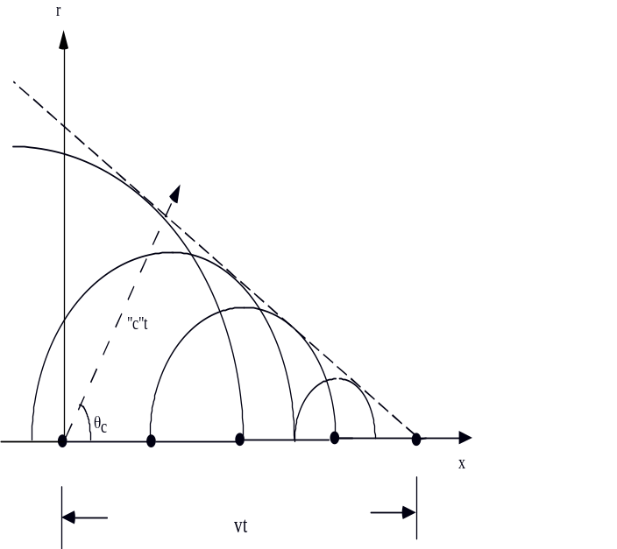
Fig. 3.1:Cerenkov cone construction using Huygen's principle.

Particles move with constant velocity in a medium whose index of refraction, n, is greater than 1. Hence, the effective velocity of light in the medium is less than the vacuum velocity of light. If the particle velocity exceeds the velocity of light in the medium, a shock wave or "Mach cone" is set up in the medium. The construction shows that the Hugyens wavelets emitted from each point in time add up constructively along a line defined by the Cerenkov angle 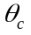. Since the particle energy is constant (non-destructive detection), 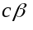 is the constant particle velocity.
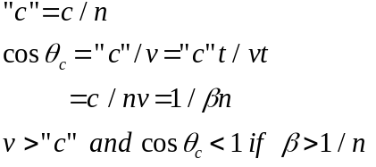 (3.13)
There are common related phenomena that are well known to us. When a projectile or aircraft exceeds the velocity of sound in air a shock wave is sent out whose characteristic angles have exactly the same functional form as the Cerenkov angle. The bow wave of a boat going faster than the speed of water waves is another familiar example. The Cerenkov angle just at threshold velocity, when β = 1/n, is 0o. As particle velocities increase the Cerenkov angle opens up into a cone whose maximum angle is given by 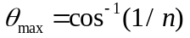 which occurs as 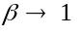.
An example is light emission in water, with n = 1.33. The threshold velocity is β > 0.752, which means T_{e} > 0.26 MeV and T_{μ} > 54 MeV. Therefore, the emission of Cerenkov light in water casn be used to distinguish between electrons and muons with kinetic energies in the few MeV range. This technique is used in neutrino experiments at Kamioka and elsewhere.
For an alternate “derivation” of the Cerenkov angle consider Fig. 3.2 where we show single photon emission by a charged particle.
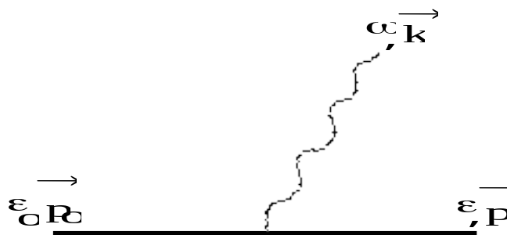
Fig. 3.2: Kinematic quantities for photon emission by a charged particle.

Energy and momentum conservation, (see Appendix A), require that
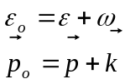 (3.14)
Squaring both equations, and assuming 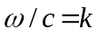, we find that for free photons;
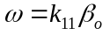c (3.15)
Therefore, applying this derivation to emission with an index of refraction, since 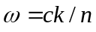, Eq. 3.2,
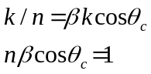 (3.16)
The relationship should hold in general given that the derivation basically used only energy and momentum conservation. Note that in the case of vacuum, n = 1, since is always less than 1, 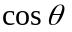 is greater than 1. We thus regain the statement that free particles in uniform motion do not emit photons.
An example of the reality of the Cerenkov emission cone is given by data shown in Fig. 3.3. In this case the photons emitted at the Cerenkov angle are focused onto a plane and are detected in a gas filled device (see Section 8). In these particular plots there are several individual particle passages which are added together. We can see the cone built up by the individual emitted photons. The “hits” at the center of the circle are due to ionization energy (see Section 6) deposited by the incoming particle itself.

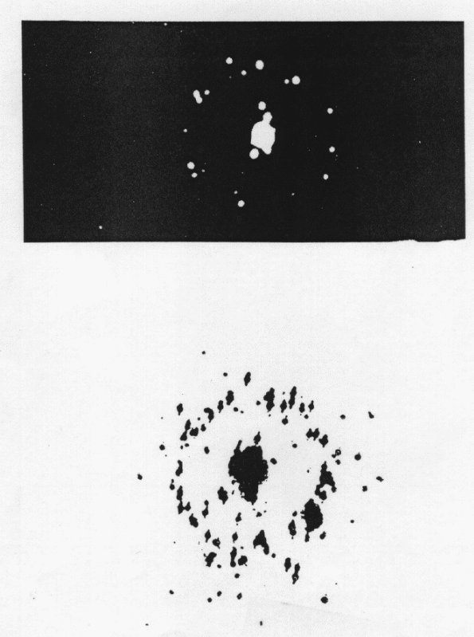
Fig. 3.3: Cerenkov cone for detected photons and ionization products in a gas filled detector for ~10 individual particle passages. (From Ref. B.1 and Ref. B.2, with permission.)

A photograph of an actual “ring imaging” device showing the gaseous detector used to detect the ultraviolet photons by passage through a UV transmitting window and subsequent photoelectric detection is shown in Fig. 3.4.
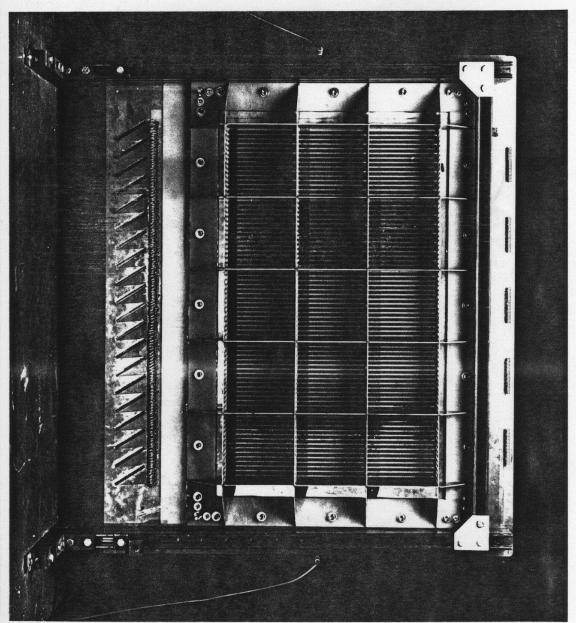
Fig. 3.4: Photo of a ring imaging detector chamber showing the thin UV transmitting window. (Photo - Fermilab.)

This is a functioning device which has been used in a high energy physics experiment. The transmission of a CaF₂ window 3 mm thick is compared to quartz and LiF in Fig. 3.5 as a function of photon wavelength and/or photon energy. Clearly these windows pass light down into the far UV, 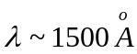, which is well matched to the useful absorption bands of the detecting vapors, TMAE and TEA.
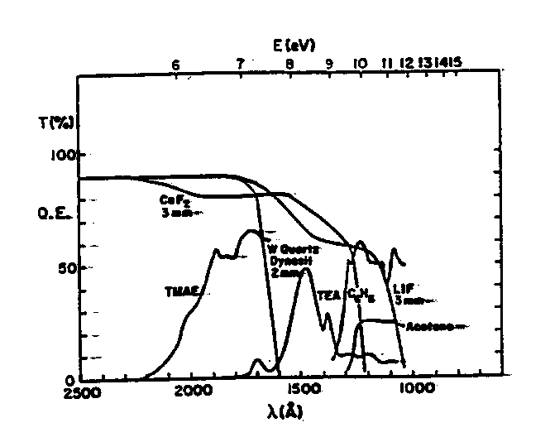
Fig. 3.5: Transmission of different window materials as a function of photon wavelength compared to absorption in different vapors. (From Ref B.2, with permission.)

The use of such a “Ring Imaging Cerenkov Counter”, or RICH, as a particle identification device is illustrated in Fig. 3.6. Charged particles are momentum analyzed by measuring their trajectories in a magnetic field (Section 7). For a given momentum the observed Cerenkov cone angle, , is then measured.
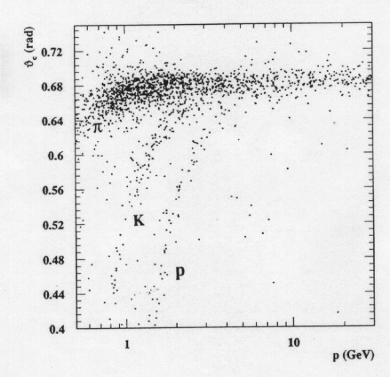
Fig. 3.6: Plot of observed Cerenkov cone size as a function of momentum. The bands for π, K, and p are evident indicating the utility of a Cerenkov detector for particle identification. (From Ref. 4.9, with permission.)
The data showed three distinct bands of correlation between the Cerenkov angle and the momentum, which correspond to particles of 3 distinct masses, pions, (mass ~ 0.14 GeV), kaons K (mass ~ 0.5 GeV), and protons p (mass ~ 0.94 GeV). In Fig. 3.6 we see the angle 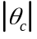 beginning at threshold at 0º and opening up with increasing momentum to the common maximum Cerenkov angle as . For example, in helium gas at STP (Table 1.2) we have 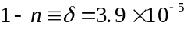. In a beam with 200 GeV particles, the Cerenkov angle for pions is 8.7 mrad and for protons it is 7.4 mrad.
Another technique that is used in experiments is to place a Cerenkov counter in a momentum analyzed beam and change n. Variation of the counter gas pressure varies the index of refraction (see Eq. 3.3) and hence the threshold value. A plot of the yield of Cerenkov photons into a fixed angle at fixed beam momentum and variable n, or , is shown in Fig. 3.7. The existence of 5 distinct particle species in the negative beam is observed. Clearly, the Cerenkov counter pressure can be set to “tag” each species and hence to achieve beam particle identification of even rare components of the secondary beam. Note that Fig. 3.7 is a semilog plot spanning 5 orders of magnitude. A resolution of 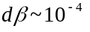 can be achieved before intrinsic limitations such as optical dispersion are reached.
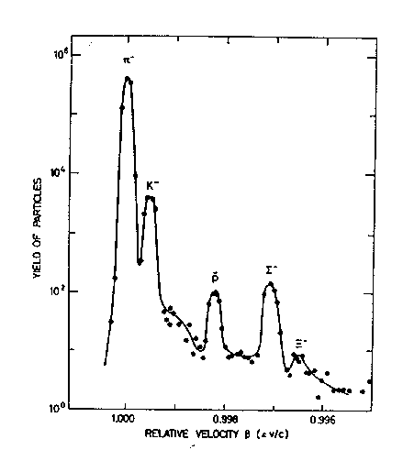
Fig. 3.7: Yield of Cerenkov photons in a negative beam of fixed momentum as a function of n. Peaks at the value of appropriate to 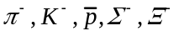 are indicated. (From Ref. B.2, with permission.)

3.7 A “Derivation” of the Frequency Spectrum
The emission of Cerenkov radiation is due to the interaction of the field of a charged particle with a medium. Hence, it is truly a form of energy loss, dE/dx (see Section 6). A rigorous derivation is not attempted here. If that is desired, the reader should consult a standard text, e.g. Ref. 3.1, on electromagnetism or consult Appendix E for an outline of the derivation. The photons in the case of ionization energy loss are “virtual”, transmitting the forces to the atomic electrons of the medium. In the Cerenkov effect real photons are emitted.
Energy loss by ionization will be derived in Section 6. For our purposes now we simply quote the result for the energy loss per unit path length by ionization, dE_{I}/dx up to slowly varying logarithmic factors.
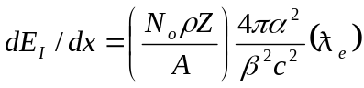 (3.17)
Inserting Eq. 3.12 for the plasma frequency, 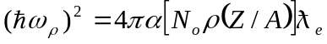, Eq. 3.17 can be written in the suggestive form:
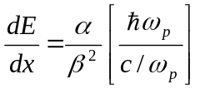 (3.18)
We now assert that the results for ionization can be carried over to also describe the related process of Cerenkov radiation and ascribe the energy loss, dE, to the emission of N photons, 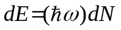 were dN is the number of emitted photons of frequency causing energy loss dE. Since 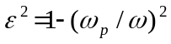, Eq. 3.11:
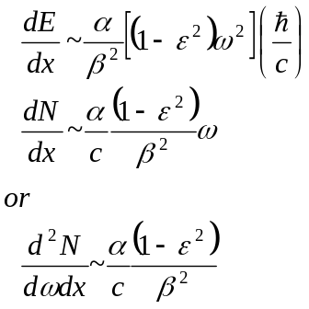 (3.19)
This is in no sense a derivation. However, it does manage to show the deep connection between ionization and Cerenkov radiation. The fact that 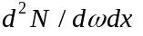 is independent of and is proportional to 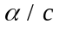 times a function of 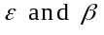 is “demonstrated”. In vacuum 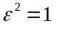 and there is no radiation. The fact that the function is really 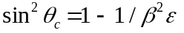 and not 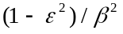 can only appear in a full and rigorous derivation. Assuming such a derivation, and using 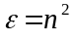, we then attain the Cerenkov result.

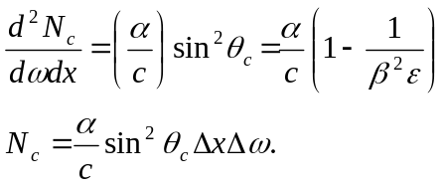 (3.20)
Note that in Eq. 3.20 all energies for the photon have equal probability. That fact puts a premium on full detection efficiency over as wide a photon energy range as possible. Indeed, that is the reason for using UV transmitting "windows" which are an important feature of Cerenkov devices.
A finite length, L, of radiator leads to a more complex emission distribution. Note that the existence of a diffraction pattern, shown in Eq. 3.21, is due to the fact that there is a finite coherence length for the radiation. We cannot have an infinitely precise emission angle because of the uncertainty relationship inherent in wave phenomenon. This fact will be of critical importance in the next Section. Note that diffraction is important, δ ~ 1, only if L < λ. In the case of optical photons any radiator > 1 cm is “long”. We will revisit this issue in Section 4, where the radiating foils can be “short”.

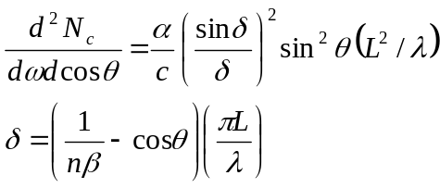 (3.21)
In the limit that the radiator becomes very long, the diffraction pattern, 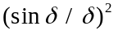, becomes extremely sharp and approaches a “delta function” which can then be integrated over. In this approximation there are 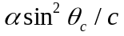 photons emitted at the Cerenkov angle, per unit path length and per unit frequency interval. Numerically, we can evaluate the factors in Eq. 3.20 to find out that the yield is 365 photons times 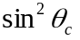 per eV of frequency range per centimeter of radiator length.
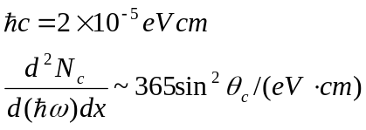 (3.22)

3.8 Examples and Numerical Values
For example, take a 10 meter long gas radiator filled with N₂ . The index (1 - n), is about 3x10⁻⁴ per atmosphere (see Table 1.2). Visible photons cover about one eV of frequency range, 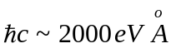. We then expect, for fully efficient light collection, 220 photons collected. A PMT with a 25% quantum efficiency would yield a healthy current pulse suitable for high speed operation (see Section 2).
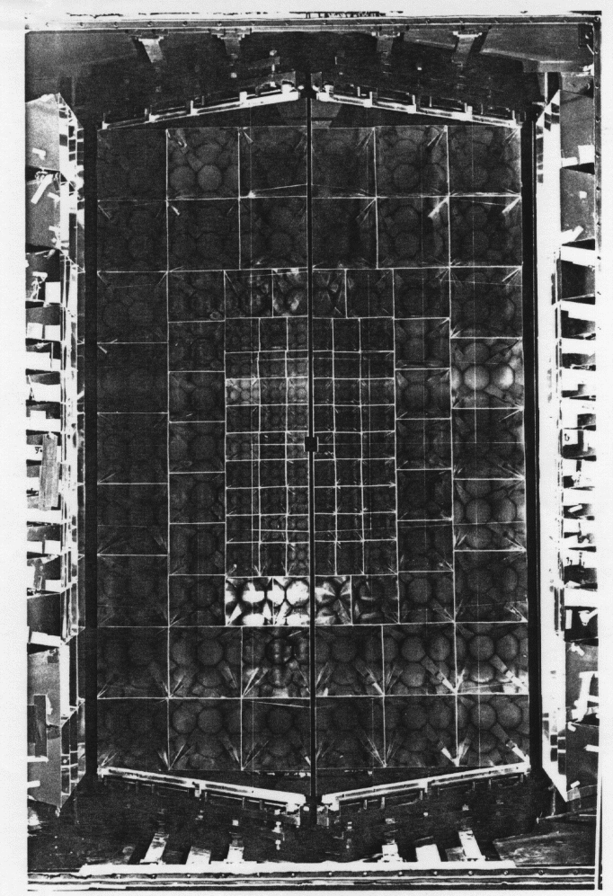
Fig. 3.8: Photo of a gaseous Cerenkov detector showing the mirrors, light collecting cones and the circular windows of the photomultipliers (FNAL E687). (Photo - Fermilab.)
A photograph of a typical large area Cerenkov detector is given in Fig. 3.8. We see the reflecting mirrors which bounce the emitted Cerenkov light into the light collecting cones on the sides. By looking into the mirrors we can see the circular PMT windows which are used for detecting the light.
The relationship between the index of refraction, the Cerenkov angle and the of the particle traversing the detector is shown below. Note that is used in this Section to denote both the photon optical phase difference in emission, Eq. 3.21, and the value of 1 - n. In subsequent Sections will refer only to the optical phase difference. Taking the small angle, high energy, and n ~ 1 limit:
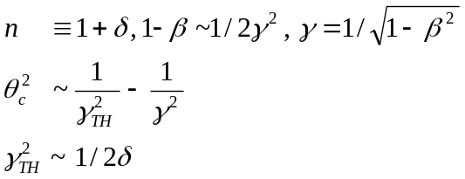 (3.23)
The threshold gamma factor, 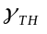, is proportional to 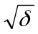. The maximum Cerenkov angle, 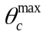, occurs when the particle has extremely large . The maximum number of photons, 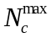, thus goes as 1/². In terms of index of refraction, is proportional to .
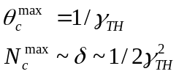 (3.24)
For example, in nitrogen is 3x10-4, which means that is 40.8 or that the threshold for pions is 5.6 GeV, for kaons 20.2 GeV and for protons 38.2 GeV. Below those momenta the incident particles will not radiate photons. The maximum Cerenkov angle in this gas is only 1.4o so the light is thrown very forward. That is the reason for the forward mirrors (the hole for incident beam passage is in the center) seen in Fig. 3.8.
The number of photons is proportional to 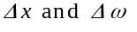. Increasing the counter length, L, is expensive. The other way to increase the number of photons is to extend the frequency range 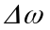 over which we can capture photons. As an example, calcium fluoride windows have transmission above 50% for photon energies of about 9 eV and below (See Fig. 3.5.) or wavelengths above about 1380 . That gives a rather larger frequency range than the ~ 1 eV visible range we have previously assumed.
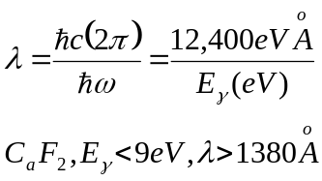 (3.25)
Particle identification for particles with high momenta requires an attempt to go to lower indices of refraction. Lower indices of refraction, such as helium, mean fewer photons produced, as we can see looking at Eq. 3.24. A way to recoup photons is to use a larger frequency range . However, at very high momentum the required resolution, dβ, cannot be obtained. For example, the limitation due to dispersion, n a function of , or optical aberration limit the achievable resolution in (see Fig. 3.7). Particle identification at very high energies requires a technique which does not depend on , since at high energy 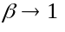 independent of particle type. Both time of flight (Section 2) and Cerenkov radiation (Section 3) become increasingly difficult and the use of “transition radiation” (Section 4) is called for.

References
Section 3: Cerenkov Radiation

[1] Classical Electrodynamics, J.D. Jackson, John Wiley & Sons, Inc. (1962).
[2] P.A. Cherenkov, Phys. Rev. 52 378 (1937).
[3] Nobel Lectures in Physics, P.A. Cherenkov, I.M. Frank, I.E. Tanm, Elsevier Publishing (1964).
[4] Sub-atomic Physics, H. Fraugnfelder, E.M. Henley, Prentice-Hall, Inc. (1974).
[5] P. Lecompze et. al., Phys. Script 23 377 (1981).
[6] J. Litt and R. Meunier, Ann. Rev. Nucl. Sci. 23 1 (1973).
Table of Contents
3. Cerenkov Radiation 1
3.1 Units 1
3.2 Index of Refraction 3
3.3 Optical Theorum 4
3.4 Conducting Medium and Skin Depth 4
3.5 Plasma Frequency 6
3.6 Two “Derivations” of the Cerenkov Angle 8
3.7 A “Derivation” of the Frequency Spectrum 14
3.8 Examples and Numerical Values 16
References 19

