Package Characteristics: 1206 capacitor

Feature | Value
Package Length | 3.33 mm
Package Width | 1.65 mm
Package Thickness | 0.74 mm
End of cap Length | 1.553 mm
End of cap Width | 0.631 mm
Weight | 0.0202 g
CTE | 8.885 ppm/C
Layer 1 Metallization | Tin
Layer 1 Plating Thickness | 0.007 mm
Layer 2 Metallization | Nickel
Layer 2 Plating Thickness | 0.012 mm
End Cap Base Metal Alloy | Silver
 | 0.013 mm

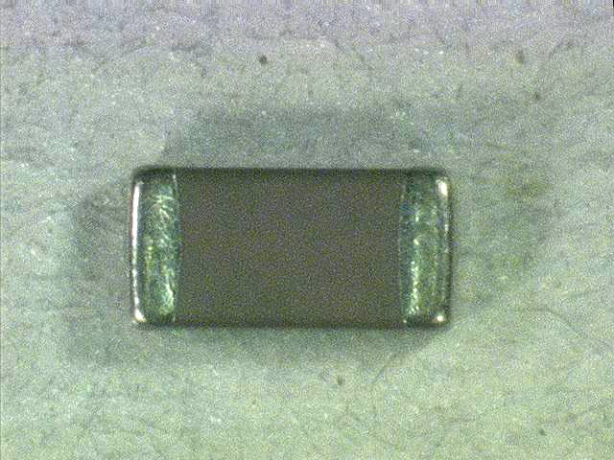
Top View

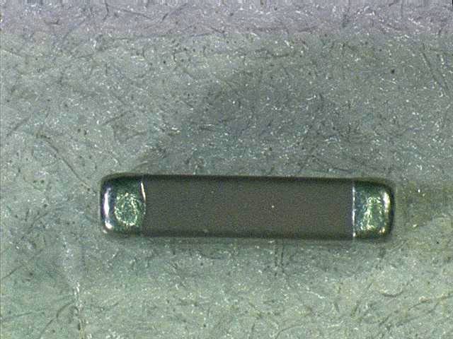
End View

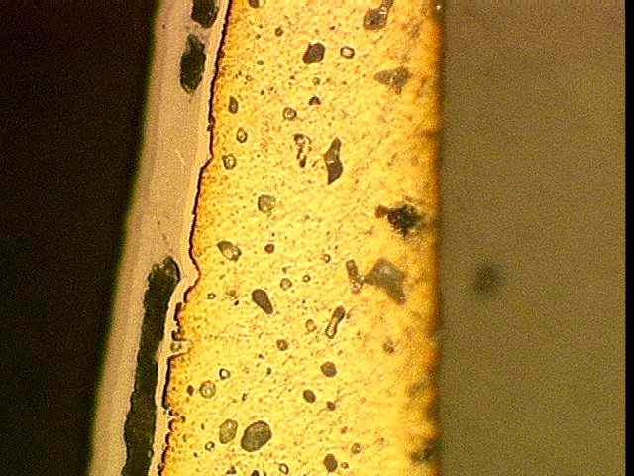
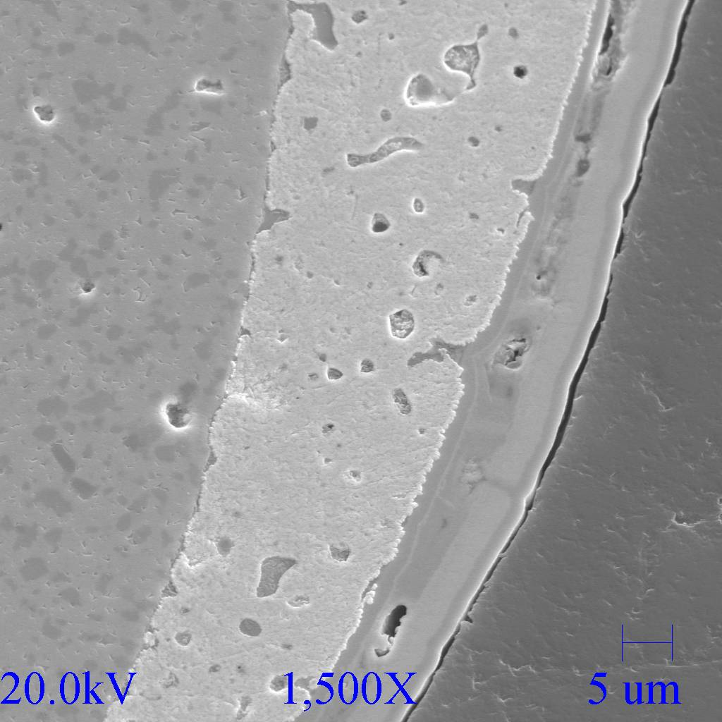
End cap cross-section

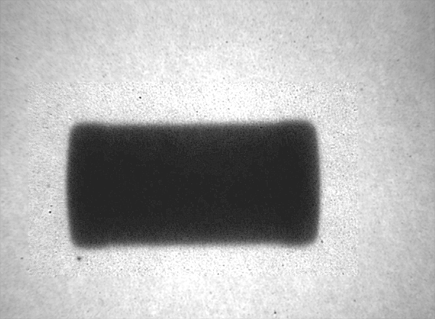

X-ray SEM of end cap cross section

