Annual Technical Status Report
For
February 2003 – January 2004

Monolithically Interconnected Silicon-FilmTM
Module Technology

Prepared by
AstroPower, Inc.
461 Wyoming Road
Newark, DE 19716-2000
USA

NREL Technical Monitor: B. von Roedern

Prepared under Subcontract No. RAT-3-30630-29

January 2004

EXECUTIVE SUMMARY

AstroPower is developing a thin-silicon on ceramic photovoltaic product. Work has focused on understanding the efficiency potential of silicon layers formed by atmospheric chemical vapor deposition and recrystallized by zone melting recrystallization. The thermal properties of the ceramic continue to be refined to more closely match silicon. Key results for this period include:

Ceramic Substrate Development:

- Decreased the amount of solvent in the slurry by 5%.

Solar Cell Device Results:

- Completed a 30-watt module comprised of CVD epi on p+ single crystal.

Silicon Recrystallization:

- New large area zone melt recrystallization (ZMR) system installed.

Solar Cell and Sub-Module Fabrication:

- Designed new monolithically interconnected solar cell (MISC) grid pattern to reduce both I²R losses and aperture area.
- SIMS and thermography characterization tools used on new MISC design.

CERAMIC SUBSTRATE DEVELOPMENT

Experiments were performed with the standard formulation in an attempt to reduce the cracking that occurs occasionally as the cast tape dries. The amount of binder in the slurry was increased from 3.5 % to 6.5 % in one percent increments. This did not reduce any of the cracking and at 6.5 % the green density of the ceramic was reduced considerably. Previous experiments to look at the effects of reducing the amount of binder in the slurry only caused the cracking to increase upon drying. The amount of solvent in the slurry was also adjusted and it was found that 5 % less solvent in the slurry reduced the cracking enough to improve the yield of dried green ceramics by ~ 15 %.

Work was performed to match the CTE of our ceramic with the CTE of silicon by using ZrW₂O₈ material as a CTE modifier in our ceramic. ZrW₂O₈ exhibits negative thermal expansion (NTE) but this phase is apparently only thermodynamically stable between 1105° C and 1231° C. This phase can be obtained at room temperature by rapidly cooling from 1200° C, and remains kinetically stable on heating to about 600° C. Our ceramic firing process takes the ceramics to 1500° C, however, it is a very slow cooling process and would not allow the NTE phase to be locked in. The ZMR process, however, would take the substrate to 1200° C and allow for rapid cooling from this temperature. We tried this heat treatment step previously using the small area ZMR system but the bottom set of lamps only brought the substrate temperature to about 850° C, and the top lamp only brought the 2mm wide region below it to 1200° C as it scanned the surface. Our new large area ZMR system is capable of heating a sample to 1250° C using only the bottom bank of lights, and allows for rapid cooling, making it an effective RTP system. Utilizing the large area ZMR system we heat-treated our standard ceramic formulation containing 3% and 6% ZrW₂O₈ as an additive to adjust CTE. The substrates were heated to 1200° C and held for intervals of 10, 20, and 30 minutes before the lamps were turned off, allowing the substrates to rapidly cool to room temperature. CTE measurements were done using our dilatometer, and it was found that for times up to 30 minutes at 1200° C there was not a reduction in CTE but rather an increase, indicating that the ZrW₂O₈ had decomposed into its components ZrO₂ and WO₃. The CTE curves for additions of 3 % and 6 % heated to 1200° C for 30 minutes are pictured in Figure 1. The 10 and 20-minute curves for each of the percentages were not included, as they closely mimicked one another.
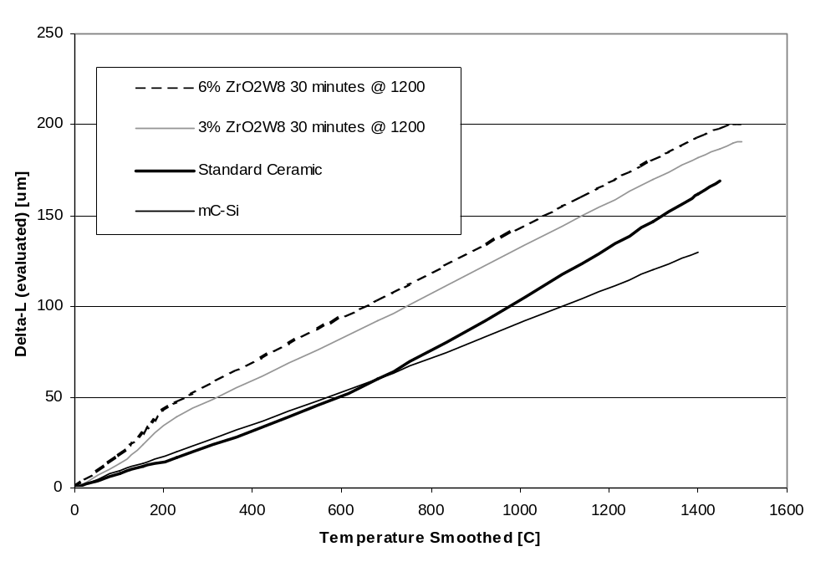
Figure 1. CTE curves for 3% and 6% ZrW₂O₈ additions to ceramic after heat treatment

CVD Development

Efforts with respect to the CVD for the first half of the year were primarily focused on 100-cm2 device processing development. This included depositing 20 to 25μm thick, 1 Ω-cm, epitaxial layers on low resistivity p+ single crystal and p-type Silicon-Film™ wafers. The single crystal wafers had a sand blasted and NaOH etched surface texture. The Silicon-Film™ samples were etched with a chemical polish (CP), which helped planarize the surface, prior to epitaxy.
The epitaxial growths on the Silicon-Film™ samples first had an in-situ p+ (0.02 ohm-cm) layer deposited to reduce any contribution from the p-type bulk followed by the standard active layer. The epitaxial growth rates for these samples averaged 4.2 μm / min.

The following structure was used for the Silicon-Film™ devices:

- in-situ HCl etch (0.5 μm) to remove any native oxide
- 22 μm in-situ p+ (0.02 Ω-cm) epitaxial BSF
- 22 μm 1 Ω-cm epitaxial active layer

The latter part of the year involved a restructuring of the company, which included a change in personnel and a learning curve in both the operation and maintenance of the CVD system. A high scrubber pressure during a polycrystalline silicon on ceramic run, led us to completely dismantle and clean the scrubber system only to find that a faulty manual valve was creating too much back pressure in the system. After fixing the valve and doing a couple of polycrystalline Si seed layer depositions on ceramic, we then developed a low pressure problem with the scrubber system. This time the problem was tracked to a solenoid valve that was stuck open causing the recirculation pump to suck air into the system. A few runs later another problem developed. This time it was with the RF power supply. While powering up the RF heating system an arcing was heard coming from the power supply. Although it has not been determined what is causing the arcing, two of seventeen ceramic resistors were found cracked in the power supply. New resistors were installed, and CVD development has resumed.

Grain Growth

The new large area ZMR was completed. The large area ZMR system is capable of recrystallizing samples as large as 6″ x 6″ square at speeds from 1 mm to 1 cm /min. and has the capability to heat the sample to 1200 °C using only the bottom lamps. Being able to heat the sample to this temperature with only the bottom lamps results in less power required to obtain a melt using the top lamp, and the ability to recrystallize at faster speeds. Being able to recrystallize at faster speeds will allow us to study the effect of grain growth and crystal orientation as a function of growth speed on the ceramic substrate. The new ZMR system, pictured in Figure 2, was built in part by CVD Equipment Corporation of Ronkonkoma New York, and part in-house. CVD Equipment Corporation fabricated the square quartz tube system with automated load/unload, and the bottom heater configuration consisting of nine infrared lamps in a gold plated reflector housing. The top lamp configuration and scan drive mechanism were fabricated in-house. This consists of a single infrared lamp in a reflective housing that is suspended from a linear slide and driven with a ball screw and DC motor. The top lamp housing is quickly adjustable in .002″ increments to accommodate varying sample thickness and the scan speed is variable from 1 mm to 1 cm/min.

After the new large area ZMR system was turned on and brought up to temperature, it became apparent that there was insufficient heat shielding. The motor and drive mechanism for the top lamp, and the lead wires for the bottom lamps were not shielded from the bottom IR lamps causing them to become too hot. A heat shield was fabricated from specular aluminum sheet and is connected to one side of the top lamp to protect the drive motor and one end of the drive mechanism. On the other side of the top lamp we needed some type of folding or collapsible heat shield that would compact as the top lamp neared the bulkhead at the end of its travel. For this we fabricated something similar to a bellows type way-cover out of aluminized fiberglass cloth. The aluminum coating on the fiberglass reflects 95 % of the IR light providing an excellent heat shield. We used the same material to fabricate heat shields over the lead wires for the bottom lamps.

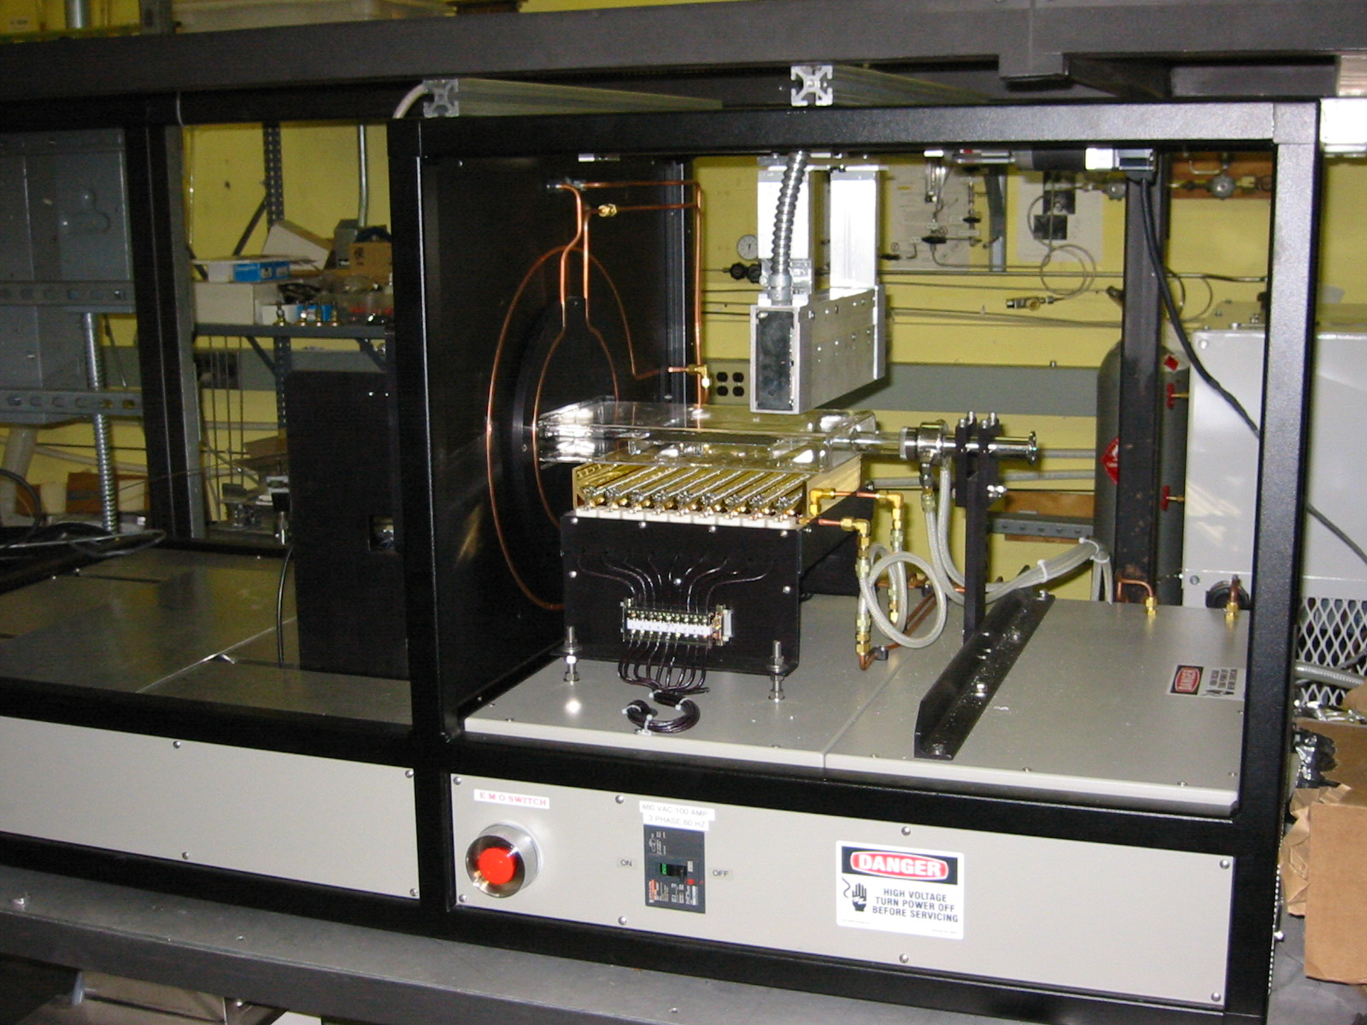

Figure 2. New AstroPower large are recrystallization system.

The first experiments in the new ZMR system were the heat treatment experiments done on the ZrW₂O₈ containing ceramics. There appeared to be no problems, with the bottom lamps heating the system to 1200° C for as long as 30 minutes. The first recrystallizations done in the new large area ZMR system were an experiment to look at the silicon growth morphology as a function of scan speed. After adjusting the top scan IR lamp to provide a narrow focused beam, the melt uniformity was adjusted side to side at a speed of 0.3 cm/min. With the ZMR speed of 0.3 cm/min. providing long extended grains, we began increasing the ZMR speed of the top lamp while the bottom lamps held the samples at ~ 1200° C. For each sample, melt zones were obtained at the 0.3 cm/min. speed before the speed was increased. The speeds investigated and the resulting morphology are listed in Table 1. Figure 3 displays the three different morphologies observed as a function of the different growth speeds.
Growth Speed (cm/min.) | Resulting Morphology
0.3 | Long extended grains
0.5 | Long extended grains
0.7 | Dendritic grains
1 | Small grains
Table 1. Growth speeds and resulting morphology

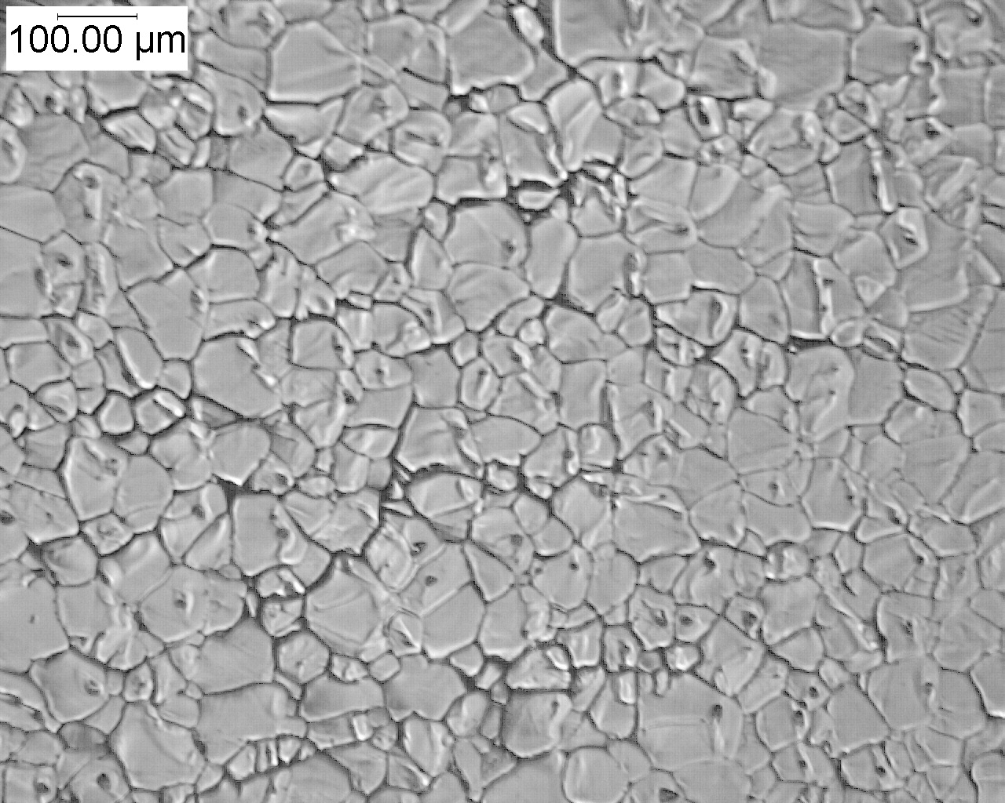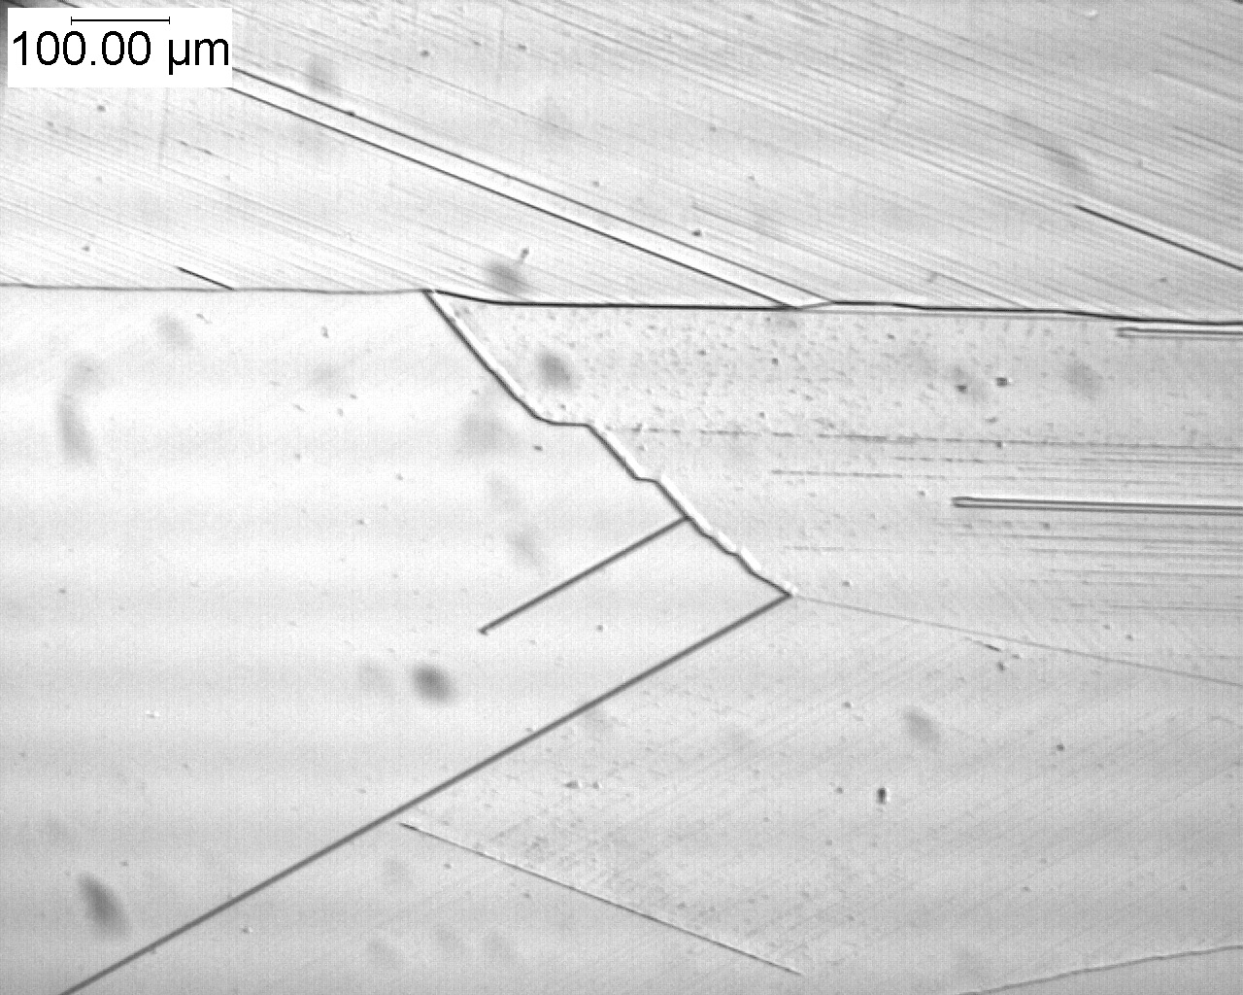
Figure 3. (a) Small grained growth (b) Long extended grain growth

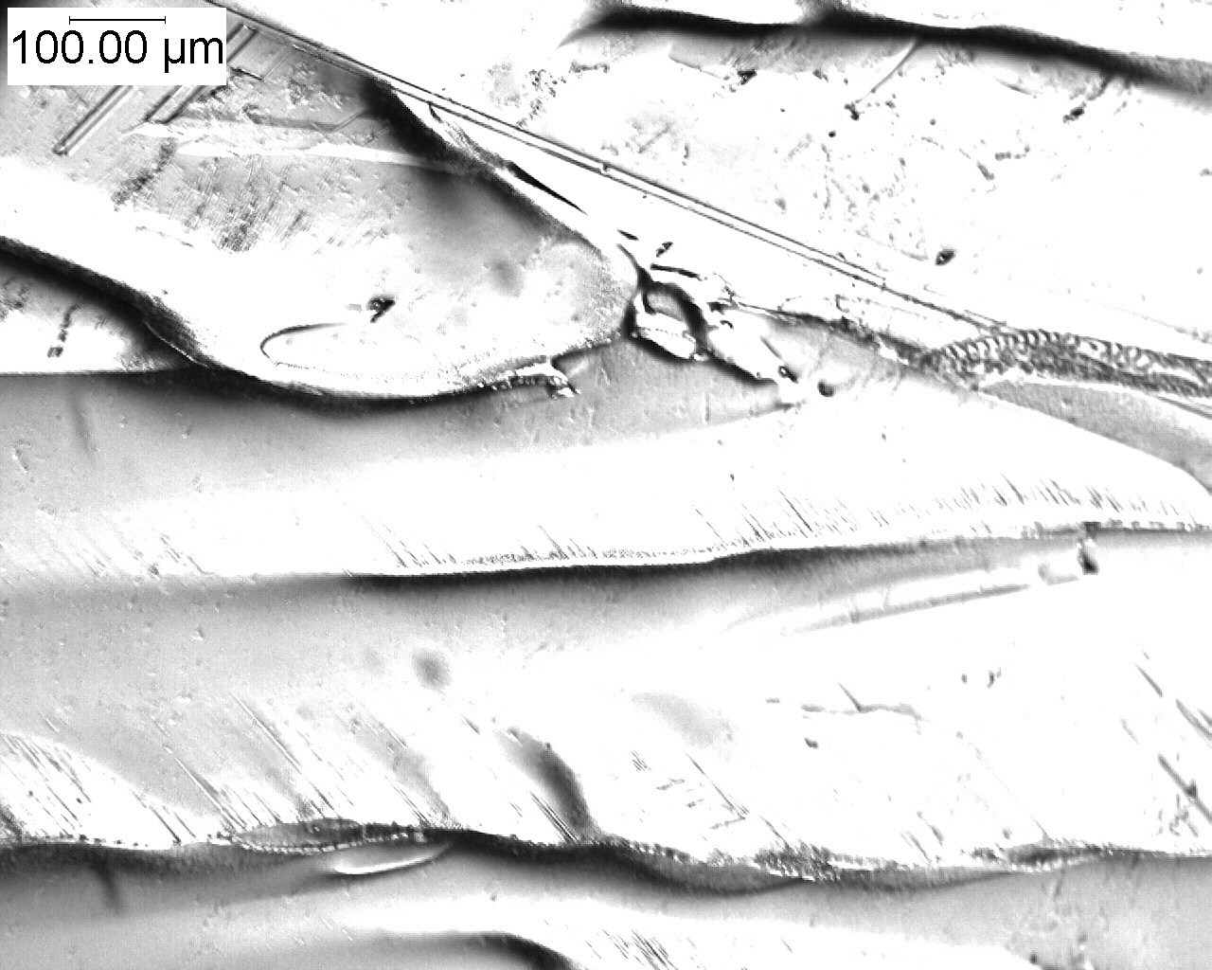
(c) Dendritic grain growth

Figure 3. Displays the three different morphologies observed as a function of the different growth speeds.

The dendritic growth is generally observed in our thin Si films when the heat is extracted too rapidly from the recrystallizing film. The small- grained growth occurs with even faster heat extraction, indicating that if we want to be able to grow at these speeds we will need to put more heat into the sample. In October of 2002 we had XRD performed on some of our thin-film silicon on ceramic that had been grown at 0.3 cm/min. to determine the crystallographic orientation. The XRD indicated that our dominant orientation was <111> with the <220> peak also apparent. It has been proposed that by varying the scanning speed and base temperature during the ZMR process, that a preferred <100> orientation can be achieved. XRD will be performed on these samples grown at faster speeds, and experiments will continue to obtain large extended grain growth at faster scan speeds.

Device Fabrication Development

A device process was developed for silicon deposited on both 100 cm² Silicon-Film™ wafers and low resistivity single crystal CZ wafers. The two primary variables for the optimization of a production viable process on these devices are the post diffusion anneal (PDA) and the contact firing. The PDA is required because the samples are diffused utilizing a phosphorous-based production spray and a continuous belt diffusion. In order to optimize the emitter and reduce any inactive phosphorous at the surface the post diffusion annealing step is performed. Initially, both the CVD on Silicon-Film™ and the CVD on single crystal samples were fabricated into devices using the appropriate production PDA and screen-printed contact process for those respective materials. Device results were poor due to low voltages and fill factors with fill factors being reduced by both series and slight shunt resistance. It was clear from these results that both the PDA and the contact process required further optimization to maximize performance. In order to isolate the problems associated with the PDA from those associated with the contact firing, a photo-mask and evaporated contact process was used for device fabrication. The evaporated contact process greatly reduced the series resistance increasing the fill factor by an average of 15-20 %. For the CVD on single crystal material the open circuit voltage was increased by an average of 30 mV with a 40° C increase in PDA temperature. The CVD on Silicon-Film™ material did not fair as well and displayed no improvement with the variation of the PDA temperature. Both materials responded to PECVD hydrogenation with an average of 13-15 % increase in efficiency. This increase could possibly be due to the passivation of surface defects or further annealing of the emitter that is not being completed in PDA.

Forty of the epitaxially grown CVD silicon on p+ single crystal substrate samples were current matched and then tabbed. The average device results for the forty tabbed cells are listed in Table 2.

# of cells | avg. Voc (mV) | avg. Isc (A) | avg. FF (%) | avg. Pmax (W)
40 | 563 | 2.6 | 67 | 0.98

Table 2. Device results for tabbed epitaxial CVD silicon on p+ single crystal substrate with evaporated contacts.

A module was then fabricated with these forty cells. The tabbing had to be done manually, as our production tabbing and stringing processes are not tooled to handle evaporated contacts. The remainder of the module fabrication step, however, was performed in our module production line. The module was tested here at AstroPower and the IV curve is pictured in Figure 4, with test results listed in Table 3.
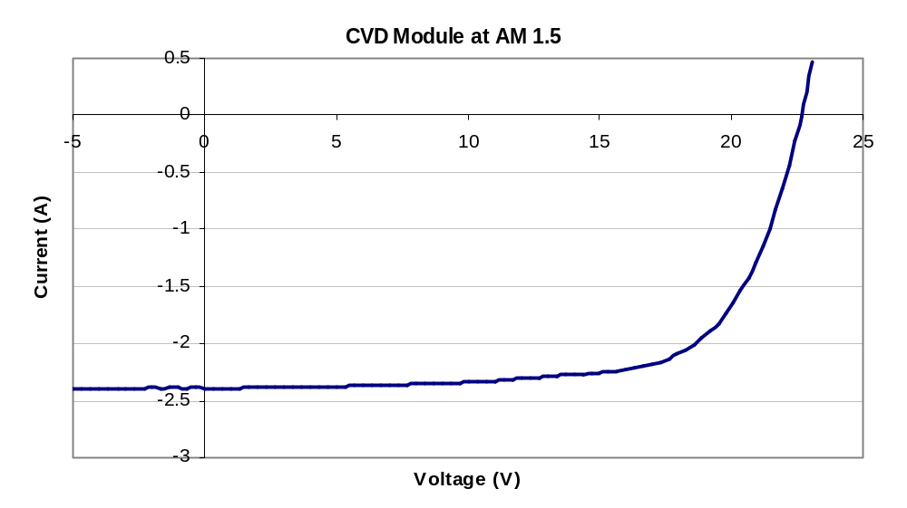

Figure 4. IV curve for 40 (100 cm²) cell module

Voc (V) | Isc (A) | FF (%) | Pmax (W) | Module efficiency (%) | Aperture efficiency (%)
22.52 | 2.39 | 69.74 | 37.57 | 7.6 | 9.1

Table 3. Device results for 40 cell module

Previously, device processing utilized both our Research & Development and Production facilities to perform diffusions. Since it was determined that tube diffusion causes a back junction and lower current on our ceramic devices, spray diffusion was chosen as the replacement. This was performed inline with our Silicon FilmTM production furnace. Problems arose due to scheduling and different spray formulations. Repeatability and cleanliness became difficult to control. In order to maintain uniformity among our samples, experiments were conducted to bring spray diffusion online at our Solar Park (R&D) facility.

With spray diffusion, an oxide needs to be present in order to ensure uniform coverage of the sample. This is accomplished in production by growing a thin oxide prior to the belt diffusion process. The lack of appropriate equipment to form this oxide required the development of a new spray formulation for the phosphorous dopant that eliminated the need for the oxide. Isopropyl alcohol (IPA) was added to the mixture to allow surface tension to hold the uniformity of the spray. When viewed under the microscope, large droplets were noticed along with areas without spray coverage. The spray gun was replaced with one which produced a finer mist. This reduced the size of the droplets as well as the amount of spray used. We can now routinely achieve sheet resistivities of 40-50 Ω/square on polycrystalline control wafers using the spray belt diffusion process.

A new contact scheme was designed for the monolithically interconnected sub-module structure. The new design, pictured in Figure 5, has the cross-over interconnects in the middle of the cells as opposed to the ends, as in the previous design. With this new design the I ² R losses are minimized and the non-aperture area is reduced. The original sub-module design was primarily developed as a proof of concept to show that we could successfully electrically insulate the dice cuts and then reconnect the segments in series with minimal losses. The interconnects were placed at the ends of the segments on this structure so that we could use a dielectric epoxy as cross-over insulation as opposed to the expensive photo-patterned polyimide. The epoxy wasn’t used in a center cross-over structure for fear of shading the emitter with slop from the application process. This is no longer a problem as we now can deposit the epoxy in a very small-defined area with our direct write ink dispenser. The further reduction of losses and reduction of non-aperture area with the new design should increase sub-module efficiency by as much as 25 %.
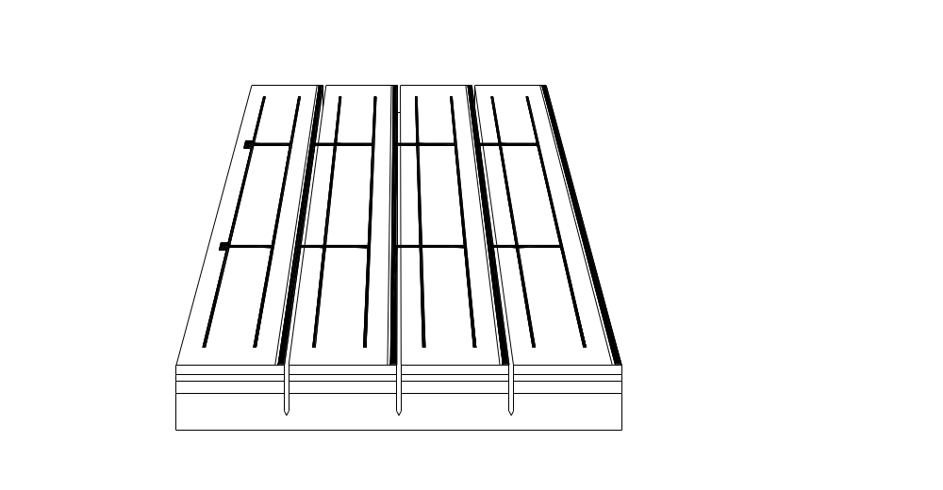
n-contact
Interconnect
p-contact

Active layer
BSF
Seed layer
Ceramic substrate
Figure 5. Schematic of monolithically interconnected solar cell design.

Mesa devices fabricated on the silicon on ceramic material have had good current densities (17-18 mA/cm²) with diffusion lengths from 15-21 μm, however, voltages have varied from the mid 300 mV to 500 mV range within a small area (9-16 cm²). These results have changed our focus from device processing to characterization.

A MISC device (#254) was fabricated using the new design. The electrical data without AR is listed in Table 4.

V_{oc} (mV) | J_{sc} (mA/cm²) | FF (%)
422 | 18 | 54

Table 4. Electrical results for new MISC design (#254).

This device was studied using SIMS, I-V measurements under sun simulator, I-V measurements using Sinton tester, quantum efficiency measurements, and contactless light lock-in-thermography.
Figure 6 shows results of SIMS measurements of the sample #254, which has three layers: active (20 μm), BSF (12 μm), and seed (50 μm). Only a part (about 20 μm) of the seed layer is shown in Fig.1. Regarding the profile of Boron, one should mention two important facts: (i) relatively low concentration near the surface (2x10¹⁶cm⁻³), and (ii) gradient of doping from the interface towards the surface. To understand the role of this doping gradient, we performed PC1D modeling of the solar cell parameters. In particular, we compared a homogenously doped (2x10¹⁶cm⁻³) active layer and active layer with the doping profile from Fig. 6. However, no marked difference regarding Isc and Voc values was observed in these structures.

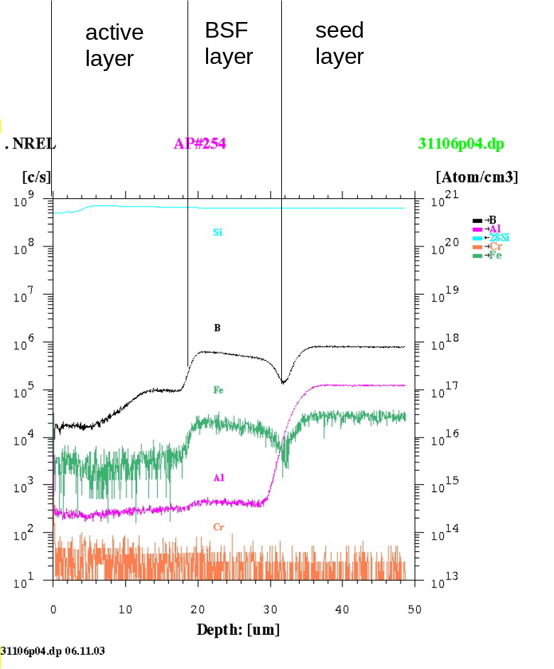Figure 6. SIMS profiles of B, Fe, Al and Cr in a three-layer Si structure grown on a ceramic substrate (measured at NREL) [2].

To perform shunt-analysis in the solar cell array, a new method – contactless light lock-in-thermography (Figs.7, 8) - developed in the University of Konstanz, Germany was used for the first time. Contrary to the known contact lock-in-thermography method [1], which uses a current flow generated by voltage applied to the solar cell contacts, the new method allows shunt-analysis without any contacts. The voltage (V_{oc}) in the contactless solar cell (or in the open-circuited cell with contacts) is generated by a pulsed LED light. If no leakage exists in the cell or it is homogenous, no heat distribution peculiarities can be determined. However, any leaky (shunt) spots cause laterally inhomogeneous distribution of the photogenerated current (in the open-circuited cell it is equal to the dark current), and - in terms of heat – hot spots appear on the surface. The application of pulsed illumination allows the use of lock-in methods and reveals a very small heat increase over a background level.
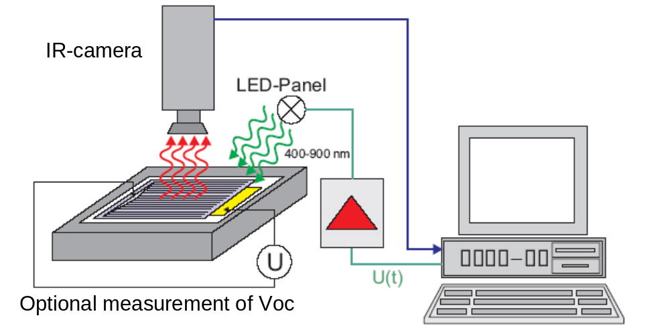

Figure 7. Schematic of contactless light lock-in thermography setup [3].

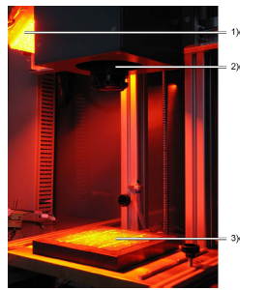
Figure 8. Photograph of contactless light lock-in thermography setup [3]:
- Panel of orange LEDs
- IR-camera
- Solar cell

Using the contactless light lock-in-thermography we studied one of the fabricated PV arrays: #254. Fig. 9 shows a picture of a light lock-in thermogram of this array. In this picture one can easily distinguish shunts, which are mostly located near the contact grid lines. As it is clear from the name of the method, the contactless light lock-in-thermography does not require contacts to reveal shunts. Thus, this method allows studying the shunt formation at different stages of the solar cell processing (after diffusion, etching, formation of contacts). This more detailed study of shunt formation is planned for the nearest future.

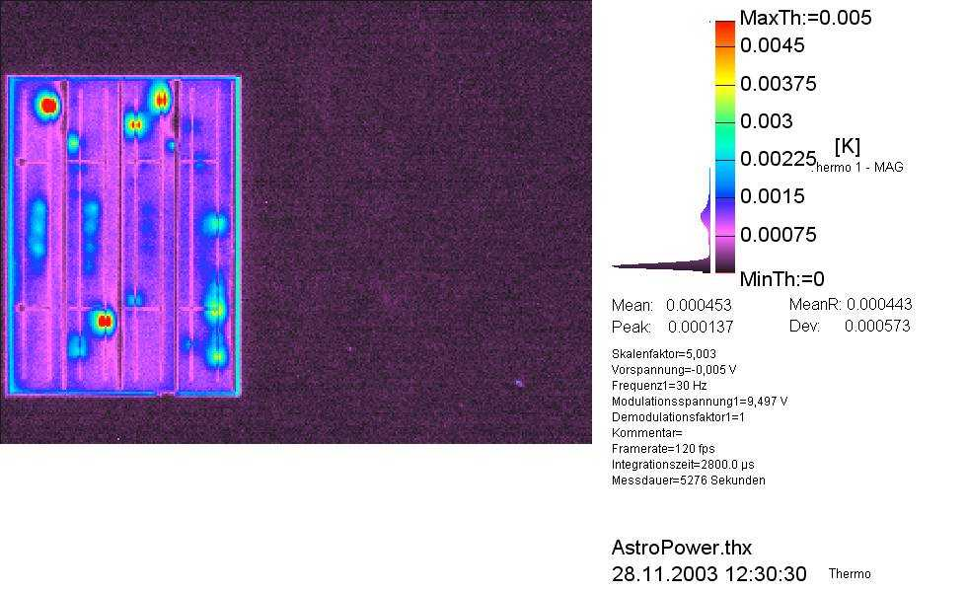

Figure 9. Light lock-in thermogram of the array #254 [3].

References

[1] O.Breitenstein, M.Langenkamp, J.P. Rakotiaina, and J.Zettner “ The imaging of shunts in solar cells by infrared lock-in thermography”, in. Proc. of 17th European Photovoltaic Solar Energy Conference, Munich, Germany, 2001, pp. 1499-1502.

[2] Data courtesy of Bob Reedy, NREL..

[3] Image courtesy of the University of Konstanz, Germany.

