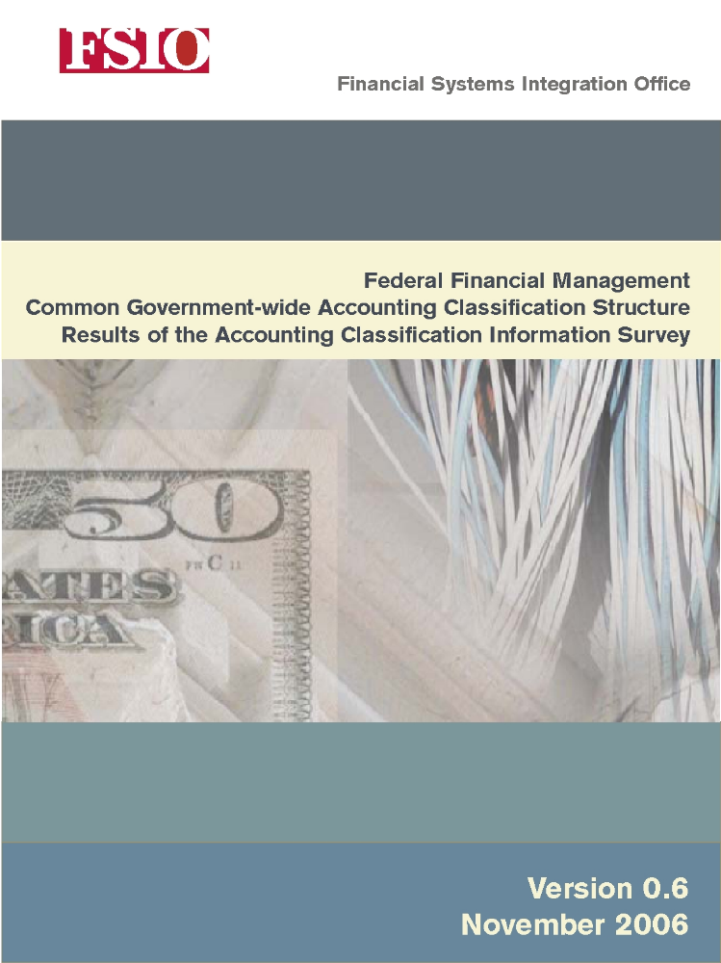

Contents
Abbreviations v
Chapter 1 Introduction 1
Chapter 2 Life-Cycle Status of Core Financial Systems 3
Chapter 3 Characteristics of Feeder Systems that Interface with the Core 5
Chapter 4 Status of Agency-Wide Accounting Classification Standardization 9
Chapter 5 Characteristics of Each Component of the Accounting Classification Structure 11
Fund 11
Organization 13
Program 14
Strategic Goal 17
Object Class 19
Revenue Source Code 20
USSGL Account Code 20
Appendix—Document Change History 21

Figures
Figure 1. Life-Cycle Stage for Agency Core Financial Management Systems 3
Figure 2. Core Interfaces by System Type 5
Figure 3. Feeder System Classification Structure 6
Figure 4. Payroll SSPs by Number of Agencies Supported 6
Figure 5. Travel SSPs by Number of Agencies Supported 7
Figure 6. Current Degree of Standardization 9
Figure 7. Agency Plans for Further Standardization 10
Figure 8. Agency Fund Codes 11
Figure 9. Agency Organization Field Lengths 14
Figure 10. Agency Organization Codes 14
Figure 11. Agency Program Field Lengths 17
Figure 12. Agency Program Codes 17
Figure 13. Data Elements Used to Prepare the Statement of Net Cost 19
Figure 14. Agency Object Class Extension Field Lengths 20
Figure 15. Agency Use of Extensions to the USSGL Account Code 20

Abbreviations
BEA Budget Enforcement Act of 1990
BFY Budget Fiscal Year
CFO Act Chief Financial Officers Act of 1990
CGAC Common Government-wide Accounting Code
COTS Commercial Off-the-Shelf
FACTS II Federal Agencies ‘Centralized Trial-Balance System II
OMB Office of Management and Budget
SSP Shared Service Provider
Treasury U.S. Department of the Treasury
USSGL U.S. Standard General Ledger

Introduction
As part of conducting the Common Government-wide Accounting Classification (CGAC) project, the 24 CFO Act agencies were surveyed to see how closely agencies’ accounting classification structures adhere to current standards and to determine whether there are natural opportunities for agencies to adopt the CGAC structure once the standard is issued. This document, a companion report to the Common Government-wide Accounting Classification Structure Exposure Draft, summarizes the survey responses.
The survey asked questions in four areas:
- Life-cycle status of the core financial management system at the agency
- Characteristics of feeder systems that interface with the core financial system
- Status of any agency-wide accounting classification standardization efforts
- Characteristics of each component of the existing accounting classification structure.
Detailed analysis of the survey results led to the following findings:
- There are agencies at every phase of the system life cycle. Agencies currently planning to upgrade or replace core financial management systems offer prime opportunities for moving to the CGAC structure.
- A large number of feeder systems at each agency will be affected by a change in classification structure. Feeder systems that are being standardized by a line of business initiative (such as e-travel) could offer good opportunities for parallel standardization that would result in simplified interfaces in the future.
- Many agencies still have not adopted an enterprise-wide accounting classification structure. Although most agencies responded that they have a standard enterprise-wide structure, analysis of the detailed information provided revealed that some of the agencies’ bureaus had independent classification structures.
- There is a wide divergence in agency accounting classification structures. Agencies that have similar fields may call them by different names, use different field lengths, or use different logic to drive similar business rules. The existing standards have not been detailed enough to drive meaningful standardization.
In some cases, survey responses included details about systems and accounting classification structures at the bureau level. Responses were simplified so that results shown here consistently report 24 agencies. Each finding is further described in the following sections.

Life-Cycle Status of Core Financial Systems
For many agencies, the software used for the core financial management system is a key factor in how the accounting classification structure is designed. It is not unusual to change the accounting classification structure when a system is upgraded or replaced. Thus, one good opportunity for implementing the CGAC structure would be when an agency is planning to upgrade or replace its core financial management system.
The survey found that agencies are at widely varying stages of the system life cycle. Figure 1 summarizes the responses to the question, “Which best describes where you are in the system life cycle?”
Figure 1. Life-Cycle Stage for Agency Core Financial Management Systems
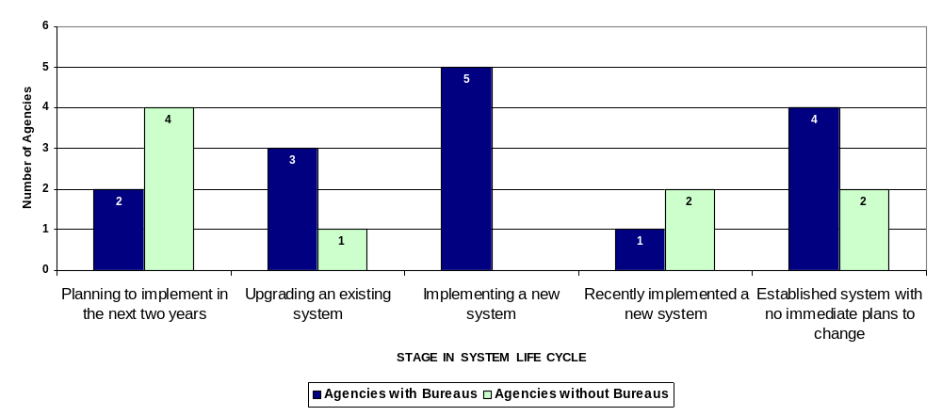
Agencies that anticipate upcoming system changes could be prime candidates to adopt CGAC as part of the system upgrade or replacement. There are six of these agencies; two have multiple bureaus.
Another nine agencies are in the process of implementing or upgrading their core financial management system now. For them, timing of CGAC adoption will depend on how far along the implementation is when CGAC is finalized.
The three agencies that have recently implemented a new system may find that the modern COTS products they are using can adopt the CGAC structure relatively easily. The vendor may be able to develop conversion strategies that can be used by several agencies to move to the new structure.

Characteristics of Feeder Systems
that Interface with the Core
Many agencies rely on feeder systems that interface with their core financial system to process transactions. Adoption of the CGAC structure will require modification to these system interfaces.
The survey found that most agencies’ core financial management systems interface with travel, payroll, purchase card, and acquisition systems. Over half interface with a grants system.
Figure 2 illustrates the responses to the question, “Which feeder systems interface with your agency’s core financial management system?”
Figure 2. Core Interfaces by System Type
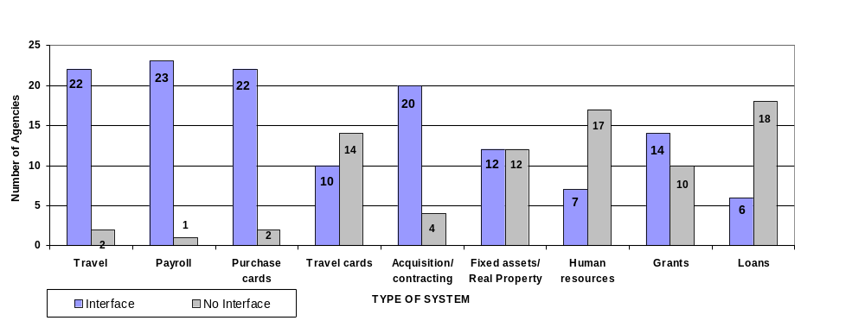
All 24 agencies reported using payroll systems, but one agency reported not having an interface with the core financial management system because its interface is under development.
While many feeder systems interface with the core financial management system, responses to “does the feeder system use the same classification structure as your agency core financial management system” vary. While most interfaces do use the same classification structure, there is considerable variation. Figure 3 demonstrates the number of systems that carry the agencies’ common accounting classification code and those that use a cross-walk.
Figure 3. Feeder System Classification Structure
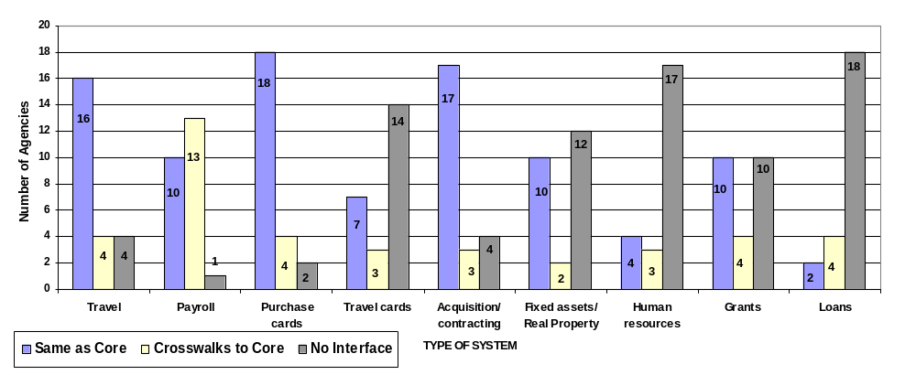
The CGAC survey also identified the number of approved e-payroll and e-travel systems being used by agencies.
Approved payroll systems are offered through the following shared service providers:
- Department of Agriculture, National Finance Center (NFC)
- Department of Defense, Defense Finance and Accounting Service (DFAS)
- Department of the Interior, National Business Center (NBC)
- General Services Administration, Heartland Finance Center (HFC).
Figure 4 shows the breakdown of payroll SSPs by the number of agencies supported.
Figure 4. Payroll SSPs by Number of Agencies Supported
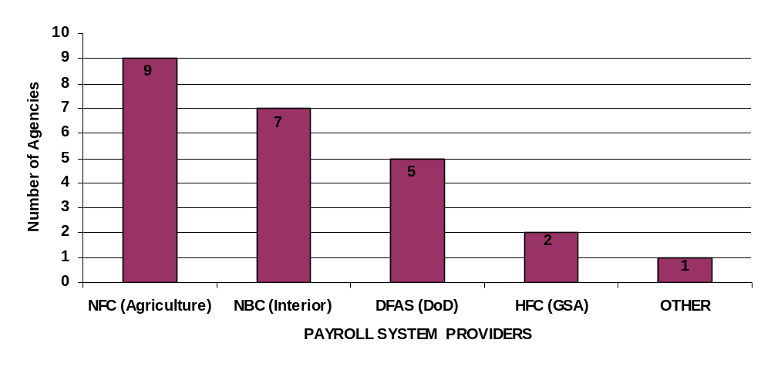
Approved travel systems are offered through the following shared service providers:
- Carlson Wagonlit Government Travel’s E2 Solutions
- EDS’s FedTraveler
- Northrop Grumman Mission System’s GovTrip.
Figure 5 shows the breakdown of travel SSPs by the number of agencies supported.
Figure 5. Travel SSPs by Number of Agencies Supported
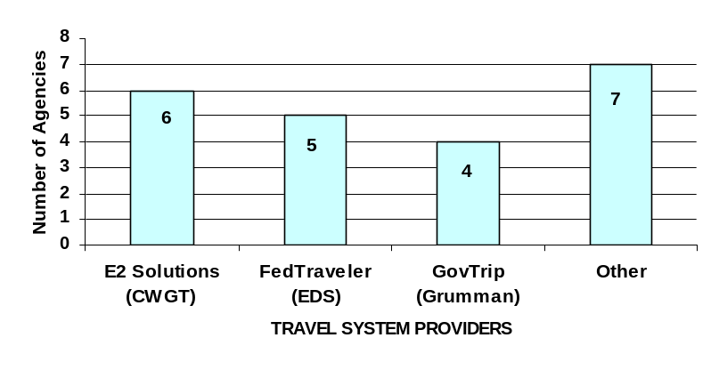

Status of Agency-Wide Accounting Classification Standardization
OMB Circular A-127, Financial Management Systems, requires that each agency use an agency-wide financial information classification structure. Figure 6 provides the responses to question 6 of the survey, “Have you adopted an agency-wide accounting classification structure?” While many agencies responded in the affirmative, analysis of the detailed accounting classification information they provided in other parts of the survey revealed that some of their bureaus had independent structures. As illustrated in the figure, the resulting determination was that not all agencies have agency-wide structures.
Figure 6. Current Degree of Standardization
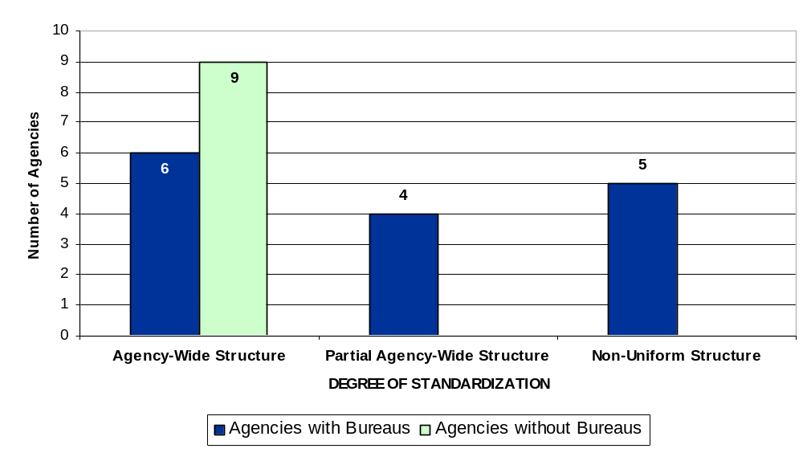
Since all agencies are required to use an agency-wide structure, availability of the CGAC structure provides a common ground for the bureaus within an agency to move toward.
Another question asked was whether there were any plans to change the accounting classification structure. Figure 7 shows these results.
Some agencies see a need for changing their existing accounting classification structure. Three agencies with bureaus indicated that their existing structure does not meet their needs. These agencies are excellent candidates to adopt CGAC. Four more agencies expect to standardize as part of a system replacement and thus may be in a good position to adopt the CGAC structure.
Figure 7. Agency Plans for Further Standardization
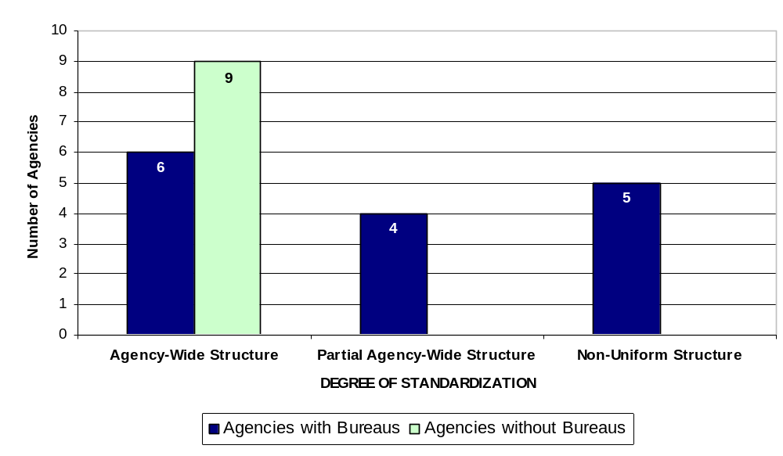

Characteristics of Each Component of the Accounting Classification Structure
The survey showed a wide variation in agency accounting classification structures. Each of the following classification areas is discussed below:
- Fund
- Organization
- Program
- Strategic Goal
- Object Class
- Revenue Source Code
- USSGL Account Code.

Fund
Most agencies reported using an internal fund code that derived the full Treasury Account Symbol and other classification elements needed for external reporting. However, unlike the internal fund code in the CGAC structure, some agency’s fund codes use considerably longer fields. In fact, the field length of fund codes varies from 1 character to 18. In general, those agencies using a fund code longer than 6 characters have built “intelligence” into the code. For example, these codes might include characters that identify the bureau within the agency or attributes needed for FACTS II reporting, such as the apportionment category or BEA category associated with the fund. Rather than building this type of intelligence into the code, the CGAC structure uses a separate element to identify the bureau and derives fund attributes through logical associations built into the structure.
Figure 8 shows the various fund codes used by agencies.
Figure 8. Agency Fund Codes
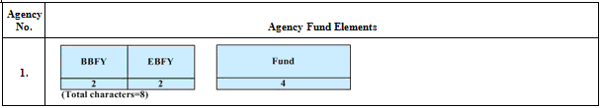

Figure 8. Agency Fund Codes (Continued)
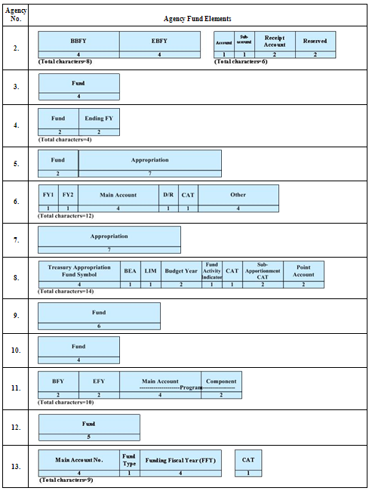
Figure 8. Agency Fund Codes (Continued)
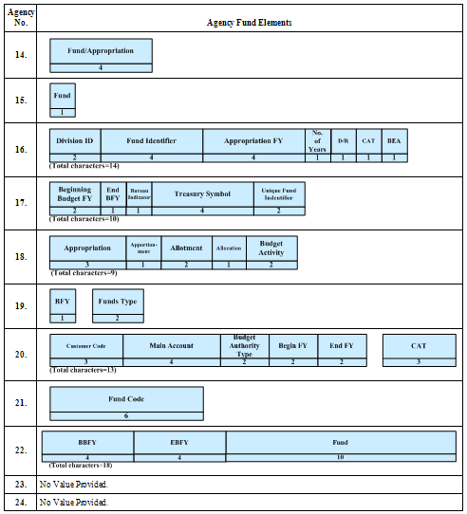

Organization
While all agencies have an organization structure, the number of levels and number of characters vary widely. The smallest organization field was reported as 1 position long while the largest was 20 positions (see Figure 9). Organization definitions also varied; some agencies use levels while other agencies define the actual type of organization represented by each field (region, directorate, division, branch, etc.). Four agencies reported having two separate fields that represent an organization or group of organizations. One agency reported 4 separate fields that capture organizations. Figure 10 shows the various organization codes used by agencies.
Figure 9. Agency Organization Field Lengths
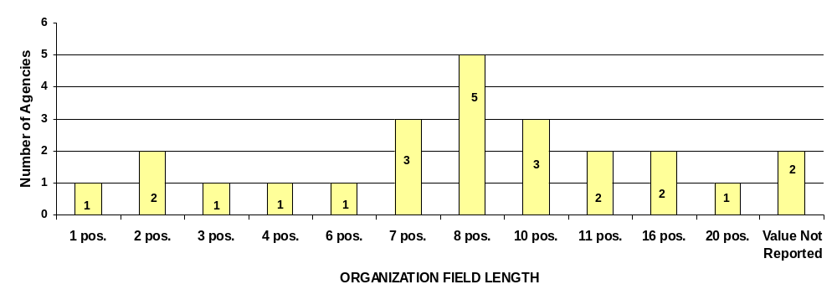
Figure 10. Agency Organization Codes
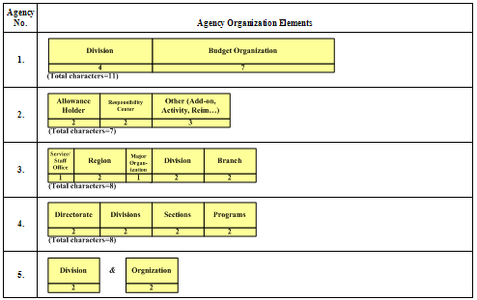
Figure 10 Agency Organization Codes (Continued)
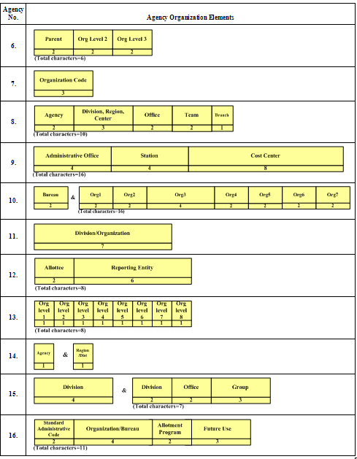

Figure 10. Agency Organization Codes (Continued)

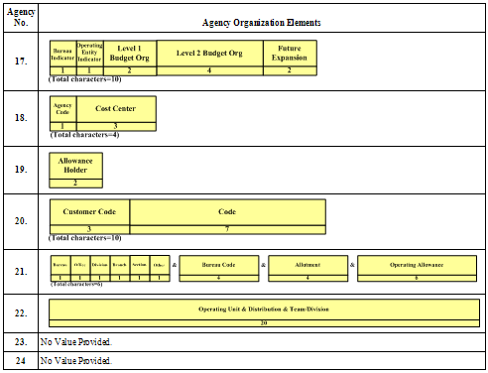

Program
Agencies have developed program structures to accommodate unique needs related to how their funds are appropriated and to meet unstructured reporting requirements. The number of positions available for program codes in agency systems range from 2 to 20 positions long (see Figure 11). Some agencies have hierarchical structures, while others have cross-cutting elements. Three agencies use two separate fields to identify programs. Figure 12 shows the variation in agency program codes.
Figure 11. Agency Program Field Lengths
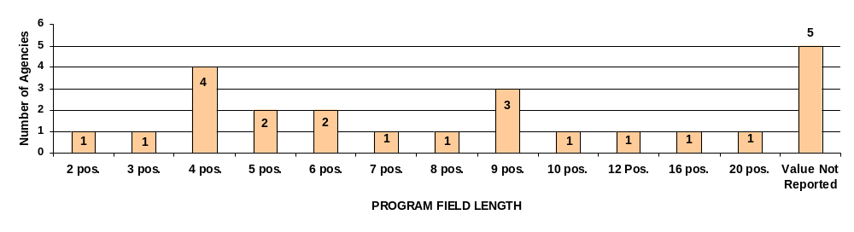
Figure 12. Agency Program Codes
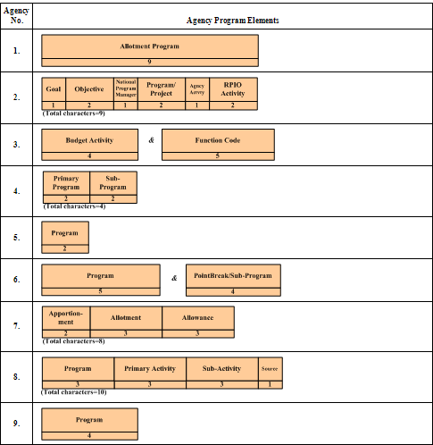
Figure 12. Agency Program Codes (Continued)

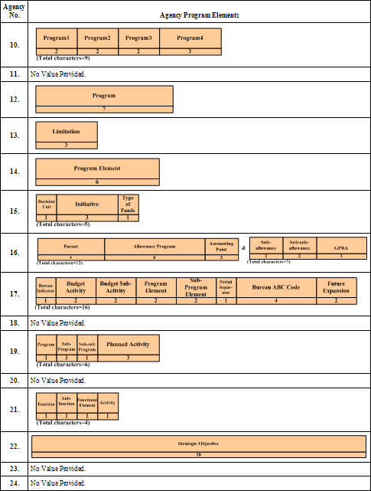

Strategic Goal
The CGAC survey identified how agencies have adopted OMB guidance on the form and content of the Statement of Net Cost. OMB Circular A-136, Financial Reporting Requirements, provides the following guidance on preparing this financial statement:
Preparers of the Statement of Net Cost should present responsibility segments that align directly with the major goals and outputs described in the entity’s strategic and performance plans, required by the Government Performance and Results Act.
In most cases, agencies reported preparing the Statement of Net Cost by strategic goal. In some cases, they reported on programs that aligned with strategic goals. In a few cases, they reported on bureaus or funds. Figure 13 illustrates which data elements are used by agencies to prepare the Statement of Net Cost. (The strategic goal code element is included in the CGAC structure to support the need of agencies that prepare the Statement of Net Cost by strategic goal.)
Figure 13. Data Elements Used to Prepare the Statement of Net Cost
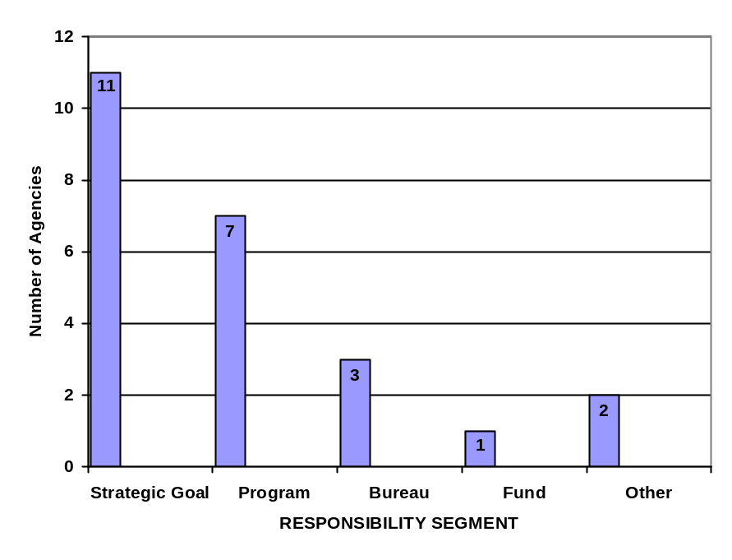

Object Class
Most agencies use the standard OMB object classes. Some use extensions to provide additional detail about how money is spent. The object class extension varied in size from 1 character long to 5 characters long (see Figure 14). The object class size was either 3 or 4 characters long for each agency. One agency uses a shortcut key to point back to the object class code.
Figure 14. Agency Object Class Extension Field Lengths
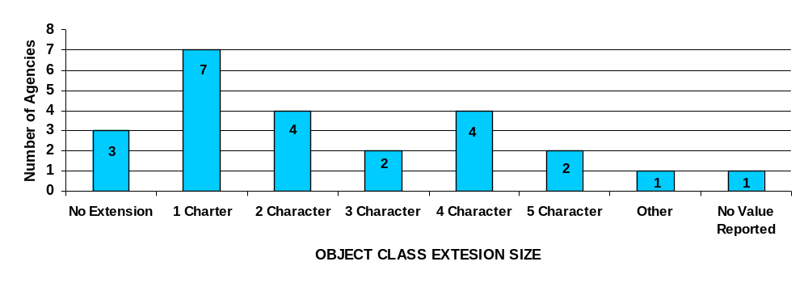

Revenue Source Code
A little over half of the agencies (13) reported using a revenue source code to track categories of revenue, collections, and fees. These categories are used primarily for management information and may facilitate external reporting. While revenue source codes varied in size from 2 to 8 characters, most of the agencies use a 4-character code.

USSGL Account Code
Agencies have made a lot of progress in adopting the USSGL account code at the transaction level. The majority of agencies use extensions to provide additional detail about the nature of the transaction. Agencies not using extensions reported that they modify the 4-character USSGL account code to accommodate agency-specific needs and summarize to the standard account code when reporting externally to Treasury. Reasons for using extensions or for modifying the basic 4-digit code vary from agency to agency, but in general, they relate to the nature of their business. Figure 15 illustrates agency use of extensions to the USSGL account code.
Figure 15. Agency Use of Extensions to the USSGL Account Code
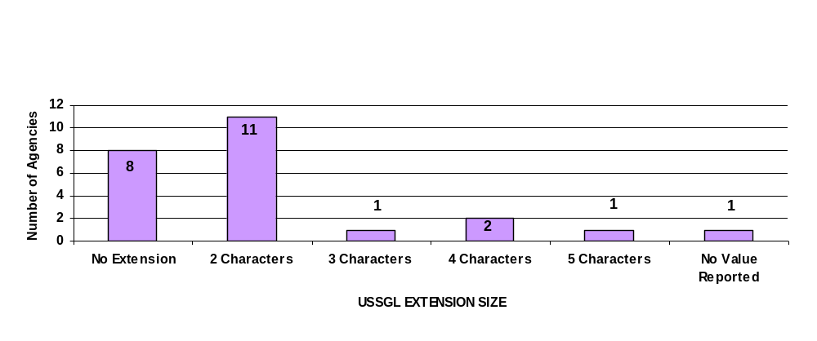

Appendix Document Change History
Table A-1 provides a history of the changes made to this document.
Table A-1. Document Change History
Version | Description of change | Name of author | Date published
0.5 | Initial draft as a separate document. Previously this was an appendix in the CGAC Structure report. | FSIO | November 17, 2006

The relevant language in A-127 is “Agency-wide Financial Information Classification Structure. The design of the financial management systems shall reflect an agency-wide financial information classification structure that is consistent with the U.S. Government Standard General Ledger, provides for tracking of specific program expenditures, and covers financial and financially related information.”

