 | TO: Bob Miley/OZ2 (281) 244-8261  NASA Contact: Larry Walter/ER3 (281) 483-5591  Analyst: John Bussell/MAGIK Team (281) 244-7934  DATE: July 11, 2000 Action Item #: 1192  RE: AMS Configuration #4 Assessment  CC: Phillip Callen/ER3, Skip Hatfield/OM7, RS Library  PAGES: 17 total

The MAGIK Robotic Analysis Team has assessed a fourth configuration for the Alpha Magnetic Spectrometer on the S3 Truss. MAGIK Action Items 1110, 1146, and 1174 addressed three other configurations. This analysis addressed the robotic installation clearances to the AMS installed at the S3 Inboard Upper Payload Attach System (PAS) with a 12 degree tilt toward the inboard side.

A high fidelity model of the AMS with a 12 degree tilted PAS interface and a modified debris shield was received from Ross Harold/Lockheed Martin in June, 2000 and was used in this analysis to assess robotic clearances.

Assumptions:
- Assembly operations completed at UF4 (Rev E Assembly Sequence) timeframe
- AMS manifest keel location is 1175.20 inches
- AMS is installed to S3 Inboard Upper PAS
- EXP is installed to S3 Outboard Upper PAS
- Distance (ISS +Y) from Inboard S3 PAS to Outboard S3 PAS is 113.38 inches

Summary:

The AMS installation operation was assessed, and violations of the Remote Manipulator System (RMS) Grapple Fixture (GF) approach envelopes and EVA Contingency Release envelopes were found. Violations of the SSRMS twenty-four inch requirement during AMS installation were also identified. These violations are severe enough to be brought to the End to End Berthing Integration Team (EBIT) for review. The Mission Operations Directorate (MOD) Robotics Section (DX22) and EVA Section (DX3) must also be consulted, and waivers must be granted for all 24 inch violations.

Detailed Discussion:

The AMS unberth and installation operation was assumed to occur as in the MAGIK Design Analysis Cycle #8 (DAC 8). The SpaceLab Logistics Pallet (SLP) carrying the manifested SPDM is removed first. Figure 1 shows the clearance from the SLP Ammonia Tank Assembly (ATA) to the AMS at manifest. The AMS may need to be manifest further aft in the payload bay to maintain twenty-four inches to the ATA.

After the SLP is removed, the AMS is grappled by the SRMS. Figure 2 shows a violation of the SRMS GF approach envelope as defined in NSTS-21000-IDD-ISS section 14.4.4.1. The MOD Robotics Section (DX 22) would have to review this violation to determine if it is acceptable. The SRMS EVA Contingency Release Envelope, NSTS-21000-IDD-ISS section 14.4.2.1, is also violated by the AMS structure (Figure 3). MOD EVA (DX 3) would have to review this violation. The AMS is unberthed and handed off to the SSRMS. The SSRMS EVA Contingency Release Envelope, NSTS-21000-IDD-ISS section 14.4.2.2, for the SSRMS GF is violated (Figure 4).

SSRMS violations of the twenty-four inch clearance requirement to the S1 Outer Upper camera and the S1 truss during installation of the AMS to the S3 Inboard Upper PAS were documented in Action Item 1174. The same clearance violations were found for this analysis, but were not documented.

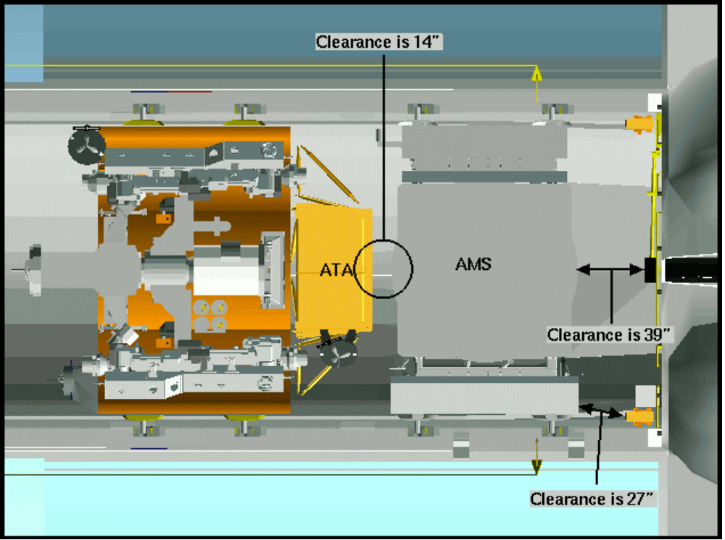

Figure 1 – AMS and SLP Manifested in Payload Bay

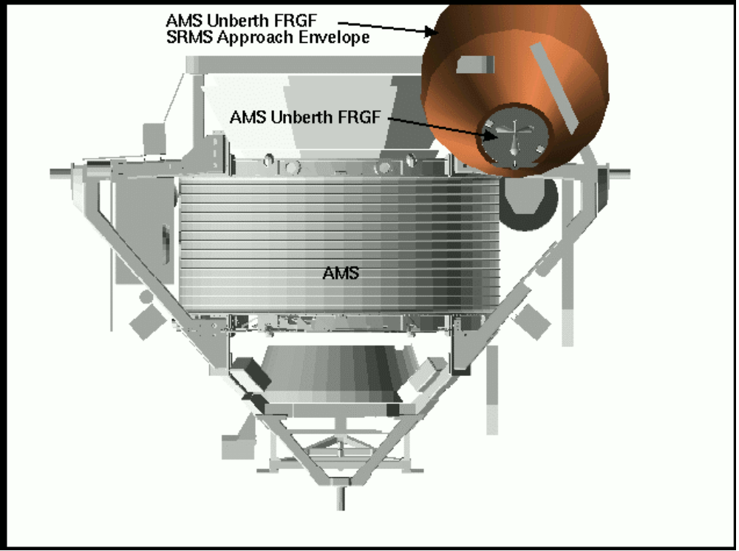

Figure 2 – Violation of SRMS Approach Envelope

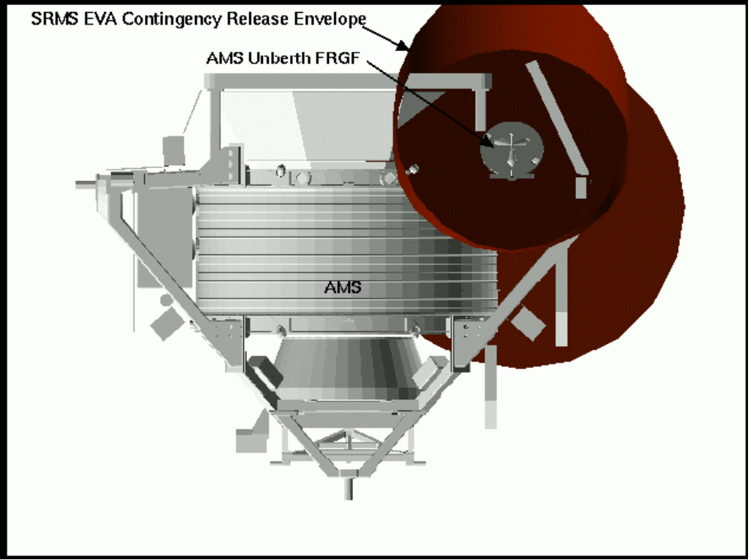

Figure 3 – SRMS EVA Contingency Release Envelope Violation

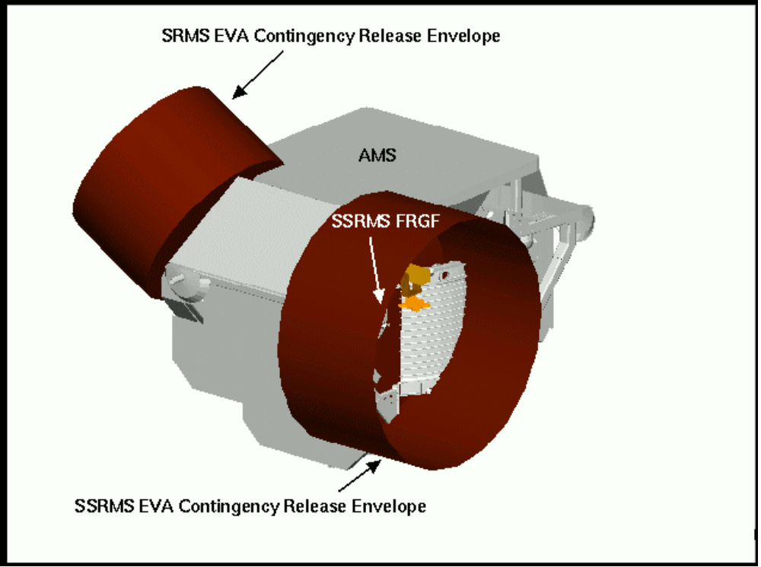

Figure 4 – SSRMS and SRMS EVA Contingency Release Envelope Violations

MAGIK DAC 8 analysis documents the AMS as being installed before the Express Pallet. This analysis shows the EXP present during the AMS installation for reference. Figure 5 shows the AMS 36 inches from being mated to the truss. As previously stated, the EXP is not currently baselined to be present during the AMS install, but if it were there, there would be only 9.2 inches from the AMS debris shielding to the EXP structure.

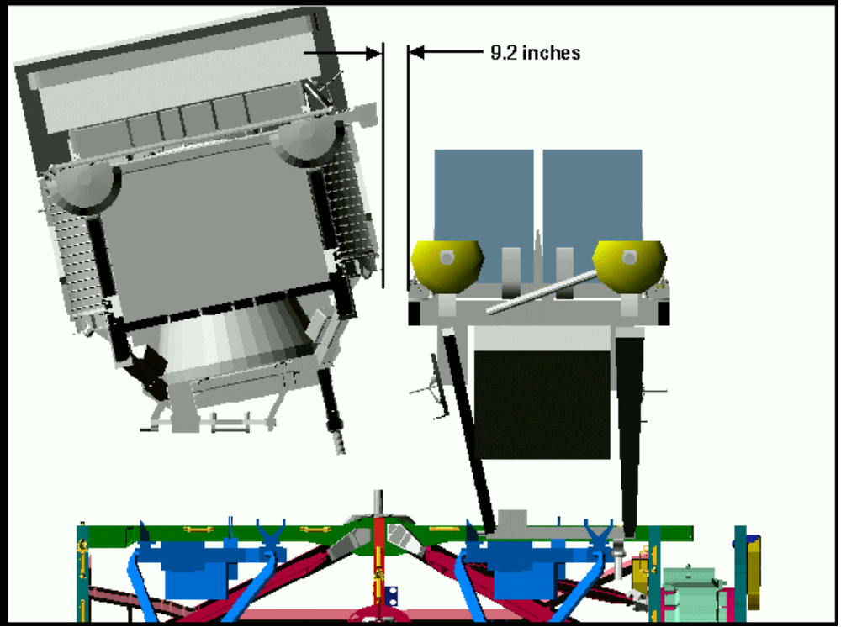

Figure 5 – AMS 36 inches from being mated to S3 truss
(ISS Back View)

Figure 6 shows the clearances between the AMS and EXP and their respective PAS Payload Envelopes. The EXP protrudes through the Attached Payload Envelope making the clearance between the AMS and EXP smaller than the clearance between the AMS and the Payload Envelope.

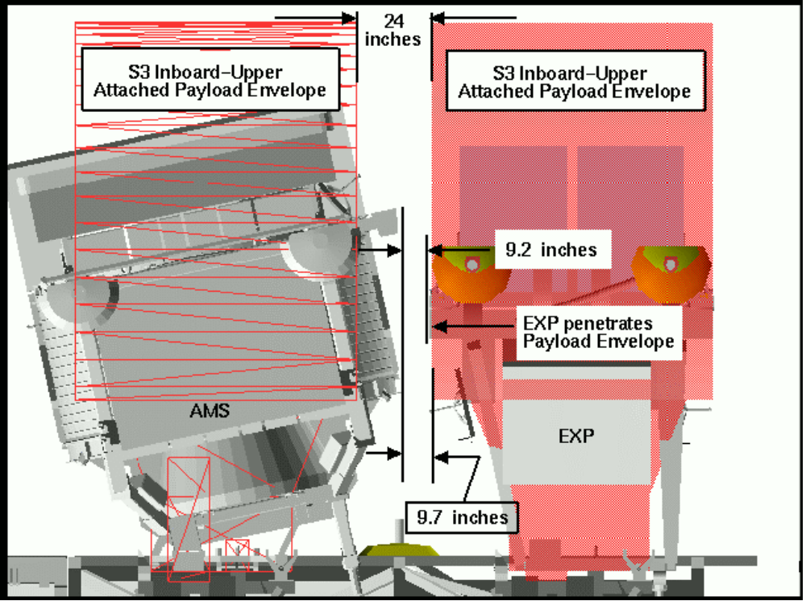

Figure 6 – AMS to EXP Clearances

As the AMS is berthed to the S3 Inboard Upper PAS, the keel structure comes close to the S3 truss structure. The closest clearance is when the AMS is fully berthed. This clearance is shown in Figure 7 as 13 inches from the AMS keel structure to the S3 EVA Worksite Interface (WIF) on the truss.

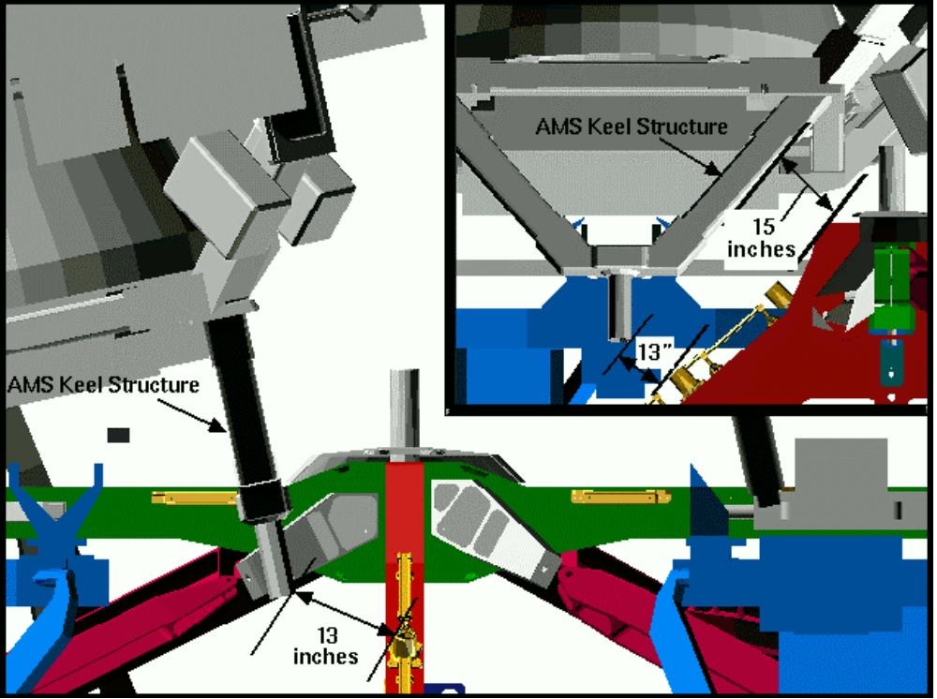

Figure 7 – AMS Keel to S3 EVA WIF = 13 inches

The clearances shown in Figure 7 are representative of a perfectly aligned mating operation. However, if any robotic misalignments are present, these clearances will be affected. For this analysis, the axis of rotation for the misalignments was assumed to be in the geometric center and on the same plane as the AMS PAS interface. If the point of resolution (POR) chosen by the Mission Operations Directorate (MOD) is different from this assumed POR, the clearances represented in Table 1 will be altered. Additional analysis may need to be done when the final POR is chosen. The clearances from the AMS keel and structure to surrounding structure are given in Table 1 below for different cases of misalignment. These clearances and misalignment issues must be reviewed by the End to End Berthing Integration Team (EBIT). It should also be noted that these clearances do not take into account any manufacturing tolerances or thermal deformations which may be present. The models used for the analysis represent as-designed, and the as-built hardware could be larger or smaller which will affect the clearances shown below.

Distance Between Passive  And Active Halves of PAS  (inches) | Tilt  (Wobble)  (degrees) | Lateral  Translation  (inches) | Roll  (degrees) | AMS Keel  To S3 WIF  (inches) | AMS to  EXP Payload Envelope  (inches) | AMS to EXP Structure  (inches) | See Figure#
0 | 0 | 0 | 0 | 13 | 9.7 | 11.9 | 7
12 | 0 | 0 | 0 | 20 | 9.7 | 10.0
12 | 2 | 0 | 0 | 19 | 7.4 | 8.1
12 | 0 | 2 | 0 | 19 | 7.7 | 8.0
12 | 0 | 0 | 2 | 21 | 8.0 | 7.6
12 | 5 | 0 | 0 | 18 | 1.7 | 5.3 | 8
12 | 0 | 5 | 0 | 18 | 4.7 | 5.0 | 9
12 | 0 | 0 | 5 | 22 | 4.2 | 3.7 | 10
12 | 2 | 2 | 2 | 18 | 3.9 | 3.4
12 | 2 | 2 | -2 | 17 | 2.8 | 6.3
12 | 2 | 2 | 4 | 20 | 1.3 | 0.8 | 11
12 | 2 | 2 | -4 | 16 | 0.3 | 6.3
12 | 3 | 3 | 3 | 18 | 0.5 | 0.2
12 | 3 | 3 | -3 | 16 | 0 | 2.7
12 | 4 | 2 | 2 | 18 | 1.8 | 1.6
12 | 5 | 4 | 5 | 18 | 0 | 0
12 | 5 | 5 | 5 | 17 | 0 | 0

Table 1 – AMS Misalignments on Approach to S3 while EXP is Present

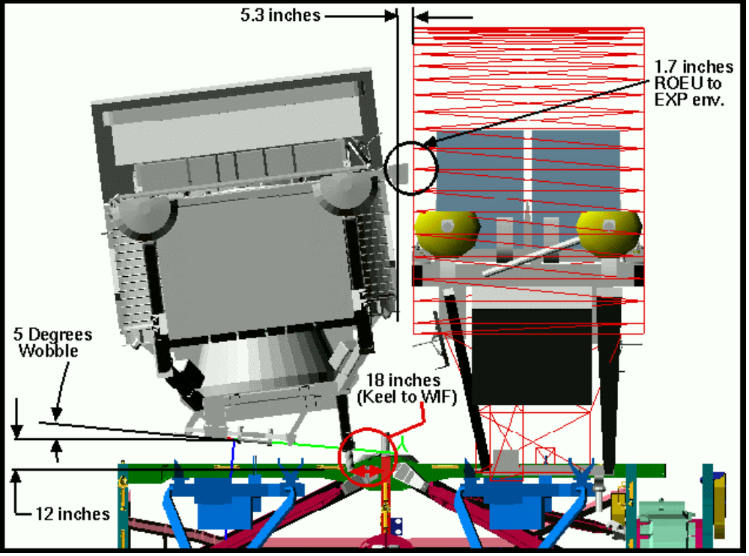

Figure 8 – AMS 12 inches away from berth, 5 Degree Wobble toward EXP
(ISS Back View)

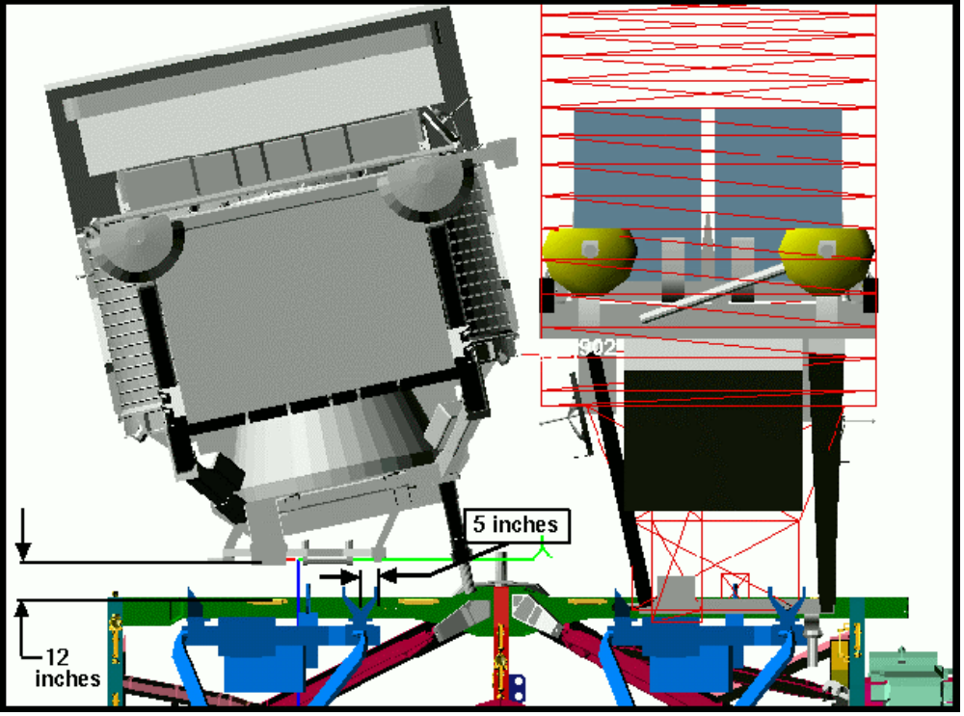

Figure 9 – AMS 12 inches away from berth, 5 inch Lateral Translation toward EXP
(ISS Back View)
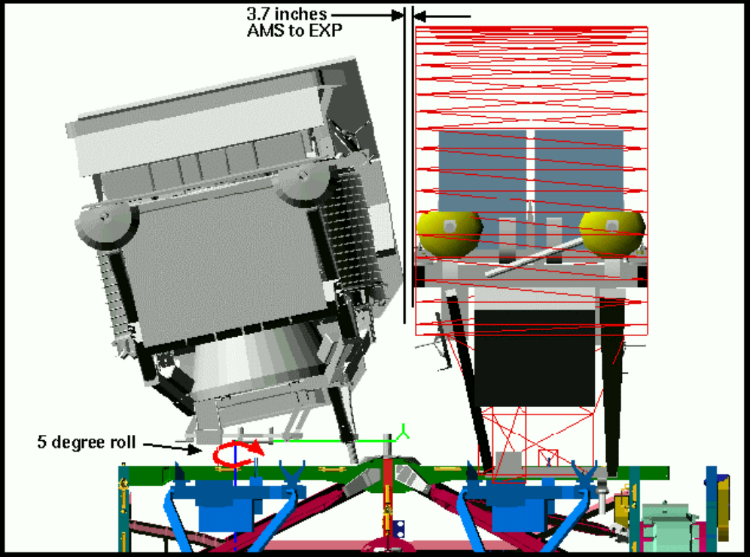

Figure 10 – AMS 12 Inches away from berth, 5 Degree Roll toward EXP
(ISS Back View)

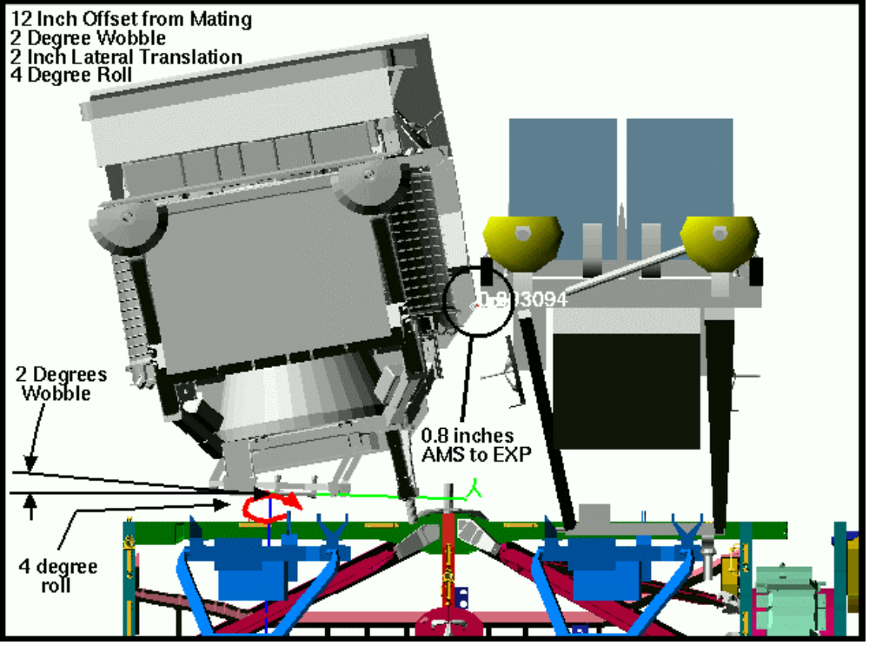

Figure 11 - AMS 12 Inches away from berth, 2Degree Wobble toward EXP,
2 Inch Lateral Translation toward EXP, 4 Degree Payload Roll
(ISS Back View)
One critical element in determining whether clearance violations are waiverable is the possible viewing of the operation. The S3 aft camera provides a view of the AMS installation to the S3 PAS site. Figure 12 shows the view from that camera of the AMS at a point 36 inches from its berth.

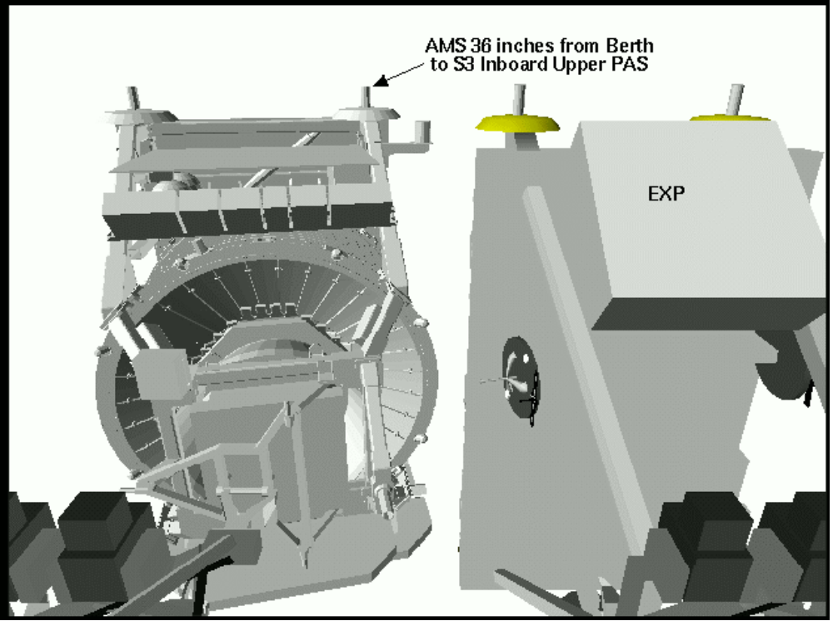

Figure 12 – View from S3 Aft Camera of AMS installation to S3 Inboard Upper PAS

If the clearance violations found for the AMS installation to the S3 PAS are not waived, the P3 PAS site may provide an alternate location. The installation of the AMS to the P3 Upper PAS was assessed and found to be robotically feasible. Figures 13 through 15 show the SRMS to SSRMS AMS handoff and the installation to the P3 Upper PAS. Figures 16 and 17 show the views from the P1 Outboard Upper and P3 Aft cameras. There were no clearance violations found for this installation.

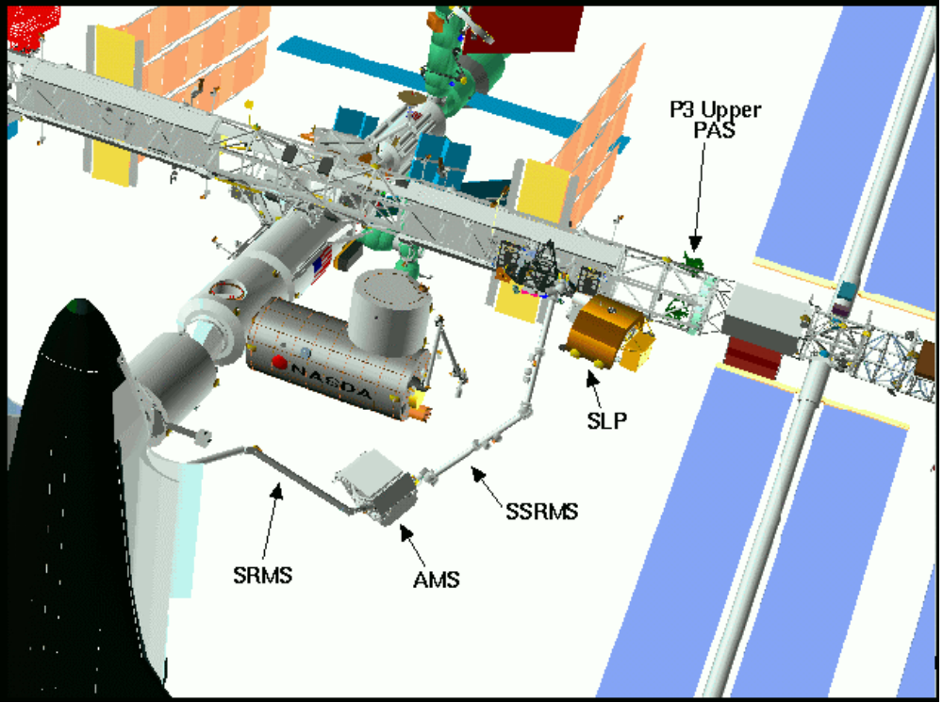

Figure 13 – SRMS to SSRMS Handoff of the AMS
(ISS Front-Port View)

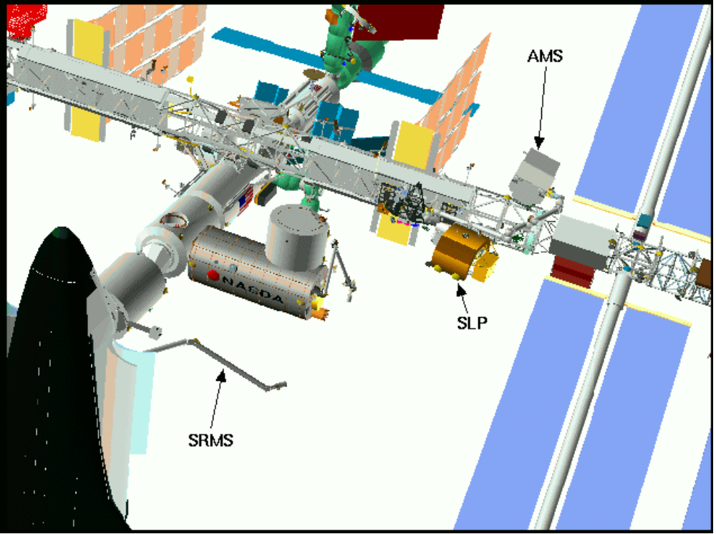

Figure 14 – SSRMS Installation of AMS to P3 Upper PAS
(ISS Front-Port View)

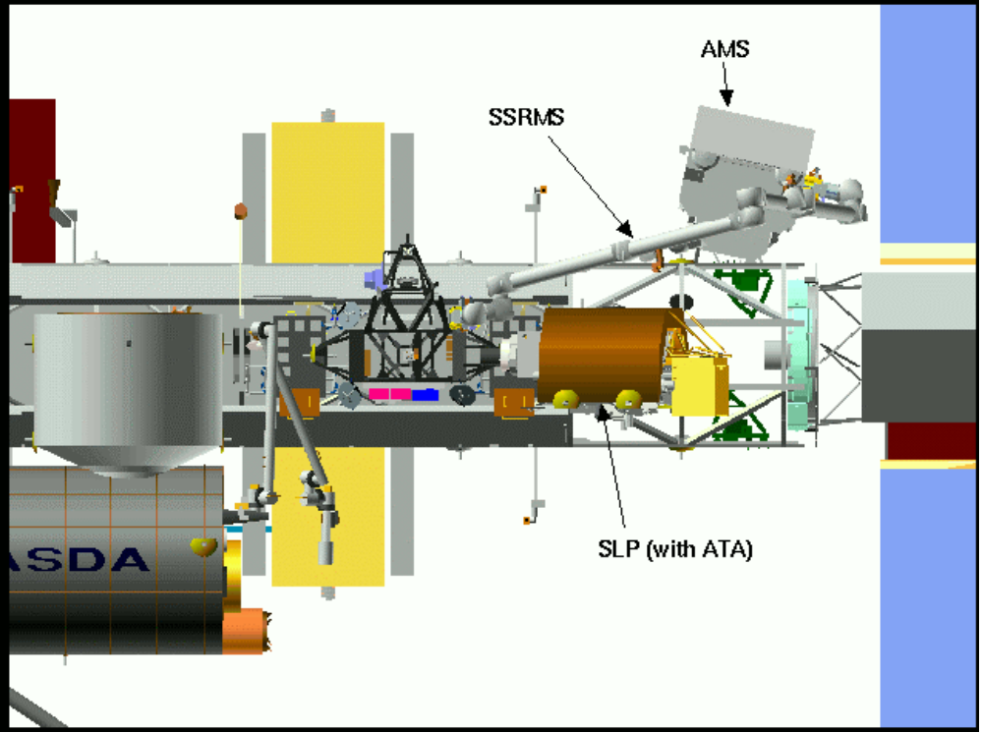

Figure 15 - SSRMS Installation of AMS to P3 Upper PAS
(ISS Front View)

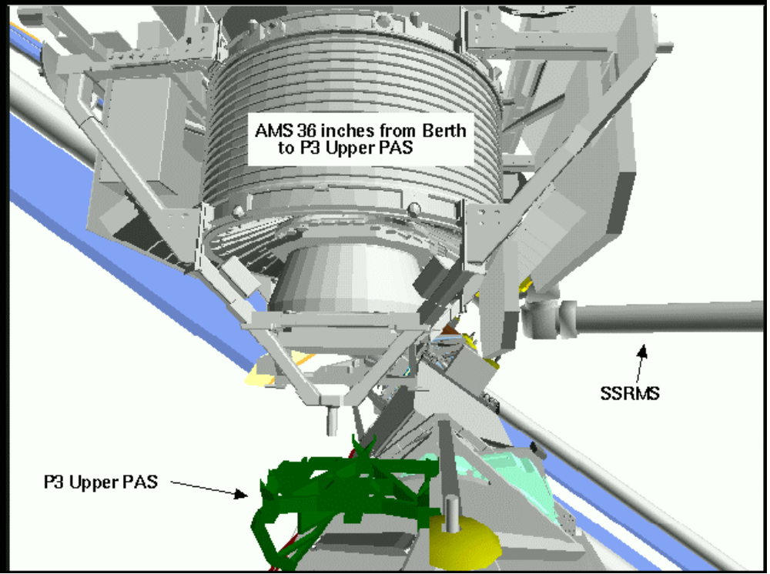

Figure 16 - View from P1 Outboard Upper Camera of AMS installation to P3 Upper PAS

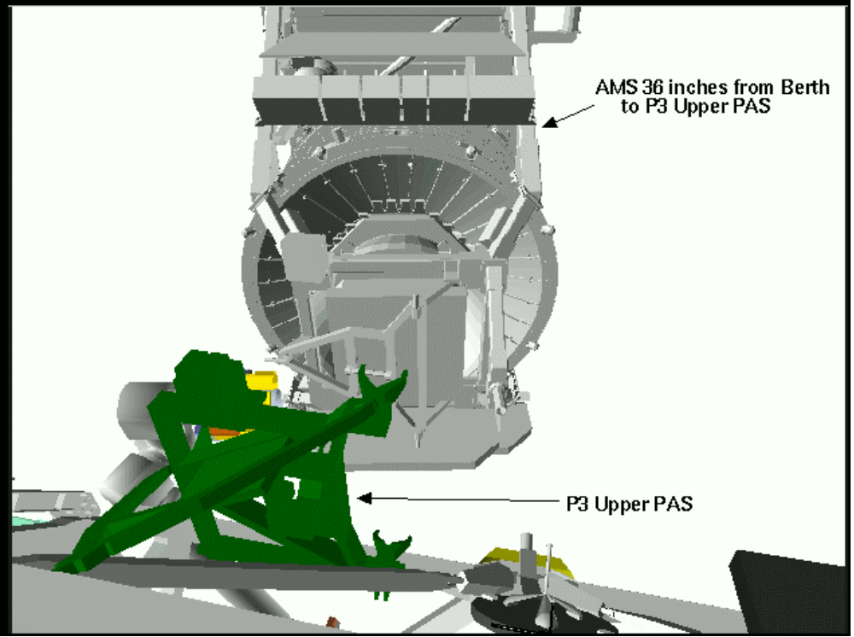

Figure 17 - View from P3 Aft Camera of AMS installation to P3 Upper PAS

The baselined operation of installing the EXP after the AMS is installed to the S3 truss was assessed for clearances. Using the same misalignments as were assumed for the AMS approach, the EXP approach clearances are slightly better. Table 2 shows these clearances from the EXP to the AMS. These clearances, like the AMS berthing clearances, are under the required twenty-four inch distance. The EBIT must consider these clearances as well as the AMS berthing clearances before a waiver may be granted for this operation.

Distance Between Passive  And Active Halves of PAS  (inches) | Tilt  (Wobble)  (degrees) | Lateral  Translation  (inches) | Roll  (degrees) | EXP to AMS Structure  (inches)
0 | 0 | 0 | 0 | 11.9
12 | 0 | 0 | 0 | 12.5
12 | 2 | 0 | 0 | 9.7
12 | 0 | 2 | 0 | 10.6
12 | 0 | 0 | 2 | 9.5
12 | 5 | 0 | 0 | 5.9
12 | 0 | 5 | 0 | 7.6
12 | 0 | 0 | 5 | 5.3
12 | 2 | 2 | 2 | 5.0
12 | 2 | 2 | 4 | 2.3
12 | 3 | 3 | 3 | 1.5
12 | 4 | 2 | 2 | 2.4
12 | 5 | 4 | 5 | 0
12 | 5 | 5 | 5 | 0

Table 2 – EXP Misalignments on Approach to S3 while AMS is Present

The worst case clearances from the EXP to the AMS occur when the EXP is approximately 27 inches from its berth instead of the 12 inches shown in Table 2. This is due to the proximity of the AMS’s ROEU to the EXP pallet top. Table 3 shows the clearances from the EXP to the AMS at a point 27 inches away from berthing. Figures 18 and 19 show two cases of these clearance violations.

Distance Between Passive  And Active Halves of PAS  (inches) | Tilt  (Wobble)  (degrees) | Lateral  Translation  (inches) | Roll  (degrees) | EXP to AMS Structure  (inches) | See Figure#
27 | 2 | 0 | 0 | 7.9
27 | 0 | 2 | 0 | 8.7
27 | 0 | 0 | 2 | 8.0
27 | 5 | 0 | 0 | 4.5
27 | 0 | 5 | 0 | 5.7
27 | 0 | 0 | 5 | 3.9
27 | 2 | 2 | 2 | 3.2 | 18
27 | 2 | 2 | 4 | 0.5
27 | 3 | 3 | 3 | 0.4 | 19
27 | 4 | 2 | 2 | 1.6
27 | 5 | 4 | 5 | 0
27 | 5 | 5 | 5 | 0

Table 3 – EXP Misalignments on Approach to S3 while AMS is Present

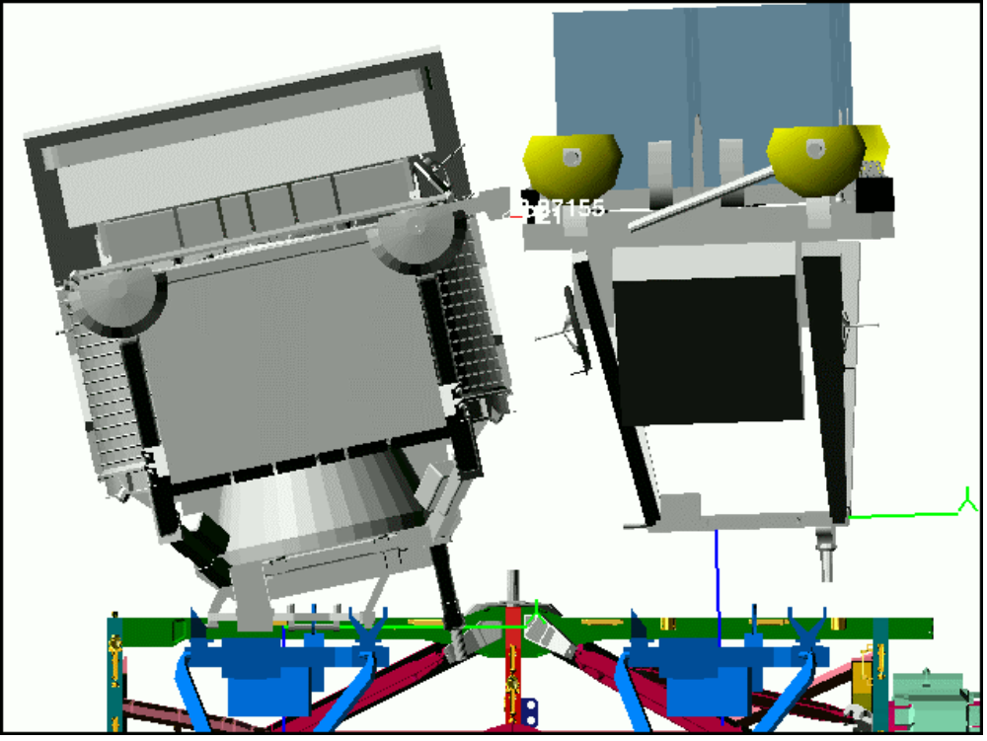

Figure 18 – EXP 27 inches from berth – 2 degree pitch, 2 inch lateral offset,
2 degree roll – ISS Back View

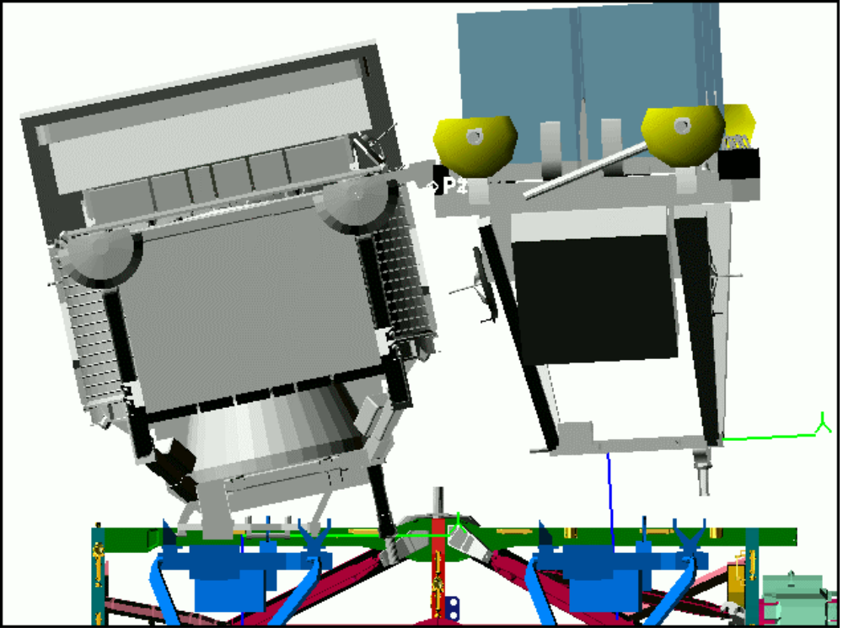

Figure 19 – EXP 27 inches from berth – 3 degree pitch, 3 inch lateral offset,
3 degree roll – ISS Back View

