THE PHYSICS OF
PARTICLE DETECTORS

Dan Green
Fermilab

Introduction

The subject of particle detectors covers those devices by which the existence and attributes of particles in a detecting medium is made manifest to us. The full and complete understanding of these devices requires a good understanding of basic physics. Without that knowledge we are simply "mechanics" without the capacity to advance the state of the art of detector technology. On the other hand, a rigorous understanding from first principles is also not an optimal approach. The "useful" understanding of a given device proceeds from an understanding of what approximations to full rigor are possible. That understanding can only come from experience and it is the purpose of this volume to communicate that experience. The aim of this text is to steer a perilous course between the purely descriptive and the purely theoretical.
The role of detectors can be visualized by assuming that an interesting interaction occurs at a point in space and time. From that point several secondary particles of different masses are emitted with various angles and momenta as shown in Fig. I.1. It is the job of the detector designer to measure the time of interaction, t, and the vector momenta, ${\vec{p}}_{i}$, and masses, M_{i}, of those emitted particles. The text is organized so as to show the ensemble of tools available to the designer. Typically, mathematical detail and topics outside the main scope of the text are relegated to the Appendices.
Fig. I.1: A schematic representation of the reaction A+B → 1+2+3+4+5+6. The reaction is specified when the vector momentum and mass of each particle is determined.

A list of the topics covered is given in the Table of Contents. The first Section is an introduction devoted to a numerical description of the appropriate size, energy scales, and cross sections for different processes. The numerical data given in the tables of Section 1 will constantly be referred to in later Sections.
There then follow eight Sections on "nondestructive" measurements, or those which do not appreciably change the measured particle’s position or momentum. The first subtopic concerns the measurement of time and velocity. Section 2 starts with the basic physics of the photoelectric effect and leads into photomultiplier tubes, scintillator and time of flight measurement. Section 3 describes velocity measurement by way of the emission of optical photons in the Cerenkov process. Section 4 follows with a discussion of the closely related emission of x-ray photons in transition radiation which also determines the velocity of a particle.
The second subtopic within nondestructive readout first lays the physics groundwork of elastic scattering in Section 5. Section 6 then covers the application of single scattering to scattering off atomic electrons and the resulting energy loss. Detection of the energy lost is the physical basis of many of the techniques used in charged particle detection. The third subtopic then follows up with the nondestructive measurement of the position and momentum of charged particles. Section 7 contains a derivation of the particle trajectory in a magnetic field and the consequent measurement of momentum. Those measurements have intrinsic limitations which are explored first in Section 8 in studying diffusion in gases and wire chambers. Section 9 looks at faster and higher spatial resolution Si detectors for more accurate position measurements.
The text then switches to destructive measurements, where the particle to be measured loses a significant fraction of its energy or is fully absorbed in the detector. First, in Section 10, we lay the physics foundation by exploring radiation and photon scattering. Then these concepts are applied in exploring the topic of destructive energy measurements. Section 11 describes measurements of electron and photon energy, while Section 12 describes the measurement of the energy of strongly interacting particles.
Finally, a general-purpose high energy physics detector using all the previously described techniques is sketched in Section 13. The concept of multiple redundant measurements is introduced and several examples are given.
The full set of material in the text is suitable for a 1 year course. If a 1 semester course is desired, the algebraic details in the Appendices can be skipped as well as Section 1, the first half of Section 2 and Sections 5, 6, and 10 assuming that no supplementary physics background was required.
Note that the subjects covered in the text are strongly limited to detectors themselves. Exceptions are a brief description of coincidence circuits in Section 2 and front end noise processing in Section 9. These brief forays were made since these special topics were tightly connected to the detectors themselves. However, there is no other discussion of front end electronics, trigger systems, data acquisition, or computer programming. In addition, the vital area of detector modeling and Monte Carlo techniques is only sketched in Appendix K. Probability theory and statistical analysis appears only briefly in Appendix J. References to these vital areas are given at the end of the text for readers who want to go beyond the scope of this volume.
The aim of this text is to describe the full ensemble of particle detectors from first principles. The goal is to strike a balance between simply presenting the final result and a full and rigorous derivation and thus to extract the relevant physics in a clear fashion. Intuition and order of magnitude numerical estimates are stressed throughout in an attempt to communicate the insights garnered from experience.

“Ah, but a mans reach should exceed his grasp or what’s a heaven for.”

Robert Browning

“Curiosity is, in great and generous minds, the first passion and the last.”

Dr. Samuel Johnson, 1750

General References - A
Mechanics, Electricity and Magnetism and Quantum Mechanics

[1] The Feynman Lectures in Physics, R. Feynman, R. Leighton, M. Sands, Addison-Wesley Publishing Co., Inc. (1963).
[2] Classical Mechanics, H. Goldstein, Addison-Wesley Publishing Co., Inc. (1950).
[3] Classical Electricity and Magnetism, W.K.H. Panofsky and M. Phillips, Addison-Wesley Publishing Co., Inc. (1962).
[4] Quantum Mechanics, E. Merzbacher, John Wiley & Sons, Inc. (1961).

General References - B
Textbooks on Particle Detectors

[1] Detectors for Particle Radiation, K. Kleinknecht, Cambridge University Press (1987).
[2] Experimental Techniques in High Energy Physics, T. Ferbel, Addison-Wesley Publishing Co., Inc. (1987).
[3] Instrumentation in High Energy Physics, Ed. F. Sauli, World Scientific (1992).
[4] Instrumentation in Elementary Particle Physics, J.C. Anjos, D. Hartill, F. Sauli, M. Sheaf, Rio de Janeiro, 1990, World Scientific Publishing Co. (1992).
[5] Instrumentation in Elementary Particle Physics, C.W. Fabjan, J.E. Pilcher, Trieste 1987, World Scientific Publishing Co. (1988).
[6] “Particle Detectors” C.W. Fabjan, H.F. Fisher, Repts. Progr. Phys. 43, 1003 (1980).

1. Size, Energy, Cross Section
"Beauty depends on size as well as symmetry."......Aristotle
"Energy is eternal delight.".......W. Blake
Textbooks on detectors often jump directly into a description of the devices themselves. The relevant descriptive formulae are then simply given without derivation and readers are instead referred to the relevant texts. A complementary approach is taken here. A “derivation” of the relevant physics is always attempted first. Armed with the derivations, the reader is then introduced to the detector where approximations which are made are explained along with the reasons why they are valid. In order to contain the length of the text, all “derivations” are heuristic and thus either compressed or left to the Appendices.
Numerical examples are given at regular intervals in order that the reader be firmly connected to real devices and have a firm grasp of the appropriate orders of magnitude. We note that "intuition" is largely the result of experience. The judgement that allows a simplifying approximation to be made usually comes with an appreciation of orders of magnitude of the quantities involved. In this text, that hard won "intuition" is, it is hoped, passed on to the student.
Detectors function by causing a particle to interact with some detecting medium. For example, a charged particle might ionize a gas in a device and the freed charge might be collected as an electrical signal localized in time, a “pulse”, on a detector electrode. To characterize the detector it is fundamental to understand the probability of interaction of the particle with the device. The aim of Section 1 is to provide the basic numerical data needed to later characterize the interaction probability of the different particles which we wish to detect.

1.1 Units
It is traditional in high energy physics to work in dimensionless units where $ℏ$ and c are defined to be equal to 1. In those units momentum (pc), energy (ε), mass (mc²), inverse time $\left(ℏ/t\right)$ and inverse length ($ℏ/x$) all have the same dimensions, which we take to be energy. Units for energy are taken to be the electron volt, where one electron volt, eV, is the energy, , gained by an electron of charge e, in dropping through a potential difference, , of 1 Volt, A tabulation of many of the physical quantities used throughout the text is given in Table 1.1[1].
Table 1.1
Fundamental Physical Constants
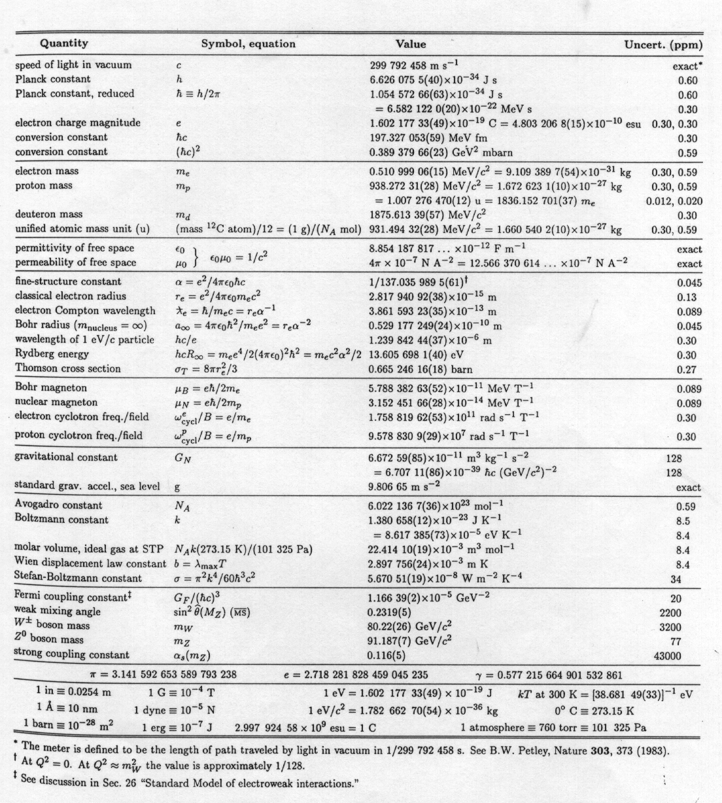
(From Ref. 1.1)
In that table, the speed of light, Planck’s constant, the electron charge, the masses of elementary particles, the fine structure constant, the classical electron radius, the Compton wavelength of the electron etc. are gathered together in electron volt and in MKS units. This table and Table 1.2 contain sufficient numerical information for the needs of this text. Kinematics, the constraints imposed by energy-momentum conservation, are worked out in Appendix A.

Table 1.2
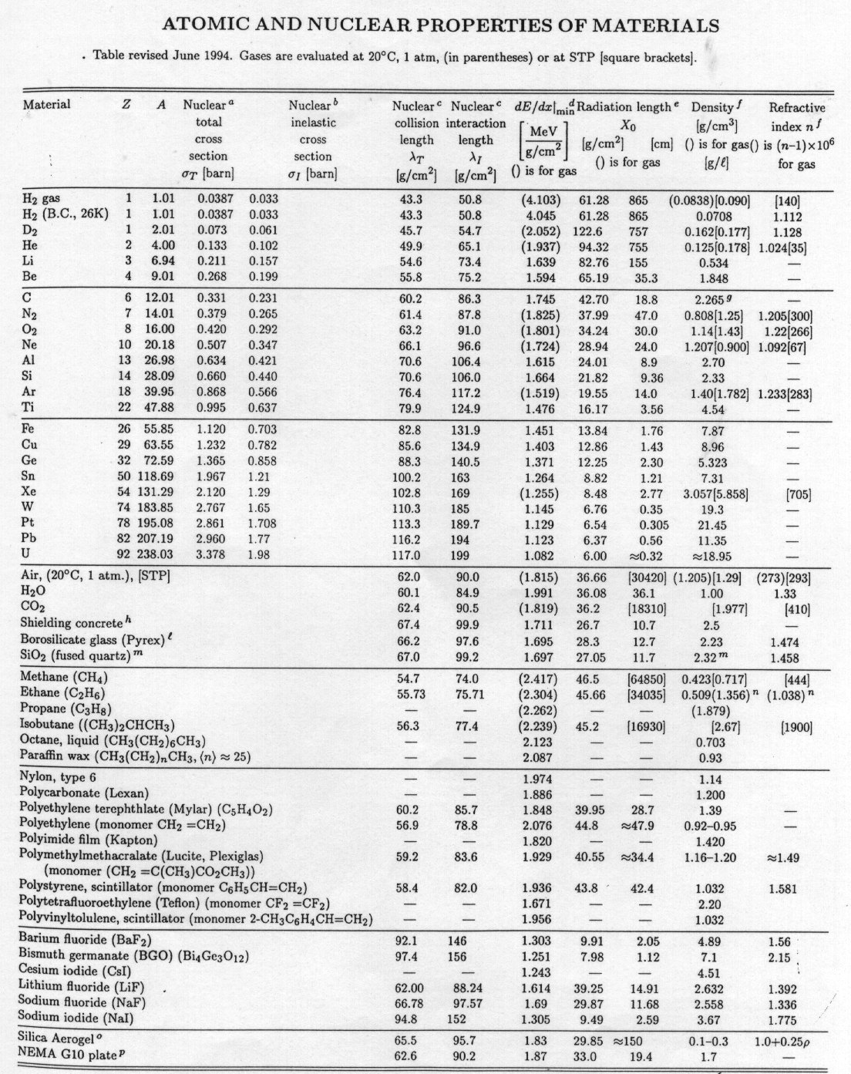
(From Ref. 1.1)

1.2 Planck’s Constant
In going from the dimensionless calculations of high energy physics to dimensional quantities, it is necessary to know the Planck constant and be able to use it. (See Table 1.1.)
$\begin{aligned}hc=0\text{.}2\text{GeV}\text{fm},1\text{GeV}={\text{10}}^{9}\text{eV} \\ \text{2000}\text{eV}\overset{o}{A} \\ 1\overset{o}{A}={\text{10}}^{−8}\text{cm},1\text{fm}={\text{10}}^{−\text{13}}\text{cm} \\ \text{10}\text{nm}\text{.}\end{aligned}$ (1.1)
Planck’s constant is given for two different distance scales, the Angstrom and the Fermi. Those two distance scales are characteristic of the size of an atom and the size of a nucleus respectively. The conversion of size to energy leads us to the immediate conclusion that nuclear energy scales are GeV whereas atomic energy scales are of order a few electron volts. The ratio of one Angstrom to one Fermi is 100,000 to 1.

1.3 Electromagnetic Units
In the body of the text we will most often use CGS units in symbolic manipulations and we will freely convert back and forth to MKS units. It is a fact of life that practicing physicists must acquire a facility with both systems of units since experimentalists have connections to both theory and engineering. (See the beginning of Section 3 for a full explanation.) We will later explicitly give a prescription for converting between MKS and CGS units.

1.4 Coupling Constants
What about the characteristic strength of the forces between particles? These are defined by dimensionless coupling constants whose size gives us a measure of the strength of the interaction. For electromagnetism we have the familiar fine-structure constant, , which has the strength of roughly 1/137, Table 1.1. The strong interactions have a coupling constant α_{s} which is larger because the forces are stronger. Why is α dimensionless? The dimension of U = e²/r, indicated by brackets, is energy so [e²] = [energy • length]. The dimension of $h$ is [energy • time] and of $hc$ is [energy • length]. Thus α = e²/$hc$ is indeed dimensionless.
$\begin{aligned}α={e^{2}}/{hc}\text{\sim }1/{\text{137}} \\ α_{s}={g_{s}^{2}}/{hc}\text{\sim }(1/{\text{10}}−1)(\text{Table}1\text{.}1)\end{aligned}$ (1.2)
The electromagnetic force is very familiar in everyday life. The existence of a strong force may be inferred by the observation that nuclei are bound systems containing one or more protons. Coulomb repulsion of the protons must then be overcome by another, stronger force. The strong interaction is responsible for binding the hadronic, or strongly interacting, particles like the proton together. Nuclei are then bound together by means of a residual “strong interaction” in analogy to the Van Der Waals molecular binding of neutral atoms. Our treatment of the strong interactions will be completely phenomenological and contained only in the last two Sections. We will not discuss the weak interactions which are responsible for radioactive decay nor the gravitational interactions. Detectors using non-destructive methods usually use only the electromagnetic interaction of a particle with the detecting medium.

1.5 Atomic Energy Scales
Let us now turn towards a description of the energy scales of systems, beginning with the atomic energy scale. The atom is held together by the electromagnetic attraction between the nucleus and the "orbiting" electrons. Since the proton is so much heavier than the electron, m_{e}/m_{p} ~ 1/2000 (Table 1.1), it is essentially at rest and there is only one dynamic mass scale in the problem which is the electron mass, as illustrated in Fig. 1.1.

Fig. 1.1: Definition of orbital radius and velocity of the electron.

The bound state lowest Bohr energy level is E_{o}.
(1.3)
We know experimentally from spectroscopy that the energy levels of bound systems are quantized. The hydrogen atom is characterized by a quantum number n defining an energy E_{n} = -E_{o}/n². An example of data for atomic hydrogen is shown in Fig. 1.2 where the discrete atomic spectrum of the emitted light is obvious and the 1/n² behavior of the lines is evident. 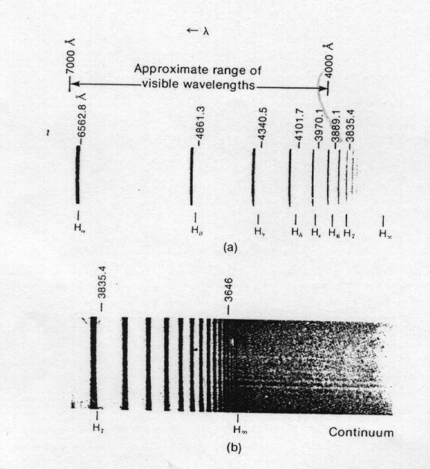

Fig. 1.2: Discrete emission spectrum for atomic hydrogen. (From Ref. 1.8, with permission) a) visible region, b) full spectrum.

Let us compute the H_{α} wavelength to give us confidence. This line is due to a transition from n = 3 to n = 2 which causes emission of a photon with energy (Eq. 1.3) of 1.89 eV. Using Planck’s constant to convert energy to frequency, λ = 2π($ℏc$)/1.89 eV = 6645 $\overset{o}{A}$ as seen in Fig. 1.2. The ionization continuum where the atom is broken apart and the electron is freed is also seen in Fig. 1.2.

It is easy to “derive” the Bohr energies by appealing to the minimization of the total system energy in the ground, or lowest energy, state. The kinetic, T, plus the potential energy, U, is the total system energy, E, which is a conserved constant. There is a balance between the negative attractive potential, whose magnitude increases as the radius of the system, a, decreases and the positive kinetic energy which also increases as the radius decreases. Since T goes as 1/a², while U goes as 1/a, there is a stable minimum. The minimum occurs at the first Bohr radius, a_{o}, which defines the atomic size scale, 0.54 Angstroms, Table 1.1. The Heisenberg uncertainty principle for position and momentum uncertainties $Dp,Dx$, $DpDx\text{\sim }h$ supplies the crucial element of this “derivation”. Throughout this text p represents particle momentum, and we assume that the uncertainty in p, , is of order p while the uncertainty in position, , is of order a.
$\begin{aligned}T+U=E,DpDx\text{\sim }h\text{\sim }\text{pa} \\ \frac{{\left(Dp\right)}^{2}}{2m}+U=E=\frac{h^{2}}{2{\text{ma}}^{2}}−{e^{2}}/a \\ ¶E/¶a=0@a=a_{o}\end{aligned}$ (1.4)
The other characteristic length scale is the Compton wavelength of the electron, $D=h/{\text{mc}}$, which is much smaller than a_{o} (see Table 1.1). The characteristic size in the atomic bound state is the Compton wavelength divided by .
$\begin{aligned}a_{o}=D/α=0\text{.}\text{54}\overset{o}{A},E=E_{o}={−e^{2}}/2a_{o} \\ D=h/{\text{mc}}=0\text{.}\text{004}\overset{o}{A}(\text{Table}1\text{.}1) \\ β=α,β=v/c\end{aligned}$ (1.5)
For example, if the coupling, α, went to zero the characteristic size for the system would become infinite, which means that the system is unbound. A larger would mean tighter binding or a smaller bound state radius. Plugging the Bohr radius back into the expression for E we can show that the electron velocity with respect to that of light, , is in fact equal to the fine-structure constant. Therefore, the atom is fairly loosely bound and its’ motion is nonrelativistic, << 1.

Perhaps this should not surprising because we know that, for example, batteries are driven by processes with atomic (or chemical) energy scales. Hence we expect them to produce of the order of 1 Volt and they do. As another example, since the atomic energy scales are electron volts, we expect the light which is emitted in making transitions between those energy levels to be a few thousand Angstroms which is indeed the wavelength of visible light, Eq. 1.1. Thus, if we knew only that human beings see at the thousand Angstrom scale of wavelength, we could infer that they live in a world with atomic energy levels that were of the order of electron volts.

1.6 Atomic Size
The structure of multielectron atoms is determined by the Fermi exclusion principle which states that one and only one electron can occupy a quantum state. Recall that the energy levels in the hydrogen atom are E_{n} = E_{o}/n², n = 1, 2... Higher level atomic states, with larger n, have more momentum, and are thus less deeply bound. Since E ~ T ~ p² and p ~ $¶/¶x$, a state with n oscillations of the wave function will have energy ~1/n² (see Appendix B). As n increases the electrons are less tightly bound, a_{n} = a_{o}n (see Appendix B). Therefore in atoms lower n values are filled by electrons first.
The angular momentum, L, is quantized in units of $h,L^{2}=l(l+1)h^{2},l<n$ and the number of projections of angular momentum along an arbitrary axis is $L_{z}=mh,−l<m<l$ or $(2l+1)$ projections. The electron spin, $s_{Z}={sh}/2$ can be or . Thus there are $2(2l+1)$ electron states for a given $l$. These are called “shells”. Since the centrifugal force pushes us away from the origin, the effective potential is positive (repulsive) and lower $l$ states lie lower in energy and hence are filled first (see also Appendix B). The fact that lower n fill first and that within a given n lower $l$ fill first is sufficient to understand much of the periodic table of the elements.
The atomic size, a, and ionization potential I (the energy needed to free a single electron from the element) of the first, Z = 36, elements are shown in Fig. 1.3.

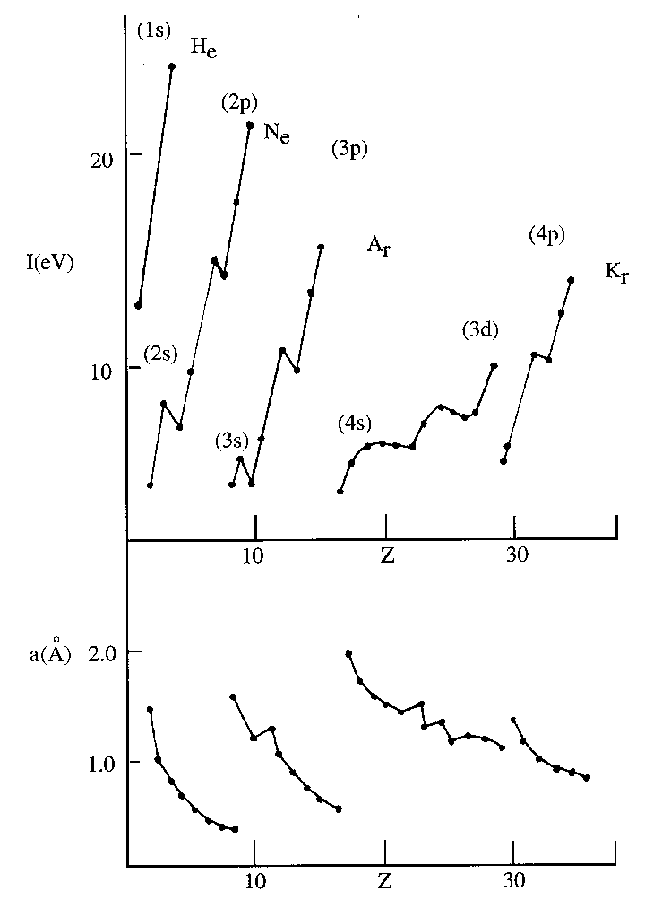

Fig. 1.3: Ionization potential and atomic size for atoms with Z ≤ 36. The scales are ~ 10 eV for I and ~ 1 for a.

Note that the atomic "shell structure" (labeled in the figure) is clearly mirrored in the behavior of I, which rises until the shell is filled at the location of a noble gas. That is n=1, $l$=0, 2 states (1s). For n=2 $l$=0, 2 states (2s) plus $l$=1 or 6 states (2p). For n=3 $l$=0, 2 states (3s), plus $l$=1 or 6 states (3p). At that point n=4 $l$=0, 2 states (4s) intervenes prior to n=3, $l$=2 or 10 states (3d)
The behavior of the size is to decrease with the filling of the shell. The largest atoms therefore correspond to metals with a single electron loosely bound outside a closed (noble gas) shell. The variation of a and I is less than a factor ~4 for Z < 36. Thus, to lowest approximation, all atoms have the same size because as Z increases the force on the electrons becomes stronger but the Pauli exclusion principle forces the occupation of higher quantum states, n, which are more loosely bound. The inner closed shells of electrons are tightly bound and largely chemically inert and only the outer or valence electrons are chemically active.
The small size of atoms means that we perceive macroscopic bodies as continuous. For example, for atoms of 10 $\overset{o}{A}$ size, a 1m × 1 m × 1 m object has 1 billion × 1 billion “pixels”. Compared to a computer screen of high resolution this number is enormous. A dust speck 0.1 mm on a side, just visible to us, contains 100,000 × 100,000 atomic “pixels”.

1.7 Atomic Spin Effects
In what follows we will essentially ignore spin effects. The reason we can do this is that the energy of an electron magnetic moment, $m={eh}/2m_{e}$, in a magnetic field, B, is, . Numerically , Table 1.1. For B = 20 kG, E_{B} ~ 1.2 x 10⁻⁴ eV . Hence, the spin energies are normally tiny with respect to E_{o} which allows us to ignore them for the purposes of describing detectors.

1.8 Cross Section and Mean Free Path
Let us now consider the cross section, , which describes the probability of collision. It gets its name from the fact that in some cases it is related to the geometric cross sectional area of the system which is scattered from. The kinematic definitions of circular frequency, , wavelength, , and wave number, k, for an incident wave packet scattering off an extended object of radius a are shown in Fig. 1.4. The linear frequency is f and . Assuming the velocity of propagation is c, then . The wave number k is related to as, , .
Fig. 1.4: Kinematic quantities for wave packet scattering off an extended object of size ~a.

The geometric cross section of the scattering centers is classically simply the cross sectional area of a sphere of characteristic size a.
$\begin{aligned}s_{\text{atom}}\text{\sim }{pa}_{o}^{2}\text{\sim }3x{\text{10}}^{8}b,a_{o}\text{\sim }1\overset{o}{A} \\ s_{\text{nuc}}\text{\sim }{pa}_{N}^{2}\text{\sim }\text{31}\text{mb},a_{N}\text{\sim }1\text{fm} \\ (hc)^{2}=0\text{.}4{\text{GeV}}^{2}\text{mb} \\ 1\text{mb}={\text{10}}^{−\text{27}}{\text{cm}}^{2},1b={\text{10}}^{−\text{24}}{\text{cm}}^{2}\end{aligned}$ (1.6)
The geometric cross section for atoms is expected to be hundreds of millions of barns, while the cross section for nucleons is expected to be on the order of tens of millibarns. That ratio of 1010 is simply the square of the ratios of the characteristic sizes of the systems. For reference, the dimensionless quantity $(hc)^{2}$ is 0.4 (GeV)2 mb which means that a system bound with typical energies of GeV has a geometric cross section of order millibarns. The cross section will be a fundamental concept in what follows because it quantifies the probability of a particle to interact with the detecting medium.
It is useful to define a quantity related to which is called the mean free path, <L>. The quantity <L> is defined to be the average distance between scatterings. The scatterings are distributed in distance x of material traversed as , where is the cross section to scatter off a nucleus, N_{o} is Avagadros number, (see Table 1.1), $ρ$, is the mass density of scattering centers and A is the atomic weight. Thus $N_{o}ρ/A$ is the number of nuclei per unit volume of the medium having density $ρ$.
This equation can be easily visualized. Suppose we throw N objects at a slab of material of thickness dx. We cannot aim at the nuclei, so the chance to scatter is probabilistic. The number of nuclei per unit area transverse to the incident x direction is . Therefore, if each nucleus has an effective transverse area of σ, the probability to scatter is which has the solution
$N(x)=N(0)\text{exp}(−N_{o}{ρxs}/A)$ (1.7)
The mean free path <L> is then.
(1.8)
We define the mean free path in centimeters or in grams per centimeter squared by using the mass density . The latter definition is more compact in that different systems will typically have mean free paths which are fairly constant in [gm/cm²] units. See, for example, the column of entries in Table 1.2 for which varies only a factor ~2 over the full periodic table. As defined, dN/N = -dx/<L>, so that <x> = <L> where the bracket notation denotes an average over some statistical distribution. For example, taking from Eq. 1.6, assuming a gas with (Table 1.2) and we find an atomic mean free path of . In contrast, using , we find in the gas, or in a solid of density equal to . Thus the atomic mean free path in a gas is of order μm, which we refer to in Section 8, while the nuclear mean free path in a solid is of order meters. Clearly detectors of atoms can be rather compact.
The atomic cross section for scattering on argon as a function of projectile energy is shown in Fig. 1.5. It should be noted that, although there is an energy dependent structure, the estimate given in Eq. 1.6 is certainly a reasonable representation of the typical size of the atomic cross section. The two decades shown span the region from 107 to 109 barns.
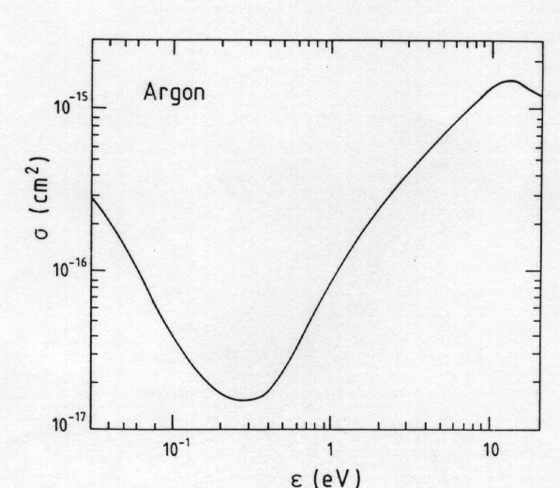
Fig. 1.5: Atomic cross section off argon as a function of projectile energy. (From Ref. B.1, with permission).

1.9 Partial Waves and Differential Cross Section
In order to motivate the geometric cross section given in Eq. 1.6 let us very briefly review the quantum mechanical theory of scattering[6]. Some additional detail is given in Appendix B.
The wave function of a scattering state, , consists of an incoming plane wave and an outgoing spherical wave with a scattering amplitude, A, which can be decomposed into individual partial waves since central forces conserve angular momentum. The wave number is k which is related to the momentum p as $\vec{p}ºh\vec{k}$. In the spinless case the conservation of angular momentum means that the quantum number $l$ is conserved. The elastic differential cross section, or the distribution function for the scattering angle, , is related to the square of the scattering amplitude. The solid angle is the spherical area element . Note that is dimensionless and that the dimensions of are inverse momentum squared, or length squared, as expected.
In the case of purely elastic scattering the amplitude is;
$\begin{aligned}ψ → e^{\text{ikz}}+ A(θ)({e^{\text{ikr}}}/{\text{kr}}) \\ A(θ) = \frac{1}{2i}\sum_{ℓ}{(2ℓ+1)(e^{iδℓ}−1)P_{l}(\text{cos}θ)} \\ \frac{dσ}{dΩ} = {\left|A(θ)\right|}^{2}/k^{2}\end{aligned}$ (1.9)
The phase shift $d_{l}$ is caused by the scattering interaction; $d_{l}→0$ means $A(q)→0$. $P_{ℓ}$ (cosθ) is the Legendre polynomial of index $l$. The total scattering cross section, , integrated over all scattering angles can also be decomposed as a sum over partial waves.
$\begin{aligned}σ=\frac{4π}{k^{2}}\sum_{ℓ}{(2ℓ+1){\text{sin}}^{2}δ_{ℓ}} \\ \text{}=\frac{4π}{k^{2}}\left[\text{Im}(A(0))\right]\end{aligned}$ (1.10)
The optical theorem relates the imaginary part of the forward scattering amplitude, Im(A(0)), to the total cross section, σ. We can relate the total cross section to the index of refraction in order to make the connection to optics. As we will see in Section 3, a wave propagating in a medium is characterized by an index of refraction n. Since the phase factor of the associated field is $i(\vec{k}⋅\vec{x}−wt)$ and , the attenuation of the wave is . Since the probability goes as the square of the wave function, the mean free path is = c/[2ωIm(n)]. (See Section 3.)
Unitarity is another incarnation of the conservation of probability. Each partial wave, labeled by $l$, has an unitary upper limit which, as can be seen from Eq. 1.10, occurs when the sine of the phase shift $d_{l}$ is a maximum. The center of mass (CM) wave number is k, while the CM energy is . (See Appendix A.)
$\begin{aligned}σ_{ℓ} < \frac{4π}{k^{2}} (2ℓ+1) \\ k = p^{}≃ \sqrt{s}/2,\text{} p = ℏk,\text{} ℏ = 1 \\ s = (\text{CM} \text{energy})^{2}\end{aligned}$ (1.11)
If there are absorptive processes then the phase shift becomes complex, and we must distinguish between elastic scattering, , inelastic scattering, , and the total cross section, .
In the absence of absorption A classical example with non-zero
inelastic cross section is scattering off a completely absorbing body. In that case . The intermediate case of partial absorption is discussed in the references given at the end of this Section, e.g. Ref. 6, and in Appendix B.
The ratio of is shown in Fig. 1.6 for proton scattering off nuclei (see Table 1.2). As indicating little absorption, while heavy nuclei look like “black” fully absorbing objects, since as These facts will be applied in our description of calorimetry in Section 12.
A geometric interpretation of the cross section is possible if the incoming wave suffers no scattering when it is outside an absorbing object of radius a but is totally absorbed when it is inside radius a. In that case there is an absorption of all angular momenta, $\vec{L}$, up to some maximum which is proportional to the radius.
$\begin{aligned}ℓ_{\text{max}} \text{\sim } \text{ka} \text{}(\vec{L} ≡ \vec{r} × \vec{p}, \vec{L}\text{\sim }ℏℓ, \vec{p}=ℏ\vec{k}) \\ σ_{T}\text{}\text{\sim }\sum_{0}^{ℓ\text{max}}{σ_{ℓ}} = \frac{4π}{k^{2}} \sum_{0}^{(\text{ka})}{(2ℓ+1)} \\ \text{} \text{}\text{\sim } 4{πa}^{2}\end{aligned}$ (1.12)
Fig. 1.6: Ratio of elastic to inelastic cross section for proton scattering off nuclei of different atomic weight A. A “transparent” nucleus has while a “black” nucleus has .

Indeed, the cross section is proportional to the geometric cross section of the object. The fact that the cross section exceeds the physical area is due to the quantum mechanical wave nature of the scattering. Basically in the presence of absorption there must be elastic “shadow” scattering. At high energies the absorptive diffraction pattern is confined to an angle where $q\text{\sim }{{Dp}_{T}}/p\text{\sim }λ/a\text{\sim }h/{\text{ap}},$ since the uncertainty principle implies that there is in irreducible momentum impulse given to the wave in scattering off an object of size a, ${Dp}_{T}\text{\sim }h/a$.

1.10 Nuclear Scales of Energy and Size
We now turn to the cross section and size scale characteristic of the atomic nucleus. Basically we think of a nucleus as containing Z protons plus (A-Z) neutrons or A “nucleons” in total. If we consider them to be spherical objects with a size of order the Compton wavelength of a proton, $ƛ_{p}$, packed together in a nucleus of volume V, it is clear that the size of the nucleus, a_{N}, scales as the atomic weight, A, to the 1/3 power.
$\begin{aligned}\underline{V}=\frac{4p}{3}a_{N}^{3}=A\frac{4p}{3}D_{P}^{3} \\ a_{N}\text{\sim }D_{P}A^{1/3}\end{aligned}$ (1.13)
Notice that the Compton wavelength of a proton, $ƛ_{P}$, is about 0.2 Fermi. Referring to Eq. 1.4, $a=D/α$, and knowing that the strong coupling constant α_{s} is large, we expect a proton size ~$D_{P}$. Using the derived geometrical interpretation of the total cross section, we expect scaling of the nuclear cross section, , as the 2/3 power of the atomic weight, and the scaling of the mean free path, <L> as the 1/3 power of the atomic weight. In Table 1.2 <L> is given, in gm/cm² units, as the column labeled λ_{I}.
$\begin{aligned}s_{N}\text{\sim }{pa}_{N}^{2} \\ \text{\sim }A^{2/3} \\ \left\langle L\right\rangle \text{\sim }A^{1/3}(\text{Eq}\text{.}1\text{.}8) \\ λ\text{\sim }(\text{35}{\text{gm}}/{{\text{cm}}^{2}})A^{1/3}\end{aligned}$ (1.14)
For example, a detection device which absorbed all the energy in an incident proton might take ~10λ_{I} since the secondary debris may itself interact. Thus, a steel device (Hadron Calorimeter - Section 12) could be expected to be ~ 1.6m "deep".

1.11 Nuclear Cross Section
In Fig. 1.7 is shown the proton-protron and antiproton-proton scattering cross section as a function of energy. The geometric cross section is about 30 millibarns which is comfortably within an order of magnitude of the observed total cross section over a substantial range of energy.
The nuclear cross section, atomic number Z, and atomic weight A are given in Table 1.2 along with several other properties of materials. For different materials the total cross section, , the inelastic cross section, , the inelastic mean free path, and other quantities which will be discussed later, (the ionization, the ionization per unit length and the radiation length) are all given in Table 1.2. This table serves as the source of data for many of the numerical calculations given in later Sections of the text. For example, using Table 1.2 we find that a 1m long liquid hydrogen target has a 14% (/A = 0.14) probability that an incident proton will interact in traversing it.

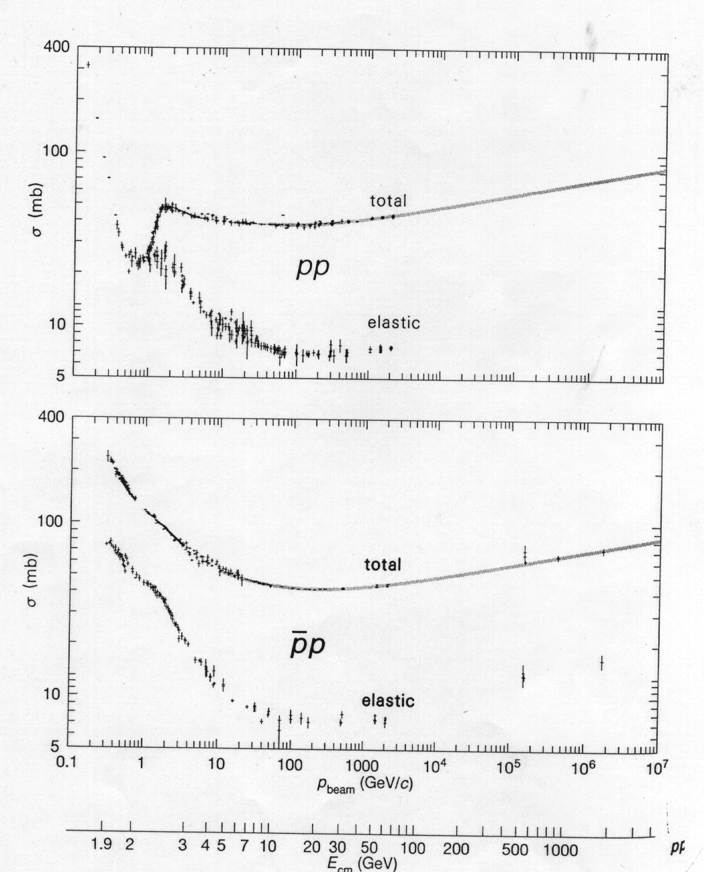
Fig. 1.7: Proton/antiproton cross section on proton as a function of projectile energy. (From Ref. 1.1.)

In order to display the expected functional dependence of the inelastic cross section, that quantity is plotted as a function of the atomic weight in Fig. 1.8. It's clear that the expected power law dependence of the cross section going as A^{2/3} describes the data well.

Fig. 1.8: Proton cross section on nuclei, as a function of atomic weight, A. The straight line has A^{2/3} functionality.

1.12 Photon Cross Section
In the case of photons scattering off protons, a compilation of the energy dependence of the total cross section is shown in Fig. 1.9. Note that the scale is about 0.2 millibarns which, compared to the nucleon scattering case, is reduced by a factor of about 100. As shown in Eq. 1.2, this is roughly the ratio of the strong to the electromagnetic coupling constant. The factor of α can be thought of as the probability that a photon will virtually disassociate into a strongly interacting particle.

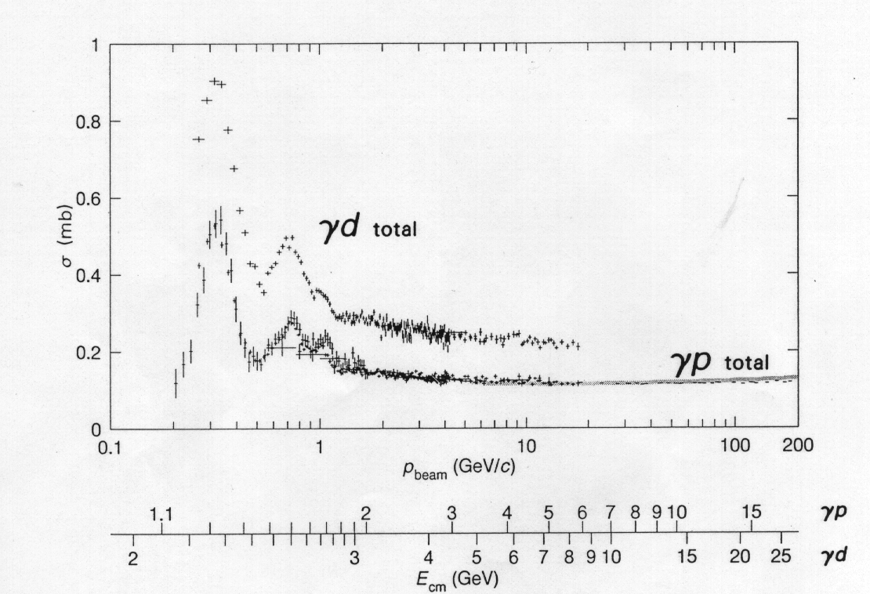

Fig. 1.9: Photon cross section on nucleons as a function of photon energy. (From Ref. 1.1.)

The energy dependence of the cross section after some low energy structure at ~ 2-3 GeV is reasonably constant over several decades in energy. In analogy to the transition from nucleon-nucleon to nucleon-nucleus cross sections, in Fig. 1.10 we show the cross section of photons on nuclei.
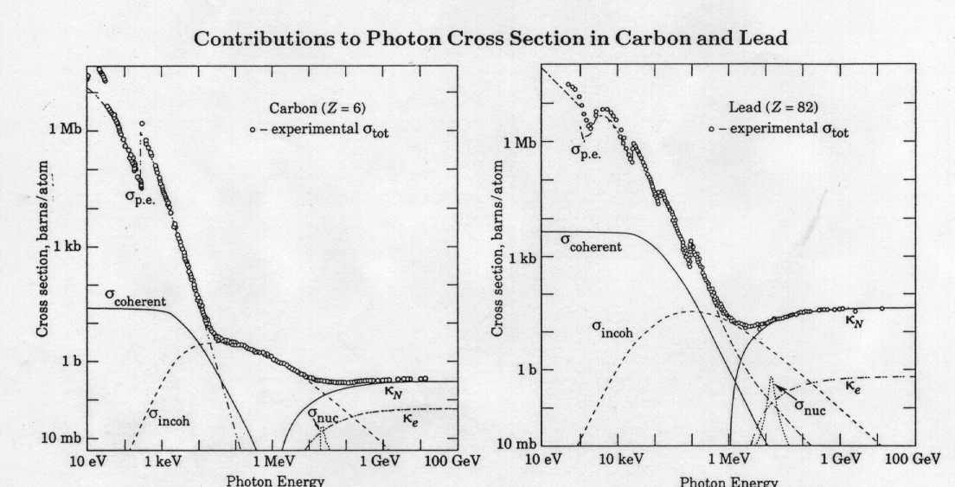
Fig. 1.10: Photon cross section on carbon and lead as a function of photon energy. (From Ref 1.1)

The high energy behavior is fairly straight forward. The energy dependence above about 1 GeV is very slight. However, the low energy behavior of the photon-nucleus cross section is rather complicated. At energy scales of a few keV the photoelectric effect, which will be discussed in Section 2, is the dominant process. In the intermediate range, at energy scales of order 1 MeV, the Compton cross section, discussed in Section 10, becomes the dominant process. At high energies radiative processes such as pair production, which are constant in energy, dominate. We will discuss all of these processes in subsequent Sections. The cross section for photons on nuclei above a few MeV is of order ~(10-100)b which is intermediate between atomic (Fig. 1.5) and nuclear (Fig. 1.8) cross sections.
Some interaction rates are remarkably small. For example, we are all bathed in a sea of photons of temperature 2.3 ºK with a blackbody frequency spectrum which are a relic of the “big bang” creation of the universe. The number density of these photons is ~400 photons/cm³ which implies flux of ~ 1.2 × 10¹³ photons/(cm² sec). However, since these photons are below the energy threshold to excite any bound atoms (photon energy ~ kT = 1/40 eV @ T = 300º or kT ~ 1/4000 eV, k = Boltzmann constant, see Table 1.1), our atoms are transparent to the photons. Therefore, we do not experience those photons. They only appear in sensitive detectors. For example they can be seen as the “snow” on our personal photon detectors – our T.V. sets. For example, if you tune to a blank channel, some of the speckles you see are relic photons from the birth of the Universe.

References
Section 1: Size, Energy, Cross Section

[1] Review of Particle Properties, Phys. Rev D. Particles and Fields 50, August 1, 1994.
[2] Twentieth Century Physics, J. Norwood, Jr., Prentice-Hall, Inc. (1976).
[3] Elementary Modern Physics, A.P. Arya, Addison-Wesley (1974).
[4] Principles of Modern Physics, R.B. Leighton, McGraw-Hill Book Company, Inc. (1959).
[5] Atomic Physics, M. Born, Hafnor Publishing Company (1935).
[6] Quantum Mechanics, L.I. Schiff, McGraw-Hill Book Company, (1955).
[7] An Introduction to Quantum Physics, A.P. French and Edwin F. Taylor, W.W. Norton & Company, Inc. (1978).
Table of contents
I. Introduction 2
General References - A 5
General References - B 5
1. Size, Energy, Cross Section 6
1.1 Units 6
1.2 Planck’s Constant 9
1.3 Electromagnetic Units 9
1.4 Coupling Constants 9
1.5 Atomic Energy Scales 10
1.6 Atomic Size 13
1.7 Atomic Spin Effects 15
1.8 Cross Section and Mean Free Path 15
1.9 Partial Waves and Differential Cross Section 18
1.10 Nuclear Scales of Energy and Size 20
1.11 Nuclear Cross Section 21
1.12 Photon Cross Section 23
References 26

