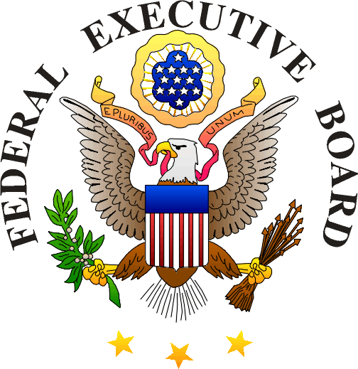

PROFESSIONAL DEVELOPMENT SEMINARS
REGISTRATION & ENFOLLMENT INFORMATION

SUCCESSFUL PROJECT MANAGEMENT
and/or
LEAD FIRST-MANAGE SECOND

26 Federal Plaza
6th Floor Conference Center, Suite “B”
8:30AM-9:00AM Registration
9:00AM-4:30PM

Please complete the registration form and mail it and fee to:
Checks should be made payable to the: New York Federal Executive Board
TIN#:111 64 6834

Cynthia Gable
Federal Executive Board
26 Federal Plaza, Suite 3016
New York, NY 10278
212 264 -1172 Fax

To register by Credit Card please call 212 264 1890
Purchase orders cannot be accepted
Registration cannot be accepted without payment

No refunds after July 13th but substitutions are welcome

Registration and payment are due by Thursday July 13th, although the class may be filled prior to that date.

Please (x) the seminar(s) that will be attended

( ) Successful Project Management (SPM) July 20 $125.00

( ) Lead First-Manage Second (LFMS) July 21 $125.00

( ) Both SPM and LFMS July 21-July 21 $225.00
Different employees may attend the two courses
A $25 savings!

Name(s):____________________________________________

Agency:___________________________________________

Phone Number:____________________________________

E-Mail:___________________________________________

