

NOAA Acquisition Career Program
1102 Supervisor Guide

September 2008

Background
As part of the National Oceanic and Atmospheric Administration (NOAA) Acquisition Career Program, supervisors will be expected to play an active role in the professional development of the Contract Specialists (CS) who directly report to them within the Acquisition and Grants Office (AGO). Not only are supervisors expected to play a day-to-day role in providing guidance and direction to employees, or careerists, they will also assume the responsibilities for conducting skills assessments and co-developing Individual Development Plans (IDPs).

Objectives
The objectives of the Supervisor Guide are to:
- Increase understanding of the role of the supervisor within the NOAA Acquisition Career Program
- Provide supervisors with sufficient guidance for executing their employee development responsibilities.

Purpose
This document outlines the role of the supervisor in the NOAA Acquisition Career Program and provides supervisors with step-by-step instructions for executing their responsibilities in regard to the Career Program and employee development in general. Specifically, this guide is designed to help Acquisition supervisors in selecting, evaluating and documenting training and developmental activities for individuals assuming the role of Contract Specialist. While this guide is primarily intended to be used with 1102 trainees/interns, it may be utilized to address and track training and development for any newly assigned or current 1102. Use whatever information in this guide is pertinent to the individual 1102. Portions of this document have been based upon the guidance contained in Federal Acquisition Institute’s (FAI) Contract Specialist Blueprints (http://www.fai.gov/training/blueprints.asp).

The following list provides recommended uses of this Guide:
- Communication: Use this guide to understand your role as a supervisor, and to guide you through executing your employee development responsibilities.
- Acquisition: During initial orientation conversations with any new CS, use the content relating to the current perspective towards acquisition and the associated key roles played by high performing CSs as a basis for your discussions.
- Consistency: Follow the instructions for conducting the CS Competency Assessment and Training Discussion each time you engage in a discussion to ensure you provide consistent, thorough attention to each person.
- Documentation: After the CS Competency Assessment and Training Discussion is completed, document the discussion in some fashion and include in the Employee Performance Folder.
- Records: Whenever a CS participates in a T&D activity, ensure it is documented within their employee training record, found within the NOAA Learning Center (NLC) at http://doc.learn.com/noaa.

Career Program Cycle Overview
The overall career program process, or lifecycle, is depicted below and outlined in more detail in this section.

Career Program Cycle
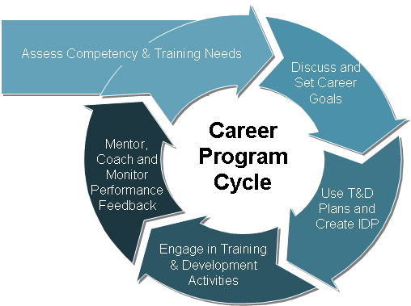

Upon entrance on duty, the first step is to assess the new employee’s competency and training needs. Employees will be required to take a competency self-assessment to identify competency gaps and initial training needs. Assessing the skills of employees upon entry on duty will ensure that the most accurate data on employee competency levels are captured to serve as a baseline for future development efforts.

Supervisors will then be expected to discuss and set the CS’s specific career goals and aspirations. Once set, these will be revisited on an annual basis between the supervisor and the employee. Using the competency assessment results, the supervisor and careerist will work together to develop an IDP that maps to the curriculum in the applicable Career Program T&D Plan (containing grade level-appropriate T&D activities) and aligns with career goals. The careerist will then attend the training or engage in the developmental activities appropriate for their level and aspirations as outlined on their IDP and within their level- and role- specific T&D Plan. They will receive coaching, feedback and guidance along the way, with specific focus on knowledge transfer and on-the-job training (OJT), if required. Employees in an intern or career ladder position will be paired with an OJT Trainer to help guide them through T&D activities and will play an active role in monitoring their performance and completion of training.

Supervisor Role and Responsibilities
Supervisors play a very important role within the Acquisition Career Program, particularly as it relates to the employee’s professional development. Supervisors typically interact with employees on a daily basis and are a key source of guidance and direction. The responsibilities of the Supervisor as they relate to the Acquisition Career Program and more specifically employee training and development (T&D) is outlined below, along with the needed competencies to execute their responsibilities.

Supervisor Responsibilities | Competencies
- Conducting skills assessments and determining the best training options to mitigate skill gaps.  - Submitting careerist feedback to the Career Development Board annually.  - Co-developing the Individual Development Plans of direct reports.  - Reviewing and accepting or declining employee’s requests for T&D opportunities, based on the employee’s needs and qualifications.  - Deciding if employee has met experience, education, and T&D requirements needed to progress to the next level. | - Employee Development  - Communication  - Planning  - Leadership  - Analytical thinking

Supervisor Guidance on Conducting the Competency Assessment and Training Discussion
This section provides step-by-step guidelines for how you and the CSs that report to you collaboratively identify those duties for which a training need exists. Additionally, the initial competency discussion provides a forum to identify training and developmental opportunities to address those needs.

Competencies are the skills, knowledge and behaviors required to perform a specific role or job. A competency model is the compilation of competencies and professional qualities identified as necessary to the successful operation of a business. The competency model communicates what is expected of individuals as they grow within the organization.

NOAA and the Department have adopted the 1102 competency model developed by Federal Acquisition Institute (FAI) for use across all civilian governmental agencies. The model includes 24 General Business Competencies and 17 Technical Competencies. A description of each of the competencies is available at http://www.fai.gov/workforce/concom.asp and provided in Appendix C.

Careerists will take a competency self-assessment upon hire into AGO, and annually thereafter, to identify competency gaps and training needs. WFMO will analyze the assessment results and calculate any skills gaps. Once the results of the assessment are complete, the WFMO will send the report to you, the supervisor. You will then follow the instructions below to have the Competency Assessment and Training Discussion.

How to Conduct the Competency Assessment and Training Discussion
Step 1. Schedule the Discussion.
Make initial contact with your CS and arrange a day, time and location for the discussion. Ideally, the discussion should be scheduled as soon as possible, providing two or three days for each party to prepare. You should allow at least one hour for the discussion and arrange to hold the discussion in a private location where you will not be interrupted.

Step 2. Describe the Purpose of the Discussion.
Clearly articulate to the CS that your responsibility is to do all you can to ensure success at his/her job. Emphasize that the purpose of the discussion is to identify the appropriate training experiences and developmental tools that will permit the individual to effectively perform CS responsibilities.

Step 3. Perform a High-Level Review of the Procurement Process.
Use the AGO Acquisition Process Guide charts (included in Appendix A of this document) to structure a high-level review of the process. Highlight the areas in which the CS has critical responsibility within NOAA. Tie effective performance of CS activities to the attainment of NOAA’s business objectives.
Also, review the high-level role of the CS and its importance to the acquisition process, using information found in Appendix B: Towards a Results-Oriented View of the Acquisition Process.

Step 4. Identify CS Duties.
Review the duties to be performed by the CS utilizing the applicable T&D Plan, which outlines the required developmental work assignments that are expected to be performed by 1102s at the applicable full-performance grade level. For any trainee/intern CS, explain that they will be assigned an OJT Trainer who will provide oversight and guidance as they complete their assignments; identify who has been designated their OJT Trainer. Tasks will be performed on increasingly more complex procurements as an employee progresses through training to the full performance level. As the employee completes the tasks, they will be monitored and verified as complete by the OJT Trainer.
Step 5. Review Skills Assessment Results to Assess Proficiency.
Interview the employee to discuss his/her current proficiency at performing applicable CS duties, as reflected in the results of the initial or annual skills assessment survey. Also document relevant coursework or certifications already completed by the employee.

Step 6. Prescribe Training and/or Developmental Activities and Document them on the IDP.
Based on those competencies, knowledge and skills the individual needs to develop, select training and/or developmental activities appropriate to fulfill those needs and mitigate any skills gaps identified through the skills assessment. Refer to the grade-appropriate NOAA T&D Plan, as well as the Federal Acquisition Institute’s (FAI’s) website, for suggested T&D activities. Document the agreed upon T&D to be accomplished that fiscal year within the IDP (for more information on developing the IDP, see Appendix D and the separate NOAA Career Program 1102 IDP Guide).

Step 7. Ensure CS Has Necessary Support for Training.
Speak with all necessary stakeholders (i.e., acquisition office members) and ask them to help you support the new CS in his/her training and initial job performance. Make sure the new CS knows you take your responsibility to provide him/her support seriously. Begin to create bi-directional communication patterns, a fluid partnership and an overall climate of support for T&D with your actions and words.

Step 8. Reward Full Competency.
For trainees, work with the employee’s OJT Trainer to determine when the employee has completed all training in the IDP. Consider awarding a certificate to the employee or otherwise provide recognition for this accomplishment.

Best Practices for Having the Discussion
Throughout the discussion, keep in mind the following tips for avoiding some common pitfalls:
- Avoid allowing the things you hear early in the discussion to distort how you listen to and perceive information later in the discussion.
- Listen carefully throughout the discussion.
- Do not ask vague questions – you are more likely to get low quality answers.
- Do not ask “leading” questions, or questions that direct or subtly sway the respondent.
- Explore an interesting answer until you are certain you understand every point the individual intended to communicate.
- Accurately and comprehensively record the discussion incrementally – do not wait until the end to take notes.

Quick Reference List to Support the Discussion
Below is a quick reference list to guide usage of the CS materials before and after the discussion.
- Discussion Steps: Familiarize yourself with the steps outlined in the How to Conduct the Competency Assessment and Training Discussion section of this document. Refer to these steps during the discussion to make sure you follow the prescribed steps.
- Charts of the Procurement Process: Use the AGO Acquisition Process Guide charts (included in Appendix A of this document) to structure a high-level review of the process.
- Results Oriented View of Acquisition: Use the content from Appendix B (i.e., a results-oriented view of acquisition) as a foundation for your discussions with newly designated individuals.
- CS Competencies: Use the list of competencies and definitions to become aware of the wide range of competencies that are instrumental when performing CS duties. A copy of this list can be found in the Appendix C of this Guide.

- Individual Development Plan: Found in Appendix D, the IDP should be an output of the Competency Assessment and Training Discussion with the employee.
Appendix A: Acquisition Process Charts

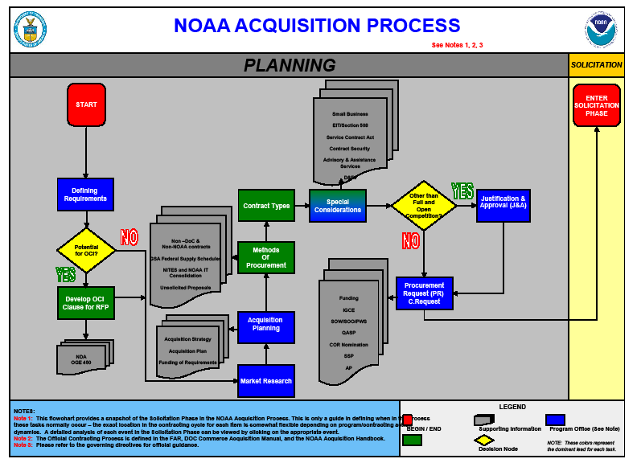

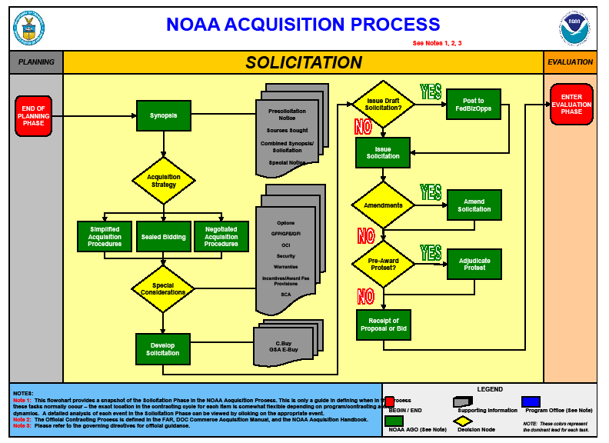

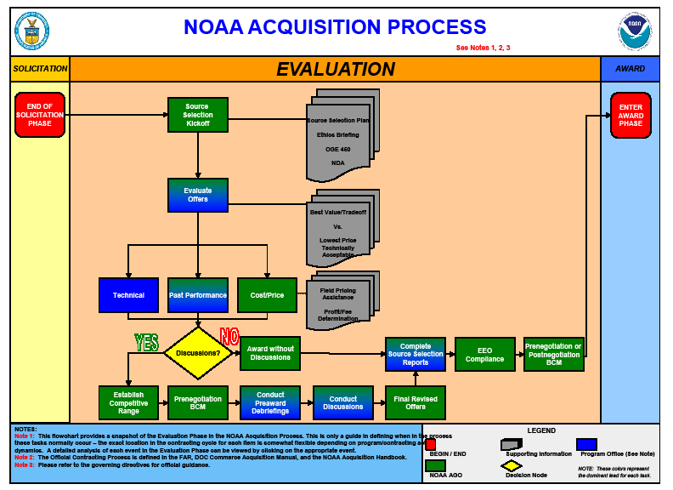

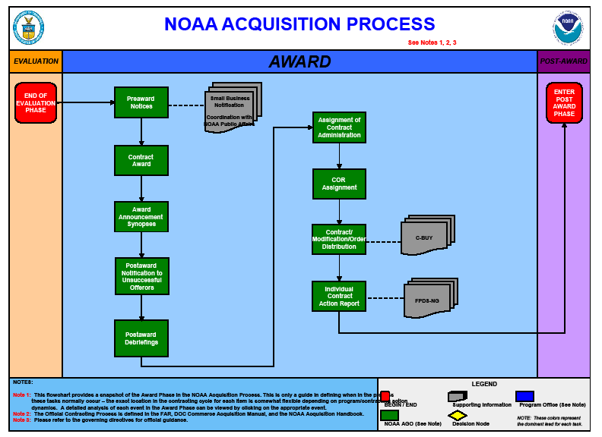

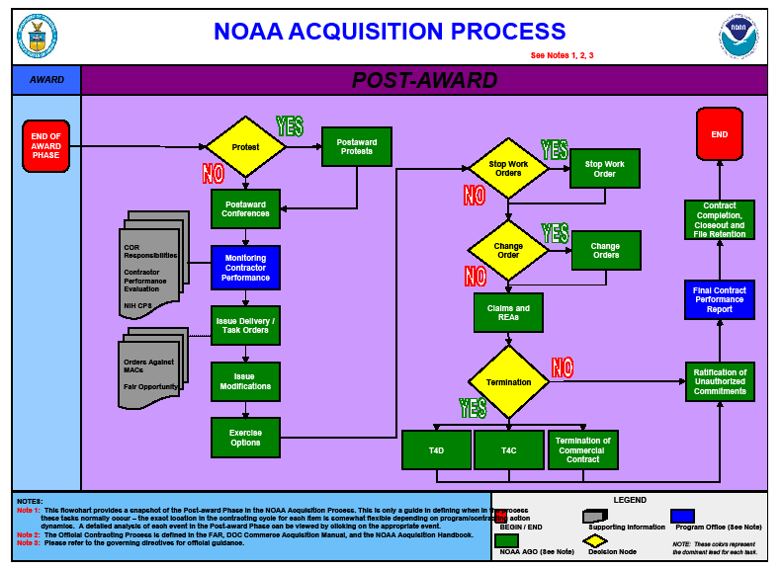

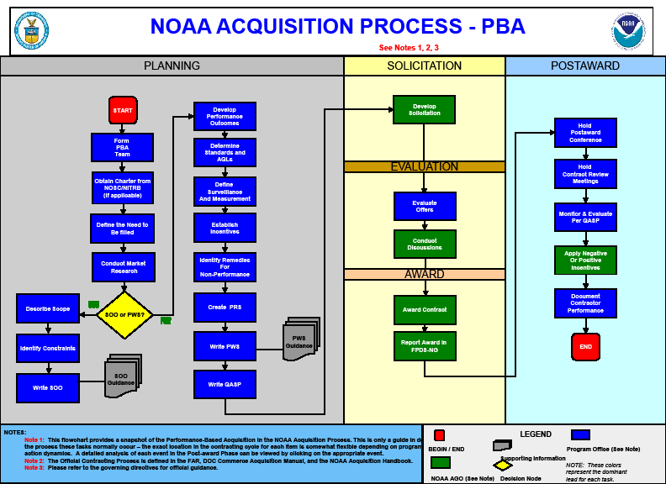
Appendix B: Towards a Results-Oriented View of the Acquisition Process

CSs sit in the center of a multi-pronged acquisition process, with stakeholders distributed across departmental lines as well as within and outside the federal government. Several changes have occurred to present CSs with a vibrant, challenging acquisition environment in which to contribute.
Acquisition reforms, technology-driven changes in work processes and communication, competition for acquisition work, and the focus on leveraging acquisition to achieve mission-relevant outcomes are driving new ways of doing business in the federal government. Historically, agencies and acquisition professionals have approached procurement and contracting from a process-based perspective. Legislation was then enacted that affected the nature of tasks performed by the acquisition workforce. The 1993 Government Performance and Results Act, (GPRA), the 1994 Federal Acquisition Streamlining Act (FASA), and the 1996 Clinger-Cohen Act, moved the government toward acquiring services and products against established performance measures and outcomes.

Today, acquisition contributors are responsible for the entire business cycle, from using relevant marketplace knowledge to inform strategy and planning activities to managing contractor performance and maintaining useful business relationships into the future. Successful acquisitions now require a fresh, results-oriented view of the process with acquisition professionals serving as business advisors to their respective agency stakeholders. A key guiding principle for any acquisition contributor is to develop a sound business solution that links short-and long-term goals.

Appendix C: 1102 Contracting Series Competencies

This appendix outlines key information intended to serve as a foundation for role/responsibility discussions among CSs, Contracting Officers and other supervisors and stakeholders (as applicable). These discussions will help ensure all parties build a common perspective about the knowledge, skills, and abilities (i.e., competencies) required. This unified view can help determine the training and developmental activities most likely to create high-performing CSs. Both future CSs and their Contracting Officers (and other supervisors) benefit when targeted and valuable training and/or developmental experiences are selected.

Core Capabilities The acquisition career model, as articulated by the Federal Acquisition Institute (FAI), offers advice on how to develop the skills and capabilities necessary for effective performance of acquisition roles (including the CS role). At the heart of the acquisition career model are nine (9) core capabilities:

- Develop, negotiate and manage business deals
- Communicate effectively
- Manage and lead change
- Solve problems in an ambiguous environment
- Analyze and understand the marketplace
- Build and manage relationships across functions and organizations
- Understand and effectively operate in the customer environment
- Develop and implement outcome oriented solutions
- Execute
Each CS will, in due course of his/her training and progressive work responsibilities, have the opportunity to build and strengthen these core capabilities. Ultimately, each CS will perform as a fully effective acquisition contributor.

Key Competencies FAI has identified an initial set of competencies essential for effectively performing CS duties. Using these competencies as the foundation for all CS-related work accomplishes several objectives. First, it unites all parties on the acquisition contributor’s central “business advisor” role and subsequent responsibilities. Second, the focus on training and development of these competencies can help manage individuals’ acquisition careers. By reinforcing the need for business acumen, customer service, flexibility, leadership, and integrity through these competencies, the adoption of a results-oriented approach to acquisition and the attainment of business goals can be more easily accomplished.

Professional Business Competencies
- Oral Communication  - Decision-Making  - Interpersonal Skills  - Problem Solving  - Teamwork  - Reasoning (analysis)  - Customer Service  - Reading  - Attention to Detail  - Contracting/Procurement  - Influencing/Negotiating  - Integrity/Honesty |  | - Planning and Evaluating  - Flexibility  - Self-Management/Initiative  - Stress Tolerance  - Writing  - Creative Thinking  - Learning  - Self-Esteem  - Information Management  - Memory  - Arithmetic  - Math Reasoning
Technical Competencies (by acquisition phase)
Acquisition Planning | Contract Formation |  | Contract Administration
- Strategic Planning  - Understanding the Marketplace  - Understanding Sourcing  - Defining Government Requirements in Commercial and Non-commercial Terms  - Effective Communication | - Defining Business Relationships  - Detailed Evaluation Skills  - Effective Negotiation and Analytical Skills  - Effective Award Resolution |  | - Effective Communication of Contract Requirements  - Effective Performance Management  - Effective Financial Management  - Determining Allowability of Contract Costs  - Effectively Resolving Contract Termination and/or Closeout

Appendix D: Individual Development Plan (IDP) Form

The following page contains a blank Individual Development Plan (IDP) form, to be used in establishing short- and long-range goals and projecting developmental activities and formal training needs. It is advised that both parties (Supervisor and CS) become familiar with this form prior to the discussion.
Acquisition Career Management Program – Sample Individual Development Plan

NAME |  |  |  | CURRENT POSITION, SERIES, GRADE AND ORGANIZATION |  |  |  |  | FOR FY
SHORT-RANGE GOALS (1 year)

LONG-RANGE GOALS (3-5 years)

DEVELOPMENTAL ACTIVITIES/FORMAL TRAINING
ACTIVITY/COURSE TITLE |  |  | PURPOSE |  |  |  | DURATION | PROJECTED COMPLETION DATE AND ESTIMATED COST
EMPLOYEE’S SIGNATURE | DATE | SUPERVISOR’S SIGNATURE |  |  | DATE | SECOND LEVEL SUPERVISOR’S SIGNATURE |  |  |  | DATE

