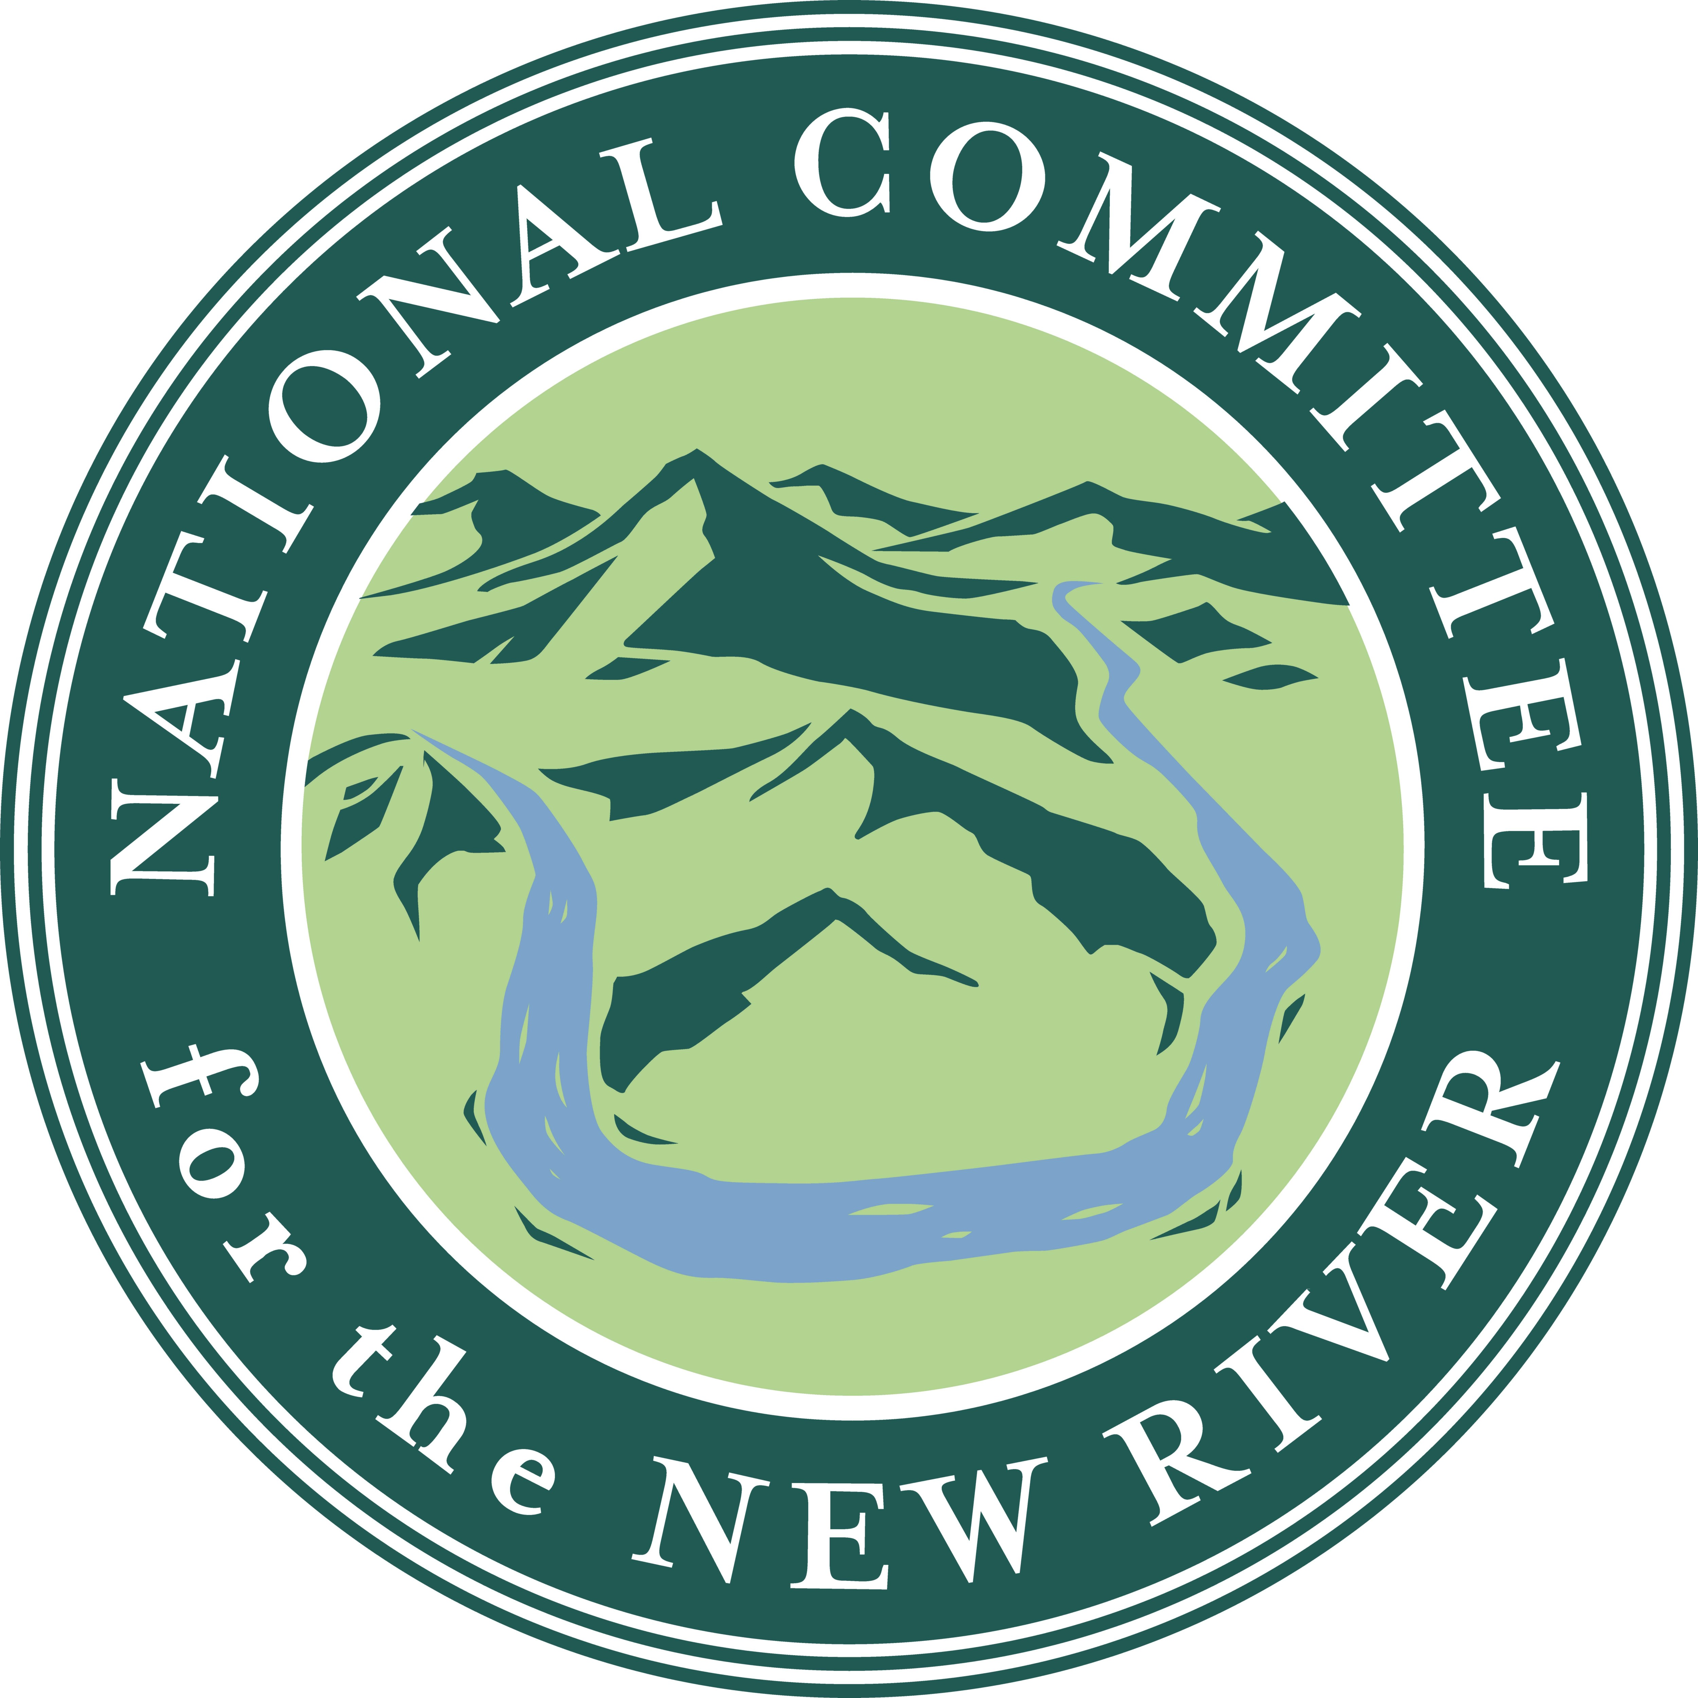

Testimony of George Santucci
National Committee for the New River

Senate Energy and Natural Resources Committee
United States Senate
in support of
Senate Bill 1057
To amend the Wild and Scenic Rivers Act to designate certain segments of the New River in the States of North Carolina and Virginia as a component of the National Wild and Scenic Rivers System
May 15, 2007
Mister Chairman and Members of the Subcommittee:
Good afternoon. Thank you for the opportunity to present testimony in support of SB 1057 to amend the Wild and Scenic Rivers Act to designate certain segments of the New River in the States of North Carolina and Virginia as a component of the National Wild and Scenic Rivers System. I am George Santucci, the Executive Director of the National Committee for the New River. I am here today representing our members, supporters, and the New River. With the permission of the committee, I’d like to submit a statement and the attached map and photograph for the record. My statement today will highlight those comments.
The New River is the oldest river on the North American Continent. It defies common wisdom by flowing north and west through the ancient Appalachian Mountains. The New, descendant of the ancient Teyas River, was altered by the last ice age, resulting in the path it follows today. The New begins above 5000 feet in the high peaks of North Carolina, as two forks, North and South. The main stem of the River is formed at the confluence of the forks near the North Carolina and Virginia border. The New then meanders north through Virginia into West Virginia where it confluences with the Gauley River and forms the Kanawha River.
The section of the New River for which we are seeking Wild and Scenic status flows through beautiful undeveloped farmland. In fact, many of the landowners along this stretch of the New River retain the original land grants for these farms from the 1700’s. This section of the River is home to threatened and endangered species including the Kanawha Minnows and Darters, Tounge-Tied Minnows, Green Floater mussels, Green-faced clubtailed dragonflies, and Virginia Spiraea. Bald Eagles and Herons nest and fish the New River.
The National Committee for the New River was founded over 30 years ago when the Appalachian Power Company proposed constructing two dams on the New River in Southwestern Virginia. The dams would have destroyed over 40,000 acres in farmland, hundreds of homes and the whole of many communities.
The grassroots response to the proposed dam was enormous. Opposition, beginning with local communities, escalated exponentially. The 1976 National Scenic Designation garnered nationwide attention, including coverage by Walter Cronkite (CBS), Harry Reasoner (ABC) and David Brinkley (NBC). The grassroots effort also garnered broad by-partisan support as well; Sen. Sam Ervin, Sen. Jessie Helms, Rep. Steve Neal, Gov. Holshouser, Sen. Ham Horton and many others helped get the scenic designation legislation passed. It was signed into law on September 11, 1976. The federal government recognized then what we have known all along – the New River is a national treasure.
Thirty years after this battle to protect the New, the River was threatened once again. This time, prison construction, on the very banks of the River, was proposed -- ironically in the same location as the would-be dam of the 1970’s. The grassroots response was again swift and strong. Local citizens organized to oppose the proposed location. Local newspapers like the Galax Gazette covered the controversy extensively. The Winston-Salem Journal, editorially agreed with the community concern, saying, “…officials should heed the citizen protests and find another site – one that doesn’t have the potential to threaten the river or the tourist money it brings in…All communities along this river should try hard to limit development nearby and make sure that any development does not detract from its scenic beauty.”
As a result of this grassroots action, a compromise was recently reached. The state’s Department of Corrections selected a different sight in the county, one more cost-effective, and not on the banks of the New River.
The National Committee for the New River and its local and regional partners have protected over 20,000 acres throughout the New River Basin. Our work is a testament to the dedication of our local communities along the River. Over the last 30 years, thousands have volunteered to steward the River through contributions of time and financial support. Volunteers monitor the New’s water quality, donate easements, provide restoration funding, and work on clean-up efforts throughout the year.
Currently there are hundreds of acres of permanently protected land along the section of the River we are speaking of today, and hundreds more proposed for protection. On the existing designated scenic section in North Carolina, the state has created the New River State Park, which includes approximately 2,000 acres, and has had 100-200% increases in visitation over the last few years.
Every year thousands of people fish and canoe the New River. Currently tourism revenue in Ashe County, North Carolina, is almost $40 million annually -- the New River is the major attraction. Statewide North Carolina’s tourism dollars continue to grow with more than 45 million visitor spending more than $15 billion dollars last year.
As said by Charlotte Hanes, a property owner along the River in both North Carolina and Virginia, “People holding NC or VA fishing licenses may fish this area with just one state license. We share the River and we need to take care of it equally. It would be good for both states to make a pledge to keep the River as it is now for future generations and for clean source of water. The river in this area is in such good, undeveloped condition and there are hundreds of acres already under conservation easements thanks to the volunteer efforts of caring landowners and the organizations that work for the River.”
National Wild and Scenic designation will be another acknowledgement as recognition of the New River as America’s oldest River and an American Heritage River.
I appreciate the opportunity to present this testimony to the Subcommittee today.

