Testimony of

W. Jeff Greenlee

On Behalf of the
AMERICAN BANKERS ASSOCIATION

Before The

United States House of Representatives

Committee on Agriculture

Subcommittee on Conservation, Credit, Energy, and Research

March 27, 2007

Testimony of

W. Jeff Greenlee

On Behalf of the

AMERICAN BANKERS ASSOCIATION

Before The

United States House of Representatives

Committee on Agriculture

Subcommittee on Conservation, Credit, Energy, and Research

March 27, 2007

Mr. Chairman and members of the committee I am pleased to be here today representing the American Bankers Association (ABA) to discuss the availability of credit in rural America.

My name is Jeff Greenlee and I am President of NBanC in Altus, Oklahoma. NBanC, also known as NBC Bank, is a community bank chartered in Tulsa, OK, with banks located in Tulsa, Altus, Enid, and Kingfisher, Oklahoma. NBC is a member of NBC Corp. of Oklahoma, a bank holding company which also owns a separately chartered bank: NBC, Oklahoma City.

I serve as president of the Altus, Oklahoma location of NBC. The Altus bank has total loans of $37 million of which thirty-five percent are agricultural. The population of Altus is approximately 20,000 people, and much of the rest of our loan portfolio is somehow related to financing rural businesses and rural consumers. I also serve as the Vice Chairman of the American Bankers Association’s Agricultural and Rural Bankers Committee.

ABA, on behalf of the more than two million men and women who work in the nation’s banks, brings together all categories of banking institutions to best represent the interests of this rapidly changing industry. Its membership – which includes community, regional and money center banks and holding companies, as well as savings associations, trust companies and savings banks – makes ABA the largest banking trade association in the country.

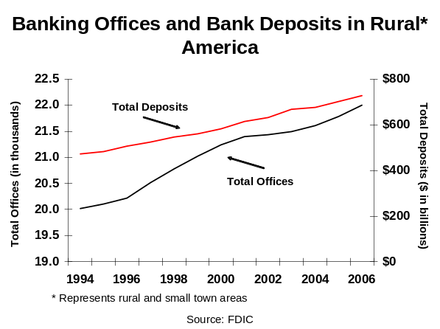Banks Provide the Credit That Drives the Rural Economy

I am pleased to report to you that the banking industry in the United States with 8,681 banks and
savings institutions operates nearly 22,000 banking offices in rural and small town America. The rural and small town presence our industry provides guarantees that rural Americans have the same access to financial products and services that urban Americans enjoy. To give you an example of the scale of what the banking industry manages in rural America, consider the fact that rural and small town
deposits in banks are estimated to be around $720 billion.

In the area of agricultural production and agricultural real estate finance, the banking industry had $106.9 billion loaned to America’s farmers and ranchers at the end of 2006. This is the most credit banks have ever had outstanding to farmers and ranchers in the history of our country.
I am pleased to report to you that the agricultural loan portfolio is performing very well. The willingness of the banking industry to lend to this sector continues to be robust, and the availability of choices producers have to select from numerous competitive offers to finance their operations has never been higher.
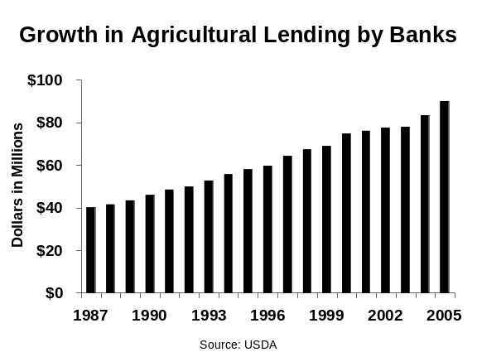
People from other countries often visit our banks to learn more about how well the private sector handles the credit demands of agriculture and rural America. Many times they come from countries that have tried numerous experiments with government backed lenders of one type or another, and in every case they come away with a keen appreciation of the value of our privately capitalized, non-government financial institutions.

I report this information to you not to brag about what we have achieved as an industry, but to point out to you that our system is unique, efficient, and is the result of over 200 years of positive and negative experience. We have a unique and enviable system of agricultural and rural banking in this country, and it is a system that should be carefully cultivated so it continues to grow and flourish.

Congress deserves some of the credit for what we have achieved in financing rural America too, since federal agricultural policy has, for more than 70 years, provided farmers and ranchers with the safety net they need to be able to withstand the vagaries of weather, globalization, economic setbacks, and other uncontrollable factors. Bankers, who understand how these complex programs work, have the certainty they need to be able to forecast loan repayment, a critical factor in the credit making process. This certainty in being able to forecast repayment, along with stable asset values and knowledge of agriculture by the bankers who do the lending, is why the banking industry provides forty percent of all agricultural credit, making the banking industry the largest supplier of credit to American agriculture.

By providing the safety net that supports agriculture, Congress strengthens the ability of farmers and ranchers to obtain the credit they need. Farmers and ranchers benefit greatly from this, as do the rural communities they live in, because they purchase their inputs from the retailers in those communities, they send their kids to school there, and they shop on Main Street.

Federal energy policy has further contributed to the exciting economic activity taking place today as rural America is seen as our nation’s greatest hedge against dependence on foreign oil. The banking industry has been an early and active participant in the development of the biofuels industry, and in the development and commercialization of other sources of renewable energy such as wind power.
Rural America, with unlimited resources to be tapped to help our nation meet the challenges of energy production in the future, is an exciting place to live and bank these days, and I am confident that the banking industry has the resources to meet the future financial needs of rural America as we retool to become a producer of food and energy.

The Role of Government Backed Lenders in Rural America

No discussion on the availability of credit in rural America could be complete without an examination of the role played by government backed lenders. Ninety years ago, Congress created the Farm Credit System (Farm Credit, FCS, or System), a government backed retail lender that enjoys considerable tax advantages (an effective combined state and federal tax rate of 3.4 percent in 2006 ), which further relies on taxpayers who “loan” the FCS their credit rating so FCS can borrow lendable funds in the government sponsored bond market at very advantageous rates. Further, when the Farm Credit System collapsed in 1987 it received a $4 billion line of credit from the Treasury.

The other government backed lender that we have had experiences with since the founding of our country has been the government itself. Following the farm debt crisis of the 1980s, the experience USDA had as a direct lender was very costly to the federal treasury. Since that time, USDA has transitioned from being a direct lender to farmers and ranchers to a provider of credit guarantees to banks who then use their capital and expertise to lend to farmers and ranchers. That transition has been positive. Later in my testimony I have some specific recommendations for you to consider that would further improve the USDA, Farm Service Agency guaranteed farm loan program.

The Farm Credit System is a Government Backed Lender That Wishes to Lend Anywhere But the Farm

For over a year, the Farm Credit System has publicized its Horizons Project. FCS has touted how it assembled all of the stake holders in rural America to solicit opinions about what the FCS should do next. First and foremost, I wish to point out to you that no representative of the Farm Credit System ever consulted with the American Bankers Association, or to my knowledge, with any banker in the country. As you listen to their story about all of the people they consulted, please know that the banking industry was not invited to participate in their project. The Horizons Project is really just about expanding the System. It is not sound policy, and it would set the FCS on a path that would take them further than they are today from financing agricultural producers.

Secondly, it is important to know that this is not about giving the Farm Credit System additional authorities to make more credit available to farmers and ranchers, since FCS has ample authority provided by Congress that allows them to offer farmers and ranchers every possible credit opportunity.
Third, in order to fully appreciate where the FCS wants to land next, it is important that we examine what the Farm Credit System is today; because that will give you an indication of what kinds of deals they will want to do in the future.

The following information was gleaned from the 2006 Annual Information Statement issued by the Federal Farm Credit Banks Funding Corporation:
- Net income in 2006 was $2.46 billion
- Farm Credit had an effective combined state and federal tax rate that amounted to just 3.4 percent of net income
- FCS had $123.4 billion in loans outstanding at the end of 2006, and total assets of $162.9 billion
- Between 2005 and 2006 loans grew at a 16.2 percent rate, which is considered to be rapid growth by federal banking regulators --- in fact, FCA warned System institutions about “significant asset growth that may contribute to increased risk…” in an informational memo issued to all System institutions on February 9, 2007.
- 58 percent of FCS lending in 2006 was in loans over $500,000
- 24 percent of FCS lending in 2006 was in loans over $5 million
- $18.5 billion of FCS bank and association capital on12-31-06 was unallocated surplus, meaning it is capital within the FCS that has no clear ownership, which is a curious condition for an institution that claims to be “borrower owned.” Just 16 percent of all Farm Credit bank and association capital is clearly allocated to the “farmer-borrowers.”

Clearly, FCS is a large, fast growing institution with a concentration of its credit to large borrowers. In fact, the average FCS institution is 13 times larger than banks the Federal Deposit Insurance Corporation defines as an “Ag Bank.”

What is the Farm Credit System’s Horizons Effort Really About?

Farm Credit is seeking expanded authorities from Congress and from their regulator. The recommendations in the Horizons report, the proposed legislative language they have just released, and the proposed rules they have convinced their regulator to issue all point to the fact that Farm Credit wishes to become a large scale commercial lender to big businesses, and to finance suburban housing and consumers who have little or no relationship to agriculture or to rural America.

Farm Credit System lenders have, for decades, had the authority to finance farmer owned businesses that provide services directly related to a producer’s on-farm operating needs. Initially it was understood that these “farm related” businesses were limited to custom combining, hoof trimming, on-farm cattle de-lousing, and other similar services delivered to producers on their farms. Over time, FCS lenders have looked increasingly at the commercial lending space and have desired to expand into more and more business financing that is, at best, marginally related to agriculture.

This has, in recent years, led to FCS loans to businesses such as luxury pet hotels, trucking companies, restaurants, tourist destinations, golf courses, duck camps and other types of businesses that do not fit the mission established by Congress.

We have closely monitored these developments over the years and we have voiced our concerns to the federal regulator of the FCS, and yet these instances of questionable lending continue to crop up.

CoBank, the last remaining bank for cooperatives, is chartered specifically to lend to farmer owned, farmer controlled cooperatives. CoBank is not satisfied with this limitation of authority and now seeks the authority to finance corporate entities regardless of the organizational structure of the entity being financed. If granted these new authorities, CoBank would be allowed to finance entities that compete directly with farmer owned cooperatives.
From a 2004 Farm Credit System institution’s annual report.

FCS Desires Major Expansion into Corporate Finance

It is clear from the legislative language that Farm Credit has released that they seek to circumvent their mission of financing businesses that provide for the “on-farm operating needs” of farmers and ranchers in order to shift their attention and resources to any business that processes, markets, handles, purchases, tests, grades, distributes, or markets farm or aquatic goods. In addition, they seek to finance, for the first time, businesses that provide capital goods or equipment to farmers or to those who may qualify under FCA regulations to be defined as farmers.

Further, FCS proposes to create a new class of borrower, the Agribusiness. The language that FCS has released creates a new class of borrower who would be eligible to borrow from the associations, the Farm Credit Banks, and from CoBank. The new Agribusiness borrower would not have to be a farmer-owned business or a farmer-owned cooperative to be able to borrow from any Farm Credit institution. The Agribusiness borrower would not have any requirement that product thru-put be owned by farmers or ranchers, nor is there any restriction that limits the scope of the businesses other than qualifier that the business is “primarily engaged” in providing a wide range of services and goods to those who meet FCA’s regulatory definition of a farmer, rancher or harvester of aquatic products. The term “primarily engaged” would be defined later by the regulator. Our experience with the regulatory process at the Farm Credit Administration is that they will seek the broadest possible definition of who is “primarily engaged” as they work to enable FCS institutions to engage in all kinds of new financing activities.

Creating the Agribusiness borrower may seem to be fairly innocuous until you consider the vast range of businesses that process, market, handle, purchase, test, grade, distribute, or market farm or aquatic goods or that provide capital goods and equipment to farmers, or those who may qualify under FCA regulations to be defined as farmers. Suddenly FCS entities would be eligible to finance very large corporate entities such as equipment manufacturers or floor plan dealer inventory.

What FCS is seeking is a major expansion and it raises a public policy question-- what does Congress want the Farm Credit System do?

FCS Desires Major Expansion into Urban Home Lending

One of the positive aspects of the American economy is the opportunity for a majority of its citizens to acquire financing for a home. Home mortgage financing is efficient, competitive, and widely distributed among all Americans. The Farm Credit System recognizes that home lending is a profitable business to be in, and they are seeking to expand their current authority to finance homes in towns of 2,500 or less to cities of up to 50,000 people. There is no justification for such action.
I can tell you that in Oklahoma, rural America is not in cities of 50,000. What FCS is proposing would enable them to engage more fully in financing homes for retirees, second homes for urban residents, and developing subdivisions. What public policy mission would be fulfilled by allowing FCS lenders to finance homes in cities with up to 50,000 people?

FCS Wants to Dilute Farmer Ownership of the Farm Credit System in Order to Pursue Consumer Lending

Finally, FCS is suggesting to Congress that the basic ownership structure of the System be rendered irrelevant. Farm Credit was created 90 years ago as a farmer-owned and farmer-controlled cooperative.
Today, in order to borrow from a Farm Credit System lender, borrowers must buy $1,000 of FCS stock, or purchase stock equal to two percent of the loan (2 percent), whichever is less. This is a low threshold for FCS borrowers to meet. More importantly, ownership of some FCS stock helps to remind FCS borrowers that FCS is a cooperative organization which follows certain cooperative guidelines and accepts cooperative governance. In exchange, FCS benefits from various special provisions of law Congress enacted for cooperatives.

Now FCS lenders are trying to convince Congress to remove the stock ownership requirement from statute and to allow the “local” boards of directors of each FCS institution to determine how much stock each borrower is required to buy. Such action will result in a future FCS that is “owned” by one favored class of borrower while others who borrow would be barred from voting, or from receiving other benefits of cooperative membership. This will only increase the questions that already surround the ownership of the $18.5 billion in unallocated capital that was on the books of FCS institutions at year end 2006.

ABA Strongly Opposes Expansion of the Farm Credit System

We urge Congress to reject Farm Credit’s expansion plan. The banking industry, along with other private sector lenders, is financing rural America today and has more than enough capacity to meet rural America’s needs in the future. The Farm Credit System was created to serve the credit needs of farmers, ranchers, rural home owners, farmer-owned service businesses, and farmer-owned cooperatives. They should not be allowed to abandon their mission to serve these borrowers while retaining the tax, regulatory, and other special provisions of law that now apply to them.

The USDA, Farm Service Agency Guaranteed Farm Loan Programs are an Example of How Government Backed Credit Programs Should Work

I am pleased to report to you that the relationship between the banking industry and FSA is strong and that we are all working together to provide credit to farmers and ranchers who would not be able to get credit without the guaranteed loan program. Thanks to the determination of my peers around the country, and the willingness of FSA to constantly make adjustments and improvements to their programs, the FSA guaranteed farm loan programs enabled 46,000 farmers and ranchers to have 62,500 loans with an outstanding principal balance of $8.9 billion at the end of FY 05.

Every year approximately $2.2 billion of new credit is advanced under the FSA guaranteed loan program, in the form of approximately 10,300 new loans. Loans are made to purchase and improve farm real estate, build new farm buildings, make conservation improvements, purchase machinery, livestock, and crop inputs, and refinance debt.

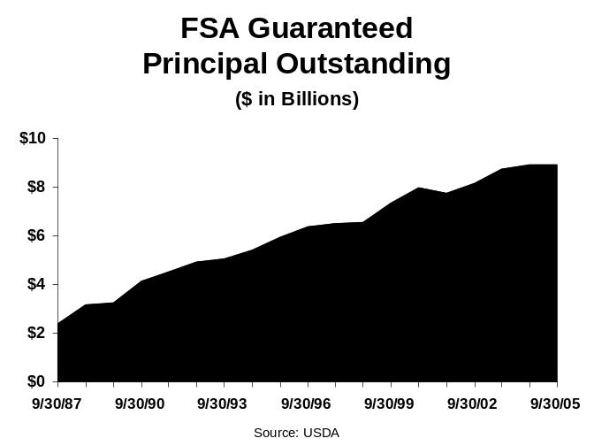The credit made available under these programs is going to modest sized farms and ranches as the average guaranteed loan in FY 05 was $212,000. Twenty-six percent of all FSA guaranteed loans made in FY 05 went to farmers and ranchers who FSA defines as beginning farmers, and nearly twelve percent of all guaranteed loans were made to farmers and ranchers who FSA classifies as socially disadvantaged farmers. These loans are made for purposes that we all agree are “agricultural”.

The Transition from Direct USDA Lending to Credit Guarantees Has Gone Well

For the last 30 years Congress and succeeding administrations have supported the transition from direct USDA loans to providing credit guarantees to private sector lenders (and government backed lenders like the Farm Credit System). Private sector lenders do a better job of underwriting and servicing agricultural credits, and FSA’s role is to oversee the lenders. In addition, instead of hiring a large field staff to administer a direct loan portfolio, the guaranteed loan programs leverage the assets of the commercial lenders to do the field work. However, guaranteed loans do not work for every farmer and rancher. Even with a 90 percent guarantee against potential loan losses, not all producers can qualify for this type of credit. Congress and succeeding administrations have continued to fund a direct loan program to meet the needs of these very limited resource farmers.

Banks Make the Most Guaranteed Loans

I am pleased to report to you that banks make more loans under the FSA guaranteed loan programs than anyone else. Today, there are 3,222 lenders that participate and of that
number, 93 percent or 2,987 are banks.

FSA Guaranteed Loan Losses Have Been Very Modest

Considering the fact that FSA guaranteed loans are made to those farmers and ranchers who have some sort of credit deficiency, the losses incurred under the program have been very modest and have been comparable to non guaranteed lending by banks and other lenders. This is a great success story that does not get told enough. Loan losses are low because banks make the initial credit decision, and are responsible for servicing the loan from cradle to grave. In addition, private sector lenders know that FSA will not pay on the guarantee until the lender liquidates and accounts for all of the collateral that was pledged for the loan. Private lenders must strictly adhere to FSA policies and procedures in order to ensure that the guarantee will be honored in case of a loan loss.
Any bank that has had experience with guaranteed loan liquidations knows that FSA is very thorough in their settlement procedures. Over the years, led by the American Bankers Association, the banking industry has worked closely with FSA to ensure that bankers understand the unique responsibilities that come with the credit guarantee.

Recommendations for the USDA, FSA Guaranteed Loan Program to be included in the Next Farm Bill

ABA Requests Level Funding for the USDA, FSA Guaranteed Loan Programs
Recommendation:

We request level funding for the FSA guaranteed loan program, at a level that would allow annual guaranteed loan making in the $2.5 to $3.0 billion range, which is consistent with annual demand over the past few years. In addition, we support permanent legislative language that would prohibit USDA from raising fees without Congressional authorization.

Use of the Term “Average Agricultural Loan Customer Interest Rate” Should be Abandoned

Banks and other lenders that make loans using FSA guarantees are supposed to price guaranteed loans based on a concept that is impossible to define. Due to the inability of anyone to objectively define the concept, banks that make guaranteed loans have been exposed to increased lender liability. For example, last year a small bank in Oklahoma was forced to pay $2.127 million to settle a lawsuit based on the claim that the bank charged the customer an interest rate that was higher than the “average agricultural loan customer rate.”

The statute authorizing the guaranteed loan program, for loans sold into the secondary market (7 USC Sec. 1929(h) (2)), states the following:

"the interest rate payable by a borrower on the portion of a guaranteed loan that is sold to the
secondary market under this chapter may be lower than the interest rate charged on the portion
retained by the lender, but shall not exceed the average interest rate charged by the lender on
loans made to farm and ranch borrowers."

The Farm Service Agency has taken this definition from the federal statute and has applied it to all FSA guaranteed loans. FSA’s handbook, “Guaranteed Loan Making and Servicing” (2-FLP) requires that each lender comply with the following:

“ Neither the interest rate on the guaranteed portion nor the unguaranteed portion may exceed
the rate the lender charges its average agricultural loan customer.”

We do not believe that FSA has done an adequate job of objectively defining “average agricultural loan customer” because they do not know what it is. Is that an average rate on all loans that are currently outstanding at a particular institution? Is it on loans of the same duration? Is it for all types of loans made to anyone who is a farmer or rancher? The statute is unclear, and FSA’s regulation is equally problematic. Essentially both the statute and the regulation attempt to define what cannot be clearly and objectively defined.

Market forces should determine the rate of interest charged on loans guaranteed by FSA just as market forces determine the interest rate charged on all other financial products offered by banks. The agricultural credit marketplace is very competitive. The Internet has created a great deal of transparency about interest rates, loan terms, and collateral requirements. The marketplace is transparent. Attempts to impose an artificial cap on interest rates have backfired. Instead of it being a protection to the borrower, it has exposed the lending community to additional lender liability, resulting in a reduction in the number of banks and other lenders that are willing to use the program. The net result will be that fewer farmers and ranchers will get the credit they need. The small bank in Oklahoma I spoke about earlier will no longer use the program.

Recommendation: The provision in statute should be repealed, and FSA should eliminate all references to pricing from their regulation. Market forces should determine the price of credit. As the regulations currently stand, any bank that writes a guaranteed loan is exposed to additional lender liability because no one can consistently define who is an average agricultural loan customer. The statute and the regulation does not protect borrowers. Instead of making more credit available, more lenders will not use the program.

The Resumption of Borrower Term Limits Will Represent a Significant Obstacle to Credit Access for Farmers and Ranchers

In the mid 1990s, Congress sought to limit the amount of time that a borrower would be eligible for either direct or guaranteed credit from FSA. The Farm Security & Rural Investment Act of 2002 suspended what is commonly referred to as borrower term limits. ABA supported the suspension. When the legislation expires on September 30, 2007, term limits will again take effect and the result could be devastating to those farmers and ranchers who still need the additional support that an FSA guarantee provides them in meeting their credit needs.
While we strongly support the idea that all farm and ranch businesses should be able to stand entirely on the strength of their individual balance sheet and earnings statements, we recognize the reality that there will always be a number of farms and ranches who will require some type of credit enhancement in order to continue to fund their operations. Requiring these firms to meet an arbitrary deadline for eligibility is inconsistent with the program.

Recommendation: Language imposing borrower term limits on FSA direct and guaranteed loans should be repealed.

The Family Farm Definition Needs to Be Based on Fact, Not Subjective Factors

Over the years FSA has attempted to define a family farm, for purposes of determining eligibility, in many different ways. These attempts, no matter how well intended, have failed.

For example, the current definition requires lenders to subjectively determine if the farm is “recognized in the community as a farm,” and that it “has a substantial amount of the labor requirements for the farm and non-farm provided by the borrower’s immediate family,” and that it “may use a reasonable amount of full-time labor and seasonal labor during peak loan periods.” (2-FLP pages 6 and 7, emphasis added)

We are concerned that some legitimate family farms do not qualify for a guaranteed loan because of the subjective nature of the definition. Without a definition that can be objectively defined and clearly documented, there will continue to be uneven application of the definition around the country resulting in some legitimate family farmers being denied credit.

Recommendation: FSA should adopt a definition that can be objectively measured and documented. We recommend the definition of a family farm be that the entity being financed files a federal farm tax return (1040 Schedule F or appropriate corporate form). If the entity has farm income and expenses, it will file a farm tax return.

Summary

The American Bankers Association appreciates the opportunity to discuss the issue of credit availability in rural America. Rural Americans enjoy unlimited opportunities to finance their farms, ranches, businesses, and homes at competitive rates and terms. We reject the Farm Credit System’s claim that something is missing in rural America.

Our system works so well because there is so much competition, and because Congress has wisely chosen to restrict the role played by government backed retail lenders that compete directly with the private sector while at the same time creating ways for public resources to be leveraged by the private sector to address the needs of limited resource farmers and ranchers. We urge you to continue this policy.

I will be happy to answer any questions you may have.

Calculated from the “Combined Statement of Income” found in the 2006 Annual Information Statement published by the Federal Farm Credit Banks Funding Corporation, page F-6.

