CONTENTS

1.0 INTRODUCTION 1-1
1.1 Presentation of SDWIS/STATE Components 1-1
1.1.1 SDWIS/STATE Hardware and Software Testing Environment 1-1
1.2 Release Content Overview 1-3
1.2.1 Rule Requirements 1-3
1.2.2 User Requested Requirements 1-4
1.2.3 System Maintenance Requirements 1-4
1.2.4 Design Document Structure 1-4
1.2.5 Design Document Section Versioning 1-4
1.3 SDWIS/STATE Home Page 1-5
1.4 Log In Authentication / Log Off 1-6
1.5 Who Am I 1-13
1.6 Standards and Conventions 1-14
1.6.1 Interpreting Prompts 1-15
1.6.2 Record Maintenance and Search Results Information on Pages 1-15
1.6.3 Filter By Function 1-16
1.6.4 Sort Function 1-18
1.6.5 Cancel Confirm Function 1-20
1.6.6 Section 508 (Rehabilitation Act) Design Features 1-21
1.7 Water System Group 1-22
1.7.1 Model Changes for Water System Group 1-23
1.7.2 Water System Group Page Flow 1-23
1.7.3 Water System Group Make Current 1-24
1.7.4 Water System Group Maintenance List 1-26
1.7.5 Recalculate 1-47
1.8 Icons 1-51
1.8.1 Water System Information 1-51
1.8.2 Point of Contact Information 1-54
1.8.3 Historical Sampling Information 1-56
1.8.4 Violation Information 1-58
1.8.5 Enforcement Action Information 1-60

EXHIBITS

Exhibit 1-1. SDWIS/STATE Certification Hardware/Software 1-2
Exhibit 1-2. SDWIS/STATE Home Page 1-6
Exhibit 1-3. Log In Page 1-7
Exhibit 1-4. SDWIS/STATE User Roles 1-9
Exhibit 1-5. SDWIS/STATE Log In Failure Page 1-11
Exhibit 1-6. Network Log In Failure Page 1-12
Exhibit 1-7. Log Off Page 1-13
Exhibit 1-8. Who Am I Page 1-14
Exhibit 1-9. Filter Parameter with Manual Entry Option 1-17
Exhibit 1-10. Filter Parameter with Dropdown List Entry Option 1-17
Exhibit 1-11. Sort Order Selection with Three Sort Fields 1-19
Exhibit 1-12. Sort Order Selection with One Sort Field 1-19
Exhibit 1-13. Cancel Confirm 1-20
Exhibit 1-14. Menu Items Dialog Box 1-22
Exhibit 1-15. Water System Group Menu 1-23
Exhibit 1-16. Water System Group Make Current 1-24
Exhibit 1-17. Water System Group Maintenance List 1-27
Exhibit 1-18. Delete Water System Group Confirm 1-29
Exhibit 1-19. Water System Group Copy 1-30
Exhibit 1-20. Water System Group Combine 1-32
Exhibit 1-21. Dynamic Group Maintenance 1-34
Exhibit 1-22. Static Group Maintenance 1-44
Exhibit 1-23. Delete Water System from Group Confirmation 1-45
Exhibit 1-24. Recalculate Water System Group 1-48
Exhibit 1-25. Water System Information 1-51
Exhibit 1-26. Water System Related POC Maintenance List 1-55
Exhibit 1-27. Historical Sampling Information 1-56
Exhibit 1-28. Violation Information 1-59
Exhibit 1-29. Enforcement Action Information 1-61

INTRODUCTION

The United States Environmental Protection Agency (EPA) Office of Groundwater and Drinking Water is responsible for implementing the Public Water System Supervision Program established under the auspices of the Safe Drinking Water Act of 1974 (Public Law 93-523) and the 1996 Amendments to the Act (Public Law 104-183). EPA developed the Safe Drinking Water Information System (SDWIS)/STATE to enable state primacy agencies to improve implementation of the National Primary Drinking Water Regulations (NPDWR) in their jurisdictions.

The detailed design for SDWIS/STATE Release 2.0 is documented in the chapters of the SDWIS/STATE Release 2.0 Design Document. Because of its size, EPA is electing to publish the SDWIS/STATE Release 2.0 Design Document in individual chapters, rather than as a single document.

Presentation of SDWIS/STATE Components
SDWIS/STATE Web Release 1.0 delivered most, but not all, components as web pages that users viewed through a standard browser (e.g., Internet Explorer). SDWIS/STATE Release 2.0 will additionally transfer functionality of the following components to the web:

- CDS Setup – will continue to be available only to those with System Administrator authority.
- Compliance Determination Reports (including TCR Compliance Determination).
- Post Compliance Determination functions.
- Enforcement Reports

The following SDWIS/STATE MS Access-based components are planned to remain client server because users are accustomed to “owning/tailoring” each of the databases on their local workstations.

- View SDWIS/STATE Data via MS Access (Relation.mdb).
- Migrate to CCR Writer.
- Online Data Dictionary (ODD).

SDWIS/STATE Hardware and Software Testing Environment
Exhibit 1-1 presents the hardware and software configurations within which the SDWIS/STATE software application will be tested and certified for use. No minimum hardware specifications needed to operate SDWIS/STATE are provided. The client workstation configuration and three server configurations on which EPA expects to test each of the three targeted databases (Oracle, SQL/Server, and DB2), and to some degree, information about software that is needed to run SDWIS/STATE is provided. In addition, other software needs that could be used with SDWIS/STATE are documented, even if not part of the test certification suite.

Exhibit 1-1. SDWIS/STATE Certification Hardware/Software

Platform | Operating System | Software | Hardware
Application Server / Web Server | Windows 2003 Standard Edition Server with Service Pack 1 | Java 2 SDK Standard Edition (J2SE) 1.5  Database permutations (depends on targeted database)  Oracle – Apache Tomcat v6.13 and Oracle JDBC drivers for 10G  SQL Server – Microsoft Internet Information Services (IIS) v6 with Apache Tomcat v6.13, isapi_redirector2.dll, and Microsoft JDBC drivers, and MS SQLServer 2000 Client Service Pack 2  DB2 - Microsoft IIS v6 with Apache Tomcat v6.13, isapi_redirector2.dll, and DB2 JDBC drivers | HP ProLiant DL380G3.  Four Intel Xeon CPU 3.2 GHz.  4 GB RAM  HP Smart Array 5i (Hardware Raid 5) Controller  HP NC7781 Gigabit Server (network) Adapter.  Four 72.8 GB 15K Ultra320 SCSI Disk Drives
Database Server | Windows 2000 with Server Service Pack 4 | Databases  Oracle 10g Enterprise Edition rel 2 (10.2.0.1)  Microsoft SQLServer 2000 with Service Pack 2  IBM DB2 v8.2 with Fixpac 8 | Dell PowerEdge 1750  2 Xeon Processors with Hyper-threaded to four logical processors  4GB RAM  Dell PERC 4/Di (Hardware RAID 5) Controller  Intel PRO/100 S Server (Network) Adapter  Three 72 GB 10K RPM Ultra 320 SCSI Disk Drives
E-Mail Server | Windows 2000 Server | MS Exchange 2000 | Compaq Proliant ML370 G2, two 1.3 MHz CPU, 2 MB of memory
Client Workstation | Windows XP Professional Version 2002 with Service Pack 2 | Microsoft Internet Explorer 6.0 with Service Pack 1 | Dell OptiPlex GX400  Intel Pentium 4 CPU 1.7 GHz with 256 KB L2 Cache  1GB RAM  3Com Integrated Fast Ethernet Adapter

Components of SDWIS/STATE will be tested for deployment on an intranet, that is, a network (either a Local Area Network [LAN] or Wide Area Network [WAN]) that resides inside a security firewall. SDWIS/STATE can, however, be deployed via the Internet (World Wide Web going across security firewalls) as well as an intranet. To deploy across the Internet, an additional layer of data encryption security is required. The primacy agency may elect to have the Network Administrator install/configure its Web Server to use SSL (Secure Sockets Layer), which provides the encryption and decryption of data between SDWIS/STATE and the World Wide Web. This layer, providing data encryption security, is not a component of SDWIS/STATE but can be acquired independently from a certified vendor.

Release Content Overview
Requirements for SDWIS/STATE Release 2.0 were initially discussed during the SDWIS/STATE User Group meeting held in New Orleans, Louisiana in May 2005. Requirements were published in the SDWIS/STATE 2.0 Requirements Document, dated February 27, 2006. Additional high level, as well as detailed, design requirements emerged prior to and during the SDWIS/STATE Joint Applications Design (JAD) meeting held in April 2006. The requirements identified for SDWIS/STATE fall into “Rule” requirements, “User Requested” requirements, and “System Maintenance” requirements.

Rule Requirements
Rule requirements are those primarily triggered by implementation of new drinking water rules, and implementation of approved EPA data standards. Examples of EPA data standards with which SDWIS/STATE will be reviewed for compliance are the Facility Identification Data Standard, Locational Data Policy Standard, Biological Taxonomy Standard, Chemical Identification, etc. SDWIS/STATE will incorporate changes triggered by the following rules:

- Long Term 2 Enhanced Surface Water Treatment Rule.
- Stage 2 Disinfectants and Disinfection Byproducts Rule.
- Groundwater Rule. (Note that at the publication of the design document details on the Groundwater Rule were not yet available.)
- Arsenic Rule.

Verification of Section 508 compliance will be conducted by testing SDWIS/STATE web pages using SSB Technologies’ In-Focus tool and using IBM’s Home Page Reader (version 3.0).

User Requested Requirements
Another set of requirements are those that were submitted by the primacy agencies and EPA headquarters. These were gathered via input to the SDWIS User Support line. These include items such as additional functionality, more clear presentation, and features that facilitate ease of use.

System Maintenance Requirements
Another set of requirements are those that are necessary to keep the application functioning optimally. These include items such as expanding column sizes and re-keying tables.

Design Document Structure
All components of the online application are being completely documented in the SDWIS/STATE Design Document. Each design subsection (e.g., 4.1, 7.5) is presented consistently using redline/redline strikeout to indicate where the functionality of an existing object (such as a field, button, menu item, etc.) has changed or where new functionality is intended for this release of SDWIS/STATE.

To ensure that sections that you review are red and red strikeout, you may need to reset your MS Word "Track Changes" options. To do this, select Tools, Track Changes, and Highlight Changes, which present the Highlight Changes dialog box. Check the Highlight Changes on Screen and Highlight Changes in printed document options and press the Options button. This presents the Track Changes dialog box. Make sure that "Inserted" and "Deleted" text options are set to red. Different versions of MS Word may have slight variations.

Design Document Section Versioning
The design enhancements in the SDWIS/STATE Design Document trace back to SDWIS/STATE requirements via design requirement numbers. These numbers are parenthetically embedded at the end of a discrete section of design text. An example of a design requirement number is: R0001:A.1.2.4.a. The design requirement numbers consist of four components:

- The first component is the requirement number. In this example, R001: indicates requirement number 0001.

- The second component is an upper-case letter. In this example, it is the letter “A.” This component indicates the version of the design section. The first time that a section of the document is released, the design requirement numbers in that section will all start with “A.” If one or more design requirement numbers are either changed or added to the section when the same section of the design is re-released, they will start with “B.” For example, if Version A, section 1.2, contains design document numbers A.1.2.a, A.1.2.b, and A.1.2.c, and all three of these design requirements are changed after the first version, the same design requirement numbers in the second version of section 1.2 will be B.1.2.a, B.1.2.b, and B.1.2.c.

- The third component indicates the subsection number determined by the heading in which the design is documented. For example, a number referencing design documented in this subsection for the first release would begin A.1.1.4. The combination of the first letter (first component) and the numbers of the second component is always associated with a specific date. This lets all parties (designers, developers, testers, users) identify a given design requirement with a specific version of a specific section of the SDWIS/STATE Design Document.

- The fourth component is an ascending lower case alpha character beginning with letter “a” that simply makes the design document number unique within the section.

Each section of the design document may be released either in whole or part, multiple times. Re-release occurs by additional design requirements being included or corrections to prior design re-releases. In order to aid the tracking of changes to the document, Appendix A contains a matrix that will be updated with each release of the SDWIS/STATE Design Document, listing the most current delivery date of the document section.

SDWIS/STATE Home Page
SDWIS/STATE will present users a Home Page, as shown in Exhibit 1-2 where the components are listed as menu items down the left frame. When the user first executes the URL in the browser, the SDWIS/STATE Home Page will be presented. All access to SDWIS/STATE will be controlled via the homepage in order to provide security as well as navigation and presentation controls for pages that are data-dependent. Attempts to access URLs that address subsequent SDWIS/STATE application pages will automatically be redirected to the Home Page via the web.xml file delivered with SDWIS/STATE. This will render bookmarking of SDWIS/STATE pages, other than the Home Page, inoperable.

At this point, before the user logs in, the only two Main Menu options available are Drinking Water Watch and Log In as shown in Exhibit 1-3. Drinking Water Watch is a component to which users can link from the SDWIS/STATE Home Page. Drinking Water Watch lets users view SDWIS/STATE drinking water information including inventory, samples, and violations and enforcement actions. It is a public access application and no security is required to view its contents. It can be installed on the Internet to provide drinking water information to the primacy agency constituency. Accessing the Drinking Water Watch will link to a different URL in a separate browser session.

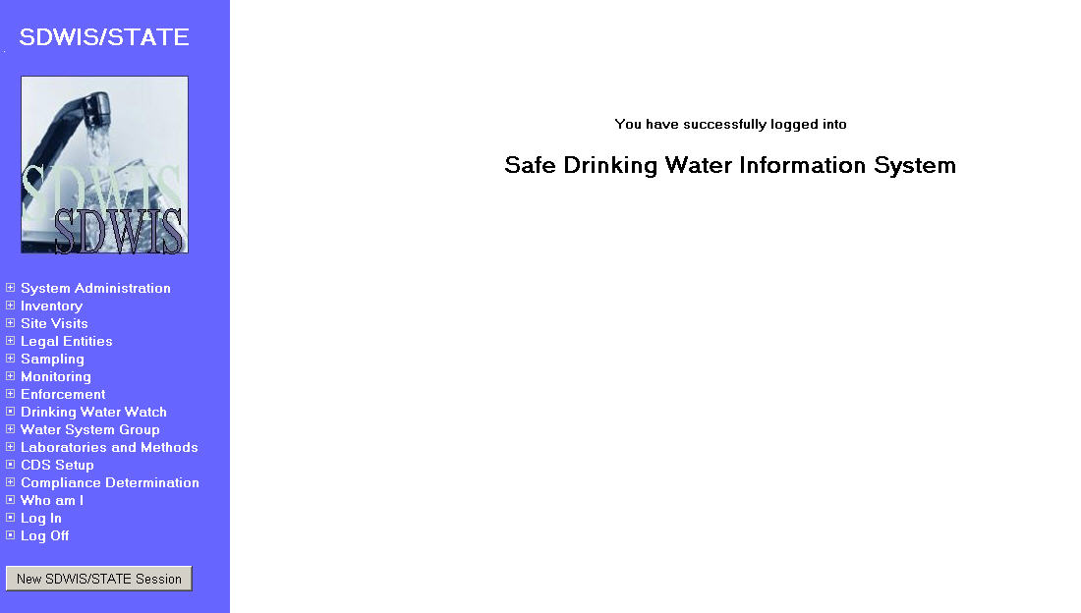
Exhibit 1-2. SDWIS/STATE Home Page

The SDWIS/STATE Home Page presented in Exhibit 1-2 above shows the new SDWIS/STATE menu options being implemented for this release. Throughout this chapter and all other chapters of the design document you will see a mix of old and new menu items. The SDWIS/STATE Home Page presented at the beginning of each chapter has been updated as a representation of the new menu selections.

Log In Authentication / Log Off
The Log In option will present a Log In Page (Exhibit 1-3) where the user will provide a User ID and password.

Entry Fields:

UserID: This will be the network User ID maintained by the network System Administrator. The rules for creating User IDs fall under the jurisdiction of the network and are not enforced as part of the SDWIS/STATE application. SDWIS/STATE is a consumer of this network service.

Password: This will be the network password maintained by the network System Administrator. The rules for creating passwords fall under the jurisdiction of the network and are not enforced as part of the SDWIS/STATE application. SDWIS/STATE is a consumer of this network service.

To ensure security, the password field will display as asterisks (*).

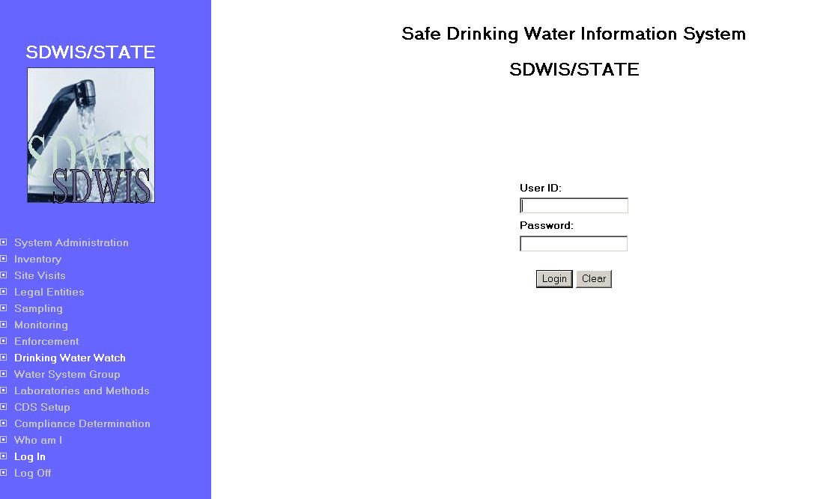
Exhibit 1-3. Log In Page

Buttons:

Log In SDWIS/STATE will follow the J2EE standard for User authentication. The User ID and password entered at the Log-In Page will be sent to the server for authentication as an encoded string. The J2EE standard for authenticating users is to send a literal “j_securitycheck,” along with the User ID and password. The receiving server will automatically invoke its corresponding user management system to validate the user. For example, Tomcat® web servers use the tomcat-users.xml file to perform the user authentication. Each J2EE compliant server will use its own proprietary user management architecture but all will recognize the “j_securitycheck” request.

The SDWIS/STATE application will expect a network role within the user management architecture defined as “SDWIS” for the network login. All users logging in to SDWIS/STATE at the network level will belong to the “SDWIS” role. Details regarding definition of the user accounts will be available in the SDWIS/STATE Installation Guide.

Once the network has authenticated the User ID, it must then be authenticated by the SDWIS/STATE database to determine the SDWIS role the User ID has been assigned by the SDWIS System Administrator. This SDWIS authentication will enable access to one or more SDWIS/STATE Home Page Main Menu items as permitted by the user’s role.

After logging in, any menu item to which the user is authorized will appear in white. Selecting a menu item will launch that component in a new server session. Users can launch multiple server sessions. For example, a user may press Inventory/Add New Water System to launch a server session. To simultaneously start work in Sampling, the user then presses Sampling/ Maintain Sample/Sample Summary to launch another session in order to work in both areas at the same time. For the menu items on the Home Page, it is only necessary to log in once. (When using any of the MS Access based components, it will be necessary to log into those separately, even if the user is already logged into the web server.)

Another function of logging in will be to evaluate the user’s current designation of water system group or regulating agency. If the current designation is a dynamic water system group, the Recalculate Water System Group page will be presented requesting confirmation to continue with dynamic water system group recalculation. This function is described in Section 1.7.5.

SDWIS/STATE user roles definitions and authorizations are shown in Exhibit 1-4.

Exhibit 1-4. SDWIS/STATE User Roles

Role Name | Code | Enabled Menu Item | Authorization
System Administrator | SA | All | Full access to all data and components of SDWIS/STATE.
Compliance Officer | CO | Inventory  Site Visit  Legal Entity  Sampling  Monitoring  Enforcement  Drinking Water Watch  Water System Group  Who Am I  Log Off  CDS Setup  CDS Reports | User may maintain Inventory,  Site Visits,  Legal Entities,  Samples, and  Monitoring and  Enforcement information.
Enforcement Officer | EO | Enforcement  Drinking Water Watch  Water System Group  Who Am I  Log Off | User may maintain Enforcement information including ability to view associated violations.
Sampling Data Entry | SD | Sampling  Drinking Water Watch  Water System Group  Who Am I  Log Off | User may maintain Samples and Sample Summaries.
Inventory | IN | Inventory  Drinking Water Watch  Water System Group  Who Am I  Log Off | User may maintain Inventory.
Site Visit | SV | Site Visit  Drinking Water Watch  Water System Group  Who Am I  Log Off | User may maintain Site Visits.
Data Entry | DE | Inventory  Site Visit  Legal Entity  Drinking Water Watch  Water System Group  Who Am I  Log Off | User may maintain Inventory,  Site Visit, and  Legal Entity information.
Laboratory | LB | Laboratories and Methods  Drinking Water Watch  Water System Group  Who Am I  Log Off | User may maintain Laboratories and Methods. (R0059:A.1.4.a)

A function within System Administration/User Accounts/Maintain User path will allow for a single SDWIS/STATE user to be assigned multiple roles at any given time. This would allow a user who is performing data entry duties for Sampling, Inventory, and Legal Entity to be assigned both the Sampling Data Entry and Data Entry roles. The assignments will contain effective and discontinue dates and will maintain a history of a user’s rights. Complete documentation of this function, including data and page design, will be located in the System Administration chapter of this design document.

The Log Off and Who Am I menu items will become available upon successful log in.

In case of log in failure, the user will be presented with a Log In Failure page, (Exhibit 1-5). Clicking on again will return to the Log In page.

The lock-out rules for password violation attempts and resetting of the password are maintained by the network System Administrator and are not controlled by SDWIS/STATE.
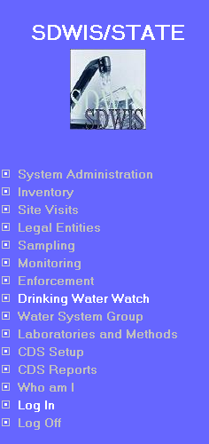 | 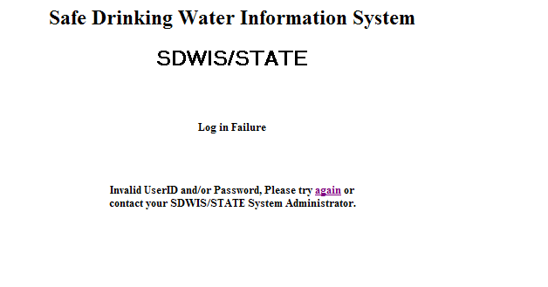

Exhibit 1-5. SDWIS/STATE Log In Failure Page

A message will indicate the source of the failure. If the SDWIS/STATE authentication failed, the message will advise to contact the SDWIS/STATE System Administrator. If the network authentication failed, the message will advise to contact the Network System Administrator as shown in Exhibit 1-6.

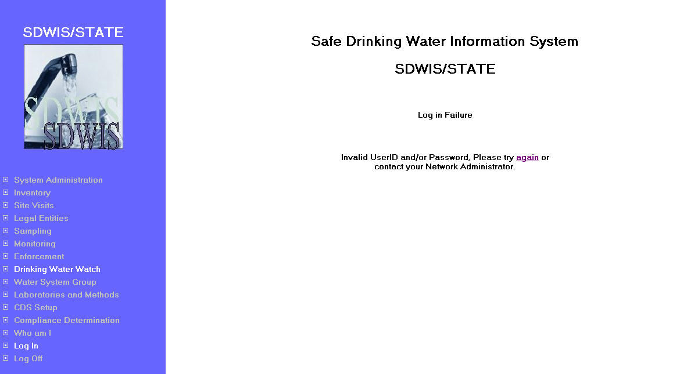
Exhibit 1-6. Network Log In Failure Page

Reset The Reset button will clear both fields in the Log In page.

The Log Off option is the way a user can, with one click, terminate all SDWIS/STATE web server sessions. Pressing Log Off will end any SDWIS/STATE web server session that is open and abort any pending processing; it will present the user with an informational Log Off page reminder (Exhibit 1-7) to close any browsers that are open. Users are expected to have several server sessions open simultaneously. Each server session can be closed at the user’s convenience by pressing the X in the upper right-hand corner of the browser; closing a session leaves all other sessions open. Because pressing Log Off terminates all SDWIS/STATE server sessions, to avoid loss of data, users should press Log Off only after exiting all other SDWIS/STATE browser pages.

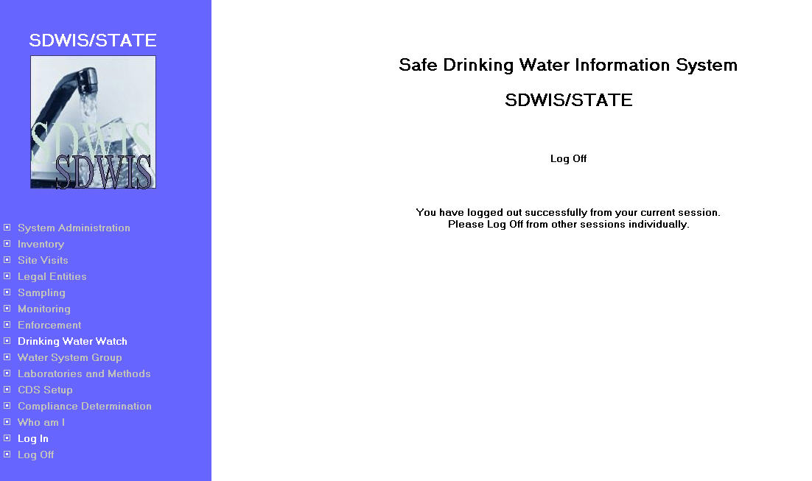
Exhibit 1-7. Log Off Page

Who Am I
The Who Am I page (Exhibit 1-8) provides the current release of SDWIS/STATE and shows information about the user who is logged in, current user view selections, and the name of the data schema the user is currently targeting.

Protected Fields:

Release: Currently installed version of SDWIS/STATE. This field will be updated with each release of SDWIS/STATE retrieved from the software release (TINSFTWR) table. (B.1.5.a)

User ID: The User ID field shows the ID of the user currently logged into SDWIS/STATE.

State ID: The State ID field shows the State Code of the current SDWIS/STATE installation. This field is populated from the TINPRT table.

Government Agency: The Government Agency field will show the user’s current government agency selection. This filters the user’s view of drinking water data by only showing those water systems that fall within the jurisdiction of the Government Agency to which the user is associated. This field will be populated from the TINUSER table. The user can select either a Government Agency or Current WS Group.

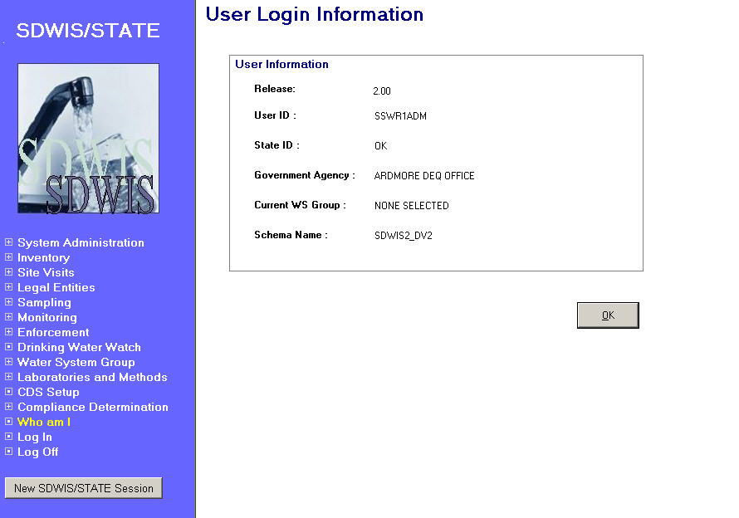
Exhibit 1-8. Who Am I Page

Current WS Group: The Current WS Group field will show the current Water System Group selected by the user as their current water system group. This filters the user’s view of drinking water data by only showing the water systems valid for the current Water System Group. This field will be populated from the TINUSER table. The user can select either a Government Agency or Current WS Group.

Schema Name: The Schema Name field will show the name of the database schema to which the SDWIS/STATE application is connected. This field will be populated from the OS2_Userid (TINOUSER view) schema_name. The new attribute (schema_name, text, 30, variable length) will be added to the OS2_Userid entity and the TINOUSER view.

Standards and Conventions
SDWIS/STATE software will use the conventions described here for indicating that a field is mandatory or an EPA Core Data Element. The software will also provide, on some maintenance pages, read-only information about by whom and when a record was last updated, as well as by whom and when a record was first created. On most list pages, the software will also display how many records were found during a search and how many of those records are displayed. In addition, the application will consistently use the same type of dialog box when presenting sorting, filtering, and cancel confirm options.

Rather than discuss these conventions throughout the design document in the many places they are presented, they are included here for reference.

Interpreting Prompts
Whenever there are entry fields on a page, the user will be able to tell whether or not the information is mandatory or optional by looking at the field’s prompt.

- Each field that is mandatory for SDWIS/STATE will have a blue prompt and will be preceded with an asterisk (*).
- Each field that is designated as an EPA Core Data Element for federal reporting will be preceded with a plus sign (+).
- If the field is required for both SDWIS/STATE and Federal reporting, the field will have a blue prompt and will be preceded with both “*” and “+.”

Record Maintenance and Search Results Information on Pages
Per user request, the following maintenance pages will display the User ID of the person who created and last updated the record as well as the timestamp of those events.

- Water System Annual Operating Period.
- Population Served.
- Geographic Areas Assigned to the Water System.
- Service Connections.
- Points of Contact for the Water System.
- Regulating Agency Assignments for the Water System.
- Water Purchases.
- Water System Facilities.
- Locational Details.
- Water System Facility (WSF) Annual Operating Periods.
- Sampling Points.
- Sample Results.
- Violations.
- Enforcement Actions.
- Samples and Sample Summary List.

This information will appear in the bottom right-hand footer of the page. The format for this information will be as follows:

Record Updated by XXXXX on MM/DD/YYYY HH:MM:SS
Record Created by XXXXX on MM/DD/YYYY HH:MM:SS

On maintenance list pages, the software will display information about the number of records that were retrieved by the search (i.e., the number of records that met the search criteria) and the number records displayed in the list:

Number of rows resulting from the search criteria used: 999
Number of rows displayed: 999

This information can be used to determine if the search criteria should be refined (i.e., if the number of rows displayed is fewer than the number that satisfies the search, the search may need to be refined to return fewer records).

Filter By Function
Any time a user chooses the View/Filter by option while viewing a list page, SDWIS/STATE will invoke a dropdown parameter list displaying all the available filter criteria fields. Once the user selects the parameter to filter by, the Filter Parameter dialog box will be presented. The Filter Parameter dialog box will allow the user to filter out some of the records displayed on the list page by specifying a specific value for the filtering field. Only rows that match the filtering criteria value will be displayed in the list.

Note: The number of rows displayed on the maintenance list page will change to show the count of records resulting from the filter.

The Filter Parameter dialog box will be presented as either an entry field (when there are not permitted values for the selected field) as shown in Exhibit 1-9, or a dropdown selection (when there are permitted values for the selected field) as shown in Exhibit 1-10. The fields available for filtering are unique to each list page design. The exhibits below are intended to be examples of how the filter parameter dialog box will function and not to imply the specific field will be a standard filter parameter field.

Filter Parameter Entry Field:

- When there are no permitted values for the field selected, the user will need to manually enter the value desired (Exhibit 1-9).

- When there are permitted values for the field selected, the user will be able to pick from a list of permitted values that are presented in a dropdown list (Exhibit 1-10).
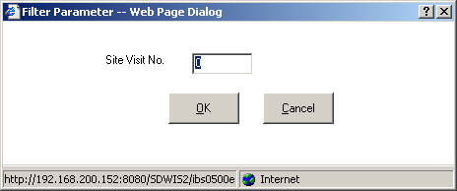

Exhibit 1-9. Filter Parameter with Manual Entry Option

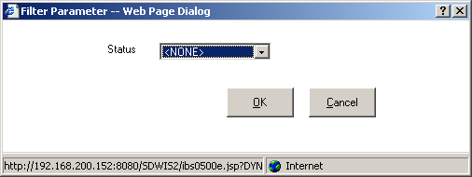

Exhibit 1-10. Filter Parameter with Dropdown List Entry Option

Filter Parameter Buttons:

OK Will present the maintenance list page with the records that match the user’s filter criteria. To obtain this list, the software will evaluate each record on the current list against the provided filter value. Only the matching rows will be presented.

The number of rows displayed will be modified to the newly filtered count.

Filters can be compounded by filtering again on a different available field. To re-filter the entire list, users can request a View/Refresh before applying a second filter.

Cancel Will close the Filter Parameter dialog box and return the user to the maintenance list page from where the View/Filter option was selected without applying the indicated filter. Any previously applied filter will be in affect. Only selecting View/Refresh will remove a previously applied filter parameter.

Sort Function
Any time a user chooses the View/Sort option while viewing a maintenance list, the Sort Order Selection dialog box will be presented. The Sort Order Selection dialog box (Exhibit 1-11, Exhibit 1-12) will allow the user to modify the order of the records displayed in a list page. Users may choose to sort in either ascending or descending order by selecting one of the radio buttons beside each sort field. The default sort will be ascending (Asc).

The Sort Order Selection dialog box will be standard for all components of SDWIS/STATE. The design within each SDWIS/STATE list will define which fields will be available for sort and how many levels the user will be able to sort.

All sorts will have the option of ascending (Asc) and descending (Desc).

- First Order Sort will be a dropdown list where the columns specified in the design are available. The column chosen will be the primary sorting field.

The First Order Sort must be selected and valued for the OK button to be enabled. Selecting a value will also enable the Asc and Desc radio buttons and if available, the next sort field.

Removing the value from this field will void all selections in subsequent sort fields, protect the subsequent fields from input, disable the Asc and Desc radio buttons, and disable the OK button.

- Second Order Sort will be a dropdown list where the columns specified in the design are available. Users may choose any one of these columns as the secondary sorting field; however, the Second Order Sort can be chosen only after selecting the First Order Sort, and cannot be the same as the First Order Sort.

Selecting a value for the Second Order Sort will enable the Asc and Desc radio buttons for this sort and the next sort field.

If available, the Second Order Sort will be an optional field.

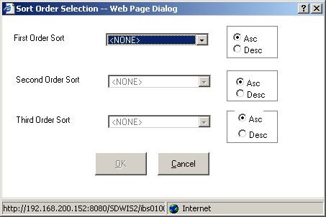

Exhibit 1-11. Sort Order Selection with Three Sort Fields

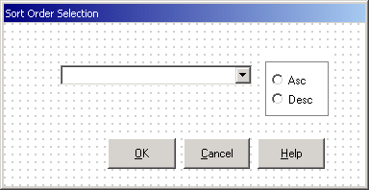

Exhibit 1-12. Sort Order Selection with One Sort Field

- Third Order Sort will be a dropdown list where the columns specified in the design are available. Users may choose any one of these columns as the third sorting field; however, the Third Order Sort can be chosen only after selecting the First Order Sort and Second Order Sort, and cannot be the same as the First Order Sort and Second Order Sort.

Selecting a value for the Third Order Sort will enable the Asc and Desc radio buttons for this sort.

If available, the Third Order Sort will be an optional field.

If any of the columns selected for a sort is the name field from Legal Entity, when the sort encounters an individual, it will be sorted by last name (e.g., Doe, John).

Sort Order Selection Buttons:

OK After one or more of the Sort Order Selection fields has been valued, this button will reorder the records on the maintenance list page according to the parameters noted in the dialog box.

Cancel Will close the Sort Order Selection dialog box and return the user to the page from where the View/Sort option was selected. The order of the records in the list box will not be altered.

Cancel Confirm Function
Anytime a user chooses the Cancel option after making changes to a maintenance page, the Cancel Confirm dialog box (Exhibit 1-13) will be presented. The Cancel Confirm dialog box will allow the user to save or discard the changes already made to the maintenance page.

The Cancel Confirm dialog box will be standard for all components of SDWIS/STATE. When the Cancel Confirm dialog box is presented, the user will be required to select Yes, No, or Cancel.

Note: The default entry for this box will be Yes.

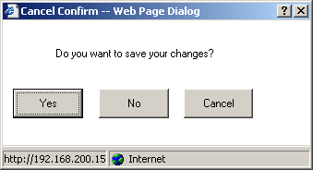

Exhibit 1-13. Cancel Confirm

Cancel Confirm Buttons:

Yes Pressing Yes will initiate processing as if the OK button was pressed from the maintenance page. Refer to documentation for the maintenance page’s OK button for details of edit.

No Pressing No will discard all changes and return the user to the maintenance list page. The database will not be affected by the changes to information on the maintenance page and the timestamp will not be updated.

Cancel Pressing Cancel will abort the cancel requested on the maintenance page and return the user to the maintenance page. All information will be presented as the user left it prior to selecting either cancel request, including any data changes made.

Section 508 (Rehabilitation Act) Design Features
Throughout the SDWIS/STATE Web pages, two objects will be used as necessary to support the use of electronic page reads in compliance with the Rehabilitation Act. The first is a button labeled Menu Items that will appear on all pages with menu item dropdowns. The second is arrowed scroll buttons used whenever a scrollable list box is present on a page.

Menu Items Button
When a page has a Menu Item tool bar with dropdown items, such as File/Exit, on the top of the page, an additional button will be positioned near the top right of the page for the electronic page reader to access. The button looks like this:

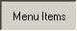

When pressed, a dialog box will be presented with a series of objects matching the same menu items as are available from the Menu Item dropdowns. Each dialog box will be specific to the menu items available of their host page. The objects will enable and disable under the same scenarios documented with the menu items and are not specifically mentioned outside of this chapter in the design document.

Most menu items are implemented as buttons on the dialog box. The Filter By menu item is implemented as a dropdown list with the appropriate selections as defined on the host page.

An example of a dialog box accessed from a Menu Items button is below.
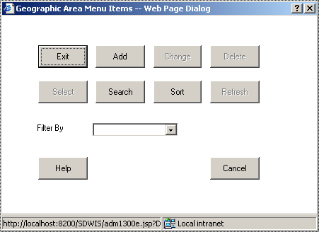

Exhibit 1-14. Menu Items Dialog Box

Arrowed Scroll Buttons
Pages that contain scrollable list boxes will also contain a set of scroll buttons for each list box on the page. List boxes that scroll horizontally as well as vertically will contain four buttons.

Will scroll the list box up one page. Positioned to the top right corner of list box when possible.
Will scroll the list box down one page. Positioned to the bottom right corner of list box when possible.
Will scroll the list box to the left one page. Positioned to the bottom left corner of list box when possible.
Will scroll the list box to the right one page. Positioned to the bottom right corner of list box when possible.

Water System Group
This chapter documents Water System Group functionality. Water System Groups can be used to assemble a list of water systems with similar characteristics (e.g., transient, noncommunity, groundwater, systems in the Northeast district). Water System Groups can also be used to limit the list of water systems that may not be similar in characteristics but contain similar issues (e.g., non-transient, noncommunity systems that have exceeded the lead action level). The first type of group can be created using the dynamic group function. The second type of group is created using the static water system group function. Water System Groups can be used in most components of SDWIS/STATE.

Prior to SDWIS/STATE Web Release 1.0, users needed to create Water System Groups in order to run TCR preliminary compliance for a current monitoring period. Water System Groups are no longer needed for this purpose. Users will be able to run TCR compliance for a current monitoring period using either a Water System Group or a Regulating Agency.

Model Changes for Water System Group
None

Water System Group Page Flow
Three menu items will be available from the SDWIS/STATE Home Page Water System Group menu item (Exhibit 1-15).

Make Current Will present the Water System Group Make Current page.
Maintain Will present the Water System Group Maintenance List page.
Recalculate Will present the Recalculate Water System Group page.

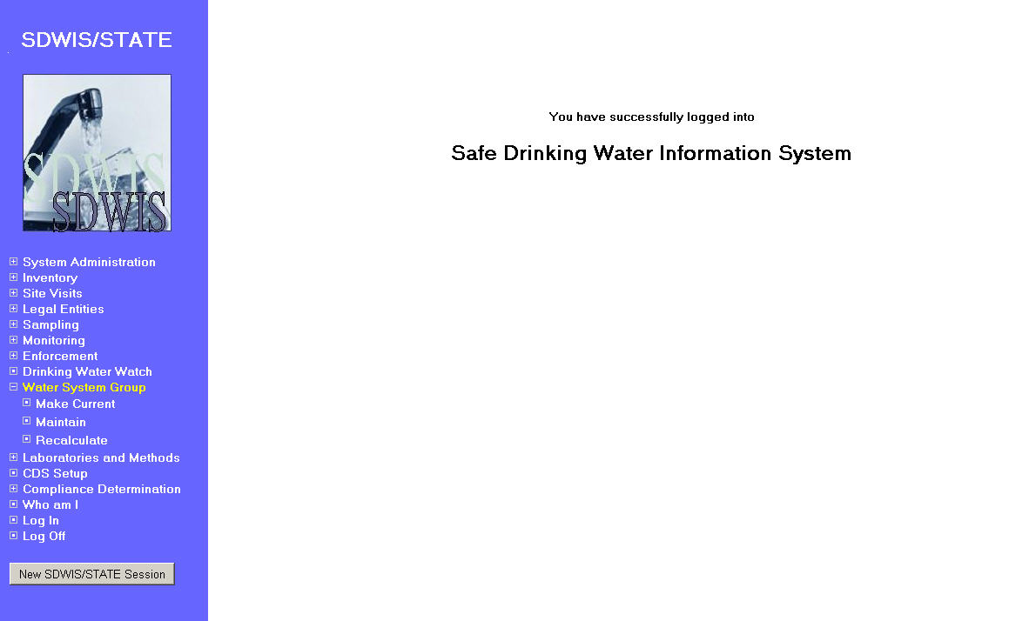
Exhibit 1-15. Water System Group Menu

Water System Group Make Current
The Water System Group Make Current page (Exhibit 1-16) allows the user to specify a Water System Group or Regulating Agency as the current selection. The Water System Group or Regulating Agency designated as current controls the access to Water Systems in all components of SDWIS/STATE.

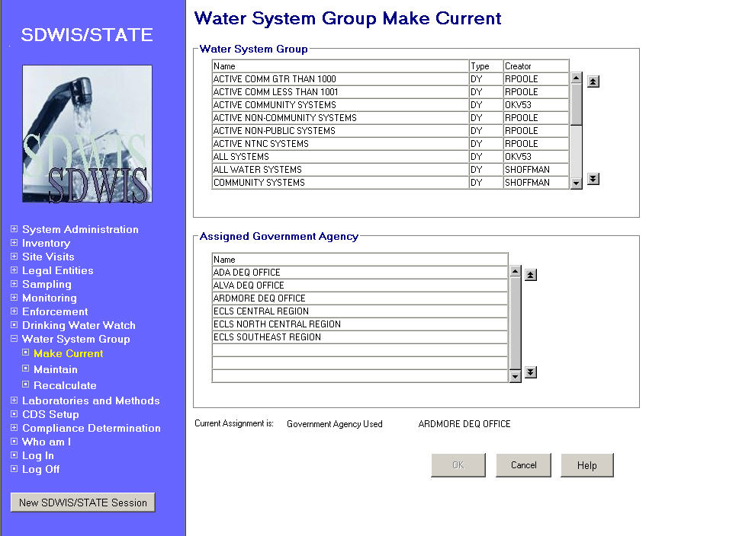
Exhibit 1-16. Water System Group Make Current

Water System
Group This section displays the Water System (WS) Group(s) owned by the user. If the user is defined as a system administrator, the list of water system groups is a complete list of all WS groups defined in SDWIS/STATE. The list of water system groups will be listed in ascending name order.

Only one selection may be made in the list. A selection in this list will disable selection in the Assigned Government Agency list box.

List Columns:

[Water System Group]
Name The name of the Water System Group.

[Water System Group]
Type The type of the Water System Group. The values are:
DY - Dynamic
ST - Static

Creator The User ID of the creator that defined the water system group.

Assigned Government
Agency This section displays the government agencies associated with the user who is logged in. The government agencies will be listed in ascending name order. Only one selection may be made in the list. A selection in this list will disable selection in the Water System Group list box.

Protected Fields:

Current Assignment
is Will display the user’s current assignment of either a Water System Group or Government Agency. If a Water System Group is current, the following will be displayed: “Water System Group,” followed by the name of the water system group. If a Government Agency is current, the following will be displayed: “Government Agency Used,” followed by the name of the government agency.

Buttons:

OK Will be available only if a row is highlighted in either of the list boxes.

If an Assigned Government Agency is highlighted, the D_User row for the logged-in user is updated with the selected government agency in the Current_Tingovag_IS_Number and Current_Tingovag_ST_Code fields. If a water system group is highlighted, the D_USER row for the logged-in user will be updated with the selected water system group in the Current_Group_IS_Number field. The last update User ID and timestamp will be updated with current information. The page will close and return the user to the home page.

If the selected water system group is dynamic, the software will apply the criteria of the selected dynamic group to create the associations between the group and the water systems that satisfy the criteria. The time to complete this recalculation will be dependent on the number of water systems in the SDWIS application. Note that if a dynamic group is current when a user logs into SDWIS/STATE, the software will prompt the user to recalculate by presenting the Recalculate Water System Group page on login. In addition, the group of water systems associated to the dynamic group can be recalculated via the Recalculate Water System Group page. This process is defined in Section 1.1.5.

Cancel Will close the page and return to the home page.

Help Will invoke online Help for this page

Water System Group Maintenance List
Exhibit 1-17 depicts the Water System Group Maintenance List page.

Water System
Group Will display the WS Groups owned by the user logged in to SDWIS/STATE. If the user is defined as a system administrator, the list of WS groups is a complete list of all water system groups defined in SDWIS/STATE. The list of water system groups will be listed in ascending name order.

Two selections may be highlighted at a time (in order to enable a user to combine two water system groups to make a new group – see below).

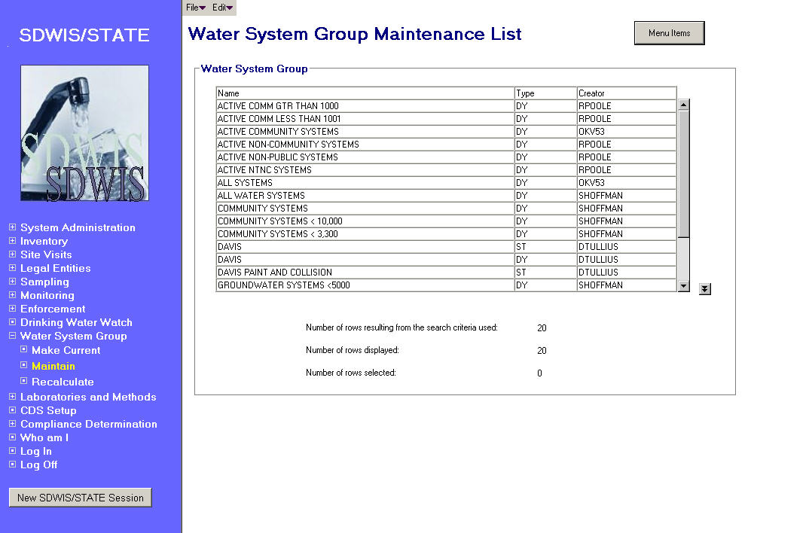
Exhibit 1-17. Water System Group Maintenance List

List Columns:

[Water System]
Name The name of the Water System Group.

[Water System]
Type The type of the Water System Group. The values are:
DY - Dynamic
ST - Static

Creator The User ID of the creator that defined the water system group.
Menu Items:

File
Exit Will close the page and return to the home page.

Edit
Add Dynamic Will present the Dynamic Group Maintenance page in add mode. This item will be available regardless of selections made in the list area.

Add Static Will present the Static Group Maintenance page in Add mode after one or more water systems have been selected. The first page presented after selecting the Edit/Add Static menu item will be the Water System Search page, where criteria can be entered to focus the resulting list presented on the Water System Maintenance List page. The Water System Maintenance List page will be presented with the Edit/Select menu item enabled and allows multiple water systems to be selected. The resulting list will be restricted to water systems defined for the user’s current Water System Group designation. After the water systems are highlighted on the Water System Maintenance List and the Edit/Select menu item chosen, the Static Group Maintenance page will be presented with the selected list of Water Systems displayed in the list area.

Change This item will be enabled only when a single row is highlighted. It will present the appropriate maintenance page in Change mode based on the type of water system group selected, i.e., dynamic or static.

Pass
Ownership This item will allow the SDWIS system administrator to change the creator User ID of a selected water system group to a different User ID. No checking is done to ensure that the newly selected User ID would have access to the group’s member water systems based upon the new User ID’s regulating agency assignments.

This item will be enabled only when a single row is highlighted and the logged-in user has system administrator access. The item will present the SDWIS User Maintenance List in single-select mode where a User ID can be selected and designated as the creator of this water system group. The change will occur at this time and be displayed in the list area.

Delete Will be enabled only when a single row is highlighted.

If the highlighted water system group is designated as the current group for a user, including the delete requestor, the delete will be disallowed and error message will be Water System Group is current selection for Creator.

Clicking OK will close the page and return the user to the Water System Group Maintenance List.

If the water system group is not designated as a current assignment for any user, the Water System Group Delete Confirm dialog box, (Exhibit 1-18), will be presented.

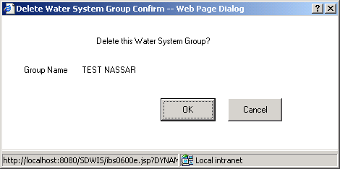

Exhibit 1-18. Delete Water System Group Confirm

Delete Water System Group Confirm Buttons:

OK Will proceed with the delete. The WATER_SYSTEM_GROUP and all associated WATER_SYSTEM_GROUP_ASSIGNMENTS will be deleted. The dialog box will close and will return the user to the Water System Group Maintenance List with this group removed from the list box display.

Cancel Will abort the delete and return the user to the Water System Group Maintenance List with no change in the display.

Copy This item will be enabled only when a single row is highlighted.

Will present the Water System Group Copy dialog box (Exhibit 1-19) where a name can be entered for the new water system group.

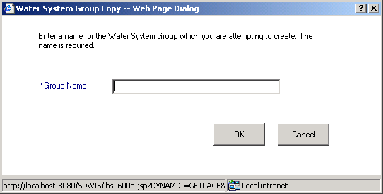

Exhibit 1-19. Water System Group Copy

Copy Group Entry Field:

Group Name The name for the new group. It will be a required field and if left blank, the invoked error message will be: The Group Name cannot be blank. The group name must be unique within the group type of either static or dynamic. If a group of the same name is found for the creating User ID, the error message will be one of the following, based upon the group type being copied: A Static Group with this name already exists for this user or A Dynamic Group with this same name already exists for this user.

Copy Group Buttons:

OK The new WATER_SYSTEM_GROUP will be created and the user is associated to the new Water System Group.

The Last_Calculated_Date will be set to the current date.

If the original water system group is static, all water systems associated with the original group are also assigned to the new static group. The begin date will be the current date and the end date will be null.

If the original water system group is dynamic, the group will be recalculated.

Cancel Will close the page, abort the copy request, and return the user to the Water System Group Maintenance List page.

Make Static This item will be enabled only when a single row is highlighted. The row must be a dynamic group type. If not, the error message will be Dynamic Water System Group must be selected to Make Static.

When a dynamic group is converted to a static group using this function, the last update timestamp for the water system group will be set to the current date and time, both the Group Creator and the Derived User ID will be set to the User ID of the current User, and the Group Type will be changed from DY (dynamic) to ST (static). The fields used to define the dynamic group will not be removed (they will be retained for historical reference purposes although not be viewable online). The water system group will be updated in the list box to display as an ST (Static) type. It cannot be made dynamic again.

Combine This item will be enabled only when two rows are highlighted. It allows the user to combine two groups: two dynamic groups, two static groups, or one of each type into a new static group. If a water system is part of both groups selected, the software will make only one association to the water system (rather than two) when the new static group is created.

Note: When the Combine function is successful, no criteria for the creation of the group are retained in SDWIS/STATE.

When Combine is selected, the software will present the Water System Group Combine dialog box (Exhibit 1-20) where a name must be entered for the proposed new water system group.

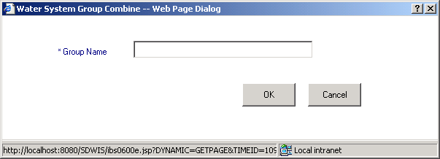

Exhibit 1-20. Water System Group Combine

Water System Group Combine Entry Field:

Group Name The name for the new group. This is a required field and if left blank, the invoked error message will be: The Group Name cannot be blank. The group name combined with the User ID is required to be unique. If a static group with the same name and same Group Creator ID is found, the error message will be A Static Group with this name already exists for this user.

Water System Group Combine Buttons:

OK A new static water system group will be created and the user will be associated to it.

The Last Update Timestamp will be set to the current date and time.

All water systems associated to the original groups will be assigned to the new group without duplicating an association. This new group will be a static group. The begin date for each assignment record will be set to the current date and its end date will be set to null.

Cancel Will close the page, abort the combine request, and return the user to the Water System Group Maintenance List page.

Recalculate This item is enabled only when a single row is highlighted.

If the highlighted group is a static group, the following error message will be invoked: Static Groups do not need to be recalculated.

If the group can be recalculated, the Recalculate Water System Group page will be presented. Recalculation is discussed thoroughly in Section 1.1.5.

Help Will invoke online Help for this page.

Protected Fields:

Number of rows
Displayed: The number of Water System Groups presented in the list box.

Number of rows
Selected: The number of Water System Group rows selected in the list box. Up to two may be selected.

Default Sort Order:

The list of Water System Groups will be listed in ascending name order.

Dynamic Group Maintenance
Dynamic Group Maintenance (Exhibit 1-21) allows the user to add the characteristics of dynamic water system groups for which the user has access. A dynamic group means that filtering criteria is applied against all water systems and those that meet the criteria are associated to this group. Recalculation of the dynamic group may change the membership based upon either a change in criteria or a change in water system’s characteristics.

Note: When using Dynamic Group Maintenance to add or change the characteristics of a dynamic Water System Group, the usual implied criteria for filtering by current WS Group assignment will not be in effect.

Entry Fields:

[Water System Group]
Name The name of the WS Group. Apostrophes should not be included in the name; this character will cause an error when running TCR Noncompliance.

Name will be a mandatory field and if left blank, the following error message will be invoked: Group Name cannot be left blank.

A uniqueness check will be performed using the name field combined with the User ID of the user who created the group. If a dynamic group with the same name and same creator is found, the software will invoke the error message: A Dynamic Group with this same name already exists for this user.

[Water System]
Description The description or purpose of the WS Group. Use this field to fully describe the reason for creating and maintaining the group.

Description will be an optional field.

Filter Criteria: Filter criteria will be used to select the water systems that are members of the Dynamic Water System Group when it is calculated.

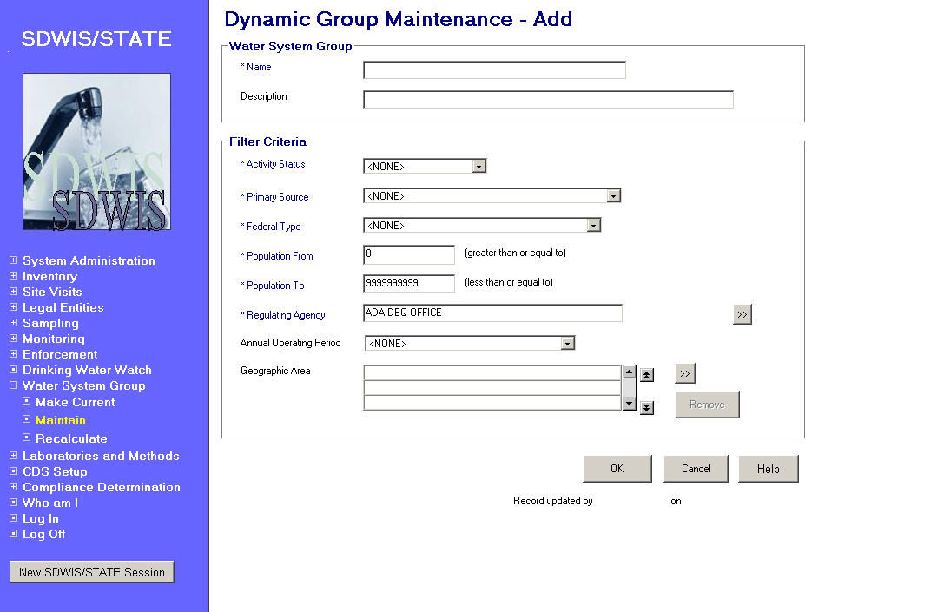
Exhibit 1-21. Dynamic Group Maintenance

Activity Status Will be used to select water systems with a match on the activity status. This value will be compared against the water system Activity_Status_Code during calculation. Specific values available in the dropdown list are:
All Types
Active
Inactive
Proposed

The default value will be All Types.

Activity Status will be a required field.

Primary Source An indication of the federal primary water source for the water system. This value will be compared against the water system D_Fed_Primary_Source_Code during calculation. Specific values available in the dropdown list are:

All Types
GW – Groundwater
GWP – Groundwater Purchased
GU – Groundwater UDI Surface Water
GUP – Groundwater UDI Surface Water Purchased
SW – Surface Water
SWP – Surface Water Purchased
SPH – Subpart H (SW+GU+SWP+GUP)
SSH – Source Subpart H (SW+GU)
PSH – Purchased Subpart H (GUP+SWP)
AGW – All Groundwater (GW + GWP)
AWS – All Surface Water (SW + SWP)
AGU – All Groundwater UDI Surface Water (GU + GUP)

The default value will be All Types.

Primary Source will be a required field.

Federal Type Will be used to select water systems with the designated federal classification type. Specific values available in the dropdown list are:

All Types
C – Community
NTNC – Non-Community Non-Transient
NC – Non-Community Transient
NP – Non-Public
NC + NTNC
C + NTNC
C + NC
C + NTNC + NC

The default value will be All Types.

Federal Type will be a required field.
Population From
(Greater than or
equal to) Will be used to select water systems with a population count greater than or equal to the specified value. The default value will be 0. The maximum value will be 9999999999. Negative numbers will not be permitted.

Population From will be a required field.

Population To
(Less than or
equal to) Will be used to select water systems with a population count less than or equal to the specified value. The default value will be 9999999999. The maximum value will be 9999999999; the minimum value will be 0. Negative numbers will not be permitted.

Population To will be a required field.

Regulating Agency Will be used to select water systems that are regulated by the selected agency. A regulating agency name may be input in whole or part. When the user tabs off the field, the regulating agency will be validated in the database. If an exact match is not found, the Legal Entity Maintenance List will be presented listing the government agencies available for selection. The list will display only the regulating agencies associated to the user. A single selection can be made and returned to this field. The Go To button may also be used to access the Legal Entity Maintenance List where a selection can be made.

Regulating Agency will be a required field.

Annual Operating
Period Will be used to select water systems with Annual Operating Periods (AOP) that fall within the AOP criteria specified. The available choices included in a dropdown list are as below:

FYR – Year Long
SE – Seasonal
LSE – Long Season, 180 Days to 364 Days
SSE – Short Season, 60 Days to 179 Days
LT60 – Less than 60 days
(Spaces)

If no AOP is selected, the default value will be spaces so that AOP is not used as a selection criterion.

Annual Operating Period will be an optional field.

When valued, the software will compare the value entered for an Annual Operating Period against the Days In Operation for the Water System (Days In Operation is a new field in Water System that can be optionally valued by a user for special situations such as a church that is open every weekend all year long). If Days in Operation is not valued for a water system, then the software will compare the value entered against each Annual Operating Period that is in effect on the date of recalculation (Effective_Begin_Date <= current date and Effective_End_Date either null or > current date). The number of days operating will be calculated between the Start_Month/Start_Day and End_Month/End_Day. The software will be able to determine the correct number of days, even when the Start Month and Day is later than the End Month and Day (e.g., 9/1 to 5/31).

This calculated number will then be used in the chart below to determine whether or not the AOP and associated water system satisfy the criteria. Since a Water System may have multiple, current, annual operating periods, a water system could qualify for more than one AOP criteria. Each annual operating period will be evaluated independently (i.e., annual operating periods will not be aggregated by the software).

AOP Selection | Will select water systems with the following calculated number of days operating value
YR - Year Long | = 365
SE – Seasonal | > 0 and < 365
LSE – Long season, i.e., 180 Days to 364 Days | > 179 and < 365
SSE – Short season, i.e., 60 Days to 179 Days | > 59 and < 180
LT60 | 0 to 59
(Spaces) | Will not filter on this criterion

Geographic Area

Will be used to select one or more geographic areas in order to filter the water systems to be included in the Dynamic Group. The Go To button will invoke the Geographic Area Search page, which will flow to the Geographic Area Maintenance List. Multiple geographic areas can be selected and returned to the Geographic Area List box, which will list the Geographic Area selections that will be used for filtering. Only water systems associated with those geographic areas will be included in the dynamic group. An item can be removed from the list by highlighting a selection and pressing the Remove button.

If no Geographic Area is selected, the implied default value will be All Geographic Areas.

Geographic Area will be an optional field.

Tab Sequence:

Name, Description, Activity Status, Primary Source, Federal Type, Population From, Population To, Regulating Agency, Regulating Agency Go To button, Annual Operating Period, Geographic Area Go To button, Geographic Area list box, Remove, OK, Cancel, and Help.

Buttons:

[Regulating Agency]
Go To Will present the Legal Entity Maintenance List with government agencies that can be selected and returned to the Regulating Agency field. The list will display only the regulating agencies associated to the user.

[Geographic Area]
Go To Will present the Geographic Area Search page that flows to the Geographic Maintenance List. Multiple geographic areas may be selected and returned to the Geographic Area list box. Duplicates should not be listed.

Remove Will be enabled only if a Geographic Area has been highlighted in the Geographic Area list box. It will remove the geographic area from the list box. No database activity will be performed until the OK button is selected.

OK Will perform edits on the information valued on the Dynamic Group Maintenance page and will store the filtering criteria provided so that it will be used when recalculating the Water System Group.

Pressing OK with Filtering Criteria:

If the user chooses to specify one or more criteria, only the water systems that exactly match the criteria noted will be included in the Dynamic Water System Group when it is recalculated. The following are filtering permutations that will be available on this search page:

Activity Status
AOP
Federal Type
Geographic Area
Population
Primary Source
Regulating Agency
(If a user accepts all the defaults after selecting a Regulating Agency, the resulting dynamic group will consist of the same water systems as are associated to the selected Regulating Agency.)
Activity Status + AOP
Activity Status + Federal Type
Activity Status + Geographic Area
Activity Status + Population
Activity Status + Primary Source
Activity Status + Regulating Agency
AOP + Federal Type
AOP + Geographic Area
AOP + Population
AOP + Primary Source
AOP + Regulating Agency
Federal Type + Geographic Area
Federal Type + Population
Federal Type + Primary Source
Federal Type + Regulating Agency
Geographic Area + Population
Geographic Area + Primary Source
Geographic Area + Regulating Agency
Population + Primary Source
Population + Regulating Agency
Primary Source + Regulating Agency
Activity Status + AOP + Federal Type
Activity Status + AOP + Geographic Area
Activity Status + AOP + Population
Activity Status + AOP + Primary Source
Activity Status + AOP + Regulating Agency
Activity Status + Federal Type + Geographic Area
Activity Status + Federal Type + Population
Activity Status + Federal Type + Primary Source
Activity Status + Federal Type + Regulating Agency
Activity Status + Geographic Area + Population
Activity Status + Geographic Area + Primary Source
Activity Status + Geographic Area + Regulating Agency
Activity Status + Population + Primary Source
Activity Status + Population + Regulating Agency
Activity Status + Primary Source + Regulating Agency
AOP + Federal Type + Geographic Area
AOP + Federal Type + Population
AOP + Federal Type + Primary Source
AOP + Federal Type + Regulating Agency
AOP + Geographic Area + Population
AOP + Geographic Area + Primary Source
AOP + Geographic Area + Regulating Agency
AOP + Population + Primary Source
AOP + Population + Regulating Agency
AOP + Primary Source + Regulating Agency
Federal Type + Geographic Area + Population
Federal Type + Geographic Area + Primary Source
Federal Type + Geographic Area + Regulating Agency
Federal Type + Population + Primary Source
Federal Type + Population + Regulating Agency
Geographic Area + Population + Primary Source
Geographic Area + Population + Regulating Agency
Geographic Area + Primary Source + Regulating Agency
Population + Primary Source + Regulating Agency
Activity Status + AOP + Federal Type + Geographic Area
Activity Status + AOP + Federal Type + Population
Activity Status + AOP + Federal Type + Primary Source
Activity Status + AOP + Federal Type + Regulating Agency
Activity Status + AOP + Geographic Area + Population
Activity Status + AOP + Geographic Area + Primary Source
Activity Status + AOP + Geographic Area + Regulating Agency
Activity Status + AOP + Population + Primary Source
Activity Status + AOP + Population + Regulating Agency
Activity Status + AOP + Primary Source + Regulating Agency
Activity Status + Federal Type + Geographic Area + Population
Activity Status + Federal Type + Geographic Area + Primary Source
Activity Status + Federal Type + Geographic Area + Regulating Agency
Activity Status + Federal Type + Population + Primary Source
Activity Status + Federal Type + Population + Regulating Agency
Activity Status + Geographic Area + Population + Primary Source
Activity Status + Geographic Area + Population + Regulating Agency
Activity Status + Geographic Area + Primary Source + Regulating Agency
Activity Status + Population + Primary Source + Regulating Agency
AOP + Federal Type + Geographic Area + Population
AOP + Federal Type + Geographic Area + Primary Source
AOP + Federal Type + Geographic Area + Regulating Agency
AOP + Federal Type + Population + Primary Source
AOP + Federal Type + Primary Source + Regulating Agency
AOP + Geographic Area + Population + Primary Source
AOP + Geographic Area + Primary Source + Regulating Agency
AOP + Population + Primary Source + Regulating Agency
Federal Type + Geographic Area + Population + Primary Source
Federal Type + Geographic Area + Primary Source + Regulating Agency
Federal Type + Geographic Area + Population + Regulating Agency
Federal Type + Population + Primary Source + Regulating Agency
Geographic Area + Population + Primary Source + Regulating Agency
Activity Status + AOP + Federal Type + Geographic Area + Population
Activity Status + AOP + Federal Type + Geographic Area + Primary Source
Activity Status + AOP + Federal Type + Geographic Area + Regulating Agency
Activity Status + AOP + Federal Type + Population + Regulating Agency
Activity Status + AOP + Federal Type + Primary Source + Regulating Agency
Activity Status + AOP + Geographic Area + Population + Primary Source
Activity Status + AOP + Geographic Area + Population + Regulating Agency
Activity Status + AOP + Geographic Area + Primary Source + Regulating Agency
Activity Status + AOP + Population + Primary Source + Regulating Agency
Activity Status + Federal Type + Geographic Area + Population + Primary Source
Activity Status + Federal Type + Geographic Area + Primary Source + Regulating Agency
Activity Status + Federal Type + Population + Primary Source + Regulating Agency
AOP + Federal Type + Geographic Area + Population + Primary Source
AOP + Federal Type + Geographic Area + Population + Regulating Agency
AOP + Federal Type + Geographic Area + Primary Source + Regulating Agency
AOP + Federal Type + Population + Primary Source + Regulating Agency
AOP + Geographic Area + Population + Primary Source + Regulating Agency
AOP + Federal Type + Geographic Area + Population + Primary Source
Federal Type + Geographic Area + Population + Primary Source + Regulating Agency
Activity Status + AOP + Federal Type + Geographic Area + Population + Primary Source
Activity Status + AOP + Federal Type + Geographic Area + Population + Regulating Agency
Activity Status + AOP + Federal Type + Geographic Area + Primary Source + Regulating Agency
Activity Status + AOP + Federal Type + Population + Primary Source + Regulating Agency
Activity Status + AOP + Geographic Area + Population + Primary Source + Regulating Agency
Activity Status + Federal Type + Geographic Area + Population + Primary Source + Regulating Agency
AOP + Federal Type + Geographic Area + Population + Primary Source + Regulating Agency
Activity Status + AOP + Federal Type + Geographic Area + Population + Primary Source + Regulating Agency

SDWIS will perform the following edits:

- Group Name must not be blank and if it is, the following error message will be invoked: WS Group Name cannot be left blank.

- Group Name plus Creator must be unique among dynamic water system groups and if it is not, the error message will be invoked: A Dynamic Group with this name already exists for this user.

- Primary Source must be valued. If it is not, the following error message will be invoked: Primary Source cannot be left blank.

- Federal Type must be valued. If it is not, the following error message will be invoked: Federal Type cannot be left blank.

- Population From must be valued. If it is not, the following error message will be invoked: Population From cannot be left blank.

- Population To must be valued. If it is not, the following error message will be invoked: Population To cannot be left blank.

- The Population From field must contain a value equal to or less than the Population To field. If it does not, the error message will be invoked: Population To must contain a value greater than or equal to the Population From field.

- Regulating Agency must be valued with a valid regulating agency. If it is valued but does not match a regulating agency to which the user is assigned, the Legal Entity Maintenance List will be presented listing government agencies for selection.

Note: The list will display only the regulating agencies associated to the user.

Add Mode Will create a WATER_SYSTEM_GROUP and associate it to the D_USER that created it. A row will be added in the WS_GROUP_GEO_AREA_ASGMT table for each row in the Geographic Area list box.

The page will close and return the user to the Water System Group Maintenance List page.

The group members will not be selected at this point. The group will instead be calculated when the user makes the group current or uses the Recalculate function available under the Water System Group menu item on the SDWIS/STATE Home Page.

Change Mode The WATER_SYSTEM_GROUP will be updated with the changed criteria and the last update timestamp and User ID will be updated with current values. Each row in the Geographic Area list box will be evaluated. Removed rows will cause the deletion of the WS_GROUP_GEO_AREA_ASGMT and new rows will cause the insertion of new WS_GROUP_GEO_AREA_ASGMTs.

The page will close and return the user to the Water System Group Maintenance List page.

The group members will not be selected at this point. The group will instead be calculated when the user makes the group current or uses the Recalculate function available under the Water System Group menu item on the SDWIS/STATE Home Page.

Cancel If no changes have been made to the enterable fields, the page will close and return the user to the Water System Group Maintenance List page. The timestamp will not be updated.

If changes have been made, a standard Cancel Confirmation dialog box will be presented.

Help Will invoke online Help for this page.

1.7.4.2 Static Group Maintenance
The Static Group Maintenance (Exhibit 1-22) will be used to create a new, static Water System Group and maintain the water systems that are members of the group.

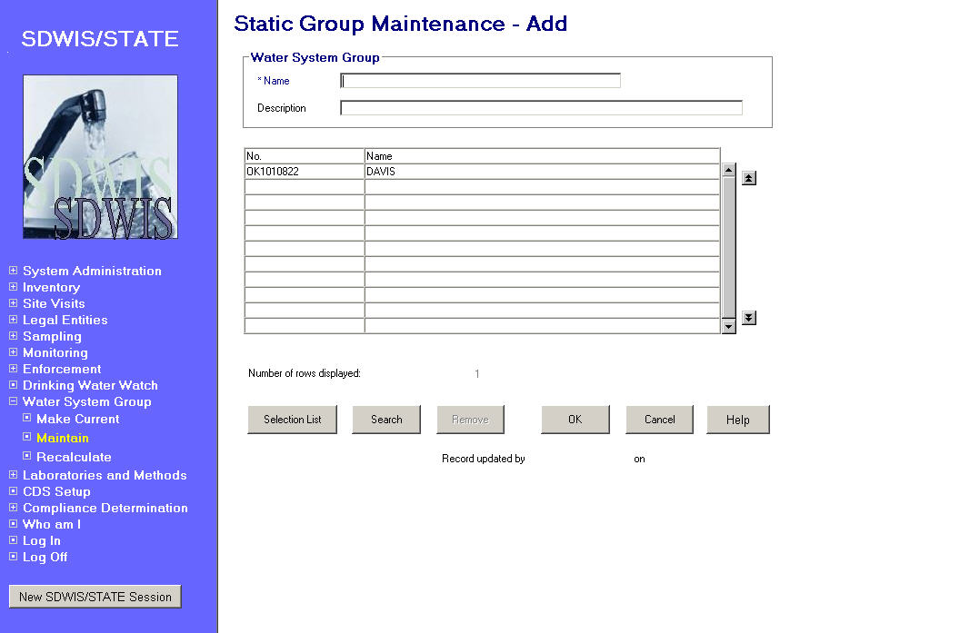
Exhibit 1-22. Static Group Maintenance

Entry Fields:

[Water System
Group] Name The name of the WS Group. Do not include an apostrophe in the name; this character will cause an error when running TCR Noncompliance.

Name will be a required field.

Description The description or purpose of the water system group. Use this field to fully describe the reason for creating and maintaining the group.

Description will be an optional field.

List Area In Add mode this list area will list the water systems selected from the multiple selection list. They are not members of the group until the group is created using the OK button.
In Change mode, this list area will list the water systems that are currently members of the group. Any new water systems being added to the group will also be listed once selected from the Water System Maintenance List but they will not be members of the group until the group is updated using the OK button.

[Water System]
No. The Water System No.

[Water System]
Name The Water System name.

Buttons:

Selection List Will present the Water System Maintenance List where additional water systems can be selected for addition to the group. Multiple selections can be made and returned to the list area.

Search Will present the Water System Search page where criteria can be entered to control the resulting Water System Maintenance List.

Remove Will remove the association to the water system highlighted in the list box. It will only be enabled if a water system is selected. A Delete Water System from Group Confirmation dialog box (Exhibit 1-23) will be presented.

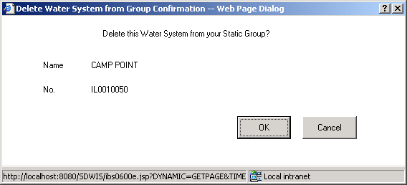

Exhibit 1-23. Delete Water System from Group Confirmation

Remove Water System from Group Confirmation Buttons:

OK Will remove the highlighted water system from the list box. If the water system is a member of the water system group, the WATER_SYSTEM_GROUP_ASGMT will be deleted.

Cancel Will abort the delete request and return the user to the Static Group Maintenance page.

OK The following edits will be performed:

- Name will be a mandatory field and if left blank, the following error message will be invoked: WS Group Name cannot be left blank.

- Uniqueness checking will be performed using the WS Group User ID of the Name and WSG creator. If a static water system group already exists with the same name and group creator, the following error message will be invoked: A Static Water System Group with this name already exists for this user.

Add mode A water system group will be created as a static group and the current user will be recorded as the creator of the group. The last update timestamp will be set to the current date and time. For each water system in the list area, the WATER_SYSTEM_GROUP_ASGMT will be created between the water system group and the water system. The Begin Date for the assignment will be set to current date and the End Date for the assignment will be set to null.

The page will close and return the user to the Water System Group Maintenance List where this new static group will be displayed.

Change mode The water system group will be updated with any change in name or description. The last update timestamp will be changed to the current date and time. The User ID will be set to the ID of the current user.

For each water system in the list area that is not already a member of the group, the WATER_SYSTEM_GROUP_ASGMT will be created between the water system group and the water system. The Begin Date for the assignment will be set to current date and the End Date for the assignment will be set to null.

The page will close and return the user to the Water System Group Maintenance List where this new static group will be displayed.

Cancel If no changes have been made to the enterable fields, the page will close and return the user to the Water System Group Maintenance List.

If changes have been made, the standard Cancel Confirm dialog box will be presented.

Help Will invoke online Help for this page.

Protected Fields:

Number of Rows
Displayed Lists the number of water systems displayed in the list box.

Recalculate
This function will recalculate the members of a Dynamic Water System Group. When the function is requested from Water System Group item on the SDWIS/STATE Home Page, the recalculation applies to the dynamic group that is designated as the current water system group for the logged-in user. The function can also be selected from the Edit/Recalculate menu item on the Water System Maintenance List page where it will recalculate the highlighted WS group.

If the current group is a static group, the following error message will be invoked: User is assigned to a Static Group. Static Groups do not need to be recalculated.

If the current designation is a government agency, the following error message will be invoked: User is assigned to a Regulating Agency. Regulating Agencies do not need to be recalculated.

If the group can be recalculated, the Recalculate Water System Group page (Exhibit 1-24), will be presented requiring the selection of Yes or No.

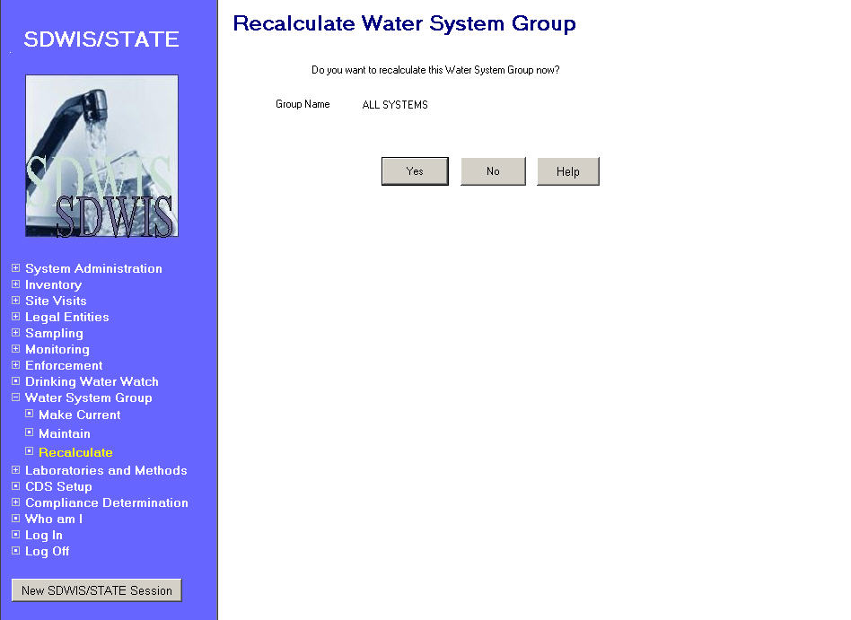
Exhibit 1-24. Recalculate Water System Group
Buttons:

Yes Will begin by deleting all WATER_SYSTEM_GROUP_ASGMT that are associating water systems to the water system group. The population of water systems in SDWIS/STATE will then be evaluated against the filtering criteria defined with the dynamic water system group.

- For activity status, only water systems that have an Activity_Status_Code equal to the criteria selection will be included.

- For federal type, the following logic will be applied for inclusion:

Federal Type Selection | Will select water systems with the following value(s) in D_PWS_Federal_Type_Code
All Types | Will not filter by this criteria
C – Community | C
NTNC – Non-Transient Non-Community | NTNC
NC – Non-Community Transient | NC
NP – Non-Public | NP
NC+ NTNC | NTNC or NC
C + NTNC | C or NTNC
C + NC | C or NC
C + NTNC + NC | C or NTNC or NC

- For primacy source type, the following logic will be applied for inclusion:

Primacy Source Selection | Will select water systems with the following value(s) in D_Fed_Primary_Source_Code
All Types | Will not filter by this criteria
GW (Groundwater) | GW
GWP (Groundwater Purchased) | GWP
GU (Groundwater UDI Surface Water) | GU
GUP (Groundwater UDI Surface Purchased) | GUP
SW (Surface Water) | SW
SWP (Surface Water Purchased) | SWP
SPH (Subpart H) | SW or GU or SWP or GUP
AWG (All Groundwater) | GW or GWP
AWS (All Surface Water) | SW or SWP
AGU (All Groundwater UDI Surface Water) | GU or GUP
SSH (Source Subpart H) | SW or GU
PSH (Purchased Subpart H) | GUP or SWP

- If geographic areas are defined for the Water System Group, only water systems that are associated to all selected geographic areas will be selected for inclusion.

- For regulating agency, only water systems that have a REGULATING_AGENCY_ASGMT to the defined Regulating Agency.

- If an AOP is defined, the following logic will be applied for inclusion:

If the water system has a value in the days_of_operation field, that value will be used in the determination chart below. If there is no value, each Annual Operating Period associated to the Water System that is in effect on the date of recalculation (Effective_Begin_Date <= current date and Effective_End_Date either null or > current date) will be evaluated. The number of days operating will be calculated between the Start_Month/Start_Day and End_Month/End_Day. This number will then be used in the table below to determine if inclusion is valid. Since a Water System may have multiple annual operating periods, a water system could qualify for more than one selection. Each annual operating period will be evaluated independently and number of days operating is not aggregated prior to evaluation.

AOP Selection | Will select water systems with the following calculated number of days operating value
YR - Year Long | = 365
SE – Seasonal | > 0 and < 365
LSE – Long season, i.e., 180 Days to 364 Days | > 179 and < 365
SSE – Short season, i.e., 60 Days to 179 Days | > 59 and < 180
LT60 | 0 to 59
(Spaces) | Will not filter on this criteria

- The water system’s D_Population_Count must be greater than or equal to the Population From criteria and less than or equal to the Population To criteria.

For each water system that meets the criteria, a WATER_SYSTEM_GROUP_ASGMT will be created between the water system group and the water system. The Begin_Date will be set to the current date and the End_Date will be set to null. The Last_Calculated_Date will be set to the current date.

The time to complete this recalculation will be dependent on the number of water systems in the database.

When completed, the SDWIS/STATE Home Page will be presented.

No Will not initiate the recalculation and returns the user to the SDWIS/STATE Home Page.

Help Will invoke online Help for this page.

Icons
Pages throughout SDWIS/STATE have icon pictures that allow quick, read-only access to additional water system information. These pages are described below and referenced through out the design document.

Water System Information


The Water System Information page is a display-only synopsis of water system information.

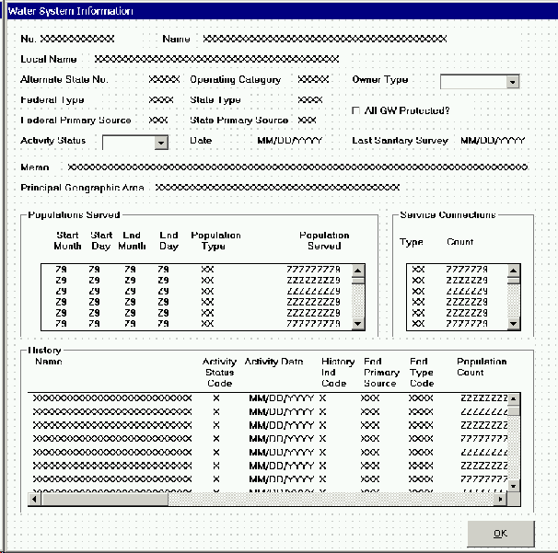

Exhibit 1-25. Water System Information

Protected Fields:

Water System No. The Water System No.

Name The Water System name.

Local Name The Water System local name.

Alt State No. The Water System alternate state number.

Op Cat Code The Water System operating category code.

Owner Type The Water System owner type code.

Fed PWS Type The Water System Federal type code from d_pws_federal_type_code.

State PWS Type The Water System State type code from d_pws_state_type_code.

Population Count The average population for the Water System retrieved from the d_populated_served_count.

Days Serving The days serving a population over 25 count retrieved from the Water System days_serving_count.

Fed Source Type The Water System federal primary water source code from d_fed_primary_source_code.

State Source Type The Water System state primary water source code from d_state_primary_source_code.

All GW Protected? When checked indicates that all groundwater is protected.

Activity Status The current status of the Water System.

Status Date The date that the Water System entered the displayed activity status.

Extra Date 1 The use of this field will be controlled by the user. This field date will be retrieved from the “LAST_SNTY_SRV_DT” (Last Sanitary Survey Date with no Defects) field of the TINWSYS table. The label for this field will be retrieved from the TINPVALS table with the code name = “TINWSXDT1.”

Extra Indicator 1 The use of this field will be controlled by the user. This field will be retrieved from the “D_DSNFCT_GW_IND_CD” (Disinfected Groundwater Indicator) field of the TINWSYS table. The label for this field will be retrieved from the TINPVALS table with the code name = “TINWSXIN1.”

Extra Date 2 The use of this field will be controlled by the user. This date will be retrieved from the “D_LAST_TCR_VIO_DT” (Last TCR Violation Date) field of the TINWSYS table. The label for this field will be retrieved from the TINPVALS table with the code name = “TINWSXDT2.”

Extra Indicator 2 The use of this field will be controlled by the user. This field will be retrieved from the “D_SW_OR_GUDI_FILTER_INDCTOR_CODE” (Surface Water or Groundwater UDI Filtered Indicator) field of the TINWSYS table. The label for this field from the TINPVALS table with the code name = “TINWSXIN2.”

Comments The comments documented with the Water System.

Principal City
Served The principal city served by the Water System retrieved from the d_principal_city_served_name.

Populations Served A list box of the Water System’s Annual Operating Periods and their Population Served records.

Service Connections A list box of the Water System’s Service Connection Categories.

Active Sources of
Water A list box of water system facilities for the Water System that are in active status and that are a source-type facility. (Determined when the WSF type code is one of the TINPVALS table text values where code_name = WSFSRCTYPE.) The list box will list the WSF State Asgn ID, Name, and Type in ascending WSF State Asgn ID order.

Regulating Agency
Assignments A list box of Regulating Agencies to which the Water System has an active association. The list box will display the Name of the regulating agency in ascending order.

History A list box of the Water System’s history of changes which will contain the following fields from entity WATER_SYSTEM_HISTORY (table TINWASH): Name, Activity Status, Status Date, History Ind Code, Fed Source, Fed PWS Type, Population Count, Days Serving, Owner Type, Activity Reason Text.

The Water System History records will be presented in descending Internal No. order so that the most recent change appears first on the list.

Buttons:

OK Will close the page and return to the invoking page.

Point of Contact Information


The Point of Contact Information page will present the Water System Related POC Maintenance List in single-select mode (Exhibit 1-26). This page is shown below but described in detail in Chapter 4. The description below details page behavior of the Edit/Select, which is the only menu item available when accessed from the Icon.

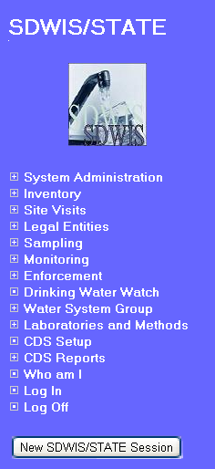 | 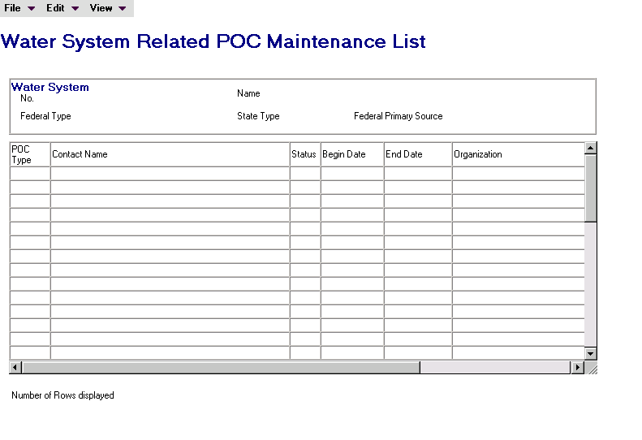

Exhibit 1-26. Water System Related POC Maintenance List

Menu Items:

Edit (Select will be the only menu item available when page is presented from the Icon navigation path.)

Select Will present the Water System Related POC Maintenance page, described in Chapter 4, where all fields and button will be protected except the following:

List Box scrolling of the Phone Numbers
List box scrolling of the Electronic Addresses
Email/URL Launch button
Cancel button
More button

If the More button is used, all fields and buttons on the MORE POC page will be protected except for the Cancel button.

Historical Sampling Information
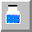

The Historical Sampling Information page will present a list of the most recent samples collected for the Water System (Exhibit 1-27). All fields are display only.

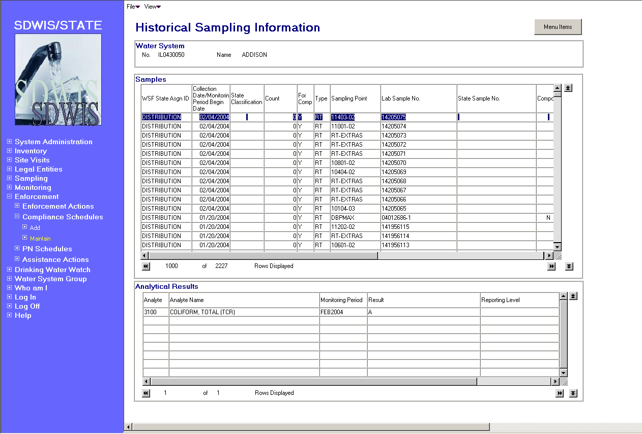

Exhibit 1-27. Historical Sampling Information

Protected Fields:

Water System
Group Box This group box will display the water system’s number and name.

Samples List Box This list will display sample information for the water system. Columns displayed are WSF State Asgn ID, [Sample] Collection date or [Sample Summary] Monitoring Period Begin Date, State Classification, Count, For Comp[liance], [Sample] Type, Sampling Point, Lab Sample No., State Sample No., Composite?, Sample Rejection Reason, Sampling Location, Monitoring Period [Name], Lab State ID No., Lab Fed ID No. as defined on the General Sample/Sample Summary Maintenance List page documented in Chapter 5 section 5.2.4.

The list will default to display samples collected in the past 6 months and summaries in the past 6 monthly monitoring periods sorted by descending [Sample] Collection date or [Sample Summary] Monitoring Period Begin Date column. The list will display 20 of 1000 rows on the page without requiring scrolling.

XX of XX Rows
Displayed Will present the number of sample/sample summary rows displayed of the entire count of existing samples/sample summaries for the water system in the past 6 months.

Analytical Results
List Box This list will display sample results information when a sample has been highlighted in the Samples List box. When no sample is highlighted or when the highlight is on a sample summary, this list box will be empty. When the highlight is moved from one sample to another, this list box will refresh. When the highlight is removed from the sample this list box will be cleared.

The list columns will be Analyte [Code], Analyte Name, Monitoring Period [Name], Result, Reporting Level, Level Type, [Monitoring Period] Begin Date, and [Monitoring Period] End date, as defined on the General Sample Maintenance page documented in Chapter 5, Section 5.5.1.

The list will be sorted by ascending Analyte [Code] column. The list will display 10 of 200 rows on the page without requiring scrolling.

XX of XX Rows
Displayed Will present the number of sample analytical result rows displayed of the entire count of existing sample analytical results for the selected sample.

Menu Items:

File
Exit Will close the page and return to the invoking page.

View
Filter By Selecting View/Filter By will allow the user to filter the Samples List Box by WSF State Asgn ID, Collection Date, Sample Summary Result Count Qty, Compliance Purpose Indicator, Sample Type Code, State Classification, Sampling Point, Lab Sample No., State Sample No., Sampling Point Location, Monitoring Period Name, Laboratory Fed ID No. and Laboratory State ID No.

Refresh Selecting View/Refresh will retrieve the unfiltered list of samples. Disabled if list is unfiltered.

Sort Selecting View/Sort will invoke the standard Sort window allowing the contents of the Samples List box to be sorted. Sorting will be allowed by WSF State Asgn ID, Collection Date, Sample Summary Result Count Qty, Compliance Purpose Indicator, Sample Type Code, State Classification, Sampling Point, Lab Sample No., State Sample No., Sampling Point Location, Monitoring Period Name, Laboratory Fed ID No., and Laboratory State ID No.

Three sort levels will be supported.

Buttons:

Menu Items Will present the standard menu items dialog box.

Scroll Buttons Will scroll the list box in the direction of the arrow displayed on the button.

Violation Information


The Violation Information page will display a list of violations and their related enforcement actions for the Water System (Exhibit 1-28). All fields are display only.

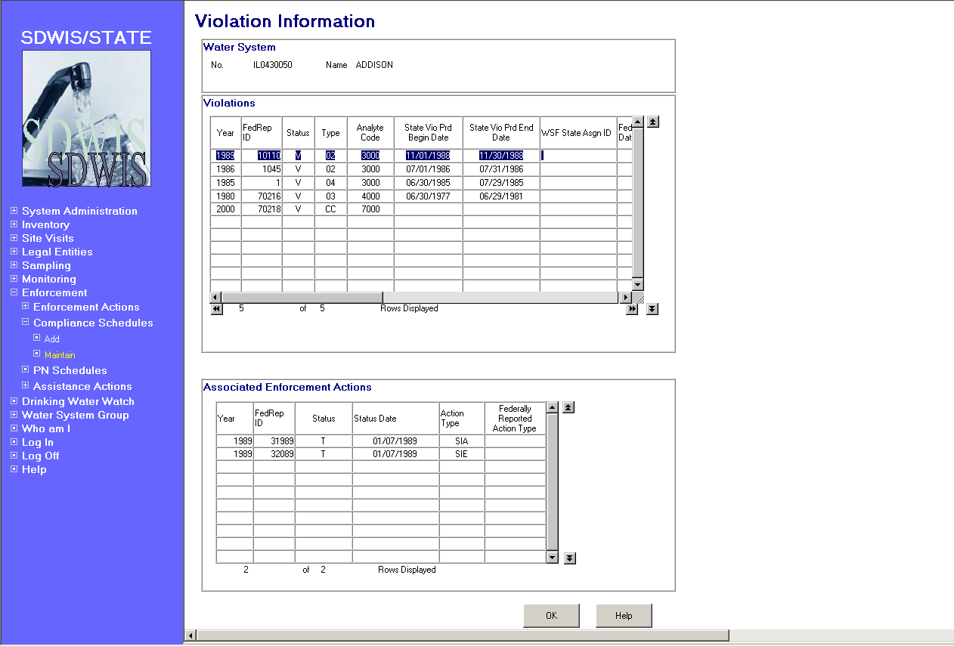

Exhibit 1-28. Violation Information

Water System

Group Box The number and name of the Water System for which the Violations displayed in the list box apply.

Violations List Box The Violations list box will display violations for the water system. It will present 1000 violations sorted by State Vio Prd Begin Date descending; State Vio Prd End Date descending; Type Code ascending.

List columns will present the following fields: Violation Year, FedRep ID, Status, Vio. Type, Analyte Code, State Vio Prd Begin Date, State Vio Prd End Date, WSF State Asgn ID, Fed Vio Prd Begin Date, Fed Vio Prd End Date, Package Number, Report Pckgd Vio?, Monitoring Period, Analyte Name, Analyte Result/UOM, Determination Date.

The list will be single select for the purpose of populating the Enforcement Actions list box. When a violation is highlighted, the Enforcement Actions list box will be populated. If the highlighting is moved to a different violation, the Enforcement Actions list box will be refreshed. If the highlighting is removed, the Enforcement Actions list box will be cleared.

XX of XX Rows
Displayed Will present the number of violation rows displayed of the entire count of existing violations for the water system.

Associated Enforcement Actions
List Box The Enforcement Actions list box will display enforcement actions associated to the highlighted violation. It will present 1000 enforcement actions sorted by Status date, descending; Action Type ascending.

List columns will present the following fields: Enforcement Action Year, FedRep ID, Status, Status Date, Action Type, Federally Reported Action Type.

XX of XX Rows
Displayed Will present the number of enforcement action rows displayed of the entire count of existing enforcement actions for the highlighted violation.

Buttons:
OK Will close the page and return to the invoking page.

Help Will invoke online Help for this page.

Scroll Buttons Will scroll the list box in the direction of the arrow displayed on the button.

Enforcement Action Information


The Enforcement Action Information page will display a list of enforcement actions and their related violations for the water system (Exhibit 1-29). All fields are display only.

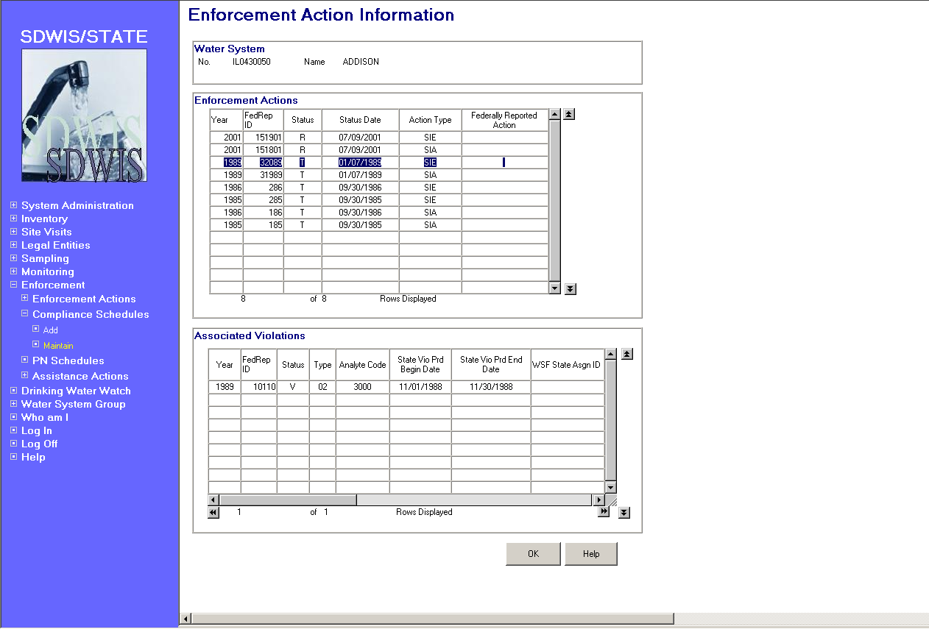

Exhibit 1-29. Enforcement Action Information

Water System

Group Box The number and name of the water system for which the Enforcement Actions displayed in the list box apply.

Enforcement Actions
List Box The Enforcement Actions list box will display enforcement actions associated to the water system. It will present 1000 enforcement actions sorted by Status date, descending; Action Type ascending.

List columns will present the following fields: Enforcement Action Year, FedRep ID, Status, Status Date, Action Type, Federally Reported Action Type.

The list will be single select for the purpose of populating the Violations list box. When an enforcement action is highlighted, the Violations list box will be populated. If the highlighting is moved to a different enforcement action, the Violations list box will be refreshed. If the highlighting is removed, the Violations list box will be cleared.

XX of XX Rows
Displayed Will present the number of enforcement action rows displayed of the entire count of existing enforcement actions for the water system.

Associated Violations
List Box The Violations list box will display violations for the highlighted enforcement action. It will present 1000 violations sorted by State Vio Prd Begin Date descending; State Vio Prd End Date descending; Type Code ascending that are associated to the highlighted enforcement action.

List columns will present the following fields: Violation Year, FedRep ID, Status, Vio. Type, Analyte Code, State Vio Prd Begin Date, State Vio Prd End Date, WSF State Asgn ID, Fed Vio Prd Begin Date, Fed Vio Prd End Date, Package Number, Report Pckgd Vio?, Monitoring Period, Analyte Name, Analyte Result/UOM, Determination Date.

XX of XX Rows
Displayed Will present the number of violation rows displayed of the entire count of existing violations for the highlighted violation.

Buttons:
OK Will close the page and return to the invoking page.

Help Will invoke online Help for this page.

Scroll Buttons Will scroll the list box in the direction of the arrow displayed on the button.

This page is intentionally left blank.

