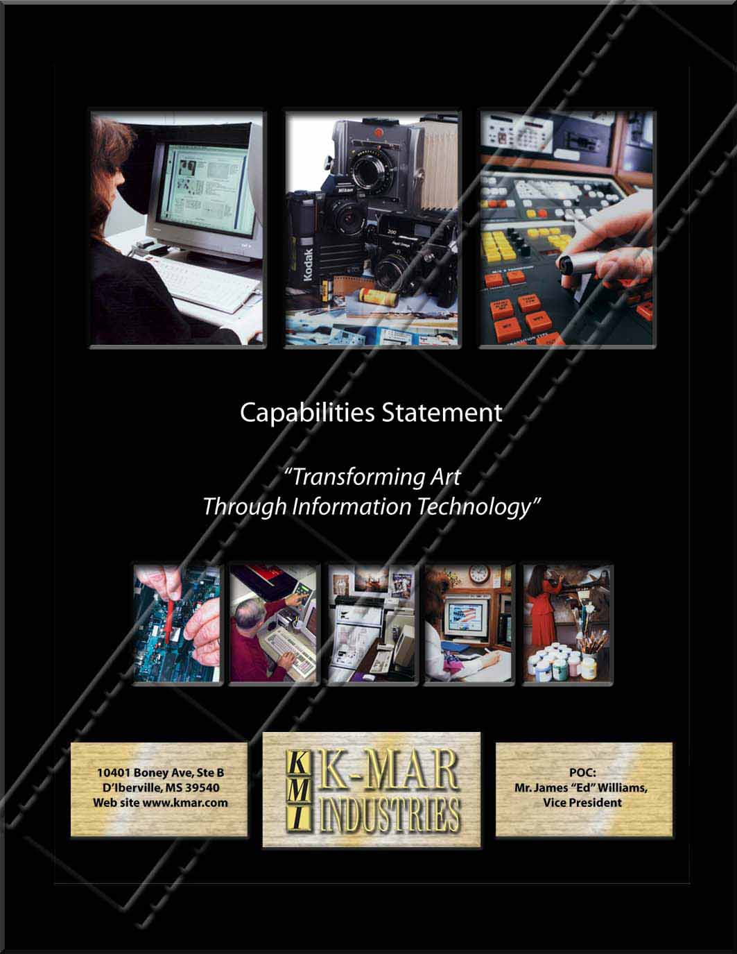
Introduction

K-MAR Industries, Inc. (KMI) is a highly qualified, veteran owned, small business concern, with extensive hands-on experience in Visual Information/Multimedia Services. Since its inception in 1987, K-MAR Industries, Inc. has specialized in producing customized multimedia solutions that meet our customer’s unique requirements. We help our customer’s "think outside the box," enabling them to move beyond traditional methods of training and communication.

KMI has superior ratings from prior and existing contracts. As a matter of fact, KMI is presently performing Visual Information/Multimedia Services at ten (10) Department of Defense facilities. For the US Air Force, KMI is presently performing at Keesler, Lackland, Pope, Los Angeles, Tinker and Tyndall Air Force Bases. For the US Army KMI provides these services at Fort Rucker, Fort Dix, Fort Knox and Fort Sill. In addition, we have extensive hands-on experience in Electronic Weather Equipment Maintenance which we currently perform at ten (10) facilities throughout the United States through a contract administered by Langley AFB.

K-MAR Industries Inc, (KMI) corporate office is cleared at the TOP SECRET Level and staffed with a Facility Security Officer (FSO). Our security administration process is fully electronic, which expedites the personnel clearance process using the Joint Personnel Adjudication System (JPAS) and the e-Qip on line application process.

Through a powerful combination of highly-skilled people, proven processes and industry-leading automation technology, KMI has established itself as the leading provider of Visual Information/Multimedia services. With the use of today's multimedia tools, our products and services can drive the message home more effectively than ever before. We deliver hard-hitting dynamic multimedia products and services to our customers.

KMI offers a wealth of expertise, experience and creative talent in the development of multimedia products and services and communication and information technology services. KMI is staffed by a talented and diverse team of dedicated professionals with extensive expertise in all phases of multimedia products and services. KMI core skills include:

- Project Management
- Systems Administration
- Networking
- Website Development and Maintenance
- Computer Based Training
- Photography
- Graphics
- Military Fine Arts
- Graphic Support for Career Development Courses
- Television Production
- Commander Access Television Channel
- Video Teleconferencing
- Interactive Video Teletraining (Distance Learning)
- Interactive Courseware Development
- Loan and Issue of Audiovisual Equipment
- Presentation Support
- Public Address Support
- Warehousing
- MILES
- TADSS
- Exhibits/Displays/Mock-ups
- Property Control
- Electronic Weather Equipment Maintenance

As a service provider to the government we focus on cost-effective, timely delivery of quality products and services. KMI is committed to developing a partnership with our customers. To meet our customers' challenges, we recruit, hire, train and retain the most experienced and innovative professionals available. We strive to exceed the goals of our customers.

KMI provides a broad range of services to support a wide variety of applications. Our personnel take advantage of the latest technologies to design and generate applications that meet the precise objectives whether informative, motivational, or educational. Our approach is structured including specific requirements definition, design, story boarding, development, testing, and documentation phases. At every step, we involve our customers in the process to ensure their objectives and results are exactly what they seek.

Although our niche market is in the Multimedia arena, at each of our contract sites, we provide administrative support to each of these contracts as well as operating systems applications and network support, information assurance, hardware/software assessment, acquisition support, user orientation and training, information center/help desk, infrastructure planning and maintenance, computer/network systems operations, and workstation maintenance. Each of the above mentioned areas are described below:

- Systems Design and Development: This includes but is not limited to, incorporating user requirements, existing system configurations and performance data to recommend system enhancements, modifications and upgrades and upon approval to implement such recommendations.

- Operating Systems, Applications and Network Support: This includes but is not limited to, maintaining existing software and performing patches, modifications and upgrades as required. This also includes providing user assistance, configuration management, requirements analysis and recommendations for new and proposed software.

- Information Assurance: This includes but is not limited to, risk analyses, vulnerability assessments, system accreditation documentation, security audits, security awareness training and managing information assurance software to include Intrusion Detection and virus protection software configuration and updating.

- Hardware/Software Assessment and Acquisition Support: This includes but is not limited to, test and analysis of new and proposed equipment and recommendations for alternative hardware

- User Orientation and Training: This includes but is not limited to, professional level training courses for. Training methods include formal classroom training, interactive video, computer assisted training, web based training, individual tutoring and other methods as may be specified.

- Information Center/Help Desk: This includes but is not limited to, 24 hour a day, seven days a week assistance for hardware, software, communications, and applications problems and questions.

- Infrastructure Planning and Maintenance: This includes but is not limited to, LAN, WAN, network cable installation and maintenance.

- Computer/Network Systems Operations: This includes but is not limited to, web server support, incident tracking and reporting, systems performance evaluations and reports, maintaining software licenses, boot media and all other standard systems operations tasks.

- Workstation Maintenance: This includes but is not limited to, developing a maintenance management plan that specifies response time requirements and how they will be met for all workstations and peripherals. Types of maintenance service include on-call, on-site, preventive, corrective, diagnostic, and remedial, carry-in, mail-in and spare provisioning. This also includes managing other maintenance support services provided by subcontractors if applicable.

Our goal is to understand an organization’s unique needs. Our value to your business is extended through the wealth of experience provided by our skilled employees. These professionals bring experience and depth to examine your requirements all the way through the planning, design, testing, implementation and support phases. Blending industry knowledge, proven methodologies and best of breed technology, KMI can deliver a series of business strategies and solutions to support your vision.

Because of the depth of our experience we are very quick in understanding and translating our customers need into an effective media product or service. By applying efficient production standards, we are able to offer highly competitive prices without compromising on quality. We can ensure a successful end-product through our emphasis on customer service, and our involvement from the initial contact throughout to product completion. By developing solutions which meet the customer’s objectives and create long term benefits, and delivering above standard quality products on time, we create true value where it counts.

KMI is committed to serving and satisfying our customers by building a team of trustworthy, competent, and committed professionals. To achieve this objective, we emphasize quality and the continuous pursuit of excellence by maintaining our core professional values, striking a balance between personal and professional fulfillment, empowering and strengthening our employees, and by sharing in our customer’s goals of cost-effectiveness and efficiency.

At KMI our people make the difference, to be successful and recognized as an innovative, highly productive, excellent organization, we create an environment which fully utilizes the talents and capabilities of all our employees. We embrace the richer, broader perspective that each individual brings to the workplace, and we respect the dignity of our employees and our customers.

KMI was founded on innovation, experience, customer satisfaction and integrity. It’s how we do business, and it’s how we build better interactive experiences for each customer and its audience. We develop creative and successful digital solutions for organizations by not only listening to the voice of technology, but by listening to the needs and goals of our customers.
We provide our services with one basic premise in mind: "Every customer is satisfied because Quality and Customer Service is at the heart of every decision we make!" Our services are customized to our customers needs through the use of proven, reliable tools and processes that ensure our customers receive the finest multimedia products and services available.

Corporate Organization
KMI’s Corporate Organization Chart, (figure below), illustrates the KMI Corporate organizational structure. Each Project Manager reports directly to the Vice President and Chief Operating Officer. This short, clear channel of communication promotes responsive and timely reaction from the senior company level and focuses attention and resources on resolving problems.

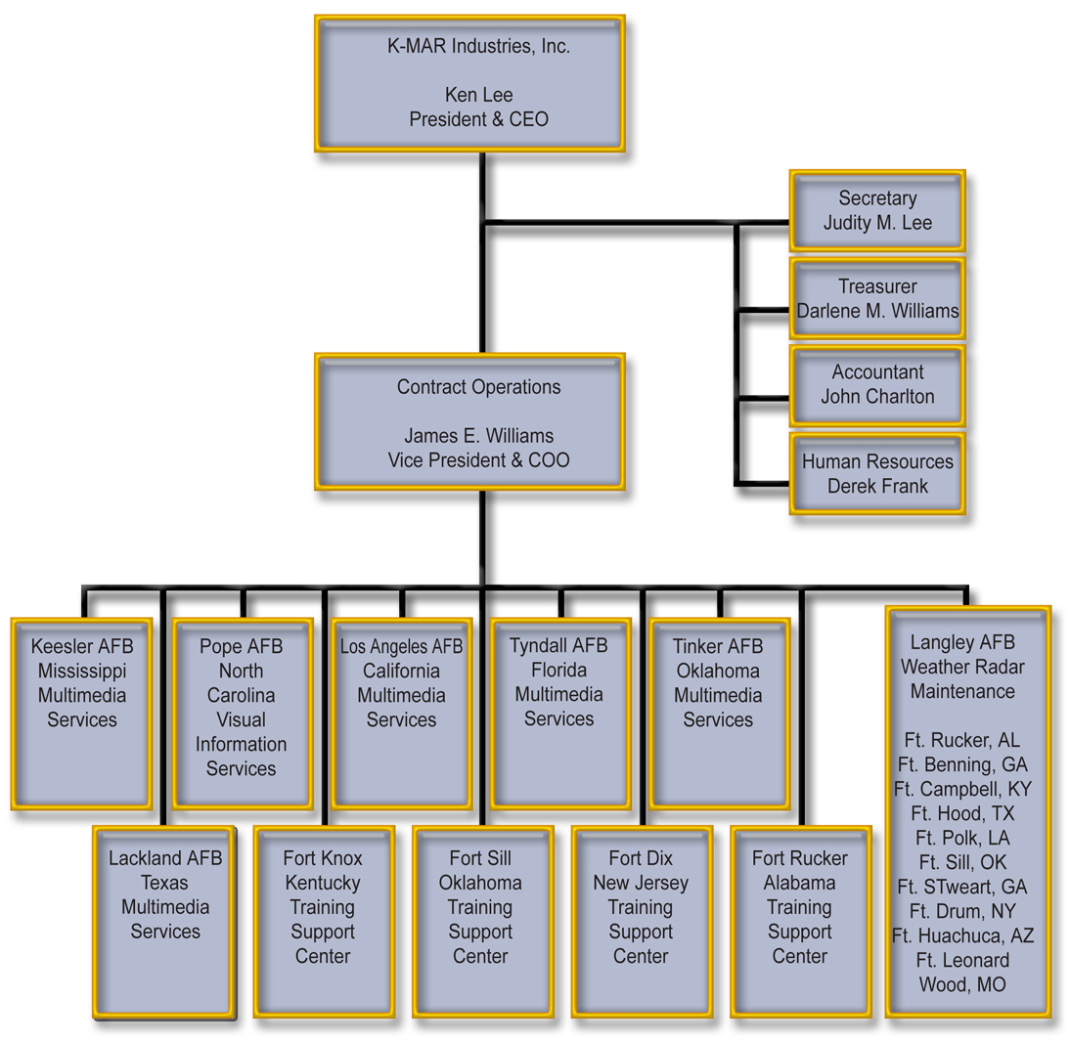
K-MAR Industries, Inc. Organizational Chart

Why KMI
KMI has demonstrated success in leading multidisciplinary teams on complex projects and applying task order management techniques that result in cost-effective, successful project completion. Emphasis being placed on task planning, timely and accurate execution, and quality control. We are dedicated to the delivery of top quality products services to our customers. Our multidisciplinary experts ensure innovative services and timely, efficient, and cost-effective project planning, implementation, and delivery. Our company is dedicated to meeting customers’ needs through innovation and technology. We have researched and tested methods to find the most efficient way to produce multimedia products of the highest possible quality. But we have done so much more. We have built a company that cares. Each product we produce becomes an opportunity for us to prove our commitment to our customers.

KMI offers a proven track record of successful contract operation and management providing a full range of expertise related to all multimedia requirements. Our service-oriented approach consists of four main components to ensure the best value to our customers:

- Build a personal relationship of trust and respect the customer
- Assign the most qualified employees to serve the customer
- Maintain a center of excellence that combines staff expertise and information resources to preserve intellectual knowledge
- Constant and consistent drive for new and innovative practices

We provide our services with one basic premise in mind: "Every customer is satisfied because Quality and Customer Service is at the heart of every decision we make!" Our services are customized to our customers needs through the use of proven, reliable tools and processes that ensure our customers receive the finest multimedia products and services available.

People
At KMI, our people make our company, and we never lose sight of it. It is our employee's commitment to service and to exceeding customer expectations on time, and on budget that gets them up in the morning and keeps them working. This has been our philosophy since the company began in 1987 and has been the key to our success.

The employees of KMI operate as a cohesive team of proven professionals. Through our cross training initiatives, our employees can develop skills in multiple disciplines. This insures our customers that our "team" can meet the unexpected head on, while providing excellent products and services on time and in a cost efficient manner.

Each KMI employee is empowered to act for the benefit of the customer. Where other companies give "lip service" to the practice of empowerment, we practice empowerment each and every working day. Where others "promise", we deliver.

Talent
With our highly skilled team designing, developing and producing the most progressive digital and multimedia solutions, KMI is able to creatively apply innovative solutions to any organization, and positively impact what matters most, our customer.

Management
At KMI we operate as a team, we function as a business and we have a clear vision for the future. Our company mission, goal, motto and standard operating procedures, along with active management and empowerment, make us unique in the field of Visual Information contractors.

The KMI Vision is to simply be the Best Services Contractor in the Department of Defense. To achieve this goal, each full time on site Project Manager is empowered to act to the complete satisfaction of each of his or her customers and of the government's contracting oversight personnel.

Our unique combination of outstanding and committed business and technology professionals, together with our depth of industry experience, set us apart. KMI has the proven expertise in all areas of Visual Information and Multimedia products and services. We bring together perspectives from a wide range of disciplines. Using our internal resources and drawing upon extensive relationships with best-of-class creative partners, we execute tactics to achieve clear objectives and deliver measurable results. We believe that business strategies and technology strategies must be aligned and developed to support each other; therefore we put methodology before technology since technology frequently changes and methodologies must always remain flexible and adaptable.

Contract Experience
The following is a listing of our Past Performance Information so you can get a general idea of the services that our company has been providing the government and can provide to you.

Visual Information Services Keesler AFB, Mississippi
Award Date: 1 Apr 06 – 30 Sep 08 Contract Type: FFP

Point of Contact: Joel Van Nice, Base Multimedia Manager, 228-377-4636
Email: joel.vannice@keesler.af.mil

81st CS/SCSV, Keesler AFB, MS 39534

KMI has been providing Visual Information/Multimedia Services to Keesler AFB customers since 1992. We perform all tasks under the Visual Information umbrella to include location, studio, alert and medical photography in digital, film and 35mm slides. In addition we have dedicated full time personnel assigned to the Wing Public Affairs Office. Our photographers have been significant contributors to the Keesler Newspaper receiving numerous AETC Command Level and Air Force Level Awards. Our photographers are well versed in traditional film photography as well as digital imaging. Being one of the largest full-service multimedia contracts in the Air Force, KMI develops and produces unique one-of-a-kind graphics, from simple Vu-graphs to complex Military Fine Art to complex models and devices used for training purposes at Keesler AFB. Our Graphics Art department has set the standard for the Air Education & Training Command for Publication Art according to publishers at Maxwell AFB, AL for the past six years. The Photography department at Keesler has significantly contributed to a number of Air Education & Training Command and Air Force Level Awards. KMI has a full time Graphic Illustrator assigned to work with the 81 TRSS Instructional Technology Unit, TSUI for the purpose of developing and producing IMI and Air Force Qualification Training Packages. Our Illustrator assists in integrating text, sound, graphics, still photos and full motion video into a digital interactive multimedia program or an Air Force Qualification Training Package (QTP). They also render custom computer graphics, drawings, including three-dimensional (3D) designs and 3D animation and simulation. KMI implemented the Distant Learning Complex at Keesler, and was responsible for obtaining the information that lead to the purchase of the "Smart Board." The use of this technology has saved the Air Force thousands of dollars in training costs. Our innovative forward thinking helps to benefit our customers, as we work to develop and implement new technology. Our television department performs a full range of tasks to include scripting, narrating, directing and producing simple video documentation to full productions. Our capabilities and experience operating analog as well as digital television equipment have proven to be invaluable as we transition from analog to digital. We take pride in the fact that we are vigilant and remain current on ever-evolving television standards. We maintain the commander's cable access television channel at Keesler on a twenty-four hour, seven day a week basis. Our television department produces a monthly Public Affairs news magazine that is shown on the commander’s access channel as well as the internet. We operate an Interactive Video Teletraining (IVT) Complex as well as operating 3 Video Teleconferencing facilities on base to include 2AF that will be going secure in the next few months. Our Engineer ensures broadcast signals from both satellite and T1 lines are being received at their optimum rate. In addition, our engineer ensures that audiovisual equipment is in good working order, repairing and providing preventative maintenance when necessary. For this contract, KMI has purchased and provided approximately $750,000 of contractor furnished equipment, including film processors, computers, plotters, cameras, copiers, and printers in support of the contract. We provide presentation and public address support to base personnel for events such as Special Olympics and base Open Houses. We establish and maintain control of the loan and use of Government Furnished Property. These items include televisions, videocassette recorders/players, digital projection equipment, slide and opaque projectors, and camera equipment. Our Air Force certified equipment custodian maintains the government equipment, inventory and accountability utilizing the CA/CARL listing. We maintain a multimedia library. Our customer service is of the highest level and beyond compare. We utilize a KMI developed automated work order-tracking program that allows us up to the minute status of any work order. In addition we utilize another KMI developed automated Management Program that allows us to track costs and production.

Visual Information Services Pope AFB, North Carolina
Award Date: 1 Oct 02 – 30 Sep 07 Contract Type: FFP

Point of Contact: Gail Williams, 910-394-9285, gail.williams@pope.af.mil
43 CONS/LGCS, Pope AFB, NC 28308

Visual Information Service at Pope AFB, NC furnishes the entire management and staff to operate and maintain Photography and Graphics sections. We perform all tasks under the Visual Information umbrella to include location, studio, and alert photography in black and white prints, color prints and slides. Graphics Art are largely computer based graphics: however, conventional illustrations, vu-graphs, certificates are produced in addition to a wide range of signs, charts, posters, briefing booklets, book covers and wall mounted charts.

Visual Information Services: Los Angeles AFB, California
Award Date: 01 Apr 2003 – 31 Mar 08 Contract Type: FFP

Point of Contact: John Bohn, Base Multimedia Manager, 310-353-5598,
john.bohon@losangles.af.mil, 2420 Vela Way, Suite 1467, El Segundo, CA 90245

Visual Information Services at Los Angeles AFB, CA. KMI furnishes the entire management and staff to operate and maintain Photography and Graphics sections. We perform all tasks under the Visual Information umbrella to include location, studio, and alert photography in black and white prints, color prints and slides. Graphics Art are largely computer based graphics: however, conventional illustrations, vu-graphs, certificates are produced in addition to a wide range of signs, charts, posters, briefing booklets, book covers and wall mounted charts.

Visual Information Services: Tyndall AFB, FL
Award Date: 1 Oct 2003 – 30 Sep 08 Contract Type: FFP

Point of Contact: Thomas Bonifay, Base Multimedia Manager, 850-283-2825
Email: Thomas.bonifay@tyndall.af.mil

325th CS/SCSV, Tyndall AFB, FL

Visual Information Services at Tyndall AFB, FL furnish the entire management and staff to operate and maintain Photography, Graphics and VTC sections. We perform all that include location, studio, and alert photography in black and white prints, color prints and slides. Graphics Art are largely computer based graphics: however, conventional illustrations, vu-graphs, certificates are produced in addition to a wide range of signs, charts, posters, briefing booklets, book covers and wall mounted charts.

Visual Information Services Tinker AFB, Oklahoma
Award Date: 1 Jan 2005 – 31 Dec 2010 Contract Type: FFP

Point of Contact: Mariane Arshad, 405-734-5993, mariane.arshad@tinker.af.mil
72 CS, Bldg 3, Door D, Room 134, Tinker AFB, OK 73145

KMI is performing subcontractor duties under this contract to DenMar Services Inc. Visual Information Services is performed at Tinker AFB, OK we assist in the management and staff to operate and maintain Photography, Graphics, Television and VTC sections. We perform location, studio, and alert photography in black and white prints, color prints and slides. Graphics Art are largely computer based graphics: however, conventional illustrations, vu-graphs, certificates are produced in addition to a wide range of signs, charts, posters, briefing booklets, book covers and wall mounted charts. Our television department performs a full range of tasks to include scripting, narrating, directing and producing simple video documentation to full productions. Our capabilities and experience operating analog as well as digital television equipment have proven to be invaluable as we transition from analog to digital. We take pride in the fact that we are vigilant and remain current on ever-evolving television standards.

Visual Information Services Lackland AFB, Texas
Award Date: 1 Oct 05 – 30 Sep 2010 Contract Type: FFP

Point of Contact: Ted Herman, 210-671-3761, ted.herman@lackland.af.mil
37 CS/SCSV, 1359 Tinker Street, Lackland AFB, TX 78236

K-MAR Industries, Inc. is providing subcontractor duties to DenMar Services, Inc. We provide a full range of visual information services to Lackland AFB including multimedia support to satellite operations.

KMI operates the visual information center at Lackland AFB where customers are provided multimedia services that include graphic arts services (including self-help graphics), photographic services, multimedia library services, and equipment maintenance and repair services. In addition, we provide multimedia systems administration services supporting the multimedia center network and the Commander’s Access Channel at Lackland AFB. We also provide advice and assistance to all customers on current multimedia information, materials, methods, equipment and facilities available to users.

Training Support Center Fort Knox, Kentucky
Award Date: 1 Apr 03 – 31 Mar 08 Contract Type: Cost Plus Award Fee

Point of Contact: Theresa Jones, Contract Officer, 502-624-5751, theresa.jones@knox.army.mil, Bldg 1109B, Room 250, Fort Knox, KY 40121-5000

KMI is partnered with Rohmann Services Inc., to provide a full range of Visual Information Services the Devices Section at Fort Knox fabricates training aids, devices, simulators and simulations (TADSS), exhibits, displays and mock-ups. This contract award was under the A-76 process for the TRADOC Army Command. We provide detailed and final design and fabrication of two and three-dimensional TADSS designed to represent operational equipment, components, procedures or processes. We design and fabricate scaled replicas of land, road and water terrain. The Devices Section is also responsible for repair, refurbishment and modification of existing and fabricated TADSS, displays, exhibits and instructional support items, to include podiums, platforms and work surfaces.

In the Logistical Support Section, we provide for acquisition, storage, safeguarding and disposition of TADSS and VI products and equipment, to include, but not limited to: property control-receipting for loan, hand-receipt updating, requirements determination and issue of Graphic Training Aids (GTAs); warehousing, loaning, and maintenance of training aids, dummies, and Multiple Integrated Laser Engagement System (MILES) equipment; instructional services (instruction in the operation and operator’s maintenance of equipment); operation of a media loan library; and providing for fielding of new systems. We loan and issue TADSS and VI products and equipment which includes televisions, videocassette recorders/players, digital projection equipment, slide and opaque projectors, camera equipment, sound and sound mixing systems and some automated data processing equipment. The Fort Knox Training Support Center is the primary hand receipt holder for a 7 state regional property book of over 600 sub-hand receipts of training devices and other property that totals over $175 million dollars. Our proprietary software allows for up to the minute viewing and management of all the item records, their hand receipt history and other pertinent data. The Fort Knox Training Support Center is an Army wide fabrication facility for training weapons and other devices. During the 3 years of operation at Fort Knox, KMI as initiated process improvements in the urethane casting of mock weapons. Our current production method, using machined aluminum molding and an improved urethane chemistry has yielded a 75% decrease in demold times. In addition through the Fort Knox contract, KMI was awarded an additional contract for the fabrication of 2,000 improvised exploding devices (IEDs) to be used for training purposes. One of the biggest threats to soldiers who are deployed in Iraq and Afghanistan is home-made bombs remotely detonated by terrorists. Eighty percent of the U.S. casualties sustained in Operation Iraqi Freedom were as a result of IEDs. Even more challenging is the speed in which the terrorists adapt to new and different threats. The Army has been responding to this threat by offering more realistic training IEDs to help prepare soldiers, sailors, airmen and Marines when they go in harm’s way. The simulations provide training in approaching, identifying, transiting, processing, handling and disposing of IEDs. KMI accomplished this immediate production request from the Army and delivered the requested 2,000 devices in 120 days.

Training Support Center Fort Sill, Oklahoma
Award Date: 1 Apr 03 – 31 Mar 08 Contract Type: Cost Plus

Point of Contact: Jerry Zahn, 580-442-4958, jerry.a.zahn@us.army.mil
Training Service Center, Bldg 700, Knox Hall, Fort Sill OK 73503

We perform a full range of Visual Information/Multimedia Services, such as Photography, Graphics Art and Television. KMI performs location and studio photography in black and white, color prints and slides. Our graphics art section produces briefing charts, wall charts, and status boards with overlays for both computer and hard copy presentations. Signs and posters are produced using hand or machine lettering. Our illustrators design and produce posters to the specifications of the customer. KMI provides 2-D Display Art services to include design, illustration, layout, image transfer, and assembly of special purpose displays. KMI also provides 3-D Display Art services to include design, layout, assembly, construction, or fabrication of 3-D special displays. We produce Publication Pages to include brochures, pamphlets, invitations, and business cards. Our illustrators consider the theme, the type of audience, and prepare rough sketches to portray the general idea in the recommended style and manner of artistic presentation necessary to portray the customers intended message.

In addition to the full range of Visual Information Services addressed above, the Devices Section fabricate training aids, devices, simulators and simulations (TADSS), exhibits, displays mock-ups, and a wide range of Graphical Firing Tables (GFTs), Graphical Site Tables (GSTs) and Graphical Munitions Effects Tables (GMETs) for the U. S. Army Field Artillery. We provide detailed and final design and fabrication of two and three-dimensional TADSS designed to represent operational equipment, components, procedures or processes. The Devices Section is also responsible for repair, refurbishment and modification of existing and fabricated TADSS, displays, exhibits and instructional support items, to include podiums, platforms and work surfaces.

In the Logistical Support Section, we provide for acquisition, storage, safeguarding and disposition of TADSS and VI products and equipment, to include, but not limited to: property control-receipting for loan, hand-receipt updating, requirements determination and issue of Graphic Training Aids (GTAs); warehousing, loaning, and maintenance of training aids, dummies, and Multiple Integrated Laser Engagement System (MILES) equipment; instructional services (instruction in the operation and operator’s maintenance of equipment); operation of a media loan library; and providing for fielding of new systems. We loan and issue TADSS and VI products and equipment which includes televisions, videocassette recorders/players, digital projection equipment, slide and opaque projectors, camera equipment, sound and sound mixing systems and some automated data processing equipment.

We have developed and maintain an interactive, informational website for the Fort Sill Training Service Center (TSC) on the Fort Sill IntraNet. This website provides pertinent information regarding TSC operational policies and procedures, hours of operation, department physical locations/maps, various catalogs featuring GTAs, TADSS and items available for loan and issue. In addition, the website provides for online submission of work orders requesting TSC services.

Training Support Center Fort Dix, New Jersey
Award Date: 1 Oct 03 – 30 Sep 08 Contract Type: FFP

Point of Contact: Maureen Coughlin, 609-562-5271, Email:Maureen.coughlin@dix.army.mil
Director of Contracting, Fort Dix, NJ 08604

Training Support Services at Fort Dix, NJ work includes furnishing the entire management and staff to operate and maintain the Training Service Center. Location and studio photography in black and white, color prints and slides are produced. Since the Army has gone to a digital format for their official promotion package, we are able to capture an image and provide the customer with a digital print utilizing a FUJI Pictrography 4000 within moments after the image has been captured. Our Graphic Arts section produces computer illustrations in addition to a wide range of signs, charts, posters, briefing booklets and freehand sketches. As a matter of fact we received National level recognition for the graphic work we performed during the Kosovo Crisis. Over 4,000 refugees were processed through Fort Dix, NJ. We provided graphic support to the village set-ups on Fort Dix, in both English and Albanian. We are especially proud of this because we did it during our transition and mobilization period of the contract with no additional cost the government. We operate the Training Set Fire Observation (TSFO). Our instructors are certified to train on this piece of equipment. We teach all aspects for indirect fire procedures from skill level one through skill level four. We perform warehousing, scheduling and maintenance for MILES and TADS equipment. We establish and maintain control of the loan and use of Government Furnished Property. We established a Property Administration Plan to include a complete property control system identifying the protection, accountability, preservation and control of the property. This is the first time that a contractor property book has been considered the official property book of record.

Training Support Center Fort Rucker, Alabama
Award Date: 1 Oct 04 – 30 Sep 09 Contract Type: FFP

Point of Contact: Glenn Wallace, 334-255-2620, glenn.wallace@rucker.army.mil

KMI is a subcontractor to Mission Critical Solutions, (MCS) on this contract. KMI previously had this contract but when it was recompeted it was released under a HubZone set aside, therefore, MCS being a HubZone company was able to use us as a subcontractor. In addition to performing a full range of Visual Information Services in support of USAAVNC and Training Support Center customers, we fabricate training devices, cockpit trainers, aviation mockups, operational terrain boards, as well as performing the maintenance and repair of these items. We develop and implement plans for work and quality management, safety, environmental protection, and physical security. Many of these devices are located in areas such as the Night Vision Devices Laboratory. Maintenance of our classroom support area includes electronic training devices constructed as joint projects in which both our device fabrication shop and our electronics shop had input. Some of the larger devices must periodically be transported back to our shops from flight simulator labs for refurbishing and major maintenance. Our electronic maintenance shop has maintenance responsibility for all visual information equipment issued by our logistics loan and issue section. These items include televisions, videocassette recorders/players, digital projection equipment, slide and opaque projectors, camera equipment, sound and sound mixing systems, and some automated data processing equipment. We also serve as warranty coordination and service contract points of contact for Army purchased training devices and simulation equipment. Some of these devices are valued in excess of $10,000,000.00 and are issued through our property accountability section, a sister section to our electronic maintenance section. At Fort Rucker we also have primary maintenance and repair responsibility for all image capture, edit, and broadcast equipment at our educational television facility. Visual Information Services in support of USAAVNC and TSC customers. Develop and implement plans for work and quality management, safety, environmental protection, and physical security. Perform warehousing, scheduling and maintenance duties for Miles and TADS equipment.

Weather Radar Maintenance Services: Langley AFB, Virginia
Award Date: 01 Jan 03 – 30 Sep 08 Contract Type: FFP

ACC CONS/LGCB, 130 Douglas St, Suite 400, Langley AFB, VA 23665
Linda Weis, 757-225-2731, linda.weis@langley.af.mil

KMI furnishes all management, personnel, equipment, tools, materials, supervision and other items and services necessary to maintain weather equipment for multiple Army locations. Maintenance of five Next Generation Weather Radar, and seven Automated Surface Observation Systems, and various meteorological weather equipment include all forms and levels of maintenance form simple preventive maintenance and cleaning to complex inspection, and assembly repair, corrosion control, alignment and calibration.

Our Commitment to Quality
KMI is committed to achieving total quality in all areas of the services we provide. Our expertise in managing projects and our excellent customer service is the foundation for our success. We have many years experience in project management in the Visual Information/Multimedia arena. We have the proven ability to plan, schedule, budget, produce and manage our projects from the transition phase to contract completion. Our strong project management record ensures that the government is getting the most efficient organization.

If you are seeking further information regarding how we can provide our services to you, please contact Mr. Ron Benne at 228-392-4968, via e-mail rjb@kmar.com or Mr. Ed Williams at 228-392-4968 or via e-mail edw@kmar.com.

