Run II Luminosity Progress*
K. Gollwitzer, Fermilab, Batavia, IL 60510, U.S.A.

Abstract
The Fermilab Tevatron Collider Run II program continues at the energy and luminosity frontier of high energy particle physics. To the collider experiments CDF and D0, over 3 fb⁻¹ of integrated luminosity has been delivered to each. Upgrades and improvements in the Antiproton Source of the production and collection of antiprotons have led to increased number of particles stored in the Recycler. Electron cooling and associated improvements have help make a brighter antiproton beam at collisions. Tevatron improvements to handle the increased number of particles and the beam lifetimes have resulted in an increase in luminosity.

Introduction
Run II is part of the Fermilab accelerator based experiment program. The collider program consists of colliding proton and antiproton beams at the B0 and D0 collision points within the Tevatron. Each beam is at 980GeV. The layout of the Fermilab accelerator complex associated with the Run II program is shown in Figure 1.

Figure 1: Layout of the Fermilab Tevatron Collider accelerator complex.

The process to accelerate protons to collisions is the following:
- The Crockroft-Walton accelerates H¯ ions to 750 keV
- The Linac accelerates the ions to 400 MeV
- The H¯ ions are stripped during multi-turn injection into the Booster
- The Booster accelerates the protons to 8 GeV
- Protons transferred to the Main Injector are either accelerated to 120 GeV for antiproton production or to 150 GeV for injection to the Tevatron
- The Tevatron accelerates to 980 GeV
The process to produce, store and accelerate antiprotons to collisions is the following:
- The 120 GeV proton beam impinges on a nickel alloy target every 2.4 sec
- Downstream of the production target, a collection lens focuses 8 GeV secondaries into a transfer line
- The secondaries are injected into the Debuncher Ring where only antiprotons survive the first hundred turns
- The phase space density is increased by stochastic cooling systems before transfer to the Accumulator Ring
- The Accumulator momentum stacks ~3000 pulses of antiprotons; stochastic cooling systems further increase the phase space density
- The 8 GeV antiprotons are transferred to the Recycler via the Main Injector

*Work supported by the U.S. Department of Energy under contract No. DE-AC02-07CH11359
#gollwitz@fnal.gov
- Electron and stochastic cooling increase the phase space density in the Recycler
- After 36 bunches of protons are established in the Tevatron, Recycler antiprotons are prepared in 9 injections of 4 bunches
- Recycler RF manipulations make 9 parcels of antiprotons
- A parcel is re-formed into 4 bunches and transferred into the Main Injector where it is accelerated to 150 GeV for injection into the Tevatron
- The Tevatron accelerates the antiproton and proton beams to 980GeV and brings the beams into collision for the CDF and D0 experiments

Performance
Run II has shown steady progress over the last five years as can be seen in the peak luminosity and total integrated luminosity shown in Figures 2 and 3. Since PAC 2005, the record peak luminosity has more than doubled from 127 x 10³⁰ cm⁻²sec⁻¹ to 292 x 10³⁰ cm⁻²sec⁻¹. The total integrated luminosity was less than 1 fb⁻¹ two years ago; recently the total surpassed 3 fb⁻¹.

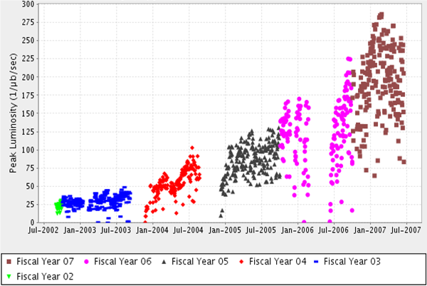
Figure 2: Run II history of the peak luminosity.

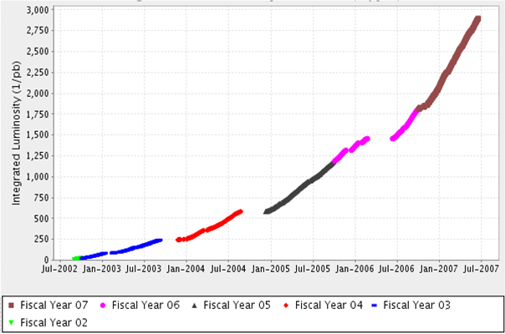
Figure 3: Run II history of the integrated luminosity.

Luminosity Factors
For a proton-antiproton collider, the instantaneous luminosity is
$L=\frac{3γ⋅f_{0}}{β∗}⋅\frac{N_{p}N_{a}}{(ε_{p}+ε_{a})}⋅F(β\text{*,}ε_{p},ε_{a},σ_{z})$
(1)

The major contributors to determining the luminosity are the number of particles in each bunch (N), the transverse emittance of the beams (ε) and transverse beam optics at the interaction point (β*). The quantity and beam quality of the antiprotons available to the Tevatron Collider are key. In particular, the rate of production is determines how fast the program is able to recover from any failure that loses antiprotons.
The evolution of luminosity for each store is dependent upon how fast the beams’ emittance increase [1]. There are numerous near collisions of different bunches from each beam [2]. These beam-beam effects have been studied. Each beam is on a helical orbit; there have been efforts to increase the separation of the orbits during the past few years.

Antiprotons
At the start of Run II, the Accumulator was the only source of antiprotons for the Tevatron collider program. The Accumulator had to balance production rate and the ability to hold onto large antiproton stacks. The largest Accumulator stack was 250 x 10¹⁰ antiprotons. The limitations of stochastic cooling result in the rate of antiproton production to decrease as the stack size increased.
While the Recycler was being commissioned, some of the Accumulator antiprotons were diverted to Recycler activities. Once the Recycler became a viable storage ring, antiprotons were transferred from the Accumulator to the Recycler before the stacking rate decreased too much. In this manner, the combination of both rings made it possible to have up to 350 x 10¹⁰ antiprotons for the Tevatron program. Combination shots, where antiprotons from both rings were sent to the Tevatron, happened between December 2004 and October 2005.
The first evidence of relativistic electron cooling on antiprotons occurred in July 2005 [3]. Figure 4 shows two traces 15 minutes apart showing the decrease in the antiproton momentum beam spread due to electron cooling. Two and a half months later, electron cooling was brought into operations. Soon thereafter, the Recycler became the sole source of antiprotons for the Tevatron. The Accumulator began to tune for production rate since stack size would be limited to <100 x 10¹⁰ antiprotons. The Recycler is able to provide smaller beam emittance which increases the luminosity.

Figure 4: First demonstration of relativistic electron cooling of antiprotons.

Figure 5 shows the antiproton intensities in the Accumulator and Recycler and the Tevatron luminosity for a typical week of operations. Every 2.4 sec, ~2 x 10⁸ antiprotons from the Debuncher Ring are transferred to the Accumulator. Momentum stacking occurs for 2-3 hr to acquire ~50 x 10¹⁰ antiprotons at which time ~80% are transferred to the Recycler Ring. Taking into account the overhead of loading the Tevatron and luminosity lifetime, store duration has a broad optimization for integrated luminosity around 20 hr. Hence, the Recycler Ring is nearly emptied once a day for the collider program. Also shown are gaps in antiproton production and luminosity. There are downtimes due to failures and studies. Depending upon the length of downtime or when a failure occurs in the case of losing the Tevatron store, the number of antiprotons available can be affected.
Figure 5: Antiproton intensities about the Fermilab complex.

Target Station Improvements
The Main Injector slip-stacking process has been able to provide consistently 8-9 x10¹² protons on the target. Besides the target module being subjected to the beam intensities, the Lithium Collection Lens and Pulsed Magnet need to accommodate the large flux of secondaries. Whenever one of these components need to be replaced, antiproton production is stopped for at least 16 hours.
The target material is a nickel alloy and cooling is provided by air flow. The design of the heat sinks is continually evolving to extend the life of the target module. A smaller beam spot size improves the yield however the target degrades quicker. There is a balance between yield and target lifetime. Recently, the proton beam has been made to “sweep” a circle during the pulse on the target to distribute the energy deposition over a larger volume and has been shown to increase the target lifetime. Currently, there is an operational program to explore the yield and target degradation as the beam size and sweep radius are changed.
Historically, Collection Lens failures have two modes: lithium breaches the electron welded steel body of the lens or the transformer ground faults due to radiation damage of the kapton insulator. A multiyear program to improve the Collection Lens design has resulted in a titanium body which is diffusion bonded. This lens design has been used in operation for about a year and can be operated at a higher gradient. More secondaries are focused into the beam line and reach the Debuncher Ring as the gradient is increased. The transformer has been redesigned to use an internally water-cooled ceramic insulator and just been put into operations. The brief operational experience shows that the transformer and Collection Lens are operating at lower temperatures.
The Pulsed Magnet directs the 8 GeV secondaries into the beam line which transports beam to the Debuncher Ring. These magnets tended to fail after ~2 x 10¹⁹ protons were on target. A collimator was added between the Collection Lens and the Pulsed Magnet. The current magnet has seen >5.5 x 10¹⁹ protons.

Acceptance Improvements
Part of the Run II upgrade plan was to increase the admittance of the beam line from the Target Station and the Debuncher Ring to 35π mm-mr. This goal means that a beam (95% normalized) emittance of 325π mm-mr will be accepted. The upgrade included removal and modifications of aperture restrictions, motorization of stands of small aperture components, addition of orbit control (dipole trims and motorization of quadrupole stands), modification of the lattice to decrease the beam size in tight apertures, and instrumentation. The admittance has been increased from 23π mm-mr to nearly the goal. The majority of progress came with instrumentation commissioning and orbit control studies performed during Tevatron Magnet replacements in December 2005 and January 2006. Similar orbit control studies are planned for the Accumulator to achieve >10π mm-mr acceptance.

Cooling Improvements
The Debuncher stochastic cooling systems have to be continually monitored and adjusted to keep the systems optimized. The gain of each system is changed throughout the cooling cycle to maximize the kicker power. There are plans to add two-turn notch filters which would be switched into the circuit in the middle of the cooling cycle.
The Accumulator stacktail stochastic system does the momentum stacking. The 2-4 GHz stacktail system is what limits the antiproton stacking rate. Several on-going upgrades and constant tuning have help to increase the stacking rate. A summary of changes are the following:
- Addition of an equalizer which improves the effective bandwidth by fixing the phase at band edges and more gain at higher frequencies
- Radially offset one pickup tank to move one set of pickups away from the core orbit
- Operate the closest set of pickups to the core
- Change the Accumulator lattice to increase the slip factor and better match the phase advances between stochastic cooling systems pickups and kickers
The increase in slip factor and effective bandwidth allows for a larger maximum flux through the stacktial system. These changes also decreased the amount of power needed to run the stacktail which decrease the amount of transverse heating.
The Accumulator also includes core stochastic cooling systems. Improvements have been mainly to the two longitudinal stochastic cooling systems operating at 2-4 GHz and 4-8GHz. These two systems changed roles of main and helper system in February 2006. Now the 2-4 GHz is used to transition from the stacktail system to the main 4-8 GHz core system. The bandwidth of the 4-8 GHz system was nearly doubled when the main trunk line was changed from coax cable to fiber optic. There are plans to introduce a new equalizer into the 4-8 GHz system to further increase the bandwidth.
The Recycler stochastic cooling systems have been working well. Electron cooling is necessary for longitudinal cooling for >200 x 10¹⁰ antiprotons. Since the electron cooling has been made operational there has been effort to understand the cooling rate as a function of beam position and current [4].
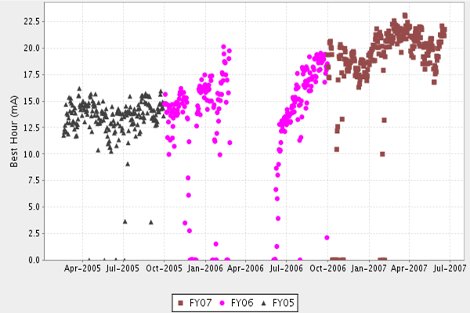
Figure 6: Best hour of stacking each day (mA = 10¹⁰).
Figure 7: Stacking rate as a function of stack size.

Summary
Figure 6 shows the best hour of stacking for each day during the past two years. Figure 7 shows the change in performance of the Accumulator of the increase in stacking rate as a function of stack size. In addition, there has been an effort to reduce the amount of time it takes to transfer antiprotons from Accumulator to the Recycler from about an hour to ~10 minutes; this means more stacking time per day. The number of antiprotons collected each week is shown Figure 8.
Figure 8: Number of Antiprotons produced in a week.

Other Improvements
The Recycler has changed its working point which improved the lifetime for large number of antiprotons [5-6]. An adaptive Feed Forward RF correction has been applied in the Recycler [7]. Prior to the correction, there would be a wide range in the intensity of the parcels, and for bunches within each parcel, sent to the Tevatron. The antiproton bunch intensities within a store did have variations of >100% which leads to large tune shifts and differences in luminosity for each crossing. With the correction, the antiproton bunches are more uniform with a variation <25%.
Table 1: Run II records
Record | Pre-2006 | Current | Units
Antiprotons Stacking Rate | 17.5 | 23.1 | 10¹⁰/hr
Antiprotons produced in one week | 1710 | 2810 | 10¹⁰
Antiprotons in Recycler | 325 | 465 | 10¹⁰
Peak Instantaneous Luminosity | 180 | 292 | 10³⁰cm⁻²s⁻¹
Weekly Integrated Luminosity | 25 | 45 | pb⁻¹
Monthly Integrated Luminosity | 85 | 167 | pb⁻¹
Tevatron efforts have been to measure, understand and mitigate the effects of beam-beam interactions; those efforts are presented by others at this conference [8-11]. The optics was change to decrease β* [12-13]. About the same time that the Recycler became the only source of antiprotons for the Tevatron. The optics change and Recycler only operation occurred in October 2005 and the peak luminosity increase can be seen in Figure 2.
There have been small improvements to the antiproton transfer efficiencies and Main Injector coalescing process [14]. There has been work to improve the reliability of the storage rings and Tevatron.

Summary
Since the last Particle Accelerator Conference in 2005, there has been enormous progress made in Run II. Table 1 shows a comparison of records prior to 2006 and current. The integrated luminosity has increased significantly mostly due to a larger number of antiprotons being available. The antiproton production rates are the result of the Run II upgrade program, bringing into operation the Recycler with electron cooling and attacking reliability issues so that downtime is infrequent and minimal.
Work continues on further increasing the antiproton stacking rate in the Accumulator. Both the Recycler and Tevatron have projects to handle the increase in number of antiprotons expected to circulate in each ring. Both rings will have new challenges in either cooling or beam-beam effects. The Run II program expects to easily provide 4 fb⁻¹ over the next two years.

References
[1] R. Moore, “Review of Recent Tevatron Operations,” PAC’07, Albuquerque, June 2007, TUOCKI01.
[2] Y. Alexahin, “Optimization of the Helical Orbits in the Tevatron,” PAC’07, Albuquerque, June 2007, FRPMS006.
[3] S. Nagaitsev et al., “Antiproton Cooling in the Fermilab Recycler Ring,” Beam Cooling and Related Topics, International Workshop on Beam Cooling and related Topics – COOL05, Galena IL, USA, September 2005, p. 39.
[4] L. Prost and A.V. Shemyakin, “Electron Cooling Rates Characterization at Fermilab’s Recycler,” PAC’07, Albuquerque, June 2007, TUPAS030.
[5] A. Burov and V. Lebedev, “Instabilities of Cooled Antiproton Beam in the Fermilab Recycler Ring,” PAC’07, Albuquerque, June 2007, WEYC01.
[6] B. Chase et al., “Longitudinal Momentum Mining of Antiprotons at the Fermilab Recycler: Past, Present, and Future,” PAC’07, Albuquerque, June 2007, WEOCKI04.
[7] M. Hu et al., “Uniform Longitudinal Beam Profiles in the Fermilab Recycler Using Adaptive RF Correction,” PAC’07, Albuquerque, June 2007, MOPAS011.
[8] A. Valishev et al., “Observations and Modeling of Beam-Beam Effects at the Tevatron,” PAC’07, Albuquerque, June 2007, TUOCKI03.
[9] V. Shiltsev et al., “Experimental Demonstration of Beam-Beam Compensation and Prospects for the LHC,” PAC’07, Albuquerque, June 2007, TUOCKI04.
[10] V. Kamerdzhiev, “Experimental and Simulation Studies of Beam-Beam Compensation with Tevatron Electron Lenses,” PAC’07, Albuquerque, June 2007, TUPAS024.
[11] E. Stern and A. Valishev, “Simulation of Coherent Beam-Beam Effects in the Presence of Impedance,” PAC’07, Albuquerque, June 2007, FRPMS012.
[12] M.J. Syphers and R. Miyamoto, “Direct Measurements of Beta-star in the Tevatron,” PAC’07, Albuquerque, June 2007, THPAN115.
[13] A. Valishev, “Correction of Second Order Chromaticity at Tevatron,” PAC’07, Albuquerque, June 2007, FRPMS015.
[14] C. Bhat, “Anti-Buckets at Fermilab Recycler for Antiprotons Stacking and Unstacking,” PAC’07, Albuquerque, June 2007, TUPAS008.

