Tropical Cyclone Report
Hurricane Marie
(EP142008)
1-6 October 2008

Stacy R. Stewart
National Hurricane Center
16 November 2008
(updated to correct tables)

Marie was a category 1 hurricane (on the Saffir-Simpson Hurricane Scale) that remained over water during its entire lifetime and did not threaten any land areas.

- Synoptic History

Marie originated from a tropical wave that emerged from the west coast of Africa on 6 September 2008. The wave moved quickly westward with little or no associated convection until it reached Central America about two weeks later. On 24 September when the wave emerged over the eastern North Pacific, a few weak bands of convection finally developed. However, this system showed no signs of having a closed surface circulation until 28 September when the system was located about 300 n mi south of Manzanillo, Mexico. The low pressure system moved west-northwestward at about 10 kt for the next few days and gradually acquired enough convective organization to be classified as Tropical Depression Fourteen-E at 0600 UTC 1 October about 510 n mi southwest of the southern tip of Baja California, Mexico. The “best track” chart of the tropical cyclone’s path is given in Fig. 1, with the wind and pressure histories shown in Figs. 2 and 3, respectively. The best track positions and intensities are listed in Table 1.
After becoming a tropical cyclone, the system continued its west-northwestward motion for the next 24 h and quickly strengthened into Tropical Storm Marie at 1200 UTC that same day. The intensity leveled off at an estimated 45 kt for the ensuing 24 h. A second significant intensification phase of 25 kt in 24 h occurred between 0000 UTC 3 October and 0000 UTC 4 October, during which time Marie reached hurricane status by 1800 UTC 3 October about 755 n mi west-southwest of the southern tip of Baja California (Fig. 4).

Marie’s status as a hurricane was relatively short-lived even though the upper-level vertical wind shear conditions were quite favorable for strengthening to occur. By 1200 UTC 4 October, a steady weakening trend was initiated as Marie turned westward and began moving slowly over lower sea-surface temperatures, below 26º C, and also into a more stable atmospheric environment. Marie weakened to a tropical storm late on 4 October, became a depression at 1200 UTC 6 October, and degenerated into a non-convective low pressure system 12 h later when the cyclone was located about 860 n mi west-southwest of Baja California.
After losing its deep vertical structure, the remnant low lingered in the same general area for about 24 h before turning to the southwest on 7 October. Over the course of the next 12 days, Marie’s tenacious remnant circulation sped up and slowed down, and made a couple of small, tight loops while moving in a direction between southwest and west-southwest. Other than a few brief periods with deep convection, the remnant low remained devoid of any convective organization due to unfavorable upper-level shear conditions. On 19 October, the system was finally absorbed into the eastern North Pacific Intertropical Convergence Zone (ITCZ) about 1050 n mi east-southeast of the Hawaiian Islands.

- Meteorological Statistics

Observations in Hurricane Marie (Figs. 2 and 3) include satellite-based Dvorak technique intensity estimates from the Tropical Analysis and Forecast Branch (TAFB) and the Satellite Analysis Branch (SAB). Data and imagery from NOAA polar-orbiting satellites, the NASA Tropical Rainfall Measuring Mission (TRMM), the NASA QuikSCAT, and Defense Meteorological Satellite Program (DMSP) satellites, among others, were also useful in tracking Marie.

There was only one ship that reported tropical storm force winds associated with Marie. At 0600 UTC 5 October, the ship Jo Spruce (call sign PFAS) located about 70 n mi due north of the center of Marie reported a sustained easterly wind of 35 kt and a pressure of 1009.0 mb.

- Casualty and Damage Statistics

There were no reports of damage or casualties associated with Hurricane Marie.

- Forecast and Warning Critique

The possible genesis of Marie was first mentioned in the Tropical Weather Outlook (TWO) beginning at 1800 UTC 29 September. The possibility of tropical cyclone formation was included in the TWO issued at 0000 UTC 1 October, only 6 h prior to genesis. Likewise, the experimental genesis forecast probability did not reach the high category (> 50%) until just 6 h prior to formation.

A verification of official and guidance model track forecasts is given in Table 2. Average official track errors for Marie were 29, 46, 74, 106, 169, 215, and 182 n mi for the 12, 24, 36, 48, 72, 96, and 120 h forecasts, respectively. The number of forecasts ranged from 21 at 12 h to only 3 at 120 h. These errors are lower than the average long-term official track errors from 12 h to 36 h, greater than average at 48, 72, and 96 h, and lower than average at 120 h (Table 2). The NHC official track forecasts (OFCL) generally outperformed all available model guidance except for the GFDI, AEMI, and EMXI models, and the model consensus, TVCN. The EMXI model performed exceptionally well with Marie and had track errors that were about 50 percent those of OFCL.

Average official intensity errors were 5, 10, 12, 12, 10, 6, and 7 kt for the 12, 24, 36, 48, 72, 96, and 120 h forecasts, respectively. For comparison, the average long-term official intensity errors are 6, 10, 14, 16, 19, 19, and 19 kt, respectively (Table 3). Although the official intensity forecasts were better than average at all forecast times, the same top-performing track models – GFDI, AEMI, EMXI, and TVCN – also outperformed the OFCL intensity forecasts.

No tropical cyclone watches or warnings were associated with Marie.
Table 1. Best track for Hurricane Marie, 1-6 October 2008.

Date/Time  (UTC) | Latitude  (°N) | Longitude  (°W) | Pressure  (mb) | Wind Speed  (kt) | Stage
01 / 0600 | 16.3 | 115.4 | 1006 | 30 | tropical depression
01 / 1200 | 17.0 | 116.1 | 1000 | 45 | tropical storm
01 / 1800 | 17.6 | 117.5 | 1000 | 45 | "
02 / 0000 | 17.8 | 118.6 | 1000 | 45 | "
02 / 0600 | 17.9 | 119.3 | 1000 | 45 | "
02 / 1200 | 17.9 | 119.9 | 1000 | 45 | "
02 / 1800 | 17.8 | 120.6 | 1000 | 45 | "
03 / 0000 | 17.7 | 121.1 | 1000 | 45 | "
03 / 0600 | 17.6 | 121.6 | 997 | 50 | "
03 / 1200 | 17.6 | 121.9 | 990 | 60 | "
03 / 1800 | 17.6 | 122.1 | 987 | 65 | hurricane
04 / 0000 | 17.7 | 122.2 | 984 | 70 | "
04 / 0600 | 17.9 | 122.2 | 984 | 70 | "
04 / 1200 | 18.1 | 122.1 | 987 | 65 | "
04 / 1800 | 18.3 | 122.1 | 992 | 55 | tropical storm
05 / 0000 | 18.5 | 122.1 | 1000 | 45 | "
05 / 0600 | 18.8 | 121.9 | 1001 | 40 | "
05 / 1200 | 18.8 | 122.2 | 1001 | 40 | "
05 / 1800 | 18.7 | 122.5 | 1004 | 35 | "
06 / 0000 | 18.7 | 122.8 | 1004 | 35 | "
06 / 0600 | 18.7 | 123.1 | 1004 | 35 | "
06 / 1200 | 18.7 | 123.3 | 1006 | 30 | tropical depression
06 / 1800 | 18.9 | 123.6 | 1007 | 25 | "
07 / 0000 | 18.8 | 124.1 | 1007 | 25 | remnant low
07 / 0600 | 18.4 | 124.5 | 1007 | 25 | "
07 / 1200 | 18.1 | 125.0 | 1008 | 25 | "
07 / 1800 | 17.7 | 125.5 | 1008 | 25 | "
08 / 0000 | 17.5 | 125.8 | 1009 | 25 | "
08 / 0600 | 17.3 | 126.3 | 1009 | 25 | "
08 / 1200 | 17.1 | 126.7 | 1009 | 25 | "
08 / 1800 | 16.9 | 127.1 | 1009 | 25 | "
09 / 0000 | 16.6 | 127.3 | 1009 | 25 | "
09 / 0600 | 16.3 | 127.5 | 1009 | 25 | "
09 / 1200 | 16.0 | 127.5 | 1009 | 25 | "
09 / 1800 | 15.6 | 127.3 | 1009 | 25 | "
10 / 0000 | 15.2 | 127.0 | 1009 | 25 | "
10 / 0600 | 14.7 | 126.5 | 1009 | 25 | "
10 / 1200 | 14.2 | 125.9 | 1009 | 25 | "
10 / 1800 | 13.7 | 125.4 | 1009 | 25 | "
11 / 0000 | 13.1 | 124.9 | 1009 | 25 | "
11 / 0600 | 12.5 | 124.3 | 1009 | 25 | "
11 / 1200 | 12.2 | 124.0 | 1009 | 25 | "
11 / 1800 | 12.0 | 123.5 | 1010 | 20 | "
12 / 0000 | 12.0 | 123.0 | 1010 | 20 | "
12 / 0600 | 11.7 | 122.5 | 1010 | 20 | "
12 / 1200 | 11.5 | 122.5 | 1010 | 20 | "
12 / 1800 | 11.6 | 122.7 | 1010 | 20 | "
13 / 0000 | 11.7 | 123.0 | 1010 | 20 | "
13 / 0600 | 11.8 | 123.2 | 1011 | 15 | "
13 / 1200 | 11.8 | 123.4 | 1011 | 15 | "
13 / 1800 | 11.8 | 123.7 | 1011 | 15 | "
14 / 0000 | 11.7 | 124.0 | 1010 | 20 | "
14 / 0600 | 11.5 | 124.0 | 1010 | 20 | "
14 / 1200 | 11.5 | 124.2 | 1010 | 20 | "
14 / 1800 | 11.5 | 124.5 | 1010 | 20 | "
15 / 0000 | 11.5 | 124.8 | 1010 | 20 | "
15 / 0600 | 11.3 | 125.0 | 1010 | 20 | "
15 / 1200 | 11.1 | 125.4 | 1010 | 20 | "
15 / 1800 | 11.0 | 126.0 | 1010 | 20 | "
16 / 0000 | 11.0 | 126.6 | 1009 | 25 | "
16 / 0600 | 10.9 | 127.2 | 1009 | 25 | "
16 / 1200 | 10.9 | 127.8 | 1009 | 25 | "
16 / 1800 | 10.9 | 128.4 | 1009 | 25 | "
17 / 0000 | 10.9 | 129.2 | 1009 | 25 | "
17 / 0600 | 11.0 | 130.0 | 1009 | 25 | "
17 / 1200 | 11.2 | 130.9 | 1009 | 25 | "
17 / 1800 | 11.2 | 131.9 | 1009 | 25 | "
18 / 0000 | 11.0 | 132.9 | 1009 | 25 | "
18 / 0600 | 10.9 | 133.9 | 1009 | 25 | "
18 / 1200 | 10.8 | 134.9 | 1009 | 25 | "
18 / 1800 | 10.7 | 136.0 | 1009 | 25 | "
19 / 0000 | 10.6 | 137.0 | 1009 | 25 | "
19 / 0600 | 10.6 | 138.0 | 1010 | 20 | "
19 / 1200 | 10.6 | 139.0 | 1010 | 20 | "
19 / 1800 |  |  |  |  | absorbed into ITCZ
04 / 0000 | 17.7 | 122.2 | 984 | 70 | minimum pressure

Table 2. Track forecast evaluation (heterogeneous sample) for Hurricane Marie, 1-6
October 2008. Forecast errors (n mi) are followed by the number of forecasts in parentheses. Errors smaller than the NHC official forecast are shown in boldface type.

Forecast Technique | Forecast Period (h)
Forecast Technique | 12 | 24 | 36 | 48 | 72 | 96 | 120
GFNI | 29 (19) | 61 (17) | 98 (15) | 128 (13) | 152 ( 9) | 224 ( 5) | 808 ( 1)
GFDI | 28 (21) | 40 (19) | 63 (17) | 88 (15) | 132 (11) | 197 ( 7) | 180 ( 3)
HWFI | 31 (21) | 48 (19) | 73 (17) | 116 (15) | 224 (11) | 318 ( 7) | 318 ( 3)
GFSI | 37 (21) | 56 (19) | 79 (17) | 110 (15) | 193 (10) | 293 ( 6) | 349 ( 1)
AEMI | 28 (21) | 39 (19) | 56 (17) | 69 (15) | 140 (11) | 217 ( 7) | 233 ( 3)
NGPI | 37 (21) | 58 (19) | 88 (17) | 133 (15) | 210 (11) | 262 ( 7) | 357 ( 3)
UKMI | 40 (19) | 69 (17) | 105 (15) | 152 (13) | 259 ( 9) | 365 ( 5) | 266 ( 1)
EGRI | 40 (19) | 68 (17) | 104 (15) | 151 (13) | 257 ( 9) | 363 ( 5) | 288 ( 1)
EMXI | 22 (16) | 32 (15) | 45 (13) | 60 (11) | 77 ( 8) | 50 ( 4) | 163 ( 1)
BAMD | 37 (21) | 70 (19) | 107 (17) | 144 (15) | 239 (11) | 384 ( 7) | 503 ( 3)
BAMM | 41 (21) | 78 (19) | 120 (17) | 161 (15) | 252 (11) | 335 ( 7) | 379 ( 3)
BAMS | 44 (20) | 85 (18) | 130 (16) | 185 (14) | 276 (11) | 295 ( 7) | 333 ( 3)
LBAR | 36 (19) | 75 (17) | 122 (15) | 165 (13) | 253 (10) | 355 ( 6) | 399 ( 3)
TVCN | 28 (21) | 40 (19) | 64 (17) | 96 (15) | 135 (11) | 163 ( 7) | 84 ( 3)
GUNA | 27 (19) | 46 (17) | 74 (15) | 114 (13) | 201 ( 8) | 287 ( 4)
FSSE | 28 (20) | 43 (18) | 73 (15) | 104 (14) | 167 (10) | 228 ( 5) | 205 ( 1)
CLP5 | 43 (21) | 83 (19) | 141 (17) | 189 (15) | 310 (11) | 407 ( 7) | 365 ( 3)
OFCL | 29 (21) | 46 (19) | 74 (17) | 106 (15) | 169 (11) | 215 ( 7) | 182 ( 3)
NHC Official  (2003-2007 mean) | 31.9  (1282) | 55.1  (1129) | 77.4  (979) | 97.9  (849) | 136.2  (620) | 180.1  (439) | 226.1  (293)

Table 3. Intensity forecast evaluation (heterogeneous sample) for Hurricane Marie, 1-6
October 2008. Forecast errors (kt) are followed by the number of forecasts in parentheses.
Errors smaller than the NHC official forecast are shown in boldface type.

Forecast Technique | Forecast Period (h)
Forecast Technique | 12 | 24 | 36 | 48 | 72 | 96 | 120
OCD5 | 6.7 (21) | 11.8 (19) | 15.4 (17) | 17.2 (15) | 12.0 (11) | 5.0 ( 7) | 6.7 ( 3)
GHMI | 6.3 (21) | 11.4 (19) | 14.4 (17) | 16.7 (15) | 13.5 (11) | 5.4 ( 7) | 2.3 ( 3)
HWFI | 6.1 (21) | 8.7 (19) | 13.3 (17) | 17.1 (15) | 14.1 (11) | 13.6 ( 7) | 18.7 ( 3)
LGEM | 6.7 (21) | 11.5 (19) | 14.8 (17) | 14.7 (15) | 11.7 (11) | 5.4 ( 7) | 7.0 ( 3)
DSHP | 6.3 (21) | 10.6 (19) | 12.6 (17) | 13.1 (15) | 13.2 (11) | 8.0 ( 7) | 13.7 ( 3)
FSSE | 5.8 (20) | 10.2 (18) | 13.7 (15) | 15.5 (14) | 10.2 (10) | 4.2 ( 5) | 4.0 ( 1)
ICON | 6.0 (21) | 9.7 (19) | 12.3 (17) | 15.3 (15) | 12.7 (11) | 6.6 ( 7) | 10.3 ( 3)
OFCL | 5.2 (21) | 10.0 (19) | 11.8 (17) | 12.0 (15) | 10.0 (11) | 5.7 ( 7) | 6.7 ( 3)
NHC Official  (2003-2007 mean) | 6.2  (1282) | 10.4  (1129) | 13.9  (979) | 16.3  (848) | 18.7  (620) | 19.2  (439) | 19.1  (293)

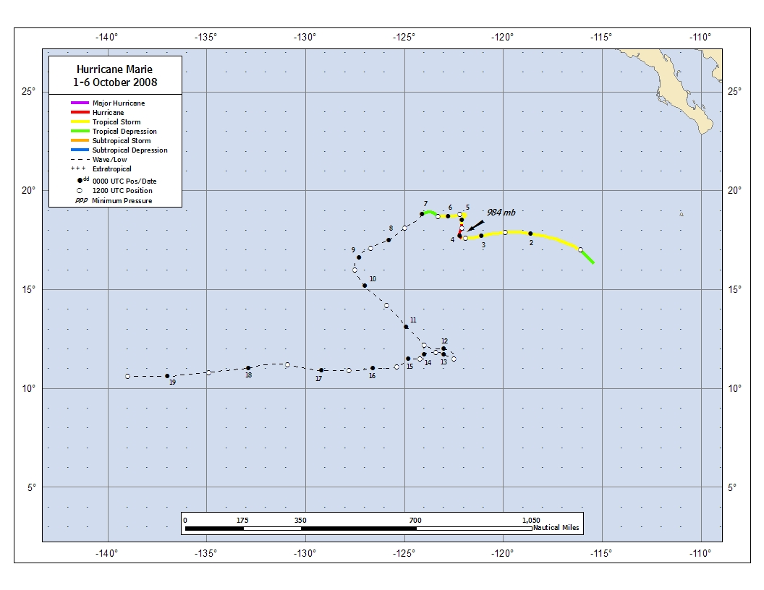
Figure 1. Best track positions for Hurricane Marie, 1-6 October 2008. Track positions during the remnant low stage
are based on analyses from the NOAA Tropical Prediction Center’s Tropical Analysis and Forecast Branch (TAFB).
Figure 2. Selected wind observations and best track maximum sustained surface wind speed curve for Hurricane Marie,
1-6 October 2008. Dashed vertical lines correspond to 0000 UTC.
Figure 3. Selected pressure observations and best track minimum central pressure curve for Hurricane Marie,
1-6 October 2008. Dashed vertical lines correspond to 0000 UTC.
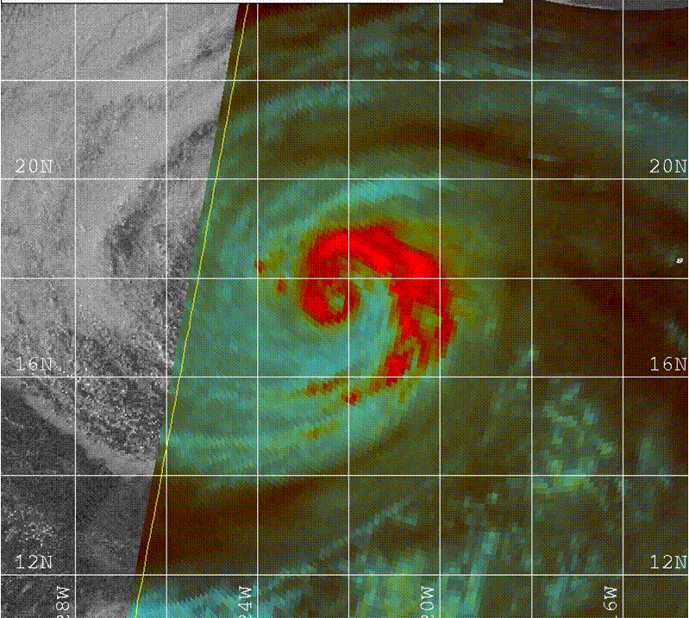
Figure 4. A 1447 UTC 3 October 2008 SSM/I 85 GHZ Color image depicting the closed eyewall
of Hurricane Marie located near 17.6º N 122.0º W (image courtesy of the U.S. Navy Fleet Numerical
Meteorology and Oceanography Center, Monterey, CA).

A digital record of the complete best track, including wind radii, can be found on line at ftp://ftp.nhc.noaa.gov/atcf. Data for the current year’s storms are located in the btk directory, while previous years’ data are located in the archive directory.

