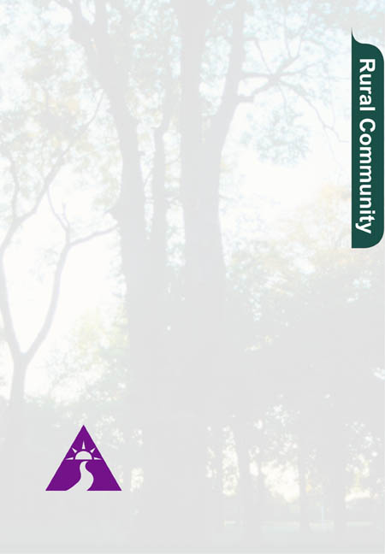

Alzheimer’s Disease: Rural Community

Mobile Day Care

Bringing Social Day Care to Rural Communities

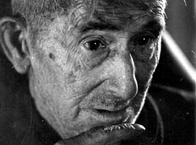

Developed by the

State of Georgia, the Atlanta

Alzheimer’s Association,

the Georgia Division of

Aging Services

A Program of the U.S. Administration on Aging

Alzheimer’s Disease Demonstration Grants to State Program

Mobile day care is an innovative approach to providing social day care in rural communities that may not have the resources to develop their own full-time, day care program. Leaving each morning from a central location, program staff (with materials and supplies needed for the day) travel to a rural site. Depending on the needs of the community, each center is open one or two days per week, for six hours a day. Day care is held in a community building (church, senior center, etc.) in the rural community. When possible, transportation for participants is arranged through community resources. The mobile day care model allows rural communities to have their own adult day care program by sharing staff and resources that move from location to location.

Why Mobile Day Care?

The need for specific respite for Alzheimer's Disease in Georgia's rural areas was identified by state service agencies as a critical social need. Georgia set out to use Alzheimer's Demonstration funds to deliver respite in rural areas in a cost-efficient manner and with well-trained staff. The initial grant addressed the need for respite care by developing several mobile day care sites throughout Georgia. The Atlanta Alzheimer's Association initially located the mobile day cares in various chapters around the state and began to develop, direct, and staff these rural programs from their central office. In a short time it became clear that one central agency for the entire state did not work well. Only one Alzheimer's Association chapter in Augusta was able to develop one mobile day care program that served two counties for one day each week. Georgia is currently learning from the Augusta model and has replicated the program in five additional counties.

How a Mobile Day Care Program Is Developed

Specific tasks necessary for the development of a rural mobile day care site include hiring staff, identifying an appropriate location, and making arrangements for client transportation and meals. The staff described below can handle approximately eight day care clients.

Four staff positions are needed for a mobile day care program. A Community Development Coordinator works three days per week. Responsibilities include public relations, trouble shooting for mobile day care operations, making local arrangements for educational programs and community outreach. The coordinator is also responsible for developing a coalition of community professionals and caregivers to assist in promoting the mobile day care.

A Day Center Director works two and a half days per week for each site. Responsibilities include development of program activities, supervising aides, gathering supplies, and providing feedback to families about the client, and transporting staff and supplies to mobile day care sites.

A Certified Nursing Assistant works two and a half days per week. Persons for this position are hired from the local community if possible. Responsibilities include assisting the director, assisting clients with activities (crafts, meals, toileting) and providing one-on-one contact with each client during the day.
The Case Management Coordinator works one day per week in each site. This position is held by an experienced social worker who assesses clients for day care attendance, assists families with other community services and conducts reassessments.

Arrangements for a day care location, transportation, and meals must be made. An appropriate facility must provide adequate, part-time, safe space for persons with dementia. In Georgia, churches and senior centers have been used. Gaining the commitment and support of a host organization is critical to the mobile day care's success. This may require educating possible host organizations about individuals with dementia and negotiating liability concerns and insurance issues.

Transportation for day care participants is also an issue. In one county the local aide rides in the Senior Services van to pick up clients for the mobile day care program.

Meals need to be coordinated. One Georgia site was located in a senior center that provided the meals on-site, which reduced the cost of meals. Meals on Wheels is another resource for mobile day care meals.

How Georgia Made the Mobile Day Care Concept Work

The initial step in implementing the model was to hire the Community Development Coordinator. This person directed the education and outreach campaign. The main venues were for general outreach, human interest stories with pictures in the local newspapers, and the development and distribution of flyers throughout the community. Additionally, the community development coordinator developed a community coalition and advisory board that included pharmacists, physicians, church leaders and service providers to assist with marketing and oversight. The community coalition began by providing joint educational presentations or events at community and civic meetings.

Local agencies saw the benefits from working together. They found that group efforts were stronger and more successful than solo efforts. They began pooling resources to strengthen community opportunities. The community coalition and the coordinator gave public talks to local groups and service agencies concerned with elderly individuals, had booths at local health fairs, and donated books on Alzheimer's disease to the local library. Gaining community support is essential to the success of the mobile day care program.

The community coalition served as an advisory committee and was instrumental in building community awareness and trust. The coalition included partners from local nursing homes, home health agencies, the Department of Family and Children services and community leaders. Each partner was represented in the coalition. This group directed marketing efforts, monitored appropriateness of efforts for the community, provided an entrance into community service links, held support groups in nursing homes, and worked with the hospital to open an adult day care center. Through these efforts the coalition members became more aware of the needs of Alzheimer's families in their own community. They used that knowledge in their own service work. They became additional local resources. Partner agencies had difficulty freeing up staff time for coalition meetings-until they saw positive results of teamwork.

Barriers and Obstacles

The mobile day care program had to address several community concerns. When negotiating with the host organization about space, liability issues were a concern. Additionally, the comfort of other groups using the shared space with a dementia population needed to be accommodated through education. The community coalition was helpful in guiding the project's outreach and education efforts to assure compatibility with rural culture tenets of "taking care of our own." Transportation remains a key element in rural family participation in the mobile day care program.

Other challenges have been identified and successful resolutions are still being sought. For instance, if Medicaid patients participate in mobile day care, they lose "home-bound" status.

Benefits to Georgia and to Families

Benefits of the mobile day care program can be seen at many levels. First and foremost, dementia-specific respite is now available in rural communities that previously had no dementia services. The costs of this extension of service have been minimal. Most of the costs are in salaries, which become cost effective as staff are integrated into multiple sites. Additionally, less money is needed to start a new mobile program. The craft budget is nominal, meals are purchased as needed, and facility costs are lower when space is shared.
Another major benefit is that staff capacity is strengthened by integrating the staff with the Alzheimer's Association day care program in Augusta. Staff are cross-trained to fill in during sick and vacation days. By making the positions full time, better-trained and more skilled staff can be hired. By integrating staff into the central location (Augusta) as well as the rural sites, staff experience more job satisfaction and there is less turnover and less staff isolation.

When possible, the program aides are hired from the local communities and work with the community development director from Augusta. Hiring from the community means that clients know the staff member. This facilitates an easier transition for families and clients to begin using the program services.

A major benefit is that the community coalition brings together individuals and agencies that have not previously worked together. Their increased awareness of Alzheimer's disease filters into other community projects. For example, Alzheimer's issues are being considered in designing other service spaces and a home health agency is now opening an office in a remote area of Georgia.

Costs and Funding for Mobile Day Care

The Georgia program has a budget of just over $31,000 per year (1999). This includes $22,000 for staff positions. The additional money covers supplies, telephone, equipment, insurance, staff training, staff travel, and client services. The program pays for insurance ($500 per year) in lieu of rent for shared space. This budget covers two sites offering services two days a week.
Because of the success of the Augusta mobile day care, Georgia has funded several new mobile programs using Brookdale Foundation funding.

New day care programs are frequently difficult to sustain because of insufficient enrollment. However, the mobile day care concept spreads staff costs between two sites thus decreasing both the cost and the risk to each site. A major effort in our program is to make better use of funds we have while seeking additional financial support.

Keys to Success

- A well-trained, enthusiastic Community Development Coordinator.
- A well-developed and active community coalition.
- Members from diverse areas of the community.
- After start-up, the community coalition is maintained and continues in an active role in the program.

Contacts:
Administration on Aging: (202) 401-4547
330 Independence Ave.
Washington, DC 20201

Cliff Burt: (404) 657-5336
Georgia Alzheimer's Demonstration Project; Division of Aging Services
2 Peachtree St. NW Ste. 36.385
Atlanta, GA 30303

Other Projects that Serve Rural Populations:
Dawn Harlock: (904) 414-2073
Florida Alzheimer's Demonstration Project in West Palm Beach; Office of Volunteer and Community Services; Department of Elder Affairs
4040 Esplanade Way, Suite #260
Tallahassee, FL 32399-7000

Romaine Turyn: (207) 624-5335
Maine Alzheimer's Demonstration Project; Adult Services; Department of Human Services
State House Station 11
Augusta, ME 04333

Lisa Brakebill: (410) 561-9099
Maryland Alzheimer's Demonstration Project; Alzheimer's Association
1850 Yrok Rd., Ste. D
Tomonium, MD 21093

Irene Kazieczko or Dale Adler:
(517) 335-0226
Michigan Alzheimer's Demonstration Project; Michigan Department of Health
Lewis Cass Building, 6th Floor
Lansing, MI 48913

Marian Sigmund: (919) 733-3983
North Carolina Alzheimer's Demonstration Project; NC Dept. of Human Resources
693 Palmer Dr.
Raleigh, NC 27626-0531

Barbara Kelly: (803) 253-6177
South Carolina Alzheimer's Demonstration Project; SC Dept. of Health & Human Services
Office on Aging
PO Box 8206
Columbia, SC 29202-8206

The Administration on Aging is the official Federal agency dedicated to policy development, planning and the delivery of supportive home and community-based services to older persons and their caregivers through the national aging network of state and local agencies on aging, tribal organizations, service providers and volunteers.

