UNITED STATES DEPARTMENT OF EDUCATION
OFFICE OF INSPECTOR GENERAL

Audit Services

New York Audit Region

January 29, 2008
Control Number
ED-OIG/A02H0006

Dr. Laverne Terry
Acting Commissioner
Virgin Islands Department of Education
No. 44-46 Kongens Gade
St. Thomas, VI 00802

Dear Dr. Terry:

This Final Audit Report, entitled Audit of the Virgin Islands Department of Education’s 2003 Reopened Consolidated Grants, presents the results of our audit. The purpose of the audit was to determine whether the Virgin Islands Department of Education (VIDE) had sufficient evidence of obligations to support its request to reopen the 2003 Consolidated Grant. Our review covered the period February 2006 through May 2006.

BACKGROUND

The U. S. Department of Education (ED) has determined that the Virgin Islands (VI) is a “high-risk grantee” under 34 C.F.R. § 80.12. According to 34 C.F.R. § 80.12, a grantee may be considered high-risk if an awarding agency determines that a grantee or subgrantee has a history of unsatisfactory performance or has not conformed to the terms and conditions of previous awards.

VIDE has had a history of unsatisfactory performance of not meeting the requirements of previous ED awards. ED entered into a three-year comprehensive Compliance Agreement with VIDE on September 23, 2002. The Compliance Agreement was designed so that ED and VIDE could develop integrated and systemic solutions to VIDE’s problems with managing Federal education funds and programs. VIDE did not comply with the terms and conditions of the 2002 Compliance Agreement and, as a result, VIDE was required to hire a third-party fiduciary to manage all grant funds starting with the 2004 grant awards.

In December 2005, VIDE requested ED’s approval to reopen the 2003 Consolidated Grant. ED responded to VIDE in February 2006 and requested that VIDE provide the amount obligated, amount to be drawn, reason for the need to reopen, an attestation that the obligations were valid and that the costs were allowable, and an explanation of the failure to liquidate funds in a timely manner. VIDE submitted a brief letter stating that it had $4,959,803 in expenditures that could be charged to the 2003 Consolidated Grant, and an attestation signed by the former VIDE Commissioner. ED approved the request to reopen the 2003 Consolidated Grant on March 24, 2006, and VIDE made three drawdowns totaling $3,952,676.

AUDIT RESULTS

The objective of our audit was to determine whether VIDE had sufficient evidence of obligations to support its request to reopen the 2003 Consolidated Grant. We found that VIDE did not have sufficient evidence of obligations to support its entire request to reopen the 2003 Consolidated Grant. VIDE did not have documentation to support over $1 million of the $4.9 million requested to reopen the 2003 Consolidated Grant. In addition, VIDE did not include an additional $1.3 million available for liquidation because it did not reconcile the grant balances. Therefore, $2.3 million of the 2003 Consolidated Grant may lapse.
In its response to the draft report, VIDE concurred with the finding and recommendations. VIDE’s comments are summarized at the end of the finding. The full text of VIDE’s comments on the draft report are included as an Attachment to the report.

FINDING – VIDE did not have sufficient evidence of obligations to support its entire request to reopen the 2003 Consolidated Grant

We found that VIDE did not have sufficient evidence of obligations to support $1,007,585 of its $4,959,803 request to reopen for liquidation the 2003 Consolidated Grant. We reviewed the 2003 Consolidated Grant approval and noted that the budget period for the 2003 Consolidated Grant was from July 1, 2003 to September 30, 2004. VIDE received an additional 12 months to obligate these funds under the Tydings Amendment. VIDE requested, and ED approved, the reopening of the 2003 Consolidated Grant to liquidate $4,959,803 of expenditures, the amount VIDE requested. VIDE provided ED with an attestation, signed by the VIDE Commissioner of Education in February 2006, that it had valid expenditures to support its request to reopen and expend funds from the 2003 Consolidated Grant. ED approved the request for $4,959,803. We found that VIDE only had evidence to support expenditures of $3,952,218 of the $4,959,803. (See Table 1.)
Table 1: 2003 Consolidated Grant Funds Reopened to VIDE

Amount Requested by VIDE to reopen | $4,959,803
Amount of Request Supported by VIDE | $3,952,218
Amount of Request Unsupported by VIDE | $1,007,585

Our review of VIDE’s supporting documentation determined that VIDE based its request on erroneous information from the VI Financial Management System (FMS) that had not been verified or reconciled to ED’s Grant Administration and Payment System (GAPS). VIDE submitted the unverified information to ED. A VIDE staff member, who prepared the documents submitted to ED, stated that VIDE did not have accurate information at the time of the liquidation request because some expense information was not ready to be processed. This VIDE staff member further stated that VIDE simply took the data from FMS, applied the Indirect Cost Rate to the FMS totals, and provided the information to the Commissioner so that it could be forwarded to ED.

Although the laws and regulations for reopening grants are very clear, they allow discretion regarding the necessary actions to be followed in approving or not approving the reopening of grants.

According to 34 C.F.R. § 80.23(b), “A grantee must liquidate all obligations incurred under the award not later than 90 days after the end of the funding period. The Federal agency may extend this deadline at the request of the grantee.”

Many State-administered programs are also “forward-funded;” i.e., Congress makes the funds available for obligation by the states on July 1 before the start of the fiscal year, instead of at the start of the fiscal year on October 1.

Per 34 C.F.R. § 76.709 (a) and (b), after adding the extra three months at the beginning of the grant and the twelve-month Tydings period at the end of the grant, grantees and sub-grantees have 27 months to obligate grant funds. Funds not obligated within the Tydings period lapse and must be returned to the U.S. Treasury.

In ED’s policy letter dated January 28, 2005, the principal operating component (POC) within ED has the responsibility to consider and approve or disapprove late liquidation requests made up to 12 months after the end of the Tydings period. Late liquidation requests made after the expiration of the Tydings Amendment must be approved by the Chief Financial Officer (CFO) in conjunction with the Office of the Deputy Secretary, the Office of the Under Secretary, and the Office of the General Counsel. The CFO approves or disapproves the request, informs the POC of its decision, and the POC takes the necessary steps to process the late liquidation request.

In our report entitled, The Virgin Islands Department of Education Did Not Effectively Manage Its Federal Education Funds, ED-OIG/A02C0012 issued September 2003, one of the Office of Inspector General’s (OIG) recommendations to ED was to ensure that VIDE provide ED program officials with requisition documentation when requesting grants to be reopened. ED agreed with this recommendation and further stated that the condition should not occur in the future due to the September 2002 Compliance Agreement.

We requested and received from ED the documentation that had been submitted in support of VIDE’s request. We found that VIDE did not ensure that the information submitted to ED was complete and accurate according to its own financial system. As a result, VIDE did not have competent financial data to fully support the requested amount of $4,959,803 submitted to ED to reopen its 2003 Consolidated Grant.

Recommendations

We recommend that the Assistant Secretary for OESE require VIDE to:

1.1 Provide additional documentation of the type and amount of expenditure when submitting a request to reopen a grant for late liquidation, and

1.2 Ensure financial data is accurate, verified, and reconciled to GAPS, FMS, and its own financial records before it is provided to OESE.

VIDE Comments

VIDE concurred with the finding and recommendations. In its response, VIDE stated that, with the assistance of the third party fiduciary, it has started to use reconciliations to certify that balances are accurate, verification is made of all obligations, and confirmation is given that all goods and services have been received before requesting a late liquidation from the grantor agency. VIDE stated that in its FY 2004 late liquidation request, with the assistance of the third party fiduciary, it had started to provide additional documentation and will continue to do so on future requests. Further, in its FY 2004 late liquidation request, VIDE used reconciled data and will continue to do so in the future to ensure financial information is accurate.

OTHER MATTERS

VIDE is at risk of lapsing $2.3 million from the 2003 Consolidated Grant. VIDE did not maintain accurate financial records of grant balances and expenditures and the entire available balance in GAPS. We also found there was no evidence that VIDE reconciled the financial data to GAPS. At the time of their request, VIDE had an available balance in GAPS of $6.2 million, but only requested $4.9 million. VIDE subsequently drew down $3.9 million of the balance, leaving an available grant balance of $2.3 million. Approximately $2.3 million is likely to lapse and revert to the U. S. Treasury unless VIDE can provide sufficient evidence of obligations to support a request for these funds. (See Table 2.) VIDE could lose $2.3 million of education funds that could have been used to improve the educational system and enhance education programs and activities in the VI.
Table 2: 2003 Consolidated Grant Funds Available to VIDE

Balance of Funds in GAPS Before Reopened | $6,224,620
Amount Drawn | $3,952,676
Amount of funds that may lapse | $2,271,944

OBJECTIVE, SCOPE, AND METHODOLOGY

The objective of our audit was to determine whether VIDE had sufficient evidence of obligations to support its request to reopen the 2003 Consolidated Grant.

To accomplish our audit objective, we:

- Reviewed documentation regarding the reopened 2003 Consolidated Grant;
- Interviewed VIDE officials to obtain an understanding of the process employed to request the reopening of the grant;
- Reviewed VIDE check listings, miscellaneous disbursement vouchers, and drawdown requests;
- Reviewed the 2003 Consolidated Grant award document;
- Reviewed financial reports from ED’s GAPS;
- Reviewed correspondence between OESE and VIDE regarding the 2003 Consolidated Grant.

We reviewed VIDE’s listing of expenditures totaling $3,952,218 to determine whether there was adequate evidence of the obligations. Of this amount, we judgmentally sampled the 20 largest non-payroll expenditures totaling $940,208 of $3,952,676 in drawdowns for the 2003 Consolidated Grant to determine whether the expenditures were allowable.

We relied, in part, on computer-processed data from VIDE and VI Finance. We verified the completeness of the data by comparing source records to computer-generated data, and verified its authenticity by comparing computer-generated data to source documents. Based on our testing, we concluded that the computer-processed data was sufficiently reliable for the purpose of our audit.

We performed our fieldwork at VIDE offices between January 2007 and July 2007.

We conducted the audit in accordance with generally accepted government auditing standards appropriate to the limited scope of the audit described above.
ADMINISTRATIVE MATTERS

Statements that managerial practices need improvements, as well as other conclusions and recommendations in this report, represent the opinion of the Office of Inspector General. Determinations of corrective action to be taken will be made by the appropriate Department of Education officials.

If you have any additional comments or information that you believe may have a bearing on the resolution of this audit, you should send them directly to the following Education Department official, who will consider them before taking final Departmental action on this audit:

Kerri L. Briggs
Assistant Secretary
Office of Elementary and Secondary Education
U.S. Department of Education
400 Maryland Avenue, SW
Washington, D.C. 20202

It is the policy of the U.S. Department of Education to expedite the resolution of audits by initiating timely action on the findings and recommendations contained therein. Therefore, receipt of your comments within 30 days would be appreciated.

In accordance with the Freedom of Information Act (5 U.S.C. § 552), reports issued by the Office of Inspector General are available to members of the press and general public to the extent information contained therein is not subject to exemptions in the Act.

Sincerely,

/s/
Daniel P. Schultz
Regional Inspector General
for Audit

Attachment

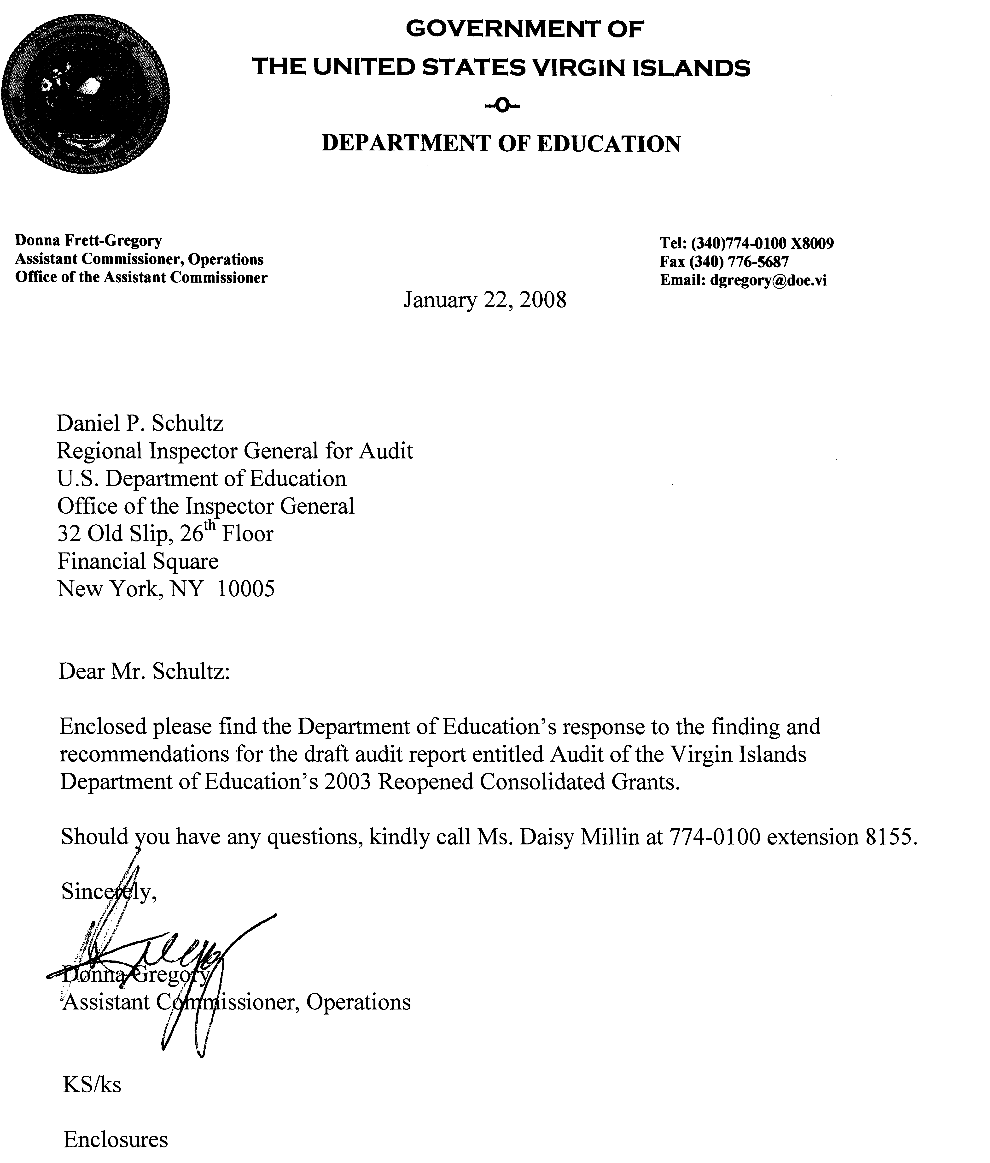
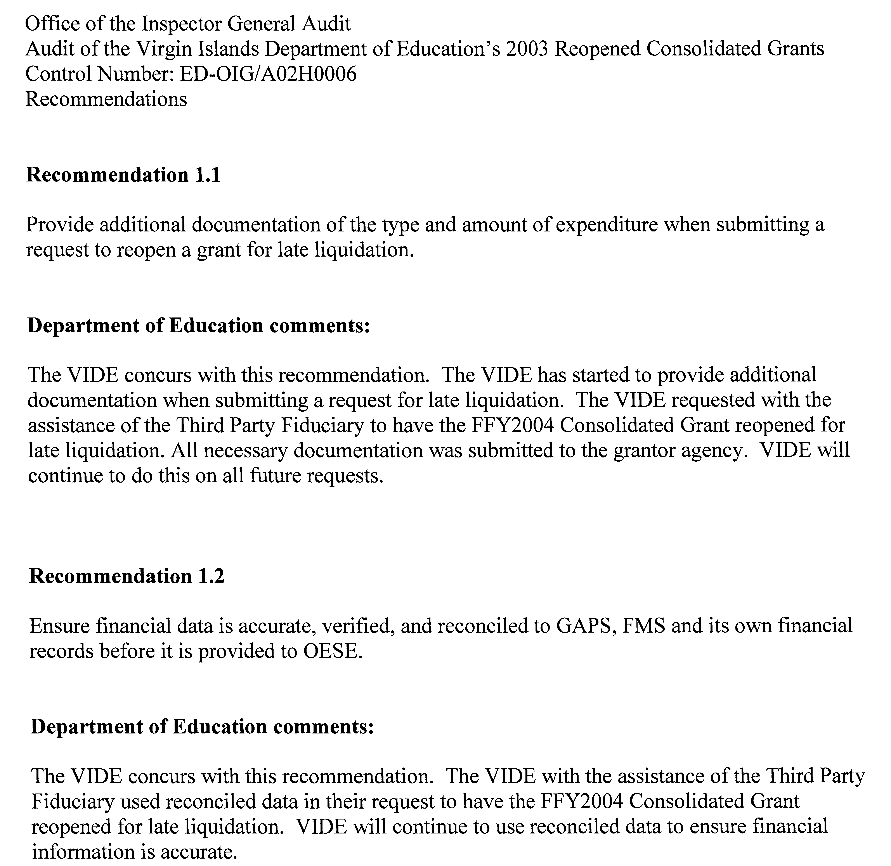

The attestation stipulated, “under penalty of perjury under the laws of the United States that all attached information being submitted to the Office of Elementary and Secondary Education (OESE) for the purpose of liquidation of obligations was compete and accurate.”
ED’s policy on reopening grants has been revised as of October 2007.
We did not determine whether VIDE has additional valid expenses as part of our review.

