National Library of Medicine
Preservation and Collection Management Section
Binding Services for Unbound Serials & Selected Monographs

Period of Performance: 02/01/07 – 01/31/12 with four one-year options
LIBRARY BINDING
I. Statement of Work 3
A. Background Information 3
B. Objectives 3
II. Services to be Performed 3
A. General Requirements 3
1. Scope 3
2. Compliance with Specifications 3
3. Communication 4
4. Binding System 4
5. Facility 5
B. Specific Requirements 5
1. Preparation for Binding: 5
a. Examination 5
b. Folded Sheets, Illustrations and Maps 6
c. Original covers 6
d. Flush binding 6
e. Preparation of the Spine 6
2. Leaf Attachment 7
a. Sew-Through-the-Fold 7
b. Double Fan Adhesive 7
c. Oversewing 8
d. Standard Recase 9
3. Trimming 10
4. Gluing the spine 10
5. Rounding and backing 10
6. Lining the spine 11
7. Covers 11
8. Lettering 11
9. Boards and Inlays 12
10. Assembling the Case 12
11. Library Corners 13
12. Casing-In 13
13. Special Features 13
14. Newspapers and Oversized Volumes 14
15. Boxes 14
16. Quality Control 15
17. Errors and Corrections 17
18. Workmanship/Warranty 17
19. Damage or Loss 17
20. Packing and Shipping 18
21. Insurance 18
22. Standards of Performance 19
23. Deliverables 19
APPENDICES Error! Bookmark not defined.
APPENDIX I -- Guidelines for the Care and Handling of Library Materials 21
APPENDIX II -- Customer Profile for National Library of Medicine Binding Contract 22
APPENDIX III -- References 25
APPENDIX IV -- Examples 26

I. Statement of Work

A. Background Information
The National Library of Medicine, Bethesda, Maryland, (hereafter NLM or the Library) houses an estimated 2 million bound volumes, plus thousands of unbound items, mostly individual serial pieces. Approximately 125,000 unbound serial issues are received each year. Unbound serials and selected monographs are collected and bound for preservation purposes.

B. Objectives
The Contractor shall bind up to 18,000-20,000 serial units and 500-2,000 monograph volumes at a rate of approximately 600-900 items bi-weekly. A binding preparation contractor working onsite at NLM assembles, collates, and prepares binding instructions, noting conditions that the Contractor must consider, and instructions the Contractor shall follow. The Library’s binding preparation contractor specifies the type of leaf attachment and other special instructions. Volumes for binding will be picked up every other week at the Library and be returned bound two weeks later.

II. Services to be Performed

A. General Requirements

1. Scope
Independently, and not as an agent of the Government, the Contractor shall furnish all necessary labor, materials, supplies, equipment, and services (except as otherwise specified herein) and perform the work set forth in the tasks outlined below.

The work to be performed under this statement of work is to be performed at the Contractor’s facility. The materials to be bound are those which the Library is mandated to collect and preserve. They are a permanent part of the Library’s collection and are often irreplaceable. The Contractor shall follow the “Guidelines for the Care and Handling of Library Materials” which is attached, as Appendix I. All work under this contract shall be monitored by the Project Officer whose position is defined elsewhere in this contract.

2. Compliance with Specifications
All work is to be done for the Library according to the attached specifications, unless instructions from the Library direct otherwise. Throughout this contract the Contractor is referred to the specifications of ANSI/NISO/LBI Standard for Library Binding. ANSI/NISO/LBI Z39.78.2000 hereafter referred to as Z39.78.2000. Should this standard be revised during the life of this contract, the Contractor shall meet the relevant specifications of that revision.

Any improvement in methods or materials used by the Contractor may be acceptable to the Library within the terms of this contract under the following conditions: the methods and/or material must undergo extensive, documented testing which measures their strength, durability, and functional qualities (e.g. openability of the volume); and tests must clearly indicate that the innovations(s) shall lead to better protection and to greater longevity of the text block. Adoption of any innovation must be approved in writing by the Library prior to implementation.

3. Communication
- The Contractor shall be willing to respond promptly to telephone calls and/or emails related to unusual problems, changes in schedules, etc.

- A representative from the Bindery shall visit the Library periodically and be available upon request. The representative shall be thoroughly familiar with the terms of this contract; shall have in-depth knowledge of the technical aspects of library binding and of the Contractor he/she represents; and shall have a thorough understanding of the relationship between library binding and the preservation of library materials.

- The Contractor shall be prepared to allow on-site visits during normal working hours by Library staff members interested in bindery activities.

4. Binding System
The Contractor shall maintain an automated database that allows electronic transfer of binding instructions from the Library to the bindery, that eliminates rekeying of variable spine label data, and that facilitates the generation of reports, statistics and invoices.

The Contractor’s database shall accommodate the transfer and maintenance of the following information.
- Library Title ID
- Bindery Title ID
- Library Barcode
- ISSN/ISBN
- Title
- Sub-title
- Author
- Series
- Volume
- Number
- Months
- Index
- Supplement
- Year
- Page numbers
- Abstract numbers
- Call number
- Leaf attachment
- Color
- Special handling instructions
- Shipment Lot ID
- Date sent to the Bindery
- Expected return date
- Date returned
- Library Internal Location Name

5. Facility
The Contractor shall ensure that the facility where the materials will be stored and processed has adequate security against theft, vandalism, fire, flood, rodent and insect infestation, and other environmental hazards. The Contractor’s facility shall have securely locking doors and windows, and shall have an intrusion alarm system connected to a local police department or building security service. The Contractor shall limit off-hours access to the building to times when authorized company personnel are present, and have in place a plan to lock all doors and windows when no staff is on the premises. The environment within the Contractor’s facility shall be maintained a relatively cool and dry, constant and stable level without extended periods of fluctuation or extreme temperature and/or relative humidity. The Contractor shall have in place a fire extinguishing system that conforms to local building code. The Contractor shall have in place a plan for responding to fire, water or other emergencies that may put NLM materials at risk. The Contractor shall notify the NLM Project Officer immediately if NLM materials are damaged or at risk because of fire, water or environmental contamination.

B. Specific Requirements
Specifically, the Contractor shall perform the following tasks:

1. Preparation for Binding

a. Examination
Each shipment received from the Library shall be inspected for completeness by checking off each item on the shipping list. (See Appendix IV) The Contractor shall notify the Library’s representative within 24 hours after receipt if a shipment is found to be incomplete.

The Contractor shall examine all volumes prior to binding. The Library will provide binding instructions on a printed slip (See Appendix IV) and electronically. Each volume will contain two copies of the binding slip; one copy shall be returned with the bound volume. The Contractor shall review the binding slip for any special handling instructions and to determine that the volume in hand can be bound according to the instructions. If the Contractor determines that the Library’s instructions cannot be followed or are not the best practice for the particular volume, the Contractor shall set the volume aside and contact the Library Project Officer for directions. If the paper is brittle (i.e. breaks before 4 double folds in a corner), the volume should not be bound. In some cases it may be necessary to return the volume unbound to the Library for further review.

Mending will be done by the Library prior to shipment to the bindery. If the Contractor observes unrepaired damage, such as torn covers or pages or defects that will impact the binding of the volume, the Contractor shall return the volume to the Library unbound. If the volume can be bound without repair to the defect, the Contractor shall flag the defect and bind as is.

The Library will collate and check serial issues for completeness and correct order. The arrangement of issues, title pages, indices, inserts, supplements, etc. should be left as is unless the Contractor notices an obvious error in the ordering of issues or the completeness of the volume or there are specific binding instructions about the order of these materials. The volume may be bound incomplete only if indicated on the binding slip. If a unit is incomplete and there is not a specific instruction to bind incomplete, the unit should be returned to the Library unbound.

Books originally bound by spiral, plastic combs, or similar methods, are to be handled in accordance with the binding instructions.

b. Folded Sheets, Illustrations and Maps
Volumes with double leaves, folded illustrations or inserts shall be handled carefully to preserve folds and to prevent them from catching in the binding. As instructed by NLM, loose or detached inserts and folded materials may be set out on a strip of reinforcing cloth or alkaline paper; attached to the binding margin, or placed in a pocket. Refolding of such materials to accommodate a pocket enclosure is not permitted.

c. Original covers
Original paper covers are to be retained on all volumes or issues, unless NLM requests otherwise. If the original covers are extremely stiff which might result in binding failure, NLM will provide photocopied surrogates. If the Contractor determines that a cover is too stiff and a photocopy has not been provided, the volume should be returned to NLM.

d. Flush binding
When serial issues of different heights must be bound together the issues will be jogged flush at the tail, rather than the head. In no case will one or more issues be trimmed for the purpose of making them conform to the smaller issues with which they must be bound.

e. Preparation of the Spine
For text blocks which must have the spine edge trimmed or milled away in preparation for oversewing or double fan adhesive binding, the Contractor shall take care to remove as little as possible (and not more than 1/16 inch of the edge) in order to preserve as much as possible of the inner margin to allow for a possible rebinding at a later date

Very bulky serial issues which are saddle stitched and which cannot be sewn through the fold (e.g., when they must be bound together with non-saddle stitched issues) shall be prepared for adhesive binding or oversewing by slitting through the fold rather than by trimming or milling.

The Contractor shall remove all staples before trimming, milling or sewing.

Rounded and backed text blocks, which must be rebound shall have boards removed and the old rounding and backing taken out by nipping before the spine edge is milled or trimmed.

2. Leaf Attachment
NLM will determine the method of leaf attachment for serials and assemble batches of all the same leaf attachment. Instructions about leaf attachment and special treatment will be found on paper binding slips inside the bindable units. Unless specified otherwise in this document, methods of leaf attachment should strictly adhere to the guidelines provided by the Z39.78-2000. The only acceptable methods of leaf attachment are those specified below. Neither cleat sewing nor side sewing shall be considered methods of leaf attachment under the terms of this contract. In cases where the Contractor ascertains that side sewing is the only suitable method of leaf attachment, the volume will be returned to NLM. All volumes in folded sections shall be sewn through the fold by machine unless otherwise instructed by NLM.

Endpapers for all methods of leaf attachment shall meet the specifications of Z39.78.2000 Section 15.1 and reinforcing materials shall meet the specifications of Section 17.1

a. Sew-Through-the-Fold
Sewing through the fold is a method of attaching separate signatures, one to another in succession, to create a text block. When NLM specifies sew-through-the-fold, the signatures shall be sewn by machine.

- Preparation
NLM will reinforce or repair weak or damaged folds before sending volumes to be sewn through the fold. NLM will also tip in or hinge loose leaves and inserts. If upon examining a volume prior to binding, the Contractor finds that the necessary processing preparatory to sewing through the fold has not been done, the Contractor shall return the volume to NLM.

- Sewing
As many needles as possible shall be used. Stitches shall be no closer than ¼ inch and no farther than 1-½ inches from the head and tail of the text block after trimming. Endpapers shall be sewn onto text blocks as if the endpapers were the outermost signatures of the text block, front and back. The thread used in sewing through the fold should conform to the specifications stated in Z39.78.2000 Section 20.2.

- Endpaper Construction
Endpapers for volumes consisting of multiple signatures shall be constructed from two folded sheets, nested. The fold of the sheet shall be reinforced with a ¾ inch wide strip of reinforcing material.

b. Double Fan Adhesive
The text block is created by using an emulsion copolymer or internally plasticized polyvinyl acetate adhesive (PVA) to adhere loose leaves together to form a text block. This method is appropriate for loose or adhesive bound pages. The adhesives must meet the requirements of Z39.78-2000 Section 19.2. The thickness of double fan adhesive bound volumes shall not exceed 2 inches.

- Preparation
The spine of the volume shall be milled to roughen it, to remove all old adhesives and threads, and to free all leaves to allow for optimal fanning. As many paper fibers as possible shall be exposed for optimum bonding of paper and adhesive. Notching the spine is permitted, no deeper than 3/32 inch, and in no case shall the notching invade the text. The number of notches shall be the minimum required to enhance exposure to adhesive. The Library may request extra sanding of extremely glossy and stiff covers to expose more paper fibers to the adhesive. Where the binding margins of adhesive-bound volumes are extremely narrow, the pages should be pulled away from the original adhesive manually and not milled, if this can be without damage to the text block. Serial volumes having single-signature issues with narrow binding margins that must be bound together with an adhesive-bound issue shall be prepared for adhesive binding by slitting through the folds rather than milling.

- Endpapers
An endpaper for double-fan adhesive binding shall consist of a single folded sheet that is tipped no more than ¼ inch onto the first leaf of the text block during the fanning process.

iii.) Fanning and gluing
The milled text block shall be securely clamped. The endpapers shall be attached at the same time as the leaves as if they were the outermost leaves of the text block front and back. The binding edge shall be fanned first in one direction, as adhesive is applied by brush or by roller and then in the opposite direction, as adhesive is applied. The penetration of adhesive between leaves shall be approximately 1/32 inch so that each leaf is tipped to the next. No adhesive shall run into the margins between pages farther than 1/8 inch and in no case shall it run into the text area. If the binding edge is notched, all notches shall be filled with adhesive.

iv.) First spine lining
A stretchable fabric lining, meeting the specifications of the Z39.78-2000 Section 17.2, shall be squarely and snugly adhered to the spine of the text block. This lining shall cover the entire spine, to within ¼ inch of the head and tail (after trimming), and shall extend onto each endpaper at least 1 inch. The text block shall be positioned squarely and allowed to dry without the use of a heating or drying device.

c. Oversewing
Oversewing consists of sewing thin sections of loose pages together. Multiple needles and threads pass obliquely through the binding margin of each section, forming stitches that attach it to previously attached sections. When instructed to oversew by NLM, the contractor shall oversew by machine volumes in single sheets, with inner margins at least 5/8 inch after milling or with paper unsuitable for adhesive binding, such as heavily coated paper. For thick volumes without enough margin to be oversewn, NLM will generally instruct the Contractor to split the volume into 2 parts and adhesive bind. NLM will provide title pages for each volume.

- Preparation
The spine of the volume shall be milled if necessary to free the leaves for sewing. No more than 1/16 inch of the binding margin shall be removed.

ii.) Endpapers
Endpapers shall be constructed in one of the following ways:

a) A single folded sheet tipped ¼ inch from the edge of a single leaf to make three leaves. A 1-1/4 inch strip of reinforcing material shall be adhered along the binding edge of the folded sheet and the exposed ¼ inch margin of the single leaf. After sewing, the outermost leaf shall be folded and tipped back flush and parallel to (but not extending beyond) the binding edge of the text block, to cover the sewing thread and to allow the endpaper to hinge from the binding edge.
b) Two or three leaves. One leaf has a 1-1/4 inch wide extension of reinforcing material; the second leaf is tipped to the extension along the binding edge; a third leaf may be tipped to the second leaf. When this type of endpaper is used, boards shall be cut according to Section 12.3.2 of the Z39.78.2000.

iii.) Sewing
All volumes shall be divided into uniform sections approximately 1/16 inch thick, the thickness varying depending on the nature and condition of the paper. Endpapers shall be sewn onto the text blocks with the outermost sections of the text block, front and back. Sewing shall be no closer to the head or tail of the volumes than ¼ inch after trimming and no farther than 1 inch away from the head and tail. The shuttle thread shall be coated with an adhesive during sewing; or a thin line of paste shall be applied along the binding margin of each section prior to sewing. The threads used for oversewing shall meet the requirements of Z39.78.2000, Section 20.1. The adhesives shall meet the requirements of Z39.78-2000, Section 19. In no case shall the sewing be closer to the text than 1/8 inch.

d. Standard Recase
Text blocks that are strongly sewn with a number of stitches adequate to the size of the text block and have sewing intact shall be recased only, not resewn. Also included in this category are volumes that have previously been bound by a publisher or library binder that have worn or damaged covers with intact sewing.

i.) Preparation
Old cases shall be removed, and old spine lining and adhesive shall be carefully and completely removed from the text blocks. Paper covers will be removed and tipped back in. Sewing is not to be disturbed. In the case of volumes originally bound as paperbacks, the Contractor shall remove adhesive from the spine, if possible. After cleaning the spine, the Contractor shall inspect the text block. If the sewing is not sound, the Contractor shall contact the Library Project Officer to determine the appropriate method of leaf attachment. If agreement about an alternate method of leaf attachment cannot be reached, the Contractor shall return the volume to the Library.

ii) Endpaper attachment
New endpapers shall be sewn to the text block using a method that is compatible with the original sewing structure. In the case of text blocks originally sewn through the fold, endpapers shall be attached by sewing through the fold of one or two outer-outermost signatures of the text block, and then through the folds of the endpapers. In the case of text blocks originally double fan adhesive bound, endpapers shall be hinged on with reinforcing material. In the case of text blocks originally oversewn, endpapers shall be attached by whip stitching on with sewing stitches approximately 1 inch apart. After sewing, the outermost leaf shall be folded and tipped back flush and parallel to (but not extending beyond) the binding edge of the text block, to cover the sewing thread and to allow the endpaper to hinge from the binding edge.

iii.) Endpaper construction
Endpapers shall be constructed in one of the following ways:

- A single folded sheet with a hinge of reinforcing material that is adhered along the binding edge of the endpaper and extends beyond the fold.

- A single leaf hinged with reinforcing material to form a single folded sheet.

3. Trimming
All books shall be trimmed squarely and as slightly as possible or left untrimmed, if so instructed. The trimmed edges shall be smooth and without rough knife marks. Excessive trimming of irregularly sized issues for the purpose of making them uniform shall be avoided. Under no circumstances shall any volume be trimmed to the extent that printed matter shall be removed in any part, unless the Library grants specific permission. Trimming should not be in excess of 1/8 inch at the head, tail, or fore-edge and no folds are to be trimmed. If any text or printed matter is trimmed, the Contractor is responsible for the cost of the replacement volume.

4. Gluing the spine
Spines of all sewn text blocks shall be glued with polyvinyl acetate adhesive prior to rounding and backing. The adhesive shall thoroughly coat the spines. Text blocks shall be stacked squarely and allowed to dry without the use of a heating or drying device. For volumes that are sewn through the fold, the adhesive shall be applied prior to trimming. The adhesives used in gluing the spine must meet the specifications of Z39.78.2000, Section 19.2.

5. Rounding and backing
With the exceptions noted below, all text blocks ½ inch or more in thickness shall be evenly rounded to form a smooth and convex spine and a concave fore edge. Rounded text blocks shall be backed to form shoulders that are symmetrical, uniform head to tail, and as nearly equal in size to the anticipated board thickness as possible. Rounding and backing may be done using a semiautomatic hydraulic machine, a roller backer, or by hand. Good results often require a combination of hand and machine processes.

Exceptions
- Double-fan adhesive bound text blocks shall not be rounded and backed.

- Text blocks sewn through the fold, but with signatures of more than ¼ inch in thickness shall be rounded, but not backed.

- No rounding and backing will be required in the following cases:
i.) text blocks already rounded and backed that are to be recased only;
ii.) text blocks under ½ inch in thickness;
iii.) flat backed text blocks being recased.

6. Lining the spine
The spines of all text blocks shall be lined with spine lining cloth that meets the specifications of Z39.78.2000 Section 17.2. The spine lining shall be adhered with an adhesive that meets the specifications of Z39.78.2000, Section 19.2. Double-fan adhesive bound text blocks to which a stretchable spine lining has already been applied shall receive another spine lining. The cloth shall be cut to within ½ inch of both head and tail of the text block, and shall extend squarely onto each endpaper at least 1 inch. The grain of the spine-lining cloth shall be straight along the spine of the text block.

The spines of all volumes over 1-1/2 inch in thickness that have been sewn through the fold or recased, and the spines of all other volumes over 2-1/2 inches in thickness or that weigh more than 5 pounds, shall be reinforced by an extra layer of material. This reinforcement may be alkaline paper no lighter than 60-pound text weight or a second layer of spine lining cloth.

7. Covers
Covering materials shall be impregnated with a nonmigratory resinous material and shall meet or exceed the tests for Group F buckram as specified in ANSI Standard L29.1-1977 Fabrics for Book Covers as listed in Z39.78-2000, Section 18. If the text block weighs less than 2 pounds the Library may instruct the Contractor to use a material that is impregnated or coated with a nonmigratory resinous material and that meets or exceeds the tests for C-1 Grade book cloth as specified in ANSI Standard L29.1-1977 Fabrics for Book Covers as listed in Z39.78-2000, Section 18.

Covering material shall be cut squarely, approximately 1-½ inches taller and wider than the anticipated size of the finished case. This allows for a ¾ inch overhang on all four sides of the unfinished case and results in a turn-in of approximately 5/8-inch, although turn-ins may be wider.

8. Lettering
Lettering of author, title, and call number shall be done in white foil unless gold foil is explicitly specified. Stamping foils shall meet the performance specifications set forth in Section 22 of the Z39.78.2000. Lettering shall be permanent, sharp, clean, legible, and stamped with adequate pressure, temperature, and dwell to ensure adhesion of the foil to the covering material. All lettering shall be on the spine or the cover of the volume as directed by the Library.

All lettering shall be in 18-point type, except for books thinner than 1 inch that may be lettered in 14-point type. Upper and lower case fonts shall be used in accordance with the instructions on the binding slip. The preferred orientation for title data is horizontal, centered on the spine. If the title is too long or the volume too narrow, the title may stamped vertically. Call numbers should be stamped horizontally, if possible, even if the title is stamped vertically. The top of the first line of the call number should be positioned 2 inches from the bottom of the volume. If the call number cannot fit on the spine, it must be stamped in the upper left-hand corner of the front cover, ½ inch from the top of the volume and ½ inch from the joint. The volume/part/date designations should be stamped horizontally. All monographs and serials must be stamped with author, title, call number, volume, pages, year, and other variable information as specified by the binding instructions. Some serial volumes will also require that the letters “IM” be placed 1 inch from the top of the spine. The Contractor shall keep records of stamping patterns and color of stamping foil for serial titles so that uniformity of sets may be maintained. Occasionally the Library will send for binding office copies that will have special instructions as to the placement of lettering and will not have call numbers. Proper and accurate stamping of all volumes, including accents in foreign titles, is essential.

The Library will specify words to be abbreviated. If the label text is too long and needs to be abbreviated, the Contractor shall contact the Library Project Officer for the proper abbreviation and should not construct an abbreviation without instructions from the Library.

9. Boards and Inlays
Boards shall be cut squarely and smoothly, with the grain running parallel to the binding edge. Boards shall meet the specifications of Z39.78-2000 Section 16. The height of the boards shall be approximately ¼ inch taller than the text block, unless the text block is to be bound flush with the bottom of the case in which case the height of the boards shall be approximately 1/8 inch taller than the text block. The thickness of the board shall be between 1/16 inch and 1/8 inch, and appropriate for the size and weight of the text block. For exceptionally large text blocks, (e.g. newspapers) boards shall be no less than 1/8 inch thick. For heavy or large text blocks the boards shall be no less that 1/11 inch thick. For small or light text blocks the board shall be no more than 1/12 inch thick.

For narrow-hinge cases the width of the boards for rounded and backed volumes shall be equal to the width of the text block from shoulder to fore edge.
For wide-hinge cases the width of the boards for rounded and backed volumes shall be approximately ¼ inch narrower than the width of the text block from shoulder to fore edge. The width of the boards for flat-backed volumes shall be approximately 3/8 inch narrower than the width of the text block.

All covers shall have an inlay of flexible, durable paper, meeting the specifications of Z39.78-2000, Section 15.3. The inlay shall be cut with the grain running parallel to the spine, the same length as the cover boards and the same width as the spine of the text block from shoulder to shoulder.

10. Assembling the Case
The boards and the inlay shall be squarely and securely adhered to the covering material. The spaces between the inlay and the boards shall be uniform and approximately ¼ inch wide. Pieces of cord approximately 1/8 inch in diameter or a piece of braid shall be placed at the head and tail of the inlay. The corners of the cloth shall be left uncut so that library corners can be made. The covering material shall be turned in snugly and uniformly, approximately 5/8 inch on all sides, and shall adhere neatly and tightly to the edges of the boards. The adhesives used in making the case should conform to Z39.72.2000 Section 19.3.

11. Library Corners
Each of the four uncut corners of the overhanging cover material shall be folded at a 45-degree angle and adhered onto the inside surface of the cover boards. The already glued-off overhang shall be turned in at the head and tail, fore edge and back edge of the case.

12. Casing-In
All adhesive materials and applications shall be in accordance with the specifications outlined in Z39.78.2000, Section 19.4. Text blocks shall be cased in squarely and tightly. All squares shall be uniform around the perimeter of the text block; and shall be between 1/16 inch wide and 3/16 inch wide. Very heavy or thick text blocks may be bound flush with the bottom of the case (that is the case will have no square at the tail) per instructions from the Library. When text blocks are bound flush with the bottom of the case, the cord at the tail of the inlay shall be omitted.

Cased-in volumes shall either be pressed between metal-edged boards until thoroughly dry; or pressed in a building-in machine using sufficient pressure, dwell, and heat to ensure good adhesion of the endpapers to the boards and turn-ins, and good adhesion of the covering material to the spine lining and endsheets in the joint area of the text block. The amount of adhesive applied to the joints, and the method used for building in, shall be sufficient to ensure that joints are tight and secure and cannot be separated without damaging the bonded surfaces. Endpapers shall adhere to all surfaces smoothly, and be free of wrinkles and bubbles.

13. Special Features
All materials used for pockets, stubbing or inserts shall conform to the Z39.78.2000, Section 15.2.

- Pockets
Pockets may be made of cloth or paper as instructed by the Library. Cloth pockets shall be made of lightweight pyroxylin impregnated book cloth over heavy alkaline paper. Cover material shall be turned-in enough to insure good adhesion and glued into position with an archival flexible glue. Paper pockets shall be made of heavyweight alkaline paper.

Material (i.e., maps, charts, etc.) will be gathered and inserted into pockets, which will be glued in place, as indicated on the binding instructions. Pocket size and capacity will be as instructed. Surrogates may be sent to indicate the size of the pocket.

- Inserts
Inserts for CD’s and other media shall be made of plastizote or an equivalent inert material that has been approved by the Library. The item to be inserted shall fit snugly into the cutout. A thumblike notch will be cut out to ease in removal of the item. Stubbing shall be used to compensate for the thickness of the insert. The Library will provide samples of the standard formats so that the Contractor can produce a die so that a surrogate does not need to be sent for each occurrence.

c. Binding Stubs
When parts with different heights are to be bound together, the tail of the resulting text block shall be flush, not the head. Stubbing shall be used, whenever practical, to make up for the size differences. In no case shall one piece be trimmed for the purpose of making it conform to a smaller piece with which it must be bound. Stubbing shall be added to volumes to compensate for thick pockets on back covers and to correct text blocks that flare out towards the fore edge.

14. Newspapers and Oversized Volumes
Newspapers and volumes over 16 inches in height shall be prepared and bound to conform to the specifications for binding given within this document according to the leaf attachment style selected by the Library, except for the variations set out below.

- Rounding and backing is not required.

- End papers shall be reinforced with cloth joints of lightweight buckram or fabric of equal weight. The cloth shall be wide enough so that it will extend at least 2 inches beyond the sewing.

- Backs shall be lined with approved cotton fabric extending to within one inch of the head and tail and leaving an extending flap at least 2-1/2 inches wide on each side.

When sew through the fold leaf attachment is specified:

- Sections shall be refolded whenever the original fold is crooked or is so far off-center that it would cause the sewing to encroach on the print.

- Every volume shall be sewn in sections on three or more tapes or cords with linen thread unless otherwise instructed by the Library. Tapes shall be not less than 1/2 inch wide.

15. Boxes
Portfolios, clamshell boxes or phase boxes will be made for materials unsuitable for binding upon request from the Library. Portfolios and clamshell boxes shall be constructed of binder’s board that conforms to the specifications of the Z39.78.2000, Section 16. Covering material used for portfolios and clamshell boxes shall meet the specifications of Section 18 of the Z39.78.2000. The adhesives used in the construction of protective enclosures shall conform to Section 19 of the Z39.78.2000. The Library may send measurements and labeling instructions rather than the physical piece to be boxed. The lettering on boxes shall follow the same specifications as those for bound volumes in Section II.8 of this document.

- Portfolios
A portfolio shall consist of a case with three internal flaps, large enough to completely cover the contents, with an interior tie to secure the head and tail flaps and an exterior tie to be placed at the center of the fore edge. The case shall be lined with alkaline buffered paper that conforms to the Z39.78.2000 Section 15.1 for endpapers. Ties shall be of high quality dye fast cotton twill or unbleached linen and the end of the tape shall not ravel. Portfolios shall be constructed of binder’s board of a thickness appropriate to the material to be enclosed: board used for the case shall be no less than 1/12 inch and for the flaps no less than 1/25 inch.

- Clamshell boxes
A clamshell box shall consist of a case and two trays, which fit into one another. The case shall be lined with alkaline buffered paper that conforms to the Z39.78.2000 Section 15.1 for endpapers.

c. Phase boxes
A phase box shall be of a design approved by the Library. Phase boxes shall be constructed of board high in alpha-cellulose, free of lignin and metal particles, waxes, plasticizers, residual peroxide and other components that could lead to the degradation of the paper stored inside the box. The pH of the board should be between 8.0-9.5 and it should have an alkaline reserve between 2% and 5% with a thickness of approximately 1/16-inch. The fasteners should be button and string or a style other than Velcro buttons approved by the Library.

16. Quality Control
The Contractor shall have an established quality control program. The Contractor shall be responsible for quality control at various stages during the binding process and before return of completed volumes to the Library. The Contractor’s quality control program should assure a high standard of workmanship and adherence to the Z39.78.2000 standard as well as the specific binding instructions provided by NLM. Quality control of the completed bound volume shall consist of the following procedures based on Guide to the Library Binding Institute Standard for Library Binding.

a. Inspection of the Unopened Volume
1) Spine Stamping
The spine must be stamped correctly, matching the binding slip and text. The lines must be properly positioned, both vertically and horizontally. The letters must be evenly impressed and crisp.

2) Covering Material
The covering material must be clean, free from dust and glue residue. It must be smoothly and completely adhered to both boards. If a color has been specified in the binding instructions, the cover must be that color.

3) Joints
The joints must be parallel to the spine, and uniformly and adequately deep.

4) Rounding and Backing
If the volume has been rounded and backed, the spine of the text block must be properly shaped at both the head and tail. The boards must fit correctly into the spine.

5) Squares
The squares (the edges of the boards that extend beyond the text block at the head, fore edge, and tail) must be even, and an appropriate width (1/16 to 3/16 inch, depending on the size of the text block).

6) Trimming
No text or illustrative matter must be damaged or obscured by trimming. If the instructions stated NO TRIM, the edges will be uneven.

b. Inspection of the Spine
The Contractor shall open the volume to its approximate center, look down the hollow of the spine, between the covering material and text block. The spine lining must extend to within ½ inch of the head and tail of the spine. It must be smoothly and completely adhered. If the volume is heavy or thick, an extra paper lining must be adhered over the cloth one. There should be no lumpiness caused by old adhesive and paper.

c. Inspection of the Boards
The Contractor shall open both boards so that the inner surface of each board can be inspected.

1) Endpapers
The endpapers must be smoothly and completely adhered to the boards. They must be properly positioned so that the squares of the boards appear uniformly wide. The edges of the endpapers must be straight-cut and smooth.

2) Turn-Ins
The turn-ins (the margins of cloth that wrap from the front of the boards onto the inside) must be uniform, and approximately 5/8 inch wide. The edges must be straight-cut and smooth.

3) Spine Lining
The spine lining must extend onto each board at least 1 inch. It must be uniformly wide, head to tail, on each board.

d. Inspection of the Text Block
The Contractor shall examine the binding slip and leaf through the text block to determine that all instructions on the binding slip have been followed and that an appropriate method of leaf attachment was selected.

1) Endpapers
The style of endpaper must be appropriate for the method of leaf attachment used. The endpapers for volumes in signatures must be sewn on through the fold. For text blocks that have been double-fan adhesive bound, the endpaper must be tipped no more than ¼ inch onto the first leaf. (Ideally it should be less.) For text blocks that have been recased, the gutter between endpaper and first leaf must be neat and free from the residue of old spine lining.

2) Text Block
All leaves must be securely attached. Their edges must be free from adhesive that inhibits their opening. Leaves and issues must be in the correct order. For volumes that have been oversewn, sewing must not run into the print. The text block must be positioned in the casing right side up.

3) Openability
A well-bound volume should open well and stay open. For various reasons, this is sometimes not an achievable goal. The paper may be stiff or its grain may run at right angles to the spine of the volume rather than parallel to it. A high percentage of all volumes should have good openability.

17. Errors and Corrections
Any error made by the Contractor should be corrected (provided that corrections do not damage the text block) prior to the shipment’s return to NLM. Returned volumes with errors in lettering or defects in workmanship that are noted by NLM may be returned to the Contractor for corrections. Completed corrections shall be returned with the slip on which correction instructions were indicated. The Contractor shall make all bindery corrections and return them to the Library within fourteen days of receipt by the Contractor and shall bear all costs incurred thereby, including transportation.

The National Library of Medicine shall assume responsibility for all charges related to corrections resulting from errors or oversights made in preparation of the binding instructions.

18. Workmanship/Warranty
The Contractor shall warrant the volumes bound under this contract as conforming to the Z39.78.2000, Section 3, except as agreed in this contract or agreed in writing with the Library. Defects in materials or manufacture (such as errors in lettering, lettering worn off so as to be illegible, defective sewing, use of improper adhesives, failure of the leaf attachment, etc.) shall be corrected at no cost to the Library. Normal wear of the covering material shall be excluded. The warranty shall be in effect for 5 years from the date of the original binding.

To indicate the Contractor’s responsibility for the binding of the volume a label or stamp shall be placed on the pasted down endsheet of the inside back cover, approved by NLM, showing the Contractor’s identification and the month and year when the particular volume was bound. This shall serve as the company’s guarantee of the binding of that specific volume. Materials used for a binder’s mark (paper, adhesive, and ink) shall be chemically neutral so as not to cause deterioration of the paper of the text block.

19. Damage or Loss
If the Contractor’s error results in loss of text or irreparable damage to the volume, the Contractor must replace the volume or the damaged issue(s) in the bindable serial unit. The cost and burden of locating replacement volumes, due to loss or damage by the Contractor, shall be borne by the Contractor. If the Contractor cannot replace the damaged issue(s), the Contractor shall notify the Project Officer and provide documentation on the sources that the Contractor contacted to obtain a replacement issue(s). If the Library is able to obtain a borrowed volume from another library that duplicates the damaged volume or issue(s), the Contractor shall make a bound preservation photocopy from the volume supplied by the Library at no cost to the NLM. If the volume cannot be replaced by the Contractor or the Library, the Contractor shall credit the Library $250.00 per volume.

20. Packing and Shipping
a. Packing
Packing of volumes for pickup and delivery must be in sturdy shipping containers furnished by the Contractor. In addition to the cartons, the Contractor shall supply labels and packing material. Shipment integrity shall be maintained. The cartons shall be labeled with the lot number and the shipping list will be enclosed in each lot. The items from the original shipping list shall be checked off and annotated as the lots are packed. If necessary, volumes shall be wiped clean before packing. Filled weight of containers shall not exceed 45 pounds. The volumes shall be placed flat in the cartons and wrapping materials shall be used to avoid shifting during transit.

b. Schedule
The Contractor will be required to pick up material for binding at least once a week on a regular basis. Bound volumes or volumes returned unbound will be due back two weeks after pickup. If a delivery or partial shipment cannot be made on the regularly scheduled date, the Contractor must give the Library 24 hours notice. The delivery day and approximate time of day shall be agreed upon by the Contractor and Library and adhered to as closely as possible.

c. Shipping
The Contractor must be able to ship volumes in its own vehicles. Vehicles must afford adequate protection from water damage. If the storage area of the vehicle used to transport Library materials is not air conditioned, volumes shall not be kept in the vehicle more than 24 hours. Vehicles shall be loaded and unloaded immediately before transport and upon arrival at the Contractor’s facility.

d. Location
Pick up and delivery shall be made to the Binding Preparation area in B1E23 of Building 38, National Library of Medicine, 8600 Rockville Pike, Bethesda, MD 20894.

e. Accountability
The Contractor must verify the number of volumes picked up and delivered and will be responsible for the safekeeping of NLM’s materials submitted for binding under the terms and conditions of this contract while in the Contractor’s plant, or during transit to or from Contractor’s plant, and will be responsible for replacing any items lost or damaged.

21. Insurance
The Contractor shall insure, at his expense, all books and other NLM materials against loss or damage from any cause, from the time they leave the NLM until they are returned. Each shipment is to be insured for $225,000 or for a greater amount if specified. As proof of compliance with the requirement the Contractor shall furnish a certificate of insurance to NLM.

22. Standards of Performance
The Contractor shall maintain quality control that will assure a high standard of performance. The Library will inspect samples of the finished work and, where it is not satisfactory, the Contractor shall correct or rework at the Contractor’s expense.

Excessive errors will be considered evidence of an inadequate quality control system. Error rates over 2% will be considered “excessive”. The error rate will be based on the number of volumes requiring correction (either by the Contractor or by the Library), excluding preparation errors not reasonably detectable by the Contractor, divided by the number of volumes in each shipment.
The following requirements shall be met:

- There shall be no errors in lettering.

- Volumes shall be bound in correct order and in correct position.

- All binding instructions for leaf attachment, trim, and special handling, such as pockets, must be followed, unless the Library has approved alternate methods.

- The binding shall show a high quality of workmanship with smooth cloth adhesion, even corners, squares and trimming and no excessive glue.

- The measurements of the boxes made for library materials should be closely adhered to so that the volumes do not shift around, but are not so tight that removing them causes damage.

- Shipment integrity must be maintained. All items within a lot must be returned together.

- Shipments must be returned within fourteen (14) days of pickup, unless special arrangements have been made with the Library.

23. Deliverables
- Periodical - Sew through the fold
- Periodical - Double fan adhesive bind
- Periodical – Oversew
- Periodical – Standard recase
- Monograph – Sew through the fold
- Monograph – Double fan adhesive bind
- Monograph – Oversew
- Monograph – Standard recase
- Newspaper – Sew through the fold
- Newspaper – Double fan adhesive bind
- Newspaper – Oversew
- Newspaper – Standard recase
- Portfolio
- Clamshell box, buckram cover
- Phase box
- Paper Pocket
- Cloth Pocket
- Plastizote Insert
- Special Handling Charges (Itemized)
- Reports

The Contractor shall furnish the following reports to the Library:
i.) For each shipment: total number of serials and monographs bound by type of leaf attachment, the number of portfolios, clamshell boxes, phase boxes, pockets and inserts produced, and the special handling charges incurred.

ii.) Monthly: the total number of serials and monographs bound by type of leaf attachment and the number of newspapers, portfolios, clamshell boxes, phase boxes, pockets and inserts produced and the number of items given special handling; a brief narrative describing any unusual problems or concerns.

iii.) As requested: status reports on items requiring special handling or overdue from the bindery.

APPENDIX I -- Guidelines for the Care and Handling of Library Materials

The Contractor will give bindery staff training in the care and handling of Library materials and maintain the following procedures:

- Do not permit smoking, eating or drinking in areas where books or stored or work is performed.

- Do not use metal paper clips or self-sticking notes or adhesive tapes to secure instructions on covers or text. Remove all paper clips, self-sticking notes and adhesive tape on Library materials before binding.

- Never stack books in such a way that they are in danger of toppling over or being knocked off. Do not place books on the top edges of other books. Take special care to support unbound materials, which tend to bend and slip.

- Do not apply any tape or undertake any repairs.

- To avoid water damage, never place books directly on the floor. Shelve books at least 4 inches above the floor. Store cartons of books on pallets while in process. Report any water damage to the Project Officer by telephone immediately.

APPENDIX II -- Customer Profile for National Library of Medicine Binding Contract

Ship to:
1.
National Library of Medicine
Bldg. 38, Room B1E23
Bindery Preparation Contractor
8600 Rockville Pike
Bethesda, MD 20894

Contact Person: Mary Kate Dugan
Voice: 301-435-7113 Fax: 301-480-1698
e-mail duganm@nlm.nih.gov

Invoices
Copy included with shipment; attn. Mary Kate Dugan

An original and two copies to the following designated payment office:
National Institutes of Health
Division of Financial Management
Chief, Contracts Section, FAAB
Building 31, Room B1B05A
31 Center Drive MSC 2050
Bethesda, MD 20892-2050

Two copies to the following approving officer
Karen Riggs,
Contracting Officer
Office of Acquisitions Management
National Library of Medicine
Building 38A, Room B1N17
8600 Rockville Pike
Bethesda, MD 20894

Shipment Cycle: 2 weeks, with weekly pickup and delivery

Collation/Preparation: Library will collate and prepare items for binding.

Periodical collation: Library will collate, but Contractor is responsible for accurate collation before binding Library materials.

Books collation: Library will collate.

Brittle volumes: return unbound (Library pre-screens for brittle volumes)

Questions: call, email, or return unbound with explanation

Barcodes: leave in place.

Insert security devices: no

Binding slip: must return; leave loose inside front board (no adhesive)

Incomplete volumes: bind as-is if noted on binding slip; otherwise return unbound.

Binding:
Uneven issues: align flush bottom and stub as appropriate; no trim
Periodicals too thick: bind as instructed on binding slip; otherwise call, email, or return unbound.
Volume with issues/pages to be inserted: bind as instructed on binding slip; otherwise call, email, or return unbound. (Library pre-screens for and tips in loose pages.)

Mending: do not mend; bind as is and flag or return unbound

Trimming:
Books: do not trim unless instructed otherwise on binding slip
Periodicals: minimal trim at head/tail/fore edge unless instructed otherwise on binding slip

Preferred leaf attachment: Library determines. If Contractor is not able to follow Library instruction, volume is returned unbound.

If unable to recase: Return unbound.

Bind flush with the bottom of the case: Only when instructed by Library

Paper covers (books): Hinge and bind in original paper covers

Spine Stamping:
Print color: white, very infrequently gold upon special instruction

Type (in order of preference):
(1) 18-point upper case only in authors and titles;
(2) 14-point permitted on narrow (less than 5/8 inch) spines
(3) Upper and lower case as indicated on the binding slip

Call number position (order of preference):
(1) Horizontal on the lower spine. Text begins 2 inches from the bottom edge
(2) [If volume less than 5/8 inch thick] in horizontal lines stamped on the upper left corner of the upper cover

Position of title and variable information for periodicals (order of preference):
(1) Horizontal across spine
(2) Vertical from head to tail

Year format: Follow instruction on binding slip

Book author/title information (order of preference):
(1) Horizontal across spine
(2) Vertical from head to tail, start 3/4 inch from head

Break lines: follow instructions on binding slip; no hyphenation except as Library instructs.

Head and tail lines: None

Abbreviations: The Library will specify words to be abbreviated. If the label text is too long and needs to be abbreviated, the Contractor shall contact the Library Project Officer for the proper abbreviation and should not construct an abbreviation without instructions from the Library.

APPENDIX III -- References

- National Information Standards Organization. ANSI/NISO/LBI Library Binding, Z39.78-2000. Bethesda, MD: NISO Press, 2000.

2. American National Standards Institute. Permanence of Paper for Printed Library Materials, ANSI/NISO Z39.48-1992.

3. American National Standards Institute. Fabrics for Book Covers, ANSI L29.1-1977.

4. Merrill-Oldham, Jan and Paul Parisi. Guide to the Library Binding Institute Standard for Library Binding. Chicago, IL: American Library Association, 1990.

APPENDIX IV -- Examples

- Binding Instructions
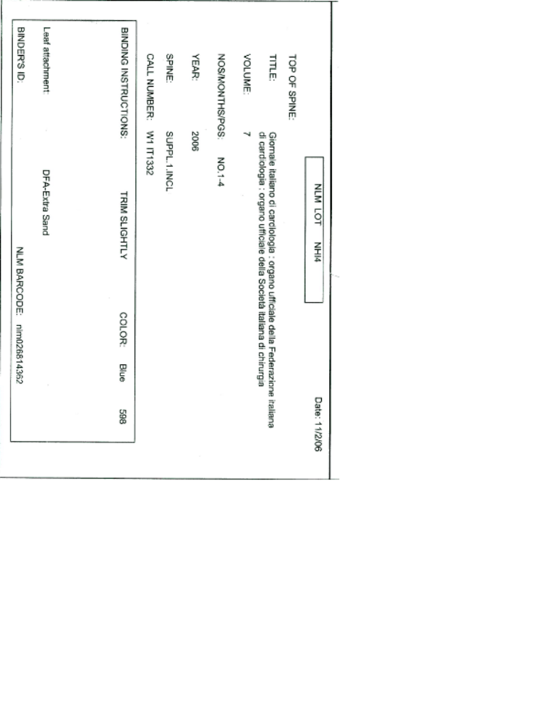
2. Shipping List

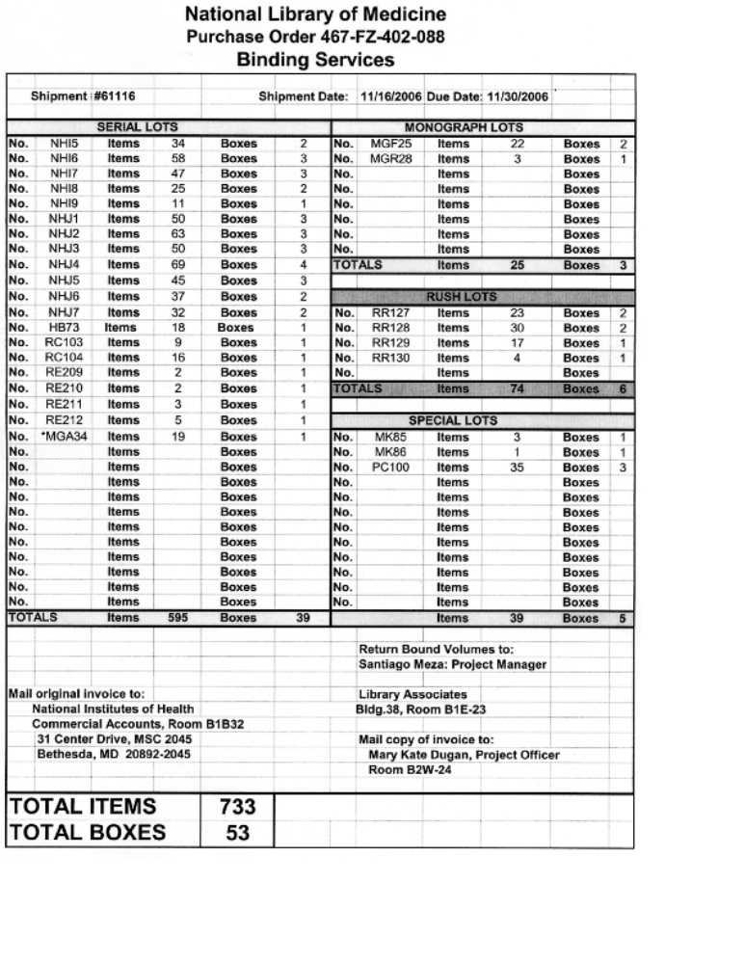

3. Lot information



