TECHNICAL REPORT
MATERIALS AND PROCESSES
Subject: Joint Group on Pollution Prevention Electro-chemical Migration Resistance (EMR)/Surface Insulation Resistance (SIR) |  | No. TR 05-882-AP/M&P-JAK-01
 |  | Date: March 21, 2005
To:  D. W. Swanson  Anaheim Site-Engineering  882, 031-GE22 | By:  John A. Kerr  Anaheim Site-Engineering  882, 031-DE03 x5375 | Approved:  J. A. Messner  Functional Manager  Materials and Processes

INTRODUCTION

The European Union and Asia have agreed to remove lead from electronic solder in commercial products by July 2006. Although military products are exempt, suppliers are adapting to the larger worldwide consumer market and dropping tin-lead finishes from their products. Also, some overseas customers may be unwilling to purchase military products that are not lead-free. Boeing is part of a consortium of government and civilian manufacturers called “JG-PP” (Joint Group Pollution Prevention), which is investigating lead-free alloys for the United States. The Anaheim facility agreed in the first quarter of 2004 to perform Electrochemical Migration Resistance (EMR) and Surface Insulation Resistance (SIR) tests per IPC Test method 650 to compare the lead-free alloys to traditional tin-lead (Sn63) solder. All test coupons were cleaned using the same semi-aqueous process. Fluxes used were those recommended by the solder manufacturers. The test coupons were assembled under the supervision of Lety Campuzano-Contreras.at Boeing/BAE Irving, Texas.

EMR TEST PLAN

- EMR was performed per IPC-TM-650 2.6.14.1.
65° C, 85% RH, 100VDC, 96 hrs unbiased, 500 hrs biased (596 hrs total)

- Test vehicles employed IPC-B-25A Test Vehicles Comb D (six boards each) for:

Reflow solder
SnAgCu solder alloy ECO Solder 7100-GRN360K and no-clean flux Senju ROL1
SnAgCuBi solder alloy Haraeus CL30-8467 and no-clean flux RMA
Sn37Pb Kester R244 solder alloy and flux Kester ROL0
Wave solder
SnCu SN100C, Nihon Superior NR310B, Alpha VOC-Free no-clean flux
SnAgCu (Kester) E-Bar Sn 95.8Ag3.5Cu.7 flux NR310B Alpha
Sn37Pb Kester Ultra Pure and NR310 Alpha Type ORM0 flux

` Control coupons were bare copper finish boards processed to simulate reflow, wave solder, and cleaning procedures only.
All coupons were cleaned with semi-aqueous process using IONOX I3330.

- Appearance after testing was:

Tin-silver-copper reflow and wave soldered with 7100 GNR 360K had the fewest dendrites and corrosion.
Tin copper had residual polymer material and dendrites. See photo 1.
Tin-silver-copper-bismuth reflow had black corrosion and residual polymer material between traces. Solder exhibited poor wettability. A more active flux may help. See photo 2.

SIR TEST PLAN

1. SIR was performed per IPC-TM-650 2.6.3.3.
- 85 ° C, 85%RH, 100 VDC, 168 hrs

2. Test vehicles employed IPC-B-24 Test Vehicles (six boards each) for:

Reflow solder
SnAgCu solder alloy ECO Solder 7100-GRN360K and no-clean flux Senju ROL1
SnAgCuBi solder alloy Haraeus CL30-8467 and no-clean flux RMA
Sn37Pb Kester R244 solder alloy and flux Kester ROL0
Wave solder
SnCu SN100C, Nihon Superior NR310B, Alpha VOC-free no-clean flux
SnAgCu (Kester) E-Bar Sn95.8Ag3.5Cu.7 flux NR310B Alpha
Sn37Pb Kester Ultra Pure and NR310 Alpha Type ORM0 flux

Control coupons were bare copper finish boards processed to simulate reflow, wave solder, and cleaning procedures only.
All coupons were cleaned with semi-aqueous process using IONOX I3330.

3. Appearance after testing was:
- Tin-lead samples (wave and reflow)
- One of four samples (S/N W4) had dendritic growth across multiple traces. See photo 3.
- Tin-silver-copper-bismuth (reflow)
- Two of four samples had black corrosion observed as well as a residual binder material between the traces. Wettability was the poorest of materials tested. Different flux may improve soldering. See photo 4.
- Tin-copper wave – No dendrites (four of four samples)
- Tin-silver-copper (wave and reflow)
- No dendrites (four of four samples)

OVERALL OBSERVATIONS

- Operations desiring to use a single lead-free alloy which is suitable for reflow and wave-solder processes which have electrochemical-migration-resistance and surface-insulation-resistance performance comparable to or exceeding tin-lead should consider tin-silver-copper.

  - Tin-silver-copper-bismuth reflow turned dark black and had a translucent material between the traces after SIR and EMR testing. Wetting looked poorest of samples. Perhaps the flux was not sufficiently removed or the cleaning was insufficient.

  - EMR testing was much more harsh than SIR. If the test was done again, it is recommended that visual inspection be performed at the half-way point to get a better idea of which samples corroded first.

  - Tin-copper wave also had black corrosion and white dendrites after EMR testing. OA flux or insufficient cleaning may have contributed. Tin-copper was dendrite free after SIR.

- Tin-silver-copper wave and reflow were visually similar to each other after EMR and SIR.

CONCLUSION

Of the three alloys tested (tin-silver-copper, tin-copper, and tin-silver-copper-bismuth), tin-silver-copper and tin-copper performed as well or better than tin-lead alloys. The tin-silver- copper and tin-copper alloys both used NR310B VOC-free no-clean flux. The tin-silver-copper-bismuth, which used a Heraeus no-clean RMA flux, developed black spots on the solder during EMR and SIR testing. The discoloration appears to be corrosion, which may be a result of flux residues left after cleaning. Some kind of cleanliness evaluation/ comparison such as Ion Chromatography could measure contaminants before environmental testing. The discoloration of tin-silver-copper-bismuth may be exacerbated by flux residues left after cleaning. It appears the polymers left from no-clean processes are not robust enough to withstand the corrosive effects of 596 hours EMR testing. There was weak correlation between resistance measurement and dendrites on comb patterns.

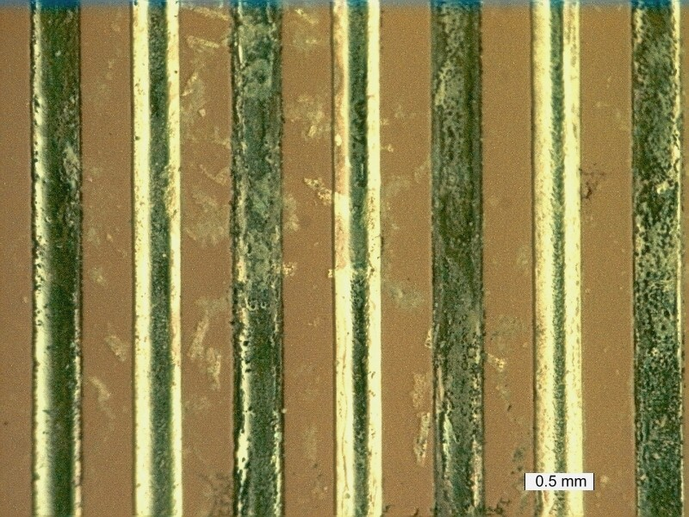

Photo 1
Tin-copper residual polymer material and dendrites

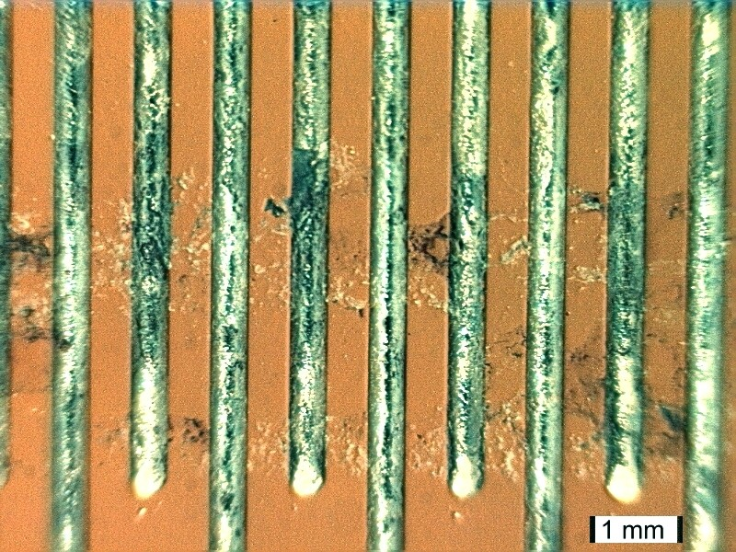

Photo 2
Tin-silver-copper-bismuth reflow with black corrosion and residual polymer material after EMR testing

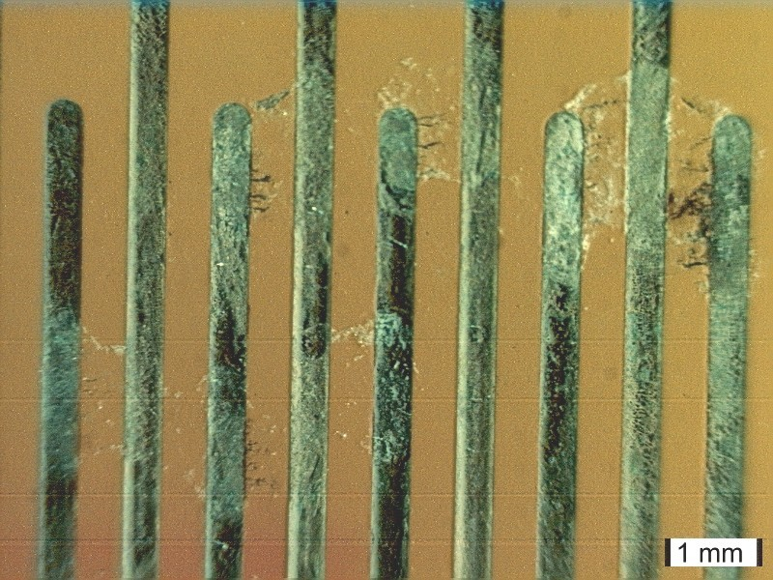

Photo 3

Tin-lead dendritic growth across multiple traces after EMR

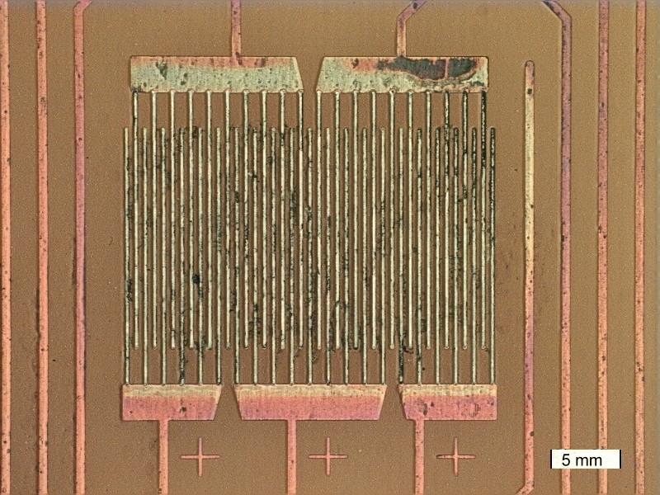

Photo 4

Tin-silver-copper-bismuth reflow with black corrosion and residual polymer material after SIR testing

SIR TEST COUPONS

Finish | S/N Comb | Initial | 72 hours | 120 hours | 168 hours
Bare copper control not baked | CU4A | 1.20E+13 | 4.50E+11 | 1.20E+12 | 8.00E+11
Bare copper control not baked | CU4B | 1.20E+13 | 2.60E+11 | 7.50E+11 | 6.00E+11
Bare copper control not baked | CU4C | 8.00E+11 | 4.00E+11 | 3.00E+12 | 8.00E+11
Bare copper control not baked | CU4D | 1.10E+12 | 4.50E+11 | 4.50E+11 | 8.00E+11
Bare copper control not baked | CU5A | 1.20E+13 | 4.50E+11 | 3.00E+12 | 8.00E+11
Bare copper control not baked | CU5B | 2.00E+13 | 4.50E+11 | 5.50E+11 | 8.00E+11
Bare copper control not baked | CU5C | 2.40E+12 | 4.00E+11 | 5.50E+11 | 1.00E+12
Bare copper control not baked | CU5D | 2.80E+11 | 6.00E+11 | 5.50E+11 | 1.00E+12
Tin-silver-copper wave soldered | SACW1A | 8.00E+10 | 1.30E+11 | 6.00E+11 | 2.00E+12
Tin-silver-copper wave soldered | SACW1B | 1.80E+11 | 3.60E+11 | 7.50E+11 | 4.00E+12
Tin-silver-copper wave soldered | SACW1C | 5.50E+12 | 2.60E+11 | 6.50E+11 | 2.00E+12
Tin-silver-copper wave soldered | SACW1D | 1.00E+13 | 2.20E+11 | 6.00E+11 | 2.00E+12
Tin-silver-copper wave soldered | SACW2A | 5.00E+12 | 1.10E+11 | 1.80E+11 | 2.80E+11
Tin-silver-copper wave soldered | SACW2B | 7.00E+12 | 9.50E+10 | 1.40E+11 | 2.00E+11
Tin-silver-copper wave soldered | SACW2C | 1.80E+11 | 4.50E+11 | 6.50E+11 | 1.00E+12
Tin-silver-copper wave soldered | SACW2D | 5.20E+10 | 1.40E+11 | 1.50E+12 | 4.00E+11
Bare copper control not baked | CU1A | 6.00E+12 | 1.00E+12 | 1.20E+12 | 6.50E+11
Bare copper control not baked | CU1B | 5.00E+10 | 9.00E+11 | 1.20E+12 | 1.50E+12
Bare copper control not baked | CU1C | 2.00E+13 | 1.00E+14 | 2.00E+13 | 3.00E+13
Bare copper control not baked | CU1D | 2.00E+13 | 1.00E+13 | 3.00E+13 | 2.00E+13
Bare copper control baked | CONT4A | 1.10E+13 | 6.00E+11 | 8.00E+11 | 1.00E+12
Bare copper control baked | CONT4B | 1.10E+13 | 5.50E+11 | 7.50E+11 | 1.00E+12
Bare copper control baked | CONT4C | 7.50E+10 | 6.00E+11 | 5.00E+12 | 1.00E+12
Bare copper control baked | CONT4D | 1.90E+11 | 5.50E+11 | 6.00E+12 | 1.00E+12
Bare copper control not baked | CU2A | 1.40E+13 | 5.50E+11 | 9.00E+11 | 1.00E+12
Bare copper control not baked | CU2B | 1.00E+13 | 4.50E+11 | 7.50E+11 | 1.00E+12
Bare copper control not baked | CU2C | 1.10E+11 | 4.50E+11 | 9.00E+11 | 4.00E+12
Bare copper control not baked | CU2D | 1.40E+11 | 5.00E+11 | 3.00E+12 | 5.00E+12
Bare copper control not baked | CU3A | 2.00E+13 | 9.00E+11 | 7.00E+11 | 1.50E+12
Bare copper control not baked | CU3B | 2.00E+13 | 9.00E+11 | 1.20E+12 | 4.50E+12
Bare copper control not baked | CU3C | 5.50E+12 | 7.00E+11 | 1.10E+12 | 1.50E+12
Bare copper control not baked | CU3D | 2.00E+12 | 8.00E+11 | 1.20E+12 | 1.50E+12
SIR TEST COUPONS (continued)

Finish | S/N Comb | Initial | 72 hours | 120 hours | 168 hours
Tin-silver-copper wave soldered | SACW3A | 7.50E+12 | 1.70E+11 | 3.20E+12 | 5.00E+11
Tin-silver-copper wave soldered | SACW3B | 1.40E+13 | 2.40E+11 | 4.50E+11 | 6.50E+11
Tin-silver-copper wave soldered | SACW3C | 9.50E+10 | 2.60E+11 | 4.50E+11 | 6.50E+11
Tin-silver-copper wave soldered | SACW3D | 1.30E+11 | 2.40E+11 | 4.50E+11 | 7.00E+11
Tin-silver-copper wave soldered | SACW4A | 4.80E+10 | 2.20E+11 | 3.00E+12 | 3.60E+12
Tin-silver-copper wave soldered | SACW4B | 7.00E+10 | 2.50E+11 | 4.00E+12 | 4.00E+12
Tin-silver-copper wave soldered | SACW4C | 7.00E+12 | 2.80E+11 | 6.00E+11 | 8.00E+11
Tin-silver-copper wave soldered | SACW4D | 1.20E+13 | 2.80E+11 | 5.50E+11 | 8.00E+11
Tin-silver-copper wave soldered | SACW5A | 6.00E+12 | 3.00E+11 | 6.00E+11 | 8.00E+11
Tin-silver-copper wave soldered | SACW5B | 1.00E+13 | 3.00E+11 | 6.00E+11 | 8.50E+11
Tin-silver-copper wave soldered | SACW5C | 1.05E+11 | 2.20E+11 | 3.00E+12 | 6.00E+11
Tin-silver-copper wave soldered | SACW5D | 1.10E+11 | 3.10E+11 | 3.50E+12 | 6.00E+11
Tin-silver-copper wave soldered | SACW6A | 1.00E+13 | 9.00E+11 | 1.10E+12 | 1.50E+12
Tin-silver-copper wave soldered | SACW6B | 1.40E+13 | 1.00E+12 | 1.20E+12 | 1.50E+12
Tin-silver-copper wave soldered | SACW6C | 4.20E+10 | 8.00E+10 | 4.00E+12 | 1.60E+12
Tin-silver-copper wave soldered | SACW6D | 4.00E+11 | 5.50E+11 | 1.00E+13 | 5.50E+12
Bare copper control baked | CONT1A | 1.40E+12 | 7.00E+11 | 8.00E+11 | 9.00E+11
Bare copper control baked | CONT1B | 1.20E+12 | 6.00E+11 | 7.00E+11 | 5.50E+12
Bare copper control baked | CONT1C | 5.50E+11 | 6.50E+11 | 7.00E+11 | 4.00E+12
Bare copper control baked | CONT1D | 5.20E+11 | 6.50E+11 | 7.00E+11 | 4.00E+12
Bare copper control baked | CONT2A | 2.00E+13 | 5.00E+11 | 6.50E+11 | 1.00E+12
Bare copper control baked | CONT2B | 2.00E+13 | 4.00E+11 | 7.00E+11 | 9.00E+11
Bare copper control baked | CONT2C | 2.60E+12 | 4.50E+11 | 7.50E+11 | 9.00E+11
Bare copper control baked | CONT2D | 1.40E+12 | 6.50E+11 | 7.50E+11 | 9.00E+11
Bare copper control baked | CONT3A | 1.20E+13 | 6.00E+11 | 7.50E+11 | 8.50E+11
Bare copper control baked | CONT3B | 1.20E+13 | 7.00E+11 | 7.50E+11 | 9.00E+11
Bare copper control baked | CONT3C | 2.60E+12 | 6.00E+11 | 7.50E+11 | 1.00E+12
Bare copper control baked | CONT3D | 7.00E+11 | 6.00E+11 | 6.50E+11 | 9.00E+11
Bare copper control baked | CONT5A | 1.2 E113 | 6.50E+11 | 9.00E+11 | 1.00E+12
Bare copper control baked | CONT5B | 1.2 E113 | 6.50E+11 | 7.50E+11 | 1.00E+12
Bare copper control baked | CONT5C | 3.60E+12 | 7.00E+11 | 7.50E+11 | 9.00E+11
Bare copper control baked | CONT5D | 2.00E+12 | 6.50E+11 | 8.00E+11 | 9.00E+11

SIR TEST COUPONS (continued)

Finish | S/N Comb | Initial | 72 hours | 120 hours | 168 hours
Tin-silver-copper reflow soldered | SAC5A | 1.50E+13 | 1.80E+10 | 3.00E+10 | 4.00E+10
Tin-silver-copper reflow soldered | SAC5B | 5.00E+13 | 2.00E+10 | 2.80E+10 | 3.20E+10
Tin-silver-copper reflow soldered | SAC5C | 5.00E+13 | 2.20E+10 | 7.00E+11 | 3.80E+10
Tin-silver-copper reflow soldered | SAC5D | 5.00E+13 | 2.80E+10 | 3.50E+11 | 4.50E+10
Tin-silver-copper reflow soldered | SAC6A | 1.00E+13 | 1.60E+10 | 2.00E+10 | 2.60E+10
Tin-silver-copper reflow soldered | SAC6B | 1.00E+13 | 1.50E+10 | 1.90E+10 | 2.60E+10
Tin-silver-copper reflow soldered | SAC6C | 5.00E+13 | 2.00E+10 | 3.00E+11 | 2.80E+10
Tin-silver-copper reflow soldered | SAC6D | 5.00E+13 | 1.80E+10 | 2.00E+11 | 2.80E+10
Tin-silver-copper-bismuth reflow soldered | SACB8A | 5.00E+13 | 1.10E+10 | 1.60E+10 | 1.50E+10
Tin-silver-copper-bismuth reflow soldered | SACB8B | 5.00E+13 | 1.20E+10 | 1.70E+10 | 1.80E+10
Tin-silver-copper-bismuth reflow soldered | SACB8C | 4.00E+13 | 1.20E+10 | 3.90E+11 | 2.20E+10
Tin-silver-copper-bismuth reflow soldered | SACB8D | 5.00E+13 | 1.20E+10 | 3.20E+11 | 2.20E+10
Tin-silver-copper-bismuth reflow soldered | SACB11A | 5.00E+13 | 1.10E+10 | 1.70E+10 | 1.80E+10
Tin-silver-copper-bismuth reflow soldered | SACB11B | 3.00E+13 | 1.10E+10 | 1.60E+10 | 1.80E+10
Tin-silver-copper-bismuth reflow soldered | SACB11C | 3.00E+13 | 9.50E+09 | 3.90E+11 | 1.60E+10
Tin-silver-copper-bismuth reflow soldered | SACB11D | 3.00E+13 | 1.20E+10 | 3.80E+11 | 1.80E+10
Tin-silver-copper-bismuth reflow soldered | SACB12A | 1.50E+13 | 5.20E+09 | 8.50E+09 | 1.00E+10
Tin-silver-copper-bismuth reflow soldered | SACB12B | 2.00E+13 | 8.00E+09 | 1.00E+10 | 1.20E+10
Tin-silver-copper-bismuth reflow soldered | SACB12C | 5.00E+13 | 1.40E+10 | 1.50E+11 | 2.20E+10
Tin-silver-copper-bismuth reflow soldered | SACB12D | 5.00E+13 | 1.20E+10 | 1.40E+11 | 2.20E+10
Tin-silver-copper-bismuth reflow soldered | SACB13A | 4.00E+13 | 1.10E+10 | 8.00E+09 | 6.50E+09
Tin-silver-copper-bismuth reflow soldered | SACB13B | 5.00E+13 | 1.80E+10 | 2.20E+10 | 2.10E+10
Tin-silver-copper-bismuth reflow soldered | SACB13C | 1.20E+12 | 1.10E+10 | 2.60E+11 | 1.70E+10
Tin-silver-copper-bismuth reflow soldered | SACB13D | 5.00E+13 | 7.00E+09 | 2.00E+11 | 1.30E+10
Tin-silver-copper-bismuth reflow soldered | SACB14A | 2.00E+13 | 1.30E+10 | 2.20E+10 | 2.40E+10
Tin-silver-copper-bismuth reflow soldered | SACB14B | 2.00E+13 | 1.30E+10 | 1.80E+10 | 2.40E+10
Tin-silver-copper-bismuth reflow soldered | SACB14C | 2.00E+13 | 1.30E+10 | 3.20E+11 | 2.20E+10
Tin-silver-copper-bismuth reflow soldered | SACB14D | 2.00E+13 | 1.50E+10 | 2.80E+11 | 2.80E+10
Tin-silver-copper-bismuth reflow soldered | SACB100A | 3.20E+12 | 5.30E+09 | 6.00E+09 | 7.00E+09
Tin-silver-copper-bismuth reflow soldered | SACB100B | 1.50E+13 | 7.00E+09 | 8.50E+09 | 9.00E+09
Tin-silver-copper-bismuth reflow soldered | SACB100C | 2.00E+13 | 9.50E+09 | 8.50E+09 | 1.50E+10
Tin-silver-copper-bismuth reflow soldered | SACB100D | 2.00E+13 | 9.00E+08 | 1.50E+09 | 5.50E+09

SIR TEST COUPONS (continued)

Finish | S/N Comb | Initial | 72 hours | 120 hours | 168 hours
Sn63 tin-lead wave soldered | 1WA | 2.50E+13 | 8.00E+09 | 1.30E+10 | 9.00E+09
Sn63 tin-lead wave soldered | 1WB | 2.50E+13 | 8.00E+09 | 1.30E+10 | 1.40E+10
Sn63 tin-lead wave soldered | 1WC | 2.50E+13 | 1.20E+10 | 1.10E+10 | 1.80E+10
Sn63 tin-lead wave soldered | 1WD | 2.50E+13 | 1.10E+10 | 1.10E+10 | 1.70E+10
Sn63 tin-lead wave soldered | 2WA | 1.50E+13 | 4.00E+09 | 1.30E+09 | 1.20E+08
Sn63 tin-lead wave soldered | 2WB | 1.50E+11 | 4.00E+09 | 1.30E+09 | 1.20E+08
Sn63 tin-lead wave soldered | 2WC | 1.50E+11 | 7.00E+09 | 5.00E+08 | 9.00E+09
Sn63 tin-lead wave soldered | 2WD | 1.50E+11 | 6.00E+09 | 5.00E+07 | 1.00E+08
Sn63 tin-lead wave soldered | 3WA | 5.00E+13 | 7.50E+10 | 1.50E+11 | 1.50E+11
Sn63 tin-lead wave soldered | 3WB | 5.00E+13 | 1.20E+11 | 2.80E+11 | 2.20E+11
Sn63 tin-lead wave soldered | 3WC | 4.00E+13 | 6.50E+09 | 1.10E+10 | 1.30E+10
Sn63 tin-lead wave soldered | 3WD | 2.00E+13 | 6.50E+09 | 1.30E+10 | 1.30E+10
Sn63 tin-lead wave soldered | 4WA | 3.00E+13 | 5.50E+09 | 9.00E+09 | 1.20E+10
Sn63 tin-lead wave soldered | 4WB | 3.00E+13 | 5.50E+09 | 8.50E+09 | 1.10E+10
Sn63 tin-lead wave soldered | 4WC | 2.50E+13 | 4.00E+09 | 7.00E+10 | 1.30E+08
Sn63 tin-lead wave soldered | 4WD | 2.50E+13 | 2.20E+09 | 3.20E+10 | 1.20E+10
Tin-silver-copper reflow soldered | SAC1A | 9.00E+13 | 1.20E+10 | 1.60E+10 | 2.10E+10
Tin-silver-copper reflow soldered | SAC1B | 5.00E+13 | 4.00E+11 | 1.80E+10 | 2.20E+10
Tin-silver-copper reflow soldered | SAC1C | 5.00E+13 | 5.40E+10 | 1.60E+11 | 2.20E+10
Tin-silver-copper reflow soldered | SAC1D | 5.00E+13 | 5.20E+11 | 1.30E+11 | 2.40E+10
Tin-silver-copper reflow soldered | SAC2A | 4.00E+13 | 1.40E+10 | 2.20E+10 | 2.30E+10
Tin-silver-copper reflow soldered | SAC2B | 1.30E+12 | 1.80E+10 | 2.40E+11 | 2.20E+10
Tin-silver-copper reflow soldered | SAC2C | 5.00E+13 | 1.60E+10 | 2.10E+11 | 2.40E+10
Tin-silver-copper reflow soldered | SAC2D | 5.00E+13 | 1.30E+10 | 1.90E+10 | 2.60E+10
Tin-silver-copper reflow soldered | SAC3A | 5.00E+13 | 1.60E+10 | 2.10E+11 | 2.20E+10
Tin-silver-copper reflow soldered | SAC3B | 5.00E+13 | 1.30E+10 | 1.90E+10 | 2.20E+10
Tin-silver-copper reflow soldered | SAC3C | 5.00E+13 | 1.40E+10 | 2.00E+10 | 2.60E+10
Tin-silver-copper reflow soldered | SAC3D | 5.00E+13 | 1.50E+10 | 2.40E+11 | 5.00E+10
Tin-silver-copper reflow soldered | SAC4A | 5.00E+13 | 1.30E+10 | 1.50E+10 | 1.40E+10
Tin-silver-copper reflow soldered | SAC4B | 5.00E+13 | 1.10E+10 | 2.20E+10 | 2.00E+10
Tin-silver-copper reflow soldered | SAC4C | 5.00E+13 | 3.60E+10 | 1.00E+12 | 2.20E+10
Tin-silver-copper reflow soldered | SAC4D | 5.00E+13 | 3.60E+10 | 6.50E+11 | 2.40E+10

EMR TEST COUPONS
S/N | Out of bag | After 96 hr. bake |  |  |  |  |  |  |  |  |  | Per para 5.2.5 | Dendrites 10x
SN AG CU 7100 GNR 360 K
SACU 1 | 1.4 +E11 | 6.6+E8 | 2.9+E8 | 3.4+E8 | 3.0+E6 | 3.2+E8 | 1.52+E8 | 1.50+E8 | 2.5 +E7 | 1.0+E8 | 2.6 +E7 | 2.0 +E10 | Y
SACU 2 | 2.0 +E11 | 1.0+E9 | 5.8+E8 | 5.5+E8 | 5.4+E8 | 5.8+E8 | 3.1+E8 | 3.05+E8 | 2.2+E8 | 5.3 +E7 | 6.25+E7 | 8.5 +E4 | N
SACU 3 | 9.0 +E10 | 2.95+E8 | 1.5+E8 | 1.75+E8 | 1.70+E8 | 2.0+E8 | 1.2+E8 | 1.15+E8 | 1.05+E8 | 1.15+E8 | 1.15+E8 | 3.3 +E4 | N
SACU 4 | 5.5 +E9 | 8.8+E6 | 3.1+E6 | 2.8+E6 | 3.1+E6 | 3.1+E6 | 2.0+E6 | 2.1+E6 | 2.3+E6 | 2.3+E6 | 2.4+E6 | 3.8+E8 | N
SACU 5 | 9.5 +E10 | 1.4+E8 | 6.8+E7 | 4.4 +E7 | 4.7 +E7 | 6.2+E7 | 3.7 +E7 | 3.5 +E7 | 2.6+E7 | 2.6+E7 | 3.0 +E7 | 5.5 +E9 | Y
SACU 6 | 7.5 +E10 | 2.75+E8 | 1.15+E8 | 1.07+E8 | 1.00+E8 | 1.02+E8 | 6.2+E7 | 5.5 +E7 | 4.8 +E7 | 5.1 +E7 | 5.5 +E7 | 1.1+E10 | N
BARE COPPER CONTROL
Cont.1 | 2.1 +E11 | 3.2 +E9 | 4.2+E9 | 1.75 +E9 | 1.80 +E9 | 1.70 +E9 | 4.0+E9 | 8.5+E8 | 6.4+E8 | 6.2+E8 | 7.5 +E8 | 8.5+E10 | N
Cont.2 | 2.1 +E11 | 2.1 +E9 | 2.8+E9 | 5.9 +E9 | 3.8 +E9 | 5.20 +E9 | 2.3 +E9 | 2.4 +E9 | 1.35 +E9 | 7.6 +E7 | 1.2+E8 | 5.50 +E9 | Y
Cont.3 | 2.0 +E11 | 2.8 +E9 | 6.2+E8 | 1.05 +E9 | 9.0 +E8 | 1.65 +E9 | 9.0 +E7 | 8.5+E6 | 8.5 +E7 | 4.2 +E7 | 3.0 +E7 | 6.50 +E9 | Y
Cont.4 | 2.1 +E11 | 4.3 +E9 | 5.8+E9 | 5.5 +E9 | 3.6 +E9 | 6 .0 +E9 | 4.0 +E7 | 6.5+E6 | 1.0 +E8 | 2.8+E7 | 6.5+E6 | 5.0 +E8 | Y
Cont.5 | 2.0 +E11 | 1.8 +E9 | 2.2+E9 | 2.6 +E9 | 1.7 +E9 | 3.1 +E9 | 1.3 +E7 | 4.3 +E7 | 8.0 +E7 | 1.0+E7 | 3.6+E6 | 2.3 +E8 | Y
BARE COPPER CONTROL BAKED
Cu 1 | 1.6 +E11 | 2.8 +E9 | 2.4+E6 | 6.5+E6 | 5.5+E9 | 7.4 +E9 | 4.4+E9 | 3.5+E8 | 2.6+E8 | 1.15 +E9 | 1.4 +E9 | 1.2 +E9 | Y
Cu 2 | 2.3 +E11 | 1.2+E8 | 8.2+E9 | 1.0+E6 | <1.0+E6 | 1.25+E6 | 1.0+E6 | 1.3+E6 | <1.0+E6 | 1.7 +E6 | 1.9 +E6 | 1.05 +E8 | Y
Cu 3 | 2.2 +E11 | 1.03+E10 | 8.0 +E9 | 8.0 +E9 | 5.7+E6 | 1.7 +E7 | 1.7 +E7 | 2.35 +E7 | 6.5+E6 | 2.38 +E7 | 2.2 +E7 | 1.05 +E12 | N
Cu 4 | 2.3 +E11 | 1.2+E10 | 5.9 +E9 | 2.8+E6 | 1.8+E8 | 1.7 +E8 | 6.2 +E7 | 10.6 +E7 | 5.5+E8 | 9.0 +E7 | 9.0 +E7 | 7.5 +E8 | Y
Cu 5 | 2.3 +E11 | 1.58+E11 | 4.7+E9 | 1.8+E8 | 5.3+E6 | 2.7 +E7 | 2.0 +E7 | 2.1 +E7 | 6.5+E6 | 2.9+E7 | 8.4 +E7 | 1.2+E10 | N
SN 37 PB KESTER-ULTRAPURE
Pb 1 | 1.0 +E11 | 7.0 +E7 | 1.25+E8 | 1.1+E8 | 1.35+E8 | 2.1+E8 | 7.0 +E7 | 1.0 +E7 | 6.0 +E7 | 4.1 +E7 | 5.5 +E7 | 2.6+E8 | N
Pb 2 | 2.3 +E11 | 1.1 +E9 | 8.5+E8 | 7.2+E8 | 7.5+E8 | 1.1 +E9 | 1.3 +E9 | 1.3 +E9 | 1.3 +E9 | 1.4 +E9 | 1.45 +E9 | 8.5 +E9 | N
Pb 3 | 2.4 +E11 | 1.8 +E9 | 7.2+E9 | 1.0 +E10 | 7.2+E12 | 3.8+E12 | 1.2+E12 | 4.5+E12 | 7.5+E12 | 3.0+E13 | 1.1+E13 | 7.0+E12 | N
Pb 4 | 3.6 +E10 | 2.6 +E7 | 4.6 +E7 | 5.6 +E7 | 5.6 +E7 | 6.7 +E7 | 6.5 +E7 | 6.5 +E7 | 7.2 +E7 | 6.5 +E7 | 6.3 +E7 | 5.1+E8 | N
Pb 5 | 2.6 +E11 | 2.6 +E7 | 1.0 +E8 | 4.2 +E7 | 6.0 +E7 | 4.8 +E7 | 1.4 +E7 | 8.5 +E6 | 4.6 +E6 | 5.5 +E6 | 5.5 +E6 | 3.0 +E7 | Y
Pb 6 | 6.0 +E10 | 2.3 +E7 | 2.3+E6 | <1.0 E6 | <1.0 E6 | <1.0 E6 | <1.0 E6 | <1.0 E6 | <1.0 E6 | <1.0 E6 | <1.0 E6 | <1.0 E6 | Y

EMR TEST COUPONS (continued)

S/N | Out of bag | After 96 hr. bake |  |  |  |  |  |  |  |  |  | Per para 5.2.5 | Dendrites 10x
SN AG CU BI CL30-8467
SABC 1 | 1.5 +E11 | 1.3+E8 | 1.05+E6 | 6.5+E6 | 1.1 +E7 | 1.45 +E7 | 2.3+E6 | 5.0+E6 | 5.0+E6 | 3.4+E6 | 4.0+E6 | 2.4+E6 | Y
SABC 2 | 1.0 +E11 | 1.3+E8 | 6.5 +E7 | 1.7+E8 | 2.3+E8 | 6.0 +E6 | 1.1 +E7 | 1.4 +E7 | 9.0 +E6 | 6.0 +E6 | 8.5 +E6 | 1.6 +E7 | Y
SABC 3 | 4.1 +E10 | 1.0+E8 | 6.0 +E7 | 9.0 +E7 | 1.7+E8 | 1.2 +E7 | 1.8 +E7 | 1.6 +E7 | 2.4 +E7 | 4.3 +E7 | 9.5+E6 | 3.0 +E7 | N
SABC 7 | 9.5 +E10 | 8.5 +E7 | 5.5+E6 | 1.9+E6 | 6.5+E6 | 1.2 +E6 | <1.0 E6 | 1.5+E6 | <1.0 E6 | <1.0 E6 | <1.0 E6 | <1.0 E6 | Y
SABC 5 | 1.4 +E11 | 1.7+E8 | 3.8+E8 | 5.1 +E8 | 4.0 +E8 | 4.2 +E8 | 4.1 +E8 | 2.4 +E7 | 5.2 +E7 | 1.3+E8 | 9.0 +E7 | 6.5+E8 | N
SABC 6 | 3.8 +E10 | 1.25+E8 | 2.3+E8 | 2.2 +E7 | 5.5 +E7 | 2.2 +E7 | 3.5 +E7 | 3.0 +E7 | 1.9+E6 | 3.3+E6 | 3.2+E6 | 1.1 +E7 | Y
SN CU SN100C
SCW 1 | 1.8 +E11 | 1.2 +E7 | 6.5 +E6 | 5.7+E6 | 5.5+E6 | 2.0 +E7 | 2.2 +E7 | 2.4 +E7 | 2.3 +E7 | 2.4 +E7 | 2.4 +E7 | 2.7 +E8 | N
SCW 2 | 8.0 +E9 | 6.5+E6 | 3.7+E6 | 2.4+E6 | 2.4+E6 | 1.5+E6 | 1.5+E6 | 1.4+E6 | 1.4+E6 | 1.4+E6 | 1.4+E6 | 9.0+E6 | N
SCW 3 | 1.05 +E11 | 4.5 +E7 | 5.0 +E7 | 4.3 +E7 | 4.0 +E7 | 3.5+E6 | 3.2+E6 | 3.2+E6 | 3.2+E6 | 4.7+E6 | 7.5+E6 | 8.1 +E7 | Y
SCW 4 | 8.5 +E9 | 9.2+E6 | 6.9 +E6 | 5.5+E6 | 5.5+E6 | 3.4+E6 | 3.2+E6 | 3.0+E6 | 2.7+E6 | 2.8+E6 | 2.7+E6 | 1.5 +E7 | N
SCW 5 | 1.8 +E11 | 1.25 +E9 | 1.8+E8 | 1.65+E8 | 1.5+E8 | 1.1+E8 | 1.3+E8 | 9.5+E7 | 8.5+E6 | 7.8 +E7 | 7.5+E7 | 5.7+E8 | N
SCW 6 | 1.4 +E11 | 7.0 +E7 | 6.0+E7 | 5.3+E7 | 3.6+E7 | 3.6+E7 | 3.5+E7 | 3.0+E7 | 2.6 +E7 | 2.4 +E7 | 2.3 +E7 | 1.7+E8 | N
SN PB KESTER R244
1 | 2.6 +E11 | 3.5 +E10 | 3.8 +E10 | 3.3 +E10 | 3.3 +E10 | 3.2 +E10 | 3.2 +E10 | 3.7 +E10 | 3.2 +E10 | 3.3 +E10 | 3.3 +E10 | 1.2 +E12 | N
2 | 2.6 +E11 | 1.2 +E9 | 2.0 +E9 | 2.4 +E9 | 1.7 +E9 | 1.1 +E9 | 3.0 +E9 | 3.4 +E10 | 3.0 +E9 | 3.2 +E9 | 1.5 +E9 | 4.2 +E10 | N
5 | 2.4 +E11 | 9.0 +E9 | 1.1 +E7 | 1.15 +E7 | 2.2 +E7 | 9.5 +E7 | 6.5 +E7 | 3.2 +E9 | 5.5 +E7 | 4.0 +E7 | 6.5 +E7 | 1.5 +E8 | N
9 | 2.6 +E11 | 2.1+E8 | 2.3+E8 | 1.1+E8 | 3.2 +E7 | 1.35 +E7 | 1.15 +E7 | 4.6 +E8 | 2.2 +E7 | 1.7 +E7 | 1.8 +E7 | 3.2 +E8 | N
8 | 2.6 +E11 | 2.2+E8 | 2.8+E8 | 3.8+E8 | 3.2 +E8 | 5.7 +E8 | 5.0 +E8 | 1.9 +E7 | 4.0 +E8 | 3.6 +E8 | 3.1 +E8 | 3.0 +E9 | N
6 | 2.6 +E11 | 1.5 +E9 | 5.0 +E7 | 4.5 +E7 | 8.0 +E7 | 1.9 +E9 | 2.6 +E7 | 5.5 +E7 | 2.9 +E7 | 3.4 +E7 | 6.5 +E6 | 6.0 +E6 | Y
SN AG CU 7100 GNR 360 K
SACU 11 | 2.6 +E11 | 2.0+E8 | 5.3+E6 | 2.0+E6 | 2.0+E6 | <1.0 E6 | <1.0 E6 | <1.0 E6 | <1.0 E6 | <1.0 E6 | <1.0 E6 | <1.0 E6 | Y
SACU 9 | 1.8 +E11 | 4.1 +E7 | 1.3 +E7 | 1.3 +E7 | 1.6 +E7 | 3.2 +E6 | 2.6+E6 | 2.3+E6 | 2.2+E6 | 1.3+E6 | 1.2+E6 | 1.8+E6 | N
SACU 3 | 3.2 +E11 | 1.15 +E9 | 7.0+E6 | 1.0+E6 | <1.0 E6 | <1.0 E6 | <1.0 E6 | <1.0 E6 | <1.0 E6 | <1.0 E6 | <1.0 E6 | <1.0 E6 | Y
SACU 12 | 2.4 +E11 | 5.8+E8 | 7.5+E6 | <1.0 E6 | 1.15 E6 | <1.0 E6 | <1.0 E6 | <1.0 E6 | <1.0 E6 | <1.0 E6 | <1.0 E6 | <1.0 E6 | N
SACU 16 | 2.6 +E11 | 2.8+E8 | 3.5+E8 | 2.1+E8 | 2.5+E8 | 1.9 +E7 | 1.4 +E7 | 3.6+E6 | 7.5+E6 | 3.0 +E7 | 2.6+E7 | 1.5+E8 | N
SACU 4 | 2.4 +E11 | 3.8 +E9 | 1.2 +E7 | 7.0+E6 | 7.0+E6 | <1.0 E6 | <1.0 E6 | <1.0 E6 | <1.0 E6 | <1.0 E6 | <1.0 E6 | <1.0 E6 | Y

