Firm Description

LOWE ENGINEERS is a full service Engineering, Surveying, and Mapping firm founded and headquartered in Atlanta and has been providing comprehensive design services to federal agencies, local government, utilities, industrial and private sector clients throughout United States and abroad for 50 years. Lowe Engineers was formed to allow the accomplishment of projects such as:

- All types of surveying;
►
Lowe Engineers is approaching their 50th anniversary. We have the experience, knowledge and expertise backing our firm.
- GIS;
- Aerial mapping;
- Photogrammetry,
- Civil design;
- Utility systems analysis;
- And improvement design;
- Hydrology/hydraulics;
- Solid and hazardous waste management;
- Water and wastewater master planning;
- Land use planning;
- Collection and distribution systems

Our professional services have encompassed conceptual planning, field surveys, design and specifications for construction, cost estimating, project management, and construction supervision.

Our Contacts

LOWE ENGINEERS
2000 RIVEREDGE PARKWAY, SUITE 400
ATLANTA, GA 30328

For additional information about or ordering services, please contact:
William J. Daniel, III, PLS, CP - Principal
Daniel@loweengineers.com
770.857.8416 phone
770.857.8401 fax
Sally Riker - Marketing Director/
Contract Administrator
Riker@loweengineers.com
770.857.8426 phone
770.857.8401 fax

Our Government Contracting Officer:
Tonja Ferguson
Tonja.ferguson@gsa.gov
253.931.7914

Services offered under sin 899-7

SURVEYING: Lowe Engineers’ surveying staff has broad experience and capabilities throughout the United States, Europe, the Caribbean, and Central America. Surveys are regularly performed for:

Geodetic photo control;

Automated hydrographic mapping;

Cross sectional work for flood studies;

Boundary surveys;

Topographic surveys, and

Engineering surveys for project design and construction.

Lowe Engineers is equipped with modern high precision instruments; our crews can perform high accuracy geodetic surveys and datum establishment in areas remote from national control. On major projects, up to 20 fully equipped crews have been fielded with the latest computational devices. The crews are trained and experienced in the development of plats and surveys on interactive graphics systems.

GLOBAL POSITIONING SYSTEMS (GPS): Surveys are used where practical and applicable for geodetic and hydrographic surveys. In addition to GPS, the firm has the capability to use state-of-the-art total surveying stations with automatic data recorders. These instruments allow field crews to capture digital data in the field, readily download into computers for on-site computations, and review information while crews are still on site.

AM/FM/GIS (Automated Mapping/Facilities Management/Geographic Information Systems): Lowe Engineers’ staff has been pioneers in the Automated Mapping, Facilities Management, and Geographic Information Systems (AM/FM/GIS) business since the early 1980s. Additionally, because of our full service capabilities – to include engineers, surveyors and mappers – we have the ability to provide all aspects of an AM/FM/GIS project. Capabilities and services include landbase creation; aboveground and below ground utility location; utility inventory, mapping, planning; and design; graphic and non-graphic design and development; stereodigitization and map compilation; scanning; and conversion.

PHOTOGRAMMETRY: Lowe Engineers’ professional staff has provided aerial mapping and photogrammetry services including digital mapping, orthophotography, analytical aerial triangulation, cadastral, planimetric, and topographic mapping for over 45 years. Our photogrammetry, computer, CADD, and cartographic specialists provide complete mapping services utilizing efficient analytical stereoplotters and various computer software programs and hardware peripherals to output deliverables in paper, film, and customized digital formats to meet clients’ needs. Imagery can be provided in both digital and conventional forms including orthographically rectified raster and hardcopy formats. Conventional imagery includes natural color, color infrared, black and white infrared, and panchromatic.

Lowe’s Quality Control Program

QUALITY CONTROL: Lowe Engineers currently operates with existing Quality Control and Quality Assurance programs that have been approved by Federal Agencies, including the U.S. Army Corps of Engineers and the National Geospatial-Intelligence Agency. Lowe is currently ISO 9001:2000 compliant and working toward being ISO certified. Lowe’s Quality Management System (QMS) outlines the processes that the firm undertakes and delineates the necessary procedures, guidelines, instructions, check lists, etc. to perform the tasks for surveying and mapping.

For additional information regarding out Quality Control Program please contact:
Mr. William J. Daniel, III, PLS, CP at Daniel@loweengineers.com or 770.857.8416 phone

Lowe’s Past Experience

Lowe Engineers past experience includes many successful stories of projects completed in the past 50 years at several different locations. Recent experience includes:

HARTSFIELD-JACKSON ATLANTA INTERNATIONAL AIRPORT – Atlanta, GA
City of Atlanta/Aviation Consulting Engineers

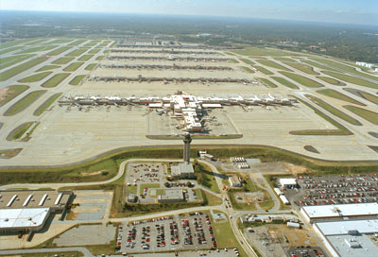
Burt Cohen, 404.853.6800

Project Value: $200K
SIN: 899-7

Lowe Engineers has been involved in a wide variety of projects at Hartsfield-Jackson Atlanta International Airport (HJAIA) working with Aviation Consulting Engineers (ACE) and the City of Atlanta. These projects have involved transitioning the airport into managing their data spatially. The final deliverables have been submitted in the industry standard GIS format (ESRI shape file). In addition to providing data, Lowe Engineers has given several presentations regarding their work to the DOA, ACE, and at the 2001 AAAE GIS Conference. Lowe Engineers also provided GIS training and continual support to airport personnel.

Lowe Engineers completed the following tasks on this complex infrastructure and database project:

- New Color and Black and White Aerial Photography. New photography was flown of approximately 10,000 acres to be used for conventional mapping on the stereoplotter as well as for use in the database preparation using ARC-Info.
- GPS Control Surveys. GPS surveys were performed to establish coordinates and elevations for multiple datums (airport grid, WGS84, ITRF). GPS RTK surveys were also performed on utilities and other infrastructure.
- MicroStation Mapping/GIS. To date, the database that Lowe created has more than 20,000 utility points, more than 40,000 GPS RTK infrastructure points, and more than 24,000 parcels with each parcel having the capability of 200 fields per parcel.
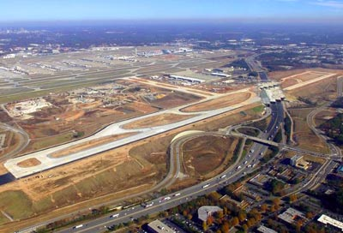
- Obstruction Mapping. Lowe Engineers updated HJAIA’s Air Obstruction Charts, and Plan and Profile Sheets using photogrammetric methods. The airport’s entire Air Obstruction surface, approximately 35,000 acres, was flown using 1"=800' black and white aerial photography. Additional photography was flown at 1"=333', which Lowe used to provide the 1"=50' base maps for HJAIA’s main property, was also used to update the Obstruction data. Aerial Triangulation of the photography and compilation of the Obstruction charts were performed using high order Zeiss P3 stereo plotters.
- Utilities Geographic Information System. Lowe Engineers has submitted a set of GIS-based utility files to ACE. A 1” = 50’ planametric base map of the entire airport was created using 1” = 333’ scale photography. Over 20,000 individual survey points were collected as part of the utility mapping effort. The data associated with these points was used in conjunction with existing maps to create themes for the following utilities: electric, FAA, fire, fuel, gas, sanitary, storm, telephone, and water.

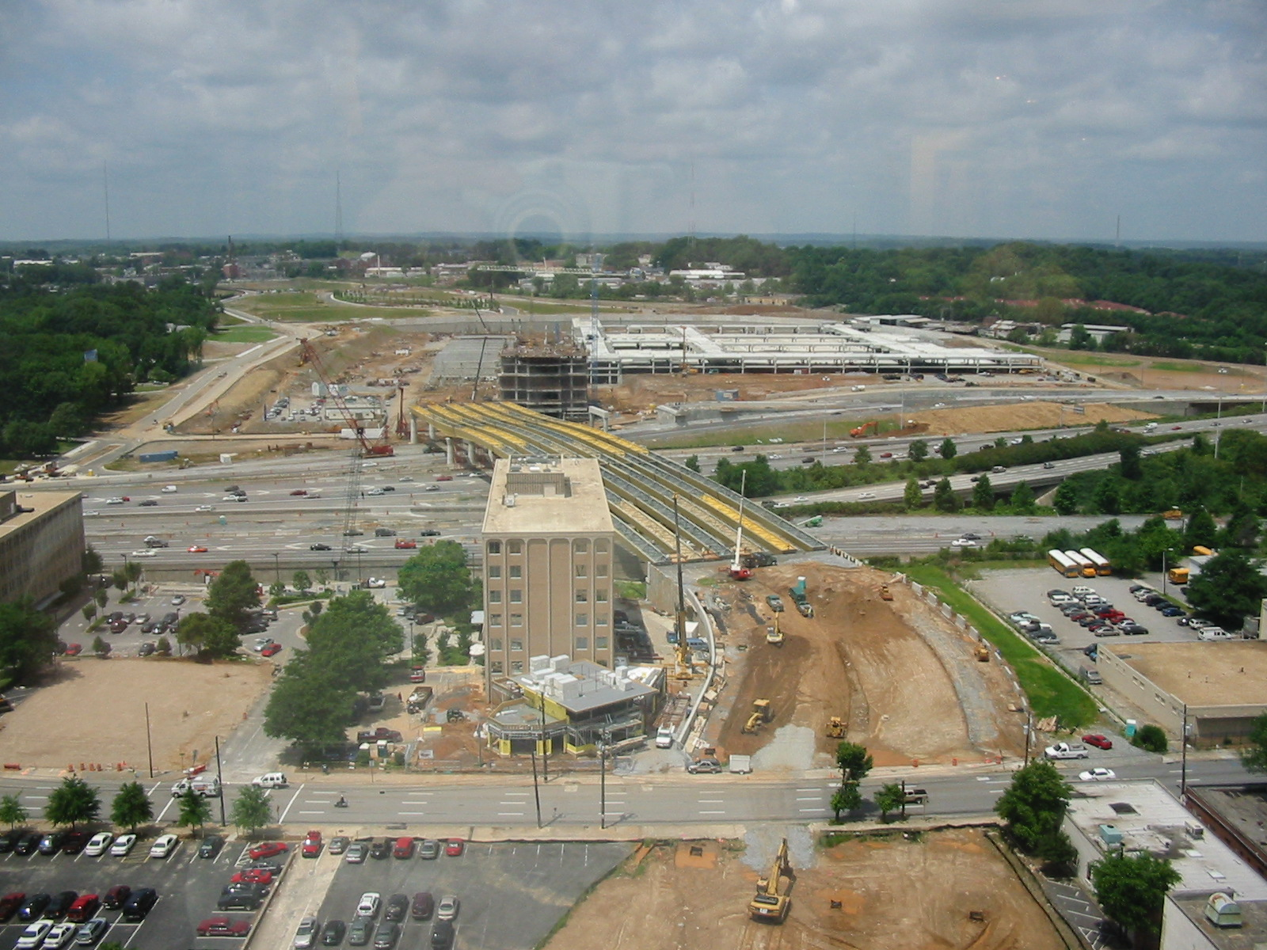
ATLANTIC STATION – Atlanta, GA
C.W. Matthews
Al Eckford, 770.442.4520

Project Value: $1M
SIN: 899-7

Lowe Engineers performed complete construction stakeout and data collection of existing conditions for this large 138-acre (hazardous site) development in downtown Atlanta, Georgia.

Tasks included the field location of old utilities and entering the existing field conditions into a GIS database. Projects also included the stakeout location of new improvements, utilities, and other infrastructure. Utilities locations included stormwater, sewer, gas, electrical, cable, fiber optic, telephone, and water. All of the existing data was merged with new improvements for a complete GIS database.
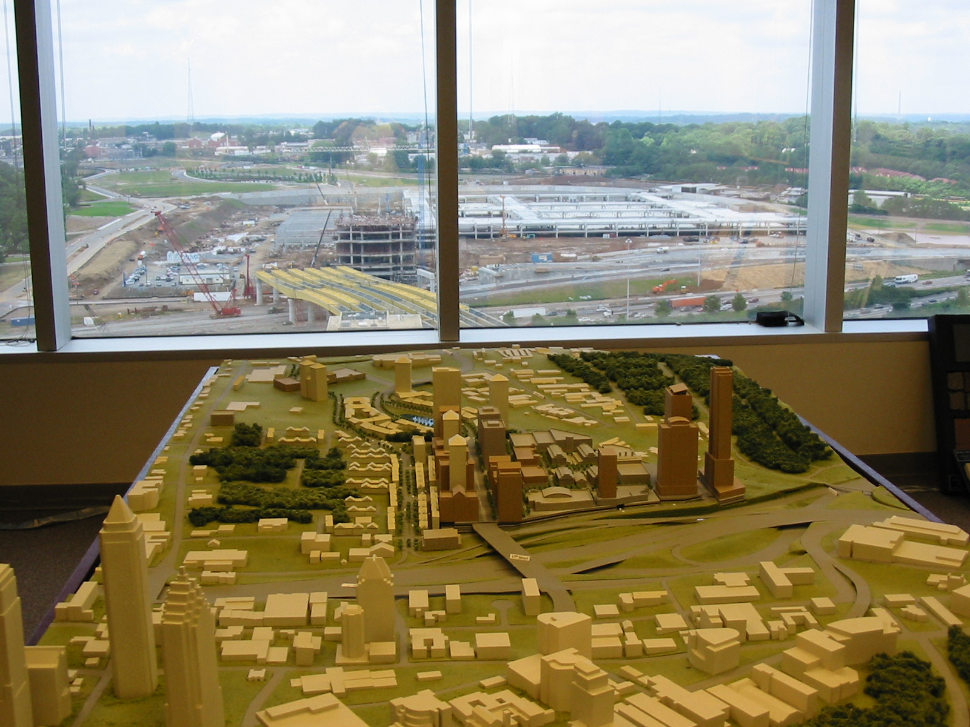
Because this site was constructed on a hazardous landfill, Lowe employees were subject to periodic medical monitoring. OSHA managed this job site. Our crews conducted safety tailgate strategy sessions before every new project.

GIS DATABASE NAME AND LOCATION FOR PAULDING COUNTY – Dallas, GA
Paulding County Government
Pat Westbrook, 770.505.1352

Project Value: $1.5M
SIN: 899-7

Paulding County is one of the fastest growing counties in the metropolitan Atlanta area. In order to keep up with the fast growth and large amount of development and infrastructure improvements, Paulding County selected Lowe Engineers to perform a complete Geographic Information System of the entire county. The project started in 2001 with the monumentation and GPS observation of more than 200 horizontal and vertical control points spread across the county. Aerial photography was used to prepare digital topographic data broken out by tiles, or map sections, starting on the last side of the county and working westerly.

Road intersections, utilities, and other infrastructure were located using photography. Field checks and data accuracy checks were performed using Pro XR GPS receivers and RTK methods.
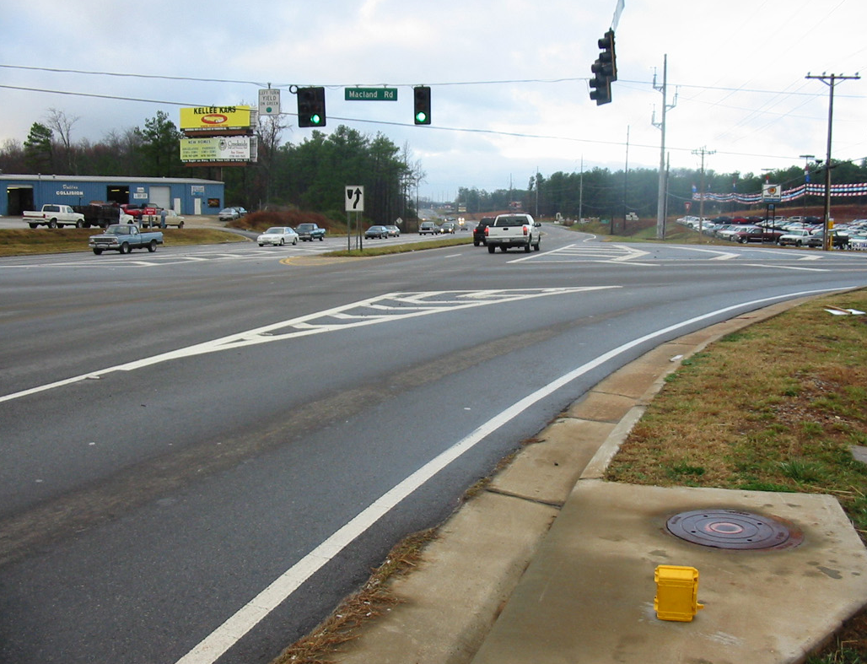
All data was prepared digitally in ARCVIEW and ARC GIS format. Additionally, all cadastral land records were cataloged and registered into the GIS. The county-wide GIS, GPS, and other digital data are currently being used by all sectors of the Paulding County Government.

The GIS database includes LIDAR topographic data, aerial mapping topographic data, field-located utility and infrastructure data, and other information to support all county government functions.

Labor Category & Rates

Labor Category  SIN 899-7 |  | On-Site | Off-Site | Exempt | Non-Exempt | GSA Hourly Rate ¹
Program Manager |  |  | ▲ | ▲ |  | $ 140.97
Senior Project Manager |  |  | ▲ | ▲ |  | $ 127.40
Project Manager |  |  | ▲ | ▲ |  | $ 102.90
Geodesist |  |  | ▲ | ▲ |  | $ 106.00
Survey Supervisor |  |  | ▲ | ▲ |  | $ 98.00
3-Person Survey Crew | Survey Crew Chief 2 |  | ▲ |  | ▲ | $121.52
3-Person Survey Crew | Instrument Operator 3 |  | ▲ |  | ▲ | $121.52
3-Person Survey Crew | Rod Worker ⁴ |  | ▲ |  | ▲ | $121.52
Survey Technician ⁵ |  |  | ▲ |  | ▲ | $ 56.84
Photogrammetrist |  |  | ▲ |  | ▲ | $ 78.40
Photogrammetric Technician 6 |  |  | ▲ |  | ▲ | $ 63.70
Cartographer ⁷ |  |  | ▲ |  | ▲ | $ 53.00
Geospatial Analyst |  |  | ▲ |  | ▲ | $ 76.32
Geospatial Technician |  |  | ▲ |  | ▲ | $ 55.12
Environmental Scientist |  |  | ▲ | ▲ |  | $ 127.40
Environmental Field Technician ⁸ |  |  | ▲ |  | ▲ | $ 63.70
Senior GIS Database Developer/Programmer |  |  | ▲ | ▲ |  | $ 88.20
Senior GIS Specialist |  |  | ▲ |  | ▲ | $ 79.50
GIS Specialist |  |  | ▲ |  | ▲ | $ 73.50
Clerical ⁹ |  |  | ▲ |  | ▲ | $ 44.10
Facility Security Officer |  |  | ▲ |  | ▲ | $ 79.50
¹ The 0.75% Industrial Funding Fee is incorporated into the GSA Hourly Rate.
² Wage Determination No. 1994-2133, REV. 28, Occupation Code 99658, Survey Party Chief
³ Wage Determination No. 1994-2133, REV. 28, Occupation Code 99659, Surveying Technician
⁴ Wage Determination No. 1994-2133, REV. 28, Occupation Code 99660, Surveying Aide
⁵ Wage Determination No. 1994-2133, REV. 28, Occupation Code 29083, Engineering Technician III
⁶ Wage Determination No. 1994-2133, REV. 28, Occupation Code 29084, Engineering Technician IV
⁷ Wage Determination No. 1994-2133, REV. 28, Occupation Code 29030, Cartographic Technician
⁸ Wage Determination No. 1994-2133, REV. 28, Occupation Code 29090, Environmental Technician
⁹ Wage Determination No. 1994-2133, REV. 28, Occupation Code 01313, Secretary III

Lowe Engineers is proposing an annual escalation fee of 4% over the course of the 20-year contract period. This 4% increase will be applied towards the cost of equipment and facility upgrades and maintenance, insurance costs, required certifications, payroll increases, and staff education and training. Constant staff education is required as different governmental agencies amend scientific and QA/QC methodologies and standards.

