PUBLIC NOTICE
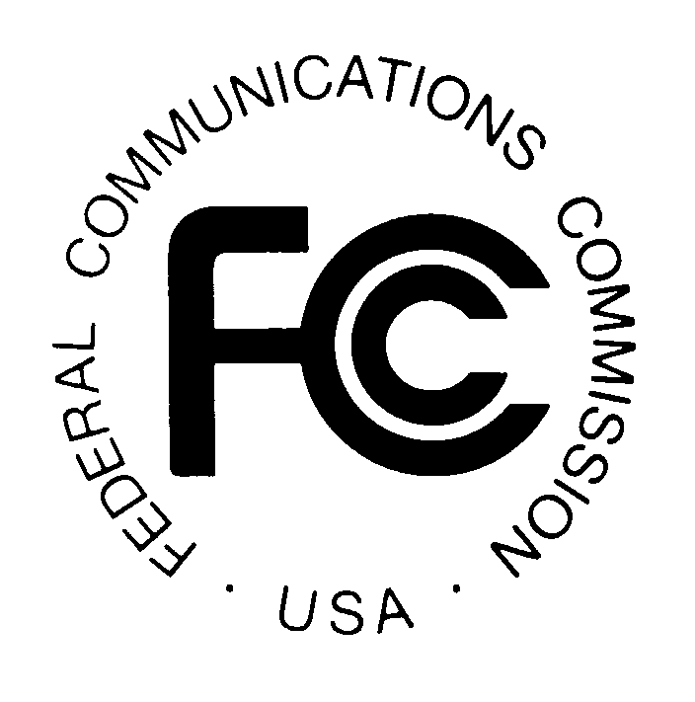
News media information 202 / 418-0500
Fax-On-Demand 202 / 418-2830
Internet: http://www.fcc.gov
TTY 202 / 418-2555

Federal Communications Commission
445 12th St., S.W.
Washington, D.C. 20554

DA 00-2688
Released: November 29, 2000

COMMENTS SOUGHT ON
PETITIONS FOR EMERGENCY RELIEF
REGARDING RELEASE OF THE 855 TOLL FREE CODE

CC DOCKET NO: 95-155

File No: NSD–L-00-249

Comments Due: December 13, 2000 Reply Comments Due: December 20, 2000

On November 9 and November 14, 2000, respectively, the Toll Free Number Coalition (TFNC) and The Toll Free Commerce Coalition (TTFCC) individually filed petitions for emergency relief seeking to defer the release of the new 855 toll free code, which was scheduled for November 18, 2000. The petitioners raised issues regarding whether deferral would ensure the fair, equitable, and orderly allocation of 855 toll-free numbers. They argued that the SMS/800 toll free number reservation process favors Responsible Organizations (RespOrgs) using Mechanized Generic Interface (MGI) and “locks out” other RespOrgs (using Graphical User Interface (GUI) and dial-up (3279) systems).

On November 17, 2000, the SMS/800 Management Team (SMT) and Database Management Services, Inc. (DSMI) jointly filed comments responding to the TFNC and TTFCC petitions. They stated that the SMS/800 Number Administration Committee (SNAC), which is comprised of RespOrgs and is part of the Alliance for Telecommunications Industry Solutions (ATIS), decided to move ahead with the release of the 855 code. They also stated that all RespOrgs had been invited to participate in a conference call on November 3, 2000, at which SNAC reached unanimous consensus that the lock-out problem did not recur in tests and enhancements of the number reservation system. SMT and DSMI also acknowledged that toll-free numbering resources are not in imminent danger of exhaustion and stated that they would accept a Commission decision to defer the 855 code roll out in order to permit further testing of the enhanced reservation system.

On November 17, 2000, therefore, DSMI was directed, by Commission staff letter, to postpone the release of the 855 code until further notice. The letter noted that toll-free numbers in the existing 800, 888, 877, and 866 codes will not be exhausted until the year 2002, based on the current reservation rate of available toll-free numbers, so that it appears that no pressing need exists for the immediate release of the 855 code. Without expressing any opinion about the merits of the petitions for emergency relief, the letter noted their existence and stated that the Commission staff would not be able to evaluate them before the scheduled release of the 855 code. Therefore, the letter directed DSMI to delay the release of the 855 code until the Commission has had the opportunity to review the issues raised in the petitions in greater detail.

The Commission now seeks the views of all interested parties on the issues raised in the emergency petitions as they relate to the release of the 855 toll-free code. The documents described above and all additional documents and comments received will be available for review and copying during regular business hours at the FCC Reference Center, Portals II, 445 12th Street, SW, Room CY-A257, Washington, DC 20554, (202) 418-0270. Petitions may also be viewed online at the FCC’s E-filing System located at http://gullfoss2.fcc.gov/cgi-bin/ws.exe/prod/ecfs/comsrch_v2.hts, by typing 95-155 in the Proceeding Block and clicking on Retrieve Document List. Comments responding to this Public Notice should refer to file number, NSD-L-00-249. Comments must be filed with the Commission by December 13, 2000 and Reply Comments by December 20, 2000, and sent to the Office of the Secretary, Federal Communications Commission, 445 12th Street, SW, Room TW-A325, Washington, DC 20554. Two copies of the comments should also be sent to Network Services Division, 445 12th Street, SW, Room 6-A207, Washington, DC 20554. The petitions and comments described above, and all additional comments that are received, will be available for review and copying during regular business hours at the FCC Reference Center, Portals II, 445 12th Street, SW, Room CY-A257, Washington, DC 20554, (202) 418-0270.

Comments may be filed using the Commission's Electronic Comment Filing System (ECFS) or by filing paper copies. Comments filed through the ECFS can be sent as an electronic file via the Internet to <http://www.fcc.gov/e-file/ecfs.html>. If using this method, please reference CC Docket No. 95-155 in the Proceeding block. Generally, only one copy of an electronic submission must be filed. In completing the transmittal screen, commenters should include their full name, postal service mailing address, and the applicable docket or rulemaking number. Parties may also submit an electronic comment by Internet e-mail. To get filing instructions for e-mail comments, commenters should send an e-mail to ecfs@fcc.gov, including "get form <your e-mail address>" in the body of the message. A sample form and directions will be sent in reply. After filing your comments electronically, please send an e-mail to Marty Schwimmer, mschwimm@fcc.gov, indicating that comments have been filed.

This is a "permit but disclose" proceeding for purposes of the Commission's ex parte rules. As a "permit but disclose" proceeding, ex parte presentations will be governed by the procedures set forth in Section 1.1206 of the Commission's rules applicable to such proceedings.

Parties making oral ex parte presentations are reminded that memoranda summarizing the presentation must contain a summary of the substance of the presentation and not merely a listing of the subjects discussed. More than a one or two sentence description of the views and arguments presented is generally required. Other rules pertaining to oral and written presentations are set forth in Section 1.1206(b) as well.

For further information, contact Marty Schwimmer, (202) 418-2320 (voice), mschwimm@fcc.gov, of the Network Services Division, Common Carrier Bureau. The TTY number is (202) 418-0484.

-FEDERAL COMMUNICATIONS COMMISSION-

Letter from L Charles Keller, Chief, Network Services Division, Common Carrier Bureau, to Mr. Michael Wade, President, Database Service Management, Inc., dated November 17, 2000.

