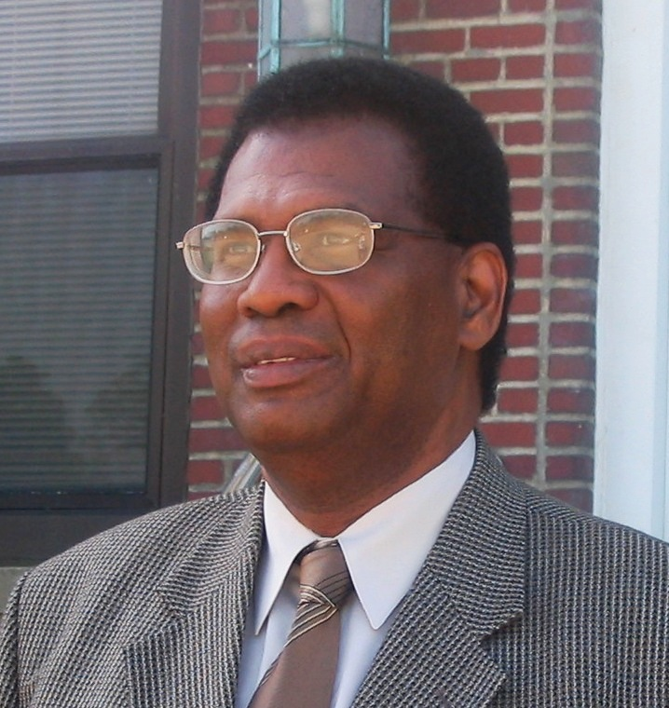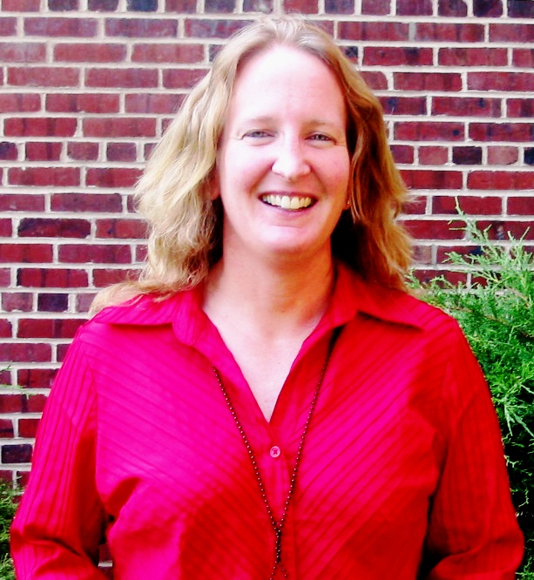
VA HUDSON VALLEY HEALTH CARE SYSTEM
OEF/OIF Program Staff
Castle Point Campus
Wavell Hodge, M.D.
OEF/OIF Program
Medical Director
(845) 831-2000 ext 5016
Wanda Robinson
HAS Benefits Coordinator (845) 831-2000 ext 5413
Juliana Laurenzi, LCSW-R
OEF/OIF Program Manager
(845) 831-2000 ext 4628
Cell (914) 943-8146
Debra L.B. Lucas
OEF/OIF Patient Advocate
(845) 831-2000 ext 4629
Cell: (914) 943-8489
Betsy Valentine, RN
OEF/OIF Case Manager
(845) 831-2000 ext 4616
Cell: (914) 447-0295
Frank Amoruso, LCSW-R
OEF/OIF Case Manager
(845) 831-2000 ext 4617
Cell: (914) 804-2426

