National Park Service  U.S. Department of the Interior | Lincoln Boyhood NM  Use the complete site name here (e.g. Palo Alto Battlefield Historic Site). |  | P.O. Box 1816  Lincoln City, IN 47552  812-937-4541 phone  812-937-9929 fax
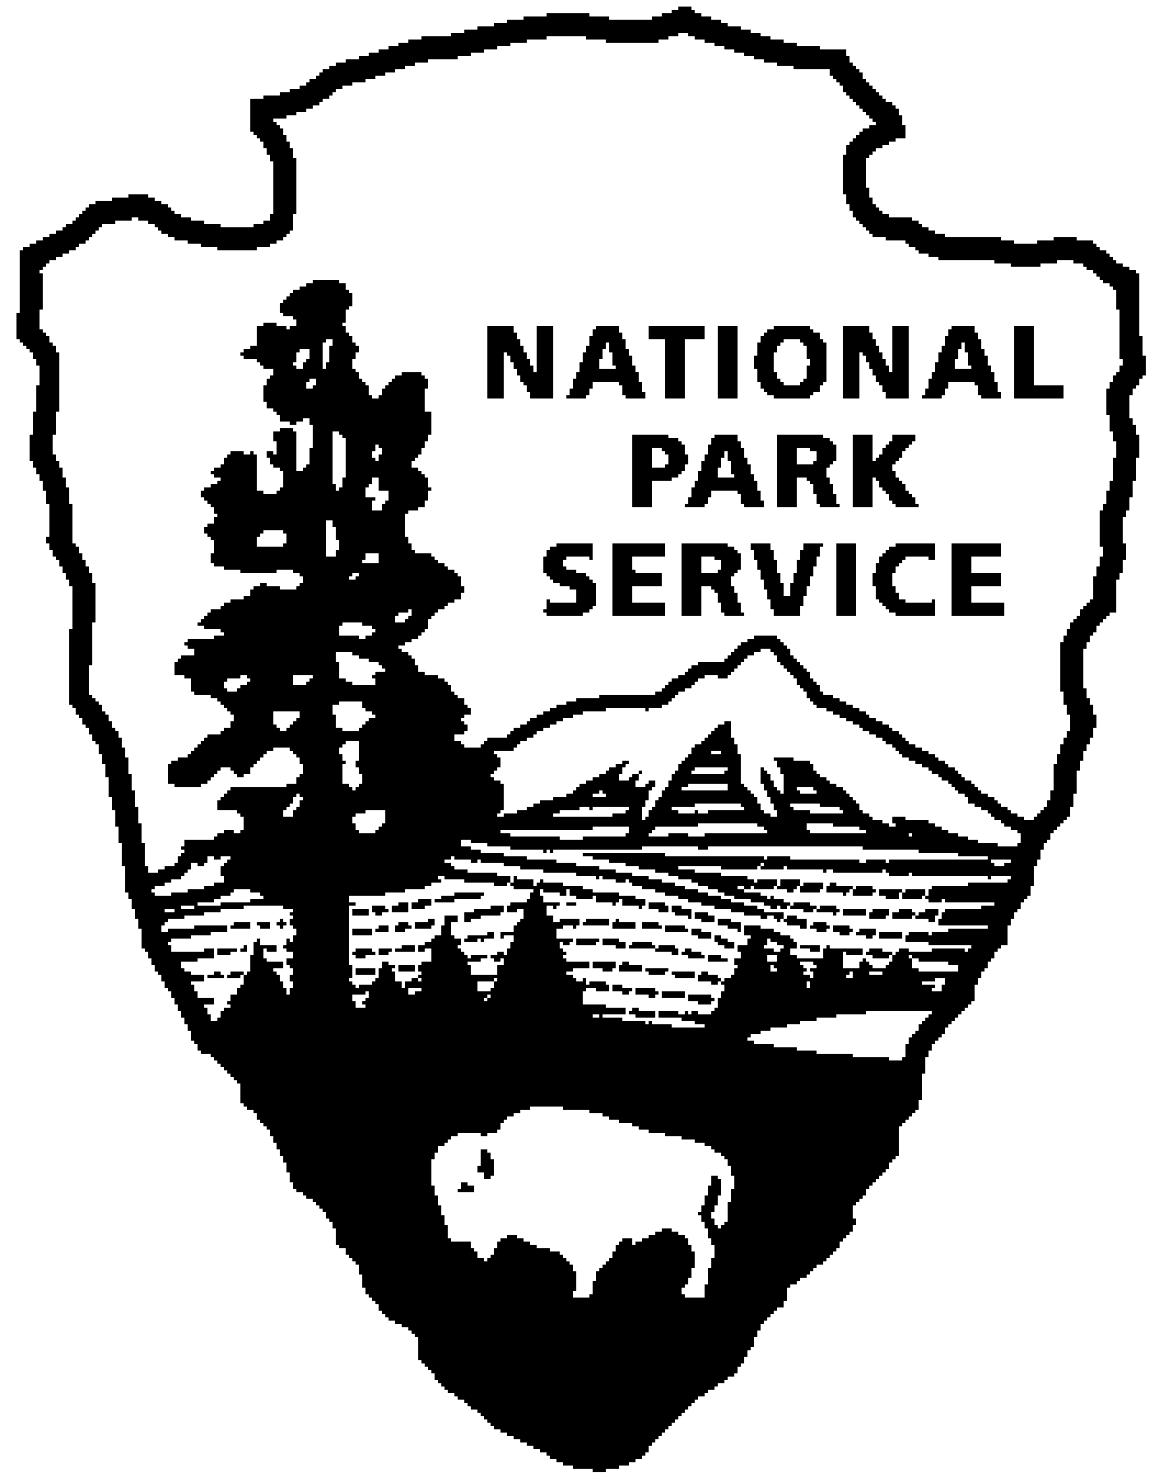
Lincoln Boyhood NM News Release
Use a “short-hand” version of the site name here (e.g. Palo Alto Battlefield not Palo Alto Battlefield National Historical Site).
January 10, 2008
For Immediate Release

Chief Justice to be Speaker at 2008 Lincoln Day Program

Frank J. Williams, Chief Justice of the Supreme Court of Rhode Island and one of the country's most renowned experts on Abraham Lincoln will be the featured speaker at the annual Lincoln Day program on Sunday, February 10, 2008. The program will begin at 2:00 p.m. (CST) and will be held in the Abraham Lincoln Hall of Lincoln Boyhood National Memorial, Lincoln City, Indiana.
Judge Williams is the author or editor of over thirteen books and has contributed chapters to several others and lectured on the subject throughout the country. At the same time, he has amassed an unsurpassed private library and archive that ranks among the nation's largest and finest Lincoln collections. In 2000, the Chief Justice was appointed to the United States Abraham Lincoln Bicentennial Commission created by Congress to plan events to commemorate the 200th birthday of Abraham Lincoln in 2009. Since 1996, Chief Justice Williams has served as founding Chairman of The Lincoln Forum, a national assembly of Lincoln and Civil War devotees. For 9 years, he served as President of the Abraham Lincoln Association and, for 14 years, as President of The Lincoln Group of Boston. He is currently at work on an annotated bibliography of all the Lincoln titles published since 1865. His book of essays, Judging Lincoln, was published by Southern Illinois University Press in 2002. He also serves as Literary Editor of the Lincoln Herald where his quarterly “Lincolniana” survey appears.

The 2008 Lincoln Day program will include presentation of the colors by the Sons of Union Veterans of the Civil War, choral music and other ceremonial activities to honor the memory of Abraham Lincoln and his family.

Following the indoor program, the traditional pilgrimage to the gravesite of Nancy Hanks Lincoln for a wreath laying ceremony will be held. All are invited to a reception in the Memorial Visitor Center at the conclusion of the program. The park entrance fee will be waived for this special event.

Lincoln Boyhood National Memorial preserves the Indiana farm where Abraham Lincoln lived for 14 years -- from 1816 to 1830, and the site where his mother, Nancy Hanks Lincoln, is buried. The Memorial is located eight miles south of Interstate 64 on Indiana Highway 162, adjacent to Lincoln State Park.

For more information, please contact the park office at 812-937-4541.

