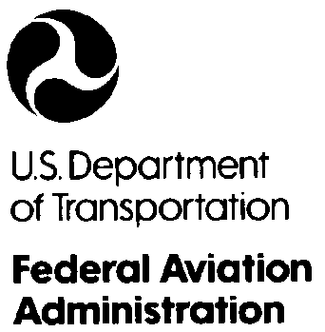 |  | Federal Aviation Administration  North Florida Flight Standards District Office-15  5950 Hazeltine National Drive  Citadel International, Suite 500  Orlando, Florida 32822  (407)812-7700 Facsimile: (407) 812-7710

!ALERT! - "I.A. RENEWAL CHANGES" - !ALERT!

December 10, 2008

To: All Inspection Authorization (IA) Holders

Dear IA Holder:

This letter is to inform you of the changes to the eligibility requirements and to announce the upcoming IA Renewal Meetings. This year the FAA will not be conducting an approved 8-hour Refresher Course in Lakeland. However, we will continue with the convenient regional renewal meetings throughout our district. Enclosed is a sheet providing a list of all the renewal meetings scheduled and there locations. Please remember these meetings are for renewal only and do not apply towards the approved training requirements.

Prior to renewing this year, we ask that you review the CHANGES to the eligibility requirements of the following regulations:

If your renewal eligibility is based on the completion of one of the activities listed in 14 CFR PART 65.93(a)(1) through (3) for each year in the two year period as required, then:
- Complete your application in IACRA. (See enclosed reference instructions) and
- Schedule an appointment at our office or
- Attend one of the renewal meetings.

If your renewal eligibility is based on attending and successfully completing an FAA approved 8-hour minimum refresher course, as required by 14 CFR PART 65.93(a)(4) for each year of the two year period, then:
1. Complete your application in IACRA. (See enclosed reference instructions) and
2. Schedule an appointment at our office or
3. Attend one of the renewal meetings.

NOTE: Bring the training certificates for each year to the renewal meeting or to the scheduled office appointment.

If you can not meet the renewal eligibility requirements listed above for each year in the two year period, then:
- You will have to pass an oral test administered by an FAA inspector as required by 14 CFR PART 65.93(a)(5).
NOTE: The oral test will only be administered by FAA inspectors at the following two locations and by appointment only:
- North Florida FSDO-15 (Orlando location) 407-812-7700
- North Florida FSDO-15 (Tampa location) 813-287-4900

"Please call immediately to schedule your appointment.
Oral testing will start in February 2009"
________________________________________________________________________________

!ALERT! - "I.A. RENEWAL CHANGES" - !ALERT!
!ALERT! - "I.A. RENEWAL CHANGES" - !ALERT!
__________________________________________________________________________________

These oral tests are scheduled on a first come first serve basis. We will not conduct oral tests at the renewal sites. All eligibility requirements are due prior to renewal but no later than of March 31, 2009.

The enclosed sheet with Subject: Inspection Authorization Renewal Locations is provided so that you may utilize a facility that is closest to you for renewal, but only if your renewal eligibility is based on the completion of one of the activities listed in 14 CFR PART 65.93(a)(1) through (3) for each year, of the two year period or if your renewal eligibility is based on attending and successfully completing an FAA Approved 8-hour minimum refresher course, as required by 14 CFR PART 65.93(a)(4), for each year in the two year period.

If you fail to renew by March 31, 2009 and wish to exercise the privileges of an IA, after this date, you will be required to re-apply for this authorization in accordance with 14 CFR Part 65.91.

Should you have any questions, please feel free to contact the Airworthiness Duty Inspector, Monday to Friday, between 8:00 am to 4:30 pm, at our Orlando Office at 407-812-7700 or at our Tampa Office at 813-287-4900.

Sincerely,

Diana Frohn
Manager
North Florida FSDO-15

Enclosure: Inspection Authorization Renewal Location Letter
IA Refresher Course Options Letter
Activity Worksheet
IACRA Procedures

!ALERT! - "I.A. RENEWAL CHANGES" - !ALERT!

