U.S. Department of Education September 2003

2003-2004

No Child Left Behind –

Blue Ribbon Schools Program



- Part I – Eligibility Certification …………………………….2 - 3
- Part II – Demographic Data .4
- Part III – Summary…………………………………………….. 7
- Part IV – Indicators of Academic Success 8
- Part V – Curriculum and Instruction 10
- Part VII – Assessment Results 13

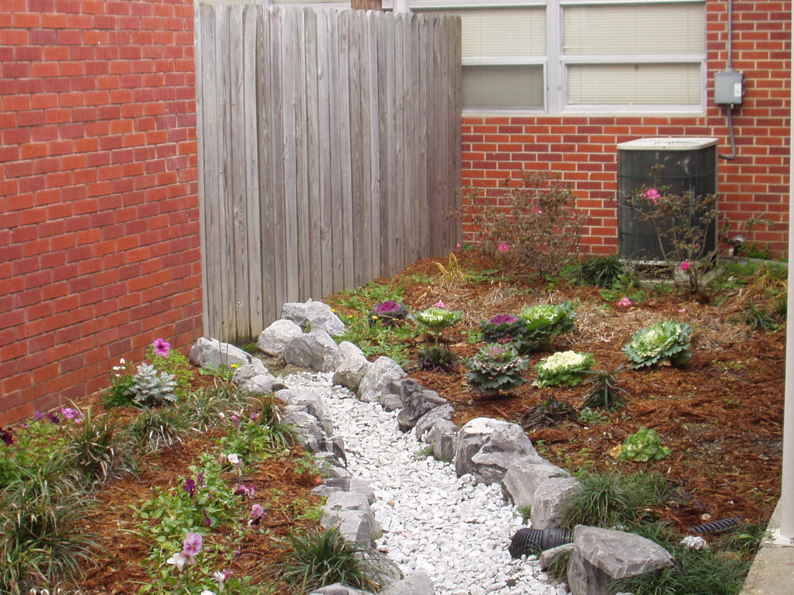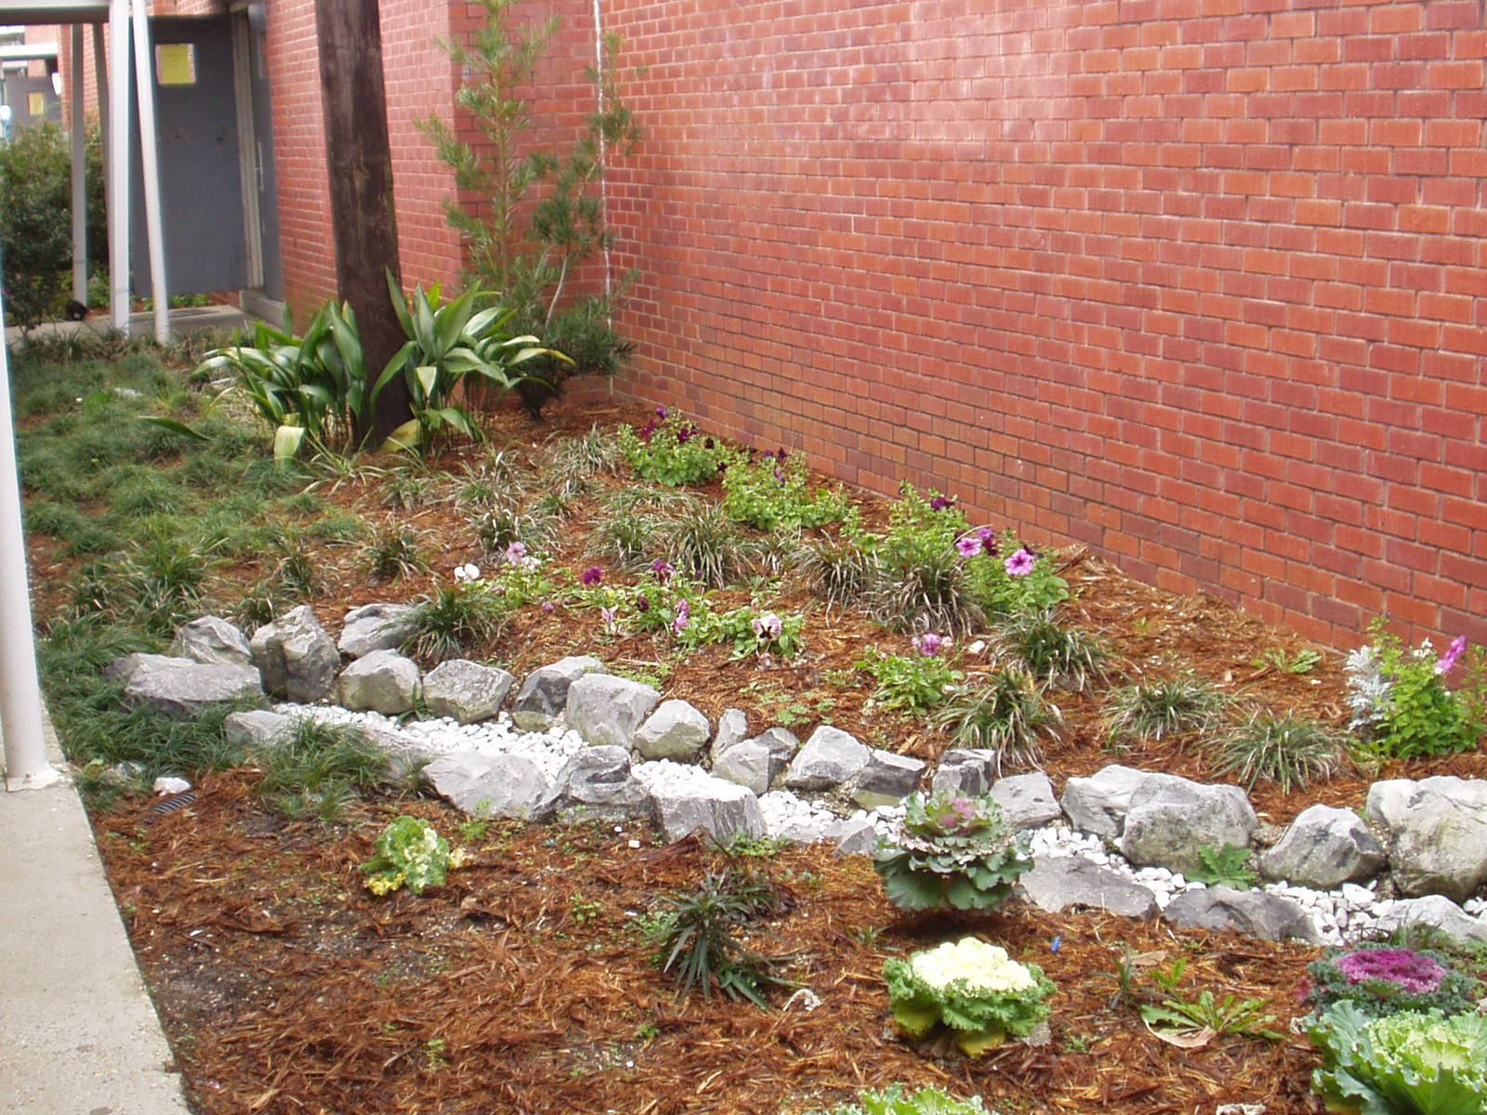
OMB Control Number: 1860-0745
Expiration Date: November 30, 2005
U.S. Department of Education September 2003

2003-2004 No Child Left Behind—Blue Ribbon Schools Program
Cover Sheet

Name of Principal Dr. Joseph White

Official School Name Pearl River Central Junior High School

School Mailing Address 7391 Highway 11 __________________________

(If address is P.O. Box, also include street address)

Carriere, Mississippi__________39426-7577____________

City State Zip Code+4 (9 digits total)

Tel. ( 601 ) 798-5654 Fax ( 601 ) 798-2822

Website/URL www.datastar.net/users/prck12 E-mail jwhite@prchs.k12.ms.us

I have reviewed the information in this application, including the eligibility requirements on page 2, and certify that to the best of my knowledge all information is accurate.

Date____________________________
(Principal’s Signature)

Name of Superintendent* Mr. Dennis Penton

District Name Pearl River County School District Tel. ( 601 )798-7744

I have reviewed the information in this application, including the eligibility requirements on page 2, and certify that to the best of my knowledge it is accurate.

Date____________________________ (Superintendent’s Signature)

Name of School Board Mrs. Michelle Boyd
President/Chairperson

I have reviewed the information in this package, including the eligibility requirements on page 2, and certify that to the best of my knowledge it is accurate.

Date____________________________
(School Board President’s/Chairperson’s Signature)

*Private Schools: If the information requested is not applicable, write N/A in the space.

PART I - ELIGIBILITY CERTIFICATION

[Include this page in the school’s application as page 2.]

The signatures on the first page of this application certify that each of the statements below concerning the school's eligibility and compliance with U.S. Department of Education, Office of Civil Rights (OCR) requirements is true and correct.

- The school has some configuration that includes grades K-12. (Schools with one principal, even K-12 schools, must apply as an entire school.)
- The school has not been in school improvement status or been identified by the state as "persistently dangerous" within the last two years. To meet final eligibility, the school must meet the state’s adequate yearly progress requirement in the 2003-2004 school year.
- If the school includes grades 7 or higher, it has foreign language as a part of its core curriculum.
- The school has been in existence for five full years, that is, from at least September 1998.
- The nominated school or district is not refusing the OCR access to information necessary to investigate a civil rights complaint or to conduct a district-wide compliance review.
- The OCR has not issued a violation letter of findings to the school district concluding that the nominated school or the district as a whole has violated one or more of the civil rights statutes. A violation letter of findings will not be considered outstanding if the OCR has accepted a corrective action plan from the district to remedy the violation.
- The U.S. Department of Justice does not have a pending suit alleging that the nominated school, or the school district as a whole, has violated one or more of the civil rights statutes or the Constitution's equal protection clause.
- There are no findings of violations of the Individuals with Disabilities Education Act in a U.S. Department of Education monitoring report that apply to the school or school district in question; or if there are such findings, the state or district has corrected, or agreed to correct, the findings.
PART II - DEMOGRAPHIC DATA

All data are the most recent year available.

DISTRICT (Questions 1-2 not applicable to private schools)

1. Number of schools in the district: ___1_ Elementary schools
_____ Middle schools
___1_ Junior high schools
___1_ High schools
____ Other (Briefly explain)

___3_ TOTAL

2. District Per Pupil Expenditure: _$ 3,711.36___

Average State Per Pupil Expenditure: _$ 3,664.93___

SCHOOL (To be completed by all schools)

3. Category that best describes the area where the school is located:

[ ] Urban or large central city
[ ] Suburban school with characteristics typical of an urban area
[ ] Suburban
[ ] Small city or town in a rural area
[ X] Rural

4. __9___ Number of years the principal has been in her/his position at this school.

If fewer than three years, how long was the previous principal at this school?

5. Number of students enrolled at each grade level or its equivalent in applying school:

Grade | # of Males | # of Females |  | Grade Total |  | Grade | # of Males | # of Females | Grade Total
K |  |  |  |  |  | 7 | 144 | 116 | 260
1 |  |  |  |  |  | 8 | 114 | 121 | 235
2 |  |  |  |  |  | 9
3 |  |  |  |  |  | 10
4 |  |  |  |  |  | 11
5 |  |  |  |  |  | 12
6 |  |  |  |  |  | Other
 |  |  | TOTAL STUDENTS IN THE APPLYING SCHOOL → |  |  |  |  |  | 495
6. Racial/ethnic composition of 95 % White
the students in the school: 4 % Black or African American
.1 % Hispanic or Latino
.5 % Asian/Pacific Islander
.4 % American Indian/Alaskan Native
100% Total

7. Student turnover, or mobility rate, during the past year: ____32__%

(This rate includes the total number of students who transferred to or from different schools between October 1 and the end of the school year, divided by the total number of students in the school as of October 1, multiplied by 100.)

(1) | Number of students who transferred to the school after October 1 until the end of the year. | 87
(2) | Number of students who transferred from the school after October 1 until the end of the year. | 63
(3) | Subtotal of all transferred students [sum of rows (1) and (2)] | 150
(4) | Total number of students in the school as of October 1 | 464
(5) | Subtotal in row (3) divided by total in row (4) | .32
(6) | Amount in row (5) multiplied by 100 | 32

8. Limited English Proficient students in the school: ___0____%
___0____Total Number Limited English Proficient
Number of languages represented: ________
Specify languages:

9. Students eligible for free/reduced-priced meals: ___62.6___%

____310___Total Number Students Who Qualify

If this method does not produce a reasonably accurate estimate of the percentage of students from low-income families or the school does not participate in the federally-supported lunch program, specify a more accurate estimate, tell why the school chose it, and explain how it arrived at this estimate.

10. Students receiving special education services: ___6___%
__32___Total Number of Students Served

Indicate below the number of students with disabilities according to conditions designated in the Individuals with Disabilities Education Act.

__0_Autism __0__Orthopedic Impairment
__0_Deafness __5__Other Health Impaired
__0_Deaf-Blindness _21 _Specific Learning Disability
__0_Hearing Impairment __1 _Speech or Language Impairment
__5_Mental Retardation __0 _Traumatic Brain Injury
__0_Multiple Disabilities __0__Visual Impairment Including Blindness

- Indicate number of full-time and part-time staff members in each of the categories below:

Number of Staff

Full-time Part-Time

Administrator(s) ____ 2__ _____0___
Classroom teachers ____23__ _____3___

Special resource teachers/specialists _____2__ _____2___

Paraprofessionals _____5__ _____0___
Support staff _____2__ _____1___

Total number ____34__ _____6___

12. Average school student-“classroom teacher” ratio: ___22____

13. Show the attendance patterns of teachers and students as a percentage. The student dropout rate is defined by the state. The student drop-off rate is the difference between the number of entering students and the number of exiting students from the same cohort. (From the same cohort, subtract the number of exiting students from the number of entering students; divide that number by the number of entering students; multiply by 100 to get the percentage drop-off rate.) Briefly explain in 100 words or fewer any major discrepancy between the dropout rate and the drop-off rate. (Only middle and high schools need to supply dropout rates and only high schools need to supply drop-off rates.)

 | 2002-2003 | 2001-2002 | 2000-2001 | 1999-2000 | 1998-1999
Daily student attendance | 93 % | 93 % | 91 % | 91 % | 92.2
Daily teacher attendance | 82 % | 75 % | 87 % | 90 % | 78 %
Teacher turnover rate | 15.6 % | 11 % | 18.5 % | 21.4 % | 12.5 %
Student dropout rate | .05% | .07 % | 1 % | 2 % | 2.1 %

14. (High Schools Only) Show what the students who graduated in Spring 2003 are doing as of September 2003.
N/A

Graduating class size | _____
Enrolled in a 4-year college or university | _____%
Enrolled in a community college | _____%
Enrolled in vocational training | _____%
Found employment | _____%
Military service | _____%
Other (travel, staying home, etc.) | _____%
Unknown | _____%
Total | 100 %

PART III - SUMMARY

Pearl River Central Junior High School is one of three schools that comprise the Pearl River County School District. The Pearl River Central Junior High School is located on the same campus with the high school. The two schools share the gym facilities and the cafeteria. The mission statement for the Pearl River County School District plays an important role in guiding the focus of our school.
A Partnership for the Future - PRC Moving Forward With Students: Recognizing that quality public education is essential to a progressive community, the Pearl River County School District is committed to excellence by providing a broad range of challenging educational experiences through a partnership with supportive parents and community members, enabling each student to become a confident, self-directed, life-long learner.
Pearl River County School District serves approximately 2800 students in grades K-12. Located in Pearl River County, the district is within close proximity to Stennis Space Center, the Mississippi Gulf Coast and New Orleans, Louisiana. All students are transported by bus from this rural bedroom community. Most parents of the students commute forty-five to sixty-five miles to work outside the county. This school district is one of the fastest growing districts in the state of Mississippi. The unemployment rate for Pearl River County is 3.4 % which is slightly below the state average of 4.6 %. The National unemployment rate is 5.6 % according to the November 2003 report.
Pearl River Central Junior High School is home to approximately 500 students in grades 7-8. A highly qualified staff includes two principals, one certified counselor, one certified librarian, twenty-five certified teachers, and seven teacher assistants. French, Spanish, Chorus, Band, and Art are shared cooperatively by the junior high and high school since both schools reside on the same campus. Three certified teachers on the junior high staff hold National Board Certification. All teachers have met the highly qualified status in the subject area that they teach. Current free/reduced lunch status indicates that approximately 62.6% of junior high students receive free or reduced lunch. Title I school-wide funding assists with professional development opportunities, supplies and remediation services for all students.
Statewide test results for the 2001-2002 school term yielded the junior high school a level 4 accreditation rating, up from a level 3 during the 2000-2001 school term. Test results from the 2002-2003 school term yielded the junior high school a more prestigious rating of level 5. On a scale of 1-5, level 5 is the highest accreditation rating awarded by the Mississippi Department of Education to any particular school throughout the State of Mississippi. In addition to rating a level 5, Pearl River Central Junior High School also exceeded Adequate Yearly Progress (AYP) in Reading/Language, Math, and other indicators.

PART IV – INDICATORS OF ACADEMIC SUCCESS

According to results from the Mississippi Curriculum Test (MCT) for the 2001-2002 and 2002-2003 school terms, students attending Pearl River Central Junior High School showed dramatic levels of improvement in their overall academic performance. The table below indicates that positive improvement took place in Reading, Language and Math for grades 7 and 8 in curriculum and instruction. In reviewing the data in the table below, it is important to note the overall marked level of positive improvement in each grade over a five-year period between the 1998-1999 and 2002-2003 school terms. Columns two and three indicate 7th and 8th grade students’ subject area score means resulting from the Terra Nova Test. The Terra Nova Test is a nationally norm-referenced test. Columns five, six and seven indicate 7th and 8th grade students’ subject area score means resulting from the Mississippi Curriculum Test (MCT). The numbers shown in red indicate the significant positive levels of improvement that occurred in Reading, Language and Math for grades 7 and 8. The numbers shown in blue indicate a brief decline of scores that occurred in Reading for grades 7 and 8 during the first two years of the comparison.
The table also indicates that the greatest areas of improvement were noted in 7th grade Language and 8th grade Math. However, the students in grade 7 in 2002 improved by 15.3 points in grade 8 reading 2003 and 17 points in language in 2003 in the 8th grade. The greatest improvement for the same students was in math. The 7th grade math students in 2002 scored 576.5, and in 2003 in grade 8 the same students scored 608.4 which is an improvement of 21.9 points. This chart indicates not only an improvement in curriculum and instruction but also an improvement in student achievement. In the 2002-2003 school year there were 82 % of the students in grade 7 who scored proficient and above on the Mississippi Curriculum Assessment in reading, 69.1 % in language, and 71.6 % scored proficient and above in Math. The same year, 76 % of the students in grade 8 scored proficient and above in reading. 70.4 % of the students scored proficient and above in language, and 72.2 % of the students scored proficient and above in math. These were all increases over the preceding school year.

Five-year Comparison of Pearl River Central Junior High School’s Test Score Means
 | PRC  98/99  Terra Nova Score Means | PRC  99/00  Terra Nova  Score Means | +/-  Improvement | PRC  00/01  MCT  Score Means | PRC  01/02  MCT  Score Means | PRC  02/03  MCT  Score Means | +/-  Improvement
7th Grade
Reading | 50.4 | 47.7 | -2.7 | 534.8 | 557.0 | 565.9 | +31.1
Language | 48.0 | 49.1 | +1.1 | 534.2 | 555.2 | 570.9 | +36.7
Math | 43.9 | 46.2 | +2.3 | 551.3 | 576.5 | 583.0 | +31.7
********* | ***** | ***** |  | ***** | ***** | ***** | **********
8th Grade
Reading | 57.2 | 54.4 | -2.8 | 560.3 | 561.1 | 572.3 | +12.0
Language | 51.5 | 56.7 | +5.2 | 559.5 | 559.5 | 572.2 | +12.7
Math | 46.3 | 52.0 | +5.7 | 581.8 | 588.9 | 608.4 | +26.6

Pearl River Central Junior High School follows the Mississippi curriculum framework in all subject areas. Each framework across the curriculum has been enhanced by adding objectives specifically related to the Mississippi Curriculum Test (MCT) and State Writing Assessment. The school utilizes two teacher teams to monitor student progress: departmental and grade level teams. Teachers within the same subject area are scheduled to meet as a departmental team twice per month to discuss progress and/or problems related to the specific subject taught. Each grade level’s chairperson meets at least once per month with other teachers on the 7th and 8th grade team. Each team provides the principal with a written copy of each meeting’s minutes.
Teachers within the same subject areas of grades 7 and 8 work together to maintain consistency in lesson planning as they progress through the curriculum framework. The faculty and staff work diligently to maintain a positive learning environment while consistently promoting fair and impartial student discipline in their respective classrooms. Students refusing to complete classroom assignments are scheduled to attend Grade Improvement Detention (GID) during their break time. In GID, students are required to make-up all incomplete work assignments or be reassigned for another day. In-School Suspension (ISS) is assigned when students fail to maintain positive behavior while in the classroom. When a student receives an ISS referral, they must complete the same or similar work assignments that are normally encountered in the regular classroom. The ISS room is equipped with computers, encyclopedias, dictionaries and various textbooks to accommodate students’ needs. A full-time ISS manager monitors the students and assists them with classroom work assignments as necessary.
One lab equipped with thirty computers offers a variety of instructional software to target specific student needs through a hands-on approach. A full time computer lab manager is employed to provide specific remediation to students in deficient academic areas. Students scoring below proficient on the Mississippi Curriculum Test (MCT) receive tutoring services during the school day in the lab. In an ongoing effort to preserve academic class time, students are scheduled to attend tutoring twice weekly during their elective class period only. The lab manager maintains a daily log of events, detailing the names of each student and the services rendered. A second tutoring lab was implemented at the beginning of the 2003-2004 school term and is maintained by a part-time retired certified teacher. This lab is designed to assist students with deficiencies in language arts, primarily those who scored below proficient on the MCT or State Writing Assessment. Managers of both labs maintain copies of student state level achievement scores and current work samples. After-school tutoring is also available for students who desire remediation in a particular academic subject.

Teachers maintain a healthy partnership with parents and/or guardians by keeping them informed about their child’s educational progress. E-mail, telephone calls, letters, schoolnotes.com website, junior high school website and parent/teacher conferences are just a few examples of how teachers routinely communicate with each student’s parent/guardian. The school sponsors a newsletter to highlight a variety of student works, projects, sports, announcements and current activities. Local businesses are invited to purchase advertisements for publication in each issue. The newsletter is distributed bi-weekly to all faculty, staff, students and parents. Parents receive student progress reports from each teacher every four and one-half weeks and report cards every nine weeks. Open house is scheduled once per semester and provides parents with an opportunity to view their child’s projects and work samples, as well as speak one-on-one with teachers concerning academic progress.
The local news media play an important role in helping to maintain positive school/community support. The Picayune Item newspaper frequently prints articles highlighting student accomplishments such as honor roll, sports highlights and announcements of school related activities. A junior high school student is appointed to provide the newspaper with a weekly article. WRJW radio station provides a block of time each month to interview local school principals. Each principal is invited to share comments and success stories about their school and community. An experienced radio station personality conducts the interview and provides informed feedback throughout the broadcast.

The Pearl River Central Junior High teachers will conduct in-service training for other school districts who desire to improve student achievement. These teachers have worked as a team to develop curriculum and teaching strategies that enhance the state objectives and improve student performance. The junior high teachers have been instrumental in curriculum alignment for the elementary and high school language arts and mathematics programs. On-site visits will be welcomed by the administration and faculty for school districts that wish to visit the school. The teachers are role models for student teachers and educational students from universities who desire to improve their teaching abilities. All teachers have email addresses that are available on the school district’s website.

PART V – CURRICULUM AND INSTRUCTION

In an ongoing effort to improve student achievement across the curriculum, teachers have consistently utilized school-wide programs such as Thinking Maps, Accelerated Reader (AR), Life Skills and Mississippi MCT Coach workbooks. Thinking Maps incorporate eight different organizational templates that assist students in organizing their thoughts into more effective and meaningful paragraphs. The Accelerated Reader program offers students hands-on practice in developing effective reading skills and improved levels of reading comprehension. Accelerated Reader is an individualized program that supplements the curriculum in students’ regular reading class. From an approved reading list, students may select the book of their choice at or near their reading level. Once the book is completed, the student demonstrates mastery in reading comprehension by completing a computer-based test. The librarian assists the teachers and students in the Accelerated Reading Program. The library is equipped with computers and Internet access to meet students’ needs. Over the past three years, the librarian has been instrumental in the increase of book circulation at the junior high by 75 %. The school’s librarian is responsible for administering all AR tests. Following the tests, the librarian provides a detailed statistical report to each student, teacher and the principal. Students receive varied AR awards for participation and achievement in the program. Phase I of the Life Skills program was implemented during the 2002-2003 school term, and is taught once per week to 7th grade students. Phase II will be implemented during the 2003-2004 school term and will include instructional lessons for 8th grade students. The program teaches students responsibility, self-control and self respect. Students learn how to develop goals and resolve daily conflicts that can influence how they function within society. The program helps to impact student behavior and improve academic achievement. Mississippi MCT Coach is a workbook used by all academic teachers to provide students with hands-on practice in a variety of lesson formats. The lessons help students to improve their test-taking skills in preparation for the Mississippi Curriculum Test (MCT). Each lesson throughout the workbook includes tips and strategies for improving knowledge in subject areas such as Reading, Language Arts and Math.
Other successful school-wide procedures include daily bell-ringers and writing assignments across the curriculum. Students begin each new class period with a different bell-ringer assignment. Teachers post a bell-ringer assignment related to the lesson on the board to keep students on task while performing roll call and other clerical duties. Weekly writing assignments are carefully selected and incorporated to compliment each classroom’s curriculum framework, including elective areas such as Physical Education. Each assignment provides students with opportunities for hands-on practice and feedback from their teachers and their peers. Foreign Languages (Spanish and French) are taught by the high school teachers and their seniors to students in language arts classes for a nine week period. Under the supervision of the high school French or Spanish teacher, the students conduct foreign language classes for the junior high students. Beginning next school year, the students will select one foreign language course for each semester. Art, Chorus, and Band are taught by high school teachers. Students choose one of these classes as an elective. Science classes use hand-on activities and stress the scientific inquiry process. Social Studies classes stress geographical locations and current events along with the state objectives. Students compete in numerous essay contests throughout the school year that involve a number of different topics.

The foundation of the language arts curriculum utilized by Pearl River Central Junior High School is based on the curriculum framework provided by the Mississippi Department of Education. In addition to the state’s framework, the school works diligently to enhance its site-based curriculum to include objectives that will target the specific learning needs of all students served in the community. The textbook selected for seventh and eighth grade language arts classes is titled Writer’s Choice by Glencoe/McGraw and includes interactive CD-ROMs filled with lesson plans and activities. An additional resource book utilized by teachers includes a classroom set of Mississippi MCT Reading and Language Arts Coach by Educational Design. Teachers often incorporate a variety of skill building activities into the classroom instruction. Activities such as Thinking Maps assist students with organizing their ideas into more complete and effective writing compositions. Students compose written entries in their classroom journal based on different topics which change on a daily basis.
Students are encouraged to improve their reading skills with opportunities to read both silently and aloud during most academic class periods. The language arts curriculum at the school level includes objectives which encourage all students to actively participate in the Accelerated Reader program to improve reading skills. The program is designed to evaluate each students reading level as they progress through successive assignments. In addition, the school provides all students with twenty minutes of free reading time at the end of each day. Students occasionally participate in activities that involve role-playing to act out stories that are covered in class. In the process of reading aloud, teachers are often able to document noticeable learning deficiencies. Depending on the severity of each child’s learning deficiency, teachers are usually confident in helping to prescribe an immediate remedial course of action. Remedial action often includes referring students to the school’s tutoring program. Students can be referred to in-school and/or after school tutoring to receive one-on-one and small group attention.

The math curriculum utilized by Pearl River Central Junior High School is based on the curriculum framework provided by the Mississippi Department of Education. The schools’ site-based curriculum was enhanced through a process of curriculum renewal to include more hands-on opportunities for students. The textbook selected for seventh and eighth grade math classes is titled New Progress in Math by Sadlier. Resource books utilized by teachers include classroom sets of Math on Call by Great Source and Mississippi MCT Math Coach by Educational Design. Student textbooks and resource books are carefully selected to compliment the state’s curriculum framework and correlate with math instruction utilized at the elementary and high school levels.
In keeping with the school’s mission, Pearl River Central Junior High is committed to providing a broad range of challenging educational experiences for all students. Classroom teachers incorporate a variety of skill building activities into their weekly lesson plans. Hands-on activities, including manipulatives are used by teachers to assist students in strengthening their grasp and mastery of important mathematical skills and concepts. Each math classroom is outfitted with a set of student calculators, rulers, resource books and other aids to assist in the teaching and learning process. Teachers carefully monitor overall student progress and document specific areas of difficulty that individual students encounter. Some of the school’s math teachers utilize teacher assistants in the classroom setting to provide one-on-one and small group instruction as necessary. Students requiring a more specific intervention are often referred to the tutoring lab to receive remediation. The tutoring lab is equipped with a full-time assistant and utilizes a variety of computer assisted software designed to provide hands-on practice for each student.

A proactive approach is employed to assist students with their academic and personal growth needs. A highly motivated faculty and staff work cooperatively together in assisting students to achieve their highest academic potential for increased levels of overall success. Over the past two school terms (2001-2002 and 2002-2003), a variety of student-oriented programs were implemented to aid in the assessment and corrective prescription for targeting each student’s particular learning deficiency.
Counseling and nursing services are provided at the school to assist in maintaining each student’s social, mental and physical well being. The school also maintains a partnership with a licensed social worker within the community. The social worker is contracted as a part-time employee to counsel and assist troubled youths with specific needs. The Special Services Department, located on the junior high school campus, is available to screen, evaluate and provide educational services to eligible students. Student tutorial services beginning with the 2002-2003 school term, were incorporated to assist students with their academic learning needs. Tutoring is provided before, during and after school. Several teachers volunteer their free time to tutor students in academic subject areas before school. Two tutoring labs are located within the school and provide students with individualized and small group assistance.
The school’s principal plays an important role in monitoring and adjusting student progress. Following each nine week grading period, a list is compiled of students failing any of the academic course areas. Students who fail one or more academic subject areas are scheduled to receive counseling from the principal, either in small groups or in a one-on-one setting. Upon receiving the Mississippi Curriculum Test (MCT) results, the principal compiles a list of students with their corresponding scores in each area tested. Another list is compiled to include students who must re-take one or more parts of the MCT. As copies of each list are distributed to teachers and support staff, a student remediation plan is developed and initiated. Classroom instruction is monitored daily by the principal and assistant principal. An open-door policy exists for faculty, students and parents to meet with the administration or counselor should a problem or concern arise. Teachers and administrators meet as often as necessary to collaborate on all curriculum and instructional materials used in classrooms.

Teachers are encouraged to attend professional development workshops in their specific areas of certification. Professional development opportunities are provided locally through partnerships with Stennis Space Center, Pearl River Community College and the University of Southern Mississippi. Title I funds are used to assist teachers in becoming highly qualified. Teachers are also encouraged to seek advanced degrees and become national board certified. The principal schedules routine faculty meetings to keep teachers and staff informed of relevant changes and/or updates concerning curriculum and other elements needed to maintain an effective and efficient school. The district sponsors routine meetings to review and correlate the curriculum across all K-12 instructional areas, including academic, special education and gifted. The district’s technology coordinator provides a variety of specific training opportunities in the use of classroom technology and multi-media for teachers and students. New teachers and support staff receive orientation concerning district policies and procedures. Mentors are assigned to assist them through the transitional stages of their employment.
Guest speakers and school-wide programs are scheduled often to present ideas, messages, or innovative concepts to teachers and students. Dr. Charles Lyle recently presented teachers and administrators with a program to promote effective and efficient teaching practices. In a lecture provided by Dr. Ronald Kent, teachers and administrators received vital information concerning Attention Deficit Hyperactive Disorder (ADHD). Mr. Cliff Beaman, owner of American Art Assemblies entertained students with a multimedia art show as part of Drug Awareness Week. The Big Picture was presented by Camfel Productions to encourage students to resolve conflicts, clarify dreams, and transform those dreams into reality.
In early 2001, all teachers were trained to implement the Thinking Maps program into their respective classrooms. Thinking Maps help students to organize their thoughts into more effective and meaningful paragraphs. Teachers were trained to implement Phase I of the Life Skills program during the 2002-2003 school term and Phase II training at the beginning of the 2003-2004 school term. The Life Skills program teaches students responsibility, conflict resolution, and self-control. Two teachers on staff have been certified to train other teachers to implement both programs in the classroom.

PART VII – ASSESSMENT RESULTS
Norm-Referenced Test Results
Year 2001-2002
Test: Terra Nova Publisher: CTB McGraw Hill Number of Students in Grade 8: 189 Month Tested: May
Number of Students Tested: 180 Excluded: 9 absent
Mississippi State Pearl River Central
Grade 8 | Mean NCE | Percentile |  | Mean  NCE | Percentile
Reading | 50.1 | 50 |  | 56 | 61
Language | 52.2 | 54 |  | 57.4 | 64
Math | 47.4 | 45 |  | 51.8 | 53
Total Battery | 49.9 | 50 |  | 55.7 | 61

Pearl River Central Junior High School
Grade 8 | Reading | Language | Math | Total Battery
National Mean Score | 688.4 | 686.1 | 691.2 | 688.6
Standard Deviation | 39.3 | 39.9 | 34.7 | 32.9

State of Mississippi Scores
Grade 8 | Reading | Language | Math | Total Battery
National Mean Score | 675.8 | 676.3 | 681.7 | 678.1
Standard Deviation | 41.3 | 43.5 | 40.7 | 37.0
Norm-Referenced Test Results
Year 2000-2001
Month Tested: May
Test: Terra Nova Publisher: CTB McGraw Hill
Mississippi State Pearl River Central
Grade 7  Total Enrolled  210 | Mean | Percentile |  | Mean | Percentile | Number Tested
Reading | 47.8 | 46 |  | 47.7 | 46 | 209
Language | 49.5 | 49 |  | 49.1 | 48 | 209
Math | 45.1 | 41 |  | 46.2 | 43 | 208
Total Battery | 47.3 | 45 |  | 47.3 | 45 | 207
Grade 8
Total Enrolled
182
Reading | 47.9 | 46 |  | 54.4 | 52 | 174
Language | 50.6 | 51 |  | 56.7 | 55 | 174
Math | 46.5 | 43 |  | 52.0 | 50 | 172
Total | 48.3 | 47 |  | 55.4 | 54 | 172

Students who were in Special Education Classes with a Learning Disability were tested. Students in TMR(trainable mentally retarded) Special Education Classes were not tested.

Stanford Achievement Test Tenth Edition
Grade 8 of Pearl River Central Junior High
Year 2002-2003
Publisher: Harcourt Brace Month Tested: April
Number of Students Enrolled: 209

Subject | Mean Scale Score | Mean National NCE | Number  Tested
Reading | 697 | 60 | 202
Math | 691 | 56.9 | 203
Language | 668 | 58.5 | 202
Science | 675 | 54.8 | 202
Social Studies | 674 | 54.5 | 202
Total Battery |  | 56.9 | 201

This test was given to all students including Special Education Learning Disabled Students. The results were also used for high school course placement. Special Education students who are self-contained in TMR (trainable mentally retarded) classes were not tested.

The following charts represent the Mississippi Criterion-Referenced Test results. Proficiency levels are defined in terms of what students know and can do. For each proficiency level, students can perform most of what is described for that level, as well as what is described for the levels below. Students may also be capable of performing some of what is described in the next higher level, but not enough to have reached that level. Students at the advanced level consistently perform in a manner clearly beyond that required to be successful at the next grade. Students at the proficient level demonstrate solid academic performance and mastery of the content area knowledge and skills required for success at the next grade. Students at the basic level demonstrate partial mastery of the content area knowledge and skills required at the next grade. Students below basic do not demonstrate mastery of the content area knowledge and skills required for success at the next grade. Special Education students were tested at their instructional level which means that if the seventh grade special education student was working at the fourth grade level, he or she received the fourth grade curriculum test and their scores were excluded. TMR students were given alternate assessments. The regular education students scored above the state average in every proficiency each year in 8th grade except once in the Advanced area Language Arts 2001-2002 year. In reading, the percentage of students at or above proficient increased by 18 % from May 2002 to May 2003 in the 8th grade. Less than 10 percent of the students are Hispanic or Native American.

Language Arts Criterion-Referenced Test Results
Grade 7
Test: Mississippi Curriculum Test
Publisher: CTB McGraw Hill
 | 2002-2003 | 2001-2002 | 2000-2001
Testing month May
SCHOOL SCORES
% At or Above Basic | 96.5 | 95.52 | 83.2
% At or Above Proficient | 69.1 | 62.69 | 52.4
% At Advanced | 21.1 | 14.9 | 7.7
Number of students tested | 223 | 215 | 208
Percent of total students tested | 98 | 96.8 | 92
Number of students excluded | 4 | 6 | 3
Percent of students excluded | 2 | 3 | 2.5
Mean Scale Score | 570.9 | 555.2 | 534.2
SUBGROUP SCORES
1.___Black_______
% At or Above Basic | 100 | 91 | 88
% At or Above Proficient | 25 | 42 | 32
% At Advanced | 25 | 17 | 12
Number of students tested | 4 | 12 | 8
2.___Hispanic and Native American
% At or Above Basic | 83 | 100 | N/A
% At or Above Proficient | 66.5 | 100
% At Advanced | 0 | 50
Number of students tested | 5 | 2
3. Economically Disadvantaged
% At or Above Basic | 93 | 95 | 93
% At or Above Proficient | 57 | 67 | 43
% At Advanced | 8 | 12 | 15
Number of students tested | 134 | 112 | 128
STATE SCORES
% At or Above Basic | 91.8 | 89.7 | 85
% At or Above Proficient | 51.9 | 50.7 | 42
% At Advanced | 12.1 | 9.6 | 7
State Mean Scale Score | 550.2 | 543.1 | 535.8

Mathematics Criterion-Referenced Test Results
Grade 7
Test: Mississippi Curriculum Test
Publisher: CTB McGraw Hill

 | 2002-2003 | 2001-2002 | 2000-2001
Testing month May
SCHOOL SCORES
% At or Above Basic | 86.5 | 82.3 | 59.4
% At or Above Proficient | 71.6 | 63.6 | 41.1
% At Advanced | 31.5 | 24.5 | 16.9
Number of students tested | 222 | 212 | 207
Percent of total students tested | 97 | 91 | 98
Number of students excluded | 5 | 9 | 3
Percent of students excluded | 2.2 | 4.3 | 1.4
Mean Scale Score | 583 | 576.5 | 551.3
SUBGROUP SCORES
1.___Black_______
% At or Above Basic | 75 | 58 | 88
% At or Above Proficient | 50 | 42 | 75
% At Advanced | 25 | 17 | 12
Number of students tested | 4 | 12 | 8
2.___Hispanic and Native American |  |  | N/A
% At or Above Basic | 83 | 100
% At or Above Proficient | 64 | 100
% At Advanced | 23 | 50
Number of students tested | 3 | 2
3. Economically Disadvantaged
% At or Above Basic | 83 | 82 | 49
% At or Above Proficient | 62 | 65 | 32
% At Advanced | 23 | 19 | 9
Number of students tested | 134 | 112 | 128
STATE SCORES
% At or Above Basic | 69.9 | 64.8 | 58
% At or Above Proficient | 53 | 45.4 | 40
% At Advanced | 23.1 | 20.7 | 15
State Mean Scale Score | 566.8 | 561.5 | 551.5

Reading Criterion-Referenced Test Results
Grade 7
Test: Mississippi Curriculum Test
Publisher: CTB McGraw Hill

 | 2002-2003 | 2001-2002 | 2000-2001
Testing month May
SCHOOL SCORES
% At or Above Basic | 93 | 91.50 | 80.7
% At or Above Proficient | 82 | 76.50 | 62.2
% At Advanced | 30.5 | 19.2 | 10.6
Number of students tested | 223 | 214 | 207
Percent of total students tested | 98 | 96.8 | 96
Number of students excluded | 4 | 7 | 4
Percent of students excluded | 2 | 3 | 2
Mean Scale Score | 565.9 | 557 | 534.8
SUBGROUP SCORES
1.___Black_______
% At or Above Basic | 75 | 67 | 75
% At or Above Proficient | 75 | 58 | 75
% At Advanced | 0 | 17 | 12
Number of students tested | 4 | 12 | 8
2.___Hispanic and Native American |  |  | N/A
% At or Above Basic | 77.5 | 100
% At or Above Proficient | 68.5 | 100
% At Advanced | 33.3 | 50
Number of students tested | 3 | 2
3. Economically Disadvantaged
% At or Above Basic | 93 | 89 | 61
% At or Above Proficient | 44 | 75 | 49
% At Advanced | 22 | 19 | 18
Number of students tested | 134 | 112 | 128
STATE SCORES
% At or Above Basic | 84.2 | 81.5 | 78
% At or Above Proficient | 62.3 | 59.3 | 56
% At Advanced | 16.9 | 14.6 | 14
State Mean Scale Score | 545.1 | 540.8 | 535.6

Language Arts Criterion-Referenced Test Results
Grade 8
Test: Mississippi Curriculum Test
Publisher: CTB McGraw Hill

 | 2002-2003 | 2001-2002 | 2000-2001
Testing month May
SCHOOL SCORES
% At or Above Basic | 97 | 93.2 | 89
% At or Above Proficient | 70.4 | 48.3 | 54.7
% At Advanced | 11.8 | 8.5 | 12.8
Number of students tested | 203 | 176 | 172
Percent of total students tested | 96 | 93.6 | 92
Number of students excluded | 5 | 7 | 5
Percent of students excluded | 2.4 | 3.7 | 3
Mean Scale Score | 572.2 | 559.5 | 558.4
SUBGROUP SCORES
1.___Black_______
% At or Above Basic | 100 | 62 | 70
% At or Above Proficient | 60 | 0 | 56
% At Advanced | 0 | 0 | 14
Number of students tested | 10 | 8 | 7
2.___Hispanic and Native American
% At or Above Basic | 100 | 100 | N/A
% At or Above Proficient | 100 | 0
% At Advanced | 50 | 0
Number of students tested | 2 | 3
3. Economically Disadvantaged
% At or Above Basic | 96 | 88.7 | 95.6
% At or Above Proficient | 67 | 37.7 | 34
% At Advanced | 24 | 16 | 11
Number of students tested | 158 | 116 | 113
STATE SCORES
% At or Above Basic | 92.5 | 90.6 | 86
% At or Above Proficient | 53.3 | 43.6 | 44
% At Advanced | 10.4 | 9.5 | 7
State Mean Score | 558.3 | 551.7 | 546.4

Mathematics Criterion-Referenced Test Results
Grade 8
Test: Mississippi Curriculum Test
Publisher: CTB McGraw Hill

 | 2002-2003 | 2001-2002 | 2000-2001
Testing month May
SCHOOL SCORES
% At or Above Basic | 90 | 81.7 | 74.7
% At or Above Proficient | 72.2 | 58.3 | 56.3
% At Advanced | 37.1 | 22.9 | 19.5
Number of students tested | 202 | 175 | 174
Percent of total students tested | 96 | 92.6 | 95
Number of students excluded | 5 | 7 | 5
Percent of students excluded | 2.4 | 3.7 | 3
Mean Scale Score | 608.4 | 588.9 | 581.8
SUBGROUP SCORES
1.___Black_______
% At or Above Basic | 80 | 12.5 | 56
% At or Above Proficient | 60 | 12.5 | 14
% At Advanced | 0 | 0 | 0
Number of students tested | 10 | 8 | 7
2.___Hispanic and Native American
% At or Above Basic | 75 | 100 | N/A
% At or Above Proficient | 75 | 0
% At Advanced | 50 | 0
Number of students tested | 4 | 3
3. Economically Disadvantaged
% At or Above Basic | 96 | 66.8 | 44
% At or Above Proficient | 67 | 45.9 | 38
% At Advanced | 24 | 16 | 7
Number of students tested | 158 | 116 | 113
STATE SCORES
% At or Above Basic | 72.9 | 69.9 | 62
% At or Above Proficient | 48.1 | 45.6 | 37
% At Advanced | 20.8 | 17.2 | 14
State Mean Score | 583.3 | 577.4 | 569.1

Reading Criterion-Referenced Test Results
Grade 8
Test: Mississippi Curriculum Test
Publisher: CTB McGraw Hill

 | 2002-2003 | 2001-2002 | 2000-2001
Testing month May
SCHOOL SCORES
% At or Above Basic | 91.7 | 86 | 80.9
% At or Above Proficient | 76 | 58 | 62.5
% At Advanced | 16.7 | 14.2 | 16.8
Number of students tested | 204 | 176 | 173
Percent of total students tested | 97 | 93 | 94
Number of students excluded | 5 | 7 | 5
Percent of students excluded | 2.4 | 3.7 | 3
Mean Scale Score | 572.3 | 561.1 | 560.3
SUBGROUP SCORES
1.___Black_______
% At or Above Basic | 80 | 87 | 56
% At or Above Proficient | 60 | 59 | 14
% At Advanced | 0 | 12 | 0
Number of students tested | 10 | 8 | 7
2.___Hispanic and Native American
% At or Above Basic | 100 | 100 | N/A
% At or Above Proficient | 75 | 0
% At Advanced | 0 | 0
Number of students tested | 4 | 3
3. Economically Disadvantaged
% At or Above Basic | 88 | 76.8 | 84.6
% At or Above Proficient | 70 | 49 | 34
% At Advanced | 24 | 16 | 11
Number of students tested | 158 | 116 | 113
STATE SCORES
% At or Above Basic | 80.9 | 75.3 | 75
% At or Above Proficient | 56.7 | 48.4 | 50
% At Advanced | 10.9 | 12.2 | 9
State Mean Score | 556.7 | 551.3 | 548.5

