FINAL REPORT

Workshop on
Advanced System Integration and Control for Life Support
(ASICLS)
Monterey Plaza Hotel
26 – 28 August 2003
Monterey, CA

Issued: January, 2005
JPL clearance CL#05-0540
JPL document D-30410

Exploration Systems Mission Division
Life Support & Habitation Program
National Aeronautics and Space Administration
Washington, DC 20546-0001

Table of Contents
1. Preface 1
1.1 Charter 1
2. Executive Summary 1
3. Introduction AND BACKGROUND 3
3.1 Description of Advanced Life Support Systems 3
3.2 Description of Exploration Missions 4
4 Results and Discussion 5
4.1 Day One – Presentations 5
4.2 Group 1: Ground-Based Human-Rated Test Facility 6
4.2.1 Day Two – Breakout Sessions: Scenarios 6
4.2.1.1 Identification of Needs, Problems, and Challenges 7
4.2.1.2 Scenarios 7
4.2.1.3 Discussion and Relevance 8
4.2.2 Day Three – Breakout Sessions: Topics 8
4.2.2.1 Categorization of Problem Space 9
4.2.2.2 Identification of Solutions, Technologies, or Research Areas 9
4.2.2.3 Existing Technologies Addressing a Particular Need 10
4.2.2.4 Discussion and Relevance 10
4.3 Group 2: Mars Transit Vehicle 11
4.3.1 Day Two – Breakout Sessions: Scenarios 11
4.3.1.1 Identification of Needs, Problems, and Challenges 11
4.3.1.1.1 Programmatic Issues 12
4.3.1.1.2 Mission Architecture for Autonomy 13
4.3.1.1.3 Control for Long-Term Operation 14
4.3.1.1.4 Human Issues 15
4.3.2 Day Three – Breakout Sessions: Topics 15
4.3.2.1 Integrated Systems Modeling 15
4.3.2.2 Online Monitoring and Diagnosis 16
4.3.2.3 Control Systems Architecture for Integrated Control 17
4.3.2.4 Software Methodologies 17
4.3.2.5 Integrating Human Expertise 17
4.3.2.6 Programmatic Issues 18
4.4 Group 3: Martian Planetary Exploration 18
4.4.1 Day Two – Breakout Sessions: Scenarios 18
4.4.1.1 Identified Needs Based on Scenario 19
4.4.1.2 Identified Needs by Areas 20
4.4.1.3 Finding Existing Technologies Applicable for Spaceflight 23
4.4.2 Day Three – Breakout Sessions – Topics 24
4.4.2.1 Grouping of Identified Technologies by Topic 24
4.4.2.1.1 System Design 24
4.4.2.1.2 System Operation and Control 25
4.4.2.1.3 Coordination and Integration of a Distributed Control System 26
4.4.2.1.4 Determining and Predicting System State and Diagnosing Faults 27
4.4.2.1.5 Resource Management 27
4.4.2.1.6 Human Interfaces 28
4.5 Group 4: Mars Planetary Base 28
4.5.1 Day Two – Breakout Sessions: Scenarios 28
4.5.1.1 Identified Needs 28
4.5.1.1.1 Reliable Sensors 28
4.5.1.1.2 Early-Detection of Off-Normal Processes 29
4.5.1.1.3 Communication/Network (Earth - Vehicle & Devices - Vehicle) 29
4.5.1.1.4 Crew Training 29
4.5.1.1.5 Comprehension of Complex System Interaction/Compatibility 30
4.5.1.1.6 Management of Change 30
4.5.1.1.7 Transition Between Operational Stages 30
4.5.1.1.8 Common Technical Language and Symbology 31
4.5.1.1.9 Off-Nominal Data 31
4.5.1.1.10 Biomass Production Unit Robustness 31
4.5.1.1.11 Methodology to Proof Positive 32
4.5.1.1.12 Useful, Appropriate Models for Every Component and the System as a Whole 32
4.5.1.1.13 System Readiness Level (SRL) 32
4.5.1.1.14 Well Designed Experiments 32
4.5.1.1.15 Tools/Resources for Testing/Validation of Processes and Control strategies and for Technology Selection 32
4.5.1.1.16 Standard Control Architecture 33
4.5.1.1.17 Selection and Assignment of Control Strategies/Decision Processes 33
4.5.1.1.18 Planetary Protection 33
4.5.1.2 Existing Technologies be Adapted to Spaceflight 33
4.5.2 Day Three – Breakout Sessions: Topics 33
4.5.2.1 Solutions 33
4.5.2.1.1 Good Data and Modeling (off-nominal/nonlinear interactions) 34
4.5.2.1.2 Information Processing and Decision Making/Support Algorithms 35
4.5.2.1.3 Process and System Design 35
4.5.2.1.4 Methodologies and Guidelines 35
4.5.2.1.5 Things that Must be Managed/Supervised 36
4.5.2.1.6 Programmatic Decisions 36
4.5.2.1.7 Human/Computer Interaction 36
4.6 Group 5: Ground-Based Human-Rated Test Facility and Mars Planetary Base 37
4.6.1 Day Two – Breakout Sessions: Scenarios 37
4.6.1.1 Identification of Needs, Problems, and Challenges 37
4.6.2 Day Three – Breakout Sessions: Addressing the Solutions 40
4.6.2.1 Identification of Solutions, Technologies, or Research Areas 40
4.6.2.2 Top Needs, Problems, and Challenges and Identification of Solutions and Existing Technologies 40
5 Conclusions 50
5.1 Programmatic and Technical Findings 50
5.2 Workshop Strengths and Weaknesses 53
6 Future Directions 53
7 Acronym List 55
8 References 58

APPENDIX A – WORKSHOP AGENDA
APPENDIX B – PARTICIPANT LIST
APPENDIX C – BREAKOUT GROUPS & ORGANIZERS
APPENDIX D – ADVANCED LIFE SUPPORT SYSTEM DESCRIPTION
APPENDIX E –SCENARIOS & QUESTIONS
APPENDIX F – PRESENTATION ABSTRACTS

Preface
The Workshop on Advanced System Integration and Control for Life Support (ASICLS) was conceptualized in 2003 as a method to bring together NASA, academic, and industrial experts in the areas of spacecraft human life support, environmental monitoring, control systems, and process control.

The workshop was implemented by the focused effort of many individuals. These included the workshop NASA management team, the workshop organizers who implemented the event, and the many workshop participants. The NASA Advanced Human Support Technology (AHST) Program elements of Advanced Environmental Monitoring and Control (AEMC) and Advanced Life Support (ALS) worked together to create the ASICLS Workshop.

Charter
Future long-duration, human space exploration missions will rely upon tightly integrated regenerative life support systems that will operate with small margins for error and limited capacities. The goal of controlling these future missions challenges many areas of research whose products must be integrated into a coherent, safe, and reliable system that runs day after day for years and that can effectively and efficiently interact with crewmembers who place their lives in its hands. These control strategies must deal with continuous and discrete, biological and chemical processes and handle dynamic interactions between the multiple systems that impact regenerative life support. The control system must also be capable of interacting with its human crew with varying degrees of autonomy, as is appropriate in the context of the situation. In some cases this means that the control system must adapt to new situations, solve problems, and take opportunistic actions. The design process for such a reconfigurable integrated system will be multi-disciplinary, involving advanced controls development, systems modeling and integration, data acquisition, data analysis, embedded systems design, systems architecture, and information systems design.
The workshop will address how NASA will develop and implement a highly integrated regenerative life support system with a reliable and self-sufficient automated control system. It will identify the issues, problems, and challenges associated with using available technology and identify technological gaps that require investment and development. The results of the workshop will help NASA in creating a strategic plan and associated roadmap for the development of advanced system integration and control system design strategies and operational interfaces for regenerative life support systems in future human exploration missions.

Executive Summary

This objective of this workshop was to identify life support system integration and control issues, problems, and challenges associated with using available technology and identify technological gaps that require investment and development. To address these issues, breakout discussion groups were formed along the lines of future mission scenarios. Since the meeting occurred prior to the President’s Vision for Space Exploration (also known as VSE, announced January 2004), the assumed mission set, as follows, is slightly different from VSE in that it omits a lunar scenario: Ground-based Human-Rated Test Facility, Mars Transit Vehicle, Mars Planetary Exploration, and Mars Planetary Base.

Important findings of the breakout groups are as follows: Ground based testing is an interative process. A major usage, for example, will be to transition technologies from low to high TRL. The facility should therefore be made able to support small, iterative tests. Reconfigurability is a must, and in order to attain enough data to diagnose failures it must be allowable to run technology and processes to their breaking points. It will be efficient to mirror the hardware facility with a software-based “cyber” facility. The overall facility must be able to emulate various levels of ground control, communications latencies, and adjustable autonomy.

Much technology can be leveraged from the industrial process control community. However, most industrial operations do not undergo unplanned transitions. Furthermore, almost all control systems assume a process which transforms known inputs into known outputs. While components of a life support system operate this way, the overall life support system is closed loop, a new and unique requirement for which there is no readily available solution. Industrial solutions may be driven by economics rather than flexibility or stability. Space exploration missions, and therefore the ground facility, will have to deal with transitions such as transit mode to orbit mode. The orbit mode may operate in a resource saving mode while the crew is on the surface, but will also need to transition to operational status when the crew returns. The system must be flexible enough to operate stably during unplanned scenarios such as a seriously ill crew. The human interface to mission control and to the crew will have many levels of accommodation. Data from past, present, and future experiences in human space flight needs to be appropriately captured for use in modeling.

By the conclusion of the workshop, a broad consensus was reached on the following recommendations to NASA:

- Advanced System Integration and Control for Life Support needs to be recognized as a real need and a critical gap in current programs.

- Keeping the system testbed activities alive and for use in testing and validating both controls approaches and methodologies is of paramount importance.

- A Virtual Testbed facility should be developed to make data and models widely available to researchers, to permit development of a "theory-experiment" process to transition technologies through the TRL's, and to benchmark new technologies.

Introduction AND BACKGROUND
When facing a challenge of the scale of controlling the life support system of a future interplanetary mission, it is efficient to address that challenge well in advance, by bringing together expertise from around the country, both within and outside NASA. Furthermore, under the One NASA spirit, it is timely to grow the relationships between NASA’s life support community and its experts in advanced control research. This workshop takes on both the technical challenges of the future and task of nurturing the organizational underpinnings that support those challenges.

In advance of the workshop, background material and a conceptual framework for the workshop discussions were provided to all participants by the NASA Advanced Human Support Technology (AHST) Program. This material included a description of spacecraft advanced life support requirements and systems, as detailed in Appendix D, Advanced Life Support Systems Description. It also included a description of four conceptual missions that fit within NASA’s long-term strategy of developing the capability to carry out human exploration missions beyond low Earth orbit, contained in Appendix E.

Description of Advanced Life Support Systems
During a human space flight mission, artificial supplies of air, water, and food are critical to the crewmembers’ life, health, and performance. A human requires substantial amounts of oxygen, water and food to sustain life. These consumables inevitably become waste products, requiring storage if not recycled. One estimate of the resupply mass requirements of a long duration space habitat with an open-loop life support system is about 33 kg per person-day, which includes crew supplies, gas leakage to space and maintenance items. Over a one-year period, a single crewmember requires about 12 metric tons of consumable materials. Minimizing initial launch mass and reducing the need for resupply are essential to the economic and logistical feasibility of long duration exploration missions.

Life support systems are described as "open-loop" or "closed-loop," depending on the flow of material resources through, or within, the system. Open-loop life support systems provide all required resources, such as water, oxygen, and food, from storage or resupply, and store waste materials for disposal or return to Earth. In an open-loop system, the resources required increase proportionally as mission duration and crew size increase. Closed-loop life support systems require an initial supply of resources but then process waste products, such as carbon dioxide, urine, and wastewater, to recover useful resources, such as oxygen or water for reuse, thus reducing dependence on resupply. Both open-and closed-loop systems require energy from outside the system. The ultimate combination of technologies will be chosen based on results of system trade-offs to determine the optimal degree of closure, which is defined as the percentage of the total required resources provided by recycling.

Advanced regenerative life support systems are under development by the NASA Advanced Human Support Technology (AHST) Program to meet the requirements for human life support on long duration space missions, while using significantly less input of consumable materials. These systems will be composed of combinations of biological and/or physico-chemical technologies to recycle waste products back to consumable inputs. Major functions of a regenerative life support system include atmosphere revitalization (oxygen production, carbon dioxide and trace contaminant removal), water purification, solid waste processing, thermal control (ventilation, temperature and humidity control, and heat rejection), and food production (crop growth, processing, and storage).

The advanced life systems in future long duration spacecraft will rely on sophisticated monitoring and control systems, to ensure high availability of all critical life support functions over the entire mission.

Description of Exploration Missions
Four mission architectures were defined to provide a context for the workshop. Each architecture included a description of a conceptual ALS system. This provided a basis for small, structured groups of participants to discuss control systems challenges and potential solutions.

Mission Architecture: Ground-based Human-rated Test Facility
It has been proven repeatedly that pre-mission, integrated systems testing is the only effective way to address complex integration issues of space hardware and software. Including humans in the ground testing of the hardware and software needed for environmental control and life support, and testing of these systems for a duration equivalent to that of the space mission add rigor that can greatly reduce risk and cost later. Ground-based human-rated test facilities will be required to design, develop and test the advanced life support systems that will ultimately be used for long-duration human exploration missions. Unlike flight systems, the ground-based facilities will be reconfigurable, supporting multiple configurations of candidate ALS system hardware and control software, test protocols and operational methods. Such facilities will be designed to support rapid reconfiguration of both the ALS hardware and control system between tests.

Mission Architecture: Mars Transit Vehicle
Transit missions between Earth and Mars are characterized by very limited power resources and little or no extravehicular activity (EVA). The life support systems consist of tightly integrated physico-chemical hardware, with little or no biological life support hardware. Food will be principally sent from Earth and will be shelf-stabilized. A small vegetable growth unit is anticipated, to augment the crew diet with fresh food. The life support system will consist of partially closed air and water systems. Solid wastes will be stabilized and stored. The one-way communication transit time from Earth to Mars can be as long as 20 minutes. Therefore, the control system must be designed to meet the varying constraints of ground controllers, crew, and equipment maintenance/control system requirements.

Mission Architecture: Martian Planetary Exploration
Planetary exploration missions are the initial planetary surface stays by humans. Earth-based Mission Control will continue to possess the bulk of the expertise about the mission hardware, software, and operations. The life support system consists mostly of tightly integrated physico-chemical hardware. ALS biological systems, however, are expected, with perhaps small bioreactors and/or vegetable growth units. The system must support daily EVA of 4-hour duration. The system has some open and some partially closed material loops.

Mission Architecture: Mars Planetary Base
A planetary base is ultimately established, and its crews are rotated from Earth every two years. There are daily EVA excursions, some extended to several days in duration. The ALS system has integrated physico-chemical and biological processes. There are inflatable greenhouses on the Martian surface that take advantage of the ambient sunlight. Food is harvested from both the greenhouses and vegetable growth units within the crew habitat area.

Results and Discussion
The workshop was held on August 26-28, 2004 in Monterey, California, and was hosted by the Advanced Environmental Monitoring & Control (AEMC) and Advanced Life Support (ALS) elements of the AHST Program. It assembled approximately 50 individuals from multiple NASA enterprises, five NASA centers, nine academic institutions, and several industrial firms to define both challenges and potential solutions for the development of advanced control systems technologies for spacecraft life support. In plenary sessions the participants described relevant historical experiences, the current state of technology, and issues for future space missions.

The mission scenarios described in section 3.0 were used to focus the subsequent discussions in structured breakout group sessions. Each group included NASA and external participants, providing an environment for defining current technology issues and future solutions.

The first day consisted of a series of background presentations and discussion. Breakout groups were convened on the following two days, with reporting at the end of each day.

Day One – Presentations
The plenary session was opened by Darrell Jan of NASA/JPL, the lead for the AEMC technology area, and Jitendra Joshi from Universities Space Research Association, the AHST Program deputy lead from NASA Headquarters. Dr. Jan described the vision for the workshop:
NASA will develop and implement a highly integrated regenerative life support system with a reliable and self-sufficient automated control system.

The Objective of the workshop was described as follows:
This workshop will identify the issues, problems, and challenges associated with using available technology and identify technological gaps that require investment and development.

Breakout group members were to identify the major challenges on the first breakout day, and enumerate solutions to these challenges, and the status of these solutions, on the following day. Attendees were encouraged to be creative and thoughtful, but to leave behind personal agendas.

The first day presentations are summarized below. The complete workshop agenda can be found in Appendix A.

International Space Station (ISS) environmental control and life support systems (ECLSS) design and operational experiences were presented by Jay Perry, the NASA/MSFC ECLSS representative. Advanced life support system architectures and control challenges were described in a presentation by Richard Boulanger and Harry Jones from the NASA/ARC life support systems branch. Exploration missions and related ground testing were presented by Dan Barta, the NASA/JSC deputy manager for ALS.

Challenges and opportunities of ALS systems analysis and modeling were presented by K. C. Ting of The Ohio State University. ALS control metrics and the concept of equivalent system mass (ESM) were presented by Alan Drysdale of the Boeing Company. Advantages of hierarchical, centralized architectures for controlling real-world systems were presented by David Kortenkamp of Metrica, Incorporated. David Overland of NASA/JSC presented ALS integrated control challenges. Daniel Cooke of Texas Tech University gave a presentation on orchestrating control systems solutions. Debra Schreckenghost of Metrica, Incorporated presented crew/ground control interface requirements. Jane Malin of NASA/JSC provided a presentation of reliability, safety, and error recovery for advanced control software. Jon Erickson of Berkley Street Consulting presented challenges for the future of ALS monitoring and control.

For representation of the community outside NASA, industrial process measurement and control technologies were presented by R. Russell Rhinehart of the Oklahoma State University. David Musliner of Honeywell Laboratories described research directions in industrial process control, and Francisco Maturana of Rockwell Automation presented an example reconfigurable autonomous agent architecture for shipboard automation.

Carl Ruoff from NASA/JPL presented control approaches for NASA’s robotic missions. Barney Pell from NASA/ARC described autonomous control with the Remote Agent architecture for the Deep Space One mission. On Day 2, Peter Bonasso from Metrica described control issues in water processing, and David Kortenkamp presented an ALS simulation for integrated controls research.

Group 1: Ground-Based Human-Rated Test Facility

Day Two – Breakout Sessions: Scenarios
Group 1 investigated the controls & automation challenges of a ground-based, human-rated test facility, such as a “bio-dome.” The facility is an enclosed ecosystem that is used to design, develop and test the advanced life support (ALS) systems that will ultimately be used for long-duration human exploration missions. Prior facilities were designed to support one experiment at a time, each of which could last several months. NASA is considering a new facility that could be reconfigured to support multiple experiments ongoing simultaneously.

Identification of Needs, Problems, and Challenges
Previous facilities evaluated life support systems in monolithic, long duration-tests. The panel felt that the design and analysis of life support processes, technologies, and controls is an iterative process, but that the single-experiment approach of previous facilities discouraged this. ALS technologies and processes will mature faster if the facility also supported smaller, iterative tests and simplified access to the facility from the ALS community. Access includes integration of new technologies and processes, design of experiments, and access to experimental data.

Access challenges/desirements included:
- Ability to access test data remotely
- Ability to identify integration and process issues early, perhaps via analysis or simulation, before attempting high-cost, short-schedule integration.
- Need for standard interfaces & integration standards
- Ability to reconfigure the facility quickly for various tests
- Ability to run multiple tests simultaneously (lower-risk tests, and more opportunities to run tests reduces the “entry cost” and increases availability to the ALS community).

Usability issues included:
- Ability to reconfigure facility for tests
- Having enough data to diagnose failures
- Risk posture that allows technology & processes to be run to their breaking point (where one learns the most)

The panel concluded that many of these needs would best be addressed by mirroring the reconfigurable ground-based test facility with a “cyber” facility. The cyber facility (a set of simulations and data exploration utilities) would provide a way to validate new ALS technologies and processes prior to integration, would provide a standard integration interface, provide the ALS community remote access to experiment data, and provide knowledge management tools for diagnosing, understanding, and archiving test results.
The facility is to be used to test new ALS technologies and to mature them through the technology readiness levels. A transition path from cyber to the physical facility to space flight needs to be developed in conjunction with the test facilities.

Scenarios
The group feels that in addition to the facility’s use to certify new technologies, it can also be employed to shadow actual space flight missions. The facility would be “overly instrumented” and may be capable of finding states hidden in the presumably less instrumented space borne systems. Therefore, it and the cyber facility could be used to diagnose problems and to perform other forms of post-mortems when systems do not operate correctly or otherwise fail.

The scenarios also included plug and play test articles that could be switched in and out of the test facility while multiple tests were underway. Ideally, these article switches could be switched with minimal interruptions to the other experiments being conducted. A capability to rollback the facility to earlier states was viewed as an enabling capability for plug and play features.

Discussion and Relevance
Discussions of these needs and scenarios revealed consensus among the members of the group. The utility of a cyber and physical facility was brainstormed and revealed a number of excellent uses and motivations for the facility. For example, the group held the opinion that the facility could be an excellent experimental and test facility to transition new technologies from low to high TRL’s. By providing secure access to actual test data, researchers could test their low TRL approaches against real test data through secure access to the Internet. In fact, these tests could be used to compare a remote researcher’s approach against other approaches in order to identify new candidates for cyber and physical tests in order to pull technologies from remote labs. The use of the facility for support in helping to identify new projects for research program funding seems clear.

The potential utility of these facilities before, during, and for post-mortems after missions is very high. Before missions the facility can be used to perform multiple experiments at the same time, through a desirable plug and play capability, together with an ability to “roll back” the facility to earlier points when, e.g., the air lock is breached to change out experimental devices. The facility can be used to pull technology from remote labs, through TRLs towards flight certification. Finding the breaking point of technologies was seen to be a particularly excellent use of the facility. Data archiving facilities can be used for analyses to determine causal links among data in experiments and tests. Secure internet access to “live” test data can be used by remote researchers. During missions the facility can be used to shadow actual missions to provide greater insights into problems that may occur. It is assumed that the ground facility will be overly instrumented to “fill in the gaps” in flight data. Clearly, there is significant need for efficient policies to manage the configuration of these facilities in order to preserve the integrity of the systems.

After missions are completed, the ground facility can be used for post-mortems in order to determine problems and to run “what-if” tests for future missions.

Day Three – Breakout Sessions: Topics
The solution space includes significant hardware and software advances that provide a revolutionary environment for the testing of ALS control systems. These advances will require standards for interfacing hardware and software articles, simulating hardware and software capabilities, an ability to model the discrete and continuous features of an environment and the effects of systems on the environment, a scientific process to facilitate theoretical and experimental validation of technologies that assures confidence in the results of tests, thresholds and barriers in which mission planners have confidence for advancing technologies through TRLs, and new approaches for expressing software and hardware solutions.

Categorization of Problem Space
The problem space includes the need for theoretical advances that will express the continuous and discrete aspects of a system. The paradigm will need to accommodate the impact and interactions of complicated chemical and biological processes. The paradigm will also need to be capable of predicting the impact of individual control systems on the facility’s environment and upon other control systems. The theoretical advance will provide for the experimental testing of the effect of new test articles. See figure 1.1 for the solution space.

The ability to plug and play with new technologies in the test facility or in the cyber facility is an important need requiring the development of standards for interfacing systems as well as new approaches to expressing software control systems at a reasonably high level of abstraction.

The cyber facility, physical facility, and space-borne systems will need to mirror one another in a manner that inspires the confidence of mission planners. Therefore, besides a need to validate theoretical predictions for ALS scientists, the theory-experiment cycle needs to facilitate the movement of technologies through the Technology Readiness Levels. In addition to ALS scientists, the audience of these validation steps will be mission planners.

In many ways the problems NASA faces in controlling environmental factors is unique. However, in addition to past and present NASA ALS systems, technologies developed for nuclear submarines as well as approaches taken in support of chemical processing plants should provide baselines.

Identification of Solutions, Technologies, or Research Areas
The categories of research include theoretical/mathematical definitions to combine discrete and continuous models, science process research, technology transition research, standards development based in part upon ontological research, software architecture research, and simulation research and development.

Results in the research areas are required for the development of the physical, ground test facility and the cyber facility that mirrors the ground test facility. These facilities are to have these features, which define the target solution space:

- Identify subsystem to augment to be a demonstrator
- Demonstrate experimental process to evaluate ALS controls
  - Processes, tools, & instrumentation that enable flexible control of experiment, data collection, and post-hoc exploration
- Demonstrate robust controls that handle challenges
  - Explore full operating range (nominal to breaking point)
  - Respond to/prevent systemic, cascading failures.
- Demonstrate ability to “plug-and-play” new components
  - Challenges: standards, modeling, integration, data creation
- Demo cyber system that mirrors physical subsystem
  - To evaluate new control strategies, algorithms, and processes
  - Coordinated simulators at multiple levels & types
  - To explore & access data for forensic analysis
- Demonstrate secure, remote access to subsystem & data

Figure 1.1
TRL
9
8
7
6
5
4
3
2
1
Ground
Facility
Cyber
Facility
Remote
Researchers &
Operators
Cyber
@home
Secure access
Facility actively pulls new technology
Remote access, shadow-mode access
Policy & operation must support continual integration/eval of new tech.

Existing Technologies Addressing a Particular Need
Existing technologies include tools for software architecture support such as CORBA, existing process technologies like those found in the chemical industries, and other newer software technologies that may further support plug and play components. Critical enabling technologies will require research support to develop the theoretical and experimental capabilities required for the facilities and process research for science and technology transfer processes.

Discussion and Relevance
Discussions in the group tended to stay firmly on topic and were of a type that promoted brainstorming and developed consensuses among the group. There were few, if any, contentious points raised.

Group 2: Mars Transit Vehicle

Day Two – Breakout Sessions: Scenarios
Transit missions are characterized by very limited power resources, little or no extra-vehicular activity (EVA), and life support systems that consist of tightly integrated physico-chemical hardware, with little or no biological life support hardware. There will likely be a small salad machine to augment the crew diet with fresh food. Food will be shelf-stabilized. The life support system will consist of partially closed air and water systems. Solid wastes will be stabilized and stored. The one-way communication transit time from Earth to Mars can be as long as 20 minutes.

The scenarios presented in the Mission architecture document highlighted some of the unique features that the transit vehicle may face during its mission. Some of these are summarized below.
- Responding to alarms. The task of separating false alarms from alarms that are caused by failure and degradation of components and subsystems. The role of the ground station, crew on board, and the on board autonomous monitoring, diagnosis, and control system in analyzing the scenario and responding to the situation.
- Dealing with Operational Transitions. The transit vehicle goes through a number of operational scenarios: launch, near earth travel or orbit, progressively increasing its distance from earth (which will make ground control operations less effective), injecting itself into Mars orbit where the crew transfers to the ascent/descent vehicle and the transit vehicle is put into a sleep mode, and the reactivation of the vehicle systems once the crew return for the journey back to earth. Therefore, the Mars transit vehicle monitoring and control systems have to be designed to take care of a variety of scenarios, where communication delays and the effectiveness of earth-based control decrease progressively with time, the systems and crew on board have to deal with different gravity situations (Earth and Mars gravity plus microgravity situations during transit), and the vehicle has to operate in a hibernation (or sleep) mode for an extended period of time, while the crew is involved in activities on the Martian surface. The vehicle has to reactivate itself, and return to a correctly functioning mode when the crew return for the journey back to Earth.

Identification of Needs, Problems, and Challenges
A concerted effort was made by discussion group two to identify and categorize problem areas associated with a hypothetical Mars Transit Vehicle as described in the scenario documentation. The committee decided not to be limited by the specific aspects of the scenarios in discussing design, implementation, testing, and deployment issues for the transit vehicle. The document was used to foster discussion in broader terms. The ideas generated by the committee can be categorized under four areas:
- Programmatic Issues,
- Mission Architecture for Autonomy,
- Control for Long-term Operation, and
- Human Factors Issues.

Programmatic Issues
The committee identified many issues that were beyond the scope of its charter to recommend solutions for. These were categorized as programmatic issues that management should be made aware of. These were further subdivided into the a) Use of Commercial-Off-The-Shelf (COTS) Technologies, b) Integrated Testing of Technologies, c) ALS System Design and Development, and d) Operations Development. Solution of many of these challenges would require NASA policy changes or active participation of NASA management.

Use of Commercial-Off-The-Shelf (COTS) Technologies
The committee was concerned that use of COTS technologies was vital to the success of any future space mission. The challenges revolved around allowing the research, design and development processes to move forward while still enabling the use of evolving COTS technologies. There was considerable discussion about how NASA might partner with industry to foster the development of the technologies and standards it requires. Not all COTS solutions will always be practical, however. The example of radiation hardening of commercial electronics was given as a specific stumbling block in the use of COTS technologies for actual missions.

Integrated Testing of Technologies
It was recognized that in order for missions beyond Low Earth Orbit to succeed, considerable testing must occur. Testing in a suitable environment (microgravity) is an essential to validate ALS operations, which include a lot of flow processes. It was determined that currently the ISS is the only platform suitable for long-duration testing of such systems. Furthermore, there needs to be recognition on the part of program management that failures during such long-duration missions are inevitable, and that success should be defined as detecting failures early, and recovering from them without significant damage to the spacecraft, loss of life and compromising mission objectives.

ALS System Design and Development
Design of an integrated ALS system is technologically challenging. There was, however, considerable discourse that similar types of control problems in the industrial controls world were being routinely addressed and solved. The consensus of the committee was that major technological gaps existed in the areas of
- High-speed, real-time monitoring and control especially in unknown environments, which may make system behavior difficult to predict,
- Integration of the ALS system with other vehicle subsystems, such as power generation, communication, etc.,
- Testing and validation of integrated systems with advanced controls,
- The lack of systematic design, analysis, and verification tools for such multi-paradigm (physico-chemical and biological), multi-modal (system operates in various modes and configurations during mission) systems. Similarly, there is are no well-established techniques for iterative design of complex control systems, and
- Integrated design, implementation, and testing of complex hardware and software systems (i.e., embedded systems), which need to satisfy a number of hard constraints, such as real-time requirements, performance guarantees, and the ability to work seamlessly with ground control and the crew on board under widely varying conditions.

Operations Development
A Mars transit vehicle will change the current spacecraft operations paradigm. The communications delays and latencies alone will drive the design requirement away from strong ground control towards greater autonomous control and operation of the spacecraft. The operations concept clearly needs to be evolved prior to flight. The three primary players in this scenario are: (i) mission control on Earth, (ii) the human crew on board the spacecraft, and (iii) the spacecraft control system. To get a better understanding of the most effective way of combining the roles of these three groups to achieve reliable and efficient spacecraft operation, a number of different scenarios will have to be studied. These scenarios should be based on parameters, such as (i) communication latencies, (ii) the nature of the faults and their potential effects on long-term operation of the mission, and (iii) crew schedules. Scenarios should also be developed to test human factors issues for collaborative analysis and action. These issues may not only play a role in system and controller design and implementation, but also in training mission control and crew in the operation of such complex, autonomous systems over long periods of time. The range of gravity levels needs to be decided early to determine any constraints on ALS flight hardware design.

Mission Architecture for Autonomy
The committee expanded on the design and operation of autonomous spacecraft for Mars transit and identified several key challenges. The overarching needs fall into two primary categories: (i) designing a control architecture that is evolvable, multi-paradigm, and multi-level, and (ii) addressing the human-machine communication and collaboration issues for a system that is autonomous, intelligent, and comprehensive. Given that this is a project with a long time-scale, both the hardware technology and software tools will advance as the system design and implementation of sub systems is in progress. It is important that the system architecture be designed to be evolvable to ensure that technology employed in subsystems does not become obsolete by the time the system is ready for deployment. As discussed earlier, the overall ALS system will include a wide variety of physical processes, and different control paradigms may be suitable for the different subsystems. Further, it makes sense that the system and control architecture be developed as distributed but interacting modules. All of these present significant challenges that have not been fully addressed in research work or industrial practice in the past.

The committee also discussed in more detail several key challenges that are listed below.
- Determining and testing the effectiveness of autonomous systems. An interesting paradigm that was presented was whether the effectiveness of the autonomous system could be tested early in the mission, and depending on the results, guidelines could be evolved for autonomous monitoring and control, and the interactions between ground stations, the crew, and the control system. There also was discussion about autonomy being fully exercised from the very start of the mission, as opposed to being gradually phased in, as was suggested in Scenario 3 for the Mars Transit vehicle.
- Determining the scope of autonomy in different situations. As discussed earlier, the transit vehicle will go through distinct operational modes through various stages of the mission. This implies the need for adjustable autonomy. The challenge is how to define the scope of autonomy for various situations. A particularly intriguing challenge is how to deal with the transit vehicle while it operates in an unmanned orbit around Mars. Other issues that were discussed had to do with how much were humans were integrated into the monitoring, diagnosis, and control tasks. When unusual situations were detected, what is reported and to whom? To what extent should the system rely on human expertise and intervention, and under what conditions should it seek such intervention as opposed to operating autonomously?
- Addressing design issues for the interface between humans and autonomous systems,
- How do communication delays affect autonomous control,
- What degree of commonality is needed across transit and base systems? This is important especially in situations where humans and the autonomous control will have to collaborate to make joint decisions.
- How to deal with problems as they occur. In other words, there is a need for online, real time, monitoring and decision-making systems. Implementing these in a large, distributed system brings up a number of theoretical, logistic, and computational challenges.

There has been some work on the design of hybrid controllers and reconfiguration control to handle a variety of situations, but the application to a Mars Transit vehicle will require dealing with significant complexity and scaling-up issues.

Control for Long-Term Operation
A discussion of the relevance and implementation of model-based techniques for monitoring and diagnosis and model-predictive control dominated a large portion of the committee’s time. Several key issues and challenges were identified:
- Design and automation challenges associated with closed, embedded systems – in addition to online, and near real-time monitoring, diagnosis, and decision making, the software must reason about resource availability and spares,
- Models will have to evolve over time as the system evolves. This is because component performance will degrade with time, and characteristics may change as the environment of operation changes.
- Monitoring the system and environment changes and degradations over time,
- Determining if a system has a nominal signature and using that signature to predict failure,
- Optimal sensing, placement and number, redundancy and the effects of varying gravity and microgravity (possibly artificial gravity) on sensors,
- Recovery from catastrophic events, systems that operate under a wide variation of conditions, both nominal and off nominal.

Again, there is preliminary work on tracking, fault diagnosis and fault-adaptive control of hybrid embedded systems, but significant scaling up issues will have to be addressed in applications to the transit vehicles. Design of verifiable advanced controllers is also an open and unsolved research problem.

Human Issues
The committee identified two principle human / control system issues:
- What impact or design constraints are likely given the impact radiation has on both human health and equipment operation?
- How can crew and ground personnel be effectively trained with an autonomous control system and its interfaces as that system evolves over the life of the mission?

Day Three – Breakout Sessions: Topics

Integrated Systems Modeling
As discussed earlier, ALS systems are complex, contain multiple physio-chemical and biological processes, and are made up of distributed, but interacting subsystems. Building computationally efficient models for such systems is a nontrivial task, because it brings in multiple research issues: modeling of hybrid and distributed systems, systems with complex nonlinear behaviors, and systems whose characteristics change over time. Building and validating ALS subsystem models will be a significant challenge.

Related to this, there exists an immediate need for the application of hybrid modeling tools (e.g., MatLAB, Simulink, StateFlow) to model combinations of discrete and continuous behaviors). Also, there is need to build models that integrate hardware subsystems with software controllers, i.e., embedded systems. There was some concern that modeling of hardware operations is critical, and it is NOT being done. Similarly, it is critical to develop integrated testbeds for studying embedded systems behaviors. Preliminary work on building ALS subsystem models for monitoring, diagnosis, and control tasks are now in progress [Kortenkamp, et al.; Biswas, et al.]. There is preliminary discussion on building a testbed at NASA JSC, INTEGRITY, for testing, integrated distributed systems that include hardware, software, and the networking layers.

Possible modeling environments that were suggested:
- FIIPA – Foundation Infrastructure for Intelligent Physical Agents – inter-agent communication standards.
- HSIF – Hybrid Systems Interchange Format.

The advantage of adopting these modeling paradigms early is that it then makes available a number of tools that can be employed for analysis of various aspects of the system.

Another important task is the construction of models that are geared toward online monitoring and diagnosis tasks. Presumably for such complex systems, controller synthesis techniques will also have to be developed, therefore, integrating controller models into the system modeling scheme is critical.

Online Monitoring and Diagnosis
This task requires building of hybrid observer systems for tracking system behavior, fault detection schemes that are tuned to be sensitive to small deviations in the system, while avoiding false alarms, and robust and efficient diagnosis schemes for fault isolation and identification. There has been some work on monitoring and diagnosis of complex nonlinear systems and hybrid systems, but a lot needs to be done before their effectiveness is proven for real applications. The tasks are also further complicated when one has to deal with heterogeneous, coupled systems. The group identified a number of important problems that would have to be solved for online monitoring and diagnosis systems.
- Tuning fault detection systems to achieve the right balance between sensitivity and false alarm rates.
- Developing the right diagnosis methodologies to find the faults. Faults can occur in many different forms. The easiest to detect and isolate are complete failures of components, and the hardest are the intermittent faults. In between, there is a spectrum of fault profiles from abrupt changes to slow incipient changes (that can be attributed to degradation). Fault isolation methods can be model-based or pattern-based. Model-based techniques can be qualitative, quantitative, and stochastic. A combination of fault isolation methods may have to be employed to cover a variety of possible fault scenarios that may occur.
- Diagnosis of coupled distributed systems. The ALS is made up of a number of subsystems that are interdependent. Presumably, each subsystem will have its own models, and their own monitoring, diagnosis, and control modules. However, when faults occur, their effects may propagate to different subsystems. Fault isolation and then performing corrective actions online becomes a very challenging task.
- What kind of fault-adaptive control technologies need to be incorporated into the controller design schemes? Recently, there has been significant work done in robust model-predictive control, and this has been applied to a number of industrial processes, especially in the chemical industry. However, a more autonomous control system with fault-adaptation capabilities would need to include intelligence and a suite of tools, such as controller retuning, controller reconfiguration, and system reconfiguration to handle a variety of different fault situations and scenarios.
- Reconfiguration requires a global view of the system, and analysis of the effects of reconfiguration over a long projected time horizon. Keeping humans informed about reconfigurations being performed, and getting them to adjust to changes in the system is another critical problem that needs to be addressed as part of the system design, implementation, and analysis.

Control Systems Architecture for Integrated Control
Controllers for complex, distributed systems are necessarily multi-paradigm and hierarchical. A high-level controller description language needs to be evolved to capture hierarchical controller specifications, and interactions among multiple controllers. System design will necessarily take on a layered approach, and vertical composition techniques will have to be developed across a general n-tier control architecture.

Such safety-critical and reliable systems may need to incorporate a safety executive – an independent authority from the primary controller, whose sole task is to monitor system operations and compare them against mission goals to minimize the effects of risk. This is similar to work in hybrid control, where the goal is to ensure the system is in “safe” region of control. The safety executive will deal with performance issues, such as how quickly can the problem be caught, pre-empted and recovered from? For long-duration missions, safety has to be a very important part of the control requirement. Another suggestion is that safety may be broken down into long- and short horizons. Short-term safety should be handled primarily by the autonomous control system, and long-term safety decisions may involve collaborative what-if analysis between the human crew, mission control, and the autonomous controller.

Again, strong emphasis was laid on designing for autonomy through the mission, not just for situations where the transit vehicle is in the communication shadow or as it moves sufficiently far away from earth orbit. The complexity of the tasks and the need to push beyond the current state-of-the art require a strong emphasis on building integrated test beds on Earth, as well as to use the Space Shuttle and the ISS for testing and data collection purposes.

Software Methodologies
There was discussion on the need for advanced software design and synthesis methodologies, and the need for verification and validation methods to ensure the reliability and robustness of the software. The software tools developed should be designed to support all elements of the mission (ground support, transit, base, etc).

Integrating Human Expertise
The need to allow for and enable smooth and transparent human intervention through the various control system layers is another critical requirement for such missions.
Two very important issues that were discussed were the concepts of situational awareness and adjustable autonomy.
- Situational awareness
    - Human guided machine learning to recognize situations
    - Visualization of the situation in the context of the task – interpretation of data for the user; physical models as well as data: finding useful patterns for the human
- Adjustable autonomy
- Transfer of control responsibility implied. Allocation of responsibility dynamically between humans and autonomous control. Adjust based on plan, individual, workload, situation, etc. Investigate robotics overlap in research. Smoothness of control transfer.
- Scope of control: recognize where conflicts in activities exist.
- Component level intelligence would enable adjustable autonomy.
- Requirements / performance evaluation of autonomous control
- Metrics for autonomous control systems (effectiveness evaluation for early TRL)
- Technology for tracking of human activities: (human-human, human-automation, human-stores)
- ISS/Shuttle for operations research -- simulation of transit mission with prototype of transit LSS (Undersea tests?)
- Multi-modal interfaces crosscuts both Situational Awareness and Adjustable Autonomy
- Do not expect the crew to know less, expect crew to know more.
- Just in time training indicated.

Programmatic Issues
Last, some of the programmatic issues that were discussed on the previous day were revisited. The two primary points that were discussed at some length are summarized below.
- Research funding and technology selection models
    - Consider DARPA model. Drives integration with industry early on by defining testbed requirements. Fund from TRL level 1-8. Technology selection required. Diverse fundamental: expands scope.
    - Non-profit consortium model. Form a consortium with industry to create requirements for system design. Increases diversity of agencies.
- Radiation hardening of commercial electronics
    - Inevitable. Still research issues. No radiation hard non-volatile memory available. Being done for a current mission and can leverage for Mars transit.

Group 3: Martian Planetary Exploration

Day Two – Breakout Sessions: Scenarios
Group 3 identified a wide range of needs, problems and challenges. These ranged from system design and integration to real-time control to human interfaces. The challenges were grouped into six broad categories: 1) system design, which focuses on making pre-deployment decisions about an optimal system configuration; 2) system operation and control, which focuses on controlling the system during a mission to achieve mission success; 3) coordination and integration of a distributed control system, which focuses on bringing temporally and spatially disparate parts of the control system together; 4) determining and predicting system state and diagnosing faults, which focus on using sensory information and system knowledge to understand the state of system such as where is it going and what is going wrong with it; 5) resource management, which focuses on tracking and assigning resources in the system; and 6) human interfaces, which focuses on how the crew, ground controllers and system experts can understand the system’s state and how decisions affect its performance.

Identified Needs Based on Scenario
The six broad areas identified as “needs” were: 1) system design; 2) system operation and control; 3) coordination and integration of a distributed control system; 4) determining and predicting system state and diagnosing faults [Hoo et al 2003; Kosanovich et al 1994]; 5) configuration control; and 6) human interfaces. These mapped onto the scenarios as follows:

Scenario 1
Remote habitat deployment and checkout
Identified areas: 1) system design 2) system operation/control 3) coordination/integration of distributed system.

The control system must be able to perform system checkout, system startup, coordination/integration of the distributed systems [Vasbinder et al 2004].

From the scenario described: checkout (areas 1 and 5), interface with ground controllers (areas 2, 3, and 5), transition [Tian et al 2003] from startup to continuous operation (areas 1, 2 and 3)

Scenario 2
ALS Physico-chemical subsystem failure
Identified areas: 1) system design 2) system operation/ control solutions 4) determining/ predicting system state and fault diagnosis 5) control configuration 6) human interaction with the system.

In the scenario described, system reliability must be established (area 1) in concert with determining the state of the system. Once the state is known diagnosing the root cause or possible cause of the failure follows (area 2). Once determined, risk planning and contingencies (alternatives) must be identified quickly (areas 1, 2, and 5) with input from the crew (area 6). Some contingencies may be time-based, thus some means of iterative analysis is necessary to derive a robust set of contingencies.

Aspects from the scenario described: limited bandwidth (area 5), human, machine remote interactions and communications (areas 2, 4, 5, and 6), possible reconfiguration (areas 2 and 6)

Scenario 3
Food handling and preparation
Identified areas: 1) system design 2) system operation/ control solutions 6) human interaction with the system.

Aspects from the scenario described: assist the crew in meal preparation (areas 2 and 6), address variable loads (area 1)

To the question is there an industrial analogue for variable loads – the answer is affirmative. Industrial plants that have a biopond or water recovery and cleanup must plan for unusual loads and loads whose composition vary from nominal design. Model-based control and adaptive control methods are used.

Scenario 4
Scheduling of mission critical activities
Identified areas: 1) system design 2) system operation/ control solutions control 3) coordination/integration of distributed system

To the question is there an industrial analogue – the answer is affirmative. Government regulations force re-planning for unexpected toxic releases. Redundant sensors and inferential estimates are routinely part of the system design to discover critical weaknesses; estimation, monitoring, and detection strategies are part of the system design and control strategy.

To the question about scheduling tools, software and algorithms – Gantt charts, statistical process control charts, and LP optimization.

Scenario 5
Extended operation at reduced power levels
Identified areas: 1) system design 2) system operation/ control solutions control 3) coordination/integration of distributed system 4) determining/ predicting system state and fault diagnosis 5) control configuration
Tools needed: intelligent adaptive control [Tian et al 2003], model predictive control [Krishan et al 1999], intelligent reasoning, and accurate data reconciliation [Kosanovich et al 1994], rapid means to initialize and analyze “what-if” cases.

All of the identified needs cut across the various missions, although they do so to varying degrees. For example, transit missions will also have to deal with distributed operations, but the time lag will be minimal at the beginning of the mission and considerable at the end of the mission. Also, transit missions will not have EVA considerations. There is much overlap among the scenarios but almost all cannot be achieved if the system design did not permit resiliency, flexibility, switchability and stability [Vasbinder et al 2004].

Identified Needs by Areas
System Design
Existing concepts include concurrent engineering design, the integration of conceptual design and control structure synthesis concepts being explored by [Vasbinder et al 2004], system-theoretic analysis for control, and life cycle concepts.

Modeling – different levels of abstraction (black to grey to white box models) and the use of hybrid (mixture of fundamental and empirical) modeling. Many paradigms exist to accommodate a range (deterministic to stochastic) of model abstraction. Hybrid models and multi-scale models [Krishnan et al 1999] are needed to represent ALS systems. Need models at several levels of detail. Consider models from the hybrid systems community (augmented finite state machines) which were used in Deep Space One [Muscettola 1998]. Model-checking with such systems has come a long way (Henzinger at UC Berkeley, and Ed Clarke at CMU).

System Operation and Control
Regulatory and advanced control structures include: model-based [Zheng et al 2002], feedback/feedforward control types, centralized and decentralized control configurations [Vasbinder et al 2004], machine learning [Kortenkamp, Bonasso & Subramanian 2001], control-relevant models [Zheng et al 2003], hybrid control, and stability analysis – Lyapunov direct and indirect, linear analysis [Tian et al 2003]. Risk management theory and contingency planning.

Architectures developed in the artificial intelligence community offer solutions to higher level control, planning and execution. These include 3T [Bonasso et al 1997], Remote Agent [Muscettola 1998], CIRCA [Musliner et al 1995], IDEA [Muscettola 2000], etc., which are all roughly at TRL 1 to 6. 3T in particular has been applied to advanced life support system tests [Bonasso et al 2003; Schreckenghost et al 2002].

Verification and validation -- Testing software by model checking (Clarke at CMU and Henzinger at Berkeley) should be considered. Software model checking is a booming business with a demonstrated track record in verifying complex hardware and software systems: these tools are in routine use in industry like Intel and IBM. Since the control policies for coupled systems like the BioPlex are quite complex, it is clear we will need testing tools like reinforcement learning which exercise (in the limit) all state space trajectories, to supplement verification tools like model checkers (which can effectively find counter-examples for given control policies).

Coordination and Integration of a Distributed Control System
Very few standards or formalisms exist for distributed control architectures. However, there is a great deal of integrity checking, hard safety components, redundant sensors (mostly same type), supply chain management, etc. in industry. There is a fundamental issue in coordination of distributed elements – that is, to use a centralized control scheme or a distributed control scheme (DCS). The former are more traditional (military operations or NASA’s mission control), while the latter take their inspiration from market economies and advocate local decision-making and control [Wellman 1995] and the DCS is practiced widely by the chemical and refining industries. CICT (Computer Information & Communication Technologies) is funding some work through its Mobile Agents project (PI: Bill Clancey) that addresses coordination between ground, base and EVA [Clancey 2003], which is still at TRL 1-3.

Data distribution amongst the distributed control components is an issue. Current techniques include choosing in advance what data are returned, returning only off-nominal data, various compression and abstraction schemes and more knowledge-based summarization of data. Integration of distributed software systems (even those that are co-located) currently relies on standards and customization. Verification and validation of distributed systems from the perspective of software integrity is a significant research area [Tsai et al 1996]. From the perspective of hardware integrity, the chemical industries have resorted to redundant systems, and there is always the approach of using hard interlocks. Data integrity is addressed by dedicated historians (this too is redundant).

Determining and Predicting System State and Diagnosing Faults
Existing tools for predictions when sensors are not available rely on inferencing. Multivariate statistics, artificial neural networks [Hoo et al 2001; Gurumoorthy et al 1998], understanding of the underlying principles of the problem, Kalman filter, observers. Fault diagnosis begins with steady state data reconciliation, projection of current operations on pre-determined normal operating range (sweet spot – word coined by Piovoso and co-workers [Kosanovich et al 1994] based on statistics) to detect situations different from “normal”, trend analysis based on model predictions.

Most industrial operations do not undergo transitions [Tian et al 2003] that are not planned. Unplanned transitions do occur but they are usually due to parameter uncertainty and large unexpected disturbances. The quality of the monitoring, detection and isolation of faults is not rigorous. Some of the top companies are resorting to six-sigma tactics to improve monitoring, tightening statistical control limits to recover economic profits once considered unattainable [Hoo et al 2003]. With the availability of high performance platforms, large LP optimization problems are now tractable in real time and nonlinear model-based control (nonlinear optimal control solution over a horizon) is now a reality. Statistical approaches are also common including Partially Observable Markov Decision Processes (POMDP), Baysian networks, neural networks and radial basis function networks [Gurumoorthy et al 1998]. Time series analysis is appropriate for well-defined state spaces.

Reasoning over qualitative system models has also been used for fault detection and prediction, including Livingstone and Titan [Williams etc.] and work by Gautam Biswas [Biswas et al 2003]. Results have been applied to life support [Malin et al 2000] and deep space missions [Muscettola et al 1998].

Many of the approaches described above can also be used to predict future system states under specific assumptions. There is forecasting and trend extrapolation software available that use pattern recognition to detect trends. Current methods have difficulty at unplanned transition points and with unknown reference trajectories. “What-if” analysis relies on prediction of future system states and will play an important role in control of ALS systems.

Resource Management
Resource management includes knowing what resources you have. Current industry approaches rely on RF tracking (emit and store information) for inventory coupled with a database. Crew time is also a precious resource for current flight models (this may not be true for all future missions. What for example does the crew do during a Mars transit?) and currently scheduling crew time on space station is a mostly manual process [Korth & LeBlanc 2002]. Research into interactive planning and scheduling tools for crew activities is on-going.

Human Interfaces
Human interfaces is a large research area in industry, government and academia. Natural language understanding and speech understanding are both being investigated by significant research groups. NASA has investment in these areas as well, including the RIALIST group at NASA ARC. Chemical, power, and refining industries have used the intelligent systems tools available from Gensym (Cambridge, MA) that can reason about faults and comes with a written natural language interface. The vocabulary of the language is based on these industries. Bonasso et al at NASA JSC have linked typed language to control knowledge in the advanced water recovery system. Dialog management (i.e., managing an on-going conversation between automation and humans) is an area of academic research with expected benefits such as historical event logging for fault detection and monitoring. Ontologies (as presented by Overland) represent the organization of world knowledge – control systems and humans need to have shared ontologies. [Probably need to look at co-development of ontologies.] Projects at NASA JSC have looked at customizable/adaptable interfaces conditioned on location, role, skills, etc. [Schreckenghost et al 2002]. Human factors research plays a key role in interfaces between automation and humans and excellent work is on-going in this area both at NASA and elsewhere [Roth et al 1996].

Another aspect of human interaction is maintaining crew and ground expertise/knowledge. Current approaches include just-in-time (JIT) training, including searchable databases and reference materials. This area also includes procedure development and execution, including procedures that are customizable to crew skill levels and procedure assistance software (e.g., [Bonasso et al 1997]. Virtual reality and continual training approaches also play a role in this area. Medical procedures are of particular importance because there is some concern that medical emergencies may occur and there will not be adequate resources to deal with the problem. There is a heightened awareness due to the expected communication delays. It is concluded that interaction of medical procedures with the life support systems is something that must be given adequate priority so that it is handled appropriately.

Finding Existing Technologies Applicable for Spaceflight
The existing technologies form a strong starting point (no need to re-invent the wheel). What needs to be in place is a technology team with a solid background in these areas – solid in control theory and implementation, fundamental modeling, logic and experience. It appears that these issues are considered solvable by software paradigms – but software solutions must have a basis. It is what the software represents that is valuable. It is recognized that the maintenance of the software is important and that some software paradigms are better than others but what they represent from the technology point of view addresses the needs here not the other way around.

People that have both theoretical and practical experience with similar technologies in the chemical, nuclear, and petrochemical industries would have knowledge on this issue.

A major obstacle to any control system is the difficulty of obtaining performance data on current systems. Sometimes the data is not collected. Sometimes it is not available to researchers. Thus, there is no realistic data set to develop applications on. Even ALS funded research tends to use ad-hoc control systems rather than having documented requirements. There is no evolving body of corporate knowledge in the areas that the group is familiar with (mostly related to bioregeneration).

If no such technology exists, or it is at a very low TRL, seek researchers, universities and companies who are working on it, on similar problems, or whose work could be adapted to the problem. As a starting point, seek collaborations from some of the academics with chemical industrial experience that were invited to the workshop. At least two of the universities have an industrial consortium and at least three of the chemical industries invitees have more than five years of real industrial experience. A word of caution, the team needs a diversity of experience.

Day Three – Breakout Sessions – Topics

Grouping of Identified Technologies by Topic

System Design
System design refers to the pre-mission development of an integrated life support system. This means choosing and sizing components, determining appropriate automation and conducting experiments and tests. Challenges in this area include integrating all process knowledge, including effects of actions on processes and knowledge of global flows. Lack of system performance data, model complexity and limited testbeds impede progress in this area. Criteria for judging system design are currently too simplistic and have difficulty reflecting the influences of control automation and information technology. Defining the optimal mix (and judging optimal) of automation and human tasks is a challenge, as is the integration of physical automation with the overall control system.

In any design one wants to achieve the optimal or best design. The characterization of the best design among alternative designs is based on tradeoffs between competing objectives such as economics versus stability or operability [Vasbinder et al 2004]. The chemical industries for instance, choose the best plant design based solely on economic considerations, thus design of the plant is a steady state exercise. This does not necessarily yield the most flexible, stable, or robust plant design. Hence, the paradigm of concurrent engineering is recommended. Concurrent engineering can be interpreted to be a design, develop, test, and operate cycle [Vasbinder et al 2004]. Moreover, it was stressed that these serial steps include the control configuration, control strategy, and controller type selection. This necessarily requires the development of dynamic rather than steady state models to validate the performance of the closed-loop system. Concurrent engineering does not negate the validation of the open-loop system. Additionally, criteria (hazard analysis, contingency planning) for performance validation must be carefully selected and testing must be carefully planned. In other words, ad hoc testing/verification are not recommended. Rather, rigorous testing and measures for acceptable risk management must be planned to validate the system design and control architecture.

Modeling activity is almost always used to represent the system response. The typical model development usually yields a phenomenological (fundamental) quantitative model that is parametric. Hence, the outputs are highly susceptible to parametric uncertainties, modeling assumptions, input distribution assumptions, and the functional forms used. Propagation of errors due to these assumptions should be quantified for mission readiness. Models of other types are equally useful – these include behavioral models developed from symbolic reasoning and input/output models that represent stochastic nature of the system. It is recommended that these models be integrated into a common environment (perhaps a vertical alignment) as specialized end users may wish to analyze a different performance (actual energy consumption on a minute basis, trend of energy consumption predicted over week). It is also recommended that models of human behavior be developed and validated.

Other recommended integration aids include: hardware and virtual testbeds and pilot plants and dissemination of data, lessons learned, and mission scenarios. Data fidelity is a requirement for validation of the models, verification of the performance measures, and for historical event analysis.

System Operation and Control
The challenge in system operation and control is to minimize required crew oversight of and involvement in the operation of the life support system. It is expected that the crew may face many unusual operating conditions, some life challenging. Thus, they must be able to respond in a timely fashion, and the control system must also respond to mitigate/regulate the situation without conflicting with crew decisions. Because there may be more than one operating issue there must be a means of prioritizing among them from one time shift to the next. What constitutes an emergency may shift between sampling times; thus priorities need to be updated dynamically. In addition, what may constitute a solution at the current sample time may no longer be an option at the next sample time due to changing resources or criticality of the situation. Thus, tools are needed to provide prioritization and risk analysis continuously. Such tools are already available and are being used by chemical and nuclear industries. For instance, decision theory, eigenvalue/singular value analysis, life cycle analysis, environmental burden measures, etc. These tools may have to be modified to include interactive components as the crew may wish to add symbolic information available from visual measurements, which may not be available to these tools in the usual measurement signal format.

Other tools may have to be developed to accommodate contingency planning, risk assessment, and reactive and adversarial planning. The ability to predict failures by assessing trends in the data is another characteristic of such tools. Other approaches such as neural networks and binary fault tree analysis can provide satisfactory predictions. Other means to assess trends or signatures in multiple data streams include: multivariate statistical analysis, wavelet (multi-scale) theory, and multi-resolution theory.

Since missions are very intensive events, minimizing crew oversight and involvement in life systems support are imperative objectives. (Although some group members argued that there may be plenty of crew time on certain missions such as transit to Mars). To wit, estimating the optimal autonomous control/human control balance is essential. This requires a planning model that allows for task scheduling and dynamic adjustments as tasks are completed or higher priority tasks subsume lower priority tasks. There are scheduling tools that are being used in industries such as the automobile industry and discrete event manufacturing that may provide a very good start at developing a more specific tool for mission crew. However, the tool must balance active constraint handling, and time to reach a solution, in the reasoning approach so that the new schedule or re-appropriation of tasks is balanced. In fact, scheduling in the chemical industry for large complex system is often achieved using steady state optimization on a frequency of weeks rather than minutes.

Machine learning and hybrid systems that use adaptation and reinforcement learning may provide robust solutions in the case of total or partial reconfiguration of the system. This situation may be envisioned as switching to a new operating state when the setpoints and the inputs to attain this state are not known a priori. By collecting data and continuous learning from the data, parameter adaptation can be achieved to determine feasible reference trajectories, speed of response, and accuracy of response. Of course stable adaptation has to be assured with an intelligent adaptation scheme.

The overall issue of autonomy must be integrated with system stability [Tian et al 2003; Zheng et al 2002]. Closed and open loop stability must be guaranteed for all possible autonomous configurations. These issues are routinely addressed in chemical, nuclear and petrochemical industries. Currently, linear system-theoretic analysis is applied. Nonlinear analysis is more difficult to perform analytically and thus numerical simulation of stability, robust control theory and the Lyapunov direct method are used to establish stability.

Tools should be developed starting from this basis with customization or modification for mission limits, constraints, and objectives.

Coordination and Integration of a Distributed Control System
The control system for an advanced life support system will be distributed, both in time and in space. Some control components will reside in the Mars base, some on Earth, some on EVA vehicles, etc. Communication and coordination of tasks for mission success is shared by EVA components, the base, the Earth, etc. [4]. Issues for a distributed system are far more complex. Indeed, from a control perspective is it better to employ centralized or decentralized control structures considering autonomy, multiple time scales, and shared resources? Should there be a vertical hierarchy with more autonomy designated for the high level tasks especially those having to do with risk management? How should communication and computing be distributed – grids for instance? There does not appear to be a COT available. The only paradigm that comes close (relative) is the one used in the chemical industry to complete a plant design that involves several contractors located in different countries. Time is not an issue in this paradigm while for the space mission, time is essential to critical decision-making and to contingency planning and communications lags can be many minutes in duration.

Other related issues – how to handle data distribution efficiently when there is an obvious delay in communication that with current technology cannot be dismissed. The software format itself is not available and must be developed to address synchronization, off-nominal information, compression, abstraction, and poor signal-to-noise ratio.

Determining and Predicting System State and Diagnosing Faults
The location, type, and number of sensors are critical to the effectiveness of any control scheme and to related applications such as monitoring, detection and fault diagnosis. Sensor data are also used for model validation and collectively are used to identify the state of the system. Currently sensor type is dependent on what is to be measured, the number of redundant or dissimilar sensors is application dependent, and the location selected is not necessarily optimal. Tools are needed to determine the optimal sensor network as a function of the criticality of the measurement, cost, etc. The system-theoretic state of being observable can be used to determine if a given set of measurements is enough to characterize the observed behavior of the system.

In those cases where the reliability of the measurement device is questionable (sometimes such sensors require heavy maintenance) or the measurement is not possible, an inferential or soft sensor can be developed. Usually the inference is obtained from an analysis of other data [6]. Typical tools used to develop this inference range from very simple, hand-written algorithms to time-series analysis, multivariate statistical analysis, and even artificial neural networks [Hoo et al 2001, Gurumoorthy et al 1998].

While determining the current state of the system is important, the ability to predict future system states and in particular trends for faults is also equally important. In the case where the system is not completely observable, estimates of the state can be obtained using tools such as Kalman filter, Luenberger observer and other linear and nonlinear observer methods. Existing tools that can assist with the development of the observer or filter include Matlab by Mathworks (Natick, MA).

It is also desirable to have a means to pose “what-if” questions when studying fault propagation and risk analysis. Most often this is achieved with numerical simulations (random using Monte Carlo simulation or Latin hypercube sampling simulations).

Resource Management
Resource management means knowing where things are, how they are connected, how much of them you have, what you can make, etc. The discussion centered on database, sensing, and RF tracking. Data source, type and fidelity will impact control configuring in terms of connectivity, autonomy, scheduling, etc. Data fidelity can be improved using dynamic data reconciliation and multi-resolution theory, data sparseness can be improved using numerical simulation output or Monte Carlo simulations, missing data may be replaced with predictions from artificial neural networks, data analysis can be done with multivariate statistical analysis. Understanding feasible real-time control (not the creation of control software) objectives is what is needed here. Communication is important for obtaining a critical response, determining controller action in real-time or estimating bounds on variables.

Resources are not limited to consumables like food and water, but include crew time, EVA activities, planting, crew abilities and skills. Thus, interactive scheduling of these kinds of resources with crew and ground control input is essential. Also necessary are tools to help manage dynamic resource needs like variable crew sizes and resupply opportunities. Finally, software configuration and version control for an advanced life support mission is essential and needs addressing.

Human Interfaces
Clearly, new paradigms are necessary to permit human interaction with the hardware and software components of the system. Humans communicate using all their senses. Some means of translating the output of these senses (quantitative and qualitative) into a general knowledge representation and vocabulary (ontology) that can be used readily by the machine parts of the systems is necessary. In addition, other communication means such as colors, touch screens, customizable interfaces (as a function of skill set and role of the user), and other human factors must be considered in the development of the human interface. In the chemical, nuclear, electric and pulp and paper industries, the tool marketed by Gensym (Cambridge, MA) is one tool that has a knowledge representation parser and interface to their intelligent reasoning tool. Although still primitive (it does not contain all the requirements that maybe needed here) it is a starting point well worth investigating.

Adjustable autonomy is a key requirement for autonomous control systems. Adjustable autonomy means designing a system that minimizes the necessity for human interaction, but maximizes the capability to interact. Adjustable autonomy allows a system to operate with dynamically varying levels of independence, intelligence and control. This can involve changes in the complexity of commands the system executes, the resources (including time) consumed by its operation, the circumstances under which it will either override or allow manual control, the circumstances under which it will request user information or control and the number of subsystems that are being controlled autonomously. NASA has taken the lead in research into adjustably autonomous systems and a number of prototypes have been designed [Dorais et al 1998; Dorais and Kortenkamp 2001; Bonasso et al 1997].

Group 4: Mars Planetary Base

Day Two – Breakout Sessions: Scenarios

Identified Needs

Reliable Sensors
Under the Mars Base scenario with consideration to the other scenarios, reliable sensors were identified as a need to ensure quality data collection by detecting sensor failures, by correcting and adapting for failures, by self-calibration and recalibration, and by adjusting for drift. Reliability of a system of sensors will depend on the synergy between different types of sensors (chemical, environmental, bio-sensors, etc.) through the use of sensor fusion, data validation procedures, and data reconciliation. Inferential/soft sensing could also be critical in this realm. To improve reliability, it is necessary to develop and implement consistent methodologies and techniques for data validation, reconciliation, outlier detection, and replacement. This could include extended Kalman filtering along with other pattern recognition and signal processing techniques. These technologies should also be able to asynchronously process independent sensor inputs. Reliable sensors will likely involve the use of small sensors (microsensors, nanosensors) and involve the use of Micro-Electromechanical (MEM) sensors. Such sensors may be considered miniature laboratories. Other topics to consider include sensor placement, analysis of failures and accuracy, and minimization of consumables during recalibration.

Early-Detection of Off-Normal Processes
Under the Mars Base scenario, early-detection of off-normal processes was identified as a need to ensure timely correction of batch processes (e.g., crop harvests, biological waste treatment, cooking) so that systems are less likely to completely fail. The control system and model performance monitoring should be used for early detection, so that astronauts don’t have to detect and identify off-normal processes. The control system should monitor the process and predict the batch state. The control system should then make any necessary corrections to the process to enable recovery. The system should also predict and schedule maintenance. Early detection will likely involve computer perception (vision, auditory, olfaction, etc.), machine reasoning, machine learning, and knowledge of the environment, along with modeling and estimation. These technologies must recognize trends, drifts, and inconsistencies in the data and be able to separate knowns from unknowns. Modeling will be critical, and updates to models will be necessary. It will be important to know when and how to make a correction per a specific anomaly. To do this, there must also be knowledge on how to instrument the processes and what data to collect. Early-detection should be designed to work even if all of the desired sensors are not available or working. There should be a way to reset some systems (e.g., reset computer) should the off-normal process be uncorrectable. However, not all systems, such as crop production, can be reset.

Communication/Network (Earth - Vehicle & Devices - Vehicle)
Under the Mars Base scenario, the need for a communication network to enable distributed control for redundancy and to provide guidelines/protocols for command and data exchange was identified. It must be scalable with distance and will need to include a standard control architecture and data historian as a fundamental part of the system. This network must work for Earth to the Mars base, Mars Base to the remote team, remote team to Earth, and for remote control situations.

Crew Training
Under the Mars Base scenario along with consideration of the other long-term scenarios, crew training was identified as a need. During a two-year mission on Mars, systems will change through human intervention to continuously improve operation and through general on-site tinkering. The crew must be trained to operate the processes and the control systems. The crew must be trained in what they need to know to maintain a nominally-operating system. The algorithms used in the process and control systems are highly specialized and the crew will need to understand how they work to handle unknown situations that might not be simulated in training. They must respond to these unknowns through problem solving by understanding the life support system and its control and how the algorithms perform optimization, model prediction, and scheduling. Lessons learned and corporate knowledge will need to be archived and used in crew training to aid in training new people. This will involve capturing how decisions were made and something of the personalities of those decision makers. This also will involve management of change, which is discussed later.

Comprehension of Complex System Interaction/Compatibility
For the Mars Base and other scenarios, a comprehension of complex system interaction and system compatibility was determined to be a need for control system design and to determine the sharing of functional responsibility for conflict resolution. It involves data collection, modeling, simulation, and local versus global optimization.

Management of Change
For all the mission scenarios, management of change was identified as a need. It is a set of procedures to ensure that mistakes are not made by human naivety. It involves knowing if a change or fix is right. It also involves knowing and trusting the intent of the person making the change. For example, if the person is suffering from depression or madness, the change might not be desirable. Management of change is important to the safety and success of the mission. For it to work, it will require a consensus for the change so that one person can’t be solely responsible. There is an issue as to whether this consensus should be entrusted to a few or to all involved in the mission. It will require keeping Earth ground control informed, but there must also be remote autonomy due to the distance and delays in communication. Other aspects that must be included in management of change are protocols, training, record keeping (activity log), documentation, common language definitions, and human factors.

Transition Between Operational Stages
For multi-stage missions such as transit to Mars and decent to Mars Base, a well-planned transition between operational stages was identified as a need to ensure system stability. This involves the start-up or restart of one stage while shutting down another. Transitions involve the transfer of processing between stages, requiring interfaces to the control system that would handle parameter changes of one operation to another. The systems in the next stage must be verified that they are working correctly. For example, one operation stage could be an unmanned Mars base and another stage could be the manned version of that base. Stages would progress from full-up automation to human habitation with manual control. The reverse would be the case when humans leave. Since control parameters change when people show up, simulation of human presence must be included in each unmanned stage. For example during the transition, systems could be taken out of sleep mode and the communication networks could be revived. When landing on Mars, this involves transition between micro-gravity to Martian gravity (1/3 g). It could also involve keeping existing plants growing between the conditions of no human presence and human presence. Transition involves design of the system architecture, modeling, simulation, distributed computing, logistics, resource allocation and scheduling, and building functional redundancy into the systems.

Common Technical Language and Symbology
To improve communications between contractors, cross-disciplines teams, multinational groups, and a mix of institutions, a common technical language and symbology was identified as a need for all the mission scenarios. This common technical language and symbology would include ontologies, standards, common definitions, unit conventions (SI, English, CGS to MKS scaling, etc.), and specifications. Such a language would result in increased precision in communications. It must be inherent to program management and must reside on a shared database. It must handle the subtleties between different disciplines. It must be included in all documents, manuals, and training.

Off-Nominal Data
Because there is a lack of off-nominal data and because most experiments push for best or nominal conditions, identifying and collecting off-nominal data was identified as a need for all the mission scenarios. Off-nominal data is necessary to generate models that mimic off-nominal behavior and to develop sensors and controls that will recognize and respond to those behaviors. This will involve the use of well-designed experiments, modeling, simulation, physical processes, pilot lab scale processes, testing and verification, failure mode analysis, and life cycle testing.

Biomass Production Unit Robustness
Under the Mars Base scenario and possibly other long-term mission scenarios, biomass production unit robustness was identified as a need. This involves ensuring the stability of the crop production system and its by-products. The biomass production system must be insensitive to upsets and model uncertainties, or it must be able to recover from upsets. Upsets can be abrupt or gradual. Problems from upsets can be as simple as poor taste, to serious problems such as low nutrition and bad yields, to critical problems such as entire crop failure. In industry, robustness is ensured by cultivating a combination of crops. On Mars, other approaches may be required.

The development of a robust biomass production unit will require well-designed experiments, modeling, and simulation. The models must consider that a biomass system is a tightly coupled system. The model must take into account how events affect nutrition and determine ways for the plants to produce what is needed. The items that need to be monitored must be identified as well as the data needs for lab analysis. It must be verified that the models represent the real biomass system. Finally, models must scale upwardly to a large-scale production of plants. Other things to consider are the external effects on the biomass of low gravity, zero gravity, low light levels, no magnetic field, dust storms, and meteors.

Methodology to Proof Positive
Under the Mars Base scenario but applicable to all missions, a methodology to proof positive was identified as a need. This methodology would be used to develop a high confidence that the processes and control systems are reliable. It will require an understanding as to whether the process or control is a data or algorithm problem. It will require an understanding of the assumptions and a way to verify results. It also requires knowing how to mature technology. By using experimental testing and extensive fault/hazard/reliability analysis along with heuristic knowledge, this methodology would determine when something worked, at what level of success, and why. This involves verification and validation of the methodology, including the use of standard software methodologies and standardization of software coding.

Useful, Appropriate Models for Every Component and the System as a Whole
Based on the Mars scenario, useful and appropriate models for every component were identified as a need. These component models would be used for scheduling, design, training, control, prediction, optimization, and fault diagnosis, and they must be linked together (particularly because life support subsystems tend to be very integrated). To build these models will require well-designed experiments, cause and effect analysis, and system analysis. The models must be well documented to make sure assumptions and parameter ranges within which the models are applicable are known. There must be a way to continually evolve human knowledge by adding new levels of detail to the models. Meta-knowledge of the components, systems, and models (i.e., knowing “what you know” and “what you don’t know”) is also important.

System Readiness Level (SRL)
Based on all of the mission scenarios, development of a system readiness level to complement the existing technology readiness level (TRL) was identified as a need. In all the mission scenarios, subsystems must integrate and it is necessary to know when they are ready for deployment. The SRL should be a more objectively and quantitatively defined scale than TRL, and it would be oriented to the system level. This will require well-designed experiments to test at the component, subsystem, and system levels. It will also involve defining the SRL requirements.

Well Designed Experiments
Under the Mars Base scenario with consideration to other scenarios, a technical need for well-designed experiments was identified. A good experimental design will test the limits and generate knowledge of the space encapsulated by those limits. It includes finding the starting points to define the requirements and finding a way to get the data needed to mature the technology. This will involve ground-based experiments to determine what works and what fails to drive out the requirements.

Tools/Resources for Testing/Validation of Processes and Control strategies and for Technology Selection
Under the Mars Base scenario as well as many of the others, testing and validation was identified as a technical need. Such testing and validation is necessary for the advancement of technologies for the missions of focus. Also, crosscutting technologies that apply to multiple missions or provide multiple functions must be identified.

Standard Control Architecture
Based on several of the scenarios, a standard control architecture was identified as a technical need. A standard control architecture would minimize difficulties with the integration of components into larger system. It must be based on an open architecture and be amenable to plug-and-play components.

Selection and Assignment of Control Strategies/Decision Processes
Based on all of the scenarios, a process or methodology for selecting and assigning the control strategies and decision processes was identified as a technical need. The methodology would determine how to pick and choose the appropriate control strategy and decision process for the specific application. This is needed because every vendor will indicate that theirs is the best technique.

Planetary Protection
Under the Mars Base scenario, planetary protection measures were identified as a technical requirement, both to control Earth biological contamination (e.g., via microorganisms) of Mars and to control possible contamination of Earth and the Mars Base itself. Based upon policy directives and science goals in place at the time of the mission, a protocol may be needed for managing all materials that could potentially contain biological markers. If astronauts will potentially contact areas of Mars that may support martian life, the life support system should be capable of providing sequestration of areas exposed to novel martian materials, as well as being capable of taking conservative measures with respect to biological marker contamination.

Existing Technologies be Adapted to Spaceflight
In many cases, existing technologies can be adapted for spaceflight. In many of the cases technologies still need to advance. This can be done both inside and outside of NASA, but NASA needs to be a driver to ensure the needed technologies are matured at the appropriate times.

Day Three – Breakout Sessions: Topics

Solutions
Out of the Mars Based mission scenario, seven solution areas were identified:
- Good Data and Modeling (off-nominal/nonlinear interactions),
- Information Processing and Decision Making/Support Algorithms,
- Process and system Design,
- Methodologies and Guidelines,
- Things that Must be Managed/Supervised,
- Programmatic Decisions, and
- Human/computer interaction.

Good Data and Modeling (off-nominal/nonlinear interactions)
This solution area centers on the need for good data that represents real systems and includes off-nominal conditions for use in developing accurate models of integrated subsystems. This solution is of the most critical importance and has the potential to benefit all areas of life support controls. Many of the needs mentioned in previous sections would benefit from well-planned data collection and modeling efforts, as would many technical needs that were not explicitly stated in previous sections. Effective data collection and modeling must be done for the entire realm of both nominal and off-nominal operating space. Additionally, because of the possible high degree of interaction between life support subsystems, data on potentially interacting parameters must be collected in order to identify any significant interactions. All data collection efforts should be carried out according to proven quality assurance/quality control (QA/QC) practices and made available to modelers in the life support community. While derived from Mars base discussions, it is applicable to all missions. This area covers identified needs for early-detection and correction of off-normal processes; computer perception where computers use visual/auditory/olfactory sensing for making predictions analogous to human sensing analog; comprehension of complex system interaction and compatibility; reliable sensors; off-nominal data; useful and appropriate models for every component and the system as a whole; and transition between operational stages. Solutions to these problems and needs include the following:
- Data archiving - This is mature.
- Inferential sensors - This area is mature for physical-chemical processes but could require research for biological processes.
- Data validation - This currently needs a lot of human intervention.
- MEMs - These are currently in development.
- Generation of models - There is confidence in existing physical-chemical models. Research is needed for biological systems. There is a clear need for test facilities and experiments designed to collect the data of nonlinear dynamic interactions and off-nominal processes.
- System models - Currently there is a need to study hidden interactions and incorporate these into the models.
- Diagnostic tools - These tools currently are poor on cause and effect relationships.
- Automate generation of causal models from Data - This is currently a largely manual process.
- Six Sigma Techniques - This is mature in industry.
- Computer Perception that includes visual, auditory, olfaction, and machine intelligence. This is currently in development.
- Data Mining - It is established with linear techniques, but currently does not incorporate cause and effect. This is an area for development. Also, realistic data is needed.
- Shared Data Base - Realist data is needed.
- Distributed Processors - This area is a development area.
- Best Practices in Industry - Look to examples that are well established in industry (e.g. DuPont).

Information Processing and Decision Making/Support Algorithms
This solution area, derived from Mars base discussions though more widely applicable, covers identified needs for human-free techniques for scheduling and optimizing in constrained, nonlinear problems/situations and exploration of near or off-optimum solutions. Solutions to these problems and needs include the following:
- Hardening
- Autonomous agents - Look at what is commercially available - This hasn't started yet at NASA.
- Multi-objective/Pareto optimization - This topic is in research development.
- Evolutionary Computation (e.g, genetic algorithms, stochastic techniques) - This is in research and development with some industrial use.

Process and System Design
This solution area looks at process and system design and draws heavily on standard practices of industry. While derived from Mars base discussions, it is more widely applicable and covers identified needs for communication/network; biomass production and physical-chemistry process and control system robustness; and transition between operational stages. Solutions to these problems and needs include the following:
- Deploy distributed processing to provide some redundancy. For example, fly four units each a third of the needed capacity and run three of four units during the mission with one saved for backup – This is mature in industry and is commonly applied.
- Use a distributed computing over the network instead of hierarchical computing – This is mature in industry.
- Perform “what if” analysis for hazard and transition events – This is mature and common practice in industry.
- Employ SCADA (supervisory control and data acquisition) systems – This is mature in many industries.
- Employ advanced control techniques – This is mature in industry. They use a variety of techniques including feedforward, cascade, ratio, select, multivariable control, model predictive, neural network, fuzzy logic, expert systems, etc.
- Prioritize tasks – This is standard and mature in industry, but is currently a human-performed task in NASA.

Methodologies and Guidelines
This solution area, derived from Mars base discussions though more widely applicable, covers the following identified needs:
    - Common technical language and symbology;
    - Management of change;
    - Standard control architecture;
    - Definition of a System Readiness Level;
    - Tools and resources for test/validation of processes and control strategies and technology selection;
    - Selection and assignment of control strategies and decision process.

Solutions to these problems and needs include the following:
    - Getting involved in industry consortiums – This is a mature area.
    - Adapt NASA internal language to industry standard – This area needs work.
    - Revise the system engineering process to define SRLs – This has not started.
    - Engage systems engineering at early stage.
    - Engage control community at early stage.
    - Engage the process design community in NASA efforts (e.g., engineering and construction community, CH2MHill, Bechtel, etc.) – This has not started.
    - Identify challenge problems – This requires a culture change, but is common in other areas.

Things that Must be Managed/Supervised
This area covers things that need to be managed and supervised. It was derived from Mars base discussions but is more widely applicable. Example areas that it covers include selection of crew skill set and training to perceive interaction effects and interpret problems; the transition between operational stages, and the evolution of operational strategies. Solutions to these problems and needs include the following:
    - Standardizing all procedures and algorithms including scheduling, optimization, and diagnostics.
    - Engaging training experts to train people effectively.
    - Using an operator training simulator – This is mature technology.
    - Using a training room for problems within Advanced Life Support (ALS).
    - Using open standards – This is a developing area for ALS but it is mature in many places.

Programmatic Decisions
This solution area involves decisions at the programmatic level. Although the discussions were derived from the Mars base scenario, this topic is widely applicable. Example areas that require programmatic decisions include planning for planetary protection needs and resource sharing between concurrent programs (e.g. an orbiter may provide you information that you need for future planning, resulting in value added). Solutions to these problems and needs include the following:
    - Cross Program reference missions – This is an evolving area.
    - General set of possible requirements for planetary protection, including scientific and political needs
    - International collaboration
    - Advanced controls advisory group made up of experts

Human/Computer Interaction
This solution area was derived from Mars base discussions, though more widely applicable, covers identified needs in how humans and computers interact such as virtual advisors and a common human interface presentation and actions. A virtual advisor is an adaptive/self-learning agent that observes what is happening, provides causes and suggests investigation approaches/likelihoods. The common human interface presentation includes visual, auditory, and touch. Solutions to these problems and needs include the following:
- Cross Program reference missions – This is an evolving area.
- General set of possible requirements for planetary protection, including scientific and political needs
- International collaboration
- Advanced controls advisory group made up of experts
- Machine learning – This is a research topic.
- Human centered computing – This is at the prototype stage.
- Assistant agent technology – This is at the prototype stage.
- Other simulators such as flight, chemical plant, shuttle, and military simulators – This is mature for commercial areas, but not for ALS.
- Usability engineering – This is a mature area.
- Human factors engineering – This is currently at the research stage but with much work in specific areas including industrial plants, software, etc.
- Build a Mars flight simulator (including ALS) and place it on Internet for students to play with (e.g., Bioblast) to test and develop interfaces
- Abnormal situation management, which uses existing expertise in dealing with off-nominal cases in control room and operating room interfaces (e.g., alarms, prioritizing events) – This is mature in industrial areas (e.g., Honeywell, Invensys, Rockwell, Emerson, etc.), but not in ALS.

Group 5: Ground-Based Human-Rated Test Facility and Mars Planetary Base

Day Two – Breakout Sessions: Scenarios

Identification of Needs, Problems, and Challenges
During the breakout session on day two, Group 5 focused on identification of needs, problems and challenges facing advanced system integration and control for life support relating to two mission scenarios: ground-based human-rated test facilities and a Mars planetary base. The group began by brainstorming, in which group members identified top problems; most were given in the form of questions. Initially, 40 problem areas were identified, which were later reduced to 35 by combining and merging those that were judged to be conveying the same idea. Problem areas for the two scenarios were combined into one list, as it was perceived that ground-based test facilities would be developed to ultimately evaluate planetary base architectures, and so the two scenarios had similar challenges. The problem areas were then ranked by voting, with each group member choosing ten problem areas that were felt to be most important. A ranking score, a value from 1 to 7, with lower values being more important, was assigned to each based on the number of votes received. The problem areas were then grouped into eight natural categories: Modeling, Simulations and Knowledge; Planning & Scheduling; Robustness & Fault Protection; Situation Assessment and Awareness; Systems Analysis; Testing and Verification; Control System Architecture; and Crew Autonomy.

      - Ranked Needs, Problems, and Challenges

This section provides a listing of needs, problems and challenges that were developed by Group 5 during the Day Two breakout session. The needs, problems and challenges are grouped into one of eight categories (Modeling, Simulations and Knowledge; Planning & Scheduling; Robustness & Fault Protection; Situation Assessment and Awareness; Systems Analysis; Testing and verification; Control System Architecture; and Crew Autonomy). Within each category, the needs, problems and challenges are listed in priority order. Those that ranked within the top 11 out of 35 are listed in italics. Detailed discussion of the highest ranking problems were performed during the breakout groups on the third day of the workshop.

Modeling, Simulations and Knowledge
- What systems can be used to capture corporate knowledge gained from long duration integrated test facilities and off-Earth facilities? What is the best way to capture and transfer knowledge between NASA, contractors (who have private interests) and international partners?
- How can the amount of required modeling work for an advanced control system be minimized, given the expected diversity and complexity of all elements, each with different requirements and needs: hardware, low level control systems simulation, artificial intelligence models, etc.
- Developers of life support hardware need to have defined requirements for information that is to be provided to control system designers for development of control systems involving their technologies, including models and simulations.

Planning & Scheduling
- How does a control system manage and plan for the long time constants of certain biological processes that lead to changes days, even months later? How does a control system reconcile between discrete events, continuous processes and systems with a wide range of time constants?
- How can a control system be set up to support strategic mission decisions, such as launch readiness, mission abort/return home decisions and procedures?

Robustness & Fault Protection
- How can autonomous software be set up to learn from what goes wrong, since mission designers can’t always predict before hand all failure scenarios and required control system responses prior to flight?
- How robust does the control system need to be (stability; insensitivity to external and internal stimulus)?
- Control system modes for safe haven vs operations?
- How will the life support control system compensate for off nominal power, energy and thermal fluctuations, with reference to physicochemical and/or bioregenerative systems, including crop systems?
- How can the control system detect, diagnose and adjust to network failures?
- How can we provide adequate, robust, state-of-the-art computing power in the space environment, including fault tolerance, spares, distributed architectures?

Situation Assessment and Awareness
- Human situation awareness in a largely unattended situation.
- Develop real time prognostic capabilities to predict failures before they occur and sense degradations before they have impact.
- In very large and complex systems, how can we synchronize system states across subsystems?
- What is the best balance of approaches to confirm reliability of data from sensors? Three general approaches have been identified: 1) sensor redundancy; 3) in situ calibration; 3) indirect analytical methods to confirm sensor function and accuracy through measurement of other process characteristics and parameters. Are expected values for sensor measurements calculable using other data that is available?
- What integrated system characteristics and conditions need to be sensed to make control decisions or to inform crew?

Systems Analysis
- What is the correct balance and trades between buffers and controls to ensure safe & reliable operation of an advanced life support system?
- What is the correct balance between added launch mass for replacement parts, spares and other consumable maintenance materials against planned repair and novel maintenance functions performed real-time during missions? How can maintenance and repair functions be accommodated by the control system? What are the interfaces and interferences?
- What important control parameters and functions are limited by lack of sensors? Sensors can’t be everywhere. How can the choice of and location for sensors be optimized?
- Is there a quantitative way to measure the performance of a control system that will support control system development and control system trade studies, including evaluation, comparison, design and real-time adaptation?
- Is special life support for “sick” crewmembers required (specialized environments, isolation, enriched oxygen, hypo/hyperbaric chambers)? Is it a control problem? Is it a life support systems or medical requirement?

Testing and verification
- How can we get useful results during integrated human tests when human life and safety is at stake? Such tests have often been success oriented and limited to technology demonstration within conservatively safe boundaries of hardware operation. Pushing systems to their limits by pushing the envelope, limiting resources and injecting real faults may be necessary to gain the most knowledge but may put the crew at risk or cause the tests to fail. Systems may need to be put through planned multiple failures to obtain the most information.
- How can we verify software to reliability levels for human safety?
- How can the ground based test bed control system mimic conditions, faults and constraints that may be imposed by the planetary environment of Moon or Mars for more realistic simulation, including mimicking leakage from large delta pressures, EVA use of airlock and associated gas losses, thermal impacts and energy availability?
- How can gas dynamics, sensing and distribution be monitored and controlled for cases where the space vehicles and or ground-based test facilities are compartmented, resulting in physical separation of gas volumes?
- How are combinations of technologies to be selected for evaluation in ground-based scenarios given test opportunities will be both limited and expensive? What are the advantages and disadvantages of conducting a few long term tests vs many short term tests?

Control System Architecture
- How do we design an effective control system with flexibility, modularity, growth potential and anti-obsolescence to accommodate new, varied and unknown test articles, using standardized hardware interfaces?
- How do you plug & play hardware and software without adversely affecting the running system?
- What are the control interfaces between ECLSS control systems and the control systems for thermal, electrical power, communications and other systems that interface with ECLSS?

Crew Autonomy
- Ground/mission control – when do you want it, why do you want it? What is the role for Earth-based mission control?
- How do we enable the crew to do a safe and effective manual over-ride, including case without mission control
- How do we incorporate the crew as components of the control system?
- What are the criteria to determine the level of autonomy or human involvement in control?
- What is role for ground based systems to support flight and how do we deal with divergences between ground and flight systems?

Day Three – Breakout Sessions: Addressing the Solutions

Identification of Solutions, Technologies, or Research Areas
During the breakout session on day three, Group 5 focused its attention on identification of solutions to the top problem areas facing advanced system integration and control for life support relating to the two mission scenarios considered by the group: ground-based human-rated test facilities and a Mars planetary base. The approach taken was to step through each problem area, in ranked order from most important to least important, conduct a general discussion to further define the problem, identify the status and state of the art especially with respect to industrial solutions and list examples if available. Due to time constraints, the group was only able to discuss the top 11 needs, problems, and challenges.

4.6.2.2 Top Needs, Problems, and Challenges and Identification of Solutions and Existing Technologies
This section provides a summary of discussions of the top 11 needs, problems, and challenges in ranked order from highest to lowest importance. For each need, problem or challenge, the general discussion is summarized, with notes on the state of the art (with emphasis on industrial solutions) and examples, if available.

- How do we design an effective control system with flexibility, modularity, growth potential and anti-obsolescence to accommodate new, varied and unknown test articles, using standardized hardware interfaces?

Ground-based human-rated test facilities should not be used solely to evaluate the integration of prototype hardware used to provide the basic functions of advanced life support, but also evaluate potential software and hardware used to control the integrated systems. Thus the control system needs to be considered to be a test article as well. Historically, control systems implemented in test facilities have provided basic control functionality, are fixed on an infrastructure of a particular suite of control and communications hardware and software and are thus relatively inflexible, and are designed for test operations rather than development.

Setup for new test configurations and test articles can be a laborious process, requiring extensive control system software recoding, restringing data and communication lines and altering test article hardware interfaces for compatibility with the facility control system. It is desirable for the test facility control system infrastructure, including control system hardware, software and data networks to be flexible and modular, provide for control system growth and anti-obsolescence, and allow for substitution of new control technologies as they are developed. In addition, the control systems must be flexible to accommodate future test articles and test configurations which will be ever changing and have unknown requirements. Interfaces to the control system need to be fixed and defined so that developers of test articles can easily integrate their hardware into the test facility. This requirement for defined and fixed interfaces will be a challenge given the almost opposite requirement for control system flexibility, changeability and reconfigurability. For example during some tests it is expected that even the interfaces between the control system and test articles could be under evaluation.
Preventing control system obsolescence will also be a challenge. New and more powerful control system hardware becomes commercially available on a daily basis. What is the correct approach and set of requirements for the design or selection of generic, flexible and reconfigurable control software? How do we gather information for and what tools are available to support trade studies for control system decisions, including whether to develop and manufacture hardware in-house or buy commercial off-the-shelf (COTS) hardware, or whether to write unique control code or buy COTS control software?

The commercial process control industry faces similar challenges relative to control system obsolescence, reconfigurabiltiy and upgradeability. Control hardware is an investment. Hardware is entrenched in plants and continues to be serviced by the control industry tens of years later. Backward compatibility generally exists in control hardware. New hardware trends on the horizon include smaller, faster, and more distributed systems and sensor networks. There is a plethora of hardware available with standardized protocols. What are the new trends in standardization? MIL-STD-1773 defines a communications bus, widely used for on-board command and telemetry transfer between military spacecraft components, subsystems and instruments, and within complex components themselves. Deep Space One used a “publish and subscribe” architecture. Communications middleware can eliminate incompatibilities and substitute for lack of standardization in hardware and software. Commercial compatibility is on the lowest level, the function, device and firmware controller level, which are often distributed and disparate. Less compatibility is on higher levels, the network, visualization and applications levels. Communications middleware is used to provide compatibility and interoperability between the two levels, allowing heterogeneity in hardware, firmware, software, networks, applications and operating systems. Control system reconfiguration and plug and play is still in the research stage.

  - Human situation awareness in a largely unattended situation.

During long duration planetary exploration missions it is expected that crew time will be at a premium. Crews will need to have a high level of productivity and will need to be focused at accomplishing the objectives of the mission, including tasks associated with science and discovery. Life support and other spacecraft systems will need to function autonomously in the background, with minimal real-time crew involvement. When human involvement or intervention is required, it must be focused and facilitated by the control system. Providing the right amount of the correct information at the right time to the crew will be critical for optimal productivity and to reduce information overload.

This is an active research area for both industry and the government. Work in this area includes modeling tasks by tracking or by anticipating roles and responsibilities and associating the information necessary to perform those tasks. Human situation awareness is a topic area that addresses this question and is addressed in the fields of man-machine interaction, human interface design, industrial psychology, supervisory control and C³I (Command, Control, Communications and Intelligence). Human situational awareness is an important research area in aviation, including air traffic control. To perform any difficult control task such as flying an aircraft, operating a chemical plant, controlling a power grid, or exercising military command it is necessary to have a grasp of the overall situation. Government organizations active in this area include the Defense Advanced Research Projects Agency (DARPA) and NASA through the Space Human Factors Engineering element of the Advanced Human Support Technology Program. The goal of Augmented Cognition (AugCog), sponsored by DARPA, is to extend the information management capacity of the human-computer integral by developing quantifiable enhancements to human cognitive ability in diverse, stressful, operational environments, ultimately improving human performance. AugCog seeks to improve the way humans interact with computer-based systems, advance systems design methodologies, and fundamentally revolutionize decision making. NASA and military mission control systems use variations of C³ architectures that include situational awareness but are structured for remote centralized command and control.

- How does a control system manage and plan for the long time constants of certain biological processes that lead to changes days, even months later? How does a control system reconcile between discrete events, continuous processes and systems with a wide range of time constants?

An advanced life support system will be an implementation of multiple component processes within discrete subsystems that are integrated into larger systems that function as integrated processes. A classic illustration of potential system complexity is the CELSS reference configuration. Each process will have individual time constants and specific interface requirements. Individual processes may be carried out in batch or continuous modes. Control will be implemented on the component, subsystem and system levels. Time constants for each component, subsystem or system process will range from extremely rapid (milliseconds to seconds) for many discrete events (e.g., operation of valves, sensing states and conditions), intermediate (minutes to hours) for many physicochemical processes and multistage tasks (e.g., adsorption and desorption of beds, refilling tanks) and long (days to months) for many biological processes (e.g., bioreactors & crop production systems). The multitude of tasks, the varied time constants, and the limited availability and dependency of resources, products and byproducts poses a significant challenge to control system design.

This is an active area of research and development and has been applied more completely in government applications than industry. A primary area of focus is that of development of layered software architecture, where the various levels have different functions and information is abstracted. Two examples of this architecture in government applications are Remote Agent and Three-Tier (3T) Autonomous Control Architecture. Remote Agent was developed for command and control of autonomous spacecraft systems and was flown on Deep Space 1 as a technology validation flight experiment. Remote Agent is made up of three components which each play a significant, integral role in controlling the spacecraft: 1) The Planner and Scheduler (PS) produces flexible plans, specifying the basic activities that must take place in order to accomplish the mission goals; 2) The Smart Executive (EXEC) carries out the planned activities; 3) The Mode Identification and Recovery (MIR) component monitors the health of the spacecraft and attempts to correct any problems that occur.

The 3T Control Architecture was developed at NASA’s Johnson Space Center and demonstrated for control of gas transfer and water recovery systems. 3T consists of three concurrently operating tiers of closed-loop control processing, which permits execution monitoring and reactive replanning and reconfiguration in response to dynamic changes in the environment. The top layer (the “planner”) incorporates models and predicts the control tasks required to achieve control objectives. The middle layer (the “sequencer”) reactively selects and orders procedures to accomplish the planned tasks passed to it by the top tier. This is accomplished by decomposing high-level planned tasks into low-level procedural steps appropriate for the particular control situation. The bottom tier (the “skill manager”) interfaces with the hardware to execute basic monitoring and control actions passed to it by the middle tier. Industrial applications of layered architecture have been limited. Implementations have generally not incorporated more than two layers and don’t allow operation outside of nominal boundaries.

Biological systems offer a particular challenge to model-based control. Crop plants pose a particularly difficult modeling problem. Currently, Advanced Life Support is investigating approximately 15 unique crops. Each may have multiple choices of cultivars, each which respond differently to 5 cardinal factors and13 mineral nutrients, creating complicated multivariate response surfaces. On the other hand, biological systems are responsive, can easily be throttled up or down, and may be self-healing. Crop systems that utilize artificial light will be significant users of electrical power which will impose requirements for real-time systems optimization and resource scheduling upon the control system.

- Develop real time prognostic capabilities to predict failures before they occur and sense degradations before they have impact.

It is desirable for a control system to have prognostic capability to predict failures before they occur and to sense degradations in performance before they have impact so that preventative maintenance or other steps can be performed to maintain systems operation and performance continuously with minimal perturbation. Implementation of this may be model, anomaly or learning based, and may include mining of historical data to learn trends or signatures of pre-failure states or to characterize hardware and component life and reliability.

Use of system models may be vital for prediction of the response, interactions, performance, trends and states for crop production systems, biological systems including waste processors, physicochemical systems, and the cabin environment. Modelers will need data to develop models. Some data may be available from integrated testing (such as the Lunar Mars Life Support Test Project) and flight programs (such as ISS and Shuttle) but will likely be insufficient, either because it may be incomplete, not addressing all factors, or may not be accessible to other groups. It needs to be determined what level of detail of models will be necessary and how such as system can be validated

This is an active research area and has been implemented in industry. Within NASA, Integrated Vehicle Health Management (IVHM) systems are being developed for the Second Generation Reusable Launch Vehicle (RLV), crew, and cargo transfer vehicles. These highly integrated systems will likely include advanced smart sensors, diagnostic and prognostics software for sensors and components, model based reasoning systems for subsystem and system level managers, advanced on-board and ground-based mission and maintenance planners, and a host of other software and hardware technologies. The NASA Aviation Safety Program is investing in aviation system modeling with the goal to reduce accident rates. Technologies under study at NASA will alert pilots of loss of control in time to take action-or take action for them. Vast amounts of data available within the aviation system are being used to identify and correct aircraft system problems before they lead to accidents. It includes examination of data from flight data recorders and other cockpit resources for model development and error detection using the Crew Activity Tracking System (CATS). Boeing has a commercially available safety management system.

- How can a control system be set up to support strategic mission decisions, such as launch readiness, mission abort/return home decisions and procedures?

Should a control system perform strategic decisions normally reserved for mission controllers, such as launch, mission abort and associated procedures? There may be cases where a remote crew is isolated from mission control or when a crew is unable to make these decisions due to lack of training or incapacitation. In some scenarios, the crew may not be able to respond quickly enough. What decisions are appropriate to be taken over by a control system? Would it be better for a control system to serve in decision support mode, providing information and recommendations to support a decision by the crew? How would a control systems decision or recommendations be validated? Mission critical decisions require many trade-offs, may have many alternatives and there may be no right or wrong answer. Information necessary will include system history, current states, probabilities, models to predict and characterize various outcomes. This topic is in the discipline area of decision theory. It is a specialized field, limited to experts in consulting positions using analytical tools. One aerospace application is launch plume analysis prior to launch.

- In very large and complex systems, how can we synchronize system states across subsystems?

Large and complex systems such as regenerative life support systems will have many simultaneous integrated processes and will require multiple decisions to be performed simultaneously. How can all systems, subsystems and components be provided with current states and values in real-time? This is a question relating to distributed systems and networking. Data latency must be accommodated within the design. Network or communication failures may isolate sections of distributed systems. Systems must be able to function when communication has lapsed and recover smoothly once communications are re-established.

Techniques to synchronize data and recover from communication faults exist, but may be hard to implement. In deep space missions, protocols exist for communication data transfers. Buffers in spacecraft are not deleted until ground confirms the transfer. Parallels exist in communications between Mission Control and the ISS – communication is not continuous and orbit synchronization issues exist. A Distributed Collaboration and Interaction (DCI) system has been developed by NASA to address difficulties in human-agent interaction and to create an environment in which humans and mostly-autonomous software agents together can form an integrated multi-agent system. In this system,
different decision making components get different levels of data to make decisions.

- What is the correct balance and trades between buffers and controls to ensure safe & reliable operation of an advanced life support system?

This question addresses the need for physical buffers (such a process water tanks, gas reservoirs, etc.) between systems, subsystems and component technologies of an advanced life support system and how an advanced control system could be used to reduce the need or size of these buffers. Buffers are often exploited if one or more processes with interdependence on resources such as source or product streams have different time constants or occur at different rates and cannot be throttled. Also, if certain resources are limited and sharing must occur serially rather than concurrently, holding tanks or similar buffers must be utilized to pass products from one intermittent process to another. An advanced control system may replace the need for buffers by carefully orchestrating all processes simultaneously, but will likely do so with narrow envelopes of performance and little room for error. This is easier when the rates of component processes can be adjusted. Buffers are more important for batch processes than continuous processes and provide operating margin for when rates of component performance decline or when certain failures occur. Buffers offer a level of insensitivity to anomalies and system instability and a level of protection from unknown events. In industry, buffers are inventory and holding inventory is costly. Resources are carefully scheduled and reduced to minimum levels.

One solution to eliminate buffers between individual component technologies is to combining several functions into a single technology. For example, integration of the ISS Carbon Dioxide Removal System (CDRS) with the Sabatier Carbon Dioxide Reduction System (CRS) requires a compressor and accumulator between the two units, in-part because each as a different operating cycle. The Temperature Swing Absorption Compressor (TSAC) might be configurable to serve simultaneously as both a carbon dioxide removal system and compressor and to operate on the same duty cycle as the CRS.

Crop systems are multifunctional, revitalizing the air through photosynthesis and purifying water through transpiration while producing food. Crops and other biological technologies are tunable systems – growth rates can be ramped up or down, but depend on the availability of power for lighting and temperature control. Adjusting crop growth rate to meet short term requirements such as air revitalization will affect the quantity and timing of yield and so must not be done except in a systems optimization context. Biological systems act as buffers and can contain a considerable quantity of standing biomass. Waste products can be considered buffers if components are recoverable and not deadlocked. Buffers may be required in some cases. Water processing systems need tanks to hold product water because human usage of potable and hygiene water is intermittent and because tests to certify water to potable specifications using conventional microbiological tests can take several days. If real-time potable water sensors are available, the size of holding tanks could potentially be reduced.

- What is the correct balance between added launch mass for replacement parts, spares and other consumable maintenance materials against planned repair and novel maintenance functions performed real-time during missions? How can maintenance and repair functions be accommodated by the control system? What are the interfaces and interferences? [4]

Flexibility of the control system is provided, to accommodate changeout or repair of hardware during the mission, without impacting the essential life support functions. Appropriate applications are made of component redundancy and/or other methods of accommodating this hardware changeout. Human involvement is, in most cases, required to change components or make repairs.

Planned maintenance is designed for in life support systems, in order to maintain high functional reliability. However, life support systems are also designed for recovery from unforeseen breakdowns and accidents. The resulting need to replan to accommodate unplanned maintenance requires replanning automation. Model-based control systems allow this automated replanning, in that control is not modified but the model is modified to adapt to the unplanned situation.

Biological systems have a degree of capability for self repair, which is modelable. Such models need to be extended in terms of the bounding factors for biological systems, to accommodate anomalous conditions.

Multiple smaller parallel processors constitute a control systems trend to be utilized. If one of these processor units is lost there is less upset to the life support system. This strategy also allows handling of capacity variations through scaling of processes.

Burn in of electrical components is a method used to detect early failures before operational use in a mission. During the mission, component monitoring can be used to predict component failure, but this requires the collection of specialized monitoring information.

Commercial practice in process control systems is to provide “k out of n” redundancy at the component level. Commercial chemical plants cannot afford to shut down, and hardware-based reliability solutions are practiced.

Reprogramming of controls during space missions is practiced to an extent. The Cassini, Remote Agent, and Deep Space One systems include managers that track system health, have knowledge of control alternatives, and use configuration management for changes in system configuration. Error detection and correction are performed within onboard software for single point upsets. Control system flexibility is in place with current deep space robotic missions, but this remains an area for further research. The Reliable Systems Community is a resource to be accessed. Support for novel repairs in life support systems is an open challenge.

- What important control parameters and functions are limited by lack of sensors? Sensors can’t be everywhere. How can the choice of and location for sensors be optimized? [4]

Improved sensors within life support systems can be employed to design control systems that allow decreased fluid buffers, thus reducing system mass. In microgravity, without natural convective flow mixing, there is a greater potential for spatial differences in fluid qualities, necessitating a greater degree of spatial sensing.

Currently we lack adequate sensing of trace contaminants in life support systems fluid flows, both air and water, to ensure human safety under all expected mission conditions. This includes sensing of pathogens that affect humans and those that affect higher plants and bioreactor microorganisms used in bioregenerative life support systems.

Improvements to existing sensors for parameters such as oxygen concentration and atmospheric humidity may use instruments such as mass spectrometers that add more complex maintenance and input requirements.

In-place self calibration and/or long-term stability of sensors are issues that must be addressed for remote human missions. Water sensors have particular difficulties in this area when subjected to low flow and biofouling.

The NASA AEMC program element is tasked to develop new spacecraft environment and life support system sensors. An example is the tunable diode laser, in development as a solution for atmospheric trace contaminant monitoring. A related recent effort, Sensors 2000, was conducted by the Fundamental Space Biology Program.
On the horizon is the technology of sensor nets. It is anticipated that the process control industry will develop this technology, including sensor development and networking.

- What systems can be used to capture corporate knowledge gained from long duration integrated test facilities and off-Earth facilities? What is the best way to capture and transfer knowledge between NASA, contractors (who have private interests) and international partners? [4]

Knowledge management is a programmatic challenge to be met by the AEMC program element. Today, knowledge management systems exist within various programs, but there is a lack of consistency. Procedures will be put in place to ensure that knowledge generated under AEMC is identified, captured, managed, and transferred to appropriate user programs. The specific requirements for this knowledge management process must be described. A key aspect will be the development of technical standards.

Among NASA research and technology programs, the Engineering for Complex Systems Program and the KSC Biomass Production Chamber project are examples of employing knowledge management principles. Other government program examples include the Aviation Safety and Security Program. Industry examples include products from IBM, Documentum, Plumbtree, and Verity.

- Ground/mission control – when do you want it, why do you want it? What is the role for Earth-based mission control? [4]

On a planetary exploration mission, it is anticipated that crew autonomy, the ability for the spacecraft crew to conduct the mission without realtime support from Earth personnel, will be critical to mission success. Development of this capability requires a large change in programmatic strategy from the Space Shuttle, ISS, and even the Apollo programs. Some support from Earth mission control will still be essential, even when the exploration crew is at Mars, with speed-of-light communications delays of 6 to 40 minutes roundtrip. Non-realtime support will continue to be important to mission success.

To fully address the issue of Earth-based support to the mission, a systems analysis of the entire ground-spacecraft-crew system must be performed. This would consider the roles of ground personnel, space crew personnel, and automation in carrying out mission functions. It is anticipated that this systems analysis will show that mission control should be used as an extension of the crew with shifting involvement and flexible allocation of tasks over the duration of a Mars mission, versus the currently inflexible task allocations made for low Earth orbit missions. The analysis will also involve modeling and planning crew involvement in mission tasks from a systems optimization point of view. This will lead to an understanding of the need for spacecraft life support control system autonomy to maintain a reasonable crew workload.

The Brahms system is a simulation program for modeling work practices--the combination of facilities, organization, tools, and processes by which work gets done, in contrast with system dynamic models that aggregate agent behaviors and process simulation models that idealize functions and logistics. Brahms has been used to develop model-based, distributed architectures that integrate diverse components in a system designed for lunar and planetary surface operations, created as a distributed ‘multiagent system'.
(References: http://www.agentisolutions.com/documentation/papers/FLAIRS03WClancey.pdf http://www.agentisolutions.com/documentation/papers/Clancey02FallAAAI.pdf http://homepage.mac.com/WJClancey/~WJClancey/WJCBrahms.html )

Planetary analog studies are numerous and involve the use of terrestrial facilities and environments to simulate planetary missions. Subsea, polar, desert, and other environments are often used in these studies, when environmental factors are most important to the research efforts. Built facilities such as closed environment chambers at NASA or other institutional locations are also used often, when the aspects of human confinement and human-machine systems integration are most important to the research.

Systems analysis of complex systems, including humans and machines is currently performed by NASA and other agencies. Substantial research has been conducted on mission autonomy, including its programmatic aspects, human autonomy, machine autonomy, ground versus spacecraft trade studies, and trades of crew involvement versus automated control system autonomy. Implementing a truly flexible / adjustable autonomy remains a challenge to be researched.

A major challenge for this control system is to achieve a flexible and adjustable autonomy that allows the crew insight into the automated system’s workings and varying levels of direct crew control when necessary.

Conclusions

Programmatic and Technical Findings

Several programmatic and technical needs were identified:
1. Funding. Efforts to formalize and understand controls architectures are needed. In support of the formalisms, better definitions of hybrid systems that capture the discrete and continuous aspects of control systems are needed. The development of high fidelity physical and cyber systems that mirror each other and can operate in shadow mode for actual missions are the tall poles. Controls needs to have funding and a project plan rather than being peripheral to other areas.
2. A technology team with a solid background in the areas of control theory, implementation/industrial experience, fundamental/empirical modeling, statistics and logic, software creating validation/verification, information theory, and cognitive science.
3. Criteria for controller performance, system performance, communication performance, etc.
4. Pilot processes to study real-time responses, garner data for parameter estimation, model validation, and optimization, realize scale-up issues, and gain experience with systems.
5. A suite of verification scenarios.
6. A baseline concept.
7. Preparation of a challenge problem (with associated data and/or simulations) that is carefully worded and disseminated to the community to garner new ideas and foster new collaborations.
8. Program focus. Current efforts are not focused on the right set of problems. Currently funded research is not based on an analysis of the problem space, a review of existing technology (differentiated from existing research), nor have NASA administrators vetted it. Very few NRAs have targeted the controls domain, and no proposals have been reviewed by controls experts. Automation, while a necessary part of the long-term solution, is neither the hardest part, nor the primary part. Current research is prioritized differently than the actual priorities of the domain. Although integrating plants into the regenerative life support systems is the hardest problem posed by ALS, we are decades away from being able to grow plants on Mars (or the Moon) for food. There are a large number of other technological and engineering problems that must be solved before then, one of the greatest being the difficulties associated with simply managing, developing, testing and integrating currently available controls technology into a mission context.

Many of the problems identified in the workshop are intrinsic to the systems engineering aspects of software development.

Software engineering problems, and system engineering problems are much more critical to the actual development of advanced control software than recognized R&D categories. No money is spent on developing either software engineering technology (methods and tools) or on building the technological infrastructure required. Some of the major long poles are not research issues at all, but require basic engineering efforts such as trade studies and standards evaluations. The research programs do not fund these types of efforts; in fact these efforts are entirely unfunded. Advanced Control Software also performs an integration function across all the ALS subsystems as well as providing the architecture for integrating local autonomous control, crew control, and ground (mission) control functionality. As such, solutions do not decompose cleanly across subsystem or organizational boundaries. This is markedly different from previous human space flight programs. The agency must first identify, and then solve these problems before undertaking exploration-class missions.

Several "long poles", critical gaps in needed technology that must be addressed now, have been identified. Although definitive studies haven’t been performed, enough work has been done to enable definition of some fundamental problems.

Long Pole #1a - Problem Space is undefined. Identify the problems associated with advanced control systems for long-duration human space flight. This encompasses more than control software for life-support subsystems; however control of closed-loop life support is unique to human space flight missions and complex enough to provide a solution space of architectures and methodologies that will support the other systems. This requires a set of studies, scenarios and simulations to bound and characterize the problem space, then to do the trades to identify which problems have solutions and which don’t, to determine how to apply known solutions to the problem space, etc. This needs to be a funded activity – it will not happen without a supported and focused interdisciplinary effort. If this is to be funded under the research codes, the definition of R&D needs to be broadened to encompass what is fundamentally an engineering process.

Long Pole #1b - Infrastructure undefined. Identify the infrastructure or architecture necessary to support both advanced life support and other mission functions. This is related to LP#1a; a controls solution that doesn’t co-exist with the mission architecture is not a viable solution. This constraint, the mission operations concept, is part of the bounding of the solution space described in LP#1a. This is a NASA unique requirement, and is also unique to human missions, i.e. the solution is different for human exploration missions than for unmanned missions or for Low Earth Orbit. This includes standards definitions, ontology definitions, protocol selection, information architecture, process definition, etc.

Long Pole #2 - Closed Loop control. From the perspective of control software there are unknowns associated with closed-loop systems. Almost all control systems are designed as transformative systems, i.e. they control a process that transforms known inputs into known outputs. Although components of closed-loop systems act his way, overall the system has no inputs and outputs. The controls must balance a very dynamic set of interrelated processes into something resembling an overall stable equilibrium. This is both a unique and new requirement for which there is no ready available solution. In other words this is a new research area that AFAIK we are not addressing. This problem is independent of the trades associated with biological versus physicochemical processes, however the solution may be different depending on the ALS technology under consideration. We don’t know enough.

Long Pole #3 - Lack of data for control system development. Models, simulations and operational tests need to be developed to generate off-nominal and failure data necessary to develop control regimes for ALS processes. Potential control solutions need to be tested and evaluated, similar to hardware R&D performance and evaluation testing. This type of technology maturation currently falls under no NASA program.

Long Pole #4 - Engineering Methodologies. The capability for developing software for large heterogeneous projects depends more on engineering methodologies than on new software technology. The current agency experience base doesn’t support large software projects very well, particularly when the software is mission infrastructure. Traditional separation of concerns conflicts with the type of complex standards and commonality necessary to use software as an integration function. We need to evaluate and use methodologies that support the types of systems that must be developed for exploration missions. To do that we need to build an experience base inside the agency.

Problems unique to NASA were identified.

Everything, even mature technologies, needs to be evaluated in the context of the mission goals, architecture and operations. Most NASA activities are unique enough to stress even well understood solutions, so even COTS solutions are not free of risk or cost.

Identification of mature technologies that could be adapted (from section 4.3.2 - Group 4)

Distributed control
Hazard analysis
Supervisory Control And Data Acquisition
Advanced control techniques including feedforward, cascade, ratio,
select, multivariable control, model predictive, neural network,
fuzzy logic, expert systems, etc.
Task prioritization
Industry Consortiums
Identification of challenge areas
Open Standards
Operator training simulator
Standardization
Useability engineering

Identification of mature technologies that could be applied to current programs

This is problematic as current programs have already made choices on infrastructure and operations which would be very hard to overcome or undo, and which were designed to prevent any kind of onboard control automation or data integration between systems. Existing program management methodologies prevent the introduction of any but the simplest software, relying on human procedures for integration across systems.

Conceptual system design needs to be integrated with dynamics operational and control issues. Obtain individuals with real knowledge about operating chemical plants, control theory, and practice. Determine what is acceptable (system, controllers, risks, safety, communications) versus what is achievable and affordable. Develop a challenge problem to bring new ideas to the table.

Workshop Strengths and Weaknesses

The Breakout groups were invited to comment on the workshop itself. The following are comments from the groups:

The meeting was very productive. Presentations on the first day ran a bit too long, which led to meeting fatigue. More time outside of the scheduled meetings should have been available during which more informal exchanges could take place while on walks, etc. The breakout group meetings were excellent. Good dialogues took place allowing all involved to understand the issues from varying perspectives. All in all an excellent meeting.

A major strength was the openness to permit different opinions especially from attendees who do not have NASA connections. Bravo to Darrell Jan and the organizers. The weakness will be in what happens after the workshop. Will teams with a diversity of backgrounds be assembled to carry out the recommendations or is it back to business as usual with the current teams? Will NASA put this subject on the back burner so that no funds or too few funds are allocated to pursue this?

Future Directions

First and foremost, Advanced System Integration and Control for Life Support needs to be recognized as a real need and a critical gap in the programs. Initial funding needs to be focused on identifying and prioritizing needs, and to laying out a roadmap for filling the gaps. The Workshop was a start, but insufficient for a definitive or authoritative roadmap and subsequent plan. Because this is an integrating technology, it does not exist apart from the systems that are to be integrated. In other words, it cannot be developed in the absence of real-world data, models, equipment or testing. This effort needs to be tied to the ALS, AEMC and SIMA work, both influencing and being influenced by them. A Systems Engineering view needs to be taken. Models, simulations and hardware tests need to be developed and validated to support not only software and methodology, but also hazard analysis, operations concepts, procedures, infrastructure, training, and technology maturation.

In parallel with this, the Virtual Testbed concept could be started relatively inexpensively by making data and models available to researchers through a website. This should be developed with the intent of eventually making the interface interactive, even providing command and data interfaces to the real test facility someday. The virtual facility would permit development of a "theory-experiment" process that will transition new technologies through the TRL's. At the lowest TRL's researchers should have secure access to real simulation and ultimately mission data in order to run experiments with their technologies in order to benchmark results for comparison.

Keeping the existing testbed project alive and using it to test and validate both controls approaches and methodologies is of paramount importance. In previous human life support tests we have learned more than we ever could by developing systems individually. And because of the dependence of controls technology and software engineering methodologies on actual projects, the argument could be made that these technologies (which are mandatory for exploration missions) can not be developed any other way, and by themselves justify the facility for NASA.

Acronym List

AEMC Advanced Environmental Monitoring and Control

AHST Advanced Human Support Technology

ALS Advanced Life Support

ALSS Advanced Life Support Systems

ARC Ames Research Center

ARS Atmosphere Revitalization Subsystem

ASICLS Advanced System Integration and Control for Life Support

BLSS Bioregenerative Life Support Systems

C³I Command, Control, Communications and Intelligence

CATS Crew Activity Tracking System

CDRS Carbon Dioxide Removal System

CELSS Closed Ecological Life Support System

CGS Centimeter, Gram, Second

CICT Computer Information & Communication Technologies

COTS Commercial-Off-The-Shelf

CPI Chemical Process Industries

CRS Carbon Dioxide Reduction System

CWS Chilled Water System

DARPA Defense Advanced Research Projects Agency

DCI Distributed Collaboration and Interaction

DCS Distributed Control Scheme

ECLSS Environmental Control and Life Support Systems

ESM Equivalent System Mass

EVA Extravehicular Activity

EXEC Executive

ISS International Space Station

IVHM Integrated Vehicle Health Management

JIT Just-in-Time

JPL Jet Propulsion Laboratory

JSC Johnson Space Center

KSC Kennedy Space Center

LMLSTP Lunar/Mars Life Support Test Program

M&C Monitoring and Control

MEM Micro-Electromechanical

MIR Mode Identification and Recovery

MKS Meter, Kilogram, Second

MSFC Marshall Space Flight Center

NASA National Aeronautics and Space Administration

NRA NASA Research Announcement

POMDP Partially Observable Markov Decision Processes

PS Planner and Scheduler

QA/QC Quality Assurance/Quality Control

R&D Research and Development

RF Radio Frequency

RLV Reusable Launch Vehicle

SCADA Supervisory Control and Data Acquisition

SI Systeme Internationale

SRL System Readiness Level

TRL Technology Readiness Level

TSAC Temperature Swing Absorption Compressor

3T Three-Tier

WRS Water Recovery System

References

Biswas, G., G. Simon, N. Mahadevan, S. Narasimhan, J. Ramirez, and G. Karsai. 2003. A Robust Method for Hybrid Diagnosis of Complex Systems. Proc. Safeprocess. Washington, DC, June.

Bonasso, R. Peter, David Kortenkamp and Troy Whitney. 1997 Using a Robot Control Architecture to Automated Space Shuttle Operations. Proceedings of the 9th Conference on Innovative Applications of Artificial Intelligence.

Bonasso, R. P., R. J. Firby, E. Gat, D. Kortenkamp, D. Miller, and M. Slack. 1997. Experiences with an architecture for intelligent, reactive agents. J. Experimental and Theoretical AI. 9(1).

Bonasso, R. P., David Kortenkamp and Carroll Thronesbery. 2003. Intelligent Control of a Water Recovery System. AI Magazine, 24(1).

Clancey, William J. 2003. Roles for Agents Assistances in Field Science: Understanding Personal Projects and Collaboration. To appear in IEEE Transactions on Systems, Man and Cybernetics special issue on Human-Robot Interaction (also available at http://bill.clancey.name).

Dorais, Greg, R. Peter Bonasso, David Kortenkamp, Barney Pell and Debra Schreckenghost. 1998. Adjustable Autonomy for Human-Centered Autonomous Systems on Mars. Proceedings of the Mars Society Conference.

Dorais, Greg, and David Kortenkamp. 2001 Designing Human-Centered Autonomous Agents. PRICAI Workshop Reader LNAI 2112, editors. R. Kowalcyk, S.W. Lake, N. Reed, G. Williams, editors. Springer-Verlag, New York.

Gurumoorthy, A. and K. A. Kosanovich, 1998. Improving the Prediction Capability of Radial Basis Function Networks. Ind. & Eng. Chem. Res. 37(10):3956-3970.

Hoo, K. A., M. J. Piovoso, and E. D. Sinzinger. 2001. Improving the Predictions of Neural Networks. J. Process Control. 12(1):193-202.

Hoo, K. A., M. J. Piovoso, P. D. Schnelle, and D. A. Rowan. 2003. Process and Controller Performance Monitoring: Overview with Industrial Application. J. Adaptive Control & Signal Processing. 17(7-9):635-662.

Kosanovich, K. A. and M. J. Piovoso. 1994. Applications of Multivariable Statistical Methods to Process Monitoring and Controller Design. Int. Journal Control. 59(3):743-765.

Krishnan, A. and K. A. Hoo. 1999. A Multi-Scale Model Predictive Control Strategy. Ind. & Eng. Chem. Res. 38(5):1973-1986.

Kortenkamp, David, R. Peter Bonasso, and Devika Subramanian. 2001. Distributed, Autonomous Control of Space Habitats. IEEE Aerospace Conference.

Korth, David H. and Troy P. LeBlanc. 2002. International Space Station Alpha Operations Planning. In Proceedings of the 3rd International NASA Workshop on Planning and Scheduling for Space, (available from www.systems.org).

Malin, Jane et al [Please write out all authors.]. 2000. Multi-agent Diagnosis and Control of an Air Revitalization System for Life Support in Space. Proceedings of the IEEE Aerospace Conference.

Muscettola N. et al [Please write out all authors.]. 2000. A Unified Approach to Model-based Planning and Execution. Proceedings of the Sixth International Conference on Intelligent Autonomous Systems.

Muscettola, Nicola, P. Pandurang Nayak, Barney Pell, and Brian Williams. 1998. Remote Agent: To boldly go where no AI system has gone before. Artificial Intelligence Journal. 103(1):5-47.

Musliner, David, Ed Durfee and Kang Shin. 1995. CIRCA: A Cooperative, Intelligent, Real-time Control Architecture. IEEE Transactions on Systems, Man and Cybernetics, 23(6):1561-1574.

Roth, E., Jane Malin, and Debra Schreckenghost. 1996. Paradigms for Intelligent Interfaces. In The Handbook of HCI. M. Helander, editor. Elsavier, New York.

Schreckenghost, Debra, Carroll Thronesbery, R. Peter Bonasso, David Kortenkamp, and Cheryl Martin. 2002. Intelligent Control of Life Support for Space Missions. IEEE Intelligent Systems Magazine. 17(5).

Schreckenghost, Debra, Cheryl Martin, David Kortenkamp, Tod Milam, and Carroll Thronesbery. 2002. Supporting group interactions among humans and autonomous agents. Connection Science. 14(4):361-369.

Tian, Z. and K. A. Hoo. 2003. Transition Control Using State-Shared Model Approach. Compt. & Chem. Engng. 27(11: 1641-1656.

Tsai, J., Y. Bi, S. Yang, and R. Smith. 1996. Distributed Real-Time Systems: Monitoring, Visualization and Analysis, Wiley & Sons, New York.

Vasbinder, E. M. and K. A. Hoo. 2003. A Decision-Based Approach to Plantwide Control Structure Synthesis. Ind. & Eng. Chem. Res. 42:4586-4598.

Vasbinder, E. M., K. A. Hoo, and U. Mann. 2004. Synthesis of Plantwide Control Structures Using a Decision-based Methodology. In The Integration of Design and Control. P. Seferlis and M. Georgiadis, editors. Elsevier Science, Amsterdam.

Wellman, Michael. 1995. The Economic Approach to Artificial Intelligence. ACM Computing Surveys. 27:360-362.

Zheng, D., K. A. Hoo, and M. J. Piovoso. 2002. Low-order Model Identification of Distributed Parameter Systems by a Combination of Singular Value Decomposition and the Karhunen-Love Expansion. Ind. & Eng. Chem. Res. 41(6):1545-1556.

APPENDIX A – WORKSHOP AGENDA

Tuesday, August 26, 2003

Point Lobos, Monterey Plaza Hotel
Introduction
8:00 AM - | 8:05 AM | Welcome | Darrell Jan
8:05 AM - | 8:15 AM | Remarks from Headquarters | Jitendra Joshi
8:15 AM - | 8:20 AM | Logistics - NPRS | Pauline Burgess
8:20 AM - | 8:35 AM | Objectives of Workshop | Darrell Jan
8:35 AM - | 8:55 AM | International Space Station  Environmental Control & Life Support:  Overview of System Architecture & Control | Jay Perry
8:55 AM - | 9:40 AM | Advanced Life Support:  System Architectures and Control Challenges | Richard Boulanger
9:40 AM - | 10:25 AM | Exploration Missions, Architectures and Ground Based Test Beds | Daniel Barta
10:25 AM - | 10:55 AM | ------ Break -----
System Integration & Control Description
10:55 AM - | 11:10 AM | Challenges and Opportunities of Advanced Life Support Systems Analysis and Modeling | K.C. Ting
11:10 AM - | 11:25 AM | ALS Control Metrics and Equivalent System Mass | Alan Drysdale
11:25 AM - | 11:40 AM | Advantages of Hierarchical, Centralized Architectures for Controlling Real-World Systems | David Kortenkamp
11:40 AM - | 11:55 AM | ALS Integrated Control Challenges | David Overland
11:55 AM - | 12:55 PM | ------ Lunch -----  Lower Terrace
Point Lobos, Monterey Plaza Hotel
12:55 PM - | 1:10 PM | Putting It All Together:  Orchestrating Control Solutions | Richard Boulanger
1:10 PM - | 1:25 PM | Crew/Ground Control Interfacial Requirements | Debra Schreckenghost
1:25 PM - | 1:40 PM | Reliability, Safety and Error Recovery for Advanced Control Software | Jane Malin
1:40 PM - | 2:10 PM | The Future of ALS Monitoring and Control: Challenges | Jon Erickson
2:10 PM - | 2:40 PM | ------ Break -----
Examples of Control R&D
2:40 PM - | 3:00 PM | Industrial Process Measurement and Control | R. Russell Rhinehart
3:00 PM - | 3:20 PM | Research Directions in Industrial Control | David Musliner
3:20 PM - | 3:40 PM | Reconfigurable Autonomous Agent  Architecture for Shipboard Automation | Francisco Maturana
3:40 PM - | 4:00 PM | ------ Break -----
4:00 PM - | 4:20 PM | Control in Unmanned NASA Missions | Carl Ruoff
4:20 PM - | 4:40 PM | Autonomous Control with the Remote Agent in Deep Space One | Barney Pell
4:40 PM - | 5:00 PM | Control Issues in Water Processing | Peter Bonasso
5:00 PM - | 5:10 PM | An Advanced Life Support Simulation for Integrated Controls Research | David Kortenkamp
5:10 PM - | 5:20 PM | Charge to the Group, Breakout Assignments | Darrell Jan
5:20 PM - | 6:20 PM | ------ Break -----
6:20 PM - | 7:50 PM | ------ Dinner & Speaker -----  Monterey Bay  Distributed Design vs. Reliability | Ken Arnold

Wednesday, August 27, 2003

Point Lobos, Monterey Plaza Hotel
8:30 AM - | 8:40 AM | Briefing, Logistics | Darrell Jan,  Pauline Burgess
Group #1 Big Sur 1
Group #2 Big Sur 2
Group #3 Big Sur 3
Group #4 RLS 1
Group #5 RLS 2

8:40 AM - | 10:10 AM | Breakout Discussions, by ALS Scenarios:  Ground-based Testbed, Transit Mission, Planetary Surface, Planetary Base | All groups meeting in breakout rooms
10:10 AM - | 10:30 AM | ------ Break -----
10:30 AM - | 12:00 PM | Continue Breakout Discussions | All
12:00 PM - | 1:00 PM | ------ Lunch -----  Lower Terrace | All
1:00 PM - | 2:30 PM | Breakout: Converge on Key Areas and Prepare Materials for Presentation to the Assembly | All
2:30 PM - | 3:00 PM | ------ Break -----
Point Lobos, Monterey Plaza Hotel
3:00 PM - | 3:20 PM | Breakout Presentation #1 | Group #1
3:20 PM - | 3:40 PM | Breakout Presentation #2 | Group #2
3:40 PM - | 4:00 PM | Breakout Presentation #3 | Group #3
4:00 PM - | 4:20 PM | Breakout Presentation #4 | Group #4
4:20 PM - | 4:40 PM | Breakout Presentation #5 | Group #5
4:40 PM - | 5:00 PM | Assignment to Topic Groups for Next Day | Darrell Jan and all
5:00 PM - | 5:15 PM | Charge to the Group for Day 3 | Darrell Jan and all

Thursday, August 28, 2003

Point Lobos, Monterey Plaza Hotel
8:30 AM - | 8:40 AM | Briefing, Logistics & NPRS Survey | Darrell Jan  Pauline Burgess
Group #1 Big Sur 1
Group #2 Big Sur 2
Group #3 Big Sur 3
Group #4 RLS 1
Group #5 RLS 2

8:40 AM - | 10:10 AM | Breakout Discussions, by Topic:  Modeling, Integrated System Control, Dynamically Reconfigurable Systems, Software Methodologies, Integrating Human Expertise | All groups meeting in breakout rooms
10:10 AM - | 10:25 AM | ------ Break -----
10:25 AM - | 11:55 AM | Continue Breakout Discussions | All
11:55 AM - | 12:55 PM | ------ Lunch & Speaker -----  Monterey Bay  Proofs and Paths from The Book of Mars | Daniel Cooke
12:55 PM - | 2:25 PM | Breakout: Converge on Tools & Gaps  and Prepare Presentations to the Assembly | All
2:25 PM - | 2:40 PM | ------ Break -----
Point Lobos, Monterey Plaza Hotel
2:40 PM - | 3:00 PM | Breakout Presentation #1 | Group #1
3:00 PM - | 3:20 PM | Breakout Presentation #2 | Group #2
3:20 PM - | 3:40 PM | Breakout Presentation #3 | Group #3
3:40 PM - | 4:00 PM | Breakout Presentation #4 | Group #4
4:00 PM - | 4:20 PM | Breakout Presentation #5 | Group #5
4:20 PM - | 5:20 PM | Conclusions and Consensus | Darrell Jan and all

APPENDIX B – PARTICIPANT LIST

Mr. Ken Arnold  EventMonitor, Inc.  Lexington, MA 02421  arnold@moonhill.org | Dr. Christopher Assad  Jet Propulsion Laboratory  Pasadena, CA 91109-8099  Christopher.Assad@jpl.nasa.gov
Dr. Daniel Barta  NASA Lyndon B. Johnson Space Center  Houston, TX 77058  daniel.j.barta1@jsc.nasa.gov | Dr. Gregory Bearman  Jet Propulsion Laboratory  Pasadena, CA 91109-8099  gbearman@jpl.nasa.gov
Dr. Gautam Biswas  Vanderbilt University  Nashville, TN 37212  Biswas@eecsmail.vuse.vanderbilt.edu | Mr. Peter Bonasso  NASA JSC/Metrica Inc.  Houston, TX 77059  r.p.bonasso@jsc.nasa.gov
Mr. Richard Boulanger  NASA Ames Research Center  Moffett Field, CA 94035-1000  rboulanger@mail.arc.nasa.gov | Mr. Paul Campbell  NASA JSC/Lockheed Martin  Houston, TX 77058  paul.d.campbell1@jsc.nasa.gov
Dr. George Cheng  CyboSoft, General Cybernation Group Inc.  Rancho Cordova, CA 95670  gscheng@cybosoft.com | Dr. Daniel Cooke  Texas Tech University  Lubbock, TX 79409-3104  Daniel.Cooke@coe.ttu.edu
Dr. Taher Daud  Jet Propulsion Laboratory  Pasadena, CA 91109-8099  Taher.Daud@jpl.nasa.gov | Dr. Alan Drysdale  Boeing  Titusville, FL 32780-8046  alan.e.drysdale@boeing.com
Dr. Jon Erickson  Berkley Street Consulting, Inc.  Houston, TX 77089-4326  JErick5481@aol.com | Dr. David Fleisher  USDA  Beltsville, MD 20905  dfleishe@asrr.arsusda.gov
Dr. Michael Gelfond  Texas Tech University  Lubbock, TX 79409-3104  mgelfond@cs.ttu.edu | Dr. Karen Gundy-Burlet  NASA Ames Research Center  Moffett Field, CA 94035  kgundyburlet@mail.arc.nasa.gov
Dr. Karlene Hoo  Texas Tech University  Lubbock, TX 79409-3121  Karlene.Hoo@coe.ttu.edu | Dr. Darrell Jan  Jet Propulsion Laboratory  Pasadena, CA 91109  djan@mail2.jpl.nasa.gov
Dr. Harry Jones  NASA Ames Research Center  Moffett Field, CA 94035-1000  hjones@mail.arc.nasa.gov | Dr. Jitendra Joshi  NASA Headquarters/USRA  Washington, DC 20546  jjoshi@hq.nasa.gov
Dr. Paul Keller  Washington State University  Richland, WA 99352  pekeller@yahoo.com | Dr. Mark Kliss  NASA Ames Research Center  Moffett Field, CA 94035  Mark.H.Kliss@nasa.gov
Dr. David Kortenkamp  NASA JSC/Metrica Inc.  Houston, TX 77058  david.m.kortenkamp1@jsc.nasa.gov | Mr. Wen-Ching Lee  Lockheed Martin Space Operations Co.  Houston, TX 77058-3799  wen-ching.lee@lmco.com
Ms. Julie Levri  NASA Ames Research Center  Moffett Field, CA 94035  jlevri@mail.arc.nasa.gov | Mr. Jim Luth  Rockwell Software  Mayfield Village, OH 44144
Dr. Jane Malin  NASA Lyndon B. Johnson Space Center  Houston, TX 77058  jane.t.malin@nasa.gov | Dr. Francisco Maturana  Rockwell Automation  Mayfield Heights, OH 44124  fpmaturana@ra.rockwell.com
Dr. Robert McCann  NASA Ames Research Center  Moffett Field, CA 94036  rmccann@mail.arc.nasa.gov | Dr. Cary Mitchell  Purdue University  West Lafayette, IN 47907-1165  mitchell@hort.purdue.edu
Dr. Charles Moore  University of Tennessee at Knoxville  Knoxville, TN 37996-2200  cfmoore@utk.edu | Dr. David Musliner  Honeywell Laboratories  Minneapolis, MN 55418  musliner@htc.honeywell.com
Dr. Seza Orcun  Purdue University  West Lafayette, IN 47907-1283  orcun@ecn.purdue.edu | Dr. David Overland  NASA Lyndon B. Johnson Space Center  Houston, TX 77058  david.overland1@jsc.nasa.gov
Dr. Charles Pecheur  NASA Ames Research Center  Moffett Field, CA 94035  pecheur@ptolemy.arc.nasa.gov | Dr. Joseph Pekny  Purdue University  West Lafayette, IN 47907-2100  pekny@ecn.purdue.edu
Dr. Barney Pell  NASA Ames Research Center/RIACS  Moffett Field, CA 94035-1000  pell@email.arc.nasa.gov | Mr. Jay Perry  NASA Marshall Space Flight Center  Marshall Space Flight Center, AL 35812  Jay.L.Perry@nasa.gov
Mr. Bill Poe  Invensys  Houston, TX 77042  wpoe@Foxboro.com | Dr. Marco Quadrelli  Jet Propulsion Laboratory  Pasadena, CA 91109-8099  marco@grover.jpl.nasa.gov
Dr. Russell Rhinehart  Oklahoma State University  Stillwater, OK 74078-5021  rrr@okstate.edu | Dr. Luis Rodriguez  NASA Lyndon B. Johnson Space Center  Houston, TX 77058  lrodrigu@ems.jsc.nasa.gov
Dr. Carl Ruoff, Jr  Jet Propulsion Laboratory  Pasadena, CA 91109-8099  Carl.F.Ruoff@jpl.nasa.gov | Ms. Debra Schreckenghost  NASA JSC/Metrica Inc.  Houston, TX 77058  ghost@ieee.org
Dr. Ben Smith  Jet Propulsion Laboratory  Pasadena, CA 91109-8099  Benjamin.D.Smith@jpl.nasa.gov | Mr. Robert Smylie  NASA Headquarters/USRA  Washington, DC 20546  rsmylie@hq.nasa.gov
Dr. K.C. Ting  Ohio State University  Columbus, OH 43210-1057  ting.14@osu.edu | Dr. Eugene Tu  NASA Ames Research Center  Moffett Field, CA 94035  Eugene.L.Tu@nasa.gov

APPENDIX C – BREAKOUT GROUPS & ORGANIZERS

Group 1: Ground-Based Human-Rated Test Facility
Chair: Daniel Cooke Co-Chairs: Joseph Pekny, Ben Smith
Group Members:
Ken Arnold Christopher Assad
Jon Erickson Karen Gundy-Burlet
Jane Malin Joseph Pekny
Ben Smith

Group 2: Mars Transit Vehicle
Chair: Richard Boulanger Co-Chair: Gautam Biswas
Group Members:
Paul Campbell George Cheng
Taher Daud Michael Gelfond
Francisco Maturana Debra Schreckenghost

Group 3: Martian Planetary Exploration
Chair: David Kortenkamp Co-Chair: Karlene Hoo
Group Members:
Thomas Burke Alan Drysdale
Harry Jones Robert McCann
Seza Orcun Charles Pecheur
Carl Ruoff

Group 4: Mars Planetary Base
Chair: Paul Keller Co-Chair: Julie Levri
Group Members:
David Fleisher Charlie Moore
David Overland Bill Poe
Marco Quadrelli Russell Rhinehart
K.C. Ting

Group 5: Ground-Based Testbed and Mars Planetary Base
Chair: Daniel Barta Co-Chair: David Musliner
Group Members:
Gregory Bearman Peter Bonasso
Wen-Ching Lee Cary Mitchell
Barney Pell Jay Perry
Luis Rodriguez

Organizers:
Darrell Jan, Jitendra Joshi, Daniel Barta, Richard Boulanger, Daniel Cooke, Wen-Ching Lee, Chin H. Lin, David Kortenkamp, and David Overland.
APPENDIX D – ADVANCED LIFE SUPPORT SYSTEMS DESCRIPTION

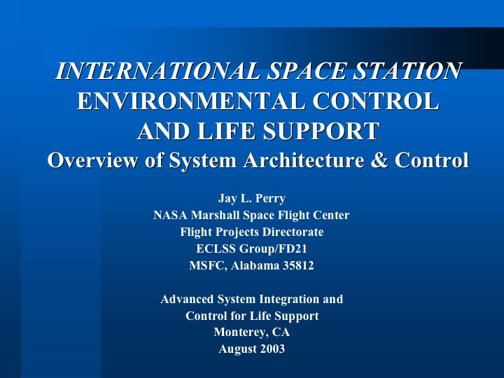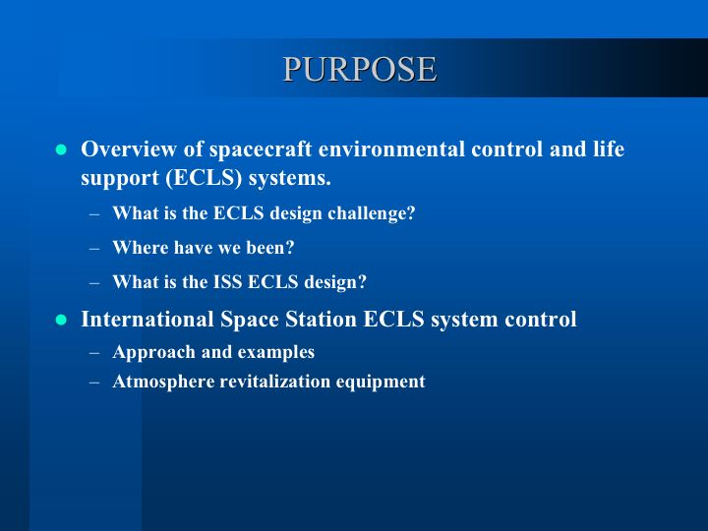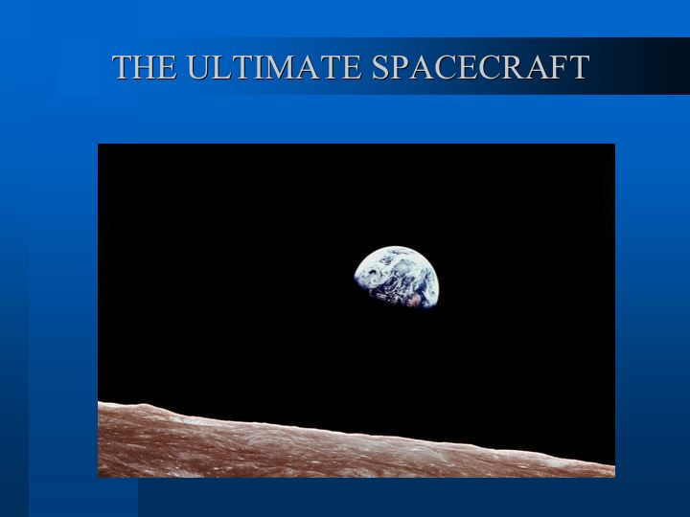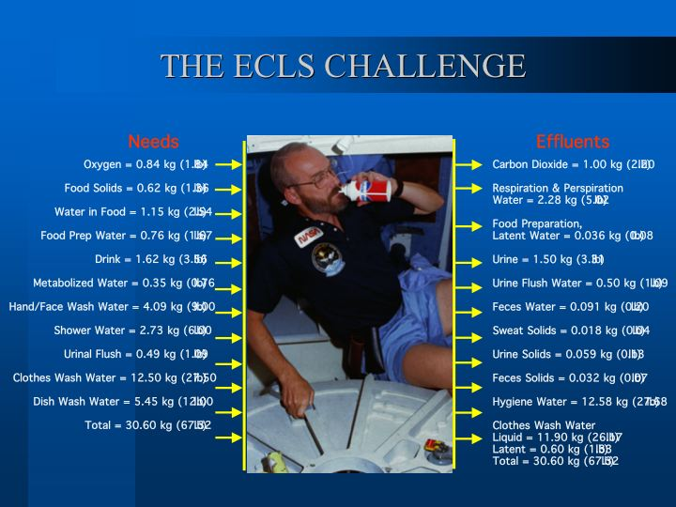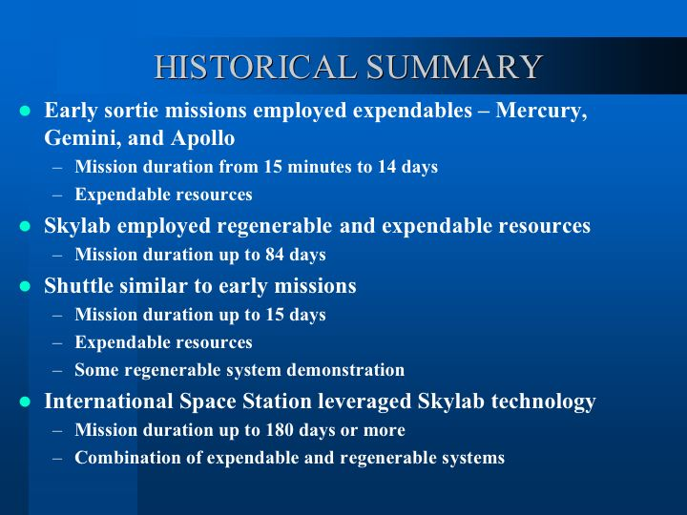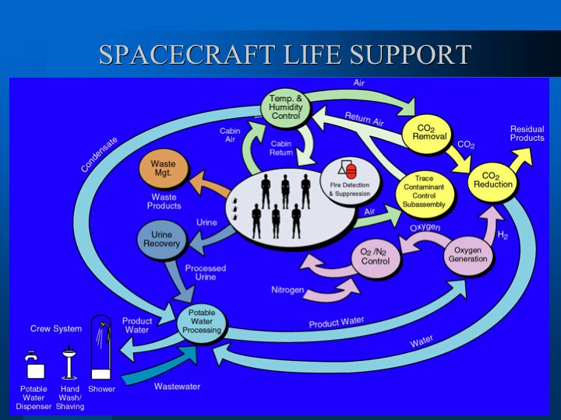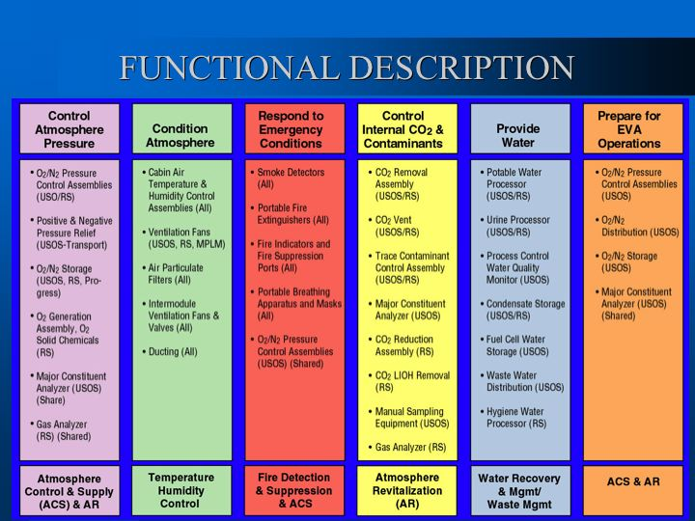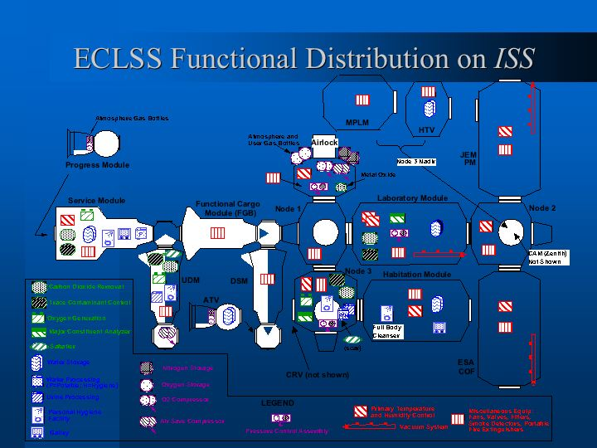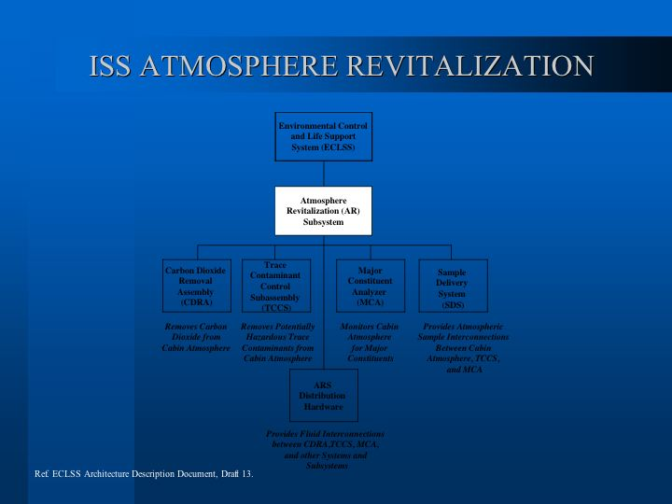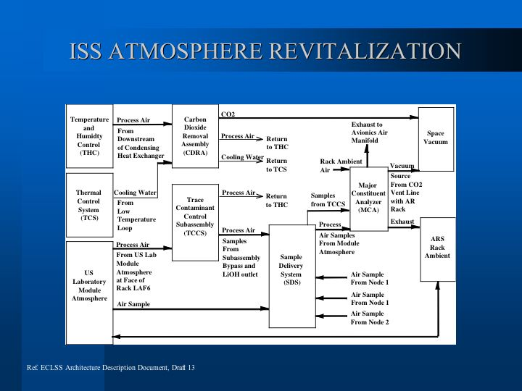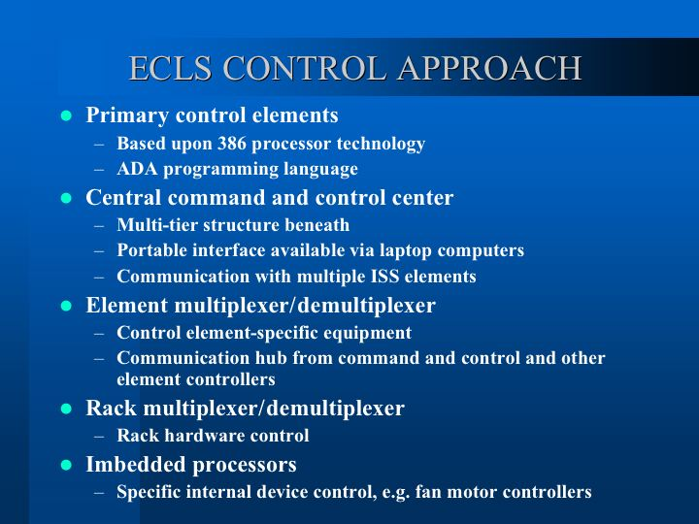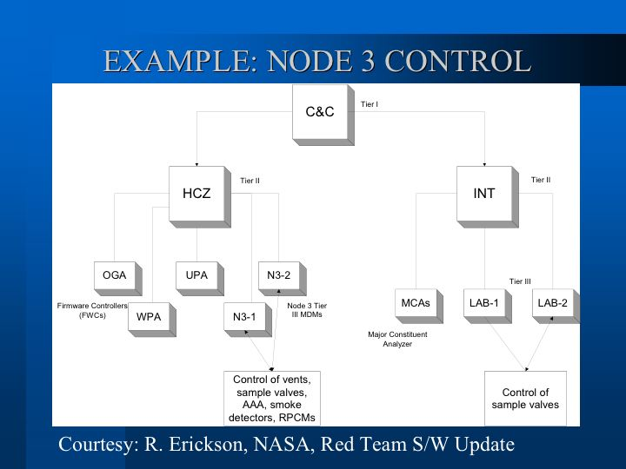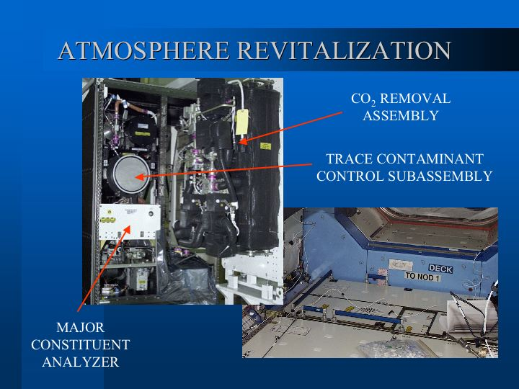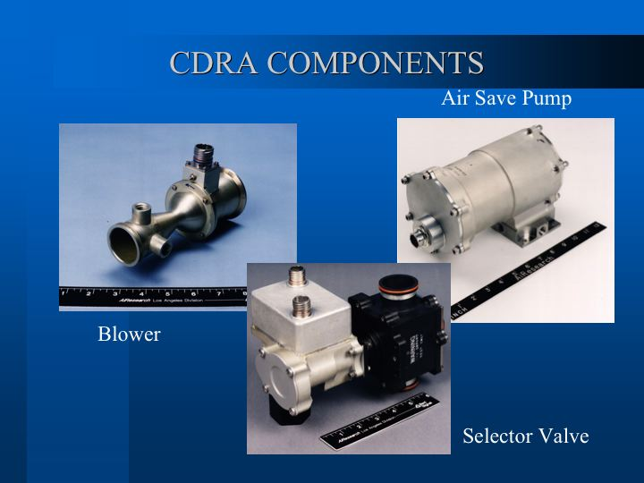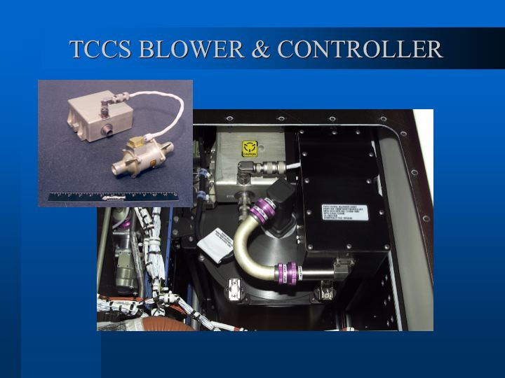
APPENDIX E – SCENARIOS & QUESTIONS

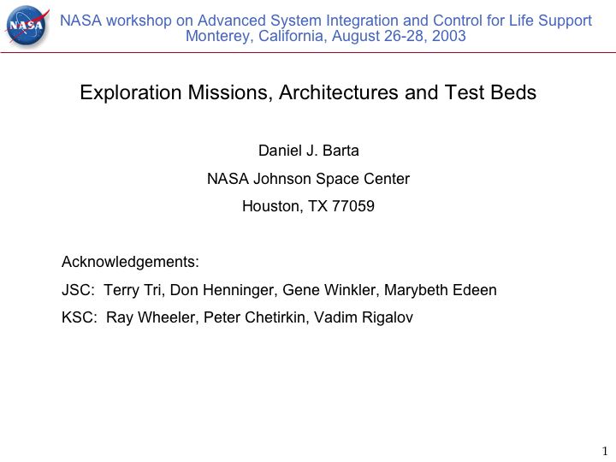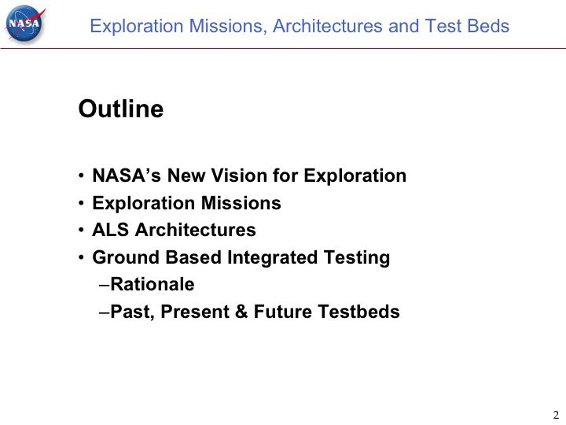
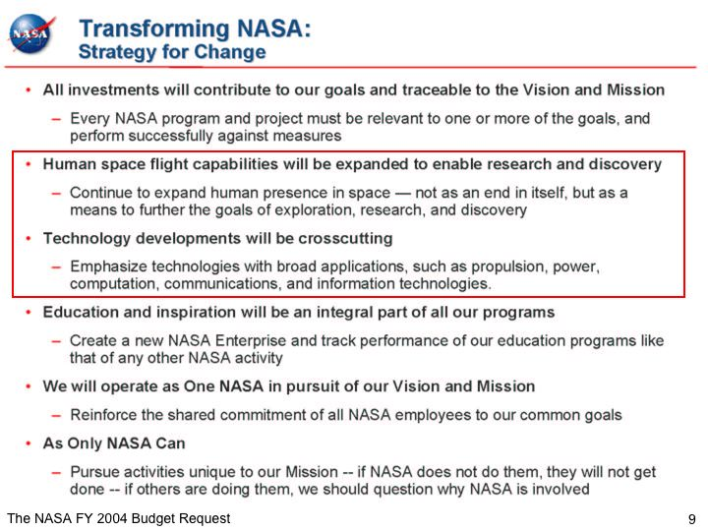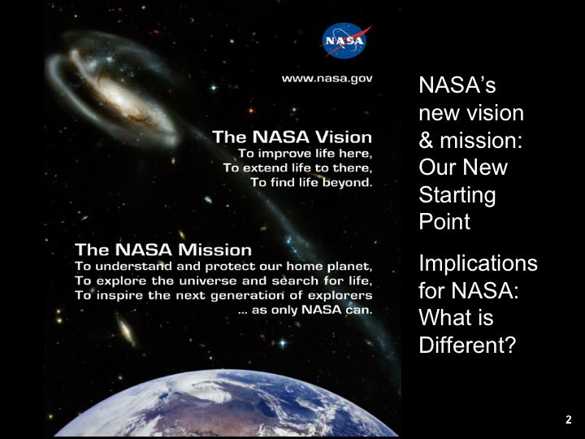
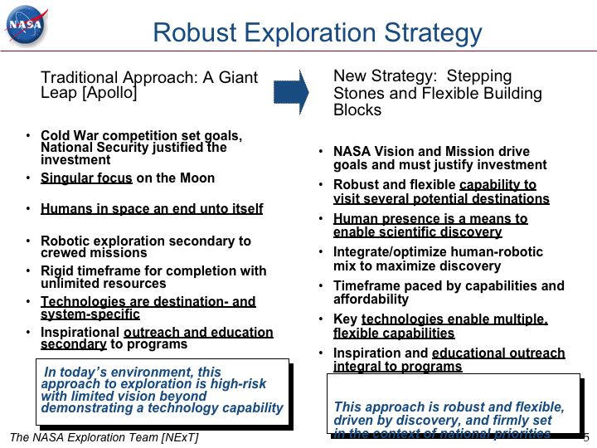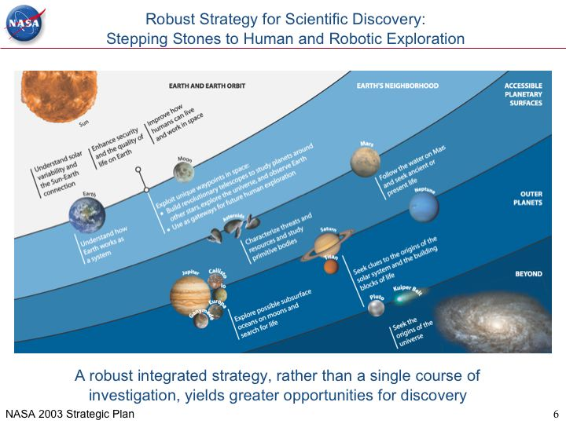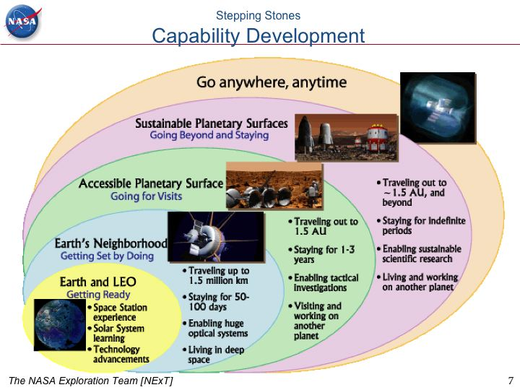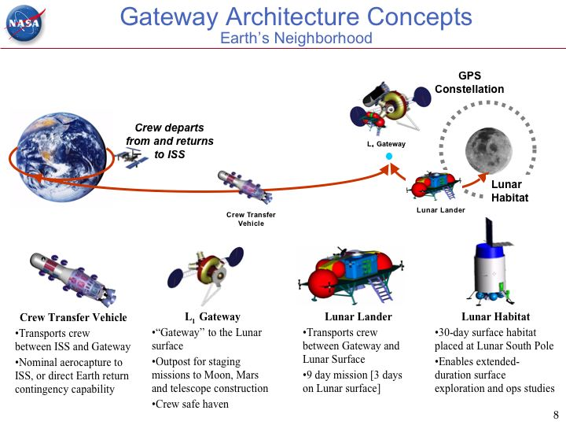
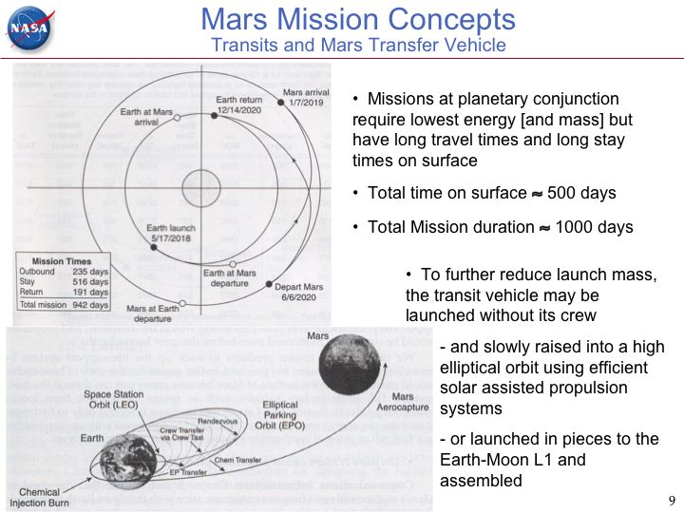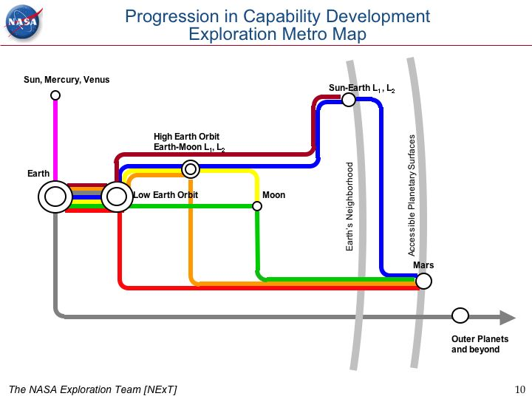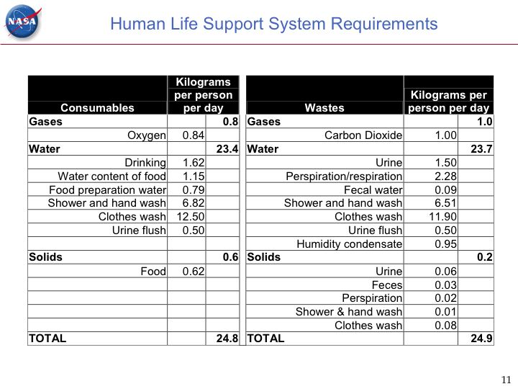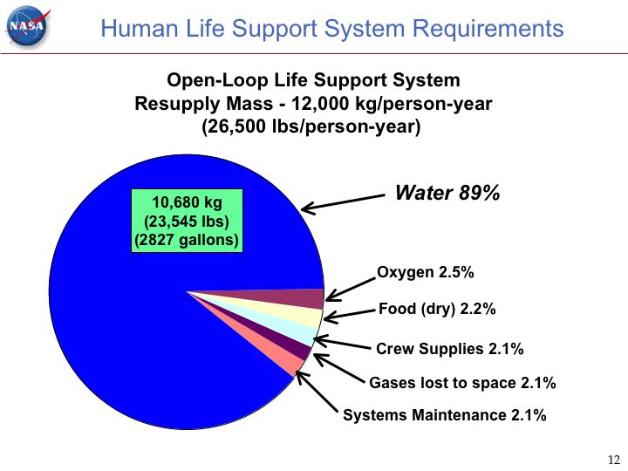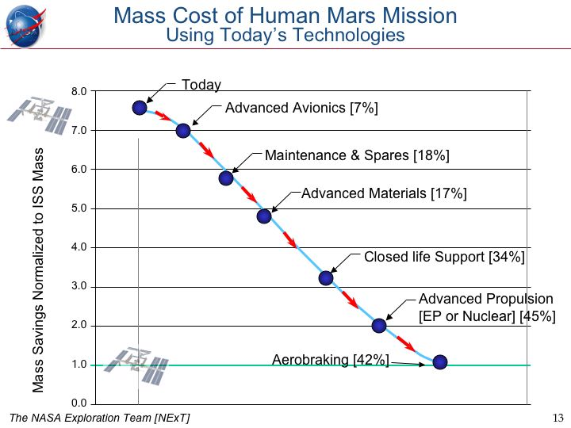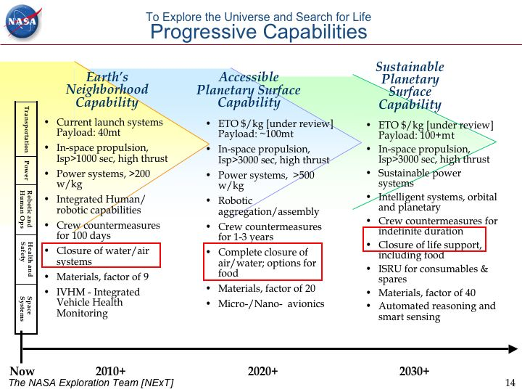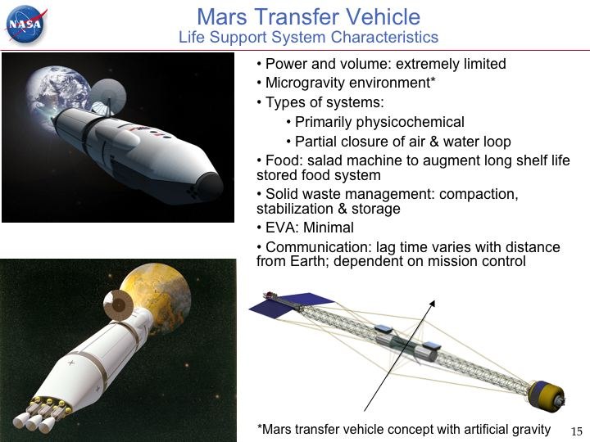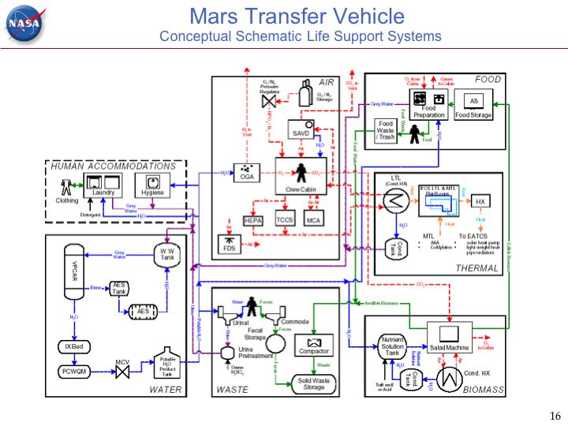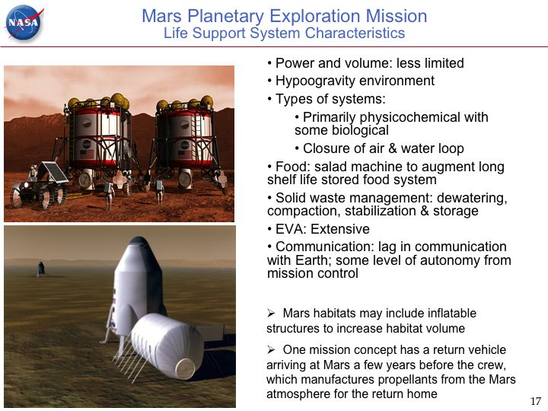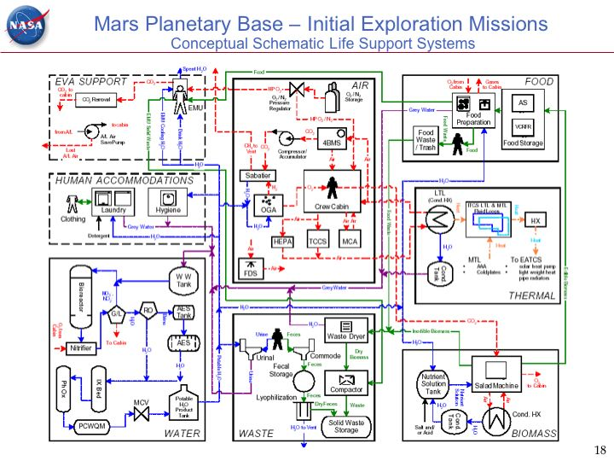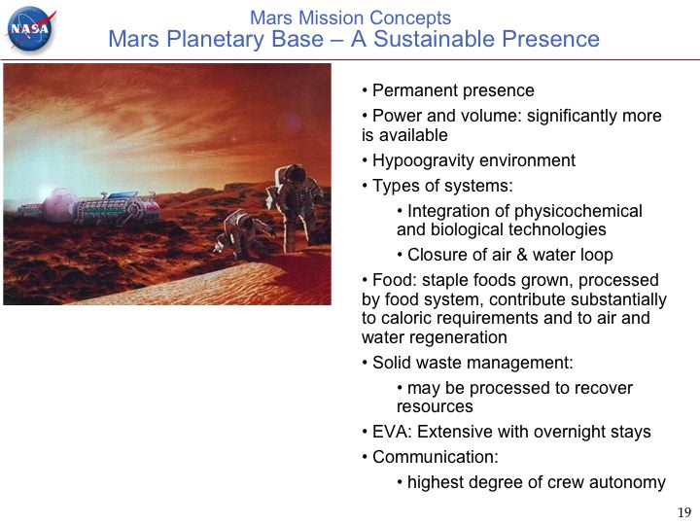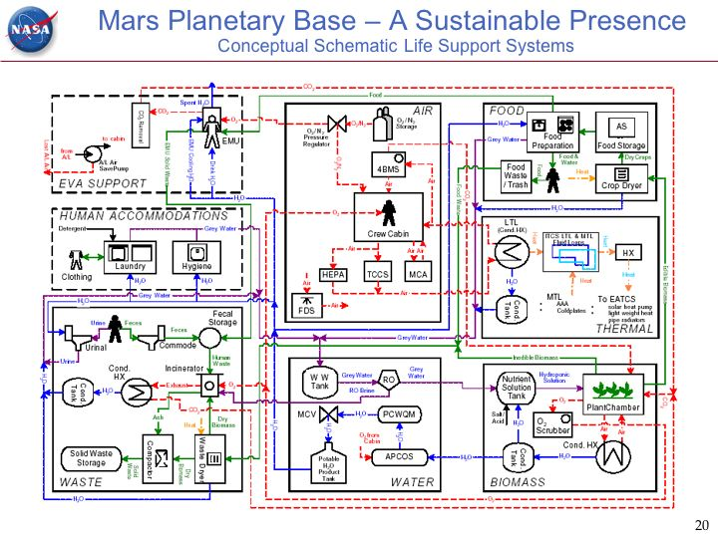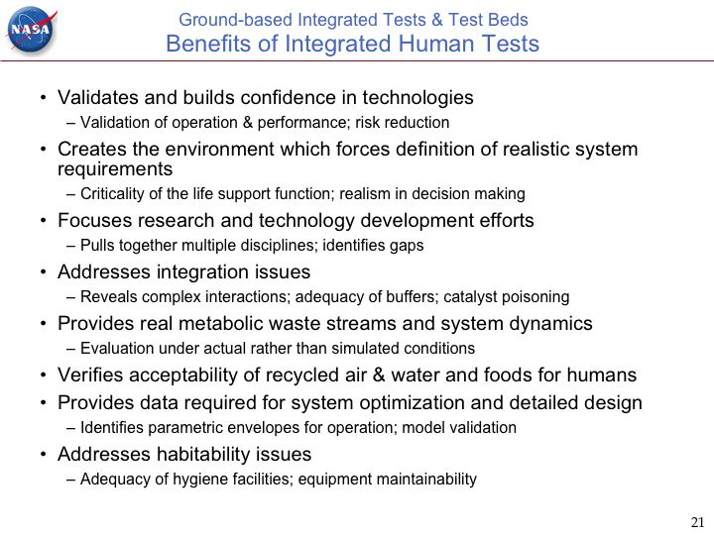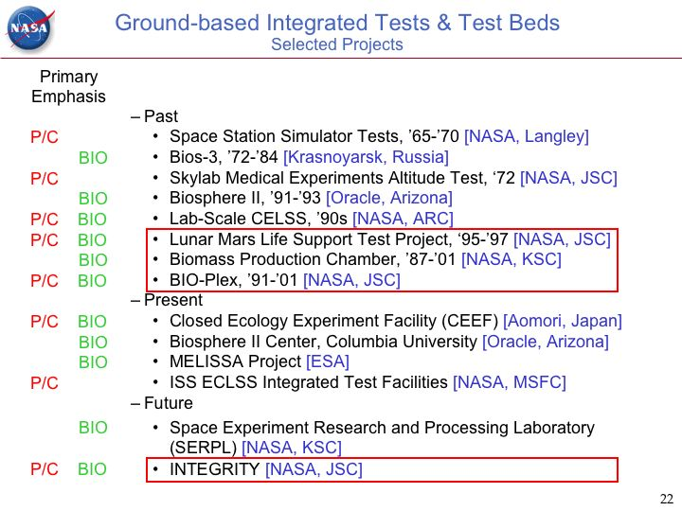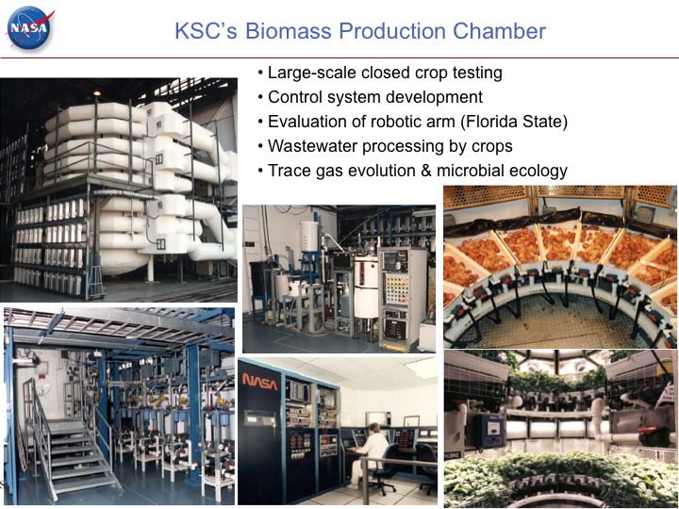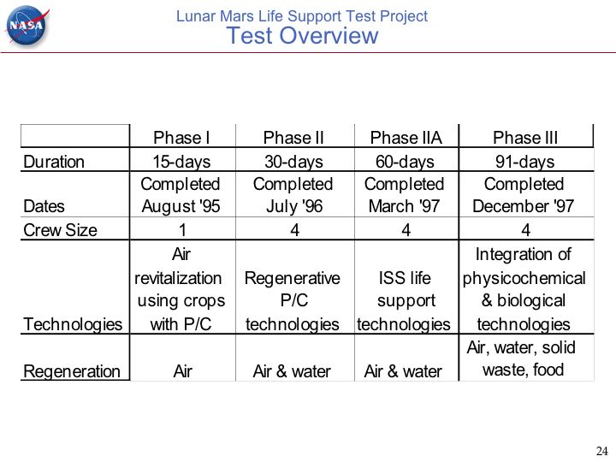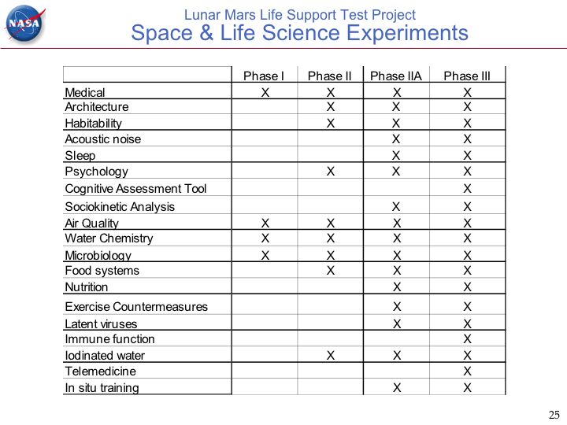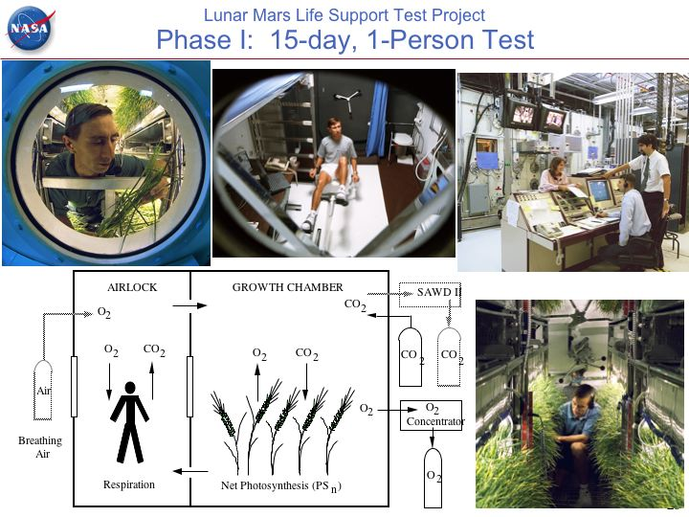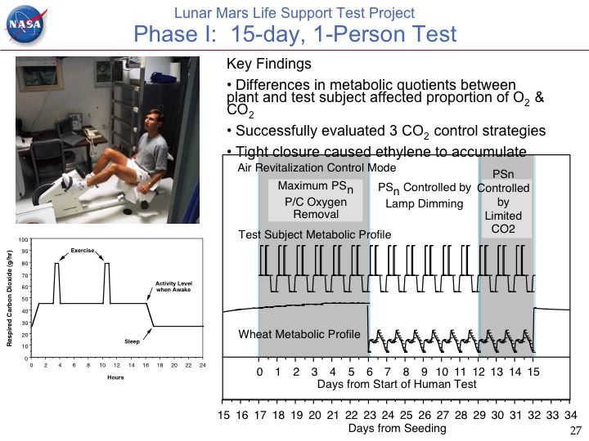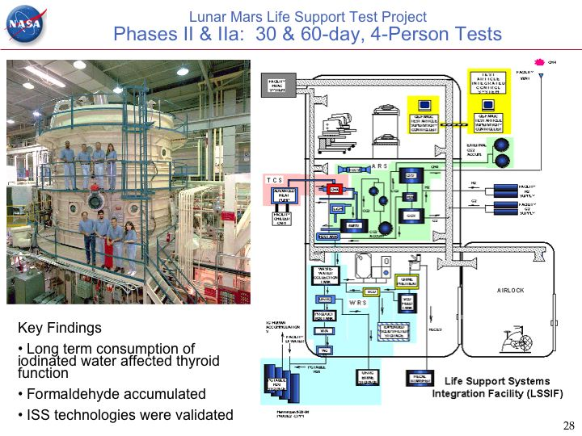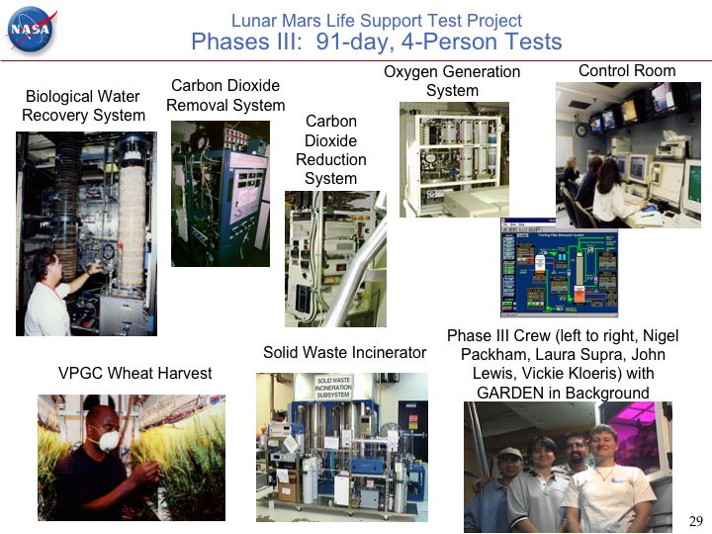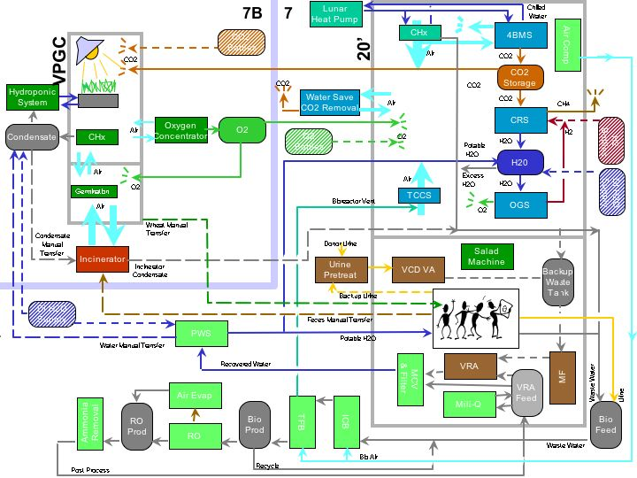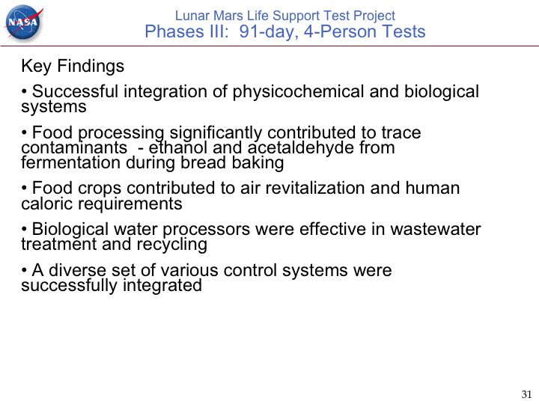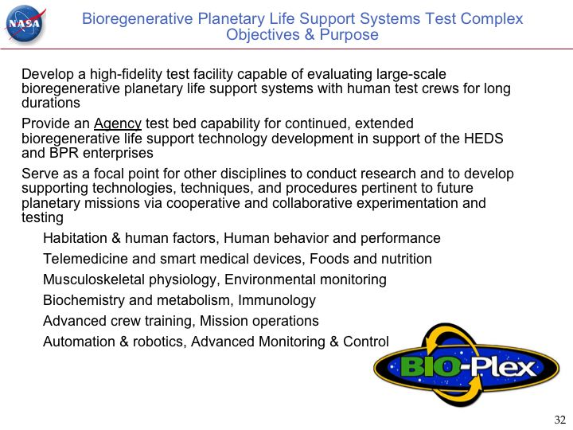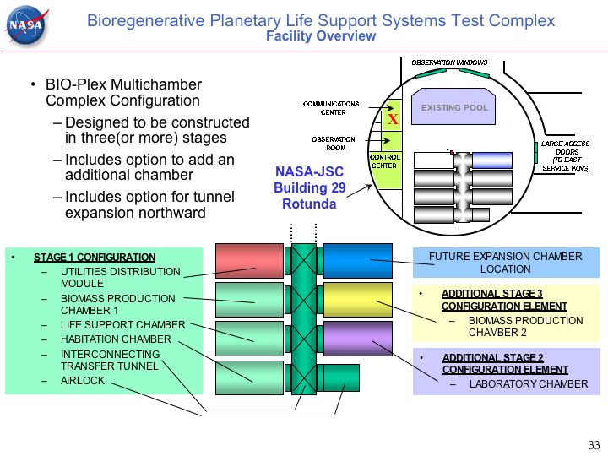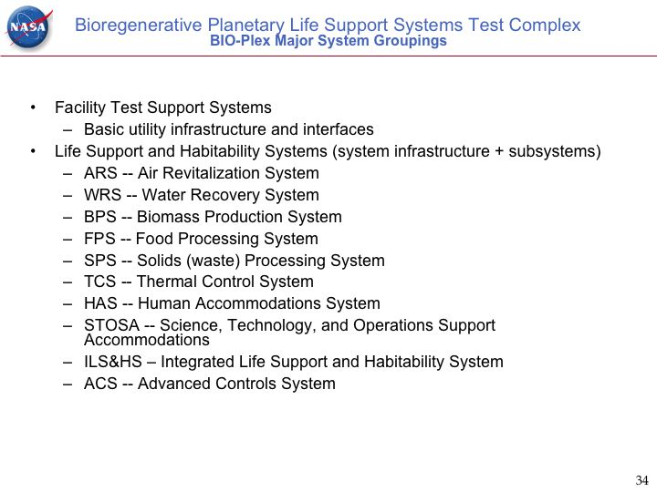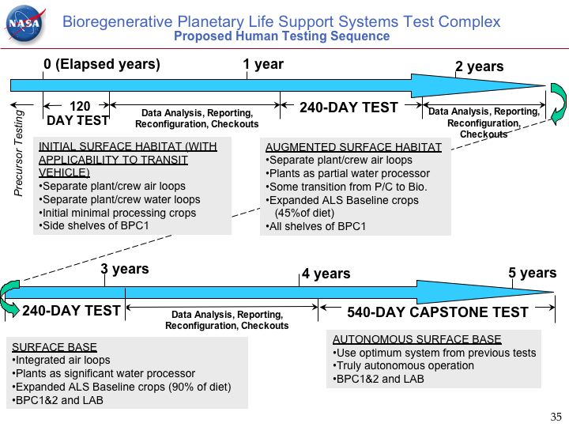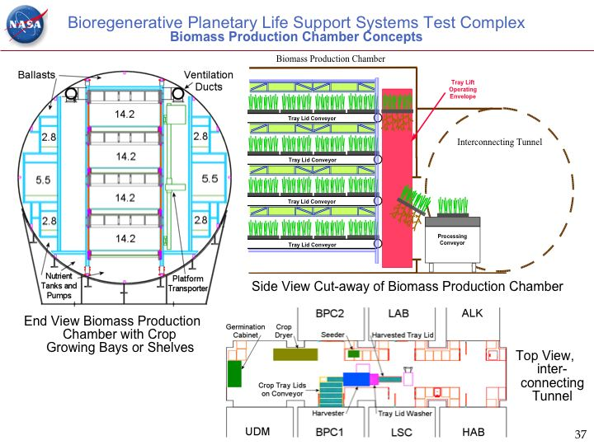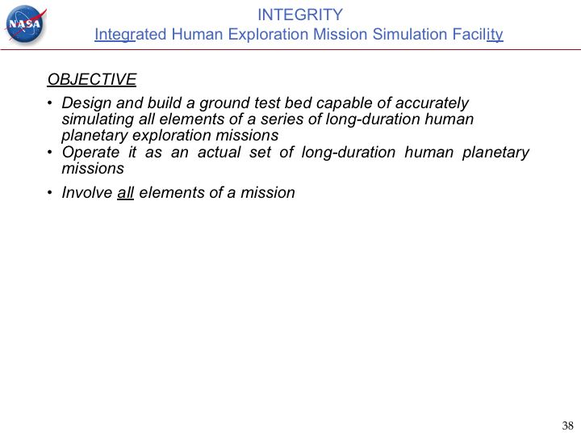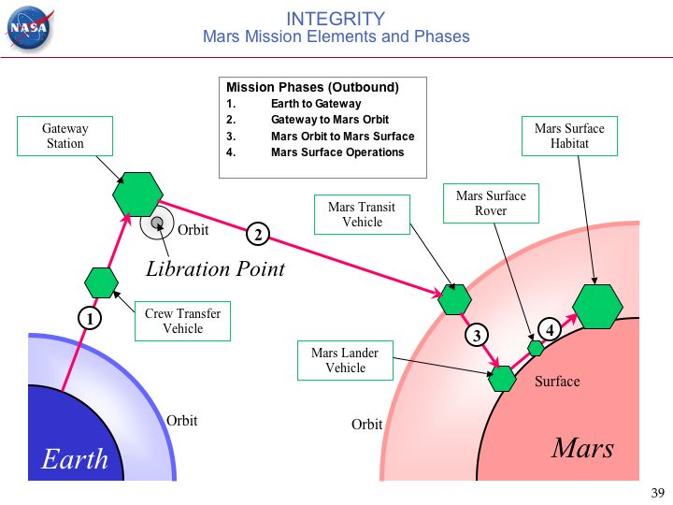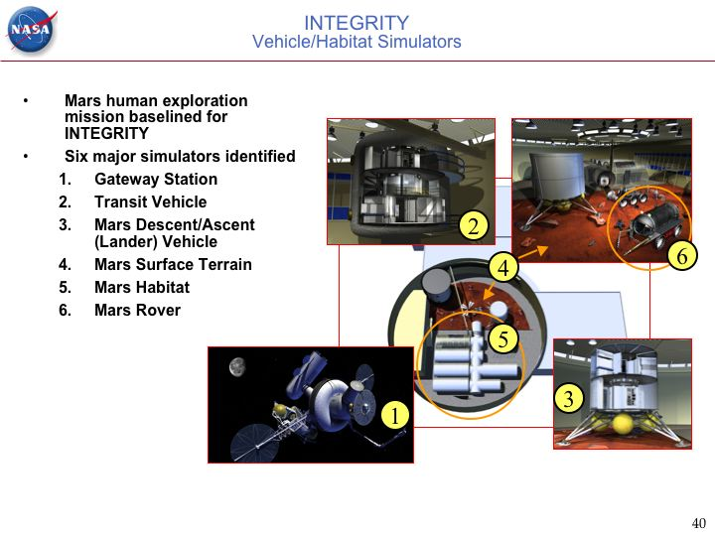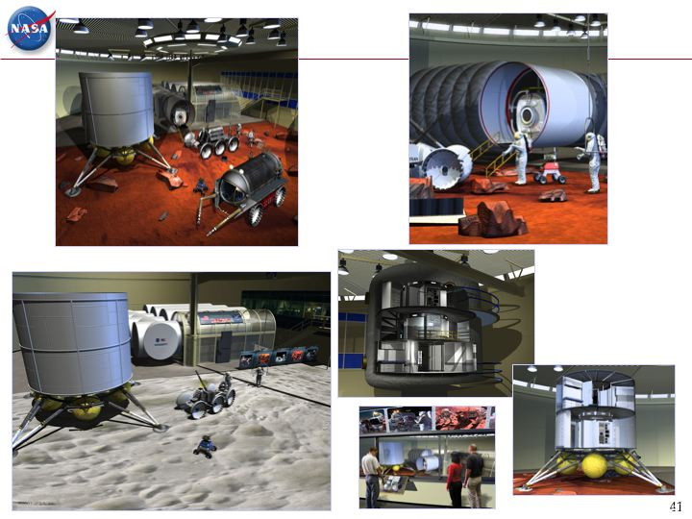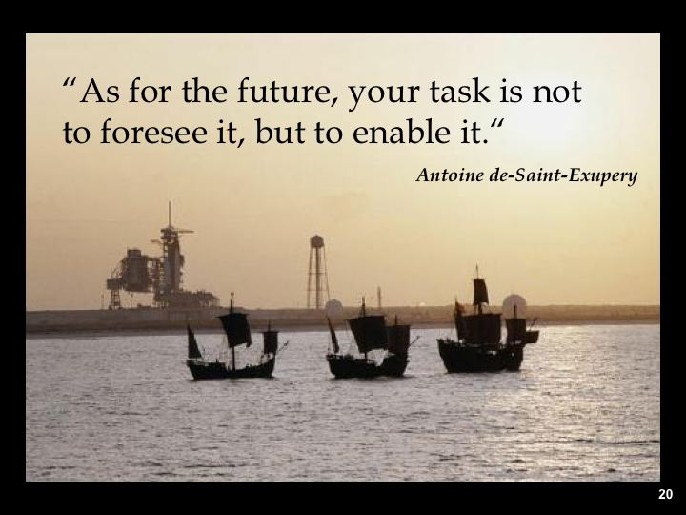
APPENDIX F – PRESENTATION ABSTRACTS

International Space Station Environmental Control & Life Support: Overview of System Architecture & Control
Jay Perry, NASA Marshall Space Flight Center
Providing a comfortable, safe environment in which one may live and work has been a challenge since the beginning of crewed space travel. Supplying human beings with oxygen, water, and food for their basic survival amounts to more than 5 kg/person/day. At the same time, an equivalent amount of waste products must be dealth with daily. These wastes include carbon dioxide, urine, and solid waste. As crewed space exploration expands toward longer, more complex missions, the environmental control and life support (ECLS) system required to maintain their comfort and safety also increases in complexity. An overview of the ECLS system design change is presented. An example control architecture is discussed and representative components requiring local control are reviewed. The International Space Station (ISS) Atmosphere Revitalization Subsystem (ARS) serves as the discussion reference.

Advanced Life Support: System Architectures and Control Challenges
Richard Boulanger, Jacobs Engineering / Sverdrup Technology at NASA ARC
Advanced Life Support systems consist of tightly coupled technologies which process the material flow streams necessary to support a human crew during spaceflight. The principle control objective is to provide the conditions necessary to support the lives of the human crew at all times. Life support technologies can be physicochemical or biologically based, can be continuous, batch or semi-batch processes, or can have widely varying time-constants, which result in systems that are challenging, at best, to control. This presentation will familiarize the audience with:
- Example system architectures, which depict the material mass flows typical of Advanced Life Support systems,
- The types of advanced life support technologies currently available for air, water, waste and food,
- The operation and control challenges of these technologies.

Exploration Missions, Architectures and Ground Based Test Beds
Daniel J. Barta, NASA Johnson Space Center
The National Aeronautics and Space Administration's (NASA) 2003 Strategic Plan introduced a robust, integrated exploration strategy to extend our sphere of human exploration far beyond the bounds of Earth. This vision includes exploiting unique waypoints in the Earth's neighborhood that may serve as gateways for future human exploration to accessible planetary surfaces such as Mars. Through fundamental research and strategic investment in transformational, crosscutting technologies, capabilities will be developed to overcome the limitations of human space travel and open new pathways for science-driven exploration and discovery. This presentation will describe several of NASA's candidate design reference missions for human exploration, requirements and possible architectures for advanced life support systems for these missions and how ground based test beds may be utilized for closed integrated testing during systems development.
Challenges and Opportunities of Advanced Life Support Systems Analysis and Modeling
K.C. Ting, The Ohio State University
Long-duration space missions require the design of advanced life support systems (ALSS). Functionality and reliability of ALSS are of critical importance. Each individual component, process, or database within the system is a building block. While it is obvious that the workability of the entire system ultimately depends on the performance of each building block, the interrelationships among them are important concerns as well. The identification, understanding, description, specification, utilization, and manipulation of these relationships are the tasks of systems studies. Computer models have been used as the main tool in conducting systems studies. Efforts have been made to facilitate and conduct analyses of ALSS at the systems level. The goal needs to be achieved by establishing effective communication within the advanced life support (ALS) community and developing methodologies/computational tools for integrating ALS information.

Several specific challenges have been identified in systems analysis of ALSS: (1) Attention to top-level versus process-level modeling; (2) Emphasis on breadth versus depth; (3) Establishment of effective information/data exchange protocol; (4) Consideration of model and analysis expandability, compatibility, and adaptability; (5) Develop optimum system abstraction; (6) Use of appropriate computational platforms; (7) Identification of targeted participants and audiences; (8) Validation of models and results of analysis; (9) Handling of heuristic, uncertain, and incomplete information; (10) Forms of deliverables (i.e. case-by-case versus computational tools); and (11) Coordination of activities. Opportunities that may potentially generate highly valuable results by building on the past experience of systems approach include: (1) Systems approach to monitoring and control of ALSS; (2) Systems approach to reliability analysis of ALSS; and (3) Information and analysis environment for ALSS (i.e. the concept of “Concurrent Science & Engineering”).

ALS Control Metrics and Equivalent System Mass
Alan Drysdale, Boeing
Using KSC experience in developing control systems for large plant chambers and in operating these chambers, relationship between controls and ESM are explored.

ALS controls issues are identified. KSC experience is particularly relevant due to the duration and the scale of the CELSS Breadboard Facility compared to those of anticipated missions.

In particular, reasons for implementing controls, costs, and risks are addressed. Recommendations based on KSC experience are identified. Configuration control must be addressed, maintenance is an issue, and data fusion is essential for robustness.

Advantages of Hierarchical, Centralized Architectures for Controlling Real-World Systems
David Kortenkamp, Metrica Inc. at NASA Johnson Space Center
This talk will define a control architecture and its major features and requirements. A brief history of hierarchical control architectures will be given. A specific instance of a hierarchical, centralized control architecture developed at NASA JSC, 3T, will be described in detail. 3T has been applied to control of several advanced life support system tests. The talk will end with discussion of the advantages and disadvantages of a hierarchical, centralized control architecture.

ALS Integrated Control Challenges
David Overland, NASA Johnson Space Center
There are several possible control architectures for advanced life support. Whichever architecture is eventually implemented must also interface and interoperate with other spacecraft and ground support systems to support mission goals. I will provide an overview of the complexity of the functions such control systems must support, a description of the challenges of integrating spacecraft control systems, and reasons for using a distributed, heterarchical approach to both the development of such control systems, and the support of mission operations.

Putting It All Together: Orchestrating Control Solutions
Richard Boulanger, Jacobs Engineering / Sverdrup Technology at NASA ARC
Advanced Life Support systems consist of tightly coupled physicochemical and biological processes which interact to produce changes to material streams (air, water, waste, etc.) in ways which are necessary to maintain an environment which continuously supports human life. It is critical to the success of such systems that these processes interact with high fidelity. To achieve this degree of interdependence, common, low-level interfaces are indicated to transport the process instrument and meta-data which reflect the state of the subsystems, sensors, and by extension, the ALS system itself. This presentation will familiarize the audience with the various interfaces which have been investigated and tested for application to ALS control systems and the results of those tests.

Crew/Ground Control Interfacial Requirements
Debra Schreckenghost, Metrica/TRACLabs at NASA Johnson Space Center
Our experience in developing and deploying automated control software for extended operation during both the Phase III Lunar/Mars Life Support Test Program (LMLSTP) manned test and the unmanned Water Recovery System (WRS) ground tests at JSC has provided valuable insights into requirements for human interaction with crew life support systems. The use of control automation can remove the need for vigilant monitoring of crew life support systems by humans. This reduces the workload of ground controllers and enables moving ground support out of a centralized control room into the work place, a critical capability for distributing ground support operations. The use of control automation also can standardize routine anomaly management, reducing the need for crew and ground involvement in handling anticipated problems. These changes in operations, however, will change the roles that humans fulfill in manned space operations. New policies and protocols for interaction between humans and automated control agents must be developed. Existing policies and protocols for human–human interaction likewise must be adapted to account for the change in human roles. These policies ensure that the right people are notified of significant events regarding operations, including events indicating that they might need to take manual action. These policies also address consistent, reliable commanding among groups of human and software control agents. The resulting new tasks and changed protocols require new types of software to assist humans in performing them. Based on our experience with advanced life support control, we believe that such new software requires more than just good display design. It requires developing support software to aid people in interacting and cooperating with both the automation and the underlying life support system as well as modifying the design of the control systems for such interaction.

In this presentation we describe the lessons learned about human interaction with life support systems resulting from the deployment of control automation during life support ground tests at JSC. We also present the Distributed Collaboration and Interaction (DCI) environment developed to support crew and ground controllers when interacting with life support systems that include automated control software.

Reliability, Safety and Error Recovery for Advanced Control Software
Jane T. Malin, NASA Johnson Space Center
For long-duration automated operation of regenerative life support systems in space environments, there is a need for advanced integration and control systems that are significantly more reliable and safe, and that support error recovery and minimization of operational failures. This presentation outlines some challenges of hazardous space environments and complex system interactions that can lead to system accidents. It discusses approaches to hazard analysis and error recovery for control software and challenges of supporting effective intervention by safety software and the crew.

The Future of ALS Monitoring and Control: Challenges
Jon D. Erickson, Berkley Street Consulting, Inc.
In this presentation we present a summary of the problem of Advanced Life Support (ALS) Monitoring and Control (M&C) and goals to address solving the problem in the future.

The following goals and challenges speak to a summary of the problem and ways to address it:
- To build a self-sustaining life support system for long-duration human space missions by replacing the large-scale, long-term processes and large reservoirs of Earth with small-scale, short-term processes, small reservoirs, and an external intelligent monitoring and control (M&C) system that can take dynamics into account.
- To build an adjustably autonomous monitoring and control system for life support in space that supports migration from physicochemical to bioregenerative life support systems (BLSS) with minimal resupply, as the BLSS is built and is operated on a planetary surface. Adjustable autonomy refers to allowing humans to supervise and adjust the M&C agents’ behavior if necessary and is required for safety purposes.
- To meet the requirements for minimal crew time in ALS M&C (remember it is a small crew) and the requirements for M&C response in fractions of a second to seconds (faster than communications to ground control).
- To build a combined distributed collaboration and interaction capability (crew and ground) with a layered intelligent, adjustably autonomous monitoring and control system at each level of the asset hierarchy (Base or Vehicle, Systems[Life Support], Subsystems, Assembly) that provides a deliberative planning and scheduling layer, an operations procedures layer, and a layer of situated skills based on sense-act loops. This distributed collaboration and interaction capability, consisting of active, vigilant, and tightly coupled external software processing as by “liaison agents,” is required to allow the human to work effectively in a multi-agent world while avoiding overload of the M&C agents and degrading their performance on their primary tasks. This approach also provides, by design, pre-integration of the monitoring and control software.

Other challenges such as building and adequately testing truly representative ALS hardware and M&C software are addressed. Some specific next steps are also addressed to aid the workshop participants, such as developing software-motivated ALS hardware requirements and design guidelines so as to enable the intelligent control software to be safer and more reliable.

Industrial Process Measurement and Control
R. Russell Rhinehart, Oklahoma State University
Control is information processing, and uses both hardware (sensors, transmission equipment, final elements) and software (algorithms for state estimation, transmission protocol, and decision automation). "Best practices" for control within the chemical process industries (CPI) must balance the use of best technology with practical issues of human training, maintenance standardization, and performance/cost analysis. Depending on the business, best practice might be either today's leading technology or tried-and-true 100-year old approaches. I will summarize the range of techniques for sensing and perception, process measurement and analysis, decision automation, and operator engagement currently used within the CPI; and will provide insight as to why certain approaches are chosen.

Research Directions in Industrial Control
David Musliner, Honeywell Labs
Current industrial control systems operate quite reliably in hazardous and mission-critical environments, using both simple PID control loops and more advanced model-predictive optimization techniques. However, the scale of industry and the severe consequences of even minor disruptions mean that oil refineries alone lose over ten billion dollars each year due to abnormal situations. Existing control systems do not operate well during abnormal situations. In this presentation I will summarize several causes of abnormal situations, discuss the weaknesses in existing approaches, and overview a series of research projects we have been investigating to reduce the frequency and costs abnormal situations. These research projects address topics including automated state estimation, automated adaptive response, human interface/understanding, and mixed-initiative procedural assistance.

Reconfigurable Autonomous Agent Architecture for Shipboard Automation
Francisco Maturana, Rockwell Automation
A multi-agent architecture is proposed to create highly distributed autonomous control systems. The multiple distributed agents are created with artificial social behaviors to enable component level intelligence and cooperative decision making in highly dynamic systems. Adaptation and auto configuration behaviors enable the intelligent agent to configure the physical equipment to fulfill mission specific tasks while satisfying real time constraints. Agents organize their respective views about the system to react to changes and to discover and deploy system capabilities. We explore the implications of using agent technology in the design and operation of a Chilled Water System (CWS) to support the operations of a real shipboard system. Implications such as sustainability and survivability are addressed throughout dynamic reconfiguration and learning. Our aim is to contribute with a set of guidelines on how to build autonomous agents for automation using COTS components.

Control in Unmanned NASA Missions
Carl Ruoff, Jet Propulsion Laboratory, California Institute of Technology
NASA missions are becoming increasingly ambitious, with operational requirements ranging from exploring remote planetary surfaces, to imaging extrasolar planets with constellations of spacecraft, to assuring the well-being of astronauts during planetary missions. Successfully meeting these requirements requires sophisticated control systems.

Using the MER and MSL missions as examples, this presentation summarizes some of the control approaches used in planetary missions and indicates future extensions. It also describes research in formation flying, adaptive optics, and wavefront control being conducted for astronomical missions, and briefly describes a trace gas sensor being developed for life support.

Autonomous Control with the Remote Agent in Deep Space One
Barney Pell, RIACS at NASA Ames Research Center
The Remote Agent is an autonomous agent architecture for control systems based on the principles of model-based programming, on-board deduction and search, and goal-directed closed-loop commanding. This architecture addresses the unique characteristics of the spacecraft domain that require highly reliable autonomous operations over long periods of time with tight deadlines, resource constraints, and concurrent activity among tightly coupled subsystems. The Remote Agent integrates constraint-based temporal planning and scheduling, robust multi-threaded execution, and model-based mode identification and reconfiguration. The Remote Agent was demonstrated as an on-board controller for Deep Space One, NASA's first New Millennium mission, during a week-long experiment in early 1999. During the experiment, the spacecraft was not given the usual detailed sequence of commands to execute. Instead, the spacecraft was given a list of goals to achieve during the experiment. In flight, the Remote Agent flight software generated plans to accomplish the goals, executed the plans in a robust manner, diagnosed and recovered from simulated failures, created new plans when necessary, and provided an interface to human operators that supported variable levels of autonomy.

Control Issues in Water Processing
Peter Bonasso, Metrica Inc. at NASA Johnson Space Center
This talk discusses a JSC experience building and running an intelligent control system for a NASA advanced water recovery system. We used the 3T intelligent control architecture to produce software that operated autonomously, 24/7 for sixteen months. The article covers our development approach and our lessons learned from the perspectives of autonomy and long-duration monitoring and control.

An Advanced Life Support Simulation for Integrated Controls Research
David Kortenkamp, Metrica Inc. at NASA Johnson Space Center
This talk will describe a simulation of an integrated advanced life support system. The simulation contains models of the major components of a life support system including crew, biomass, water recovery, air revitalization and food processing. The simulation
models malfunctions and stochastic processes. Sensors and actuators are modeled to allow controllers to interact with the simulation. The simulation is designed for testing and evaluation of life support system control approaches.

Distributed Design vs. Reliability
Ken Arnold, EventMonitor, Inc.
Ever since we could get two computers to talk, we have tried to get them to cooperate reliably. As with computer translation of human language, this has proven more difficult than imagined. Centralized systems can be more controlled, and hence more stable, but they scale poorly. As more things happen in space, more problems will become distributed problems, and they will be increasingly critical to human safety and success. In the hope that it will inform the design of distributed control systems in space, this talk will give an overview of distributed computing problems and some historical and current approaches.

Proofs and Paths from The Book of Mars
Daniel Cooke, Texas Tech University
Research and exploration have a lot in common. Drawing upon Paul Erdos's notions of "proofs from the book," the goal of this talk is to demonstrate the relationship between the exploration of intellectual and physical spaces. In the context of exploring intellectual spaces, proofs from the book are viewed as the simplest, most elegant pathways for achieving a goal (or hypothesis). Likewise, in the context of exploring physical spaces there tend to be simpler approaches that may reduce risk and cost. This talk will introduce a staged approach to Mars exploration involving libration points, so-called interplanetary superhighways, and telepresent exploration, all in support of the ultimate goal: to place a light-weight human footprint on Mars. Subgoal: To be entertaining and informative.

