



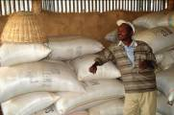
BEST ANALYSIS – Madagascar
BELLMON ESTIMATION STUDIES
FOR TITLE II (BEST) PROJECT

December 2008
This publication was produced for review by the United States Agency for International Development. It was prepared by Fintrac Inc.
Fintrac Inc.
www.fintrac.com
info@fintrac.com

US Virgin Islands
3077 Kronprindsens Gade 72
St. Thomas, USVI 00802
Tel: (340) 776-7600
Fax: (340) 776-7601

Washington, D.C.
1436 U Street NW, Suite 303
Washington, D.C. 20009 USA
Tel: (202) 462-8475
Fax: (202) 462-8478

December 2008
The author’s views expressed in this publication do not necessarily reflect those of the United States Agency for International Development or the United States Government.
BEST ANALYSIS – Madagascar
BELLMON ESTIMATION STUDIES
FOR TITLE II (BEST) PROJECT

Content
acronyms iii
Preface iv
1.0 Executive Summary 1
2.0 Food Aid Historical Overview 4
2.1 Summary of Overall Emergency and Non-Emergency Food Aid 4
2.2 USAID/USDA 4
2.2.1 Cooperating Sponsor Target Geographic Area Activities and Project Descriptions 4
2.2.2 Historical Food Aid 5
2.2.3 WFP and Other Donor Programs 8
3.0 Distribution and Storage 10
3.1 Warehousing/Storage Capacity 10
3.2 Port Facilities 10
3.3 Transport Capacity 11
4.0 Policy Issues 12
4.1 Free Trade and Bi-lateral Agreements 12
4.2 Regulatory Climate 12
4.3 Other Policy Issues Affecting Food Aid 13
5.0 Selection of Products 14
6.0 pRODUCT sPECIFIC ANALYSIS 15
6.1 Rice 15
6.1.1 Domestic Production 15
6.1.2 External Trade 15
6.1.3 Domestic Markets 16
6.1.4 Prices 17
6.1.5 Impact Analysis 18
6.1.6 Adequate Storage Capacity 18
6.2 Hard Red Winter Wheat (HRWW) 19
6.2.1 Domestic production 19
6.2.2 External trade 19
6.2.3 Domestic markets 20
6.2.4 Impact analysis (monetization) 21
6.2.5 Adequate Storage Capacity 22
6.3 Crude Degummed Soybean Oil (CDSO) 23
6.3.1 Domestic Edible Oilseed Production 23
7.3.2 External Trade 23
6.3.3 Domestic Markets 23
6.3.4 Impact Analysis 24
6.3.6 Storage Capacity 25
6.4 Non-Fat Dry Milk (NFDM) 26
6.4.1 Domestic Production 26
6.4.2 External Trade 27
6.4.3 Domestic Markets 27
6.4.4 Impact Analysis 27
6.4.6 Storage Capacity 29
6.5 International Monetization 30
7.0 Analysis and Recommendations 32
7.1 Analysis of food aid program issues 32
7.1.1 Product Specific Analysis for Monetization 32
7.2 Analysis of storage and distribution issues 34
7.3 Analysis of key policy issues 35
Annex I: Country Background and Overview 36
Annex II: Population 39
Annex III: Crop Production 40
Annex iV: Cooperating Sponsors’ Programs 43
Annex v: Rice Statistics 45
Annex vI: Wheat Statistics 48
Annex vII: Edible Oil Statistics 52
Annex vIII: Milk Powder statistics 56
Annex IX: FFP Policy on USE OF Milk Powder FOR Monetization 59

acronyms
ADP Agricultural Development Program
ADRA Adventist Development and Relief Agency
APHIS Animal and Plant Health Inspection Service
CAADP Comprehensive African Agricultural Development Programme
CDSO Crude Degummed Soybean Oil
CEMM Companie des Experts Maritime de Madagascar
CET Common External Tariff
COMESA Common Market for Eastern and Southern Africa
CRS Catholic Relief Services
CS Cooperating Sponsor
CSB Corn Soy Blend
EAC East African Community
FFP Food for Peace
FTA Free Trade Area
GDP Gross Domestic Product
GMO Genetically Modified Organisms
GoM Government of Madagascar
HIPC Heavily Indebted Poor Countries
HRWW Hard Red Winter Wheat
IMF International Monetary Fund
IPP Import Parity Price
LOL Land O’Lakes
MGFSC Madagascar Food Security Consortium
MT Metric Ton
MYAP Multi-Year Assistance Program
NEPAD New Partnership for Africa’s Development
NFDM Non-Fat Dry Milk
NGO Non-Governmental Organization

OVC Orphans and Vulnerable Children

SADC Southern Africa Development Community

TOP TIKO Oil Production
USAID US Agency for International Development
USDA US Department of Agriculture
VAC Vulnerability Assessment Committee
WFP World Food Programme

Preface
During the months of September and October 2008, the newly formed Bellmon Estimation Studies for Title II (BEST) team undertook a study to generate recommendations for a Bellmon determination made by USAID Office of Food for Peace.

The purpose of the analysis is to determine that the distribution and monetization of U.S. agricultural commodities provided for use in Madagascar during FY09 through United States Government (USG) food aid assistance programs (including Title I, Title II, Food for Peace (FFP), Food for Progress (FFPr), and 416(b)) meet the criteria set forth in the Food For Peace Act and Related Statutes, including the Bellmon amendment. In particular, the study will provide guidance for compliance with the stipulations as defined in Section 402 and 403, as stated below:

SEC. 402. 7 U.S.C. 1732 DEFINITIONS.
As used in this Act:

(2) AGRICULTURAL COMMODITY.—The term “agricultural commodity,” unless otherwise provided for in this Act, includes any agricultural commodity or the products thereof produced in the United States, including wood and processed wood products, fish, and livestock as well as value-added, fortified, or high-value agricultural products. Effective beginning on October 1, 1991, for purposes of Title II, a product of an agricultural commodity shall not be considered to be produced in the United States if it contains any ingredient that is not produced in the United States, if that ingredient is produced and is commercially available in the United States at fair and reasonable prices.

SEC. 403. 7 U.S.C. 1733 GENERAL PROVISIONS.

(a) PROHIBITION.—No agricultural commodity shall be made available under this Act unless it is determined that—
(1) adequate storage facilities will be available in the recipient country at the time of the arrival of the commodity to prevent the spoilage or waste of the commodity; and
(2) the distribution of the commodity in the recipient country will not result in a substantial disincentive to or interference with domestic production or marketing in that country.

(b) IMPACT ON LOCAL FARMERS AND ECONOMY.—The Secretary or the Administrator, as appropriate, shall ensure that the importation of United States agricultural commodities and the use of local currencies for development purposes will not have a disruptive impact on the farmers or the local economy of the recipient country.

(c) TRANSSHIPMENT.—The Secretary or the Administrator, as appropriate, shall, under such terms and conditions as are determined to be appropriate, require commitments designed to prevent or restrict the resale or transshipment to other countries, or use for other than domestic purposes, of agricultural commodities donated or purchased under this Act.

(d) PRIVATE TRADE CHANNELS AND SMALL BUSINESS.—Private trade channels shall be used under this Act to the maximum extent practicable in the United States and in the recipient countries with respect to—
(1) sales from privately owned stocks;
(2) sales from stocks owned by the Commodity Credit Corporation; and
(3) donations.
Small businesses shall be provided adequate and fair opportunity to participate in such sales.

(e) WORLD PRICES.—
(1) IN GENERAL.—In carrying out this Act, reasonable precautions shall be taken to assure that sales or donations of agricultural commodities will not unduly disrupt world prices for agricultural commodities or normal patterns of commercial trade with foreign countries.

Sec. 403 FOOD FOR PEACE ACT 1–20
(2) SALE PRICE.—Sales of agricultural commodities described in paragraph (1) shall be made at a reasonable market price in the economy where the agricultural commodity is to be sold, as determined by the Secretary or the Administrator, as appropriate.

In this regard, the “Bellmon Amendment” of 1977 to section 401.b of P.L. 480 (the “Bellmon Amendment”), specify that no agricultural commodity shall be made available under this act unless it is determined that:

- Adequate storage facilities are available in the recipient country at the time of exportation of the commodities to prevent the spoilage or waste of the commodity;

- The distribution of the commodities in the recipient country will not result in a substantial disincentive or interference with domestic production or marketing in that country, and

- The importation of U.S. agricultural commodities and the use of local currencies for development purposes will not have a disruptive impact on the farmers or the local economy of the recipient country.

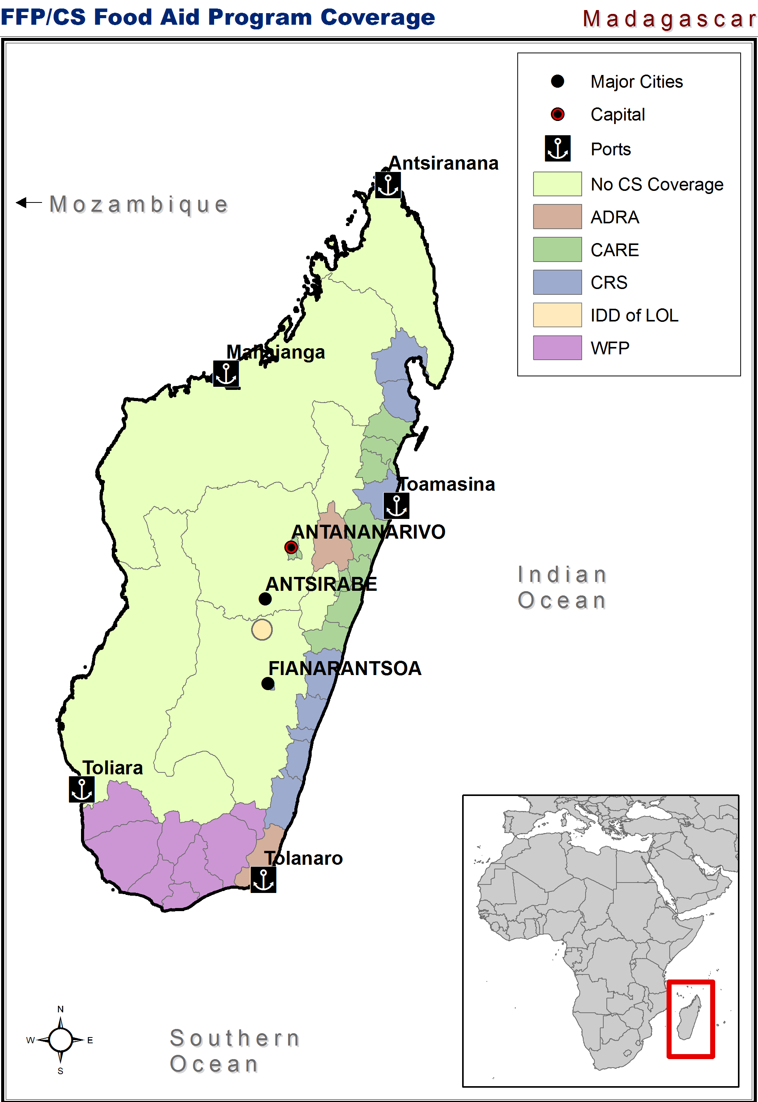

1.0 Executive Summary
This is a preliminary determination study that includes recommendations for commodities for monetization in Madagascar. This monetization analysis is being released in advance of the distribution analysis, which will be available in January 2009.
The commodities recommended for monetization in this study were selected on the bases that:
- They are available in accordance with PL 480 and USAID regulations;
- There is significant domestic demand in Madagascar;
- Domestic demand is not being met by local production; therefore supply shortfalls are filled through commercial importation and food aid;
- There is competition for the commodity(ies) recommended; and
- In all cases the negotiated price must be a reasonable market price in the economy where the agricultural commodity is to be sold; that is, a price competitive with price paid for by commercial importers for a comparable commodity of a comparable quality to avoid potential local market disruptions and production disincentives.

Summary Analysis

In 2007, Madagascar received a total of 74,800 MT of food aid from all donors, including USAID, USDA, WFP and other bilateral donors, of which non-emergency food aid represented 83 percent (62,500MT) and emergency food aid represented 16.4 percent (12,300 MT). Fifty-two percent of non-emergency food aid provided by USAID and USDA was monetized, and the balance was distributed. From 2005 to 2007, total non-emergency food aid levels increased by 45 percent. While distributed food aid levels were stable, monetized food aid increased by 161 percent.
The Malagasy markets for monetization of vegetable oil and wheat are not currently competitive. Both are dominated by a commercial enterprise owned by the President of Madagascar. Seaboard, a U.S. agribusiness concern, discontinued its wheat milling and flour distribution operations in the country, claiming anti-competitive actions taken by its only competitor, TIKO Mana Mills. The owner of the Seaboard mill, KOBAMA/Groupe Prey, has resumed operations at that facility.
The following commodities were analyzed for their suitability for monetization under current market conditions in Madagascar:
Rice. Estimated demand in 2007 was nearly 2.38 million MT, domestic production totalled 2.19 million MT, and approximately 2,000 MT was exported. The remaining demand deficit has been met by imports totalling 172,000 MT, primarily from Pakistan, India, the U.S. and Thailand. Imports have averaged 193,000 MT over the past five years. An analysis of the potential market for monetized rice indicates that there are at least five rice importers that could compete for a monetization tender. Since rice is the most important crop in Madagascar, any monetization must meet import parity price to avoid market disruption and production disincentive.
Because the domestic demand for imported rice continues to grow in a competitive market environment, the market analysis below indicates that rice monetization would be in compliance with the regulations as stipulated in the U.S. Food for Peace Act, and would be a good commodity for monetization.
Milk Powder. Madagascar is taking steps to meeting its internal milk requirements through increased domestic production. Annual milk powder imports averaged 2,100 MT valued at US$5.4 million over the past four years. Suppliers include India, France, New Zealand and Ukraine. Milk product processor SOCOLAIT requires approximately 1,000 MT per year of non-fat dry milk (NFDM) for its processed dairy products, primarily yogurt. TIKO imports approximately 400 MT per year of NFDM for reconstituting into whole milk. Two other wholesalers import milk powder for general retail distribution in powdered form. Since there is a competitive market for imported NFDM between TIKO and SOCOLAIT, it is recommended for monetization. Any monetization would need to comply with the International Code of Marketing of Breastmilk Substitutes and any World Health Assembly resolutions pertinent to the sale or distribution of breastmilk substitutes. NFDM may be sold for industrial use as an ingredient in processed foods, baked goods, yogurt, etc. NFDM cannot substitute for breastmilk or be used for products represented or locally perceived as breastmilk substitutes. It cannot be sold for direct market distribution, for example, in small tender sales, and cannot be sold directly to consumers. In addition, NFDM cannot be sold to known manufacturers or marketers of breastmilk substitutes or replacement foods with breastmilk substitute production facilities.
Wheat. Annual estimated demand for wheat was approximately 123,000 MT (92,000 MT wheat flour equivalent) in 2007, with less than one percent of this volume supplied by local producers. Thirty-five percent of total imports have been supplied through food aid programs, primarily by monetizing hard red winter wheat (HRWW). Proceeds from two monetization programs in the past years averaged 70 percent of full cost recovery based on cost to USAID, and ranged from 65 to 89 percent of estimated IPP based on FOB quote Argentina plus ocean freight and handling. Wheat millers/distributors include TIKO Mana Mill at Toamasina, owned by the President of Madagascar, and KOBAMA/Groupe Prey at Antsirabe. Seaboard/LMM, which leased a silo and milling complex from KOBAMA, has ceased its operations in Madagascar as of October 2008 and KOBAMA resumed milling in their place, but is reportedly facing startup challenges that may limit its ability to be fully competitive with Mana. Mana has a modern mill, linked to a new high-speed unloading facility at the port, with an offloading efficiency more than double that of the KOBAMA facilities. Both facilities have adequate storage to accommodate expected food aid shipments. Both companies have expressed an interest in bidding on upcoming HRWW shipments. But, given KOBAMA’s startup status, the market’s competitive environment appears to be heavily skewed toward one buyer. Therefore, wheat monetization is not recommended at this time.
Vegetable Oil. Annual demand for vegetable oil is currently 57,000 MT, with commercial imports supplying over 90 percent of this volume and food aid approximately nine percent. Less than one percent is produced domestically, and this figure continues to decline. Domestic edible oil processing and marketing is dominated by one firm, TIKO Oil Production (TOP), also owned by the President, which controls 90 percent of the market. Two other firms, HITA (eight percent) and INDOSUMA (two percent) supply the balance and neither expressed interest in participating in upcoming monetization programs. TOP was the sole purchaser of the 2007 shipment, which recovered 73 percent of the cost of the commodity to USAID and 81 percent of IPP, based on the value of the commodity (FOB – Argentina), plus ocean freight and handling. Given the lack of competition in the domestic market for monetized vegetable oil, a reasonable market price may not be realizable and vegetable oil is not recommended for monetization during the upcoming MYAP.
Given anticipated import needs and competition among at least five interested buyers, up to 19,000 MT of rice could be monetized. Up to 200 MT of NFDM could also be monetized. Wheat and vegetable oil are not recommended for monetization at this time.

2.0 Food Aid Historical Overview

2.1 Summary of Overall Emergency and Non-Emergency Food Aid
From 2005-2007, Madagascar received in aggregate 182,000 MT (expressed in wheat equivalent) in total food aid. Of this amount, 72 percent was supplied by the U.S., 14 percent by the EU, and 10 percent by Japan. Rice and soybean oil were the most significant food aid commodities by volume, accounting for 28 percent and 26 percent of the total respectively.
Emergency
Table 1: Total Food Aid 2005-2007 (MT)
Donor/Program | 2005 | 2006 | 2007
USAID | 7,670 | 11,590 | 9,190
USDA | 18,500 | - | 4,235
WFP | 4,538 | 6,922 | 16,696
Total Distributed | 30,708 | 18,512 | 30,121
USAID | 12,430 | 17,810 | 20,000
USDA | - | - | 12,450
Total Monetized | 12,430 | 17,800 | 32,450
Total Nonemergency | 43,138 | 36,312 | 62,571
WFP | 10,724 | 17,359 | 12,324
Total Emergency | 10,724 | 17,359 | 12,324
Total Food Aid | 53,862 | 53,671 | 74,895
Source: Donors, Cooperating Sponsors
Emergency food aid accounted for 40,000 MT from 2005-2007, with over 75 percent consisting of rice donations in response to cyclones that struck the island in consecutive years.
Non-emergency
All non-emergency food aid to Madagascar in the most recent year documented (2007) amounted to 62,571 MT of commodities, of which 32,450 MT (52 percent) was monetized through USAID (32 percent) and USDA (20 percent), while 30,121 MT (48 percent) was distributed. The overall volume of non-emergency food aid increased 45 percent from 2005 to 2007. Monetized food aid increased 161 percent over the same period.

2.2 USAID/USDA

2.2.1 Cooperating Sponsor Target Geographic Area Activities and Project Descriptions
The USAID/USDA food aid landscape consists of four U.S.-based NGOs: ADRA, CARE, CRS and Land O’Lakes. In activities under the current MYAPs (2004-2008), three Cooperating Sponsors concentrate their work in the central east coast; two have activities in the urban areas of Antananarivo, Fianarantsoa, and Ft. Dauphin, and one focuses on the “dairy triangle” in the central plateau. Each operates in a distinct commune, village or urban center. There is no overlapping of targeted communities assisted by the four Cooperating Sponsor programs.
Food distribution programs assist vulnerable populations using a number of targeting methodologies. ADRA targets food for work to individuals identified by community partners, while CARE uses food for work for vulnerable populations identified by district committees. CRS also provides food for work resources as well as supporting a network of 105 safety net centers for the handicapped, orphans, elderly and prisoners. Programming includes improving agriculture productivity and marketing, improving natural resource management (particularly to fight erosion and deforestation), health and nutrition programs (such as village health workers, reproductive health and immunization programs), and governance. Land O’ Lakes has a new project working to improve dairy productivity, milk quality, and marketing. Summaries of each Cooperating Sponsor program are provided in Annex IV.

2.2.2 Historical Food Aid
Distributed
Over the past five years, distribution of food aid by Cooperating Sponsors and WFP under Title II programs consisted of four products – rice, corn/soy blend (CSB), vegetable oil and beans (dried haricot, lentil, etc.) – targeted to food deficit areas in the country’s south, south central, and eastern coast, and poor urban pockets in Antananarivo, Fianarantsoa and Ft. Dauphin. Each Cooperating Sponsor distributes food aid through programs such as food for work, school lunches, and food assistance for the most vulnerable in society (elderly, HIV/AIDS victims, disabled, prisoners).

Table 2: Historical Distributed Food Aid USAID & USDA (MT)
Commodity | Program | CS | 2004 | 2005 | 2006 | 2007
Rice | USAID | ADRA | 720 | 1,250 | 650 | 1,020
Rice | USAID | CARE | - | 4,000 | 3,700 | 2,600
Rice | USAID | CRS | 668 | 740 | 1,020 | 1,060
Total Rice |  |  | 1,388 | 5,990 | 5,370 | 4,680
Corn/Soy Blend (CSB) | USAID | ADRA | 910 | 370 | 900 | 250
Corn/Soy Blend (CSB) | USAID | CARE | - | 400 | 2,080 | 870
Corn/Soy Blend (CSB) | USAID | CRS | 1,340 | 60 | 1,550 | 2,100
Total Corn/Soy Blend (CSB) |  |  | 2,250 | 830 | 4,530 | 3,220
Vegetable oil | USAID | ADRA | 290 | - | 130 | 100
Vegetable oil | USAID | ADRA | - | - | 270 | 250
Vegetable oil | USAID | CRS | 200 | 20 | 240 | 300
Total Vegetable Oil |  |  | 490 | 20 | 640 | 650
Beans | USAID | CARE | - | 700 | 870 | 420
Beans | USAID | CRS | 120 | 130 | 180 | 220
Total Beans |  |  | 120 | 830 | 1,050 | 640
TOTAL USAID |  |  | 4,248 | 7,670 | 11,590 | 9,190
Soybean Oil | USDA | CARE | - | - | - | 200
Rice | USDA | CARE | - | - | - | 600
Wheat | USDA | CRS | - | - | - | 3,095
Soybean meal | USDA | CARE | - | - | - | 340
Non-Fat Dry Milk (NFDM) | USDA | GoM | - | 500 | - | -
Soybeans | USDA | GoM | - | 15,000 | - | -
Wheat | USDA | GoM | - | 3,000 | - | -
TOTAL USDA |  |  | - | 18,500 | - | 4,235
TOTAL FOOD AID |  |  | 4,248 | 26,170 | 11,590 | 13,425
Source: Donors, Cooperating Sponsors

Monetized
Revenues from monetized food aid, both from USAID and USDA combined, have increased from US$5.5 million in 2004 to US$11.5 million in 2007. Since 2000, CRS/Madagascar has been the lead monetization agent of the Madagascar Food Security Consortium (MGFSC), which also includes CARE and ADRA. CRS monetized two commodities through Title II programs, HRWW and crude degummed soybean oil (CDSO). The MGFSC’s Bellmon analysis conducted in 2002 concluded that HRWW and CDSO were the “most viable commodities based on marketing criteria…and supports emerging domestic industry.”
Table 3: Historical Monetized Food Aid USAID & USDA
Commodity | Program | CS | 2004 |  | 2005 |  | 2006 |  | 2007
Commodity | Program | CS | MT | $000s | MT | $000s | MT | $000s | MT | $000s
CDSO | USAID | ADRA | 1,450 | 795 | 2,430 | 1,266 | 2,590 | 1,806 | 1,780 | 1,059
CDSO | USAID | CARE | 2,713 | 1,557 | 1,400 | 729 | 2,040 | 1,015 | 1,210 | 722
CDSO | USAID | CRS | 680 | 537 | 2,430 | 1,507 | 2,370 | 1,189 | 1,020 | 607
Subtotal CDSO |  |  | 4,843 | 2,889 | 6,260 | 3,502 | 7,000 | 4,010 | 4,010 | 2,388
HRWW | USAID | ADRA | 4,400 | 1,578 | 1,100 | 231 | 4,320 | 821 | 5,470 | 1,280
HRWW | USAID | CARE | 1,780 | 409 | 5,070 | 1,064 | 3,670 | 704 | 6,350 | 1,495
HRWW | USAID | CRS | 2,330 | 638 | 1,430 | 300 | 2,820 | 536 | 4,170 | 976
Subtotal Wheat |  |  | 8,510 | 2,625 | 7,600 | 1,595 | 10,810 | 2,061 | 15,990 | 3,751
Subtotal USAID |  |  | 13,353 | 5,514 | 13,860 | 5,297 | 17,810 | 6,071 | 20,000 | 6,139
HRWW | USDA | LOL | - | - | - | - | - | - | 12,450 | 5,320
Subtotal USDA |  |  | - | - | - | - | - | - | 12,450 | 5,320
TOTAL |  |  | 13,353 | 5,514 | 13,860 | 5,297 | 17,800 | 6,071 | 32,450 | 11,459
Source: Donors, Cooperating Sponsors

In 2007, the MGFSC monetized 4,010 MT of CDSO and 15,990 MT of HRWW in three sales advertized through local newspapers using a negotiated sales option. Only one buyer, TIKO Oil Products (TOP) owned by the Malagasy firm TIKO, bid on the CDSO request. This contract was signed in February 2007 for US$596/MT, which represents 73 percent cost recovery based on actual cost to USAID, and 81 percent compared with a six-month moving average IPP for Argentinean CDSO plus sea freight. Delivery terms in the call forward guaranteed delivery in April 2007. However actual delivery was made on June 6, 2007. A table of historical monetization and IPP annual average prices for CDSO is found in Annex VII.
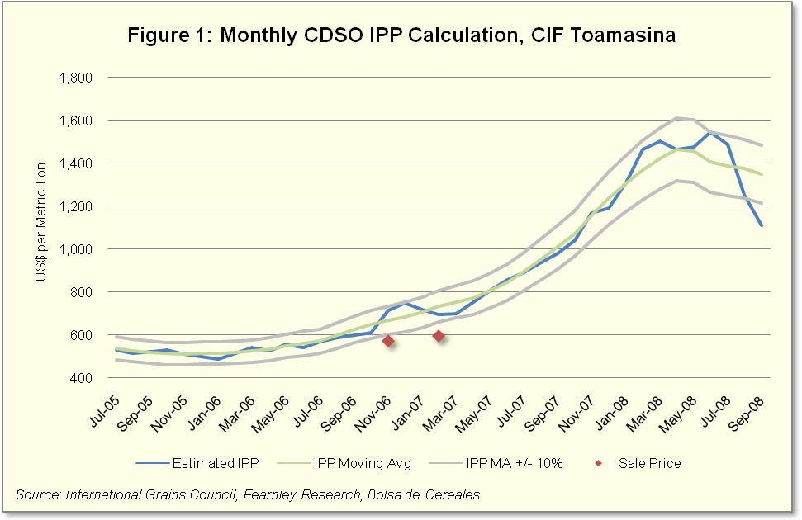
Details of IPP Calculation
- Uses as a base price the FOB value of the commodity from a common source country including quality adjustment factor when applicable
- Applies average insurance rate of 0.3% FOB value
- Freight calculation includes the following:
  - Source country to Durban: assuming Handysize 20,000 – 30,000 MT Vessel (Source: IGC)
  - Durban to destination (Toamasina): assuming Handysize 53,000 MT Vessel with a capacity of 47,250 (Source: Fearnleys Research)
    - Fuel Consumption: 33 MT/day at sea
    - Best and Worst case scenarios are averaged to estimate rate
      - First Scenario: assumes 4 days at sea with a full load of 47,250
      - Second Scenario: assumes 8 days at sea (to account for empty backhaul) and a load of just 10,000 MT (common food aid shipment)
  - Freight Forwarders Fee: 5%
- Port disbursement fees: $15/MT
The 2007 HRWW monetization included bids submitted by two wheat milling companies, Seaboard/LMM and TIKO/Mana for two separate lots of 2,000 MT each. Seaboard/LMM provided the winning bids for February and June 2007 delivery at US$235/MT for each shipment, representing 68 percent recovery of costs to USAID for the February contract, and 73 percent for the June contract. Cost comparison to IPP, based on a six-month moving average of Argentinean HRWW plus ocean freight equaled 78 percent and 65 percent respectively. Contracted deliveries were for no later than April and August 2007, but actual deliveries were made on June 6 and September 20, 2007. Previous monetizations of wheat in March 2005 and January 2006 yielded better results in comparison to IPPs, representing 89 percent and 79 percent of corresponding IPPs at their respective times of sale. The decreasing trend of monetized price versus IPP can be explained in part due to the uncertainty of the international commodity markets in 2007 and 2008. A table with historical monetization and IPP annual average prices for HRWW is found in Annex VI.
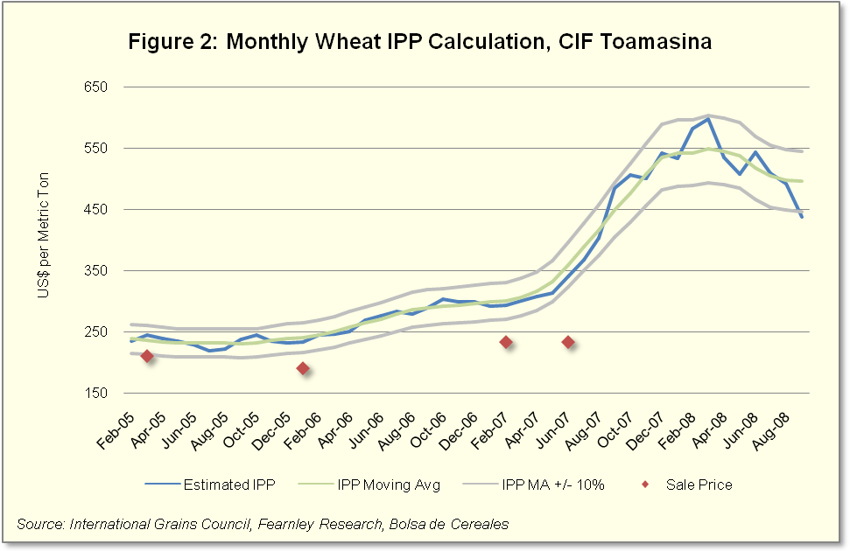
Table 4: WFP Commodity Distribution (MT)
Products | 2005 | 2006 | 2007
Rice | 4,000 | 3,744 | 11,972
Sorghum | - | 2,000 | 2,000
Whole Green Peas | - | 420 | 1,200
Split Peas | 197 | 420 | 480
Beans | - | - | 440
Peas Wheat Blend | 131 | - | 300
Vegetable Oil | - | 100 | 250
CSB | 210 | 200 | 43
Biscuit | - | 38 | 11
TOTAL | 4,538 | 6,922 | 16,696
Source: Food Aid Shipment 2006-07, Food Aid Convention, International Grain Council; CEMM: Compagnie des Experts Maritimes de Madagascar
It is important to note that Seaboard has ended commercial operations in Madagascar in October 2008 and KOBAMA, the owner of the facility that was being leased to Seaboard, has resumed its commercial operations at that facility, with the goal of producing a reported 2,500 MT of wheat flour per month.

2.2.3 WFP and Other Donor Programs
The World Food Program (WFP) activities make up the balance of food aid being distributed in Madagascar. In the most recent year analyzed (fiscal year July 2006-June 2007), WFP received 53 percent of its non-emergency food for distribution programs from the U.S. Government, and the balance from a consortium of EU members (France, Germany, Norway, Holland, Italy), Switzerland, Japan and Canada.
The WFP non-emergency program, targeted in the south and southeast of the country, consists of a food for work program for road building, feeding programs for lactating and pregnant women, and school feeding programs. WFP currently does not procure any of its donated commodities locally, although it is considering local procurement of CSB and nutrition biscuits in the near future. WFP does procure commodities from third countries, most notably rice from Pakistan and India.

3.0 Distribution and Storage

3.1 Warehousing/Storage Capacity
An inspection of CARE and CRS warehouses in Toamasina confirmed that facilities are clean, dry and secure. Contracted guard service is 24 hours a day, seven days a week. The entrances to the buildings are secure, and the warehouses are surrounded by walls topped by barbed wire. There are pest traps in the interior of each facility. CRS has conducted calls forward on several occasions in the past three years that were in excess of its Toamasina facility’s 1,200 MT capacity. CRS representatives indicated that when deliveries exceed storage capacity, transportation to up-country distribution points is coordinated to avoid any overcapacity at the main facility. ADRA is currently looking for new storage facilities in Ambositra and Antsirabe. LOL has not arranged storage as it has not been involved in distribution.
Table 5: CS Warehouse/Storage Capacity Table
Location | CS | Rented, Owned, Leased | Capacity (MT)
Tamatave | CARE | Rented | 2,550
Fenerive Est | CARE | Rented | 998
Vatomandry | CARE | Rented | 450
Mahanoro | CARE | Rented | 350
Moromanga | ADRA* | TBD | TBD
Tamatave | CRS** | Owned | 1,200
Total |  |  | 5,548
*ADRA: is moving from its current location and has not selected a new site
** CRS: Made three calls forward/year of 1,400 to 2,000 MT each; is able to transport some volumes immediately to up-country distribution points

3.2 Port Facilities
The port of Toamasina has available warehousing surface of 53,020 m² capacity of 28,000 MT of bagged food aid, with 6,000 MT of additional storage that can be arranged by the port authority, if necessary. This warehouse space is not secure from access within the port area (the overall port is guarded), was damp, and not protected from rodents. Considerable upgrades would be necessary to use this facility for storage. There is a new, automated offload conveyer system that can discharge 300 MT/hour of bulk commodities into the TIKO Mana Mill facility at the port. TIKO has 32,000 MT of modern grain storage (for bulk wheat or soybean) at this location. Offloading into the former Seaboard/LMM facility, which has reverted back to KOBAMA with the departure of Seaboard, is at the rate of 125 MT/hour, and that facility has older silos that can accommodate up to 24,000 MT of bulk grain.
The port also has a modern container loading/offloading facility managed by a private concession, International Container Terminal Services Ltd. This facility has two berths, 12-meter draft, and can discharge over 800 short containers per day. The facility also has storage for up to 12,000 containers, with a 2,000-container expansion in the works.
The peak operating months at the port are September through February.
The port of Tolanaro in southern Madagascar is being upgraded to accommodate exports from the mining industry. Other international ports include Antsiranana, Mahajanga, and Toliara. None of these ports are currently viable to receive non-emergency food aid shipments.

3.3 Transport Capacity
Truck transport remains the dominant mode of inland transportation for regions covered by Cooperating Sponsor programs. Rehabilitating road transport has been slow and difficult, particularly to access the Toamasina region. Secondary and tertiary roads in the Cooperating Sponsors’ regions of operation have deteriorated, making delivery in the region difficult. Tertiary roads in the southern region have not improved and continue to make deliveries to these isolated areas almost impossible during the rainy season months of November through April.
National primary roads have improved and continue to benefit from road rehabilitation projects funded by donors and the Malagasy government.
The Toamasina to Antananarivo railroad has improved and is providing daily freight round-trip service. The Antananarivo section to Antsirabe remains irregular. The Fianarantsoa to Manakara line is only providing irregular service.
Truck service from the port to Antananarivo is approximately US$43/MT and rail service varied from US$30-50/MT over the past year. While usually higher cost, trucking is preferred for its more predictable delivery schedules.

4.0 Policy Issues

4.1 Free Trade and Bi-lateral Agreements
Madagascar is a member of the New Partnership for Africa’s Development (NEPAD) Comprehensive African Agriculture Development Program (CAADP), under which it is required to commit at least 10 percent of its annual budget to agricultural development. It is also a member of the Southern African Development Community (SADC) and the Common Market for Eastern and Southern Africa (COMESA) which provides reduced tariffs and trade barriers among member countries.
SADC’s goal is to further socio-economic cooperation and integration as well as political and security cooperation among 14 southern African states. Following the introduction of its Free Trade Zone in 2000, SADC and member states have successfully lowered or removed some trade barriers and improved both the region’s institutional and physical infrastructure. It is reported that tariffs have been removed on 85 percent of products traded while some other commodities will retain their duty until 2012.
COMESA is a Free Trade Area (FTA) of 19 countries in the region that allows for lower customs duty rates on imports from member countries and allows it to apply a Common External Tariff (CET) to non-member countries.

4.2 Regulatory Climate
To simplify the general import tariff structure applicable in Madagascar, the customs and the import tax were consolidated into a single tax referred to as the customs duty. The customs duty has four bands: 5, 10, 20 and 25 percent. This restructuring has led to import duty reductions for over 200 goods. There is no import duty on rice; however an excise taxes remains on CDSO (5 percent) and powdered milk (20 percent). Tariffs on imported commodities that are also produced in Madagascar carry a 20 percent duty. In 2008, the value-added tax on all goods was increased to 20 percent.
The GoM has worked on improving customs operations and boosting revenues by prohibiting ad hoc tax and/or tariff exemptions outside those specified in the Customs Code and trade agreements. It has strengthened monitoring and oversight by using modern scanners for custom clearance in collaboration with Companie des Experts Maritime de Madagascar (CEMM).
Table 6: Madagascar Tariff Schedule for Various Commodities (%)
 | Wheat | Rice | CDSO | Dried Milk | Wheat  Flour | Corn | Beans | Lentils | Peas
Customs Duty | 0 | 0 | 0 | 0 | 10 | 20 | 20 | 20 | 20
Excise Tax | 0 | 0 | 5 | 20 | 10 | 0 | 0 | 0 | 0
VAT (a) (%) | 20 | 20 | 20 | 20 | 20 | 20 | 20 | 20 | 20
Source: Ministry of Commerce
(a) VAT Calculation = (CIF + CD + ET) x 20 percent

The Ministry of Agriculture imposes health certification restrictions on the import of most agricultural commodities, including rice, wheat products, and pulses. These regulations require presentation of:
- Certificate of origin;
- Certificate of inspection of ship’s holds;
- International phytosanitary certificate, subject to verification by customs upon arrival;
- Fumigation certificate; and
- Non-radiation certificate.
For any imported food, an import permit is also required before a phytosanitary certificate is issued. The permit must be obtained from the Ministère d’Etat au Développement Rural et ā la Reforme Foncière quarantine service prior to any preshipment inspection by the USDA Animal and Plant Health Inspection Service (APHIS) in the U.S.
The GoM imposes no specific GMO-related restrictions on the importation of agricultural commodities.

4.3 Other Policy Issues Affecting Food Aid
- The Government agreed with the IMF to simplify and streamline the taxation system. Madagascar started liberalizing its trade regime and reducing its average tariff from 16.2 percent at the end of 2005 to 13.5 percent in 2006 and then to 12.9 percent in 2007, slightly below the SSA average of 13.0 percent.
- As an SADC member Madagascar has begun to phase out its tariff on imports from SADC countries. In a first phase, customs duties on the majority of tariff lines will be eliminated by 2012, leading to a significant liberalization of imports. SADC countries account for 12.5 percent of Madagascar imports and this is expected to grow over the next three to five years as investment increases in agribusiness targeting broadly consumed food items (rice, dairy products, vegetable oils and meat). As of August 2008, Madagascar has fully complied with the SADC FTA regime.
- Concerns with rising food prices led the Government to remove the tariff and temporarily lower the VAT on rice imports during the second half of 2008.
- To prevent shortages and hoarding, the Government imposed a suspension of rice and maize exports in April 2008. The IMF has issued a strong warning against this policy.
- In January 2006, under the Multilateral Debt Relief Initiative (MDRI), Madagascar received about US$2.3 billion (42 percent of GDP) in debt relief from the IMF, the World Bank, and the African Development Bank. The debt service declined by 45 percent because of the implementation of the MDRI. The debt relief is freeing up resources for priority spending by several ministries, including the Ministry of Agriculture.

5.0 Selection of Products
To identify potential products for monetization, import statistics were analyzed to indicate which commodities are consistently imported in sufficient quantities and values to meet the requirements of a monetization program. Based on import data, rice, vegetable oil, wheat and milk powder were analyzed as candidates for monetization.
Table 7: Madagascar Top Food Commodity Commercial Imports Average 2003-2007
Commodity | MT | US$000s
Rice (whole grain and broken) | 193,313 | 53,116
Vegetable oil (non refined) | 68,497 | 39,470
Wheat (whole grain) | 44,500 | 11,701
Milk powder (whole and skim) | 2,104 | 5,445
Maize | 2,593 | 887
Source: UN Comtrade

6.0 pRODUCT sPECIFIC ANALYSIS

6.1 Rice

6.1.1 Domestic Production
As a result of GOM emphasis to increase self-sufficiency in this priority food crop, domestic rice production has increased from approximately 2.8 million MT of paddy in 2003 to 3.6 million MT in 2007. Two provinces, the upper parts of Toamasina in the Lac Alaotra region, and Mahajanga in the Marovoay region, produce the bulk of irrigated rice during three distinct growing seasons, while four other provinces produce one crop per year, using either rain-fed or hillside irrigation. Southern Madagascar does not produce rice.
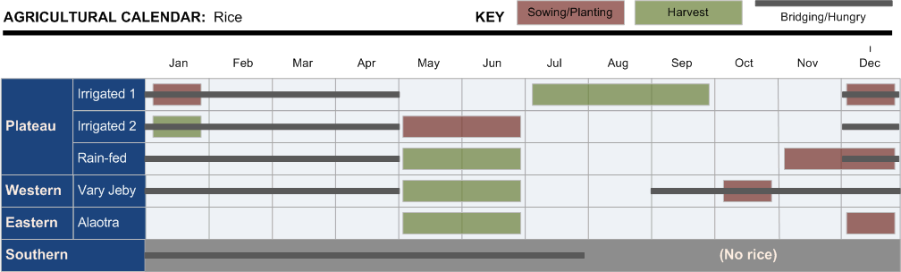
Source: Observatoire du Riz

Average on-farm productivity of paddy has increased by over 230 percent in the last eight years to reach to 2.8 MT/ha according to official government statistics. While such yields may be attained by some producers, others (Uphoff of Cornell) estimate average yields to be closer to 2 MT per hectare.
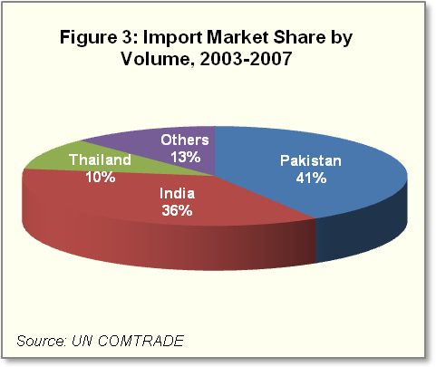
Much of the harvested crop is sold as paddy either directly to millers or through collectors/consolidators. Using mechanized milling technology, optimal milled rice recovery is about 70 percent by weight from paddy (20 percent is hull and 10 percent bran), although recovery in Madagascar ranges from 55 to 65 percent.

6.1.2 External Trade
Madagascar has imported nearly 1 million MT (US$266 million) of rice over the past five years, with three countries (Pakistan, India and Thailand) providing the majority of these imports (87 percent of total). In 2007, imports totaled 172,000 MT valued at US$60 million (US$349/MT average).
Domestic demand in 2007 increased four percent over the previous year, to 2.38 million MT, and increased at an average 5 percent per year from 2003-07. Domestic production increased 19 percent over the same period.
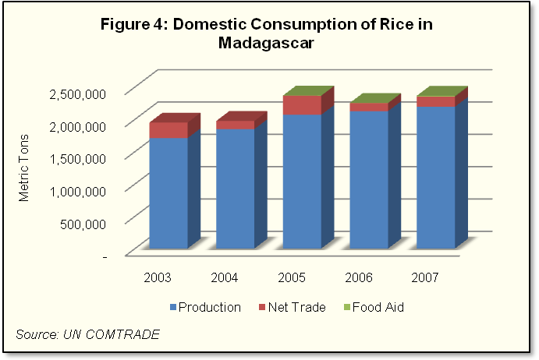
While Madagascar consistently supplies over 90 percent of its demand through domestic production, becoming an important regional supplier is an objective of the current government. Meeting this objective will require more intensive rice production techniques, improvements in transportation and milling, and other improvements in marketing efficiencies. Currently, there is a small percentage of the Madrigal variety (a basmati-type) rice exported to neighboring islands of Comoros and Mauritius, reportedly for Malagash populations in those locations. Since rice available through Title II programs will be of a different variety, the likelihood of re-exporting is low.

6.1.3 Domestic Markets
Rice is the most economically important agricultural commodity in Madagascar, with estimates of up to 70 percent of the population playing some role in the value chain. Surplus rice is marketed through a variety of consolidators or through small-scale village-level rice mills. In the last 10 years there has been an expansion of smaller private mills, including a dozen small to mid-size mills within Antananarivo and the city’s periphery, as well as in other rice-producing regions. These mills process locally produced paddy and use imports to fill supply gaps during the main bridging period (November-April).
Larger companies involved in collection, import, processing and wholesale/distribution business are likely buyers of monetized rice. These include:
- Fanamby Rice Mill, largest mill in the country; owned by TIKO group (collection; importing, milling, packaging, wholesaling), with processing capacity of 14 MT/hour and storage of 30,000 MT. Estimated annual imports of 100,000 MT.
- MADRIGAL (collection, importing, milling, packaging, wholesaling), with processing capacity of 5 MT/hour and storage capacity of 3,000 MT in Marovoay and 20,000 MT in Ambatondrazaka (Lac Alaotra). Estimated annual imports of 10,000 MT.
- KOBAMA (collection, importing, milling, wholesaling). Estimated annual imports of 10,000 MT.
- OMD (collection, importing, wholesaling). Estimated annual imports of 5,000 MT.
- Ramanandraibe exportation (collection, importing, wholesaling). Estimated annual imports of 6,000 MT.
Domestic rice is rated in two general quality categories: supermarkets selling white rice in one to 25 kg bags of two to 20 percent broken; and small local shops that sell loose rice that is up to 40 percent broken.

The private-sector group Plateforme du Riz meets regularly to coordinate with the Ministry of Commerce, Industry and Private Sector on the quantity and timing of rice imports in order to avoid abrupt price fluctuations throughout the year. Domestic reporting of rice price and production information is provided via the l’Observatoire du Riz, a weekly bulletin of price and volume information on different rice varieties, both milled and paddy, as well as international markets.
Based on production and consumption trends, Madagascar will need to import an average 150,000-160,000 MT per year to meet demand over the period covered by the MYAP.

6.1.4 Prices
Rice prices in Antananarivo’s wholesale market have fluctuated over the past two years, increasing from US$420/MT in July 2007 to more than US$900/MT by May 2008. Since then, however, prices have rapidly declined. The average wholesale price for domestic rice during this period ranged from US$450 to US$661/MT, while paddy sold for as little as US$250/MT farmgate. Price data is summarized below and in Annex V.
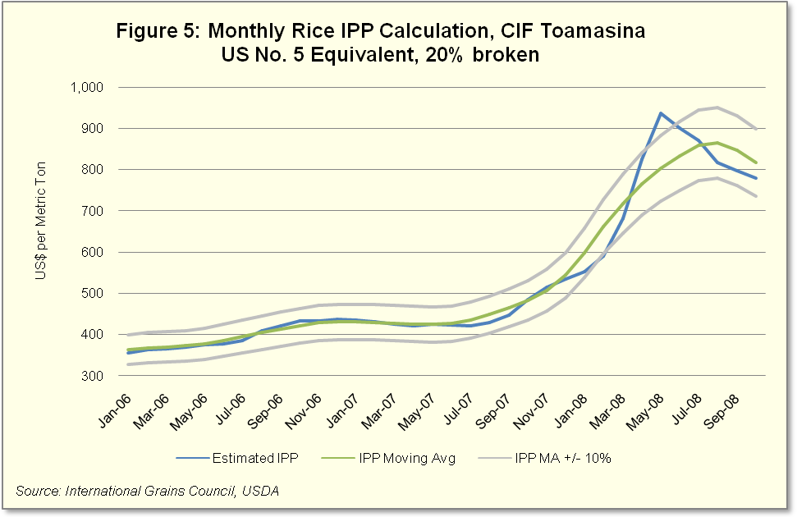

6.1.5 Impact Analysis
Volume of food aid in proportion to imports and production
Although the GOM goal is to become a regional rice exporter, the country will need to import between 160,000 and 175,000 MT of rice per year if domestic consumption and production continue at their current rates.
Impact on Local Production
Rice is the country’s most important food crop but current production is not meeting domestic demand. Imports valued at over US$60 million (2007) supply approximately five percent of domestic consumption.
It should be noted that rice is a highly political crop in Madagascar. In order to avoid any impression that monetized rice may be undercutting domestic prices, leading to claims of local production and market disincentives, it is critical that monetization achieves import parity price.
Impact on Local Markets
There is an expanding and competitive local market where rice can be monetized. The importers cited above have indicated their interest in purchasing rice through a monetization program. Several smaller wholesale companies have also expressed an interest in rice if smaller lots are made available.
Seasonality and delivery issues
Based on the rice production calendar, optimum months for monetizing rice are November through April. It is critical to ensure that the delivery corresponds to this bridging season in order to avoid depressing local prices during harvest seasons.
Degree of substitution
According to observers who work in rice marketing in Madagascar, when prices increase 8-10 percent, four out of five households adjust their purchasing to lower-cost substitutes such as cassava, potatoes and maize. Bread has also gradually become a permanent staple in place of rice among many, mainly urban, consumers.
Relation to other food aid imports and local purchases
No rice has been monetized by USAID or USDA during the past five years. In 2007, ADRA, CARE and CRS brought in 4,680 MT of rice for their distribution program, a decrease from 5,990 MT distributed in 2005. The WFP distributed 11,972 MT of rice in 2007, an increase from 4,000 MT distributed in 2005.

6.1.6 Adequate Storage Capacity
Adequate storage may be at issue if monetization takes place during or shortly after harvest seasons. The country’s storage and transport capacity is at or near capacity during and after harvest, but becomes available in the bridging season. If rice is monetized at the port, as has been the practice for wheat and CDSO, then storage problems are not anticipated.

6.2 Hard Red Winter Wheat (HRWW)

6.2.1 Domestic production
Domestic production of wheat compared to national consumption is insignificant. Production is limited to two regions: Vakinakaratra region producing 963 MT; and Mahajanga province producing 2 MT. It is estimated that wheat production has increased slightly in 2007 to 982 MT. Millers indicate that the quality of local wheat is not suitable for baking.
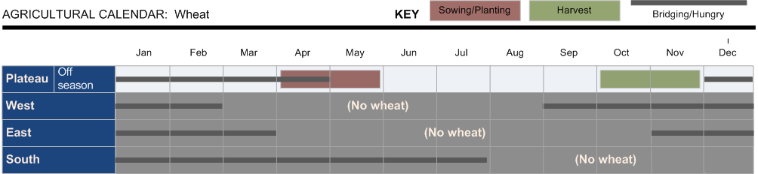

6.2.2 External trade
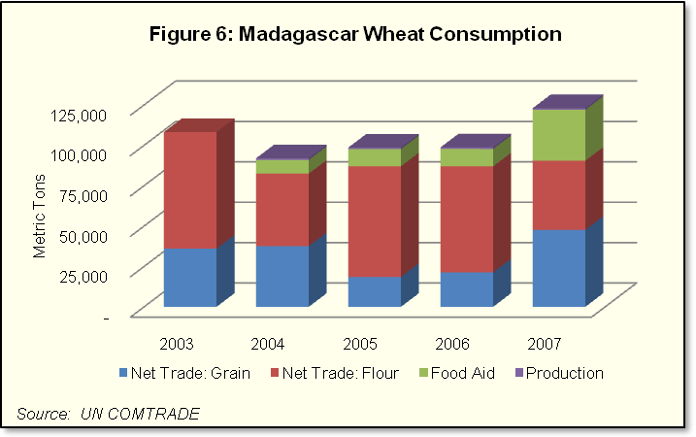
In 2007, of the 80,000 MT of wheat grain imported to Madagascar, France supplied nearly 70 percent (54,775 MT) while the U.S. and Argentina supplied 19 percent and 10 percent respectively. The U.S. supply consisted entirely of wheat monetized through Title II programs. Of the 32,000 MT of imported wheat flour, the leading supplier was also France, accounting for 36 percent of total imports by volume (11,448 MT), followed by Turkey and Mauritius, accounting for 32 percent and 21 percent of the market share respectively. Figure 6 illustrates the proportion of wheat and wheat flour (expressed in wheat grain equivalent) imports to total consumption over the last five years. Total wheat grain equivalent consumed in Madagascar, including food aid, averaged 103,000 MT per year over the past five years (see Annex VI).
U.S. wheat monetized by CRS increased from 8,510 MT in 2004 to 15,990 MT in 2007. Land O’ Lakes monetized 12,450 MT of HRWW in 2007 through USDA’s Food for Progress program. These sales represent 35 percent of all wheat imports in 2007, an increase from 18 percent just three years earlier. The increase in volume of wheat grain imports, at the expense of wheat flour, is due to the expanding milling capacity. There is no data to indicate that any volumes of wheat or wheat flour are currently being exported from Madagascar, nor are there data showing wheat being imported or monetized by other donor programs.

6.2.3 Domestic markets
The wheat sector has undergone significant changes over the past six years. In 2004, Madagascar imported 46,000 MT tons of wheat, 45,000 MT (expressed in wheat grain equivalent) of flour and produced 1,000 MT of locally grown wheat, which equaled a national consumption level of 7,600 MT per month. Current consumption is more than 10,000 MT per month.
Through early 2006, KOBOMA was Madagascar’s sole wheat flour mill, producing medium-quality flour using a mix of locally produced and imported wheat. KOBOMA’s milling and storage operations were in two sites: Antsirabe, with a capacity of 180 MT per day supplying the country’s southern coast and plateau regions; and Toamasina, with a production capacity of 280 MT per day supplying Toamasina, Antananarivo and the north. The Toamasina facility also includes a 24,000 MT-capacity storage silo.
In March 2006, Seaboard, an integrated U.S.-based conglomerate, entered into a lease arrangement for both KOBOMA milling facilities under the name Les Moulins de Madagascar (LMM). In June 2007, the TIKO Group opened a new milling facility called the Mana Mill. Mana is a completely modern milling operation located at the port in Toamasina, with 120,000 MT per year milling capacity. Because of the expanded milling capacity these two companies provided, wheat flour imports declined drastically (from 46,000 MT in 2004 to only 2,000 MT in 2008), and wheat grain imports increased to 79,000 MT in 2007. The Mana facility, with its state-of-the-art blending equipment, was able to reduce raw material costs by importing cheaper soft white wheat grain at between US$320/MT – US$350/MT, instead of HRWW that was trading for up to US$420/MT during the same period. Since soft white wheat is lower in gluten, Mana supplemented its flour with gluten to meet baking requirements. Mana’s plant manager has indicated that it still prefers using HRWW, but cost considerations are an important part of their buying decision.
The port of Toamasina has installed a modern high-speed bulk load discharger that feeds directly into the Mana mill, enhancing that facility’s operating efficiency at the expense of its competitor. Because of the modern offloading facility, which increased dockside efficiency over 140 percent (300 MT/hr versus 125 MT/hr to the KOBAMA facility), coupled with Mana’s aggressive pricing strategy for wholesale flour, Seaboard/LMM decided to terminate its operations in Madagascar the month of October 2008. In their place, KOBAMA/Groupe Prey has resumed milling operations at the Antsirabe facility, but is reportedly experiencing startup difficulties. KOBAMA’s plan is to produce 2,500 MT/month of flour and estimate that its raw material requirements will total 40,000 MT of imported wheat per year. KOBAMA has expressed its interest in procuring wheat of up to 5,000 metric tons every three months.

6.2.4 Impact analysis (monetization)
Volume of food aid in proportion to imports and production
It is estimated that wheat consumption in Madagascar, averaging 104,000 in the past five years, will continue to increase by one to three percent per year. Wheat provided through USDA and USAID food aid increased from 8 percent of total imports in 2004 to 35 percent in 2007, and in that year monetized HRWW sold at 18 percent and 35 percent below estimated IPP in two monetizations.
Impact on Local Production
Domestically produced wheat comprises less than one percent of the total annual demand. Consequently, there will be little impact from further monetization. There are indications that wheat is being substituted for rice and other staples, primarily in urban households, but this is a market trend that would continue regardless of food aid. Monetization below market prices may be a contributing factor, however.
Impact on Local Markets
The local wheat grain market is comprised of two companies, the TIKO-owned Mana Mill and the KOBAMA Mill in Antsirabe which has resumed operations in October 2008. The most recent monetization of HRWW through Seaboard/LMM resulted in prices that were on average 30 percent below the cost to USAID and ranged from 11 to 35 percent below estimated IPP. Price competition for monetization of wheat is a concern going forward with TIKO in a dominant competitive position in the domestic market due to its size and the efficiency of its milling facility in Toamasina, and the uncertainty of competitiveness of KOBAMA as it resumes operations after the departure of Seaboard/LMM.
Seasonality and delivery issues
Since production volumes are less than one percent of total demand, and domestic demand for wheat is consistent throughout the year, the seasonality of monetization will not create any local production disincentives. However, the timing of wheat delivery has been an issue with buyers in the past, with the most recent deliveries arriving one month or more after the contracted date. Since commercial mills plan their raw material inventory purchases in advance, delayed deliveries disrupt processing schedules. Breaking the stated delivery terms of a contract has the effect of lowering the value of future sales as businesses factor this into their offer price.
Degree of substitution among other commodities
The study team could not find definitive proof that wheat food aid is a substitute for other food consumed in Madagascar. Data indicates that wheat consumption is growing, particularly in cities. The substitution effect of wheat flour for corn flour and for rice consumption is an area that needs further analysis.
Relation to other food aid imports or local purchases
In addition to wheat made available through the Title II program for monetization in 2007, Land O’Lakes monetized 12,450 MT while CRS distributed 3,095 MT of wheat provided through USDA. In 2007, total monetized wheat was very high in relation to total commercial imports (35 percent), up from 8 percent just four years earlier. Full recovery of import parity price is critical to prevent food aid monetization from having a disincentive effect on local competition, prices and markets.

6.2.5 Adequate Storage Capacity
Since all wheat is monetized at the port, storage facility capacity is not at issue in the determination decision. That said, Mana has 32,000 MT of silo storage at its Toamasina port/milling facility, which is sufficient for four months of its required raw material inventory. KOBAMA has storage silos also at the Toamasina port that can hold 24,000 MT of grain.

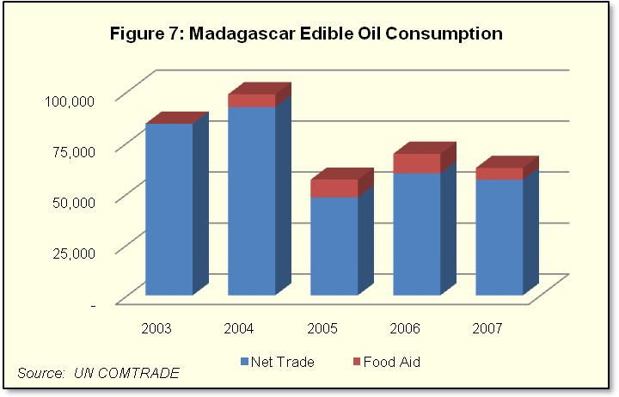
6.3 Crude Degummed Soybean Oil (CDSO)

6.3.1 Domestic Edible Oilseed Production
Madagascar’s edible oilseed production is very low compared to domestic demand. A small amount of coconut oil, mainly artisanal, is produced in coastal areas. Groundnuts were once Madagascar’s main source of vegetable oil but production has decreased significantly from 44,000 MT in the 1970s to its current level because of disease problems that have never been addressed. There is still an artisanal industry using small hand-operated village presses in rural areas that produce oil, a protein paste, and animal feed. Cotton seed, a by-product of cotton fiber production, has continued to decrease from its 2005 level due to the decline in cotton production in the country. Soybean production dropped from 14,000 MT in 1990s to an estimated 3 MT in 2007.

7.3.2 External Trade
Average consumption of vegetable oil over the past five years has been approximately 69,000 MT per year. Import data from 2007 shows that more than 92 percent of Madagascar’s vegetable oil is imported commercially. The vast majority of Madagascar’s vegetable oil imports come from Argentina, with 68 percent of the market share (comprised primarily of crude soybean oil) and Malaysia, with 25 percent of the market share (comprised primarily of crude palm oil). The U.S., Canada, South Africa and Kenya supply most of the balance.
Over the past five years, vegetable oil supplied from food aid sources has averaged 7 percent of total consumption. During this period, ADRA, CARE and CRS monetized more than 22,000 MT of CDSO. ADRA and CRS also distributed an additional 1,800 MT of refined vegetable oil, while WFP distributed 350 MT of refined vegetable oil.

6.3.3 Domestic Markets
Local edible oil processing and marketing is a monopoly controlled by TIKO Oil Production (TOP). TOP operates two plants, in Antsirabe and Toamasina, with a combined processing capacity of 140,000 MT/year. The Toamasina plant imports roughly 70 percent soybean oil and 30 percent palm oil. Vegetable oil is marketed domestically in either 55-gallon drums (the majority of production since TOP’s principal market is the wholesale trade) or in one-liter bottles. In addition to vegetable oil, TOP produces 5,000 MT of margarine per year for industrial and retail markets. TOP provides approximately 90 percent of the country’s edible oil and margarine.
Table 8: Edible Oil Processing Capacity (MT/year)
 | Capacity | Actual 2007
TOP Toamasina | 60,000 | 43,000
TOP Antsirabe | 80,000 | 6,000
HITA | 15,000 | 4,000
INDOSUMA | 3,000 | 1,000
Total | 158,000 | 54,000
Source: Private Sector Interviews (September 2007)
Other companies involved in smaller scale processing of refined vegetable oil are the Huilerie Industriel de Tamatave (HITA) which operates a processing facility in Toamasina that is reported to be operating at 30 percent of its 15,000 MT/year capacity. HITA cannot handle bulk shipments and instead prefers to procure small containerized lots via South Africa. Their facility processes soybean and palm oil. INDOSUMA is the only oil processing plant in the southern region. This company has a 3,000 MT/year capacity which is one-third utilized processing cotton seed into oil and cottonseed cake for animal feed.
Total vegetable oil processing capacity and actual production in 2007 are provided in Table 8.

6.3.4 Impact Analysis
Volume of food aid in proportion to imports and production
Since local production of oilseeds negligible, Madagascar relies on imported vegetable oil in crude and refined form to meet local demand. Vegetable oil made available through food aid programs, primarily for monetization, has averaged 6,000 MT or 9 percent of the average domestic market of 69,000 MT per year. Two monetization sales of CDSO, in late 2006 and early 2007, were at 86 percent and 81 percent of estimated IPP, respectively. The industry estimates that annual demand will increase an average four percent per year to approximately 72,000 MT by 2013.
Impact on Local Production
Local oilseed production for commercial use has declined over the years to the point that Madagascar relies almost exclusively on imports for their domestic consumption. An average of 6.4 percent of domestic consumption is provided by monetized food aid, and a very small percentage is provided by distributed food aid.
Impact on Local Markets
As the largest oil processor in Madagascar, TOP is the principal competitor for vegetable oil monetization. HITA and INDOSUMA were not interested in participating in upcoming tenders of bulk CDSO. Therefore the disadvantage to monetizing CDSO is that there will be no competition and, as a result, it is uncertain whether market rates will be achieved. The track record backs this up. The most recent monetization of CDSO, in February 2007, returned a sales price of US$595/MT, which was 72.6 percent recovery of costs to USAID, and 81.2 percent return against a moving average IPP. Since there is only one domestic buyer of unprocessed vegetable oil, there is insufficient competition, which will lead to monetization below IPP.

Seasonality and delivery issues for CDSO
Since local supply is minimal and storage available at TOP is more than adequate, seasonality of delivery will only be affected by port congestion during the peak traffic period.
Degree of substitution among other commodities
Domestic supply of all vegetable oil crops is minimal; therefore substitution is not a significant issue.
Relation to other food aid imports or local purchases
Under the USDA program, 1,780 MT of CDSO were monetized by ADRA in 2007. The WFP imported less than 400 MT in the past two years for its distribution programs.

6.3.6 Storage Capacity
TOP’s oil storage facility in Toamasina holds 8,500 MT, with plans to increase this to 14,000 MT, and an additional 2,500 MT in Antsirabe. The HITA plant can store up to 3,000 MT. This is adequate storage for the historical average of calls forward during the past four years of 4,000–6,000 MT.

6.4 Non-Fat Dry Milk (NFDM)

6.4.1 Domestic Production
Madagascar’s dairy production falls into three general categories: traditional dairy production with local purebred cows and a low yield of 1 to 5 liters/day; artisanal dairy production with improved local purebred cows imported from Europe, herds of no more than five dairy cows and an average yield of 8-20 liters/day; and industrial production comprised of imported dairy cows with at least 20 productive cows and producing yields of up to 30 liters/day. The dairy landscape is changing as a result of pilot projects launched to increase milk consumption in schools and the importation of highly productive dairy cows over the last three years. The current Government goal is to increase the dairy herd fourfold to meet rising demand for fresh milk products.
The majority of dairy farms and principal processing operations are located in the “dairy triangle” in the central plateau between Antsirabe and Fianarantsoa. TIKO reportedly sources over 80 percent of its raw material needs from local farms. It also owns a dairy farm with plans to expand the herd from 1,200 to 5,000 milking cows.
Overall milk production, including reconstituted milk and by-products, is estimated at 33 million liters of liquid milk per year. An estimated 50 percent of this production is consumed on the farm or marketed locally. The balance is sold and processed by the two main dairies in Madagascar, TIKO and SOCOLAIT, located in Antsirabe. TIKO has a production capacity of 200,000 liters/day and is the largest dairy operation in Madagascar. SOCOLAIT, with a capacity of 6,000 liters/day, is currently operating at 33 percent capacity producing drinking yogurt and UHT, with both products incorporating NFDM as part of the blend with raw milk purchased on the local market. They also produce baby formula (Farilac) using milk powder as part of the blend.
SOCOLAIT purchases approximately 1,000 MT of NFDM per year for reconstituting in its yogurt and baby food formulas. TIKO’s annual requirements were unavailable but are believed to be less than 400 MT/year of NFDM. Distributors PANDORA and SOREDIM together import one to two containers of powdered milk (20-40 MT) per month for wholesale and retail sale as milk powder.

6.4.2 External Trade
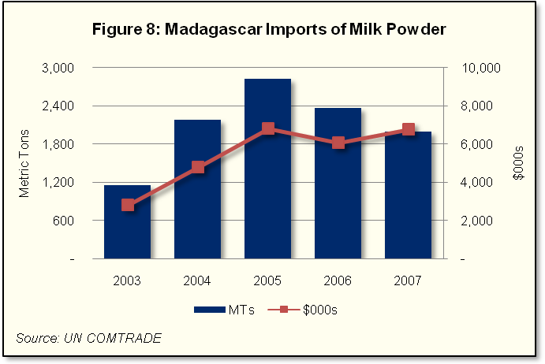
Madagascar’s imports of milk powder have fluctuated over the last five years peaking at 2,826 MT in 2005. In 2007, milk powder prices increased by 56 percent, peaking at US$4,750/MT, which depressed demand in 2006 and 2007.
Over the four year period 2004-2007, India has been the largest exporter to Madagascar totalling 2,208 MT, followed by New Zealand (1,519 MT) and Ukraine (853 MT).

6.4.3 Domestic Markets
Milk powder is available at the retail level for household use, including TIKO brand, SOREDIM-Ravi brand, SOCOLAIT-O’Lait brand, and PANAGOR. Milk powder is preferred by many consumers over fresh milk for several reasons: it does not require expensive cooling equipment (and related energy costs), it is more efficiently transported due to lower unit weight per unit of liquid milk, and can be sold in small units, which works particularly well in Madagascar’s large rural sector and limited purchasing power.

6.4.4 Impact Analysis
Volume of milk powder in proportion to imports and production
Madagascar averaged 2,100 MT/year of milk powder imports over the past four years despite international prices that increased to record levels in mid-2008. Prices have dropped dramatically and are returning close to historical levels. SOCOLAIT uses approximately half of the milk powder imported per year, as NFDM, to blend into its process products. They have also bid on a contract with the GoM Ministry of Health (World Bank funding) to develop a milk powder/cereal blend to supply domestic nutrition programs. TIKO reportedly uses up to 400 MT of NFDM per year and has indicated it would be interested in procuring NFDM made available through Title II programs. Because of the increased local production resulting from private sector expansion and Government support for dairy development, the amount of imports is projected to remain relatively stable or even decline in the coming years.
Impact on Local Production
There is no local production of milk powder but as international prices continue to decline both whole-fat and non-fat milk powder are becoming competitive with locally-produced milk. At estimated IPP (October 2008) plus inland transport, the price of non-fat dried milk was US$0.55/liter compared to local whole milk quoted at US$0.41/liter at the SOCOLAIT factory gate.
Impact on Local Markets
At current international prices milk powder is becoming competitive with domestic whole milk as international prices continue their steep decline. There is insufficient domestic production to keep either plant at full capacity so each plant will continue to procure some milk powder, with a stated preference for NFDM. There is a legitimate argument for enhancing domestic supply with imported milk powder to help build the industry. Supplementing local supply with milk powder will result in increased volumes and lower costs for the processing sector, and more supply of products at a lower cost on the local market, resulting in higher dairy product consumption. For any milk powder sale, the buyer would need to ensure that the FFP policy on infant formulas would be followed (see Annex IX for policy).
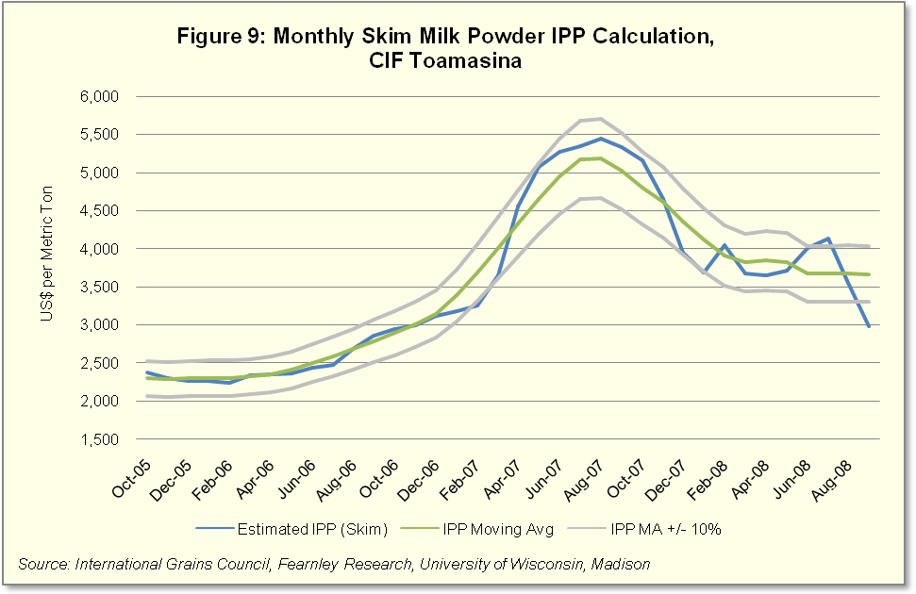
Seasonality and Delivery Issues
Fresh milk production declines significantly during the dry season which is between June and October and powdered milk can fill this supply gap. However, at current volumes of milk powder imports, seasonality of delivery is not an issue according to the industry.

Degree of substitution among other commodities
Milk powder for reconstitution is often cited as displacing locally produced fresh milk. TIKO, the main dairy processors in Madagascar, sources nearly all of its raw material from local sources and is in the process of expanding its dairy herd to 5,000 head to help meet processing requirements. However there is still significant unmet demand by the processing industry that can be met through milk powder.
Relation to other food aid imports or local purchases
USDA’s Title I program has provided only a small amount of milk powder through GoM distribution programs (in 2005) and according to sources will not provide milk powder in the foreseeable future. The WFP indicated they are orienting their feeding program policy to purchase as much of their commodity needs as possible through local sources, as has the French Government’s feeding program. Both programs have contacted SOREDIM and SOCOLAIT to produce a nutritional blend that includes some powdered milk. At the date of this report neither company had reached an agreement on local production of these blends.

6.4.6 Storage Capacity
There is clean, dry and secure space at TIKO, SOCOLAIT and SOREDIM for storage of milk powder. PANAGORA’s facilities have not been visited.

6.5 International Monetization
When competition in a commodity market is severely limited, monetization activities in that market run the risk of introducing or intensifying such market distortions and deficiencies. In so doing, the monetization activity would reinforce those factors that frustrate the development of an openly and fully competitive market, thereby contributing to either excessive profits or barriers to entry. By denying producers and consumers the opportunity to operate within a competitive market, the monetization activity over time could lead to reduced national economic efficiency and assign indeterminate costs to producers and consumers. Monetization in such a market would be contrary to the legal prescription of the U.S. agricultural legislation, which requires that monetization does not introduce local market or production disincentives.
International monetization (IM), or regional or third country monetization, can offer an alternative for cooperating sponsors who find themselves operating in a country with less than fully competitive domestic commodity markets.
IM provides cooperating sponsors with the option of selling into a market where there is sufficient competition among buyers for a commodity, in order to increase the likelihood that bids will be at or near import parity. With sufficient competition, there is assurance that the monetization is not distorting the market and can result in higher revenue generation than if the monetization was conducted in a domestic market with limited or no competition. IM can result in generating greater revenue for food security activities and thereby increase the efficiencies of the FFP program. Because of highly limited competition in the Madagascar market, IM is a reasonable option for proposed monetization commodities.
FFP 2009 Guidelines
Monetization in the recipient country is preferred over monetization in a “third” country, a country where the food security activities will not take place. If it is not feasible to monetize in the country where proceeds will be utilized, monetization may be carried out in another low-income food-deficit country (LIFDC) in the region, i.e., “third country.” A list of LIFDCs can be found on FAO’s Web site at: http://www.fao.org/countryprofiles/lifdc.asp?lang=en. If the LIFDC option is not feasible, then monetization may take place in a U.N. classified, least-developed country (LDC) in the region: http://www.un.org/special-rep/ohrlls/ldc/list.htm. In the case of “third country” sales, the USAID Mission and/or U.S. Embassy in both the program country and the monetization country must endorse the plan.
The appropriate third country or regional market is that market in which it is reasonable to expect to receive a price reflective of the international price. As the final destination of the commodities sold is indeterminate, the relevant reference to ensure that the Bellmon “market” conditions are satisfied is that the final negotiated price is comparable to the import price for that market. In addition, the port facilities of the selected market platform need to be sufficient to physically accommodate the commodities.
Monetization in a relatively large port city is preferred as inland freight and other costs can be assumed by the buyer. The preferred currency in which the transaction would be conducted would be specified in the offer.
Based on the above criteria, the following products and markets can be considered for IM:
Table 9: Potential Products and Markets for International Monetization
 | Mombasa, Kenya |  |  |  | Mozambique Ports |  |  |  | Dar Es Salaam, Tanzania
 | MT |  | $000s |  | MT |  | $000s |  | MT | $000s
Total Annual Import Market* | 1,725,952 |  | 607,396 |  | 743,080 |  | 318,324 |  | 1,034,552 | 335,272
Wheat | 844,558 |  | 198,126 |  | 280,425 |  | 63,569 |  | 623,732 | 139,393
Rice | 314,899 |  | 81,604 |  | 258,645 |  | 117,527 |  | 62,501 | 12,995
Vegetable Oil** | 564,531 |  | 323,398 |  | 180,119 |  | 96,849 |  | 347,070 | 182,068
Milk Powder | 1,964 |  | 4,268 |  | 23,890 |  | 40,379 |  | 1,249 | 817
LIFDC | ✓ |  |  |  | ✓ |  |  |  | ✓
Port City | ✓ |  |  |  | ✓ |  |  |  | ✓
No FE Restrictions | ✓ |  |  |  | ✓ |  |  |  | ✓
Adequate Port Facilities | ✓ |  |  |  | ✓ |  |  |  | ✓
No Significant Security Issues |  |  |  |  | ✓ |  |  |  | ✓
Source: UN Comtrade
*Excluding U.S. sourced food aid
**Average 91 percent palm oil

If IM is selected as an option, a widely advertised competitive procurement using newspapers, the Internet and radio is recommended. Advertisement should be explicit regarding commodity specifications, delivery time range and transaction location, payment terms and required currency. An auction process using a commodity exchange should be considered. Finally, both the Mission Director of the IM country and the MYAP country must approve the use of this procedure.

7.0 Analysis and Recommendations

7.1 Analysis of food aid program issues
Non-emergency food aid provided by all identified sources increased 45 percent by volume between 2005 and 2007, primarily due to an expanded monetization program that increased 161 percent over this period. ADRA, CARE, CRS and LOL monetized a total of US$32.8 million from 2004-2007 in CDSO (54 percent of total by value) and HRWW (46 percent of total by value).

7.1.1 Product Specific Analysis for Monetization
Rice
Estimated demand for rice is 2.38 million MT in 2007 while domestic supply (including domestic production, less a small amount exported to the EU) stands at 2.19 million MT. Imports of 172,000 MT made up the balance. Because of GoM emphasis on increasing rice production to the point of becoming an important regional exporter, growth in national production has been exceeding growth in consumption on average by one percent per year over the past five-year period. We expect rice imports to continue to decrease over time from the current five-year average of 193,000 MT, but still play an important role in meeting domestic demand.
Competition among importers is better than in other commodity sectors in the country, with five companies importing over 75 percent of total imported rice. All five companies have expressed an interest in procuring rice from the MYAP program. The optimum months for monetizing rice are November through April. This is when commercial stocks are lowest, domestic prices increase, and storage facilities have available space. Care must be given to ensure timely delivery. To meet the entire annual budget needs of the new MYAP, approximately 7,000 MT (four percent of imports) of rice would need to be monetized at current market prices. Since international prices are declining, the required amount may be higher when the actual tender takes place, but should not exceed 10 percent of total imports. Because of the national importance placed on rice self-sufficiency, it is critical that monetization does not create local production and market disincentive.
Wheat
Estimated annual domestic demand for wheat was approximately 123,000 MT in 2007, with less than one percent produced by local farmers. Twenty-six percent of imported wheat is brought in through food aid programs, primarily for monetization. Wheat grain is imported to supply the Mana Mill of the TIKO Group, and for mills in Toamasina and Antsirable that were leased by Seaboard/LMM, which in October 2008 ended operations in Madagascar. The owner of those mills, KOBAMA, has reportedly resumed production in Antsirabe with plans to produce 2,500 MT/month of flour.
There is adequate storage at the Port of Toamasina for up to 54,000 MT of grain, with approximately 20,000 MT used on average by the Mana Mill. KOMBAMA has silo capacity for 24,000 MT of grain. There may be port congestion to consider during the peak shipping season of September through February. Delays in monetized wheat delivery have occurred in the past and are a concern of the buyers. Mana Mill purchases a mix of wheat, both hard (high gluten) and soft (requiring gluten supplements) for its flour blends. The cost to Mana of their commercial mix was not available to the team, but six-month moving average IPPs were calculated using prices from Argentina, a key supplier of wheat to Madagascar, in an attempt to more accurately compare costs. The FOB Argentina price was adjusted to more accurately reflect the cost of U.S.-produced HRWW.
Two calls forward were conducted in 2007 for monetized HRWW, in February and June for US$234/MT, which was at a recovery rate 68 and 73 percent of cost to USAID respectively. When compared to historical estimates of IPP costs for FOB Argentina wheat, plus shipping and port costs, the monetized prices received in February and June 2007 are 78 and 65 percent of IPP respectively.
With the departure of Seaboard and KOBAMA just restarting production, and TIKO operating a highly efficient mill at the port, the level of competition in the market for HRWW is uncertain at the moment. Without adequate bidding competition, results of future monetization tenders will continue to be below prevailing commercial prices. Wheat monetization, unlike rice, it will not compete with local production.
Vegetable Oil
Vegetable oil demand in Madagascar has averaged 69,000 MT per year, with over 90 percent supplied from imported commercial sources and approximately eight percent through food aid programs. Domestic oilseed production, primarily groundnut, soybean, cottonseed and coconut, has declined in the last decade to approximately 100 MT per year, sufficient to produce only 30 MT of oil.
Local edible oil processing and marketing is dominated by one company, TIKO Oil Production (TOP). With two refining plants in Madagascar, TOP controls 90 percent of the market, while two smaller companies supply the balance. Neither of these processors is interested in participating in upcoming monetization tenders, which leaves TOP as the only company that will bid for vegetable oil. The most recent monetization (Feb 2007) of CDSO with TOP resulted in a 73 percent recovery rate of costs to USAID and only 81 percent of the estimated IPP. An earlier monetization recovered approximately 86 percent of estimated IPP. Without adequate bid competition, the likelihood of future monetization tenders being at or near IPP is low.
Milk powder
Milk powder imports supply a small share of the overall milk market in Madagascar, averaging just 2,100 MT/year over the past five years. SOCOLAIT requires an estimated 1,000 MT/year for drinkable yogurt and other processed products, and TIKO reportedly uses 400 MT/year. Both use NFDM in their blending. The balance is marketed through wholesale and retail distributors to consumers in powdered form. World market prices for milk powder were at record levels in mid-2008, but have declined by November 2008 to make milk powder more competitive with domestically produced raw milk. Local processors prefer raw milk, but there will continue to be demand for powdered milk until domestic production increases. The GoM as well as donor programs, notably Land O’Lakes, have introduced programs to meet this objective.
Demand for milk powder at current prices does present an opportunity for monetization, with both processors interested in participating in upcoming monetization tenders. It is estimated that 200 MT of NFDM can be monetized, which would be approximately 10 percent of the import market. Since the development of the domestic dairy industry is of high national priority, care must be taken to ensure that sales are made at market rates.
Any monetization of NFDM would need to comply with the International Code of Marketing of Breastmilk Substitutes and all subsequent relevant World Health Assembly (WHA) resolutions pertinent to the sale or distribution of breastmilk substitutes. NFDM may be sold for industrial use as an ingredient in processed foods, baked goods, yogurt, etc. NFDM cannot substitute for breastmilk or be used for products represented or locally perceived as breastmilk substitutes. It cannot be sold for direct market distribution, for example, in small tender sales, and cannot be sold directly to consumers. In addition, NFDM cannot be sold to known manufacturers or marketers of breastmilk substitutes or replacement foods with breastmilk substitute production facilities.

7.2 Analysis of storage and distribution issues
Terms of sale of monetized wheat and oil have been at the Port of Toamasina. There is adequate storage for grain in both the TIKO/Mana Mill and in KOBAMA facilities (total 56,000 MT capacity for wheat, soybean, or maize). Mana receives shipments of 20,000 MT each 45-60 days, and KOBAMA estimates its needs at 10,000 MT each three months. There is adequate capacity to store monetized wheat, estimated to be up to 12,000 MT per call forward, in either facility. TOP (TIKO) oil facilities in Antsirabe and Toamasina have a combined 11,000 MT of oil storage capacity, which is being increased to 14,000 MT. Oil processing capacity per annum at both facilities total approximately 6,000 MT, and with average monetization ranging from 1,000 to 2,500 MT over the past two years, storage is determined to be sufficient. Potential buyers of powdered milk have clean and dry storage capacity sufficient for any anticipated calls forward of that product. Because rice is a major domestic crop in Madagascar, storage capacity will depend on the seasonality of the monetization.
Storage facilities maintained by CARE and CRS for their distribution programs are clean, dry and well guarded. The CRS facility is too small to handle distributed food aid, that have averaged 1,400 to 2,000 MT per delivery, since their facility only has a 1,200 MT capacity. CRS has indicated that they have other storage upcountry to handle any excess. ADRA is currently looking for new storage facilities in Ambositra and Antsirabe. LOL does not currently distribute food aid and does not require storage facilities.
Port facilities are adequate to handle deliveries of bulk commodities and container shipments. Both are operated by concessionaires, and the container facility is state-of-the-art. Peak season for the port is September through February, where delays in docking and unloading may occur.
Inland transport is dominated by trucking, and secondary and tertiary roads in the areas where CSs operate are poorly maintained and often impassable during the rainy season. National primary roads are paved and adequate. A railroad between the port of Toamasina and the capital Antananarivo provides daily freight service, and all other lines (to Antsirabe, Fianarantsoa, Manakara) provide only irregular service. Trucking is more expensive, but also provides a more predictable delivery schedule.
There are no constraints to storing monetized wheat and vegetable oil. Our recommendation is that CRS address their storage capacity issue in greater detail for future calls forward, and that secondary and tertiary road transport of food aid be avoided during the rainy season, when possible.

7.3 Analysis of key policy issues
Because of rising prices and shortages of rice, the GOM has removed import tariffs and temporarily lowered the VAT on imported rice. It has also suspended exporting of rice and maize.
There are no other identified policy issues that will have an adverse effect on food aid monetization and distribution. As a member of COMESA and SADC free trade agreements, tariffs and other trade barriers with other member countries have been or are being removed. This should result in increased trade flows of surplus commodities between countries, including pressure on national commodity prices to be more in line with international prices

Annex I: Country Background and Overview
Demographic and Geographic Information
- The population of Madagascar was about 20 million persons in 2008, with an annual growth rate of 3 percent.
- The world’s fourth largest island, Madagascar has a land area of approximately 587,000 square kilometers, composed of a central province that encompasses Antananarivo and five other provinces: Fianarantsoa in the south central plateau; Toamasina in the central east coast; Toliary in the southern tip of the island; Antsiranana to the north; Mahajanga in the northwest.
- Madagascar ranks 143 out of 177 countries in the 2005 Human Development Index. Life expectancy is 58 years and GDP per capita is US$923.
Economic Overview
- Exports totaled $986 million in 2007 and included coffee, vanilla, shellfish, sugar, cotton cloth, chromite and petroleum products to France, U.S., Germany, U.K., and Italy.
- Imports totaled $1.92 million in 2007 and included capital goods, petroleum, consumer goods and food from France, China, Iran, and South Africa.
- Madagascar received nearly US$1 billion in economic aid in 2005 from the U.S., EU, World Bank, Canada and Japan.
Agricultural Sector Overview
- Madagascar’s agriculture is one of the most diversified in Africa due to the island’s differentiated landscapes, seacoasts and climatic environments.
- Agriculture base includes livestock (Zebu, draught oxen, dairy cattle, goat, sheep, swine, poultry), fisheries (artisanal small-net casting, waterway traps, large shrimp farms), tree crops (tropical wild fruits, desert sisal plantations), and cereals, pulses, legumes, and root crops, as well as a large variety of exotic high-value export products such as vanilla, herbs, spices, litchi, clove, black pepper, medicinal plants and cocoa.
- Formerly a major rice exporter to the East African region, Madagascar is now a net rice importer.
- Arable land makes up 5 percent (30,000 square kilometers) of the total land area, and over 10,000 square kilometers are irrigated. The average cultivated farm is 1.2 hectares in size.
- Soil erosion and declining fertility significantly impact productivity. An estimated 200-400 tons of soil is lost annually per hectare, compared to the world average of 11 tons per hectare.
- Madagascar’s Action Plan prioritizes activities in the agriculture and rural development sector; the Ministry of Agriculture, Livestock and Fisheries (MAEP) has committed to substantially increase agricultural production, establish agribusiness centers (ABCs) that function as extension and training centers, and provide agricultural inputs and storage facilities to rural producers. Rice production receives the most attention with the objective of self-sufficiency and becoming a major regional exporter.
Key Food Crop Production Volumes (MT)
 | 2000 | 2007 | %Change
Corn | 169,800 | 403,160 | 137%
Cassava | 2,463,360 | 2,573,550 | 4%
Sweet Potato | 512,640 | 643,600 | 26%
Potatoes | 286,790 | 325,200 | 13%
Groundnuts | 35,030 | 55,300 | 58%
Rice | 2,480,470 | 3,595,760 | 45%
Source: MAEP statistics and National Agricultural Survey
Major Food and Cash Crops
- Primary products for domestic consumption, by category of food types, are root crops, cereals, sugar cane, and leguminous and oleaginous crops. Rice and cassava are the key staples in the Malagasy diet.
- Sweet potatoes, potatoes, beans, groundnuts and small amounts of meat, fish, fruits and vegetable oil complement the diet, with considerable differences depending on geographic zones.
- Area planted has increased considerably in the past eight years (with the exceptions of cassava and potatoes) and yields (production per hectare) have shown increases for most crops based on MAEP actual and estimated data (see Annex 2 for more detailed crop production data).
- Key high-value export crops include coffee, liche, clove and cocoa (grown in the Cooperating Sponsors’ central east coast target zones), as well as vanilla and tobacco (grown in the north and northeast). These products accounted for over $100 million in exports in 2007.
Overview of Normal Dietary Requirements for Households
- In a 2005 survey, over 67 percent of an average household’s budget was spent on food, a reduction from 80 percent in 1997.
- In addition to the food items referred to above, new food products such as noodles, milled-flour breads, and fried and packaged snacks have taken on increasing importance in the national diet in both urban and rural areas. Corn, cassava, sorghum, potato, sweet potato and legumes are eaten in periods when rice prices increase by over 10 percent. The most consumed meat is beef, followed by poultry and pork.
Food Consumption Patterns by Region (kg/head/year)
Commodity | Antananarivo | Antsiranana | Toliary | National
Rice | 118 | 144 | 54 | 114
Corn | 14 | 3 | 31 | 12
Cassava | 37 | 11 | 55 | 36
Other tuber plants | 24 | 3 | 20 | 15
Legume | 22 | 11 | 21 | 15
Fruits | 14 | 12 | 7 | 11
Meat and fish | 14 | 15 | 17 | 14
Milk & eggs | 16 | 3 | 8 | 9
Edible oil | 3 | 2 | 2 | 2
Sugar | 5 | 5 | 9 | 6
Bread | 6 | 2 | 1 | 3
Other food | 7 | 5 | 8 | 6
Source: Priority Household Survey (EPM) main report (INSTAT, August 2000)

Dietary intake varies considerably from region to region, with rice comprising 67 percent of the diet in the north (Antsiranana), while only 23 percent of the diet in the south (Toliary). The national average dietary intake of rice is 47 percent. Tubers such as cassava and potatoes are important food security crops in rural areas of Madagascar during hunger seasons, but are also an important staple crop in the southern part of the country and Antananarivo (32 percent of the diet versus national average of 20 percent). Bread is becoming an increasingly important food in urban areas. Table 2 shows the diversity of diet in different regions of the country as well as the national average.
There continue to be shortages of food in areas with poor infrastructure linkages, markets and farm productivity. These zones include USAID’s focus areas in the cyclone-prone central-eastern coast, and WFP target areas in the south.

Annex II: Population
Population by Provinces: Madagascar
Province | 2004 | 2005 | 2006 | 2007 | 2008
Antananarivo | 5,370,900 | 5,484,263 | 6,843,483 | 7,065,896 | 7,676,297
Antsiranana | 1,291,100 | 974,178 | 964,878 | 996,236 | 1,082,297
Fianarantsoa | 3,730,200 | 4,257,523 | 3,823,160 | 3,914,913 | 3,166,723
Mahajanga | 1,896,000 | 2,038,558 | 2,019,096 | 2,084,716 | 2,264,808
Toamasina | 2,855,600 | 2,669,970 | 2,644,479 | 2,730,424 | 2,966,297
Toliary | 2,430,100 | 2,615,849 | 2,573,007 | 2,656,629 | 2,886,127
Total | 17,573,900 | 18,040,341 | 18,868,103 | 19,448,814 | 20,042,549
Source: INSTAT

PROVINCES
1.Antananarivo | 2.Antsiranana | 3.Fianarantsoa | 4.Mahajanga | 5.Toamsina | 6.Toliary
Analamanga | Diana | Amronn’I Mania | Betsiboka | Alaotra | Androy
Bongolava | Sava | Atsimo- Atsianana | Boenny | Mangoro | Anosy
Itasy |  | Matsiatra | Melaky | Analanjirofo | Atsimo
Vakinakaratra |  | Ihorombe | Sofia | Atsinanana | Andrefana
 |  | Vatovavy- Fitovinany |  |  | Mena
Regions are names mentioned in body of the analysis

Annex III: Crop Production
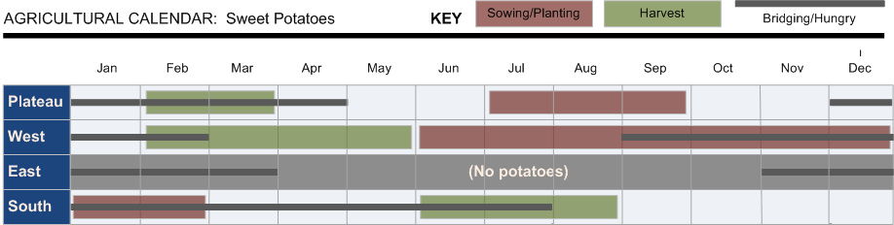

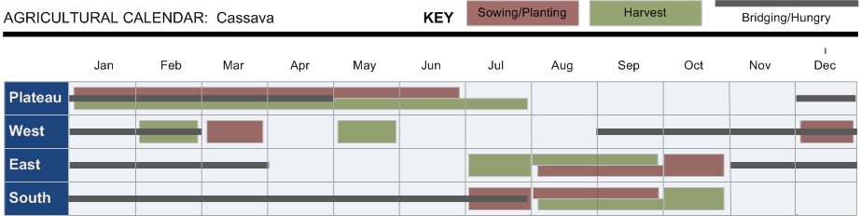

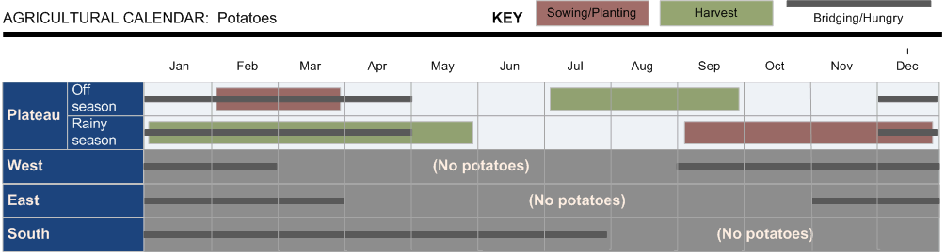

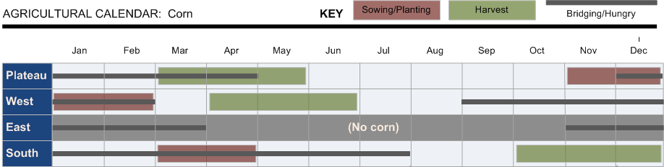

MADAGASCAR: PROGRESSION OF AGRICULTURAL PRODUCTION, AREA and YIELD 2000 – 2007
 | 2000 | 2001 |  | 2002 |  | 2003 | 2004 | 2005 | 2006* | 2007* | % ∆ '00-'07
CORN
Ha | 192,135 |  | 193,270 |  | 194,405 | 195,530 | 196,660 | 252,838 | 330,000 | 333,000 | 72%
MT | 169,800 |  | 179,550 |  | 171,950 | 317,860 | 308,510 | 390,902 | 373,300 | 403,160 | 122%
MT/Ha | 0.9 |  | 0.9 |  | 0.9 | 1.6 | 1.6 | 1.5 | 1.1 | 1.2 | 29%
CASSAVA
Ha | 351,730 |  | 351,985 |  | 352,345 | 352,815 | 353,285 | 388,779 | 310,370 | 313,200 | -11%
MT | 2,463,360 |  | 2,510,340 |  | 2,366,250 | 1,992,200 | 1,949,400 | 2,963,945 | 2,358,780 | 2,573,550 | -1%
MT/Ha | 7.0 |  | 7.1 |  | 6.7 | 5.6 | 5.5 | 7.6 | 7.6 | 8.2 | 12%
SWEET POTATOES
Ha | 91,025 |  | 91,240 |  | 94,455 | 105,735 | 118,360 | 123,913 | 122,400 | 123,500 | 35%
MT | 512640 |  | 525,130 |  | 493,030 | 492,940 | 487,600 | 878,539 | 869,000 | 643,600 | 46%
MT/Ha | 5.6 |  | 5.8 |  | 5.2 | 4.7 | 4.1 | 7.1 | 7.1 | 5.2 | 8%
POTATOES
Ha | 49,205 |  | 49,410 |  | 49,655 | 49,965 | 50,275 | 36,830 | 37,840 | 38,200 | -23%
MT | 286790 |  | 294,810 |  | 296,050 | 255,000 | 246,370 | 214,652 | 220,600 | 325,200 | -6%
MT/Ha | 5.8 |  | 6.0 |  | 6.0 | 5.1 | 4.9 | 5.8 | 5.8 | 8.5 | 22%
GOUNDNUTS
Ha | 47,205 |  | 47,450 |  | 47,725 | 47,950 | 48,480 | 61,018 | 61,380 | 61,740 | 30%
MT | 35030 |  | 35,240 |  | 35,410 | 35,610 | 34,590 | 54,506 | 54,800 | 55,300 | 57%
MT/Ha | 0.7 |  | 0.7 |  | 0.7 | 0.7 | 0.7 | 0.9 | 0.9 | 0.9 | 20%
RICE
Ha | 1,209,300 |  | 1,212,650 |  | 1,216,020 | 1,219,350 | 1,237,000 | 1,250,092 | 1,291,000 | 1,302,600 | 7%
MT | 2,480,470 |  | 2,662,465 |  | 2,603,965 | 2,800,000 | 3,030,000 | 3,392,460 | 3,485,000 | 3,595,760 | 38%
MT/Ha | 2.1 |  | 2.2 |  | 2.1 | 2.3 | 2.4 | 2.7 | 2.7 | 2.8 | 29%
Source: MAEP statistics and National Agricultural Survey 2005
*2006 and 2007 are estimates based on 2005 Survey

Cereals prices at Antananarivo wholesale market 2007-2008, MGA/Kg
Wholesalers | Products | Jan-Mar | Apr-Jun |  | Jul-Sept |  | Oct
 | Rice, local | - | - |  | - |  | -
 | Rice, imported | - | - |  | - |  | -
Mme ONY | White beans | 1,300 | 920 |  | 1,000 |  | 1,100
033 02 812 60 | Red beans | 980 | 980 |  | 940 |  | 940
Anosibe | Lima beans | 920 | 850 |  | 800 |  | 850
 | Garbonza | 920 | 850 |  | 800 |  | 850
 | Corn | 800 | 700 |  | 750 |  | 800
 | Coffee | 3,050 | 3,700 |  | 3,700 |  | 3,100
 | Soy beans | 1,100 | 1,000 |  | 950 |  | 1,000
 | Corn meal | - | - |  | - |  | -
 | Rice, local | 1,000 | 950 |  | 1,000 |  | 1,040
 | Rice, imported | 1,000 | 1,000 |  | 1,000 |  | 1,080
 | White beans | 1,400 | 1,000 |  | 1,100 |  | 1,100
Mme Dine | Red beans | 1,000 | 1,000 |  | 950 |  | 950
032 04 239 23 | Lima beans | 950 | 850 |  | 900 |  | 950
Anosibe | Garbonza | 950 | 850 |  | 900 |  | 950
 | Corn | 850 | 750 |  | 800 |  | 850
 | Coffee | 3,200 | 3,750 |  | 3,750 |  | 3,150
 | Soy beans | 1,100 | 1,000 |  | 950 |  | 1,100
 | Corn meal | - | - |  | - |  | -
 | Rice, local | 1,000 | 900 |  | 950 |  | 1,150
 | Rice, imported | - | - |  | - |  | -
 | White beans | 1,450 | 1,100 |  | 1,150 |  | 1,180
M. Ramaro | Red beans | - | - |  | - |  | -
Isotry | Lima beans | 1,100 | 950 |  | 1,000 |  | 1,100
 | Garbonza | 1,100 | 950 |  | 1,000 |  | 1,100
 | Corn | 850 | 750 |  | 800 |  | 850
 | Coffee | 3,300 | 3,800 |  | 3,800 |  | 3,200
 | Soy beans | - | - |  | - |  | -
 | Corn meal | - | - |  | - |  | -
 | Rice, local | - | - |  | - |  | -
 | Rice, imported | 1,250 | 1,200 |  | 1,120 |  | 1,200
SOCOMA | White beans | - | - |  | - |  | -
Mlle Zoly | Red beans | - | - |  | - |  | -
032 40 594 58 | Lima beans | - | - |  | - |  | -
 | Garbonza | - | - |  | - |  | -
 | Corn | - | - |  | - |  | -
 | Coffee | - | - |  | - |  | -
 | Soy beans | - | - |  | - |  | -
 | Corn meal | - | - |  | - |  | -
Exchange rate calculator: http://www.oanda.com/convert/classic

Annex iV: Cooperating Sponsors’ Programs
ADRA | CARE | CRS | Land O’ Lakes
Overall scope of programs
Increase household food security for 18,000 HH in at least 25 districts | Increase food security in rural provinces | FELANA (Food security to Enhance Livelihood through Agriculture & Nutritional Activities) | FFP Title I USDA dairy value chain development program
Principal activities
- Agriculture/ Infrastructure/ Marketing: double HH ag. Productivity; reduce post harvest loss; stabilize soil erosion; regenerate soil fertility; increase ag products and handicrafts sold by rural HH  - Health & Nutrition: immunization of children 12-23 mo; home mgt of childhood illness; responsible reproductive health decision | - Agriculture: extend cultivation areas; increase yield through improved seeds, techniques, tools, establish home gardens; Facilitate access to markets: Rehabilitate transport network; train community staff; strengthen producer associations.  - Health & Nutrition: build water related infrastructure; establish network of Village Health promoters; access to health related goods.  - Environmental health: urban Tana & Ft Daulphin; governance activities, supply and demand of services. | - Agriculture: increase resiliency of HH revenues; production, commercial sales, reduce crop and asset losses; disaster preparedness.  - Health and nutrition: improve health status of most vulnerable of rural families.  - Safety Net: basic human dignity of most vulnerable members in society | - Livestock/dairy sector
Specific Areas of intervention
30 communes of Mongoro Region, Toamasina Province | 50 Communes/ Districts: Fenerive E, Vavatenina, Sonierana Ivongo, Mahanoro, Vatomandry  -Antananarivo and Ft Dauphin | Agriculture:Toamasina E, Manajary,Farafangana(S-East), Anstsirabe (S.Cent)  Safety Net:Antananarivo, Finarantsoa | Dairy Triangle, Vakinakaratra

ADRA | CARE | CRS | Land O’ Lakes
Targeting strategy
- Food for Work  - MCH direct distribution  - Food for Training  - Incentives for community partners | - Select communes with ag potential and motivation.  - Target population lives on <US$1/day.  - Sign implementation MOU with Mayors; CARE establishes a Mgt committee tailored to activities; Committee is responsible to select FFW participants according to vulnerability criteria. | - Prioritize the most vulnerable; the decisions of who to select rest with the targeted municipalities.  - Guidance is provided regarding categories of most vulnerable.  - Includes women (the most marginalized in the region), those in jail, illiterates.  - Work closely with the Diocese in identifying target populations. | • Demonstrate willingness & ability to voluntarily participate in the project.  • Have access to land and a water source.  • Demonstrate willingness/ability to invest own resources & implement best practices.  • Currently engaged in milk marketing.  • Demonstrate willingness/apply & adhere to industry quality & hygiene.
Type of information collected at the client level
- Monitoring and evaluation documentation | - Farmers trained in improved rice cultivation & cropping techniques.  - % adopting 2 or more best practices.  - Farmers establish home gardens.  - % growing >2 recommended veg.  - % HH improved latrines & water from improved source. | - From the Diocese, obtain information on use of commodities and progress on distribution. | Production and sales.

Annex v: Rice Statistics
Madagascar Rice Production (MT)
 | 2003 | 2004 | 2005 | 2006 | 2007 | Average
Hectares | 1,219,350 | 1,237,000 | 1,250,092 | 1,291,000 | 1,302,600 | 1,260,008
Paddy(MT) | 2,800,000 | 3,030,000 | 3,392,460 | 3,485,000 | 3,595,760 | 3,260,644
Yield(MT/ha) | 2.3 | 2.4 | 2.7 | 2.7 | 2.8 | 2.6
Rice(MT) | 1,708,000 | 1,848,300 | 2,069,401 | 2,125,850 | 2,193,414 | 1,988,993
Source:AgriculturalSurvey2005and2006and2007MAEPestimates

Madagascar Rice Imports
 | 2003 |  | 2004 |  | 2005 |  | 2006 |  | 2007
 | MT | $000s | MT | $000s | MT | $000s | MT | $000s | MT | $000s
Pakistan | 104,284 | 19,773 | 51,236 | 10,754 | 60,390 | 17,507 | 73,518 | 19,819 | 109,765 | 37,210
India | 72,982 | 13,603 | 32,231 | 7,016 | 182,448 | 51,772 | 12,066 | 3,403 | 49,283 | 15,702
Thailand | 3,131 | 955 | 36,532 | 9,179 | 34,735 | 14,037 | 24,207 | 6,811 | 1,323 | 518
China | 57,747 | 11,938 | 2,005 | 259 | 5,613 | 2,453 | 10 | 4 | 1,928 | 655
Others | 2,176 | 660 | 33 | 23 | 9,677 | 3,330 | 11,351 | 4,001 | 1,535 | 789
USA | 1,000 | 174 | 4,089 | 1,792 | 6,229 | 2,421 | 7,020 | 3,776 | 6,159 | 4,077
S. Africa | - | - | - | - | 24 | 18 | 4 | 3 | 1,835 | 1,147
Total | 241,320 | 47,103 | 126,126 | 29,023 | 299,116 | 91,538 | 128,176 | 37,817 | 171,828 | 60,098
Source: UN COMTRADE
100630: Semi-milled/wholly milled rice, whether or not polished/glazed

Madagascar Rice Exports
 | 2003 |  | 2004 |  | 2005 |  | 2006 |  | 2007
 | MT | US$ | MT | US$ | MT | US$ | MT | US$ | MT | US$
Italy | - | - | - | - | - | - | - | - | 572 | 253
Comoros | 0 | 0 | 20 | 7 | 0 | 0 | 0 | 0 | 402 | 169
France | 347 | 201 | 340 | 198 | 203 | 143 | 125 | 85 | 394 | 216
Portugal | - | - | - | - | - | - | - | - | 286 | 134
Spain | - | - | - | - | - | - | - | - | 286 | 134
Others | 3 | 4 | 3 | 3 | 1 | 2 | 0 | 0 | 0 | 0
Total | 350 | 205 | 363 | 208 | 204 | 145 | 126 | 85 | 1,941 | 906
Source: UN COMTRADE
100630: Semi-milled/wholly milled rice, whether or not polished/glazed

Madagascar Rice Consumption
 |  |  | 2003 |  | 2004 |  | 2005 |  | 2006 |  | 2007 |  | Average
01 | Domestic Production |  | 1,708,000 |  | 1,848,300 |  | 2,069,401 |  | 2,125,850 |  | 2,193,414 |  | 1,988,993
02 | Imports |  | 241,320 |  | 127,514 |  | 305,106 |  | 133,546 |  | 177,108 |  | 196,919
03 | Commercial |  | 241,320 |  | 126,126 |  | 299,116 |  | 128,176 |  | 171,828 |  | 193,313
04 | Concessional |  | - |  | 1,388 |  | 5,990 |  | 5,370 |  | 5,280 |  | 3,606
05 | Distributed |  | - |  | 1,388 |  | 5,990 |  | 5,370 |  | 5,280 |  | 3,606
06 | Monetized |  | - |  | - |  | - |  | - |  | - |  | -
07 | Exports |  | 350 |  | 363 |  | 204 |  | 126 |  | 1,941 |  | 597
08 | Commercial |  | 350 |  | 363 |  | 204 |  | 126 |  | 1,941 |  | 597
09 | Local Procurement |  | n/a |  | n/a |  | n/a |  | n/a |  | n/a |  | n/a
10 | Apparent Disappearance |  | 1,948,970 |  | 1,975,451 |  | 2,374,303 |  | 2,259,270 |  | 2,368,581 |  | 2,185,315
11 | Producer Price (US$/MT paddy) |  | n/a |  | n/a |  | n/a |  | 268 |  | 312 |  | 290
12 | Wholesale Market Price (US$/MT) |  | n/a |  | n/a |  | n/a |  | 491 |  | 533 |  | 512
13 | Retail Prices (US$/MT) |  | n/a |  | n/a |  | n/a |  | 561 |  | 656 |  | 609
14 | Monetized Price |  | n/a |  | n/a |  | n/a |  | n/a |  | n/a
15 | IPP (US$/MT) |  | n/a |  | n/a |  | n/a |  | 393 |  | 449
16 | FOB – Pakistan |  | n/a |  | n/a |  | n/a |  | 354 |  | 391
17 | International transport |  | n/a |  | n/a |  | n/a |  | 39 |  | 58
18 | Customs duty |  | 0% |  | 0% |  | 0% |  | 0% |  | 0%
19 | Inland Transport |  | - |  | - |  | - |  | - |  | -
 |  | n/a=not available
01 |  | MAEP/Agricultural Survey Estimates
02 |  | Commercial (03) + Concessional (04) Imports
03 |  | UN Comtrade
 |  | 100630: Semi-milled/wholly milled rice, whether or not polished/glazed
04 |  | Distributed (05) + Monetized (06) Food Aid Imports
05 |  | Cooperating Sponsors
06 |  | N/A: Rice has not previously been monetized in Madagascar
07 |  | Commercial Exports (08) + Local Procurement for Export (09)
08 |  | UN Comtrade
09 |  | N/A
10 |  | Domestic Production (1) + Imports (2) - Exports (7)
11 |  | Observatoir du riz data
12 |  | Observatoire du rizdata
13 |  | Antananarivo market survey
14 |  | N/A: Rice has not previously been monetized in Madagascar
15 |  | Calculation of (Thai 100% B white rice, 50 Kg bagsFOB Value + International Transport) x (1 + Customs Duty) + Internal Transport
16 |  | FAO
17 |  | Estimate based on IPP Toamasina Port
18 |  | Ministry of Commerce
19 |  | Assume monetization at port

Detailed IPP Calculation
Month | FOB - PAK | Price Adjust* | FOB Adjust | INS | Freight | Handling | Estimated IPP | IPP Moving Avg
Jan-06 | 220.00 | 45% | 318.65 | 0.96 | 20.17 | 15.00 | 354.77 | 362.73
Feb-06 | 215.00 | 53% | 328.87 | 0.99 | 18.83 | 15.00 | 363.69 | 367.88
Mar-06 | 218.00 | 50% | 327.94 | 0.98 | 20.13 | 15.00 | 364.05 | 369.74
Apr-06 | 228.00 | 46% | 332.58 | 1.00 | 19.83 | 15.00 | 368.41 | 372.26
May-06 | 238.00 | 42% | 338.16 | 1.01 | 21.20 | 15.00 | 375.37 | 377.40
Jun-06 | 239.00 | 41% | 338.16 | 1.01 | 23.00 | 15.00 | 377.17 | 385.44
Jul-06 | 247.00 | 40% | 344.66 | 1.03 | 24.17 | 15.00 | 384.86 | 395.12
Aug-06 | 248.00 | 48% | 366.96 | 1.10 | 25.20 | 15.00 | 408.26 | 404.33
Sep-06 | 237.00 | 59% | 377.17 | 1.13 | 26.67 | 15.00 | 419.97 | 413.04
Oct-06 | 224.00 | 73% | 388.32 | 1.16 | 27.33 | 15.00 | 431.82 | 421.19
Nov-06 | 221.00 | 76% | 389.25 | 1.17 | 27.47 | 15.00 | 432.89 | 427.84
Dec-06 | 227.00 | 73% | 392.97 | 1.18 | 27.17 | 15.00 | 436.31 | 430.11
Jan-07 | 233.00 | 67% | 390.18 | 1.17 | 27.87 | 15.00 | 434.22 | 430.27
Feb-07 | 249.00 | 56% | 387.39 | 1.16 | 27.83 | 15.00 | 431.39 | 429.17
Mar-07 | 264.00 | 43% | 376.25 | 1.13 | 31.83 | 15.00 | 424.21 | 427.60
Apr-07 | 263.00 | 41% | 371.60 | 1.11 | 33.33 | 15.00 | 421.05 | 425.26
May-07 | 273.00 | 35% | 368.81 | 1.11 | 39.20 | 15.00 | 424.12 | 424.35
Jun-07 | 293.00 | 26% | 368.81 | 1.11 | 37.00 | 15.00 | 421.92 | 426.56
Jul-07 | 305.00 | 19% | 364.17 | 1.09 | 39.67 | 15.00 | 419.93 | 435.14
Aug-07 | 295.00 | 24% | 366.96 | 1.10 | 44.80 | 15.00 | 427.86 | 448.58
Sep-07 | 300.00 | 28% | 383.68 | 1.15 | 47.00 | 15.00 | 446.83 | 464.25
Oct-07 | 314.00 | 32% | 414.33 | 1.24 | 53.73 | 15.00 | 484.31 | 482.85
Nov-07 | 350.00 | 26% | 441.28 | 1.32 | 57.50 | 15.00 | 515.10 | 507.02
Dec-07 | 342.00 | 35% | 460.78 | 1.38 | 56.67 | 15.00 | 533.83 | 543.35
Jan-08 | 369.00 | 30% | 481.22 | 1.44 | 54.40 | 15.00 | 552.07 | 597.46
Feb-08 | 388.00 | 35% | 524.89 | 1.57 | 47.67 | 15.00 | 589.13 | 662.06
Mar-08 | 488.00 | 26% | 616.86 | 1.85 | 48.50 | 15.00 | 682.21 | 717.04
Apr-08 | 641.00 | 18% | 758.06 | 2.27 | 50.27 | 15.00 | 825.60 | 765.17
May-08 | 723.00 | 19% | 860.25 | 2.58 | 58.67 | 15.00 | 936.50 | 803.16
Jun-08 | 700.00 | 17% | 815.66 | 2.45 | 66.83 | 15.00 | 899.94 | 833.00
Jul-08 | 620.00 | 28% | 793.37 | 2.38 | 60.00 | 15.00 | 870.75 | 858.13
Aug-08 | 508.00 | 47% | 745.06 | 2.24 | 55.67 | 15.00 | 817.96 | 864.64
Sep-08 | 472.00 | 56% | 734.84 | 2.20 | 46.00 | 15.00 | 798.04 | 846.67
Oct-08 | 400.00 | 79% | 717.19 | 2.15 | 44.80 | 15.00 | 779.14 | 816.47
*FOB – Pakistan prices adjusted for quality difference between Pakistan 25% broken and US Grade 5, 20% broken

Annex vI: Wheat Statistics
Madagascar Imports of Wheat
 | 2003 |  | 2004 |  | 2005 |  | 2006 |  | 2007
 | MT | $000s | MT | $000s | MT | $000s | MT | $000s | MT | $000s
France | 26,000 | 7,140 | 36,001 | 7,279 | 20,000 | 4,545 | 18,501 | 3,843 | 54,775 | 19,106
USA | 10,030 | 1,588 | 10,019 | 2,516 | 9,110 | 2,056 | 13,610 | 4,056 | 15,440 | 3,525
Argentina | - | - | - | - | - | - | - | - | 8,000 | 2,537
Pakistan | - | - | - | - | - | - | - | - | 1,000 | 313
Other | - | - | 7 | 1 | 1 | 1 | 2 | 2 | 1 | 0
Total | 36,030 | 8,729 | 46,027 | 9,796 | 29,111 | 6,601 | 32,113 | 7,900 | 79,216 | 25,481
Source: UN COMTRADE
100110: Durum wheat
100190: Wheat other than durum wheat; meslin

Madagascar Imports of Wheat Flour
 | 2003 |  | 2004 |  | 2005 |  | 2006 |  | 2007
 | MT | $000s | MT | $000s | MT | $000s | MT | $000s | MT | $000s
France | 14,780 | 3,675 | 9,142 | 2,899 | 13,210 | 4,109 | 13,421 | 4,100 | 11,448 | 4,727
Turkey | 4,486 | 827 | 4 | 14 | 9,240 | 2,335 | 17,697 | 4,516 | 10,246 | 3,257
Mauritius | 14,557 | 4,397 | 10,800 | 3,451 | 9,151 | 2,995 | 8,825 | 3,009 | 6,794 | 2,991
UAE | 334 | 81 | 1,119 | 315 | 4,997 | 1,096 | 7,024 | 1,149 | 3,288 | 1,088
Other | 19,965 | 4,075 | 12,634 | 2,987 | 14,790 | 3,221 | 2,256 | 638 | 310 | 145
Total | 54,122 | 13,055 | 33,699 | 9,666 | 51,387 | 13,756 | 49,225 | 13,412 | 32,086 | 12,207
Source: UN COMTRADE
110100: Wheat/meslin flour

Madagascar Wheat Consumption
 |  | 2003 | 2004 |  | 2005 |  | 2006 |  | 2007 |  | Average
01 | Domestic Production | - | 1,000 |  | 965 |  | 972 |  | 982 |  | 784
02 | Imports | 108,193 | 90,960 |  | 97,628 |  | 97,746 |  | 121,998 |  | 103,305
03 | Commercial - Wheat | 36,030 | 37,517 |  | 18,511 |  | 21,303 |  | 47,681 |  | 32,209
04 | Commercial - Wheat Flour | 72,163 | 44,933 |  | 68,516 |  | 65,633 |  | 42,782 |  | 58,805
05 | Concessional | - | 8,510 |  | 10,600 |  | 10,810 |  | 31,535 |  | 12,291
06 | Distributed | - | - |  | 3,000 |  | - |  | 3,095 |  | 1,219
07 | Monetized | - | 8,510 |  | 7,600 |  | 10,810 |  | 28,440 |  | 11,072
08 | Exports | - | - |  | - |  | - |  | - |  | -
09 | Commercial - Wheat | - | - |  | - |  | - |  | - |  | -
10 | Commercial - Wheat Flour | - | - |  | - |  | - |  | - |  | -
11 | Local Procurement | - | - |  | - |  | - |  | - |  | -
12 | Apparent Disappearance | 108,193 | 91,960 |  | 98,593 |  | 98,718 |  | 122,980 |  | 104,089
13 | Producer Price (US$/MT) | n/a | n/a |  | n/a |  | n/a |  | n/a |  | -
14 | Wholesale Market Price (US$/MT) | n/a | n/a |  | n/a |  | n/a |  | n/a |  | -
15 | Retail Prices (US$/MT) | n/a | n/a |  | n/a |  | n/a |  | n/a |  | -
16 | Monetized Price (Avg.) | n/a | n/a |  | 210 |  | 191 |  | 234 |  | n/a
17 | IPP (Annual Avg.) US$/MT | n/a | n/a |  | 235 |  | 273 |  | 392 |  | n/a
18 | FOB - Argentina | n/a | n/a |  | 159 |  | 200 |  | 269
19 | International Transport | n/a | n/a |  | 76 |  | 73 |  | 123
20 | Customs Duty | 0% | 0% |  | 0% |  | 0% |  | 0%
21 | Inland Transport | n/a | n/a |  | n/a |  | n/a |  | n/a
22 | % IPP | n/a | n/a |  | 89% |  | 70% |  | 60%
 | N/A: Not Available
01 | MAEP/Agricultural Survey Estimates
02 | Commercial (03,04) + Concessional (05) Imports
03 | UN Comtrade
 | 100110: Durum wheat
 | 100190: Wheat and meslin (excl. durum wheat)
04 | UN Comtrade, converted to wheat equivalent at 1 MT wheat = 0.75 MT wheat flour
 | 110100: Wheat/meslin flour
05 | Distributed (06) + Monetized (07) Food Aid Imports
06 | Cooperating Sponsors
07 | Cooperating Sponsors
08 | Commercial Exports (08,09) + Local Procurement for Export (09)
09 | UN Comtrade, no exports reported
10 | UN Comtrade, no exports reported
11 | Cooperating Sponsors, no local procurement of wheat for Export
12 | Domestic Production (1) + Imports (2) - Exports (7)
13 | Insignificant domestic volumes produced
14 | N/A
15 | N/A
16 | Cooperating Sponsors
17 | Calculation of (FOB Value + International Transport) x (1 + Customs Duty) + Internal Transport
18 | FOB Argentina, Price adjusted for difference in quality to US HRWW
19 | International Grains Council/Fearnresearch, Calculation based on TC and fuel rates
20 | Ministry of Commerce
 | Note: Historically Wheat has been monetized at port and is therefore not subject to customs duties at time of sale
21 | Historically Wheat has been monetized at port and therefore has not incurred inland transportation costs
22 | IPP percentage based on average annual prices. Actual IPP percentage at time of monetization in Detailed IPP Calculation table

Detailed IPP Calculation
Month | FOB | Quality Adjust | FOB Adjust | INS | Freight | Handling | Est. IPP | IPP Moving Avg. | Sale Price | % IPP
Feb-05 | 115.75 | 33% | 153.75 | 0.46 | 65.73 | 15.00 | 234.94 | 238.41
Mar-05 | 127.50 | 24% | 157.50 | 0.47 | 71.16 | 15.00 | 244.13 | 236.64 | 209.89 | 89%
Apr-05 | 129.40 | 14% | 147.80 | 0.44 | 76.35 | 15.00 | 239.59 | 233.66
May-05 | 133.25 | 12% | 149.25 | 0.45 | 70.27 | 15.00 | 234.97 | 231.99
Jun-05 | 132.75 | 13% | 150.00 | 0.45 | 64.11 | 15.00 | 229.56 | 232.29
Jul-05 | 143.40 | 4% | 148.60 | 0.45 | 54.73 | 15.00 | 218.77 | 232.28
Aug-05 | 141.75 | 11% | 158.00 | 0.47 | 48.49 | 15.00 | 221.96 | 231.62
Sep-05 | 136.40 | 24% | 169.20 | 0.51 | 52.31 | 15.00 | 237.01 | 231.14
Oct-05 | 135.75 | 28% | 174.00 | 0.52 | 54.57 | 15.00 | 244.09 | 231.78
Nov-05 | 135.67 | 24% | 168.33 | 0.51 | 51.16 | 15.00 | 234.99 | 235.59
Dec-05 | 130.20 | 29% | 168.00 | 0.50 | 48.08 | 15.00 | 231.58 | 239.08
Jan-06 | 132.75 | 29% | 170.75 | 0.51 | 47.80 | 15.00 | 234.06 | 240.91 | 190.66 | 79%
Feb-06 | 137.25 | 34% | 184.50 | 0.55 | 45.38 | 15.00 | 245.43 | 244.57
Mar-06 | 135.00 | 35% | 182.40 | 0.55 | 48.45 | 15.00 | 246.40 | 250.39
Apr-06 | 136.25 | 36% | 185.50 | 0.56 | 48.77 | 15.00 | 249.82 | 257.85
May-06 | 145.75 | 39% | 202.75 | 0.61 | 51.31 | 15.00 | 269.67 | 264.27
Jun-06 | 156.00 | 31% | 204.80 | 0.61 | 55.33 | 15.00 | 275.74 | 270.59
Jul-06 | 158.50 | 32% | 209.75 | 0.63 | 58.43 | 15.00 | 283.81 | 278.66
Aug-06 | 161.25 | 25% | 201.00 | 0.60 | 62.42 | 15.00 | 279.02 | 285.62
Sep-06 | 168.80 | 23% | 208.00 | 0.62 | 66.03 | 15.00 | 289.66 | 289.78
Oct-06 | 191.50 | 15% | 220.25 | 0.66 | 66.96 | 15.00 | 302.87 | 292.04
Nov-06 | 186.00 | 16% | 216.33 | 0.65 | 66.57 | 15.00 | 298.55 | 293.50
Dec-06 | 186.40 | 16% | 216.40 | 0.65 | 66.75 | 15.00 | 298.80 | 296.57
Jan-07 | 180.25 | 15% | 207.75 | 0.62 | 68.17 | 15.00 | 291.54 | 299.21
Feb-07 | 174.75 | 20% | 210.00 | 0.63 | 68.45 | 15.00 | 294.08 | 300.81 | 234.00 | 78%
Mar-07 | 188.00 | 11% | 208.40 | 0.63 | 76.49 | 15.00 | 300.52 | 306.72
Apr-07 | 210.50 | 0% | 211.25 | 0.63 | 81.21 | 15.00 | 308.09 | 316.52
May-07 | 218.50 | -7% | 202.50 | 0.61 | 95.96 | 15.00 | 314.07 | 332.44
Jun-07 | 240.40 | -4% | 231.80 | 0.70 | 92.43 | 15.00 | 339.93 | 359.71 | 234.00 | 65%
Jul-07 | 255.00 | 0% | 253.75 | 0.76 | 97.94 | 15.00 | 367.45 | 389.13
Aug-07 | 275.40 | 1% | 278.20 | 0.83 | 108.91 | 15.00 | 402.95 | 416.56
Sep-07 | 326.75 | 7% | 350.50 | 1.05 | 118.43 | 15.00 | 484.98 | 449.15
Oct-07 | 323.25 | 9% | 353.00 | 1.06 | 137.39 | 15.00 | 506.45 | 476.86
Nov-07 | 290.40 | 16% | 337.60 | 1.01 | 146.47 | 15.00 | 500.09 | 507.60
Dec-07 | 317.00 | 21% | 383.50 | 1.15 | 142.54 | 15.00 | 542.19 | 535.45
Jan-08 | 331.25 | 16% | 385.50 | 1.16 | 132.25 | 15.00 | 533.91 | 542.51
Feb-08 | 367.00 | 22% | 446.00 | 1.34 | 120.32 | 15.00 | 582.66 | 542.76
Mar-08 | 347.00 | 31% | 453.75 | 1.36 | 127.78 | 15.00 | 597.90 | 548.97
Apr-08 | 372.00 | 4% | 387.50 | 1.16 | 130.69 | 15.00 | 534.36 | 544.35
May-08 | 353.00 | -2% | 346.40 | 1.04 | 145.77 | 15.00 | 508.21 | 538.41
Jun-08 | 362.75 | 2% | 368.75 | 1.11 | 158.72 | 15.00 | 543.58 | 517.70
Jul-08 | 329.25 | 5% | 346.25 | 1.04 | 147.52 | 15.00 | 509.81 | 504.33
Aug-08 | 306.60 | 12% | 342.60 | 1.03 | 133.72 | 15.00 | 492.35 | 498.32
Sep-08 | 280.00 | 11% | 309.75 | 0.93 | 112.00 | 15.00 | 437.68 | 495.85

Annex vII: Edible Oil Statistics
Madagascar Oilseeds Production (MT)
 | 2004 | 2005 | 2006 | 2007 | Average
Coconut oil (copra) | 28 | 28 | 28 | 28 | 28
Groundnut | 34 | 61 | 61 | 62 | 55
Seed cotton* | 13 | 9 | 10 | 10 | 11
Soy | 3 | 3 | 3 | 3 | 3
Total | 78 | 101 | 102 | 103 | 96
Source: MAEP, National Agricultural Survey 2005
*www.Indexmundi.com/Madagascar/agriculture

Madagascar Imports of Edible Oils
 | 2003 |  | 2004 |  | 2005 |  | 2006 |  | 2007
 | MT | $000s | MT | $000s | MT | $000s | MT | $000s | MT | $000s
Crude | 69,535 | 40,559 | 86,746 | 53,381 | 47,120 | 25,798 | 57,692 | 32,757 | 55,243 | 44,856
Refined | 5,452 | 1,928 | 5,922 | 5,023 | 1,076 | 957 | 2,750 | 2,545 | 1,860 | 1,999
Total | 84,987 | 52,486 | 92,669 | 58,404 | 48,196 | 26,754 | 60,442 | 35,303 | 57,103 | 46,855
Source: UN COMTRADE

Madagascar Exports of Edible Oils
 | 2003 |  | 2004 |  | 2005 |  | 2006 |  | 2007
 | MT | $000s | MT | $000s | MT | $000s | MT | $000s | MT | $000s
Crude | 0 | 0 | 20 | 5 | 62 | 35 | 463 | 219 | 309 | 196
Refined | 5 | 2 | 23 | 16 | 20 | 11 | 3 | 3 | 1 | 2
Total | 5 | 2 | 44 | 21 | 82 | 45 | 466 | 222 | 310 | 198
Source: UN COMTRADE

Monthly FOB Prices for Argentine CDSO
 | JAN | FEB | MAR | APR |  | MAY |  | JUN |  | JUL |  | AUG |  | SEP |  | OCT |  |  | NOV |  | DEC
2006 | 425 | 453 | 477 | 460 |  | 488 |  | 471 |  | 494 |  | 509 |  | 517 |  | 527 |  |  | 631 |  | 665
2007 | 631 | 611 | 604 | 655 |  | 692 |  | 748 |  | 776 |  | 809 |  | 842 |  | 885 |  |  | 1004 |  | 1030
2008 | 1162 | 1326 | 1355 | 1315 |  | 1310 |  | 1369 |  | 1320 |  | 1100 |  | 981
Source: Bolsa de Cereales, Argentina

Madagascar Edible Oil Consumption
 |  |  | 2003 | 2004 | 2005 | 2006 | 2007 | Average
01 |  | Domestic Production | - | - | - | - | - | -
02 |  | Imports | 84,987 | 92,669 | 48,196 | 60,442 | 57,103 | 68,679
03 |  | Commercial - Crude | 69,535 | 81,903 | 40,860 | 50,692 | 51,233 | 58,845
04 |  | Commercial - Refined | 15,452 | 5,406 | 1,054 | 2,076 | 965 | 4,991
05 |  | Concessional | - | 5,359 | 6,281 | 7,674 | 4,905 | 4,844
06 |  | Distributed | - | 516 | 21 | 674 | 895 | 421
07 |  | Monetized | - | 4,843 | 6,260 | 7,000 | 4,010 | 4,423
08 |  | Exports | 5 | 45 | 83 | 466 | 310 | 182
09 |  | Commercial - Crude | 0 | 20 | 62 | 463 | 309 | 171
10 |  | Commercial - Refined | 5 | 25 | 21 | 3 | 1 | 11
11 |  | Local Procurement | - | - | - | - | - | -
12 |  | Apparent Disappearance | 84,982 | 92,624 | 48,112 | 59,976 | 56,793 | 68,497
13 |  | Producer Price (US$/MT) | n/a | n/a | n/a | n/a | n/a | n/a
14 |  | Wholesale Market Price (US$/MT) | n/a | n/a | n/a | n/a | n/a | n/a
15 |  | Retail Prices (US$/MT) | n/a | n/a | n/a | n/a | n/a | n/a
16 |  | Monetized Price (Avg) | n/a | n/a | 559 | 573 | 596
17 |  | IPP (Annual Avg.) US$/MT | n/a | n/a | 532 | 583 | 894
18 |  | FOB - Argentina | 512 | 541 | 456 | 510 | 774
19 |  | International Transport/Handling | n/a | n/a | 76 | 74 | 120
20 |  | Customs Duty* | 5% | 5% | 5% | 5% | 5%
21 |  | Inland Transport | n/a | n/a | n/a | n/a | n/a
22 |  | % IPP | - | - | - | 98.2% | 66.7%
 | N/A: Not Available
01 |  | N/A
02 |  | Sum of Commercial (03 + 04) and Concessional (08 + 09) Imports
03 |  | UN Comtrade
 |  | 150710: Soya bean oil, crude, whether or not degummed, not chemically modified
 |  | 150790: Soya bean oil, other than crude, & fractions thereof , whether or not ref. ...
 |  | 151110: Palm oil, crude
 |  | 151190: Palm oil, other than crude, & fractions thereof , whether or not ref. but n ...
 |  | 151311: Coconut (copra) oil, crude
 |  | 151319: Coconut (copra) oil, other than crude, & fractions thereof , whether or not ...
 |  | 151211: Sunflower seed/safflower oil, crude
 |  | 151219: Sunflower seed/safflower oil, other than crude, & fractions thereof , wheth ...
 |  | 150890: Ground-nut oil, other than crude, & fractions thereof , whether or not ref. ...
 |  | 151229: Cotton seed oil, other than crude, & fractions thereof , whether or not ref ...
04 |  | UN Comtrade, converted to crude equivalent at a rate of 1 MT Crude = 0.95 MT Refined
05 |  | Distributed (06) + Monetized (07) Food Aid Imports
06 |  | Cooperating Sponsors, converted to crude equivalent at a rate of 1 MT Crude = 0.95 MT Refined
07 |  | Cooperating Sponsors
08 |  | Commercial Exports (09,10) + Local Procurement for Export (11)
09 |  | UN Comtrade
10 |  | UN Comtrade
11 |  | N/A
12 |  | Domestic Production (1) + Imports (2) - Exports (8)
13 |  | Wide range and small volumes of oilseed production make estimation difficult
14 |  | N/A
15 |  | N/A
16 |  | Cooperating Sponsors
17 |  | Calculation of (FOB Value + International Transport) x (1 + Customs Duty) + Internal Transport
18 |  | Bolsa de Cereales, Argentina
19 |  | Fearnresearch, Calculation based on TC and fuel rates
20 |  | Ministry of Commerce
 |  | *Note: Historically CDSO has been monetized at port and customs duties/excise taxes are not factored into the sale,
 |  | therefore customs duties of 5% are not factored into the IPP
21 |  | Historically CDSO has been monetized at port and therefore has not incurred inland transportation costs
22 |  | IPP percentage based on average annual prices. Actual IPP percentage at time of monetization in Detailed IPP Calculation table

Detailed IPP Calculation
Month | FOB | INS | Freight | Handling | Estimated IPP | IPP Moving Avg | Sale Price | % IPP
Feb-05 | 427.45 | 1.28 | 65.73 | 15.00 | 509.47 | 552.91
Mar-05 | 482.18 | 1.45 | 71.16 | 15.00 | 569.79 | 549.33
Apr-05 | 487.36 | 1.46 | 76.35 | 15.00 | 580.17 | 545.79
May-05 | 465.56 | 1.40 | 70.27 | 15.00 | 552.23 | 541.46
Jun-05 | 454.52 | 1.36 | 64.11 | 15.00 | 534.99 | 543.25
Jul-05 | 457.00 | 1.37 | 54.73 | 15.00 | 528.10 | 537.34
Aug-05 | 450.64 | 1.35 | 48.49 | 15.00 | 515.48 | 527.26
Sep-05 | 453.35 | 1.36 | 52.31 | 15.00 | 522.01 | 519.87
Oct-05 | 457.43 | 1.37 | 54.57 | 15.00 | 528.37 | 513.28
Nov-05 | 442.13 | 1.33 | 51.16 | 15.00 | 509.61 | 511.44
Dec-05 | 436.13 | 1.31 | 48.08 | 15.00 | 500.51 | 515.26
Jan-06 | 424.80 | 1.27 | 47.80 | 15.00 | 488.88 | 515.66
Feb-06 | 453.46 | 1.36 | 45.38 | 15.00 | 515.19 | 519.52
Mar-06 | 477.38 | 1.43 | 48.45 | 15.00 | 542.27 | 524.19
Apr-06 | 459.66 | 1.38 | 48.77 | 15.00 | 524.80 | 533.96
May-06 | 487.62 | 1.46 | 51.31 | 15.00 | 555.40 | 548.09
Jun-06 | 470.52 | 1.41 | 55.33 | 15.00 | 542.26 | 560.21
Jul-06 | 494.00 | 1.48 | 58.43 | 15.00 | 568.91 | 570.00
Aug-06 | 508.86 | 1.53 | 62.42 | 15.00 | 587.81 | 597.05
Sep-06 | 517.44 | 1.55 | 66.03 | 15.00 | 600.03 | 624.74
Oct-06 | 527.24 | 1.58 | 66.96 | 15.00 | 610.78 | 649.62
Nov-06 | 630.73 | 1.89 | 66.57 | 15.00 | 714.18 | 667.83 | 572.86 | 86%
Dec-06 | 665.42 | 2.00 | 66.75 | 15.00 | 749.17 | 683.49
Jan-07 | 631.41 | 1.89 | 68.17 | 15.00 | 716.47 | 705.32
Feb-07 | 611.05 | 1.83 | 68.45 | 15.00 | 696.33 | 733.10 | 595.60 | 81%
Mar-07 | 604.14 | 1.81 | 76.49 | 15.00 | 697.44 | 753.53
Apr-07 | 654.72 | 1.96 | 81.21 | 15.00 | 752.89 | 773.81
May-07 | 692.19 | 2.08 | 95.96 | 15.00 | 805.23 | 805.12
Jun-07 | 747.50 | 2.24 | 92.43 | 15.00 | 857.17 | 845.40
Jul-07 | 775.88 | 2.33 | 97.94 | 15.00 | 891.14 | 894.27
Aug-07 | 809.32 | 2.43 | 108.91 | 15.00 | 935.66 | 953.64
Sep-07 | 842.32 | 2.53 | 118.43 | 15.00 | 978.27 | 1008.71
Oct-07 | 884.50 | 2.65 | 137.39 | 15.00 | 1039.54 | 1073.77
Nov-07 | 1003.95 | 3.01 | 146.47 | 15.00 | 1168.44 | 1155.79
Dec-07 | 1030.11 | 3.09 | 142.54 | 15.00 | 1190.74 | 1236.67
Jan-08 | 1161.86 | 3.49 | 132.25 | 15.00 | 1312.60 | 1306.14
Feb-08 | 1325.95 | 3.98 | 120.32 | 15.00 | 1465.25 | 1368.37
Mar-08 | 1355.00 | 4.07 | 127.78 | 15.00 | 1501.85 | 1422.40
Apr-08 | 1314.90 | 3.94 | 130.69 | 15.00 | 1464.54 | 1464.65
May-08 | 1310.43 | 3.93 | 145.77 | 15.00 | 1475.13 | 1455.96
Jun-08 | 1368.85 | 4.11 | 158.72 | 15.00 | 1546.68 | 1405.33
Jul-08 | 1320.05 | 3.96 | 147.52 | 15.00 | 1486.52 | 1389.24
Aug-08 | 1099.75 | 3.30 | 133.72 | 15.00 | 1251.77 | 1374.18
Sep-08 | 980.86 | 2.94 | 112.00 | 15.00 | 1110.80 | 1348.94

Annex vIII: Milk Powder statistics
Madagascar Milk Powder Imports
 | 2003 |  | 2004 |  | 2005 |  | 2006 |  | 2007
 | MT | $000s | MT | $000s | MT | $000s | MT | $000s | MT | $000s
India | 0 | 0 | 0 | 0 | 1,209 | 2,827 | 689 | 1,558 | 310 | 862
France | 252 | 861 | 418 | 1,106 | 426 | 1,183 | 222 | 671 | 346 | 1,370
New Zealand | - | - | 718 | 1,109 | 556 | 1,164 | 245 | 535 | - | -
Ukraine | - | - | - | - | 1 | 1 | 250 | 637 | 602 | 2,328
Belgium | 364 | 680 | 242 | 773 | 10 | 19 | 1 | 2 | 137 | 609
USA | - | - | - | - | - | - | 508 | 1,319 | - | -
Switzerland | 88 | 496 | 116 | 462 | 102 | 510 | 112 | 629 | 70 | 460
Argentina | - | - | 208 | 335 | 121 | 257 | 50 | 123 | 50 | 137
Netherlands | 60 | 237 | 41 | 126 | 316 | 710 | - | - | 0 | 0
Australia | 81 | 112 | 64 | 80 | 14 | 15 | 117 | 232 | 84 | 193
Others | 307 | 440 | 376 | 784 | 72 | 125 | 173 | 351 | 391 | 794
Total | 1,152 | 2,827 | 2,184 | 4,775 | 2,826 | 6,810 | 2,368 | 6,058 | 1,990 | 6,754
Source: UN COMTRADE
040210: Milk in powder/granules/oth. solid form, fat content by wt. not >1.5%
040221: Milk in powder/granules/oth. solid form, unsweetened, fat content by wt. >1 ...
040229: Milk in powder/granules/oth. solid form, sweetened, fat content by wt. >1.5 ...

Madagascar Milk Powder Consumption
 |  | 2003 | 2004 | 2005 | 2006 | 2007 | Average
01 | Domestic Production | - | - | - | - | - | -
02 | Imports | 1,152 | 2,184 | 3,326 | 2,368 | 1,990 | 2,204
03 | Commercial | 1,152 | 2,184 | 2,826 | 2,368 | 1,990 | 2,104
04 | Concessional | - | - | 500 | - | - | 100
05 | Distributed | - | - | 500 | - | - | 100
06 | Monetized | - | - | - | - | - | -
07 | Exports | - | - | - | - | - | -
08 | Commercial | - | - | - | - | - | -
09 | Local Procurement | - | - | - | - | - | -
10 | Apparent Disappearance | 1,152 | 2,184 | 3,326 | 2,368 | 1,990 | 2,204
11 | Producer Price (US$/MT) | n/a | n/a | n/a | n/a | n/a | n/a
12 | Wholesale Market Price (US$/MT) | n/a | n/a | n/a | n/a | n/a | n/a
13 | Retail Prices (US$/MT) | n/a | n/a | n/a | n/a | n/a | n/a
14 | Monetized Price | n/a | n/a | n/a | n/a | n/a
15 | IPP US$/MT | 1,743 | 2,068 | 2,338 | 2,601 | 4,566
16 | FOB - Europe | 1,743 | 2,068 | 2,263 | 2,522 | 4,432
17 | International Transport | n/a | n/a | 75 | 79 | 134
18 | Customs Duty* | 20% | 20% | 20% | 20% | 20%
19 | Inland Transport | - | - | - | - | -
 | n/a=not available
01 | N/A
02 | Commercial (03) + Concessional (04) Imports
03 | UN Comtrade
 | 040210: Milk in powder/granules/oth. solid form, fat content by wt. not >1.5%
 | 040221: Milk in powder/granules/oth. solid form, unsweetened, fat content by wt. >1 ...
 | 040229: Milk in powder/granules/oth. solid form, sweetened, fat content by wt. >1.5 ...
04 | Distributed (05) + Monetized (06) Food Aid
05 | Cooperating Sponsors
06 | Cooperating Sponsors
07 | Commercial Exports (08) + Local Procurement for Export (09)
08 | UN Comtrade, no reported milk powder exports
09 | Cooperating Sponsors
10 | Domestic Production (1) + Imports (2) - Exports (8)
11 | N/A
12 | N/A
13 | N/A
14 | N/A, NFDM has not previously been monetized
15 | Calculation of (FOB Value + International Transport) x (1 + Customs Duty) + Internal Transport
16 | University of Wisconsin, Madison
17 | N/A
18 | Ministry of Commerce
 | *Note: Assumes monetization at port, therefore customs duties/excise taxes (20%) are not factored into the IPP
19 | N/A

Detailed IPP Calculation
Month | FOB | INS | Freight | Handling | Estimated IPP (Skim) | IPP Moving Avg
Oct-05 | 2,294 | 6.88 | 56.21 | 15.00 | 2,372 | 2,299
Nov-05 | 2,225 | 6.68 | 52.38 | 15.00 | 2,299 | 2,288
Dec-05 | 2,188 | 6.56 | 50.14 | 15.00 | 2,259 | 2,296
Jan-06 | 2,194 | 6.58 | 49.39 | 15.00 | 2,265 | 2,303
Feb-06 | 2,175 | 6.53 | 46.95 | 15.00 | 2,243 | 2,302
Mar-06 | 2,269 | 6.81 | 47.82 | 15.00 | 2,338 | 2,322
Apr-06 | 2,275 | 6.83 | 48.59 | 15.00 | 2,345 | 2,353
May-06 | 2,294 | 6.88 | 50.32 | 15.00 | 2,366 | 2,413
Jun-06 | 2,363 | 7.09 | 53.40 | 15.00 | 2,438 | 2,501
Jul-06 | 2,394 | 7.18 | 56.56 | 15.00 | 2,472 | 2,588
Aug-06 | 2,603 | 7.81 | 61.25 | 15.00 | 2,687 | 2,680
Sep-06 | 2,771 | 8.31 | 66.18 | 15.00 | 2,860 | 2,788
Oct-06 | 2,856 | 8.57 | 68.68 | 15.00 | 2,949 | 2,894
Nov-06 | 2,900 | 8.70 | 66.47 | 15.00 | 2,990 | 3,006
Dec-06 | 3,031 | 9.09 | 66.90 | 15.00 | 3,122 | 3,143
Jan-07 | 3,088 | 9.26 | 68.33 | 15.00 | 3,180 | 3,386
Feb-07 | 3,163 | 9.49 | 69.15 | 15.00 | 3,256 | 3,689
Mar-07 | 3,546 | 10.64 | 73.87 | 15.00 | 3,645 | 4,014
Apr-07 | 4,450 | 13.35 | 80.28 | 15.00 | 4,559 | 4,331
May-07 | 4,945 | 14.84 | 96.83 | 15.00 | 5,072 | 4,655
Jun-07 | 5,140 | 15.42 | 95.45 | 15.00 | 5,266 | 4,951
Jul-07 | 5,213 | 15.64 | 98.14 | 15.00 | 5,341 | 5,168
Aug-07 | 5,300 | 15.90 | 111.67 | 15.00 | 5,443 | 5,181
Sep-07 | 5,175 | 15.53 | 127.74 | 15.00 | 5,333 | 5,021
Oct-07 | 4,988 | 14.96 | 142.96 | 15.00 | 5,160 | 4,796
Nov-07 | 4,475 | 13.43 | 148.22 | 15.00 | 4,652 | 4,610
Dec-07 | 3,775 | 11.33 | 151.50 | 15.00 | 3,953 | 4,356
Jan-08 | 3,525 | 10.58 | 137.94 | 15.00 | 3,689 | 4,117
Feb-08 | 3,888 | 11.66 | 125.74 | 15.00 | 4,040 | 3,910
Mar-08 | 3,513 | 10.54 | 130.88 | 15.00 | 3,669 | 3,818
Apr-08 | 3,494 | 10.48 | 134.11 | 15.00 | 3,653 | 3,843
May-08 | 3,538 | 10.61 | 150.81 | 15.00 | 3,714 | 3,822
Jun-08 | 3,825 | 11.48 | 154.30 | 15.00 | 4,006 | 3,671
Jul-08 | 3,956 | 11.87 | 144.29 | 15.00 | 4,127 | 3,671
Aug-08 | 3,392 | 10.18 | 130.77 | 15.00 | 3,548 | 3,675
Sep-08 | 2,844 | 8.53 | 112.66 | 15.00 | 2,980 | 3,665

Annex IX: FFP Policy on USE OF Milk Powder FOR Monetization
USAID's Office of Food for Peace (FFP) will consider proposals for monetization of Non-Fat Dry Milk (NFDM) under the following conditions:
1. The Cooperating Sponsor (CS) will provide FFP a written policy for the monetization of NFDM. This policy must comply with the International Code of Marketing of Breast milk Substitutes and all subsequent relevant World Health Assembly (WHA) resolutions pertinent to the sale or distribution of breast milk substitutes. CS will include a statement under "special provisions" which states, "it is the intention of the U.S. Government that the NFDM commodities provided herein are not to be used as breast milk substitutes, nor in their production or manufacture."
2. Preference will be given to countries that have current laws or policies implementing the International Code of Marketing Breast milk Substitutes.
3. NFDM may be sold for industrial use as an ingredient in processed foods, baked goods, yogurt, etc. NFDM must not substitute for breast milk or be used for products represented or locally perceived as breast milk substitutes. It must not be sold for direct market distribution, for example, in small tender sales, and should not be sold directly to the consumer.
4. CS will not sell NFDM to known manufacturers or marketers of breast milk substitutes or replacement foods with breast milk substitute production facilities in the program country. The sales contract will have a written commitment from the buyer that the product will not be sold or freely distributed as a breast milk substitute, nor used to manufacture breast milk substitutes and that the sellers name or the name or logo of USAID will not be used in marketing, advertising, product promotion or any implied relationship to any of the manufacture's products. Further, CS shall make it clear to the buyer that failure to comply with this clause will constitute a material breach of the contract.
5. CS will submit to FFP, as part of the proposal, a plan to monitor for a reasonable period of time the end-use of the product. Information should include sensitivity to problems in countries with high lactose intolerance, proper storage and handling, and possible leakage from the buyer to the general market. This monitoring plan must be in place prior to the arrival of the commodity in the country.
6. The buyer agrees in writing that the uses of NFDM will be accessible for monitoring by USAID personnel to ensure that the use of NFDM adheres to the above policy and does not violate the International Code of Marketing of Breast milk Substitutes.
7. NFDM commodities for monetization must be labeled, "Not for feeding children under one year of age." If repackaged for any reason, any such package should also be so labeled.
8. To ensure market parity, all Title II and FFP policies and regulations, including cost-recovery, Bellman and Usual Marketing Requirement (UMR) considerations shall apply.
9. The Director of the Office of Food for Peace must approve in writing any exceptions to the above policy.

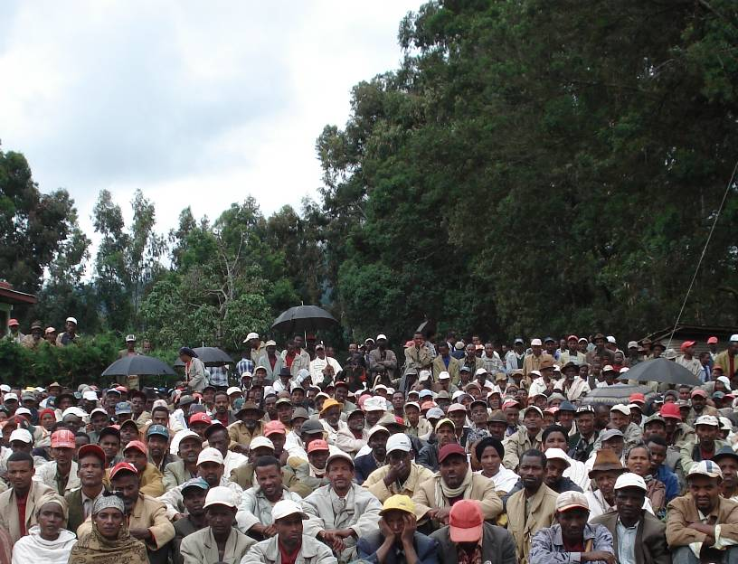
BEST ANALYSIS – MADAGASCAR
BELLMON ESTIMATION STUDIES
FOR TITLE II (BEST) PROJECT

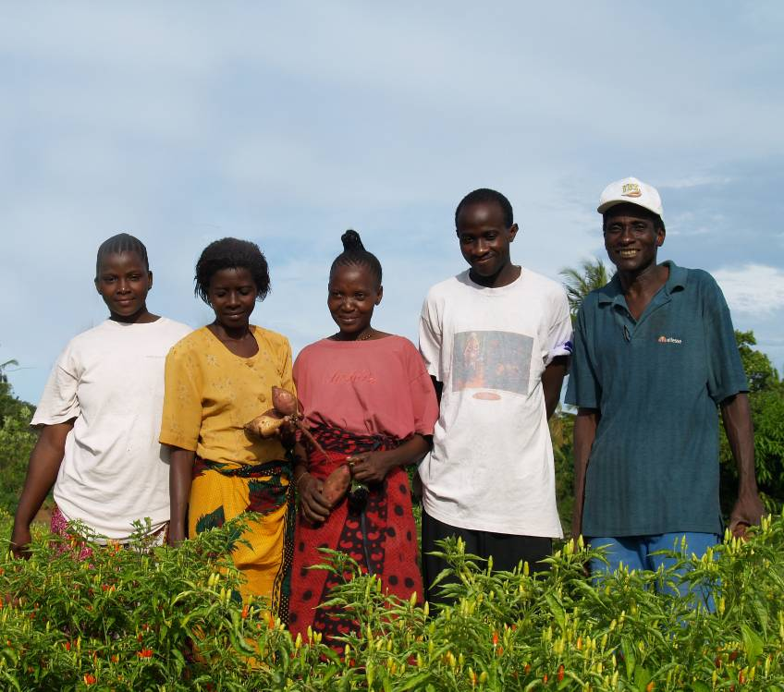
OCTOBER 2008
This publication was produced for review by the United States Agency for International Development. It was prepared by Fintrac Inc.

Based on data collected from CSs, USAID/FFP, the World Food Program (WFP) and the Food Aid Committee/International Grains Council
Ibid
Ibid
Ibid
CRS monetization report to USAID/FFP
Food Aid Committee/International Grains Council
Ibid
ICTSL http://www.ictsi.com/operations.aspx?p_id=3&catg_id=&operation_id=136&id=193
“Malagasy Phytosanitary Legislation” decree nº 86-013 of September 16th, 1986
UN COMTRADE
L’Observatoire du Riz (http://www.odr-mg.net)
UN COMTRADE
IFAP Dairy Quarterly, May June 2004, p.2
Discussions with TIKO management in Toamasina
Parson, Annie Michèle. (Director Livestock Production, MAEP), The School Milk Experience in Madagascar, Eastern and Southern African Regional School Milk conference, Kampala, 2005
IPP Toamasina plus 20% excise tax, 20% VAT and inland transport
Based on data collected from CSs, USAID/FFP, the World Food Program (WFP) and the Food Aid Committee/International Grains Council
UNDP Human Development Reports http://hdrstats.undp.org/countries/country_fact_sheets/cty_fs_MDG.html
CIA World Factbook at https://www.cia.gov/library/publications/the-world-factbook/print/ma.html
Enquête Périodique Auprès des Ménages (EPM) 2005
FANTA report “Food Situation in Madagascar: 2002”

