SECTION I PETITION FOR AIRSPACE DESIGNATION

PETITIONER INFORMATION

Headquarters Air Combat Command (HQ/ACC) Airspace, Ranges and Airfield Operation Division (A3A) POC: Edward H. Odom, 205 Dodd Blvd. Ste. 101, Langley AFB, VA 23665-2789, Duty: 757-764-6002, Fax: 757-764-6009, email: edward.odom@us.af.mil

PROPOSED ACTION

The United States Air Force (USAF), HQ/ACC petitions the Federal Aviation Administration (FAA) to apply a Special Air Traffic Rule (SATR) under the Code of Federal Regulation (CFR) Title 14, Part 93 for the airspace over Beale Air Force Base’s (BAFB) Class “C” airspace. The SATR airspace would be from and including 4,100 feet mean sea level (MSL) up to and including 18,000’ MSL, the floor of Class “A” airspace, within a 10 nautical mile radius (NMR) of 390817N/1212610W. The SATR will allow BAFB to safely operate the RQ-4 Global Hawk (GH) unmanned aircraft system (UAS) around their terminal environment. The SATR should require all Instrument Flight Rule (IFR) and Visual Flight Rule (VFR) aircraft to be transponder equipped and while entering or exiting the SATR airspace, maintain two-way radio contact with Northern California Terminal Approach Control (NCT). NCT will provide radar service and/or traffic advisories to all aircraft within the SATR during GH operations within the SATR.

HISTORY

Beale Air Force Base was selected as the first operational base for GH in 1999. Other locations evaluated were Wright Patterson AFB, OH, Tinker AFB, OK, Ellsworth AFB, SD and Edwards AFB CA. The charter at the time was to identify bases that could accommodate the GH, evaluating traffic density and airspace congestion, regardless of associated restricted airspace. Edwards AFB was the only base with associated restricted airspace which is required for UAS operations when operating without a Certificate of Authorization (COA). The restricted airspace requirement was IAW FAAO 7610.4, Chapter 12, section 9. Based on airspace, Edwards AFB was the most logical choice with restricted airspace available. Ellsworth AFB had uncongested airspace and a DOD managed ATC radar facility available. Beale AFB was the third choice. The determining factor to base GH at Beale can be attributed to mission commonality; GH is the successor to the U-2’s reconnaissance mission based at Beale AFB. In-depth GH briefings were provided to Oakland ARTCC and (then) Sacramento TRACON. Both facilities indicated they could accommodate GH operations with very little disruption to the local ATC environment. Airspace segregation was considered, but not an overriding factor since there was broad FAA support from HQ and local ATC agencies to operate from BAFB.

PURPOSE

The primary purpose of a SATR at BAFB is to increase the safety factor during GH operations; by reducing the possibility that a non-cooperative aircraft, unreported or unseen visually or on radar, would conflict with terminal UAS operations at BAFB. SATRs are permanently depicted on charts for all pilots to see and in FAAO Part 93. Requiring aircraft to have operational transponders with mode C and two-way radio communications with ATC within the SATR will be in addition to the GH pilot using radar to (sense) see-and-avoid (SAA) traffic. Although technological efforts have begun to equip GH with a SAA capability that proposes to exceed those SAA capabilities of manned aircraft, that capability will not be available until the 2017-2020 timeframe. Currently, a Temporary Flight Restriction (TFR) is used at BAFB to supplement radar as a means to segregate and identify traffic. The TFR will continue until a longer term fix is established. The USAF proposes the SATR designation be used as an additional safety measure, moving from the current TFR operations and eventually achieving a SAA long term fix. The USAF does not propose the SATR replace SAA on GH at BAFB, but to supplement radar monitoring by the UAS pilot and current requirements already imposed over Beale’s Class C airspace by FAR Part 91.215(b). This requires all aircraft to be transponder/mode C, equipped within the lateral boundaries of the Class C and up to 10,000’ MSL. Above 10,000’, all aircraft except those not originally certified with an engine-driven electrical system, balloons or gliders must also be transponder /mode C equipped. The possibility of an “excepted aircraft” operating above 10,000’over BAFB’s Class C is very remote, but a SATR would further reduce that possibility. After SAA equipment is developed and added to GH, the SATR may remain in place to continue providing additional safety or discontinued as deemed appropriate by a record of safety.

PROPOSED SATR LANGUAGE FOR SECTIONAL AERONAUTICAL CHART

SPECIAL AIR TRAFFIC RULE, F.A.R. PART 93, BEALE TERMINAL AREA, CALIFORNIA (VFR or IFR CONDITIONS)
UNMANNED AIRCRAFT OPERATIONS IN VICINITY OF BEALE AFB
A SPECIAL AIR TRAFFIC RULE FAR PART 93, REQUIRES AIRCRAFT TO BE TRANSPONDER WITH MODE C CAPABILITY EQUIPPED AND PILOTS TO MAINTAIN 2-WAY RADIO COMMUNICATIONS WITH NORCAL TRACON FOR ENTRY INTO/EXIT FROM THE SATR AIRSPACE WITHIN A 10 NM RADIUS OF 390817N/1212610W FROM AND AT 4100’ MSL UP TO AND INCLUDING 18,000’ MSL.

SECTION II JUSTIFICATION

GENERAL

Currently, TFR activation by NOTAM is used for launch and recovery of Global Hawk at BAFB. The FAA UAS ATO office has determined that a TFR is the best way to guarantee segregation of GH and non-cooperative aircraft in addition to the pilot’s use of radar to identify traffic conflicts. Although the TFR restricts access to the airspace between Beale’s Class C airspace and the base of the Class A airspace above, the NOTAM could be missed by pilots of non-cooperative aircraft. One particular incident highlighted that possibility when a General Aviation aircraft on a VFR flight plan was seen on radar entering the active TFR which caused an immediate altitude restriction for GH on departure and averted a near miss. The GA pilot had not read the NOTAM, was not aware of the TFR and was cited for violating it. The TFR adds an additional safety measure at BAFB, but the “on/off” transient nature of the TFR and NOTAM dissemination process exacerbates the possibility of oversight. A SATR however, is full-time and reduces the possibility of oversight as the local aviation community is involved with its development and its depiction on aeronautical charts. Once established and briefed annually in Beale’s Midair Collision Avoidance (MACA) program, the existence and operating rules of the SATR will be highly visible, stable and difficult to overlook; thereby increasing flight safety. NCT monitoring of the SATR would allow real time airspace oversight during GH operations and thereby enhancing access by civil aviation. The current TFR method is constrained by 24 hour advance notice for NOTAM action and offers no flexibility for arrivals/departures due to unexpected circumstances or an in-flight emergency. Keeping a TFR in place during an extended mission is overly restrictive to airspace and use by other aircraft, whereas a SATR would provide full flexibility of airspace utilization by NCT.

SPECIFIC

A TFR by nature is restrictive and increases Air Traffic Services workload. The FAA currently limits the weekly number of TFR’s at BAFB. This is disruptive and limiting to military requirements. It has inhibited BAFB’s ability to fulfill training requirements levied on USAF units to meet Combatant Commanders (COCOM) growing need for Intelligence, Surveillance and Reconnaissance (ISR). Specifically, the 9RW, in coordination with ACC, has determined that 186 RQ-4 pilots are required by FY12 to satisfy COCOM requirements (285 if Grand Forks AFB is included as a second main operating base). In FY07, using a combination of 37 local sorties, in-garrison as well as deployed Global War on Terrorism missions; the 9RW qualified 25 new RQ-4 pilots and 11 instructor pilots. Currently, 48 pilots and 16 IPs are programmed in FY08; however, the actual stated requirement from ACC is 60 pilots/20 instructors annually requiring over 295 local RQ-4 sorties per year for initial and continuation training. While a normal year has approximately 230 Operations &Maintenance days, this requires at least one sortie every day driving a need for an increased operational tempo than the current TFR process allows.

The 9RW developed procedural plans to optimize mission effectiveness/sortie generation given current TFR constraints. These procedural changes require a heavy reliance on training during actual combat sorties and adjustments to current training syllabi; however, this arrangement temporarily reduces the total number of sorties available to train aircrews from Beale as noted above (approximately 200 vs 295 sorties).
Under current constraints, BAFB is unable to train effectively and operate as required.
As a result, Beale is unable to maintain combat readiness to meet COCOM requirements. A SATR at Beale would eliminate TFR constraints and allow BAFB to fulfill national defense needs.
PUBLIC INTEREST

The explosion of UAS technology in DOD has outpaced policy changes to CFRs and in the National Airspace System. Currently, UAS conform to CFR traditionally designed for manned flight with no consideration for unmanned aircraft. Consequently, UAS flights are segregated from commercial and general aviation flights by confining them to Restricted, Warning, or Prohibited Areas. Outside those areas, UAS flight is by exception and waived or authorized through the use of a COA. Safety mitigations are required to compensate for the lack of SAA and identified in the request for a COA. The primary methods of mitigations at Beale are through radar monitoring, FAR Part 91.215 requirements and a National Security TFR. The TFR’s construct is to keep non-cooperative aircraft away from specified areas, but as the title indicates, temporary and restrictive in nature. Beale is the first permanent operational base for GH. A permanent fix for Beale is needed to ensure the flying public is aware of the unique flying operations and that all aircraft and their altitudes are displayed on radar. A SATR would insure all traffic is known and allow NCT real-time use of the airspace to move aircraft unimpeded through the Beale terminal area. Charting and full time monitoring of the airspace would significantly reduce the possibility that a non-cooperative, non-squawking aircraft would inadvertently enter the area while UAS operations are in effect.

SAFETY CONSIDERATIONS

Time, experience, and safety studies should precede full integration of manned aircraft and UAS. Until such time that manned and unmanned aircraft have proven safe and compatible flying together in desegregated airspace, mixing those flights in uncontrolled airspace should have additional safety measures in place. Currently, the airspace between Beale’s Class “C” airspace (4100’MSL) and the floor of the Class “A” airspace (18,000’ MSL) is uncontrolled. During the launch and recovery of GH a National Security TFR goes into effect. The TFR allows for positive control of the airspace above Beale. It requires all aircraft to squawk a discrete code, maintain two-way radio communications and request approval from NCT to enter. The TFR is dependent on the NOTAM system to disseminate the details and activation of the TFR. As a result, the possibility of civil aircraft not receiving the NOTAM information exists. This possibility was highlighted by the scenario in May 2007 when the GA aircraft unaware of the Beale TFR entered the TFR during a GH departure. The aircraft was identified on radar, but took an unexpected turn northbound into the TFR at Beale. NCT immediately informed the GH pilot to maintain an altitude of 7000’ on departure to avoid the GA traffic. GH leveled off at 7000’ and the GA aircraft passed overhead avoiding a near miss. The pilot GA was unaware of the UAS operations at Beale AFB or of the TFR in effect. Under SATR this information is described Under Part 93 of CFR 14, annotated on aeronautical charts on a full time basis and not dependent on the NOTAM system. The SATR would soon be known by and normalized within the aviation community. In addition BAFB has an excellent MACA program designed to inform the local flying community of the type and frequency of Beale’s flying operations. The MACA program, in conjunction with the SATR requiring transponder with altitude information and two-way radio, would make the possibility of an aircraft intrusion even more unlikely than a TFR alone.

LOCATION/DISCRIPTION OF AIRSPACE DESIGNATION

That airspace above Beale AFB California, from the top of Beale‘s Surface Class “C” airspace (at and above 4100’ MSL) to the base of Surface Class “A” airspace (up to and including 18,000’ MSL), within a 10 NM Radius of Beale AFB (390817N/1212610). The USAF is petitioning the FAA to designate, under FAR Part 93, a Special Air Traffic Rule that stipulates certain operational rules within this airspace: SATR requires aircraft transiting this area to be transponder with Mode C equipped and in direct two-way radio communications with NCT.

DESCRIPTION OF ACTIVITY IN SATR

Daily GH departures and arrivals would be the only activity requiring close monitoring of airspace between manned aircraft and UASs. The amount of time GH would be utilizing the SATR for each departure and arrival would be less than 10 minutes for each operation. Daily operations would normally be 2 arrivals and 2 departures in a 24 hour period. NCT would have full use of that airspace to operate as needed providing traffic advisories and service as necessary. The dynamic nature of DOD requirements, USAF operations and maintenance, make it unpredictable as to a specific daily schedule. As a result, the SATR must remain in effect fulltime. The actual times that UAS traffic advisories would be necessary should only constitute a small portion of a 24 hour day. NCT would maintain full awareness of operations in the SATR to include GH operations. Real time use and availability under the SATR would be unobtrusive to civil aviation and its effect would be minor to all but a very few aircraft.

COSTS AND BENEFITS

Main costs associated with SATR would involve a slight increase in workload for the Beale sector of NCT. Providing full time monitoring for that airspace over Beale AFB would have some impact, but indications from NCT are that the service would not be significantly disruptive or costly in terms of additional manpower. NCT has suggested that these services are acceptable under current manpower standards. An environmental analysis of the SATR’s affects would be accomplished by ACC and FAA as necessary. The cost of the analysis will be dependent on the depth required to support establishing the SATR. Other costs would be the administrative costs associated with the rule-making action, public comments, and the time and costs of the committee determining merits of the petition. The main benefit to the flying public would be an additional layer of safety until a reliable safety record is recorded. Until UAS activity has proven to be as safe as manned aircraft activity, to err on the conservative side of safety is paramount. Time, experience, safety studies, and SAA equipage will determine the future of UAS NAS operation integrated with manned aircraft. Until enough data is collected to fully assess the compatibility of integrated flight, efforts to segregate UAS flight or mitigate with additional safety measures should be the standard. A SATR will restrict flight above Beale only to those aircraft not required to be equipped with a transponder under FAR Part 91.215, aircraft not originally certified with an engine-driven electrical system, balloons or gliders. Those aircraft without equipage would be a very small percentage of the activity utilizing that airspace proposed for SATR. The need to confirm and ensure flight safety concerns overrides the inconvenience of a minute number of unequipped GA aircraft that could not access the Beale SATR.

SUMMARY

Beale AFB in northern California is the first operational wing to fly the RQ-4, Global Hawk, high altitude, high endurance UAS designed for Global Intelligence, Surveillance and Reconnaissance missions. CFRs and FARs were written for manned aircraft without regard to unmanned aircraft. GH currently uses primarily radar monitoring and a TFR to mitigate SAA shortcomings and is not expected to be equipped with SAA capability until 2017 or later. The current use of a TFR between Beale’s Class “C” and up to the Class “A” airspace to launch and recover GH from Beale is overly restrictive to civil aviation, coordination intensive and the NOTAM process ineffective to insure an inadvertent nonparticipating aircraft could enter the TFR undetected. Until there is a major rewrite of CFRs and FARs to include UASs, operators of UAS and manned aircraft need to be extra vigilant and safe. A SATR requiring transponder operations and two-way radio communication for all aircraft operations above BAFB would eliminate the remote possibility of an aircraft “excepted” by FAR Part 91.215 from straying into the environment. The USAF is petitioning the FAA to designate a Special Air Traffic Rule requiring all aircraft that fly in the airspace above BAFB Class “C” airspace up to and including the floor of Class “A” airspace be transponder equipped/mode C capable and maintain two way radio communications with ATC.

CURRENT TFR (SAMPLE) NOTAM/MAP

BEALE AFB, CA, (DATE) LOCAL. PURSUANT TO 49 USC 40103(B), THE FEDERAL AVIATION ADMINISTRATION (FAA) CLASSIFIES THE AIRSPACE DEFINED IN THIS NOTAM AS 'NATIONAL DEFENSE AIRSPACE'. ANY PERSON WHO KNOWINGLY OR WILLFULLY VIOLATES THE RULES CONCERNING OPERATIONS IN THIS AIRSPACE MAY BE SUBJECT TO CERTAIN CRIMINAL PENALTIES UNDER 49 USC 46307. PILOTS WHO DO NOT ADHERE TO THE FOLLOWING PROCEDURES MAY BE INTERCEPTED, AND MAY BE DETAINED AND INTERVIEWED BY LAW ENFORCEMENT/SECURITY PERSONNEL.
PURSUANT TO TITLE 14 CFR SECTION 99.7, SPECIAL SECURITY INSTRUCTIONS, ALL AIRCRAFT FLIGHT OPERATIONS ARE PROHIBITED WITHIN A 10 NMR OF 390803N/1212615W OR THE MYV055006.7 FROM AND INCLUDING 4100 FT MSL UP TO AND INCLUDING 18000 FT MSL EFFECTIVE 0804301725 UTC (1025 LOCAL xx/xx/08) UNTIL 0804301925 UTC (1225 LOCAL 04/30/08).
EXCEPT AS SPECIFIED BELOW AND/OR UNLESS AUTHORIZED BY ATC:
1. ALL AIRCRAFT ENTERING OR EXITING THE TFR MUST BE ON A DISCRETE CODE ASSIGNED BY AN AIR TRAFFIC END PART 1 OF 2. WIE UNTIL UFN. CREATED: Date/Time

FDC 8/5074 - PART 2 OF 2 CA.. FLIGHT RESTRICTIONS. CONTROL (ATC) FACILITY.
2. AIRCRAFT MUST BE SQUAWKING THE DISCRETE CODE AT ALL TIMES WHILE IN THE TFR.
3. ALL AIRCRAFT ENTERING OR EXITING THE TFR MUST REMAIN IN TWO-WAY RADIO COMMUNICATIONS WITH ATC.
4. NORTHERN CALIFORNIA TRACON, PHONE 916-366-4080, IS THE FAA COORDINATION FACILITY.
END PART 2 OF 2. WIE UNTIL UFN. CREATED: 26 APR 19:58 2008

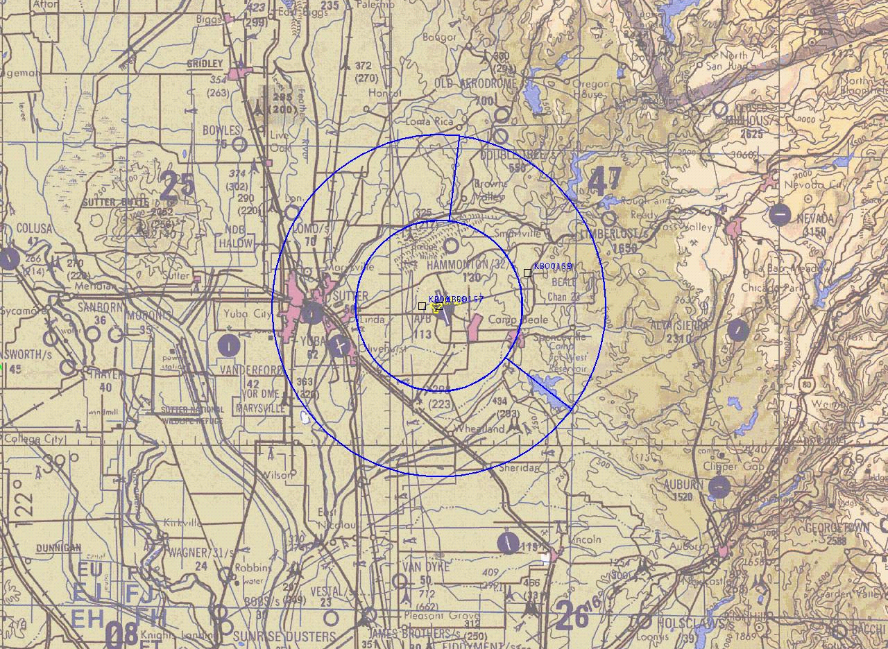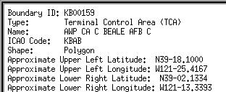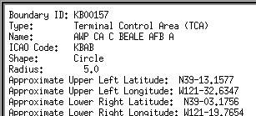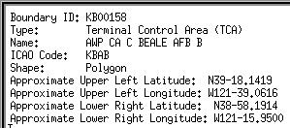
Center TACAN
N39
-
08.085
W121
-
26.439

PART 93 MAP AND PROPOSED MAP TEXT

