
Steamtown National Historic inquiries regarding the restoration of our Reading T-1 2124
locomotive, as well as other locomotives in the Steamtown NHS collection, that are similar
to the following:
“Since this locomotive is the only "Anthracite Roads" locomotive in your collection that can pull a train of any length up your hills, why isn't Reading No. 2124 being considered for restoration, and why is No. 759 being considered for restoration when it is reportedly in worse shape than 2124? PLEASE Respond. Thank You.”
In answer to these and other similar inquiries, we are posting our response on our Restoration web page. You are free to copy the following information but you may not distribute it without express written permission from Steamtown National Historic Site.
“September 24, 2000
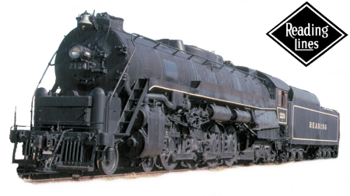
“The Steamtown NHS collection has 2 steam locomotives from the Anthracite roads: the Reading 2124 and the Delaware, Lackawanna & Western 565. RDG 2124 was put aside because a T-1 design locomotive (RDG 2100) is operational (Source: Elgin County Railway Museum, St. Thomas, ON, Canada). Considering that both are from Anthracite haulers, it may be a strong reason not to operate and cause potential harm to either or both of them.
It is our understanding that the locomotive was removed from service due to inspection (boiler interior) requirements and repairs. It, along with the other 2100s, were supposedly the best of the T-1's left, and the 2124 was the last T-1 to be out-shopped (a major shopping probably in 1955 or 1956, not the minor running repairs, inspections and paint before the Iron Horse Rambles) and the first to come out of “Rambles” service.< p> “Regarding your question about the condition of the RDG 2124 vs. NKP 759, the 2124 shows signs of high mileage, meaning that there are places where the machinery shows wear. Additionally, the Worthington feedwater heater presently on the locomotive was traded from another T-1 and is in poor shape. Lastly, the RDG 2124 has been stored outside for many years, and the degradation conditions are probably greater than the deterioration on the NKP 759’s flexible staybolts, caps & sleeves. This is a common condition on long-stored locomotive boilers. As the 2100s have an almost complete application of flexible staybolts, this would entail a very expensive change-out of the bolt, sleeve and cap. We generally estimate a 75% replacement of caps, sleeves and bolts when bringing a long-stored engine in for shopping. There are, of course, other unknowns (i.e., were the superheater units blown out thoroughly? etc.) It all amounts to time and money.
“As for the NKP 759, the mechanical condition is generally “good” with about 30,000 to 40,000 service miles of wear. The boiler has some problems, such as requiring a new set of superheater units, boiler tubes and a few other items. It is more of a known quantity than the RDG 2124.
“A mechanical engineering survey determined that the B&M 3713 can be restored with work well underway, and no other locomotive restoration will be undertaken until the B&M 3713 is completed. It does not mean that the RDG 2124 is not a candidate for possible operation. But in reality, it will be a number of years in the future, as there are no current plans for this restoration. The funding to both shop and maintain any restored locomotive “in-service” with the additional shop forces and materials that would be required to support the restored locomotive are unavailable at present. Our shop force is stretched tight to maintain and perform class repairs to the present power “in-service”. Additionally, no one has come forward to donate a few hundred thousand dollars to start the ball rolling, or sponsor a locomotive restoration as the Lackawanna & Wyoming Valley Chapter of the NRHS has done with the B&M 3713. This group is very interested in the B&M 3713 and continues to work hard to raise the necessary funding to ensure the eventual restoration of the B&M 3713.

