MPE Editor
User’s Guide
July 28, 2006
Build 7.2
NWS Office of Hydrologic Development

TABLE OF CONTENTS
1.0 Introduction 1
2.0 New Features in MPE Editor 2
2.1 DailyQC 6/24 Hour Gage Editing Tools 2
2.2 Topography Overlay Option 3
2.3 Transmit Best Estimate QPE 3
2.4 MPE Editor Legend 3
3.0 The MPE Editor Graphical User Interface 4
3.1 The Main Window 4
3.2 The Main Menubar 4
3.2.1 File Menu Options 4
3.2.1.1 Save as Gif 5
3.2.1.2 Print Image 5
3.2.1.3 Print Reverse Image 5
3.2.1.4 Close 5
3.2.2 Tools Menu Options 6
3.2.2.1 Areal Zoom 7
3.2.2.2 Point Zoom 7
3.2.2.3 Pan 7
3.2.2.4 Recenter 7
3.2.2.5 Tool Bar 7
3.2.2.6 Set Font 8
3.2.2.7 Set Colors 8
3.2.2.8 View 10
3.2.2.9 Clear Data 11
3.2.3 Projections Menu Options 11
3.2.4 Overlays Menu Options 12
3.2.5 MPEcontrol Menu Options 14
3.2.5.1 Next Hour Option 14
3.2.5.2 Previous Hour Option 15
3.2.5.3 Choose Hour Option ... 16
3.2.5.4 Save Best Estimate Top Option 17
3.2.5.5 Save Best Estimate Bottom Option 18
3.2.5.6 Regenerate Hour Fields (formerly Rerun Fieldgen...) 18
3.2.6 PrecipFields Menu Options 19
3.2.6.1 Radar Mosaic Option 20
3.2.6.2 Average Radar Mosaic Option 20
3.2.6.3 Max Radar Mosaic Option 20
3.2.6.4 Field Bias Radar Mosaic Option 20
3.2.6.5 Local Bias Radar Mosaic Option 21
3.2.6.6 Gage Only Analysis Option 21
3.2.6.7 Satellite Precip Option 22
3.2.6.8 Local Bias Satellite Precip Option 22
3.2.6.9 Multisensor Mosaic Option 22
3.2.6.10 Local Bias Multisensor Mosaic 23
3.2.6.11 Triangulated Local Bias Mosaic 23
3.2.6.12 Best Estimate QPE Option 23
3.2.7 BaseFields Menu Options 23
3.2.7.1 Local Span Option 23
3.2.7.2 Local Bias Option 24
3.2.7.3 Height Field Option 24
3.2.7.4 Radar Coverage Field 24
3.2.7.5 Gage Triangles 24
3.2.8 Gages Menu Options 25
3.2.8.1 QC Precipitation 25
3.2.8.2 QC Temp Options 30
3.2.8.3 QC Freezing Level 32
3.2.8.4 Save Level 2 Data 34
3.2.8.5 Add Pseudo Gage 35
3.2.8.6 Gage Table ... 36
3.2.8.7 Show Missing Gages 37
3.2.8.8 Gage Color 37
3.2.8.8.1 Solid Color 38
3.2.8.8.2 Contrast Color 38
3.2.8.8.3 Color By QC 38
3.2.8.8.4 Color By Value 38
3.2.8.9 Display 7 x 7 38
3.2.8.10 Show Gage Identifiers 40
3.2.8.11 Show Gage Values 40
3.2.9 Polygons Menu Options 40
3.2.9.1 Draw Polygons 40
3.2.9.2 Delete Polygons 42
3.2.10 Climo Menu Options 44
3.2.10.1 Monthly Prism Precip 44
3.2.10.2 Monthly Prism Max Temp 44
3.2.10.3 Monthly Prism Min Temp 44
3.2.11 Misc Menu Options 44
3.2.11.1 Display Bias Table 45
3.2.11.2 Review Hourly Radar ... 46
3.2.11.3 Time Lapse Submenu 48
3.2.11.4 Multi-Hour QPE 49
3.2.12 51
3.2.13 Help Menu Options 51
4.0 Mouse Controls and Hot Keys 51
4.1 Exceptions to Mouse Functionality 51
4.2 Pop Up Menu Options 53
4.3 Hot Keys 53
5.0 MPE Editor Legends 54

TABLES
Table 4- 1 MPE Editor Mouse Functionality 51
Table 4- 2 Pop up Menu Options 52
Table 4- 3 MPE Editor Hot Keys 54

FIGURES

Figure 1 File Menu Options 5
Figure 3 Tools Menu Options 7
Figure 4 Set Font Menu Options 8
Figure 5 Color Thresholds Window 8
Figure 6 View Menu Options 10
Figure 7 Projections Menu Options 12
Figure 8 Overlays Menu Options 13
Figure 9 Streams and Lakes Submenu 14
Figure 10 Topography Submenu 14
Figure 11 Highways/Roads submenu 14
Figure 12 MPE Control Menu Options 15
Figure 13 Choose Data Period Window 16
Figure 14 PrecipFields Menu 19
Figure 15 BaseFields Menu 23
Figure 16 Gages Menu Options 25
Figure 22 Show Missing Gages Submenu Options 37
Figure 23 Gage Color Submenu Options 38
Figure 25 Polygons Menu Options 40
Figure 26 The Edit Precipitation Window 42
Figure 27 Delete Polygons Window 43
Figure 28 Climo Menu Options 44
Figure 29 The Misc Menu Options 45
Figure 30 Show Single Radar Site Radar Selection Window 46
Figure 31 Show Single Radar Site Window 47
Figure 32 Time Lapse Submenu Options 48
Figure 33 The Multi-Hour Precipitation Accumulation 49
Figure 34 Help Menu Options 51
Figure 35 Popup Menu Options 53
Figure 36 Point Precipitation Legend 54
Figure 37 Point Temperature Legend 54
Figure 38 Point Freezing Level Legend 54
Figure 39 Gridded and MAP Precipitation Legend 55
Figure 40 Gridded and MAT Temperature Legend 55
Figure 41 Gridded and MAZ Freezing Level Legend 55
Figure 42 MPE and 6/24 Hour GageQC Legends 55
Figure 43 MPE, MPE Information and 6/24 Hour GageQC Legends 576

- Introduction

MPE Editor’s focus is on areal estimations of rainfall amounts based on both remotely sensed data (radar, satellite) and “ground truth” observations (rain gages). It creates hourly, gridded, multi-sensor precipitation estimates on a 4-km Hydrologic Rainfall Analysis Project (HRAP) grid. The primary inputs to MPE are the gridded Digital Precipitation Array (DPA) products - which provide radar estimates on a 4-km grid - and precipitation gage data. The main steps involved in creating the multi-sensor estimate include determining a mean field bias adjustment for each available radar, creating a multi-radar mosaic, and merging the mosaic with precipitation gage observations. One of the important features of MPE Editor is the ability to edit the gridded data fields as well as the point gage observations. In the process of performing these operations, several types of precipitation grids are generated, with one of these designated as the best grid. At RFCs, this resulting grid is then used to produce MAPX time series for input into NWSRFS. At WFOs, this resulting grid is used as input to the SiteSpecific Headwater Model.

MPE Editor also contains tools to edit 6 and 24 hour precipitation gauge observations; 6 hourly, maximum, and minimum temperature reports; and 6 hour freezing level values. These edited precipitation and temperature data can then be used as input into the NWSRFS river models. These data are not incorporated in to the 1 hour MPE precipitation fields and mosaics.

This document will describe the MPE Editor application. It starts by describing enhancements and new features in Section 2. Then, the entire application, including all of its tools will be the subject of Section 3. If you are already familiar with MPE Editor, then Section 2 will probably be of the most interest to you. However, if you are new to this application, then both Sections 2 and 3 will provide you with insight into how MPE Editor operates. Finally, in section 4 the mouse and hot key controls are discussed.

- New Features in MPE Editor

The core functionality of the Western Region DailyQC precipitation, temperature and freezing level gage editing tools has been implemented in MPE Editor. This includes automated and manual QC of 6 and 24 hour gage values. It also includes the ability to disaggregate 24 hour coop precipitation reports to 6 hour precipitation reports. This increases the quality and number of 6 hour gage values used in the NWSRFS model run. Along with these DailyQC tools comes the topography overlay menu option which allows topography information to be displayed as an image or contours.

New MPE Editor features in AWIPS Release 7.2 include the following:
  - DailyQC 6/24 Hour Gage Editing Tools

The precipitation, temperature and freezing level gage editing tools adapted from the Western Region Mountain Mapper DailyQC tool can be accessed from MPE Editor from the Choose Data Period window or from the Gages menu. Once a number of days and an area are selected from the Choose Data Period window, pressing the Precipitation, Temperature or Freezing button from the bottom of the Choose Data Period window will load gage data of that type for the chosen area and duration. Once the gage data are displayed, the dataset being viewed and edited can be switched by selecting the QC Precipitation, QC Temperatures, or QC Freezing Level options on the Gages menu.

The precipitation gage dataset consists of 6/24 hour gages. The temperature gage dataset consists of observed temperatures at each of the four 6-hour synoptic times (00z, 06z, 12z, 18z) and daily max and min temperatures. The freezing level dataset consists of freezing level heights at each of the four 6-hour synoptic times as derived from the RUC-80 model.

The temperature and freezing level datasets are used in support of the precipitation gage quality control. The main objective of DailyQC is to increase the number of 6 hour precipitation amounts available for use in the NWSRFS. This is accomplished by:

- Taking observed and summed 6 hour precipitation amounts and adding them up to create 24 hour precipitation amounts.
- Using these summed 24 hour reports to QC daily reported precipitation amounts, such as those from cooperative observers.
- Disaggregating the QC’d daily precipitation reports to 6 hour synoptic times.

The freezing level data are used to flag tipping bucket gages which may be frozen. The temperature data are used by the NWSRFS to determine where precipitation is falling as snow and where an existing snowpack may be melting.

Once the precipitation, temperature and freezing level gage datasets have been edited and quality controlled, HRAP gridded precipitation, temperature and freezing level fields are created. Also, mean areal precipitation (MAP), mean areal temperature (MAT) and mean areal freezing level (MAZ) are created based using the site’s basin definitions.

Edited gage data are written to ASCII files as SHEF-formatted reports. The HRAP gridded precipitation, temperature and freezing level data are stored as ASCII files. The MAP, MAT and MAZ are written to ASCII files as SHEF-formatted reports.

  - Topography Overlay Option

The AWIPS Release 7.2 version of MPE Editor includes a new Topography option on the Overlay menu. Selecting Topography displays a submenu with the Image, Contour, and None options. The image option displays elevation data as an image. The Contour option displays contoured elevation data, with color-coded contours at 2400, 4800, 7200, 9600, and 12000 feet.

The topography information is also used by the DailyQC gage editing tools.

  - Transmit Best Estimate QPE

This option allows an office to send its Best Estimate QPE over the Satellite Broadcast Network (SBN). It is intended to be used by RFCs; it allows them to share their Best Estimate QPE products with WFOs located within their forecast area. Generate Areal QPE (GAQ), a new OB72 application running at WFOs, will receive the RFC QPE products from the SBN. At the WFO, GAQ will mosaic the Best Estimate QPEs from all of the RFCs which cover that WFO’s MPE Forecast Area. GAQ can process 1, 6 and 24 hour QPE products. Those produced by MPE are of 1 hour duration. When producing the QPE mosaics, GAQ will only mosaic QPE products with the same duration and ending time.

  - MPE Editor Legend

The 6/24 hour precipitation, temperature and freezing level gauge editing tools have their own legends for the display of point, HRAP gridded and basin averaged data. Since the gage QC and MPE datasets can be displayed simultaneously, the MPE Editor legend area can display both the gage QC legend and the legend for the currently displayed MPE product at the same time.
The colors for the 6/24 hour precipitation, temperature and freezing level dataset legends are hardcoded in AWIPS release OB7.2 but will be setup to use the ColorValue table like the other MPE products in a future AWIPS release.

- The MPE Editor Graphical User Interface

This section of the document describes in greater detail all of the various utilities available through the menubar displayed across the top of the MPE Editor main window. It then describes the mouse-controls in greater detail.

  - The Main Window

The Main window is the first window which appears when the application is opened, and it is the primary controlling window for the MPE Editor process. This simple window consists of a main menubar across the top and a large display area. The user has extensive control over what is shown in the display area. The user can set which overlays are shown in the application by selecting the various overlay options under the Overlays menu. Also, the user has the ability to modify the initial overlays displayed by editing the overlay configuration file. This is described in more detail in the accompanying MPE Editor Implementation Document. Note that MPE data are not shown when MPE Editor is started.

  - The Main Menubar

The menubar which spans across the top portion of the MPE Editor viewer shows the following menu headings, listed from left to right: File, Tools, Projections, Overlays, MPEcontrol, PrecipFields, BaseFields, Gages, Polygons, Climo, Misc, and Help. Utilities are logically grouped by function under these menu headings. Each of these “drop down” menus is described in detail below. Note that each of these menus can be “torn-off”. This is done by clicking on the perforation across the top of the menu.

    - File Menu Options

The File sub-menu has the following available options: Save as Gif, Print Image, Print Reverse Image, Close (Figure 1)

      - Save as Gif
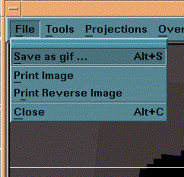
Figure 1 File Menu Options

This displays a popup window which allows the user to screen capture the current MPE Editor display and save it as a gif-formatted file. The user must make certain that the filename chosen to save the GIF image has the extension “*.gif”. If it does not, an error will result.

      - Print Image

This option will perform a screen capture of the current MPE Editor display and output the resulting image to the printer. Currently, color printing is not supported. In order to print an image to a specific printer, the user must take care to properly set the following tokens:

whfs_printcommand_LX - This token must be set to contain the full print command including any non-default user desired printer destinations. For example, to print the image out to lp2, the whfs_printcommand_LX token should be set to “lp -dlp2". This token defaults to value “lp”.

      - Print Reverse Image

This option will perform a screen capture of the current MPE Editor display and output the resulting image in reverse video to the printer. Currently, color printing is not supported. In order to print an image to a specific printer, the user must take care to properly set the tokens outlined in the section above entitled Print Image.

      - Close

Note that the information in this section also applies to the Close button (the ‘X’) on the upper right corner of the MPE Editor window frame.

Selecting this option closes the MPE Editor application. Before MPE Editor is closed, a check is made to determine if the gage QC tools were used to edit 6/24 hour precipitation, temperature and freezing level data. If any of the days in the 6/24 hour precipitation, temperature or freezing level datasets were not edited, then the Send to Database Dialog box appears (Figure 2). This box contains the message “The following datasets need to be QC’d”. Beneath this message each day of the 6/24 hour precipitation, temperature and freezing level datasets which still needs to be quality controlled is listed. Selecting the OK button closes the Send to Database window, and the MPE Editor window is not closed.
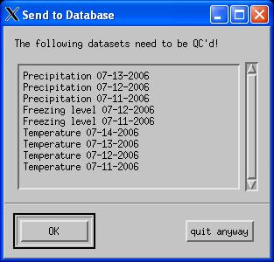
Figure 2 The Send to Database Window

If the “quit anyway” button on the Send to Database window is selected, then the Send to Database window is closed. A check is then made to determine if any days in the 6/24 hour precipitation, temperature or freezing level datasets have been quality controlled but not saved. If any are found, then the Send to Database dialog box is again displayed. This time it will contain the message, “Save the following Precipitation and MAP datasets?”. Below this message the days of the 6/24 hour gage datasets which need to be saved are shown. If the OK button is chosen, then data are saved, and the Send to Database window is closed. If the No button is pressed, then the Send to Database window is closed and the data are not saved. One last dialog box is displayed asking if the user really wants to quit. Selecting OK causes the MPE Editor application to close. If Cancel is selected, then MPE Editor will not close.

    - Tools Menu Options

The choices available on the Tools sub-menu are Areal Zoom, Point Zoom, Pan, Recenter, Tool Bar, Set Font, Set Colors, View, and Clear Data (see Figure 3). The Restore Initial and Find Station options are not available in AWIPS Release 7.1.

      - Areal Zoom
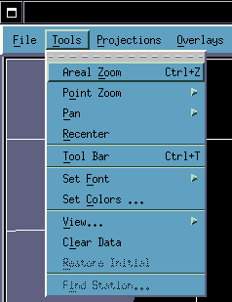
Figure 3 Tools Menu Options

Areal Zoom and its associated hot key combination <Ctrl+Z> allow the Hydroview/MPE display to be zoomed into and out of an area bounded by a zoom rectangle. They also allow the MPE Editor map to be returned to its prior state after a zoom, pan or recenter operation.

The zoom rectangle is drawn by holding down the left mouse button and dragging the mouse. Once the rectangle is the desired size the left mouse button may be released. By selecting Areal Zoom or Ctrl+Z the MPE Editor map display will zoom into the area inside the rectangle. Selecting Areal Zoom or Ctrl+Z again will unzoom the display, that is return it to its previous zoom level and orientation.

      - Point Zoom

Selecting Point Zoom brings up a small menu with the options “In” and “Out” on it. “In” zooms into the map. “Out” zooms out of the map.

      - Pan
Selecting this option brings up a small menu with the options “Up”, “Down”, “Right”, and “Left” on it. These options allow the user to easily navigate around the map.

      - Recenter

Selecting this option changes the mouse pointer to a leftward pointing hand. A single left mouse button click on the MPE Editor display while in this mode will recenter the map display around that point on the map.

      - Tool Bar

This option is a toggle button which enables or disables the display of the application’s toolbar. This toolbar by default is “off”. When it is enabled through this menu option, it is displayed just below the main menubar. This toolbar contains the following items from left to right: the pan up button, the pan down button, the pan left button, the pan right button, the recenter button, the zoom in button, the zoom out button, the latitude box, and the longitude box. These buttons offer an alternative means of accessing the map zoom, recenter, and pan functions.
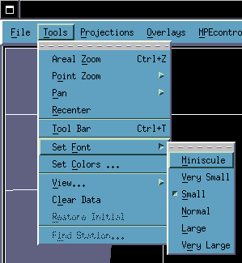
Figure 4 Set Font Menu Options

      - Set Font

This option allows the size of text shown on the MPE Editor map window to be made larger or smaller. Selecting Set Font on the Tools menu leads to the submenu shown inFigure 5 This submenu allows six font sizes to be chosen. The font choices are Miniscule, Very Small, Small, Normal, Large, and Very Large. The default font size is Small.
      - Set Colors
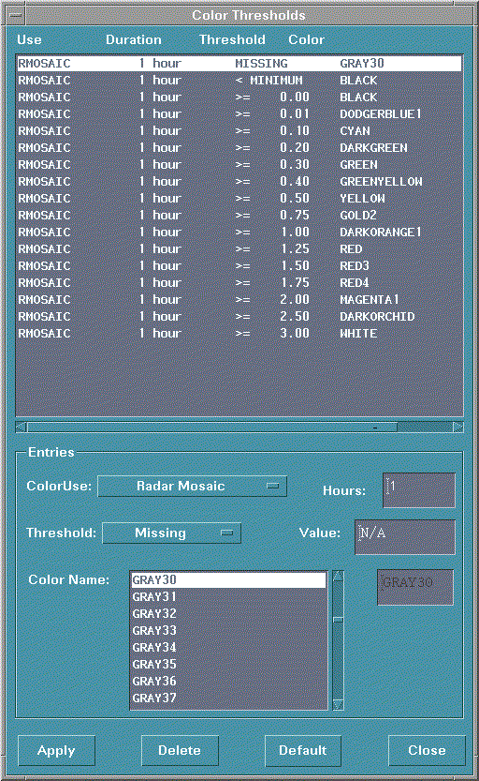
Figure 5 Color Thresholds Window

Selecting this menu item launches the Color Thresholds GUI (Figure 5). This GUI allows the precipitation ranges and the colors associated with them to be defined for each of the MPE fields and mosaics. These colors are set on a user by user basis allowing color schemes to be tailored to an individual’s preferences and needs. This color information is stored in the ColorValues table in the IHFS database. If a user does not have color information setup, then the default color scheme is used.

The large scrolled list which occupies the top half of the Color Thresholds GUI presents the thresholds and the color data associated with them for the currently selected product. This list box displays the name of the product, the duration of the product, the numeric threshold, and the color associated with that threshold. If a product has color thresholds defined for multiple durations, then all of the color thresholds defined for the product are displayed in the scrolled list ordered by increasing duration and increasing threshold value. This provides a simple way to copy and modify a color threshold for a new duration.

The bottom half of the Color Thresholds GUI contains the options which control which product is displayed in the selection list and allow the setting of individual thresholds and the colors associated with them. The ColorUse option menu allows the following MPE products to be selected: Radar Mosaic, Average Radar Mosaic, Max Radar Mosaic, Field Bias Radar Mosaic, Local Bias Radar Mosaic, Gage Only Analysis, Satellite Precip, Local Bias Satellite Precip, Multisensor Mosaic, Local Bias Multisensor Mosaic, P3 Local Bias Mosaic, Best Estimate QPE, Multi-Hour QPE, Local Span, Local Bias, Height, Radar Coverage, and PRISM.

The duration text field specifies the number of hours the MPE product spans. This text field can be used to define color thresholds of differing durations for a MPE product. This will be useful for defining different color scales for different duration displays of multi-hour QPE. For example, separate color scales may be defined and used for 3 hour and 24 hour precipitation accumulations. When displaying a multi-hour QPE for a duration not specified in the ColorValues table, the color scheme of the closest matching duration will be used. For example, if a 9 hour multi-hour QPE product is displayed, but there are color schemes defined for 3 and 12 hour accumulations, then the 12 hour color scheme will be used.

The threshold may be Missing, < Min Threshold or >=Value. Note that each product must have a Missing and a < Min Threshold Value defined for it.

The Value text box specifies the value associated with the threshold. A value does not apply to the Missing and < Min Threshold categories - they are assigned internally by the MPE Editor application.

Below these options is the Color Name scrolled list. This list contains the names of all the colors which may be used in defining the thresholds. These are read in from the ColorNames table in the IHFS database.

The four buttons at the bottom of the Color Thresholds GUI behave as follows:

Apply - Updates the color scheme for the selected product. This includes adding a new color threshold and associated color or modifying an existing color threshold.

Delete - Removes the color threshold selected in the list of color thresholds. The Missing and < Min Threshold definitions may not be removed.

Default - Resets the color scheme for the selected product back to the default. The default color scheme is arrived at by first checking the ColorValues table for user “default” and then determining if the currently selected product has defined color thresholds. If there is no user “default”, then hard coded colors are used.

Close - Closes the Color Thresholds GUI.

      - View
Figure 6 shows the View submenu. It includes the Full Screen and Split Screen options. Selecting Split Screen causes the MPE Editor map window to split into two maps with one map occupying the top half of the MPE Editor window and one map occupying the bottom half of the MPE Editor window. Selecting Full Screen causes MPE Editor to display only one map.
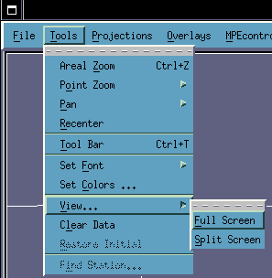
Figure 6 View Menu Options

The Split and Full Screen options are only available when MPE data are displayed. When MPE data are first displayed, the token mpe_split_screen controls whether the screen is full or split by default. The MPE Editor Implementation Document explains the use of the mpe_split_screen token.

When in split screen mode, only MPE data in the top window may be directly edited through the application of polygons and gage edits. The bottom map window is view only, although it may be affected by edits to the top window and a rerun of MPE Fieldgen. Specifically:

- The top and bottom map windows are linked. Zooming and panning in either of the windows will cause the other window to also zoom and pan.
- Changing to a new projection under the Projections menu causes the map projection to change in both map windows.
- Overlays selected from the Overlays menu are applied to both windows.
- The options under the MPEcontrol menu apply to both windows. The MPEcontrol menu provides the ability to save either the top or bottom window as the Best Estimate QPE through the Save Best Estimate Top and Save Best Estimate Bottom menu options, respectively.
- The options under the PrecipFields menu only apply to the top window. To change the MPE field displayed in the bottom map window, the user must right click on the bottom window and select a field from the popup menu.
- With the exception of the Gage Triangles option, the options under the BaseFields menu only apply to the top window. Because of its overlay-like nature, the Gage Triangles option applies to both windows.
- On the Gages menu, the Add Pseudo Gage and Display 7x7 options only work in the top window. The Show Gage Identifiers, Show Gage Values, Show Missing Gages, and Gage Color options work in both windows.
- The options under the Polygons menu apply only the top window. Edit polygons may not be drawn on the bottom window.
- The options under the Climo menu apply only to the top window.
- The Misc menu options to time lapse and display the multi-hour QPE apply only to the top window. The Display Bias Table and Review Hourly Radar options are independent of the MPE Editor windows.

Possible uses of the split screen mode include but are not limited to:
- Visually comparing two MPE fields
- Displaying how gage, polygon and bias edits to a base field affect a derived field after a rerun of MPE Fieldgen.
- For substitute polygon edits, split screen mode allows the field being substituted from to be displayed side by side with the field into which the substitution is being performed.
      - Clear Data

This option clears MPE data from the MPE Editor display. If the display is in split screen mode, then it will be returned to a full screen display. Once the MPE data have been cleared from the display, they can be redisplayed by selecting the Choose Hour option under the MPEcontrol menu. This option does not clear the 6/24 hour precipitation, temperature, and freezing level gauge datasets.
    - Projections Menu Options

The projections menu (see Figure 7) offers the Flat Lat/Lon, Polar Stereographic, and HRAP projections.
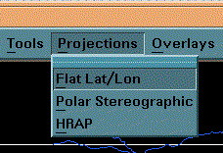
Figure 7 Projections Menu Options

The Flat Lat/Lon projection treats latitude and longitude as a rectangular grid which results in increasing amounts of map distortion at higher latitudes.

The Polar Stereographic projection creates a more realistic map of the earth’s surface. The spacing between lines of longitude decreases towards the north pole. This is also the projection that the HRAP grid uses. So, distortion in the MPE precipitation fields and map overlays is minimized.

The HRAP projection is a specialized case of the Polar Stereographic projection in that it uses the 105 west longitude line as the reference longitude. Because a site’s MPE forecast area represents a section of the national HRAP grid, it will always appear as a rectangle when using the HRAP projection. MPE Editor takes advantage of this and attempts to fit the site’s MPE forecast area as best as possible to the viewing area.

The HRAP projection offers another convenience. Selecting Areal Zoom or Ctrl+Z after any zooming, panning, or recentering operation will return the map view to the initial view. This can be very useful for cases where consistent screen captures of a several hours worth of precipitation data are required.

When MPE Editor is first started, it uses the Flat Lat/Lon projection by default. This default setting may be changed by altering the value of the hv_map_projection token.

    - Overlays Menu Options

The Overlays menu contains toggle buttons which can be used to enable or disable the display of the overlays offered on the MPE Editor application (Figure 8). The overlays are drawn on top of the spatial data such as the precipitation fields and the FFG grids.

Overlays remain displayed when changing hours. Radar rings are a special case where if MPE data are being viewed, then they will change colors when changing hours to indicate the availability of data at the radar sites. A green radar ring indicates that there is radar data. A red radar ring indicates that there is no radar data. Note that radar ring colors do not change during a time lapse.
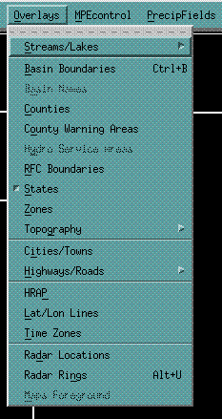
Figure 8 Overlays Menu Options

The Streams/Lakes and Highways/Roads Overlays Menu options lead to submenus which allow the resolution and density of the displayed overlay to be chosen. Figure 9 shows the options on the Streams/Lakes submenu. These include All Streams/Lakes, Major Streams/Lakes, No Streams/Lakes. Only one of these options may be chosen at a time. The All Streams/Lakes overlay shows the most detailed water body information. The Major Streams/Lakes overlay shows only significant rivers and lakes. The No Streams/Lakes option does not show any stream and lake information.

Figure 10 shows the options on the Topography submenu. These include Image, Contour and None. The Image option draws a topography image on the MPE Editor display. The Contour option draws a contoured topography map with colored contour lines at 2400, 4800, 7200, 9600, and 12000 feet. The None option turns off the display of topographic information. Figure 11 shows the options on the Highways/Roads submenu. These include Highways/Roads, Highways, and None. Only one of these options may be selected. The Highways/Roads option displays both interstates and secondary roads. The Highways option displays only interstates, and the None option does not display any interstate or road information.

The management of the overlays and their sources relies on the mpe_editor_overlay_configuration file, located in hydroview’s local data apps directory, to specify the sources of overlay data. There is one row per overlay in this file, and each row contains information that controls how that particular overlay is displayed, its default state upon startup of the application, whether or not it is stored in memory, and its source.

The overlay configuration file allows a user to switch overlay sources and properties with relative ease. For example, the MPE Editor overlay configuration file may be set up to use town and city data from the WHFS database City table or the FSL cities and towns lpi files. In addition to this, RFCs may set up the overlay configuration file so that city and town information are plotted from their geodata files. The overlays used by MPE Editor come from several different sources which in turn have multiple formats that the program needs to be able to recognize and interpret. The overlay configuration file provides an efficient mechanism of informing the application where it needs to retrieve its overlay information from. The specific format of the overlay configuration file is covered in detail in the MPE Editor Implementation Document.
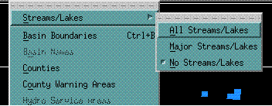
Figure 9 Streams and Lakes Submenu
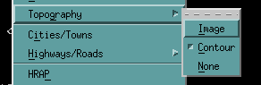
Figure 10 Topography Submenu

The grayed out options on the Overlays menu are overlays which will be implemented in MPE Editor for a future AWIPS release.

    - MPEcontrol Menu Options

The MPEcontrol menu provides the options to choose the date and time for which to display MPE data. It also provides options for both saving MPE data and regenerating the MPE fields and mosaics. None of the MPEcontrol, PrecipFields, BaseFields, Gages, Polygons, Climo, and Misc menu items are accessible until an hour for displaying the MPE data has been chosen from the “Choose Hour …” menu item on the MPEcontrol menu. Once an hour has been selected, the other MPEcontrol, PrecipFields, BaseFields, Gages, Polygons, Climo, and Misc menu items are automatically made selectable. Figure 12 shows the options available on the MPEcontrol menu.
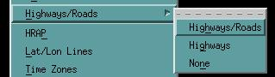
Figure 11 Highways/Roads submenu
      - Next Hour Option

The next hour option selects and displays the next hour’s worth of MPE data. The application keeps track of the specific data field that the user is looking at so that the same product can be properly loaded for the next hour, producing continuity for viewing the products while making sure that the user does not have to reset the field type every time a new hour is selected.
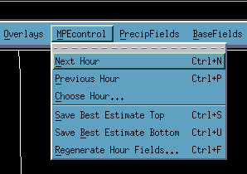
Figure 12 MPE Control Menu Options

For the radar mosaic, maximum radar mosaic, average radar mosaic, mean field bias radar mosaic, local bias radar mosaic, gage-only analysis, multisensor mosaic, local bias multisensor analysis, triangulated local bias mosaic, local bias satellite precipitation field, and the best estimate QPE, when the next hour option is selected and the field currently being viewed has not been saved, a warning dialog box is launched stating that the data has not been saved. This dialog box gives the user the option to cancel the next hour callback and save the data first or to discard any changes made and continue to load the next hour’s worth of data.

If data for the most recent hour are being viewed, then the Next Hour button will be grayed out and not selectable.

      - Previous Hour Option

The previous hour option selects and displays the previous hour’s worth of MPE data. Like the next hour option, the application keeps track of the specific field the user is looking at so that the same product will be properly loaded when showing the previous hour’s data.

For the radar mosaic, maximum radar mosaic, average radar mosaic, mean field bias radar mosaic, local bias radar mosaic, gage-only analysis, multisensor mosaic, local bias multisensor mosaic, local bias satellite precipitation field, triangulated local bias mosaic, and the best estimate QPE, when the previous hour option is selected and the field currently being viewed has not been saved, a warning dialog box is launched stating that the data has not been saved. This dialog box gives the user the option to cancel the previous hour callback and save the data first or to discard any changes made and continue to load the previous hour’s worth of data.

If data for the oldest hour are being viewed, then the Previous Hour menu option will be grayed out and not selectable.

      - Choose Hour Option ...
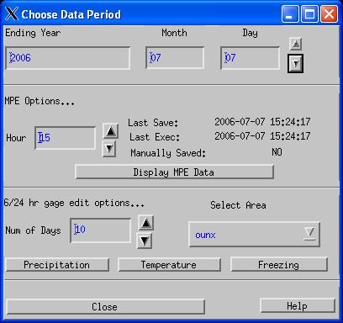
Figure 13 Choose Data Period Window
The choose data period window provides the ability to select a date and a time for which to display an hour’s worth of MPE data (Figure 13). From left to right across the top of this window are fields for entering the year, month, and day of the date to retrieve MPE data for. Selecting the up and down arrow buttons next to the day field adjusts the day up or down respectively. The selected date not only applies to the displayed MPE data, but it also serves as the base date for 6/24 hour DailyQC gage QC and editing operations. All dates and times displayed in this window are GMT.

By default, the initial date and hour displayed in the Choose Data Period window are the current date and hour. This can be changed by specifying the date/hour in the form yyyymmddhh (Z time) as an argument to the “-t” option on the command line of the call to the MPE Editor application in the start_mpe_editor startup script.

The MPE Options portion of the Choose Data Period window allows the hour for which to view and edit MPE data to be selected. The hour may be increased or decreased by selecting the up or down arrow button next to the hour text field. Next to the Hour field are three labels indicating the date and time when the this hour’s Best Estimate QPE was last saved (“Last Save”), the date and time this hour’s MPE data set was last regenerated by MPE Fieldgen (“Last Exec”) and whether or not the Best Estimate QPE has been manually saved. If “n/a” is displayed for Last Save, it means that a field has not previously been saved for this hour. A value of “n/a” for Last Exec indicates that MPE Fieldgen has not yet run for this hour.

Once a date and hour have been selected, MPE data can be displayed by pressing the Display MPE Data button.

The “6/24 hr gage edit options …” portion of the Choose Data Period window can be used to access the DailyQC precipitation, temperature and freezing level gage editing tools. Up to 10 days worth of gage data can be selected for editing. This is done by using the up and down arrows on the Num of Days text box to adjust the day value. A day of gage data runs from 12z to 12z. So, if 10 days are selected in the Num of Days text box then 10 days worth of precipitation, temperature and freezing level gage data will be retrieved, ending at 12z on the selected year, month and day.

The DailyQC gage editing tools may be used to edit gages located over the entire forecast area or to edit gages in just a particular portion of the forecast area. The Select Area pull down menu allows the area for which to edit gages to be chosen. This list always contains as the first option the name of the office and represents the entire forecast area. Selecting this option will load precipitation, temperature and freezing level data for the entire forecast area. If a list of subareas is supplied using the mpe_area_names token, then these subareas will also be listed on the Select area pull down menu. More information about setting the mpe_area_names token and creating sub areas can be found in the MPE Implementation Guide.

When the precipitation, temperature or freezing level button is pressed, MPE Editor will load data for each of the three data types while performing automated QC checks. Once the gage data are loaded and processed, the QC Precipitation Options window will be launched if the Precipitation button was presses, the QC Temp Options window will be launched if the Temperature button was pressed, or QC Freeze Options window will be launched if the Freezing button was pressed. These windows provide the ability to manipulate the displayed gage data and the tools needed to manually QC these data. More information about these three windows is provided below in the sections about the QC Precipitation, QC Temperatures, and QC Freezing Level options on the Gages Menu.

Once the MPE or the DailyQC data have been loaded, the Choose Data Period window closes. It can be launched again by selecting the Choose Hour option on the MPE Control menu. If using the DailyQC gage editing tools, a new gage dataset will be loaded if the number of days or the area is changed and one of the precipitation, temperature, or freezing buttons is pressed. If the number of days and area are unchanged then selecting the precipitation, temperature or freezing buttons will display gages of that data type for the gage dataset currently in memory.

The “Close” button pops-down the “choose hour” window. The “Help” button launches the Help window which provides help on a variety of MPE Editor topics.

      - Save Best Estimate Top Option

Choosing this option saves the currently displayed MPE precipitation field as the “best estimate” precipitation field for the hour. When in Split Screen mode, this option saves the field displayed in the top map window as the Best Estimate QPE field.

The Best Estimate QPE is saved as an xmrg-formatted file. When a file is saved, a record is written to the IHFS RWResult table containing the filename, the id of the user running the MPE Editor application (as indicated by the LOGNAME environmental variable) and the date/time that the file was saved. Note that missing values are replaced by 0.0 in the precipitation field before creating the xmrg file. This is done specifically for MAPX, an OFS function which relies on these xmrg precipitation estimates not containing any missing values.

The option to save the best estimate precipitation field only exists for valid precipitation fields. Base data fields, which include the “Radar Coverage”, “Height”, “Local Span”, “Local Bias”, and “Prism” fields, cannot be saved as the best estimate QPE.

The “Save Hour’s Data” option will also save the data in a netCDF format, GIF format, JPEG format, and/or in a GRIB format depending on the values of the “mpe_save_netcdf”, “mpe_save_gif”, “mpe_save_jpeg”, and “mpe_save_grib” tokens in the .Apps_defaults file(s). When saving GIF and JPEG images, make sure that the MPE main window is on top of the window stack until the confirmation message is printed. Failure to do this will result in creation of an image with other windows obscuring the main window.

Saving data also sets the auto_save flag to ‘F’ in the RWResult table for that hour. This prevents MPE FieldGen from overwriting the best estimate precipitation field during a subsequent cron or manual rerun. This preserves the user’s edits.

      - Save Best Estimate Bottom Option

This option is only selectable when in split screen mode. Choosing this option saves the MPE precipitation field displayed in the bottom map window as the “best estimate” precipitation field for the hour. The same file format and rules apply to the bottom window when it is saved as the Best Estimate QPE as the top window when it is saved as the Best Estimate QPE (see the previous section, Save Best Estimate Top Option).

      - Regenerate Hour Fields (formerly Rerun Fieldgen...)

When modifying precipitation and gage data, the user may wish to incorporate these changes into the the MPE fields and mosaics. An example of this would be if a radar site was “ignored” (through the Single Site Radar window) and two new gages are added using the “Add Pseudo Gage” option. To incorporate this new data into the “Field Bias Radar Mosaic”, “Local Bias Radar Mosaic”, “Gage Only Analysis”, and “Multisensor Mosaic” MPE Fieldgen should be run. MPE FieldGen will regenerate each of these fields with the updated radar and rain gauge data. If the “Best Estimate QPE” field has not yet been manually saved for that hour, then it will be updated by rerunning FieldGen. Otherwise, it will be left unchanged. For this reason, the user should first perform gage and radar data edits, then rerun FieldGen, then perform polygon edits, and finally save the hour’s data as the Best Estimate QPE.

When the Regenerate Hour Fields option is selected, the “Regenerate Hour Fields Dialog” pop-up window appears. Selecting the Yes button will cause MPE Fieldgen to run and recreate the MPE fields and mosaics for the current hour. This may take up to 10 seconds. Selecting the No button will close the Regenerate Hour Fields Dialog and MPE Fieldgen will not be run.

    - PrecipFields Menu Options

As shown in Figure 14, these menu options allow the display of the different MPE precipitation mosaics and fields. The first 11 field options listed on the menu are the “Radar Mosaic”, the “Average Radar Mosaic”, the “Max Radar Mosaic”, the “Field Bias Radar Mosaic”, the “Local Bias Radar Mosaic”, the “Gage Only Analysis”, the “Satellite Precip” field, the “Local Bias Satellite Precip” field, the “Multisensor Mosaic”, the “Local Bias Multisensor Mosaic”, and the “Triangulated Local Bias Mosaic”. These mosaics and fields are derived from remotely sensed precipitation estimates (from radar and the satellite autoestimator) and ground truth rain gauge observations. The next field on the PrecipFields menu is the “Best Estimate QPE”. This is the precipitation field selected by MPE Fieldgen or saved by the user as the best estimate for the hour.
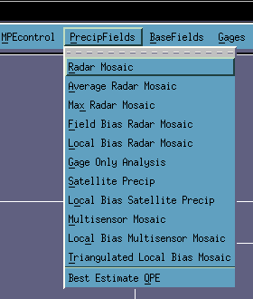
Figure 14 PrecipFields Menu

The availability of the first 11 field options listed on the PrecipFields Menu depends on the setting of the mpe_generate_list and mpe_qpe_fieldtype tokens. The mpe_generate_list token allows the forecast office to pick which MPE products it needs for its operations. Only these products will be generated by MPE FieldGen and be available for viewing in MPE Editor. The fields which are not available will be grayed out in the PrecipFields menu.

The mpe_generate_list token, the mpe_qpe_fieldtype token, and interproduct dependencies are discussed in the MPE Editor Implementation Guide.

      - Radar Mosaic Option

This field represents the rainfall estimate as derived directly from the mosaic of DPA grids for each of the individual radar sites that provide coverage for the WFO or RFC MPE area. It is the raw radar precipitation estimate. Selecting this option will cause the radar mosaic to be displayed on the MPE Editor viewing area. For each HRAP grid bin in the raw radar mosaic, the radar which provides coverage at the lowest height above sea level is selected to fill that bin. The “Height” and “Radar Coverage” fields described below are used in determining this optimal radar value for each of the grid bins.
.

      - Average Radar Mosaic Option

The Average Radar Mosaic is derived from the mosaic of DPA grids for each of the individual radar sites that provide coverage for the office’s MPE area. It is the raw radar precipitation estimate with no bias corrections applied. The radar estimates have not been adjusted using gage data.

During the creation of this radar mosaic, if a HRAP grid bin is covered by more than one radar site, the radar estimated precipitation values for that HRAP grid bin from each of the radar sites are averaged and assigned to the grid bin.
      - Max Radar Mosaic Option

The Maximum Radar Mosaic is derived from the mosaic of DPA grids for each of the individual radar sites that provide coverage over a portion of the office’s MPE area. It is the raw radar precipitation estimate with no bias corrections applied. The radar estimates have not been adjusted using gage data.

During the creation of this radar mosaic, if a HRAP grid bin is covered by more than one radar site, the maximum radar value for that HRAP grid bin is assigned to the grid bin.

      - Field Bias Radar Mosaic Option

This option displays the raw radar mosaic with mean field bias corrections applied to it. Each radar site has its own mean field bias value for “correcting” the radar estimated precipitation amounts based on gage data. These mean field bias values are viewable in the “Display Bias Table” menu option, discussed more in depth below in the section about the Misc menu options. The application of the mean field bias value is an attempt to make the radar-estimated precipitation amounts more accurate and reliable. In effect, the mean field bias value is applied to remove biases from the radar estimated precipitation amounts.

The bias values are arrived at by comparing ground truth precipitation observations (from rain gauges) with the raw radar-estimated rainfall amounts over ten different spans of time (also known as memory spans) ranging from under an hour to daily, weekly, monthly, seasonal, and period of record.

      - Local Bias Radar Mosaic Option

The local bias mosaic created by computing the bias for each grid bin of the HRAP grid that resides within a WFO’s or RFC’s MPE area. The resulting grid of local bias values is then applied to the raw radar mosaic to produce the local bias corrected radar mosaic. By computing the bias for each HRAP grid bin, it is hoped that local geographical effects on rainfall can be captured. The actual bias value for each grid bin can be viewed with the “Local Bias” field. The number of hours of rain gauge/radar pairs used in the computation of the chosen bias value can be determined by viewing the “Local Span” field.

      - Gage Only Analysis Option

The gage only analysis represents the precipitation as estimated by gages only. In order to compensate for the generally large spacing between gages, an attempt is made to spatially smooth the precipitation around a gage point when there are other non-missing gage reports nearby.

The mpe_del_gage_zeros token controls the handling of gages reporting values of zero. If this token is set to “ON”, then a gage reporting zero is not considered in the gage only analysis if radar is reporting precipitation over that gage’s location. If the mpe_del_gage_zeros token is set to “OFF”, the default value, then a gage reporting zero is used regardless of whether or not radar is reporting precipitation over its location.

The radius of influence of a gage report is 15 HRAP grid bins or approximately 60 km. This means if an HRAP grid bin is more than 60 km from the nearest gage site, then it will be assigned a missing value and will be displayed grayed out. If the grid bin is within 60 km of several gages, then the gage values are weighted based on their distance and the mean weighted value is assigned to the HRAP grid bin.

      - Satellite Precip Option

The satellite precipitation option allows satellite estimated precipitation amounts to be viewed in the MPE Editor display. Satellite precipitation estimates (SPE) are not included in the multisensor mosaic.

Note that the SPE product may be time lapsed just like any of the other products. Also, it may be saved as the best estimate QPE. Unlike the other MPE precipitation products, the satellite precipitation field is not created by MPE Fieldgen. It is read from the D2D National Auto Satellite Precipitation Estimate (Auto SPE) product. The portion of this national Auto SPE product corresponding to the office’s forecast area is cropped and displayed in MPE Editor each time this product is displayed.
      - Local Bias Satellite Precip Option

For this product, a bias value is computed for each HRAP grid bin in the site’s MPE forecast area using collocated rain gauge and satellite estimated precipitation amounts. These biases are then applied to each HRAP grid bin within the satellite precipitation field. The net effect of this is to “correct” or “unbias” the satellite precipitation estimates. This should make the satellite precipitation estimates more accurate and reliable. Note that the Local Span Field and Local Bias Field do not apply to this product. They apply only to the Local Bias Radar Mosaic. The local span and local bias information for the Local Bias Satellite Precip field are not displayable in MPE Editor.

      - Multisensor Mosaic Option

The multisensor mosaic is a combination of bias corrected radar values and gage values. Each grid bin in the MPE forecast area is assigned a value based on neighboring gage and bias corrected radar values. If the grid bin contains a gage site reporting a non missing value, then it is assigned the gage’s value. Otherwise, it is assigned a value based on its radar estimated precipitation value and the weighed values of the closest gages. If there are no nearby gages, then the HRAP bin is assigned the radar value.

The multisensor mosaic also incorporates Parameter-elevation Regressions on Independent Slopes Model (PRISM) data (see below). This is done in areas where there is no radar data but there are some nearby gages. This often occurs in mountainous regions where the mountain peaks block the radar beam. If there are a few gages scattered around the mountain bases, then the climatological PRISM data is applied to the gage values to estimate what the precipitation amounts were over the higher terrain.

      - Local Bias Multisensor Mosaic

Unlike the Multisensor Mosaic which incorporates the mean field bias (a bias determined on a radar by radar basis), the Local Bias Multisensor Mosaic incorporates a bias computed for each HRAP grid bin in the office’s MPE area. The computed bias for each grid bin can be seen by displaying the Local Bias Field. The memory spans used to compute these local biases can be viewed by displaying the Local Span Field. The local bias multisensor mosaic is the result of combining local bias corrected radar estimates with gage data. The effect of this is to fill in areas of poor radar coverage using spatially smoothed and climatologically weighted rain gauge data.

      - Triangulated Local Bias Mosaic

The triangulated local bias mosaic uses the same radar precipitation unbiasing algorithm used in the P3 application developed at ABRFC. This algorithm uses the rain gauge data to create a Triangular Irregular Network (TIN). This network is used to distance weight the gage and radar values used in the creation of the local bias corrected precipitation field.
      - Best Estimate QPE Option

The Best Estimate QPE field is set to the field indicated by the “mpe_qpe_fieldtype” token when MPE FieldGen is initially run. Using options such as substituting precipitation areas (through the “Draw Polygons” menu item on the Polygons menu) and adding gages (through the Add Pseudo Gage Option on the Gages submenu) the Best Estimate QPE field may be easily modified. The Best Estimate QPE field may also be manually saved through MPE Editor.

    - BaseFields Menu Options

The “Local Span”, “Local Bias”, “Height Field”, “Radar Coverage Field”, and “Gage Triangles” options on the BaseFields menu are reference fields (Figure 15). They describe radar height and coverage characteristics as well as how radar estimates were corrected using observed gauge amounts to produce more reliable precipitation amounts.
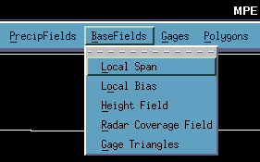
Figure 15 BaseFields Menu

      - Local Span Option

The local span field reflects the memory span that is used for computing the local bias of each of the HRAP grid bins. Just as the local bias can be different for each of the grid bins, so is the memory span value different for each of the grid bins. The “Local Span” and “Local Bias” fields are used together to compute the “Local Bias” precipitation mosaic.

      - Local Bias Option

The “Local Bias” field reflects the local bias value for each of the grid bins in the HRAP grid. The span of time (the memory span) over which the local bias was calculated is represented by the corresponding HRAP grid bin in the “Local Span” field described above.

      - Height Field Option

The height field displays the lowest available radar height that provides coverage for a given HRAP grid bin. If a low elevation radar beam is blocked relatively close to the radar emitter, then the next higher elevation radar beam is selected in hope that it will be high enough to “see” over the obstacle. If, because of missing radars or ground obstacles, the grid bin has no coverage from any radar, then it is assigned a missing value. For each HRAP grid bin, the height field represents which radar was chosen to provide reflectivity-derived precipitation estimates during the construction of the radar mosaic field. The height field does not apply to the average and maximum radar mosaics.

      - Radar Coverage Field

Based on the “Height Field”, the radar coverage field displays which radar site is providing precipitation information for each HRAP grid bin. The “Height Field” is used in determining which radar location provides the lowest coverage for each of the bins. If no radar is providing coverage for a grid bin, then the grid bin receives a missing value. Ultimately, this field is used in determining the radar biases that are applied to each of the grid bins when computing products such as the “Field Bias” radar mosaic. The radar coverage field does not apply to the maximum and average radar mosaics.

      - Gage Triangles

The creation of the Triangulated Local Bias Mosaic involves creating a gage based Triangular Irregular Network (TIN). The gage triangles option shows the TIN that was used in the creation of the current hour’s Triangulated Local Bias Mosaic.

    - Gages Menu Options
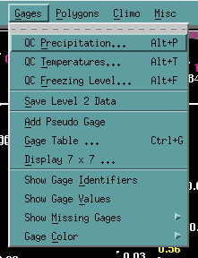
Figure 16 Gages Menu Options

The Gages menu, shown in Figure 16 contains the “QC Precipitation”, “QC Temperature”, “QC Freezing Level” “Save Level 2 Data”, “Add Pseudo Gage”, “Gage Table ...”, “Display 7x7…”, “Show Gage Identifiers”, “Show Gage Values”, “Show Missing Gages”, and “Gage Color” options.

The QC Precipitation, QC Temperature, QC Freezing Level, and Save Level 2 Data options are only available after the 6/24 hour precipitation, temperature and freezing level data have been loaded. These data are loaded when the Precipitation, Temperature, or Freezing button is pressed on the Choose Data Period window

The Add Pseudo Gage, Gage Table, Display 7x7, Show Gage Identifiers, Show Gage Values, Show Missing Gages, and Gage Color options are only available after MPE data have been loaded. These data are loaded when the Display MPE Data button is selected on the Choose Data Period window.
      - QC Precipitation

Selecting the QC Precipitation option launches the QC Precipitation Options window shown in Figure 17. This window is also launched when the Precipitation button is pressed on the Choose Data Period window.

6/24 Data Period Selection
The QC Precipitation Options window contains the tools to manipulate the display of the 6/24 hour precipitation gauge dataset on the MPE Editor map. The data options section of this window contains an option button menu which allows toggling back and forth between the 6 and 24 hour precipitation datasets. The forecaster edits one day of 6/24 hour precipitation data at a time. The 24 hour gage values span 12z to 12z. The 6 hour gage values are valid for the following 6 hour periods: 12z-18z, 18z-00z, 00z-06z, and 06z-12z. Selecting the up arrow next to the 6/24 hour option button menu causes the next period of gauge data to be displayed on the MPE Editor map. Selecting the down arrow causes the previous period of gage data to be displayed. When the upper or lower bounding date of the 6/24 gage precipitation data set is reached (as specified by the year, month, day and number of days fields in the Choose Data Period window) the up or down arrow will become desensitized, respectively.

Precipitation Data Display Options
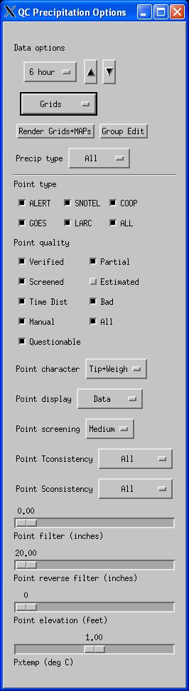
Figure 17 QC Precipitation Options Window

Below the 6/24 hour option menu is the data display option menu. The options on this menu are Points, Grids, MAPs, Points+Grids, Points+MAPs, and None:
- Points – Display the precipitation gauge data as point values.
- Grids – Display the precipitation gauge data as an HRAP gridded field.
- MAPs – Display the precipitation gauge data as basin averaged values.
- Points+Grids – Display the precipitation gauge data as an HRAP gridded field overlain with point values.
- Points+MAPs – Display the precipitation gauge data as basin average values overlain with point values.
- None – Do not display precipitation gauge data.

Initially, only the Points and None options are selectable. The other options become selectable once the gridded and MAP precipitation fields have been created.

Generating Gridded Precipitation and MAPs
The Render Grids+Maps button will generate four 6 hour and one 24 hour HRAP gridded precipitation field for the 12z-12z gage QC day currently being edited. It will also create four 6 hour basin averaged fields and one 24 hour basin averaged field for the current 12z-12z gage QC period. These data sets can then be viewed by selecting Grids or MAPs from the precipitation data display option menu.

The grids and MAPs do not use gauge values that have been set to bad.

Once the grids and MAPs have been created, the Render Grids+MAPs button becomes unselectable (grayed out). It will remain unselectable until the QC flag or value of a gage is modified.

Group Edit Option
Pressing the Group Edit button causes the Group Edit Stations window to appear (Figure 18). MPE Editor enters the Group Edit mode. This window allows the QC flags of a group of gages to be quickly modified. The user selects Verified, Screened or Bad from this window. Then, as long as this window is open the QC flag of the gauges can be set to the selected state by placing the mouse pointer over each gauge and right clicking. Note that the gauges may not be set to Questionable. Questionable is a state set only by the automated gauge QC checks adopted from DailyQC.

Pressing the OK button closes the Group Edit Stations window and exits the Group Edit mode.
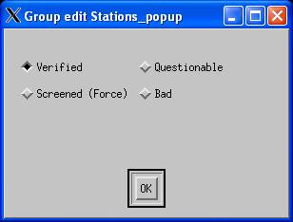
Figure 18 Group Edit Stations Window

Precipitation Data Display Filter Options
The remaining options on the QC Precipitation Options window allow the precipitation gauge points to be displayed according to type source, quality flag, the precipitation gauge mechanism (tipping or weighing), precipitation value, station elevation, and the spatial/temporal consistency of the gauge’s value. In addition to this, an option exists to control the type of information displayed (e.g. precipitation value, station identifier, station name, parameter code, or the standard deviation departure from neighboring gauges). An option also exists to control the threshold standard deviation above which gages are declared questionable by the buddy check.

Point Type
In the Point Type section of the QC Precipitation Options window, the Alert, SNOTEL, COOP, GOES, LARC, and ALL buttons allow precipitation gauge data to be selectively displayed based on type source. The value and number of these buttons are based on the mpe_type_source token. More information about the mpe_type_source token can be found in the MPE Editor Implementation Guide.

Point Quality
The Verified, Screened, Time Dist, Manual, Questionable, Partial, Estimated, Bad, and All check boxes under the Point Quality section allow precipitation gauges to be selectively displayed according to their QC flag.

Point Character
This option menu allows precipitation gauges to be selectively displayed based on the mechanism that they use for measuring precipitation. The options are Tip, Weight and Tip+Weigh. Selecting Tip causes only the tipping bucket gauges to be displayed. Selecting Weight causes only the weighing gauges to be displayed. Selecting Tip+Weigh causes both tipping and weighing gauges to be displayed.

Point Display
The Point Display option menu controls the type of information displayed at each gauge point. The following display options are available:

- Handbook 5 – The Handbook 5 identifier of the station
- PC – The source code of the precipitation datum being displayed
- Name – The name of the station
- Data – The precipitation value
- Dev – The standard deviation of the value determined during the buddy check

Only one of these items may be displayed at a time. Missing data values are not displayed. The user can determine which stations are missing by displaying their names or Handbook5 ids. The names or ids of missing stations will be displayed as light grey.

Point Screening
This option allows the standard deviation threshold to be set above which precipitation values are flagged as questionable. The choices are Coarse, Medium and Fine. Selecting Course results in the fewest questionable gauges. Selection Fine results in the most questionable gauges.

Point Tconsistency
This option allows precipitation gauges to be selectively displayed based whether or not they are temporally consistent. The options are Consistent, Inconsistent and All. The Consistent option displays only those gauges whose 6 hour amounts add up to the 24 hour amount. The Inconsistent option displays only those gauges whose 6 hour amounts do not add up to the 24 hour amount. The All option displays all gauges regardless of their temporal consistency.

Point Sconsistency
The option allows precipitation gauges to be selectively displayed based on whether or not they are spatially consistent. This applies to stations which are closely located or collocated. It checks to make sure that the values of these stations are consistent. If they are not, then the station is flagged as spatially inconsistent. The available display options are Consistent, Inconsistent and All. The Consistent option displays only those gauges whose value passes the spatial consistency check. The Inconsistent option displays only those gauges whose value did not pass the spatial consistency check. The All option displays all gauges, regardless of whether or not their values passes the spatial consistency check.

Point Filter
The point filter slider bar option allows gauges to be selectively displayed based on their values. The slider ranges from 0 to 5 inches. By default the slider bar is set to 0.00. Moving the slider with the mouse (or the left/right arrow keys to achieve greater precision) increases or decreases the minimum precipitation amount displayed on the MPE Editor map. For example, if the point filter slider bar is set to 0.25, then only gauges whose values are greater than or equal to 0.25 will be displayed.

Point Reverse Filter
The point reverse filter slider bar option allows gauges to be selectively displayed based on their values. The slider ranges from 20 inches on the left to 0 inches on the right. The default value of the slider bar is set to 20 inches. This means that all gauges with values less than 20.00 inches are displayed. Sliding the bar to the right decreases this value. Sliding the bar all the way to the right sets the value to 0. For example, if the point reverse filter is set to 1.00, then only gauges whose values are less than or equal to 1.00 are displayed.
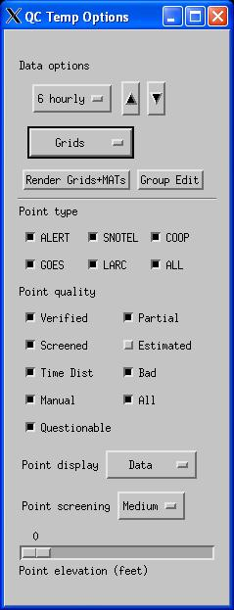
Figure 19 QC Temp Options Window

Point Elevation
The point elevation slider bar allows precipitation gauges to be selectively displayed based on their elevation. The slider ranges from 0 feet on the left to 15000 feet on the right. For example, setting the value of the slider to 1000 feet displays only those stations whose elevation is greater than or equal to 1000 feet.

Pixtemp
The Pixtemp slider controls the flagging of tipping bucket gages which may be below freezing or where the precipitation may have fallen as snow. The value of this slider ranges from -1.00 C to 3 C. The freezing level data are used in combination with the station elevations to determine which stations are at or below freezing. Since snow can fall at temperatures warmer than freezing, the pixtemp slider allows the threshold temperature at which tipping bucket gages are flagged to be adjusted. For example, if the pixtemp slider is set to 3 C, then gauges whose elevations are greater than or equal to the freezing level minus 1800 feet will be flagged (using the standard 5 C / 1000 m lapse rate). Setting the slider to -1 C will cause gauges whose elevations are greater than or equal to the freezing level plus 600 feet are flagged.

      - QC Temp Options

Selecting the QC Temperatures option launches the QC Temp Options window shown in Figure 19. This window is also launched when the Temperature button is pressed on the Choose Data Period window.

6 hourly/ Maximum/Minimum Selection
The QC Temp Options window contains the tools to manipulate the display of 6 hourly temperatures, maximum temperatures and minimum temperatures. The data options section of this window contains an option button menu which allows the 6 hourly temperature, maximum temperature or minimum temperature datasets to be selected. The forecaster edits one day of temperature data at a time. The maximum and minimum temperatures are daily values spanning from 12z to 12z. The 6 hourly temperature values are valid for the 12z-18z, 18z-00z, 00z-06z, and 06z-12z 6 hour periods. Selecting the up arrow next to the 6 hourly/maximum/minimum option menu causes the next period of temperature data to be displayed on the MPE Editor map. Selecting the down arrow causes the previous period of temperature data to be displayed. When the upper or lower bounding date (as specified by the ending year, month, day, and number of days fields in the Choose Data Period window) of the temperature data set is reached the up or down arrow will become desensitized, respectively.

Temperature Data Display Options
Below the 6 hourly/maximum/minimum option menu is the data display option menu. The options on this menu are Points, Grids, MATs, Points+Grids, Points+MATs, and None:
- Points – Display the temperature data as point values.
- Grids – Display the temperature data as an HRAP gridded field.
- MATs – Display the temperature data as basin averaged values.
- Points+Grids – Display the temperature data as an HRAP gridded field overlain with point values.
- Points+MATs – Display the temperature data as basin average values overlain with point values.
- None – Do not display temperature data.

Initially, only the Points and None options are selectable. The other options become selectable once the gridded and MAT temperature fields have been created.

Generating Gridded Temperature and MATs
The Render Grids+MATs button will generate four 6 hourly temperature HRAP gridded fields, a maximum temperature HRAP gridded field and a minimum temperature HRAP gridded field for the 12z to 12z gage QC day currently being edited. It will also create four 6 hour basin averaged temperature fields (MATs) for the current 12z to 12z gage QC period. Note that MATs are not generated for the maximum or minimum temperature fields. These data sets can then be viewed by selecting Grids or MATs from the temperature data display option menu.

The temperature grids and MATs do not use gauge values that have been set to bad.

Once the grids and MATs have been created, the Render Grids+MATs button becomes unselectable (grayed out). It will remain unselectable until the QC flag or value of a gage is modified.

Group Edit Option
Pressing the Group Edit button causes the Group Edit Stations window to appear (Figure 18). MPE Editor enters the Group Edit mode. This window allows the QC flags of a group of gages to be quickly modified. The user selects Verified, Screened or Bad from this window. Then, as long as this window is open the QC flag of the temperature values can be set to the selected state by placing the mouse pointer over each gauge and right clicking. Note that the gauges may not be set to Questionable. Questionable is a state set only by the automated gauge QC checks adopted from DailyQC.

Pressing the OK button closes the Group Edit Stations window and exits the Group Edit mode.

Temperature Display Filter Options
The remaining options on the QC Temp Options window allow the temperature gauge points to be selectively displayed according to their type source, quality flag, and elevation. An option also exists to control the type of information displayed (e.g. temperature value, station identifier, station name, parameter code, RFS, or partial). An option also exists to control the threshold standard deviation above which the temperature values are declared questionable by the buddy check.

Point Type
In the Point Type section of the QC Temp Options window, the Alert, SNOTEL, COOP, GOES, LARC, and ALL buttons allow temperature data to be selectively displayed based on type source. The value and number of these buttons are based on the mpe_type_source token. More information about the mpe_type_source token can be found in the MPE Editor Implementation Guide.

Point Quality
The Verified, Screened, Time Dist, Manual, Questionable, Partial, Estimated, Bad, and All check boxes under the Point Quality section allows temperature gauges to be selectively displayed according to their QC flag.

Point Display
The Point Display option menu controls the type of information displayed at each gauge point. The following display options are available:
- Handbook 5 – The Handbook 5 identifier of the station
- PC – The source code of the temperature datum being displayed
- Name – The name of the station
- Data – The temperature value
- RFS –
- Partial – Not implemented

Only one of these items may be displayed at a time. Missing temperature values are not displayed.
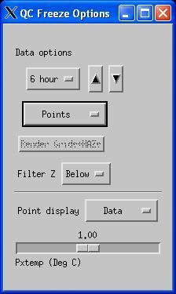
Figure 20 QC Freeze Options Window

Point Screening
This option allows the standard deviation threshold to be set above which temperature values are flagged as questionable. The choices are Coarse, Medium and Fine. Selecting Course results in the fewest questionable gauges. Selection Fine results in the most questionable gauges.

Point Elevation
The point elevation slider bar allows precipitation gauges to be selectively displayed based on their elevation. The slider ranges from 0 feet on the left to 15000 feet on the right. For example, setting the value of the slider to 1000 feet displays only those stations whose elevation is greater than or equal to 1000 feet.
      - QC Freezing Level

Selecting the QC Freezing Level option launches the QC Freeze Options window shown in Figure 20. This window is also launched when the Freezing button is pressed on the Choose Data Period window. The freezing level stations are not actual stations like the precipitation and temperature stations are. Instead, they are the RUC80 model grid points which fall within the office’s MPE forecast area.

The freezing level data are derived from the RUC80 model via a cron job. See the MPE Implementation Guide for information about setting this up.

6 Hour Data Selection
The QC Freeze Options window contains the tools to manipulate the display of 6 hour freezing level values. The data options section of this window contains an option button menu which allows the 6 hour freezing level datasets to be selected. The forecaster edits one day of freezing level data at a time. Selecting the up arrow next to the 6 hour option menu causes the next 6 hour period of freezing level data to be displayed on the MPE Editor map. Selecting the down arrow causes the previous 6 hour period of freezing level data to be displayed. When the upper or lower bounding date (as specified by the ending year, month, day, and number of days fields in the Choose Data Period window) of the freezing level data set is reached the up or down arrow will become desensitized, respectively.

Freezing Level Data Display Options
Below the 6 hour option menu is the data display option menu. The options on this menu are Points, Grids, MAZs, Points+Grids, Points+MAZs, and None:
- Points – Display the freezing level data as point values.
- Grids – Display the freezing level data as an HRAP gridded field.
- MAZs – Display the freezing level data as basin averaged values.
- Points+Grids – Display the freezing level data as an HRAP gridded field overlain with point values.
- Points+MAZs – Display the freezing level data as basin average values overlain with point values.
- None – Do not display the freezing level data.

Initially, only the Points and None options are selectable. The other options become selectable once the gridded and MAZ freezing level fields have been created.

Generating Gridded Freezing Level Data and MAZs
The Render Grids+MAZs button will generate four 6 hour freezing level HRAP gridded fields for the 12z to 12z gage QC day currently being edited. It will also create four 6 hour basin averaged freezing level fields (MAZs) for the current 12z to 12z gage QC period. These data sets can be viewed by selecting Grids or MAZs from the freezing level data display option menu.

The freezing level grids and MAZs do not use gauge values that have been set to bad.

Once the grids and MAZs have been created, the Render Grids+MAZs button becomes unselectable (grayed out). It will remain unselectable until the QC flag or value of a gage is modified.

Filter Z
This option controls the appearance of the HRAP gridded freezing level fields on the MPE Editor map display. It works in conjunction with the Pxtemp slider bar. The choices on the Filter Z option menu are Above, Below and All. Based on the freezing level data and the elevations of the HRAP grid bins, the Above option shows the freezing level grid for only the portions of the MPE forecast area which are warmer than the temperature shown on the Pxtemp slider bar. The Below option shows the freezing level grid for only the portions of the MPE forecast area which are colder than the temperature shown on the Pxtemp slider bar. The All option displays the entire freezing level data HRAP grid. These options provide a way of quickly determining where in the forecast area precipitation is liquid or frozen.

Freezing Level Data Display Filter Options
The remaining options on the QC Freeze Options window allow the type of point freezing level information displayed on the MPE Editor map to be chosen. They also control the threshold temperature used by the Filter Z option.

Point Display
The Point Display option menu controls the type of information displayed at each gauge point. The following display options are available:
- Handbook 5 – The Handbook 5 identifier of the station
- PC – The source code of the freezing level datum being displayed
- Name – The name assigned to the freezing level RUC model
- Data – The freezing level value

Only one of these items may be displayed at a time.

Pxtemp

The Pxtemp slider bar controls the threshold temperature used by the Filter Z option in determining which parts of the forecast area may be receiving snow and which parts may be receiving rain. The values pxtemp slider values range from -1 C on the left to 3 C on the right. Changing the value on the pxtemp slider also changes the value on the Pxtemp slider on the QC Precip Options window.

      - Save Level 2 Data

Precipitation, temperature and freezing level data are assigned to different levels before and after they have been QC’d using the 6/24 hour gage editing tools. The gage QC levels are raw data, level 1 data and level 2 data. Raw data are those data which have not had any QC applied to them. Level 1 data are those which have had rough range checks applied to the values. The data which comes from the SHEF Decoder are Level 1 because Data Limits range checks have been applied to them. Once precipitation, temperature and freezing level data have been QC’d using the 6/24 hour Gage QC tools in MPE Editor, they are considered to be Level 2 data.
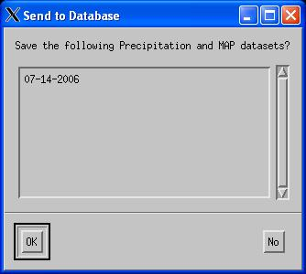
Figure 21 Send to Database Window

Once the 6/24 hour precipitation, temperature and freezing level data have been edited, the Save Level 2 data option should be selected to save these level 2 QC’d data. Point and basin averaged (MAP, MAT, MAZ) data are saved in SHEF format. The gridded data fields are stored in ASCII files.

When the Save Level 2 Data option is selected, the Send to Database dialog box is displayed (Figure 21). This box lists the daily 6/24 gage datasets to be saved. These will be the datasets for which the user has edited data and/or rendered precipitation grids and areal basin estimates. Selecting OK saves the data. Selection NO cancels the save operation.
      - Add Pseudo Gage

This option allows the user to add a false (pseudo) gage report. When this option is selected, the mouse pointer temporarily turns into a leftward pointing hand to indicate that the application is in “pseudo gage mode”. Left clicking on the portion of the MPE Editor viewing area that the user would like to insert the new gage brings up the “Add Pseudo Gage” window. This sub-window consists of a slider bar to set the gage’s value and option buttons which allow the user to set the value, to cancel the value selection and to get more help about the add pseudo gage functionality. Once the slider bar is set to the desired value and the “Ok” button is selected, the new gage report is created in the database by inserting a new record into the PseudoGageVal IHFS database table. In order for the new gage value to be used in the generated fields, the “Regenerate Hour Fields” option must be selected from the MPEcontrol menu. After MPE FieldGen has been rerun, the “Gage Only”, “Multisensor Mosaic” and “Triangulated Local Bias” analyses will reflect the new gage. If displaying the gage identifiers, then once MPE FieldGen is rerun, the pseudo gage will have a name with the format “PSEUDONN” where NN is the number of pseudo gages created for the hour, starting with the number “00".

      - Gage Table ...

The gage table provides a tabular display of all of the gages contained within the forecast area’s HRAP grid. These are the gages that contribute to the “Multisensor” and “Gage Only” fields and, and these gages are used in the computation of the mean field bias and the local bias. This gage listing includes any pseudo gages created by the user. The GUI consists of a simple menu bar with the submenu headings “Control”, “Sort Gages”, and “Help”. “Control” provides the option to quit the gage table. “Sort Gages” provides the ability to sort gages by gage value, by gage identifier, and by radar identifier. “Help” provides access to the help gui.

The main portion of the gage table consists of a large table. Each row in this table corresponds to one gage location. Each row has 11 columns. These are “GageID”, “Gage”, “BestQPE”, “MultiSensor”, “RadarID”, “RadarMosaic”, “FieldBias”, “LocalBias”, “GageOnly”, “Satellite”, and “Edit”. The “Gage ID” column displays the identifier of the gage. The “Gage” column displays the value of the gage. The “BestQPE” column displays the best estimate QPE for the HRAP bin that the gage occupies. The “MultiSensor” column displays the multi-sensor precipitation estimate for the gage’s HRAP bin. The “RadarID” column indicates which radar umbrella the gage is covered by. The “RadarMosaic” column shows the radar estimated rainfall for the HRAP grid bin the gage is located in. The “FieldBias” and “LocalBias” columns display the field bias radar mosaic values, respectively, for the HRAP bin the gage is located in. The “GageOnly” column displays the value from the Gageg Only Analysis field corresponding to the gage’s location. The “Satellite” column displays the value from the Satellite Precip field corresponding to the gage’s location. A new value for the gage may be entered under the “Edit” column. A missing value must be represented as either a “M” or a “m”. Note the when “quit” is selected from the gage table Control menu, edited gage values will be stored. These edited gage values will be applied to the MPE products when MPE Fieldgen is rerun.

      - Show Missing Gages
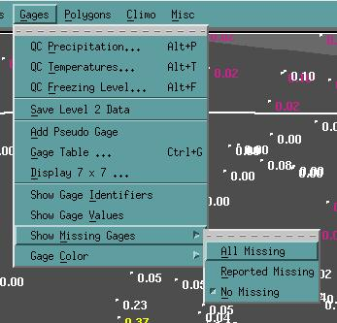
Figure 22 Show Missing Gages Submenu Options
The Show Missing Gages submenu provides three options for controlling how missing MPE gage data are displayed. As shown in Figure 22these are: All Missing, Reported Missing, and No Missing.

There are two categories of missing MPE gage data. The first includes hourly precipitation totals that are incomplete because a precipitation report has not been received for the hour. The second, the reported missing category, includes hourly precipitation totals either manually set to missing by the forecaster or reported missing (-9999) by the gage station. The distinction is important because when viewing MPE gage values for the most recent hour some gage reports may not have been received yet. These gage reports may eventually arrive. Being able to view the reported missing gage values separately from the reports which are missing because a lack of data gives the forecaster an idea of for which gages data still may still be received.

Missing gage values are displayed as “m”. When the All Missing option is selected then missing gages are displayed regardless of whether or not they are reported missing. When the Reported Missing option is selected, then only the missing gages which were either manually set to missing or reported with a value of -9999 are displayed. If the No Missing option is selected, then no missing gages are displayed.

      - Gage Color

The Gage Color item launches the submenu shown in Figure 23. The options are as follows:
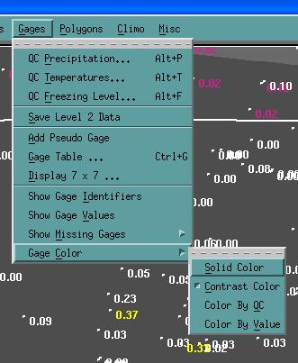
Figure 23 Gage Color Submenu Options

        - Solid Color

Gage values and identifiers are displayed in a single color. This color is “Sandy Brown”.

        - Contrast Color

The gage value and identifier colors are selected in such a way that they remain visible against their background. This eliminates the problem where a gage may be the same color as its background, rendering it hard to see or even invisible.

        - Color By QC

Gage values and identifiers are colored according to whether or not they have passed the spatial consistency and multi-sensor quality control checks. The gage identifier and value will colored red if the gage did not pass the spatial consistency check. The gage identifier and value will be colored yellow if the gage did not pass the multi-sensor check. If the gage has passed these QC checks, then it will be colored sandy brown.

        - Color By Value

Using this color option, gage data which are overlain on a MPE precipitation or gage mosaic will be colored according to their values. The gages are colored according to the color bar associate with the MPE field they are drawn on top of. For non-precipitation MPE fields (PRISM, Height Field, Radar Coverage Field, Local Span Field, Local Bias Field), the gages are drawn using the color sandy brown.
      - Display 7 x 7

The “Display 7 x 7" option provides the ability to view a 7 x 7 grid of HRAP bins centered on a precipitation gage. This feature gives the forecaster the capability of analyzing the precipitation distribution at a very detailed scale of resolution around a gage site. It also provides the ability to modify the gage’s value. For example, the user may wish to lower or raise the gage’s precipitation amount to make it more consistent with the estimated precipitation amounts in the HRAP bins surrounding it.

When the “Display 7 x 7" option is chosen from the Gages menu, the mouse pointer changes to a leftward pointing hand. A gage is selected by positioning the hand over it and performing a single click of the left mouse button. If a gage is not directly under the clicked point on the map, then the gage that is closest to the click point is selected as the center of the 7 x 7 display. After clicking on or near a precipitation gage the 7 x 7 Window appears (Figure 24). This simple window contains the identifier of the gage the grid is centered on, the value of the gage, and a 7 column by 7 row table where each element represents the estimated precipitation value of one of the HRAP bins in the vicinity of the gage.
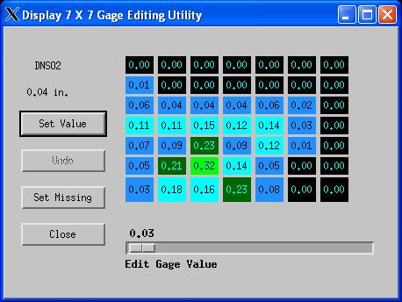
Figure 24 Display 7X7 Gage Editing Utility

The values displayed in the grid reflect the type of field that the user is viewing in the main window. For example, if the best estimate qpe field is being viewed in the main window, then the values inserted into the 7 x 7 grid will also be best estimate qpe. The colors assigned to the values in the 7 x 7 HRAP grid follow the legend displayed with the MPE product being viewed in the main window.

The 7 x 7 window does not have to be closed between successive gage edits. The 7 x 7 window display automatically updates each time a new gage is selected in the MPE Editor display.

The 7 x 7 window has four buttons arranged down its left side. The Apply button applies the value specified by the Edit Gage Value slider bar to the gage being edited. The Undo button returns the gage to the value it had before the most recent edit. The Set Missing button sets the gage’s value to missing. The Close button closes the 7 x 7 GUI and exits MPE Editor from 7 x 7 mode.

Edited gage values are applied to the MPE analysis when MPE Fieldgen is rerun.

      - Show Gage Identifiers

The show gage identifiers option toggles on and off the display of the gage ids on the MPE Editor display.

      - Show Gage Values

The Show Gage Values option toggles on and off the display of the gage values on the MPE Editor display. A missing gage value is signified by the character “m”.

    - Polygons Menu Options

The Polygons Menu, shown in Figure 25 has two options, “Draw Polygons” and “Delete Polygons”. These allow specific portions of the MPE precipitation fields and mosaics to be edited. They also allow areas of precipitation to be created or removed. The user draws a polygon around the part of the field which needs to be modified. The modification chosen by the user is applied to each HRAP grid bin contained within the drawn polygon. The modification options include setting all HRAP grid bins within the polygon to the same value, setting a minimum value limit for all bins within the polygon, setting a maximum value limit for all bins within the polygon, scaling the values of the grid bins by a multiplicative factor, or substituting a portion of one MPE field into another MPE field.
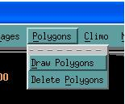
Figure 25 Polygons Menu Options
      - Draw Polygons

The Draw Polygons option allows the user to manually draw precipitation areas on the main MPE Editor window by creating edit polygons. Once the polygon is drawn, the user is given a choice of how the values of the HRAP grid bins within the polygon are to be changed.

Edit polygons are drawn on the MPE Editor display as follows:

1) Select the Draw Polygons options on the Polygons menu. The program enters the draw polygon mode.

2) A polygon may now be drawn using the mouse and left clicking wherever a polygon point is desired. To close the polygon, the right mouse button needs to be clicked once. There is no limit on the number of points a polygon may contain.

3) Once the polygon is closed, the “Edit Precipitation” GUI will appear as shown in Figure 26. At the top of this GUI, there is a check box labeled “Make Persistent”. Setting this check box will make the drawn polygon persistent. By default, Polygons are saved on a per product per hour basis. Unless set to be persistent, a polygon is only applied to the MPE product for the hour it was created. If the polygon is set to persistent, then it is applied to the MPE product every hour. By default the files containing the polygons are deleted after the amount of time specified in the purge_mpe_files script. Persistent polygons are not automatically deleted. They must be manually deleted.

4) The “Edit Precipitation” GUI also contains options for modifying the data contained within the polygon. The top part of the GUI contains a slider bar with four buttons, “Set”, “Raise”, “Lower”, and “Scale” located below it. The slider bar acts in conjunction with each of these buttons as follows:

Set - This button sets all grid boxes contained within the polygon to the value specified by the slider bar.

Raise - This feature sets the minimum value a grid bin contained within the polygon may have. This threshold value is specified by the slider bar. All grid bins with values lower than this threshold are raised to it. All grid bins with values higher than this threshold are left unchanged.

Lower - This feature sets the maximum value a grid bin contained within the polygon may have. This threshold value is set by the slider bar. All grid bins with values higher than this threshold are lower to it. All grid bins with values equal to or lower than this threshold are left unchanged.
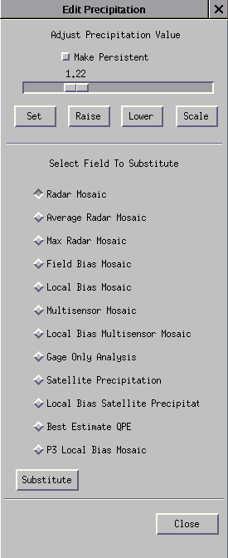
Figure 26 The Edit Precipitation Window

Scale - This feature takes the value of each grid bin contained within the polygon and multiplies it by the value specified on the slider bar.

In addition to these options, values from the other precipitation fields may be substituted into the polygon. The bottom part of the Edit Precipitation GUI contains a list of radio buttons corresponding to the precipitation products which may be substituted into the polygon. These are the Radar Mosaic, Average Radar Mosaic, Max Radar Mosaic, Field Bias Mosaic, Local Bias Mosaic, Multisensor Mosaic, Local Bias Multisensor Mosaic, Gage Only Analysis, Satellite Precipitation, Local Bias Satellite Precipitation, Best Estimate QPE, and P3 Local Bias Mosaic. The Substitute button positioned below these options will fill the polygon with data from the currently selected precipitation product.

5) Steps 2 through 4 may be repeated several times to draw multiple polygons.

The first polygon point must be placed within the bounds of the MPE forecast area. If it is not, then an error dialog will be displayed stating that the cursor is out of range. Subsequent points in the polygon may be drawn inside or outside of the forecast area. If a point is placed outside of the forecast area’s bounds, then it will be “snapped” back so that it is positioned just inside of the boundary.

Edit polygons are saved to disk. The polygons are stored on a per product per hour basis. So, polygons drawn on a field are remembered and redrawn on that field whenever it is displayed in MPE Editor.

      - Delete Polygons

Selecting the delete polygons option displays the Delete Polygons window shown in Figure 27. This window displays the date and hour and name of the MPE product currently displayed in the MPE Editor window. In the large list box in the middle of the window, a row of information is shown for each edit polygon drawn on the MPE product for the given date and hour. This information includes the polygon number, a true/false flag indicating if the polygon is currently displayed on the screen, a true/false flag indicating whether or not the polygon is persistent, how the grid bins within the polygon where modified, and the value used to modify the grid bins.
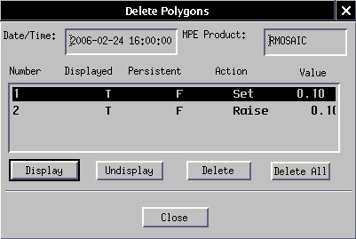
Figure 27 Delete Polygons Window

Polygons are stored in the order they are drawn in. The first polygon receives the number 1. The second polygon drawn receives the number 2, and so on. Selecting the Display/Undisplay buttons below the list of polygons will display or undisplay the selected polygon, respectively. Undisplaying the polygon does not permanently delete it. It does remove it from the MPE Editor display. It also prevents it from being used by MPE Fieldgen in the case where the polygon was drawn on a MPE Product from which other MPE products are derived. When a polygon is undisplayed, it will have an entry of ‘F’ in the Displayed column. When a polygon is displayed, it will have an entry of ‘T’ in the Displayed column.

If a persistent polygon was created, then it will have an entry of ‘T’ in the Persistent column. If the polygon is not persistent, then it will have an entry of ‘F’ in the Persistent column.

The Action column indicates how the values of the HRAP grid bins contained within the polygon were modified. The possible values in the Action column are: Set, Raise, Lower, Scale, and Sub. These actions correspond to the Set, Raise, Lower, Scale, and Substitute buttons on the Edit Precipitation window in Figure 26.

The Value column contains the value used to modify the HRAP grid bins contained within the polygon. For the Set, Raise, Lower, and Scale actions, this will be a floating point numeric value to two decimal places. For the Sub action, this will be the name of the field from which data was substituted into the polygon.

Selecting a polygon in the polygon list and then pressing the Delete button will cause that polygon to be permanently deleted. Clicking on the Delete All button will permanently delete all polygons (both persistent and non-persistent) drawn on that MPE product.

    - Climo Menu Options

PRISM (Parameter-elevation Regressions on Independent Slopes Model) data is long term climatological precipitation data. The multisensor precipitation estimates are scaled by the PRISM average monthly precipitation climatologies to improve estimates especially in mountainous regions which are subject to large orographic influences. In a future release, the average monthly maximum and minimum temperature PRISM climatologies will be available for display.
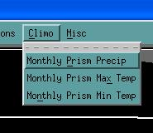
Figure 28 Climo Menu Options
-
The Climo (Figure 28) Menu has the following options: “Monthly Prism Precip”, “Monthly Prism Max Temp” and “Monthly Prism Min Temp”.
      - Monthly Prism Precip

Selecting this option will display the average monthly precipitation PRISM on the MPE Editor map window.

      - Monthly Prism Max Temp

This option is not available. It will be available in a future release of MPE Editor. It is part of the ongoing project to incorporate new gage editing tools into MPE Editor.
      - Monthly Prism Min Temp

This option is not available. It will be available in a future release of MPE Editor. It is part of the ongoing project to incorporate new gage editing tools into MPE Editor.
    - Misc Menu Options

The Misc menu (Figure 29) contains options to display the mean field bias correction factors calculated for each of the radars, to display the DPA products for the individual radars used in the creation of the radar mosaic, to time lapse the currently displayed MPE product over a user-specified period of time, and to the sum and display the Best Estimate QPE products over a user-specified duration of time.
      - Display Bias Table

The “Display Bias Table” option launches the “Edit Bias Table” GUI. From here, the user may easily view the radar-specific biases for the radar sites which provide coverage for the WFO or RFC area. The three buttons across the top of this GUI, “Close”, “Apply” and “Help” provide the means for closing the application, applying bias changes, and getting more information respectively. There are five columns of data in this table. Each row in this table provides bias information specific to a particular radar site. This information includes the radar’s identifier, its mean field bias value, whether or not the mean field bias has been manually updated, and the A and B coefficients used in the Z-R relationship by the Radar Product Generator when producing the DPA product. Note that by selecting any one of the radars listed in the bias table window, a window displaying the memory span information used in computing that radar’s mean field bias is shown.
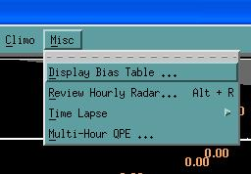
Figure 29 The Misc Menu Options
      - Review Hourly Radar ...
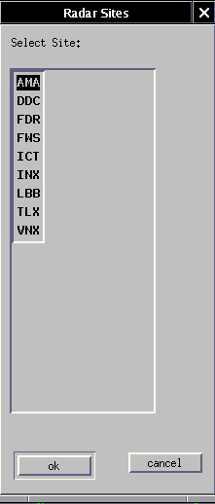
Figure 30 Show Single Radar Site Radar Selection Window
The review hourly radar option initially brings up the “Radar Sites” window (Figure 30). This window allows the selection of a specific radar site that provides coverage within the MPE forecast area. By highlighting a site and selecting the “Ok” button, the “Single Radar Site” subwindow is launched (Figure 30). This window has four panes or panels. Going clockwise starting in the upper left hand corner of the window the panes are “Raw Radar”, “Radar Climatology”, “Radar Coverage Map”, and “Mean Field Bias Corrected Radar”.

The “Raw Radar” map is the radar based digital precipitation product which has not had a bias correction applied to it. It is a 131 by 131 km grid centered on the specific radar site. The “Radar Climatology Grid” is currently unused. The “Radar Coverage Map” is a map of the radar beam blockages. It is displayed using black and red colors. The black grid boxes are the grid boxes for which there is no radar coverage available due to radar beam blockages. The red grid boxes do have radar coverage available. This information is read from a file in the “misbin” directory. If the file is not available, then the circle will be drawn all filled in with red. The “Mean Field Bias Corrected Radar” is the raw radar field data values multiplied by the mean field bias value (which is displayed at the bottom of the screen). If data is not available for the selected radar site, then the text “Missing Radar” is displayed within the “Raw Radar” and the “Mean Field Bias Corrected Radar” panes.

The menubar across the top of the “Single Radar Site” window contains the “Control”, “Options”, and “Overlays” submenus. The “Control” menu contains the “Close” button. This simply closes the single site window.

The “Options” menu contains the “Edit Bias Value”, “Ignore Radar”, “Display Adaptable Param”, and “Display Supplemental Data” items. The “Edit Bias Value” option provides the means to alter the radar mean field bias value used to “correct” its precipitation estimates to be closer to gage estimates. It launches the “Edit Bias Value” popup slider bar window through which the mean field bias value can be easily changed. The “Ignore Radar” option provides a way of excluding a specific radar’s data from the derived MPE precipitation products. When this option is selected, the radar’s data will not be used in the MPE analysis when MPE Fieldgen is rerun. The text on this menu option also changes to Unignore Radar. Selecting it again will allow the radar’s data to be used in the MPE analysis when MPE Fieldgen is rerun.

Note that for both the “Edit Bias Value” and the “Ignore Radar” options, the “Rerun FieldGen” option must be selected so that all of the MPE fields can be recomputed without that radar’s data.

The “Display Adaptable Param” option displays the radar-specific adaptable parameters which include preprocessing algorithm parameters, rate algorithm parameters, accumulation algorithm parameters, and adjustment algorithm parameters. The “Display Supplemental Data” option displays data derived from the radar field. This information includes the product generation time, the volume coverage pattern, the operational weather mode, the maximum data value, and whether or not precipitation was detected during the hour leading up to this product.
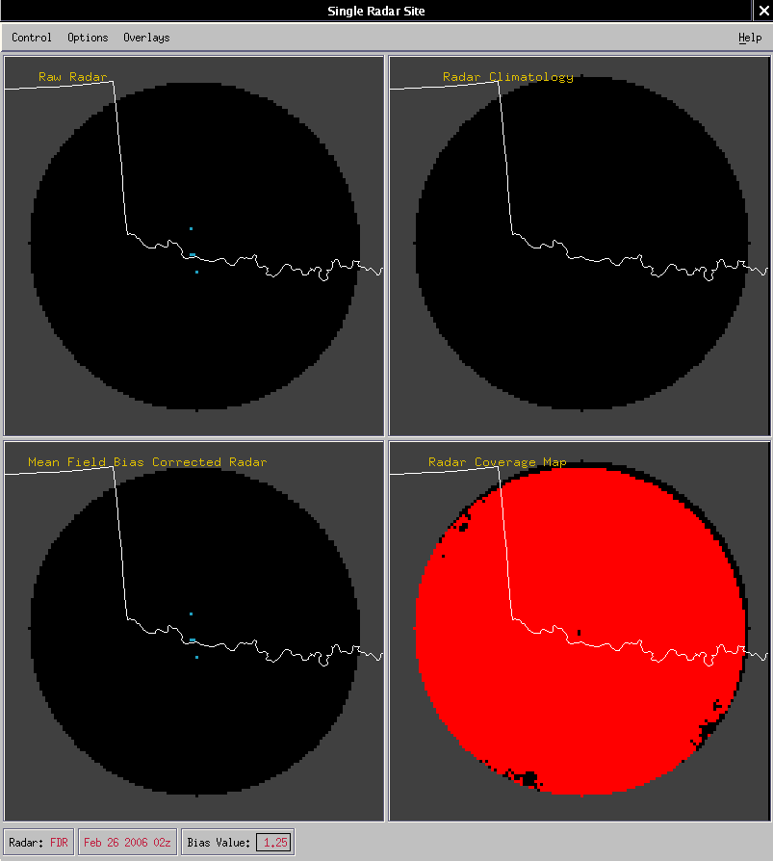
Figure 31 Show Single Radar Site Window

Finally, the “Overlays” submenu contains the following options: “RFC boundaries”, “States”, “County”, “Cities/Towns”, “Basin boundaries”, “Rivers”, “Precip Gages”, and “Radar Umbrella”. Each of these overlays provides a way of toggling on and off a specific overlay. Depending on the overlay’s initial state, the overlay selected is displayed or cleared in each of the four panes of the “Single Radar Site” window.

The user may display more than one Single Site Radar Window at a time. One window may be opened for each of the radars providing coverage to the site’s MPE forecast area.

      - Time Lapse Submenu

As shown in Figure 32 the time lapse submenu contains the following options: “6hr”, “12hr”, “24hr”, “Other ...”, and “End Loop”. The first four options specify the duration of the time lapse. All time lapse durations end with the current hour of data being examined. So, if the 6 hour time lapse is chosen, then MPE data for the last five hours plus the current hour are displayed in the time lapse. By default, when time lapse is started, it begins with the oldest data field and loops to the most recent data field. It then resets back to the oldest data field and loops again to the most recent data field. This process continues until the user ends the time lapse by selecting the “End Loop” menu item, selects manual loop frame stepping, or performs a zoom, pan or recenter action.
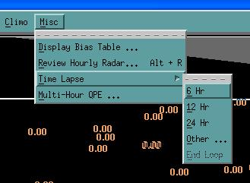
Figure 32 Time Lapse Submenu Options

When the “End Loop” option is selected, the image displayed in MPE Editor is the one being viewed before the time lapse was started.

To select manual loop frame stepping, the left or right key on the keyboard needs to be selected. The left arrow is for reverse looping while the right arrow key is for normal looping. Pressing the left arrow key will set the display to the current hour’s data field. Subsequent left arrow key presses will loop backward in time from there. Pressing the right arrow keyboard button will set the display to the oldest hour’s worth of data within the selected time lapse range. Subsequent right arrow key presses will loop forward in time from there. To resume automatic time lapsing, press the up or down keyboard key.

In addition to the “End Loop” menu option, the time lapse may be stopped by performing a zooming, panning or recentering action on the time lapsing image. For instance, if an interesting precipitation feature is observed in a particular frame during time lapsing, by placing the mouse cursor over the image and clicking the middle mouse button, the time lapse will stop on that frame and recenter and zoom into that feature. If a left mouse click was performed instead, then the time lapse would stop on the frame and recenter on the click point and zoom out.

See time lag between the successive image displays in the time lapse is specified by the token “hydroview_mpe_timelapse”. It is a value in milliseconds. If the token is not set, then the default duration is 1 second (1000 milliseconds).

A time lapse with a duration other than those explicitly shown on the time lapse submenu can be set by selecting the “Other ...” option. This launches a gui with a slider bar that allows the duration of the time lapse to be set to any value from 1 hour to 24 hours.

      - Multi-Hour QPE

This provides the ability to display multi-hour precipitation estimates. At this time, these rainfall totals are derived by summing together the hourly best estimate QPE products. The user is given full control over when and how long to tally the se rainfall estimates through a simple user interface ().
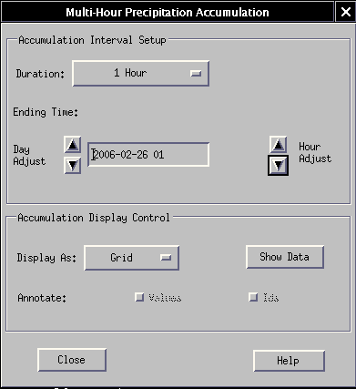
Figure 33 The Multi-Hour Precipitation Accumulation

This feature is accessed by selecting the “Multi-Hour QPE” item on the MPE Editor “Misc” menu. This displays the “Multi-Hour Precipitation Accumulation” window. This interface is divided into two distinct frames, the Accumulation Interval Setup frame and the Accumulation Display Control frame. The Accumulation Interval Setup frame has a drop down menu labeled “Duration:” which allows the user to select the interval over which to sum the rainfall amounts. If the desired duration is not on the option menu, then the user may select Other (at the bottom of the option menu). This will create the “Accumulation Interval” slider bar which allows which allows any interval from 1 to 72 hours to be chosen.

Just below the duration option menu is the ending time text field. This text field specifies the end time of the interval that multi-hour rainfall totals are being computed over. By default this text field displays the time of the MPE data field currently being viewed in the main window. However, it may be easily modified through the use of the incrementing and decrementing arrow buttons at either end of the end-time text field. The arrow buttons to the left of the text field, labeled “Day Adjust”, allow the day portion of the date to be modified. The arrows buttons to the right of the text field, labeled “Hour Adjust”, allow the hour portion of the date to be modified. The user cannot enter a date directly in the text field.

The “Accumulation Display Control” provides the “Display As” option menu which allows multi-hour precipitation totals to be displayed as HRAP grid values, basin averages, county averages, or zone averages. The “Show Data” button triggers the display of the multi-hour precipitation estimate based on the user-selected duration, ending time, and display resolution (HRAP grid, basins, counties, or zones). The identifiers and values of the precipitation areas may be shown using the “Values” and “Ids” annotation toggle buttons.

Below the Accumulation Display Control frame are the “Close” and “Help” buttons which destroy the GUI and allow for the retrieval of topic-specific help, respectively.

The multi-hour precipitation field cannot be saved as the best estimate QPE, time lapsed, have polygons drawn on it, or have pseudo gages plotted on it. Also, since this product spans a multi-hour interval, the concept of choosing the next or previous hour’s worth of data does not apply. The reason for this is that the Multi-hour precipitation estimate is not one of the base xmrg fields that is saved on disk for future reference. It is simply a displayed product that can be used for current reference. In order to regain access to the MPEcontrol menu items, one of the fields other than the multi-hour precipitation estimate must be selected from the MPEfields menu. Missing values encountered during the accumulation of hourly precipitation totals are not reported to the user. Missing values may be present on a grid bin by grid bin basis or as entire missing fields. Keeping this in mind, it is important to remember that because of missing data, a displayed multi-hour precipitation estimate for a given number of hours may not have been able to find data for all of the hours.

When viewing basin-averaged multi-hour rainfall estimates, each basin must be covered by a minimum percentage of valid, non-missing values in order to be assigned an average rainfall estimate. If this minimum percentage is not met, then the basin is assigned a value of missing and colored as light gray.
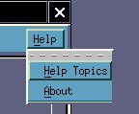
Figure 34 Help Menu Options

    - Help Menu Options

The Help menu displays three menu items: “Help Topics” and “About”(see ). The “Help Topics” item launches the MPE Editor help window which provides detailed instruction on the use of the features of the application. It also allows the user to search for keywords in the help topics. The “About” item provides the version and release of the MPE Editor application.

- Mouse Controls and Hot Keys

Mouse controls and hot keys are provided to speed up the use of the MPE Editor application. Table 4-1 shows the behaviors associated with a standard three-button mouse.

Mouse Button | Functionality that Results
Single Left Button Click | Zoom out and recenter at the click point
Single Middle Button Click | Zoom in and recenter at the click point
Single Right Button Click | Displays a “pop up” menu near the click point with additional options (see below)
Left Mouse Button Press and Drag | Draw a zoom rectangle. The rectangle is completed when the left mouse button is released. To zoom into the area defined by the rectangle, press CTRL + Z. To zoom out, press CTRL+Z again.
Right Mouse Button Press | Displays a “pop up” menu with additional options (see below). A release of the right mouse button pops down the menu.
Table 4- MPE Editor Mouse Functionality

  - Exceptions to Mouse Functionality

There are several cases in MPE Editor when the default mouse behavior is temporarily overridden.

When adding a pseudo gage ( reached from the Add Pseudo Gage item under the Gages submenu on the Gages menu), a left mouse click will select the location on the map to place the pseudo gage. To indicate that the mouse is in “add pseudo gage mode”, the mouse pointer changes from an arrow to a hand until the location of the new gage is selected.

When drawing a new polygon (reached from the Draw Polygons item under the Polygons menu), a left mouse click draws the vertices of the polygon. A middle or right mouse button click closes the polygon
Table 4- Pop up Menu Options

In - Zoom the map in.
Out - Zoom the map out.
Recenter - Recenter the map on the point where the user clicks next.
Up - Pan the map up.
Down - Pan the map down.
Left - Pan the map left.
Right - Pan the map right.
Lat/Lon - Turn on or off the latitude / longitude information that chases the cursor.
MPE Info - Turn on or off the MPE legend

Zoom mode is disabled when the user chooses the Polygons->Draw Polygons or Gages->AddPseudoGage menu item. Gages->ShowGageIdentifiers/Values menu options are available in regular or zoom mode.

When the Display 7x7 option is selected from the Gages menu, a click of the left mouse button will select the gage closest to the click point on the MPE Editor display and launch the Display 7 X 7 Gage Editing Utility GUI.

When any of the 6/24 hour precipitation, temperature or freezing level options is selected, clicking the right mouse button on the MPE Editor map will launch the Edit Precipitation Station window for precipitation data, the Edit Temperature Station window option for temperature data or the Edit Freezing Level Station window for the freezing level data. When 6/24 hour precipitation, temperature and freezing level data are not displayed, right clicking on the MPE Editor map will show the standard MPE Editor Pop Up Menu.

When the Group Edit option is selected from the QC Precipitation Options or QC Temp Options window and a QC flag is chosen from the Group Edit Stations popup window, right clicking on a station on the MPE Editor display will set its QC flag. When the Group Edit Stations popup window is closed, right clicking on the MPE Editor map will show the standard MPE Editor Pop Up menu.

  - Pop Up Menu Options
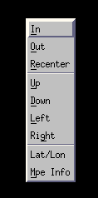
Figure 35 Popup Menu Options
A single click of the right mouse button or holding down the right mouse button while the mouse cursor is over the main viewing area will cause a “pop up” menu to be displayed at the click point. This popup menu contains the options shown in Table 4- .

  - Hot Keys

MPE Editor offers several hot keys for accessing some of the more heavily used features. These are shown in Table 4-2.
Hot Key | Action
Alt +C | Close the MPE Editor Application
Alt+R | Show a single radar site
Alt+S | Save the MPE Editor screen as a GIF
Alt+U | Draw the radar rings
Ctrl+B | Display the basins overlay
Ctrl+D | Pan down the display
Ctrl+I | Zoom in the display
Ctrl+L | Pan left the display
Ctrl+N | Show the next hour’s data field
Ctrl+O | Zoom out the display
Ctrl+P | Show the previous hour’s data field
Ctrl+R | Pan right the display
Ctrl+S | Save the displayed MPE field as the best estimate field
Ctrl+T | Toggle the toolbar on and off
Ctrl+U | Pan up the display
Ctrl+Z | Zoom in or out of a zoom rectangle. This hot key can also be used to undo the previous zoom, pan, or recenter operation.
Table 4- MPE Editor Hot Keys

- MPE Editor Legends
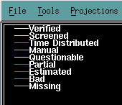
Figure 36 Point Precipitation Legend

The 6/24 hour gauge QC tools use separate legends from the MPE mosaics and fields. For 6/24 precipitation, temperature and freezing level point data, the legend is displayed in the upper left corner of the MPE Editor display. These point data are colored according to their QC flags. Figure 36 shows the legend for the 6/24 point precipitation data. Figure 37 shows the legend for the 6/24 point temperature data. Figure 38 shows the legend for the 6/24 hour point freezing level data. Note that the possible QC flags for each of these datasets are slightly different. The colors associated with these QC levels cannot be changed. These will be made modifiable in a future AWIPS release.For the gridded and basin averaged 6/24 precipitation, temperature and freezing level datasets, a legend is displayed across the bottom of the MPE Editor display. It is displayed in the same area as the legend for the MPE fields and mosaics. If both MPE data and 6/24 gage QC data are being displayed, then both the MPE and gage QC legends will be displayed.
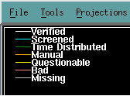
Figure 37 Point Temperature Legend
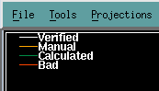
Figure 38 Point Freezing Level Legend

The legend used for the 6/24 hour gridded and basin averaged precipitation is show in Figure 39. This legend is interactive. The white rectangle drawn around the 0.01-0.1 box in the legend indicates which legend level is currently selected. A different legend level can be selected by left clicking on it. At the right hand end of the legend are three boxes labeled “down”, “up” and “off”. Left clicking on down will remove all gridded or basin averaged data whose value is below that of the currently selected legend level. Left clicking on up will color all gridded or basin averaged data whose value is greater than that of the currently selected legend level the same color as the currently selcted legend level. Left clicking on “off” will turn off legend filtering.
Figure 39 Gridded and MAP Precipitation Legend
Figure 40 Gridded and MAT Temperature Legend
Next to the down, up and off menu options are 5 menu boxes labeled 0-1.5, 0-3.0, 0-4.5, 0-8.4, and 0-15.6. Left clicking on these boxes changes the precipitation range values associated with each legend color level.
Figure 41 Gridded and MAZ Freezing Level Legend
The legend used for the 6/24 hour gridded and basin averaged temperature is shown in Figure 40. This legend is also interactive. The currently selected color level is outlined in a white rectangle. The selected color level can be changed by left clicking on a different legend color level. The “down”, “up” and “off” options operate the same as on the 6/24 point precipitation legend. The temperature range associated with each color level can be changed by selecting on the -15 to 60F legend box, the -5 to 70 F legend box or the 5 to 80 F box.
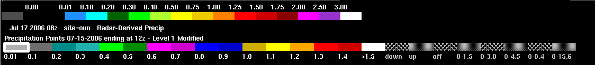
Figure 42 MPE and 6/24 Hour GageQC Legends
The legend used for the 6/24 hour gridded and basin averaged freezing level data is shown in Figure 41. Like the precipitation and temperature legends, it is interactive. The currently selected color level is outlined in a white rectangle. The selected color level can be changed by left clicking on a different legend color level box. The freezing level legend has only one available range associated with the color levels.

Figure 42 shows the appearance of the MPE Editor legend when both MPE and 6/24 gage data are displayed. Figure 43 shows the appearance of the MPE Editor legend when MPE and 6/24 gage data are being displayed along with the MPE Information Legend. The MPE Information 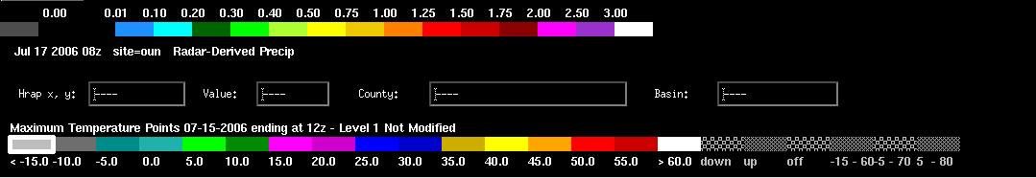
Figure 43 MPE, MPE Information and 6/24 Hour GageQC Legends
egend is launched from the MPE Info option on the right click popup menu.

